F. D. Roosevelt State Park
Business & Management Plan

Prepared July 2011; Finalized February 2013
Direction 2015 – Sustainable Business Planning

Table of Contents

Executive Summary 3

Site and Operations Assessment 8
Site Inventory and Facility Assessment 8
Operational Assessment 11
Financial Performance Assessment 17

Business and Management Plan 20
Business Goals 20
Classification of Programs and Services 21
Partnership Development Plan 22
Marketing and Sales Plan 23
Revenue Generation Plan 25
Expense Management Plan 27
Financial Pro Forma 28

Action Plan 31

Executive Summary
The Parks, Recreation and Historic Sites Division (PRHSD) of the Georgia Department of Natural Resources (DNR) is transitioning the management of F. D. Roosevelt State Park to operate more like a business, reflecting the Direction 2015 – Sustainable Business Planning initiative to improve the fiscal performance and management of the state parks and historic sites system. This business and management plan is designed to help the site recover more operating expenses through earned revenues, productive partnerships, and innovative programs.

Site Fact Sheet
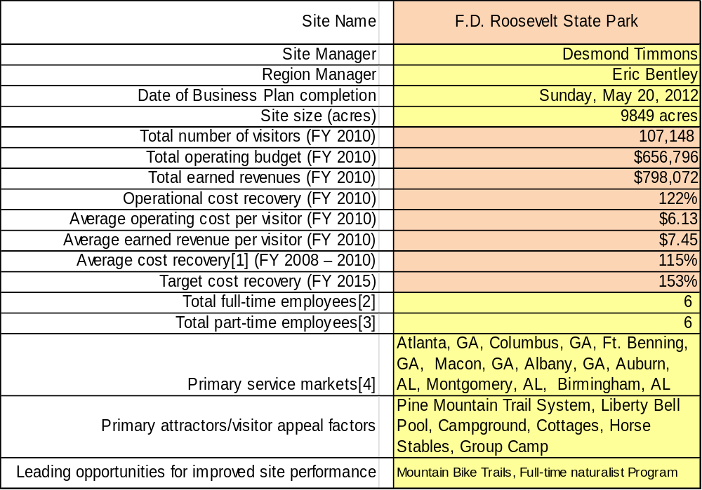

Site Summary and Key Attractions
The region containing the modern-day park was inhabited by the Creek Nation, until it ceded under the Treaties of 1825 and 1826, which granted the territories between the Flint and Chattahoochee rivers to the State of Georgia. An influx of settlers established the towns of Kings Gap, named after King’s trading Post located near the modern-day Liberty Bell Pool. The town eventually vanished by the 20th century.
Now on the most amazing mountain range in Central Georgia is 9,049 acres, which became Georgia’s largest state park and a hiker’s and backpacker’s haven. Many visitors are surprised to find rolling mountains 80 miles southeast of Atlanta. More than 40 miles of trails, including the popular 23-mile Pine Mountain Trail, winding through hardwoods and pines, over creeks and past small waterfalls. Above King’s Gap is Dowdell’s Knob where President Franklin D. Roosevelt sometimes picnicked and pondered world affairs. A life-size sculpture of the president now welcomes visitors to the overlook. Many visitors stop there for a picnic and ponder their thoughts at 1,395 feet. Hikers, backpackers and backcountry campers from all over the world visit this park, because within its boundaries is Pine Mountain.
Several park amenities were built by the Civilian Conservation Corps during the Great Depression, including cottages and the Liberty Bell Swimming Pool, fed by cool springs. The park office, constructed by the CCC, was at one time an Inn, and in later years, served as a restaurant. It is believed that President F.D. Roosevelt helped design the famous staircase of stone inside the office. A wooded campground sits near the edge of a small fishing lake, and privately operated stables offer guided horseback rides.
In 1921, FDR came to this part of Georgia to swim in naturally warm springs that offered relief from polio. Today, nearby Roosevelt’s Little White House Historic Site invites visitors to see his modest home, a museum and the pools that first drew him here.

Key Attractions
The amenities or features listed below are those that seem to be most popular for visitors.
- 22 Cottages
- 140 Campsites
- 1 Group Shelter
- Large and Small Group Camps
- Horse Stables, Trails, and Concession
- 4 Pioneer Camps
- 16 Backcountry Campsites
- 2 Picnic Shelters
- Jon Boat, Canoe and Kayak Rentals
- 2 Lakes 15 acre/25 acre
- Pine Mountain Trail
- Liberty Bell Pool

Financial Targets
The table below details the total operating expenses and earned revenues for F. D. Roosevelt State Park over the last three years (2008 – 2010). This table also calculates total cost per visitor and revenues per visitor during these operating years, and details the target financial performance goals in the context of achieving at least 153% cost recovery. This table also calculates the necessary change from 2010 operating expenses and revenues.

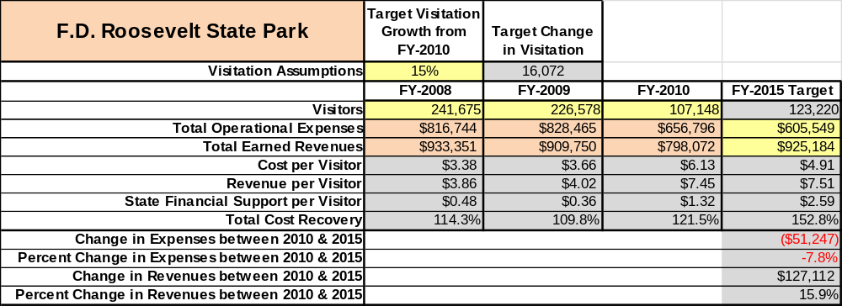

Key Recommendations

Primary / Short Term Recommendations
- Operate the site using cost-based accounting, including the net cost recovery achieved annually.
- Conduct in-park surveys annually to assess how well customer satisfaction levels are being met. F.D.R. should strive to have 90% of visitors responding to ‘Comment Cards’ report that they were either ‘satisfied’ or ‘very satisfied’ (or some comparable metric to be developed). Programs or services that fall below that standard should be critically reviewed, enhanced, and results monitored; those with a history of poor performance should be considered for elimination.
- Evaluate and pursue opportunities to employ concessionaires or private or public service providers on-site if they can be more cost-effective. For example, explore the development of a concessionaire agreement to manage private events on-site, such as weddings, which we receive dozens of requests per year.
- Collect a statistically-valid sample of ZIP code data from visitors in a non-intrusive way to gauge their origins and demographics (e.g., age, ethnicity, income, etc.) and use the results to improve programming and marketing efforts to appeal to a broader audience.
- Utilize a minimum of six special events annually to help draw more visitors to the site.
- Seek local partners to help support operations, programs, and service delivery and for cross-marketing purposes, especially from organizations like Boy Scouts of America.
- Enhance facilities and program offerings to provide a minimum of 10 unique experiences for each visitor while maintaining at least a 90% customer satisfaction rating.
- Manage F.D. Roosevelt according to well-defined maintenance, program and operational standards monitored and enforced by region managers and senior management.
- Partner with local Chambers of Commerce, Pine Mountain Visitor’s Center, City of Hamilton or other destination marketing organizations (DMOs) to promote F.D. Roosevelt State Park.
- Continue to work with the F.D. Roosevelt State Park Chapter of the Friends of Georgia State Parks and Historic Sites to help raise funds or provide volunteers for improvements and program support.
- Perform a thorough net cost-of-service analysis on major functions of site operations, including the detailed analysis of labor requirements. Thereafter, update costs to deliver services on a biennial schedule.
- Review and update rates at the site on an annual basis to recover the total net cost of service for important and visitor-supported services.
- Track total economic impact of the site on the local communities and region and share with decision-makers, elected officials, local business operators, and others to demonstrate the impact of F.D. Roosevelt State Park.
- Develop a more detailed analysis of labor requirements of all major park functions to match the right position with the right job at the right pay.
- Develop funding to provide additional training to site staff for improved business management, marketing effectiveness and customer service.
- Construct and upgrade facilities and amenities at the site that are likely to have a cost recovery level at or above 100%. Renovate and improve current group shelter by replacing exterior wood and windows. Replace and repair damaged wood on CCC cottages to maintain their historical significance.
- Add more youth-focused services, programs and amenities at the site that appeal to younger audiences, families and educational groups. This can be done with a year-round naturalist. The guests have commented on the web comment cards how much they value the programming that F. D. Roosevelt offers.
- Add more services, programs and amenities that appeal to older adults. It is difficult for most guests that are in their 70’s or 80’s to walk on the trail. Construct a walking path around Lake Delano and use the rubberized trail material as opposed to concrete.

Secondary / Long Term Recommendations
- Improve the recreational amenities of the site to address modern and diverse uses. Kayaks are about to be placed available for rent. Developing bike trails would increase revenue significantly. At this time volunteers are mapping a route for those trails, which will be presented to our Region Manager for approval. The trails would need to be friendly to the horse trails and the Pine Mountain Trail Association.
- Improve our group shelter by replacing exterior wood, windows; repaint interior and exterior of group shelter, to make the facility more attractive for guest rentals.

Site and Operations Assessment
This site and operations assessment is a culmination of analyses and findings from a review of the condition of facilities, infrastructure, and operations at F. D. Roosevelt State Park. The findings and observations are not intended to be an exhaustive review of all issues present, but provide a basic understanding of the predominant issues that contribute to the site’s current operating conditions. The assessment includes the following:
- Site Inventory and Facility Assessment
- Operational Assessment
- Financial Assessment
Site Inventory and Facility Assessment

Methodology
Facility and asset conditions are rated using a differential scale of excellent, good, fair, or poor. Descriptions of conditions that are attributed to each of these findings are also provided.
Scale of Conditions
Rating | General Description
Excellent | Facilities/amenities are in ‘excellent’ condition when they show little or no maintenance or repair problems. Facilities do not feature any major design or operational issues or flaws that contribute to diminished use or increased maintenance or upkeep. Facilities are easy to clean and maintain in order to place them back into public use and the users perceive them to be in excellent shape.
Good | Facilities/amenities are in ‘good’ condition when they show only minor maintenance or repair problems. Most maintenance issues with these facilities typically appear to be the result of age and/or heavy use. Facilities may only feature minor design or operational issues that contribute to diminished use or increased maintenance or upkeep. Facilities are moderately easy to clean and maintain in order to place them back into service and the users perceive them to be adequate for their use, but probably not in excellent shape.
Fair | Facilities/amenities are in ‘fair’ condition when they show significant maintenance or repair problems. Facilities generally exhibit ongoing maintenance issues that appear to be the result of age, heavy use, or design or operational flaws. Some maintenance and repair needs may compound their fair condition by being deferred because of budget and/or resource limitations. Facilities require more effort to clean and maintain before placing them back into service and the users may perceive them as being less than adequate for their use and in a state of deterioration. The facility or structure may need of major repair or replacement.
Poor | Facilities/amenities are in ‘poor’ condition when they show significant, on-going maintenance or repair problems that ultimately may result in suspended use for repair/replacement. Maintenance and repair issues are possibly the result of poor maintenance and clearly the result of age, heavy use, or design or operational flaws. Problems with the facilities are often compounded over time due to consistently-deferred maintenance and repair because of budget and/or resource limitations. Facilities may feature major design or operational issues that contribute to diminished use or increased maintenance or upkeep. Facilities require excessive effort to clean and maintain before placing them back into service and the users often perceive them as being inadequate for their use and in a state of serious deterioration. The facility or structure may need of major repair or replacement.

Inventory and Assessment
The table below is an inventory of facilities and amenities at F. D. Roosevelt State Park, and provides the assessed condition of each as reviewed in June, 2011.
Site Asset / Amenity | Quantity | Condition
Cottages | 22 | Fair
Camping | 140 | Good / Camp. 4 Poor (closed)
Group Shelter | 1 | Good
Picnic Shelters | 9 | Good
Pioneer Camping | 4 | Fair
Backcountry Camping | 16 | Excellent
Stables | 1 | Good
Liberty Bell Pool | 1 | Good
Amphitheater | 2 | Good
Hiking Trails | 42 Miles | Good
Office | 1 | Fair
Horse Trails | 23 Miles | Fair
Linen House | 1 | Good
Maintenance Shop | 1 | Fair
Managers Residence | 1 | Good
Assistant Managers Residence | 1 | Good
Rangers Residence | 1 | Fair
Large Group Camp | 1 | Poor (tornado damaged)
Small Group Camp | 1 | Fair (tornado damaged)
Office Spring | 1 | Fair
Campground/Cottage Spring | 1 | Good
Stables Well | 1 | Good
Group Camp Spring | 1 | Fair
Cottage 22 Well House | 1 | Good
Liberty Bell Pool Pump House | 1 | Fair
Block House | 1 | Poor
Trading Post | 1 | Fair
Comfort Stations Old | 3 | Fair
Comfort Stations New | 2 | Good
Boat House | 1 | Fair
Amphitheater Comfort Station | 1 | Poor
BBQ Pit at Group Shelter | 1 | Fair
Carriage House | 1 | Good
Sign Shop | 1 | Good
Office Chemical Room | 1 | Fair
Fishing Pier | 1 | Fair
Pool Building | 1 | Good

Prioritized Facility Needs
Based on the facility inventory and assessment, these prioritized needs have been identified. Each need has been aligned with a priority category of high, moderate, or low to support future decision making regarding project sequencing, investment of public resources, and meeting community expectations. The priority assignment for each need is not a measure of importance. Rather, these recommended priorities reflect a phased implementation approach over the next several years.

Facility Need | Priority Assignment
Large Group Camp Restoration (Tornado Damage) | High
Small Group Camp Restoration (Tornado Damage) | High
Rangers Residence upgrades | Moderate
Cottages 5-16 renovation | Moderate
Cottages 1-4 CCC | High
Cottage and Residences Roofing | High
Fishing Pier | Moderate
Campground and Comfort Station renovation—Area 4 | High (currently closed)
Amphitheater Comfort Station | High
Block House | Low
Group Camp Water System | High
Office Spring | High
Campground Renovation | High
Office Renovation | High

Operational Assessment
The Operational Assessment includes:
- An inventory and classification of programs and services being provided at the site
- A review of staffing at the site
- A review of concessionaires and partners operating at the site
- Visitation and customer satisfaction

Inventory and Classification of Programs and Services
Programs and services are classified into one of three major categories:
1) Core or Essential Services
2) Important Services
3) Visitor Supported Services
Programs and services at the site are classified into these categories based in part on the mission and public mandates for both the site and the agency. For the services in each of these categories, there are financial performance expectations that will define how services are funded and evaluated.

Category 1 – Core Services [Largely supported by tax funds]
Core programs, services and facilities are those the agency must provide and/or are essential in order to capably govern and meet statutory requirements. The failure of the agency to provide Category 1 services at adequate levels could result in significant negative consequences for the public and the resources under protection. The criteria for services to be classified as core or essential are:
- The services are mandated by the agency’s law or charter or are contractually obligated by agreement to provide the services.
- The services are essential to protecting and supporting the public’s health and safety.
- The services protect and maintain valuable assets and infrastructure.
- The services would generally and reasonably be expected and supported by residents, businesses, customers and partners.
- The services are those that cannot or should not be provided by the private sector.
- The services provide a sound investment of public funds.
The following services offered at F. D. Roosevelt State Park have been identified as core services:
- Active management of the natural and cultural resources of the site in order to protect their integrity
- Open and public access to the site and its resources
- Site appropriate education, interpretation and recreational opportunities
- Effective management of the park’s boundary and structures
- Safety of visitors and guests
- Maintenance of park grounds, buildings and infrastructure
Category 2 – Important Services [Supported by a balance of tax funds and earned revenues]
Important programs, services and facilities are those the agency should provide, and are important to governing and effectively serving residents, businesses, customers and partners. Providing Category 2 services expands or enhances the agency’s ability to provide and sustain its core services. The criteria for programs or services to be classified as important are:
- The services expand, enhance or support identified core services.
- The services are broadly supported and utilized by the community, and are considered an appropriate, important, and valuable public good. Public support may be conditional upon the manner by which the services are paid for or funded.
- The services generate income or revenue that offsets some or all of the operating cost and/or are deemed to provide economic, social or environmental outcomes or results.
The following services offered at F. D. Roosevelt State Park have been identified as important services:
- Self-guided interpretive and educational programs
- Overnight facilities: camping and cottages
- Picnic shelters
- Liberty Bell Pool – operated by Harris County
- Playground equipment
Category 3 – Visitor Supported Services [Almost exclusively supported by earned revenue]
Visitor supported programs, services and facilities are those discretionary services that the agency may provide when additional funding or revenue exists to offset the cost of providing those services. Category 3 services provide added value above and beyond what is required or expected. The criteria for programs or services to be classified as visitor supported are:
- The services expand, enhance or support core services or important services and the quality of life of the visitors, community or stakeholders.
- The services are supported and well utilized, providing appropriate and valuable public benefits.
- The services generate income or funding from sponsorships, grants, user fees or other sources that offset some or all of their cost and/or provides a meaningful return on investment.
- The services can possibly be provided through outsourcing or use of concessionaires, providing opportunities for community enterprises that may not otherwise be provided by the agency.
The following services offered at F. D. Roosevelt have been identified as visitor supported services:
- Gift shop and extended office hours
- Interpretive Ranger / Naturalist programs and other educational programs
- Special events not related to mission or interpretation or programs above the site level (North Face Challenge, Pine Mountain Run, hayrides, Halloween and Christmas programs)
- Boat rentals with concessionaire
- Horse stables concession
Staffing Assessment
Labor costs at F. D. Roosevelt State Park represent the largest area of budgetary expense at an average of 62% of the total operating budget for the last three complete years, which is lower than the target of total labor costs (including benefits) not exceeding 65% of the site’s total operating expenditures. The tables below and on the following page provide a basic review of the current staffing at the site.
Full Time Equivalent Employees
Position / Title | Quantity (FTE) | Vacancies | Annual Hours
Park Manager III | 1 | 0 | 2600
Assistant Park Manger II | 1 | 0 | 2600
Law Enforcement Ranger | 1 | 0 | 2080
Maintenance Engineer | 1 | 0 | 2340
Skilled Trades Craftsman | 1 | 0 | 2080
General Trades Craftsman | 1 | 0 | 2080
Utility Worker | 1 | 2 | 2080
Secretary | 1 | 0 | 2080
Naturalist | 0 | 1 | 0
TOTAL | 8 | 3 | 17,940
Part Time Employees
Position / Title | Quantity (FTE) | Vacancies | Hours
Housekeeping | 4 | 0 | 5564
Maintenance | 2 | 0 | 3016
Clerk | 2 | 0 | 3016
Naturalist | 1 | 0 | 1508
TOTAL | 9 | 0 | 13,104
Labor Support
Labor Support | Annual Hours
Volunteers | 2000
Community Service Workers | 500
Engineering and Construction Crews | 0
Resource Management Crews | 200
TOTAL | 2,700
Total Labor Hours
Labor Type | Annual Hours
Full Time Equivalent Employees | 17,940
Part Time Employees | 13,104
Labor Support | 2,700
TOTAL Annual Labor Hours | 33,744

Labor Budget Summary
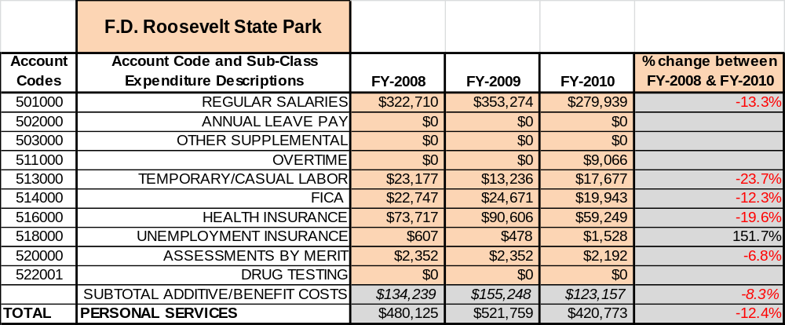

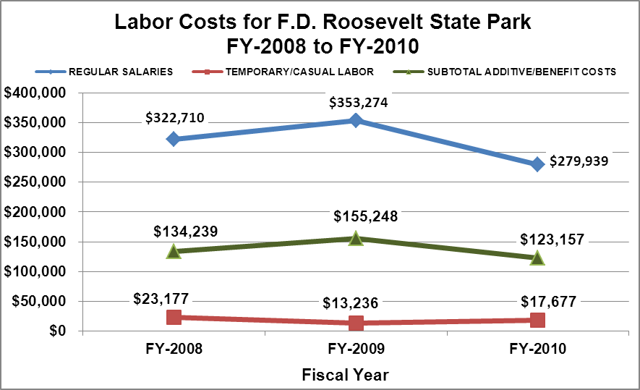

Visitation and Occupancy
Overall annual visitation to the site has trended downward from 2008 to 2010, decreasing by 38% or over 92,796 visitors. This largely attributed to economic times, cottages 17-21 being off-line for renovations for 166 days, and the tornado that struck the large and small group camps on April 28, 2011 and the condition of cottages 1-4. The pool was also closed during the 2010 season.
Year | Total Visitation
2008 | 241,675
2009 | 226,578
2010 | 107,148
Occupancy for the overnight accommodations at F. D. Roosevelt State Park the last three years is detailed in the table below. Overall occupancy has trended downward from 2008 to 2010, decreasing by 7.36% (campground), 9.05 % (cottages), 15.71 % (large group camp), and 3.12% (small group camp). This is largely attributed to economic times in conjunction with rate increases and competition from Callaway Gardens.
Year | Campground Occupancy | Cottage  Occupancy | Large Group Camp Occupancy ** | Small Group Camp Occupancy **
2008 | 32.46% | 50.99% | 31.35% | 24.32%
2009 | 28.87% | 42.83% | 31.35% | 27.03%
2010 | 25.10% | 41.94% | 15.64% | 21.20%
**Group Camp Occupancy determined on 185 days. It is unavailable for 180 days.
The graph below illustrates visitation and occupancy over the last three years.
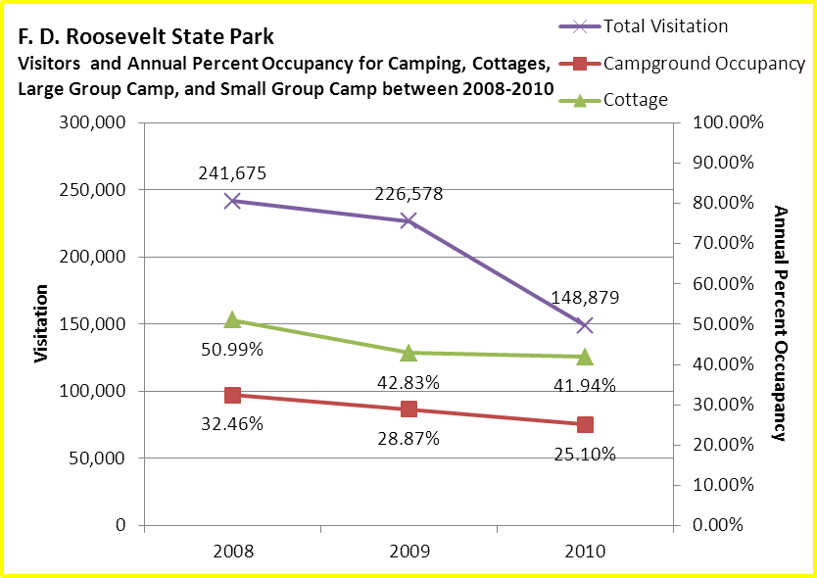

Customer Service and Satisfaction

Site | Year | Customer Satisfaction Level
F.D. Roosevelt State Park | 2009 | 72%
F.D. Roosevelt State Park | 2010 | 61%
Financial Performance Assessment

Operational Expenses
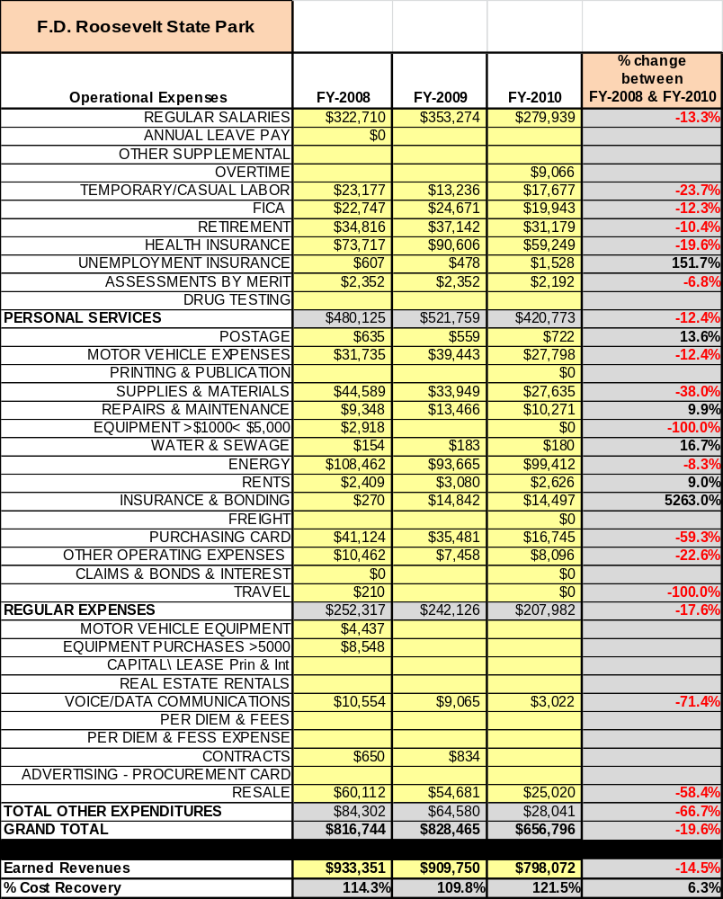
A summary of total operating expenses at F. D. Roosevelt State Park from 2008 to 2010, as well as their percent change from 2008 are provided in the table below.

Earned Revenues
Earned revenues at F. D. Roosevelt State Park have decreased since 2008, which is largely attributed to the corresponding decrease in overall visitation. Monthly earned revenues for the last two years (see table on the following page) indicate that the total annual revenue decreased 12.3% from 2009 to 2010, with the largest decreases in the months of January (-29%), August(-23%), July (-17%), February (-14%) and March (-14%).
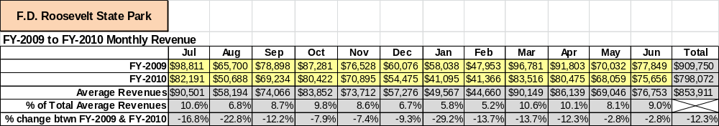

The graphs below illustrate the monthly revenue trends each year and the average percent of total annual revenue earned each month.
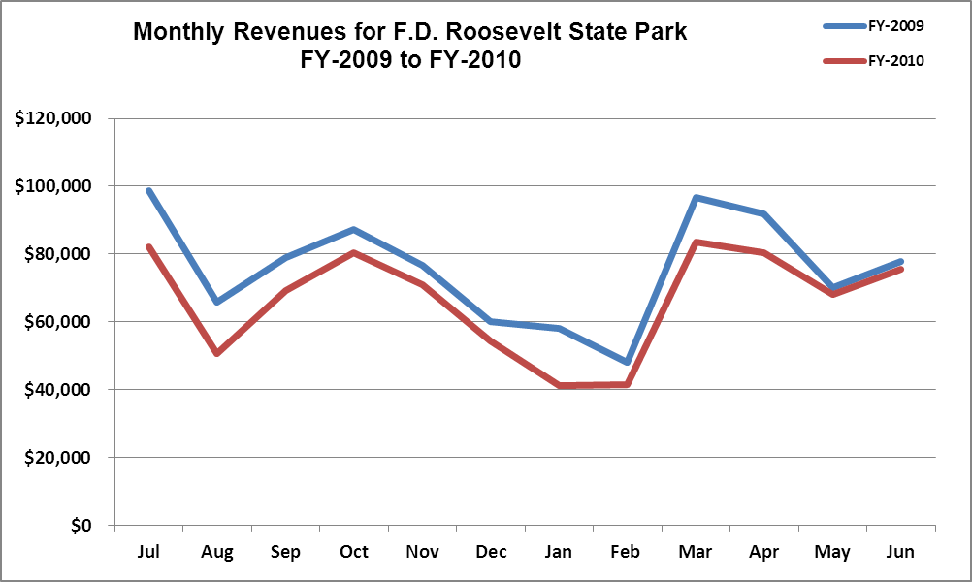

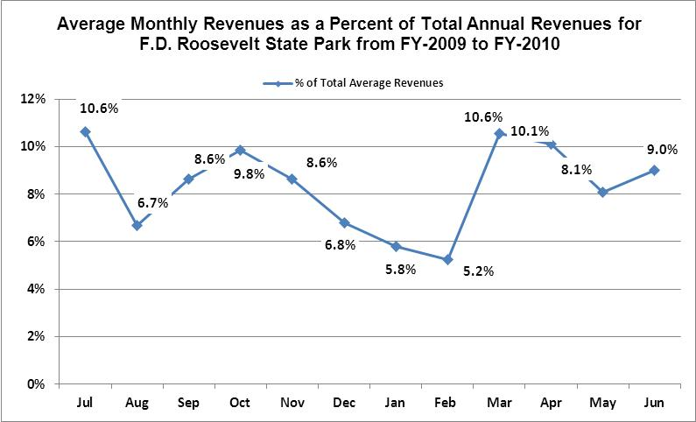

Cost Recovery Trends
F. D. Roosevelt State Park has achieved an average cost recovery of 112 % of annual operational expenses through earned revenues from FY 2008 to FY 2010. This is detailed and illustrated in the table and graph below.
Year | Operational  Expenses | Earned  Revenues | Percent Cost  Recovery
2008 | $816,744 | $865,355 | 106%
2009 | $828,541 | $909,749 | 110%
2010 | $655,670 | $798,071 | 120%

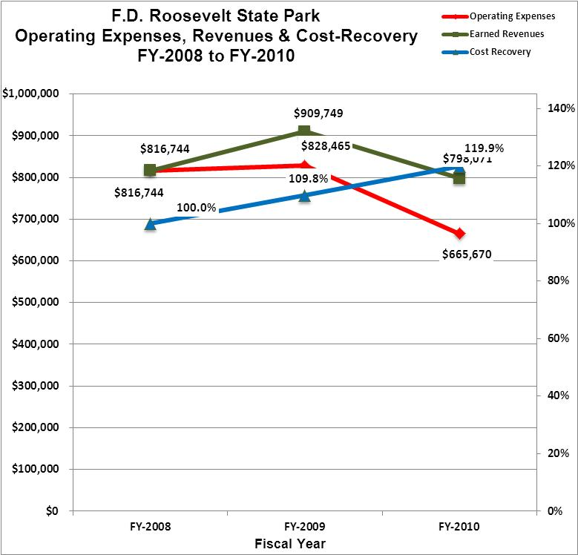

Review of Pricing
Data on rate information is available as far back as 2002, but only the last five years are evaluated. There has been notable growth in fees charged at F. D. Roosevelt State Park since 2005, with the largest increase being 200% ($6) for Backcountry Camping, 40% ($7) RV Camping, 39% ($8) Tent Camping, and 35% ($35) Group Shelter. A table detailing the rates for F.D. Roosevelt State Park is provided below.
F.D. Roosevelt State Park | 2005 | 2006 | 2007 | 2008 | 2009 | 2010 | % Increased
Camping--Tent | $18.00 | $18.00 | $20.00 | $22.00 | $23.00 | $25.00 | 38.89%
Camping--RV, Pop Up | $20.00 | $20.00 | $22.00 | $24.00 | $25.00 | $28.00 | 40.00%
Backcountry Per Person | $3.00 | $3.00 | $3.00 | $5.00 | $6.00 | $9.00 | 200.00%
Pioneer Camping | $15.00 | $15.00 | $15.00 | $15.00 | $15.00 | $18.00 | 20.00%
Large Group Camp | $500.00 | $500.00 | $550.00 | $550.00 | $600.00 | $605.00 | 21.00%
Small Group Camp | $400.00 | $400.00 | $450.00 | $450.00 | $500.00 | $505.00 | 26.25%
Cabins--1 bedroom | $90.00 | $90.00 | $95.00 | $105.00 | $105.00 | $110.00 | 22.22%
Cabins--2 bedroom | $100.00 | $100.00 | $105.00 | $110.00 | $110.00 | $115.00 | 15.00%
Cabins--3 bedroom | $135.00 | $140.00 | $145.00 | $130.00 | $130.00 | $135.00 | 0.00%
Group Shelter | $100.00 | $100.00 | $125.00 | $125.00 | $130.00 | $135.00 | 35.00%
Picnic Shelters | $40.00 | $40.00 | $40.00 | $40.00 | $45.00 | $50.00 | 25.00%
Business and Management Plan

Business Goals
The following goals serve as the foundation for the key recommendations and strategies in this business plan for F. D. Roosevelt State Park.

Enhance Cost Recovery of Site Operations
F.D. Roosevelt generally operates over 100% cost recovery. There were cottages closed down last year and the large and small group camps severely damaged by tornados.

Enhance Revenue Generation Strategies
The construction of bike trails would improve the visitation, by seeking the market of youth that ride BMX and adults with mountain bikes, and allowing us to charge an additional user fee for the mountain bike trails in addition to the park pass fees. Addition of a full-time Interpretive Ranger, instead of a 1508 hourly interpreter, is needed on site to offer better quality programming.

Expand Special Events at the Site
Discuss with local scout groups using the park for jamborees and rendezvous primarily for councils from the Columbus, Atlanta and Alabama markets.

Improve the Diversity and Innovation of Recreational and Interpretive Programs
Future programming will include celebrating the birthday of the late President F.D. Roosevelt. Expansion of the 50’s dance to include the 40’s as well, since that was the era of President F.D. Roosevelt. Develop joint programming efforts between F. D. Roosevelt and the Little White House, as many guests that visit the park also visit the Little White House, to get the full experience of both sites.

Improve the Effectiveness of Marketing and Sales
In our community there are various publications with which we have the ability to jointly advertise (primarily the magazine produced in conjunction with the Pine Mountain Visitor Center).

Establish Greater Consistency of Managing and Monitoring Customer Service & Satisfaction
F.D. Roosevelt State Park needs to continue to monitor the comment card system, to ensure that we meet the needs of the customer and provide the best possible customer service experience.

Expand Partnership Opportunities
We need to expand partnerships with volunteer groups, Pine Mountain Trail Association, Hamilton GA, Harris County, Pine Mountain Visitor Center, civic groups and most importantly Boy Scouts of America.

Classification of Programs and Services
The tables below summarize the classifications of programs and services at F. D. Roosevelt State Park as either core, important, or visitor supported and projects a range of cost recovery percentages that might be achieved for each. These classifications establish financial performance goals for each category of services that are linked to the recommendations and strategies of this business plan.
Core Services
Program / Service | Target Cost Recovery
Active management of the natural and cultural resources of the site in order to protect their integrity | 0%
Open and public access to the site and its resources | 0%
Site appropriate education, interpretation and recreational opportunities | 100%
Effective management of the park’s boundary and structures | 10%
Safety of visitors and guests | 0%
Maintenance of park grounds, buildings and infrastructure | 0%

Important Services
Program / Service | Target Cost Recovery
Self-guided interpretive and educational programs | 40%
Overnight facilities: camping and cottages | 100-125%
Picnic shelters | 25-50%
Liberty Bell Pool – Operated by Harris County | 25%
Playground equipment | 10-15%

Visitor Supported
Program / Service | Target Cost Recovery
Gift shop and extended office hours | 125-150%
Interpretive Ranger/Naturalist programs and other educational programs | 100%
Special events, not related to mission or interpretation, or programs above the site level (North Face Challenge, Pine Mountain Run, hayrides, Halloween and Christmas programs). | 200%
Boat rental with concessionaire | 15%
Horse stables concession | 10%

Partnership Development Plan
The table below summarizes existing partners and targeted partnerships by classification (operational, vendor, service, co-branding, funding partners) and by organizational type.
 | Public Partners | Not-for-profit Partners | Private / Enterprise Partners
Operational Partners | - Harris County Sheriff Dept.  - Meriwether County Sheriff Dept. | - Pine Mountain Trail Association  - Civic Groups  - Boy Scouts of America  - Nature Conservancy | - AT & T Telephone Pioneers
Vendor Partners |  | - Harris County  Recreation Department | - Coca-Cola Company  - Horse Concession contractor
Service Partners | - Harris County Board of Commissioners  - City of Hamilton  - City of Pine Mountain | - Pine Mountain Visitor Center  - Pine Mountain Chamber of Commerce  - Callaway Gardens
Co-branding Partners | - Little White House | - WRD Non-Game Division | - Wild Animal Safari
Funding Resource Development Partner |  | - Friends of Georgia State Parks  - Friends of F.D. Roosevelt State Park

Marketing and Sales Plan

Marketing and Sales Goals
Marketing and sales goals for F. D. Roosevelt State Park are based on the following desired outcomes:
- Increase cottage rentals by 10% - 12% over the next year through aggressive marketing by offering package deals during Valentine’s Day, Winter Getaways and partnership with the Little White House.
- Increase camping rentals by 10% - 15%, primarily during the winter months of December, January and February by offering extended stay discounts and package deals.
- Increase group shelter rentals by marketing for family reunions (book 10 cottages and get the group shelter free for 2 days).
- Offering package deals for weddings and business meetings as well.
In order to meet these goals, examples of specific target outcomes were identified in the areas detailed in the table below.
Area  of Focus | Current  Performance | Goal  by 2011 | Goal  by 2012 | Goal  by 2015
Cottage rentals | 42% | 45% | 48% | 52%
Camping rentals | 25% | 30% | 35% | 40%
Marketing and Promotion Strategies

Publicity and Social Media
F. D. Roosevelt State Park will approach marketing and publicity planning using the following guidelines:
- Event publicity
Major events benefit by having short stories in local, regional, and statewide newspapers and online social media hooks planted that run three to four weeks in advance of the event up to the date of the event itself. Stories and media need to be cultivated with contacts and online sales channels several weeks in advance of the time the stories need to run. Special interest interviews on morning, noon, and evening television news programs, radio interviews on popular rush-hour programs, and blogs on known affinity online sites should also be included.
- Program publicity
Special and unique programs should have feature stories in magazines, weekly newspapers, and statewide daily newspapers that are aimed at placements as front-page or sectional front-page stories. These stories are most effective if they run shortly before the season that the featured program begins. This will likely require several weeks of advanced planning with media contacts. Similar coverage on television and radio should also be considered. If pre-publicity cannot be generated, post-publicity can help promote future programs.
- Site Publicity
Site publicity focusing on a single site or sub-set of sites requires more intense planning efforts to attract multiple writers and editors from target publications. The site could host several seasonal media familiarization tours (with 10 to 15 writers or editors) to familiarize them with the site and its benefits and amenities. Stories and features resulting from such tours typically take between two and six months to materialize so the tours should focus on experiences, benefits, and programs that would be available when the stories are expected to run.
Examples and suggested opportunities for events, programs and related publicity efforts based on the themes described above at F. D. Roosevelt State Park are provided in the table below.
Event Publicity | Program Publicity | Site Publicity
North Face Challenge | Junior Ranger Camp | Interpretive Programs
Pine Mountain 40 Mile Run | Roosevelt Birthday/Book Signing | School Groups
Park Fun Run | Easter Egg Hunt | Junior Fishing Rodeo
Keep Your Trail and Highway Clean Event | 40’s – 50’s Dance/Daddy-Daughter Dance | Fight Obesity Trail Walk/Hike

Packaging
Examples and suggested packages for F. D. Roosevelt State Park are provided in the table below.
Package | Package Details
Lover’s Package | Provide chocolates, silk rose and sparkling grape juice for cottage guests for additional fee, upon request by registering for package.
Fun in the Sun | Rent a campsite or cottage and get 15% off on boat/canoe/kayak rental for one day.
Wedding Celebration/Family Reunion Special | Rent 10 cottages for your wedding or family reunion and receive 2 free rentals of the group shelter.

Group Sales
Types of groups within which specific target customers can be identified for F. D. Roosevelt State Park are listed below:
- Boy Scouts | - Local Citizens | - Track/Cross Country Running Teams

Incentivizing New and Repeat Visitation
F. D. Roosevelt State Park will utilize the following strategies and/or incentives to encourage new and repeat visitation starting in FY 2012:
- Seasonal discounts for non-peak times.
- Extended stay discounts for campers during the winter season.
- Packages for cottages, winter and lover’s package.

Marketing and Sales Metric Goals
The following marketing and sales metric goals and/or others will be monitored and progress reported at F. D. Roosevelt State Park:
- Loyalty and repeat customers = 60%.
- Brand confidence & customers-recruiting-customers = 80%
Revenue Generation Plan
Revenue / Cost Recovery Goals
F. D. Roosevelt State Park has set a financial goal of increasing annual revenues 3% annually between 2012 and 2015. The largest revenue growth opportunity is most likely an addition of mountain biking trails, renovations of cottages, and restoration of Liberty Bell Pool, the Large and Small Group Camps. The table below details projected revenue growth leading up to 2015, based upon a nominal growth of revenues each year.
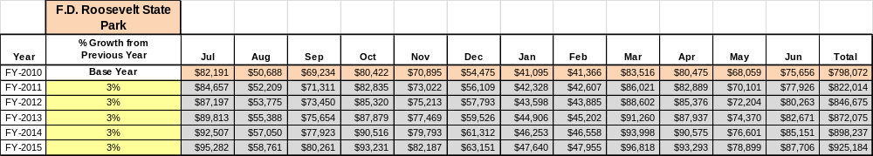

These projections would result in a total of 16% cumulative growth in total annual revenues between FY 2010 and FY 2015. If operational expenses can be managed with a cumulative decrease of 8% between FY 2010 and FY 2015, then the overall cost recovery of the site will be approximately 153% in FY 2015 at these projected revenue levels. This is higher than the annual financial performance of the site in FY 2010, which was operated at 122% cost recovery in that year.

Revenue Generation Strategies

Pricing Plan
Region | PARK RESERVABLES | Current Pricing (CY 2011) | Proposed Pricing  (CY 2012) | Yield Management Margin (%) | Positive Yield Management Margin (%) | Positive  Yield  Management  Margin ($) | Negative  Yield  Management  Margin ($)
3 | F.D. ROOSEVELT
 | Picnic Shelter | $50 | $50 | 20% | -20% | $10 | ($10)
 | Group Shelter (capacity) | $135 | $135 | 20% | -20% | $27 | ($27)
 | Camping (RV) | $28 | 28 | 30% | -30% | $8.40 | ($8.40)
 | Camping (Tent) | $25 | 25 | 30% | -30% | $7.50 | ($7.50)
 | Camping (Back) | $9 | $9 | 10% | -10% | $1 | ($1)
 | Cottage (1 BR) |  |  |  |  | $0
 | Year Round | $100 | $75 | 30% | -30% | $30 | ($30)
 | Peak - Spring Break, MDW - LD & Oct 1 - Dec 31st. | $110 | $85 | 30% | -30% | $33 | ($33)
 | Cottage (2 BR)
 | Year Round | $105 | $95 | 30% | -30% | $31.50 | -31.50
 | Peak - Spring Break, MDW - LD & Oct 1 - Dec 31st. | $115 | $105 | 30% | -30% | $34.50 | -34.50
 | Cottage (3 BR)
 | Year Round | $125 | $125 | 30% | -30% | $37.50 | -37.50
 | Peak - Spring Break, MDW - LD & Oct 1 - Dec 31st. | $135 | $135 | 30% | -30% | $40.50 | -40.50
 | Pioneer Campsite | $18 min/ 1$ pp over 15 |  | 30% | -30% | #VALUE!
 | Group Camp (capacity) | $505 |  | 10% | -10% | $51 | $-51
 | Group Camp (capacity) | $605 |  | 10% | -10% | $61 | $-61

Innovative Programming and Special Events Plan
Program / Event | Theme / Purpose | Scheduled Date/Season | Frequency | Target Participation | Target User Fee | Target Cost Recovery
Northface Endurance Challenge | Recreational | Oct 15, 16 | Annual | 1500 Runners and support staff | $ 5000 | 200%
Haunted Hayride | Haunted Trail and Hayride | October | Annual | 250 | $2500 | 100%
40’s-50’s Dance | F.D. Roosevelt Period Dance | July 4th Weekend | Annual | 100 | $500 | 125%
Pine Mountain 40 Mile Run | Recreational | December | Annual | 150 | $250 | 100%

Partnerships and Concessions Plan
Service / Partnership | Term of Service | Financial Objective | Contract Manager
Liberty Bell Pool | 3 | Additional shelter rentals +park pass | Harris County
Roosevelt Stables | 5 | 10% | Park Manager
BMX Trail | 5 | 10% | Concessionaire, possibly in conjunction with Stables

Expense Management Plan
Personnel Assignments
The following actions will be taken to proactively manage labor costs via personnel assignments and classifications.

Action | Timeline | Outcome
Reduction in Force of Housekeeping | Completed | Created 1508 positions without salary and benefits.

Management Techniques
The following actions will be taken to proactively manage labor costs via management techniques.

Action | Timeline | Outcome
Maintain two 1508 maintenance positions | As needed | Replaces frozen utility worker position without paying salary and benefits.
Maintain four or five 1508 housekeeping positions | As needed | Replaces frozen housekeeper position without paying salary and benefits.
Combined maintenance operations with the Little White House | Completed | Combined efforts of talented staff to complete maintenance in a more timely and efficient manner.

Adjusted Levels of Service
The following actions will be taken to proactively manage labor costs via reduced levels of service.

Action | Timeline | Outcome
Close unused campsites for winter. | During off season | Reduces funds and man power to maintain and run.
Reduce mowing operation | Peak Season | Requires less man power and reduction in funds spent.

Financial Pro Forma
The following five-year financial pro forma projects operating expenses, earned revenues and cost recovery through FY 2015. These pro forma are based on the strategies and desired outcomes identified in this business plan, especially the revenue generation and expense management plans, and are linked to corresponding performance goals.

Expense Pro Forma

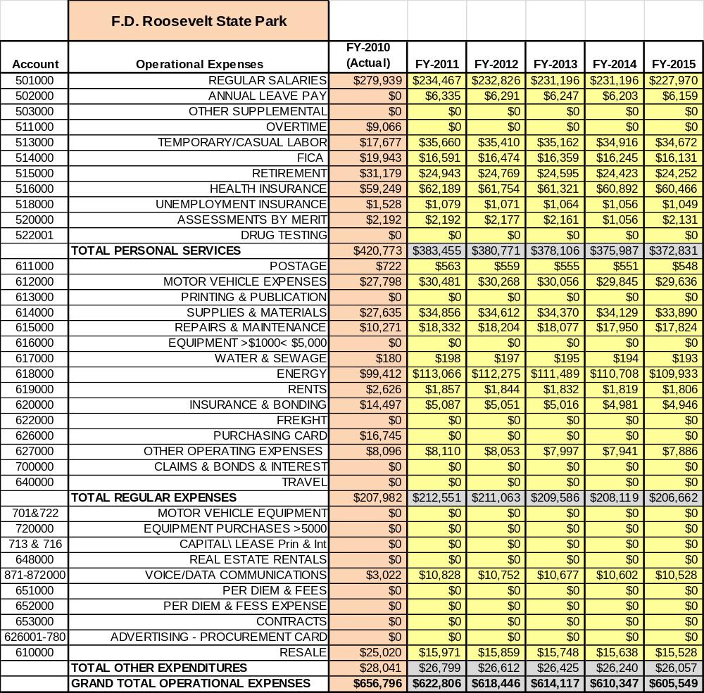

Revenue Pro Forma

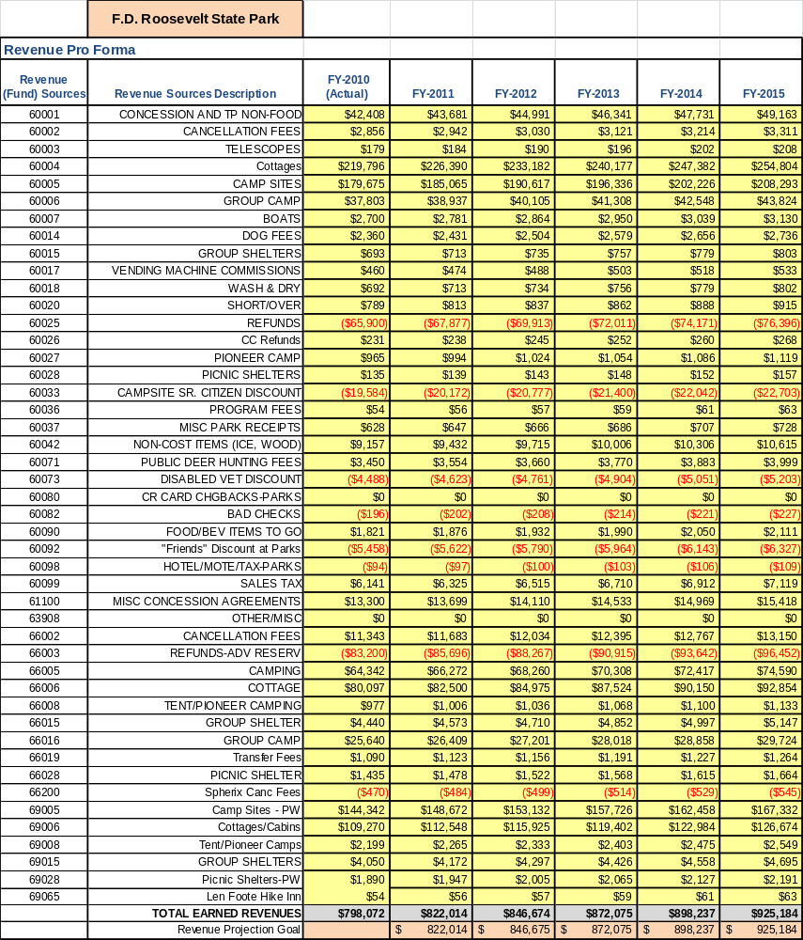

Total / Cost Recovery Pro Forma
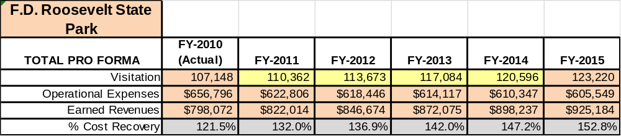

Action Plan
ACTION PLAN
Site: F. D. Roosevelt State Park |  | Site Manager: Desmond Timmons |  |  | Date:
Month:
Strategy | Tasks | Costs / Funding | Revenues / ROI | Responsibilities | Metrics

ACTION PLAN
Site: F. D. Roosevelt State Park |  | Site Manager: Desmond Timmons |  |  | Date:
Month:
Strategy | Tasks | Costs / Funding | Revenues / ROI | Responsibilities | Metrics

