Florence Marina State Park
Business & Management Plan

Prepared June 2011; Finalized February 2013
Direction 2015 – Sustainable Business Planning

Table of Contents

Executive Summary 3

Site and Operations Assessment 6
Site Inventory and Facility Assessment 6
Operational Assessment 9
Financial Performance Assessment 14

Business and Management Plan 17
Business Goals 17
Classification of Programs and Services 18
Partnership Development Plan 19
Marketing and Sales Plan 20
Revenue Generation Plan 22
Expense Management Plan 24
Financial Pro Forma 25

Action Plan 27

Executive Summary
The Parks, Recreation and Historic Sites Division (PRHSD) of the Georgia Department of Natural Resources (DNR) is transitioning the management of Florence Marina State Park to operate more like a business, reflecting the Direction 2015 – Sustainable Business Planning initiative to improve the fiscal performance and management of the state parks and historic sites system. This business and management plan is designed to help the site recover more operating expenses through earned revenues, productive partnerships, and innovative programs.

Site Fact Sheet
Site Name | Florence Marina State Park
Site Manager | Tracy Yearta
Region Manager | Eric Bentley
Date of Business Plan completion | 11/28/12
Site size | 173 acres
Total number of visitors (FY 2010) | 86,194
Total operating budget (FY 2010) | $486,335
Total earned revenues (FY 2010) | $410,503
Operational cost recovery (FY 2010) | 84%
Average operating cost per visitor (FY 2010) | $5.64
Average earned revenue per visitor (FY 2010) | $4.75
Average cost recovery (FY 2008 – 2010) | 82%
Target cost recovery (FY 2015) | 79%
Total full-time employees | 7
Total part-time employees | 3
Primary service markets | Columbus, Albany, Atlanta, Eufaula, Dothan and Tallahassee
Primary attractors/visitor appeal factors | Lake Walter F. George
Leading opportunities for improved site performance | Additional cottage, camper cabins, pioneer camp, additional programming services and expanded resale opportunities.

Site Summary and Key Attractions
The 173-acre site of Florence Marina is located in a rural setting on the northern end of Lake Walter F. George, roughly 40 miles from Columbus and 70 miles from Albany. The relative isolation of Florence Marina is a challenge, but currently is achieving the identified cost recovery target.

Key Attractions
The amenities or features listed below are those that seem to be most popular for visitors.
- Cottages
- Campground
- Marina
- Kirbo Educational Center
- Gift Shop/Trading Post
- Lighted Fishing Pier
- Boat Rentals
- Lake Walter F George

Financial Targets
The table below details the total operating expenses and earned revenues for Florence Marina State Park over the last three years (2008 – 2010). This table also calculates total cost per visitor and revenues per visitor during these operating years, and details the target financial performance goals in the context of achieving at least 79% cost recovery. This table also calculates the necessary change from 2010 operating expenses and revenues.

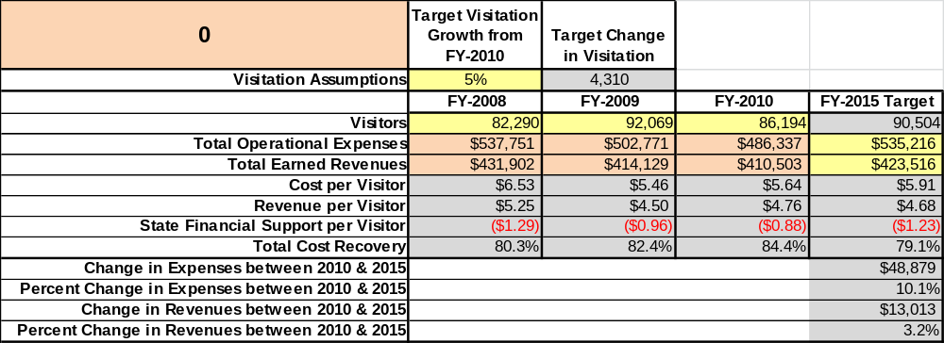

Key Recommendations

Primary / Short Term Recommendations
- Operate the site using cost-based accounting, including the net cost recovery achieved annually.
- Collect a statistically-valid sample of ZIP code data from visitors in a non-intrusive way to gauge their origins and demographics (e.g., age, ethnicity, income, etc.) and the use the results to improve programming and marketing efforts to appeal to a broader audience.
3. Expand existing 5 special events to draw more visitors and increase revenue. Florence and Providence Canyon combined has seventeen special events.
- Conduct fund raisers utilizing Friends of Florence Marina during special events.
- Enhance facilities and program offerings for each visitor while maintaining a 90% customer satisfaction rating.
- Manage Florence Marina according to well-defined maintenance, program and operational standards monitored and enforced by region managers and senior management.
- Continue to work with Florence Marina Friends Chapter of the Friends of Georgia State Parks and Historic Sites to help raise funds or provide volunteers for improvements and program support.
- Perform a thorough net cost-of-service analysis on major functions of site operations, including the detailed analysis of labor requirements (by task) that has already been produced by site staff. Thereafter, update costs to deliver services on a biennial schedule.
- Review and update rates at the site on an annual basis to recover the total net cost of service for important and visitor-supported services.
- Develop a more detailed analysis of labor requirement of all major park functions to match the right position with the right job at the right pay.
- Construct and upgrade facilities and amenities at the site that are likely to have a cost recovery level at or above 100%. Suggestions include upgrades to outside of efficiency units and landscaping. Porch steps have been replaced.

Secondary / Long Term Recommendations
- Renovate boat dock slips to enhance visitation. 98 % completed September 2012
- Renovate comfort station to enhance camping facilities. Renovation scheduled for fall 2012
- Install Pioneer camping to increase revenue.
- Construct smaller pool or splash pad for registered guests.

Site and Operations Assessment
This site and operations assessment is a culmination of analyses and findings from a review of the condition of facilities, infrastructure, and operations at Florence Marina State Park. The findings and observations are not intended to be an exhaustive review of all issues present, but provide a basic understanding of the predominant issues that contribute to the site’s current operating conditions. The assessment includes the following:
- Site Inventory and Facility Assessment
- Operational Assessment
- Financial Assessment
Site Inventory and Facility Assessment

Methodology
Facility and asset conditions are rated using a differential scale of excellent, good, fair, or poor. Descriptions of conditions that are attributed to each of these findings are also provided.
Scale of Conditions
Rating | General Description
Excellent | Facilities/amenities are in ‘excellent’ condition when they show little or no maintenance or repair problems. Facilities do not feature any major design or operational issues or flaws that contribute to diminished use or increased maintenance or upkeep. Facilities are easy to clean and maintain in order to place them back into public use and the users perceive them to be in excellent shape.
Good | Facilities/amenities are in ‘good’ condition when they show only minor maintenance or repair problems. Most maintenance issues with these facilities typically appear to be the result of age and/or heavy use. Facilities may only feature minor design or operational issues that contribute to diminished use or increased maintenance or upkeep. Facilities are moderately easy to clean and maintain in order to place them back into service and the users perceive them to be adequate for their use, but probably not in excellent shape.
Fair | Facilities/amenities are in ‘fair’ condition when they show significant maintenance or repair problems. Facilities generally exhibit ongoing maintenance issues that appear to be the result of age, heavy use, or design or operational flaws. Some maintenance and repair needs may compound their fair condition by being deferred because of budget and/or resource limitations. Facilities require more effort to clean and maintain before placing them back into service and the users may perceive them as being less than adequate for their use and in a state of deterioration. The facility or structure may need of major repair or replacement.
Poor | Facilities/amenities are in ‘poor’ condition when they show significant, on-going maintenance or repair problems that ultimately may result in suspended use for repair/replacement. Maintenance and repair issues are possibly the result of poor maintenance and clearly the result of age, heavy use, or design or operational flaws. Problems with the facilities are often compounded over time due to consistently-deferred maintenance and repair because of budget and/or resource limitations. Facilities may feature major design or operational issues that contribute to diminished use or increased maintenance or upkeep. Facilities require excessive effort to clean and maintain before placing them back into service and the users often perceive them as being inadequate for their use and in a state of serious deterioration. The facility or structure may need of major repair or replacement.

Inventory and Assessment
The table below is an inventory of facilities and amenities at Florence Marina State Park, and provides the assessed condition of each as reviewed in May 2011.
Site Asset / Amenity | Quantity | Condition
Total Acreage | 173 | Good
2 Bedroom Cottages | 6 | Good
1 Room Efficiency Units | 8 | Good
Campsites | 43 | Good
Boat Slip Marina | 66 | Good
Kirbo Educational Center | 1 | Good
Group Shelter | 1 | Good
Picnic Shelter | 1 | Good
Comfort Station | 1 | Fair
Office/Trading Post | 1 | Fair
Picnic Area | 1 | Fair
Day Use Restroom | 1 | Fair
Lighted Fishing Pier | 1 | Fair
Boat Ramp | 1 | Fair
Gas Dock | 1 | Good
Fish Cleaning Station | 2 | Fair
Mini Golf | 1 | Excellent
Playgrounds | 2 | Fair
Campers Courtesy Dock | 1 | Fair
Linen Building | 1 | Good
Mgr. Residence/Storage Building | 1 | Good
Asst. Managers Residence / Storage Building | 1 | Good
Sr. Rangers Residence/Storage Building | 1 | Good
Nature Trail | 1 | Closed
Well House | 1 | Fair
Maintenance Barn | 1 | Good
Sewage Treatment Plant | 1 | Good
Boat Ramp Parking Lot | 1 | Good
Boat Ramp Dock | 1 | Good
Dry Storage | 18 | Good
Campground Host Station | 1 | Good

Prioritized Facility Needs
Based on the facility inventory and assessment, these prioritized needs have been identified. Each need has been aligned with a priority category of high, moderate, or low to support future decision making regarding project sequencing, investment of public resources, and meeting community expectations. The priority assignment for each need is not a measure of importance. Rather, these recommended priorities reflect a phased implementation approach over the next several years.
Facility Need | Priority Assignment
Additional Cottage: water, sewer and grading done; scheduled for 2013 | High
Pioneer camping | High
Boat slip renovation Phase II, Phase I completed September 2012 | High
Remove standing dead trees along nature trail to reopen | High
Renovate comfort station (scheduled for winter 2013) | High
Boat ramp repair | Moderate
Upgrade all campsites to 50-amp service | Moderate
Replace camper courtesy dock | Low
Fish cleaning stations repairs | Low
Lighted fishing pier repairs | Low

Operational Assessment
The Operational Assessment includes:
- An inventory and classification of programs and services being provided at the site
- A review of staffing at the site
- A review of concessionaires and partners operating at the site
- Visitation and customer satisfaction

Inventory and Classification of Programs and Services
Programs and services are classified into one of three major categories:
1) Core or Essential Services
2) Important Services
3) Visitor Supported Services
Programs and services at the site are classified into these categories based in part on the mission and public mandates for both the site and the agency. For the programs and services in each of these categories, there are financial performance expectations that will define how services are funded and evaluated.

Category 1 – Core Services [Largely supported by tax funds]
Core programs, services and facilities are those the agency must provide and/or are essential in order to capably govern and meet statutory requirements. The failure of the agency to provide Category 1 services at adequate levels could result in significant negative consequences for the public and the resources under protection. The criteria for programs or services to be classified as core or essential are:
- The services are mandated by the agency’s law or charter or are contractually obligated by agreement to provide the services.
- The services are essential to protecting and supporting the public’s health and safety.
- The services protect and maintain valuable assets and infrastructure.
- The services would generally and reasonably be expected and supported by residents, businesses, customers and partners.
- The services are those that cannot or should not be provided by the private sector.
- The services provide a sound investment of public funds.
The following services offered at Florence Marina State Park have been identified as core services:
- Active management of Florence’s resources and amenities (i.e. marina basin, artifacts)
- Site appropriate education, interpretation and recreational opportunities
- Open and public access to the site and its resources
- Public safety
- Maintenance of grounds, facilities and infrastructure

Category 2 – Important Services [Supported by a balance of tax funds and earned revenues]
Important programs, services and facilities are those the agency should provide, and are important to governing and effectively serving residents, businesses, customers and partners. Providing Category 2 services expands or enhances the agency’s ability to provide and sustain its core services. The criteria for programs or services to be classified as important are:
- The services expand, enhance or support identified core services.
- The services are broadly supported and utilized by the community, and are considered an appropriate, important, and valuable public good. Public support may be conditional upon the manner by which the services are paid for or funded.
- The services generate income or revenue that offsets some or all of the operating cost and/or are deemed to provide economic, social or environmental outcomes or results.
The following programs and services offered at Florence Marina State Park have been identified as important services:
- Provide natural and cultural programs
- Support for recreational activities

Category 3 – Visitor Supported Services [Almost exclusively supported by earned revenue]
Visitor supported programs, services and facilities are those discretionary services that the agency may provide when additional funding or revenue exists to offset the cost of providing those services. Category 3 services provide added value above and beyond what is required or expected. The criteria for programs or services to be classified as visitor supported are:
- The services expand, enhance or support core services or important services and the quality of life of the visitors, community or stakeholders.
- The services are supported, valued and well utilized and provide an appropriate and valuable public benefit.
- The services generate income or funding from sponsorships, grants, user fees or other sources that offset some or all of their cost and/or provides a meaningful return on investment.

- The services can possibly be provided through outsourcing or use of concessionaires, providing opportunities for community enterprises that may not otherwise be provided by the agency.

The following programs and services offered at Florence Marina State Park have been identified as visitor supported services:
- Gift shop and gasoline sales
- Special events/programs related to the mission of the site
- Cottage rentals
- Tent/RV camping
- Boat slip rentals

Staffing Assessment
Labor costs at Florence Marina State Park represent the largest area of budgetary expense at an average of 65% of the total operating budget each year for the last three complete years, which is equal than the target of total labor costs (including benefits) not exceeding 65% of the site’s total operating expenditures. The tables below and on the following page provide a basic review of the current staffing at the site.
Full Time Equivalent Employees
Position / Title | Quantity (FTE) | Vacancies | Annual Hours
Park Manager 3 | 1 | 0 | 2400
Assistant Manager 2 | 1 | 0 | 2400
Sr. Park Ranger | 1 | 0 | 2400
Interpretive Ranger | 1 | 0 | 2080
Clerk | 1 | 0 | 2080
Secretary 1 | 0 | 1 | 2080
Skilled Utility worker | 1 | 0 | 2080
Utility Worker | 1 | 1 | 2080
TOTAL | 7 | 2 | 17,600

Part Time Employees
Position / Title | Quantity (FTE) | Vacancies | Hours
Housekeeper | 1 | 0 | 1508
Maintenance worker | 1 | 0 | 1508
Maintenance Worker | 1 | 0 | 1508
Total | 3 |  | 4,524

Labor Support
Labor Support | Annual Hours
Volunteers | 5379
Community Service Workers | 0
TOTAL | 5,379

Total Labor Hours
Labor Type | Annual Hours
Full Time Equivalent Employees | 17,600
Part Time Employees | 4,524
Labor Support | 5,379
TOTAL Annual Labor Hours | 27,503

Labor Budget Summary

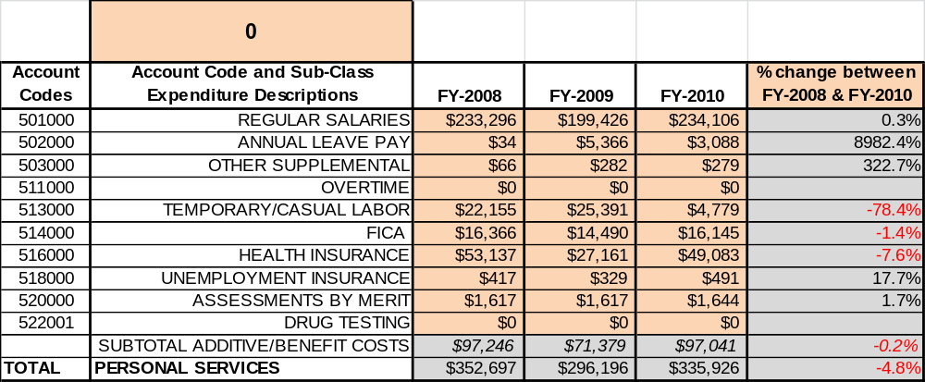

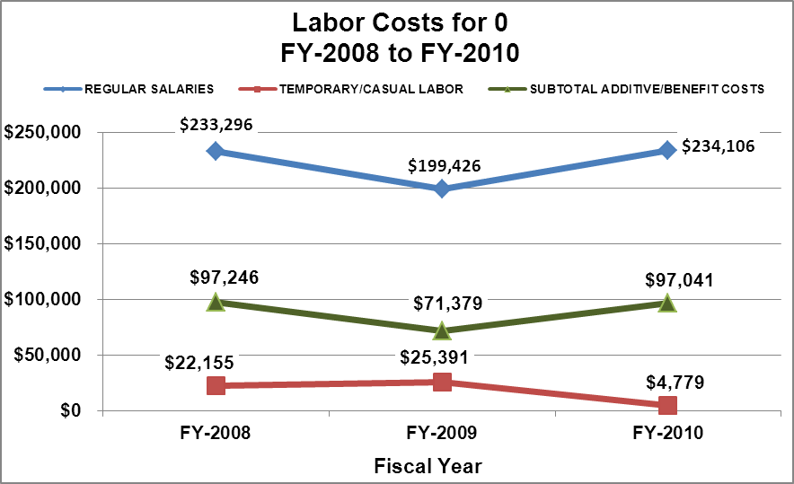

Visitation and Occupancy
Overall annual visitation to the site has trended downward from 2008 to 2010, decreasing by 6% or over 6,000 visitors. This is largely attributed to economic conditions and higher gas prices. Please note that the visitation for 2008 is low compared to the revenue. The traffic counter was faulty and the Army Corps of Engineers did not repair it until 2009. The estimated visitation for 2008 is 97,930 (based on visitation vs. revenue earned in 2009.

Year | Total Visitation
2008 | 82,290
2009 | 92,069
2010 | 86,194

Occupancy for the overnight accommodations at Florence Marina State Park the last three years is detailed in the table below. Overall occupancy has trended downward from 2008 to 2010, decreasing by 9%. This is largely attributed to higher gas prices and impacts of the economy.

Year | Camping Occupancy | Cottages Occupancy
2008 | 45.93% | 49.55%
2009 | 34.18% | 41.36%
2010 | 34.55% | 34.79%

Customer Service and Satisfaction

Site | Year | Customer Satisfaction Level
Florence Marina State Park | 2009 | 100%
Florence Marina State Park | 2010 | 100%

Financial Performance Assessment

Operational Expenses
A summary of total operating expenses at Florence Marina State Park from 2008 to 2010, as well as their percent change from 2008 are provided in the table below.

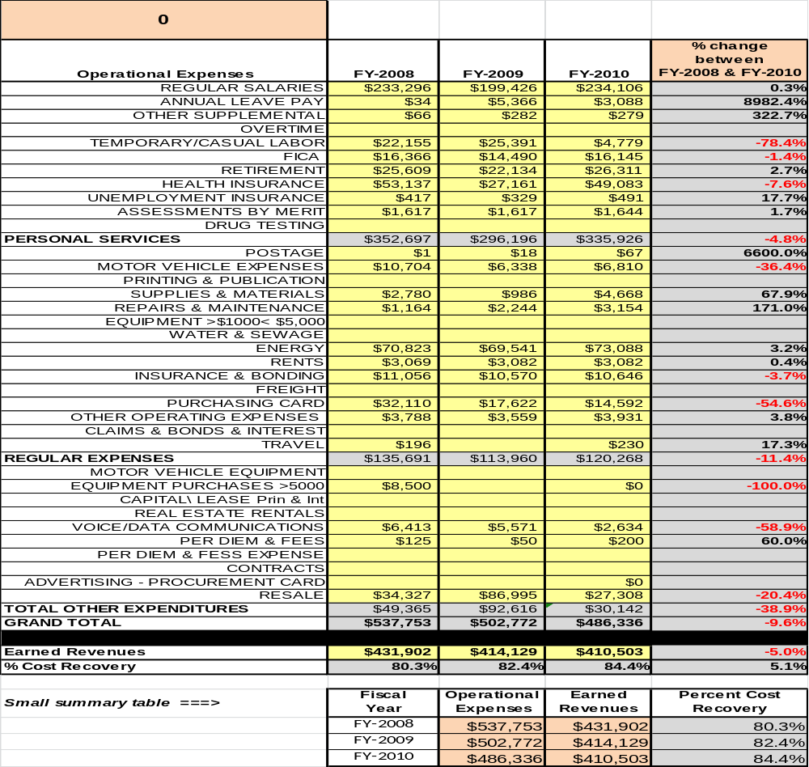

Earned Revenues
Earned revenues at Florence Marina State Park have decreased since 2008, which is largely attributed to the corresponding decrease in overall visitation.
Monthly earned revenues for the last two years (see table on the following page) indicate that the total annual revenue decreased 1% from 2009 to 2010, with the largest increases in monthly revenues in September (17%), October (9%), April (8%), and November and December 7% and the largest decreases in the months of July (-20%), January (-13%), and August, February and March (-7%). The months of increased revenue were not sufficient to account for lost revenue in the remaining months.
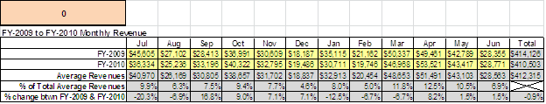

The graphs below illustrate the monthly revenue trends each year and the average percent of total annual revenue earned each month.

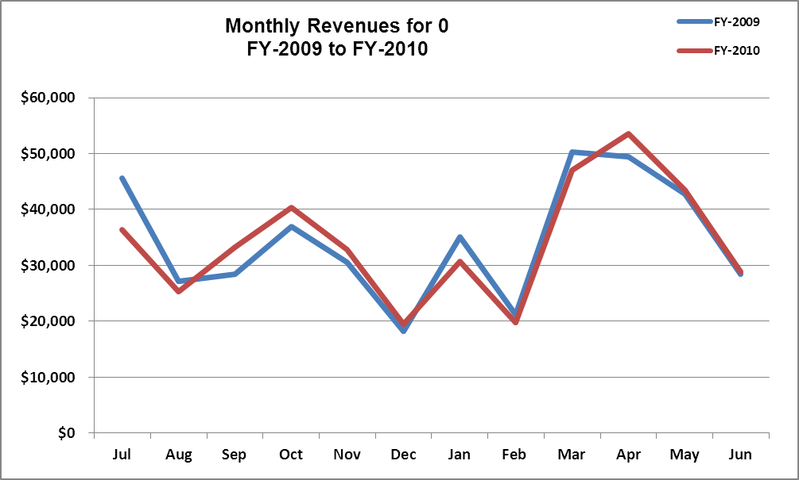

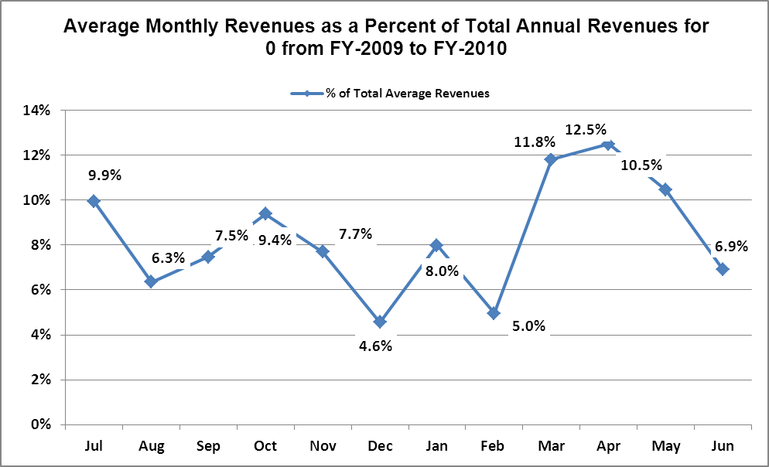
Cost Recovery Trends
Florence Marina State Park has achieved an average cost recovery of 82% of annual operational expenses through earned revenues from FY 2008 to FY 2010. This is detailed and illustrated in the table and graph below.
Year | Operational  Expenses | Earned  Revenues | Percent Cost  Recovery
2008 | $537,751 | $431,902 | 80%
2009 | $502,771 | $414,902 | 82%
2010 | $486,335 | $409,126 | 84%

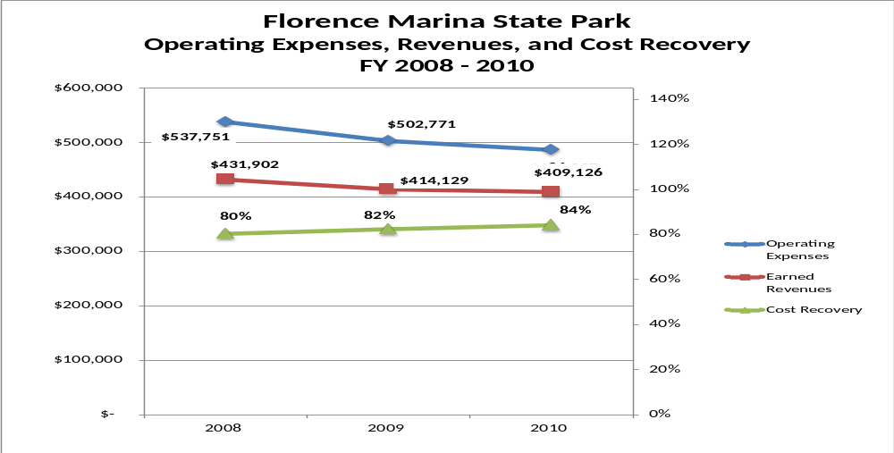

Review of Pricing
Data on rate information is available as far back as 2002, but only the last five years are evaluated.

There has been notable growth in fees charged at Florence Marina State Park since 2005, with the largest increase being Efficiency Cottages (38%) Tent Camping (28%) and RV Camping (26%). A table detailing the rates for Florence Marina State Park is provided below.
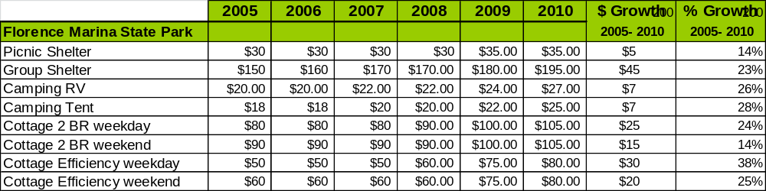
Business and Management Plan

Business Goals
The following goals serve as the foundation for the key recommendations and strategies in this business plan for Florence Marina State Park.

Enhance Cost Recovery of Site Operations
Florence Marina is operating at an 80-84% cost of recovery of operational expenses through earned revenue. Currently Florence is operating above the 75% cost of recovery goal. Florence can likely increase revenues through additional amenities and facility upgrades. It is likely that Florence can increase its cost of recovery to 95-100% through additional revenue and cost reduction.

Enhance Revenue Generation Strategies
Increasing earned revenues will most likely result from the impacts of visitation revenue enhancement strategies and cost reduction. Florence will improve revenue generation through more flexible fees, expanding retails sales, increasing special events and various other programs

Expand Special Events at the Site
A lot of the special events at Florence are scheduled when the park’s visitation is at maximum (i.e. spring break, holidays, fall break, etc.). The primary reason for this is that 80 % of the visitors are stay-use due to the location of Florence. With the addition of more special events, the park has a potential to gain extra revenue and visitation. Some of the events could include Native American programs and other programs pertaining to the area of Florence.

Improve the Diversity and Innovation of Recreational and Interpretive Programs
Unlike most parks, Florence has the Kirbo Educational Center located within the park. There are a wide variety of exhibits for both adults and younger age groups. Along with the current programs, establishing admission fees would increase revenue. Creating guided tours at the Kirbo Educational Center during peak season would better connect with visitors in order to generate repeat visitation.

Improve the Effectiveness of Marketing and Sales
The effectiveness of marketing and promotional activities at Florence Marina State Park could be improved to produce greater visitation and revenues during peak, shoulder, and off-seasons. This could be achieved in part through new target markets and marketing efforts. The areas of focus would be Ft. Benning and its expansion, which is expected to bring in tens of thousands of soldiers and their families to the area.

Establish Greater Consistency of Managing and Monitoring Customer Service & Satisfaction
Florence Marina will use the department’s online visitor comments system to gauge the level of customer satisfaction, as well as a 10-minute time frame to respond to visitor issues to help eliminate the potential for poor service. We will use these practices to obtain positive and negative feedback, to achieve a 90% overall satisfaction rating, and to help eliminate any re-occurrences of poor performance.

Expand Partnership Opportunities
Florence Marina State Park area has local area attractions such as Westville and Beddingfield Inn to work with to perhaps establish partnership opportunities that would increase community support and attract visitors. Columbus State University and the Coca Cola Space Science Center are potential opportunities as well. With the assistance of Friends of Georgia State Parks and Historic Sites and the Friends of Florence Marina, there will be a plan in place to reduce the cost of supplies and materials, and other related services needed by the site.

Classification of Programs and Services
The tables below summarize the classifications of programs and services at Florence Marina State Parkas either core, important, or visitor supported and projects a range of cost recovery percentages that might be achieved for each. These classifications establish financial performance goals for each category of services that are linked to the recommendations and strategies of this business plan.

Core Services
Program / Service | Target Cost Recovery
Active management of Florence Resource Management Plan (i.e. marina basin, artifacts) and Park amenities | 0%
Site appropriate education, interpretation and recreational opportunities | 100%
Open and public access to the site and its resources | 20% to 60%
Public safety | 0%
Maintenance of grounds, facilities and infrastructure | 0%

Important Services
Program / Service | Target Cost Recovery
Provide natural and cultural programs | 100%
Support for recreational activities | 50% to 80%

Visitor Supported
Program / Service | Target Cost Recovery
Gift shop and gasoline sales | 75%
Special events/programs related to the mission of the site | 125% to 150%
Cottage rentals | 125 to 150%
RV/Tent camping | 125 to 150%
Boat slip rentals | 150% 200%

Partnership Development Plan
The table below summarizes existing partners and targeted partnerships by classification (operational, vendor, service, co-branding, funding partners) and by organizational type.

 | Public Partners | Not-for-profit Partners | Private / Enterprise Partners
Operational Partners | - Columbus State University  - Coca-Cola Space Science Center |  | - AT&T Pioneers
Vendor Partners |  |  | - Coca Cola  - Georgia EMCs
Service Partners | - U.S. Army Corps of Engineers | - Eufaula Wildlife Refuge
Co-branding Partners | - Providence Canyon State Outdoor Recreation Area  - George T. Bagby State Park and Lodge | - Westville Historic Site.  - Beddingfield Inn  - Stewart County Historical Society
Funding Resource Development Partner |  | - Friends of Georgia State Parks and Historic Sites  - Friends of Florence Marina

Marketing and Sales Plan

Marketing and Sales Goals
Marketing and sales goals for Florence Marina State Park are based on the following desired outcomes:
- To produce more special event programs to draw more visitors to the site
- To provide more programs for individual groups to increase revenue
- To produce increased overall visitation and revenues
- Charge an entry fee (certain months) at Kirbo Educational Center to produce higher revenue
- Implement a year-round monthly camping rate to increase revenue
In order to meet these goals, examples of specific target outcomes were identified in the areas detailed in the table below.
Area  of Focus | Current  Performance | Goal  by 2011 | Goal  by 2012 | Goal  by 2015
Cottages Occupancy | 35% | 38% | 41% | 44%
Camping Occupancy | 34% | 37% | 40% | 43%
Program Participation | 5,450 | 5,,750 | 6,000 | 6,250

Marketing and Promotion Strategies

Publicity and Social Media
Florence Marina State Park will approach marketing and publicity planning using the following guidelines and themes:
- Event publicity
Major events benefit by having short stories in local, regional, and statewide newspapers and online social media hooks planted that run three to four weeks in advance of the event up to the date of the event itself. Stories and media need to be cultivated with contacts and online sales channels several weeks in advance of the time the stories need to run. Special interest interviews on morning, noon, and evening television news programs, radio interviews on popular rush-hour programs, and blogs on known affinity online sites should also be included.
- Program publicity
Special and unique programs should have feature stories in magazines, local and regional weekly newspapers, and statewide daily newspapers that are aimed at placements as front-page or sectional front-page stories. These stories are most effective if they run shortly before the season that the featured program begins. This will likely require several weeks of advanced planning with media contacts. Similar coverage on television and radio should also be considered. If pre-publicity cannot be generated, post-publicity can help promote future programs.
- Site Publicity
Site publicity focusing on a single site or sub-set of sites requires more intense planning efforts to attract multiple writers and editors from target publications. Each site could host several seasonal media familiarization tours (with 10 to 15 writers or editors) to familiarize them with the site and its benefits and amenities. Stories and features resulting from such tours typically take between two and six months to materialize so the tours should focus on experiences, benefits, and programs that would be available when the stories are expected to run.
Examples and suggested opportunities for events, programs and related publicity efforts based on the themes described above at Florence Marina State Park are provided in the table below.
Event Publicity | Program Publicity | Site Publicity
Octoberfest | Jr. Ranger
Festival by the Lake | Kite day
Alligator Day | Christmas Workshop
Easter Egg Hunt
Boat Show
Fishing Tournaments

Packaging
Examples and suggested packages for Florence Marina State Park are provided in the table below.
Package | Package Details
Guided Hike Tour | Guided hike into Providence Canyon followed by a boat tour at Florence Marina
Camping & Boat Tour | 4 night camping with a free boat tour on Lake Walter F. George
Cottage & Boat Tour | 3 night cottage rental with a free boat tour on Lake Walter F. George

Group Sales
Types of groups within which specific target customers can be identified for Florence Marina State Park are listed below:
- Families  - Schools (public, private,& home)  - Activity or special interest clubs  - Colleges & universities | - Youth service organizations  - Associations  - Business and professional interest groups  - Other public agencies | - Churches  - Community Organizations  - Women’s Group

Incentivizing New and Repeat Visitation
Florence Marina State Park will utilize the following strategies and/or incentives to encourage new and repeat visitation starting in FY 2012:
- Offer discounts on campers staying over four days
- Offer monthly camping rate year round instead of November thru February
- Offer discounts for cabins weekdays and weekends December thru February
Marketing and Sales Metric Goals
The following marketing and sales metric goals and/or others will be monitored and progress reported at Florence Marina State Park:
- Loyalty and repeat customers = 65% of customers repeat their visit in a 12 month period
- Brand confidence & customers-recruiting-customers =Customers referrals equal a minimum of 50% of “Where did you hear about us?” responses from visitors polled.
Revenue Generation Plan
Revenue / Cost Recovery Goals
Florence Mariana State Park has set a financial goal of increasing annual revenues 1% annually between 2013 and 2015. The largest revenue growth opportunity is most likely in the months of July, September, October, March, April and May. The table below details projected revenue growth leading up to 2015, based upon a nominal growth of revenues each year.

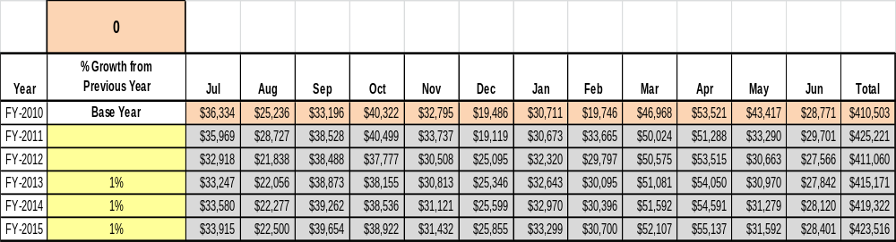

These projections would result in a total 3% increase in cumulative growth in total annual revenues between FY2010 and FY2015. If operational expenses can be managed at the current rate between FY2013 and FY2015, then the overall cost recovery of the site will be approximately 79% in FY 2015 at these projected revenue levels. This is lower than the annual financial performance of the site in FY 2010, which was operated at 84% cost recovery in that year.
Revenue Generation Strategies

Pricing Plan
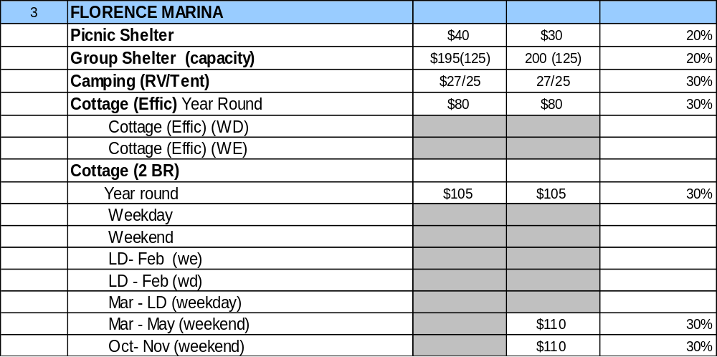

Innovative Programming and Special Events Plan
Program / Event | Theme / Purpose | Scheduled Date/Season | Frequency | Target Participation | Target User Fee | Target Cost Recovery
October Fest | Games, Hayride& Boat Rides | October | Annual | 200+ | $2 | 100%
Festival by the Lake | Crafts, Games, Food & Entertainment | April | Annual | 200+ | $0 | 100%
Alligator Day | Educational Tour & display | June | Annual | 300+ | $5 | 100%
Easter Egg Hunt | Egg Hunt & Prizes | April | Annual | 200+ | $0 | 100%
Jr. Rangers | Crafts, Fishing & Games | June & July | Two times a year | 20 | $20 | 100%
Kite Day | Making Kites & Awards | March | Annual | 50+ | $2 | 100%
Christmas Workshop | Make Christmas ornaments and a visit from Santa | December | Annual | 50+ | $3 | 100%

Partnerships and Concessions Plan
Service / Partnership | Term of Service | Financial Objective | Contract Manager
Event planning and promotion | 2 years | 15% of gross receipts | Park Manager
Triathlon at Standing Boy Creek | 1 day | 10% of gross receipts | Park Manager

Expense Management Plan
Personnel Assignments
The following actions will be taken to proactively manage labor costs via personnel assignments and classifications.

Action | Timeline | Outcome
Convert Utility Worker, Housekeeper and Secretary positions in to 1508. | Completed | Annual cost reduction of $19,000

Management Techniques
The following actions will be taken to proactively manage labor costs via management techniques.

Action | Timeline | Outcome
Increased use of volunteers for site and grounds maintenance | July, 2012 | Annual labor cost of $7,000
Increased use of volunteers from Friends of Florence Marina State Park for programming events | July, 2012 | Annual labor cost of $2,000

Adjusted Levels of Service
The following actions will be taken to proactively manage labor costs via reduced levels of service.

Action | Timeline | Outcome
Adjust mowing and landscaping schedules for portions of the site | July, 2012 | Annual cost reduction of $3,000

Financial Pro Forma
The following five-year financial pro forma projects operating expenses, earned revenues and cost recovery through FY 2015. These pro forma are based on the strategies and desired outcomes identified in this business plan, especially the revenue generation and expense management plans, and are linked to corresponding performance goals.

Expense Pro Forma

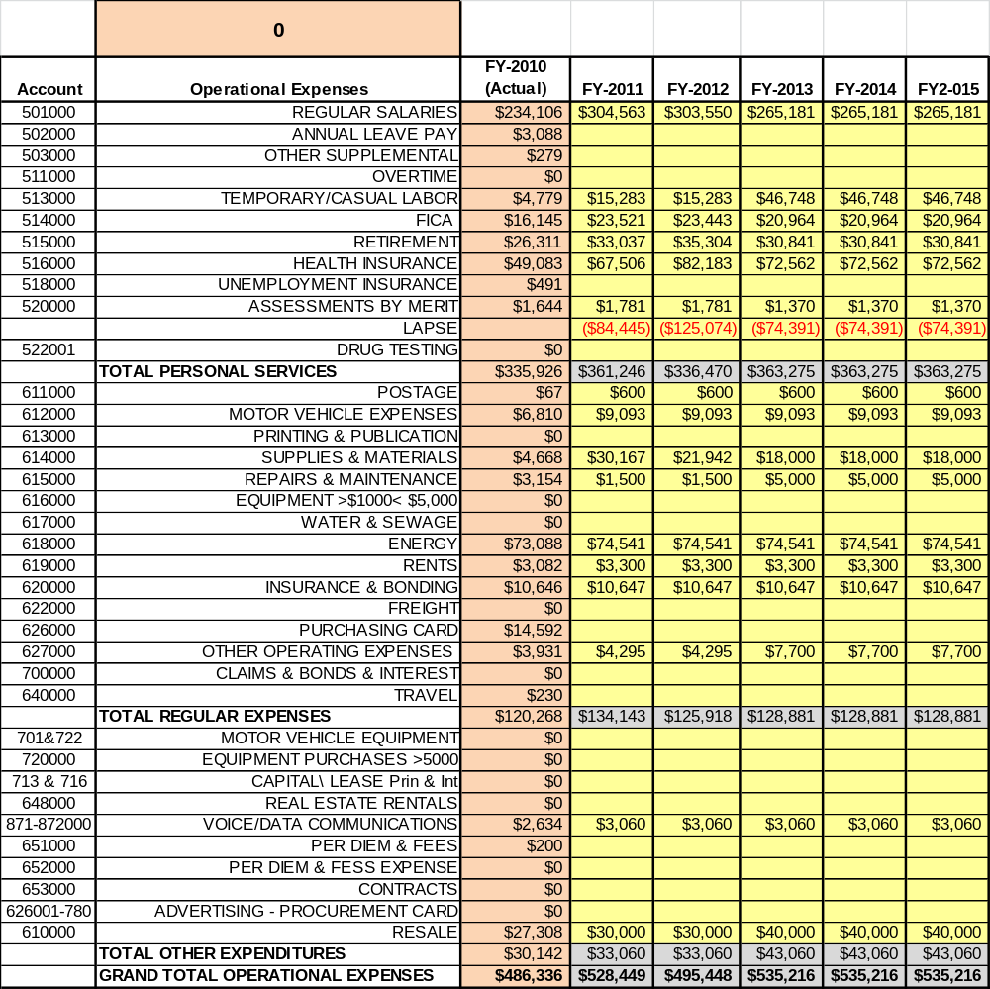

Revenue Pro Forma

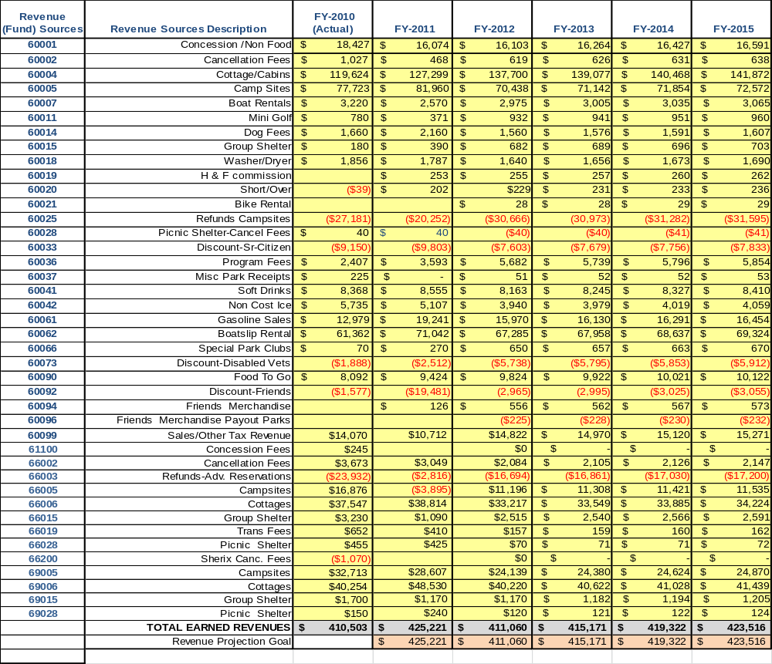

Total / Cost Recovery Pro Forma

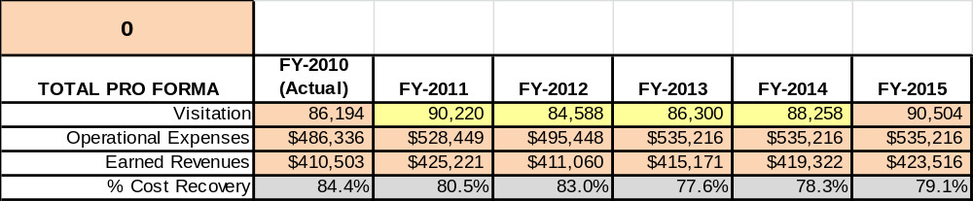

Action Plan
ACTION PLAN
Site: Florence Marina State Park |  | Site Manager: Tracy Yearta |  |  | Date:
Month: July, FY 12
Strategy | Tasks | Costs / Funding | Revenues / ROI | Responsibilities | Metrics

This is the average of the last three years – FY 2008, FY 2009, and FY 2010
Current employees, not including vacancies.
Current employees, not including vacancies.
Major population centers within a two-hour drive from the site

