Fort King George Historic Site
Business & Management Plan

Prepare June 2011; Finalized December 2012
Direction 2015 – Sustainable Business Planning

Table of Contents

Executive Summary 3

Site and Operations Assessment 6
Site Inventory and Facility Assessment 6
Operational Assessment 8
Financial Performance Assessment 12

Business and Management Plan 15
Business Goals 15
Classification of Programs and Services 17
Partnership Development Plan 18
Marketing and Sales Plan 19
Revenue Generation Plan 23
Expense Management Plan 26
Financial Pro Forma 27

Action Plan

Executive Summary
The Parks, Recreation and Historic Sites Division (PRHSD) of the Georgia Department of Natural Resources (DNR) is transitioning the management of Fort King George to operate more like a business, reflecting the Direction 2015 – Sustainable Business Planning initiative to improve the fiscal performance and management of the state parks and historic sites system. This business and management plan is designed to help the site recover more operating expenses through earned revenues, productive partnerships, and innovative programs.

Site Fact Sheet
Site Name | Fort King George Historic Site
Site Manager | Steven Smith
Region Manager | Tommy Turk
Date of Business Plan completion | 6/13/2011
Site size | 25 acres
Total number of visitors (FY 2010) | 11182
Total operating budget (FY 2010) | 197396
Total earned revenues (FY 2010) | 61,239
Operational cost recovery (FY 2010) | 31%
Average operating cost per visitor (FY 2010) | $17.65
Average earned revenue per visitor (FY 2010) | $5.48
Average cost recovery (FY 2008 – 2010) | 29%
Target cost recovery (FY 2015) | 36%
Total full-time employees | 3
Total part-time employees | 3
Primary service markets | Savannah to Jacksonville
Primary attractors/visitor appeal factors | Historic reconstruction, living history events, 18th century military history, respite from I-95 travel
Leading opportunities for improved site performance | Increased marketing and partnering with local tourism industry.

Site Summary and Key Attractions
Fort King George is a 25 acre site located in coastal McIntosh County on the north branch of the Altamaha River Delta. The site is nearly halfway between the metropolises of Savannah and Jacksonville on the I-95 corridor. Its proximity between the two poses both benefits and challenges. The benefit results from the greater traffic along I-95. The challenge results from greater competition for tourists preferring to spend their dollars in Savannah or Jacksonville. This is especially the case with tour groups.

Key Attractions
The amenities or features listed below are those that seem to be most popular for visitors.
- The Fort
- The Blockhouse, especially lookout tower
- Fort Cannons and other weapons
- Nature Trail
- Museum
- Audio-visual film
- Scenic River view
- Gift shop
- Interpretive Programs and Special Events

Financial Targets
The table below details the total operating expenses and earned revenues for Fort King George over the last three years (2008 – 2010). This table also calculates total cost per visitor and revenues per visitor during these operating years, and details the target financial performance goals in the context of achieving at least 36% cost recovery. This table also calculates the necessary change from 2010 operating expenses and revenues.
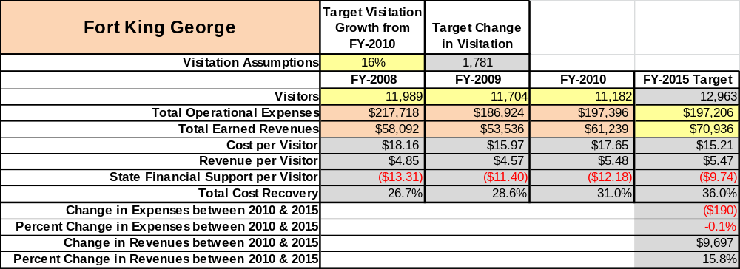

Key Recommendations

Primary / Short Term Recommendations
- Provide site specific marketing funds for Fort King George, or set up a revolving fund at the regional level. These funds will primarily be used to market special events and programming.
- Use marketing funds to enhance visitation at special events. Our goal is to see a 15% increase in attendance at all special programs by 2015
- Enlarge marketing campaign to tour operators, educators, and historically oriented civic groups.
- Develop stronger cooperative relationships with fellow stakeholders in the tourism industry in our area. These stakeholders include local chamber, civic groups, tourism destinations, etc.
- Improve fort facilities in order to make them more appealing to special group rentals and promote special group rental packages. This will be a HUGE revenue engine, and include family gatherings, birthday parties, weddings, boy/girl scout troop camp-outs, father-son weekends, etc. The fort will need electricity, water supply, sink washing area, and improved lighting.
- Explore option of contracting with a private concessionaire to manage private gatherings at site.
- Conduct sales study on site’s resale merchandise in order to define key sellers and to clear out poor sellers. Also, explore new merchandise for sales.
- Develop on-line gift shop for site items and for “friends” group items.
- Conduct demographic studies based upon visitor zip code information.
- Conduct detailed analysis on all site cost-centers to define which elements are working efficiently and those that are not. Improve those that are. Change/eliminate those that aren’t.
- Annually track local economic impact of site, and generate successful PR campaigns based upon outcome. Data should be heavily distributed to stakeholders, elected officials, and business operators.
- Strive to keep labor costs at or below 65% of total operational costs.
- Continue striving to make living history tour more compatible with public school curriculum at grades k-12.
- Continue to work with and expand operations of site friends group in order to enhance programming and marketing at the site.

Secondary / Long Term Recommendations
- Upgrade and improve site’s retail POS system so that it is more compatible with our needs and the customers.
- Streamline site purchasing practices by tracking supplies so that orders are done in a more convenient and efficient manner.
- Establish better cooperative exchange with Scout troops who are interested in conducting special projects.
- Establish a historic site host program to make use of volunteers in operating the site.
- Work with other historic sites in our system to cross promote and establish cooperative programming.
Site and Operations Assessment
This site and operations assessment is a culmination of analyses and findings from a review of the condition of facilities, infrastructure, and operations at Fort King George. The findings and observations are not intended to be an exhaustive review of all issues present, but provide a basic understanding of the predominant issues that contribute to the site’s current operating conditions. The assessment includes the following:
- Site Inventory and Facility Assessment
- Operational Assessment
- Financial Assessment
Site Inventory and Facility Assessment

Methodology
Facility and asset conditions are rated using a differential scale of excellent, good, fair, or poor. Descriptions of conditions that are attributed to each of these findings are also provided.
Scale of Conditions
Rating | General Description
Excellent | Facilities/amenities are in ‘excellent’ condition when they show little or no maintenance or repair problems. Facilities do not feature any major design or operational issues or flaws that contribute to diminished use or increased maintenance or upkeep. Facilities are easy to clean and maintain in order to place them back into public use and the users perceive them to be in excellent shape.
Good | Facilities/amenities are in ‘good’ condition when they show only minor maintenance or repair problems. Most maintenance issues with these facilities typically appear to be the result of age and/or heavy use. Facilities may only feature minor design or operational issues that contribute to diminished use or increased maintenance or upkeep. Facilities are moderately easy to clean and maintain in order to place them back into service and the users perceive them to be adequate for their use, but probably not in excellent shape.
Fair | Facilities/amenities are in ‘fair’ condition when they show significant maintenance or repair problems. Facilities generally exhibit ongoing maintenance issues that appear to be the result of age, heavy use, or design or operational flaws. Some maintenance and repair needs may compound their fair condition by being deferred because of budget and/or resource limitations. Facilities require more effort to clean and maintain before placing them back into service and the users may perceive them as being less than adequate for their use and in a state of deterioration. The facility or structure may need of major repair or replacement.
Poor | Facilities/amenities are in ‘poor’ condition when they show significant, on-going maintenance or repair problems that ultimately may result in suspended use for repair/replacement. Maintenance and repair issues are possibly the result of poor maintenance and clearly the result of age, heavy use, or design or operational flaws. Problems with the facilities are often compounded over time due to consistently-deferred maintenance and repair because of budget and/or resource limitations. Facilities may feature major design or operational issues that contribute to diminished use or increased maintenance or upkeep. Facilities require excessive effort to clean and maintain before placing them back into service and the users often perceive them as being inadequate for their use and in a state of serious deterioration. The facility or structure may need of major repair or replacement.

Inventory and Assessment
The table below is an inventory of facilities and amenities at Fort King George and provides the assessed condition of each as reviewed in May 2011.
Site Asset / Amenity | Quantity | Condition
Total acreage | 25 | Good
Museum | 1 | Good
Picnic Area | 1 | Fair
Gift Shop | 1 | Fair
Office Areas | 3 | Good
Managers Residence | 1 | Good
Site trials | 2 | Good
Cemetery | 1 | Good
Blockhouse | 1 | Good
Officers’ barracks | 1 | Good
Guardhouse | 1 | Good
Indigenous Huts | 4 | Poor
Baking & Brewing House | 1 | Poor
Blacksmith Shop | 1 | Good
Woodworking Shop | 1 | Good
Privy | 1 | Good
River Dock | 1 | Fair
Nature Trails | 1 | Good
Wayside Signage | 1 | Good
Maintenance Area | 1 | Good
Chemical Storage Shed | 1 | Fair
Storage Shed | 2 | Fair
Site Parking Lot | 1 | Poor
Audio-Visual Room | 1 | Good

Prioritized Facility Needs
Based on the facility inventory and assessment, these prioritized needs have been identified. Each need has been aligned with a priority category of high, moderate, or low to support future decision making regarding project sequencing, investment of public resources, and meeting community expectations. The priority assignment for each need is not a measure of importance. Rather, these recommended priorities reflect a phased implementation approach over the next several years.
Facility Need | Priority Assignment
Electricity and water run into fort | High
Bunks and fireplaces in indigenous huts at fort for campouts | High
Expansion and Improvement of Parking lot | High
Upgrade museum lighting and exhibits. | High
Renovate Native American Camp | Moderate
Two more wattle & daub huts in primitive camping area | Low
Screened Pavilion in Picnic Area | Low
Improved Landscaping | Low

Operational Assessment
The Operational Assessment includes:
- An inventory and classification of programs and services being provided at the site
- A review of staffing at the site
- A review of concessionaires and partners operating at the site
- Visitation and customer satisfaction

Inventory and Classification of Programs and Services
Programs and services are classified into one of three major categories:
1) Core or Essential Services
2) Important Services
3) Visitor Supported Services
Programs and services at the site are classified into these categories based in part on the mission and public mandates for both the site and the agency. For the programs and services in each of these categories, there are financial performance expectations that will define how services are funded and evaluated.

Category 1 – Core Services [Largely supported by tax funds]
Core programs, services and facilities are those the agency must provide and/or are essential in order to capably govern and meet statutory requirements. The failure of the agency to provide Category 1 services at adequate levels could result in significant negative consequences for the public and the resources under protection. The criteria for programs or services to be classified as core or essential are:
- The services are mandated by the agency’s law or charter or are contractually obligated by agreement to provide the services.
- The services are essential to protecting and supporting the public’s health and safety.
- The services protect and maintain valuable assets and infrastructure.
- The services would generally and reasonably be expected and supported by residents, businesses, customers and partners.
- The services are those that cannot or should not be provided by the private sector.
- The services provide a sound investment of public funds.
The following programs and services offered at Fort King George have been identified as core services:
- Maintain structural integrity of all site buildings, facilities, artifacts, and grounds
- Open and public access to the site and its resources
- Maintain public safety and site security.

Category 2 – Important Services [Supported by a balance of tax funds and earned revenues]
Important programs, services and facilities are those the agency should provide, and are important to governing and effectively serving residents, businesses, customers and partners. Providing Category 2 services expands or enhances the agency’s ability to provide and sustain its core services. The criteria for programs or services to be classified as important are:
- The services expand, enhance or support identified core services.
- The services are broadly supported and utilized by the community, and are considered an appropriate, important, and valuable public good. Public support may be conditional upon the manner by which the services are paid for or funded.
- The services generate income or revenue that offsets some or all of the operating cost and/or are deemed to provide economic, social or environmental outcomes or results.
The following programs and services offered at Fort King George have been identified as important services:
- Site exhibits, interpretive panels, and nature trail
- Self-directed site interpretation, education, and recreation

Category 3 – Visitor Supported Services [Almost exclusively supported by earned revenue]
Visitor supported programs, services and facilities are those discretionary services that the agency may provide when additional funding or revenue exists to offset the cost of providing those services. Category 3 services provide added value above and beyond what is required or expected. The criteria for programs or services to be classified as visitor supported are:
- The services expand, enhance or support core services or important services and the quality of life of the visitors, community or stakeholders.
- The services are supported, valued and well utilized and provide an appropriate and valuable public benefit.
- The services generate income or funding from sponsorships, grants, user fees or other sources that offset some or all of their cost and/or provides a meaningful return on investment.

- The services can possibly be provided through outsourcing or use of concessionaires, providing opportunities for community enterprises that may not otherwise be provided by the agency.
The following programs and services offered at Fort King George have been identified as visitor supported services:
- Gift Shop
- Rental of site for special gatherings such as weddings, group camps, etc.
- Site public programming and living history events

Staffing Assessment
Labor costs at Fort King George represent the largest area of budgetary expense at an average of 78% of the total operating budget each year for the last three complete years, which is higher than the target of total labor costs (including benefits) not exceeding 65% of the site’s total operating expenditures. The tables below and on the following page provide a basic review of the current staffing at the site.
Full Time Equivalent Employees
Position / Title | Quantity (FTE) | Vacancies | Annual Hours
Historic Site Manager | 1 | 0 | 2080
Interpretive Ranger | 1 | 0 | 2080
Trade Craftsman | 1 | 0 | 2080
TOTAL | 3 | 0 | 6240

Part Time Employees
Position / Title | Quantity (FTE) | Vacancies | Hours
Front Desk Clerk | 1 | 0 | 1040
Front Desk Clerk | 1 | 0 | 1040
Site Landscaper | 1 | 0 | 832
TOTAL | 3 | 0 | 2912

Labor Support
Labor Support | Annual Hours
Volunteers | 800
Community Service Workers | 416
Engineering and Construction Crews | 40
Resource Management Crews | 0
TOTAL | 1256

Total Labor Hours
Labor Type | Annual Hours
Full Time Equivalent Employees | 6240
Part Time Employees | 2912
Labor Support | 1256
TOTAL Annual Labor Hours | 10408

Labor Budget Summary
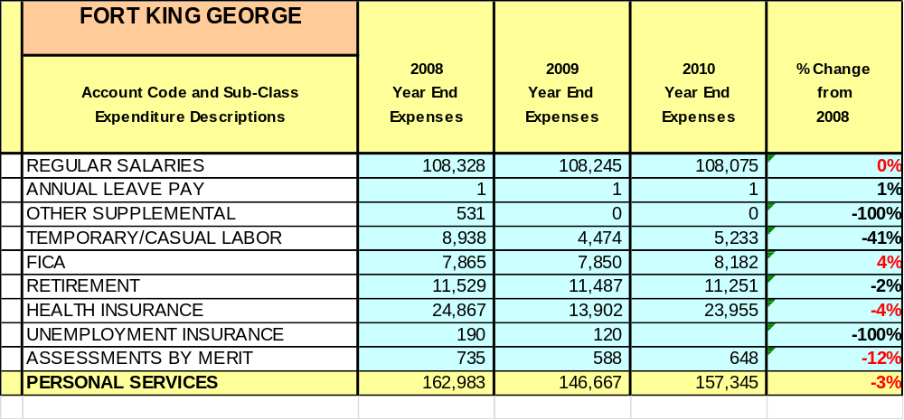

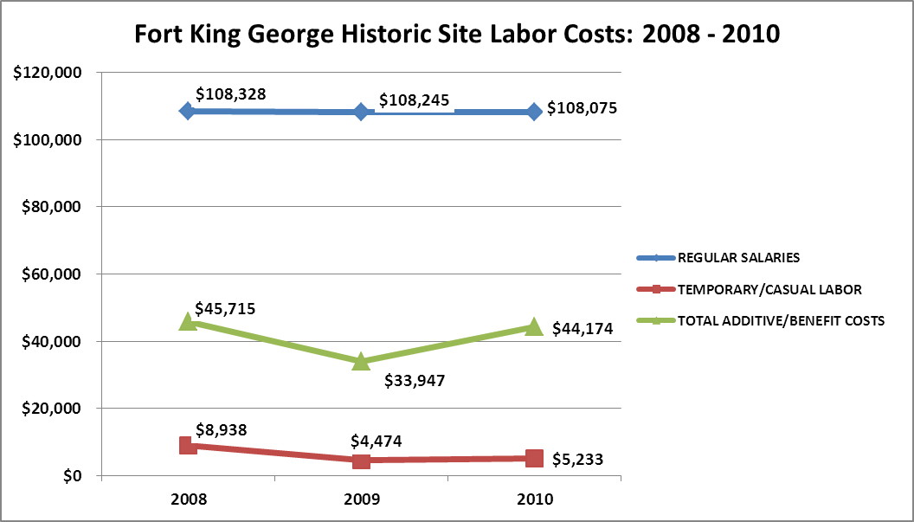

Visitation and Occupancy
Overall annual visitation to the site has remained steady from 2008 to 2010.
Year | Total Visitation
2008 | 11,989
2009 | 11,704
2010 | 11,182

Customer Service and Satisfaction

Site | Year | Customer Satisfaction Level
Fort King George | 2009 | 67%
Fort King George | 2010 | 100%

Financial Performance Assessment

Operational Expenses
A summary of total operating expenses at Fort King George from 2008 to 2010, as well as their percent change from 2008 are provided in the table below.

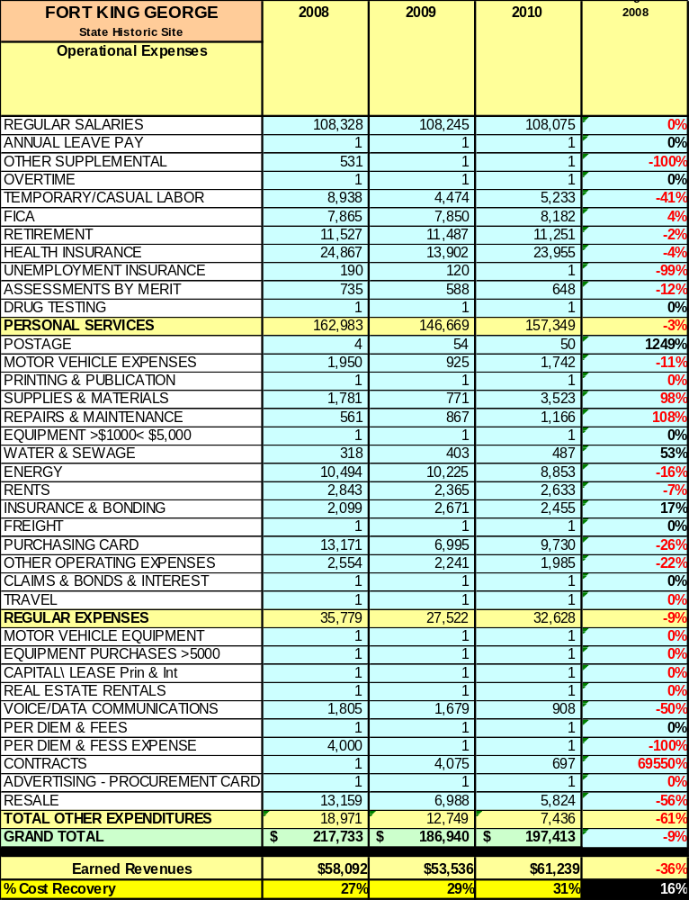

Earned Revenues
Earned revenues at Fort King George have increased since 2008, which is largely attributed to the corresponding increase in special programming and our hours of operation.
Monthly earned revenues for the last two years (see table on the following page) indicate that the total annual revenue increased 14% from 2009 to 2010, with the largest increases in monthly revenues in October (149%), September (52%), and July (29%), etc., and the largest decreases in the months of November (-16%), December (-16%), and January (-8%). Most of the decreases, such as those occurring in November and December can be explained by inclement weather.
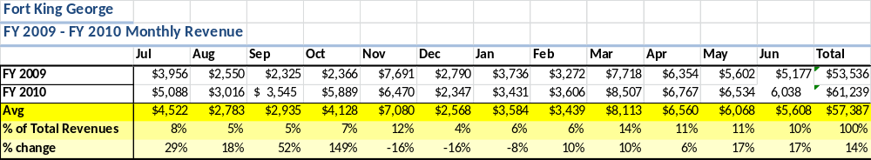

The graphs below illustrate the monthly revenue trends each year and the average percent of total annual revenue earned each month.

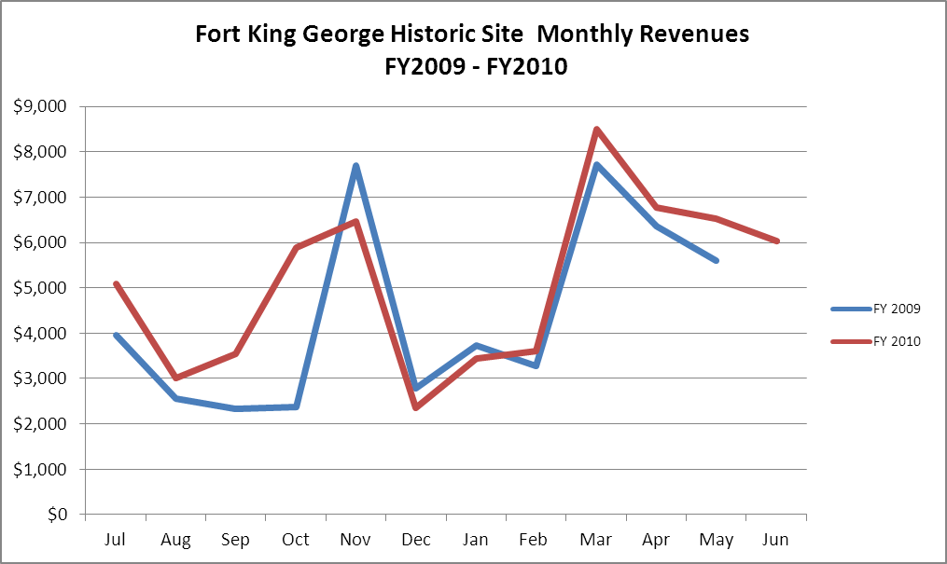

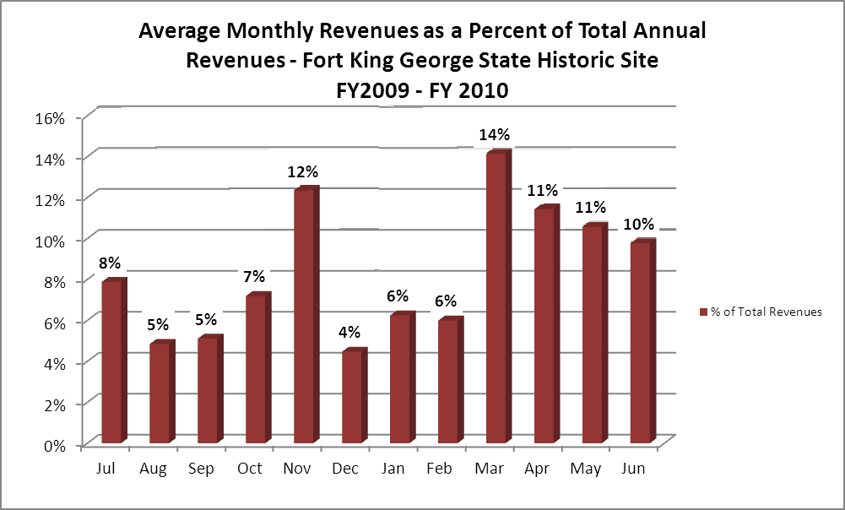

Cost Recovery Trends
Fort King George has achieved an average cost recovery of 29% of annual operational expenses through earned revenues from FY 2008 to FY 2010. This is detailed and illustrated in the table and graph below.

Year | Operational  Expenses | Earned  Revenues | Percent Cost  Recovery
2008 | 217718 | 58092 | 27
2009 | 186924 | 53536 | 29
2010 | 197396 | 61239 | 31

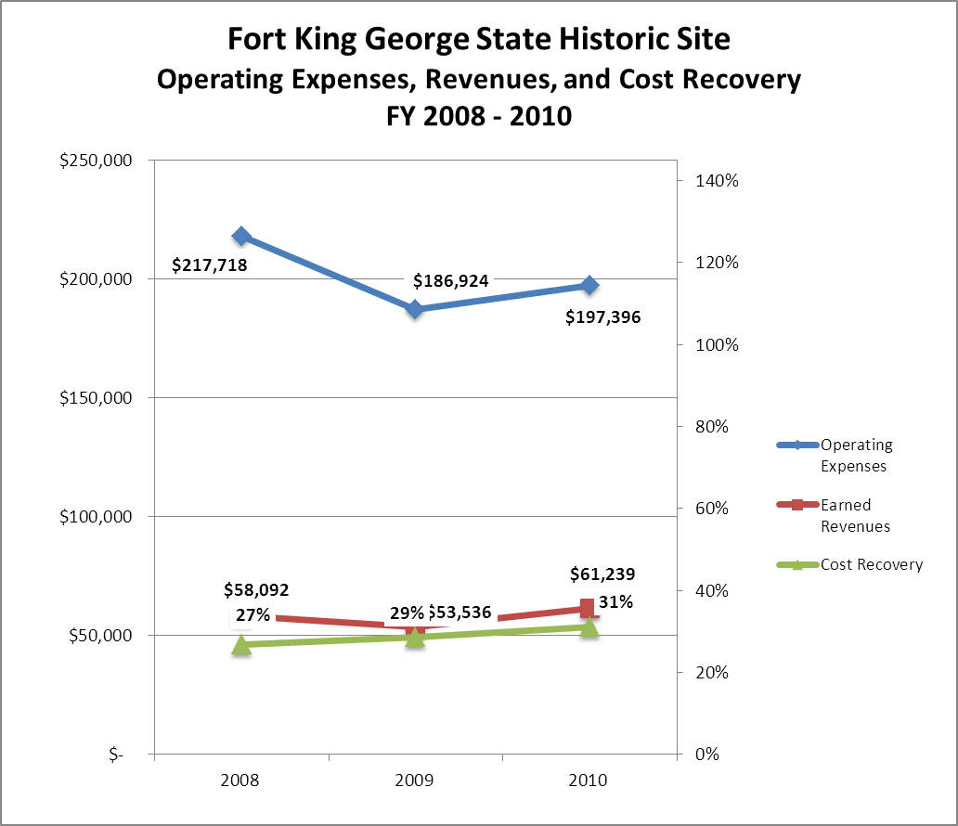

Review of Pricing
Data on rate information is available as far back as 2002, but only the last five years are evaluated.
A table detailing the rates for Fort King George is provided below.
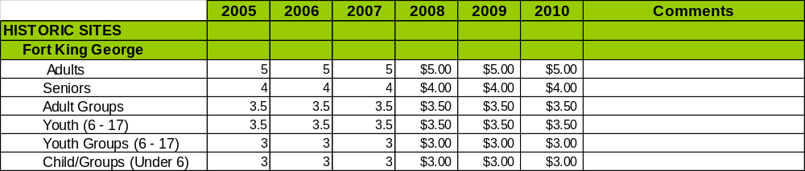
Business and Management Plan

Business Goals
The following goals serve as the foundation for the key recommendations and strategies in this business plan for Fort King George Historic Site.

Enhance Cost Recovery of Site Operations
Presently, the site is only recovering approximately 30 percent of overall cost. This is a struggle for historic sites in that volume of business is not such to enable significant cost recovery. However, I do believe it is feasible for Fort King George to generate near 100K in revenues annually in the future. If revenue is at this level, we will be recovering around 50 percent of costs. This will require a significant paradigm shift in how we use our site and it’s availability to the public.

Enhance Revenue Generation Strategies
- We will rent the site for special gatherings. These may include birthday parties, weddings, boy/girl scout retreats, business meetings, special dinners, etc.
- Expand site programming to include more special events and weekend programming. Our goal will be to offer at least one significant program each month, with minor interpretive programs occurring during the weekends.
- Expand our recreational offerings with more canoe trips and rentals. Also, we will start renting a primitive camping area for special groups.
- Continue marketing educational programming, but target home school groups and private schools more so than public schools. We have seen a dramatic decrease in public school field trips and this is because of budget issues. Private schools and home schools have more flexibility.
- Begin marketing of special fort rental options. This includes website, special brochure, and advertising in area newspapers.

Expand Special Events at the Site
In addition to the living history encampments and events we have traditionally held throughout the years, starting next fall we will begin to include evening concerts for the public. We will also consider wine tastings, moonlight canoe trips, special oyster roasts, historical art exhibitions, and other options as well.

Improve the Diversity and Innovation of Recreational and Interpretive Programs
Our mission at Fort King George has always been to use a diverse range of programs that fit into our historical theme and do not compromise the integrity of our cultural resources. We will strive to make our special events more entertaining to younger audiences. This will be done by providing more hands-on kid activities that they can engage in. Also, having birthday events at the site will enhance this mission as well.

Improve the Effectiveness of Marketing and Sales
Traditionally, Fort King George has relied almost exclusively on press releases and flyers to promote our site and programming. This is not going to be adequate any more if we want sufficient cost recovery. For our last encampment our friends group spent nearly 1K on television advertising and it more than paid for itself. We made over four times that amount in revenue. More emphasis is needed on marketing within the region, working with local chambers and area civic groups to build co-ops, building educational partnerships with county school systems, curriculum development, interpretive development, home school groups, and private schools, rack card distribution, region promotions, advertising, among other things.
We will continue to lean heavily on our friends group to help us with paid advertising. All future programs will have an advertising budget and it will be analyzed for effectiveness. We will also cross–promote the site with fellow tourism stakeholders in our area. These include the Waterfront Merchants Assoc., The McIntosh Chamber of Commerce, etc. Furthermore, starting immediately next fiscal year, we will begin an intense ad campaign in information sources extending between Jacksonville and Savannah to alert the public on our new special group offerings at the fort. More site specific marketing funds will be requested from the Division. In short, our philosophy will be an age-old, time-honored, proven concept: you have to spend money to make money.

Establish Greater Consistency of Managing and Monitoring Customer Service & Satisfaction
At Fort King George customer survey cards are available to all visitors. We will strive to see that they are used more often, especially for special events. Also, I’d like to see us develop a customer survey that focuses more on what attracts people to Fort King George. Our present one does not allow for feedback on how visitors find out about our site and what brings them to our programs. We do, however, offer a sign-in sheet that allows customers to tell us how they learned about us.

Expand Partnership Opportunities
Presently our friends group pays memberships into several local civic groups that include area chambers and the Waterfront Merchants Association. There are numerous other fellow tourism stakeholders in our area with whom we will work to forge partnerships with. Our goal is to compile a list of all such stakeholders and invite them to a tourism workshop to be held inside the fort sometime this fall. This workshop will involve a luncheon with brainstorming sessions, activities, and guest speakers on how we may all better work together to promote area tourism.

Classification of Programs and Services
The tables below summarize the classifications of programs and services at Fort King George as either core, important, or visitor supported and projects a range of cost recovery percentages that might be achieved for each. These classifications establish financial performance goals for each category of services that are linked to the recommendations and strategies of this business plan.

Core Services
Program / Service | Target Cost Recovery
Maintain structural integrity of all site buildings, facilities, artifacts, and grounds. | 0%
Open and public access to the site and its resources. | 50%
Maintain public safety and site security | 0%

Important Services
Program / Service | Target Cost Recovery
Site exhibits, interpretive panels, and nature trail  20% | 20%
Self-directed site interpretation, education, and recreation | 20-30%

Visitor Supported
Program / Service | Target Cost Recovery
Gift Shop | 150-200%
Rental of site for special gatherings such as weddings , group camps, dinners etc. | 120%
Site public programming and living history events. | 120%

Partnership Development Plan
The table below summarizes existing partners and targeted partnerships by classification (operational, vendor, service, co-branding, funding partners) and by organizational type.
 | Public Partners | Not-for-profit Partners | Private / Enterprise Partners
Operational Partners | - DNR Wildlife Resources Division  - City of Darien  - Hofwyl-Broadfield Historic Site | - The Garrison of Fort King George
Vendor Partners |  |  | - Coca Cola  - Georgia Power  - McIntosh YMCA
Service Partners | - City of McIntosh  - City Development Authority  - Fort Frederica National Monument | - The Garrison of Fort King George  - McIntosh County Chamber of Commerce  - Altamaha River-keeper Association  - Nature Conservancy  - Ashantilly Center  - Georgia Coast Travel Association  - Coastal Museum Association
Co-branding Partners |  | - Friends of Hofwyl | - Altamaha Coastal Tours  - Sapelo Island Tours
Funding Resource Development Partner |  | - Friends Group  - Ashantilly Center

Marketing and Sales Plan

Marketing and Sales Goals
Marketing and sales goals for Fort King George are based on the following desired outcomes:
- To successfully expand Fort King George’s site programming and marketing
- To expand public recreational availabilities at the site
- To increase overall visitation and revenues for the site.
In order to meet these goals, examples of specific target outcomes were identified in the areas detailed in the table below.

Area  of Focus | Current  Performance | Goal  by 2011 | Goal  by 2012 | Goal  by 2015
Special Events | Approximately 20-25% of revenue | 25% of revenue  3 K visitors | 30% of revenue  3500 visitors | 35% of revenue  5K visitors
Recreational Opportunities | Less than 1% of revenue | 5-10 % revenue | 10% revenue | 15% of revenue
Overall Visitation | 11,200 | 11,517 | 11,863 | 12,963

Marketing and Promotion Strategies

Publicity and Social Media
Fort King George will approach marketing and publicity planning using the following guidelines and themes:
- Event publicity
- Special publicity will be well documented from now on.
- All programs will have a publicity plan and a publicity budget.
- Press releases will be sent to relevant publications in our area.
- All publicity will begin one month out and saturate two weeks before the event.
- Our goal will be to get a feature article in at least two area newspapers for each special event.
- All events will be featured on relevant social media such as ExploreGeorgia.org, Facebook, etc.
- Each special event will feature some type of hands-on child activity.
- Each event will offer certain prizes for things such as raffles, scavenger hunt competitions, and hands-on challenges that visitors may be able to engage in.
- Program publicity
- All of the Event Publicity ideas apply here.
- Program publicity will involve targeting marketing to educational groups, specifically home school groups and private schools. Public school budgets are making their visitation cost prohibitive, however, we will continue to target them as well.
- Site Publicity
- Starting next fiscal year, July 2011, we will begin a media blitz announcing recreational and group gathering opportunities available at Fort King George. This will involve web-site advertising, local media advertising to include print and television, feature stories in major publications.
- Marketing funds will be requested from the Division to promote site programs. The site will host media, educator, and tour operator familiarization events that will allow these professionals the opportunity to visit our site and see what we have to offer.
- Travel brochures featuring FKG will be distributed to tour operators all over the country.
- FKG will also cross-promote the site through co-ops with other tourism stakeholders in our area. This will involve feature ads in media, radio, and television.

Examples and suggested opportunities for events, programs and related publicity efforts based on the themes described above at Fort King George are provided in the table below.

Event Publicity | Program Publicity | Site Publicity
Living History Encampments | Living history tours and talks | Rental of fort to special groups
Music Concerts | Guided canoe trips | Coastal Heritage Trail
Murder Mystery Dinner | Junior ranger camp | Geocaching
Period theme  dinners in fort | Historical lectures and presentations | Colonial life commemorations

Packaging
Examples and suggested packages for Fort King George are provided in the table below.
Package | Package Details
FKG/Hofwyl 2fer discount | Tour both sites and get a $2 discount of total price
Group Gatherings | Packages will vary but will include weddings, camping, living history workshops, canoe trips, etc.

Group Sales
Types of groups within which specific target customers can be identified for Fort King George are listed below:
- Wedding Packages | - Scouts | - Colleges/Universities
- Church groups | - Elder hostel groups | - School groups
- Tour operators | - Families | - Military heritage societies

Incentivizing New and Repeat Visitation
Fort King George will utilize the following strategies and/or incentives to encourage new and repeat visitation starting in FY 2012:
- Discount coupons offered at local area attractions such as restaurants.
- Enhanced quality and frequency of programs with more hands-on kid related activities.
- Gift shop specials such as advertised discounts on t-shirts, hats, and other items. This will be promoted through our email club.
- Get emails from at least half our customers. Emails will be used for promotional purposes.

Marketing and Sales Metric Goals
The following marketing and sales metric goals and/or others will be monitored and progress reported at Fort King George:
- Loyalty and repeat customers = 35% of all customers will repeat their visit within a 2 year period.
- Brand confidence & customers-recruiting-customers = 35% of visitors will come through customer referrals.
Revenue Generation Plan
Revenue / Cost Recovery Goals
Fort King George has set a financial goal of increasing annual revenues 3% annually between 2012 and 2015. The largest revenue growth opportunity is most likely in pleasant weather months such as October, November, March, and April. The table below details projected revenue growth leading up to 2015, based upon a nominal growth of revenues each year.

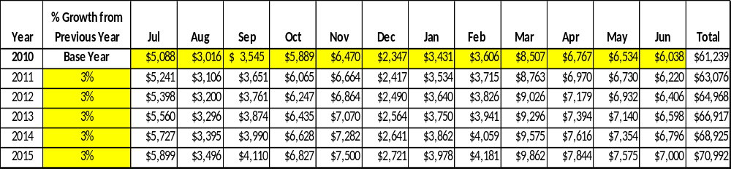

These projections would result in a total of 9% cumulative growth in total annual revenues between FY2010 and FY2015. If operational expenses can be managed with an increase of no more than 2% between FY 2011 and FY 2015 levels, then the overall cost recovery of the site will be approximately 36% in FY 2015 at these projected revenue levels. This is higher than the annual financial performance of the site in FY 2010, which was operated at 31% cost recovery in that year.

Revenue Generation Strategies

Pricing Plan
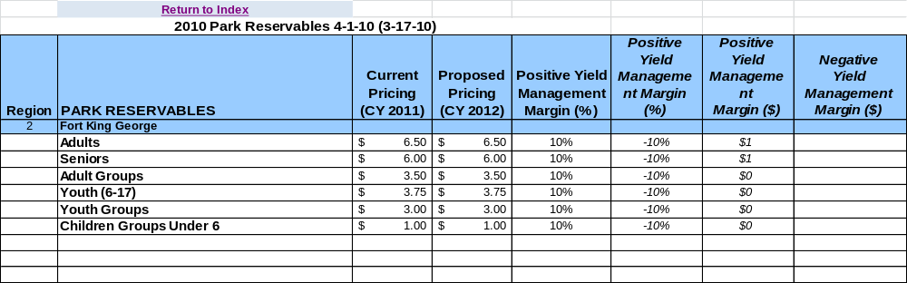

Innovative Programming and Special Events Plan

Program / Event | Theme / Purpose | Scheduled Date/Season | Frequency | Target Participation | Target User Fee | Target Cost Recovery
Cannons Across the Marsh | Independence Day Celebration | July 2-4 | Annually | 500 | $4-6 | 120%
Canoe Trips | Natural Cultural Interpretation of Altamaha River Basin | Varies | 1-2 trips monthly | 12 people per trip | $35\individual | 150%
Special Moonlight Canoe Trip | River by moonlight with dinner and campout in fort | Full moon weekend in October | Annually | 50 | $100 per person | 200-300%
The Debatable Land | British/Spanish struggle for empire on Altamaha | 2nd weekend in November | Annually | 1000 | $4-6 | 120-150%
Colonial Christmas Dinner | Christmas dinner and entertainment in soldiers barracks | 2nd Weekend in December | Annually | 60 | $50 | 200%
Soldier Life Weekends | 18th century military life | 1 Saturday per month | Once a month | 100 | $4-6 | 100-120%
Scottish Heritage Day | Scots of Darien | 3rd Weekend in March | Annually | 1000 | $4-6 | 120-150%
Weapons that Made America | Historical weapons | Last weekend in April | Annually | 200-250 | $4-6 | 120-150%
Holiday Cannon Firings | Colonial Weapons | Memorial Day and Labor Day | Annually | 200-250 | $4-6 | 120-150%
Fathers & Sons campout in fort | Recreational/historical entertainment | 3rd weekend in October | Annually | 30-60 | $50\individual | 150-200%
Junior Ranger Camp | Outdoor/historical education for young people | 2nd week in June | Annually | 15-20 | $50\individual | 100%

Partnerships and Concessions Plan

Service / Partnership | Term of Service | Financial Objective | Contract Manager
Food & Coffee Concessions | 1 year | 15% of gross receipts to site | Site Manager
Packaging & promotions with area businesses | 1 year | Shared Revenue | Site Manager

Expense Management Plan
Personnel Assignments
The following actions will be taken to proactively manage labor costs via personnel assignments and classifications.

Action | Timeline | Outcome

Management Techniques
The following actions will be taken to proactively manage labor costs via management techniques.

Action | Timeline | Outcome
Increased use of volunteers for grounds maintenance and program setup | July 2012

Adjusted Levels of Service
The following actions will be taken to proactively manage labor costs via reduced levels of service.

Action | Timeline | Outcome
Adjusted mowing and landscaping schedules for portions of site | July 2012

Financial Pro Forma
The following six-year financial pro forma projects operating expenses, earned revenues and cost recovery through FY 2015. These pro forma are based on the strategies and desired outcomes identified in this business plan, especially the revenue generation and expense management plans, and are linked to corresponding performance goals.

Expense Pro Forma
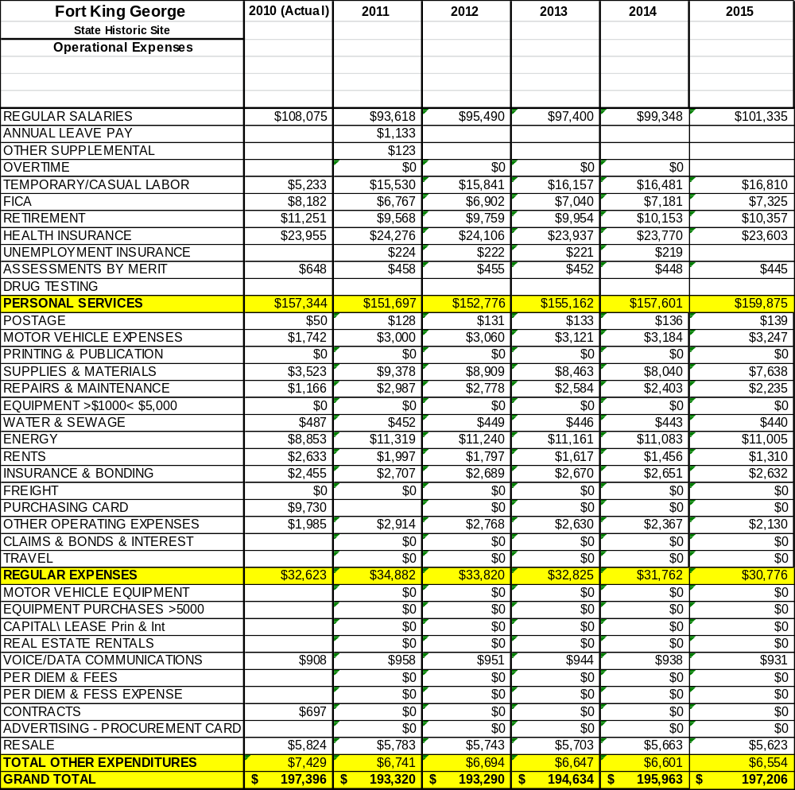

Revenue Pro Forma
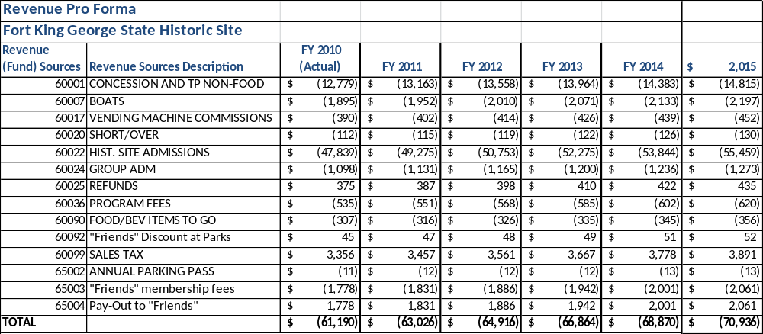

Total / Cost Recovery Pro Forma
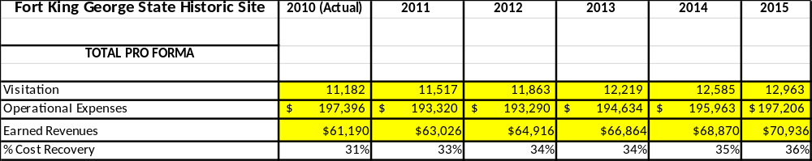

ACTION PLAN
Site: |  | Site Manager: |  |  | Date:
Month:
Strategy | Tasks | Costs / Funding | Revenues / ROI | Responsibilities | Metrics

This is the average of the last three years – FY 2008, FY 2009, and FY 2010
Current employees, not including vacancies.
Current employees, not including vacancies.
Major population centers within a two-hour drive from the site

