FORT McALLISTER HISTORIC PARK
Business & Management Plan

Prepared June 2011; Finalized January 2013
Direction 2015 – Sustainable Business Planning

Table of Contents

Executive Summary 3

Site and Operations Assessment 6
Site Inventory and Facility Assessment 6
Operational Assessment 8
Financial Performance Assessment 13

Business and Management Plan 16
Business Goals 16
Classification of Programs and Services 17
Partnership Development Plan 18
Marketing and Sales Plan 19
Revenue Generation Plan 21
Expense Management Plan 23
Financial Pro Forma 24

Action Plan 27

Executive Summary
The Parks, Recreation and Historic Sites Division (PRHSD) of the Georgia Department of Natural Resources (DNR) is transitioning the management of Fort McAllister State Historic Park to operate more like a business, reflecting the Direction 2015 – Sustainable Business Planning initiative to improve the fiscal performance and management of the state parks and historic sites system. This business and management plan is designed to help the site recover more operating expenses through earned revenues, productive partnerships, and innovative programs.

Site Fact Sheet
Site Name | Fort McAllister State Historic Park
Site Manager | Daniel Brown
Region Manager | Tommy Turk
Date of Business Plan completion | June 13, 2001
Site size | 1,700 acres
Total number of visitors (FY 2010) | 150,030
Total operating budget (FY 2010) | $386,342
Total earned revenues (FY 2010) | $347,838
Operational cost recovery (FY 2010) | 90%
Average operating cost per visitor (FY 2010) | $2.58
Average earned revenue per visitor (FY 2010) | $2.32
Average cost recovery (FY 2008 – 2010) | 90%
Target cost recovery (FY 2015) | 99%
Total full-time employees | 4
Total part-time employees | 5
Primary service markets | Savannah, Hinesville, Brunswick and Hilton Head SC
Primary attractors/visitor appeal factors | Historic Civil War fort and museum, campground, cottages, nature trails, Ogeechee River, and coastal access and fishing
Leading opportunities for improved site performance | Improvement of historic site, addition of more cottages, expansion of campground boat dock

Site Summary and Key Attractions
Fort McAllister State Historic Park is made up of 1,700 acres roughly 24 miles from downtown Savannah Georgia. It is located 9 miles off I-95 at exit 90 in Richmond Hill Georgia.

Key Attractions
The amenities or features listed below are those that seem to be most popular for visitors.
- Civil War Fort and special events
- Historic Site Museum , Exhibits and Gift Shop
- Signal Tower
- 65 site Campground
- Fishing pier, boat ramp and boat dock and playgrounds in campground
- Rental Cottages
- Nature Trail in campground
- Nature Trail on Red Bird Creek
- Picnic Grounds and Fishing Pier and Picnic Shelters with Playgrounds
- Family Group Shelter
- Ogeechee River Boat Ramp and dock
- Canoe Rentals

Financial Targets
The table below details the total operating expenses and earned revenues for Fort McAllister over the last three years (2008 – 2010). This table also calculates total cost per visitor and revenues per visitor during these operating years, and details the target financial performance goals in the context of achieving at least 103% cost recovery. This table also calculates the necessary change from 2010 operating expenses and revenue.
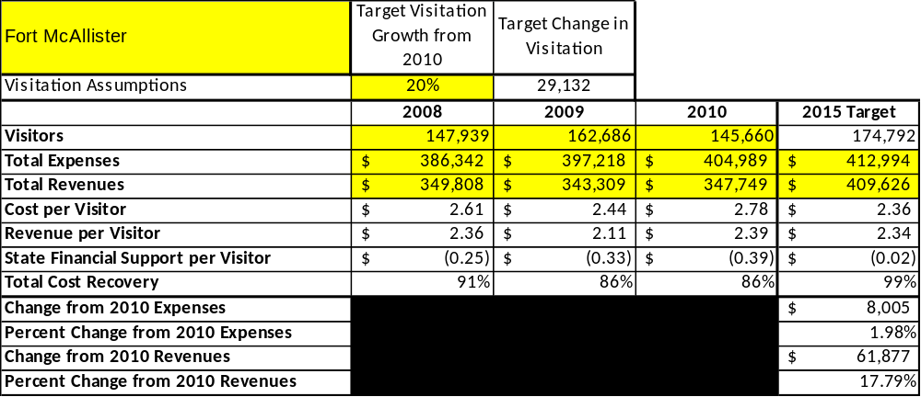

Key Recommendations

Primary / Short Term Recommendations
- Construct and upgrade facilities that are likely to have a cost recovery of 105% or more. Examples of such improvements include the adding cottages, reconfiguring the campground boat dock to handle more boats, promoting the park as a canoeing and kayaking access point and providing more areas for recreational activities such as volleyball and horseshoes.
- Add more youth-focused programs and services and amenities to attract more youths and their families. Develop new ways to attract tour and school groups such as outside games, recreational activities including hiking, expanded nature trails, and taking programs into the schools and encouraging them to visit the site.
- Operate the site using cost-based accounting, including the net cost recovery achieved annually.
- Strive for a 90% visitor comment card use with a satisfied or very satisfied comment. Find a way to track zip codes of visitors to better serve their needs by using demographic information.
- Develop a more detailed analysis of labor requirements of all major park/site functions to match the right job with the right position.
- Conduct at least 10 special events/programs per year, including lecture series, canoe trips, hikes and overnight camping trips to increase visitation and thus revenue.
- Open museum and fort for private functions and after hours events such as weddings and receptions, using caterers and event planning companies.
- Seek local partners to help support operations, programs and service delivery and for cross marketing purposes. Utilize Friends of Fort McAllister for events and support. Get involved with local chambers and tourism organizations.
- Increase the public’s experiences by enhancing facilities and program offerings such as increasing the capacity of the boat dock and working with local fishing charter companies and kayaking outfitters.
- Operate park/site according to a well-defined maintenance program and operational standards. Keep close eye on park’s infrastructure to ensure a smooth running operation.
- Perform a thorough net cost-of-service analysis on major functions of site operations, including the detailed analysis of labor, by task, which has already been produced by site staff. Thereafter, update costs to deliver services on a biennial schedule.
- Improve the recreational amenities of the park/site to address modern and diverse uses. Add rental bikes, pedal carts and rental camping equipment.

Secondary / Long Term Recommendations
- Improve resale area and add a larger variety of items for sale.
- Setup training workshops that cater to history minded people and teachers. Hands on topics.

Site and Operations Assessment
This site and operations assessment is a culmination of analyses and findings from a review of the condition of facilities, infrastructure, and operations at Fort McAllister. The findings and observations are not intended to be an exhaustive review of all issues present, but provide a basic understanding of the predominant issues that contribute to the site’s current operating conditions. The assessment includes the following:
- Site Inventory and Facility Assessment
- Operational Assessment
- Financial Assessment
Site Inventory and Facility Assessment

Methodology
Facility and asset conditions are rated using a differential scale of excellent, good, fair, or poor. Descriptions of conditions that are attributed to each of these findings are also provided.
Scale of Conditions
Rating | General Description
Excellent | Facilities/amenities are in ‘excellent’ condition when they show little or no maintenance or repair problems. Facilities do not feature any major design or operational issues or flaws that contribute to diminished use or increased maintenance or upkeep. Facilities are easy to clean and maintain in order to place them back into public use and the users perceive them to be in excellent shape.
Good | Facilities/amenities are in ‘good’ condition when they show only minor maintenance or repair problems. Most maintenance issues with these facilities typically appear to be the result of age and/or heavy use. Facilities may only feature minor design or operational issues that contribute to diminished use or increased maintenance or upkeep. Facilities are moderately easy to clean and maintain in order to place them back into service and the users perceive them to be adequate for their use, but probably not in excellent shape.
Fair | Facilities/amenities are in ‘fair’ condition when they show significant maintenance or repair problems. Facilities generally exhibit ongoing maintenance issues that appear to be the result of age, heavy use, or design or operational flaws. Some maintenance and repair needs may compound their fair condition by being deferred because of budget and/or resource limitations. Facilities require more effort to clean and maintain before placing them back into service and the users may perceive them as being less than adequate for their use and in a state of deterioration. The facility or structure may need of major repair or replacement.
Poor | Facilities/amenities are in ‘poor’ condition when they show significant, on-going maintenance or repair problems that ultimately may result in suspended use for repair/replacement. Maintenance and repair issues are possibly the result of poor maintenance and clearly the result of age, heavy use, or design or operational flaws. Problems with the facilities are often compounded over time due to consistently-deferred maintenance and repair because of budget and/or resource limitations. Facilities may feature major design or operational issues that contribute to diminished use or increased maintenance or upkeep. Facilities require excessive effort to clean and maintain before placing them back into service and the users often perceive them as being inadequate for their use and in a state of serious deterioration. The facility or structure may need of major repair or replacement.

Inventory and Assessment
The table below is an inventory of facilities and amenities at Fort McAllister, and provides the assessed condition of each as reviewed in May 2011.
Site Asset / Amenity | Quantity | Condition
Total Acreage | 1,700 | Good
Visitor Center/Museum | 1 | Excellent
Earthen Fort | 1 | Fair grass coverage
Family Group Shelter | 1 | Good
Cottages | 3 | Good
Bath House at Campground dock | 1 | Fair
Bath house in Campground | 1 | Good
Restrooms in Picnic Area | 1 | Fair
Playgrounds | 3 | Good
Manager’s Residence | 1 | Fair
Asst. Manager’s Residence | 1 | Good
Fort Barracks and Apartment | 1 | Good
Concrete Fishing Pier | 1 | Good
Alumina Boat Dock | 1 | Good
Ogeechee River Dock | 1 | Fair
Nature Trails | 2 | Good
Picnic Shelters | 4 | Good

Prioritized Facility Needs
Based on the facility inventory and assessment, these prioritized needs have been identified. Each need has been aligned with a priority category of high, moderate, or low to support future decision making regarding project sequencing, investment of public resources, and meeting community expectations. The priority assignment for each need is not a measure of importance. Rather, these recommended priorities reflect a phased implementation approach over the next several years. Artifact preservation on site level is working but in need of more space and personnel to process the artifacts. Also relying on Preservation Lab for some of our items.
Facility Need | Priority Assignment
Campground Boat Dock Expansion | High
Handicapped Board Walk Repairs | Low
Ogeechee River Dock Redeck & Erosion | High
Upgrade Museum Gallery Lighting | Moderate
Cottages Exteriors Painting | Low
Campground Dock Comfort Station Replacement | High
Maintenance Shop Replace and Relocate Off of Bluff | Moderate
Campsites and Roads Gravel | Low
Fort Grassing | High
Group Shelter Road Paving | Moderate
Savage Island Campground Causeway Repave | Moderate

Operational Assessment
The Operational Assessment includes:
- An inventory and classification of programs and services being provided at the site
- A review of staffing at the site
- A review of concessionaires and partners operating at the site
- Visitation and customer satisfaction

Inventory and Classification of Programs and Services
Programs and services are classified into one of three major categories:
1) Core or Essential Services
2) Important Services
3) Visitor Supported Services
Programs and services at the site are classified into these categories based in part on the mission and public mandates for both the site and the agency. For the programs and services in each of these categories, there are financial performance expectations that will define how services are funded and evaluated.

Category 1 – Core Services [Largely supported by tax funds]
Core programs, services and facilities are those the agency must provide and/or are essential in order to capably govern and meet statutory requirements. The failure of the agency to provide Category 1 services at adequate levels could result in significant negative consequences for the public and the resources under protection. The criteria for programs or services to be classified as core or essential are:
- The services are mandated by the agency’s law or charter or are contractually obligated by agreement to provide the services.
- The services are essential to protecting and supporting the public’s health and safety.
- The services protect and maintain valuable assets and infrastructure.
- The services would generally and reasonably be expected and supported by residents, businesses, customers and partners.
- The services are those that cannot or should not be provided by the private sector.
- The services provide a sound investment of public funds.
- Provide research files to public doing genealogy.
The following programs and services offered at Fort McAllister have been identified as core services:
- Law enforcement and 24-hour public safety
- Cultural and natural artifact and resource management, including the historic earthen fort
- Open and public access to the site and its resources
- Site oriented programs, exhibits, educational materials and recreational opportunities
- Research files and library available to the visitors
- Facility maintenance, grounds maintenance and infrastructure upkeep

Category 2 – Important Services [Supported by a balance of tax funds and earned revenues]
Important programs, services and facilities are those the agency should provide, and are important to governing and effectively serving residents, businesses, customers and partners. Providing Category 2 services expands or enhances the agency’s ability to provide and sustain its core services. The criteria for programs or services to be classified as important are:
- The services expand, enhance or support identified core services.
- The services are broadly supported and utilized by the community, and are considered an appropriate, important, and valuable public good. Public support may be conditional upon the manner by which the services are paid for or funded.
- The services generate income or revenue that offsets some or all of the operating cost and/or are deemed to provide economic, social or environmental outcomes or results.
The following services offered at Fort McAllister have been identified as important services:
- Educational programs, geo caching and self-guided tours
- Facilitation of historical and natural researchers

Category 3 – Visitor Supported Services [Almost exclusively supported by earned revenue]
Visitor supported programs, services and facilities are those discretionary services that the agency may provide when additional funding or revenue exists to offset the cost of providing those services. Category 3 services provide added value above and beyond what is required or expected. The criteria for programs or services to be classified as visitor supported are:
- The services expand, enhance or support core services or important services and the quality of life of the visitors, community or stakeholders.
- The services are supported, valued and well utilized and provide an appropriate and valuable public benefit.
- The services generate income or funding from sponsorships, grants, user fees or other sources that offset some or all of their cost and/or provides a meaningful return on investment.

- The services can possibly be provided through outsourcing or use of concessionaires, providing opportunities for community enterprises that may not otherwise be provided by the agency.
The following services offered at Fort McAllister have been identified as visitor supported services:
- Camping, shelter rental, canoe rentals, gift shop and historic fort
- Guided tours of museum and canoe trips
- Special events and programming

Staffing Assessment
Labor costs at Fort McAllister represent the largest area of budgetary expense at an average of 60% of the total operating budget each year for the last three complete years, which is lower than the target of total labor costs (including benefits) not exceeding 65% of the site’s total operating expenditures. The tables below and on the following page provide a basic review of the current staffing at the site.

Full Time Equivalent Employees
Position / Title | Quantity (FTE) | Vacancies | Annual Hours
Park Manager 2 | 1 | 0 | 2600
Asst. Park Manager 1 | 0 | 1 | 2600
Interpretive Ranger | 1 | 0 | 2080
Park Ranger | 1 | 0 | 2080
Utility Worker | 0 | 0
Desk Clerk | 0 | 0
House Keeper | 0 | 0
TOTAL | 3 | 1 | 9,360

Part Time Employees
Position / Title | Quantity (FTE) | Vacancies | Annual Hours
House Keeper | 1 | 0 | 1508
Maintenance worker | 2 | 0 | 3016
Clerical worker | 2 | 0 | 3016
TOTAL | 5 | 0 | 7,540

Labor Support
Labor Support | Annual Hours
Volunteers | 4000
Community Service Workers | 500
Engineering and Construction Crews | 200
Resource Management Crews | 0
TOTAL | 4,700

Total Labor Hours
Labor Type | Annual Hours
Full Time Equivalent Employees | 9,360
Part Time Employees | 7,540
Labor Support | 4,700
TOTAL Annual Labor Hours | 21,600

Labor Budget Summary

 | Fort McAllister
 |  | 2008 | 2009 | 2010 | % Change
 | Account Code and Sub-Class | Year End | Year End | Year End | from
 | Expenditure Descriptions | Expenses | Expenses | Expenses | 2008
 | REGULAR SALARIES | 175,000 | 170,000 | 167,926 | -4%
 | ANNUAL LEAVE PAY | 936 | 1,005 | 839 | -10%
 | OTHER SUPPLEMENTAL | 1 | 1 | 2 | 100%
 | TEMPORARY/CASUAL LABOR | 10,000 | 12,000 | 13,878 | 39%
 | FICA | 12,500 | 11,000 | 10,800 | -14%
 | RETIREMENT | 38,500 | 37,000 | 35,090 | -9%
 | HEALTH INSURANCE | 103,929 | 58,447 | 86,146 | -17%
 | UNEMPLOYMENT INSURANCE | 350 | 300 | 287 | -18%
 | ASSESSMENTS BY MERIT | 300 | 247 | 240 | -20%
 | PERSONAL SERVICES | 341,516 | 290,000 | 315,206 | -8%

Labor Budget Summary

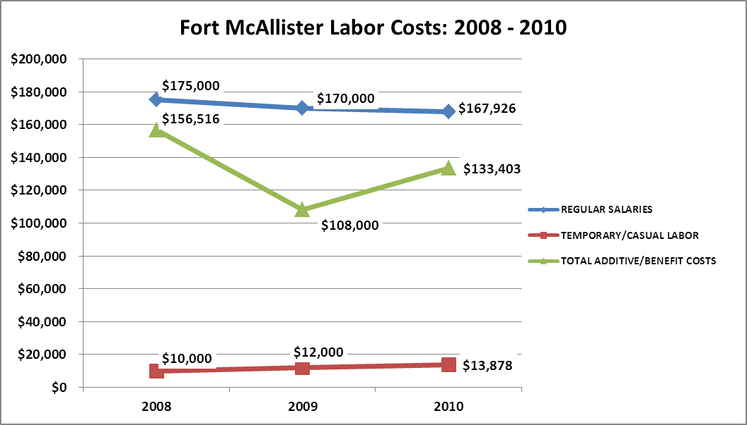

Visitation and Occupancy
Overall annual visitation to the site has trended downward from 2008 to 2010, decreasing by 2% or over 2279 visitors. This is largely attributed to gas prices.

Year | Total Visitation
2008 | 147,939
2009 | 162,686
2010 | 145,660

Occupancy for the overnight accommodations at Fort McAllister the last three years is detailed in the table below. Overall occupancy has trended downward from 2008 to 2010, decreasing by 9%. This is largely attributed to gas costs and general economic decline.

Year | Cottages Occupancy | Camp Sites Occupancy
2008 | 64.15% | 43.01%
2009 | 62.27% | 39.50%
2010 | 60.26% | 37.34%

Customer Service and Satisfaction

Site | Year | Customer Satisfaction Level
Fort McAllister | 2009 | 57%
Fort McAllister | 2010 | 91%

Financial Performance Assessment

Operational Expenses
A summary of total operating expenses at Fort McAllister from 2008 to 2010, as well as their percent change from 2008 are provided in the table below.

Earned Revenues
Earned revenues at Fort McAllister have increased since 2008, which is largely attributed to the corresponding increase in overall price increases.
Monthly earned revenues for the last two years (see table on the following page) indicate that total annual revenue increased 1% from 2009 to 2010, with the largest increases in the fall months of September (31%), August (13%), and October (13%) etc. due to fishing, and the largest decreases in the months of April (-17%), November (-16%), December (-16%), and January (-3%) etc. due to cold weather, holidays and spring breaks.

The graphs below illustrate the monthly revenue trends each year and the average percent of total annual revenue earned each month.

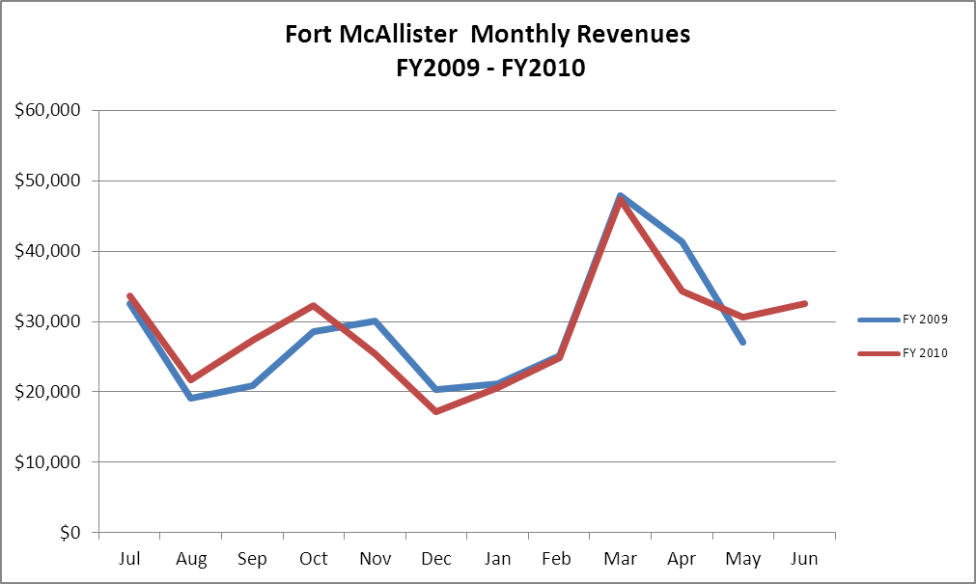

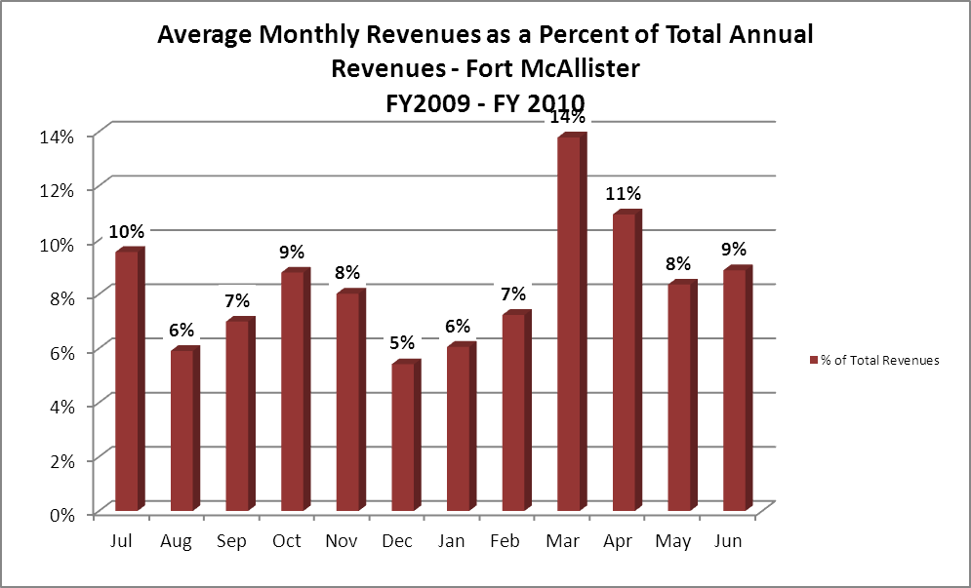
Cost Recovery Trends
Fort McAllister has achieved an average cost recovery of 90% of annual operational expense through earned revenues from FY 2008 to FY 2010. This is detailed and illustrated in the table and graph below. Cost going up due to energy increase and parks absorbing cost beforehand picked up by other sources.
Year | Operational  Expenses | Earned  Revenues | Percent Cost  Recovery
2008 | $427,888 | $349,808 | 82%
2009 | $350,998 | $343,309 | 98%
2010 | $381,016 | $347,749 | 91%

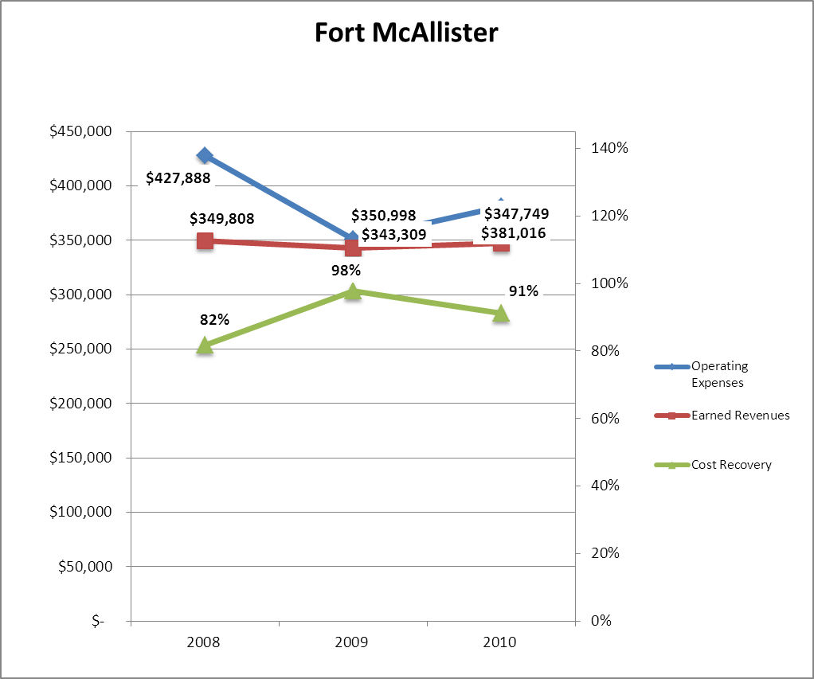

Review of Pricing
Data on rate information is available as far back as 2002, but only the last five years are evaluated. There has been notable growth in fees charged at Fort McAllister since 2005, with the largest increase being $1.00. A table detailing the rates for Fort McAllister is provided below.

 | 2005 | 2006 | 2007 | 2008 | 2009 | 2010 | Comments
Fort McAllister
Adults |  |  |  | $5.50 | $5.50 | $6.50
Seniors |  |  |  | $5.00 | $5.00 | $6.00
Adult Groups |  |  |  | $4.00 | $4.00 | $4.00
Youth (6 - 17) |  |  |  | $3.50 | $3.50 | $3.75
Youth Groups (6 - 17) |  |  |  | $3.00 | $3.00 | $3.00
Child/Groups (Under 6) |  |  |  | $1.00 | $1.00 | $1.00
Business and Management Plan

Business Goals
The following goals serve as the foundation for the key recommendations and strategies in this business plan for Fort McAllister.

Enhance Cost Recovery of Site Operations
Increase the number of paid events, rental equipment, daily programs and after hour rentals of non-traditional facilities for events such as weddings, receptions, birthday parties, and murder mystery dinners.

Enhance Revenue Generation Strategies
Since increased services mean more revenue, they also produce a higher cost in personnel costs. We would need to depend more on volunteers and donated help. By bringing more visitors and by branching out our outreach programming, we will increase revenue. Expanding our gift shop would be an easy way to increase revenue without any extra staffing. Charging for services such as nature tours, weddings and after hours events will help increase revenue.

Expand Special Events at the Site
We already do an average of 10 special events each year, but we could add Friends of Fort McAllister sponsored events such as the Labor Day Celebration; introduce new special events such as dinner and a concert on the grounds, bunk in the fort overnight, etc.; and rent out the museum and or historic site for after hour functions.

Improve the Diversity and Innovation of Recreational and Interpretive Programs
Develop new programs that focus on family activities such as overnight campouts, camp fire without the hassle program, crabbing and fishing rodeos, overnight canoe or trail hike camping trips and host night in the museum. Set up dinner and a tour night time programs at the fort to attract couples for a Civil War dinner and then a moonlight tour of the fort. Develop new exhibits that deal with other topics besides the Civil War that would attract a more diverse audience. Develop a monthly lecture series dealing with both historical and natural topics. Add rental bikes and pedal cars. Take advantage of the Coastal Birding Trail and star gazing skies. Provide nature walks and marsh eco programs.

Improve the Effectiveness of Marketing and Sales
This has always been hard to carry out due to lack of funding at the site level. There is a great need for promotional items that are branded to each site to be used as give-a -ways.

Establish Greater Consistency of Managing and Monitoring Customer Service & Satisfaction
Our goal is to provide every visitor with some positive contact with a site staff member, if just a “hello, how is your day?” We will keep our facilities clean and in good repair. The visitor’s experience is very important and we will strive for at least an 85% enjoyment rating.

Expand Partnership Opportunities
By becoming involved with local chambers and tourism councils we can jointly plan and promote events and services. We will piggy back on publicity and promotions from these organizations and offer our services where possible. By allowing outside concessionaires to operate services on our site, we gain a percentage of their revenue, publicity and an increase in visitor services.

Classification of Programs and Service
The tables below summarize the classifications of programs and services at Fort McAllister as either core, important, or visitor supported and projects a range of cost recovery percentages that might be achieved for each. These classifications establish financial performance goals for each category of services that are linked to the recommendations and strategies of this business plan.

Core Services
Program / Service | Target Cost Recovery
Law enforcement and 24-hour public safety | 0%
Cultural and natural artifact and resource management, including the historic earthen fort | 0%
Open and public access to the site and its resources | 60%
Site oriented programs, exhibits, educational materials and recreational opportunities | 65%
Research files and library available to the visitors | 0%
Facility maintenance, grounds maintenance and infrastructure upkeep | 0%

Important Services
Program / Service | Target Cost Recovery
Educational programs, geo caching and self-guided tours | 105%
Facilitation of historical and natural researchers | 45 to 85%

Visitor Supported
Program / Service | Target Cost Recovery
Camping, shelter rental, canoe rentals and gift shop and historic fort | 115%
Guided tours of museum and canoe trips | 110%
Special events and programming | 115%

Partnership Development Plan
The table below summarizes existing partners and targeted partnerships by classification (operational, vendor, service, co-branding, funding partners) and by organizational type.
 | Public Partners | Not-for-profit Partners | Private / Enterprise Partners
Operational Partners |  | - National Park Service | - Charter fishing guides, kayak guided tours and pontoon boat tours
Vendor Partners |  |  | - Georgia EMC  - Coca Cola
Service Partners |  | - Chamber of Commerce  - Colonial Coast Travel Association
Co-branding Partners |  | - Georgia Tourism Council  - Civil War Preservation Trust
Funding Resource Development Partner |  | - Friends of Fort McAllister

Marketing and Sales Plan

Marketing and Sales Goals
Marketing and sales goals for Fort McAllister are based on the following desired outcomes:
- To be able to sustain and beyond by increase revenue.
- To reach more people with our special events, programs and educational endeavors.
- To see park/site use increase by 30% above present.
In order to meet these goals, examples of specific target outcomes were identified in the areas detailed in the table below.
Area  of Focus | Current  Performance | Goal  by 2011 | Goal  by 2012 | Goal  By 2015
Visitation | 120,000 | 145,000 | 170,000 | 174,792
Special Events | 10,000 | 25,000 | 30,000 | 50,000

Marketing and Promotion Strategies

Publicity and Social Media
Fort McAllister will approach marketing and publicity planning using the following guidelines and themes:
- Event publicity
Major events benefit by having short stories in local, regional, and statewide newspapers and online social media hooks planted that run three to four weeks in advance of the event up to the date of the event itself. Stories and media need to be cultivated with contacts and online sales channels several weeks in advance of the time the stories need to run. Special interest interviews on morning, noon, and evening television news programs, radio interviews on popular rush-hour programs, and blogs on known affinity online sites should also be included.
- Program publicity
Special and unique programs should have feature stories in magazines, local and regional weekly newspapers, and statewide daily newspapers that are aimed at placements as front-page or sectional front-page stories. These stories are most effective if they run shortly before the season that the featured program begins. This will likely require several weeks of advanced planning with media contacts. Similar coverage on television and radio should also be considered. If pre-publicity cannot be generated, post-publicity can help promote future programs.
- Site Publicity
Site publicity focusing on a single site or sub-set of sites requires more intense planning efforts to attract multiple writers and editors from target publications. Each site could host several seasonal media familiarization tours (with 10 to 15 writers or editors) to familiarize them with the site and its benefits and amenities. Stories and features resulting from such tours typically take between two and six months to materialize so the tours should focus on experiences, benefits, and programs that would be available when the stories are expected to run.
Examples and suggested opportunities for events, programs and related publicity efforts based on the themes described above at Fort McAllister are provided in the table below.
Event Publicity | Program Publicity | Site Publicity
Annual Winter Battle | Junior Ranger Camp | CW Commemoration
Labor Day Festival | Candle Lantern Tour | Bunk in the Bunker
Fourth of July Old Fashion Games | CW volunteer workday | CW Historic Trail of Sherman’s march from Atlanta to the coast.
Memorial Day Celebration of Freedom | Canoeing the salt marsh | State Historic Marker Program

Packaging
Examples and suggested packages for Fort McAllister are provided in the table below.
Package | Package Details
State wide Geo Caching | Every park and site takes part
CW Heritage Driving Trail | Produce a check off brochure to gather information of all historic civil war sites on Sherman’s march to the sea
One Day Trips | Set up trips between sites along the coast that provide discounts if several are visited. Example from Savannah to Brunswick in one day

Group Sales
Types of groups within which specific target customers can be identified for Fort McAllister are listed below:
- CW history groups  - Active duty military and families  - Art organizations | - School groups  - Community organizations  - Coastal Tourist | - Camping clubs  - Churches  - Canoe clubs

Incentivizing New and Repeat Visitation
Fort McAllister will utilize the following strategies and/or incentives to encourage new and repeat visitation starting in FY 2012:
- Discounts
- Conduct more eco-friendly programs, recycling programs, star gazing programs, leave no trace and project wild programs
- Group tour packages
- Camping Club discounts
- Add new recreational activities to draw in canoeists, hikers and trail bikers
- Host local kayaking and fishing clubs tournaments
- Allow overnight use of Fort and Museum

Marketing and Sales Metric Goals
The following marketing and sales metric goals and/or others will be monitored and progress reported at Fort McAllister:
- Loyalty and repeat customers = 75%
- Brand confidence & customers-recruiting-customers = 35%
Revenue Generation Plan
Revenue / Cost Recovery Goals
Fort McAllister has set a financial goal of increasing annual revenues 3% annually between 2012 and 2015. The largest revenue growth opportunity is most likely August, September and October. The table below details projected revenue growth leading up to 2015, based upon a nominal growth of revenues each year.

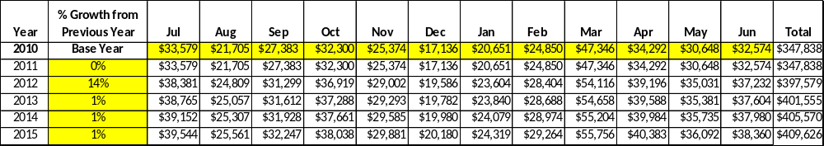

These projections would result in a total of 17 % cumulative growth in total annual revenues between FY2010 and FY2015. If operational expenses can be managed with a cumulative increase of 6% between FY 2010 and FY 2015, then the overall cost recovery of the site will be approximately 99% in FY 2015 at these projected revenue levels. This is higher than the annual financial performance of the site in FY 2010, which was operated at 91% cost recovery in that year.

Revenue Generation Strategies

Pricing Plan
2010 Park Reservables (as of 4-1-10)
Region | PARK RESERVABLES | Current Pricing (CY 2011) | Proposed Pricing  (CY 2012) | Positive Yield Management Margin (%)
H | FT. MCALLISTER | $6.50 | $6.50 | 10%
 | Picnic Shelter | $40 | $40 | 10%
 | Group Shelter (capacity) | $205(150) | $205 | 10%
 | Camping (RV/Tent) | $28/25 | $28/25 | 10%
 | Camping - Back Country | $9 pp | $10 pp | 11%
 | Cottage (2 BR) | $125 | $140 | 89%
 | Pioneer Campsite | $45 | $50 | 90%

Innovative Programming and Special Events Plan
Program / Event | Theme / Purpose | Scheduled Date/Season | Frequency | Target Participation | Target User Fee | Target Cost Recovery
Bunk in Bunker | Historical/Recreational | Jan.-Dec. | Once per month | 20 | 15.00 | 150%
Labor Day Festival | Historical/Recreational | August | Once per year | 500 | 5.00 | 110%
Canoe Campout | Recreational | Spring/Fall | Twice per year | 20 | 20.00 | 125%
Candle Lantern Tour | Historical | October | Once per year | 300 | 5.00 | 150%
Rent the Museum | Recreational/Social | Jan.-Dec. | 12 times per year | 100 | 300.00 | 150%
Lecture Series | Historical | Jan.-Dec. | 12 times per year | 40 | 5.00 | 150%

Partnerships and Concessions Plan
Service / Partnership | Term of Service | Financial Objective | Contract Manager
Canoe Trips Concessions | 1 years | 15% of gross receipts to park | Park Manager
Contract out grass cutting | 2 years | Reduce personnel costs | Park Manager
Packaging and promotions with local business | 2 years | Shared revenue | Regional Manager

Expense Management Plan
Personnel Assignments
The following actions will be taken to proactively manage labor costs via personnel assignments and classifications.

Action | Timeline | Outcome
Eliminate Desk Clerk Vacancy and staff front desk with hosts. | July 2012 | Saving $ 18,000

Management Techniques
The following actions will be taken to proactively manage labor costs via management techniques.

Action | Timeline | Outcome
Use of volunteers to cut grass etc… | July 2012 | Cost reduction
Use volunteers for programming | July 2012 | Cost reduction
Use volunteers for campground upkeep | July 2012 | Cost Reduction

Adjusted Levels of Service
The following actions will be taken to proactively manage labor costs via reduced levels of service.

Action | Timeline | Outcome
Reduce grass cutting to every other week | July 2012 | $3,000 Saved for year

Financial Pro Forma
The following five-year financial pro forma projects operating expenses, earned revenues and cost recovery through FY 2015. These pro forma are based on the strategies and desired outcomes identified in this business plan, especially the revenue generation and expense management plans, and are linked to corresponding performance goals.
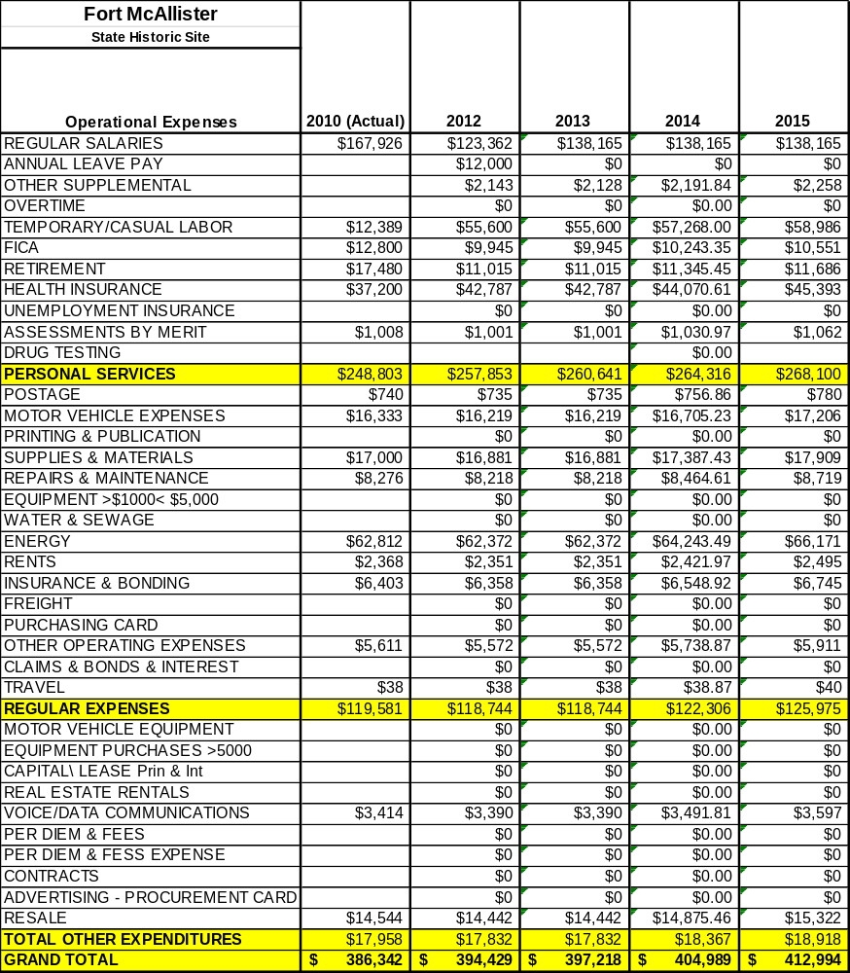
Expense Pro Forma

Revenue Pro Forma
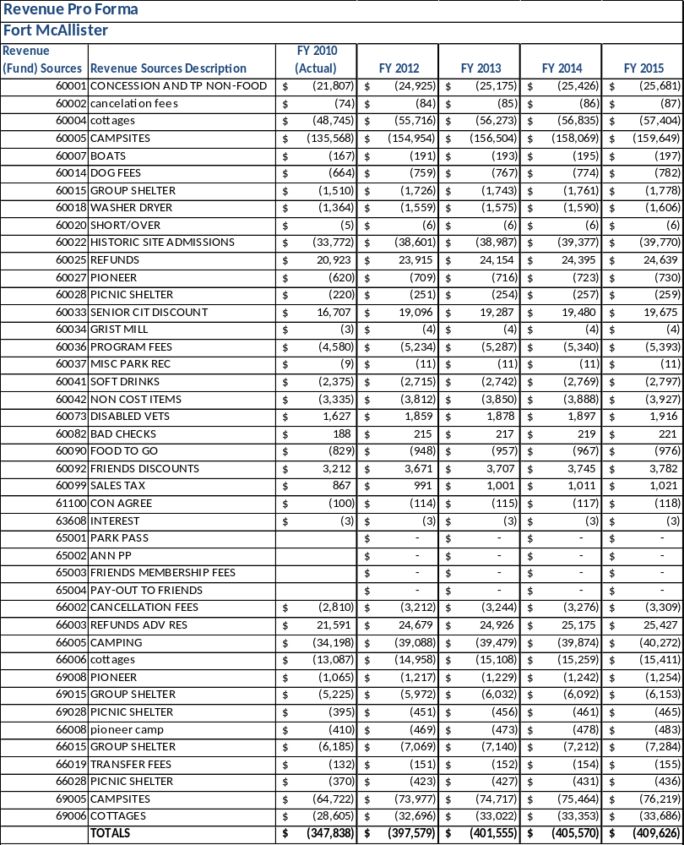

Total / Cost Recovery Pro Forma

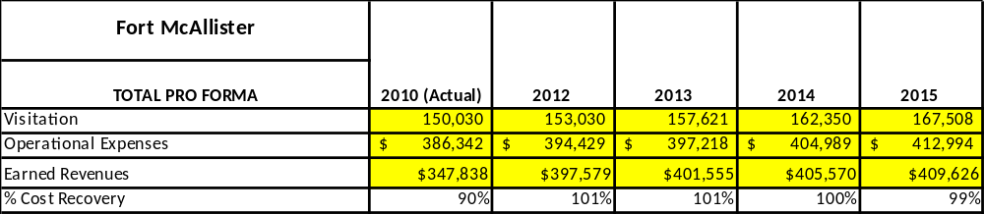

Action Plan
ACTION PLAN
Site: |  | Site Manager: |  |  | Date:
Month:
Strategy | Tasks | Costs / Funding | Revenues / ROI | Responsibilities | Metrics

ACTION PLAN
Site: |  | Site Manager: |  |  | Date:
Month:
Strategy | Tasks | Costs / Funding | Revenues / ROI | Responsibilities | Metrics

This is the average of the last three years – FY 2008, FY 2009, and FY 2010
Current employees, not including vacancies.
Current employees, not including vacancies.
Major population centers within a two-hour drive from the site

