FORT MORRIS HISTORIC SITE
Business & Management Plan
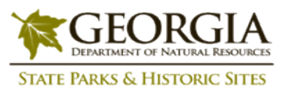
Prepared June 2011; Finalized January 2013
Direction 2015 – Sustainable Business Planning

Table of Contents

Executive Summary 3

Site and Operations Assessment 6
Site Inventory and Facility Assessment 6
Operational Assessment 8
Financial Performance Assessment 13

Business and Management Plan 16
Business Goals 16
Classification of Programs and Services 17
Partnership Development Plan 18
Marketing and Sales Plan 19
Revenue Generation Plan 21
Expense Management Plan 23
Financial Pro Forma 24

Action Plan 27

Executive Summary
The Parks, Recreation and Historic Sites Division (PRHSD) of the Georgia Department of Natural Resources (DNR) is transitioning the management of Fort Morris State Historic Site to operate more like a business, reflecting the Direction 2015 – Sustainable Business Planning initiative to improve the fiscal performance and management of the state parks and historic sites system. This business and management plan is designed to help the site recover more operating expenses through earned revenues, productive partnerships, and innovative programs.

Site Fact Sheet
Site Name | Fort Morris State Historic Site
Site Manager | Arthur Edgar
Region Manager | Tommy Turk
Date of Business Plan completion | June 13, 2001
Site size | 56 acres
Total number of visitors (FY 2010) | 8,364
Total operating budget (FY 2010) | $ 71,979
Total earned revenues (FY 2010) | $ 12,298
Operational cost recovery (FY 2010) | 17%
Average operating cost per visitor (FY 2010) | $ 8.61
Average earned revenue per visitor (FY 2010) | $ 1.47
Average cost recovery (FY 2008 – 2010) | 15%
Target cost recovery (FY 2015) | 20%
Total full-time employees | 1
Total part-time employees | 0
Primary service markets | Savannah, Hinesville, Brunswick and Hilton Head SC
Primary attractors/visitor appeal factors | Historic Revolutionary War / War of 1812 fort, picnicking, nature trail
Leading opportunities for improved site performance | Improved interpretive opportunities

Site Summary and Key Attractions
Fort Morris State Historic Site is made up of 56 acres, roughly 35 miles from downtown Savannah, Georgia. It is located 7 miles east of I-95 at exit 76 in Sunbury, Georgia.

Key Attractions
The amenities or features listed below are those that seem to be most popular for visitors.
- Revolutionary War and War of 1812 Fort Site and special events
- Historic Site Museum , Exhibits, Artifacts and Gift Shop
- Nature Trail

Financial Targets
The table below details the total operating expenses and earned revenues for Fort Morris over the last three years (2008 – 2010). This table also calculates total cost per visitor and revenues per visitor during these operating years, and details the target financial performance goals in the context of achieving at least 20% cost recovery. This table also calculates the necessary change from 2010 operating expenses and revenues.

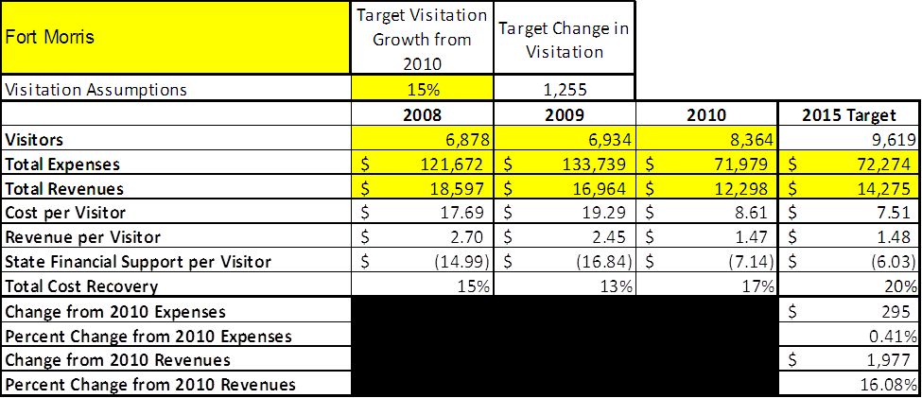

Key Recommendations

Primary / Short Term Recommendations
- Renovate 1970s era museum to more current curatorial and exhibit standards, with improved visitor interaction and appropriate artifact displays of recent discoveries.
- Install boardwalk overlook within earthworks to enhance visitor experience and earthwork protection.
- Operate the site using cost-based accounting, including the net cost recovery achieved annually.
- Strive for a 90% visitor comment card use with a satisfied or very satisfied level of comments. Find a way to track zip codes of visitors to better serve their needs by using demographic information.
- Conduct at least 9 special events/programs per year.
- Open the museum and fort for after hours private functions.
- Seek and enhance local partnerships to help support operations, programs and service delivery and for cross marketing purposes. Enhance use of Friends of Fort Morris for events and support. Get involved with local chambers and tourism organizations.
- Operate the site according to well-defined maintenance, program and operational standards. Keep a close eye on the site’s infrastructure to ensure a smooth running operation.
- Perform a thorough net cost-of-service analysis on major functions of site operations, including the detailed analysis of labor, by task, which has already been produced by site staff. Thereafter, update costs to deliver services on a biennial schedule.

Secondary / Long Term Recommendations
- Complete the archaeological study of the site to uncover as much as the site’s story as possible in order to better educate the public.
- Enhance the earthworks with a historic reconstruction of fort features including the sally port gate, wood bridge, and cannon emplacement with replica cannon.
- Improve the resale area and enhance the resale products.
- Produce a new site film.
- Acquire adjacent Sunbury property if it becomes available.

Site and Operations Assessment
This site and operations assessment is a culmination of analyses and findings from a review of the condition of facilities, infrastructure, and operations at Fort Morris. The findings and observations are not intended to be an exhaustive review of all issues present, but provide a basic understanding of the predominant issues that contribute to the site’s current operating conditions. The assessment includes the following:
- Site Inventory and Facility Assessment
- Operational Assessment
- Financial Assessment
Site Inventory and Facility Assessment

Methodology
Facility and asset conditions are rated using a differential scale of excellent, good, fair, or poor. Descriptions of conditions that are attributed to each of these findings are also provided.
Scale of Conditions
Rating | General Description
Excellent | Facilities/amenities are in ‘excellent’ condition when they show little or no maintenance or repair problems. Facilities do not feature any major design or operational issues or flaws that contribute to diminished use or increased maintenance or upkeep. Facilities are easy to clean and maintain in order to place them back into public use and the users perceive them to be in excellent shape.
Good | Facilities/amenities are in ‘good’ condition when they show only minor maintenance or repair problems. Most maintenance issues with these facilities typically appear to be the result of age and/or heavy use. Facilities may only feature minor design or operational issues that contribute to diminished use or increased maintenance or upkeep. Facilities are moderately easy to clean and maintain in order to place them back into service and the users perceive them to be adequate for their use, but probably not in excellent shape.
Fair | Facilities/amenities are in ‘fair’ condition when they show significant maintenance or repair problems. Facilities generally exhibit ongoing maintenance issues that appear to be the result of age, heavy use, or design or operational flaws. Some maintenance and repair needs may compound their fair condition by being deferred because of budget and/or resource limitations. Facilities require more effort to clean and maintain before placing them back into service and the users may perceive them as being less than adequate for their use and in a state of deterioration. The facility or structure may need of major repair or replacement.
Poor | Facilities/amenities are in ‘poor’ condition when they show significant, on-going maintenance or repair problems that ultimately may result in suspended use for repair/replacement. Maintenance and repair issues are possibly the result of poor maintenance and clearly the result of age, heavy use, or design or operational flaws. Problems with the facilities are often compounded over time due to consistently-deferred maintenance and repair because of budget and/or resource limitations. Facilities may feature major design or operational issues that contribute to diminished use or increased maintenance or upkeep. Facilities require excessive effort to clean and maintain before placing them back into service and the users often perceive them as being inadequate for their use and in a state of serious deterioration. The facility or structure may need of major repair or replacement.

Inventory and Assessment
The table below is an inventory of facilities and amenities at Fort Morris, and provides the assessed condition of each as reviewed in May 2011.

Site Asset / Amenity | Quantity | Condition
Total acreage | 56 | Good
Visitor Center/Museum | 1 | Fair  G
Earthen Fort | 1 | Fair grass coverage
Picnic Area | 1 | Fair
Primitive Camp | 1 | Fair
Nature Trail | 1 | Good
Manager’s Residence | 1 | Good

Prioritized Facility Needs
Based on the facility inventory and assessment, these prioritized needs have been identified. Each need has been aligned with a priority category of high, moderate, or low to support future decision making regarding project sequencing, investment of public resources, and meeting community expectations. The priority assignment for each need is not a measure of importance. Rather, these recommended priorities reflect a phased implementation approach over the next several years.

Facility Need | Priority Assignment
Complete Museum Exhibit Upgrade | High
Earthwork Boardwalk and Overlook | High
Continue Archaeology | High
Historic Reconstruction of Fort Features | Medium

Operational Assessment
The Operational Assessment includes:
- An inventory and classification of programs and services being provided at the site
- A review of staffing at the site
- A review of concessionaires and partners operating at the site
- Visitation and customer satisfaction

Inventory and Classification of Programs and Services
Programs and services are classified into one of three major categories:
1) Core or Essential Services
2) Important Services
3) Visitor Supported Services
Programs and services at the site are classified into these categories based in part on the mission and public mandates for both the site and the agency. For the programs and services in each of these categories, there are financial performance expectations that will define how services are funded and evaluated.

Category 1 – Core Services [Largely supported by tax funds]
Core programs, services and facilities are those the agency must provide and/or are essential in order to capably govern and meet statutory requirements. The failure of the agency to provide Category 1 services at adequate levels could result in significant negative consequences for the public and the resources under protection. The criteria for programs or services to be classified as core or essential are:
- The services are mandated by the agency’s law or charter or are contractually obligated by agreement to provide the services.
- The services are essential to protecting and supporting the public’s health and safety.
- The services protect and maintain valuable assets and infrastructure.
- The services would generally and reasonably be expected and supported by residents, businesses, customers and partners.
- The services are those that cannot or should not be provided by the private sector.
- The services provide a sound investment of public funds.
The following programs and services offered at Fort Morris have been identified as core services:
- Management and protection of cultural and natural resources, including but not limited to the historic earthen fort
- Artifact conservation and management
- Open and public access to the site and its resources
- Public and facility safety
- Facility maintenance, grounds maintenance and infrastructure upkeep
- Facilitation of historical and natural researchers

Category 2 – Important Services [Supported by a balance of tax funds and earned revenues]
Important programs, services and facilities are those the agency should provide, and are important to governing and effectively serving residents, businesses, customers and partners. Providing Category 2 services expands or enhances the agency’s ability to provide and sustain its core services. The criteria for programs or services to be classified as important are:
- The services expand, enhance or support identified core services.
- The services are broadly supported and utilized by the community, and are considered an appropriate, important, and valuable public good. Public support may be conditional upon the manner by which the services are paid for or funded.
- The services generate income or revenue that offsets some or all of the operating cost and/or are deemed to provide economic, social or environmental outcomes or results.
The following programs and services offered at Fort Morris have been identified as important services:
- Educational programs, geo-caching and self-guided tours
- Site oriented programs, exhibits, educational materials and recreational options

Category 3 – Visitor Supported Services [Almost exclusively supported by earned revenue]
Visitor supported programs, services and facilities are those discretionary services that the agency may provide when additional funding or revenue exists to offset the cost of providing those services. Category 3 services provide added value above and beyond what is required or expected. The criteria for programs or services to be classified as visitor supported are:
- The services expand, enhance or support core services or important services and the quality of life of the visitors, community or stakeholders.
- The services are supported, valued and well utilized and provide an appropriate and valuable public benefit.
- The services generate income or funding from sponsorships, grants, user fees or other sources that offset some or all of their cost and/or provides a meaningful return on investment.

- The services can possibly be provided through outsourcing or use of concessionaires, providing opportunities for community enterprises that may not otherwise be provided by the agency.

The following programs and services offered at Fort Morris have been identified as visitor supported services:
- Primitive camping
- Special events and programming
- Historic Fort
- Gift shop

Staffing Assessment
Labor costs at Fort Morris represent the largest area of budgetary expense at an average of 60% of the total operating budget each year for the last three complete years, which is (lower) than the target of total labor costs (including benefits) not exceeding 65% of the site’s total operating expenditures. The tables below and on the following page provide a basic review of the current staffing at the site.
Full Time Equivalent Employees
Position / Title | Quantity (FTE) | Vacancies | Annual Hours
Historic Site Manager 1 | 1 | 0 | 2600
TOTAL | 1 | 0 | 2,600

Part Time Employees
Position / Title | Quantity (FTE) | Vacancies | Hours
None | 0 | 0 | 0
TOTAL | 0 | 0 | 0

Labor Support
Labor Support | Annual Hours
Volunteers | 1500
Community Service Workers | 0
Engineering and Construction Crews | 100
Resource Management Crews | 0
TOTAL | 1,600

Total Labor Hours
Labor Type | Annual Hours
Full Time Equivalent Employees | 2,600
Part Time Employees | 0
Labor Support | 1,600
TOTAL Annual Labor Hours | 4200

Labor Budget Summary

 | Fort Morris
 |  | 2008 | 2009 | 2010 | % Change
 | Account Code and Sub-Class | Year End | Year End | Year End | from
 | Expenditure Descriptions | Expenses | Expenses | Expenses | 2008
 | REGULAR SALARIES | $82,023 | $82,023 | 35,457 | -57%
 | ANNUAL LEAVE PAY | $1 | $1 | 1 | 0%
 | OTHER SUPPLEMENTAL | $1 | $1 | 1 | 0%
 | TEMPORARY/CASUAL LABOR | $1 | $1 | 1 | 0%
 | FICA | $6,275 | $6,275 | 2,712 | -57%
 | RETIREMENT | $8,539 | $8,539 | 3,691 | -57%
 | HEALTH INSURANCE | $18,181 | $18,181 | 7,859 | -57%
 | UNEMPLOYMENT INSURANCE | $1 | $1 | 1 | 0%
 | ASSESSMENTS BY MERIT | $441 | $441 | 137 | -69%
 | PERSONAL SERVICES | 115,463 | 115,463 | 49,860 | -57%

Labor Budget Summary

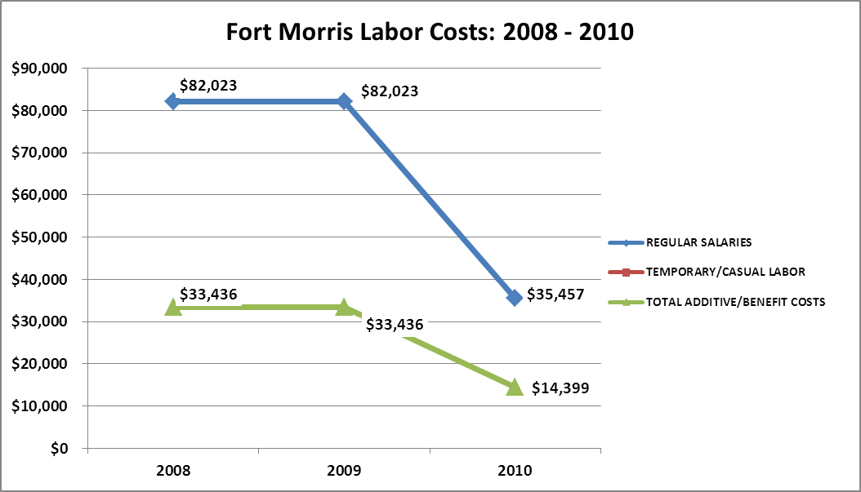

Visitation
Overall annual visitation to the site has trended downward from 2008 to 2010, decreasing by 15% or over 1,000 visitors. This is largely attributed to decreased hours of operations.

Year | Total Visitation
2008 | 6,878
2009 | 6,934
2010 | 8,364

Financial Performance Assessment

Operational Expenses
A summary of total operating expenses at Fort Morris from 2008 to 2010, as well as their percent change from 2008 are provided in the table below.

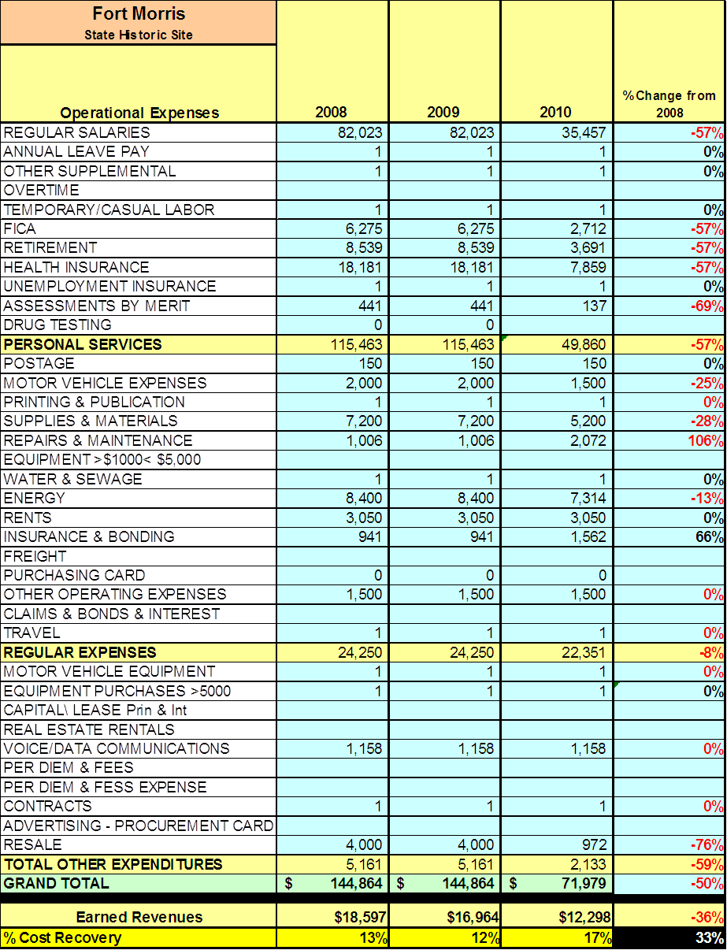

Earned Revenues
Earned revenues at Fort Morris have decreased since 2008, which is largely attributed to the corresponding decrease in hours of operations.
FY 2009 - FY 2010 Monthly Revenue
 | Jul | Aug | Sep | Oct | Nov | Dec | Jan | Feb | Mar | Apr | May | Jun | Total
FY 2009 | $2,242 | $853 | $744 | $1,058 | $2,639 | $968 | $1,211 | $2,449 | $1,717 | $2,015 | $1,762 | $1,151 | $18,809
FY 2010 | $2,237 | $768 | $1,144 | $984 | $2,026 | $1,065 | $532 | $782 | $530 | $1,000 | $1,246 | $1,252 | $12,298
Average | $2,240 | $811 | $944 | $1,021 | $2,333 | $1,017 | $872 | $1,616 | $1,124 | $1,508 | $1,504 | $1,202 | $15,554
% of Total Revenue | 14% | 5% | 6% | 7% | 15% | 7% | 6% | 10% | 7% | 10% | 10% | 8% | 100%
% Change | 0% | -10% | 54% | -7% | -23% | 10% | -56% | -68% | -69% | -50% | -29% | 9% | -35%
The graphs below illustrate the monthly revenue trends each year and the average percent of total annual revenue earned each month.
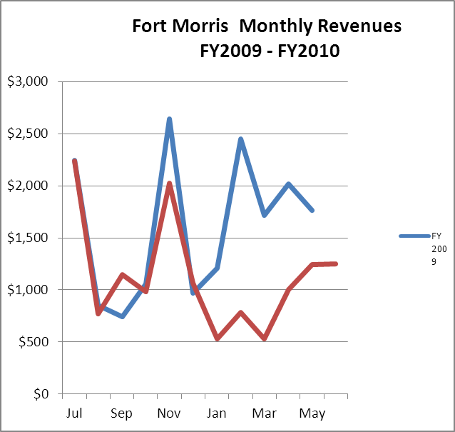

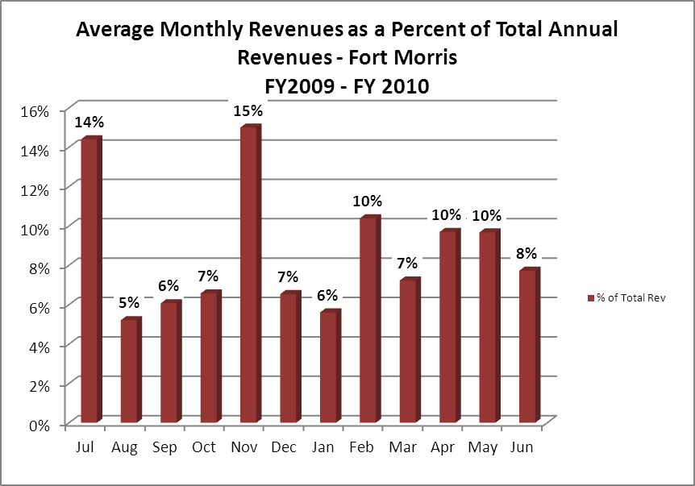

Cost Recovery Trends
Fort Morris has achieved an average cost recovery of 14% of annual operational expenses through earned revenues from FY 2008 to FY 2010. This is detailed and illustrated in the table and graph below.

Year | Operational  Expenses | Earned  Revenues | Percent Cost  Recovery
2008 | $144,864 | $18,597 | 13%
2009 | $144,864 | $16,964 | 12%
2010 | $71,979 | $12,298 | 17%
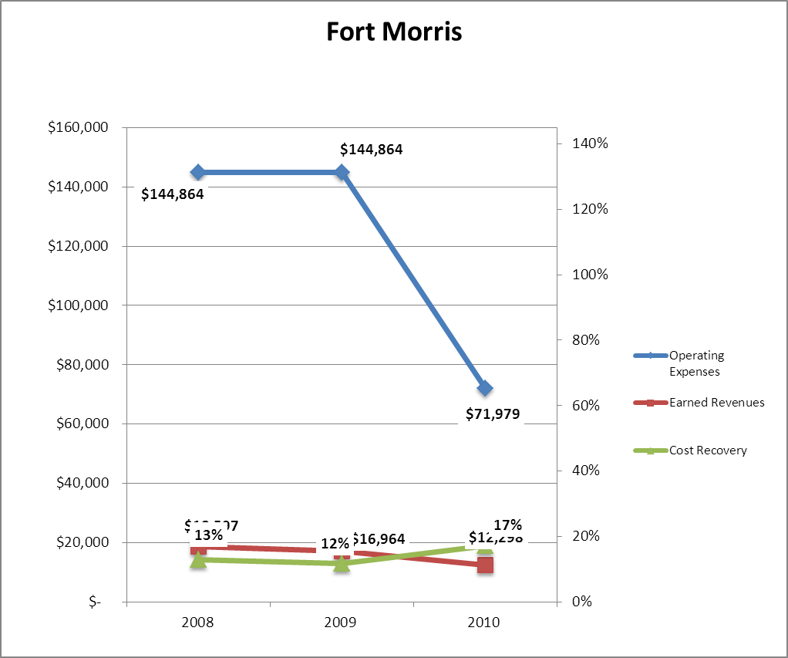

Review of Pricing
Data on rate information is available as far back as 2002, but only the last five years are evaluated. There has been notable growth in fees charged at Fort Morris since 2005, with the largest increase being $1.00. A table detailing the rates for Fort Morris is provided below.

 | 2008 | 2009 | 2010
Fort Morris
Adults | $3.50 | $4.00 | $4.00
Seniors | $3.00 | $3.50 | $3.50
Adult Groups | $2.50 | $3.25 | $3.25
Youth (6 - 17) | $2.50 | $2.75 | $2.75
Youth Groups (6 - 17) | $1.50 | $2.50 | $2.50
Child/Groups (Under 6) | $0.75 | $1.00 | $1.00

Business and Management Plan

Business Goals
The following goals serve as the foundation for the key recommendations and strategies in this business plan for Fort Morris.

Enhance Cost Recovery of Site Operations
Increase admission rates and work to attract more visitors through paid events and after hour rentals of non-traditional facilities.

Enhance Revenue Generation Strategies
By bringing more visitors and by branching out our outreach programming types, we will increase revenue. Expanding our gift shop would be an easy way to increase revenue without any extra staffing. Charging for services such as weddings, birthday parties and after hours events will help increase revenue.

Expand Special Events at the Site
Introduce new special events such as lectures and rent out the museum for after hour functions.

Improve the Diversity and Innovation of Recreational Activities
Encourage scout troops to use the primitive camping area and offer birding programs.

Improve the Effectiveness of Marketing and Sales
Increase marketing to the Savannah area to better reach the heritage tourism market.
Establish Greater Consistency of Managing and Monitoring Customer Service & Satisfaction
Our goal is to provide every visitor with some positive contact with a site staff member if just a “hello, how is your day?” We will keep our facilities clean and in good repair. The visitor’s experience is very important and we will strive for at least an 85% enjoyment rating.

Expand Partnership Opportunities
By becoming involved with local chambers and tourism councils we can jointly plan and promote events and services. We will piggyback on publicity and promotions from these organizations and offer our services where possible.

Classification of Programs and Services
The tables below summarize the classifications of programs and services at Fort Morris as either core, important, or visitor supported and projects a range of cost recovery percentages that might be achieved for each. These classifications establish financial performance goals for each category of services that are linked to the recommendations and strategies of this business plan.

Core Services
Program / Service | Target Cost Recovery
Management and protection of cultural and natural resources, including but not limited to the historic earthen fort | 0%
Artifact conservation and management | 0%
Open public access to the resource | 20%
Public and facility safety | 0%
Facility, ground and infrastructure maintenance | 0%
Facilitation of historical and natural researchers | 20%

Important Services
Program / Service | Target Cost Recovery
Educational programs, geo-caching and self-guided tours | 20%
Site oriented programs, exhibits, educational materials and recreational options | 20%

Visitor Supported
Program / Service | Target Cost Recovery
Primitive Camping | 100%
Special events and programming | 25%
Historic Fort | 25%
Gift Shop | 140%

Partnership Development Plan
The table below summarizes existing partners and targeted partnerships by classification (operational, vendor, service, co-branding, funding partners) and by organizational type.

 | Public Partners | Not-for-profit Partners | Private / Enterprise Partners
Operational Partners | - Ft. McAllister State Historic Site | - City of Flemington
Vendor Partners |  |  | - Georgia EMC  - Coca Cola  - Target Distribution Center
Service Partners |  | - Chamber of Commerce  - Colonial Coast Travel Association
Co-branding Partners |  | - Georgia Tourism Council  - Mellon Bluff Nature Center  - Midway Museum  - Seabrook Village
Funding Resource Development Partner | - Region 2 Historic Sites | - Friends of Ft Morris

Marketing and Sales Plan

Marketing and Sales Goals
Marketing and sales goals for Fort Morris are based on the following desired outcomes:
- To be able to sustain and beyond by increase revenue.
- To reach more people with our special events, programs and educational endeavors.
- To see park/site use increase by 20% above present.
In order to meet these goals, examples of specific target outcomes were identified in the areas detailed in the table below.

Area  of Focus | Current  Performance | Goal  by 2011 | Goal  by 2012 | Goal  by 2015
Visitation | 5,809 | 6,390 | 7,029 | 9,619
Special Events | 1,162 | 1,400 | 1,680 | 2,000

Marketing and Promotion Strategies

Publicity and Social Media
Fort Morris will approach marketing and publicity planning using the following guidelines and themes:
- Event publicity
Media needs to be cultivated with contacts several weeks in advance of a special event. Special interest interviews on morning, noon, and evening television news programs, radio interviews on popular rush-hour programs and social media could also be included.
- Program publicity
Special and unique programs should have feature stories in magazines, local and regional weekly newspapers, and statewide daily newspapers that are aimed at placements as front-page or sectional front-page stories. These stories are most effective if they run shortly before the season that the featured program begins. This will likely require several weeks of advanced planning with media contacts. Similar coverage on television and radio should also be considered. If pre-publicity cannot be generated, post-publicity can help promote future programs.
- Site Publicity
Site publicity focusing on a single site or sub-set of sites requires more intense planning efforts to attract multiple writers and editors from target publications. Each site could host several seasonal media familiarization tours (with 10 to 15 writers or editors) to familiarize them with the site and its benefits and amenities. Stories and features resulting from such tours typically take between two and six months to materialize so the tours should focus on experiences, benefits, and programs that would be available when the stories are expected to run.

Examples and suggested opportunities for events, programs and related publicity efforts based on the themes described above at Fort Morris are provided in the table below.

Event Publicity | Program Publicity | Site Publicity
Revolutionary War Event | Junior Ranger Camp | State Historic Marker Program
Labor Day Commemoration | Colonial Christmas
Independence Day Colonial Faire | Volunteer Workday
Memorial Day Commemoration

Packaging
Examples and suggested packages for Fort McAllister are provided in the table below.

Package | Package Details
Statewide Geo-Caching | Every park and site takes part
Colonial Coast Birding Trail | Produce a check off brochure to gather information on birds
One Day Trips | Set up trips between fort sites along the coast that provides discounts if several are visited. Example Find Fun at the Forts.

Group Sales
Types of groups within which specific target customers can be identified for Fort Morris are listed below:
- Revolutionary War history groups  - Active duty military and families | - School groups  - Community organizations  - Coastal Tourist | - Scout groups  - Church groups

Incentivizing New and Repeat Visitation
Fort Morris will utilize the following strategies and/or incentives to encourage new and repeat visitation starting in FY 2012:
- Discounts
- Group tour packages
- Allow overnight use of site and Museum.

Marketing and Sales Metric Goals
The following marketing and sales metric goals and/or others will be monitored and progress reported at Fort Morris:
- Loyalty and repeat customers = 20%
- Brand confidence & customers-recruiting-customers =20%
Revenue Generation Plan
Revenue / Cost Recovery Goals
Fort Morris has set a financial goal of increasing annual revenues 3% annually between 2012 and 2015. The largest revenue growth opportunity is most likely August, September and October. The table below details projected revenue growth leading up to 2015, based upon a nominal growth of revenues each year.

Year | % Growth from Previous Year | Jul | Aug | Sep | Oct | Nov | Dec | Jan | Feb | Mar | Apr | May | Jun | Total
2010 | Base Year | $1,920 | $768 | $1,144 | $984 | $1,709 | $748 | $532 | $782 | $530 | $1,000 | $1,246 | $935 | $12,298
2011 | 3% | $1,978 | $791 | $1,178 | $1,014 | $1,760 | $770 | $548 | $805 | $546 | $1,030 | $1,283 | $963 | $12,667
2012 | 3% | $2,037 | $815 | $1,214 | $1,044 | $1,813 | $794 | $564 | $830 | $562 | $1,061 | $1,322 | $992 | $13,047
2013 | 3% | $2,098 | $839 | $1,250 | $1,075 | $1,867 | $817 | $581 | $855 | $579 | $1,093 | $1,362 | $1,022 | $13,438
2014 | 3% | $2,161 | $864 | $1,288 | $1,108 | $1,923 | $842 | $599 | $880 | $597 | $1,126 | $1,402 | $1,052 | $13,842
2015 | 3% | $2,226 | $890 | $1,326 | $1,141 | $1,981 | $867 | $617 | $907 | $614 | $1,159 | $1,444 | $1,084 | $14,257

These projections would result in a total of 16% cumulative growth in total annual revenues between FY2010 and FY2015. If operational expenses can be managed with a cumulative reduction of 3% between FY 2010 and FY 2015, then the overall cost recovery of the site will be approximately 21% in FY 2015 at these projected revenue levels. This is higher than the annual financial performance of the site in FY 2010, which was operated at 17% cost recovery in that year.

Revenue Generation Strategies

Pricing Plan

ADMISSION FEES
Fort Morris Historic Site | Current  Pricing  (CY-2013) | Proposed  Pricing  (CY-2014) | Yield  Management  Margin (+/-)
Adults | $4.50 | $4.50 | 25%
Seniors | $4.00 | $4.00 | 25%
Adult Groups | $3.50 | $3.50 | 25%
Youth (6 - 17) | $3.00 | $3.00 | 25%
Youth Groups (6 - 17) | $2.50 | $2.50 | 25%
Child/Groups (Under 6) | $1.00 | $1.00 | 25%

Innovative Programming and Special Events Plan
Program / Event | Theme / Purpose | Scheduled Date/Season | Frequency | Target Participation | Target User Fee | Target Cost Recovery
Lectures | Historical/Recreational | Mar & Aug | Twice a year | 35 | $5 | 100%
Labor/Mem Day | Historical/Recreational | Sept & May | Twice a year | 200 | $4 | 50%
Jr Ranger Camp | Historical/Recreational | June | Once per year | 30 | $25 | 100%
July 4th | Historical/Recreational | July | Once per year | 300 | $4 | 75%
RW encamp | Historical/Recreational | Nov & Apr | Twice a year | 200 | $4 | 75%
Bird Program | Nature | tba | Once per year | 50 | $4 | 50%

Partnerships and Concessions Plan
Service / Partnership | Term of Service | Financial Objective | Contract Manager
City of Flemington | Annual | Sponsor of 3 special events | Site manager
Friends of Ft Morris | various | Support of all site programs | Site manager

Expense Management Plan
Personnel Assignments
The following actions will be taken to proactively manage labor costs via personnel assignments and classifications.

Action | Timeline | Outcome
Use hosts for maintenance | Current | Eliminate Labor Costs
Use hosts to run front desk | Current | Eliminate Labor Costs

Management Techniques
The following actions will be taken to proactively manage labor costs via management techniques.

Action | Timeline | Outcome
Use of volunteers to cutgrass etc… | Current | Eliminate Labor Costs
Use volunteers for programming | Current | Eliminate Labor Costs

Adjusted Levels of Service
The following actions will be taken to proactively manage labor costs via reduced levels of service.

Action | Timeline | Outcome
Reduce grass cutting to every other week | Current | Reduce operating costs
Museum lights on only when visitors present | Current | Reduce operating costs

Financial Pro Forma
The following five-year financial pro forma projects operating expenses, earned revenues and cost recovery through FY 2015. These pro forma are based on the strategies and desired outcomes identified in this business plan, especially the revenue generation and expense management plans, and are linked to corresponding performance goals.

Expense Pro Forma

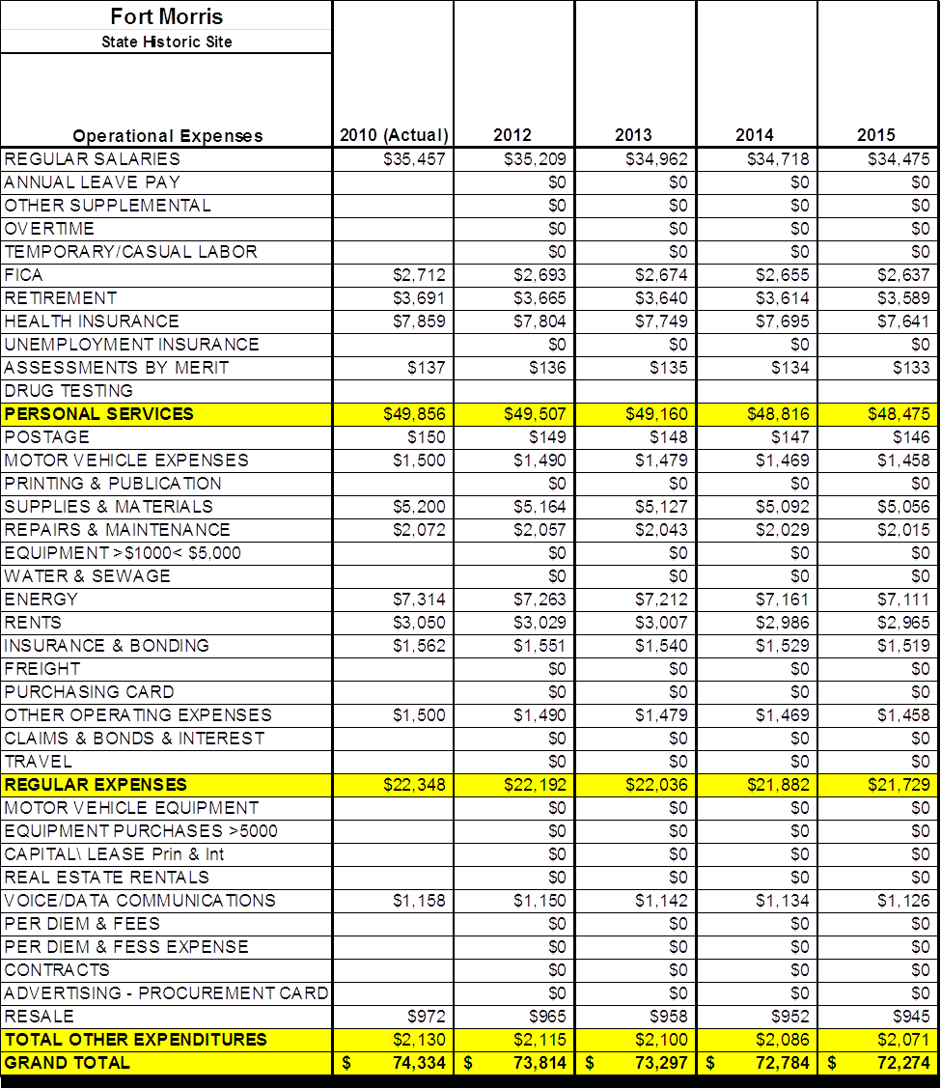

Revenue Pro Forma

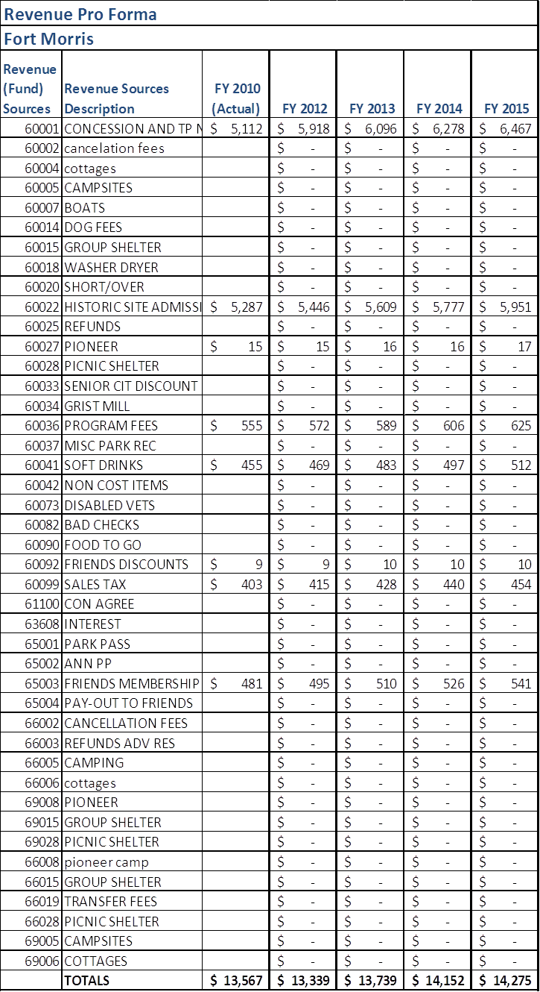

Total / Cost Recovery Pro Forma

Fort Morris | 2010 (Actual) | 2012 | 2013 | 2014 | 2015
TOTAL PRO FORMA
Visitation | 8,615 | 8,787 | 9,051 | 9,322 | 9,619
Operational Expenses | $ 74,334 | $ 73,814 | $ 73,297 | $ 72,784 | $ 72,274
Earned Revenues | $ 13,567 | $ 13,339 | $ 13,739 | $ 14,152 | $ 14,275
% Cost Recovery | 18% | 18% | 19% | 19% | 20%

Action Plan
ACTION PLAN
Site: |  | Site Manager: |  |  | Date:
Month:
Strategy | Tasks | Costs / Funding | Revenues / ROI | Responsibilities | Metrics

ACTION PLAN
Site: |  | Site Manager: |  |  | Date:
Month:
Strategy | Tasks | Costs / Funding | Revenues / ROI | Responsibilities | Metrics

This is the average of the last three years – FY 2008, FY 2009, and FY 2010
Current employees, not including vacancies.
Current employees, not including vacancies.
Major population centers within a two-hour drive from the site

