Fort Mountain
Business & Management Plan

Prepared June 2011; Finalized February 2013
Direction 2015 – Sustainable Business Planning

Table of Contents

Executive Summary 3

Site and Operations Assessment 8
Site Inventory and Facility Assessment 8
Operational Assessment 11
Financial Performance Assessment 16

Business and Management Plan 19
Business Goals 20
Classification of Programs and Services 22
Partnership Development Plan 23
Marketing and Sales Plan 24
Revenue Generation Plan 26
Expense Management Plan 28
Financial Pro Forma 29

Action Plan 32

Executive Summary
The Parks, Recreation and Historic Sites Division (PRHSD) of the Georgia Department of Natural Resources (DNR) is transitioning the management of Fort Mountain State Park to operate more like a business, reflecting the Direction 2015 – Sustainable Business Planning initiative to improve the fiscal performance and management of the state parks and historic sites system. This business and management plan is designed to help the site recover more operating expenses through earned revenues, productive partnerships, and innovative programs.

Site Fact Sheet
Site Name | Fort Mountain State Park
Site Manager | Brian Ensley
Region Manager | Joe Yeager
Date of Business Plan completion | June 12, 2011
Site size | 3,712 acres
Total number of visitors (FY 2010) | 129,719
Total operating budget (FY 2010) | $502,845
Total earned revenues (FY 2010) | $519,500
Operational cost recovery (FY 2010) | 103%
Average operating cost per visitor (FY 2010) | $3.88
Average earned revenue per visitor (FY 2010) | $4.00
Average cost recovery (FY 2008 – 2010) | 102%
Target cost recovery (FY 2015) | 120%
Total full-time employees | 8
Total part-time employees | 3
Primary service markets | Atlanta, Chattanooga, and Knoxville
Primary attractors/visitor appeal factors | Mysterious Fort Wall. Mountain Landscapes. Large Multi-use Trail System.
Leading opportunities for improved site performance | Expand upon overnight rentals both cottages and alternative camping.

Site Summary and Key Attractions
The 3,712-acre site of FMSP is located in a rural setting, roughly 90 miles from Atlanta and Knoxville and roughly 45 miles from Chattanooga Tennessee. The park is approximately 30 miles away from Interstate 75. Although FMSP is a mountainous site, its locale in Northwest Georgia may hamper visitation. Visitors looking for a state park in the mountains may gravitate to divisional sites in the Northeast side of the state due to that area’s developed tourism and main arteries of travel from Atlanta. Historically, FMSP has been considered “North Georgia’s best kept secret.” In improving the park’s target cost recovery to a higher rate, it might help if the site was less of a secret.

Key Attractions
The amenities or features listed below are those that seem to be most popular for visitors.
- 15 Cottages
- 70 RV and Tent Sites
- 17 acre Lake with Beach and Boat Rental
- Mini-Golf
- Old Fort Wall along with CCC Structures
- Visitor Center
- Pioneer Camping Area
- Backcountry Camping /Primitive Sites
- Miles of Multi-Use Trails
- Family Group Shelter

Financial Targets
The table below details the total operating expenses and earned revenues for Fort Mountain State Park over the last three years (2008 – 2010). This table also calculates total cost per visitor and revenues per visitor during these operating years, and details the target financial performance goals in the context of achieving at least 110% cost recovery. This table also calculates the necessary change from 2010 operating expenses and revenues.
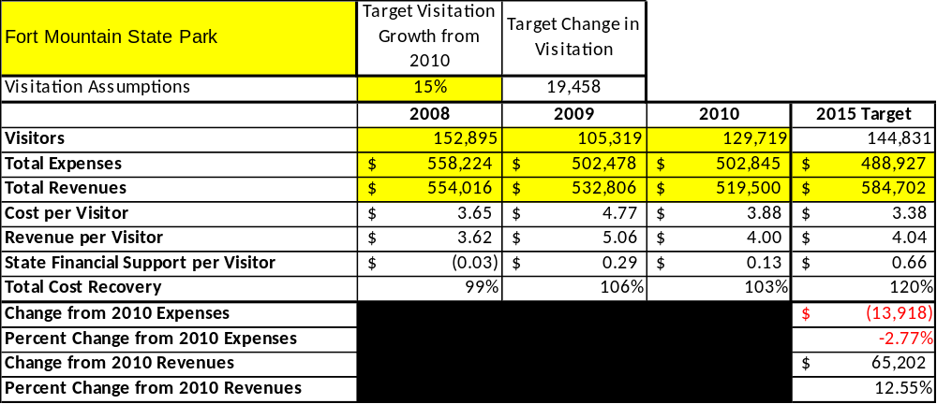

Key Recommendations

Primary / Short Term Recommendations
- Operate the site using cost-based accounting, including the net recovery achieved annually.
- Conduct in-park surveys annually to assess how well customer satisfaction levels are being met. FMSP should strive to have 90% of visitors responding to Comment Cards report that they were either satisfied for very satisfied (or some comparable metric to be developed). Programs or services that fall below that standard should be critically reviewed, enhanced, and results monitored; those with a history of poor performance should be considered for elimination.
- Evaluate and pursue opportunities to employ concessionaires or private or public service providers on-site if they can be more cost-effective.
- Collect a statistically valid sample of ZIP code data from visitors in a non-intrusive way to gauge their origins and demographics.
- Utilize a minimum of four special events annually to draw more visitors to the site.
- Seek local partners to help support operations, programs, and service delivery and for cross- marketing purposes.
- Sustain sufficient non-labor operational funding or reduce staff so that required staff operational costs (with benefits) do not exceed 65% of the total operational budget.
- Partner with local Chamber of Commerce or other destination marketing organizations (DMOs) to promote FMSP.
- Work closely with newly formed Friends of Fort Mountain State Park to help raise funds for improvements or volunteers for program support.
- Perform a thorough net cost-of-service analysis on major functions of site operations, including the detailed analysis of labor requirements (by task) that has already been produced by site staff. Thereafter, update costs to deliver services on a biennial schedule.
- Review and update rates at the site on an annual basis to recover the total or better net cost of service for important and visitor-supported services.
- Develop on-line sales of gift shop and retail items associated with the site in order to increase site generated revenues.
- Track total economic impact of the site on the local communities and regions and share with the decision-makers, elected officials, local business operators, and others to demonstrate the impact of FMSP.
- Develop a more detailed analysis of labor requirements of all major park functions to match the right position with the right job at the right pay.
- Develop funding to provide additional training to site staff for improved business management and marketing effectiveness.
- Construct and upgrade facilities and amenities at the site that are likely to have a cost recovery level of 100%.
- Add more youth-focused services, programs and amenities at the site that appeal to younger audiences, families and educational groups.
- Add more services, programs and amenities that appeal to older adults. Add interpretive programs geared towards seniors, possibly a car show, sock-hop type of event, or any activity that seniors would enjoy.

Secondary / Long Term Recommendations
- Improve the recreational amenities of the site to address modern and diverse uses.
- Install an improved retail point-of-sale and inventory tracking system.

Site and Operations Assessment
This site and operations assessment is a culmination of analyses and findings from a review of the condition of facilities, infrastructure, and operations at Fort Mountain State Park (FMSP). The findings and observations are not intended to be an exhaustive review of all issues present, but provide a basic understanding of the predominant issues that contribute to the site’s current operating conditions. The assessment includes the following:
- Site Inventory and Facility Assessment
- Operational Assessment
- Financial Assessment
Site Inventory and Facility Assessment

Methodology
Facility and asset conditions are rated using a differential scale of excellent, good, fair, or poor. Descriptions of conditions that are attributed to each of these findings are also provided.
Scale of Conditions
Rating | General Description
Excellent | Facilities/amenities are in ‘excellent’ condition when they show little or no maintenance or repair problems. Facilities do not feature any major design or operational issues or flaws that contribute to diminished use or increased maintenance or upkeep. Facilities are easy to clean and maintain in order to place them back into public use and the users perceive them to be in excellent shape.
Good | Facilities/amenities are in ‘good’ condition when they show only minor maintenance or repair problems. Most maintenance issues with these facilities typically appear to be the result of age and/or heavy use. Facilities may only feature minor design or operational issues that contribute to diminished use or increased maintenance or upkeep. Facilities are moderately easy to clean and maintain in order to place them back into service and the users perceive them to be adequate for their use, but probably not in excellent shape.
Fair | Facilities/amenities are in ‘fair’ condition when they show significant maintenance or repair problems. Facilities generally exhibit ongoing maintenance issues that appear to be the result of age, heavy use, or design or operational flaws. Some maintenance and repair needs may compound their fair condition by being deferred because of budget and/or resource limitations. Facilities require more effort to clean and maintain before placing them back into service and the users may perceive them as being less than adequate for their use and in a state of deterioration. The facility or structure may need of major repair or replacement.
Poor | Facilities/amenities are in ‘poor’ condition when they show significant, on-going maintenance or repair problems that ultimately may result in suspended use for repair/replacement. Maintenance and repair issues are possibly the result of poor maintenance and clearly the result of age, heavy use, or design or operational flaws. Problems with the facilities are often compounded over time due to consistently-deferred maintenance and repair because of budget and/or resource limitations. Facilities may feature major design or operational issues that contribute to diminished use or increased maintenance or upkeep. Facilities require excessive effort to clean and maintain before placing them back into service and the users often perceive them as being inadequate for their use and in a state of serious deterioration. The facility or structure may need of major repair or replacement.

Inventory and Assessment
The table below is an inventory of facilities and amenities at FMSP, and provides the assessed condition of each as reviewed in May 2011.

Site Asset / Amenity | Quantity | Condition
Total Acreage | 3,712 | Good
Visitor Center | 1 | Good
“Old Office” /1 bdrm cottage | 1 | Good
Rangers’ Residence | 1 | Excellent
Asst. Mgr. Residence | 1 | Good
Maintenance Office | 1 | Good
Maintenance Pole Shed | 2 | Good
Maintenance Barn | 1 | Good
Maintenance “Gas House” | 1 | Good
Maintenance Area /Well #1 | 1 | Good
Well House #4 | 1 | Good
Picnic Shelters 6& 7. CCC era. | 2 | Good
Rest Station | 1 | Excellent
Old Rest Station/ Radio Room | 1 | Fair
Lower Cottages | 5 | Good
Upper Cottages- “Ken Johnson” | 10 | Good
Developed Campsites | 70 | Good
Walk-In Campsites | 4 | Good
Squirrel’s Nest Campsites | 6 | Good
Picnic Shelters 1-5 | 5 | Good
Mini-Golf | 1 | Good
Playground | 1 | Good
Group shelter | 1 | Fair
Boat Dock | 1 | Good
Comfort Station#1 | 1 | Good
Comfort Station #2 | 1 | Good
Comfort Station#3 | 1 | Good
Day-Use Rest Station- Beach | 1 | Fair
Day-Use Rest Station | 1 | Fair
Pioneer Camping | 3 | Good
Linen/Laundry Facility | 1 | Excellent
Well Houses 2&3 | 2 | Good
Booster Pump House for #2 | 1 | Good
Booster Pump House for # 3 | 1 | Good
Horse Camp Area | 1 | Fair
CCC- Fire Tower | 1 | Fair
Overlooks/Viewing Platforms | 3 | Good
Backcountry Campsites | 4 | Good
Old Mining Co Storage/Ops Bldg. | 8 | Poor

Prioritized Facility Needs
Based on the facility inventory and assessment, these prioritized needs have been identified. Each need has been aligned with a priority category of high, moderate, or low to support future decision making regarding project sequencing, investment of public resources, and meeting community expectations. The priority assignment for each need is not a measure of importance. Rather, these recommended priorities reflect a phased implementation approach over the next several years.

Facility Need | Priority Assignment
Renovation of Upper 10 Cottages | High
Renovation of Developed Campsites w/ Utilities Upgrade | Moderate
Replacement of Day-Use Rest Stations in Main Day-Use Area | Moderate
Renovation of Current Family Group shelter | Moderate
CCC-Era Fire Tower- Includes Masonry Work | Moderate
Horse-Camp Area- Repairs to Bldgs. | Low
Acquiring Adjacent Property to insure Horseback Trail Access | High
Renovation of Lower 5 Cottages | Low
Grounds Rehabilitation of Day-Use Area | Low
Addition of 3 New Cottages for Revenue Enhancement | High
Renovation of Park’s Visitor Center | Low

Operational Assessment
The Operational Assessment includes:
- An inventory and classification of programs and services being provided at the site
- A review of staffing at the site
- A review of concessionaires and partners operating at the site
- Visitation and customer satisfaction

Inventory and Classification of Programs and Services
Programs and services are classified into one of three major categories:
1) Core or Essential Services
2) Important Services
3) Visitor Supported Services
Programs and services at the site are classified into these categories based in part on the mission and public mandates for both the site and the agency. For the programs and services in each of these categories, there are financial performance expectations that will define how services are funded and evaluated.

Category 1 – Core Services [Largely supported by tax funds]
Core programs, services and facilities are those the agency must provide and/or are essential in order to capably govern and meet statutory requirements. The failure of the agency to provide Category 1 services at adequate levels could result in significant negative consequences for the public and the resources under protection. The criteria for programs or services to be classified as core or essential are:
- The services are mandated by the agency’s law or charter or are contractually obligated by agreement to provide the services.
- The services are essential to protecting and supporting the public’s health and safety.
- The services protect and maintain valuable assets and infrastructure.
- The services would generally and reasonably be expected and supported by residents, businesses, customers and partners.
- The services are those that cannot or should not be provided by the private sector.
- The services provide a sound investment of public funds.
The following programs and services offered at Fort Mountain have been identified as core services:
- Active management of the natural and historical resources of the site in order to protect their integrity
- Open and public access to the site and its resources
- Site appropriate education, interpretation and recreation opportunities
- Public safety including law enforcement, first response, and SAR operations
- Maintenance of grounds, facilities and infrastructure

Category 2 – Important Services [Supported by a balance of tax funds and earned revenues]
Important programs, services and facilities are those the agency should provide, and are important to governing and effectively serving residents, businesses, customers and partners. Providing Category 2 services expands or enhances the agency’s ability to provide and sustain its core services. The criteria for programs or services to be classified as important are:
- The services expand, enhance or support identified core services.
- The services are broadly supported and utilized by the community, and are considered an appropriate, important, and valuable public good. Public support may be conditional upon the manner by which the services are paid for or funded.
- The services generate income or revenue that offsets some or all of the operating cost and/or are deemed to provide economic, social or environmental outcomes or results.
The following programs and services offered at Fort Mountain have been identified as important services:
- Self-guided interpretation and education programs

Category 3 – Visitor Supported Services [Almost exclusively supported by earned revenue]
Visitor supported programs, services and facilities are those discretionary services that the agency may provide when additional funding or revenue exists to offset the cost of providing those services. Category 3 services provide added value above and beyond what is required or expected. The criteria for programs or services to be classified as visitor supported are:
- The services expand, enhance or support core services or important services and the quality of life of the visitors, community or stakeholders.
- The services are supported, valued and well utilized and provide an appropriate and valuable public benefit.
- The services generate income or funding from sponsorships, grants, user fees or other sources that offset some or all of their cost and/or provides a meaningful return on investment.

- The services can possibly be provided through outsourcing or use of concessionaires, providing opportunities for community enterprises that may not otherwise be provided by the agency.

The following programs and services offered at Fort Mountain have been identified as visitor supported services:
- Trading post / retail operations
- Ranger guided interpretation and education programs
- Special events / programs beyond normal programming

Staffing Assessment
Labor costs at Fort Mountain represent the largest area of budgetary expense at an average of 58% of the total operating budget each year for the last three complete years, which is lower than the target of total labor costs (including benefits) not exceeding 65% of the site’s total operating expenditures. The tables below and on the following page provide a basic review of the current staffing at the site.
Full Time Equivalent Employees
Position / Title | Quantity (FTE) | Vacancies | Annual Hours
Park Manager III | 1 | 0 | 2860
Asst. Park Manager II | 1 | 0 | 2860
Secretary I | 1 | 0 | 2080
Enforcement Ranger | 1 | 1 | 2080
Housekeepers | 2 | 0 | 4,160
Sr. Park Ranger | 1 | 0 | 2080
General Trades Craftsman | 1 | 0 | 2080
Utility Worker | 1 | 0 | 2080
TOTAL | 9 | 1 | 20,280

Part Time Employees
Position / Title | Quantity (FTE) | Vacancies | Hours
Clerk | 1 | 0 | 1508
Housekeeper | 1 | 0 | 1200
Housekeeper | 1 | 0 | 1000
TOTAL | 3 | 0 | 3,708

Labor Support
Labor Support | Annual Hours
Volunteers | 4160
Community Service Workers | 0
Engineering and Construction Crews | 0
Resource Management Crews | 0
TOTAL | 4,160

Total Labor Hours
Labor Type | Annual Hours
Full Time Equivalent Employees | 20,280
Part Time Employees | 3,708
Labor Support | 4,160
TOTAL Annual Labor Hours | 28,148

Labor Budget Summary

 | Fort Mountain
 |  | 2008 | 2009 | 2010 | % Change
 | Account Code and Sub-Class | Year End | Year End | Year End | from
 | Expenditure Descriptions | Expenses | Expenses | Expenses | 2008
 | REGULAR SALARIES | 203,218 | 162,661 | 204,799 | 1%
 | ANNUAL LEAVE PAY | 3,240 | 6,302 | 0 | -100%
 | OTHER SUPPLEMENTAL | 349 | 2,016 | 0 | -100%
 | TEMPORARY/CASUAL LABOR | 49,526 | 55,157 | 15,983 | -68%
 | FICA | 14,235 | 12,835 | 15,592 | 10%
 | RETIREMENT | 20,266 | 19,700 | 21,320 | 5%
 | HEALTH INSURANCE | 47,241 | 24,503 | 45,394 | -4%
 | UNEMPLOYMENT INSURANCE | 342 | 269 | 0 | -100%
 | ASSESSMENTS BY MERIT | 1,323 | 1,323 | 1,229 | -7%
 | PERSONAL SERVICES | 339,740 | 284,766 | 304,317 | -10%

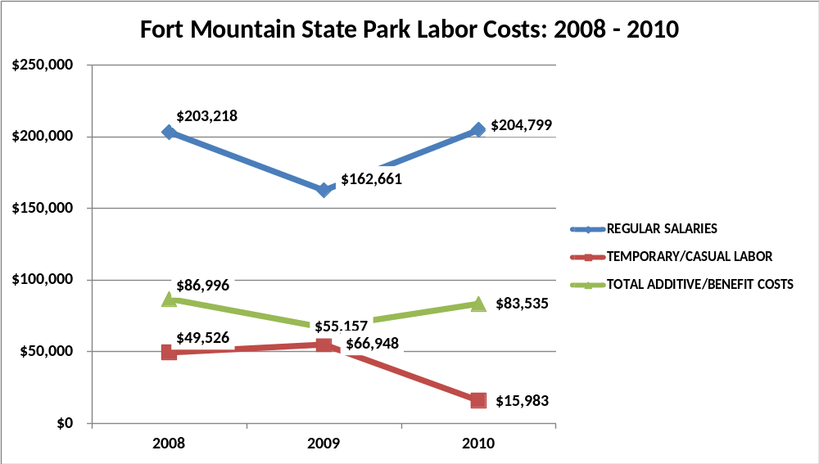

Visitation and Occupancy
Overall annual visitation to the site has trended downward from 2008 to 2010, decreasing by 15% or over 23,000 visitors. This is largely attributed to the economy.
Year | Total Visitation
2008 | 152,895
2009 | 105,319
2010 | 129,719

Occupancy for the overnight accommodations at Fort Mountain the last three years is detailed in the table below. Overall occupancy has trended downward from 2008 to 2010, decreasing by 12%. This is largely attributed to the economic down turn.
Year | Campsites Occupancy | Cottages Occupancy
2008 | 34.6 | 46.6
2009 | 31.7 | 34.1
2010 | 30.2 | 34.5

Customer Service and Satisfaction
Currently the site monitors customer service through paper, hard copy customer comment cards. These cards are not collected in a statistically valid method, are often only reviewed to identify areas of customer service concerns or issues, and are not consistently used for managing customer service performance issues overall at the site. However having said all this, the site is well known for its high level of customer service satisfaction and in both 2009 and 2010, 98% of customers responded that they were either ‘satisfied or ‘very satisfied’ with their expectations at FMSP.

Site | Year | Customer Satisfaction Level
Fort Mountain | 2009 | 78%
Fort Mountain | 2010 | 80%
Financial Performance Assessment

Operational Expenses
A summary of total operating expenses at Fort Mountain from 2008 to 2010, as well as their percent change from 2008 are provided in the table below.
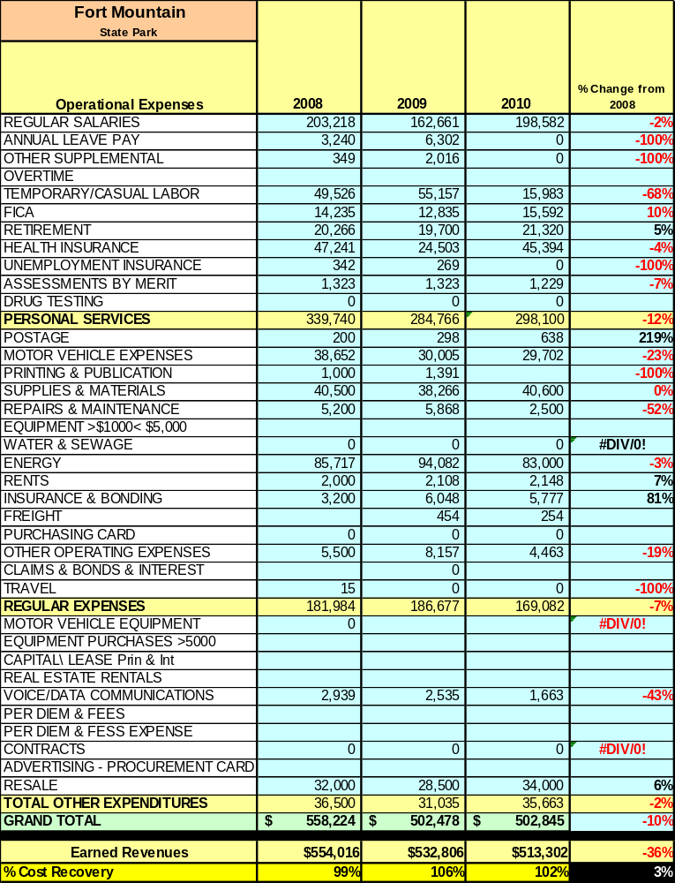

Earned Revenues
Earned revenues at Fort Mountain have decreased since 2008, which is largely attributed to the corresponding decrease in overall visitation. Monthly earned revenues for the last two years (see table on the following page) indicate that the total annual revenue decreased 2% from 2009 to 2010, with the largest increases in monthly revenues in Nov (6%), Dec (6%), and Oct (2%) and the largest decreases in the months of Sept (-16%), Jan (-13%), Feb (-9%), and Mar (-9%).

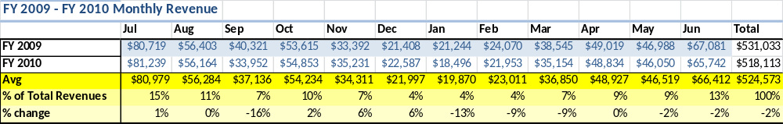

The graphs below illustrate the monthly revenue trends each year and the average percent of total annual revenue earned each month.
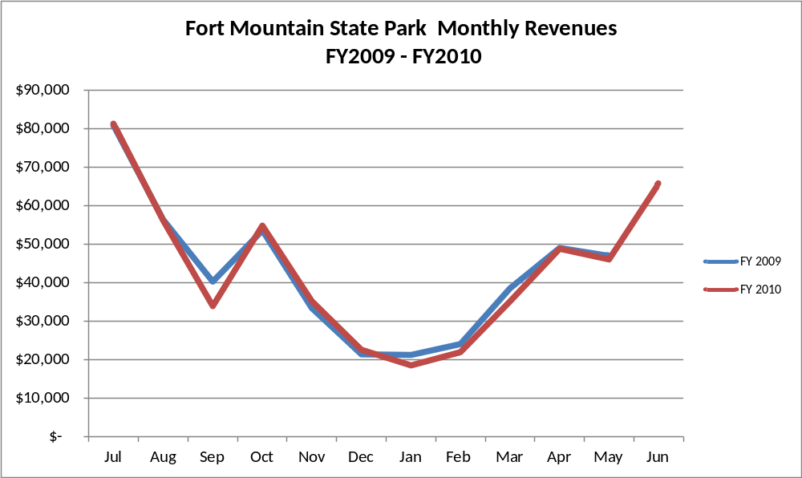

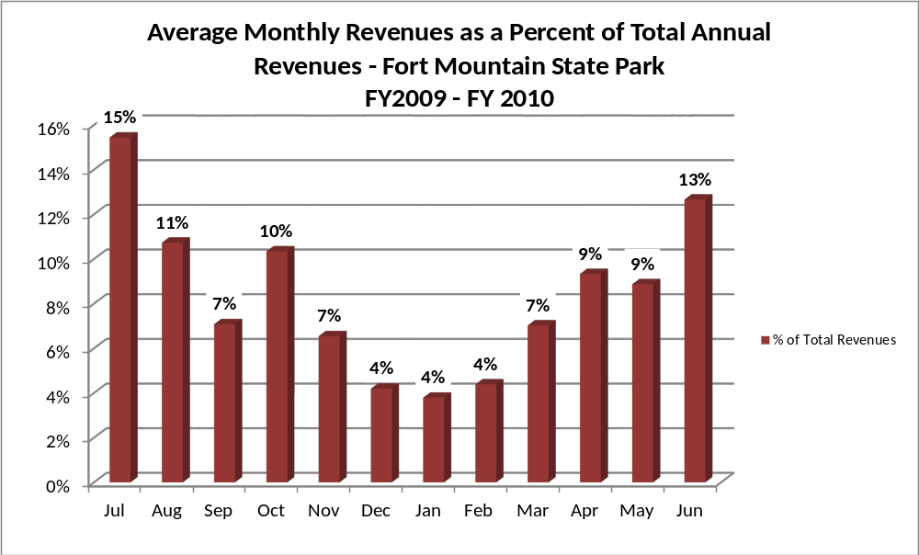

Cost Recovery Trends
Fort Mountain has achieved an average cost recovery of 102% of annual operational expenses through earned revenues from FY 2008 to FY 2010. This is detailed and illustrated in the table and graph below.

Year | Operational  Expenses | Earned  Revenues | Percent Cost  Recovery
2008 | $558,224 | $554,016 | 99%
2009 | $502,478 | $532,806 | 106%
2010 | $502,845 | $513,302 | 102%

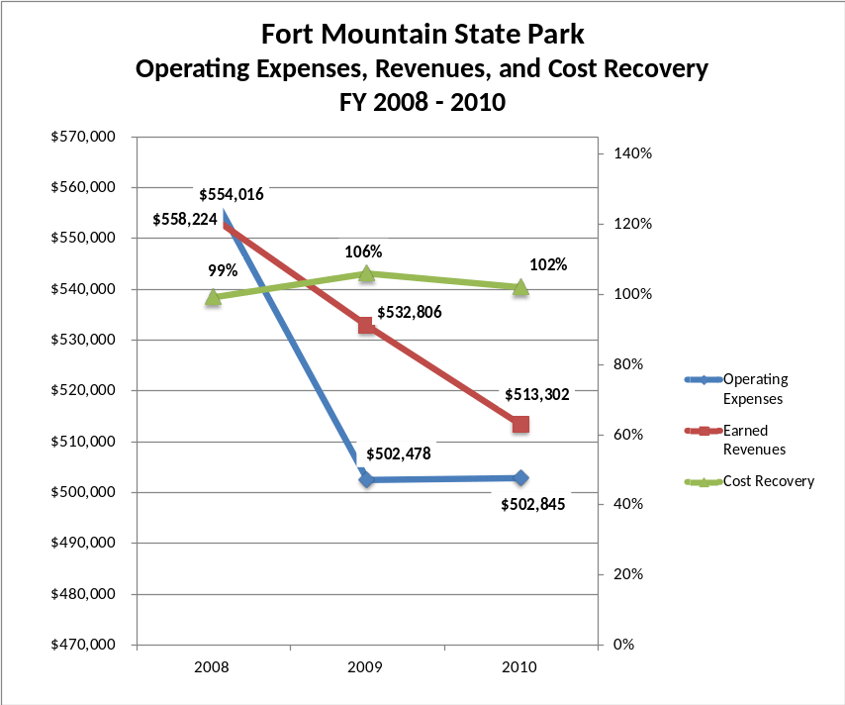

Review of Pricing
Data on rate information is available as far back as 2002, but only the last five years are evaluated. There has been notable growth in fees charged at Fort Mountain since 2005, with the largest increase being for cottage rentals. A table detailing the rates for Fort Mountain is provided below.
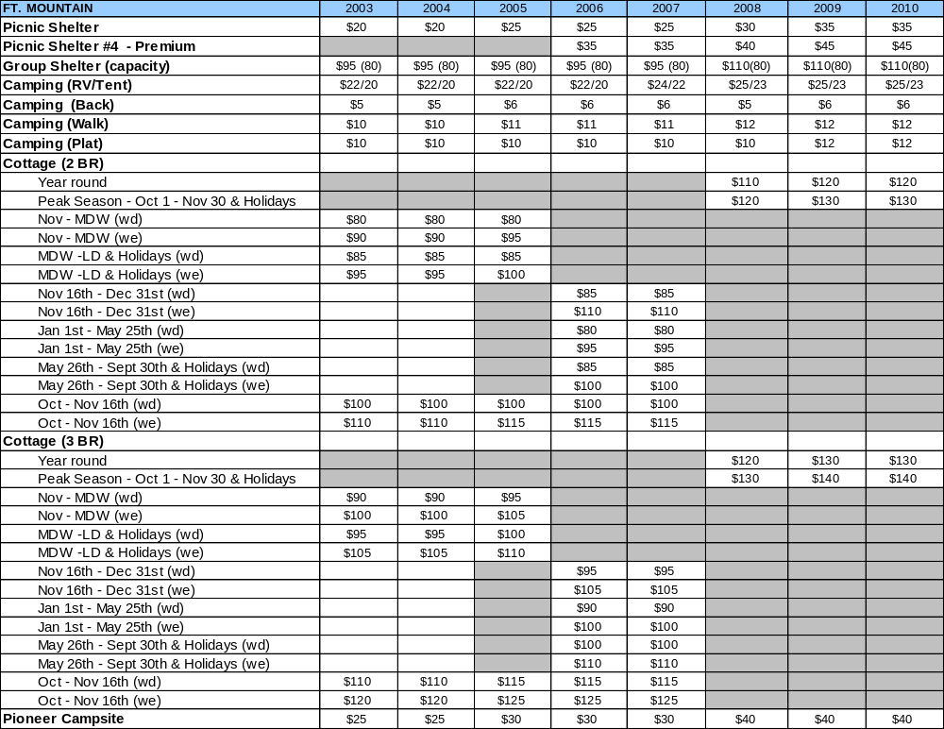

Business and Management Plan

Business Goals
The following goals serve as the foundation for the key recommendations and strategies in this business plan for Fort Mountain State Park.

Enhance Cost Recovery of Site Operations
Fort Mountain State Park is operating at 99-106% cost recovery of operational expenses through earned revenues. FMSP should be able to improve revenues through additional special events and measures to draw more visitors to the site and generate higher revenues. It is critical for the site to obtain and maintain at least a 110% recovery. This also is important for the division as a whole.

Enhance Revenue Generation Strategies
Increasing earned revenues will most likely result from the impacts of both increased visitation at the site and specific revenue enhancement strategies. Fort Mountain will improve revenue generation through enhancing retail sales operations along with the possibility of on-line sales. Fort Mountain will increase the number and types of special events held at the site.

Expand Special Events at the Site
Programming at Fort Mountain is varied but limited. Simply put, FMSP does not have the staffing and amenities to offer programming on a larger scale. Fort Mountain has hosted events such as bike races and marathons but on a limited basis. This has been done with groups that can meet their own needs with volunteers and has been very dependent on weather. An interpretive center or area and a more modern group facility would greatly enhance the site operation.

Improve the Diversity and Innovation of Recreational and Interpretive Programs
Fort Mountain will work to improve the programming to meet the needs of a wider range of age groups. Also, FMSP will look into new and innovative programming to attract visitors and build upon repeat business. Fort Mountain will work to improve on a base of outside resources to help the site with programming.

Improve the Effectiveness of Marketing and Sales
The effectiveness of marketing and promotional activities of Fort Mountain could be improved to produce greater visitation and revenues during peak, shoulder, and off seasons. This could be achieved in part through a shift in the existing marketing approach to one that is more targeted and focused on experiential messaging geared specifically towards the site. Additionally, partnerships with nearby attractions and amenities in the region should improve the ability of the site to maintain an increased and steady flow of visitors and revenue throughout the year.

Establish Greater Consistency of Managing and Monitoring Customer Service & Satisfaction
Fort Mountain plans to improve the consistency of managing and monitoring customer service and satisfaction by conducting on-site surveys annually to assess how well customer satisfaction levels are being met. FMSP will strive to have 90% of visitors responding to ‘Comment Cards’ report that they were ‘satisfied’ or ‘very satisfied’ ( or some comparable metric to be developed). Programs or services that fall below that standard should be critically reviewed, enhanced, and results monitored; those with a history of poor performance will be evaluated and potentially considered for elimination.

Expand Partnership Opportunities
FMSP will explore to find available partnerships in the region. The site will look to expand the possibilities of service partnerships in which alternative and related providers in the community support the provision of programs and services to visitors of FMSP; expanding vendor partners to reduce the costs of materials and supplies, and related services needed by the site; and seeking co-branding partners to offset event and program costs and to expand awareness of site programs and facilities in the site’s market area.

Classification of Programs and Services
The tables below summarize the classifications of programs and services at FMSP as either core, important, or visitor supported and projects a range of cost recovery percentages that might be achieved for each. These classifications establish financial performance goals for each category of services that are linked to the recommendations and strategies of this business plan.

Core Services
Program / Service | Target Cost Recovery
Active management of the natural and cultural resources of the site in order to protect their integrity | 0%
Open and public access to the site and its resources | 20% to 50%
Site appropriate education, interpretation and recreation opportunities | 20% to 50%
Public safety | 0%
Maintenance of site, grounds, facility and infrastructure | 0%

Important Services
Program / Service | Target Cost Recovery
Self-guided interpretation and education programs | 20% to 80%

Visitor Supported
Program / Service | Target Cost Recovery
Trading Post / retail operations | 150% to 200%
Ranger guided interpretation and education programs | 100% to 120%
Special events / programs beyond normal programming | 150% to 180%

Partnership Development Plan
The table below summarizes targeted partnerships by classification (operational, vendor, service, co-branding, funding partners) and by organizational type.
 | Public Partners | Not-for-profit Partners | Private / Enterprise Partners
Operational Partners |  | - Girl Scouts of NW GA
Vendor Partners |  |  | - Coca-Cola  - Georgia Power
Service Partners | - City of Chatsworth  - Murray County | - Chamber of Commerce  - March of Dimes
Co-branding Partners | - Vann House Historic Site  - New Echota Historic Site |  | - Sparkle Spring Water  - First National Bank  - Best Western
Funding Resource Development Partner |  | - Friends of Fort Mountain State Park

Marketing and Sales Plan

Marketing and Sales Goals
Marketing and sales goals for Fort Mountain are based on the following desired outcomes:
- To produce more interpretive programs that draw visitors to the site
- To produce more large, signature events with large participation.
- To produce increased overall visitation and revenues
In order to meet these goals, examples of specific target outcomes were identified in the areas detailed in the table below.

Area  of Focus | Current  Performance | Goal  by 2011 | Goal  by 2012 | Goal  by 2015
Special Events | Unknown | 1,500 | 3,000 | 6,000
Overall Visitation | 130,000 | 135,000 | 137,000 | 140,000

Marketing and Promotion Strategies

Publicity and Social Media
FMSP will approach marketing and publicity planning using the following guidelines and themes:
- Event publicity
Major events benefit by having short stories in local, regional, and statewide newspapers and online social media hooks planted that run three to four weeks in advance of the event up to the date of the event itself. Stories and media need to be cultivated with contacts and online sales channels several weeks in advance of the time the stories need to run. Special interest interviews on morning, noon, and evening television news programs, radio interviews on popular rush-hour programs, and blogs on known affinity online sites should also be included.
- Program publicity
Special and unique programs should have feature stories in magazines, local and regional weekly newspapers, and statewide daily newspapers that are aimed at placements as front-page or sectional front-page stories. These stories are most effective if they run shortly before the season that the featured program begins. This will likely require several weeks of advanced planning with media contacts. Similar coverage on television and radio should also be considered. If pre-publicity cannot be generated, post-publicity can help promote future programs.
- Site Publicity
Site publicity focusing on a single site or sub-set of sites requires more intense planning efforts to attract multiple writers and editors from target publications. The site could host several seasonal media familiarization tours (with 10 to 15 writers or editors) to familiarize them with the site and its benefits and amenities. Stories and features resulting from such tours typically take between two and six months to materialize so the tours should focus on experiences, benefits, and programs that would be available when the stories are expected to run.
Examples and suggested opportunities for events, programs and related publicity efforts based on the themes described above at FMSP are provided in the table below.

Event Publicity | Program Publicity | Site Publicity
Arts & Music Festival | Jr. Ranger Camp | Mountain Mystery Day
Mystery Mountain Marathon | Georgia Outdoor Kids | CCC-Day
Culinary Festival | Backpack Clinic
SORBA Mtn. Bike Festival | Birding 101

Packaging
Examples and suggested packages for FMSP are provided in the table below.

Package | Package Details
Vann House | Site and Park admission along with a canoe rental (seasonal)
Ride and T | In lieu of trail permit, receive a discounted bike t-shirt after your ride.
Concessions Passbook | Discounted voucher book for 10 plays of m. golf, pedal boats, or canoes

Group Sales
Types of groups within which specific target customers can be identified for FMSP are listed below:
- Families  - Youth Services  - Churches  - Activity or special interest clubs | - Businesses and professional groups  - Schools  - Colleges and universities  - Associations | - Other public agencies  - Women’s groups  - Community organizations

Incentivizing New and Repeat Visitation
FMSP will utilize the following strategies and/or incentives to encourage new and repeat visitation starting in FY 2012:
- Early registration discounts
- Group/bulk pricing options
- Post peak season follow-up with visitors
- Co-branding partner benefits

Marketing and Sales Metric Goals
The following marketing and sales metric goals and/or others will be monitored and progress reported at FMSP:
- Loyalty and repeat customers = 65% of customers repeat their visit with in a 12- month period.
- Brand confidence & customers-recruiting-customers = Customer referrals equal a minimum of 50% of “Where did you hear about us?’ responses from visitors polled.
Revenue Generation Plan
Revenue / Cost Recovery Goals
Fort Mountain has set a financial goal of increasing annual revenues by 3% annually between 2012 and 2015. The largest revenue growth opportunity is most likely in the months of Aug through Oct and Mar through May. The table below details projected revenue growth leading up to 2015, based upon a nominal growth of revenues each year.
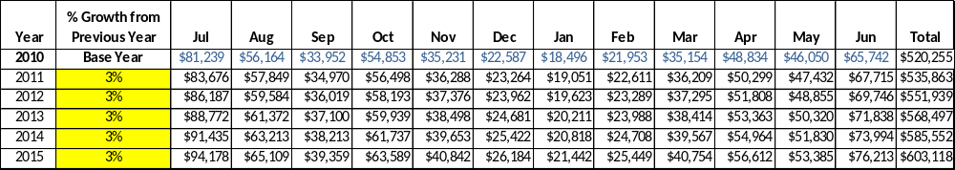

These projections would result in a total of 15% cumulative growth in total annual revenues between FY2010 and FY2015. If operational expenses can be managed with a cumulative increase of 3% between FY 2010 and FY 2015, then the overall cost recovery of the site will be approximately 120% in FY 2015 at these projected revenue levels. This is higher than the annual financial performance of the site in FY 2010, which was operated at 102% cost recovery in that year.
Revenue Generation Strategies

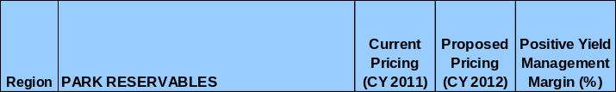
Pricing Plan

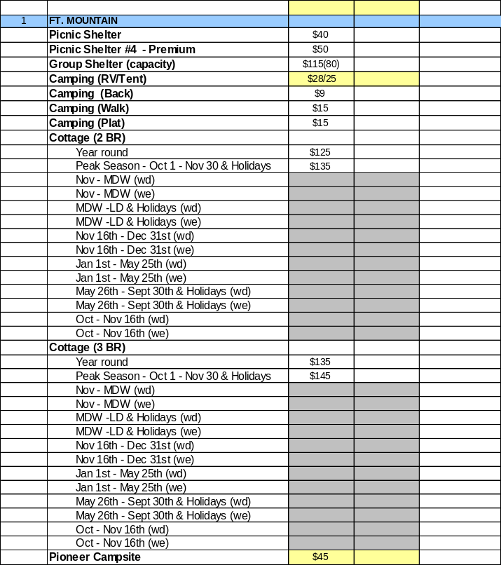

Innovative Programming and Special Events Plan
Program / Event | Theme / Purpose | Scheduled Date/Season | Frequency | Target Participation | Target User Fee | Target Cost Recovery
Mystery Mountain Day | Activities and vendors geared around FM history | October | Annual | 1500
Endurance Equestrian Event | Horseback event | Open | Annual | 1500

Partnerships and Concessions Plan
Service / Partnership | Term of Service | Financial Objective | Contract Manager
Event planning and promotion | 1-2 years | 15% of gross profits | Region Manager
Landscaping/lawn services | 1-2 years | Reduced personnel costs | Park Manager
Packaging and promotions w/ local businesses | 1 year | Shared revenue | Region Manager
Beach concessions | 1-2 years | Maintain level of service w/ no additional costs to site. | Park Manager

Expense Management Plan
Personnel Assignments
The following actions will be taken to proactively manage labor costs via personnel assignments and classifications.

Action | Timeline | Outcome
Convert two park positions to part-time employees | July 2012 | Annual labor costs reduction of  $ 21,134

Management Techniques
The following actions will be taken to proactively manage labor costs via management techniques.

Action | Timeline | Outcome
Increased use of volunteers for site and grounds maintenance | July 2012 | Annual cost reduction of  $11,600

Adjusted Levels of Service
The following actions will be taken to proactively manage labor costs via reduced levels of service.

Action | Timeline | Outcome
Adjusted mowing and landscaping of site | July 2012 | Annual cost reduction of $1,500

Financial Pro Forma
The following five-year financial pro forma projects operating expenses, earned revenues and cost recovery through FY 2015. These pro forma are based on the strategies and desired outcomes identified in this business plan, especially the revenue generation and expense management plans, and are linked to corresponding performance goals.

Expense Pro Forma

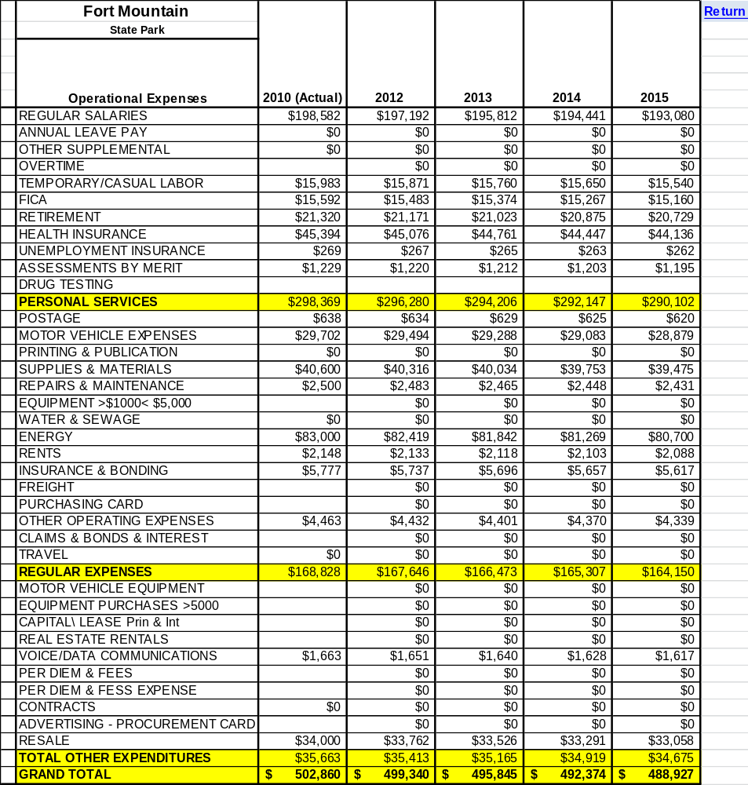

Revenue Pro Forma
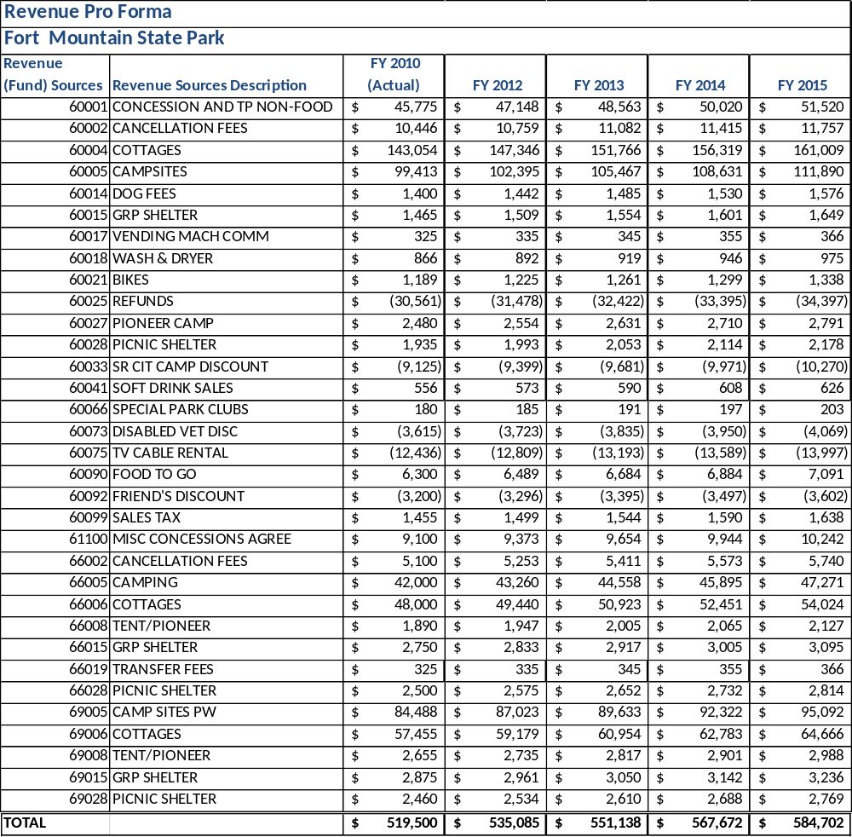

Total / Cost Recovery Pro Forma
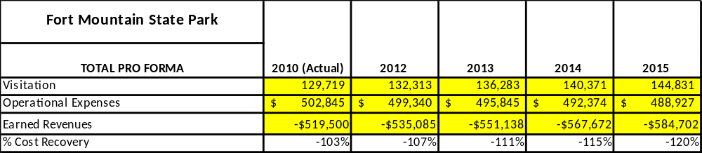

Action Plan
ACTION PLAN
Site: |  | Site Manager: |  |  | Date:
Month:
Strategy | Tasks | Costs / Funding | Revenues / ROI | Responsibilities | Metrics

ACTION PLAN
Site: |  | Site Manager: |  |  | Date:
Month:
Strategy | Tasks | Costs / Funding | Revenues / ROI | Responsibilities | Metrics

This is the average of the last three years – FY 2008, FY 2009, and FY 2010
Current employees, not including vacancies.
Current employees, not including vacancies.
Major population centers within a two-hour drive from the site

