Fort Yargo State Park
Business & Management Plan
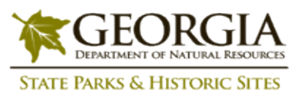
Prepared June 2011; Finalized December 2012
Direction 2015 – Sustainable Business Planning

Table of Contents

Executive Summary 3

Site and Operations Assessment 6
Site Inventory and Facility Assessment 6
Operational Assessment 8
Financial Performance Assessment 14

Business and Management Plan 17
Business Goals 17
Classification of Programs and Services 18
Partnership Development Plan 19
Marketing and Sales Plan 20
Revenue Generation Plan 22
Expense Management Plan 24
Financial Pro Forma 25

Action Plan 28

Executive Summary
The Parks, Recreation and Historic Sites Division (PRHSD) of the Georgia Department of Natural Resources (DNR) is transitioning the management of Fort Yargo State Park to operate more like a business, reflecting the Direction 2015 – Sustainable Business Planning initiative to improve the fiscal performance and management of the state parks and historic sites system. This business and management plan is designed to help the site recover more operating expenses through earned revenues, productive partnerships, and innovative programs.

Site Fact Sheet
Site Name | Fort Yargo State Park
Site Manager | Raymond Smith
Region Manager | Eric Bentley
Date of Business Plan completion | June 15, 2011
Site size | 1,816 acres
Total number of visitors (FY 2010) | 382,061
Total operating budget (FY 2010) | $495,887
Total earned revenues (FY 2010) | $300,988
Operational cost recovery (FY 2010) | 66%
Average operating cost per visitor (FY 2010) | $1.29
Average earned revenue per visitor (FY 2010) | $0.85
Average cost recovery (FY 2008 – 2010) | 62%
Target cost recovery (FY 2015) | 78%
Total full-time employees | 5
Total part-time employees | 8
Primary service markets | Winder, Gwinnett County, Atlanta, Athens, Gainesville
Primary attractors/visitor appeal factors | Camping, Yurts, Mountain Biking & Hiking Trails, Lake/Beach, Disc Golf and Camp Twin Lakes
Leading opportunities for improved site performance | Additional Yurts, Cottages, Campsites, Premium Campsites, Improved Day-use Facilities

Site Summary and Key Attractions
The 1,816-acre site of Fort Yargo State Park is located in a city setting in Winder, roughly 25 miles from major population centers in Georgia like Athens and Gainesville, 10 miles from Gwinnett County and 50 miles from Atlanta. It is roughly 10 miles from Interstate 85 and 30 miles from Interstate 20. Due to the site being located in close proximity to Atlanta it has become a premier location to host triathlons, bike races and disc golf tournaments. The location of the site near a major interstate is one of the greatest advantages in meeting the cost recovery goal.

Key Attractions
The amenities or features listed below are those that seem to be most popular for visitors.
- 12.5 miles of mountain biking trails
- 260-acre lake with beach and 2 boat ramps
- 40 RV campsites, 10 walk-in campsites
- 6 Yurts
- 7 miles of hiking trail
- 5 picnic shelters
- 3 cottages
- 2 group shelters
- Tennis and basketball courts
- Day use/picnic areas
- Colonial Fort
- Miniature golf

Financial Targets
The table below details the total operating expenses and earned revenues for Fort Yargo State Park over the last three years (2008 – 2010). This table also calculates total cost per visitor and revenues per visitor during these operating years, and details the target financial performance goals in the context of achieving at least 78% cost recovery. This table also calculates the necessary change from 2010
operating expenses and revenues.
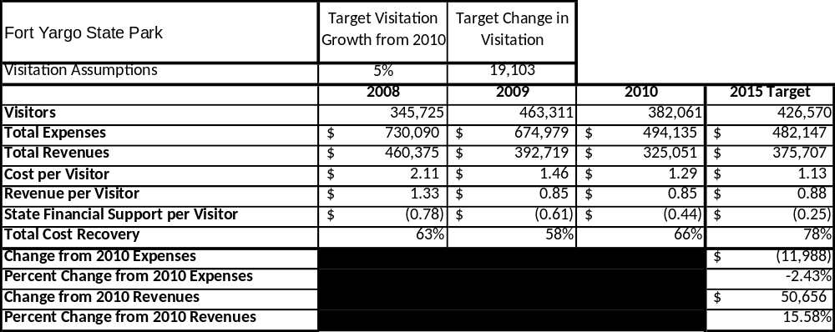

Key Recommendations

Primary / Short Term Recommendations
- Complete 2 campground comfort station replacements with bond funds
- Renovate miniature golf facilities
- Build and complete mountain bike comfort station
- Replace roofing on all three cottages

Secondary / Long Term Recommendations
- Remove beach pavilion and construct a smaller, more economical beach concession building with bathrooms for the purpose of promoting quality manageable facilities in this premier area. This will also allow the staff the ability to upkeep the facility annually using site operational funds.
- Replacement of boat rental house
- Construct 25-campsite loop with restrooms based on consistent over 40% annual occupancy rate.
- Remodel 25% of campsites to include sewage and 50 amp service to make the non-water front sites more marketable.
- Construct a picnic shelter at Campground # 1 to encourage RV group camping.

Site and Operations Assessment
This site and operations assessment is a culmination of analyses and findings from a review of the condition of facilities, infrastructure, and operations at Fort Yargo State Park. The findings and observations are not intended to be an exhaustive review of all issues present, but provide a basic understanding of the predominant issues that contribute to the site’s current operating conditions. The assessment includes the following:
- Site Inventory and Facility Assessment
- Operational Assessment
- Financial Assessment
Site Inventory and Facility Assessment

Methodology
Facility and asset conditions are rated using a differential scale of excellent, good, fair, or poor. Descriptions of conditions that are attributed to each of these findings are also provided.
Scale of Conditions
Rating | General Description
Excellent | Facilities/amenities are in ‘excellent’ condition when they show little or no maintenance or repair problems. Facilities do not feature any major design or operational issues or flaws that contribute to diminished use or increased maintenance or upkeep. Facilities are easy to clean and maintain in order to place them back into public use and the users perceive them to be in excellent shape.
Good | Facilities/amenities are in ‘good’ condition when they show only minor maintenance or repair problems. Most maintenance issues with these facilities typically appear to be the result of age and/or heavy use. Facilities may only feature minor design or operational issues that contribute to diminished use or increased maintenance or upkeep. Facilities are moderately easy to clean and maintain in order to place them back into service and the users perceive them to be adequate for their use, but probably not in excellent shape.
Fair | Facilities/amenities are in ‘fair’ condition when they show significant maintenance or repair problems. Facilities generally exhibit ongoing maintenance issues that appear to be the result of age, heavy use, or design or operational flaws. Some maintenance and repair needs may compound their fair condition by being deferred because of budget and/or resource limitations. Facilities require more effort to clean and maintain before placing them back into service and the users may perceive them as being less than adequate for their use and in a state of deterioration. The facility or structure may need of major repair or replacement.
Poor | Facilities/amenities are in ‘poor’ condition when they show significant, on-going maintenance or repair problems that ultimately may result in suspended use for repair/replacement. Maintenance and repair issues are possibly the result of poor maintenance and clearly the result of age, heavy use, or design or operational flaws. Problems with the facilities are often compounded over time due to consistently-deferred maintenance and repair because of budget and/or resource limitations. Facilities may feature major design or operational issues that contribute to diminished use or increased maintenance or upkeep. Facilities require excessive effort to clean and maintain before placing them back into service and the users often perceive them as being inadequate for their use and in a state of serious deterioration. The facility or structure may need of major repair or replacement.

Inventory and Assessment
The table below is an inventory of facilities and amenities at Fort Yargo State Park, and provides the assessed condition of each as reviewed in May 2011.
Site Asset / Amenity | Quantity | Condition
Group Shelters | 2 | Good
Picnic Shelters | 5 | 1,2,3,& 5-Good
Total Acreage | 1816 | Good
Park Office | 1 | Good
Walk-in Campsites | 9 | Excellent
RV Campsites | 40 | Good
Fishing Docks | 6 | Good
Pioneer Campsite | 1 | Good
Boat Docks | 2 | Good
Beach | 1 | Good
Maintenance Buildings | 3 | Pole barn-Excellent, New Barn-Excellent
Birdberry Trail | 1 | Good
Disc Golf | 1 | Good

Prioritized Facility Needs
Facility Need | Priority Assignment
Walk-in Campground Comfort Station needs to be built | High
Repaving Campground Road | High
Picnic Area 2 Comfort Station Replacement | High
Remove Beach Pavilion and create a smaller concession facility | High
Add additional 25 campsites based on 40% annual occupancy | Low
Replace Campground Comfort Station x2 | High
Remodel Nature Center to include Bathrooms | Moderate
Resurface Tennis/Basketball Courts | Moderate
Remodel campground to include sewage and 50 amp at 25% non-water front sites | Moderate
Renovate Cottages | Moderate
Replace Canvas on Yurts x5 | Moderate
Replace Jon Boats (8), Canoes (18) and Paddle Boats(8). | Moderate
Replace boat ramps | Low
Replace roof to Shelter #4 | Moderate
Replace greens and remodel miniature golf area (in-house with volunteers) | Low
Replace roof at the Birdberry Gazebo | Low
Renovate Maintenance Building/Office | Low
Based on the facility inventory and assessment, these prioritized needs have been identified. Each need has been aligned with a priority category of high, moderate, or low to support future decision-making regarding project sequencing, investment of public resources, and meeting community expectations. The priority assignment for each need is not a measure of importance. Rather, these recommended priorities reflect a phased implementation approach over the next several years.

Operational Assessment
The Operational Assessment includes:
- An inventory and classification of programs and services being provided at the site
- A review of staffing at the site
- A review of concessionaires and partners operating at the site
- Visitation and customer satisfaction

Inventory and Classification of Programs and Services
Programs and services are classified into one of three major categories:
1) Core or Essential Services
2) Important Services
3) Visitor Supported Services
Programs and services at the site are classified into these categories based in part on the mission and public mandates for both the site and the agency. For the programs and services in each of these categories, there are financial performance expectations that will define how services are funded and evaluated.

Category 1 – Core Services [Largely supported by tax funds]
Core programs, services and facilities are those the agency must provide and/or are essential in order to capably govern and meet statutory requirements. The failure of the agency to provide Category 1 services at adequate levels could result in significant negative consequences for the public and the resources under protection. The criteria for programs or services to be classified as core or essential are:
- The services are mandated by the agency’s law or charter or are contractually obligated by agreement to provide the services.
- The services are essential to protecting and supporting the public’s health and safety.
- The services protect and maintain valuable assets and infrastructure.
- The services would generally and reasonably be expected and supported by residents, businesses, customers and partners.
- The services are those that cannot or should not be provided by the private sector.
- The services provide a sound investment of public funds.
The following programs and services offered at Fort Yargo State Park have been identified as core services:
- Active management of the natural and cultural resources of the site in order to protect their integrity
- Open and public access to the site and its resources
- Site appropriate education, interpretation, and recreational opportunities
- Effectively manage the Marbury Creek Watershed
- Public safety to protect visitors and the natural resources
- Maintenance of grounds, facilities and infrastructure
- Self-guided interpretation and education programs

Category 2 – Important Services [Supported by a balance of tax funds and earned revenues]
Important programs, services and facilities are those the agency should provide, and are important to governing and effectively serving residents, businesses, customers and partners. Providing Category 2 services expands or enhances the agency’s ability to provide and sustain its core services. The criteria for programs or services to be classified as important are:
- The services expand, enhance or support identified core services.
- The services are broadly supported and utilized by the community, and are considered an appropriate, important, and valuable public good. Public support may be conditional upon the manner by which the services are paid for or funded.
- The services generate income or revenue that offsets some or all of the operating cost and/or are deemed to provide economic, social or environmental outcomes or results.

The following programs and services offered at Fort Yargo State Park have been identified as important services:
- Day use facilities such as mountain bike trails, tennis and basketball courts and access to the lake for recreational use.

Category 3 – Visitor Supported Services [Almost exclusively supported by earned revenue]
Visitor supported programs; services and facilities are those discretionary services that the agency may provide when additional funding or revenue exists to offset the cost of providing those services. Category 3 services provide added value above and beyond what is required or expected. The criteria for programs or services to be classified as visitor supported are:
- The services expand, enhance or support core services or important services and the quality of life of the visitors, community or stakeholders.
- The services are supported, valued and well utilized and provide an appropriate and valuable public benefit.
- The services generate income or funding from sponsorships, grants, user fees or other sources that offset some or all of their cost and/or provides a meaningful return on investment.

- The services can possibly be provided through outsourcing or use of concessionaires, providing opportunities for community enterprises that may not otherwise be provided by the agency.

- Camping, Yurts, Cottages, Pioneer Sites to be used for overnight facilities at the site.

The following programs and services offered at Fort Yargo State park have been identified as visitor supported services:
- Gift Shop
- Mountain bike races
- Ranger guided interpretation
- Special events / programs related to the mission of the site
- Special events / programs not related to the mission of the site or outside the normal programing standards (e.g. wedding receptions, etc.)
- Mini golf rentals
- Camping, Yurts, Cottages, Pioneer Sites to be used for overnight facilities at the site
- Day use facilities such as picnic shelters and group shelters.
- Day use and boat rentals at the beach

Staffing Assessment
Labor costs at Fort Yargo State park represent the largest area of budgetary expense at an average of 55% of the total operating budget each year for the last three complete years, which is lower than the target of total labor costs (including benefits) not exceeding 65% of the site’s total operating expenditures. The tables below and on the following page provide a basic review of the current staffing at the site.

Full Time Equivalent Employees
Position / Title | Quantity (FTE) | Vacancies | Annual Hours
Park Manager III | 1 | 0 | 2500
Assistant Park Manager II | 0 | 1 | 2500
Law Enforcement Ranger | 0 | 1 | 2080
Senior Ranger | 1 | 0 | 2500
Office Clerk: Secretary | 0 | 1 | 2080
Ranger I | 1 | 0 | 2080
TOTAL | 3 | 3 | 13,740

Part Time Employees
Position / Title | Quantity (FTE) | Vacancies | Hours
PSW (Clerk) | 5 | 3 | 6032
PSW (Maintenance Worker) | 4 | 4 | 6032
PSW (Housekeeper) | 0 | 1 | 1040
Seasonal Naturalist | 0 | 1 | 1508
TOTAL | 9 | 9 | 14,612

Labor Support
Labor Support | Annual Hours
Volunteers | 9350
Community Service Workers | 23360
Engineering and Construction Crews | 80
Resource Management Crews | 20
TOTAL | 32,810

Total Labor Hours
Labor Type | Annual Hours
Full Time Equivalent Employees | 13,740
Part Time Employees | 14,612
Labor Support | 32,810
TOTAL Annual Labor Hours | 61,162

Labor Budget Summary

 | Fort Yargo State Park
 |  | 2008 | 2009 | 2010 | % Change
 | Account Code and Sub-Class | Year End | Year End | Year End | from
 | Expenditure Descriptions | Expenses | Expenses | Expenses | 2008
 | REGULAR SALARIES | 219,798 | 216,002 | 206,957 | -6%
 | ANNUAL LEAVE PAY | 1 | 4,013 | 1 | 0%
 | OTHER SUPPLEMENTAL | 271 | 92 | 1 | -100%
 | TEMPORARY/CASUAL LABOR | 82,724 | 68,184 | 33,811 | -59%
 | FICA | 16,792 | 16,574 | 16,012 | -5%
 | RETIREMENT | 24,018 | 23,791 | 21,544 | -10%
 | HEALTH INSURANCE | 50,208 | 29,057 | 45,872 | -9%
 | UNEMPLOYMENT INSURANCE | 341 | 269 | 1 | -100%
 | ASSESSMENTS BY MERIT | 1 | 1 | 1,242 | 124100%
 | PERSONAL SERVICES | 394,154 | 357,983 | 325,441 | -17%

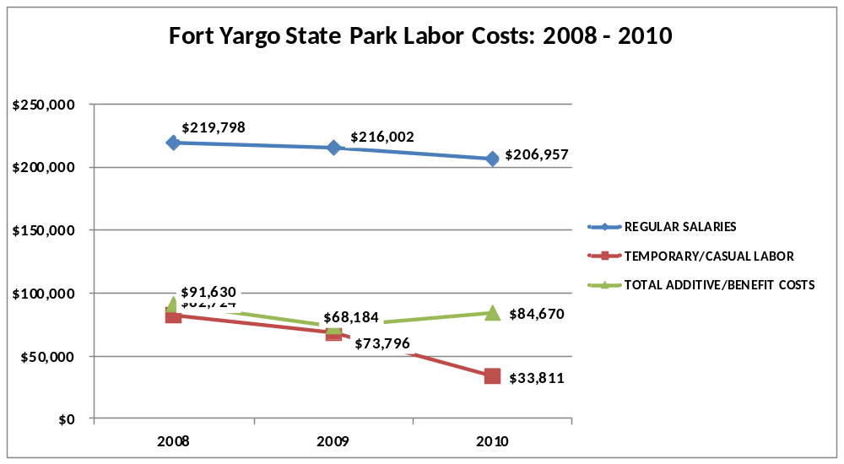

Visitation and Occupancy
Overall annual visitation to the site has trended upward from 2008 to 2010, increasing by 11% or over 36,336 visitors. This is largely attributed to the addition of 5 Yurts and improved day use facilities.

Year | Total Visitation
2008 | 345,725
2009 | 463,311
2010 | 382,061

Occupancy for the overnight accommodations at Fort Yargo State Park the last three years is detailed in the table below. Overall occupancy has trended downward from 2008 to 2010, decreasing approximately by 6%. This is largely attributed to the downturn in the economy causing more people to stay closer to home rather than traveling out of state. In regards to the decrease with cottage occupancy, it would appear guests are choosing the inexpensive overnight options offered at the park like yurts and camping since those facilities have not declined in respect to occupancy rate.

Year | Campsite Occupancy | Cottage Occupancy
2008 | 47.49% | 50.16%
2009 | 41.72% | 51.45%
2010 | 48.85% | 41.83%

Customer Service and Satisfaction

Site | Year | Customer Satisfaction Level
Fort Yargo State Park | 2009 | 68%
Fort Yargo State Park | 2010 | 90%
Financial Performance Assessment

Operational Expenses
A summary of total operating expenses at Fort Yargo State Park from 2008 to 2010, as well as their percent change from 2008 are provided in the table below.
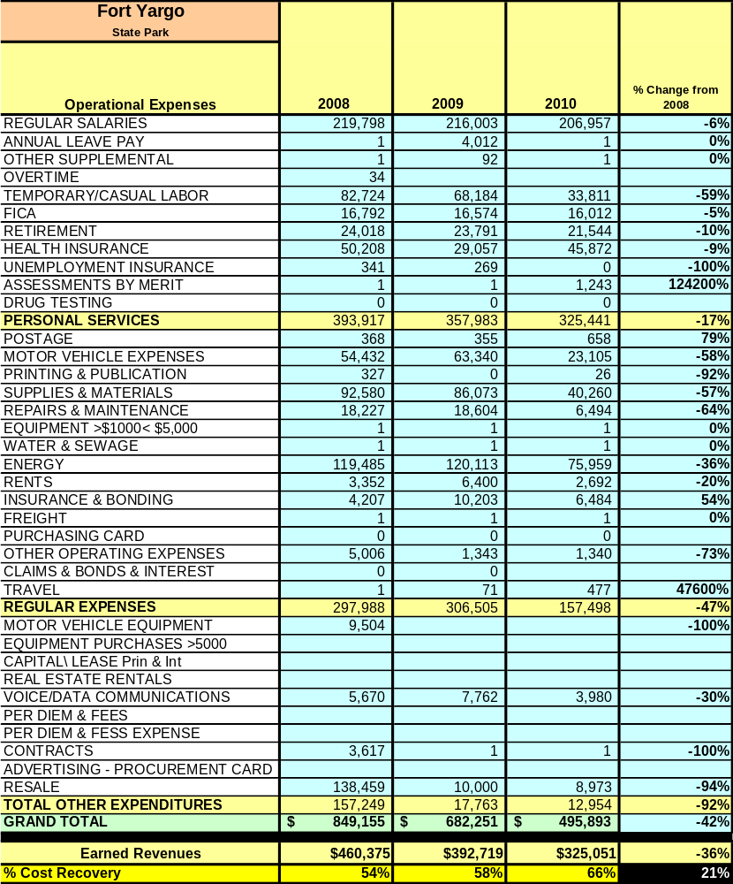

Earned Revenues
Earned revenues at Fort Yargo State Park have decreased since 2008, which is exclusively attributed to the removal of Will-A-Way group camp from Fort Yargo State Parks operation resulting in a decrease in overall revenue. However, the removal of Will-A-Way will save thousands of state funds annually on capitol funds in respects to repairs and renovations
Monthly earned revenues for the last two years (see table below) indicate that the total annual revenue decreased 17% from 2009 to 2010, with the largest increases in monthly revenues in March (13%), April (23%), and June (25%), etc., and the largest decreases in the months of Nov (-48%), Dec (-48%), Jan (-55%), and July (-45%), etc.
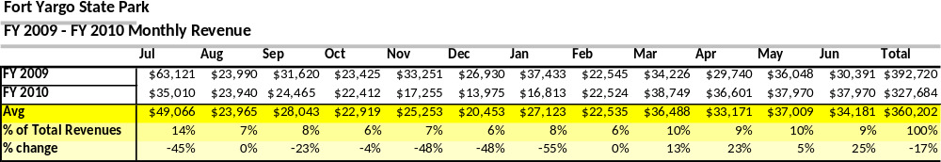
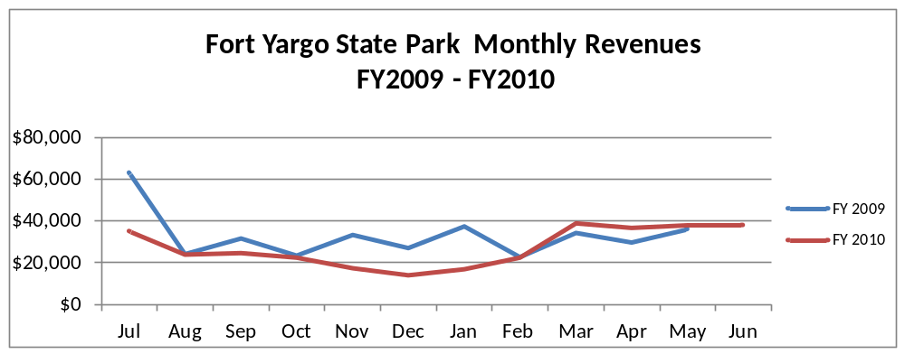
The graphs below illustrate the monthly revenue trends each year and the average percent of total annual revenue earned each month.

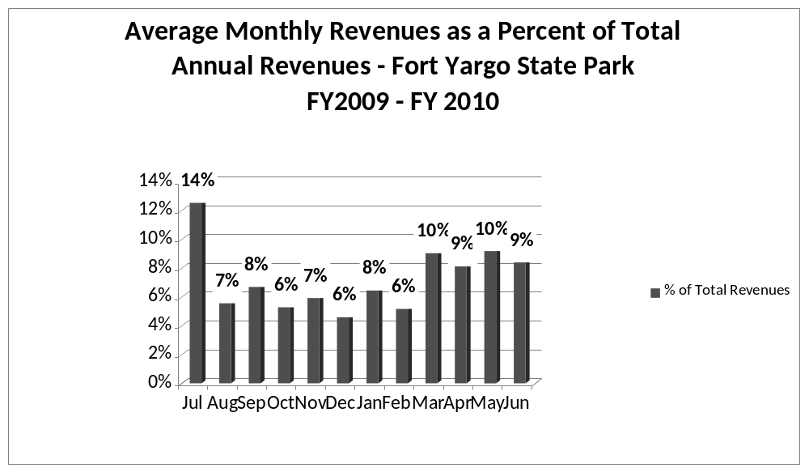

Cost Recovery Trends
Fort Yargo State Park has achieved an average cost recovery of 62% of annual operational expenses through earned revenues from FY 2008 to FY 2010. This is detailed and illustrated in the table and graph below.
Year | Operational  Expenses | Earned  Revenues | Percent Cost  Recovery
2008 | 730,090 | 460,375 | 63%
2009 | 674,979 | 392,719 | 58%
2010 | 494,135 | 325,051 | 66%
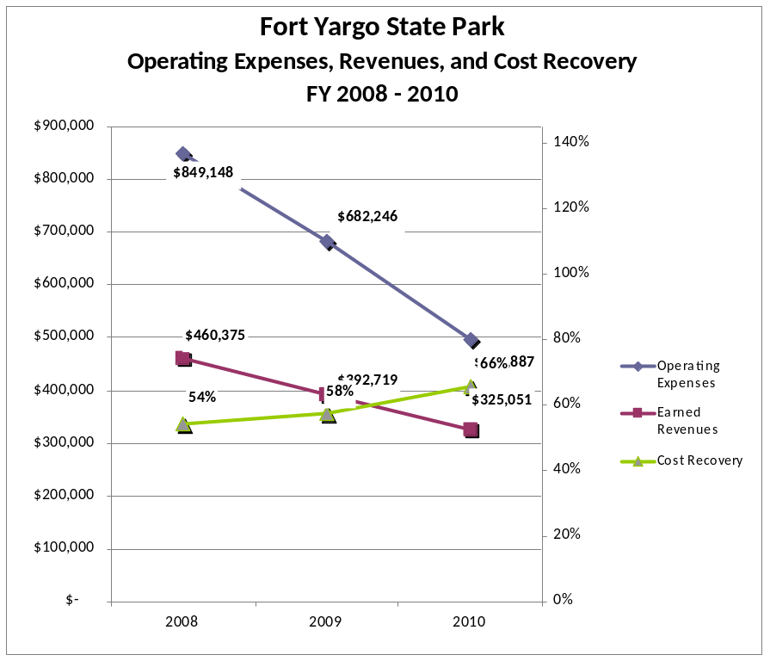

Review of Pricing
Data on rate information is available as far back as 2002, but only the last five years are evaluated. There has been notable growth in fees charged at Fort Yargo State Park since 2007, with the largest increase being Walk-in campsites. A table detailing the rates for Fort Yargo State Park is provided below.
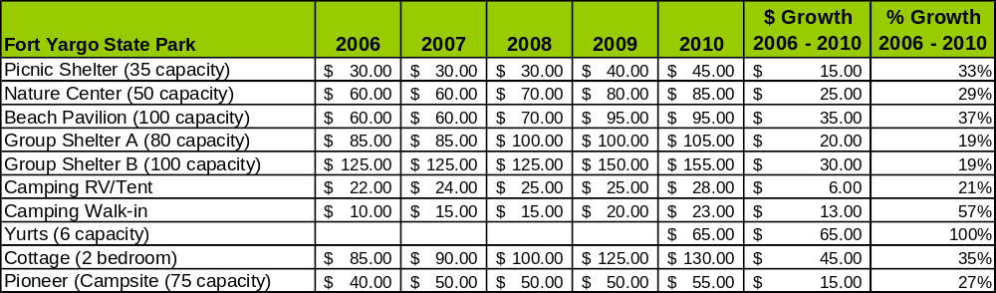
Business and Management Plan

Business Goals
The following goals serve as the foundation for the key recommendations and strategies in this business plan for Fort Yargo State Park.

Enhance Cost Recovery of Site Operations
Control employee’s hours, increase site visitation, occupancy and reduce operations cost.

Enhance Revenue Generation Strategies
- Increase retail return on investment and total sales through economical redesign of office resale area.
- Increase visitation and occupancy in the off-season by offering competitive seasonal discounts.
- Yearly, offer competitive deals for facilities with significant vacancies on the weekends: for example, 25-30% off no minimum stay on last minute deals (2-3 days upon arriving).
- Implement aggressive fee for service programs and events that adds value to guest experience and increases park revenue.

Expand Special Events at the Site
Increase programming and special event efforts by having a seasonal programmer and concessionaires.

Improve the Diversity and Innovation of Recreational and Interpretive Programs
Add / improve interpretation of site through improved signage.

Improve the Effectiveness of Marketing and Sales
Advertise winter discounts to improve occupancy during off-season.

Establish Greater Consistency of Managing and Monitoring Customer Service & Satisfaction
Encourage all guests to go on-line and fill out a customer satisfaction survey to rate their experience at Fort Yargo State Park.

Expand Partnership Opportunities
Reach out to local community services such as YMCA or Anytime Fitness to create an outdoor exercise program.

Classification of Programs and Services
The tables below summarize the classifications of programs and services at Fort Yargo State Park as either core, important, or visitor supported and projects a range of cost recovery percentages that might be achieved for each. These classifications establish financial performance goals for each category of services that are linked to the recommendations and strategies of this business plan.
Core Services
Program / Service | Target Cost Recovery
Active management of the natural and cultural resources of the site in order to protect their integrity | 0%
Open and public access to the site and its resources | 5%
Site appropriate education, interpretation, and recreational opportunities | 150%
Effectively manage the Marbury Creek Watershed | 0%
Public safety to protect visitors and the natural resources | 0%
Maintenance of grounds, facilities and infrastructure | 0%
Self-guided interpretation and education programs | 0%

Important Services
Program / Service | Target Cost Recovery
Day use facilities such as mountain bike trails, tennis and basketball courts and access to the lake for recreational use. | 5%-15%

Visitor Supported
Program / Service | Target Cost Recovery
Gift Shop | 200%
Mountain bike races | 125%
Ranger guided interpretation | 150%
Special events / programs related to the mission of the site | 150%
Special events / programs not related to the mission of the site or outside the normal programing standards (e.g., wedding receptions, etc.) | 150%
Mini Golf Rentals | 120%
Camping, Yurts, Cottages, Pioneer Sites to be used for overnight facilities at the site. | 150% - 200%
Day use facilities such as Picnic Shelters and Group Shelters. | 50%
Day use and boat rentals at the beach | 200%

Partnership Development Plan
The table below summarizes existing partners and targeted partnerships by classification (operational, vendor, service, co-branding, funding partners) and by organizational type.
 | Public Partners | Not-for-profit Partners | Private / Enterprise Partners
Operational Partners | - City of Winder Police & EMS  - Barrow County Sheriff Department and EMS  - WRD  - DOC  - DHR | - Camp Twin Lakes
Vendor Partners |  |  | - Coca Cola  - Georgia Power
Service Partners | - City of Winder  - Georgia Power  - Jackson EMC | - Barrow County Chambers of Commerce  - Yargo Area Biking Association  - Fort Yargo Living History Society
Co-branding Partners | - Hard Labor Creek State Park  - Victoria Bryant State Park  - Barrow County Chamber of Commerce |  | - Chateau Elan  - Stone Mountain Park
Funding Resource Development Partner |  | - Friends of Fort Yargo State Park

Marketing and Sales Plan

Marketing and Sales Goals
Marketing and sales goals for Fort Yargo State Park are based on the following desired outcomes:
- Increase Yurt rentals by 5%-10% over the next year through marketing the experience and rarity of Yurt Camping.
- Increase Cottage rentals by 5%-10% over the next year through advertising of special discounts offered during off peak seasons.
In order to meet these goals, examples of specific target outcomes were identified in the areas detailed in the table below.
Area  of Focus | Current  Performance | Goal  by 2011 | Goal  by 2012 | Goal  by 2015
Yurt Rentals | 60% | 62% | 63% | 66%
Campsite | 49% | 50% | 51% | 54%
Cottage Rentals | 42% | 43% | 44% | 47%

Marketing and Promotion Strategies

Publicity and Social Media
Fort Yargo State Park will approach marketing and publicity planning using the following guidelines and themes:
- Event publicity
Major events benefit by having short stories in local, regional, and statewide newspapers and online social media hooks planted that run three to four weeks in advance of the event up to the date of the event itself. Stories and media need to be cultivated with contacts and online sales channels several weeks in advance of the time the stories need to run. Special interest interviews on morning, noon, and evening television news programs, radio interviews on popular rush-hour programs, and blogs on known affinity online sites should also be included.
- Program publicity
Special and unique programs should have feature stories in magazines, local and regional weekly newspapers, and statewide daily newspapers that are aimed at placements as front-page or sectional front-page stories. These stories are most effective if they run shortly before the season that the featured program begins. This will likely require several weeks of advanced planning with media contacts. Similar coverage on television and radio should also be considered. If pre-publicity cannot be generated, post-publicity can help promote future programs.
- Site Publicity
Site publicity focusing on a single site or sub-set of sites requires more intense planning efforts to attract multiple writers and editors from target publications. Each site could host several seasonal media familiarization tours (with 10 to 15 writers or editors) to familiarize them with the site and its benefits and amenities. Stories and features resulting from such tours typically take between two and six months to materialize so the tours should focus on experiences, benefits, and programs that would be available when the stories are expected to run.
Examples and suggested opportunities for events, programs and related publicity efforts based on the themes described above at Fort Yargo State Park are provided in the table below.
Event Publicity | Program Publicity | Site Publicity
July 4th Fireworks | Bluegrass Festival | Old Fort Colonial Market Fair
Bass Tournament | Autumn Nights | Controlled Burning
Community Customer Appreciation Cookout | Mountain Bike Expo/ Meet and Greet | Special Winter Discounts

Packaging
Examples and suggested packages for Fort Yargo State Park are provided in the table below.
Package | Package Details
Yurt Package | Stay 3 nights and get the fourth night 50% off
Cottage Package | Stay 3 nights and get the fourth night 50% off
Campsite | Stay 3 nights and get the fourth night free

Group Sales
Types of groups within which specific target customers can be identified for Fort Yargo State Park are listed below:
- Travelers on Interstate 85 | - Extended Stay Workers | - Families

Incentivizing New and Repeat Visitation
Fort Yargo State Park will utilize the following strategies and/or incentives to encourage new and repeat visitation starting in FY 2012:
- Fort Yargo State Park will offer discounts for extended stay guest working in the local area.
- Fort Yargo State Park will offer special fun play packages to include a free round of disc golf, miniature golf, and the rental of a jon boat, pedal boat or canoe.

Marketing and Sales Metric Goals
The following marketing and sales metric goals and/or others will be monitored and progress reported at Fort Yargo State Park:
- Loyalty and repeat customers = 60% of those staying overnight.
- Brand confidence & customers-recruiting-customers = 30% of those returning to the park; especially for day use.
Revenue Generation Plan
Revenue / Cost Recovery Goals
Fort Yargo State Park has set a financial goal of increasing annual revenues 3% annually between 2012 and 2015. The largest revenue growth opportunity is most likely the addition of rentable overnight facilities. The table below details projected revenue growth leading up to 2015, based upon a nominal growth of revenues each year.
Year |  | % Growth from Previous Year | Jul | Aug | Sep | Oct | Nov | Dec | Jan | Feb | Mar | Apr | May | Jun | Total
2010 |  | Base Year | $35,010 | $23,940 | $24,464 | $22,412 | $17,255 | $13,975 | $16,813 | $25,524 | $38,749 | $36,601 | $37,970 | $32,011 | $324,724
2011 |  | 3% | $36,060 | $24,658 | $25,198 | $23,084 | $17,773 | $14,394 | $17,317 | $26,290 | $39,911 | $37,699 | $39,109 | $32,971 | $334,466
2012 |  | 3% | $37,142 | $25,398 | $25,954 | $23,777 | $18,306 | $14,826 | $17,837 | $27,078 | $41,109 | $38,830 | $40,282 | $33,960 | $344,500
2013 |  | 3% | $38,256 | $26,160 | $26,732 | $24,490 | $18,855 | $15,271 | $18,372 | $27,891 | $42,342 | $39,995 | $41,491 | $34,979 | $354,835
2014 |  | 3% | $39,404 | $26,945 | $27,534 | $25,225 | $19,421 | $15,729 | $18,923 | $28,727 | $43,612 | $41,195 | $42,736 | $36,029 | $365,480
2015 |  | 3% | $40,586 | $27,753 | $28,360 | $25,982 | $20,003 | $16,201 | $19,491 | $29,589 | $44,921 | $42,431 | $44,018 | $37,110 | $376,444

These projections would result in a total of 16% cumulative growth in total annual revenues between FY2010 and FY2015. If operational expenses can be managed with a cumulative reduction of 2% between FY 2010 and FY 2015, then the overall cost recovery of the site will be approximately 78% in FY 2015 at these projected revenue levels. This is higher than the annual financial performance of the site in FY 2010, which was operated at 66% cost recovery in that year.

Pricing Plan
Revenue Generation Strategies
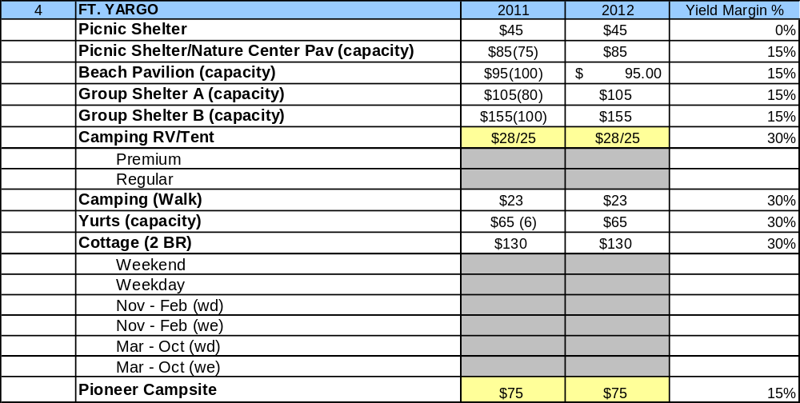

Innovative Programming and Special Events Plan
Program / Event | Theme / Purpose | Scheduled Date/Season | Frequency | Target Participation | Target User Fee | Target Cost Recovery
Mountain Bike Festival | Mountain Biking/Increase volunteers | May 2012 | Annual | Youth, Adult, Senior, Family | $5 per person | 200%
Bluegrass Festival | Bluegrass/Increase attendance and revenue | Nov 2011 | Annual | Family | $3 per person | 150%
Disc Golf Tournament | Competitive Disc Golf Tournament/Increase attendance and revenue | June 2012 | Annual | Youth/Adult | $25 | 200%
Mountain Bike Race | Race/ Increase attendance and revenue | April 2012 | Annual | Youth/Adult | $50 | 150%
Mountain Bike Beginner Lessons | Mountain Biking/Increase attendance and revenue | Sep 2011, April 2012, June 2012 | 3 – 4 times yearly | Youth | $25 per person | 150%

Partnerships and Concessions Plan
Service / Partnership | Term of Service | Financial Objective | Contract Manager
Boat Rental agreement | 1 year | 10% of rented revenue | Park Manager
Mountain bike races | 1 year | $5 per racer or $20 per team | Park Manager

Expense Management Plan
Personnel Assignments
The following actions will be taken to proactively manage labor costs via personnel assignments and classifications.

Action | Timeline | Outcome
Reduce 1508 hours during the winter and use the positions of 1 clerk and 1 maintenance worker as true seasonal positions. | 2012 | Save $10,000 in salaries
Upon retirement of Housekeeper position eliminate full time position and replace position with 1508 or contract labor | 2011-current | Save $10,000 in salary
Reduce the number of 1508 hourly maintenance workers and naturalist which are hired seasonally | 2009 – current | Save over $30,000 in salaries

Management Techniques
The following actions will be taken to proactively manage labor costs via management techniques.

Action | Timeline | Outcome
Continue to use seasonal maintenance and park office staff during peak periods and reduce use during off peak periods | As needed | Save money on salaries and benefits packages

Adjusted Levels of Service
The following actions will be taken to proactively manage labor costs via reduced levels of service.

Action | Timeline | Outcome
Close Picnic Area 2, Public Fishing & Area B (Picnic Shelter #4, Group Shelter B, Fishing Boat Ramp and Pioneer Camping) during the non-peak season (winter) | Winter 2011 - 2012 | Reduce operating expenditures of supplies, fuel/patrol and maintenance
Close Campground 2 during off peak season (winter) | Winter 2011 - 2012 | Reduce operating expenditures of supplies and maintenance
Reduce landscaped areas to be maintained and the frequency of cutting | On-going | Reduce operating expenditures of equipment maintenance and fuel cost

Financial Pro Forma
The following five-year financial pro forma projects operating expenses, earned revenues and cost recovery through FY 2015. These pro forma are based on the strategies and desired outcomes identified in this business plan, especially the revenue generation and expense management plans, and are linked to corresponding performance goals.
Expense Pro Forma

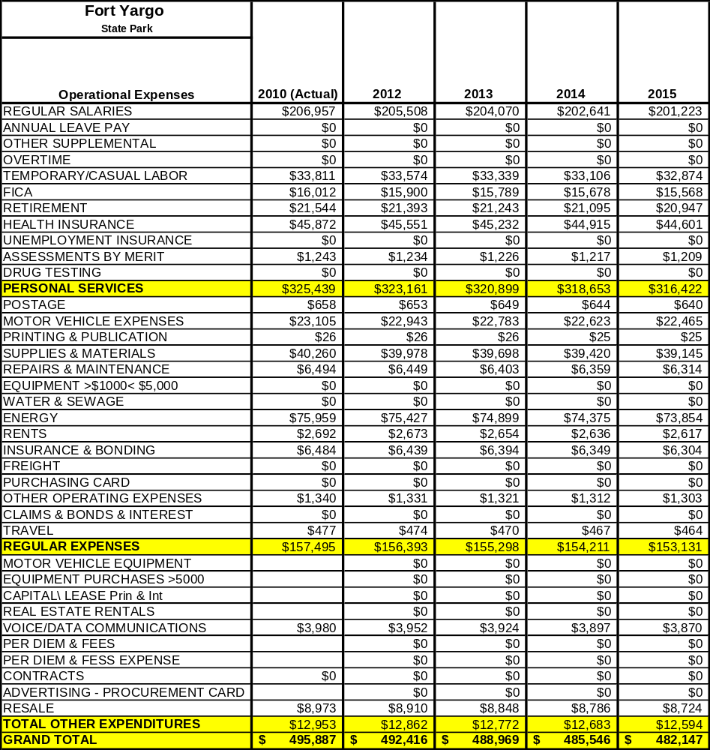

Revenue Pro Forma
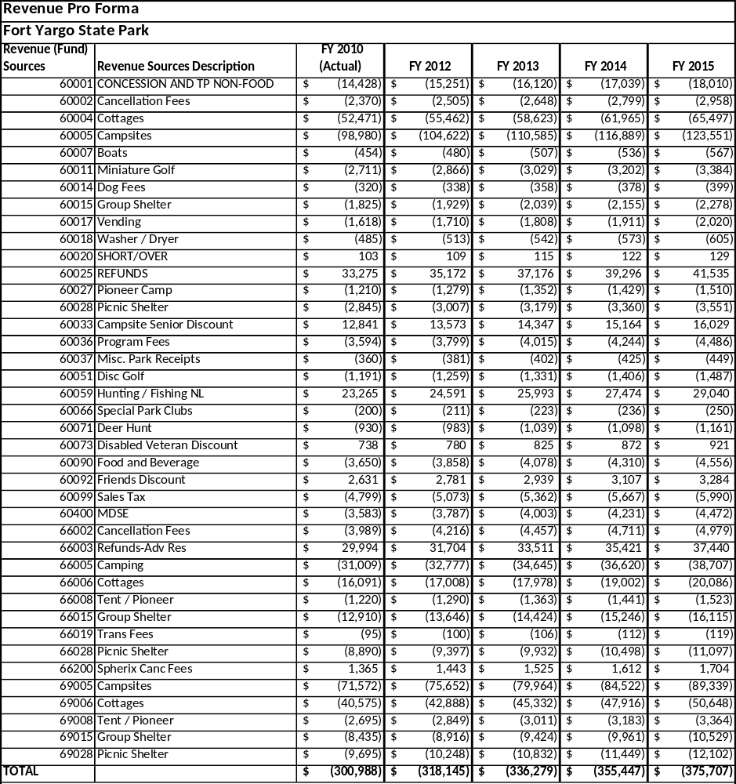

Total / Cost Recovery Pro Forma

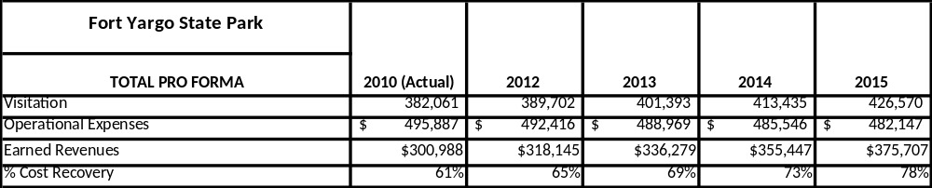

Action Plan
ACTION PLAN
Site: Fort Yargo State Park |  | Site Manager: |  |  | Date:
Month:
Strategy | Tasks | Costs / Funding | Revenues / ROI | Responsibilities | Metrics

ACTION PLAN
Site: Fort Yargo State Park |  | Site Manager: |  |  | Date:
Month:
Strategy | Tasks | Costs / Funding | Revenues / ROI | Responsibilities | Metrics

This is the average of the last three years – FY 2008, FY 2009, and FY 2010
Current employees, not including vacancies.
Current employees, not including vacancies.
Major population centers within a two-hour drive from the site

