Prepared June 2011; Finalized January 2013
GENERAL COFFEE STATE PARK
Business & Management Plan

Direction 2015 – Sustainable Business Planning

Table of Contents

Executive Summary 3

Site and Operations Assessment 7
Site Inventory and Facility Assessment 7
Operational Assessment 9
Financial Performance Assessment 14

Business and Management Plan 18
Business Goals 18
Classification of Programs and Services 19
Partnership Development Plan 22
Marketing and Sales Plan 23
Revenue Generation Plan 25
Expense Management Plan 27
Financial Pro Forma 28

Action Plan 31

Executive Summary
The Parks, Recreation and Historic Sites Division (PRHSD) of the Georgia Department of Natural Resources (DNR) is transitioning the management of General Coffee State Park to operate more like a business, reflecting the Direction 2015 – Sustainable Business Planning initiative to improve the fiscal performance and management of the state parks and historic sites system. This business and management plan is designed to help the site recover more operating expenses through earned revenues, productive partnerships, and innovative programs.

Site Fact Sheet
Site Name | General Coffee State Park
Site Manager | Wade Huffman
Region Manager | Tommy Turk
Date of Business Plan completion | Original version completed 6/07/11; 11/29/2012 updated version completed 11/29/12
Site size | 1,511 acres
Total number of visitors (FY 2010) | 93,982
Total operating budget (FY 2010) | $ 392,288
Total earned revenues (FY 2010) | $ 204,049
Operational cost recovery (FY 2010) | 52%
Average operating cost per visitor (FY 2010) | $ 4.17
Average earned revenue per visitor (FY 2010) | $ 2.17
Average cost recovery (FY 2008 – 2010) | 53%
Target cost recovery (FY 2015) | 74%
Total full-time employees | 4
Total part-time employees | 7
Primary service markets | Valdosta GA, Savannah GA, Jacksonville FL
Primary attractors/visitor appeal factors | Camping/equestrian camping, hiking trails, 4-acre lake, fishing, pedal boats, canoes, bikes, cottages, group lodge, group shelter, picnic shelters, Heritage Farm with museum, amphitheater
Leading opportunities for improved site performance | Development of equestrian facilities to include trails, stables, corrals, camping and other overnight facilities

Site Summary and Key Attractions
The 1,511-acre site of General Coffee State Park is located in a rural setting. It is roughly 130 miles from major population centers in Georgia like Macon and 120 miles from Savannah. It is also roughly 50 miles from Interstate 75 and 215 miles from Interstate 85. The most popular amenities of General Coffee State Park are as follows:
- 50 camp, trailer, and RV campsites
- 6 cabins
- 1 group lodge (sleeps 40)
- Equestrian campsites
- 4-mile nature trail and boardwalk
- 5-acre Heritage Farm
- 13.4-mile horse trail
- 4-acre lake
- Pedal boat, canoe and bike rentals
- Playgrounds
- 7 picnic shelters and 1 group shelter
- Gift shop
- Interpretive programs and special events

Financial Targets
The table below details the total operating expenses and earned revenues for General Coffee State Park over the last three years (2008 – 2010). This table also calculates total cost per visitor and revenues per visitor during these operating years, and details the target financial performance goals in the context of achieving at least 74% cost recovery. This table also calculates the necessary change from 2010 operating expenses and revenues.

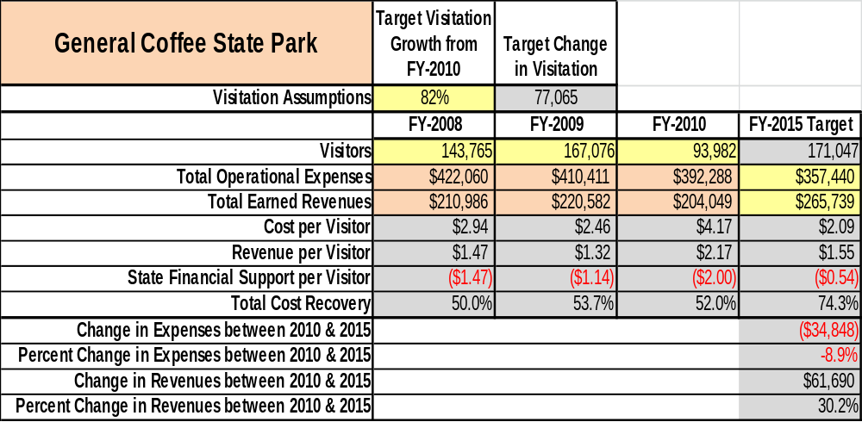
Key Recommendations

Primary / Short Term Recommendations
- Operate the site using cost-based accounting, including net cost recovery.
- Conduct in-park surveys annually to assess how well customer satisfaction levels are being met. General Coffee State Park should strive to have 90% of visitors responding to ‘Comment Cards’ and reporting that they were either ‘satisfied’ or ‘very satisfied.’ Programs or services that fall below that standard should be critically reviewed, enhanced, and results monitored; those with a history of poor performance should be considered for elimination.
- Evaluate and pursue opportunities to employ concessionaires or private or public service providers on-site if they can be more cost effective. For example, explore the development of a concessionaire agreement to manage private events on-site.
- Collect a statistically valid sample of ZIP code data from visitors in a non-intrusive way to gauge their origins and demographics (e.g., age, ethnicity, income, etc.) and use the results to improve programming and marketing efforts to appeal to a broader audience.
- Utilize a minimum of ten special events annually to help draw more visitors to the site.
- Seek local partners to help support operations, programs, service delivery and cross-marketing. In talks with Nature Conservancy for park staff to be trained in interpretation of the Broxton Rocks Natural Area; thought is to develop revenue sharing between General Coffee and the Nature Conservancy, as well as cross-promotion of our agencies.
- Sustain sufficient non-labor operational funding or reduce staff so that required staff operational costs (with benefits) do not exceed 65% of the total operational budget.
- Enhance facilities and program offerings to provide a minimum of 6 unique experiences for each visitor while maintaining at least a 90% customer satisfaction rating. (See C-O-F-F-E-E acronym description of 6 unique experiences under Business Goals below in this plan.)
- Manage General Coffee State Park according to well-defined maintenance, program and operational standards, monitored and enforced by region managers and senior management.
- Continue collaboration with local Chambers of Commerce or other destination marketing organizations to promote General Coffee State Park.
- Continue collaboration with the Friends of General Coffee State Park to maintain the Farm, Museum and animals 100%, covering all expenses, including upkeep. Also consider hosting a local blacksmithing guild that will provide programs in blacksmithing instruction (will require some expansion of the blacksmithing shop – plans are being drawn up to this end.
- Continue to work with the General Coffee Chapter of the Friends of Georgia State Parks and Historic Sites to help raise funds or provide volunteers for improvements and program support.
- Perform a thorough net cost-of-service analysis on major functions of site operations, including the detailed analysis of labor requirements (by task) that has already been produced by site staff. Thereafter, update costs to deliver services on a biennial schedule.
- Review and update rates at the site on an annual basis to recover the total net cost of service for important and visitor-supported services.
- Develop on-line sales of gift shop and retail items associated with the site in order to increase site-generated revenues.
- Track total economic impact of the site on the local communities and region and share with decision-makers, elected officials, local business operators, and others to demonstrate the impact of General Coffee State Park.
- Develop a more detailed analysis of labor requirements of all major park functions to match the right position with the right job at the right pay.
- Develop funding to provide additional training to site staff for improved business management and marketing effectiveness.
- Construct and upgrade facilities and amenities at the site that are likely to have a cost recovery level at or above 100%, including disk golf and further expansion of equestrian facilities.
- Add stables or corrals in proximity to the cottages and group lodges so that those facilities can be rented by horse riders and equestrian groups.
- Add more youth-focused services, programs and amenities at the site that appeal to younger audiences, families and educational groups, (i.e., “adventure-based” programming such as ranger-led canoeing trips on the Satilla and Ocmulgee, overnight camping trips on-site, athletic competition, trail runs, etc.
- Add more services, programs and amenities that appeal to older adults, (i.e., increase historical based programs and “food-based” programming, and utilize movie license, projector, popcorn machine, etc., to appeal to parents with younger children) to let site provide means to give parents a break from providing meals and entertainment on non-school nights.
- Increase promotion of the park as an equestrian destination and complete a master plan of the park to include a comprehensive design of an equestrian facility.
- Purchase low frequency AM-radio transmitter that allows broadcast of 5 minute loop and does not require a license (has shown to be a good promotional tool at another historic site.

Secondary / Long Term Recommendations
- Improve the recreational amenities of the site to address modern and diverse uses, such as offering a variety of non-traditional activities (i.e., geocaching, Frisbee golf, ultimate Frisbee, developing a “fitness” section for our trail, or considering the feasibility of offering archery programming).
- Engage the local community, user groups, and private organizations to improve connectivity between General Coffee State Park and other Historic or Recreational areas nearby, such as cross-promoting with similar service providers (i.e, geocaching events co-sponsored by General Coffee and Laura S. Walker, discounts offered when attending events at several area sites, etc.).
- Improve retail point-of-sale and inventory tracking system.
- Continue to develop the park as an equestrian destination by developing partnerships with local and regional equestrian clubs, partnering with Friends to offer trail rides and similar events that will highlight the site’s equestrian trails, and considering development of a trail association with a mission specifically geared to care for the site’s equestrian trails and accommodations.
Site and Operations Assessment
This site and operations assessment is a culmination of analyses and findings from a review of the condition of facilities, infrastructure, and operations at General Coffee State Park. The findings and observations are not intended to be an exhaustive review of all issues present, but provide a basic understanding of the predominant issues that contribute to the site’s current operating conditions. The assessment includes the following:
- Site Inventory and Facility Assessment
- Operational Assessment
- Financial Assessment
Site Inventory and Facility Assessment

Methodology
Facility and asset conditions are rated using a differential scale of excellent, good, fair, or poor. Descriptions of conditions that are attributed to each of these findings are also provided.
Scale of Conditions
Rating | General Description
Excellent | Facilities/amenities are in ‘excellent’ condition when they show little or no maintenance or repair problems. Facilities do not feature any major design or operational issues or flaws that contribute to diminished use or increased maintenance or upkeep. Facilities are easy to clean and maintain in order to place them back into public use and the users perceive them to be in excellent shape.
Good | Facilities/amenities are in ‘good’ condition when they show only minor maintenance or repair problems. Most maintenance issues with these facilities typically appear to be the result of age and/or heavy use. Facilities may only feature minor design or operational issues that contribute to diminished use or increased maintenance or upkeep. Facilities are moderately easy to clean and maintain in order to place them back into service and the users perceive them to be adequate for their use, but probably not in excellent shape.
Fair | Facilities/amenities are in ‘fair’ condition when they show significant maintenance or repair problems. Facilities generally exhibit ongoing maintenance issues that appear to be the result of age, heavy use, or design or operational flaws. Some maintenance and repair needs may compound their fair condition by being deferred because of budget and/or resource limitations. Facilities require more effort to clean and maintain before placing them back into service and the users may perceive them as being less than adequate for their use and in a state of deterioration. The facility or structure may need of major repair or replacement.
Poor | Facilities/amenities are in ‘poor’ condition when they show significant, on-going maintenance or repair problems that ultimately may result in suspended use for repair/replacement. Maintenance and repair issues are possibly the result of poor maintenance and clearly the result of age, heavy use, or design or operational flaws. Problems with the facilities are often compounded over time due to consistently-deferred maintenance and repair because of budget and/or resource limitations. Facilities may feature major design or operational issues that contribute to diminished use or increased maintenance or upkeep. Facilities require excessive effort to clean and maintain before placing them back into service and the users often perceive them as being inadequate for their use and in a state of serious deterioration. The facility or structure may need of major repair or replacement.

Inventory and Assessment
The table below is an inventory of facilities and amenities at General Coffee State Park, and provides the assessed condition of each as reviewed in May 2011.

Site Asset / Amenity | Quantity | Condition
Park Office | 1 | Good
Picnic Shelter | 7 | Good
Group Lodge | 1 | Good
Farm with outbuildings | 1 | Fair
Museum | 1 | Fair
Campsites (tent, RV, trailer) | 50 | Fair
Pioneer camp | 2 | Good
Horse Camping | 4 | Fair
Group Shelter | 1 | Fair
Cottages | 6 | Good
Nature trails | 4 ¾ miles | Good
Equestrian trails | 14 Miles | Good
Playgrounds | 4 | Good
Day Use Restrooms | 2 | 1 Good, 1 Fair

Prioritized Facility Needs
Based on the facility inventory and assessment, these prioritized needs have been identified. Each need has been aligned with a priority category of high, moderate, or low to support future decision-making regarding project sequencing, investment of public resources, and meeting community expectations. The priority assignment for each need is not a measure of importance. Rather, these recommended priorities reflect a phased implementation approach over the next several years.

Facility Need | Priority Assignment
Develop equestrian area with stables, rest station, riding ring, etc. | High
Install small number of full hook-up campsites when dump station repairs are completed | Low
Develop classroom area between amphitheater and day-use area | Low
Replace day-use rest station | Moderate
Renovate 2 BR cottages (new flooring, furnishings, themed?) | Moderate
Replace Loop 1 and Loop 2 comfort stations | Moderate
Replace wood shingle roof at Burnham cottage with steel roof | Moderate
Repair roofs on all buildings in farm area | Moderate
Repair damage from termites in Tobacco Barn | Low
Renovate group shelter | Moderate
Replace Nature Trail boardwalks | Moderate
Renovate campground | High
Construct small Frisbee golf course | Moderate
Expand wi-fi coverage at site | Moderate

Operational Assessment
The Operational Assessment includes:
- An inventory and classification of programs and services being provided at the site
- A review of staffing at the site
- A review of concessionaires and partners operating at the site
- Visitation and customer satisfaction

Inventory and Classification of Programs and Services
Programs and services are classified into one of three major categories:
1) Core or Essential Services
2) Important Services
3) Visitor Supported Services
Programs and services at the site are classified into these categories based in part on the mission and public mandates for both the site and the agency. There are cost recovery expectations that will define how services are funded and evaluated for each classification.

Category 1 – Core Services (Largely supported by tax funds with little or no cost recovery)
Core programs, services and facilities are those the agency must provide and/or are essential in order to capably govern and meet statutory requirements. The failure of the agency to provide Category 1 services at adequate levels could result in significant negative consequences for the public and the resources under protection. The criteria for programs or services to be classified as core or essential are:
- The services are mandated by the agency’s law or charter or are contractually obligated by agreement to provide the services.
- The services are essential to protecting and supporting the public’s health and safety.
- The services protect and maintain valuable assets and infrastructure.
- The services would generally and reasonably be expected and supported by residents, businesses, customers and partners.
- The services are those that cannot or should not be provided by the private sector.
- The services provide a sound investment of public funds.
The following services offered at General Coffee State Park have been identified as core services:
- Active management of General Coffee State Park, focusing on the natural and cultural resources of the site in order to protect their integrity
- Open and public access to the site and its resources
- Site appropriate education, interpretation, and recreational opportunities
- Public safety
- Maintenance of grounds, facilities and infrastructure

Category 2 – Important Services (Supported by a balance of taxes and earned revenues)
Important programs, services and facilities are those the agency should provide, and are important to effectively serving visitors. Category 2 services expands/enhances the agency’s ability to provide and sustain its core services. The criteria for programs or services to be classified as important are:
- The services expand, enhance or support identified core services.
- The services are broadly supported and utilized by the community, and are considered an appropriate, important, and valuable public good. Public support may be conditional upon the manner by which the services are paid for or funded.
- The services generate income or revenue that offsets some or all of the operating cost and/or are deemed to provide economic, social or environmental outcomes or results.
The following services offered at General Coffee State Park have been identified as important services:
- Interpretation and education programs
- Camping (tent/RV; pioneer; horse)
- Day-use facilities such as picnic shelters and a group shelter
- Trails (nature and equestrian)

Category 3 – Visitor Supported Services (Heavily or fully supported by earned revenue)
Services that the agency may provide when they are fiscally sustainable via visitor support; these services may add value beyond what is expected. The criteria for programs or services to be classified as visitor supported are:
- The services expand, enhance or support core services or important services and the quality of life of the visitors, community or stakeholders.
- The services are supported, valued and well utilized and provide an appropriate and valuable public benefit.
- The services generate income or funding from sponsorships, grants, user fees or other sources that offset some or all of their cost and/or provides a meaningful return on investment.

- The services can possibly be provided through outsourcing or use of concessionaires, providing opportunities for community enterprises that may not otherwise be provided by the agency.
The following services offered at General Coffee State Park have been identified as visitor supported services:
- Gift Shop
- Nature and educational programs by interpretative ranger
- Special events/programs related to the mission of the site
- Special events / programs not related to the mission of the site or outside the normal programming standards (e.g., wedding receptions, etc.)
• Boat rentals and bike rentals
• Accommodations such as group lodge, group shelter and cottages

Staffing Assessment
Labor costs at General Coffee State Park represent the largest area of budgetary expense at an average of 65% of the total operating budget each year for the last three complete years, which is lower than the target of total labor costs (including benefits) not exceeding 65% of the site’s total operating expenditures. The tables below and on the following page provide a basic review of the current staffing at the site.
Full Time Equivalent Employees
Position / Title | Quantity (FTE) | Vacancies | Annual Hours
Park Manager | 1 | 0 | 2500
Assistant Park Manager | 1 | 0 | 2500
Interpretive Ranger | 1 | 0 | 2080
Park Ranger | 1 | 0 | 2080
Housekeeper | 0 | 1 | 0
Secretary | 0 | 1 | 0
TOTAL | 4 | 2 | 9,160

Part Time Employees
Position / Title | Quantity (FTE) | Vacancies | Hours
Maintenance Worker | 3 | 0 | 3400
Office Clerk | 2 | 0 | 1508
Naturalist | 1 | 1 | 800
Housekeeper | 1 | 0 | 1508
TOTAL | 7 | 1 | 7,216

Labor Support
Labor Support | Annual Hours
Volunteers | 1600
Community Service Workers | 1700
Engineering and Construction Crews | 0
Resource Management Crews | 120
TOTAL | 3,420

Total Labor Hours
Labor Type | Annual Hours
Full Time Equivalent Employees | 9,160
Part Time Employees | 7,216
Labor Support | 3,420
TOTAL Annual Labor Hours | 19,796

Labor Budget Summary
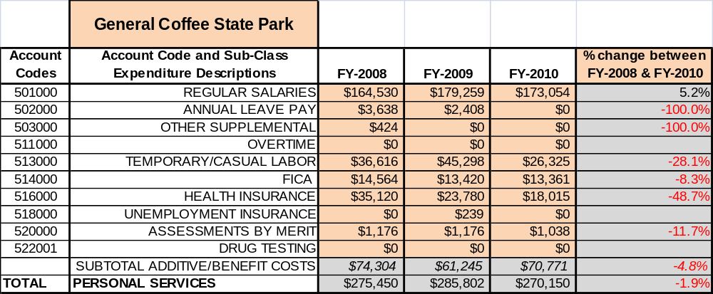

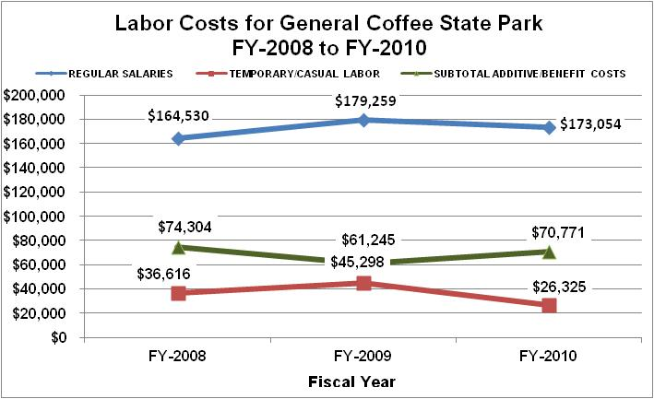

Visitation and Occupancy

Visitation and Occupancy
Overall annual visitation to the site has trended downward from 2009 to 2010, decreasing by 70% or over 73,094 visitors. This is largely attributed to correcting the inaccurate counting of park visitors and the closure of the swimming pool for summer visitation and the resulting reduction in shelter rentals, as well as a faulty traffic counter, which will be repaired and/or replaced.
Year | Total Visitation
2008 | 143,765
2009 | 167,076
2010 | 93,982

Occupancy for the overnight accommodations at General Coffee State Park the last three years isdetailed in the table below. Overall occupancy has trended downward from 2008 to 2010, decreasing by 12%. This is largely attributed to the economic down turn.

Year | Campground Occupancy | Cabin  Occupancy
2008 | 17.35% | 46.92%
2009 | 17.35% | 42.38%
2010 | 17.08% | 34.09%

Customer Service and Satisfaction

Site | Year | Customer Satisfaction Level
General Coffee State Park | 2009 | 83%
General Coffee State Park | 2010 | 75%
Financial Performance Assessment

Operational Expenses
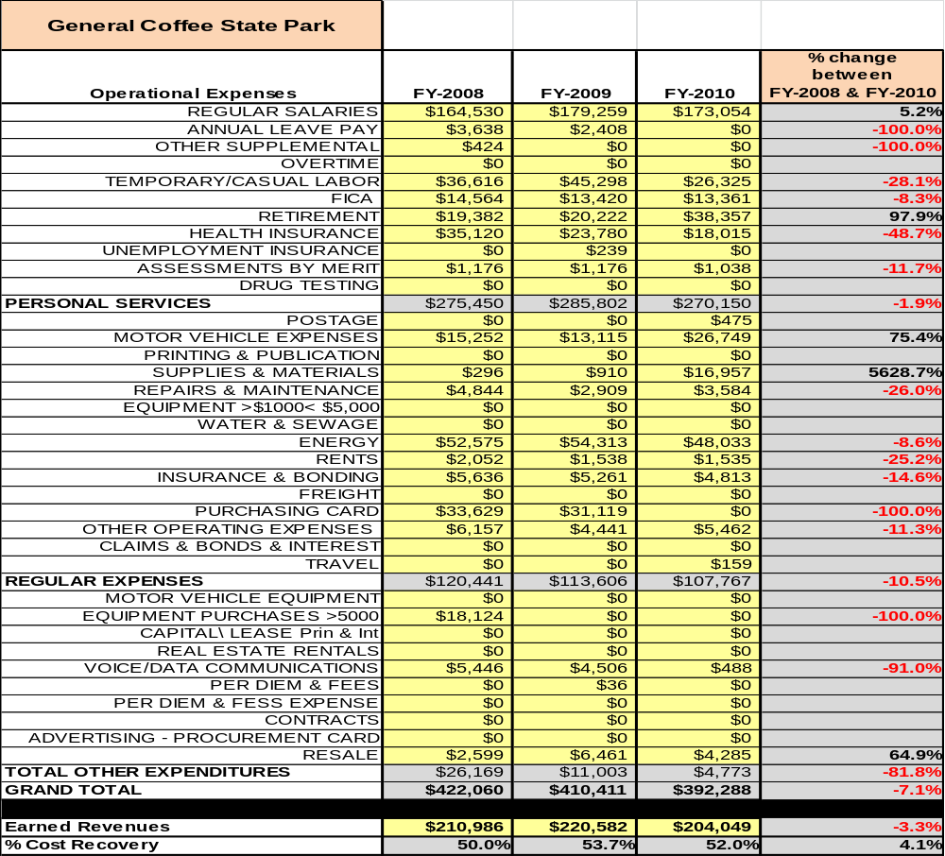
A summary of total operating expenses at General Coffee State Park from 2008 to 2010, as well as their percent change from 2008 are provided in the table below.

Earned Revenues
Earned revenues at General Coffee State Park increased from 2008 to 2009, then decreased in 2010. Also, visitation has seen radical swings in both directions, with little correlation between visitation and increases in revenue.
Monthly-earned revenues for the last two years (see table on the following page) indicate that the total annual revenue decreased 10% from 2009 to 2010, with the largest increases in monthly revenues in September (12%), December (56%), April (42%)and June (11%) and the largest decreases in the months of July (-36%), August (-29%), November (-25%), January (-19%), February (-13%) and May (-23%).

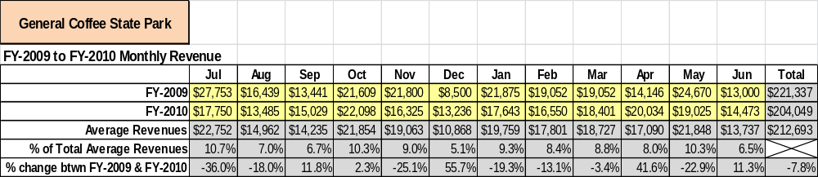

The graphs below and on the following page illustrate the monthly revenue trends each year and the average percent of total annual revenue earned each month.

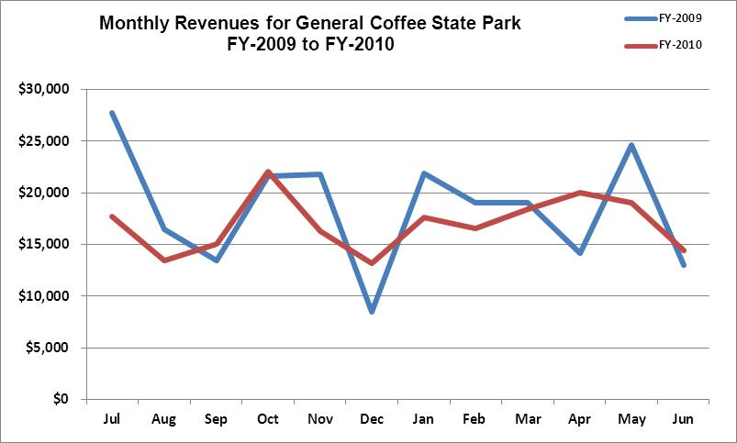
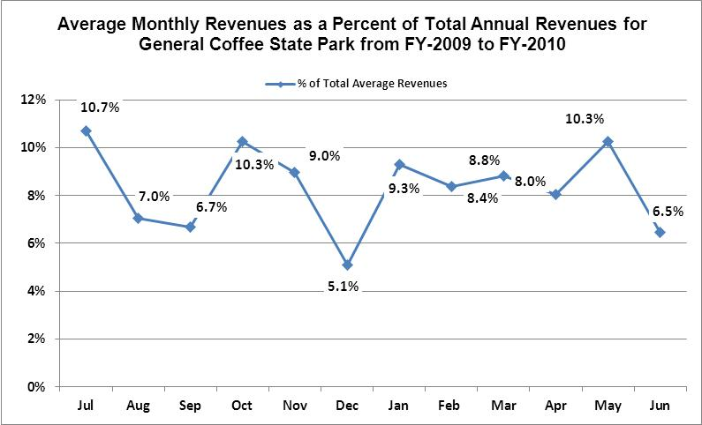

Cost Recovery Trends
General Coffee State Park has achieved an average cost recovery of 52% of annual operational expenses through earned revenues from FY 2008 to FY 2010. This is detailed and illustrated in the table and graph below.
Year | Operational  Expenses | Earned  Revenues | Percent Cost  Recovery
2008 | 422,060 | 210,986 | 50%
2009 | 410,411 | 221,008 | 54%
2010 | 392,288 | 204,049 | 52%

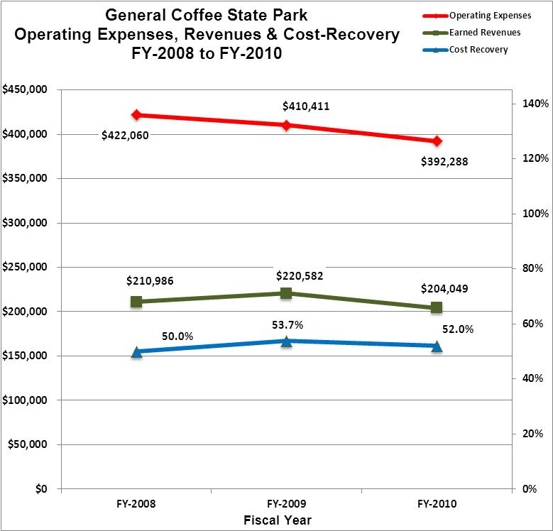

Review of Pricing
Data on rate information is available as far back as 2002, but only the last five years are evaluated. There has been notable growth in fees charged at General Coffee State Park since 2005, with the largest increase being in camping. A table detailing the rates for facilities is provided below.
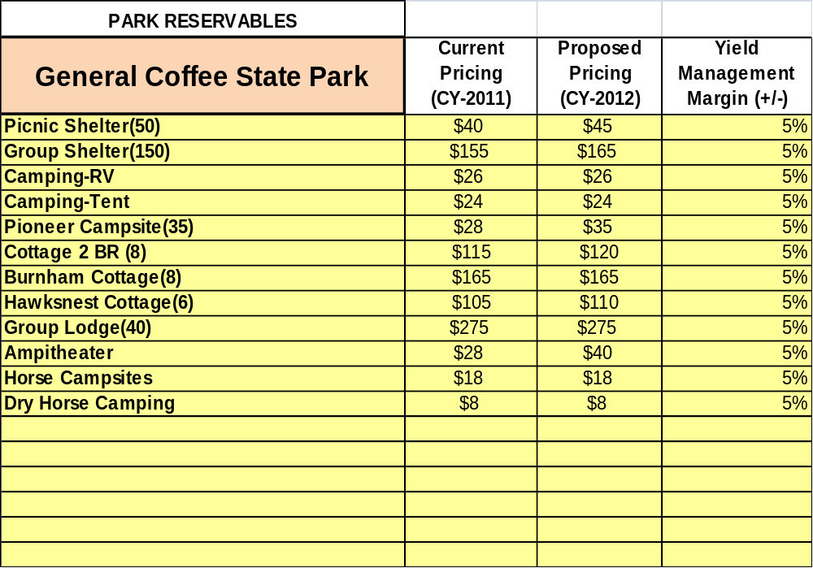

Business and Management Plan

Business Goals
The following goals serve as the foundation for the key recommendations and strategies in this business plan for General Coffee State Park.

Enhance Cost Recovery of Site Operations
General Coffee State Park is operating at a 52% cost recovery of operational expenses through earned revenues. The park operations are limited, due to staffing levels. Site operations are now heavily reliant on hourly personnel and volunteers. There is a moderate to high amount of turnover in these positions, which has a negative effect on consistent site operations and visitor experiences.

Enhance Revenue Generation Strategies
Positioning the park as an equestrian destination holds great revenue potential; there are no large, established equestrian facilities in the nearby area; the park has horse trails, but lacks the associated stalls and overnight facilities. Special events should be used to attract visitors; the events should be geared toward those that will encourage guests to stay overnight in our facilities. Special attention should be given to marketing the group shelter as a rentable meeting facility during the week. The park staff should also market specialty facilities such as the amphitheater and group lodge for weddings. Strong consideration should be given to competitive pricing and bundling services.

Expand Special Events at the Site
The special events at General Coffee State Park have been very good over the last two years, but have room for much improvement. The park has looked at specific programs it has done in the past and has adjusted them to make them more profitable. The staff has changed dates, collaborated with outside groups and eliminated programs that are just not profitable. It is currently adjusting pricing to allow for a more aggressive fee structure.

Improve the Diversity and Innovation of Recreational and Interpretive Programs
The interpretation at the site has been drastically limited due to the low level of staff. The most lucrative programs over the past couple of years have been the Halloween programs and summer camps on the farm. We would like to market the availability of educational and recreational opportunities such as stay-use camps, adventure camps and team building activities to youth user groups. We would like to improve historical interpretation on the farm to include at least one weekend a month with volunteers or staff in period dress conducting demonstrations and/or programs.

Improve the Effectiveness of Marketing and Sales
The effectiveness of marketing at General Coffee State Park could be drastically improved by marketing specifically to the target markets that we serve. The use of billboards along the interstate as one nears the park exit would be a great help to sales. A great percentage of the customer base at the site comes from reservations, not walk-ins. Attention should be directed to marketing the experience of General Coffee State Park and the added benefits of nature and security that cannot be found at the other local campgrounds. Marketing of existing and proposed equestrian facilities to target groups is necessary.

Establish Greater Consistency of Managing and Monitoring Customer Service & Satisfaction
General Coffee State Park should strive to maintain a customer satisfaction rating of at least 95%. However, there is not a mechanism in place to accurately track the numeric values of the satisfaction level of the customers served at the site. A tracking system should be established to help accurately track these ratings. The customer should be offered a small discount to make it advantageous for them to take the time to turn in their opinions on the site and the services provided. Staff is carefully monitoring online comment card responses. In addition, periodic “in-house” surveys will be conducted in order gauge the efficacy of customer’s experience’s within operational areas.

Expand Partnership Opportunities
The opportunities for partnerships are somewhat limited due to the site’s rural location and distance from major population centers, more than an hour’s drive from any major interstate. The Friends Chapter is beginning to gain momentum in the community. They will be a great source for funds, service and partnership opportunities.
Enhance Facilities and Program Offerings
Enhance facilities and program offerings to provide a minimum of 6 unique experiences for each visitor using the following C-O-F-F-E-E acronym.
Cottages – Our cottages offer a unique experience for those looking to stay overnight in South Georgia. Our two-bedroom facilities are nestled on a gated private drive and over one mile from a public road. These cottages are nestled in an isolated patch of Oak forest with direct access to several miles of nature trails and boardwalks that span the swamp created by the Seventeen Mile River. Our Burnham Cottages offers an overnight experience that is beyond compare. This 1800’s era two story log home is decorated and furnished with an antique flare and is perfect for family vacations or as a romantic couples retreat. The Burnham offers guest the opportunity to stay in classic antique luxury at a price that is below that of a single high-end hotel room.
Outdoors – General Coffee State Park offers guests a myriad of outdoor adventure opportunities. Guests can explore on several miles of hiking and horse trails. These trails meander through several distinct habitats ranging from bottomland swamp through oak and sand hill forest. Wildlife abounds here and this is one of the few places left in our state where lucky visitors can spot two of our most endangered creatures, the gopher tortoise and indigo snake. Visitors can also fish in our 4.5-acre stocked fish pond that is extremely popular for local anglers looking to test their tackle against bass and bluegill. Both canoes and pedal boats are also available for those looking to get on the water. Other outdoor activities that are available include biking, bird watching, photography, geocaching and much more.
Farm – Possibly the most unique experience the park has to offer is our Heritage Farm. The farm is a complete replica of a late 1800’s era farm complete with historic cabins, tobacco barn, corn crib, blacksmith shop, cane grinding wheel and more. Numerous heritage breed farm animals can be found on the farm including goats, donkeys, sheep and pigs. The park also specializes in raising several heritage breeds of fowl which are offered for sale to the public when available. Regularly scheduled farm and feeding tours are conducted for visitors who want to get up close and personal with the animals and learn about farming from a historical perspective.
Festivals – The park holds several festivals and special events throughout the year. These events include our Spring Fling, Halloween Moonlight Madness, Pioneer Harvest Festival and Christmas on the Pond. Many smaller events also take place such as the fishing rodeo, taste of the farm dinners, civil war encampments, and more.
Equestrian Trails – Horse enthusiasts will enjoy our several miles of equestrian trails which offer a unique experience in our part of the state. We offer both standard overnight camping (electric and water) as well as back country ride in camp sites along the trail. Our trails are wide, allowing two-abreast travel in most places. These trails wind through habitats ranging from upland oak, sand hill and bottomland swamp.
Education – There are countless education opportunities at General Coffee State Park. We offer packaged programs to both public and private schools as well as home school organizations. These programs can be catered to any age group and subject matter. Educators can choose from nature or history oriented programs or a hybrid of both. Students can learn about aquatic habitats, local flora and fauna natural history as well as cultural and living history of our state. We also offer educational programing to organized groups of visitors at the park as well as regularly scheduled educational programs and seminars that are available to everyone. In addition, we hold several hunter education related courses during the year. During the summer, the park offers a variety of camps for those looking to get their children involved in the outdoors. These camps include our Junior Ranger Camp, Outdoor Adventure Camp, and our Heritage Farm Camp. Each camp offers participants a unique outdoor educational experience.

Classification of Programs and Services
The tables below summarize the classifications of programs and services at General Coffee State Park as either core, important, or visitor supported, and project a range of cost recovery percentages that might be achieved for each. These classifications establish financial performance goals for each category of services that are linked to the recommendations and strategies of this business plan.

Core Services
Program / Service | Target Cost Recovery
Active management of General Coffee State Park, focusing on the natural and cultural resources of the site in order to protect their integrity | 0%
Open and public access to the site and its resources | 0%
Site appropriate education, interpretation, and recreational opportunities | 110%-115%
Public safety | 0%
Maintenance of grounds, facilities and infrastructure | 0%

Important Services
Program / Service | Target Cost Recovery
Interpretation and education programs | 100%-150%
Camping (tent/RV; pioneer; horse) | 50%-75%
Day-use facilities such as picnic shelters and a group shelter | 50%-75%
Trails (nature and equestrian) | 100%

Visitor Supported
Program / Service | Target Cost Recovery
Gift shop | 150%
Nature and educational programs by interpretative ranger | 100%-120%
Special events / programs related to the mission of the site | 100%-140%
Special events / programs not related to the mission of the site or outside the normal programming standards (e.g., wedding receptions, etc.) | 120%
Boat rentals and bike rentals | 125%
Accommodations such as group lodge, group shelter, and cottages | 125%

Partnership Development Plan
The table below summarizes existing partners and targeted partnerships by classification (operational, vendor, service, co-branding, funding partners) and by organizational type.

 | Public Partners | Not-for-profit Partners | Private / Enterprise Partners
Operational Partners | - County Sheriffs Office  - EMS | - Friends of General Coffee  - Area equestrian groups
Vendor Partners | - Concession trail rides with local stables. |  | - Coca Cola  - Georgia Power
Service Partners | - Public Works | - Douglas Chamber of Commerce
Co-branding Partners | - Laura Walker State Park  - Stephen Foster State Park |  | - Okefenokee Swamp Park
Funding Resource Development Partner |  | - Friends of General Coffee State Park

Marketing and Sales Plan

Marketing and Sales Goals
Marketing and sales goals for General Coffee State Park are based on the following desired outcomes:
- Increase cabins rentals by 5%-10% over the next year through marketing the experience of General Coffee State Park.
- Increase campsite rentals by 5%-10% over the next year through extended stay discounts and package deals.
- Increase day-use rentals by 5%-10% over the next year through advertising meeting facilities and special events such as weddings.
In order to meet these goals, examples of specific target outcomes were identified in the areas detailed in the table below.
Area  of Focus | Current  Performance | Goal  by 2011 | Goal  by 2012 | Goal  by 2015
Cabin Rentals | 34% occupancy | 40% occupancy | 45% occupancy | 48% occupancy
Campsite Rentals | 17% occupancy | 20% occupancy | 23% occupancy | 27% occupancy
Marketing and Promotion Strategies

Publicity and Social Media
General Coffee State Park will approach marketing and publicity planning using the following guidelines and themes:
- Event publicity
Major events benefit by having short stories in local, regional, and statewide newspapers and online social media hooks planted that run three to four weeks in advance of the event up to the date of the event itself. Stories and media need to be cultivated with contacts and online sales channels several weeks in advance of the time the stories need to run. Special interest interviews on morning, noon, and evening television news programs, radio interviews on popular rush-hour programs, and blogs on known affinity online sites should also be included.
- Program publicity
Special and unique programs should have feature stories in magazines, local and regional weekly newspapers, and statewide daily newspapers that are aimed at placements as front-page or sectional front-page stories. These stories are most effective if they run shortly before the season that the featured program begins. This will likely require several weeks of advanced planning with media contacts. Similar coverage on television and radio should also be considered. If pre-publicity cannot be generated, post-publicity can help promote future programs.
- Site Publicity
Site publicity focusing on a single site or sub-set of sites requires more intense planning efforts to attract multiple writers and editors from target publications. Each site could host several seasonal media familiarization tours (with 10 to 15 writers or editors) to familiarize them with the site and its benefits and amenities. Stories and features resulting from such tours typically take between two and six months to materialize so the tours should focus on experiences, benefits, and programs that would be available when the stories are expected to run.
Examples and suggested opportunities for events, programs and related publicity efforts based on the themes described above at General Coffee State Park are provided in the table below.

Event Publicity | Program Publicity | Site Publicity
July 4th Festivities | Bird Watching | Stay-use Packages
Memorial Day | Agriculture Day | Campsite Packages
Tri the Parks Triathlon | Spring Fling | Farm Days
Pioneer Harvest Festival | Summer Day Camps | Taste of the Farm
Moonlight Madness

Packaging
Examples and suggested packages for General Coffee State Park are provided in the table below.

Package | Package Details
Cabin Package | Stay 4 nights and get a 5th night free or a free use of a canoe or paddle boat during the week
Campsite Package | Stay 4 nights and get a 5th night free or a free use of a canoe or paddle boat during the week
Group Lodge Package | Stay 5 nights or longer and receive reduced rate for additional nights. Tailor interpretive program specifically for group lodge guests. Create a special series of programs tailored to group lodge guests. Recreational or nature-based, per group request.

Group Sales
Types of groups within which specific target customers can be identified for General Coffee State Park are listed below:
- Extended stay workers  - Equestrian groups | - Conference Groups | - Special event groups such as weddings

Incentivizing New and Repeat Visitation
General Coffee State Park will utilize the following strategies and/or incentives to encourage new and repeat visitation starting in FY 2012:
- Offer discounts for extended stays paid in full by employees working in the local area.

Marketing and Sales Metric Goals
The following marketing and sales metric goals and/or others will be monitored and progress reported at General Coffee State Park:
- Loyalty and repeat customers = 60% repeat customers.
- Brand confidence & customer recruiting customers = 20% of new customers recruited by previous customers.
- Park will purchase AM-radio transponder which will allow broadcast of a five minute loop. Park will track number of guests visiting site that heard the radio broadcast.
Revenue Generation Plan
Revenue / Cost Recovery Goals
General Coffee State Park has set a financial goal of increasing annual revenues 5% annually between 2013 and 2015. Actual revenue figures were used for FY11 and FY12. The largest revenue growth opportunities include increasing campsite occupancy, developing equestrian facilities, and continuing to grow special events and regular programming. The table below details projected revenue growth leading up to 2015, based upon a nominal growth of revenues each year.
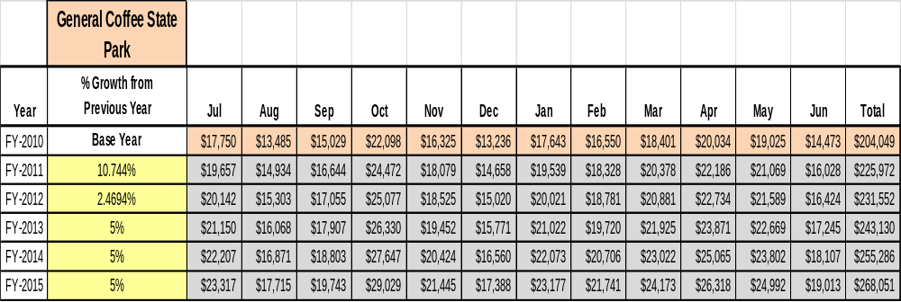

These projections would result in a total of 28% cumulative growth in total annual revenues between FY2010 and FY2015 (actual revenue figures used for FY11 and FY12). If operational expenses can be managed at an even keel with FY13 between FY 2013 and FY 2015, then the overall cost recovery of the site will be approximately 74% in FY 2015 at these projected revenue levels.
Revenue Generation Strategies

Pricing Plan
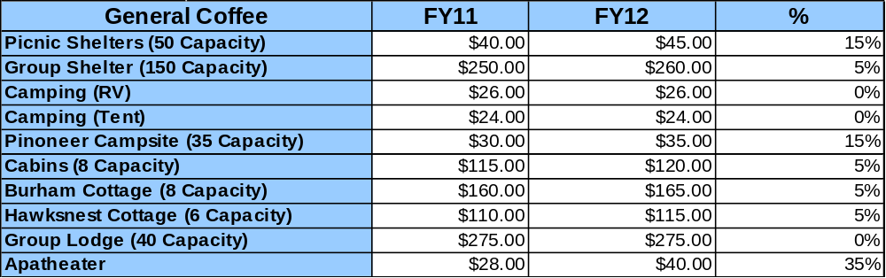

Innovative Programming and Special Events Plan

Program / Event | Theme / Purpose | Scheduled Date/Season | Frequency | Target Participation | Target User Fee | Target Cost Recovery
Fishing Derby | Recreation | Spring | Annually | 100 | Donations | 100-150%
Summer Camps | Education / Recreation | Summer | Annually | 80 - 100 | $45 | 100-150%
Pioneer Harvest Festival | Education / Recreation | Fall | Annually | 1000 | $2 | 100-150%
Moonlight Madness | Recreation | Fall | Annually | 1500 | $3 | 100-150%
Christmas on the Pond | Recreation | Winter | Annually | 500 | $2 | 100%-120%
Taste of the Farm | Education | Summer / Fall | Bi-Annually | 100 | $5 | 100%

Partnerships and Concessions Plan

Service / Partnership | Term of Service | Financial Objective | Contract Manager
Friends of General Coffee | 5 years | 100% of cost expense related to Farm operation and Programs | Park Manager
Trail Rides by area stables | Annually | 115% | Park Manager

Expense Management Plan
Personnel Assignments
The following actions will be taken to proactively manage labor costs via personnel assignments and classifications.

Action | Timeline | Outcome
Staff has been cut and further reduce hours for hourly employees | As needed | Reduction would amount to a minimal savings.

Management Techniques
The following actions will be taken to proactively manage labor costs via management techniques.

Action | Timeline | Outcome
Reduce vehicle usage with the usage of golf carts, shut facilities down and cut power during slow times | As needed | Operational expenses

Adjusted Levels of Service
The following actions will be taken to proactively manage labor costs via reduced levels of service.

Action | Timeline | Outcome
Reduce landscaped areas to be maintained | Ongoing | Reduce operating expenditures of equipment maintenance and fuel cost
Close Loop 1 campground when not in peak periods | On-going | Reduce operating expenditures of power and water cost

Financial Pro Forma
The following five-year financial pro forma projects operating expenses, earned revenues and cost recovery through FY 2015. These pro forma are based on the strategies and desired outcomes identified in this business plan, especially the revenue generation and expense management plans, and are linked to corresponding performance goals.

Expense Pro Forma
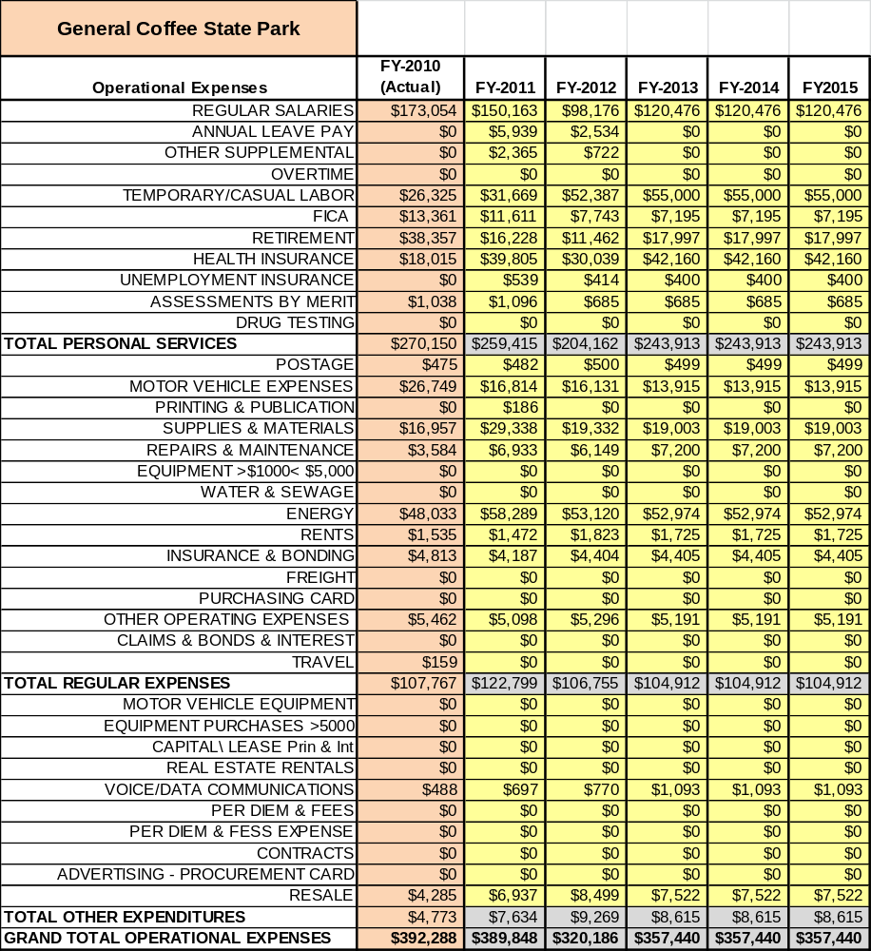

Revenue Pro Forma
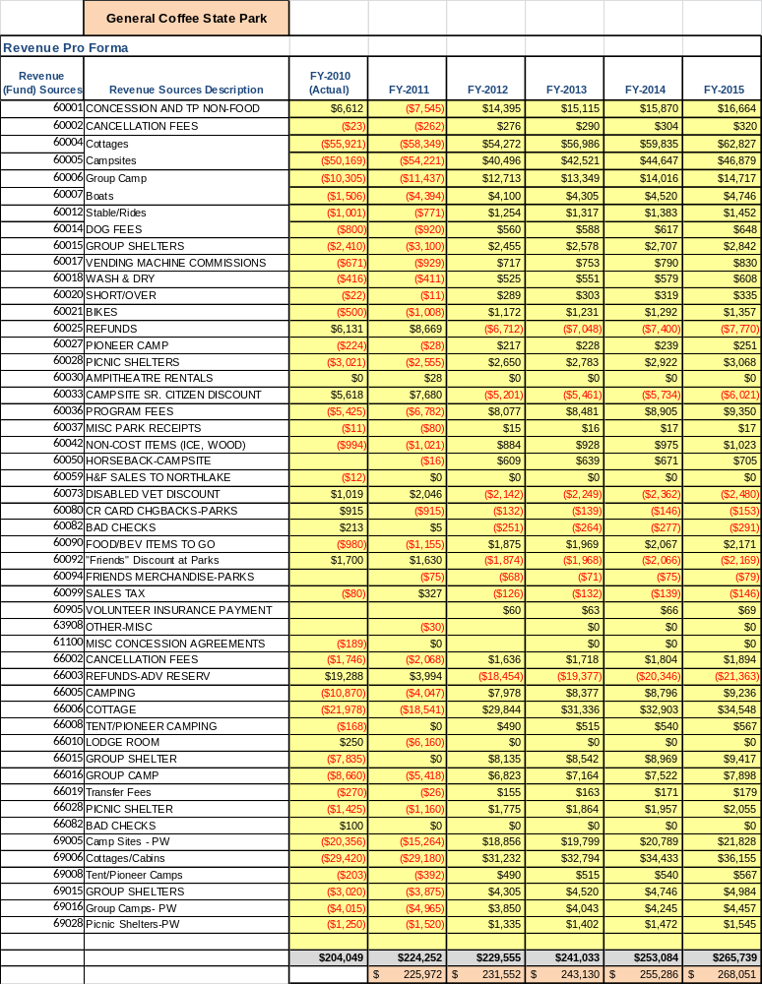

Total / Cost Recovery Pro Forma
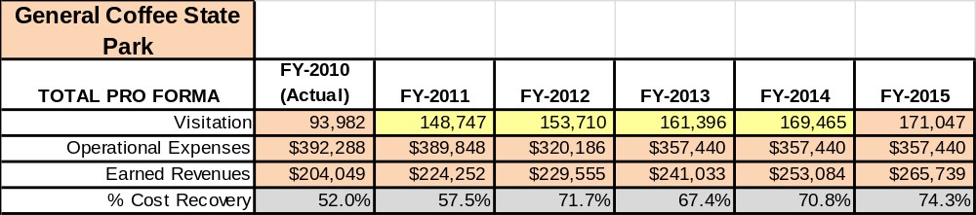

Action Plan
ACTION PLAN
Site: |  | Site Manager: |  |  | Date:
Month:
Strategy | Tasks | Costs / Funding | Revenues / ROI | Responsibilities | Metrics

ACTION PLAN
Site: |  | Site Manager: |  |  | Date:
Month:
Strategy | Tasks | Costs / Funding | Revenues / ROI | Responsibilities | Metrics

This is the average of the last three years – FY 2008, FY 2009, and FY 2010
Current employees, not including vacancies.
Current employees, not including vacancies.
Major population centers within a two and a half-hour drive from the site

