George L. Smith
Business & Management Plan

Prepared May 2011; Finalized January 2013
Direction 2015 – Sustainable Business Planning

Table of Contents

Executive Summary 3

Site and Operations Assessment 6
Site Inventory and Facility Assessment 6
Operational Assessment 8
Financial Performance Assessment 13

Business and Management Plan 16
Business Goals 16
Classification of Programs and Services 16
Partnership Development Plan 18
Marketing and Sales Plan 19
Revenue Generation Plan 21
Expense Management Plan 23
Financial Pro Forma 24

Action Plan 26

Executive Summary
The Parks, Recreation and Historic Sites Division (PRHSD) of the Georgia Department of Natural Resources (DNR) is transitioning the management of George L. Smith State Park to operate more like a business, reflecting the Direction 2015 – Sustainable Business Planning initiative to improve the fiscal performance and management of the state parks and historic sites system. This business and management plan is designed to help the site recover more operating expenses through earned revenues, productive partnerships, and innovative programs.

Site Fact Sheet
Site Name | George L. Smith
Site Manager | Matthew Muhmel
Region Manager | Tommy Turk
Date of Business Plan completion | May 29, 2011
Site size | 1,634 acres
Total number of visitors (FY 2010) | 97,199
Total operating budget (FY 2010) | $309,633
Total earned revenues (FY 2010) | $223,038
Operational cost recovery (FY 2010) | 72%
Average operating cost per visitor (FY 2010) | $3.19
Average earned revenue per visitor (FY 2010) | $2.29
Average cost recovery (FY 2008 – 2010) | 74%
Target cost recovery (FY 2015) | 94%
Total full-time employees | 3
Total part-time employees | 5
Primary service markets | Augusta, Savannah, Statesboro
Primary attractors/visitor appeal factors | Camping, cottages, lake, historic mill
Leading opportunities for improved site performance | Partnerships with local outfitters and attractions. Increased involvement with local community.

Site Summary and Key Attractions
The 1,634-acre site of George L. Smith State Park is located in a rural setting roughly 80 miles from major population centers like Savannah and Augusta, 30 miles from Statesboro and 11 miles from Metter and Swainsboro. It is roughly 13 miles from Interstate 16 and directly off Highway 80. The relative isolation of George L. Smith State Park will prove a challenge to achieving the identified cost recovery target, but the relative location to nearby Georgia Southern University may help to achieve this goal.

Key Attractions
The amenities or features listed below are those that seem to be most popular for visitors.
- Lake
- Cottages
- Campground
- Historic Mill House
- Canoe Trails
- Hiking Trails
- Day Use Areas
- Boating and Fishing
- Programs and Events

Financial Targets
The table below details the total operating expenses and earned revenues for George L. Smith over the last three years (2008 – 2010). This table also calculates total cost per visitor and revenues per visitor during these operating years, and details the target financial performance goals in the context of achieving at least 94% cost recovery. This table also calculates the necessary change from 2010 operating expenses and revenues.

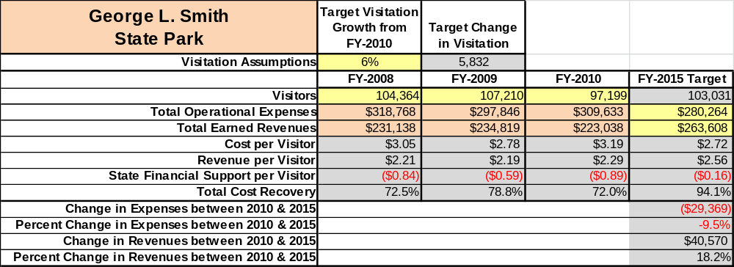

Key Recommendations

Primary / Short Term Recommendations
- Utilize at least 3 special events annually to draw more visitors to site.
- Seek local partners to help support operations, programs and services including rental agreements and discounts for cross-marketing purposes.
- Create a local Friends Chapter to help raise funds or provide volunteers for facility and amenity improvements and program support for trail clean-up, site improvements, seasonal programming, and special events.
- Partner with local Chambers of Commerce or other organizations to help promote George L. Smith.
- Perform a thorough net cost-of-service analysis on major functions of site operations to determine which areas to improve or remove.
- Review and update rates on an annual basis to recover total net cost of services. Track total economic impact on local communities and share with local businesses, and officials to demonstrate the impact of George L. Smith.
- Utilize Grist Mill to increase local farmer involvement, increasing programming and revenue. Provide public grinding events at least monthly.
- Construct and upgrade facilities and amenities including hike-in and paddle-in campsites at the site which are likely to have cost recovery greater than 100%.
- Add more services and programs such as backpacking, outdoor adventure and survival that appeal to local demographic and college community.
- Partner with local kayak outfitter to offer cottage/camping packages that include kayak tours and lessons.

Secondary / Long Term Recommendations
- Improve recreational amenities including kayak rentals, alternative camping choices, and providing guests with outdoor games equipment to address modern and diverse uses.
- Engage the local community, user groups, and private organizations to improve connectivity between George L. Smith, Gordonia-Alatamaha and Magnolia Springs through cross promotions and marketing. Install an improved retail point-of-sale and inventory tracking system.
- Improve and promote lake fishing opportunities with seasonal fishing events and tournaments.
- Add paddle-in platform camping on the lake.
- Conduct monthly corn grinding at the mill as water levels permit.
Site and Operations Assessment
This site and operations assessment is a culmination of analyses and findings from a review of the condition of facilities, infrastructure, and operations at George L. Smith. The findings and observations are not intended to be an exhaustive review of all issues present, but provide a basic understanding of the predominant issues that contribute to the site’s current operating conditions. The assessment includes the following:
- Site Inventory and Facility Assessment
- Operational Assessment
- Financial Assessment
Site Inventory and Facility Assessment

Methodology
Facility and asset conditions are rated using a differential scale of excellent, good, fair, or poor. Descriptions of conditions that are attributed to each of these findings are also provided.
Scale of Conditions
Rating | General Description
Excellent | Facilities/amenities are in ‘excellent’ condition when they show little or no maintenance or repair problems. Facilities do not feature any major design or operational issues or flaws that contribute to diminished use or increased maintenance or upkeep. Facilities are easy to clean and maintain in order to place them back into public use and the users perceive them to be in excellent shape.
Good | Facilities/amenities are in ‘good’ condition when they show only minor maintenance or repair problems. Most maintenance issues with these facilities typically appear to be the result of age and/or heavy use. Facilities may only feature minor design or operational issues that contribute to diminished use or increased maintenance or upkeep. Facilities are moderately easy to clean and maintain in order to place them back into service and the users perceive them to be adequate for their use, but probably not in excellent shape.
Fair | Facilities/amenities are in ‘fair’ condition when they show significant maintenance or repair problems. Facilities generally exhibit ongoing maintenance issues that appear to be the result of age, heavy use, or design or operational flaws. Some maintenance and repair needs may compound their fair condition by being deferred because of budget and/or resource limitations. Facilities require more effort to clean and maintain before placing them back into service and the users may perceive them as being less than adequate for their use and in a state of deterioration. The facility or structure may need of major repair or replacement.
Poor | Facilities/amenities are in ‘poor’ condition when they show significant, on-going maintenance or repair problems that ultimately may result in suspended use for repair/replacement. Maintenance and repair issues are possibly the result of poor maintenance and clearly the result of age, heavy use, or design or operational flaws. Problems with the facilities are often compounded over time due to consistently-deferred maintenance and repair because of budget and/or resource limitations. Facilities may feature major design or operational issues that contribute to diminished use or increased maintenance or upkeep. Facilities require excessive effort to clean and maintain before placing them back into service and the users often perceive them as being inadequate for their use and in a state of serious deterioration. The facility or structure may need of major repair or replacement.

Inventory and Assessment
The table below is an inventory of facilities and amenities at George L. Smith, and provides the assessed condition of each as reviewed in May 2011.
Site Asset / Amenity | Quantity | Condition
Total Acreage | 1,632 acres | Good
Lake Acreage | 412 | Good
Office/Gift Shop | 1 | Poor
Historic Mill House | 1 | Fair
Office Day Use Restroom | 1 | Good
Rental Cabins | 8 | Good
Campsites | 25 | Good
Playground 1 | 1 | Fair  f
Playground 2 | 1 | Good
Playground Day Use Restrooms | 1 | Good
Hiking Trails | 2 | Good
Group Shelter | 1 | Good
Pioneer Area | 1 | Good
Picnic Shelters | 4 | Good
Comfort Station | 1 | Fair
Boat Ramp 1 | 1 | Fair
Boat Ramp 2 | 1 | Good
Maintenance Facility | 1 | Good
Boat Ramp Day Use Restroom | 1 | Good
Day-Use Picnic Areas | 8 | Good
Managers Residence | 1 | Good
Asst. Managers Residence | 1 | Good

Prioritized Facility Needs
Based on the facility inventory and assessment, these prioritized needs have been identified. Each need has been aligned with a priority category of high, moderate, or low to support future decision making regarding project sequencing, investment of public resources, and meeting community expectations. The priority assignment for each need is not a measure of importance. Rather, these recommended priorities reflect a phased implementation approach over the next several years.

Facility Need | Priority Assignment
New Office/Visitor Center/Gift Shop | High
Historic Mill House Preservation | High
Campground Renovation | Low
Comfort Station Replacement | Moderate
Replace Boat Ramp 1 | Moderate
Replace Playground 1 | Moderate

Operational Assessment
The Operational Assessment includes:
- An inventory and classification of programs and services being provided at the site
- A review of staffing at the site
- A review of concessionaires and partners operating at the site
- Visitation and customer satisfaction

Inventory and Classification of Programs and Services
Programs and services are classified into one of three major categories:
1) Core or Essential Services
2) Important Services
3) Visitor Supported Services
Programs and services at the site are classified into these categories based in part on the mission and public mandates for both the site and the agency. For the services in each of these categories, there are financial performance expectations that will define how services are funded and evaluated.

Category 1 – Core Services [Largely supported by tax funds]
Core programs, services and facilities are those the agency must provide and/or are essential in order to capably govern and meet statutory requirements. The failure of the agency to provide Category 1 services at adequate levels could result in significant negative consequences for the public and the resources under protection. The criteria for services to be classified as core or essential are:
- The services are mandated by the agency’s law or charter or are contractually obligated by agreement to provide the services.
- The services are essential to protecting and supporting the public’s health and safety.
- The services protect and maintain valuable assets and infrastructure.
- The services would generally and reasonably be expected and supported by residents, businesses, customers and partners.
- The services are those that cannot or should not be provided by the private sector.
- The services provide a sound investment of public funds.
The following programs and services offered at George L. Smith have been identified as core services:
- Active management of the natural and cultural resources of the site to protect their integrity for future generations
- Artifact management such as Civilian Conservation Corps Memorabilia
- Public access to the site and its resources
- Public safety
- Maintenance of grounds, facilities and infrastructure

Category 2 – Important Services [Supported by a balance of tax funds and earned revenues]
Important programs, services and facilities are those the agency should provide, and are important to governing and effectively serving residents, businesses, customers and partners. Providing Category 2 services expands or enhances the agency’s ability to provide and sustain its core services. The criteria for programs or services to be classified as important are:
- The services expand, enhance or support identified core services.
- The services are broadly supported and utilized by the community, and are considered an appropriate, important, and valuable public good. Public support may be conditional upon the manner by which the services are paid for or funded.
- The services generate income or revenue that offsets some or all of the operating cost and/or are deemed to provide economic, social or environmental outcomes or results.
The following services offered at George L. Smith have been identified as important services:
- Rentals of overnight facilities such as cabins, walk-in sites, pioneer camping, and backcountry camping
- Self-guided interpretation and education programs

Category 3 – Visitor Supported Services [Almost exclusively supported by earned revenue]
Visitor supported programs, services and facilities are those discretionary services that the agency may provide when additional funding or revenue exists to offset the cost of providing those services. Category 3 services provide added value above and beyond what is required or expected. The criteria for programs or services to be classified as visitor supported are:
- The services expand, enhance or support core services or important services and the quality of life of the visitors, community or stakeholders.
- The services are supported, valued and well utilized and provide an appropriate and valuable public benefit.
- The services generate income or funding from sponsorships, grants, user fees or other sources that offset some or all of their cost and/or provides a meaningful return on investment.

- The services can possibly be provided through outsourcing or use of concessionaires, providing opportunities for community enterprises that may not otherwise be provided by the agency.

The following services offered at George L. Smith have been identified as visitor supported services:
- Retail area and gift shop
- Ranger led interpretation
- Special events related to the mission of the site
- Boat rentals
- Concessions
- Corn Grinding
- Group Shelter Rentals
- Cottage Rentals
- Camping
- Picnic Shelters

Staffing Assessment
Labor costs at George L. Smith represent the largest area of budgetary expense at an average of 72% of the total operating budget each year for the last three complete years, which is higher than the target of total labor costs (including benefits) not exceeding 65% of the site’s total operating expenditures. The tables below and on the following page provide a basic review of the current staffing at the site.
Full Time Equivalent Employees
Position / Title | Quantity (FTE) | Vacancies | Annual Hours
Park Manager | 1 | 0 | 2600
Assistant Park Manager | 1 | 0 | 2600
Maintenance Worker | 1 | 0 | 2080
TOTAL | 3 | 0 | 7,280

Part Time Employees
Position / Title | Quantity (FTE) | Vacancies | Hours
Clerk | 2 | 0 | 3016
Housekeeper | 2 | 0 | 3016
Maintenance | 1 | 0 | 1508
TOTAL | 5 | 0 | 7,540

Labor Support
Labor Support | Annual Hours
Volunteers | 1300
Community Service Workers | 160
TOTAL | 1,460

Total Labor Hours
Labor Type | Annual Hours
Full Time Equivalent Employees | 7,280
Part Time Employees | 7,540
Labor Support | 1,460
TOTAL Annual Labor Hours | 16,280

Labor Budget Summary

George L. Smith
State Park
Account  Codes | Account Code and Sub-Class  Expenditure Descriptions | FY-2008 | FY-2009 | FY-2010 | % change between  FY-2008 & FY-2010
501000 | REGULAR SALARIES | $149,534 | $152,220 | $140,262 | -6.2%
502000 | ANNUAL LEAVE PAY | $0 | $0 | $5,940
503000 | OTHER SUPPLEMENTAL | $0 | $0 | $0
511000 | OVERTIME | $0 | $0 | $0
513000 | TEMPORARY/CASUAL LABOR | $14,098 | $14,028 | $16,185 | 14.8%
514000 | FICA | $10,708 | $10,984 | $10,582 | -1.2%
516000 | HEALTH INSURANCE | $34,158 | $20,019 | $30,365 | -11.1%
518000 | UNEMPLOYMENT INSURANCE | $228 | $179 | $246 | 7.9%
520000 | ASSESSMENTS BY MERIT | $882 | $882 | $822 | -6.8%
522001 | DRUG TESTING | $0 | $0 | $0
 | SUBTOTAL ADDITIVE/BENEFIT COSTS | $62,304 | $48,705 | $71,871 | 15.4%
TOTAL | PERSONAL SERVICES | $225,936 | $214,953 | $228,319 | 1.1%

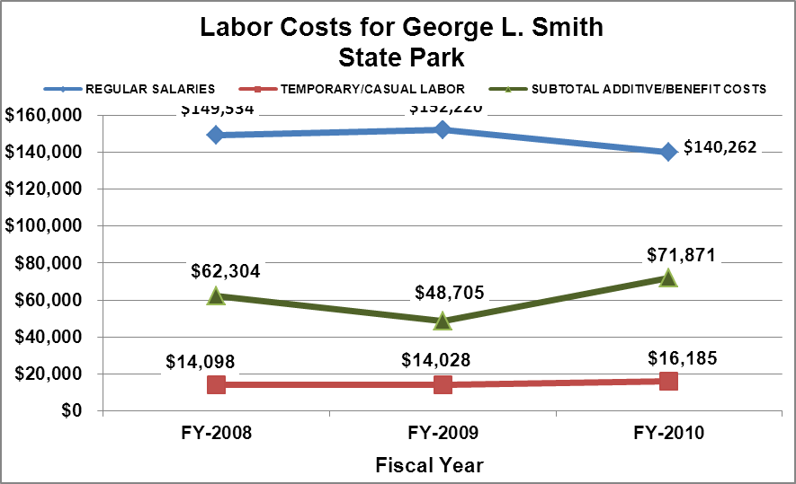

Visitation and Occupancy
Overall annual visitation to the site has trended downward from 2008 to 2010, decreasing by 7% or over 7,000 visitors. This is largely attributed to the economic downturn and correctly calculating visitation numbers starting in 2010.
Year | Total Visitation
2008 | 104,364
2009 | 107,210
2010 | 97,199

Occupancy for the overnight accommodations at George L. Smith the last three years is detailed in the table below. Overall occupancy has trended downward from 2008 to 2010, decreasing by 6%. This is largely attributed to the economic downturn.

Year | Camping  Occupancy | Cottage  Occupancy
2008 | 40% | 50%
2009 | 36% | 40%
2010 | 34% | 37%

Customer Service and Satisfaction

Site | Year | Customer Satisfaction Level
George L. Smith | 2009 | 100%
George L. Smith | 2010 | 83%

Financial Performance Assessment

Operational Expenses
A summary of total operating expenses at George L. Smith from 2008 to 2010, as well as their percent change from 2008 are provided in the table below.
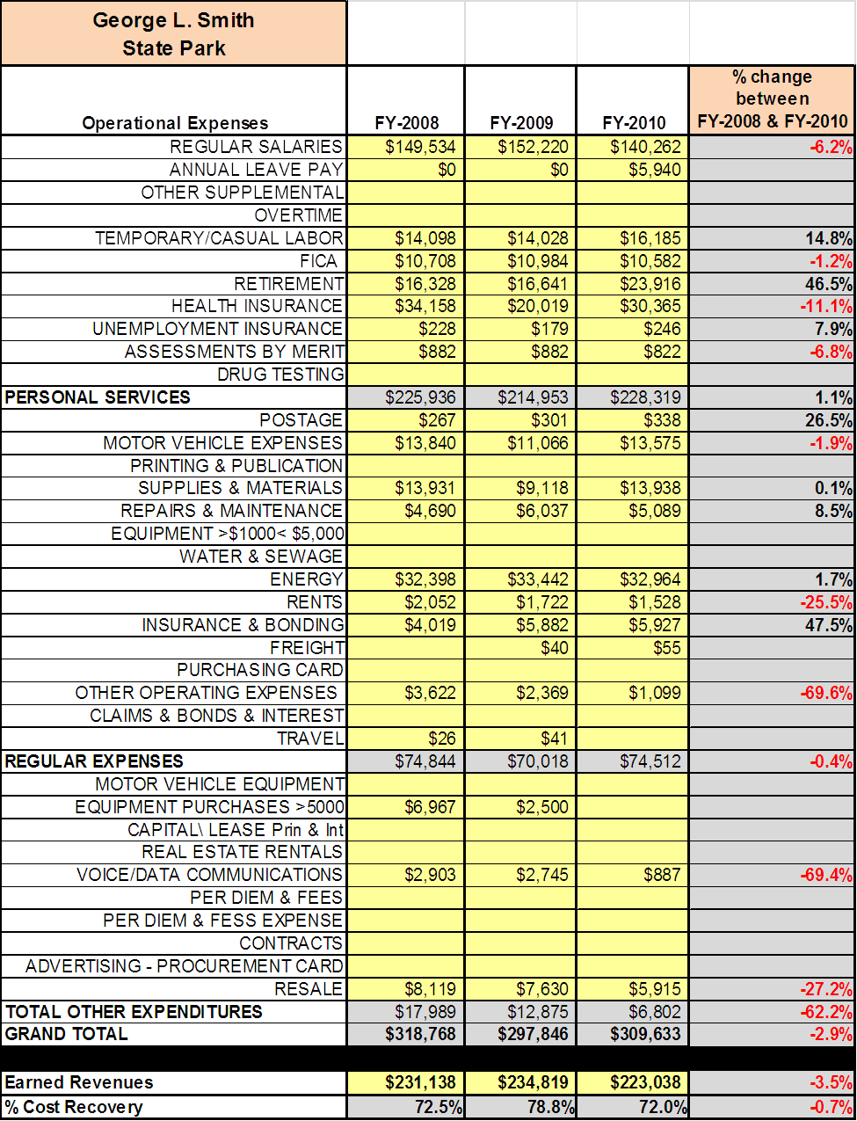

Earned Revenues
Earned revenues at George L. Smith have decreased since 2008, which is largely attributed to the corresponding decrease in overall visitation.
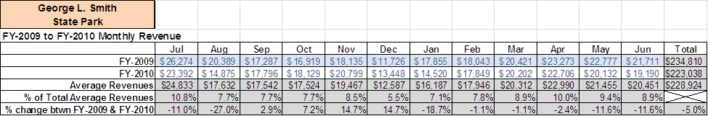
Monthly earned revenues for the last two years (see table on the following page) indicate that the total annual revenue decrease 5% from 2009 to 2010, with the largest increases in monthly revenues in November (15%), and December (15%), and the largest decreases in the months of August (-27%), and January (-19%).
The graphs below illustrate the monthly revenue trends each year and the average percent of total annual revenue earned each month.

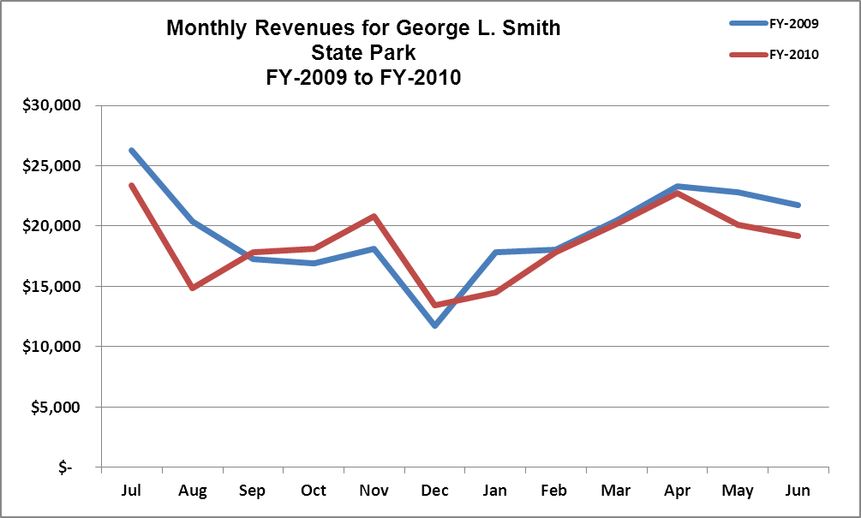

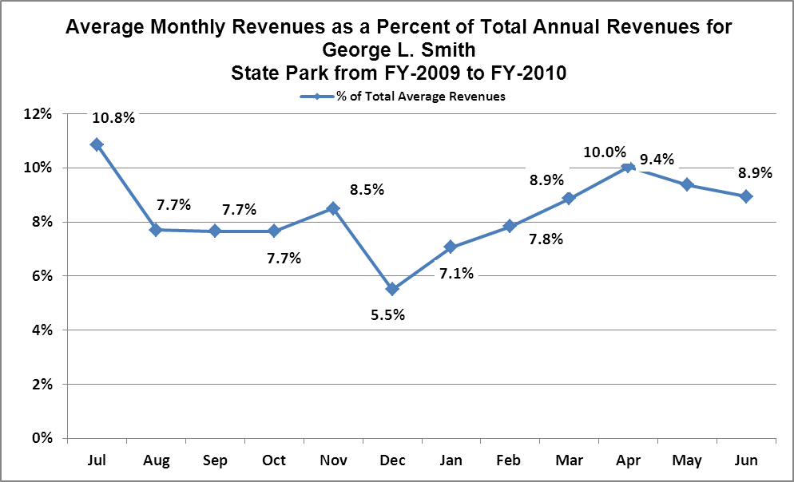

Cost Recovery Trends
George L. Smith has achieved an average cost recovery of 74% of annual operational expenses through earned revenues from FY 2008 to FY 2010. This is detailed and illustrated in the table and graph below.

Year | Operational  Expenses | Earned  Revenues | Percent Cost  Recovery
2008 | $318,768 | $231,138 | 72%
2009 | $297,846 | $234,819 | 78%
2010 | $309,633 | $223.038 | 72%

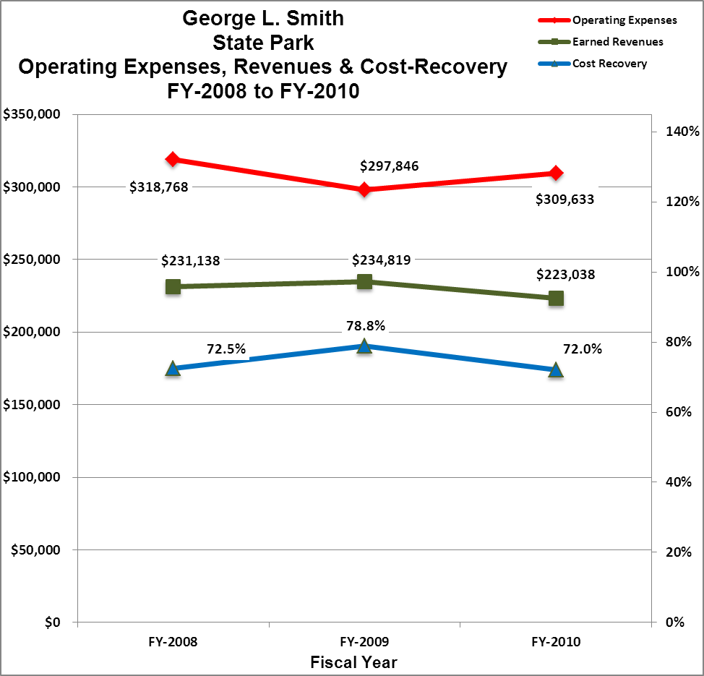

Review of Pricing
Data on rate information is available as far back as 2002, but only the last five years are evaluated. There has been notable growth in fees charged at George L. Smith since 2005, with the largest increase being cottages and campsites. A table detailing the rates for George L. Smith is provided below.
STATE PARKS
George L. Smith  State Park | FY-2005 | FY-2006 | FY-2007 | FY-2008 | FY-2009 | FY-2010 | Comments
Picnic Shelter | $35.00 | $35.00 | $35.00 | $35.00 | $40.00 | $40.00
Group Shelter (capacity) | $85.00 | $85.00 | $85.00 | $85.00 | $100.00 | $105.00
Camping RV/Tent | $20.00 | $20.00 | $20.00 | $23.00 | $26.00 | $26.00
Cottage
Peak | $75.00 | $75.00 | $75.00 | $100.00 | $105.00 | $105.00
Non-Peak | $85.00 | $85.00 | $85.00 | $110.00 | $115.00 | $115.00
Pioneer Campsite | $25.00 | $25.00 | $25.00 | $40.00 | $43.00 | $43.00
Business and Management Plan

Business Goals
The following goals serve as the foundation for the key recommendations and strategies in this business plan for George L. Smith.

Enhance Cost Recovery of Site Operations
Improve revenues through increased programming and events along with increased amenities to draw more visitors to the site.

Enhance Revenue Generation Strategies
Increase by attracting more visitation through events, programs and amenities. Partner with local outfitter to offer cottage/camping packages for guided kayak trips and lessons.

Expand Special Events at the Site
Hold monthly corn grinding programs at historic mill. Add more special events during the year.

Improve the Diversity and Innovation of Recreational and Interpretive Programs
Promote the recreational, cultural and natural aspects of the park to a younger crowd, focusing on the local college community and offering more adventure based programming.

Improve the Effectiveness of Marketing and Sales
Expand marketing to focus on groups that fit the description of those interested in related activities, and market to groups in the market area who do not currently use services offered.

Establish Greater Consistency of Managing and Monitoring Customer Service & Satisfaction
Conduct on-site surveys, respond to online comment card reports and assess customer satisfaction levels.

Expand Partnership Opportunities
Establish a Friends of George L. Smith State Park Chapter, seek co-branding partners, expand the market area through partners, and gain community support.

Classification of Programs and Services
The tables below summarize the classifications of programs and services at George L. Smith as either core, important, or visitor supported and projects a range of cost recovery percentages that might be achieved for each. These classifications establish financial performance goals for each category of services that are linked to the recommendations and strategies of this business plan.

Core Services
Program / Service | Target Cost Recovery
Active management of the natural and cultural resources of the site to protect their integrity for future generations | 0%
Artifact management such as Civilian Conservation Corps Memorabilia | 0%
Public access to the site and its resources | 0%
Public safety | 0%
Maintenance of grounds, facilities and infrastructure | 0%

Important Services
Program / Service | Target Cost Recovery
Rentals of overnight facilities such as cabins, walk-in sites, pioneer camping, and backcountry camping | 25%-85%
Self-guided interpretation and education programs | 40%-60%

Visitor Supported
Program / Service | Target Cost Recovery
Retail area and gift shop | 100%-125%
Ranger led interpretation | 100%
Special events related to the mission of the site | 125%
Boat rentals | 120%-150%
Concessions | 125%-150%
Corn Grinding | 150%
Group Shelter Rentals | 140%
Cottage Rentals | 125%
Camping | 130%
Picnic Shelters | 150%

Partnership Development Plan
The table below summarizes existing partners and targeted partnerships by classification (operational, vendor, service, co-branding, funding partners) and by organizational type.
 | Public Partners | Not-for-profit Partners | Private / Enterprise Partners
Operational Partners | - Emanuel Sheriff’s Office / EMS  - Twin City Police Department  - Metter Office WRD |  | - Mill Pond Kayak (local outfitter)
Vendor Partners |  |  | - Coca Cola
Service Partners | - Twin City | - Chamber of Commerce  - Rotary Club
Co-branding Partners | - Magnolia Springs  - Gordonia |  | - Mill Pond Kayak  - Georgia Southern University  - Raptor Center  - Splash in the Boro
Funding Resource Development Partner

Marketing and Sales Plan

Marketing and Sales Goals
Marketing and sales goals for George L. Smith are based on the following desired outcomes:
- Increased Cottage Occupancy
- Increased Campground Occupancy
- Increased Shelter Occupancy
In order to meet these goals, examples of specific target outcomes were identified in the areas detailed in the table below.
Area  of Focus | Current  Performance | Goal  by 2011 | Goal  by 2012 | Goal  by 2015
Overall Visitation | 97,199 | 82,534 | 95,000 | 103,031
Corn Grinding | 250 | 300 | 500 | 1,000

Marketing and Promotion Strategies

Publicity and Social Media
George L. Smith will approach marketing and publicity planning using the following guidelines and themes:
- Event publicity
Major events benefit by having short stories in local, regional, and statewide newspapers and online social media hooks planted that run three to four weeks in advance of the event up to the date of the event itself. Stories and media need to be cultivated with contacts and online sales channels several weeks in advance of the time the stories need to run. Special interest interviews on morning, noon, and evening television news programs, radio interviews on popular rush-hour programs, and blogs on known affinity online sites should also be included.
- Program publicity
Special and unique programs should have feature stories in magazines, local and regional weekly newspapers, and statewide daily newspapers that are aimed at placements as front-page or sectional front-page stories. These stories are most effective if they run shortly before the season that the featured program begins. This will likely require several weeks of advanced planning with media contacts. Similar coverage on television and radio should also be considered. If pre-publicity cannot be generated, post-publicity can help promote future programs.
- Site Publicity
Site publicity focusing on a single site or sub-set of sites requires more intense planning efforts to attract multiple writers and editors from target publications. Each site could host several seasonal media familiarization tours (with 10 to 15 writers or editors) to familiarize them with the site and its benefits and amenities. Stories and features resulting from such tours typically take between two and six months to materialize so the tours should focus on experiences, benefits, and programs that would be available when the stories are expected to run.
Examples and suggested opportunities for events, programs and related publicity efforts based on the themes described above at George L. Smith are provided in the table below.

Event Publicity | Program Publicity | Site Publicity
Pine Tree Festival | Junior Ranger Camp | Local Flyers
Rattlesnake Roundup | Corn Grinding
Mule Roundup | Cane Grinding/Syrup Making

Packaging
Examples and suggested packages for George L. Smith are provided in the table below.

Package | Package Details
Camp and Canoe | Rent site, get canoes
Stay and Swim | Package Deal with Splash in the Boro
Camp and Tour | Package Deal with GSU Raptor Center
Cottage/Camping/Kayaking | Overnight accommodations with kayak lessons and guided trips

Group Sales
Types of groups within which specific target customers can be identified for George L. Smith are listed below:
- Families  - Youth Service Organizations  - Churches | - Businesses  - Schools  - Special Interest Groups | - Colleges and Universities  - Community Organizations  - Other Public Agencies

Incentivizing New and Repeat Visitation
George L. Smith will utilize the following strategies and/or incentives to encourage new and repeat visitation starting in FY 2012:
- Differential Pricing Based on Slow Time and Availability
- Co-Branding With Other Recreational Service Providers

Marketing and Sales Metric Goals
The following marketing and sales metric goals and/or others will be monitored and progress reported at George L. Smith:
- Loyalty and repeat customers = 65% of customers who repeat their visit in a 12 month period.
- Brand confidence & customers-recruiting-customers = Customer referrals equal 50% or more of “Where did you hear about us?” responses from visitors polled.

Revenue Generation Plan
Revenue / Cost Recovery Goals
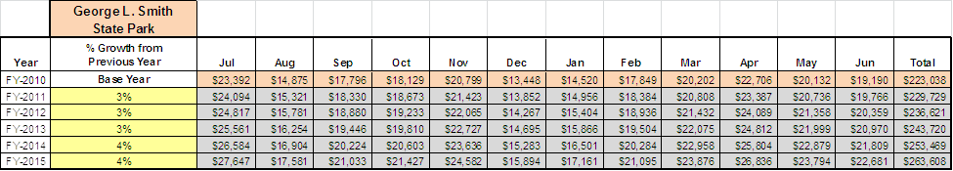
George L. Smith has set a financial goal of increasing annual revenues 3% annually between 2012 and 2015. The largest revenue growth opportunity is most likely increase cottage and camping occupancy. The table below details projected revenue growth leading up to 2015, based upon a nominal growth of revenues each year.
These projections would result in a total of 18% cumulative growth in total annual revenues between FY2010 and FY2015. If operational expenses can be managed with a cumulative reduction of 8% between FY 2010 and FY 2015, then the overall cost recovery of the site will be approximately 94% in FY 2015 at these projected revenue levels. This is higher than the annual financial performance of the site in FY 2010, which was operated at 72% cost recovery in that year.

Revenue Generation Strategies

Pricing Plan
PARK RESERVABLES
George L. Smith  State Park | Current  Pricing  (CY-2011) | Proposed  Pricing  (CY-2012) | Yield  Management  Margin (+/-)
Picnic Shelter | $40 | $40 | 25%
Group Shelter (75) | $105 | $115 | 15%
Camping RV/Tent | 26 | 26 | 20%
Cottage (2 BR)
Non-Peak | $105 | $110 | 20%
Peak | $115 | $125 | 15%
Pioneer Campsite | $43 | $45 | 20%

Innovative Programming and Special Events Plan

Program / Event | Theme / Purpose | Scheduled Date/Season | Frequency | Target Participation | Target User Fee | Target Cost Recovery
Living History | Civil War/Programming | 2011/2012 | Annually | College, Local, Historians | Parkpass | 120%
Car Show | Recreation/Programming | 2012 | Annually | Car Buffs, Local | Entry Fee, Parkpass | 120%
Cane Grinding/Syrup Making | Cultural/Programming | Indefinite | Annually | Local, Repeat | Parkpass, $5.00/bottle | 150%
Corn Grinding | Cultural/Programming | Indefinite | Monthly | Local, Repeat, Farmers | Parkpass, $1.50 | 125%

Partnerships and Concessions Plan

Service / Partnership | Term of Service | Financial Objective | Contract Manager
Program Vendor Concessions | Per event | 15% of gross receipts | Park Manager
Packaging and Promotions with other Businesses | 2 years | Shared Revenue | Park Manager
Special Events | Per event | 15% of gross receipts | Park Manager

Expense Management Plan
Personnel Assignments
The following actions will be taken to proactively manage labor costs via personnel assignments and classifications.

Action | Timeline | Outcome
Eliminate Full Time Clerk Position | July 2012 | Reduced Labor Costs
Eliminate Full Time Housekeeper Position | July 2012 | Reduced Labor Costs
Eliminate 1 Full Time Maintenance Position | July 2012 | Reduced Labor Costs

Management Techniques
The following actions will be taken to proactively manage labor costs via management techniques.

Action | Timeline | Outcome
Increased Use of Volunteers | July 2012 | Reduced Labor Costs
Contract Event Sponsors | July 2012 | Increased Revenue
Increase the number of vendors at events | July 2012 | Increased Revenue

Adjusted Levels of Service
The following actions will be taken to proactively manage labor costs via reduced levels of service.

Action | Timeline | Outcome
Adjust mowing and landscaping schedules for all areas of park | July 2012 | Reduced Operating Costs
Close areas of park to public during slow times | July 2012 | Reduced Operating Costs

Financial Pro Forma
The following five-year financial pro forma projects operating expenses, earned revenues and cost recovery through FY 2015. These pro forma are based on the strategies and desired outcomes identified in this business plan, especially the revenue generation and expense management plans, and are linked to corresponding performance goals.
Expense Pro Forma

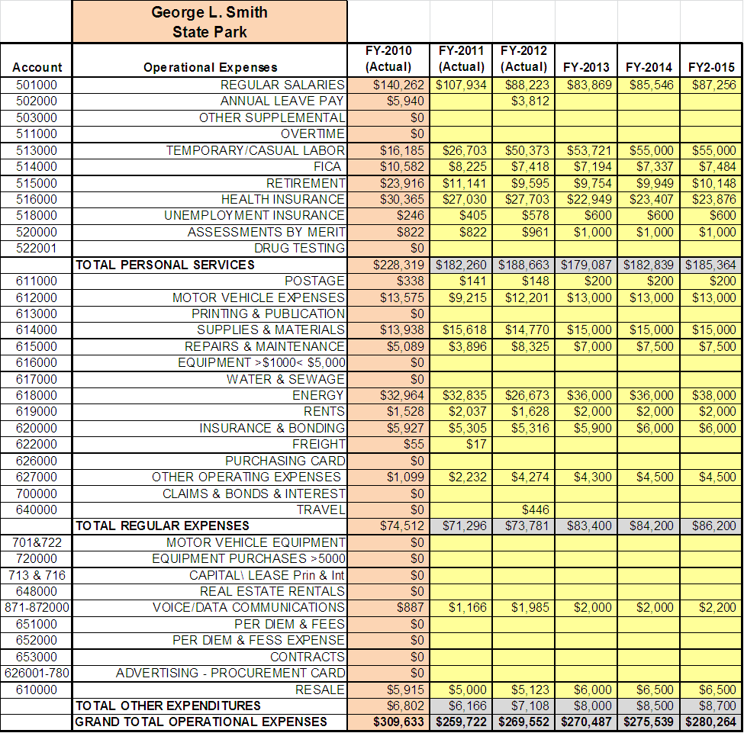

Revenue Pro Forma

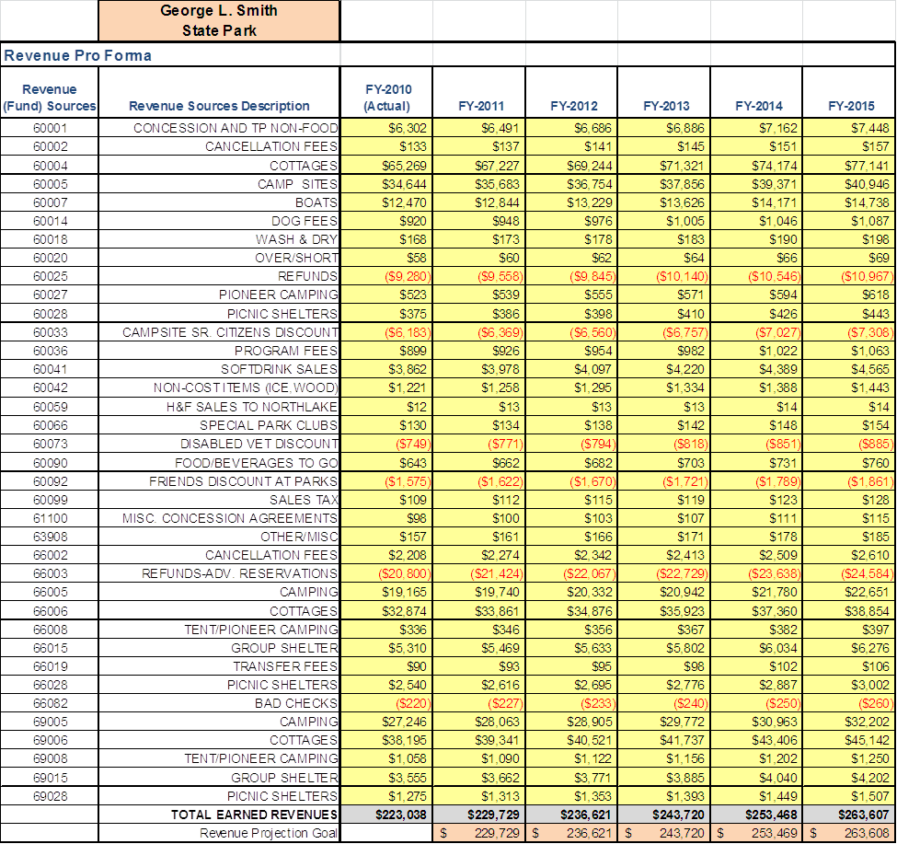

Total / Cost Recovery Pro Forma
George L. Smith
State Park
TOTAL PRO FORMA | FY-2010  (Actual) | FY-2011 | FY-2012 | FY-2013 | FY-2014 | FY-2015
Visitation | 97,199 | 82,534 | 95,000 | 98,000 | 100,000 | 103,031
Operational Expenses | $309,633 | $259,722 | $269,552 | $270,487 | $275,539 | $280,264
Earned Revenues | $223,038 | $229,729 | $236,621 | $243,720 | $253,468 | $263,607
% Cost Recovery | 72.0% | 88.5% | 87.8% | 90.1% | 92.0% | 94.1%

Action Plan
ACTION PLAN
Site: |  | Site Manager: |  |  | Date:
Month:
Strategy | Tasks | Costs / Funding | Revenues / ROI | Responsibilities | Metrics

ACTION PLAN
Site: |  | Site Manager: |  |  | Date:
Month:
Strategy | Tasks | Costs / Funding | Revenues / ROI | Responsibilities | Metrics

This is the average of the last three years – FY 2008, FY 2009, and FY 2010
Current employees, not including vacancies.
Current employees, not including vacancies.
Major population centers within a two-hour drive from the site

