George T. Bagby State Park & Lodge
Business & Management Plan

Prepared June 2011; Finalized February 2013
Direction 2015 – Sustainable Business Planning

Table of Contents

Executive Summary 3

Site and Operations Assessment 7
Site Inventory and Facility Assessment 7
Operational Assessment 10
Financial Performance Assessment 15

Business and Management Plan 17
Business Goals 18
Classification of Programs and Services 19
Partnership Development Plan 21
Marketing and Sales Plan 22
Revenue Generation Plan 24
Expense Management Plan 26
Financial Pro Forma 27
Action Plan 2

Executive Summary
The Parks, Recreation and Historic Sites Division (PRHSD) of the Georgia Department of Natural Resources (DNR) is transitioning the management of George T. Bagby State Park & Lodge (GTB) to operate more like a business, reflecting the Direction 2015 – Sustainable Business Planning initiative to improve the fiscal performance and management of the state parks and historic sites system. This business and management plan is designed to help the site recover more operating expenses through earned revenues, productive partnerships and innovative programs.

Site Fact Sheet
Site Name | George T. Bagby State Park & Lodge
Site Manager | Shawn Baltzell
Region Manager | Eric Bentley
Date of Business Plan completion | June 16, 2011
Site Size | 700 Acres
Total number of visitors (FY 2010) | 117,739
Total operating budget (FY 2010) | $1,254,594
Total earned revenues (FY 2010) | $919,375
Operational cost recovery (FY 2010) | 73%
Average operating cost per visitor (FY 2010) | $10.66
Average earned revenue per visitor (FY 2010) | $7.81
Average cost recovery (FY 2008 – 2010) | 76%
Target cost recovery (FY 2015) | 85%
Total full-time employees | 11
Total part-time employees | 17
Primary service markets | Albany GA; Columbus GA; Dothan AL; Tallahassee FL
Primary attractors/visitor appeal factors | Walter F. George Lake; Meadow Links Golf Course; lodge & conference center; marina; beach & cabins
Leading opportunities for improved site performance | Increased interpretive programs; site specific marketing with increased PR & advertising; new furnishings; bar and grill

Site Summary and Key Attractions
This 700-acre site is located on the shores of Walter F. George Lake in rural Fort Gaines, GA. Nestled 50 miles from the nearest of four major population centers, the park is definitely a destination site. There is no interstate access for 70 miles. Highway 431 in AL, the closest major corridor, is thirty miles away and our closest competitor, Lake Point State Park & Lodge in Eufaula, AL, is on that corridor and has recently undergone a multi-million dollar renovation.

Key Attractions
The amenities or features listed below are those that seem to be most popular for visitors.
- Lodge, Cottages & Conference Center
- Pilothouse Restaurant
- Meadow Links Golf Course
- Golf & Fishing Tournaments
- Annual Halloween Fest , Hayrides & Breakfast with Santa
- 48,000 Acre Lake for Swimming, Boating & Canoeing, Fishing, Beach & Picnic Sites
- Marina Bait & Tackle Store & Rented Slips
- Swimming Beach
- Hiking Trails
- Tennis Courts
- Boat Ramp
- Group & Picnic Shelters

Financial Targets
The table below details the total operating expenses and earned revenues for George T Bagby State Park over the last three years (2008 – 2010). This table also calculates total cost per visitor and revenues per visitor during these operating years, and details the target financial performance goals in the context of achieving at least 85% cost recovery. This table also calculates the necessary change from 2010 operating expenses and revenues.

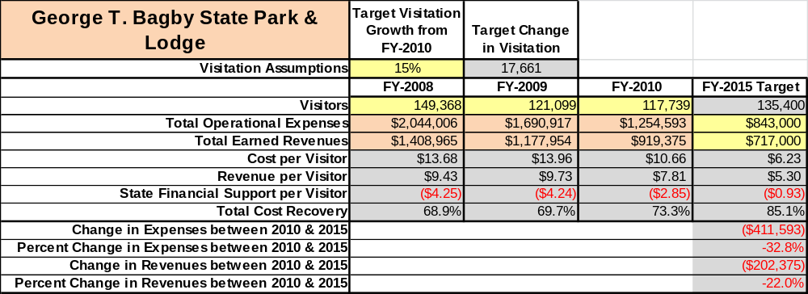

Key Recommendations

Primary / Short Term Recommendations
- Capitalize on improvement recommendations made by guests by utilization of comment card program and surveys.
- Operate the site using cost based accounting, including the net cost recovery achieved annually.
- Explore various opportunities to host events on site. For example; expand on the golf and fishing tournaments, children’s fishing rodeos, educational field trips.
- Continue to evaluate Zip Code data to gauge demographics and origins in order to improve marketing efforts
- Develop and incorporate four special events annually to attract visitation and increase revenue.
- Seek local partners to help support operations, programs and service delivery for cross marketing purposes.
- Incorporate challenging, yet motivating, staff incentive programs to reduce operating costs in services and labor.
- Manage George T. Bagby State Park according to well-defined maintenance, program and operational standards monitored and enforced by management.
- Continue partnerships with Chamber of Commerce, Clay County EDC and Visitor’s Bureau, as well as maintaining relationships with bordering state benefactors and supporting organizations.
- Continue to work with the GTB Chapter of the Friends of Georgia State Parks and Historic Sites to help raise funds or provide volunteers for improvements and program support.
- Establish a thorough net cost-of-service analysis of each department including labor requirements.
- Review and update rates at the site on an annual basis to recover the total net cost of services and amenities.
- Continue to evaluate the economic impact that GTB has on the local and regional area as a major employer and a vital component to the economic well-being of the community.
- Develop a more detailed analysis of labor requirements of all major park functions to include exit Interviews and PMP’s for part-time employees. Also implement a more in-depth training and orientation program for new hires.
- Upgrade facilities and amenities at the site that are likely to have a cost recovery level at or above 100%. For example, relocating the Gazebo from the Hiking trail to the water’s edge and renovating the Old Kitchen space into a recreational and entertainment venue.
- Add more youth-focused services, programs and amenities at the site that appeal to younger audiences, families and educational groups.
- Offer more knowledge-based customer service.
- Add a business center for guest use, including computer and copier equipment.
Secondary / Long Term Recommendations
- Large facility upgrades such as parking lot paving and correcting drainage problems, room updates and new furnishings and park style décor.
- Upgrade conference facilities with modern technology including upgraded wi-fi, projectors, sound systems and lighting.

Site and Operations Assessment
This site and operations assessment is a culmination of analyses and findings from a review of the condition of facilities, infrastructure, and operations at George T. Bagby State Park & Lodge. The findings and observations are not intended to be an exhaustive review of all issues present, but provide a basic understanding of the predominant issues that contribute to the site’s current operating conditions. The assessment includes the following:
- Site Inventory and Facility Assessment
- Operational Assessment
- Financial Assessment
Site Inventory and Facility Assessment

Methodology
Facility and asset conditions are rated using a differential scale of excellent, good, fair, or poor. Descriptions of conditions that are attributed to each of these findings are also provided.
Scale of Conditions
Rating | General Description
Excellent | Facilities/amenities are in ‘excellent’ condition when they show little or no maintenance or repair problems. Facilities do not feature any major design or operational issues or flaws that contribute to diminished use or increased maintenance or upkeep. Facilities are easy to clean and maintain in order to place them back into public use and the users perceive them to be in excellent shape.
Good | Facilities/amenities are in ‘good’ condition when they show only minor maintenance or repair problems. Most maintenance issues with these facilities typically appear to be the result of age and/or heavy use. Facilities may only feature minor design or operational issues that contribute to diminished use or increased maintenance or upkeep. Facilities are moderately easy to clean and maintain in order to place them back into service and the users perceive them to be adequate for their use, but probably not in excellent shape.
Fair | Facilities/amenities are in ‘fair’ condition when they show significant maintenance or repair problems. Facilities generally exhibit ongoing maintenance issues that appear to be the result of age, heavy use, or design or operational flaws. Some maintenance and repair needs may compound their fair condition by being deferred because of budget and/or resource limitations. Facilities require more effort to clean and maintain before placing them back into service and the users may perceive them as being less than adequate for their use and in a state of deterioration. The facility or structure may need of major repair or replacement.
Poor | Facilities/amenities are in ‘poor’ condition when they show significant, on-going maintenance or repair problems that ultimately may result in suspended use for repair/replacement. Maintenance and repair issues are possibly the result of poor maintenance and clearly the result of age, heavy use, or design or operational flaws. Problems with the facilities are often compounded over time due to consistently-deferred maintenance and repair because of budget and/or resource limitations. Facilities may feature major design or operational issues that contribute to diminished use or increased maintenance or upkeep. Facilities require excessive effort to clean and maintain before placing them back into service and the users often perceive them as being inadequate for their use and in a state of serious deterioration. The facility or structure may need of major repair or replacement.

Inventory and Assessment
The table below is an inventory of facilities and amenities at George T. Bagby State Park & Lodge, and provides the assessed condition of each as reviewed in April 2009.
Site Asset / Amenity | Quantity | Condition
Day Use Boat Ramp | 1 | Fair
Park Pass Kiosk | 1 | Good
Conference Center/Restaurant | 1 | Good
Lodge (Motel Rooms)200 Series | 30 | Good
Lodge (Motel Rooms) 100 Series | 30 | Fair
Lodge Courtesy Dock | 1 | Poor- under construction
Pool | 1 | Good
Pool Pump House | 1 | Good
Marina Lift Station | 1 | Fair
Lift Station at Cottage 4 | 1 | Good
Lodge Shop/Storage Bldg | 1 | Fair
Marina Maintenance/Storage Bldg | 1 | Fair
Marina Concession Bldg | 1 | Good
Rest Station #1 (Marina) | 1 | Poor (developing options with E&C)
Marina Picnic Shelter | 1 | Good
Marina Dock Complex | 1 | Fair
WRD Flammable Storage Bldg | 1 | Good
Fueling Station #1 | 1 | Fair
Fueling Station #2 | 1 | Fair
Maintenance Building | 1 | Fair
Maintenance Used Oil Shed | 1 | Fair
Site Manager’s Residence | 1 | Good
Maintenance Engineer Residence | 1 | Good
F& B Director Residence | 1 | Good
Group Shelter | 1 | Good
GS BBQ Shelter | 1 | Fair
Day-Use Boat Ramp Courtesy Dock | 1 | Poor
Group Lodge | 1 | Fair
Rest Station#2 (Beach) | 1 | Fair
Well House (Beach)  Pic | 1 | Fair
Picnic Shelter (Beach) | 1 | Fair
Fish Cleaning Station | 1 | Fair
Cottages | 5 | Good
Gazebo | 1 | Good
Water Tank | 1 | Good
Stewart Lodge | 1 | Good

Prioritized Facility Needs
Based on the facility inventory and assessment, these prioritized needs have been identified. Each need has been aligned with a priority category of high, moderate, or low to support future decision making regarding project sequencing, investment of public resources, and meeting community expectations. The priority assignment for each need is not a measure of importance. Rather, these recommended priorities reflect a phased implementation approach over the next several years.

Facility Need | Priority Assignment
Recreational and entertainment venue conversion (grill and bar) | High
Replace Courtesy Docks at Day Use and Lodge | High
Replace shower bathhouse at the Marina | High
Improved signage at Marina and Entrance | High
Renovations on Group Shelter, Marina concession, Lodge Building, Group Cottage, Maintenance Shop, Lodge Shop | Moderate
Add additional parking and restrooms to Boat Ramp area | Moderate
Replace Day Use Restroom | Moderate
Add pergola to point for weddings | Moderate
Upgrade Gift Shop area | Low

Operational Assessment
The Operational Assessment includes:
- An inventory and classification of programs and services being provided at the site
- A review of staffing at the site
- A review of concessionaires and partners operating at the site
- Visitation and customer satisfaction

Inventory and Classification of Programs and Services
Programs and services are classified into one of three major categories:
1) Core or Essential Services
2) Important Services
3) Visitor Supported Services
Programs and services at the site are classified into these categories based in part on the mission and public mandates for both the site and the agency. For the services in each of these categories, there are financial performance expectations that will define how services are funded and evaluated.

Category 1 – Core Services [Largely supported by tax funds]
Core programs, services and facilities are those the agency must provide and/or are essential in order to capably govern and meet statutory requirements. The failure of the agency to provide Category 1 services at adequate levels could result in significant negative consequences for the public and the resources under protection. The criteria for services to be classified as core or essential are:
- The services are mandated by the agency’s law or charter or are contractually obligated by agreement to provide the services.
- The services are essential to protecting and supporting the public’s health and safety.
- The services protect and maintain valuable assets and infrastructure.
- The services would generally and reasonably be expected and supported by residents, businesses, customers and partners.
- The services are those that cannot or should not be provided by the private sector.
- The services provide a sound investment of public funds.
The following services offered at George T. Bagby have been identified as core services:
- Active management of the natural and cultural resources of the site
- Open and public access to the site of its resources
- Site appropriate education, interpretation and recreational opportunities

Category 2 – Important Services [Supported by a balance of tax funds and earned revenues]
Important programs, services and facilities are those the agency should provide, and are important to governing and effectively serving residents, businesses, customers and partners. Providing Category 2 services expands or enhances the agency’s ability to provide and sustain its core services. The criteria for programs or services to be classified as important are:
- The services expand, enhance or support identified core services.
- The services are broadly supported and utilized by the community, and are considered an appropriate, important, and valuable public good. Public support may be conditional upon the manner by which the services are paid for or funded.
- The services generate income or revenue that offsets some or all of the operating cost and/or are deemed to provide economic, social or environmental outcomes or results.
The following services offered at George T. Bagby have been identified as important services:
- Self-guided interpretation and education programs
- Group shelter, picnic shelters and picnic sites
- Lodging to include lodge rooms, cottages and group lodging
- Lake recreation and related facilities

Category 3 – Visitor Supported Services [Almost exclusively supported by earned revenue]
Visitor supported programs, services and facilities are those discretionary services that the agency may provide when additional funding or revenue exists to offset the cost of providing those services. Category 3 services provide added value above and beyond what is required or expected. The criteria for programs or services to be classified as visitor supported are:
- The services expand, enhance or support core services or important services and the quality of life of the visitors, community or stakeholders.
- The services are supported, valued and well utilized and provide an appropriate and valuable public benefit.
- The services generate income or funding from sponsorships, grants, user fees or other sources that offset some or all of their cost and/or provides a meaningful return on investment.

The services can possibly be provided through outsourcing or use of concessionaires, providing opportunities for community enterprises that may not otherwise be provided by the agency.
The following services offered at George T. Bagby have been identified as visitor supported services:
- Restaurant
- Conference & banquet venue
- Gift shop
- Special events / programs related to the mission of the site
- Special events / programs not related to the mission of the site

Staffing Assessment
Labor costs at George T. Bagby State Park & Lodge represent the largest area of budgetary expense at an average of 63% of the total operating budget each year for the last three complete years, which is lower than the target of total labor costs (including benefits) not exceeding 65% of the site’s total operating expenditures. The tables below and on the following page provide a basic review of the current staffing.
Full Time Equivalent Employees
Position / Title | Quantity (FTE) | Vacancies | Annual Hours
Park Site Manager | 1 | 0 | 2340
Maintenance Engineer | 1 | 0 | 2340
Administrative Ops Coord  A | 1 | 0 | 2080
Food & Beverage Director | 1 | 0 | 2340
Sales & Marketing Manager | 1 | 0 | 2080
Housekeeping Manager | 1 | 0 | 2240  40
Front Desk Clerk/Audit | 1 | 0 | 2080
Food Service Operations | 2 | 0 | 4160
Maintenance Utility | 2 | 0 | 4160
TOTAL | 11 | 0 | 23,820
Part Time Employees
Position / Title | Quantity (FTE) | Vacancies | Hours
Front Desk Clerks | 5 | 0 | 7540
Marina Clerk | 1 | 0 | 1508
Servers | 7 | 0 | 10556
Kitchen Staff | 7 | 0 | 10556
Housekeepers | 5 | 0 | 7540
Maintenance Utility | 2 | 0 | 3016
Sales Coordinator | 1 | 0 | 1508
Interpretive Programmer | 0 | 1 | 0
TOTAL | 17 | 5 | 42,224
Labor Support
Labor Support | Annual Hours
Volunteers | 750
Community Service Workers | 0
Engineering and Construction Crews | 40
Resource Management Crews | 0
TOTAL | 790
Total Labor Hours
Labor Type | Annual Hours
Full Time Equivalent Employees | 23,820
Part Time Employees | 42,224
Labor Support | 790
TOTAL Annual Labor Hours | 66,834

Labor Budget Summary
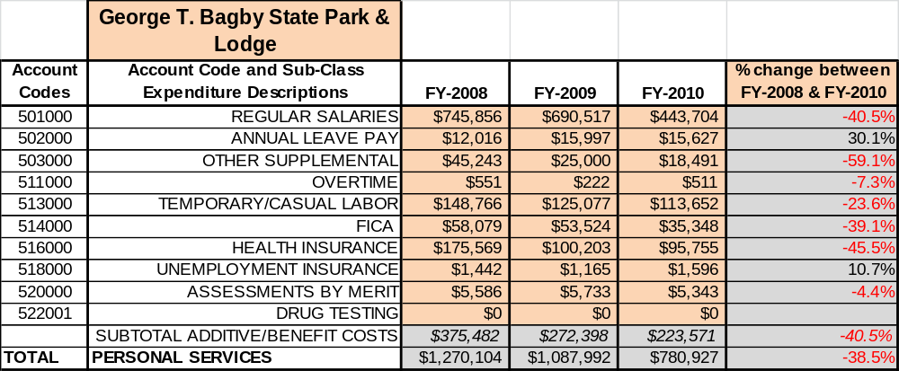

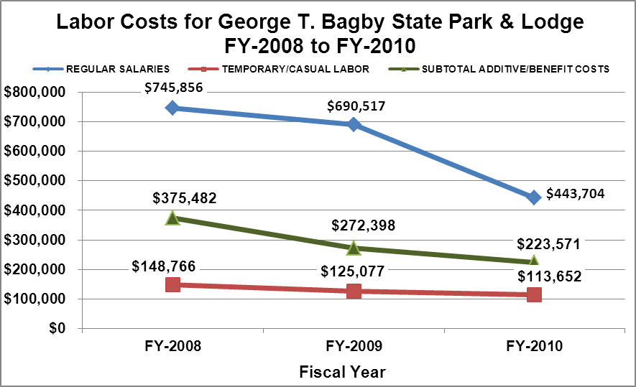

Visitation and Occupancy
Overall annual visitation to the site has trended downward from 2008 to 2010, decreasing by 21% or over 31,000 visitors. This is largely attributed to economic conditions, decreases in school visitation, the rise in gasoline prices nationwide and the overall cost-of-living.
Year | Total Visitation
2008 | 149,368
2009 | 121,099
2010 | 117,739

Occupancy for the overnight accommodations at George T. Bagby State Park & Lodge for the last three years is detailed in the table below. While the overall occupancy has trended downward from 2008 to 2010, cottage occupancy increased in 2009 by 7% but tapered back in 2010 and held out with no change from 2008. Unfortunately, lodge occupancy decreased an overall 19% between 2008 and 2010. This is largely attributed to the economic downturn, cutbacks in business and personal travel, increases in fuel costs as well as rumors that led to the public’s speculation that GTB was soon closing its doors. This not only caused canceled reservation but groups and individuals alike sought lodging elsewhere.

Year | Cottage Occupancy | Lodge  Occupancy
2008 | 54% | 45%
2009 | 61% | 39%
2010 | 54% | 26%

Customer Service and Satisfaction

Site | Year | Customer Satisfaction Level
George T. Bagby State Park | 2009 | 62%
George T. Bagby State Park | 2010 | 75%

Our most recent method of monitoring customer service and satisfaction was through paper, hard copy comment cards. This system of monitoring does not give the site an accurate assessment of how satisfied guests are. However, the site does receive cards from individuals and groups when the site has done an exceptional job in providing these services. From 2009 to 2010, Bagby experienced a 13% increase in customer satisfaction.

Financial Performance Assessment

Operational Expenses
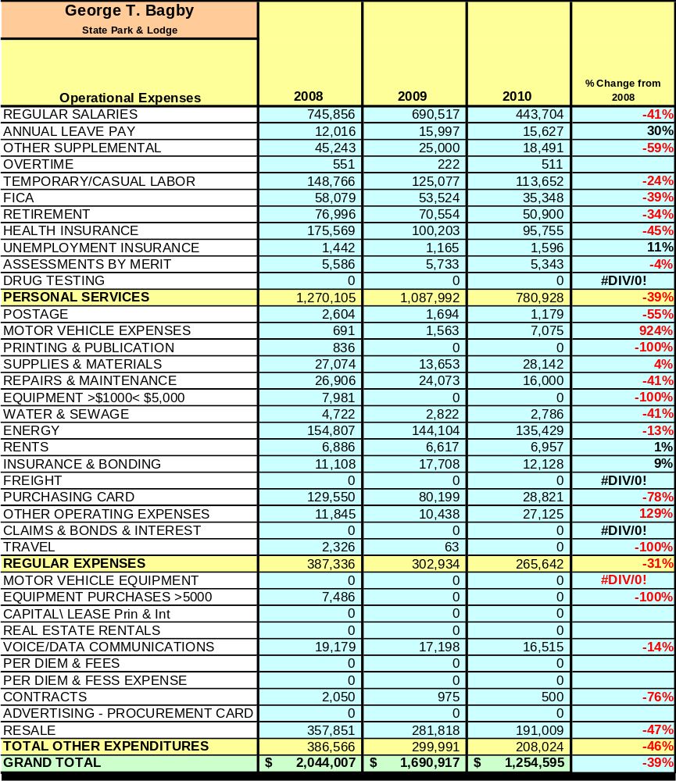
A summary of total operating expenses at George T. Bagby State Park & Lodge from 2008 to 2010, as well as their percent change from 2008 are provided in the table below.
Earned Revenues
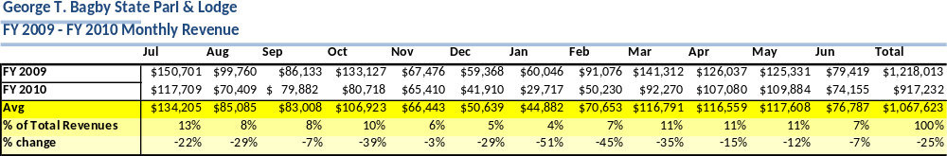
Earned revenues at George T. Bagby State Park & Lodge have decreased since 2008, which is largely attributed to the corresponding decrease in overall visitation. Visitation decreased in part due to the possibility of the lodge and conference center closing at the end of FY 2010. This caused the public to choose other venues to serve their conference and lodging needs. Monthly earned revenues for the last two years indicate that the total annual revenue decreased 22% from 2009 to 2010, with the largest decreases in monthly revenues in January (51%), February (45%), October (39%) and March (35%) with no increases in monthly revenues for 2010.

The graphs below illustrate the monthly revenue trends each year and the average percent of total annual revenue earned each month.
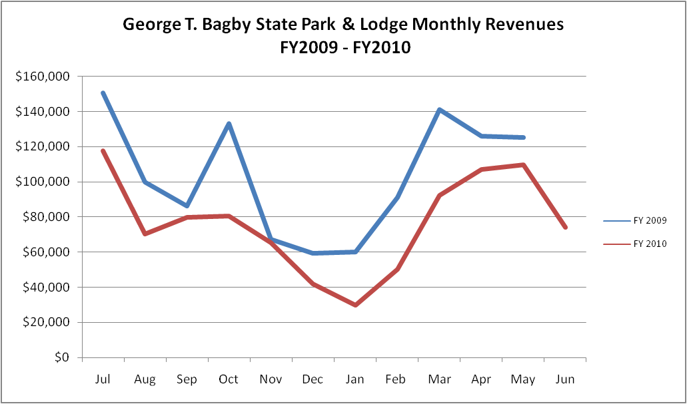

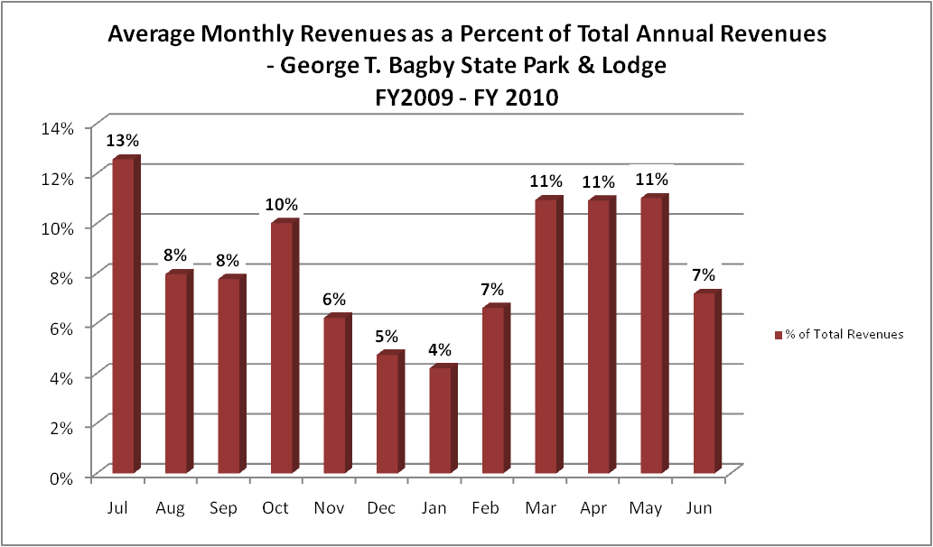

Cost Recovery Trends
George T. Bagby State Park & Lodge has achieved an average cost recovery of 71% of annual operational expenses through earned revenues from FY 2008 to FY 2010. This is detailed and illustrated in the table and graph below.
Year | Operational  Expenses | Earned  Revenues | Percent Cost  Recovery
2008 | $2,044,007 | $1,408,965 | 69%
2009 | $1,690,917 | $1,177,954 | 70%
2010 | $1,254,595 | $919,375 | 73%

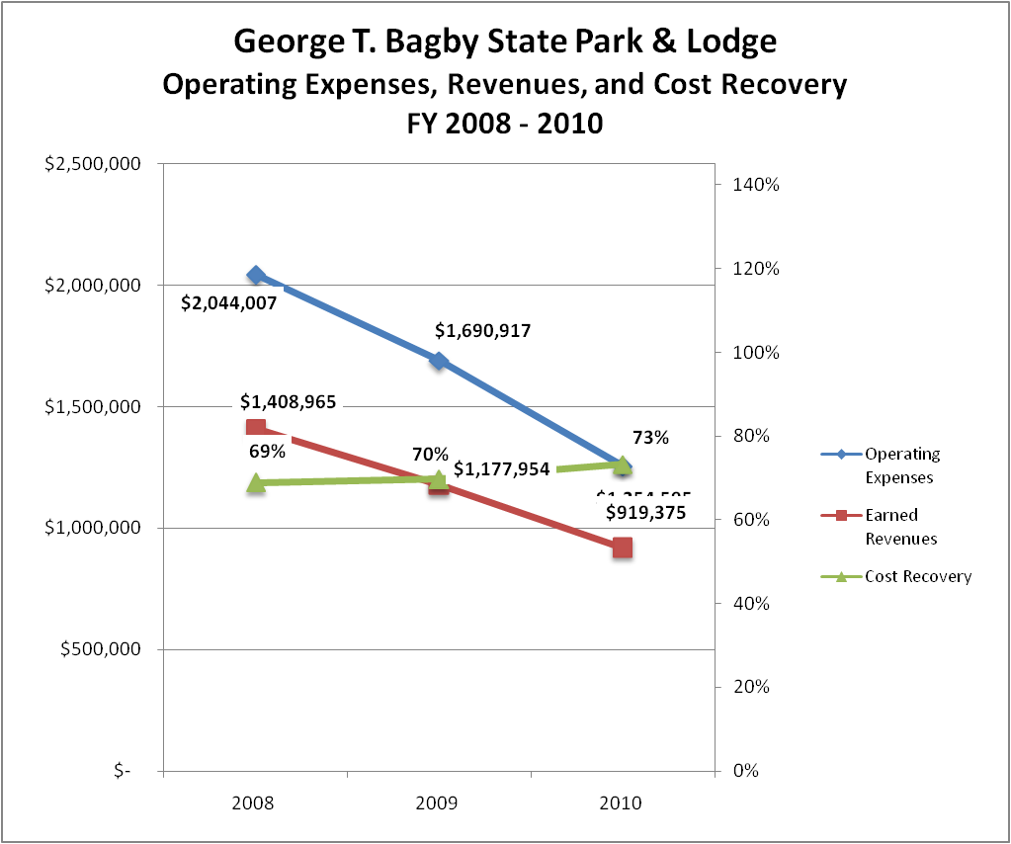

Review of Pricing
Data on rate information is available as far back as 2002, but only the last five years are evaluated. There has been notable growth in rates charged for reservables at George T. Bagby State Park & Lodge since 2005, with the largest increases being for the group shelter (27%) and cabin rates (24%). A table detailing the rates for all reservables is provided below.
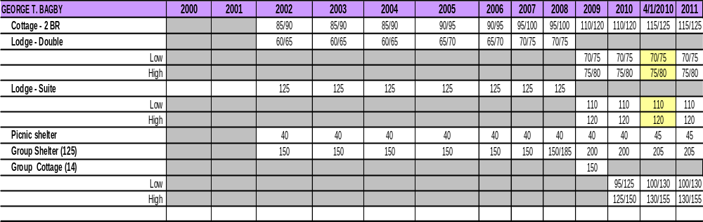
Business and Management Plan

Business Goals
The following goals serve as the foundation for the key recommendations and strategies in this business plan for George T. Bagby State Park & Lodge.

Enhance Cost Recovery of Site Operations
George T. Bagby State Park & Lodge is currently operating at 69-73% cost recovery of operational expenses through earned revenues. Bagby can likely improve revenues through additional special events and marketing to draw more visitors to the site. The site is seeking to increase its cost recovery to 85% through enhanced revenue generation and strategic expense reductions.

Enhance Revenue Generation Strategies
Train the staff to better utilize yield marketing. Update restaurant menus and adjust prices in food and beverage to offset rising F&B expenses due to rising costs and fuel surcharges. Work with Friends of GTB to enhance signage to include amenities. Offer more diverse recreational and entertainment amenities to attract new visitation while encouraging repeat visitation. Add kayak rentals to the fleet of boats currently offered. In addition to the interpretive programs offered at our site, the lodge and conference center allow the opportunity to expand unused space for events and entertainment that would increase visitation and revenue generation. The expansion would include such improvements as converting the old kitchen into a recreational/entertainment venue. Build a pergola to be located to the vista just off the restaurant and near the water’s edge. This location would allow for events such as weddings, receptions, festivals, school/interpretive programs, and concerts.

Enhance Special Events at the Site
Explore more opportunities to host golf and fishing tournaments at special pricing. Offer unique packages to include lodging, meals and conference center as well as other amenities for such events. Additionally, expand school field trips to encompass interpretive presentations, nature trails, day-use area, and sites within the park which offer educational insight. Offer more family oriented events such as the children’s fishing rodeo.

Improve the Effectiveness of Marketing and Sales
The effectiveness of marketing and promotional activities at George T. Bagby is important to produce greater visitation and revenues during peak, shoulder and off seasons. This could be achieved in part through a consistent marketing approach targeting and focusing on potential new and repeat geographic areas and market segments (family reunions, church, government, etc.), as well as creating promotional packages during the non-peak season. Additionally, we can capitalize on exposure through speaking engagements, presentations and involvement in local and regional organizations, along with partnerships with community and civic groups (Chamber of Commerce, Convention/Visitors Bureaus, EDC, State Visitor Information Centers, Regional Tourism Meetings, and Civic Organizations ex. Rotary, Lions, Kiwanis, etc.). Developing collaborative cross promotions, events and referrals with nearby attractions and amenities should improve the site’s ability to maintain and create additional visitors and revenue. Implementing special events to draw new business from local markets, drive markets and overnight markets should provide a surge in visitation and revenue.

Establish Greater Consistency of Managing and Monitoring Customer Service & Satisfaction
George T. Bagby plans to advance customer satisfaction by utilizing comment cards and customer surveys. The assessment of customer satisfaction will allow George T. Bagby the opportunity to analyze and monitor services and facilities. Those that fall below standards will be critically reviewed to enhance satisfaction; those with a history of poor performance will be evaluated to determine whether elimination is viable.

Expand Partnership Opportunities
Maintaining existing partnerships (Chamber Of Commerce, EDC, Visitor Bureaus, Friends, etc.), along with creating additional opportunities, will greatly benefit George T. Bagby. Additional opportunities will include seeking local and community advocacy, along with volunteers, to support the provision of programs and services to visitors at George T. Bagby. Seek partners to offset costs of materials and supplies, as well as related services needed by the site. Seek local partners to help support operations, programs and service delivery for cross marketing purposes. Preserving relationships with bordering state benefactors provides George T. Bagby with an additional opportunity to enhance visitation and revenue.

Classification of Programs and Services
The tables below summarize the classifications of programs and services at George T. Bagby State Park & Lodge as either core, important, or visitor supported and projects a range of cost recovery percentages that might be achieved for each. These classifications establish financial performance goals for each category of services that are linked to the recommendations and strategies of this business plan.

Core Services
Program / Service | Target Cost Recovery
Active management of the natural and cultural resources of the site | 0%
Open and public access to the site of its resources | 10-20%
Site appropriate education, interpretation and recreational opportunities | 10-20%

Important Services
Program / Service | Target Cost Recovery
Self-guided interpretation and education programs | 40%-50%
Group shelter, picnic shelters and picnic sites | 100-125%
Lodging to include lodge rooms, cottages and group lodging | 125-150%
Lake recreation and related facilities | 25%

Visitor Supported
Program / Service | Target Cost Recovery
Restaurant | 200%
Conference & banquet venue | 200%  %
Gift shop | 150%
Special events / programs related to the mission of the site | 150%
Special events / programs not related to the mission of the site | 150%

Partnership Development Plan
The table below summarizes existing partners and targeted partnerships by classification (operational, vendor, service, co-branding, funding partners) and by organizational type.
 | Public Partners | Not-for-profit Partners | Private / Enterprise Partners
Operational Partners | - U.S. Army Corps of Engineers | - Bass-N-Buddies of Albany
Vendor Partners |  |  | - Coca Cola  - Georgia Power  - Anderson Construction  - Sysco Foods
Service Partners | - City of Ft. Gaines  - Andrew College  - City of Abbeville  - Wildlife Resources Division  - Clay County , GA | - Albany Chamber of Commerce  - Dothan Chamber of Commerce  - Columbus Chamber of Commerce  - Terrell County Chamber of Commerce  - Clay County Chamber of Commerce
Co-branding Partners | - Kolomoki State Park  - Providence Canyon State Park  - Florence Marina State Park |  | - Sea Tow
Funding Resource Development Partner | - Clay County Economic Development Council | - Friends of Georgia State Parks & Historic Sites  - Friends of George T. Bagby State Park  - Friends of Lake Eufaula | - Farley Nuclear Plant

Marketing and Sales Plan

Marketing and Sales Goals
Marketing and sales goals for George T. Bagby State Park are based on the following desired outcomes:
- To produce increased revenue during non-peak season
- To retain repeat visitors and acquire new visitors
- To attain new groups for overnight stays and conference services
- To produce increased overall visitation and revenues
In order to meet these goals, examples of specific target outcomes were identified in the areas detailed in the table below.
Area  of Focus | Current  Performance | Goal  by 2011 | Goal  by 2012 | Goal  by 2015
Non-Peak  Season Revenue | $121,857 | $125,512 | $129,277 | $141,265
Overall Visitation | 117,739 | 122,154 | 126,569 | 135,400
Marketing and Promotion Strategies

Publicity and Social Media
George T. Bagby will approach marketing and publicity planning using the following guidelines:
- Event publicity
Major events benefit by having short stories in local, regional, and statewide newspapers and online social media hooks planted that run three to four weeks in advance of the event up to the date of the event itself. Stories and media need to be cultivated with contacts and online sales channels several weeks in advance of the time the stories need to run. Special interest interviews on morning, noon, and evening television news programs, radio interviews on popular rush-hour programs, and blogs on known affinity online sites should also be included.
- Program publicity
Special and unique programs should have feature stories in magazines, weekly newspapers, and statewide daily newspapers that are aimed at placements as front-page or sectional front-page stories. These stories are most effective if they run shortly before the season that the featured program begins. This will likely require several weeks of advanced planning with media contacts. Similar coverage on television and radio should also be considered. If pre-publicity cannot be generated, post-publicity can help promote future programs.
- Site Publicity
Site publicity focusing on a single site or sub-set of sites requires more intense planning efforts to attract multiple writers and editors from target publications. The site could host several seasonal media familiarization tours (with 10 to 15 writers or editors) to familiarize them with the site and its benefits and amenities. Stories and features resulting from such tours typically take between two and six months to materialize so the tours should focus on experiences, benefits, and programs that would be available when the stories are expected to run.
Examples and suggested opportunities for events, programs and related publicity efforts based on the themes described above at George T. Bagby State Park & Lodge are provided in the table below.
Event Publicity | Program Publicity | Site Publicity
Halloween Festival | Junior Ranger Camp | Bass Fishing Tournament
Breakfast with Santa | Geology Day | Crappie Fishing Tournament
Food & Crafts Festival | Astronomy Night | Annual Art’s Council Musicals

Packaging
Examples and suggested packages for George T. Bagby are provided in the table below.
Package | Package Details
Golf Package | Overnight accommodations, Breakfast, 18 holes + cart
Corporate Meeting Package | Overnight accommodations, breakfast, lunch, dinner and breaks, Conference room rental
Holiday Packages (Valentine’s Day, New Year’s Eve) | Overnight accommodations, breakfast and dinner, champagne and souvenir flutes

Group Sales
Types of groups within which specific target customers can be identified for George T. Bagby are listed below:
- Families  - Church Groups  - Activity or Special Interest Clubs and organizations  - Associations | - Business and Professional Groups  - Community and Civic Organizations  - Schools (public and private)  - Colleges and Universities | - Golf Groups  - Youth groups and organizations  - Community Organizations  - Public and State Agencies

Incentivizing New and Repeat Visitation
George T. Bagby State Park & Lodge will utilize the following strategies and/or incentives to encourage new and repeat visitation starting in FY 2012:
- Early registration discounts
- Group pricing options and packages
- Special promotions, packages and pricing during non-peak seasons and days with low occupancy
Marketing and Sales Metric Goals
The following marketing and sales metric goals and/or others will be monitored and progress reported at George T. Bagby State Park & Lodge:
- Loyalty and repeat customers = 60% of customers repeat their visit within 12 months.
- Brand confidence & customers-recruiting-customers = Word of mouth and customer referrals equal 40% of visitation.
Revenue Generation Plan
Revenue / Cost Recovery Goals
George T. Bagby has set a financial goal of increasing annual revenues 3% annually between 2012 and 2015. The largest revenue growth opportunity is most likely overnight reservables during the months of December through February, and from Sunday through Thursday for most every month of the year. The table below details projected revenue growth leading up to 2015.
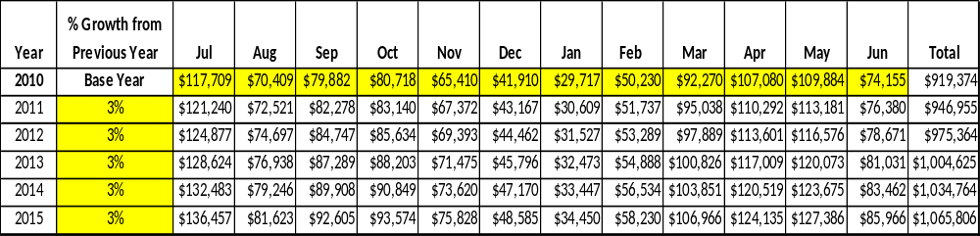
These projections would result in a total of 16% cumulative growth in total annual revenues between FY2010 and FY2015. If operational expenses can be managed with a cumulative reduction of 5% between FY 2010 and FY 2015, then the overall cost recovery of the site will be approximately 85% in FY 2015 at these projected revenue levels. This is higher than the annual financial performance of the site in FY 2010, which was operated at 73% cost recovery in that year.
Revenue Generation Strategies

Pricing Plan
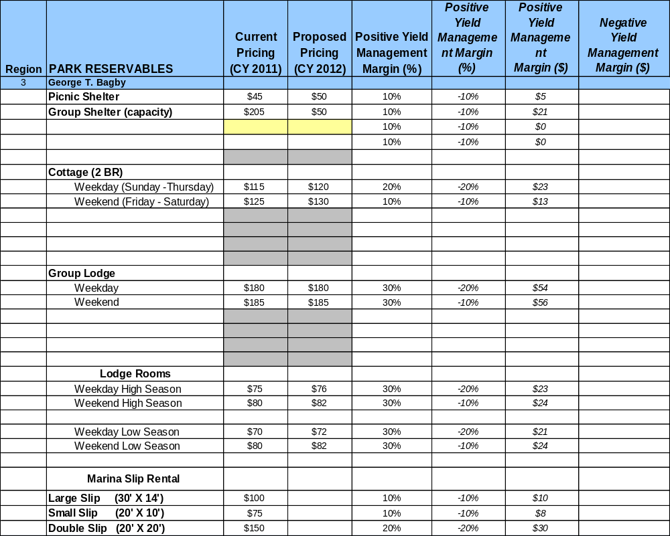

Innovative Programming and Special Events Plan
Program / Event | Theme / Purpose | Scheduled Date/Season | Frequency | Target Participation | Target User Fee | Target Cost Recovery
Halloween Festival | Halloween themed activities | Last Weekend of October | Annually | Families & Kids of All Ages | $1 – $5  Per Event | 200%
Breakfast w/Santa | Kids have Breakfast w/Santa | Second Saturday in December | Annually | Families | $5.75-$7.95  Per Person | 155%
Food, Arts & Crafts Festival | Annual Event | Either Spring of Fall of the Year | Annually | Communities within 120 mile radius | Vender Fee:  $50.00 | 200%
Junior Ranger Camp | Environment, conservation, safety and wildlife for Kids | Late June to Mid July | Annually | Children ages  6-12yrs | $50/person | 150%
Geology Day | Geologic features and formations | Late Spring or Early Summer | Annually | Families | $5 - $7/person | 175%
Astronomy Night | Observe the Night Sky | Spring & Fall | Bi-Annually | Families | $5 - $7 | 150% – 180%
Mystery Dinner Theater with Andrew College | Friends Fundraiser | September | Annually | 120 | $22.00 per person | 125%

Partnerships and Concessions Plan
Service / Partnership | Term of Service | Financial Objective | Contract Manager
Event Planning & Promotion | 2 Years | 15% or More of Gross Receipts | Park Manager
Waste Collection | 2 Years | Competitive Cost Analysis for Reduced or No Annual Cost Increase | Park Manager
Packaging & Promotions w/Local Businesses and/or Sister Parks | 1 Year | Shared Revenue | Park Manager(s)

Expense Management Plan
Personnel Assignments
The following actions will be taken to proactively manage labor costs via personnel assignments and classifications.

Action | Timeline | Outcome

Management Techniques
The following actions will be taken to proactively manage labor costs via management techniques.

Action | Timeline | Outcome
Cross train present and future staff to reduce FLSA & Compensatory Overtime | July 2013 | Annual labor cost reduction of  $2,000
Increased use of volunteers for park and lodge maintenance | July 2012 | Annual labor cost reduction of  $2,000

Adjusted Levels of Service
The following actions will be taken to proactively manage labor costs via reduced levels of service.
Action | Timeline | Outcome
Adjust mowing and landscape schedules for portions of the park | July 2012 | Annual labor cost reduction of  $1,000

Financial Pro Forma
The following five-year financial pro forma projects operating expenses, earned revenues and cost recovery through FY 2015. These pro forma are based on the strategies and desired outcomes identified in this business plan, especially the revenue generation and expense management plans, and are linked to corresponding performance goals.

Expense Pro Forma
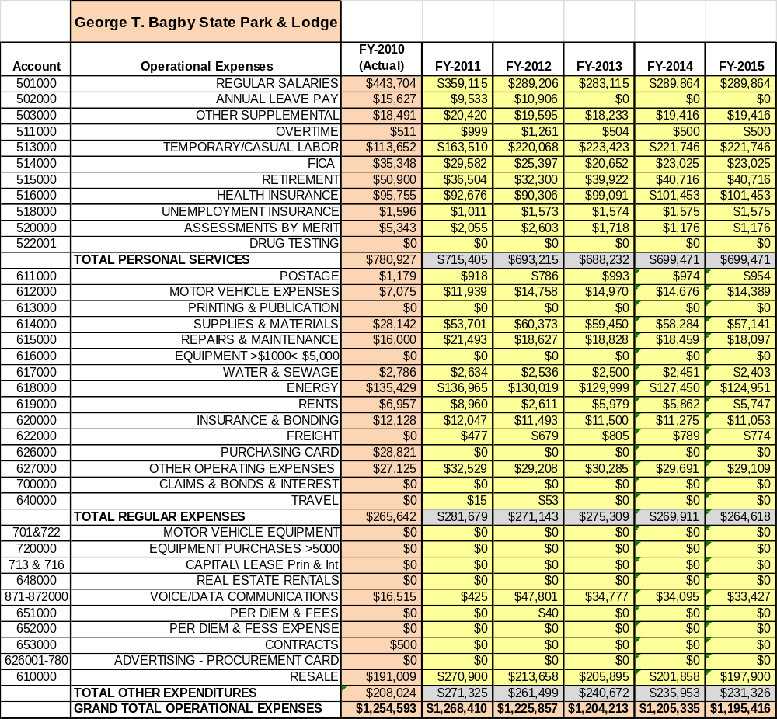

Revenue Pro Forma
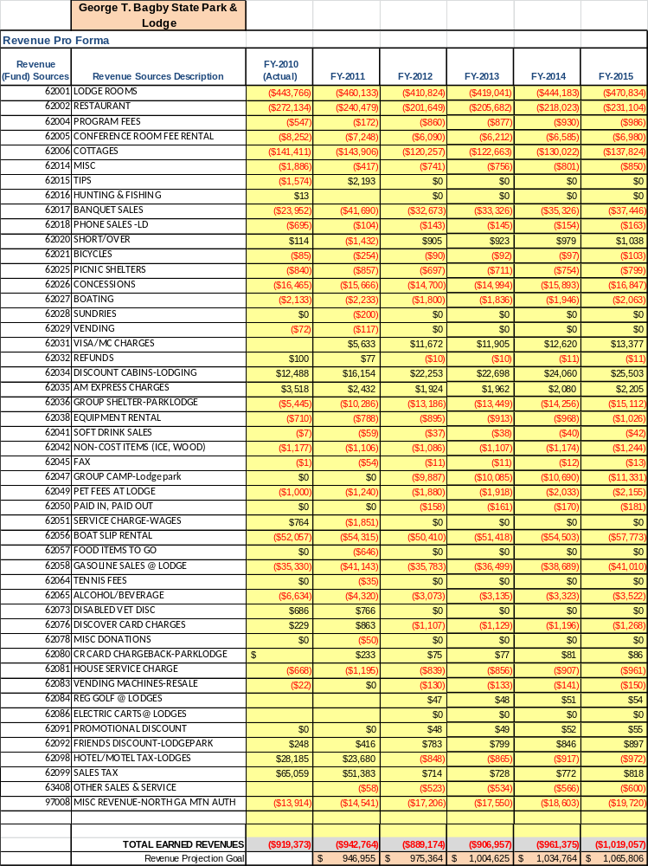

Total / Cost Recovery Pro Forma
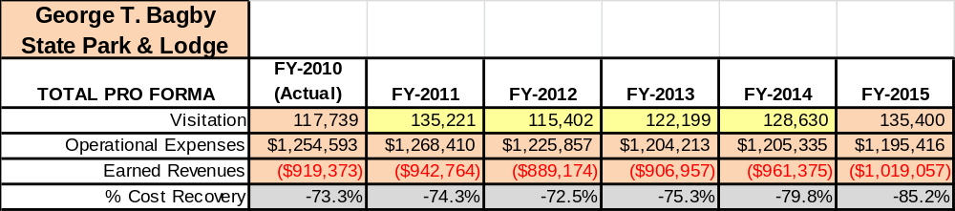

Action Plan
ACTION PLAN
Site: |  | Site Manager: |  |  | Date:
Month:
Strategy | Tasks | Costs / Funding | Revenues / ROI | Responsibilities | Metrics

ACTION PLAN
Site: |  | Site Manager: |  |  | Date:
Month:
Strategy | Tasks | Costs / Funding | Revenues / ROI | Responsibilities | Metrics

This is the average of the last three years – FY 2008, FY 2009, and FY 2010
Current employees, not including vacancies.
Current employees, not including vacancies.
Major population centers within a two-hour drive from the site

