Georgia Veterans State Park
Business & Management Plan

Prepared June 2011; Finalized December 2012
Direction 2015 – Sustainable Business Planning

Table of Contents

Executive Summary 3

Site and Operations Assessment 7
Site Inventory and Facility Assessment 7
Operational Assessment 10
Financial Performance Assessment 16

Business and Management Plan 19
Business Goals 19
Classification of Programs and Services 20
Partnership Development Plan 21
Marketing and Sales Plan 22
Revenue Generation Plan 24
Expense Management Plan 26
Financial Pro Forma 27

Action Plan 30

Executive Summary
The Parks, Recreation and Historic Sites Division (PRHSD) of the Georgia Department of Natural Resources (DNR) is transitioning the management of Georgia Veterans State Park to operate more like a business, reflecting the Direction 2015 – Sustainable Business Planning initiative to improve the fiscal performance and management of the state parks and historic sites system. This business and management plan is designed to help the site recover more operating expenses through earned revenues, productive partnerships, and innovative programs.

Site Fact Sheet
Site Name | Georgia Veterans State Park
Site Manager | Randell Meeks
Region Manager | Eric Bentley
Date of Business Plan completion | 6-13-2011
Site size | 1300 acres
Total number of visitors (FY 2010) | 752,558
Total operating budget (FY 2010) | $ $356,626
Total earned revenues (FY 2010) | $333,681
Total ParkPass FY2010 | $178,000
Operational cost recovery (FY 2010) | 94%
Average operating cost per visitor (FY 2010) | $0.42
Average earned revenue per visitor (FY 2010) | $0.44
Average cost recovery (FY 2008 – 2010) | 80%
Target cost recovery (FY 2015) | 112%
Total full-time employees | 5
Total part-time employees | 5
Primary service markets | Americus, Albany, Columbus, Cordele, Macon and Valdosta
Primary attractors/visitor appeal factors | Recreation (swimming, water sports, fishing) on Lake Blackshear, mega boat ramp, camping, golf (regular and disc), museum and artifacts, restaurant, and trails.
Leading opportunities for improved site performance | Expansion of campground, off-season incentives, camper cabins, increased programing opportunities, development of more trails and addition of renting kayaks and canoes.

Site Summary and Key Attractions

Key Attractions
The amenities or features listed below are those that seem to be most popular for visitors.
- Lake Blackshear (swimming, fishing, skiing, tubing, sailing, boating, kayaking and canoeing).
- Camping (76 rentable campsites).
- Museum with artifacts from Revolutionary War to Desert Storm.
- Outdoor artifacts that include aircraft, tanks, and guns.
- Hiking trails (4 miles of trails).
- Wildlife (plenty of opportunities to see and photograph a variety of wildlife).
- Lake Blackshear Resort (includes marina, conference center, lodge rooms, cabins and two restaurants).
- Golf (park has disc golf course and Lake Blackshear Resort has an 18-hole golf course).
- Sam Shortline Excursion Train Depot on site.
- Radio controlled flying field.
- 4 picnic shelters, 1 group shelter, 1 pavilion, 3 boat ramps.
- Rentals (Includes kayaks, canoes and bicycles)2012

Financial Targets
The table below details the total operating expenses and earned revenues for Georgia Veterans State Park over the last three years (2008 – 2010). This table also calculates total cost per visitor and revenues per visitor during these operating years, and details the target financial performance goals in the context of achieving at least 100% cost recovery. This table also calculates the necessary change from 2010 operating expenses and revenues.
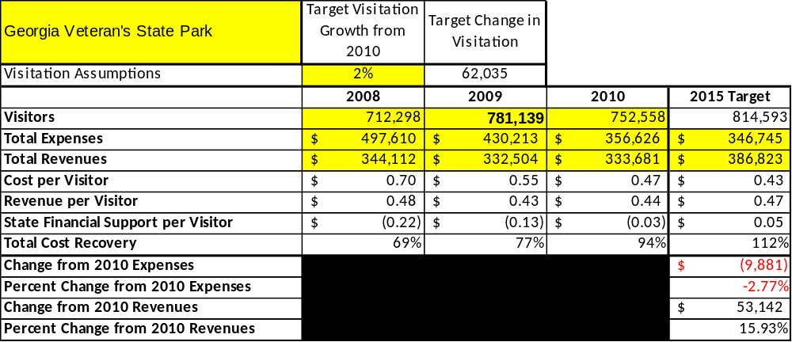

Key Recommendations

Primary / Short Term Recommendations
- Work in partnership with the Friends of Georgia Veterans to implement many of the short term recommendations listed below.
- Utilize the resources of the park to create a year round program schedule that can generate revenue and /or create a self-sustaining program. Also program surveys will be done to ensure that the programs meet the needs and expectations of the participants.
- Utilize the business plan to focus on the cost center (cost based accounting) to insure that the park is being operated as efficiently as possible.
- Utilize in-park surveys to rate customer satisfaction on accommodations, events, services and programs. Satisfaction rates need to be 90% or greater to be considered acceptable. Anything under that level needs to be reviewed, enhanced or replaced and results of such changes need to be tracked to ensure progress. .
- Work with maintenance staff to ensure best economical and ecological methods are being used to maintain the facilities to a high standard.
- Evaluate and pursue opportunities to employ public and/or private service providers on-site. Beach concessions, event concessionaires are examples.
- Create more events based on theme of the park. Examples are Memorial Day events and fishing tournaments sponsored by the park.
- Continue working with hosts in our campground hosts program to ensure that labor costs are kept down.
- Ensure that the park is operated by the standards set in Red Book and other guidelines set forth by the Department.
- Maintain working relations with the local Chamber of Commerce, local tourism boards and other local and regional tourism organizations to ensure promotion of park in the region as a usable and friendly asset.
- Adjust pricing at the park to reflect the local camping competition (KOA and small private campgrounds).
- Maintain good working partnership with the Friends of Georgia Veterans to ensure shared goals for future progress of the park..
- Install a primitive camping area (5-10 sites) to capture the tent campers who just want the basics. These have minimal cost and upkeep related to them.
- Work closely with Sam Shortline, Lake Blackshear Resort (LBR) and with the WRD division to create revenue generating opportunities. This includes the new mega ramp when it finally becomes officially operational.

Secondary / Long Term Recommendations
- Upgrade facilities and amenities at the park including, but not limited to adding 25 – 50 campsites, upgrading all sites to 50 amps, and adding WIFI to the campground.
- Keep the Friends Group of GV as a close business partner in ensuring that the park remains sustainable and active in the local community.
- Add more youth based amenities within the park.
- Creation of more trails in the undeveloped areas of the park.
- Conversion of Lakeview Pavilion into an enclosed group shelter with climate control. At least enclose the shelter with kneeboard and screen to increase paid usage.
- Improve bathrooms and development of walk-in camping at pioneer camping area.
- Work with camping groups to create annual camping visits to the campground.
- Work with local community and state agencies to build a section for camper cabins.
- Renovate and enclose the sheltered part of the beach house so that those areas may become rentable areas. Upgrade picnic shelters to screened in shelters with extra amenities added to them.

Site and Operations Assessment
This site and operations assessment is a culmination of analyses and findings from a review of the condition of facilities, infrastructure, and operations at Georgia Veterans State Park. The findings and observations are not intended to be an exhaustive review of all issues present, but provide a basic understanding of the predominant issues that contribute to the site’s current operating conditions. The assessment includes the following:
- Site Inventory and Facility Assessment
- Operational Assessment
- Financial Assessment
Site Inventory and Facility Assessment

Methodology
Facility and asset conditions are rated using a differential scale of excellent, good, fair, or poor. Descriptions of conditions that are attributed to each of these findings are also provided.
Scale of Conditions
Rating | General Description
Excellent | Facilities/amenities are in ‘excellent’ condition when they show little or no maintenance or repair problems. Facilities do not feature any major design or operational issues or flaws that contribute to diminished use or increased maintenance or upkeep. Facilities are easy to clean and maintain in order to place them back into public use and the users perceive them to be in excellent shape.
Good | Facilities/amenities are in ‘good’ condition when they show only minor maintenance or repair problems. Most maintenance issues with these facilities typically appear to be the result of age and/or heavy use. Facilities may only feature minor design or operational issues that contribute to diminished use or increased maintenance or upkeep. Facilities are moderately easy to clean and maintain in order to place them back into service and the users perceive them to be adequate for their use, but probably not in excellent shape.
Fair | Facilities/amenities are in ‘fair’ condition when they show significant maintenance or repair problems. Facilities generally exhibit ongoing maintenance issues that appear to be the result of age, heavy use, or design or operational flaws. Some maintenance and repair needs may compound their fair condition by being deferred because of budget and/or resource limitations. Facilities require more effort to clean and maintain before placing them back into service and the users may perceive them as being less than adequate for their use and in a state of deterioration. The facility or structure may need of major repair or replacement.
Poor | Facilities/amenities are in ‘poor’ condition when they show significant, on-going maintenance or repair problems that ultimately may result in suspended use for repair/replacement. Maintenance and repair issues are possibly the result of poor maintenance and clearly the result of age, heavy use, or design or operational flaws. Problems with the facilities are often compounded over time due to consistently-deferred maintenance and repair because of budget and/or resource limitations. Facilities may feature major design or operational issues that contribute to diminished use or increased maintenance or upkeep. Facilities require excessive effort to clean and maintain before placing them back into service and the users often perceive them as being inadequate for their use and in a state of serious deterioration. The facility or structure may need of major repair or replacement.

Inventory and Assessment
The table below is an inventory of facilities and amenities at Georgia Veterans State Park, and provides the assessed condition of each as reviewed in May 2011.

Site Asset / Amenity | Quantity | Condition
Visitor Center /Office | 1 | Good
Group shelter | 1 | Good
Park Pass Kiosk (front) | 1 | Good
Picnic shelter 1 | 1 | Good
Picnic shelter 2 | 1 | Good
Picnic shelter 3 | 1 | Good
Picnic shelter 4 | 1 | Good
Lake View Pavilion | 1 | Excellent
Beach house | 1 | Fair
Comfort station camp loop 1 | 1 | Good
Comfort station camp loop 2 | 1 | Good
Comfort station camp loop 3 | 1 | Good
Restroom (boy scout) | 1 | Good
Restroom (gum creek) | 1 | Good
Restroom (playground) | 1 | Good
Pioneer camp picnic shelter | 1 | Good
Pioneer tent shelters | 2 | Good
Brick pavilion at pioneer camp | 1 | Fair
Brick bathroom at pioneer camp | 1 | Poor
Gum Creek fishing pier | 1 | Fair
Gum Creek boat docks | 2 | Fair
Boy Scout fishing pier | 1 | Fair
Boy Scout boat dock | 1 | Fair
Beach fishing pier | 1 | poor
Manager Residence | 1 | Fair
Assistant Manager Residence | 1 | Good
Ranger Residence | 1 | Fair
Maintenance wood barn | 1 | Good
Maintenance barn | 1 | Good
Maintenance storage shed | 3 | Fair
Pump house | 1 | Excellent
Manager carport | 1 | Fair

Prioritized Facility Needs
Based on the facility inventory and assessment, these prioritized needs have been identified. Each need has been aligned with a priority category of high, moderate, or low to support future decision making regarding project sequencing, investment of public resources, and meeting community expectations. The priority assignment for each need is not a measure of importance. Rather, these recommended priorities reflect a phased implementation approach over the next several years.

Facility Need | Priority Assignment
Addition of 25 -50 campsites or 10 camper cabins | High
Addition of 5-10 primitive campsites for tent campers | High
Upgrade of campsites to 50 amps | Moderate
WI-FI on campground | Moderate
Renovate beach house to become a rentable asset. | Moderate
Campground renovations in loop 3 | Moderate
Fishing pier replacement | Moderate
Renovate bathroom at pioneer camp | Moderate

Operational Assessment
The Operational Assessment includes:
- An inventory and classification of programs and services being provided at the site
- A review of staffing at the site
- A review of concessionaires and partners operating at the site
- Visitation and customer satisfaction

Inventory and Classification of Programs and Services
Programs and services are classified into one of three major categories:
1) Core or Essential Services
2) Important Services
3) Visitor Supported Services
Programs and services at the site are classified into these categories based in part on the mission and public mandates for both the site and the agency. For the programs and services in each of these categories, there are financial performance expectations that will define how services are funded and evaluated.

Category 1 – Core Services [Largely supported by tax funds]
Core programs, services and facilities are those the agency must provide and/or are essential in order to capably govern and meet statutory requirements. The failure of the agency to provide Category 1 services at adequate levels could result in significant negative consequences for the public and the resources under protection. The criteria for programs or services to be classified as core or essential are:
- The services are mandated by the agency’s law or charter or are contractually obligated by agreement to provide the services.
- The services are essential to protecting and supporting the public’s health and safety.
- The services protect and maintain valuable assets and infrastructure.
- The services would generally and reasonably be expected and supported by residents, businesses, customers and partners.
- The services are those that cannot or should not be provided by the private sector.
- The services provide a sound investment of public funds.
The following programs and services offered at Georgia Veteran’s State Park have been identified as core services:
- Law enforcement (provide a safe and secure environment)
- Artifact Management (includes visitor center/museum)
- Maintenance of grounds and facilities
- Open and public access to the park and resources

Category 2 – Important Services [Supported by a balance of tax funds and earned revenues]
Important programs, services and facilities are those the agency should provide, and are important to governing and effectively serving residents, businesses, customers and partners. Providing Category 2 services expands or enhances the agency’s ability to provide and sustain its core services. The criteria for programs or services to be classified as important are:
- The services expand, enhance or support identified core services.
- The services are broadly supported and utilized by the community, and are considered an appropriate, important, and valuable public good. Public support may be conditional upon the manner by which the services are paid for or funded.
- The services generate income or revenue that offsets some or all of the operating cost and/or are deemed to provide economic, social or environmental outcomes or results.
The following programs and services offered at Georgia Veteran’s State Park have been identified as important services: (DUF) is “day use facilities”
- (DUF) Boat Ramps
- (DUF) Beach
- (DUF) Restrooms
- (DUF) Picnic Areas
- (DUF) Radio Controlled flying field
- (DUF) Disc Golf
- Hiking Trails
- Pioneer Camping Area
- Programs related to artifacts and camping experience
- Recreational opportunities such as highly maintained fishing areas (shoreline)
- Playground equipment

Category 3 – Visitor Supported Services [Almost exclusively supported by earned revenue]
Visitor supported programs, services and facilities are those discretionary services that the agency may provide when additional funding or revenue exists to offset the cost of providing those services. Category 3 services provide added value above and beyond what is required or expected. The criteria for programs or services to be classified as visitor supported are:
- The services expand, enhance or support core services or important services and the quality of life of the visitors, community or stakeholders.
- The services are supported, valued and well utilized and provide an appropriate and valuable public benefit.
- The services generate income or funding from sponsorships, grants, user fees or other sources that offset some or all of their cost and/or provides a meaningful return on investment.

- The services can possibly be provided through outsourcing or use of concessionaires, providing opportunities for community enterprises that may not otherwise be provided by the agency.

The following programs and services offered at Georgia Veteran’s State Park have been identified as visitor supported services:
- Campground
- Retail sales shop in office
- Advanced programs above and beyond those directly related to artifacts
- Group shelters
- Rental equipment (Kayaks, canoes, and bicycles)

Staffing Assessment
Labor costs at Georgia Veterans State Park represent the largest area of budgetary expense at an average of 66% of the total operating budget each year for the last three complete years, which is higher than the target of total labor costs (including benefits) not exceeding 65% of the site’s total operating expenditures. The tables below and on the following page provide a basic review of the current staffing at the site.
Full Time Equivalent Employees
Position / Title | Quantity (FTE) | Vacancies | Annual Hours
Manager | 1 |  | 2400
Assistant Manager | 1 |  | 2400
Secretary | 1 |  | 2080
Maintenance Ranger | 1 |  | 2080
Interpretive Ranger | 1 |  | 2080
Utility Worker | 0 | 1 | 2080
TOTAL | 5 | 1 | 13120

Part Time Employees
Position / Title | Quantity (FTE) | Vacancies | Hours
Clerk | 2 |  | 1508
Utility | 3 | 0 | 3800
TOTAL | 5 | 0 | 5308

Labor Support
Labor Support | Annual Hours
Volunteers | 7500
Park Pass Attendant | 1270
Community Service Workers | 0
Resource Management Crews | 100
TOTAL | 8870

Total Labor Hours
Labor Type | Annual Hours
Full Time Equivalent Employees | 13120
Part Time Employees | 5308
Labor Support | 8870
TOTAL Annual Labor Hours | 27298

Labor Budget Summary

 | Georgia Veterans State Park
 |  | 2008 | 2009 | 2010 | % Change
 | Account Code and Sub-Class | Year End | Year End | Year End | from
 | Expenditure Descriptions | Expenses | Expenses | Expenses | 2008
 | REGULAR SALARIES | 222,758 | 205,552 | 142,000 | -36%
 | ANNUAL LEAVE PAY | 0 | 0 | 6,455 | #DIV/0!
 | OTHER SUPPLEMENTAL | 959 | 0 | 8,414 | 777%
 | TEMPORARY/CASUAL LABOR | 13,090 | 14,728 | 14,870 | 14%
 | FICA | 15,775 | 14,504 | 10,300 | -35%
 | RETIREMENT | 26,057 | 24,159 | 14,900 | -43%
 | HEALTH INSURANCE | 51,104 | 28,029 | 43,000 | -16%
 | UNEMPLOYMENT INSURANCE | 379 | 269 | 500 | 32%
 | ASSESSMENTS BY MERIT | 1,470 | 1,323 | 959 | -35%
 | PERSONAL SERVICES | 331,591 | 288,563 | 241,398 | -27%

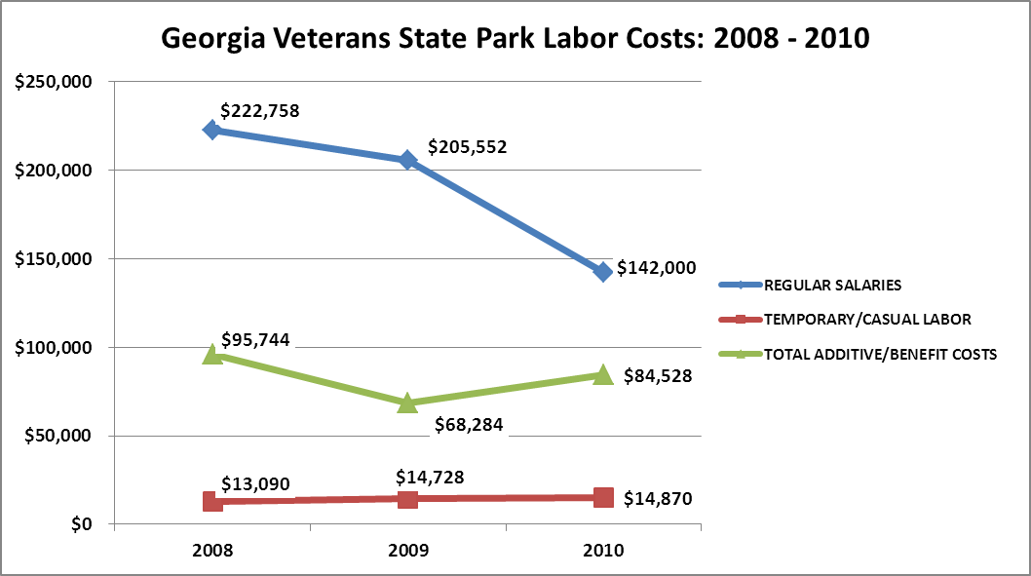

Visitation and Occupancy
Overall annual visitation to the site has trended (upward) from 2008 to 2010, increasing by 5% or over 40,000 visitors. This is largely attributed to fuel prices and economic recession. Many of our guests come from within a 30 radius; before the downturn in the economy, many of these visitors went to destinations that were a long distance commute.
Year | Total Visitation
2008 | 712,298
2009 | 781,139
2010 | 752,558

Occupancy for the overnight accommodations at Georgia Veterans the last three years is detailed in the table below. Overall occupancy has trended downward from 2008 to 2010, decreasing by 1.2%. This is largely attributed to the economy and fuel prices (whereas day use increased, camping decreased due to the same reasons).
Year | Campground Occupancy  Percentage | Campground Occupied Nights
2008 | 48.19% | 13,603
2009 | 48.44% | 13,222
2010 | 46.97% | 12,911

The graph below illustrates visitation and occupancy over the last three years.

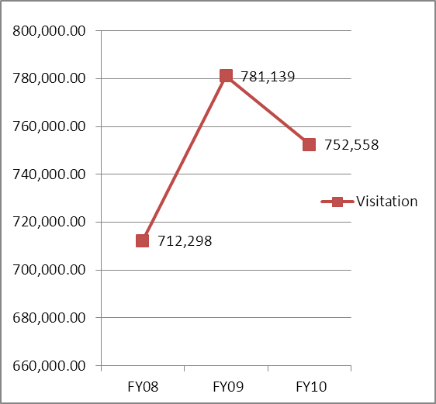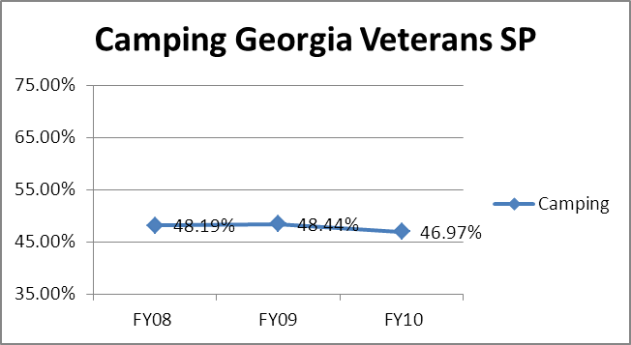

Customer Service and Satisfaction

Site | Year | Customer Satisfaction Level
Georgia Veterans State Park | 2009 | 25%
Georgia Veterans State Park | 2010 | 60%

Financial Performance Assessment

Operational Expenses A summary of total operating expenses at Georgia Veterans from 2008 to 2010, as

well as their percent change from 2008 are provided in the table below.

Georgia Veterans | 2008 | 2009 | 2010 | % Change from 2008
State Park
Operational Expenses
REGULAR SALARIES | 222,758 | 205,552 | 142,000 | -36%
ANNUAL LEAVE PAY | 0 | 0 | 6,455 | #DIV/0!
OTHER SUPPLEMENTAL | 959 | 0 | 8,414 | 777%
OVERTIME
TEMPORARY/CASUAL LABOR | 13,090 | 14,728 | 14,870 | 14%
FICA | 15,775 | 14,504 | 10,300 | -35%
RETIREMENT | 26,057 | 24,159 | 14,900 | -43%
HEALTH INSURANCE | 51,104 | 28,029 | 43,000 | -16%
UNEMPLOYMENT INSURANCE | 379 | 269 | 500 | 32%
ASSESSMENTS BY MERIT | 1,470 | 1,323 | 959 | -35%
PERSONAL SERVICES | 331,591 | 288,563 | 241,398 | -27%
POSTAGE | 273 | 445 | 542 | 99%
MOTOR VEHICLE EXPENSES | 20,611 | 19,128 | 13,438 | -35%
SUPPLIES & MATERIALS | 28,973 | 17,137 | 11,653 | -60%
REPAIRS & MAINTENANCE | 5,450 | 1,949 | 6,676 | 23%
ENERGY | 75,439 | 74,077 | 62,750 | -17%
RENTS | 2,833 | 2,190 | 1,590 | -44%
INSURANCE & BONDING | 8,416 | 8,578 | 7,619 | -9%
FREIGHT | 20 | 0 | 0
OTHER OPERATING EXPENSES | 2,854 | 2,730 | 3,073 | 8%
REGULAR EXPENSES | 144,868 | 126,233 | 107,341 | -26%
VOICE/DATA COMMUNICATIONS | 3,135 | 1,220 | 1,511 | -52%
CONTRACTS | 1,220 | 520 | 0 | -100%
RESALE | 16,795 | 12,968 | 6,376 | -62%
TOTAL OTHER EXPENDITURES | 21,150 | 25,208 | 7,887 | -63%
GRAND TOTAL | $ 497,610 | $ 440,004 | $ 356,626 | -28%
Earned Revenues | $344,112 | $332,504 | $333,681 | -36%
% Cost Recovery | 69% | 76% | 94% | 35%

Earned Revenues
Earned revenues at Georgia Veterans have decreased from 2008 to 2010 by $10,431. Monthly earned revenues for the last two years (see table on the following page) indicate that the total annual revenue increased 1% from 2009 to 2010, with the largest increases in monthly revenues in August (+41%), October (+18%), May (+15%) and June (+15%), and the largest decreases in the months of November (-17%), December (-17%), January (-19%), February (-12%), and March (-12%).

FY 2009 - FY 2010
Monthly Revenue
 | Jul | Aug | Sep | Oct | Nov | Dec | Jan | Feb | Mar | Apr | May | Jun | Total
FY 2009 | $32,389 | $19,620 | $29,264 | $23,951 | $24,395 | $11,651 | $22,861 | $26,654 | $45,778 | $36,941 | $26,296 | $32,704 | $332,504
FY 2010 | $32,478 | $27,337 | $ 29,278 | $28,093 | $19,977 | $9,401 | $18,180 | $23,195 | $40,029 | $38,443 | $29,951 | $37,319 | $333,681
Avg | $32,434 | $23,478 | $29,271 | $26,022 | $22,186 | $10,526 | $20,520 | $24,925 | $42,903 | $37,692 | $28,124 | $35,011 | $333,093
% of Total Revenues | 10% | 7% | 9% | 8% | 7% | 3% | 6% | 7% | 13% | 11% | 8% | 11% | 100%
% change | 0% | 39% | 0% | 17% | -18% | -19% | -20% | -13% | -13% | 4% | 14% | 14% | 0%

The graphs below illustrate the monthly revenue trends each year and the average percent of total annual revenue earned each month.

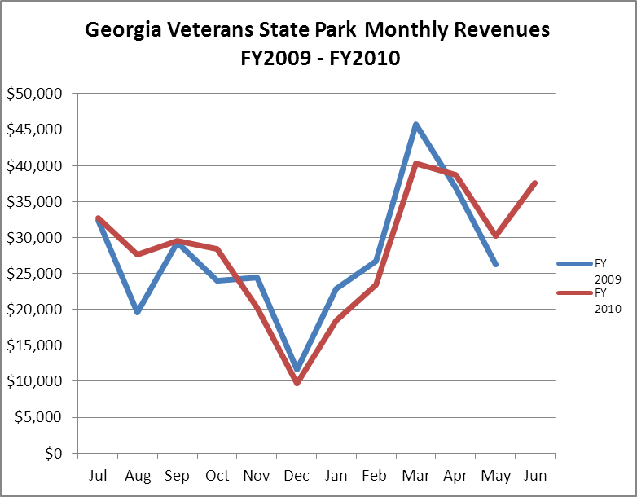
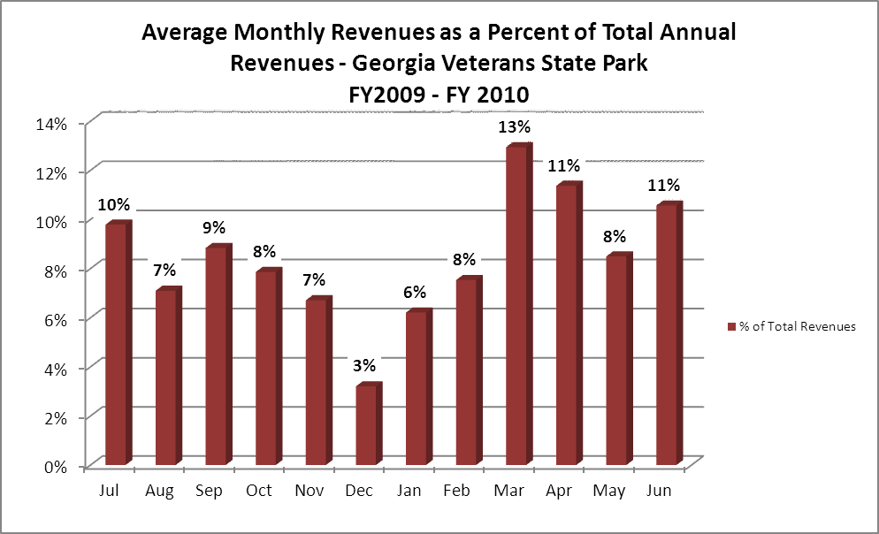

Cost Recovery Trends
Georgia Veterans has achieved an average cost recovery of 84% of annual operational expenses through earned revenues from FY 2008 to FY 2010. This is detailed and illustrated in the table and graph below.
Year | Operational | Earned | Percent Cost
Year | Expenses | Revenues | Recovery
2008 | 497,610 | 344,112 | 69%
2009 | 440,004 | 332,504 | 76%
2010 | 356,626 | 333,681 | 94%

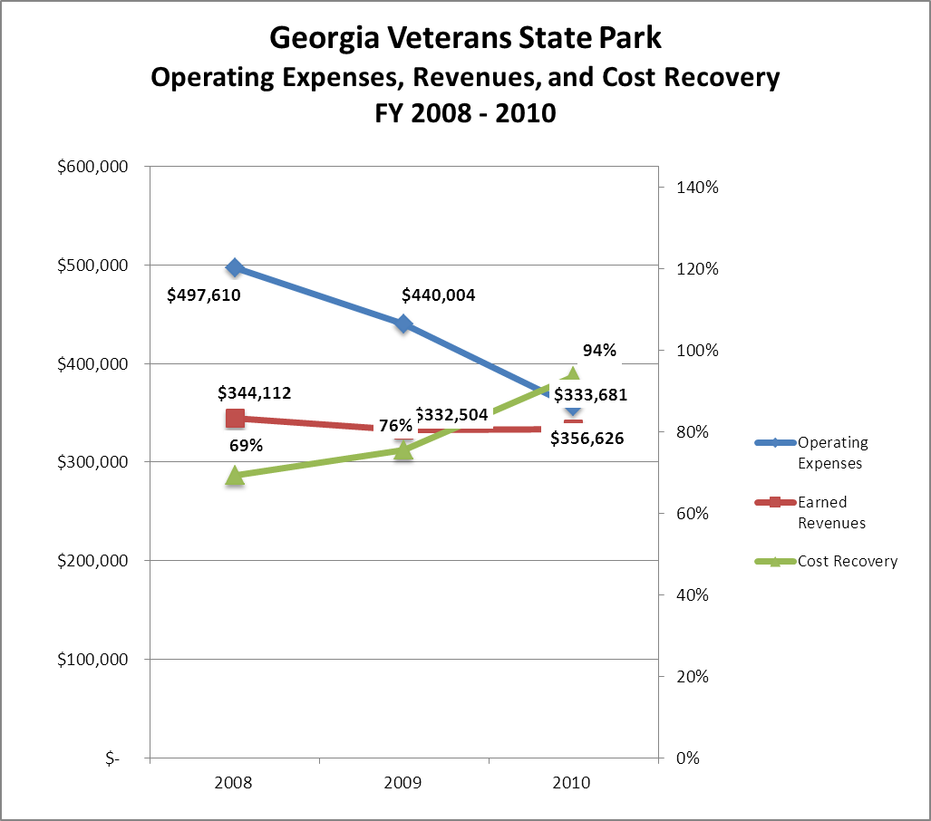

Review of Pricing
Data on rate information is available as far back as 2002, but only the last five years are evaluated. There has been notable growth in fees charged since 2005 at Georgia Veterans for virtually all the rental facilities.

Camping and  Shelter Rates | 2005 | 2006 | 2007 | 2008 | 2009 | 2010 | Comments
Picnic Shelter | $40 | $40 | $50 | $50 | $50 | $55
Activity Shelter |  |  |  | $0 | $0 | $0 | $25 as of 1/1/11
Group shelter | $160 | $160 | $200 | $200 | $225 | $230
Lake View Pavilion |  |  |  |  | $125 | $130
RV | $21 | $21 | $22 | $25 | $25 | $28
Tent | $19 | $19 | $20 | $23 | $23 | $25
Pioneer | $15 | $15 | $40 | $40 | $40 | $45
Business and Management Plan

Business Goals
The following goals serve as the foundation for the key recommendations and strategies in this business plan for Georgia Veterans State Park.

Enhance Cost Recovery of Site Operations
Georgia Veterans State Park is running on an average of 84% cost recovery of operational expenses through earned revenues. Georgia Veterans can likely increase revenues through additional programs and events which would entice more visitors to come and produce greater revenues.

Enhance Revenue Generation Strategies
Increasing earned revenues will likely come from both greater visitation to the park and revenue enhancement strategies. Georgia Veterans will improve revenue production through adding fees to some of the programs on site, implementing flexible camping fees in non-peak seasons, and expanding the inventory of the gift shop.

Expand Special Events at the Site
Most, if not all, of the programs and events at the park are directly connected to the museum or experiences in nature. This is important, but should not be the only way of performing programs at Georgia Veterans. The park has some large open fields that could accommodate larger events such as music festivals, art festivals, or anything of the type. These types of events could dramatically increase visitation to the park, resulting in greater revenues.

Improve the Diversity and Innovation of Recreational and Interpretive Programs
Georgia Veterans offers quality exhibits and programs that are mostly interesting to adult audiences. It will be necessary for the park to adapt or improve the interests of the programs to a broader range of age groups. Improvement of the programs in this manner could help to encourage repeat visitation.

Improve the Effectiveness of Marketing and Sales
Offer off-season discounts online and on social media sites in advance of the off-season. Zip code collection for day-use visitors has already been started at the park pass booth.

Expand Partnership Opportunities
Engage Friends of Georgia Veterans with the business plan and utilized that partnership to meet the goals of the business plan. The Friends of GV have funded several key additions to the park and will continue to be a voice in the community for the park. SAM Shortline and Lake Blackshear Resort are also key partners as we share space within the park boundaries. Working with them to create long term goals set is a key to the success of all three.

Establish Greater Consistency of Managing and Monitoring Customer Service & Satisfaction
Process has been started with the creation of online surveys. Cards are handed out at check in. Also personal contact with campers and guest to ensure at that any immediate problems are taken care of at that time.

Classification of Programs and Services
The tables below summarize the classifications of programs and services at Georgia Veterans as either core, important, or visitor supported and projects a range of cost recovery percentages that might be achieved for each. These classifications establish financial performance goals for each category of services that are linked to the recommendations and strategies of this business plan.

Core Programs / Services | Target Cost Recovery
Law enforcement (provides a safe and secure environment) | 0%
Artifact management (includes visitor center/museum) | 0%
Maintenance of grounds and facilities | 0%
Open and public access to the site and the resources | 0%

Important Programs / Services (DUF = Day Use Facilities) | Target Cost Recovery
** These services are provided to generate park pass revenues**
(DUF) Boat ramps** | 0%
(DUF) Beach** | 0%
(DUF) Restrooms** | 0%
(DUF) Picnic areas | 125%
(DUF) Radio controlled flying field** | 0%
(DUF) Disc golf | 100%
Hiking trails** | 0%
Pioneer camping area | 125%
Programs related to artifacts and camping experiences | 75%
Recreational activities such as maintained fishing areas (shoreline)** | 0%
Playground equipment** | 0%

Visitor Supported Programs / Services | Target Cost Recovery
Campground | 175%-200%
Retail sale shop in office | 150%
Advanced programs above and beyond those directly related to artifacts | 100%
Group shelters | 100%
Rental equipment | 125%

Partnership Development Plan
The table below summarizes existing partners and targeted partnerships by classification (operational, vendor, service, co-branding, funding partners) and by organizational type.
 | Public Partners | Not-for-profit Partners | Private / Enterprise Partners
Operational Partners | - Crisp County Sheriff Department  - DNR Fisheries  - DNR WRD | - Friends of Georgia Veterans State Park  - Loop the Lake/Graceway Charity | - Lake Blackshear Resort
Vendor Partners |  |  | - Coca Cola  - Crisp County Power
Service Partners | - Crisp County | - Cordele Chamber of Commerce
Co-branding Partners | - SAM Shortline  - Andersonville  - Historic Site  - Jimmy Carter Site  - Warner Robins Museum  - Go Fish Museum | - Telephone Museum | - Windsor Hotel
Funding Resource Development Partner |  | - Friends Of Georgia State parks and Historic Sites  - Friends of Georgia Veterans State Park

Marketing and Sales Plan

Marketing and Sales Goals
Marketing and sales goals for Georgia Veterans State Park are based on the following desired outcomes:
- Produce more Interpretive Programs that draw visitors to the site
- Produce Larger events (concerts)that draw greater participation
- Increase Overall visitation and revenues
In order to meet these goals, examples of specific target outcomes were identified in the areas detailed in the table below.
Area  of Focus | Current  Performance | Goal  by 2011 | Goal  by 2012 | Goal  by 2015
Events & Programs | 5 major programs | 5 major events | 5 major events | 8 major events and monthly creation of new programs
Overall Visitation | 752,558 | 754,000 | 756,000 | 767,609
** Many of our events are held in conjunction with Lake Blackshear Resort. Visitation numbers
will be large, with revenue numbers low.
Marketing and Promotion Strategies

Publicity and Social Media
Georgia Veterans will approach marketing and publicity planning using the following themes:
- Event publicity
Major events benefit by having short stories in local, regional, and statewide newspapers and online social media hooks planted that run three to four weeks in advance of the event up to the date of the event itself. Stories and media need to be cultivated with contacts and online sales channels several weeks in advance of the time the stories need to run. Special interest interviews on morning, noon, and evening television news programs, radio interviews on popular rush-hour programs, and blogs on known affinity online sites should also be included.
- Program publicity
Special and unique programs should have feature stories in magazines, weekly newspapers, and statewide daily newspapers that are aimed at placements as front-page or sectional front-page stories. These stories are most effective if they run shortly before the season that the featured program begins. This will likely require several weeks of advanced planning with media contacts. Similar coverage on television and radio should also be considered. If pre-publicity cannot be generated, post-publicity can help promote future programs.
- Site Publicity
Site publicity focusing on a single site or sub-set of sites requires more intense planning efforts to attract multiple writers and editors from target publications. Georgia Veterans could host several seasonal media familiarization tours (with 10 to 15 writers or editors) to familiarize them with the site and its amenities. Stories and features resulting from such tours typically take between two and six months to materialize so the tours should focus on experiences, benefits, and programs that would be available when the stories are expected to run.
Examples and suggested opportunities for events, programs and related publicity efforts based on the themes described above at Georgia Veterans are provided in the table below.
Event Publicity | Program Publicity | Site Publicity
Fireworks | Campfire/Smores | Natural Resources of the park
Triathlon/decathlon | Astronomy | Military Artifacts
Tribute to Veterans | Save our State Parks
Easter Egg Hunt | Kayak tours

Packaging
Examples and suggested packages for Georgia Veterans are provided in the table below.
Package | Package Details
Off season extended stay | Min. two week stay from Mon. after Thanksgiving to March 1. Flat rate $20.00per night can run with special from golf course or marina. Or $450 per month for months of December-February.
Large group camping incentive | 10 or more campsites receives free use of activity shelter from Oct. 1st through March 1st
Disc Golf Passes | Campers bring in Facebook Coupon to get free weekend family pass.

Group Sales
Types of groups within which specific target customers can be identified for Georgia Veterans are listed below:
- Families | - Churches | - Community Organizations
- Colleges and Universities | - Schools | - Associations
- Businesses and Professional Groups | - Service Organizations | - Special Interest Groups
- Retired persons | - RV Camping Groups

Incentivizing New and Repeat Visitation
Georgia Veterans will utilize the following strategies and/or incentives to encourage new and repeat visitation starting in FY 2012:
- Maintain clean and working facilities.
- Advertise in local and state wide media to include magazines, newspapers, radio and social websites.
- Work with SAM Shortline and Lake Blackshear Resort to offer packages.
- Group bookings can receive incentives such as free use of campground activity shelter.
- Local and regional radio promotions. Winner receives free park pass and disc golf pass for one day. Similar packages can be put together on social media.
Marketing and Sales Metric Goals
The following marketing and sales metric goals and/or others will be monitored and progress reported at Georgia Veterans State Park:
- Loyalty and repeat customers = 75% of customers repeat their visit within a one year time frame.
- Brand confidence & customers-recruiting-customers = Customer referrals equal a minimum of 50% of “Where did you hear about us?” responses from visitors polled.
Revenue Generation Plan
Revenue / Cost Recovery Goals
Georgia Veterans has set a financial goal of increasing annual revenues 3% annually between 2012 and 2015. The largest revenue growth opportunity is most likely the months of April through July. The table below details projected revenue growth leading up to 2015, based upon a nominal growth of revenues each year.
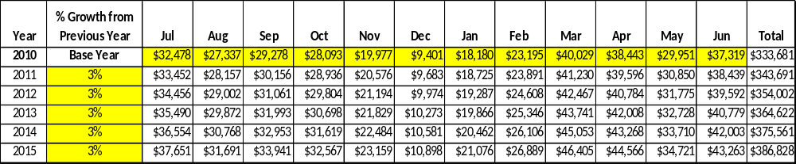
These projections would result in a total of 16% cumulative growth in total annual revenues between FY2010 and FY2015. If operational expenses can be managed with a cumulative decrease of 3% between FY 2010 and FY 2015, then the overall cost recovery of the site will be approximately 115% in FY 2015 at these projected revenue levels.
Revenue Generation Strategies

Pricing Plan
PARK RESERVABLES | Current Pricing (CY 2011) | Proposed Pricing  (CY 2012) | Positive Yield Management Margin (%)

GA. VETERANS
Picnic Shelter | $55 | $55 | 10%
Lake View Pavilion (capacity) | $130(100) | $130 | 10%
Group Shelter #2 (capacity) | $230 (150) | $230 | 10%
Camping (RV/Tent) | 28/25 | 28/25 | 10%
Camping (RV/Tent) Premium
Camping (RV/Tent) Regular
Pioneer Campsite | $45 | $45 | 10%

Innovative Programming and Special Events Plan
Program / Event | Theme / Purpose | Scheduled Date/Season | Frequency | Target Participation | Target User Fee | Target Cost Recovery
Veterans Day | Veterans Memorial | Veterans’  Day. November | Yearly | 1,000 | $1200 park pass | 0
4th of July Fireworks | Fireworks | July 4th or selected date | Yearly | 8,000 | $7000 park pass | 200%-300%  (ParkPass)
Memorial Day Tour | Same | Memorial Day | Yearly | 100 | $100 | 150%
Triathlon/Duathlon** | Same | August | yearly | 1,000 | Park pass | 0
Loop the Lake** | 5k Run | June | yearly | 500-1,000 | Park pass | 0
Easter Egg Hunt | Same | Easter | yearly | 100-500 | Park Pass/$1 | 100%
** In partnership with Lake Blackshear Resort. The events listed above are hosted by the resort and the only cost recovery is park pass. There is very little cost placed on the park.

Partnerships and Concessions Plan
Service / Partnership | Term of Service | Financial Objective | Contract Manager
Beach house concessions | Summer | 15% of gross sales | Park Manager
Parking for Thomas the Train | 2 weekends | Park Pass | Park Manager/SAM Manager
Various fishing tourneys | Ongoing | Park pass plus set amount | Park Manager
Packaging and promotions with local businesses. | Ongoing | Increase in sales and camping | Park Manager

Expense Management Plan
Personnel Assignments
The following actions will be taken to proactively manage labor costs via personnel assignments and classifications.

Action | Timeline | Outcome
Use of campground host as available. | Ongoing | $11,000 or more per year
Use of part time employee in place of fulltime general trades worker. | Ongoing | Cost savings on benefit packages

Management Techniques
The following actions will be taken to proactively manage labor costs via management techniques.

Action | Timeline | Outcome
Use of herbicides and cutting techniques of grass and plants. | Ongoing | Reduce cost of labor and supply cost
Work with volunteer groups such as Scouts and college groups for grounds maintenance | Ongoing | Reduce cost of labor

Adjusted Levels of Service
The following actions will be taken to proactively manage labor costs via reduced levels of service.

Action | Timeline | Outcome
Reduce amount of Law Enforcement rounds in campground. Camp host reports by phone if trouble arises | Ongoing | Reduce fuel cost and supply costs in operations of vehicles.
Operation of office on an 8 a.m. -5 p.m. schedule on most days, instead of staying open until 9:00 pm. | Ongoing | Reduce cost in labor and supply costs.

Financial Pro Forma
The following five-year financial pro forma projects operating expenses, earned revenues and cost recovery through FY 2015. These pro forma are based on the strategies and desired outcomes identified in this business plan, especially the revenue generation and expense management plans, and are linked to corresponding performance goals.
Expense Pro Forma
Georgia Veteran's | 2010 | 2012 | 2013 | 2014 | 2015
State Park
REGULAR SALARIES | $142,000 | $141,006 | $140,019 | $139,039 | $138,066
ANNUAL LEAVE PAY | $6,455 | $6,410 | $6,365 | $6,320 | $6,276
OTHER SUPPLEMENTAL | $8,414 | $8,355 | $8,297 | $8,239 | $8,181
OVERTIME |  | $0 | $0 | $0 | $0
TEMPORARY/CASUAL LABOR | $14,870 | $14,766 | $14,663 | $14,560 | $14,458
FICA | $10,300 | $10,228 | $10,156 | $10,085 | $10,015
RETIREMENT | $14,900 | $14,796 | $14,692 | $14,589 | $14,487
HEALTH INSURANCE | $43,000 | $42,699 | $42,400 | $42,103 | $41,809
UNEMPLOYMENT INSURANCE | $500 | $497 | $493 | $490 | $486
ASSESSMENTS BY MERIT | $959 | $952 | $946 | $939 | $932
DRUG TESTING
PERSONAL SERVICES | $241,398 | $239,708 | $238,030 | $236,364 | $234,710
POSTAGE | $314 | $312 | $309 | $307 | $305
MOTOR VEHICLE EXPENSES | $12,303 | $12,217 | $12,131 | $12,046 | $11,962
PRINTING & PUBLICATION | $0 | $0 | $0 | $0 | $0
SUPPLIES & MATERIALS | $5,628 | $5,589 | $5,549 | $5,511 | $5,472
REPAIRS & MAINTENANCE | $5,023 | $4,988 | $4,953 | $4,918 | $4,884
EQUIPMENT >$1000< $5,000 | $0 | $0 | $0 | $0 | $0
WATER & SEWAGE | $0 | $0 | $0 | $0 | $0
ENERGY | $62,750 | $62,311 | $61,875 | $61,442 | $61,012
RENTS | $1,278 | $1,269 | $1,260 | $1,251 | $1,242
INSURANCE & BONDING | $7,619 | $7,565 | $7,513 | $7,460 | $7,408
FREIGHT | $0 | $0 | $0 | $0 | $0
PURCHASING CARD | $9,915 | $9,846 | $9,777 | $9,708 | $9,640
OTHER OPERATING EXPENSES | $2,512 | $2,495 | $2,477 | $2,460 | $2,443
CLAIMS & BONDS & INTEREST | $0 | $0 | $0 | $0 | $0
TRAVEL | $0 | $0 | $0 | $0 | $0
REGULAR EXPENSES | $107,341 | $106,590 | $105,844 | $105,103 | $104,367
MOTOR VEHICLE EQUIPMENT | $0 | $0 | $0 | $0 | $0
EQUIPMENT PURCHASES >5000 | $0 | $0 | $0 | $0 | $0
CAPITAL\ LEASE Prin & Int | $0 | $0 | $0 | $0 | $0
REAL ESTATE RENTALS | $0 | $0 | $0 | $0 | $0
VOICE/DATA COMMUNICATIONS | $1,511 | $1,500 | $1,490 | $1,479 | $1,469
PER DIEM & FEES |  | $0 | $0 | $0 | $0
PER DIEM & FESS EXPENSE |  | $0 | $0 | $0 | $0
CONTRACTS | $0 | $0 | $0 | $0 | $0
ADVERTISING - PROCUREMENT CARD | $0 | $0 | $0 | $0 | $0
RESALE | $6,376 | $6,331 | $6,287 | $6,243 | $6,199
TOTAL OTHER EXPENDITURES | $7,887 | $7,832 | $7,777 | $7,722 | $7,668
GRAND TOTAL | $ 356,626 | $ 354,130 | $ 351,651 | $ 349,189 | $ 346,745

Revenue Pro Forma

Georgia Veteran's State Park
Revenue (Fund) Sources | Revenue Sources Description | FY 2010 (Actual) | FY 2012 | FY 2013 | FY 2014 | FY 2015
60001 | CONCESSION AND TP NON-FOOD | -15,311.35 | (16,230.03) | (16,716.93) | (17,218.44) | (17,950.22)
60002 | CANCELLATION FEES | -395.00 | (418.70) | (431.26) | (444.20) | (457.52)
60005 | CAMP SITES | -188,883.25 | (200,216.25) | (206,222.73) | (212,409.41) | (218,781.70)
60015 | GROUP SHELTERS | -2,288.75 | (2,426.08) | (2,498.86) | (2,573.82) | (2,676.78)
60017 | VENDING MACHINE COMMISSION | -34.90 | (36.99) | (38.10) | (39.25) | (40.42)
60018 | WASH AND DRY | -1,598.50 | (1,694.41) | (1,745.24) | (1,797.60) | (1,869.50)
60020 | SHORT / OVER | -91.07 | (96.53) | (99.43) | (102.41) | (105.49)
60025 | REFUNDS | 24,714.21 | 26,197.06 | 26,982.97 | 27,792.46 | 28,626.24
60027 | PIONEER CAMP | -433.00 | (458.98) | (472.75) | (486.93) | (501.54)
60028 | PICNIC SHELTERS | -420.00 | (445.20) | (458.56) | (472.31) | (484.12)
60033 | CAMPSITE SR. CITIZEN DISCOUNT | 30,195.20 | 32,006.91 | 32,967.12 | 33,956.13 | 34,974.82
60036 | PROGRAM FEES | -940.71 | (997.15) | (1,027.07) | (1,057.88) | (1,100.19)
60037 | MISC. PARK RECEIPTS | -90.00 | (95.40) | (98.26) | (101.21) | (104.25)
60042 | NON-COST ITEMS (ICE, WOOD) | -1,146.69 | (1,215.49) | (1,251.96) | (1,289.51) | (1,341.10)
60051 | DAY PASS FRISBEE GOLF | -1,142.00 | (1,210.52) | (1,246.84) | (1,284.24) | (1,322.77)
60073 | DISABLED VET. DISCOUNT | 1,942.75 | 2,059.32 | 2,121.09 | 2,184.73 | 2,250.27
60075 | TV CABLE RENTAL | 14,313.00 | 15,171.78 | 15,626.93 | 16,095.74 | 16,578.61
60080 | CR CARD CHGBACKS-PARKS | -100.00 | (106.00) | (109.18) | (112.46) | (115.83)
60092 | "FRIENDS" DISCOUNT AT PARKS | 2,338.27 | 2,478.57 | 2,552.92 | 2,629.51 | 2,708.40
60099 | SALES TAX | -1,093.72 | (1,159.34) | (1,194.12) | (1,229.95) | (1,266.85)
61100 | MISC. CONCESSION AGREEMENTS | -487.00 | (516.22) | (531.71) | (547.66) | (564.09)
63908 | OTHER / MISC. | -583.50 | (618.51) | (637.07) | (656.18) | (675.86)
63918 | INSURANCE RECOVERY/RESTITUTION | -2,250.00 | (2,385.00) | (2,456.55) | (2,530.25) | (2,631.46)
66002 | CANCELLATION FEES | -4,407.00 | (4,671.42) | (4,811.56) | (4,955.91) | (5,104.59)
66003 | REFUNDS-ADV. RESERV. | 26,597.50 | 28,193.35 | 29,039.15 | 29,910.33 | 30,807.63
66005 | CAMPING | -69,142.00 | (73,290.52) | (75,489.24) | (77,753.91) | (80,086.53)
66008 | TENT/PIONEER CAMPING | -585.00 | (620.10) | (638.70) | (657.86) | (684.18)
66015 | GROUP SHELTER | -18,235.00 | (19,329.10) | (19,908.97) | (20,506.24) | (21,121.43)
66019 | TRANSFER FEES | -220.00 | (233.20) | (240.20) | (247.40) | (254.82)
66028 | PICNIC SHELTER | -3,595.00 | (3,810.70) | (3,925.02) | (4,042.77) | (4,164.05)
66080 | CR. CARD CHARGE BACK | -50.00 | (53.00) | (54.59) | (56.23) | (57.91)
69005 | CAMP SITES-PW | -107,388.00 | (113,831.28) | (117,246.22) | (120,763.60) | (124,386.51)
69008 | TENT/PIONEER CAMPS | -1,075.00 | (1,139.50) | (1,173.69) | (1,208.90) | (1,257.25)
69015 | GROUP SHELTERS | -10,060.00 | (10,663.60) | (10,983.51) | (11,313.01) | (11,652.40)
69028 | PICNIC SHELTERS-PW | -1,735.00 | (1,839.10) | (1,894.27) | (1,951.10) | (2,009.63)
TOTAL |  | -333,680.51 | (353,701.34) | (364,312.38) | (375,241.75) | (386,823.03)

Total / Cost Recovery Pro Forma

Georgia Veteran's State Park | 2010 (Actual) | 2012 | 2013 | 2014 | 2015
TOTAL PRO FORMA
Visitation | 752,558 | 767,609 | 782,961 | 798,621 | 814,593
Operational Expenses | $356,626 | $354,130 | $351,651 | $349,189 | $346,745
Earned Revenues | $333,681 | $353,701 | $364,312 | $375,242 | $386,823
% Cost Recovery | 94% | 100% | 104% | 107% | 112%

Action Plan
ACTION PLAN
Site:Georgia Veterans |  | Site Manager: Randell Meeks |  |  | Date: 4/10/2012
Month: April 2012 project started in Jan. 2011. This is a review of success or failure of program.
Strategy | Tasks | Costs / Funding | Revenues / ROI | Responsibilities | Metrics
Capture after hours users of disc golf | Move a parkpass box and repaint a different color. Create a disc golf pass. | $20 for paint $20 for envelopes and pass. $100 labor for staff. | Disc golf pass revenue up 46%. | Check disc golfers for passes

ACTION PLAN
Site: Georgia Veterans |  | Site Manager: Randell Meeks |  |  | Date: Feb. 2012
Month: Feb. 2012
Strategy | Tasks | Costs / Funding | Revenues / ROI | Responsibilities | Metrics
Increase revenue by adding rentals | Build a boat shed. Stock it with kayak and canoes and needed safety supplies. | $5,000/ Funded with Tons of Fun and Friends of GV. | 100% ROI. Should need little maintenance or repairs. | Maintain vessels and must do quarterly program for Tons of Fun.
Increase revenue by adding rentals | Add bicycles to rentals | $2,200. Funded by Tons of Fun grant and region office | 100% ROI. Little maintenance of bikes from time to time. | Must do quarterly program using bikes.

ACTION PLAN
Site: |  | Site Manager: |  |  | Date:
Month:
Strategy | Tasks | Costs / Funding | Revenues / ROI | Responsibilities | Metrics

This is the average of the last three years – FY 2008, FY 2009, and FY 2010
Current employees, not including vacancies.
Current employees, not including vacancies 4/2012 and parkpass kiosk
Major population centers within a two-hour drive from the site

