Georgia Department of Natural Resources

Gordonia-Alatamaha State Park

Business &
Management Plan
Prepared 7/5/11; Finalized 3/27/12

Direction 2015 – Sustainable Business Planning



Table of Contents

- Executive Summary
- Site and Operations Assessment
- Site Inventory and Facility Assessment
- Operational Assessment
- Financial Performance Assessment
- Business and Management Plan
- Business Goals
- Classification of Programs and Services
- Partnership Development Plan
- Marketing and Sales Plan
- Revenue Generation Plan
- Expense Management Plan
- Financial Pro Forma
- Action Plan

Executive Summary
The Parks, Recreation and Historic Sites Division (PRHSD) of the Georgia Department of Natural Resources (DNR) is transitioning the management of Gordonia-Alatamaha State Park to operate more like a business, reflecting the Direction 2015 – Sustainable Business Planning initiative to improve the fiscal performance and management of the state parks and historic sites system. This business and management plan is designed to help the site recover more operating expenses through earned revenues, productive partnerships, and innovative programs.

Site Fact Sheet
Site Name | Gordonia-Alatamaha
Site Manager | Alton Alford
Region Manager | Tommy Turk
Date of Business Plan completion | 7/5/2011
Site size | 662 acres (including Golf Course)
Total number of visitors (FY 2010) | 39,018
Total operating budget (FY 2010) | $ 268,615
Total earned revenues (FY 2010) | $ 85,804
Operational cost recovery (FY 2010) | 32%
Average operating cost per visitor (FY 2010) | $ 6.88
Average earned revenue per visitor (FY 2010) | $ 2.20
Average cost recovery (FY 2008 – 2010) | 30%
Target cost recovery (FY 2015) | 54%
Total full-time employees | 3
Total part-time employees | 6
Primary service markets | Savannah, Macon, Coastal Georgia
Primary attractors/visitor appeal factors | Camping, Cottages, Golf, Picnicking
Leading opportunities for improved site performance | Additional cottages, meeting facility and allow small boats on lake

Site Summary and Key Attractions
This 662 acres Park is located in the City limits of Reidsville, Georgia, a small rural community. The site is a short drive from Macon, Savannah, and the Georgia Coast. The site is named after the rare Gordonia Tree, a member of the bay family that once grew in the park. The site is located in a small, lower income market, a factor that will make reaching the 75% sustainability level a challenge.

Key Attractions
The amenities or features listed below are those that seem to be most popular for visitors.
- Camping
- Cottages
- Brazell’s Creek Golf Course
- Picnicking
- Mini-Golf
- Pedal Boats/Jon Boats
- Lake
- Playground
- Wi-Fi

Financial Targets
The table below details the total operating expenses and earned revenues for Gordonia-Alatamaha State Park over the last three years (2008 – 2010). This table also calculates total cost per visitor and revenues per visitor during these operating years, and details the target financial performance goals in the context of achieving at least 56% cost recovery. This table also calculates the necessary change from 2010 operating expenses and revenue.
 | Gordonia-Alatamaha State Park | Target Visitation Growth from 2010 | Target Change in Visitation
 | Visitation Assumptions | 7% | 25,982
 |  | 2008 | 2009 | 2010 | 2015 Target
 | Visitors | 94,357 | 71,240 | 39,018 | 65,000
 | Total Expenses | $ 259,963 | $ 244,395 | $ 268,615 | $ 298,999
 | Total Revenues | $ 65,151 | $ 68,356 | $ 85,804 | $ 161,012
 | Cost per Visitor | $ 2.76 | $ 3.43 | $ 6.88 | $ 4.60
 | Revenue per Visitor | $ 0.69 | $ 0.96 | $ 2.20 | $ 2.48
 | State Financial Support per Visitor | $ (2.06) | $ (2.47) | $ (4.69) | $ (2.12)
 | Total Cost Recovery | 25% | 28% | 32% | 54%
 | Change from 2010 Expenses |  |  |  | $ 30,834
 | Percent Change from 2010 Expenses |  |  |  | 11.31%
 | Change from 2010 Revenues |  |  |  | $ 75,208
 | Percent Change from 2010 Revenues |  |  |  | 87.65%

Key Recommendations

Primary / Short Term Recommendations
Operational recommendations are detailed below that support the outcomes of the D15 sustainability initiative and can be considered for inclusion in each site’s business plan.

Primary / Short Term Recommendations (not in priority order)
- Operate the PRHSD system and individual sites using cost-based accounting, including the net cost recovery achieved annually.
- Conduct on-site surveys annually to assess how well customer satisfaction levels are being met. Gordonia-Alatamaha should strive to have 90% of visitors responding to ‘Comment Cards’ report that they were either ‘satisfied’ or ‘very satisfied’ (or some comparable metric to be developed). Programs or services that fall below that standard should be critically reviewed, enhanced, and results monitored; those with a history of poor performance should be considered for elimination.
- Pursue opportunities to employ concessionaires or private or public service providers on-site if they can be more cost-effective or provide desirable services, programs or amenities the Division cannot.
- Collect a statistically-valid sample of ZIP code data from day visitors in a non-intrusive way to gauge their origins and demographics (e.g., age, ethnicity, income, etc.) and use the results to improve programming and marketing efforts to appeal to a broader audience.
- Partner with community to hold a special event annually or semi-annually.
- Seek local partners to help support operations, programs, and service delivery and for cross-marketing purposes.
- Sustain sufficient non-labor operational funding or reduce staff so that required staff operational costs (with benefits) do not exceed 65% of the total operational budget.
- Increase the number of visitor experiences by allowing non-motorized private boats on the lake, providing more nature-based interpretive programs, promoting the renovated mini-golf course, and offering canoeing classes.
- Manage Gordonia-Alatamaha according to well-defined maintenance, programming and operational standards, monitored and enforced by region managers and senior management.
- Partner with local Chambers of Commerce or other destination marketing organizations (DMOs) to promote Gordonia-Alatamaha.
- Continue to work with the Gordonia-Alatamaha Chapter of the Friends of Georgia State Parks and Historic Sites to help raise funds or an/or provide volunteers for improvements and program support, including adding benches and an overlook on the nature trail, holding a 5K Run on the park, establishing an annual music event and providing resources for new programs.
- Perform a thorough net cost-of-service analysis on major functions of site operations, including a detailed analysis of labor requirements by task. Thereafter, update costs to deliver services on a biennial schedule.
- Review and update rates at the site on an annual basis to meet cost recovery targets for important and visitor supported services.
- Enhance retail operations at each site to increase site generated revenues.
- Track total economic impact of the sites on the local communities and region and share with decision-makers, elected officials, local business operators and others to demonstrate the impact of Gordonia-Alatamaha.
- Develop a more detailed analysis of labor requirements of all major park functions to match the right position with the right job at the right pay.
- Develop funding to provide additional training to site staff for improved business management and marketing effectiveness.
- Renovate the park group shelter and promote its use as a venue for public gatherings, receptions and weddings; use by civic organizations and business groups; and as part of group golf and cottage packages.
- Add more youth and family focused services, programs and amenities at state parks and historic sites that appeal to younger audiences, families and educational groups such as providing orienteering, fly fishing and fishing rodeos, and developing a curriculum for educational programs for home schoolers.
- Add more services, programs and amenities that appeal to older adults, such as working with local senior care organizations and facilities to provide day trips for seniors to the park with activities including mini-golf and fishing opportunities.

Secondary / Long Term Recommendations
- Provide more nature-based programs for park visitors by improving hiking / nature trails to include interpretive panels, wildlife viewing areas and benches, and by developing additional interpretive displays at the visitor center.
- Engage local communities, user groups, civic groups, local chambers, local governments, schools, state agencies and private organizations to improve connectivity with Gordonia-Alatamaha and partner for marketing, programming and special events.
- Improve communication and cooperation between Gordonia-Alatamaha State Park and Brazell’s Creek Golf Course for better marketing, visitation, packaging, rounds and occupancy.
- Install an improved retail point-of-sale and inventory tracking system.

Site and Operations Assessment
This site and operations assessment is a culmination of analyses and findings from a review of the condition of facilities, infrastructure, and operations at Gordonia-Alatamaha State Park. The findings and observations are not intended to be an exhaustive review of all issues present, but provide a basic understanding of the predominant issues that contribute to the site’s current operating conditions. The assessment includes the following:
- Site Inventory and Facility Assessment
- Operational Assessment
- Financial Assessment
Site Inventory and Facility Assessment

Methodology
Facility and asset conditions are rated using a differential scale of excellent, good, fair, or poor. Descriptions of conditions that are attributed to each of these findings are also provided.
Scale of Conditions
Rating | General Description
Excellent | Facilities/amenities are in ‘excellent’ condition when they show little or no maintenance or repair problems. Facilities do not feature any major design or operational issues or flaws that contribute to diminished use or increased maintenance or upkeep. Facilities are easy to clean and maintain in order to place them back into public use and the users perceive them to be in excellent shape.
Good | Facilities/amenities are in ‘good’ condition when they show only minor maintenance or repair problems. Most maintenance issues with these facilities typically appear to be the result of age and/or heavy use. Facilities may only feature minor design or operational issues that contribute to diminished use or increased maintenance or upkeep. Facilities are moderately easy to clean and maintain in order to place them back into service and the users perceive them to be adequate for their use, but probably not in excellent shape.
Fair | Facilities/amenities are in ‘fair’ condition when they show significant maintenance or repair problems. Facilities generally exhibit ongoing maintenance issues that appear to be the result of age, heavy use, or design or operational flaws. Some maintenance and repair needs may compound their fair condition by being deferred because of budget and/or resource limitations. Facilities require more effort to clean and maintain before placing them back into service and the users may perceive them as being less than adequate for their use and in a state of deterioration. The facility or structure may need of major repair or replacement.
Poor | Facilities/amenities are in ‘poor’ condition when they show significant, on-going maintenance or repair problems that ultimately may result in suspended use for repair/replacement. Maintenance and repair issues are possibly the result of poor maintenance and clearly the result of age, heavy use, or design or operational flaws. Problems with the facilities are often compounded over time due to consistently-deferred maintenance and repair because of budget and/or resource limitations. Facilities may feature major design or operational issues that contribute to diminished use or increased maintenance or upkeep. Facilities require excessive effort to clean and maintain before placing them back into service and the users often perceive them as being inadequate for their use and in a state of serious deterioration. The facility or structure may need of major repair or replacement.

Inventory and Assessment
The table below is an inventory of facilities and amenities at Gordonia-Alatamaha State Park, and provides the assessed condition of each as reviewed in April 2011.

Site Asset / Amenity | Quantity | Condition
Total Acres | 662 | Good
Manager Residence | 1 | Good
Assistant Manager Residence ResResidence | 1 | Good
Office/Visitor Center | 1 | Good
Swimming Pool | 1 | Closed
Pool Dressing Rooms Po | 2 | Closed
Mini-Golf Course | 1 | Good (renovated)
Volleyball Court | 1 | Good
Basketball Court | 1 | Good
Playground | 1 | Good
Lake | 1 | Good
Pedal Boat Building | 1 | Good
Campsites | 29 | Good
Comfort Station | 1 | Good
Cottages | 5 | Excellent
Linen Building | 1 | Excellent
Maintenance Barn | 1 | Good
Nature Trail | 1 | Good
Picnic Sites | 18 | Good
Overlook Boardwalk | 1 | Good
Day-Use Restrooms | 2 | Good/Poor (one needs replacing)
Fishing Docks | 3 | Good
Picnic Shelter-Campground | 1 | Good
Metal Storage Building | 1 | Good
Small Lake Shelters | 4 | Good

Prioritized Facility Needs
Based on the facility inventory and assessment, these prioritized needs have been identified. Each need has been aligned with a priority category of high, moderate, or low to support future decision making regarding project sequencing, investment of public resources, and meeting community expectations. The priority assignment for each need is not a measure of importance. Rather, these recommended priorities reflect a phased implementation approach over the next several years.

Facility Need | Priority Assignment
Conference Meeting Facility/Interpretive (Renovate Family Shelter) | High
Additional Playground Equipment | High
Additional Full Hookup Campsites (Sewer, Water & Electric) | Low
Roof Existing Pool Dressing Rooms at Office/Visitor Center for more space | Moderate
Fill in closed Swimming Pool | High
Wi-Fi in Cottages | High
9 Hole Frisbee Golf Course | Moderate
Add Day-Use Restroom at Shelter 11/12 Location | Moderate
Re-Roofing of Picnic Shelters | High
Renovation of Campground Comfort Station | Moderate
4 Picnic Shelters (Day-Use) Re-Roofing and Repairs | High
Family Group Shelter Renovations | High

Operational Assessment
The Operational Assessment includes:
- An inventory and classification of programs and services being provided at the site
- A review of staffing at the site
- A review of concessionaires and partners operating at the site
- Visitation and customer satisfaction

Inventory and Classification of Programs and Services
Programs and services are classified into one of three major categories:
1) Core or Essential Services
2) Important Services
3) Visitor Supported Services
Programs and services at the site are classified into these categories based in part on the mission and public mandates for both the site and the agency. For the programs and services in each of these categories, there are financial performance expectations that will define how services are funded.

Category 1 – Core Services [Largely supported by tax funds]
Core programs, services and facilities are those the agency must provide and/or are essential in order to capably govern and meet statutory requirements. The failure of the agency to provide Category 1 services at adequate levels could result in significant negative consequences for the public and the resources under protection. The criteria for services to be classified as core or essential are:
- The services are mandated by the agency’s law or charter or are contractually obligated by agreement to provide the services.
- The services are essential to protecting and supporting the public’s health and safety.
- The services protect and maintain valuable assets and infrastructure.
- The services would generally and reasonably be expected and supported by residents, businesses, customers and partners.
- The services are those that cannot or should not be provided by the private sector.
- The services provide a sound investment of public funds.
The following programs offered at Gordonia-Alatamaha have been identified as core services:
- Open and public access to the site and its resources
- Public safety
- Protection of rare and endangered plants and animals
- Active management of site to protect its natural and cultural resources
- Provide appropriate educational, interpretation and recreational opportunities to the public
- Enforce and educate public about State and Departmental laws, rules and regulations
- Maintaining the site grounds, facilities, and infrastructure
- Nature trail

Category 2 – Important Services [Supported by a balance of tax funds and earned revenues]
Important programs, services and facilities are those the agency should provide, and are important to governing and effectively serving residents, businesses, customers and partners. Providing Category 2 services expands or enhances the agency’s ability to provide and sustain its core services. The criteria for programs or services to be classified as important are:
- The services expand, enhance or support identified core services.
- The services are broadly supported and utilized by the community, and are considered an appropriate, important, and valuable public good. Public support may be conditional upon the manner by which the services are paid for or funded.
- The services generate income or revenue that offsets some or all of the operating cost and/or are deemed to provide economic, social or environmental outcomes or results.
The following programs offered at Gordonia-Alatamaha have been identified as important services:
- Picnic Shelters (Open and Family Group Shelters)
- Lake Activities (Pedal and Jon Boats)
- Day-Use/Picnicking

Category 3 – Visitor Supported Services [Almost exclusively supported by earned revenue]
Visitor supported programs, services and facilities are those discretionary services that the agency may provide when additional funding or revenue exists to offset the cost of providing those services. Category 3 services provide added value above and beyond what is required or expected. The criteria for programs or services to be classified as visitor supported are:
- The services expand, enhance or support core services or important services and the quality of life of the visitors, community or stakeholders.
- The services are supported, valued and well utilized and provide an valuable public benefit.
- The services generate income or funding from sponsorships, grants, user fees or other sources that offset some or all of their cost and/or provides a meaningful return on investment.
- The services can possibly be provided through outsourcing or use of concessionaires, providing opportunities for community enterprises that may not otherwise be provided by the agency.
The following programs offered at Gordonia-Alatamaha have been identified as visitor supported:
- Interpretive Programming
- Special Events
- Office/Visitor Center (Resale Area)
- RV/Tent Camping
- Cottages
- Mini-Golf

Staffing Assessment
Labor costs at Gordonia-Alatamaha represent the largest area of budgetary expense at an average of 73% (FY08 92%, FY09 66%, and FY10 60%) of the total operating budget for the last three complete years, which is higher than the target of total labor costs (including benefits) not exceeding 65% of the site’s total operating expenditures. The tables below and on the following page provide a basic review of the current staffing at the site.
Full Time Equivalent Employees
Position / Title | Quantity (FTE) | Vacancies | Annual Hours
Park Manager | 1 | 0 | 2444
Park Assistant Manager | 1 | 0 | 2444
Utility Worker | 1 | 0 | 2080
Clerk | 0 | 1 | 2080
TOTAL | 3 | 1 | 9048

Part Time Employees
Position / Title | Quantity (FTE) | Vacancies | Hours
Housekeeper | 1 | 0 | 1508
Housekeeper | 1 | 0 | 1508
Maintenance Worker | 1 | 0 | 1508
Clerk | 2 | 0 | 3016
Seasonal Laborer | 1 | 0 | 200
TOTAL | 6 | 0 | 7740
Labor Support
Labor Support | Annual Hours
Volunteers | 150
Prison Detail | 1200
Campground Hosts | 850
Kiosk Clerk | 768
TOTAL | 2968

Total Labor Hours
Labor Type | Annual Hours
Full Time Equivalent Employees | 9048
Part Time Employees | 7740
Labor Support | 2968
TOTAL Annual Labor Hours | 19,756

Labor Budget Summary
Gordonia-Alatamaha
 |  | 2008 | 2009 | 2010 | % Change
 | Account Code and Sub-Class | Year End | Year End | Year End | from
 | Expenditure Descriptions | Expenses | Expenses | Expenses | 2008
 | REGULAR SALARIES | 121,011 | 109,973 | 122,715 | 1%
 | ANNUAL LEAVE PAY | 1 | 7,406 | 1 | 0%
 | OTHER SUPPLEMENTAL | 1 | 1 | 1 | 0%
 | TEMPORARY/CASUAL LABOR | 26,520 | 27,131 | 23,621 | -11%
 | FICA | 8,893 | 8,726 | 9,731 | 9%
 | RETIREMENT | 13,345 | 19,702 | 12,775 | -4%
 | HEALTH INSURANCE | 27,643 | 16,263 | 27,200 | -2%
 | UNEMPLOYMENT INSURANCE | 152 | 149 | 0 | -100%
 | LAPSE | 1 | 1 | (9,377) | -937800%
 | ASSESSMENTS BY MERIT | 588 | 735 | 685 | 16%
 | PERSONAL SERVICES | 198,155 | 190,086 | 187,352 | -5%
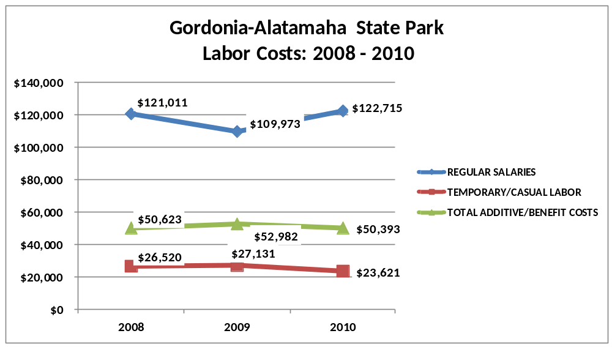

Visitation and Occupancy
Overall annual visitation to the site has trended downward from 2008 to 2010, decreasing by 58% or over 55,000 visitors, although the actual visitation for FY 2010 is likely under reported due to a malfunctioning traffic counter. The losses that may actually have occurred are largely attributed to the economy and loss of jobs.
Year | Total Visitation
2008 | 94,357
2009 | 71,240
2010 | 39,018*
*See explanation above
Occupancy for the overnight accommodations at Gordonia-Alatamaha for the last three years is detailed in the table below. Overall occupancy has trended upward from 2008 to 2010, increasing by 2%. This is largely attributed to visitors vacationing/camping closer to home. Cottage occupancy rate is only for the first two months that they were open near the end of 2010 (occupancy for 2011 was 40%).

Year | Camping Occupancy | Cottages Occupancy
2008 | 22.88% | 0.00%
2009 | 23.31% | 0.00%
2010 | 25.99% | 34.26%

Customer Service and Satisfaction

Site | Year | Customer Satisfaction Level
Gordonia-Alatamaha | 2009 | 100%
Gordonia-Alatamaha | 2010 | 100%

Financial Performance Assessment

Operational Expenses
A summary of total operating expenses at Gordonia-Alatamaha State Park from 2008 to 2010, as well as their percent change from 2008 are provided in the table below.
Gordonia-Alatamaha | 2008 | 2009 | 2010 | % Change from 2008
 | State Park
 | Operational Expenses
 | REGULAR SALARIES | 121,011 | 109,973 | 122,715 | 1%
 | ANNUAL LEAVE PAY | 1 | 7,406 | 0 | -100%
 | TEMPORARY/CASUAL LABOR | 26,520 | 27,131 | 23,621 | -11%
 | FICA | 8,893 | 8,726 | 9,731 | 9%
 | RETIREMENT | 13,345 | 19,702 | 12,775 | -4%
 | HEALTH INSURANCE | 27,643 | 16,263 | 27,200 | -2%
 | UNEMPLOYMENT INSURANCE | 152 | 149 | 0 | -100%
 | ASSESSMENTS BY MERIT | 588 | 735 | 685 | 16%
 | LAPSE | 1 | 1 | (9,377) | -937800%
 | PERSONAL SERVICES | 198,154 | 190,086 | 187,350 | -5%
 | POSTAGE | 1 | 1 | 400 | 39900%
 | MOTOR VEHICLE EXPENSES | 5,143 | 3,015 | 6,350 | 23%
 | SUPPLIES & MATERIALS | 210 | 0 | 15,590 | 7324%
 | REPAIRS & MAINTENANCE | 175 | 595 | 3,156 | 1703%
 | EQUIPMENT >$1000< $5,000 | 1 | 1 | 5,000 | 499900%
 | WATER & SEWAGE | 4,029 | 2,177 | 4,000 | -1%
 | ENERGY | 21,862 | 20,810 | 26,800 | 23%
 | RENTS | 1,881 | 1,709 | 2,250 | 20%
 | INSURANCE & BONDING | 4,424 | 8,076 | 8,076 | 83%
 | PURCHASING CARD | 18,396 | 11,284 | 0
 | OTHER OPERATING EXPENSES | 2,085 | 1,348 | 2,900 | 39%
 | TRAVEL | 87 | 1 | 500 | 478%
 | REGULAR EXPENSES | 58,298 | 49,020 | 75,022 | 29%
 | MOTOR VEHICLE EQUIPMENT | 767 | 1,700 | 0 | -100%
 | VOICE/DATA COMMUNICATIONS | 1,235 | 1,160 | 1,243 | 1%
 | PER DIEM & FEES | 176 | 0 | 0
 | RESALE | 1,341 | 2,437 | 5,000 | 273%
 | TOTAL OTHER EXPENDITURES | 3,520 | 5,299 | 6,243 | 77%
 | GRAND TOTAL | $ 259,972 | $ 244,405 | $ 268,615 | 3%
 | Earned Revenues | $65,151 | $68,356 | $85,804 | -36%
 | % Cost Recovery | 25% | 28% | 32% | 27%

 | FY 2009 - FY 2010 Monthly Revenue
 |  | Jul | Aug | Sep | Oct | Nov | Dec | Jan | Feb | Mar | Apr | May | Jun | Total
 | FY 2009 | $9,550 | $5,311 | $4,427 | $5,547 | $3,396 | $2,736 | $3,677 | $4,110 | $8,079 | $10,535 | $4,769 | $6,219 | $66,583
 | FY 2010 | $5,281 | $5,359 | $ 5,052 | $6,720 | $5,202 | $4,192 | $3,253 | $4,671 | $9,183 | $10,894 | $11,282 | $14,713 | $83,660
 | Avg | $7,416 | $5,335 | $4,740 | $6,134 | $4,299 | $3,464 | $3,465 | $4,391 | $8,631 | $10,715 | $8,026 | $10,466 | $75,122
 | % of Total Revenues | 10% | 7% | 6% | 8% | 6% | 5% | 5% | 6% | 11% | 14% | 11% | 14% | 100%
 | % change | -45% | 1% | 14% | 21% | 53% | 53% | -12% | 14% | 14% | 3% | 137% | 137% | 26%

Earned Revenues
Earned revenues at Gordonia-Alatamaha have increased since 2008, which is largely attributed to the corresponding increase in overnight accommodations with the addition of 5 new cottages.
Monthly earned revenues for the last two years (see table above) indicate that the total annual revenue increased 26% from 2009 to 2010, with the largest increases in monthly revenues in November & December (53%), May (137%), and June (137%), and the largest decreases in the months of July (-45%) and January (-12%). The increases in May and June are attributed to the opening of the new cottages; the decrease in July was due to the golf course being closed for expansion and the permanent closure of the swimming pool.
The graphs below illustrate the monthly revenue trends and the average percent of total annual revenue earned each month.
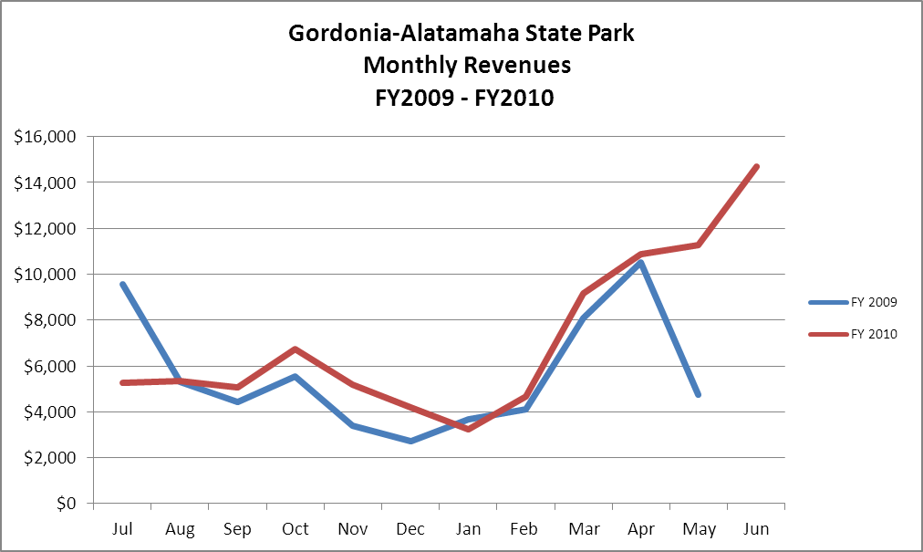

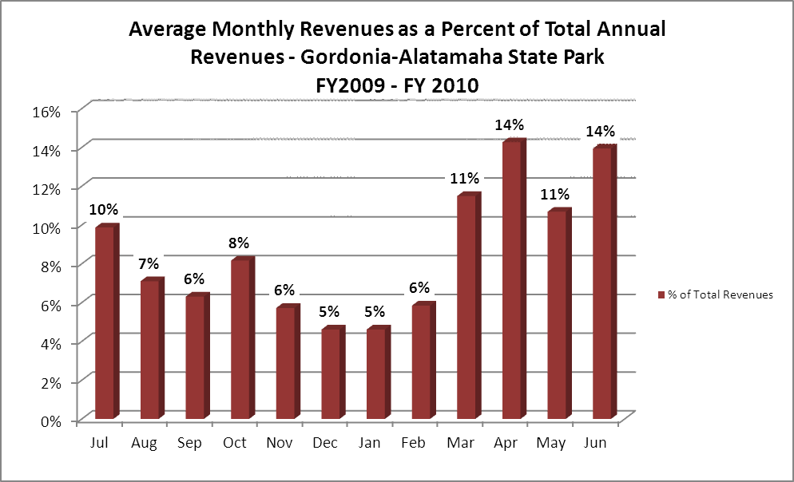

Cost Recovery Trends
Gordonia-Alatamaha has achieved an average cost recovery of 29% of annual operational expenses through earned revenues from FY 2008 to FY 2010. This is detailed and illustrated in the table and graph below.

Year | Operational  Expenses | Earned  Revenues | Percent Cost  Recovery
2008 | $259,963 | $65,151 | 25%
2009 | $244,395 | $68,356 | 28%
2010 | $268,615 | $85,804 | 32%

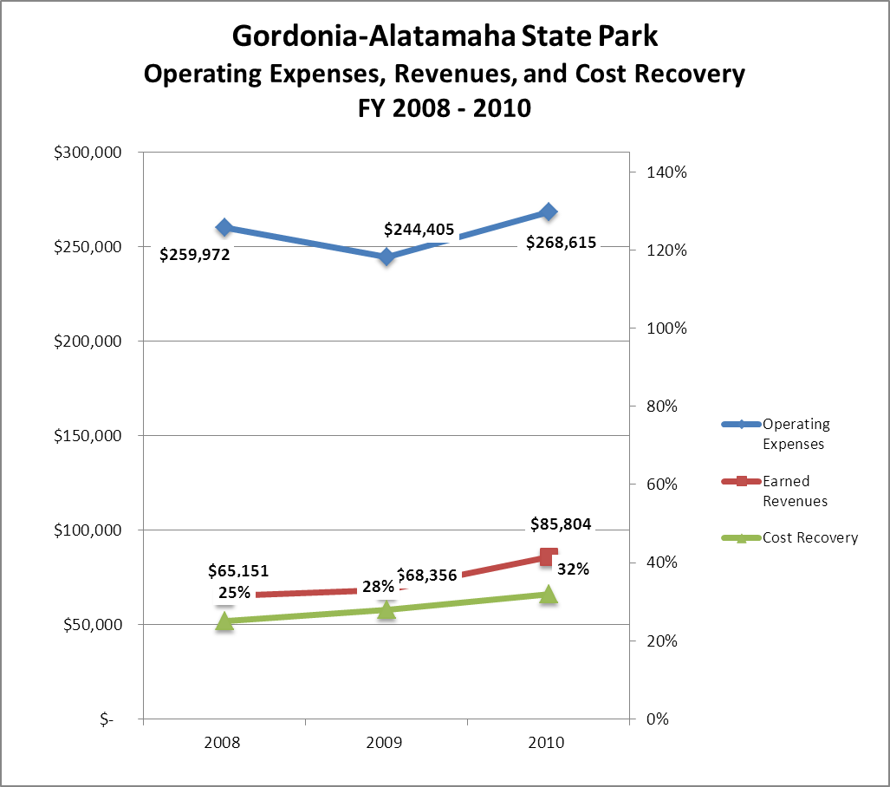

Review of Pricing
Gordonia-Alatamaha State Park | 2005 | 2006 | 2007 | 2008 | 2009 | 2010 | Comments
Picnic Shelters | $30 | $30 | $30 | $30.00 | $35.00 | $40.00
Family Group Shelter | $75 | $75 | $75 | $75.00 | $100.00 | $85.00
Mini-Golf | $2.50 | $2.50 | $2.50 | $2.50 | $3.00 | $4.00
Pedal Boats 30 Minutes | $2.50 | $2.50 | $2.50 | $2.50 | $3.00 | $4.00
Pedal Boats 1 Hour | $0.00 | $0.00 | $0.00 | $0.00 | $0.00 | $7.00
Jon Boats 1 Hour | $4.00 | $4.00 | $4.00 | $4.00 | $5.00 | $5.00
Jon Boats 4 Hours |  |  |  |  | $15.00 | $15.00
Jon Boats 8 Hours |  |  |  |  | $25.00 | $25.00
Trolling Motors/Batteries |  |  |  |  | $10.00 | $10.00 | Flat Rate
Swim Tickets | $3 | $3 | $3 | $3.00 | $4.00 | $0.00 | Pool Closed
Family Swim Pass | $75 | $75 | $75 | $75.00 | $75.00 | $0.00 | Pool Closed
RV/Tent Camping Full Hook-Up | $20 | $20 | $22 | $23.00 | $23.00 | $28.00
RV/Tent Camping Regular | $18/16 | $18/16 | $18/16 | $23/$21 | $23/$21 | $26/$24
Tent Only | $16 | $16 | $16 | $16.00 | $16.00 | $19.00
Cottages: March-October |  |  |  |  |  | $115.00
Cottages: November-February |  |  |  |  |  | $105.00
Data on rate information is available as far back as 2002, but only the last five years are evaluated. There has been notable growth in fees charged at Gordonia-Alatamaha since 2005, with the largest increase being jon boats and camping, and the addition of 5 new cottages in May 2010. The swimming pool has been closed for over 2 years now. A table detailing the rates is provided below.
Business and Management Plan

Business Goals
The following goals serve as the foundation for the key recommendations and strategies in this business plan for Gordonia-Alatamaha State Park.

Enhance Cost Recovery of Site Operations
From 2008 – 2010 Gordonia-Alatamaha State Park has been operating at a 25% - 36% Cost Recovery. The park being located in a small rural market and lower income area makes operating at a higher cost recovery percentage difficult. The increase in daily park pass entrance fees caused a sharp drop in the park day-use visitation. However, if we could add additional overnight accommodations, upgrade the family group shelter to a nice meeting facility to complement the cottages and public golf course by attracting more overnight package deals, add a 9-hole disc golf course and add a few more sewer hook-up campsites, we should be able to increase our revenue and in turn increase the park cost recovery. The park’s labor cost should stay at or below 65% by utilizing year-round part-time employees. The park target goal is to increase from a 36% cost recovery to 56% or greater with increased revenue and reduced operating expenses.

Enhance Revenue Generation Strategies
As with any state park or historic site, visitation volume is the key to increase revenue and for Gordonia-Alatamaha State Park finding new ways to increase visitation will generate more revenue. Implementing the things listed above should increase revenue. Special events would generate more day-use visitation, increase parkpass revenue and park recognition.

Expand Special Events at the Site
Gordonia-Alatamaha State Park has lost several special events recently due to policy changes and other reasons. Examples: Annual Wiregrass Festival and July 4th Fireworks Show. The park’s not having a cultural or historical theme of any significance hurts it in some ways. However, creating a special events program for the park can be done by partnering with other organizations that need a place and facilities. Working closely with the Friends Chapter to create an event such as a Bluegrass music event by the lake would bring in more visitation and revenue. Implementing innovative school programs and charging a fee would bring in additional revenue as well, but staffing issues makes this a problem.

Improve the Diversity and Innovation of Recreational and Interpretive Programs
For Gordonia-Alatamaha State Park, having a small staff makes this a difficult task.

Improve the Effectiveness of Marketing and Sales
For Gordonia-Alatamaha State Park, partnerships are the key to marketing the site. The park needs to increase its visibility by working closer with the Chamber of Commerce, using social-networking sites, getting on the local county, city and community websites, Wiregrass and Woodpecker Trails websites, working with nearby welcome centers and targeting the nearby military bases. The local radio station is also a good marketing tool.

Expand Partnership Opportunities
For Gordonia-Alatamaha, partnering with local and nearby attractions would greatly benefit the park and its partners. The park needs to seek more innovative ways to develop partnerships in this small, rural community. This would create more promotion and awareness for the park, but not so much in the area of revenue.

Classification of Programs and Services
The tables below summarize the classifications of programs and services at Gordonia-Alatamaha as either core, important, or visitor supported and projects a range of cost recovery percentages that might be achieved for each. These classifications establish financial performance goals for each category of services that are linked to the recommendations and strategies of this business plan.
Core Services
Program / Service | Target Cost Recovery
- Open and public access to the site and its resources | 0 – 50%
- Public safety | 0%
- Protection of rare and endangered plants and animals | 0%
- Active management of site to protect its natural and cultural resources | 0%
- Provide appropriate educational, interpretation and recreational opportunities to the public | 0 – 50%
- Enforce educate public about State and Departmental laws, rules and regulations | 0%
- Maintaining of the site grounds, facilities, and infrastructure | 0%
- Nature Trail | 0 – 5%

Important Services
Program / Service | Target Cost Recovery
- Picnic Shelters (Open and Family Group Shelter) | 60 – 100%
- Lake Activities (Pedal and Jon Boats) | 60 – 100%
- Day-Use/Picnicking | 20 -50%

Visitor Supported
Program / Service | Target Cost Recovery
- Interpretive Programming | 100% - 125%
- Special Events | 100% - 125%
- Office/Visitor Center (Resale Area) | 85 – 110%
- RV/Tent Camping | 100 – 120%
- Cottages | 100 – 150%
- Mini-Golf | 150%

Partnership Development Plan
The table below summarizes existing partners and targeted partnerships by classification (operational, vendor, service, co-branding, funding partners) and by organizational type.
 | Public Partners | Not-for-profit Partners | Private / Enterprise Partners
Operational Partners | - County/City Governments  - Georgia Corrections | - Easter Egg Foundation Inc.  - Martha Joiner-Endangered Plant Species Caretaker | - Kennedy Cable  - Doctors Hospital of Tattnall County
Vendor Partners |  |  | - Coca Cola  - Georgia Power
Service Partners |  | - Chamber of Commerce  - Lion Club  - C.A.R.E.S  - Boy Scouts
Co-branding Partners | - City of Reidsville  - Tatnall County | - Wiregrass Trail  - Woodpecker Trail | - WRBX Radio Station  - Anytime Fitness
Funding Resource Development Partner |  | - Friends Chapter of Gordonia State Park  - Friends of Georgia State Parks and Historic Sites

Marketing and Sales Plan

Marketing and Sales Goals
Marketing and sales goals for Gordonia-Alatamaha are based on the following desired outcomes:
- Increase overnight accommodations and shelter use by adding a few more cottages; renovate the family group shelter into a nice meeting facility to complement the golf course and promote more package deals (golf packages); and add additional sewer campsites to increase visitation and revenue.
- Add a 9-hole disc golf course in the day-use area.
- Work with local Friends Chapter and other community groups to put on special events to increase visitation and revenue.
In order to meet these goals, examples of specific target outcomes were identified in the areas detailed in the table below.
Area  of Focus | Current  Performance | Goal  by 2011 | Goal  by 2012 | Goal  by 2015
Cottage Occupancy | 34% | 40% | 41% | 43%
Campground Occupancy | 25% | 26% | 28% | 30%
Shelters | $1,735 | $2,500 | $3,000 | $3,500
Special Events | - | 1 | 1 | 2

Marketing and Promotion Strategies

Publicity and Social Media
Gordonia-Alatamaha will approach marketing and publicity planning using the following guidelines and themes:
- Event publicity
Major events benefit by having short stories in local, regional, and statewide newspapers and online social media hooks planted that run three to four weeks in advance of the event up to the date of the event itself. Stories and media need to be cultivated with contacts and online sales channels several weeks in advance of the time the stories need to run. Special interest interviews on morning, noon, and evening television news programs, radio interviews on popular rush-hour programs, and blogs on known affinity online sites should also be included.
- Program publicity
Special and unique programs should have feature stories in magazines, local and regional weekly newspapers, and statewide daily newspapers that are aimed at placements as front-page or sectional front-page stories. These stories are most effective if they run shortly before the season that the featured program begins. This will likely require several weeks of advanced planning with media contacts. Similar coverage on television and radio should also be considered. If pre-publicity cannot be generated, post-publicity can help promote future programs.
- Site Publicity
Site publicity focusing on a single site or sub-set of sites requires more intense planning efforts to attract multiple writers and editors from target publications. Each site could host several seasonal media familiarization tours (with 10 to 15 writers or editors) to familiarize them with the site and its benefits and amenities. Stories and features resulting from such tours typically take between two and six months to materialize so the tours should focus on experiences, benefits, and programs that would be available when the stories are expected to run.
Examples and suggested opportunities for events, programs and related publicity efforts based on the themes described above at Gordonia-Alatamaha are provided in the table below.

Event Publicity | Program Publicity | Site Publicity
Bluegrass Festival | Great American Backyard Campout | State Agency Day at the Park
Senior Citizen Carnival | Junior Ranger Camp
5K Run | Family Fun Day
Boy Scouts Jamboree | Archery Program
Community Cook Off Event

Packaging
Examples and suggested packages for Gordonia-Alatamaha are provided in the table below.
Package | Package Details
Cottage/Golf | Discounts on Cottage and Golf
Campsite/Golf | Discounts on Camping and Golf
Cottage/ Group Shelter/or Picnic Shelter | 3 or more Cottage Rentals discount on Shelter Rental or free open Shelter Rental
Shelters/Recreational Amenities | 2 or more Shelter Rentals discounts on Recreational Amenities
Camping Clubs | Group Discounts

Group Sales
Types of groups within which specific target customers can be identified for Gordonia-Alatamaha are listed below:
- Families  - Community Groups  - Churches  - Youth Organizations  - Repeat Visitors | - Golfers  - Businesses  - Civic Groups  - Government Agencies  - State Employees | - Special Interest Groups  - Schools  - Women’s Groups  - Out of State Visitors (Canadians)  - Military Personnel and their Family

Incentivizing New and Repeat Visitation
Gordonia-Alatamaha will utilize the following strategies and/or incentives to encourage new and repeat visitation starting in FY 2012:
- Off-season discounts
- Loyalty reward program
- Customer appreciation letter or e-mail
- Partnership discount program for overnight guests

Marketing and Sales Metric Goals
The following marketing and sales metric goals and/or others will be monitored and progress reported at Gordonia-Alatamaha:
- Loyalty and repeat customers = 70% of customers repeat their visit in a 12-month period.
- Brand confidence & customers-recruiting-customers = First time visitors who stumble upon the park while driving or those who have heard about the park through word of mouth = 20 – 30%.
Revenue Generation Plan
Revenue / Cost Recovery Goals
Gordonia-Alatamaha State Park has set a financial goal of increasing annual revenues 9%, 7% & 3% annually between 2012 and 2015. The largest revenue growth opportunity is most likely during the months of October, November, March, April, May and June. Gordonia-Alatamaha had a big jump in revenue in FY2011 because of the operation of 5 new cottages. Annual revenue growth should level off starting in FY2012. The table below details projected revenue growth leading up to 2015, based upon a nominal growth of revenues each year after FY2013.
Year | % Growth from Previous Year | Jul | Aug | Sep | Oct | Nov | Dec | Jan | Feb | Mar | Apr | May | Jun | Total
2010 | Base Year | $5,281 | $5,359 | $ 5,052 | $6,720 | $5,202 | $4,192 | $3,253 | $4,671 | $9,183 | $10,894 | $11,282 | $14,713 | $85,802
2011 | 66% | $8,766 | $8,896 | $8,386 | $11,155 | $8,635 | $6,959 | $5,400 | $7,754 | $15,244 | $18,084 | $18,728 | $24,424 | $142,431
2012 | 3% | $9,029 | $9,163 | $8,638 | $11,490 | $8,894 | $7,167 | $5,562 | $7,986 | $15,701 | $18,627 | $19,290 | $25,156 | $146,704
2013 | 3% | $9,300 | $9,438 | $8,897 | $11,835 | $9,161 | $7,383 | $5,729 | $8,226 | $16,172 | $19,185 | $19,869 | $25,911 | $151,105
2014 | 3% | $9,579 | $9,721 | $9,164 | $12,190 | $9,436 | $7,604 | $5,901 | $8,473 | $16,657 | $19,761 | $20,465 | $26,688 | $155,639
2015 | 4% | $9,963 | $10,110 | $9,531 | $12,677 | $9,813 | $7,908 | $6,137 | $8,812 | $17,324 | $20,551 | $21,283 | $27,756 | $161,864

These projections would result in a total of 105% cumulative growth in total annual revenues between FY2010 and FY2015. If operational expenses can be managed with a cumulative increase of 32% between FY 2010 and FY 2015, then the overall cost recovery of the site will be approximately 54% in FY2015 at these projected revenue levels. This is higher than the annual financial performance of the site in FY 2010, which was operated at 32% cost recovery in that year. Expense levels for FY2012 are already at $299,000 and the goal is to maintain this same approximate level through FY2015. Increases in revenue and expenses are due to the opening of five cottages in the last two months of 2010.
Revenue Generation Strategies

Pricing Plan
Region | PARK RESERVABLES | Current Pricing  (CY 2011) | Proposed Pricing  (CY 2012) | Positive Yield Management Margin (%)
2 | GORDONIA/ALATAMAHA
 | Picnic Shelter | $40 | $40
 | Group Shelter | $105(70) | $85 (70)
 | Camping (RV/Tent) Premium | $26/24 | $30/25
 | Camping (RV/Tent) Regular | $26/24 | $26/24
 | Camping (Tent only) | $19 | $19
 | Cottages (2 Bedrooms)
 | Mar - Oct | $115 | $115
 | Nov - Feb | $105 | $105

Innovative Programming and Special Events Plan
Program / Event | Theme / Purpose | Scheduled Date/Season | Frequency | Target Participation | Target User Fee | Target Cost Recovery
Senior Citizen Carnival | Recreation | October | Annually | 100+ | $8 | 50%+
Bluegrass Festival | Family and Community | October | Annually | 500+ | $10 | 100%+
Community Cook-Off | Community | February | Annually | 100+ | $20 | 100%+
Family fun Day | Family and Community | June | Annually | 200+ | $10 | 100%+
Great American Backyard Campout | Family | June | Annually | 50+ | $8 | 100%+
Boy Scouts Jamboree | Scouts | September and March | Annually | 100+ | $10 | 100%+
Archery Program | Recreation | April | Annually | 30+ | $15 | 100%+

Partnerships and Concessions Plan
Service / Partnership | Term of Service | Financial Objective | Contract Manager
Festivals | 1 year | 15% of gross receipts to park | Region Manager
C.A.R.E.S. | 1 year | Shared Revenue | Region Manager
Local Businesses Promotional Deals | 1 year | Shared Revenue | Region Manager
Friends Chapter | 1 year | Volunteer Hours/Expenses Off-set | Park Manager

Expense Management Plan
Personnel Assignments
The following actions will be taken to proactively manage labor costs via personnel assignments and classifications. Gordonia-Alatamaha State Park Staff is small and half of the staff is already part-time employees. Maintaining current levels of park operations hasn’t been easy and reducing current staffing numbers would impact the entire operation even more.

Action | Timeline | Outcome
Reducing current staff levels would negatively impact the park operations. No action needs to be taken at present with personnel.

Management Techniques
The following actions will be taken to proactively manage labor costs via management techniques.

Action | Timeline | Outcome
Use of more volunteers during events and programs | 2015 | Reduce labor cost for part-time employees.

Adjusted Levels of Service
The following actions will be taken to proactively manage labor costs via reduced levels of service.

Action | Timeline | Outcome
Reducing current levels of service would negatively impact the park

Financial Pro Forma
The following five-year financial pro forma projects operating expenses, earned revenues and cost recovery through FY 2015. These pro forma are based on the strategies and desired outcomes identified in this business plan, especially the revenue generation and expense management plans, and are linked to corresponding performance goals.
Operational Expenses |  |  |  | FY 2010  (actual) |  | FY 2012 |  | FY 2013 |  | FY 2014 | FY 2015
REGULAR SALARIES |  |  |  | $122,715 |  | $134,106 |  | $133,167 |  | $132,235 | $131,309
LAPSE |  |  |  | ($9,377) |  | ($20,749) |  | ($20,749) |  | ($20,749) | ($20,749)
TEMPORARY/CASUAL LABOR |  |  |  | $23,621 |  | $48,256 |  | $47,918 |  | $47,583 | $47,250
FICA |  |  |  | $9,731 |  | $10,960 |  | $10,883 |  | $10,807 | $10,731
RETIREMENT |  |  |  | $12,775 |  | $15,598 |  | $15,489 |  | $15,380 | $15,273
HEALTH INSURANCE |  |  |  | $27,200 |  | $36,307 |  | $36,053 |  | $35,800 | $35,550
ASSESSMENTS BY MERIT |  |  |  | $685 |  | $685 |  | $680 |  | $675 | $671
PERSONAL SERVICES |  |  |  | $187,350 |  | $225,163 |  | $223,442 |  | $221,732 | $220,035
POSTAGE |  |  |  | $400 |  | $500 |  | $497 |  | $493 | $490
MOTOR VEHICLE EXPENSES |  |  |  | $6,350 |  | $11,000 |  | $10,923 |  | $10,847 | $10,771
SUPPLIES & MATERIALS |  |  |  | $15,590 |  | $13,000 |  | $12,909 |  | $12,819 | $12,729
REPAIRS & MAINTENANCE |  |  |  | $3,156 |  | $3,000 |  | $2,979 |  | $2,958 | $2,937
EQUIPMENT >$1000< $5,000 |  |  |  | $5,000 |  | $0 |  | $0 |  | $0 | $0
WATER & SEWAGE |  |  |  | $4,000 |  | $3,700 |  | $3,674 |  | $3,648 | $3,623
ENERGY |  |  |  | $26,800 |  | $31,000 |  | $30,783 |  | $30,568 | $30,354
RENTS |  |  |  | $2,250 |  | $1,600 |  | $1,589 |  | $1,578 | $1,567
INSURANCE & BONDING |  |  |  | $8,076 |  | $8,076 |  | $8,019 |  | $7,963 | $7,908
OTHER OPERATING EXPENSES |  |  |  | $2,900 |  | $4,500 |  | $4,469 |  | $4,437 | $4,406
TRAVEL |  |  |  | $500 |  | $0 |  | $0 |  | $0 | $0
REGULAR EXPENSES |  |  |  | $75,022 |  | $76,376 |  | $75,841 |  | $75,310 | $74,783
VOICE/DATA COMMUNICATIONS |  |  |  | $1,243 |  | $770 |  | $765 |  | $759 | $754
RESALE |  |  |  | $5,000 |  | $3,500 |  | $3,476 |  | $3,451 | $3,427
TOTAL OTHER EXPENDITURES |  |  |  | $6,243 |  | $4,270 |  | $4,240 |  | $4,210 | $4,181
GRAND TOTAL |  |  |  | $ 268,615 |  | $ 305,809 |  | $ 303,523 |  | $ 301,253 | $ 298,999
 | Revenue Pro Forma
 | Revenue Sources | Revenue Sources Description |  |  |  |  | FY 2010 (Actual) |  |  | FY 2012 |  |  | FY 2013 |  |  | FY 2014 | FY 2015
 | 60001 | CONCESSION AND TP NON-FOOD |  |  |  |  | $ (3,737) |  |  | $ (3,686) |  |  | $ (3,797) |  |  | $ (3,910) | $ (4,028)
 | 60002 | Cancellation Fees |  |  |  |  | $ (73) |  |  | $ (85) |  |  | $ (88) |  |  | $ (90) | $ (93)
 | 60004 | Cottages |  |  |  |  | $ (11,224) |  |  | $ (54,989) |  |  | $ (56,639) |  |  | $ (58,338) | $ (60,088)
 | 60005 | CAMP SITES |  |  |  |  | $ (41,625) |  |  | $ (45,389) |  |  | $ (46,751) |  |  | $ (48,153) | $ (49,598)
 | 60007 | BOATS |  |  |  |  | $ (2,710) |  |  | $ (3,540) |  |  | $ (3,646) |  |  | $ (3,756) | $ (3,868)
 | 60011 | MINIATURE GOLF |  |  |  |  | $ (3,104) |  |  | $ (3,506) |  |  | $ (3,611) |  |  | $ (3,720) | $ (3,831)
 | 60014 | DOG FEES |  |  |  |  | $ (80) |  |  | $ (1,040) |  |  | $ (1,071) |  |  | $ (1,103) | $ (1,136)
 | 60015 | GROUP SHELTERS |  |  |  |  | $ (1,520) |  |  | $ (3,320) |  |  | $ (3,420) |  |  | $ (3,522) | $ (3,628)
 | 60017 | VENDING MACHINES |  |  |  |  | $ (169) |  |  | $ (131) |  |  | $ (135) |  |  | $ (139) | $ (143)
 | 60018 | WASH & DRY |  |  |  |  | $ (562) |  |  | $ (650) |  |  | $ (670) |  |  | $ (690) | $ (710)
 | 60020 | SHORT/OVER |  |  |  |  | $ 48 |  |  | $ 11 |  |  | $ 11 |  |  | $ 12 | $ 12
 | 60025 | REFUNDS |  |  |  |  | $ 7,288 |  |  | $ 12,126 |  |  | $ 12,490 |  |  | $ 12,864 | $ 13,250
 | 60028 | PICNIC SHELTERS |  |  |  |  | $ (870) |  |  | $ (1,000) |  |  | $ (1,030) |  |  | $ (1,061) | $ (1,093)
 | 60033 | CAMPSITE SR. CITIZEN DISCOUNT |  |  |  |  | $ 4,012 |  |  | $ 5,750 |  |  | $ 5,923 |  |  | $ 6,100 | $ 6,283
 | 60036 | PROGRAM FEES |  |  |  |  | $ (82) |  |  | $ (10) |  |  | $ (10) |  |  | $ (11) | $ (11)
 | 60042 | NON-COST ITEMS (ICE, WOOD) |  |  |  |  | $ (242) |  |  | $ (291) |  |  | $ (300) |  |  | $ (309) | $ (318)
 | 60073 | DISABLED VET DISCOUNT |  |  |  |  | $ 454 |  |  | $ 778 |  |  | $ 801 |  |  | $ 825 | $ 850
 | 60090 | FOOD/BEV ITEMS TO GO |  |  |  |  | $ (214) |  |  | $ (172) |  |  | $ (177) |  |  | $ (182) | $ (188)
 | 60092 | "Friends" Discount at Parks |  |  |  |  | $ 645 |  |  | $ 1,387 |  |  | $ 1,429 |  |  | $ 1,471 | $ 1,516
 | 60099 | SALES TAX |  |  |  |  | $ 551 |  |  | $ (388) |  |  | $ (400) |  |  | $ (412) | $ (424)
 | 61100 | MISC CONCESSION AGREEMENTS |  |  |  |  | $ (390) |  |  | $ (90) |  |  | $ (93) |  |  | $ (95) | $ (98)
 | 63408 | OTHER-SALES & SERVICE |  |  |  |  | $ (318) |  |  | $ (297) |  |  | $ (306) |  |  | $ (315) | $ (325)
 | 63908 | OTHER/MISC |  |  |  |  | $ (38) |  |  | $ (39) |  |  | $ (40) |  |  | $ (41) | $ (42)
 | 66002 | CANCELLATION FEES |  |  |  |  | $ (919) |  |  | $ (1,394) |  |  | $ (1,436) |  |  | $ (1,479) | $ (1,523)
 | 66003 | REFUNDS-ADV RESERV |  |  |  |  | $ 4,538 |  |  | $ 971 |  |  | $ 1,000 |  |  | $ 1,030 | $ 1,061
 | 66005 | CAMPING |  |  |  |  | $ (9,480) |  |  | $ (6,901) |  |  | $ (7,108) |  |  | $ (7,321) | $ (7,541)
 | 66006 | COTTAGE |  |  |  |  | $ (3,865) |  |  | $ (8,768) |  |  | $ (9,031) |  |  | $ (9,302) | $ (9,581)
 | 66015 | GROUP SHELTER |  |  |  |  | $ (2,940) |  |  | $ (2,200) |  |  | $ (2,266) |  |  | $ (2,334) | $ (2,404)
 | 66019 | Transfer Fees |  |  |  |  | $ (10) |  |  | $ (128) |  |  | $ (132) |  |  | $ (136) | $ (140)
 | 66028 | PICNIC SHELTER |  |  |  |  | $ (855) |  |  | $ (320) |  |  | $ (330) |  |  | $ (339) | $ (350)
 | 69005 | Camp Sites - PW |  |  |  |  | $ (13,259) |  |  | $ (13,363) |  |  | $ (13,764) |  |  | $ (14,177) | $ (14,602)
 | 69006 | Cottages/Cabins |  |  |  |  | $ (3,160) |  |  | $ (14,130) |  |  | $ (14,554) |  |  | $ (14,991) | $ (15,440)
 | 69015 | GROUP SHELTERS |  |  |  |  | $ (1,525) |  |  | $ (2,305) |  |  | $ (2,374) |  |  | $ (2,445) | $ (2,519)
 | 69028 | Picnic Shelters-PW |  |  |  |  | $ (370) |  |  | $ (240) |  |  | $ (247) |  |  | $ (255) | $ (262)
 | TOTAL |  |  |  |  |  | $ (85,804) |  |  | $ (147,349) |  |  | $ (151,769) |  |  | $ (156,322) | $ (161,012)

Total / Cost Recovery Pro Forma

Gordonia-Alatamaha State Park | FY 2010 (Actual) | FY 2012 | FY 2013 | FY 2014 | FY 2015
TOTAL PRO FORMA
Visitation | 39,018 | 43,222 | 44,519 | 45,854 | 65,000
Operational Expenses | $ 268,615 | $ 305,809 | $ 303,523 | $ 301,253 | $ 298,999
Earned Revenues | $85,804 | $147,349 | $151,769 | $156,322 | $161,012
% Cost Recovery | 32% | 48% | 50% | 52% | 54%

Action Plan
ACTION PLAN
Site: |  | Site Manager: |  |  | Date:
Month:
Strategy | Tasks | Costs / Funding | Revenues / ROI | Responsibilities | Metrics

ACTION PLAN
Site: |  | Site Manager: |  |  | Date:
Month:
Strategy | Tasks | Costs / Funding | Revenues / ROI | Responsibilities | Metrics

This is the average of the last three years – FY 2008, FY 2009, and FY 2010
Current employees, not including vacancies.
Current employees, not including vacancies.
Major population centers within a two-hour drive from the site

