Hamburg State Outdoor Recreation Area
Business & Management Plan

Prepared January 2012; Finalized February 2013
Direction 2015 – Sustainable Business Planning

Table of Contents

Executive Summary 3

Site and Operations Assessment 6
Site Inventory and Facility Assessment 6
Operational Assessment 8
Financial Performance Assessment 13

Business and Management Plan 16
Business Goals 16
Classification of Programs and Services 17
Partnership Development Plan 18
Marketing and Sales Plan 19
Revenue Generation Plan 21
Expense Management Plan 22
Financial Pro Forma 23

Action Plan 25

Executive Summary
The Parks, Recreation and Historic Sites Division (PRHSD) of the Georgia Department of Natural Resources (DNR) is transitioning the management of Hard Labor Creek State Park to operate more like a business, reflecting the Direction 2015 – Sustainable Business Planning initiative to improve the fiscal performance and management of the state parks and historic sites system. This business and management plan is designed to help the site recover more operating expenses through earned revenues, productive partnerships, and innovative programs.

Site Fact Sheet
Site Name | Hamburg State Outdoor Recreation Area
Site Manager | Andre McLendon (A.H. Stephens Park Manager)
Region Manager | Tommy Turk
Date of Business Plan completion | September 27, 2011
Site size | 741 Acres
Total number of visitors (FY 2010) | 82,409
Total operating budget (FY 2010) | $216,728
Total earned revenues (FY 2010) | $110,213
Operational cost recovery (FY 2010) | 51%
Average operating cost per visitor (FY 2010) | $2.63
Average earned revenue per visitor (FY 2010) | $1.34
Average cost recovery (FY 2008 – 2010) | 51%
Target cost recovery (FY 2015) | 68%
Total full-time employees | 0
Total part-time employees | 1
Primary service markets | Sandersville, Milledgeville
Primary attractors/visitor appeal factors | Camping, Historic Grist Mill, 225-acre lake
Leading opportunities for improved site performance | Partnerships with Friends Chapter and other local groups

Site Summary and Key Attractions
Hamburg State Outdoor Recreation Area is a 714-acre park located in Mitchell, GA. The major facilities and amenities that draw visitors to the park include 30 campsites, a 225-acre lake, an historic grist mill and hiking trails.
Key Attractions
The amenities or features listed below are those that seem to be most popular for visitors.
- Campground
- Shelters
- 1921 Water powered Grist Mill
- Hiking trails
- Lake Activities (Fishing/Boating)

Financial Targets
The table below details the total operating expenses and earned revenues for Hamburg State Outdoor Recreation Area over the last three years (2008 – 2010). This table also calculates total cost per visitor and revenues per visitor during these operating years, and details the target financial performance goals in the context of achieving at least 68% cost recovery. This table also calculates the necessary change from 2010 operating expenses and revenues.

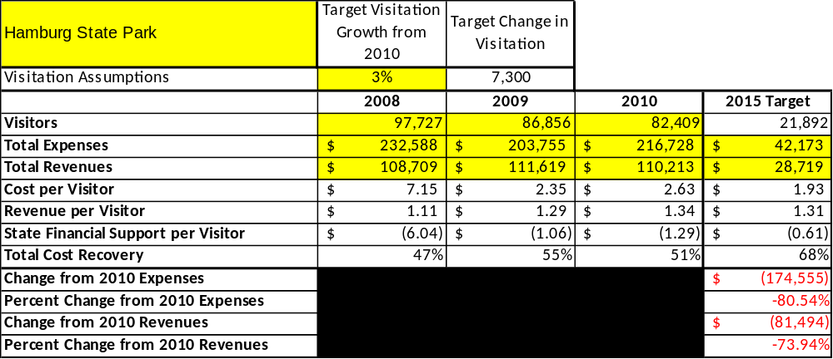

Key Recommendations

Primary / Short Term Recommendations
- Utilize the business plan to focus on each cost center (cost-based accounting) including the level of tax subsidy required or revenues over expenses that are achieved annually to operate the park.
- Seek local partners to support portions of the state park programs and services.
- Manage by maintenance standards, program standards and operational standards adopted and enforced by the Regional Directors and senior state park management.
- Engage the Friends of Hamburg in the maintenance of the site.
- Continue efforts to correct any misunderstanding by the public that the park is closed.

Secondary / Long Term Recommendations
- Seek opportunities to find an alternative operator for the site.

Site and Operations Assessment
This site and operations assessment is a culmination of analyses and findings from a review of the condition of facilities, infrastructure, and operations at Hamburg State Outdoor Recreation Area. The findings and observations are not intended to be an exhaustive review of all issues present, but provide a basic understanding of the predominant issues that contribute to the site’s current operating conditions. The assessment includes the following:
- Site Inventory and Facility Assessment
- Operational Assessment
- Financial Assessment
Site Inventory and Facility Assessment

Methodology
Facility and asset conditions are rated using a differential scale of excellent, good, fair, or poor. Descriptions of conditions that are attributed to each of these findings are also provided.
Scale of Conditions
Rating | General Description
Excellent | Facilities/amenities are in ‘excellent’ condition when they show little or no maintenance or repair problems. Facilities do not feature any major design or operational issues or flaws that contribute to diminished use or increased maintenance or upkeep. Facilities are easy to clean and maintain in order to place them back into public use and the users perceive them to be in excellent shape.
Good | Facilities/amenities are in ‘good’ condition when they show only minor maintenance or repair problems. Most maintenance issues with these facilities typically appear to be the result of age and/or heavy use. Facilities may only feature minor design or operational issues that contribute to diminished use or increased maintenance or upkeep. Facilities are moderately easy to clean and maintain in order to place them back into service and the users perceive them to be adequate for their use, but probably not in excellent shape.
Fair | Facilities/amenities are in ‘fair’ condition when they show significant maintenance or repair problems. Facilities generally exhibit ongoing maintenance issues that appear to be the result of age, heavy use, or design or operational flaws. Some maintenance and repair needs may compound their fair condition by being deferred because of budget and/or resource limitations. Facilities require more effort to clean and maintain before placing them back into service and the users may perceive them as being less than adequate for their use and in a state of deterioration. The facility or structure may need of major repair or replacement.
Poor | Facilities/amenities are in ‘poor’ condition when they show significant, on-going maintenance or repair problems that ultimately may result in suspended use for repair/replacement. Maintenance and repair issues are possibly the result of poor maintenance and clearly the result of age, heavy use, or design or operational flaws. Problems with the facilities are often compounded over time due to consistently-deferred maintenance and repair because of budget and/or resource limitations. Facilities may feature major design or operational issues that contribute to diminished use or increased maintenance or upkeep. Facilities require excessive effort to clean and maintain before placing them back into service and the users often perceive them as being inadequate for their use and in a state of serious deterioration. The facility or structure may need of major repair or replacement.

Inventory and Assessment
The table below is an inventory of facilities and amenities at Hamburg State Outdoor Recreation Area, and provides the assessed condition of each as reviewed in April 2011.

Site Asset / Amenity | Quantity | Condition
Tent & RV Campsites | 30 | Good
Picnic Shelters | 3 | Good
Group Shelters | 1 | Poor
Day Use Picnic Areas | 5 | Good
Campground Comfort Stations | 1 | Good
Day Use Bathrooms | 1 | Good
Park Office Visitor Center | 1 | Good/Closed
Manager’s Residence | 1 | Good/Closed
Ranger’s Residence | 1 | Good/Closed
Maintenance Building | 1 | Good
Nature Trails | 3.5 miles | Good
Grist Mill | 1 | Good
Lake (225 acres) | 1 | Good

Prioritized Facility Needs
Based on the facility inventory and assessment, these prioritized needs have been identified. Each need has been aligned with a priority category of high, moderate, or low to support future decision making regarding project sequencing, investment of public resources, and meeting community expectations. The priority assignment for each need is not a measure of importance. Rather, these recommended priorities reflect a phased implementation approach over the next several years.
Facility Need | Priority Assignment
Renovation of three campsites | High
Work on group shelter | Low

Operational Assessment
The Operational Assessment includes:
- An inventory and classification of programs and services being provided at the site
- A review of staffing at the site
- A review of concessionaires and partners operating at the site
- Visitation and customer satisfaction

Inventory and Classification of Programs and Services
Programs and services are classified into one of three major categories:
1) Core or Essential Services
2) Important Services
3) Visitor Supported Services
Programs and services at the site are classified into these categories based in part on the mission and public mandates for both the site and the agency. For the programs and services in each of these categories, there are financial performance expectations that will define how services are funded and evaluated.

Category 1 – Core Services [Largely supported by tax funds]
Core programs, services and facilities are those the agency must provide and/or are essential in order to capably govern and meet statutory requirements. The failure of the agency to provide Category 1 services at adequate levels could result in significant negative consequences for the public and the resources under protection. The criteria for programs or services to be classified as core or essential are:
- The services are mandated by the agency’s law or charter or are contractually obligated by agreement to provide the services.
- The services are essential to protecting and supporting the public’s health and safety.
- The services protect and maintain valuable assets and infrastructure.
- The services would generally and reasonably be expected and supported by residents, businesses, customers and partners.
- The services are those that cannot or should not be provided by the private sector.
- The services provide a sound investment of public funds.
The following programs and services offered at Hamburg State Outdoor Recreation Area have been identified as core services:
- Protect the integrity of natural and cultural resources of the site through active management
- Open and public access to the site and its resources
- Self-directed and site appropriate education, interpretation and recreational opportunities
- Public safety

Category 2 – Important Services [Supported by a balance of tax funds and earned revenues]
Important programs, services and facilities are those the agency should provide, and are important to governing and effectively serving residents, businesses, customers and partners. Providing Category 2 services expands or enhances the agency’s ability to provide and sustain its core services. The criteria for programs or services to be classified as important are:
- The services expand, enhance or support identified core services.
- The services are broadly supported and utilized by the community, and are considered an appropriate, important, and valuable public good. Public support may be conditional upon the manner by which the services are paid for or funded.
- The services generate income or revenue that offsets some or all of the operating cost and/or are deemed to provide economic, social or environmental outcomes or results.
The following programs and services offered at Hamburg State Outdoor Rec. Area have been identified as important services:
- Lake activities
- Grist Mill
- Day-use

Category 3 – Visitor Supported Services [Almost exclusively supported by earned revenue]
Visitor supported programs, services and facilities are those discretionary services that the agency may provide when additional funding or revenue exists to offset the cost of providing those services. Category 3 services provide added value above and beyond what is required or expected. The criteria for programs or services to be classified as visitor supported are:
- The services expand, enhance or support core services or important services and the quality of life of the visitors, community or stakeholders.
- The services are supported, valued and well utilized and provide an appropriate and valuable public benefit.
The services generate income or funding from sponsorships, grants, user fees or other sources that offset some or all of their cost and/or provides a meaningful return on investment.
The following programs and services offered at Hamburg have been identified as visitor supported services:
- Tent/RV camping
- Interpretive / recreation programs and events
- Group shelter rentals

Staffing Assessment
Labor costs at Hamburg State Outdoor Recreation Area represent the largest area of budgetary expense at an average of 64% of the total operating budget each year for the last three complete years, which is lower than the target of total labor costs (including benefits) not exceeding 65% of the site’s total operating expenditures. The tables below and on the following page provide a basic review of the current staffing at the site. As a result of the transition to a SORA operation, the labor cost is now reduced to 32 % of the total operating budget.

Full Time Equivalent Employees
Position / Title | Quantity (FTE) | Vacancies | Annual Hours
None | 0 | 0 | 0
TOTAL | 0 | 0 | 0

Part Time Employees
Position / Title | Quantity (PTE) | Vacancies | Hours
Maintenance Worker | 1 | 0 | 1508
TOTAL | 1 | 0 | 1,508

Labor Support
Labor Support | Annual Hours
Volunteers | 4000
Resource Management Crews | 100
TOTAL | 4,100

Total Labor Hours
Labor Type | Annual Hours
Full Time Equivalent Employees | 0
Part Time Employees | 1,508
Labor Support | 4,100
TOTAL Annual Labor Hours | 5,608

Labor Budget Summary
 | Hamburg State Park
 |  | 2008 | 2009 | 2010 | % Change
 | Account Code and Sub-Class | Year End | Year End | Year End | from
 | Expenditure Descriptions | Expenses | Expenses | Expenses | 2008
 | REGULAR SALARIES | 174,356 | 172,210 | 162,833 | -7%
 | ANNUAL LEAVE PAY | 6,948 | 6,888 | 6,646 | -4%
 | OTHER SUPPLEMENTAL | 1 | 1 | 1 | 0%
 | TEMPORARY/CASUAL LABOR | 7,216 | 6,179 | 7,869 | 9%
 | FICA | 11,202 | 11,542 | 11,195 | 0%
 | RETIREMENT | 15,989 | 16,643 | 23,855 | 49%
 | HEALTH INSURANCE | 23,416 | 22,524 | 35,184 | 50%
 | UNEMPLOYMENT INSURANCE | 344 | 269 | 368 | 7%
 | ASSESSMENTS BY MERIT | 1,218 | 1,323 | 308 | -75%
 | PERSONAL SERVICES | 240,690 | 237,580 | 248,259 | 3%

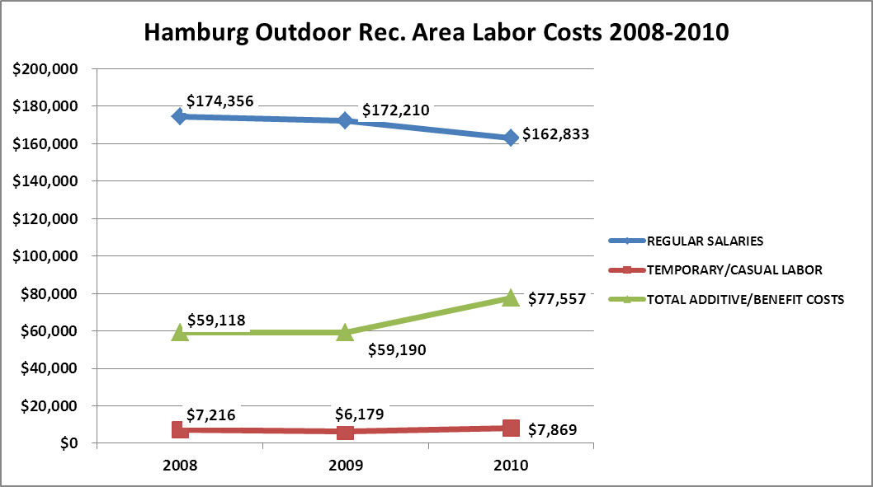
Visitation and Occupancy
Overall annual visitation to the site has trended downward from 2008 to 2010, decreasing by 16% or over 15,318 visitors due to the transition of the park to an Outdoor Recreation Area.

Year | Total Visitation
2008 | 97,727
2009 | 86,856
2010 | 82,409

Occupancy for the overnight accommodations at Hamburg the last three years is detailed in the table below. Camping occupancy has trended downward from 2008 to 2010, decreasing by 3.85%. This is largely attributed to the transition of the park to an Outdoor Recreation Area.

Year | Campground Occupancy
2008 | 37.10%
2009 | 34.78%
2010 | 33.25%

Customer Service and Satisfaction

Site | Year | Customer Satisfaction Level
Hamburg State Park | 2009 | 100%
Hamburg State Park | 2010 | 83%
Financial Performance Assessment

Operational Expenses
A summary of total operating expenses at Hamburg from 2009 to 2010, as well as their percent change from 2008 are provided in the table below.
Hamburg | 2008 | 2009 | 2010 | % Change from 2008
SORA
Operational Expenses
REGULAR SALARIES |  | 172,210 | 162,833
ANNUAL LEAVE PAY |  |  | 6,646
OTHER SUPPLEMENTAL
OVERTIME
TEMPORARY/CASUAL LABOR |  | 6,179 | 7,869
FICA |  | 11,542 | 11,195
RETIREMENT |  | 16,643 | 23,855
HEALTH INSURANCE |  | 22,524 | 35,184
UNEMPLOYMENT INSURANCE |  | 269 | 368
ASSESSMENTS BY MERIT |  | 1,323 | 308
DRUG TESTING |  | 0 | 0
PERSONAL SERVICES | 0 | 230,691 | 248,258
POSTAGE |  |  | 200
MOTOR VEHICLE EXPENSES |  | 6,369 | 13,119
PRINTING & PUBLICATION
SUPPLIES & MATERIALS |  |  | 9,925
REPAIRS & MAINTENANCE |  | 3,481 | 530
EQUIPMENT >$1000< $5,000
WATER & SEWAGE |  | 4,644 | 3,285
ENERGY |  | 41,785 | 50,362
RENTS |  | 1,968 | 2,218
INSURANCE & BONDING |  | 5,119 | 5,099
FREIGHT |  | 24
PURCHASING CARD |  | 6,085 | 5,649
OTHER OPERATING EXPENSES |  | 1,395 | 2,178
CLAIMS & BONDS & INTEREST
TRAVEL
REGULAR EXPENSES | 0 | 70,870 | 92,565
MOTOR VEHICLE EQUIPMENT
EQUIPMENT PURCHASES >5000
CAPITAL\ LEASE Prin & Int
REAL ESTATE RENTALS
VOICE/DATA COMMUNICATIONS |  | 4,156 | 3,549
PER DIEM & FEES
PER DIEM & FESS EXPENSE
CONTRACTS
ADVERTISING - PROCUREMENT CARD
RESALE |  | 5,726 | 2,622
TOTAL OTHER EXPENDITURES | 0 | 9,882 | 6,170
GRAND TOTAL | $ 232,588 | $ 203,755 | $ 216,728 | -7%
Earned Revenues | $108,709 | $111,619 | $110,213 | -36%
% Cost Recovery | 47% | 55% | 51% | 9%
Earned Revenues
Monthly earned revenues for the last two years indicate that the total annual revenue decreased 4% from 2009 to 2010, with the largest decreases in monthly revenues in January and September. Revenues actually increased in the months of October and April. These months of increased revenue were not sufficient to account for lost revenues in the remaining months.
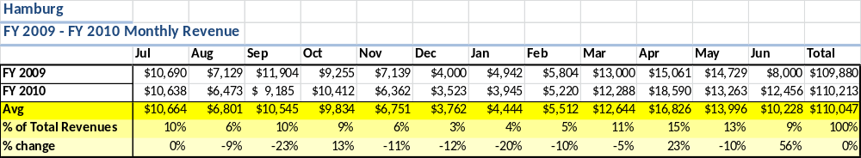

The graphs below illustrate the monthly revenue trends each year and the average percent of total annual revenue earned each month.
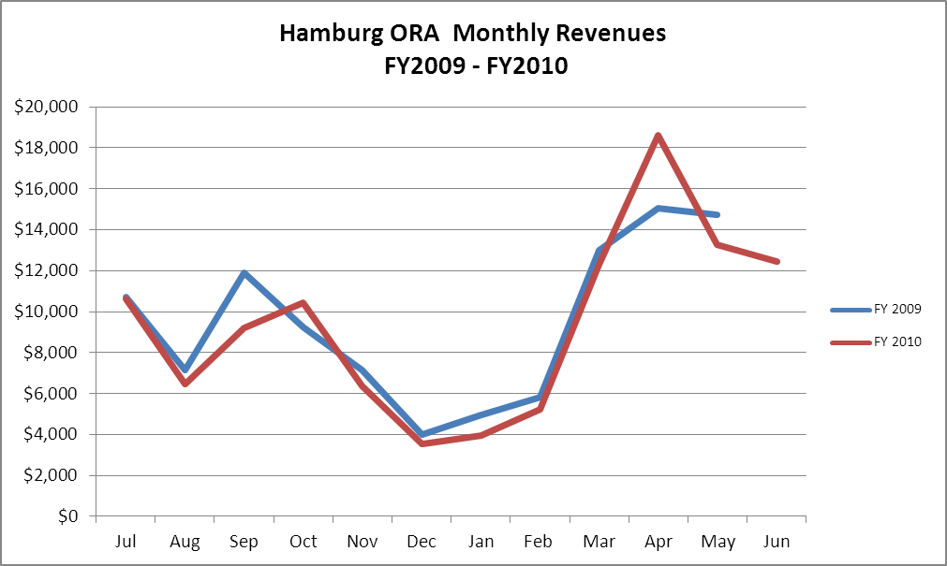

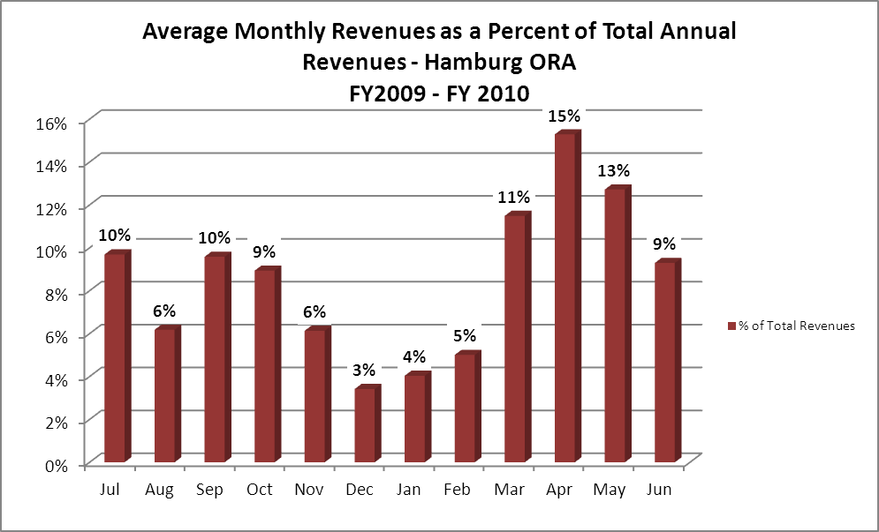
Cost Recovery Trends
Hamburg has achieved an average cost recovery of 50.3% of annual operational expenses through earned revenues from FY 2008 to FY 2010. This is detailed and illustrated in the table and graph below.

Year | Operational  Expenses | Earned  Revenues | Percent Cost  Recovery
2008 | $ 232,588 | $ 108,709 | 46%
2009 | $ 203,755 | $ 111,619 | 54%
2010 | $ 216,728 | $ 110,213 | 51%

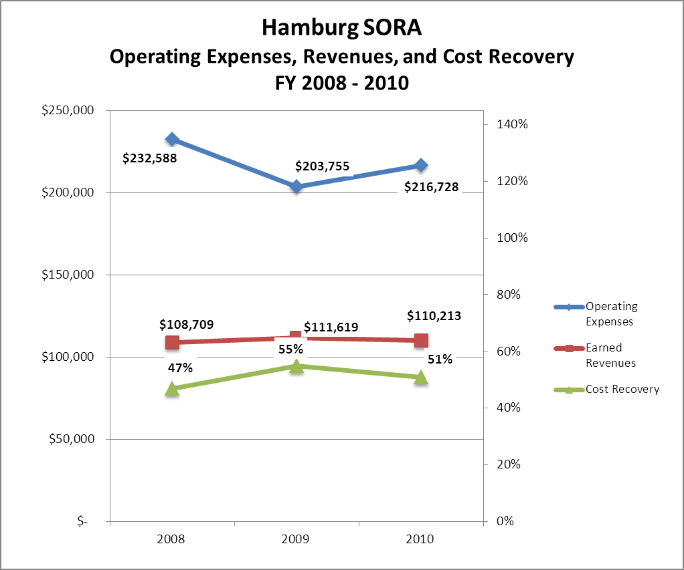

Review of Pricing
Data on rate information is available as far back as 2002, but only the last five years are evaluated. There has been notable growth in fees charged at Hamburg since 2005, with the largest increase being 2010. A table detailing the rates for Hamburg provided below.
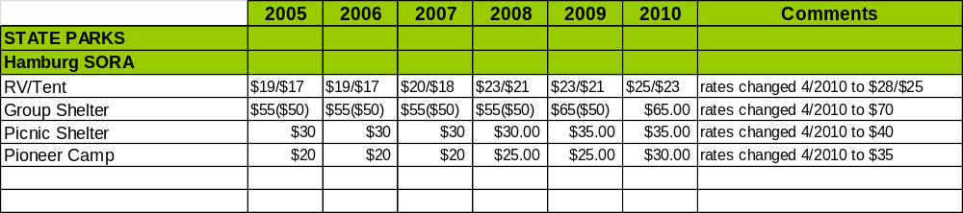
Business and Management Plan

Business Goals
The following goals serve as the foundation for the key recommendations and strategies in this business plan for Hamburg State Outdoor Recreation Area.

Enhance Cost Recovery of Site Operations
Hamburg State Park was converted to a SORA park. The operational costs have been reduced extensively. Management will continue to look for ways to reduce costs and generate revenue.

Enhance Revenue Generation Strategies
Continue to correct misleading information about park closure.

Expand Special Events at the Site
Partner with Friends of Hamburg to conduct at least four programs or events per year.

Improve the Diversity and Innovation of Recreational and Interpretive Programs
Continue to improve the diversity and innovation of the programs offered by the Friends and Hamburg site staff.

Improve the Effectiveness of Marketing and Sales
Continue to work with the Marketing Unit to target camping clubs, Boy and Girl Scout groups, etc.

Establish Greater Consistency of Managing and Monitoring Customer Service & Satisfaction
Creating a more efficient and consistent process for soliciting visitor and user feedback will improve the ability of the park to be a more proactive facility and service provider in the region.

Expand Partnership Opportunities
Continue to attend Friends Chapter meetings and seek partnerships with local businesses for support.

Classification of Programs and Services
The tables below summarize the classifications of programs and services at Hamburg as either core, important, or visitor supported and projects a range of cost recovery percentages that might be achieved for each. These classifications establish financial performance goals for each category of services that are linked to the recommendations and strategies of this business plan.

Core Services
Program / Service | Target Cost Recovery
Protect the integrity of natural and cultural resources of the site through active management | 0%
Open and public access to the site and its resources | 0%
Self-directed and site appropriate education, interpretation and recreational opportunities | 100%
Public safety | 0%

Important Services
Program / Service | Target Cost Recovery
Lake activities | 50%
Grist Mill | 50%
Day-use | 50%

Visitor Supported
Program / Service | Target Cost Recovery
Camping | 80% - 110%
Interpretive/recreation programs and events | 50% - 100%
Group shelter rentals | 100%

Partnership Development Plan
The table below summarizes existing partners and targeted partnerships by classification (operational, vendor, service, co-branding, funding partners) and by organizational type.
 | Public Partners | Not-for-profit Partners | Private / Enterprise Partners
Operational Partners | - Washington EMC  - WRD  - Washington Co. Sheriff’s Dept.  - Georgia Forestry  - A.H. Stephens State Park | - Friends of Hamburg
Vendor Partners
Service Partners | - Washington Co. School System
Co-branding Partners | - Washington County Chamber  - County Commissioner
Funding Resource Development Partner |  | - Friends of Georgia State Parks and Historic Sites

Marketing and Sales Plan

Marketing and Sales Goals
Marketing and sales goals for Hamburg are based on the following desired outcomes:
- Increase attendance by continuing to correct misinformation due to change to SORA site.
In order to meet these goals, examples of specific target outcomes were identified in the areas detailed in the table below.

Area  of Focus | 2010  Performance | Goal  by 2011 | Goal  by 2012 | Goal  by 2015
Attendance | 82,409 | 20,000 | 21,000 | 21,892

Marketing and Promotion Strategies

Publicity and Social Media
Hamburg State Outdoor Recreation Area will approach marketing and publicity planning using the following guidelines and themes:
- Event publicity
Major events benefit by having short stories in local, regional, and statewide newspapers and online social media hooks planted that run three to four weeks in advance of the event up to the date of the event itself. Stories and media need to be cultivated with contacts and online sales channels several weeks in advance of the time the stories need to run. Special interest interviews on morning, noon, and evening television news programs, radio interviews on popular rush-hour programs, and blogs on known affinity online sites should also be included.
- Program publicity
Special and unique programs should have feature stories in magazines, local and regional weekly newspapers, and statewide daily newspapers that are aimed at placements as front-page or sectional front-page stories. These stories are most effective if they run shortly before the season that the featured program begins. This will likely require several weeks of advanced planning with media contacts. Similar coverage on television and radio should also be considered. If pre-publicity cannot be generated, post-publicity can help promote future programs.
- Site Publicity
Site publicity focusing on a single site or sub-set of sites requires more intense planning efforts to attract multiple writers and editors from target publications. The site could host several seasonal media familiarization tours (with 10 to 15 writers or editors) to familiarize them with the site and its benefits and amenities. Stories and features resulting from such tours typically take between two and six months to materialize so the tours should focus on experiences, benefits, and programs that would be available when the stories are expected to run.

Examples and suggested opportunities for events, programs and related publicity efforts based on the themes described above at Hamburg are provided in the table below.

Event Publicity | Program Publicity | Site Publicity
Fall Festival | Old Timers Day | Grist Mill Operation
 | Volunteer Workdays

Packaging
Examples and suggested packages for Hamburg are provided in the table below.

Package | Package Details
RV Club package | Market current RV club packages.

Group Sales
Types of groups within which specific target customers can be identified for Hamburg are listed below:
- Fishermen | - Canoers/kayakers

Incentivizing New and Repeat Visitation
Hamburg will utilize the following strategies and/or incentives to encourage new and repeat visitation starting in FY 2012:
- Our current marketing strategies in place are great tools to increase new and repeat visitation such as the RV Camping Club offering a free night camping after the 9th night of camping.
- Contact camping clubs

Marketing and Sales Metric Goals
The following marketing and sales metric goals and/or others will be monitored and progress reported at Hamburg State Outdoor Recreation Area:
- Loyalty and repeat customers = Higher attendance.
- Brand confidence & customers-recruiting-customers = Higher attendance.
Revenue Generation Plan
Revenue / Cost Recovery Goals
Hamburg State Outdoor Recreation Area has set a financial goal of maintaining annual revenues annually between 2012 and 2015. The transition to the SORA model offers little to no opportunity to increase revenue.
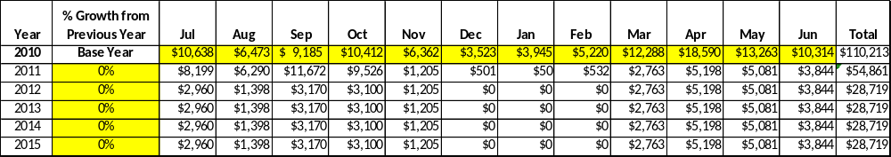

Revenue Generation Strategies

Pricing Plan
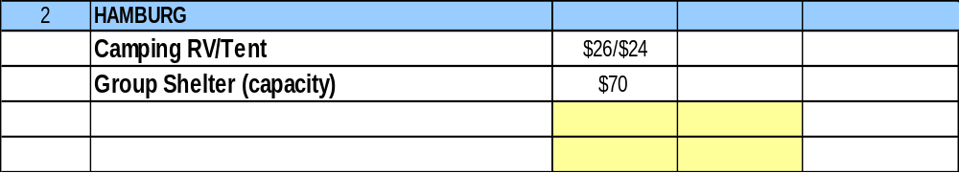

Innovative Programming and Special Events Plan
Program / Event | Theme / Purpose | Scheduled Date/Season | Frequency | Target Participation | Target User Fee | Target Cost Recovery
Fall Festival | Recreation | September | Yearly | 300 | $5 park pass hosted by Friends group | 100%
Spring Festival |  | April | Yearly | 300 | $5 park pass hosted by Friends group | 100%

Partnerships and Concessions Plan
Service / Partnership | Term of Service | Financial Objective | Contract Manager
None due to operational model

Expense Management Plan
Personnel Assignments
The following actions will be taken to proactively manage labor costs via personnel assignments and classifications.

Action | Timeline | Outcome
Labor support assigned to A.H. Stephens | October 2011 | Reduction in labor costs

Management Techniques
The following actions will be taken to proactively manage labor costs via management techniques.

Action | Timeline | Outcome
Provide only one part-time employee | October 2011 | Reduction in labor costs

Adjusted Levels of Service
The following actions will be taken to proactively manage labor costs via reduced levels of service.

Action | Timeline | Outcome
Transition to SORA operating model (seasonal operation) | October 2011 | Reduction in operating costs

Financial Pro Forma
The following five-year financial pro forma projects operating expenses, earned revenues and cost recovery through FY 2015. These pro forma are based on the strategies and desired outcomes identified in this business plan, especially the revenue generation and expense management plans, and are linked to corresponding performance goals. The charts below are based on 2010 figures when Hamburg was a state park. The park has been converted to a SORA operation.

Expense Pro Forma
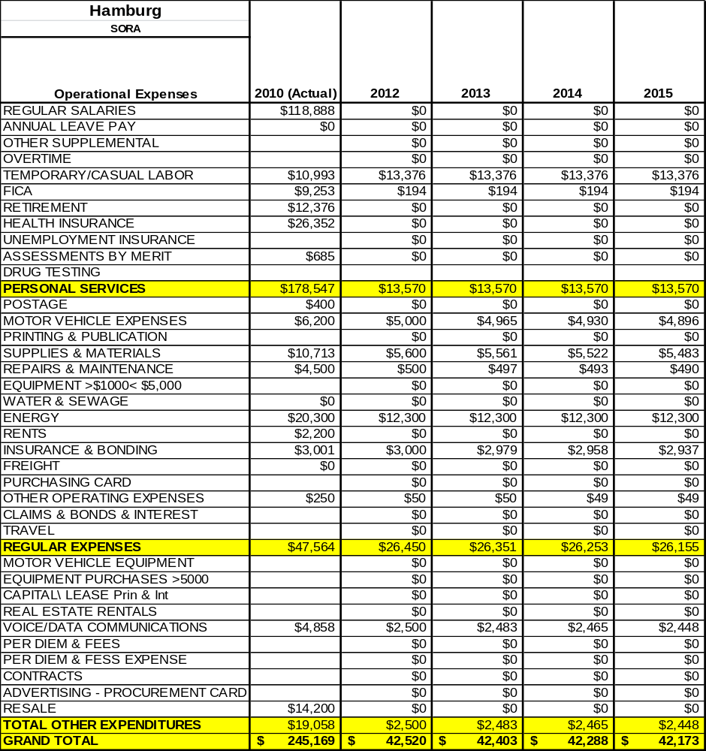

Revenue Pro Forma
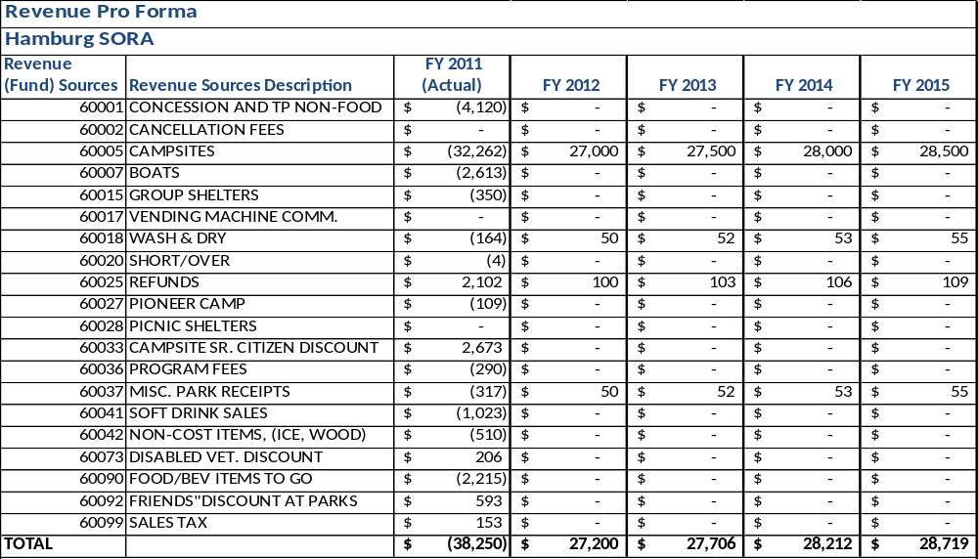

Total / Cost Recovery Pro Forma

Hamburg SORA | 2010 (Actual) | 2012 | 2013 | 2014 | 2015
TOTAL PRO FORMA
Visitation | 82,409 | 21,892 | 21,892 | 21,892 | 21,982
Operational Expenses | $ 216,728 | $ 42,173 | $ 42,173 | $ 42,173 | $ 42,173
Earned Revenues | $110,213 | $28,719 | $28,719 | $28,719 | $28,719
% Cost Recovery | 51% | 68% | 68% | 68% | 68%

Action Plan
ACTION PLAN
Site: |  | Site Manager: |  |  | Date:
Month:
Strategy | Tasks | Costs / Funding | Revenues / ROI | Responsibilities | Metrics

ACTION PLAN
Site: |  | Site Manager: |  |  | Date:
Month:
Strategy | Tasks | Costs / Funding | Revenues / ROI | Responsibilities | Metrics

This is the average of the last three years – FY 2008, FY 2009, and FY 2010
Current employees, not including vacancies.
Current employees, not including vacancies.
Major population centers within a two-hour drive from the site

