Hard Labor Creek State Park
Business & Management Plan

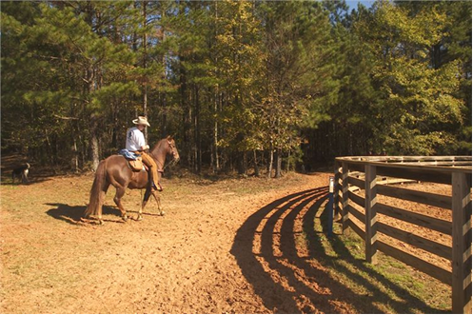
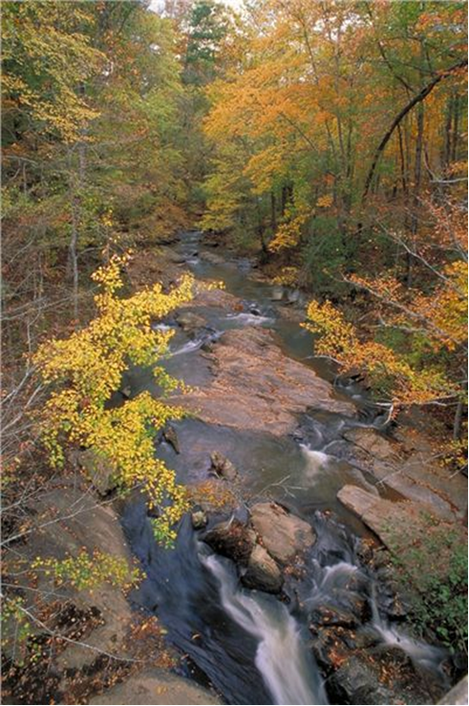
Prepared November 2012; Finalized February 2013
Direction 2015 – Sustainable Business Planning

Table of Contents
Table of Contents 2
Executive Summary 3
Site Fact Sheet 3
Site Summary and Key Attractions 4
Financial Targets 4
Key Recommendations 5
Operational Assessment 10
Business Goals 18
Classification of Programs and Services 19
Partnership Development Plan 20
Expense Management Plan 25
Financial Pro Forma 26
Action Plan 29

Executive Summary
The Parks, Recreation and Historic Sites Division (PRHSD) of the Georgia Department of Natural Resources (DNR) is transitioning the management of Hard Labor Creek State Park to operate more like a business, reflecting the Direction 2015 – Sustainable Business Planning initiative to improve the fiscal performance and management of the state parks and historic sites system. This business and management plan is designed to help the site recover more operating expenses through earned revenues, productive partnerships, and innovative programs.

Site Fact Sheet
Site Name |  | Hard Labor Creek State Park
Site Manager |  | Daniel Schay
Region Manager |  | Eric Bentley
Date of Business Plan completion |  | 11/24/2012
Site size (acres) |  | 5,804
Total number of visitors (FY 2010) |  | 379,542
Total operating budget (FY 2010) |  | $593,602
Total earned revenues (FY 2010) |  | $677,260
Operational cost recovery (FY 2010) |  | 114%
Average operating cost per visitor (FY 2010) |  | $1.56
Average earned revenue per visitor (FY 2010) |  | $1.78
Average cost recovery[1] (FY 2008 – 2010) |  | 123%
Target cost recovery (FY 2015) |  | 125%
Total full-time employees[2] |  | 5
Total part-time employees[3] |  | 11
Primary service markets[4] |  | Atlanta, Athens, Conyers, Covington, Madison, Monroe, Macon, Rutledge
Primary attractors/visitor appeal factors |  | Golf course, equestrian center, trails, group camps, cottages, campground, picnic shelters
Leading opportunities for improved site performance |  | Group camps, tiered cottage amenities, revised maintenance program

Site Summary and Key Attractions
Hard Labor Creek State Park is a 5,804-acre park located between the communities of Fairplay and Rutledge, Georgia. The major facilities and amenities that draw visitors to the park include the two large group camps, an 18-hole golf course and the equestrian facilities. Hard Labor Creek Observatory is located within the park, but managed and maintained by Georgia State University.
Key Attractions
The amenities or features listed below are those that seem to be most popular for visitors.

Golf Course
- Cottages
- Beach
- Campground
- Two Group Camps
- Picnic / Group Shelters
- Equestrian Trails
- Hiking Trails
- CCC Camp
- Lake Activities (fishing & boating)

Financial Targets
The table below details the total operating expenses and earned revenues for –Hard Labor Creek State Park over the last three years (2008 – 2010). This table also calculates total cost per visitor and revenues per visitor during these operating years, and details the target financial performance goals in the context of achieving at least 125% cost recovery. This table also calculates the necessary change from 2010 operating expenses and revenues.

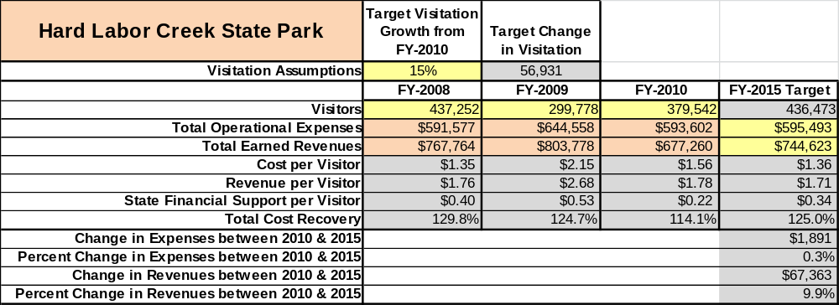

Key Recommendations

Primary / Short Term Recommendations
- Renovate cottages 11-20.
- Repair or remove dilapidated or otherwise dangerous facilities. Examples would be to repair the collapsing arts and crafts building at Daniel Morgan, remove fallen buildings at CCC camp SP-8, change over dangerous junction boxes to circuit breaker boxes at Camp Daniel Morgan, and repair the extensive termite damage at Camp Rutledge. This also includes repairing significant erosion in group camp and pioneer camp parking areas and sidewalks.
- Once dangerous facility issues have been identified and resolved, a preventative maintenance schedule should be developed for each facility individually and annually and given to the staff and volunteers as a winter work project list.
- Coordinate with volunteers to keep the horse trails safe and enjoyable for park guests. Repair washouts or re-route where necessary. Put in usable trail mile marker system.
- Utilize the business plan to focus on each cost center (cost-based accounting), including the level of tax subsidy required or revenues over expenses that are achieved annually to operate the park and golf course.
- Utilize online comment cards each year and provide a report on how well customer satisfaction levels are being met. Satisfaction levels need to be at least 90% or greater for visitor experiences to be considered acceptable. Programs or services that score below 90% require critical review and performance enhancement measures with tracked results and enforced outcomes.
- Evaluate and pursue opportunities to employ private or public service providers on-site to accomplish elements of park operations that can be more cost-effectively provided.
- Evaluate user profiles as it applies to appropriate demographic and park usage, and incorporate this information into a yearly program and marketing plan for the park to attract all demographic segments.
- Utilize a minimum of three special events annually to draw people to the park in addition to regular programming. An example of a special event would be a trail race.
- Seek local partners to support portions of the state park programs and services.
- Maintain representation at the local Chambers of Commerce or other applicable tourism and business promotional organizations within their community in order to promote the park in their region as a usable and friendly asset.
- Maintain a Friends group that supports the park with volunteers and /or raising money to use for improvements or to support programs that are agreed upon prior to fundraising.
- Update pricing at the park to reflect total cost of service in important and visitor supported services.
- Update services at the park to provide a sense of value that is balanced with the cost to the user.
- Develop a yield management strategy and procedure for maximizing use of key amenities.
- Develop a detailed analysis of labor requirements of all major park functions.
- Develop and provide additional training to staff for improved business management and marketing.
- Upgrade facilities and amenities at the park including, but not limited to, enhancing the General Store and upgrading utilities in the campground.
- Replace transit and galvanized pipes with modern waterline system.
- Expand marketing efforts from local to regional media.

Secondary / Long Term Recommendations
- Renovate the main campground to include more 50-amp service and bigger campsites.
- Increase electrical service to Camp Daniel Morgan to support heat in the winter.
- Turn CCC Camp SP-8 into a passive interpretive area for public education and to help preserve the area.
- Add more amenities in the park such as modern playgrounds and a mini-golf course.
- Improve the trail connections within the park.
- Improve the equestrian area in the park, including:
  - Equestrian trails require reinvestment of labor and materials from the state
  - New roofing and siding at each stable
  - 50-amp hookups in campground
  - Update trail signs
  - Improve riding ring (improve surface and install barriers/obstacles)
  - Create back country campsites
  - Add dump station at the equestrian campground

Site and Operations Assessment
This site and operations assessment is a culmination of analyses and findings from a review of the condition of facilities, infrastructure, and operations at Hard Labor Creek State Park. The findings and observations are not intended to be an exhaustive review of all issues present, but provide a basic understanding of the predominant issues that contribute to the site’s current operating conditions. The assessment includes the following:
- Site Inventory and Facility Assessment
- Operational Assessment
- Financial Assessment
Site Inventory and Facility Assessment

Methodology
Facility and asset conditions are rated using a differential scale of excellent, good, fair, or poor. Descriptions of conditions that are attributed to each of these findings are also provided.
Scale of Conditions
Rating | General Description
Excellent | Facilities/amenities are in ‘excellent’ condition when they show little or no maintenance or repair problems. Facilities do not feature any major design or operational issues or flaws that contribute to diminished use or increased maintenance or upkeep. Facilities are easy to clean and maintain in order to place them back into public use and the users perceive them to be in excellent shape.
Good | Facilities/amenities are in ‘good’ condition when they show only minor maintenance or repair problems. Most maintenance issues with these facilities typically appear to be the result of age and/or heavy use. Facilities may only feature minor design or operational issues that contribute to diminished use or increased maintenance or upkeep. Facilities are moderately easy to clean and maintain in order to place them back into service and the users perceive them to be adequate for their use, but probably not in excellent shape.
Fair | Facilities/amenities are in ‘fair’ condition when they show significant maintenance or repair problems. Facilities generally exhibit ongoing maintenance issues that appear to be the result of age, heavy use, or design or operational flaws. Some maintenance and repair needs may compound their fair condition by being deferred because of budget and/or resource limitations. Facilities require more effort to clean and maintain before placing them back into service and the users may perceive them as being less than adequate for their use and in a state of deterioration. The facility or structure may need of major repair or replacement.
Poor | Facilities/amenities are in ‘poor’ condition when they show significant, on-going maintenance or repair problems that ultimately may result in suspended use for repair/replacement. Maintenance and repair issues are possibly the result of poor maintenance and clearly the result of age, heavy use, or design or operational flaws. Problems with the facilities are often compounded over time due to consistently-deferred maintenance and repair because of budget and/or resource limitations. Facilities may feature major design or operational issues that contribute to diminished use or increased maintenance or upkeep. Facilities require excessive effort to clean and maintain before placing them back into service and the users often perceive them as being inadequate for their use and in a state of serious deterioration. The facility or structure may need of major repair or replacement.

Inventory and Assessment
The table below is an inventory of facilities and amenities at Hard Labor Creek State Park and provides the assessed condition of each as reviewed in April 2011.

Site Asset / Amenity | Quantity | Condition
Golf Course | 1 | Good
Cottages | 20 | Good
Tent & RV Campsites | 51 | Good
Equestrian Campsites | 12 | Good
Pioneer Campsites | 4 | Fair
Group Camp | 2 | Fair
Horse Stables | 30 | Fair
Historic CCC Camp | 1 | Poor
Picnic Shelters | 4 | Good
Group Shelters | 2 | Good
Swimming Beach | 1 | Good
Beach House | 1 | Fair
Campground Comfort Stations | 5 | 3 Fair/ 2 poor
Day Use Bathrooms | 3 | Fair
Park Office Visitor Center | 1 | Good
Manager’s Residence | 1 | Good
Assistant Manager’s Residence | 1 | Good
Intern Residence | 1 | Good
Law Enf. Rangers Residence | 1 | Fair
Golf Manager’s Residence | 1 | Poor/Uninhabitable
Maintenance Buildings | 4 | Good
Campground Dump Station | 1 | Good
Blacksmith Shop (Interpretive) | 1 | Good

Prioritized Facility Needs
Based on the facility inventory and assessment, these prioritized needs have been identified. Each need has been aligned with a priority category of high, moderate, or low to support future decision making regarding project sequencing, investment of public resources, and meeting community expectations. The priority assignment for each need is not a measure of importance. Rather, these recommended priorities reflect a phased implementation approach over the next several years.

Facility Need | Priority Assignment
Cottage renovations (10) | High
Update TV systems and Wi-Fi | High
CCC camp renovations (Historical CCC Camp) | High
Sewer and Water System repair/replacement | High
Campsite renovations and utility upgrades | High
Erosion control in Pioneer Area | High
Additional playground | High
Horse trail maintenance | High
Bike Trails | High
Re-roof senior ranger residence | High
Rutledge Dam repairs | High
Re-shingle sleeper cabins in Camp Rutledge | Moderate
Re-shingle comfort stations | Moderate
Crafts and theatre facilities | Moderate
Replacement of main well | Moderate
Concrete water tank resealing | Moderate
Erosion control and bridge replacement at Brantley Nature Trail | Moderate
Improved trail connections | Low
Equestrian area stay use enhancements  Dog Park | Low
Beach renovations and enhancements | Low
Add yurts to the campground | Low
Dredge Lake Brantley | Low

Operational Assessment
The Operational Assessment includes:
- An inventory and classification of programs and services being provided at the site
- A review of staffing at the site
- A review of concessionaires and partners operating at the site
- Visitation and customer satisfaction

Inventory and Classification of Programs and Services
Programs and services are classified into one of three major categories:
1) Core or Essential Services
2) Important Services
3) Visitor Supported Services
Programs and services at the site are classified into these categories based in part on the mission and public mandates for both the site and the agency. For the services in each of these categories, there are financial performance expectations that will define how services are funded and evaluated.

Category 1 – Core Services [Largely supported by tax funds]
Core programs, services and facilities are those the agency must provide and/or are essential in order to capably govern and meet statutory requirements. The failure of the agency to provide Category 1 services at adequate levels could result in significant negative consequences for the public and the resources under protection. The criteria for services to be classified as core or essential are:
- The services are mandated by the agency’s law or charter or are contractually obligated by agreement to provide the services.
- The services are essential to protecting and supporting the public’s health and safety.
- The services protect and maintain valuable assets and infrastructure.
- The services would generally and reasonably be expected and supported by residents, businesses, customers and partners.
- The services are those that cannot or should not be provided by the private sector.
- The services provide a sound investment of public funds.
The following services offered at Hard Labor Creek State Park have been identified as core services:
- Protect the integrity of natural and cultural resources of the site through active management (i.e. CCC structures)
- Open and public access to the site and its resources
- Self-directed and site appropriate education, interpretation and recreational opportunities
- Public safety
- Site, grounds, facility and infrastructure maintenance

Category 2 – Important Services [Supported by a balance of tax funds and earned revenues]
Important programs, services and facilities are those the agency should provide, and are important to governing and effectively serving residents, businesses, customers and partners. Providing Category 2 services expands or enhances the agency’s ability to provide and sustain its core services. The criteria for programs or services to be classified as important are:
- The services expand, enhance or support identified core services.
- The services are broadly supported and utilized by the community, and are considered an appropriate, important, and valuable public good. Public support may be conditional upon the manner by which the services are paid for or funded.
- The services generate income or revenue that offsets some or all of the operating cost and/or are deemed to provide economic, social or environmental outcomes or results.
The following services offered at Hard Labor Creek have been identified as important services:
- Lake activities / beach area
- Picnicking / day use
- Tent camping
- Nature trails
- Group camping

Category 3 – Visitor Supported Services [Almost exclusively supported by earned revenue]
Visitor supported programs, services and facilities are those discretionary services that the agency may provide when additional funding or revenue exists to offset the cost of providing those services. Category 3 services provide added value above and beyond what is required or expected. The criteria for programs or services to be classified as visitor supported are:
- The services expand, enhance or support core services or important services.
- The services are supported, well utilized and provide an appropriate and valuable public benefit.
The services generate income or funding from sponsorships, grants, user fees or other sources that offset some or all of their cost and/or provides a meaningful return on investment.
The services can possibly be provided through outsourcing or use of concessionaires, providing opportunities for community enterprises that may not otherwise be provided by the agency.
The following services offered at Hard Labor Creek have been identified as visitor supported services:
- Equestrian activities
- RV camping
- Improved accommodations (cottages, yurts, etc.)
- Visitor center / retail
- Food service
- Interpretive / recreation programs and events
- Group shelters

Staffing Assessment
Labor costs at Hard Labor Creek represent the largest area of budgetary expense at an average of 64% of the total operating budget each year for the last three complete years, which is lower than the target of total labor costs (including benefits) not exceeding 65% of the site’s total operating expenditures. The tables below and on the following page provide a basic review of the current staffing at the site.
Full Time Equivalent Employees
Position / Title | Quantity (FTE) | Vacancies | Annual Hours
Park Manager | 1 | 0 | 2080
Park Assistant Manager | 0 | 1 | 0
Park Law Enforcement Ranger | 0 | 1 | 0
Senior Maintenance Ranger | 1 | 0 | 2080
Interpretive Ranger | 0 | 1 | 0
Secretary | 1 | 0 | 2080
Senior Clerk | 0 | 1 | 0
Head Housekeeper | 0 | 1 | 0
Housekeeper | 0 | 1 | 0
General Trades Craftsman | 0 | 2 | 0
Utility Worker | 1 | 0 | 2080
Resource Manager | 1 | 0 | 2080
TOTAL | 5 | 8 | 10,400

Part Time Employees
Position / Title | Quantity (PTE) | Vacancies | Hours
Maintenance Worker | 2 | 0 | 3016
ParkPass Attendant | 2 | 1 | 3016
Front Desk Clerk | 3 | 0 | 4524
Housekeeper | 4 | 0 | 6032
TOTAL | 11 | 1 | 16,588

Labor Support
Labor Support | Annual Hours
Volunteers | 20,000
Community Service Workers | 500
Resource Management Crews | 100
TOTAL | 20,600

Total Labor Hours
Labor Type | Annual Hours
Full Time Equivalent Employees | 10,400
Part Time Employees | 16,588
Labor Support | 20,600
TOTAL Annual Labor Hours | 47,588

Labor Budget Summary

Hard Labor Creek State Park
Account Code and Sub-Class  Expenditure Descriptions | FY-2008 | FY-2009 | FY-2010 | % change between  FY-2008 & FY-2010
REGULAR SALARIES | $229,232 | $246,004 | $244,230 | 6.5%
ANNUAL LEAVE PAY | $10,166 | $78,897 | $5,385 | -47.0%
OTHER SUPPLEMENTAL | $4,596 | $4,193 | $2,586 | -43.7%
TEMPORARY/CASUAL LABOR | $27,896 | $26,412 | $41,488 | 48.7%
FICA | $17,085 | $18,064 | $17,848 | 4.5%
HEALTH INSURANCE | $55,735 | $35,543 | $52,474 | -5.9%
UNEMPLOYMENT INSURANCE | $455 | $359 | $491 | 7.9%
ASSESSMENTS BY MERIT | $1,764 | $1,764 | $1,644 | -6.8%
SUBTOTAL ADDITIVE/BENEFIT COSTS | $131,708 | $178,085 | $115,431 | -12.4%
PERSONAL SERVICES | $388,836 | $450,501 | $401,149 | 3.2%

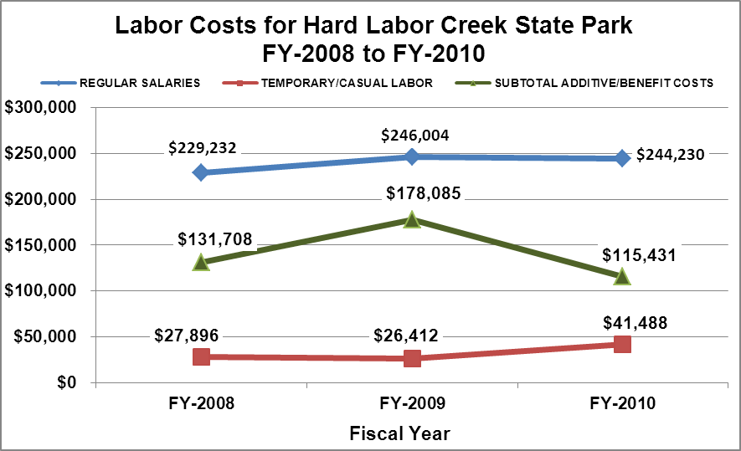

Visitation and Occupancy
Overall annual visitation to the site has trended downward from 2008 to 2010, decreasing by 15% or over 57,000 visitors. This is largely attributed to economic recession.
Year | Total Visitation
2008 | 437,252
2009 | 299,768
2010 | 379,542
Occupancy for the overnight accommodations at Hard Labor Creek for the last three years is detailed in the table below. Overall cottage occupancy has trended downward from 2008 to 2010, decreasing by 8.55%. This is largely attributed to the overall economy; however, camping occupancy has trended upward from 2008 to 2010, increasing by 5.36%.
Year | Cottage Occupancy | Campground Occupancy
2008 | 46.39% | 35.39%
2009 | 42.09% | 35.01%
2010 | 37.84% | 40.75%

The graph below illustrates visitation and occupancy over the last three years.
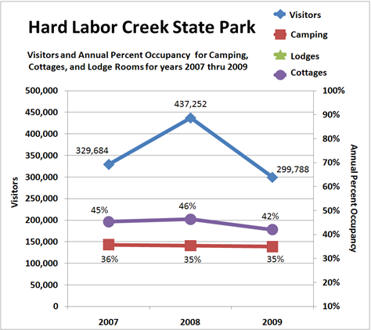

Customer Service and Satisfaction
Site | Year | Customer Satisfaction Level
Hard Labor Creek State park | 2009 | 81%
Hard Labor Creek State park | 2010 | 75%
Financial Performance Assessment

Operational Expenses
A summary of total operating expenses at Hard Labor Creek from 2008 to 2010, as well as their percent change from 2008 are provided in the table below.
Hard Labor Creek State Park
Operational Expenses | FY-2008 | FY-2009 | FY-2010 | % change between  FY-2008 & FY-2010
REGULAR SALARIES | $229,232 | $246,004 | $244,230 | 6.5%
ANNUAL LEAVE PAY | $10,166 | $78,897 | $5,385 | -47.0%
OTHER SUPPLEMENTAL | $4,596 | $4,193 | $2,586 | -43.7%
OVERTIME
TEMPORARY/CASUAL LABOR | $27,896 | $26,412 | $41,488 | 48.7%
FICA | $17,085 | $18,064 | $17,848 | 4.5%
RETIREMENT | $41,907 | $39,265 | $35,003 | -16.5%
HEALTH INSURANCE | $55,735 | $35,543 | $52,474 | -5.9%
UNEMPLOYMENT INSURANCE | $455 | $359 | $491 | 7.9%
ASSESSMENTS BY MERIT | $1,764 | $1,764 | $1,644 | -6.8%
DRUG TESTING
PERSONAL SERVICES | $388,836 | $450,501 | $401,149 | 3.2%
POSTAGE | $706 | $682 | $552 | -21.8%
MOTOR VEHICLE EXPENSES | $33,509 | $27,701 | $23,817 | -28.9%
PRINTING & PUBLICATION
SUPPLIES & MATERIALS | $21,525 | $17,309 | $33,976 | 57.8%
REPAIRS & MAINTENANCE | $7,131 | $9,844 | $8,229 | 15.4%
EQUIPMENT >$1000< $5,000
WATER & SEWAGE | $5,937 | $5,034 | $3,434 | -42.2%
ENERGY | $88,959 | $81,288 | $80,680 | -9.3%
RENTS | $1,679 | $1,781 | $1,576 | -6.1%
INSURANCE & BONDING | $6,690 | $15,294 | $13,507 | 101.9%
FREIGHT
PURCHASING CARD
OTHER OPERATING EXPENSES | $7,263 | $8,619 | $7,926 | 9.1%
CLAIMS & BONDS & INTEREST
TRAVEL | $0 | $63 | $112
REGULAR EXPENSES | $173,399 | $167,615 | $173,809 | 0.2%
MOTOR VEHICLE EQUIPMENT
EQUIPMENT PURCHASES >5000
CAPITAL\ LEASE Prin & Int
REAL ESTATE RENTALS
VOICE/DATA COMMUNICATIONS | $3,625 | $3,569 | $2,471 | -31.8%
PER DIEM & FEES
PER DIEM & FESS EXPENSE
CONTRACTS | $511
ADVERTISING - PROCUREMENT CARD
RESALE | $25,206 | $22,873 | $16,173 | -35.8%
TOTAL OTHER EXPENDITURES | $29,342 | $26,442 | $18,644 | -36.5%
GRAND TOTAL | $591,577 | $644,558 | $593,602 | 0.3%
Earned Revenues | $767,764 | $803,778 | $677,260 | -11.8%
% Cost Recovery | 129.8% | 124.7% | 114.1% | -12.1%

Earned Revenues
Monthly earned revenues for the last two years indicate that the total annual revenue decreased 15% from 2009 to 2010, with the largest decreases in monthly revenues in September (-23%), October (-21%) and June (-22%). Revenues actually increased in the months of November (6%) and March (1%). These months of increased revenue were not sufficient to account for lost revenues in the remaining months.
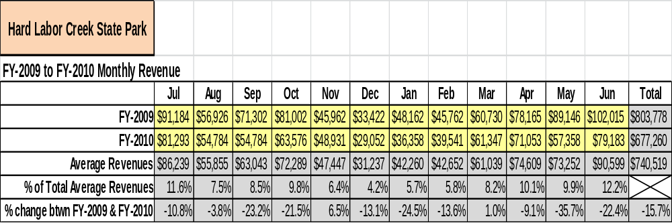

The graphs below illustrate the monthly revenue trends each year and the average percent of total annual revenue earned each month. 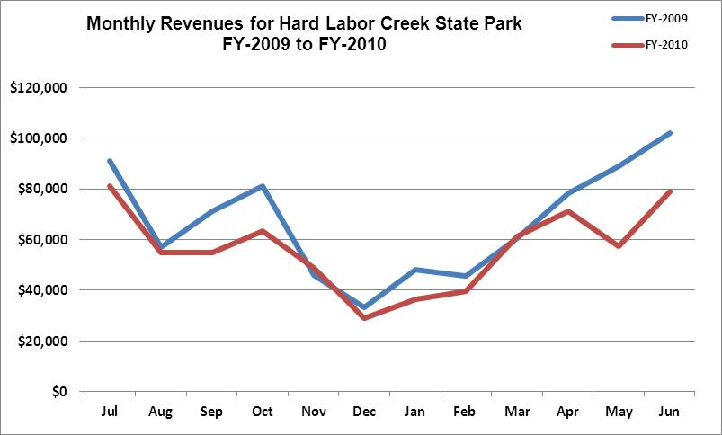
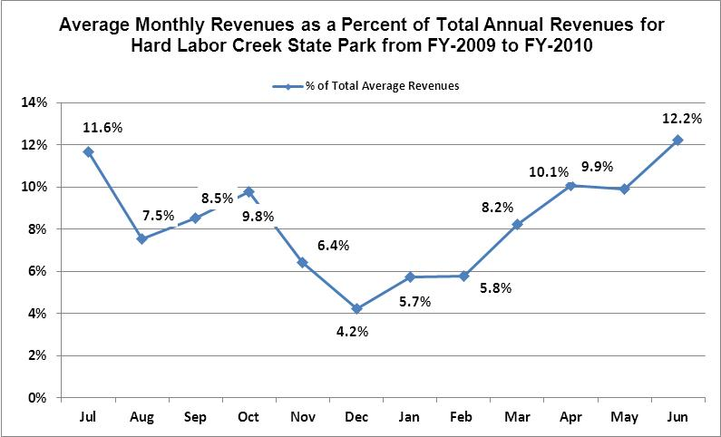
Cost Recovery Trends
Hard Labor Creek has achieved an average cost recovery of 123% of annual operational expenses through earned revenues from FY 2008 to FY 2010. This is detailed and illustrated in the table and graph below.
Fiscal  Year | Operational  Expenses | Earned  Revenues | Percent Cost  Recovery
FY-2008 | $591,577 | $767,764 | 129.8%
FY-2009 | $644,558 | $803,778 | 124.7%
FY-2010 | $593,602 | $677,260 | 114.1%

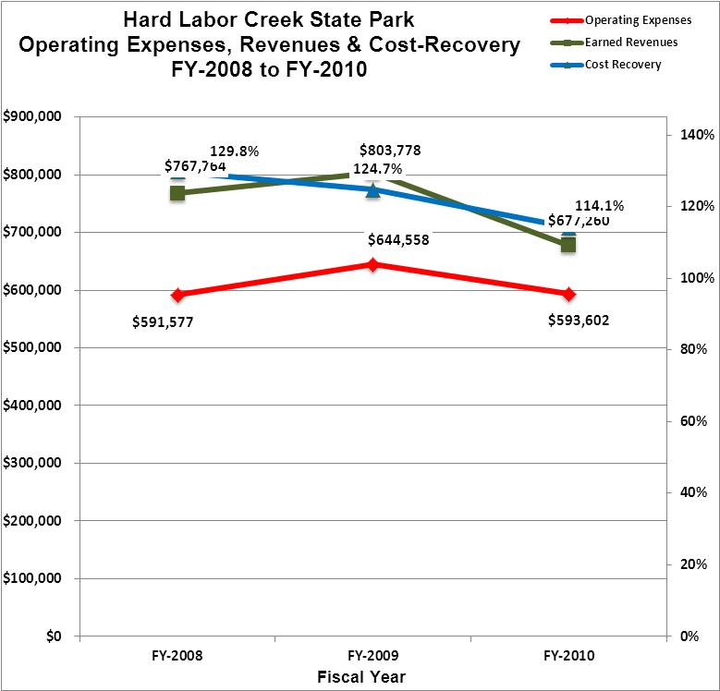

Review of Pricing
Data on rate information is available as far back as 2002, but only the last five years are evaluated. There has been notable growth in fees charged at Hard Labor Creek since 2005, with the largest increase being 2010. A table detailing the rates for Hard Labor Creek is provided below.
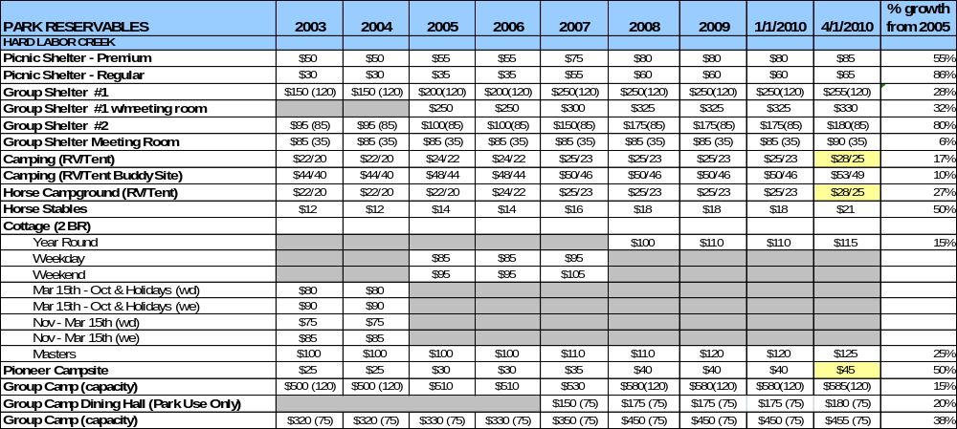
Business and Management Plan

Business Goals
The following goals serve as the foundation for the key recommendations and strategies in this business plan for Hard Labor Creek State Park.

Enhance Cost Recovery of Site Operations
Hard Labor Creek State Park is already a high performing site in the Georgia State Parks and Historic Sites System with an average recovery of 123% of operating expenses through earned revenues each year. It is critical that the park continue to perform at this level, and potentially seek to enhance the recovery of operating expenses to no less than 125% through improving revenue generation versus further cutting of expenses.

Improve the Diversity and Innovation of Recreational and Interpretive Programs
The needs of modern state park users are evolving as more diverse recreational interests grow in the market. Hard Labor Creek State Park can improve its ability to meet the needs of the modern user by diversifying the age appeal of the park, hosting special events and/or competitions in themes and activities that are becoming increasingly popular, and by engaging alternative providers in supporting the amenities and programs at the park.

Improve the Effectiveness of Marketing and Sales
The effectiveness of marketing and promotional activities of Hard Labor Creek State Park can be improved in order to produce greater outcomes from both peak, shoulder, and off seasons. Much of this can be achieved through a shift in the basic platform of marketing to a more targeted approach. Additionally, the use of pre-season incentives to promote off season usage and advanced registration for peak and shoulder seasons will improve the ability of the park to maintain an increased and balanced flow of usage throughout the year. Most importantly, all marketing and promotional efforts must be monitored through sales goals for both the park and the golf course.

Establish Greater Consistency of Managing and Monitoring Customer Service & Satisfaction

Creating a more efficient and consistent process for soliciting visitor and user feedback will improve the ability of the park to be a more proactive facility and service provider in the region.

Expand Partnership Opportunities
Many times partnerships are inequitable to the public agency and do not produce reasonable shared benefits between parties. The recommended policies will promote fairness and equity within the existing and future partnerships while helping staff to manage against what may have caused conflicts internally and externally. Certain partnership principles must be adopted by the Department for existing and future partnerships to work effectively.

Classification of Programs and Services
The tables below summarize the classifications of programs and services at Hard Labor Creek as either core, important, or visitor supported and projects a range of cost recovery percentages that might be achieved for each. These classifications establish financial performance goals for each category of services that are linked to the recommendations and strategies of this business plan.

Core Services
Program / Service | Target Cost Recovery
Protect the integrity of natural and cultural resources of the site through active management (i.e. CCC structures) | 0%
Open and public access to the site and its resources | 20% - 50%
Self-directed and site appropriate education, interpretation and recreational opportunities | 20% - 50%
Public safety | 0%
Site, grounds, facility and infrastructure maintenance | 0%

Important Services
Program / Service | Target Cost Recovery
Lake activities / beach area | 20% - 80%
Picnicking / day use | 20% - 50%
Tent camping | 100% - 120%
Trails | 0% - 20%
Group camping | 100% - 120%

Visitor Supported
Program / Service | Target Cost Recovery
Equestrian activities | 80% - 110%
RV camping | 100% - 120%
Improved accommodations (cottages, yurts, etc.) | 120% - 150%
Visitor center / retail | 120% - 150%
Food service | 120% - 150%
Interpretive / recreation programs and events | 90% - 110%
Group shelters | 100% - 120%

Partnership Development Plan
The table below summarizes existing partners and targeted partnerships by classification (operational, vendor, service, co-branding, funding partners) and by organizational type.
 | Public Partners | Not-for-profit Partners | Private / Enterprise Partners
Operational Partners | - Historic Preservation Division  - Wildlife Resources Division  - Morgan County Sheriff’s Dept.  - Georgia Forestry  - Environmental Protection Division  - Charlie Elliot Wildlife Center | - Friends  - Georgia Orienteering Club
Vendor Partners |  |  | - Beach Buns  - Coke (full service machines)
Service Partners | - GA State University  - Morgan County School System | - Rockdale Trailblazers  - Backcountry Horsemen
Co-branding Partners | - Morgan County Chamber  - Dept. of Economic Development |  | - REI
Funding Resource Development Partner |  | - Friends of Georgia State Parks and Historic Sites

Marketing and Sales Plan

Marketing and Sales Goals
Marketing and sales goals for Hard Labor Creek are based on the following desired outcomes:
- Increased stay use visitation during weekdays
- Increase advertising when possible
- Increased community involvement
- Increased programming and educational activities
In order to meet these goals, examples of specific target outcomes were identified in the areas detailed in the table below.
Area  of Focus | Current  Performance | Goal  by 2011 | Goal  by 2012 | Goal  by 2015
Community Involvement | Good | Establish manager’s role with outreach | Meet regularly with stakeholders | Complete plan implementation
Increased Programs | Some active programs – many passive | Continue working with Friends of HLC | Implement quality programming for both stay use and day use guests. | Host several annual programs throughout the year that focus on park activities/ natural and historic resources

Marketing and Promotion Strategies

Publicity and Social Media
Hard Labor Creek will approach marketing and publicity planning using the following guidelines and themes:
- Event publicity
Major events benefit by having short stories in local, regional, and statewide newspapers and online social media hooks planted that run three to four weeks in advance of the event up to the date of the event itself. Stories and media need to be cultivated with contacts and online sales channels several weeks in advance of the time the stories need to run. Special interest interviews on morning, noon, and evening television news programs, radio interviews on popular rush-hour programs, and blogs on known affinity online sites should also be included.
- Program publicity
Special and unique programs should have feature stories in magazines, local and regional weekly newspapers, and statewide daily newspapers. These stories are most effective if they run shortly before the season that the featured program begins. This will likely require several weeks of advanced planning with media contacts. Similar coverage on television and radio should also be considered. If pre-publicity cannot be generated, post-publicity can help promote future programs.

- Site Publicity
Site publicity focusing on a single site or sub-set of sites requires more intense planning efforts to attract multiple writers and editors from target publications. An expansion of advertising in select publications such as “Hoofbeats,” “Lake Oconee Living,” etc., would broaden market awareness of the park’s facilities.
Examples and suggested opportunities for events, programs and related publicity efforts based on the themes described above at Hard Labor Creek are provided in the table below.
Event Publicity | Program Publicity | Site Publicity
Junior Golf Tournament | Leaf Watch | Family Lake Getaways
Trail Rides / Equestrain Events | Georgia Outdoor Family | Georgia History Trail
Holiday Events | Get Outdoors Georgia | Georgia Golf Trail

Packaging
Examples and suggested packages for Hard Labor Creek are provided in the table below.
Package | Package Details
Equestrian Discount | 25% off Equestrian campsite with the rental of 2 or more stalls
Kayak with cottage stay | Guided kayak tour with the rental of 5 or more cottages
Winter Discount | 25% off on weekends and 30% off during the week
Golf Package | Discount on golf rounds with cottage stay

Group Sales
Types of groups within which specific target customers can be identified are listed below:
- Families | - Youth Service Organization | - Churches
- Special Interest Groups  - Equestrian Clubs  - Associations  - Colleges and Universities | - Society for Creative Anachronism  - Business and Professional Groups  - Other public agencies  - Community Organizations | - Ham Radio Clubs  - Golfers  - Women’s Groups  - Madison/Morgan Conservancy

Incentivizing New and Repeat Visitation
Hard Labor Creek will utilize the following strategies and/or incentives to encourage new and repeat visitation starting in FY 2012:
- Early registration discounts
- Group / bulk pricing
- Differential pricing (week days vs. weekends)
- Loyalty program
- Co-branding programs
- Post peak season follow-up for past season visitors
- Special discounts for repeat guests (3rd time camping – free daily boat rental)
Marketing and Sales Metric Goals
The following marketing and sales metric goals and/or others will be monitored and progress reported:
- Loyalty and repeat customers = Golfers & Full Time Campers
- Brand confidence & customers-recruiting-customers = Equestrian Groups & Group Camp Users
Revenue Generation Plan
Revenue / Cost Recovery Goals
The chart below reflects the fluctuation of real revenues from FY10 to FY12 and projects a 5% increase in revenues for FY13 to represent the current growth this fiscal year (FY12). A 3% growth over the next two fiscal years is projected reflecting the implementation of this business plan. The largest opportunity is most likely cottage and group camp rentals.
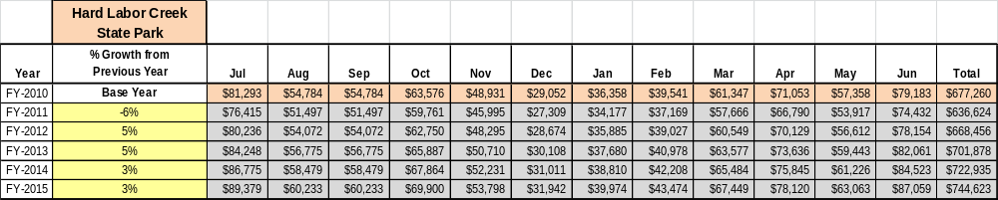

These projections and growth targets would result in a total of 10% growth in annual earned revenues from FY 2010 by FY 2015. If growth in operational expenses can be managed to 3% between FY 2010 and FY 2015, then the overall cost recovery of the park will be approximately 125% in FY 2015 at these projected revenue levels. This is close to the annual financial performance of the park in FY 2008, which was operated at 130% cost recovery in that year.

Revenue Generation Strategies

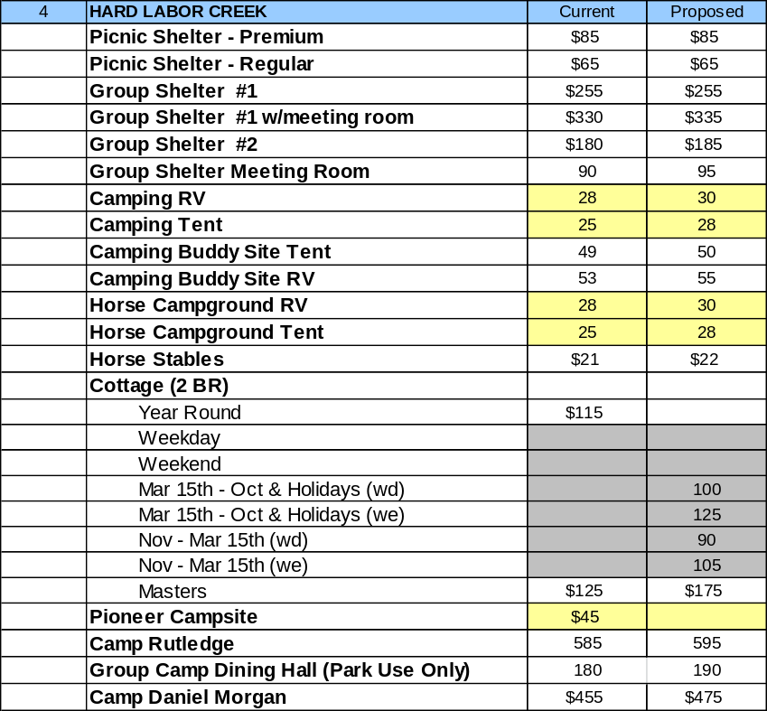
Pricing Plan

Innovative Programming and Special Events Plan
Program / Event | Theme / Purpose | Scheduled Date/Season | Frequency | Target Participation | Target User Fee | Target Cost Recovery
Hayrides | Engage stay use guests | Fall | Weekly | 40-80 | $5.00/rider | 115%
Jr. Ranger | Educate and interpret | Spring/Fall or by appointment | At least 3 annually | 60 | $50.00/person | 115%
Nature Hikes | Engage stay use guests | Annual | Weekly | 10-20 | $5.00/person | 115%
Birding Hikes | Engage stay use and new user groups | Annual | Monthly | 5-10 | Free | 0%
Kayak Tours | Engage stay use and new user groups | March through October | Weekly | 12 | $15.00 | 115%
Butterfly/ Dragonfly Walks | Engage stay use and new user groups | Spring through Fall | Monthly | 5-10 | $5.00 | 115%

Partnerships and Concessions Plan
Service / Partnership | Term of Service | Financial Objective | Contract Manager
Beach Buns | 4 Months | Operate Beach Concessionaire and Boat Rentals | Park Manager

Expense Management Plan
Personnel Assignments
The following actions will be taken to proactively manage labor costs via personnel assignments and classifications.

Action | Timeline | Outcome
Utilize campground hosts as maintenance volunteers | Ongoing | More assistance in maintenance program.

Management Techniques
The following actions will be taken to proactively manage labor costs via management techniques.

Action | Timeline | Outcome
Hire part time employees | Immediate | Shared work load and cost reduction.

Adjusted Levels of Service
The following actions will be taken to proactively manage labor costs via reduced levels of service.

Action | Timeline | Outcome
None this year

Financial Pro Forma
The following five-year financial pro forma projects operating expenses, earned revenues and cost recovery through FY 2015. These pro forma are based on the strategies and desired outcomes identified in this business plan, especially the revenue generation and expense management plans, and are linked to corresponding performance goals.

Expense Pro Forma
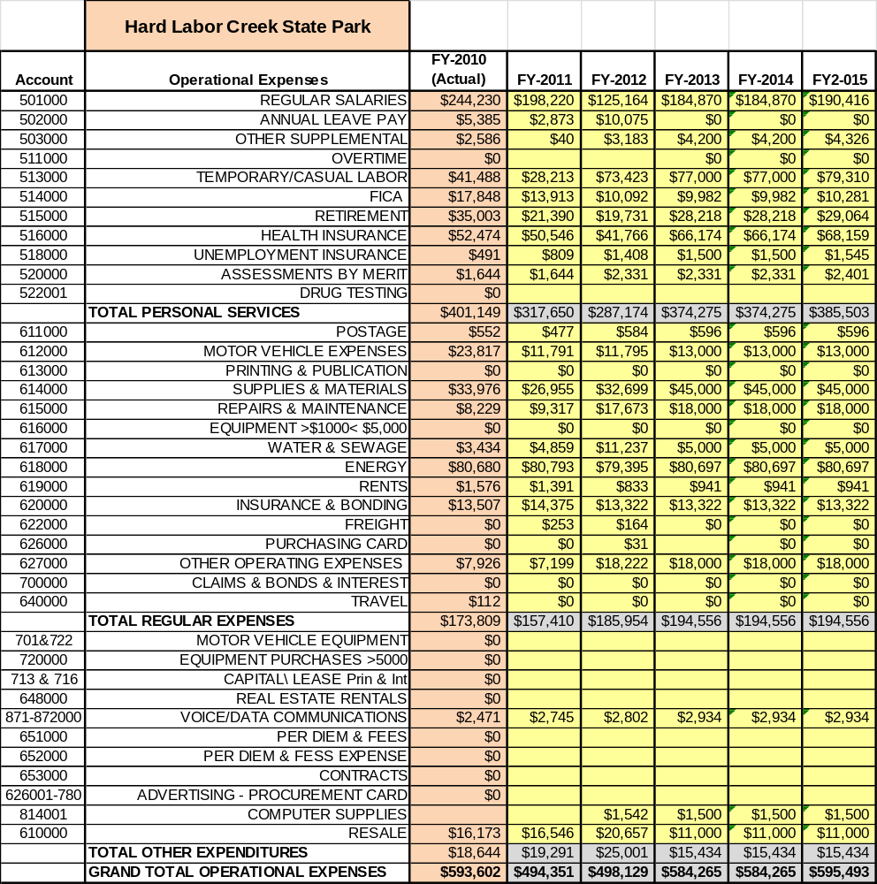

Revenue Pro Forma
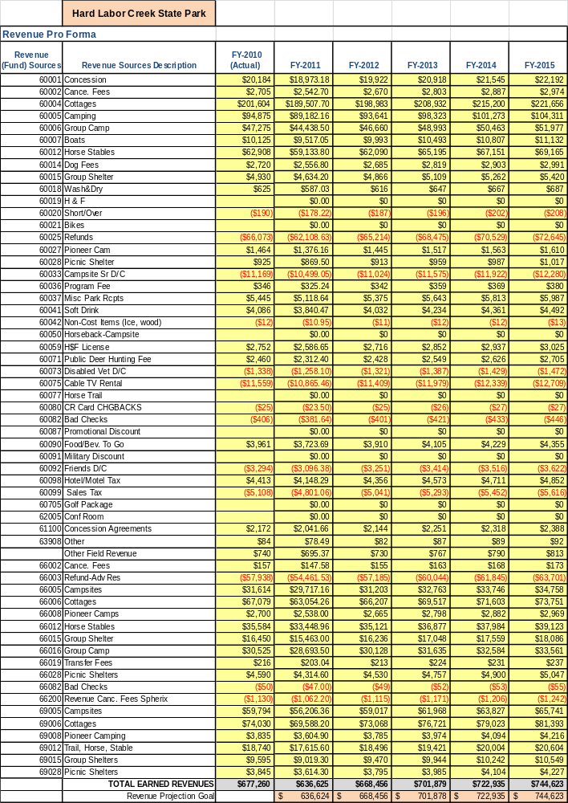

Total / Cost Recovery Pro Forma
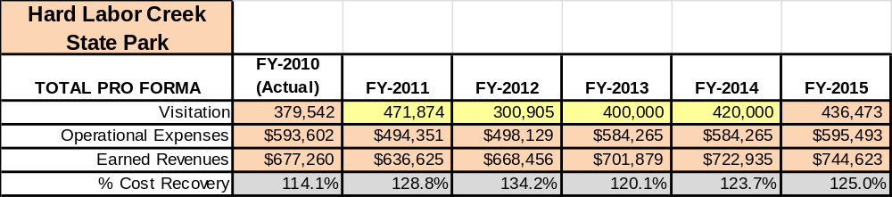

Action Plan
ACTION PLAN
Site: Hard Labor Creek State Park |  | Site Manager: |  |  | Date:
Month:
Strategy | Tasks | Costs / Funding | Revenues / ROI | Responsibilities | Metrics

ACTION PLAN
Site: Hard Labor Creek State Park |  | Site Manager: |  |  | Date:
Month:
Strategy | Tasks | Costs / Funding | Revenues / ROI | Responsibilities | Metrics

