43
High Falls State Park
Business & Management Plan

Prepared June 2011; Finalized February 2013
Direction 2015 – Sustainable Business Planning

Table of Contents

Executive Summary 3

Site and Operations Assessment 7
Site Inventory and Facility Assessment 7
Operational Assessment 9
Financial Performance Assessment 14

Business and Management Plan 17
Business Goals 17
Classification of Programs and Services 19
Partnership Development Plan 20
Marketing and Sales Plan 21
Revenue Generation Plan 23
Expense Management Plan 25
Financial Pro Forma 26

Action Plan 29

Executive Summary
The Parks, Recreation and Historic Sites Division (PRHSD) of the Georgia Department of Natural Resources (DNR) is transitioning the management of High Falls State Park to operate more like a business, reflecting the Direction 2015 – Sustainable Business Planning initiative to improve the fiscal performance and management of the state parks and historic sites system. This business and management plan is designed to help the site recover more operating expenses through earned revenues, productive partnerships, and innovative programs.

Site Fact Sheet
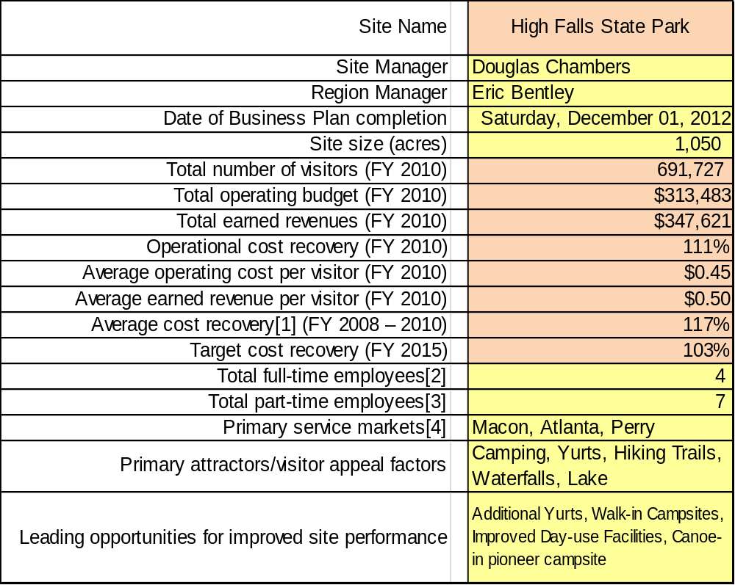

This is the average of the last three years – FY 2008, FY 2009, and FY 2010
Current employees, not including vacancies.
Current employees, not including vacancies.
Major population centers within a two-hour drive from the site

Site Summary and Key Attractions
The 1050-acre site of High Falls State Park is located in a town setting, roughly 50 miles from major population centers in Georgia, including Atlanta and Macon, but only 1 ½ miles from Interstate 75. The location of the site, near a major interstate, is one of the greatest advantages in meeting the cost recovery goal.

Key Attractions
The amenities or features listed below are those that seem to be most popular for visitors.
- Hiking trails | - Fishing
- Waterfall | - Old Power House
- 650-acre lake | - 6 yurts
- Boat rentals | - 107 campsites
- Mini golf course | - 1 group shelter
- Swimming pool | - 5 picnic phelters
- 3 playgrounds | - Dam

Financial Targets
The table below details the total operating expenses and earned revenues for High Falls State Park over the last three years (2008 – 2010). This table also calculates total cost per visitor and revenues per visitor during these operating years, and details the target financial performance goals in the context of achieving at least 103% cost recovery. This table also calculates the necessary change from 2010 operating expenses and revenues.

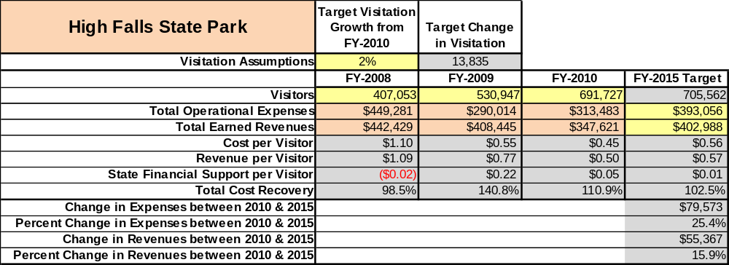

Key Recommendations

Primary / Short Term Recommendations
- Operate the site using cost-based accounting, including the net cost recovery achieved annually.
- Conduct in-park surveys annually to assess how well customer satisfaction levels are being met. High Falls State Park should strive to have 90% of visitors responding to ‘Comment Cards’ report that they were either ‘satisfied’ or ‘very satisfied’ (or some comparable metric to be developed). Programs or services that fall below that standard should be critically reviewed, enhanced, and results monitored; those with a history of poor performance should be considered for elimination.
- Evaluate and pursue opportunities to employ concessionaires or private or public service providers on-site if they can be more cost-effective. For example, explore the development of a concessionaire agreement to manage private events on-site.
- Collect a statistically valid sample of ZIP code data from visitors in a non-intrusive way to gauge their origins and demographics (e.g., age, ethnicity, income, etc.) and use the results to improve programming and marketing efforts to appeal to a broader audience.
- Utilize a minimum of two special events annually to help draw more visitors to the site.
- Seek local partners to help support operations, programs, and service delivery and for cross-marketing purposes.
- Sustain sufficient non-labor operational funding or reduce staff so that required staff operational costs (with benefits) do not exceed 65% of the total operational budget.
- Enhance facilities and program offerings to provide a minimum of 10 unique experiences for each visitor while maintaining at least a 90% customer satisfaction rating.
- Manage High Falls State Park according to well-defined maintenance, program and operational standards monitored and enforced by region managers and senior management.
- Partner with local Chambers of Commerce or other destination marketing organizations (DMOs) to promote High Falls State Park.
- Continue to work with the High Falls State Park Chapter of the Friends of Georgia State Parks and Historic Sites to help raise funds or provide volunteers for improvements and program support.
- Perform a thorough net cost-of-service analysis on major functions of site operations, including the detailed analysis of labor requirements (by task) that has already been produced by site staff. Thereafter, update costs to deliver services on a biennial schedule.
- Review and update rates at the site on an annual basis to recover the total net cost of service for important and visitor-supported services.
- Track total economic impact of the site on the local communities and region and share with decision-makers, elected officials, local business operators, and others to demonstrate the impact of High Falls State Park.
- Develop a more detailed analysis of labor requirements of all major park functions to match the right position with the right job at the right pay.
- Develop funding to provide additional training to site staff for improved business management and marketing effectiveness.
- Construct and upgrade facilities and amenities at the site that is likely to have a cost recovery level at or above 100%.
- Add more youth-focused services, programs and amenities at the site that appeal to younger audiences, families and educational groups.
20. Add more services, programs and amenities that appeal to older adults.

Secondary / Long Term Recommendations
- Improve the recreational amenities of the site to address modern and diverse uses.
- Engage the local community, user groups, and private organizations to improve connectivity between High Falls State Park, Dauset Trails Nature Center, Jarrell Plantation and Indian Springs State Park.

Site and Operations Assessment
This site and operations assessment is a culmination of analyses and findings from a review of the condition of facilities, infrastructure, and operations at High Falls State Park. The findings and observations are not intended to be an exhaustive review of all issues present, but provide a basic understanding of the predominant issues that contribute to the site’s current operating conditions. The assessment includes the following:
- Site Inventory and Facility Assessment
- Operational Assessment
- Financial Assessment
Site Inventory and Facility Assessment

Methodology
Facility and asset conditions are rated using a differential scale of excellent, good, fair, or poor. Descriptions of conditions that are attributed to each of these findings are also provided.
Scale of Conditions
Rating | General Description
Excellent | Facilities/amenities are in ‘excellent’ condition when they show little or no maintenance or repair problems. Facilities do not feature any major design or operational issues or flaws that contribute to diminished use or increased maintenance or upkeep. Facilities are easy to clean and maintain in order to place them back into public use and the users perceive them to be in excellent shape.
Good | Facilities/amenities are in ‘good’ condition when they show only minor maintenance or repair problems. Most maintenance issues with these facilities typically appear to be the result of age and/or heavy use. Facilities may only feature minor design or operational issues that contribute to diminished use or increased maintenance or upkeep. Facilities are moderately easy to clean and maintain in order to place them back into service and the users perceive them to be adequate for their use, but probably not in excellent shape.
Fair | Facilities/amenities are in ‘fair’ condition when they show significant maintenance or repair problems. Facilities generally exhibit ongoing maintenance issues that appear to be the result of age, heavy use, or design or operational flaws. Some maintenance and repair needs may compound their fair condition by being deferred because of budget and/or resource limitations. Facilities require more effort to clean and maintain before placing them back into service and the users may perceive them as being less than adequate for their use and in a state of deterioration. The facility or structure may need of major repair or replacement.
Poor | Facilities/amenities are in ‘poor’ condition when they show significant, on-going maintenance or repair problems that ultimately may result in suspended use for repair/replacement. Maintenance and repair issues are possibly the result of poor maintenance and clearly the result of age, heavy use, or design or operational flaws. Problems with the facilities are often compounded over time due to consistently-deferred maintenance and repair because of budget and/or resource limitations. Facilities may feature major design or operational issues that contribute to diminished use or increased maintenance or upkeep. Facilities require excessive effort to clean and maintain before placing them back into service and the users often perceive them as being inadequate for their use and in a state of serious deterioration. The facility or structure may need of major repair or replacement.

Inventory and Assessment
The table below is an inventory of facilities and amenities at High Falls State Park, and provides the assessed condition of each as reviewed in December 2012.
Site Asset / Amenity | Quantity | Condition
Group Shelter | 1 | Good
Picnic Shelter | 5 | All 5 Good
Pool | 1 | Fair
Mini Golf | 1 | Good
Dock | 3 | All 3 Fair
Lake Campsite | 17 | Fair
Yurt | 6 | Good
Lake Comfort Station | 1 | Fair
Day Use Comfort Station | 1 | Fair
Park Office | 1 | Good
River Campsite | 79 | Fair
River Comfort Station | 4 | A Good, B Fair, C Poor (partial renovation planned), D Good
Pioneer Campsite | 1 | Fair
River Premium Campsite | 11 | Good
Gazebo | 1 | Poor – planned removal for winter
4.5 miles of Hiking Trails | 3 | All 3 Fair

Prioritized Facility Needs
Based on the facility inventory and assessment, these prioritized needs have been identified. Each need has been aligned with a priority category of high, moderate, or low to support future decision-making regarding project sequencing, investment of public resources, and meeting community expectations. The priority assignment for each need is not a measure of importance. Rather, these recommended priorities reflect a phased implementation approach over the next several years.
Facility Need | Priority Assignment
Lake Campsites need to be rewired | High
C Loop comfort station needs to be completely remodeled | High
Gazebo needs to be removed | High
Replace all existing railing and steps on Falls Trail | High
Pave Historic Trail and add overlook for ADA accessibility | High
Day use comfort station needs to be remodeled | Moderate
Lake comfort station needs to be remodeled | Moderate
Pioneer needs to be upgraded including a new pit toilet | Moderate
Canoe to your Pioneer Campsite Completed | Moderate
Miniature golf improvements such as concrete repair and signage | Low
Install three walk-in campsites on 2.5 mile Tranquil Trail | Low

Operational Assessment
The Operational Assessment includes:
- An inventory and classification of programs and services being provided at the site
- A review of staffing at the site
- A review of concessionaires and partners operating at the site
- Visitation and customer satisfaction

Inventory and Classification of Programs and Services
Programs and services are classified into one of three major categories:
1) Core or Essential Services
2) Important Services
3) Visitor Supported Services
Programs and services at the site are classified into these categories based in part on the mission and public mandates for both the site and the agency. For the services in each of these categories, there are financial performance expectations that will define how services are funded and evaluated.

Category 1 – Core Services [Largely supported by tax funds]
Core programs, services and facilities are those the agency must provide and/or are essential in order to capably govern and meet statutory requirements. The failure of the agency to provide Category 1 services at adequate levels could result in significant negative consequences for the public and the resources under protection. The criteria for services to be classified as core or essential are:
- The services are mandated by the agency’s law or charter or are contractually obligated by agreement to provide the services.
- The services are essential to protecting and supporting the public’s health and safety.
- The services protect and maintain valuable assets and infrastructure.
- The services would generally and reasonably be expected and supported by residents, businesses, customers and partners.
- The services are those that cannot or should not be provided by the private sector.
- The services provide a sound investment of public funds.
The following services offered at High Falls State Park have been identified as core services:
- Active management of the natural and cultural resources of the site in order to protect their integrity
- Open and public access to the site and its resources
- Site appropriate education, interpretation and recreational opportunities
- Effectively manage High Falls Lake and the structures located within its boundaries
- Public safety
- Maintenance of grounds, facilities and infrastructure

Category 2 – Important Services [Supported by a balance of tax funds and earned revenues]
Important programs, services and facilities are those the agency should provide, and are important to governing and effectively serving residents, businesses, customers and partners. Providing Category 2 services expands or enhances the agency’s ability to provide and sustain its core services. The criteria for programs or services to be classified as important are:
- The services expand, enhance or support identified core services.
- The services are broadly supported and utilized by the community, and are considered an appropriate, important, and valuable public good. Public support may be conditional upon the manner by which the services are paid for or funded.
- The services generate income or revenue that offsets some or all of the operating cost and/or are deemed to provide economic, social or environmental outcomes or results.
The following services offered at High Falls State Park have been identified as important services:
- Self-guided interpretation and education programs
• Camping, yurts, pioneer sites to be used for overnight facilities at the site
• Day use facilities such as picnic shelters and a group shelter

Category 3 – Visitor Supported Services [Almost exclusively supported by earned revenue]
Visitor supported programs; services and facilities are those discretionary services that the agency may provide when additional funding or revenue exists to offset the cost of providing those services. Category 3 services provide added value above and beyond what is required or expected. The criteria for programs or services to be classified as visitor supported are:
- The services expand, enhance or support core services or important services and the quality of life of the visitors, community or stakeholders.
- The services are supported, well utilized and provide an appropriate and valuable public benefit.
- The services generate income or funding from sponsorships, grants, user fees or other sources that offset some or all of their cost and/or provides a meaningful return on investment.

The services can possibly be provided through outsourcing or use of concessionaires, providing opportunities for community enterprises that may not otherwise be provided by the agency.
The following services offered at High Falls State Park have been identified as visitor supported services:
- Gift shop
- Ranger guided interpretation and elective educational programs
- Special events / programs related to the mission of the site
• Special events / programs not related to the mission of the site or outside the normal programming standards (e.g., wedding receptions, etc.)
• Boat rentals
• Mini golf rentals
• Pool operations

Staffing Assessment
Labor costs at High Falls State Park represent the largest area of budgetary expense at an average of 52% of the total operating budget each year for the last three complete years, which is lower than the target of total labor costs (including benefits) not exceeding 65% of the site’s total operating expenditures. The tables below and on the following page provide a basic review of the current staffing at the site.
Full Time Equivalent Employees
Position / Title | Quantity (FTE) | Vacancies | Annual Hours
Park Manager II | 1 | 0 | 2600
Assistant Park Manager I | 0 | 1 | 0
Park Ranger | 1 | 0 | 2080
Law Enforcement Ranger | 1 | 0 | 2080
Clerk | 1 | 0 | 2080
TOTAL | 4 | 1 | 8,840

Part Time Employees
Position / Title | Quantity (FTE) | Vacancies | Hours
Maintenance Worker | 3 | 0 | 4524
Part time Interpreter | 1 | 0 | 1508
Office Clerk | 1 | 1 | 1508
Kiosk Clerk | 2 | 0 | 864
TOTAL | 7 | 1 | 8,404

Labor Support
Labor Support | Annual Hours
Volunteers | 4883
Community Service Workers | 1248
Engineering and Construction Crews | 960
Resource Management Crews | 120
TOTAL | 7,211

Total Labor Hours
Labor Type | Annual Hours
Full Time Equivalent Employees | 8,840
Part Time Employees | 8,404
Labor Support | 7,211
TOTAL Annual Labor Hours | 24,455

Labor Budget Summary
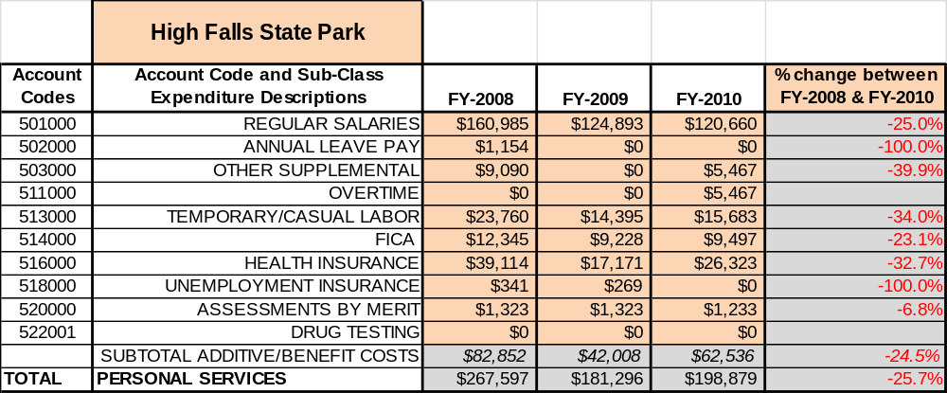

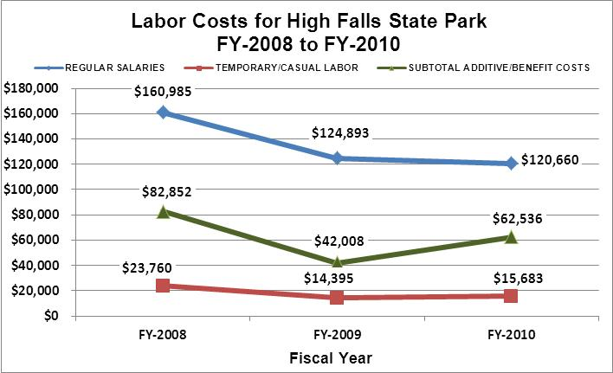

Visitation and Occupancy
Overall annual visitation to the site has trended upward from 2008 to 2010, increasing by 70% or over 284,674 visitors. This is largely attributed to the addition of yurts and improved day use aesthetic value.

Year | Total Visitation
2008 | 407,053
2009 | 530,947
2010 | 691,727

Occupancy for the overnight accommodations at High Falls State Park the last three years is detailed in the table below. Overall occupancy has trended downward from 2008 to 2010, decreasing by 12%. This is largely attributed to the economic down turn.

Year | River Campground Occupancy | Lake Campground Occupancy | Yurt Occupancy | Pioneer Campground Occupancy | Picnic Shelter Occupancy | Group Shelter Occupancy
2008 | 11,511 | 1,022 | N/A | 67 | 172 | 84
2009 | 10,683 | 973 | 310 | 45 | 164 | 67
2010 | 8,605 | 1,659 | 919 | 47 | 154 | 71

Customer Service and Satisfaction

Site | Year | Customer Satisfaction Level
High Falls State Park | 2009 | 100%
High Falls State Park | 2010 | 83%
Financial Performance Assessment

Operational Expenses
A summary of total operating expenses at High Falls State Park from 2008 to 2010, as well as their percent change from 2008 are provided in the table below.
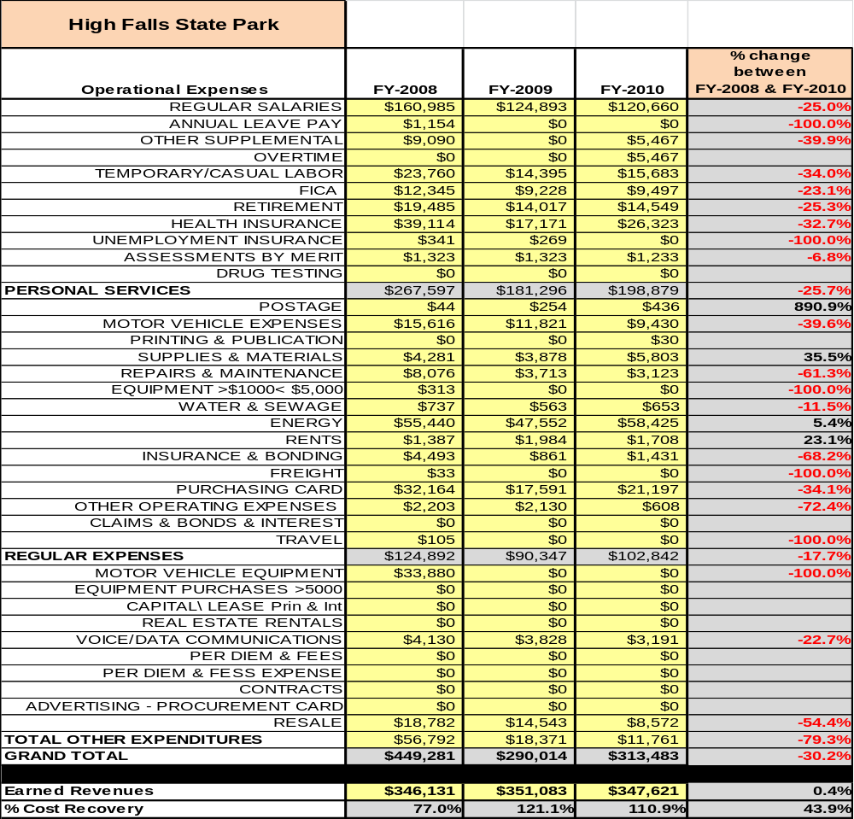

Earned Revenues
Earned revenues at High Falls State Park have increased since 2008, which is largely attributed to the corresponding increase in overall visitation. Monthly earned revenues for the last two years (see table on the following page) indicate that the total annual revenue decreased 15% from 2009 to 2010, with the largest increases in monthly revenues in October (14%) and November (12%) and the largest decreases in the months of August (-48%), December (-32%) and February (-45%).

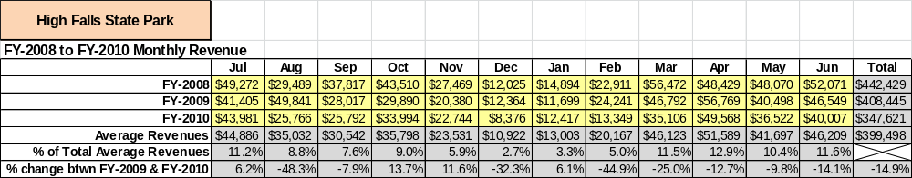

The graphs below illustrate the monthly revenue trends each year and the average percent of total annual revenue earned each month.
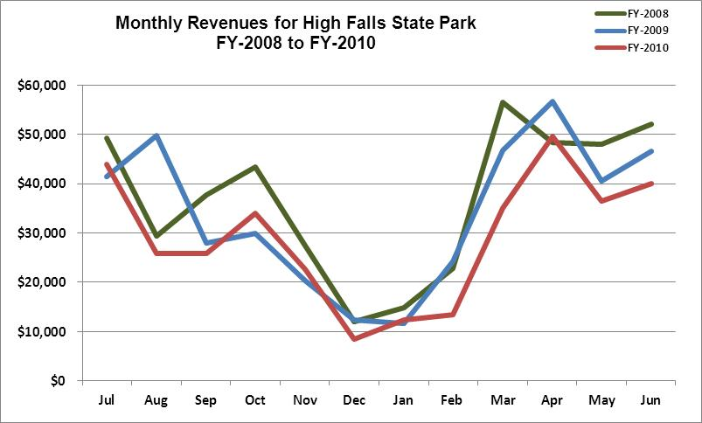

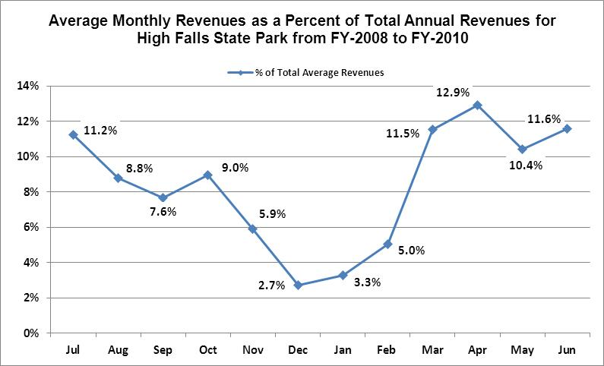

Cost Recovery Trends
High Falls State Park has achieved an average cost recovery of 103% of annual operational expenses through earned revenues from FY 2008 to FY 2010. This is detailed and illustrated in the table and graph below.
Year | Operational  Expenses | Earned  Revenues | Percent Cost  Recovery
2008 | $449,281 | $346,131 | 77%
2009 | $290,014 | $351,083 | 121%
2010 | $313,483 | $344,187 | 110%
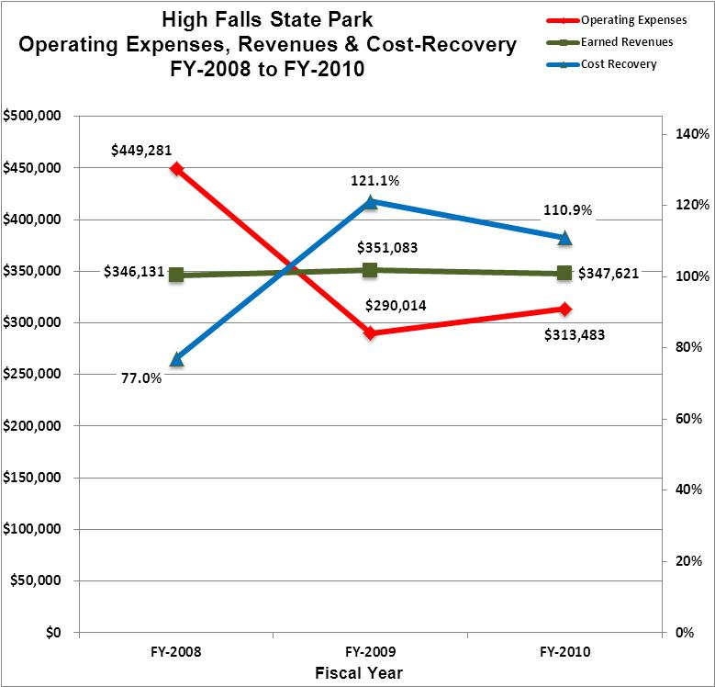

Review of Pricing
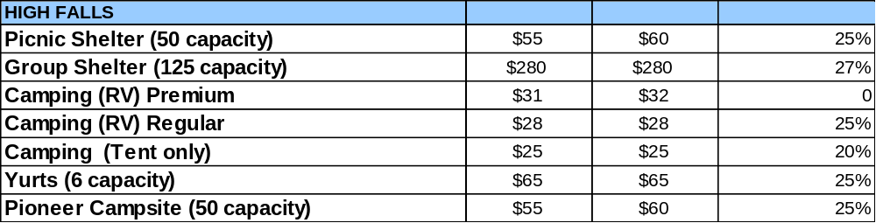
Data on rate information is available as far back as 2002, but only the last five years are evaluated. There has been notable growth in fees charged at High Falls State Park since 2005, with the largest increase being in camping. A table detailing the rates for facilities is provided below.
FY11 Pricing FY12 Pricing Yield Mgmt %
Business and Management Plan

Business Goals
The following goals serve as the foundation for the key recommendations and strategies in this business plan for High Falls State Park.

Enhance Cost Recovery of Site Operations
High Falls State Park is operating at a 93% cost recovery of operational expenses through earned revenues. The cost recovery was elevated in 2009 and 2010 due to the five vacancies in a full time staff of nine. The park operations are limited due to staffing levels.

Enhance Revenue Generation Strategies
Special events should be used to attract visitors when the staffing level increases. The events should be geared toward events that will encourage the guest to stay overnight in our facilities. Special attention should also be given to marketing the group shelter as a rentable meeting facility. The park staff should also market specialty facilities such as the gazebo for weddings. Strong consideration should be given to competitive pricing and bundling services.

Expand Special Events at the Site
The special events at High Falls State Park have been very limited over the past two years due to extremely low staffing levels. The High Falls Lake Association has done an Independence Day Boat Parade with limited success. The Tri the Parks Triathlon has also been held at this site. The location of High Falls State Park makes it ideal for hosting special events. However, the staff will need to be in place or the park should partner with other agencies to produce the required special events.

Improve the Diversity and Innovation of Recreational and Interpretive Programs
The interpretation at the site has been drastically limited due to the low level of staff. A seasonal naturalist has been hired to work through the summer season. The most lucrative program over the past couple of summers has been the paddling trips on the lake and down the river. The paddling trips can be marketed in several ways. They can appeal to the beginner and teach basic skills. The program can be geared to suit an environmental education slant. Finally, the programs can be geared to interest social paddlers simply looking to have an organized paddling trip to meet new people. The program could be expanded to include night paddling or overnight trips.

Improve the Effectiveness of Marketing and Sales
The effectiveness of marketing at High Falls State Park could be drastically improved by marketing specifically to the target markets that we serve. The use of billboards along the interstate as you near the park exit would be a great help to sales. A great percentage of the customer base at the site comes from walk-ins off of the interstate. The area around the site has a great number of campgrounds competing for the same market. Attention should be directed to marketing the experience of High Falls State Park and the added benefits of nature and security that cannot be found at the other local campgrounds.

Establish Greater Consistency of Managing and Monitoring Customer Service & Satisfaction
High Falls State Park should strive to maintain a customer satisfaction rating of at least 90%. However, there is not a mechanism in place to accurately track the numeric values of the satisfaction level of the customers served at the site. A tracking system should be established to help accurately track these ratings. The customer should be offered a small discount to make it advantages for them to take the time to turn in their opinions on the site and the services provided.

Expand Partnership Opportunities
The opportunities for partnerships are limitless in the High Falls area. The Friends of High Falls State Park Chapter is beginning to gain momentum in the community. They will be a great source for funds, service and partnership opportunities. A great deal of progress could be made through reaching out to local non-profit organizations such as Dauset Trails Nature Center.

Classification of Programs and Services
The tables below summarize the classifications of programs and services at High Falls State Park as either core, important or visitor supported and project a range of cost recovery percentages that might be achieved for each. These classifications establish financial performance goals for each category of services that are linked to the recommendations and strategies of this business plan.

Core Services
Program / Service | Target Cost Recovery
Active management of the natural and cultural resources of the site in order to protect their integrity | 0%
Open and public access to the site and its resources | 0%
Site appropriate education, interpretation and recreational opportunities | 10%-15%
Effectively manage High Falls Lake and the structures located within its boundaries | 10%-15%
Public safety | 0%
Maintenance of grounds, facilities and infrastructure | 0%

Important Services
Program / Service | Target Cost Recovery
Self-guided interpretation and education programs | 50%-75%
Camping, yurts, pioneer sites to be used for overnight facilities at the site | 125%-150%
Day use facilities such as picnic shelters and a group shelter | 100%-125%

Visitor Supported
Program / Service | Target Cost Recovery
Gift shop | 100%-125%
Ranger guided interpretation and elective educational programs | 100%-125%
Special events / programs related to the mission of the site | 100%-125%
Special events / programs not related to the mission of the site or outside the normal programming standards (e.g., wedding receptions, etc.) | 100%-125%
Boat rentals | 100%-125%
Mini golf rentals | 100%-125%
Pool operations | 100%-125%

Partnership Development Plan
The table below summarizes existing partners and targeted partnerships by classification (operational, vendor, service, co-branding, funding partners) and by organizational type.
 | Public Partners | Not-for-profit Partners | Private / Enterprise Partners
Operational Partners | - Monroe County Sheriffs Office  - Monroe County EMS  - Georgia Forestry Commission  - Wildlife Resources Division | - Dauset Trails Nature Center  - Towaliga Watershed Alliance
Vendor Partners |  |  | - Coca Cola  - Stananco  - Home Deopt  - Bass Pro  - Academy Sports
Service Partners | - Monroe County Public Works | - Forsyth-Monroe County Chamber of Commerce | - Georgia Power  - Central Georgia EMC
Co-branding Partners | - Indian Springs State Park  - Jarrel Plantation Historic Site |  | - Buck Creek Market  - Macon KOA  - Beaver Creek Campground  - High Falls Hide Away
Funding Resource Development Partner |  | - Friends of High Falls State Park | - Central Georgia EMC

Marketing and Sales Plan

Marketing and Sales Goals
Marketing and sales goals for High Falls State Park are based on the following desired outcomes:
- Increase yurt rentals by 5%-10% over the next year through marketing the experience and rarity of yurt camping.
- Increase campsite rentals by 5%-10% over the next year through extended stay discounts and package deals.
- Increase day-use rentals by 5%-10% over the next year through advertising meeting facilities and special events such as weddings.
In order to meet these goals, examples of specific target outcomes were identified in the areas detailed in the table below.
Area  of Focus | Current  Performance | Goal  by 2011 | Goal  by 2012 | Goal  by 2015
Yurt Rentals | 42% occupancy | 48% occupancy | 49% occupancy | 50% occupancy
Campsite Rentals | 27% occupancy | 37% occupancy | 38% occupancy | 40% occupancy

Marketing and Promotion Strategies

Publicity and Social Media
High Falls State Park will approach marketing and publicity planning using the following guidelines:
- Event publicity
Major events benefit by having short stories in local, regional, and statewide newspapers and online social media hooks planted that run three to four weeks in advance of the event up to the date of the event itself. Stories and media need to be cultivated with contacts and online sales channels several weeks in advance of the time the stories need to run. Special interest interviews on morning, noon, and evening television news programs, radio interviews on popular rush-hour programs, and blogs on known affinity online sites should also be included.
- Program publicity
Special and unique programs should have feature stories in magazines, local and regional weekly newspapers, and statewide daily newspapers that are aimed at placements as front-page or sectional front-page stories. These stories are most effective if they run shortly before the season that the featured program begins. This will likely require several weeks of advanced planning with media contacts. Similar coverage on television and radio should also be considered. If pre-publicity cannot be generated, post-publicity can help promote future programs.
- Site Publicity
Site publicity focusing on a single site or sub-set of sites requires more intense planning efforts to attract multiple writers and editors from target publications. The site could host several seasonal media familiarization tours (with 10 to 15 writers or editors) to familiarize them with the site and its benefits and amenities. Stories and features resulting from such tours typically take between two and six months to materialize so the tours should focus on experiences, benefits, and programs that would be available when the stories are expected to run.
Examples and suggested opportunities for events, programs and related publicity efforts based on the themes described above at High Falls State Park are provided in the table below.

Event Publicity | Program Publicity | Site Publicity
July 4th Boat Parade | Canoe/Kayak programs | Yurt Packages
Triathlon | Geology Hike | Controlled Burning
Fishing Tournament | Bird Watching | Premium Campsite Packages
Forsyth Christmas Parade | History Walk | Facebook

Packaging
Examples and suggested packages for High Falls State Park are provided in the table below.

Package | Package Details
Yurt Package | Stay 3 nights and get a fourth night free or free use of a boat during the week
Campsite Package | Stay 3 night and get a fourth night free or a free use of a boat during the week
Extended Stay Campers | Stay for 30 days at $18 per night
Wedding | 10% off combination rental of Yurt, Wedding Gazebo and Shelter (users choice)

Group Sales
Types of groups within which specific target customers can be identified for High Falls State Park are listed below:
- Extended stay workers | - Travelers on Interstate 75 | - Special event groups such as weddings

Incentivizing New and Repeat Visitation
High Falls State Park will utilize the following strategies and/or incentives to encourage new and repeat visitation starting in FY 2012:
- High Falls State Park will offer discounts for extended stays paid in full by employees working in the local area.
- High Falls State Park will start to offer the gazebo as a rentable facility to host weddings in front of the waterfall.

Marketing and Sales Metric Goals
The following marketing and sales metric goals and/or others will be monitored and progress reported at High Falls State Park:
- Loyalty and repeat customers = 60% repeat customers.
- Brand confidence & customer recruiting customers = 20% of new customers recruited by previous customers.
Revenue Generation Plan
Revenue / Cost Recovery Goals
High Falls State Park has set a financial goal of increasing annual revenues 3% annually between 2012 and 2015. The largest revenue growth opportunity is most likely Yurts and Premium Campsites. The table below details projected revenue growth leading up to 2015, based upon a nominal growth of revenues each year.
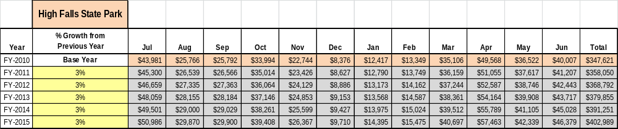

These projections would result in a total of 16% cumulative growth in total annual revenues between FY2010 and FY2015. If operational expenses can be managed with a cumulative increase of 25% between FY 2010 and FY 2015, then the overall cost recovery of the site will be approximately 103% in FY 2015 at these projected revenue levels. This is lower than the annual financial performance of the site in FY 2010, which was operated at 111% cost recovery in that year.

Revenue Generation Strategies

Pricing Plan
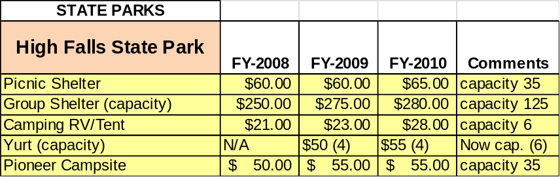

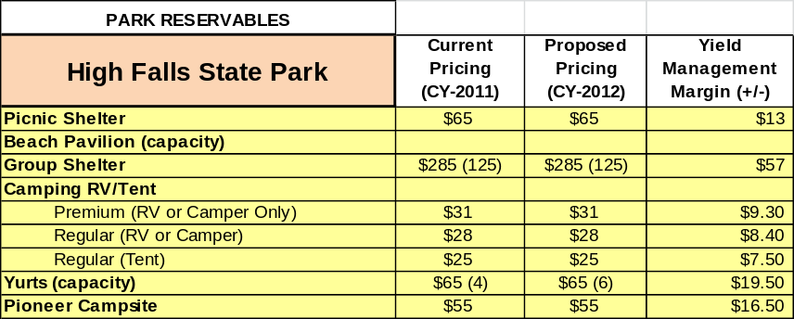

Innovative Programming and Special Events Plan
Program / Event | Theme / Purpose | Scheduled Date/Season | Frequency | Target Participation | Target User Fee | Target Cost Recovery
Boat Parade | 4th of July | July 4th | Annual | 100 | Park pass | 100%
Canoe | Program | Summer | 2x’s monthly | 6 – 12 | $18 | 130%
Triathlon | Event | April | Annual | 300 – 500 | $2 per racer | 150 - 200%
Fishing Tournament | Event | May | Annual | 50 – 100 | $20 per person | 150%
Geology Hike | Program | Year Round | 2x’s monthly | 10 - 20 | $5 per person | 150%
History Hike | Program | Year Round | 2x’s monthly | 10 – 20 | $5 per person | 150%
Forsyth Christmas Parade | Christmas | December | Annual | N/A | N/A | %100
Wedding | Dam Wedding | Year Around | Daily Upon Reservation | 4 - 100 | $65 - $200 | 200%

Partnerships and Concessions Plan
Service / Partnership | Term of Service | Financial Objective | Contract Manager
Pool concession agreement | 5 years | 10% of entry fees | Park Manager
Lake events such as fishing tournaments | 1 year | 10% of profit | Park Manager
Boat concession agreement | 5 year | 15% of profit | Park Manager

Expense Management Plan
Personnel Assignments
The following actions will be taken to proactively manage labor costs via personnel assignments and classifications.

Action | Timeline | Outcome
Eliminate two vacant Utility Worker positions | Summer 2012 | Save over $30,000.00 in salaries plus the additional money saved on paying benefits for the two positions

Management Techniques
The following actions will be taken to proactively manage labor costs via management techniques.

Action | Timeline | Outcome
Hire additional part time maintenance workers as needed for peak periods | As needed | Reduce time to hire the employee and save money on salaries and benefit packages

Adjusted Levels of Service
The following actions will be taken to proactively manage labor costs via reduced levels of service.

Action | Timeline | Outcome
Reduce landscaped areas to be maintained | Summer 2012 | Reduce operating expenditures of equipment maintenance and fuel cost
Close A and B Loop campgrounds when not in peak periods | On-going | Reduce operating expenditures of power and water cost

Financial Pro Forma
The following five-year financial pro forma projects operating expenses, earned revenues and cost recovery through FY 2015. These pro forma are based on the strategies and desired outcomes identified in this business plan, especially the revenue generation and expense management plans, and are linked to corresponding performance goals.

Expense Pro Forma
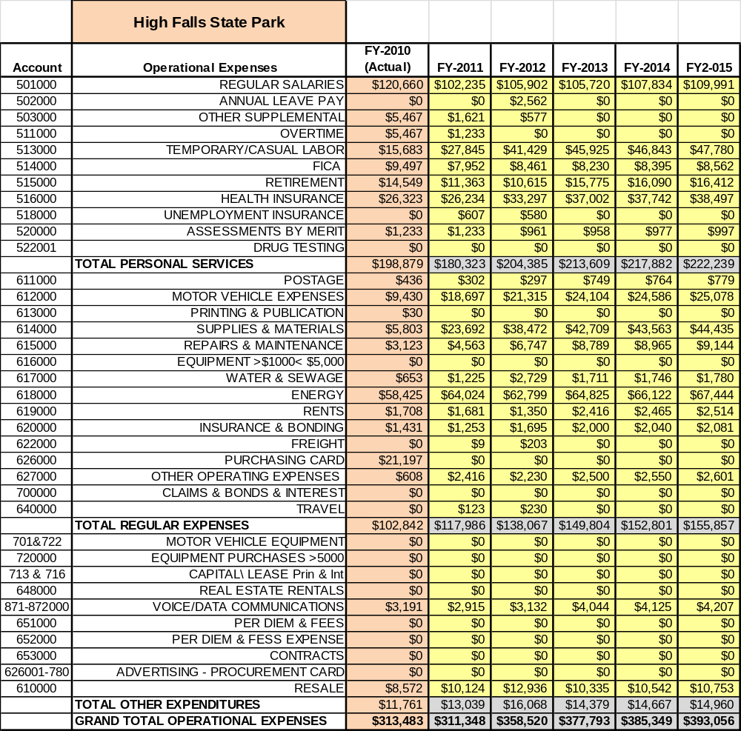

Revenue Pro Forma
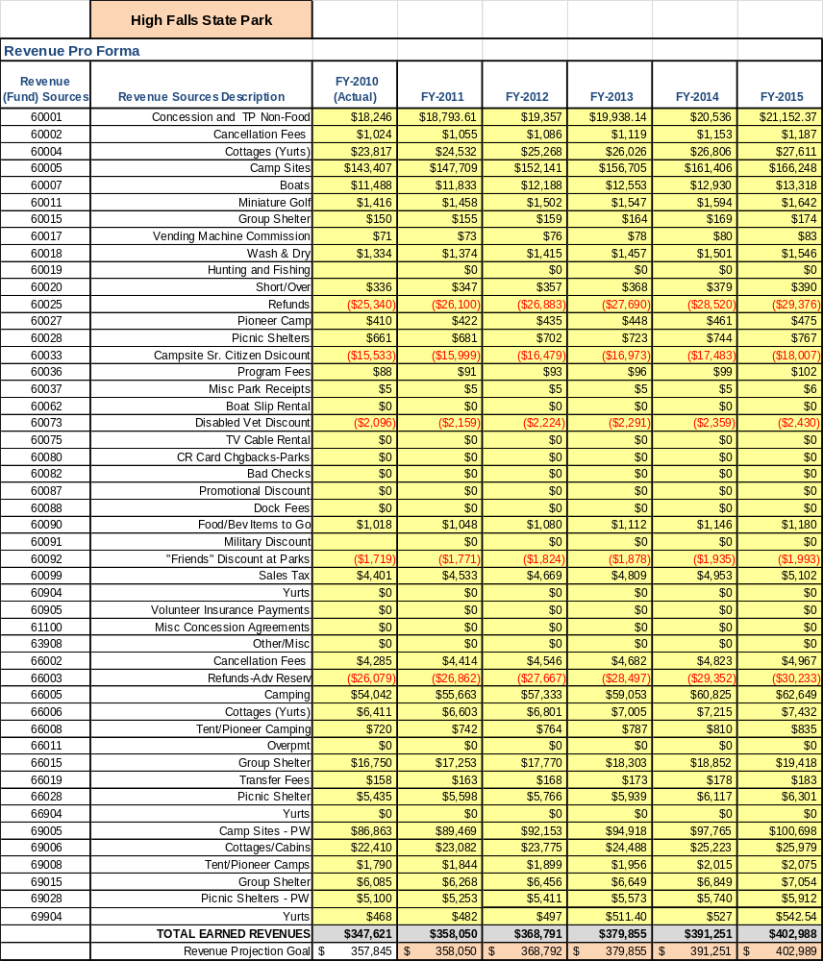

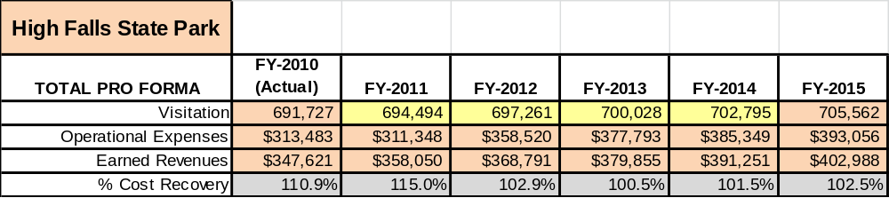
Total / Cost Recovery Pro Forma

Action Plan
ACTION PLAN
Site: |  | Site Manager: |  |  | Date:
Month:
Strategy | Tasks | Costs / Funding | Revenues / ROI | Responsibilities | Metrics

ACTION PLAN
Site: |  | Site Manager: |  |  | Date:
Month:
Strategy | Tasks | Costs / Funding | Revenues / ROI | Responsibilities | Metrics

