Hofwyl-Broadfield Plantation
Business & Management Plan

Prepared June 2011; Finalized February 2013
Direction 2015 – Sustainable Business Planning

Table of Contents

Executive Summary 3

Site and Operations Assessment 8
Site Inventory and Facility Assessment 8
Operational Assessment 10
Financial Performance Assessment 15

Business and Management Plan 18
Business Goals 18
Classification of Programs and Services 20
Partnership Development Plan 21
Marketing and Sales Plan 22
Revenue Generation Plan 24
Expense Management Plan 26
Financial Pro Forma 27

Action Plan 29

Executive Summary
The Parks, Recreation and Historic Sites Division (PRHSD) of the Georgia Department of Natural Resources (DNR) is transitioning the management of Hofwyl-Broadfield Plantation to operate more like a business, reflecting the Direction 2015 Sustainable Business Planning initiative to improve the fiscal performance and management of the state parks and historic sites system. This business and management plan is designed to help the site recover more operating expenses through earned revenues, productive partnerships, and innovative programs.

Site Fact Sheet
Site Name | Hofwyl-Broadfield Plantation
Site Manager | Bill Giles
Region Manager | Tommy Turk
Date of Business Plan completion | 12/1/12
Site size (acres) | 1,268
Total number of visitors (FY 2010) | 8,054
Total operating budget (FY 2010) | $176,443
Total earned revenues (FY 2010) | $42,324
Operational cost recovery (FY 2010) | 24%
Average operating cost per visitor (FY 2010) | $21.91
Average earned revenue per visitor (FY 2010) | $5.26
Average cost recovery[1] (FY 2008 – 2010) | 28%
Target cost recovery (FY 2015) | 45%
Total full-time employees[2] | 3
Total part-time employees[3] | 0
Primary service markets[4] | Savannah, Jacksonville
Primary attractors/visitor appeal factors | Southern history, African-American experience, plantations
Leading opportunities for improved site performance | Extended hours, marketing

Site Summary and Key Attractions
Hofwyl-Broadfield Plantation is 1,243 acres in size and is located 60 miles south of Savannah and 70 miles north of Jacksonville in a high tourism area. It is on busily travelled US Highway 17 and just one mile off of Interstate 95. According to Georgia Department of Transportation statistics, over 150,000 people travel within one mile of the site each day. These sources could easily be tapped for visitation increases. The key challenge of that strategy would be to not get so many visitors that historic and natural resources are not endangered.

Key Attractions
The amenities or features listed below are those that seem to be most popular for visitors.
- Plantation House
- Visitor Center
- Trails
- Commissary Barn
- Old Kitchen
- Servant’s Quarters
- Garage/Ice House
- Gift Shop
- Picnic Area
- Programs/Special Events

Financial Targets
The table below details the total operating expenses and earned revenues for Hofwyl-Broadfield Plantation over the last three years (2008 – 2010). This table also calculates total cost per visitor and revenues per visitor during these operating years, and details the target financial performance goals in the context of achieving at least 45% cost recovery. This table also calculates the necessary change from 2010 operating expenses and revenues.
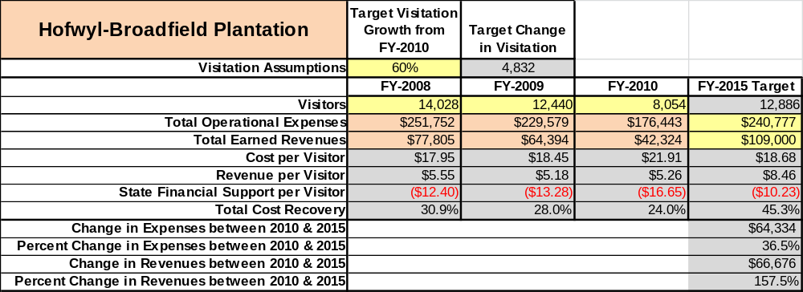

Key Recommendations

Primary / Short Term Recommendations
- Adjust the operating hours of Hofwyl-Broadfield Plantation seasonally:
  - February-July & October-November open 9 a.m. – 5 p.m. 7 days per week.
  - August-September & December-January open 9 a.m. – 5 p.m. Thursday thru Saturday.
    - Note: The months listed in b (above) are our slowest months. Less is to be gained by opening full time in those months.
    - Our proximity to I-95, and additional staff (see #2 below) would allow us to be open seasonally on Monday. It is expected that we would receive visitation sufficient to raise our cost recovery by an additional 5%.
- Hire three 1,508 employees. These positions would all start at $8 per hour and work 40 hours per week for 8 months. This would add an expense of $33,280 per year and would initially result in (with increased hours) increased revenue of not less than $50,000 and up to $66,000). These associates would be augmented by Historic Site Ambassadors (see #6 below).
  - These figures serve as a minimum baseline. This action is intended to return our visitation to pre-budget cut with raised fees.
  - Additional staff would also result in additional programming which would lead to additional revenue (not counted above).
  - Additional staffing and increased hours would also allow us to market our site to tour planners (this segment made up 20% of our pre-budget cut operation).
- Increase general admission rate to $7.50 per person. This would result in additional revenue of approximately $11,000.
- Redo the site entrance to make us more visible to travelers. This would increase our annual revenue by $7,500 to $15,000 annually.
- Install an ultra-low power radio station targeted at our parking lot to disseminate information on our site to potential visitors. This would reduce the number of visitors who leave without touring our site and increase revenue by at least $5,000 per year. (Note: Purchase and installation of such a transmitter has been completed.)
- Increase utilization of Historic Site Ambassadors to offset labor constraints and maintain site at pre budget cut levels.
- Introduce a low power radio station aimed at traveler s on Interstate 95 and US Hwy 17.
- Explore option of paying a private concessionaire to manage private gatherings at site.
- Develop stronger cooperative relationships with fellow stake-holders in the tourism industry in our area. These stake holders include local chamber, civic groups, tourism destinations, etc.
- Operate the PRHSD system and individual sites using cost-based accounting, including the net cost recovery achieved annually.
- Conduct on-site surveys annually to assess how well customer satisfaction levels are being met. Sites should strive to have 90% of visitors responding to ‘Comment Cards’ report that they were either ‘satisfied’ or ‘very satisfied’ (or some comparable metric to be developed). Programs or services that fall below that standard should be critically reviewed, enhanced, and results monitored; those with a history of poor performance should be considered for elimination.
- Collect a statistically-valid sample of ZIP code data from day visitors in a non-intrusive way to gauge their origins and demographics (e.g., age, ethnicity, income, etc.) and use the results to improve programming and marketing efforts to appeal to a broader audience.
- Utilize a minimum of six special events annually to help draw more visitors to the site.
- Seek local partners to help support operations, programs, and service delivery and for cross-marketing purposes.
- Manage Hofwyl-Broadfield Plantation according to well-defined maintenance, programming and operational standards, monitored and enforced by region managers and senior management.
- Partner with local Chambers of Commerce or other destination marketing organizations (DMOs) to promote local sites.
- Continue to work with the statewide and chapter Friends of Georgia State Parks and Historic Sites to help raise funds or provide volunteers for improvements and program support.
- Perform a thorough net cost-of-service analysis on major functions of site operations, including a detailed analysis of labor requirements by task. Thereafter, update costs to deliver services on a biennial schedule.
- Review and update rates at the site on an annual basis to meet cost recovery targets for important and visitor supported services.
- Enhance retail operations at each site to increase site generated revenues.
- Track total economic impact of the sites on the local communities and region and share with decision-makers, elected officials, local business operators and others to demonstrate the impact of each site.
- Add more youth and family focused services, programs and amenities at state parks and historic sites that appeal to younger audiences, families and educational groups.
- Manage Hofwyl-Broadfield Plantation using at least 10 performance measures. It is critical that the system evolves to adopt additional performance measures over time. These could include the following:
- Capacity management by amenity
- Revenue versus expenses based against anticipated budget
- Cost center goals for efficiency and revenue development are met at 95% of the goal
- Customer satisfaction is at least 90%
- Retention of the core market with return visits at least once each year at 40% or greater
- Manage constituent groups to maintain balanced and appropriate park use
- Leverage annual volunteer hours equal to a minimum of 15% of paid staff hours
- Base equipment replacement on a schedule that is met at a 95% level annually

Secondary / Long Term Recommendations
- Restore the Servants Quarters behind the main house to increase interest in the site by better interpreting the story of the African American slaves/servants.
- Develop a management plan for the rice fields to include recommendations for use, interpretation and restoration.
- Develop trails through the marshlands, rice fields and upland pines.
- Engage local communities, user groups and private organizations to improve connectivity between and within sites through trail development and maintenance projects.
- Install an improved retail point-of-sale and inventory tracking system.

Site and Operations Assessment
This site and operations assessment is a culmination of analyses and findings from a review of the condition of facilities, infrastructure, and operations at Hofwyl-Broadfield Plantation. The findings and observations are not intended to be an exhaustive review of all issues present, but provide a basic understanding of the predominant issues that contribute to the site’s current operating conditions. The assessment includes the following:
- Site Inventory and Facility Assessment
- Operational Assessment
- Financial Assessment
Site Inventory and Facility Assessment

Methodology
Facility and asset conditions are rated using a differential scale of excellent, good, fair, or poor. Descriptions of conditions that are attributed to each of these findings are also provided.
Scale of Conditions
Rating | General Description
Excellent | Facilities/amenities are in ‘excellent’ condition when they show little or no maintenance or repair problems. Facilities do not feature any major design or operational issues or flaws that contribute to diminished use or increased maintenance or upkeep. Facilities are easy to clean and maintain in order to place them back into public use and the users perceive them to be in excellent shape.
Good | Facilities/amenities are in ‘good’ condition when they show only minor maintenance or repair problems. Most maintenance issues with these facilities typically appear to be the result of age and/or heavy use. Facilities may only feature minor design or operational issues that contribute to diminished use or increased maintenance or upkeep. Facilities are moderately easy to clean and maintain in order to place them back into service and the users perceive them to be adequate for their use, but probably not in excellent shape.
Fair | Facilities/amenities are in ‘fair’ condition when they show significant maintenance or repair problems. Facilities generally exhibit ongoing maintenance issues that appear to be the result of age, heavy use, or design or operational flaws. Some maintenance and repair needs may compound their fair condition by being deferred because of budget and/or resource limitations. Facilities require more effort to clean and maintain before placing them back into service and the users may perceive them as being less than adequate for their use and in a state of deterioration. The facility or structure may need of major repair or replacement.
Poor | Facilities/amenities are in ‘poor’ condition when they show significant, on-going maintenance or repair problems that ultimately may result in suspended use for repair/replacement. Maintenance and repair issues are possibly the result of poor maintenance and clearly the result of age, heavy use, or design or operational flaws. Problems with the facilities are often compounded over time due to consistently-deferred maintenance and repair because of budget and/or resource limitations. Facilities may feature major design or operational issues that contribute to diminished use or increased maintenance or upkeep. Facilities require excessive effort to clean and maintain before placing them back into service and the users often perceive them as being inadequate for their use and in a state of serious deterioration. The facility or structure may need of major repair or replacement.

Inventory and Assessment
The table below is an inventory of facilities and amenities at Hofwyl-Broadfield Plantation, and provides the assessed condition of each as reviewed in May 2011.

Site Asset / Amenity | Quantity | Condition
Plantation House | 1 | Fair
Visitor Center | 1 | Good
Servant’s Quarters | 1 | Poor
Kitchen | 1 | Fair
Garage/Ice House | 1 | Good
Commissary Barn | 1 | Fair
Pay Shed | 1 | Good
Dairy Barn | 1 | Good
Bottling Shed | 1 | Good
Picnic Area | 1 | Fair
Manager’s Residence | 1 | Good
Ranger’s Residence | 1 | Good  good
Maintenance Complex | 1 | Good
Rice Fields Observation Deck | 1 | Fair
Intern Cottage | 1 | Fair
Interpretive Center | 1 | Good
Trails | 2 | Fair

Prioritized Facility Needs
Based on the facility inventory and assessment, these prioritized needs have been identified. Each need has been aligned with a priority category of high, moderate, or low to support future decision making regarding project sequencing, investment of public resources, and meeting community expectations. The priority assignment for each need is not a measure of importance. Rather, these recommended priorities reflect a phased implementation approach over the next several years.

Facility Need | Priority Assignment
Improved signage at entrance | High
Upgrade to museum and silver storage | High
Storage area for artifacts | High
Widen site entrance road – provide bus and RV parking | High
Restoration of Servants Quarters | High
Construction of new restrooms for plantation area | Moderate
Restoration of upstairs deck and stairwell on rear of plantation house | Low
Nature/Historical boardwalk & trails in marsh and through upland pines | Low

Operational Assessment
The Operational Assessment includes:
- An inventory and classification of programs and services being provided at the site
- A review of staffing at the site
- A review of concessionaires and partners operating at the site
- Visitation and customer satisfaction

Inventory and Classification of Programs and Services
Programs and services are classified into one of three major categories:
1) Core or Essential Services
2) Important Services
3) Visitor Supported Services
Programs and services at the site are classified into these categories based in part on the mission and public mandates for both the site and the agency. For the programs and services in each of these categories, there are financial performance expectations that will define how services are funded and evaluated.

Category 1 – Core Services [Largely supported by tax funds]
Core programs, services and facilities are those the agency must provide and/or are essential in order to capably govern and meet statutory requirements. The failure of the agency to provide Category 1 services at adequate levels could result in significant negative consequences for the public and the resources under protection. The criteria for programs or services to be classified as core or essential are:
- The services are mandated by the agency’s law or charter or are contractually obligated by agreement to provide the services.
- The services are essential to protecting and supporting the public’s health and safety.
- The services protect and maintain valuable assets and infrastructure.
- The services would generally and reasonably be expected and supported by residents, businesses, customers and partners.
- The services are those that cannot or should not be provided by the private sector.
- The services provide a sound investment of public funds.
The following programs and services offered at Hofwyl-Broadfield Plantation have been identified as core services:
- Protection and preservation of natural and cultural resources
- Management of artifacts and historic structures
- Public safety
- Open and public access to site and its resources
- Appropriate levels of public education and interpretation
- Maintenance of grounds, structures and infrastructure

Category 2 – Important Services [Supported by a balance of tax funds and earned revenues]
Important programs, services and facilities are those the agency should provide, and are important to governing and effectively serving residents, businesses, customers and partners. Providing Category 2 services expands or enhances the agency’s ability to provide and sustain its core services. The criteria for programs or services to be classified as important are:
- The services expand, enhance or support identified core services.
- The services are broadly supported and utilized by the community, and are considered an appropriate, important, and valuable public good. Public support may be conditional upon the manner by which the services are paid for or funded.
- The services generate income or revenue that offsets some or all of the operating cost and/or are deemed to provide economic, social or environmental outcomes or results.
The following programs and services offered at Hofwyl-Broadfield Plantation have been identified as important services:
- Ranger-guided house tours
- Trails
- Picnicking
- Visitor Center

Category 3 – Visitor Supported Services [Almost exclusively supported by earned revenue]
Visitor supported programs, services and facilities are those discretionary services that the agency may provide when additional funding or revenue exists to offset the cost of providing those services. Category 3 services provide added value above and beyond what is required or expected. The criteria for programs or services to be classified as visitor supported are:
- The services expand, enhance or support core services or important services and the quality of life of the visitors, community or stakeholders.
- The services are supported, valued and well utilized and provide an appropriate and valuable public benefit.
- The services generate income or funding from sponsorships, grants, user fees or other sources that offset some or all of their cost and/or provides a meaningful return on investment.

The services can possibly be provided through outsourcing or use of concessionaires, providing opportunities for community enterprises that may not otherwise be provided by the agency.
The following programs and services offered at Hofwyl-Broadfield Plantation have been identified as visitor supported services:
- Gift shop
- Special events

Staffing Assessment
Labor costs at Hofwyl-Broadfield Plantation represent the largest area of budgetary expense at an average of 76% of the total operating budget each year for the last three complete years, which is higher than the target of total labor costs (including benefits) not exceeding 65% of the site’s total operating expenditures. The tables below and on the following page provide a basic review of the current staffing at the site.
Full Time Equivalent Employees
Position / Title | Quantity (FTE) | Vacancies | Annual Hours
Site Manager | 1 | 0 | 2,500
Interpretive Ranger | 2 | 0 | 2,080
TOTAL | 3 | 0 | 6,660

Part Time Employees
Position / Title | Quantity (FTE) | Vacancies | Hours
None | 0 | 0 | 0
TOTAL | 0 | 0 | 0

Labor Support
Labor Support | Annual Hours
Volunteers | 3,000
Community Service Workers | 100
Engineering and Construction Crews | 40
Resource Management Crews | 0
TOTAL | 3,140

Total Labor Hours
Labor Type | Annual Hours
Full Time Equivalent Employees | 6,660
Part Time Employees | 0
Labor Support | 3,140
TOTAL Annual Labor Hours | 9,800

Labor Budget Summary
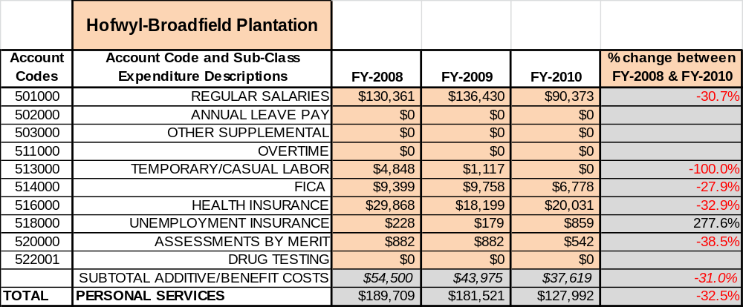

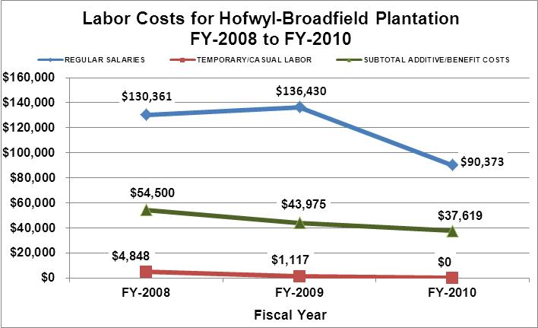

Visitation
Overall annual visitation to the site has trended downward from 2008 to 2010, decreasing by 43% or over 5,900 visitors. This is largely attributed to reduced operating hours.
Year | Total Visitation
2008 | 14,028
2009 | 12,440
2010 | 8,054

Customer Service and Satisfaction

Site | Year | Customer Satisfaction Level
Hofwyl-Broadfield Plantation | 2009 | 100%
Hofwyl-Broadfield Plantation | 2010 | 100%
Financial Performance Assessment

Operational Expenses
A summary of total operating expenses at Hofwyl-Broadfield Plantation from 2008 to 2010, as well as their percent change from 2008 are provided in the table below.
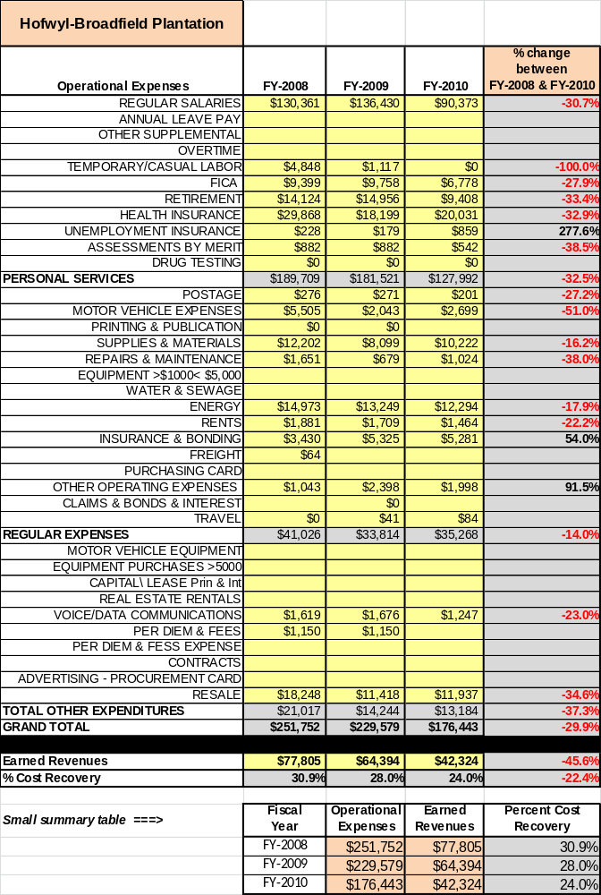

Earned Revenues
Earned revenues at Hofwyl-Broadfield Plantation have decreased since 2008, which is largely attributed to the corresponding decrease in overall visitation from reduced operating hours. Monthly earned revenues for the last two years (see table below) indicate that the total annual revenue decreased 34% from 2009 to 2010, with no months showing increases and the largest decreases occurring in the months of January (-59%), December (-54%), November (-54%), and February, March, May and June
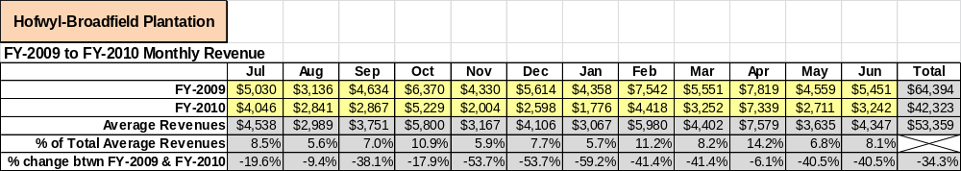
(-41%). Decreases are attributed to reduced operating hours.

The graphs below illustrate the monthly revenue trends each year and the average percent of total annual revenue earned each month.

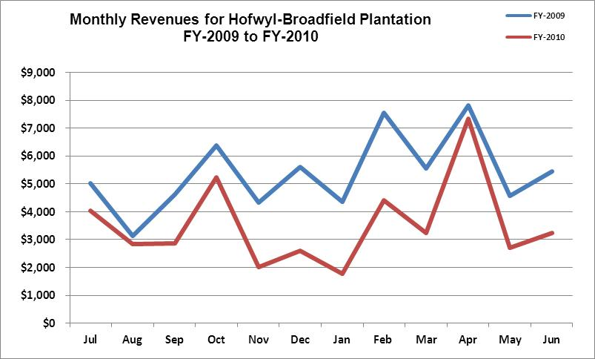
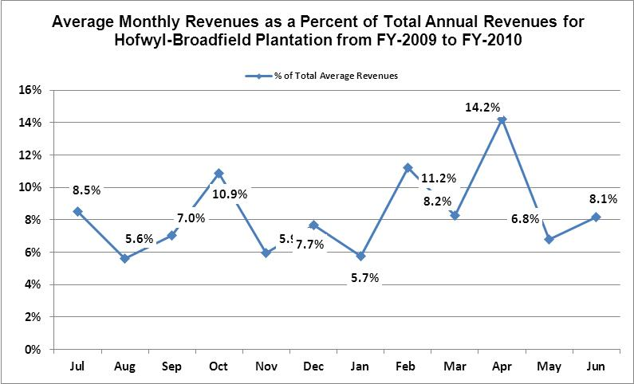

Cost Recovery Trends
Hofwyl-Broadfield Plantation has achieved an average cost recovery of 28% of annual operational expenses through earned revenues from FY 2008 to FY 2010. This is detailed and illustrated in the table and graph below.
Year | Operational  Expenses | Earned  Revenues | Percent Cost  Recovery
2008 | $251,752 | $77,805 | 31%
2009 | $229,579 | $6,394 | 28%
2010 | $176,443 | $42,324 | 24%

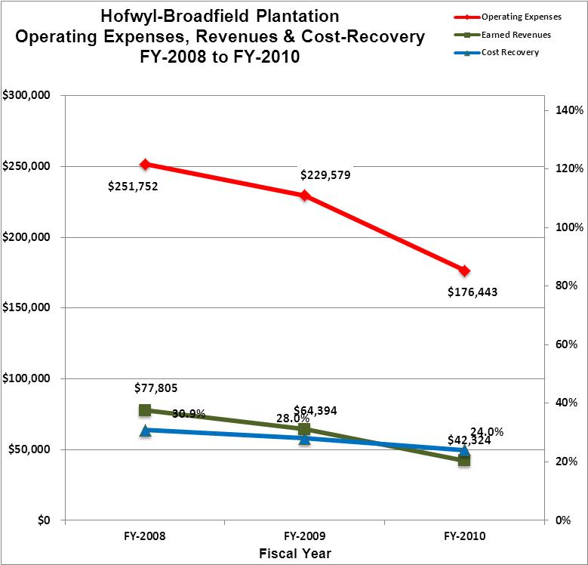

Review of Pricing
Data on rate information is available as far back as 2002, but only the last five years are evaluated. There has NOT been notable growth in fees charged at Hofwyl-Broadfield Plantation since 2005. A table detailing the rates for Hofwyl-Broadfield Plantation is provided below. Note: Fees were not increased since FY 2003, but were increased by $1 mid-way through FY 2011 (but not shown in table below).
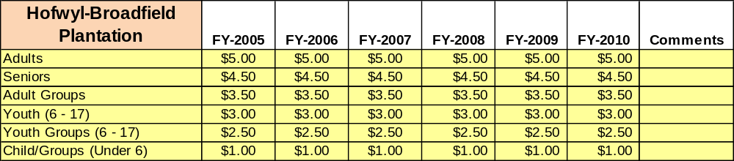
Business and Management Plan

Business Goals
The following goals serve as the foundation for the key recommendations and strategies in this business plan for Hofwyl-Broadfield Plantation.

Enhance Cost Recovery of Site Operations
Hofwyl-Broadfield Plantation presently operates at 24% cost recovery, down from 28-31% prior to budget cuts and reduction in hours. A return to full operating hours is vital to our efforts to increase revenue. This would require the hiring of three 1,508 workers at a cost of approximately $35,000 per year and would result in increased revenue of not less than $45,000.

Enhance Revenue Generation Strategies
Our admission fee should also be raised to not less than $7 per person. Our rates remained static at $5 from FY-2003 through FY-2011, when they were raised to $6. Sites which offer comparable programs to ours in comparable areas charge an average fee of over $11. An increase to $7 would result in additional revenues of around $11,000 per year.
The present configuration of our site entrance is not conducive to attracting visitors. Our gate runs parallel to US Highway 17 and is hardly visible to passing travelers. We need attractive signage running perpendicular to the highway to increase our visibility. This is something that we are going to accomplish on-site utilizing the skills of our volunteers and anticipate increasing revenue by at least $10,000 per year through this.
We also have completed installing a low power radio transmitter targeted towards our parking lot. This will play a repeating message with visitor information on our site. This will reduce the number of potential visitors who pull out of our site without paying admission and will increase our revenue by at least $5,000 per year.

Expand Special Events at the Site
All of Hofwyl-Broadfield Plantation’s previous programs and events have been tied to the history of the site. The area in which the site is located offers a broad range of additional opportunities. At present we are having a pole barn converted into an interpretive center, which could also be used for special events. This building will be approximately 600 square feet, screened in with ceiling fans. It is located at the edge of a large field which could also be utilized. These events can include, but not be limited to, art and music festivals, wine festivals, local culinary festivals, weddings and receptions.

Improve the Diversity and Innovation of Recreational and Interpretive Programs
As with many historic sites, Hofwyl-Broadfield Plantation features quality exhibits and displays that are predominantly appealing to adults. It will be crucial for the site to improve the appeal of all interpretative resources (e.g., displays, exhibits and programs) to a wider range of age groups. For example, consideration should be given to developing exhibits that are tactile and experiential in order to best connect with younger audiences. Repeat visitation could be encouraged through using rotating exhibits in the museum and increased programming.

Improve the Effectiveness of Marketing and Sales
Improved marketing could result in a large increase in visitation and revenue for Hofwyl-Broadfield Plantation. Approximately 60 million people pass within one mile of Hofwyl-Broadfield every year on highways I-96, US-17 and GA-99. Presently, the only outreach to these travelers is through the use of static metal signage. We could cost effectively reach these travelers through the use of a 10-watt information station radio placed strategically on the grounds of our site. This would give us the ability to directly communicate with travelers and local commuters who likely are not knowledgeable about our site. It would also give us a direct marketing method of publicizing our special programs and events and increasing general interest in our site. Additionally, partnerships with nearby attractions and amenities in the region should improve the ability of the site to maintain an increased and steady flow of visitors and revenue throughout the year.

Establish Greater Consistency of Managing and Monitoring Customer Service & Satisfaction
Hofwyl-Broadfield Plantation plans to improve the consistency of managing and monitoring customer service and satisfaction by conducting on-site surveys annually to assess how well customer satisfaction levels are being met. We will strive to have 90% of visitors responding to ‘Comment Cards’ report that they were either ‘satisfied’ or ‘very satisfied’ (or some comparable metric to be developed). Programs or services that fall below that standard should be critically reviewed, enhanced, and results monitored; those with a history of poor performance will be evaluated and potentially considered for elimination.

Expand Partnership Opportunities
Partner with local historical and recreational attractions to increase the number of visitors and revenue at our site. Work to make the local community more aware of Hofwyl-Broadfield, and the cultural, natural, and recreational resources that are available here.

Classification of Programs and Services
The tables below summarize the classifications of programs and services at Hofwyl-Broadfield Plantation as either core, important, or visitor supported and projects a range of cost recovery percentages that might be achieved for each. These classifications establish financial performance goals for each category of services that are linked to the recommendations and strategies of this business plan.

Core Services
Program / Service | Target Cost Recovery
Protection and preservation of natural and cultural resources | 0%
Management of artifacts and historic structures | 0%
Public safety | 0%
Open and public access to site and its resources | 30%-60%
Appropriate levels of public education and interpretation | 30%-60%
Maintenance of grounds, structures and infrastructure | 0%

Important Services
Program / Service | Target Cost Recovery
Ranger-guided house tours | 50%-70%
Trails | 50%-70%
Picnicking | 100%
Visitor center | 25%-50%

Visitor Supported
Program / Service | Target Cost Recovery
Gift shop | 125%-150%
Special events | 120%-200%

Partnership Development Plan
The table below summarizes existing partners and targeted partnerships by classification (operational, vendor, service, co-branding, funding partners) and by organizational type.
 | Public Partners | Not-for-profit Partners | Private / Enterprise Partners
Operational Partners | - Ft. King George Historic Site
Vendor Partners |  |  | - Coca Cola  - Georgia Power
Service Partners | - Glynn County  - GIAHA – Golden Isles Arts and Humanities Assoc. | - Golden Isles Chamber of Commerce | - Epworth by the Sea  - Cassina Garden Club
Co-branding Partners | - Ft. King George Historic Site  - Jekyll Island Historic District  - Ft. Frederica National Monument | - Coastal Georgia Historical Society | - Moore Methodist Museum
Funding Resource Development Partner |  | - Friends of Georgia State Parks  - Friends of Hofwyl-Broadfield  - Friends of Coastal Georgia History

Marketing and Sales Plan

Marketing and Sales Goals
Marketing and sales goals for Hofwyl-Broadfield Plantation are based on the following desired outcomes:
- To increase visitation and site revenue.
- To increase number of tour groups visiting site
- Increase number of senior citizen visitors
In order to meet these goals, examples of specific target outcomes were identified in the areas detailed in the table below.

Area  of Focus | Current  Performance | Goal  by 2011 (Actual) | Goal  by 2012 (Actual) | Goal  by 2015
Site Visitation | 7,500 | 7,493 | 7,142 | 12,886
Tour Group Visitation | 866 | 889 | 1,067 | 3,026
Senior visitors | 1,800 | 1,767 | 1,989 | 2,938

Marketing and Promotion Strategies

Publicity and Social Media
Hofwyl-Broadfield Plantation will approach marketing and publicity planning using the following guidelines and themes:
- Event publicity
Major events benefit by having short stories in local, regional, and statewide newspapers and online social media hooks planted that run three to four weeks in advance of the event up to the date of the event itself. Stories and media need to be cultivated with contacts and online sales channels several weeks in advance of the time the stories need to run. Special interest interviews on morning, noon, and evening television news programs, radio interviews on popular rush-hour programs, and blogs on known affinity online sites should also be included.
- Program publicity
Special and unique programs should have feature stories in magazines, local and regional weekly newspapers, and statewide daily newspapers that are aimed at placements as front-page or sectional front-page stories. These stories are most effective if they run shortly before the season that the featured program begins. This will likely require several weeks of advanced planning with media contacts. Similar coverage on television and radio should also be considered. If pre-publicity cannot be generated, post-publicity can help promote future programs.
- Site Publicity
Site publicity focusing on a single site or sub-set of sites requires more intense planning efforts to attract multiple writers and editors from target publications. The site could host several seasonal media familiarization tours (with 10 to 15 writers or editors) to familiarize them with the site and its benefits and amenities. Stories and features resulting from such tours typically take between two and six months to materialize so the tours should focus on experiences, benefits, and programs that would be available when the stories are expected to run.
Examples and suggested opportunities for events, programs and related publicity efforts based on the themes described above at Hofwyl-Broadfield Plantation are provided in the table below.

Event Publicity | Program Publicity | Site Publicity
Christmas Program | Share Your History | Evening Ghost Walks
Rice Festival | Spring/Fall Birding
Civil War Program | Gullah-Geechee
 | Jewish History

Packaging
Examples and suggested packages for Hofwyl-Broadfield Plantation are provided in the table below.

Package | Package Details
Golden Isles | $1 off of admission with visit to other area attractions

Group Sales
Types of groups within which specific target customers can be identified for Hofwyl-Broadfield Plantation are listed below:
- Families  - National bus tour groups  - Schools  - Churches | - Women’s groups  - Special interest groups  - Community organizations  - Clubs

Incentivizing New and Repeat Visitation
Hofwyl-Broadfield Plantation will utilize the following strategies and/or incentives to encourage new and repeat visitation starting in FY 2012:
- Group pricing options
- Gift shop discounts

Marketing and Sales Metric Goals
The following marketing and sales metric goals and/or others will be monitored and progress reported at Hofwyl-Broadfield Planation:
- Loyalty and repeat customers = 50% of customers repeat their visit in a 12 month period.
- Brand confidence & customers-recruiting-customers = Customer referrals equal a minimum of 40% of “Where did you hear about us?” responses from visitors polled.
Revenue Generation Plan
Revenue / Cost Recovery Goals
Hofwyl-Broadfield Plantation as set a financial goal of increasing annual revenues 117% between FY 2012 and FY 2015. The largest revenue growth opportunity is most likely increasing site hours. The table below details projected revenue growth leading up to 2015, based upon a nominal growth of revenues each year (except for a significantly larger increase during FY 2014.
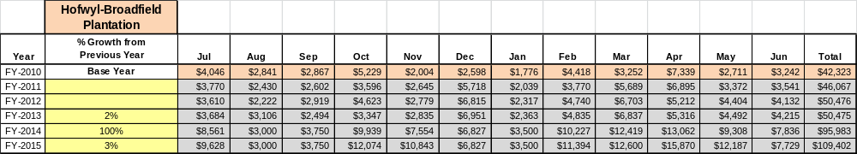

These projections would result in a total of 158% cumulative growth in total annual revenues between FY 2010 and FY 2015. If operational expenses can be managed with a cumulative increase of 36% between FY 2010 and FY 2015, then the overall cost recovery of the site will be approximately 45% in FY 2015 at these projected revenue levels. This is higher than the annual financial performance of the site in FY 2010, which was operated at 24% cost recovery in that year.

Revenue Generation Strategies

Pricing Plan
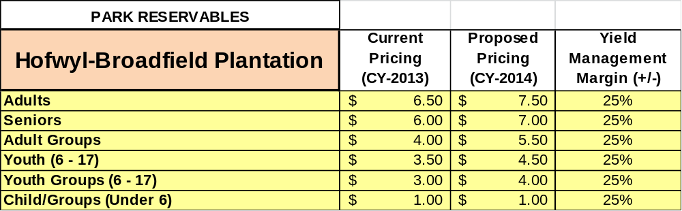

Innovative Programming and Special Events Plan
Program / Event | Theme / Purpose | Scheduled Date/Season | Frequency | Target Participation | Target User Fee | Target Cost Recovery
Christmas | Family event | 1st wkend in December | Annual | 600+ | $7 | 150%-200%
Gullah-Geechee | Family event/education | 3rd wkend in February | Annual | 200 | $7 | 100%
Rice Festival | Family recreational event | 1st wkend in October | Annual | 500+ | $7 | 150%
Lantern Ghost Walks | Family event | Saturdays in summer & fall | Monthly | 25 | $15 | 150%-200%
Victorian Day | Family event/education | 1st Saturday in March | Annual | 100 | $7 | 100%-125%
Birding | Family event/education | April-October | Bi-Annual | 10 | $10 | $150%-200%
Civil War | Family event/education | 1st or 2nd wkend in April | Annual | 200 | $7 | $150%-200%

Partnerships and Concessions Plan
Service / Partnership | Term of Service | Financial Objective | Contract Manager
Packaging and promotions with local attractions | Continual | Increase site visitation and revenue | Site Manager

Expense Management Plan
Personnel Assignments
The following actions will be taken to proactively manage labor costs via personnel assignments and classifications.

Action | Timeline | Outcome
Hire three 1,508 hourly positions | Fall 2011 | Labor reduction of $26,000 from FY-2009

Management Techniques
The following actions will be taken to proactively manage labor costs via management techniques.

Action | Timeline | Outcome
Continue to use and increase use of volunteers |  | Labor reduction of $26,000 from FY-2009

Adjusted Levels of Service
The following actions will be taken to proactively manage labor costs via reduced levels of service.

Action | Timeline | Outcome
Re-open site on full-time basis | Fall 2011 | Increase in revenue of $45,000 to $80,000

Financial Pro Forma
The following five-year financial pro forma projects operating expenses, earned revenues and cost recovery through FY 2015. These pro forma are based on the strategies and desired outcomes identified in this business plan, especially the revenue generation and expense management plans, and are linked to corresponding performance goals.

Expense Pro Forma
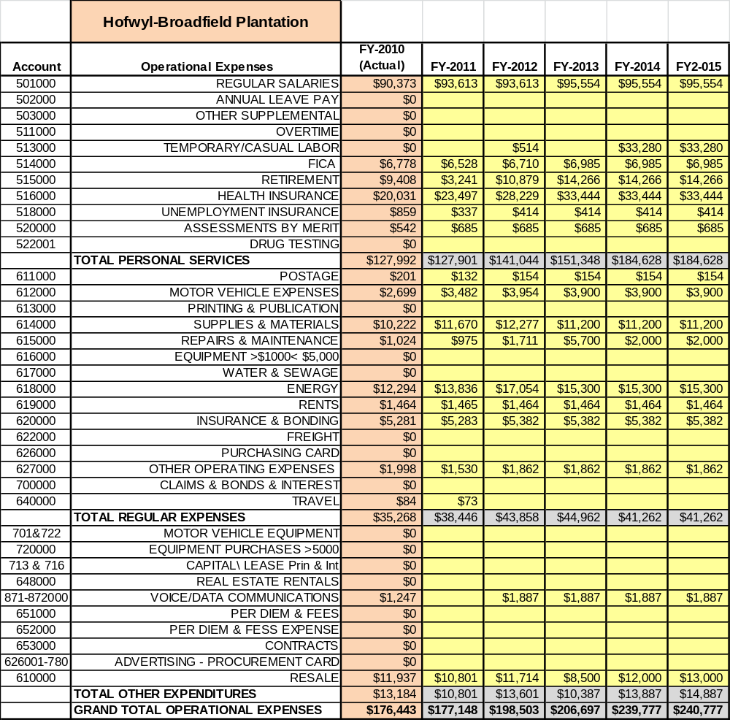

Revenue Pro Forma
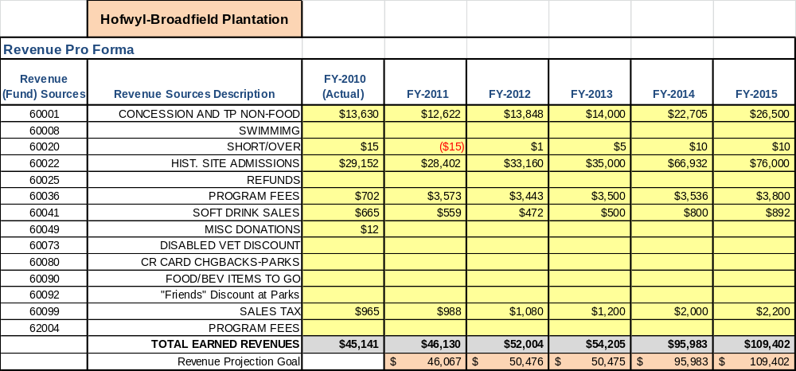

Total / Cost Recovery Pro Forma

Hofwyl-Broadfield Plantation
TOTAL PRO FORMA | FY-2010  (Actual) | FY-2011 | FY-2012 | FY-2013 | FY-2014 | FY-2015
Visitation | 8,054 | 7,493 | 7,132 | 8,000 | 10,000 | 12,886
Operational Expenses | $176,443 | $177,148 | $198,503 | $206,697 | $239,777 | $240,777
Earned Revenues | $45,141 | $46,130 | $52,004 | $54,205 | $95,983 | $109,402
% Cost Recovery | 25.6% | 26.0% | 26.2% | 26.2% | 40.0% | 45.4%

Action Plan
ACTION PLAN
Site: |  | Site Manager: |  |  | Date:
Month:
Strategy | Tasks | Costs / Funding | Revenues / ROI | Responsibilities | Metrics

ACTION PLAN
Site: |  | Site Manager: |  |  | Date:
Month:
Strategy | Tasks | Costs / Funding | Revenues / ROI | Responsibilities | Metrics

