Indian Springs State Park
Business & Management Plan

Prepared June 2011; Finalized February 2013
Direction 2015 – Sustainable Business Planning

Table of Contents

Executive Summary 3

Site and Operations Assessment 7
Site Inventory and Facility Assessment 7
Operational Assessment 9
Financial Performance Assessment 14

Business and Management Plan 17
Business Goals 17
Classification of Programs and Services 18
Partnership Development Plan 19
Marketing and Sales Plan 20
Revenue Generation Plan 22
Expense Management Plan 24
Financial Pro Forma 25

Action Plan 28

Executive Summary
The Parks, Recreation and Historic Sites Division (PRHSD) of the Georgia Department of Natural Resources (DNR) is transitioning the management of Indian Springs State Park to operate more like a business, reflecting the Direction 2015 – Sustainable Business Planning initiative to improve the fiscal performance and management of the state parks and historic sites system. This business and management plan is designed to help the site recover more operating expenses through earned revenues, productive partnerships, and innovative programs.

Site Fact Sheet
Site Name | Indian Springs State Park
Site Manager | Ken Lalumiere
Region Manager | Eric Bentley
Date of Business Plan completion | 11/28/2012
Site size | 523 Acres
Total number of visitors (FY 2010) | 175,442
Total operating budget (FY 2010) | $441,645
Total earned revenues (FY 2010) | $411,153
Operational cost recovery (FY 2010) | 93%
Average operating cost per visitor (FY 2010) | 2.52
Average earned revenue per visitor (FY 2010) | 2.34
Average cost recovery (FY 2008 – 2010) | 85%
Target cost recovery (FY 2015) | 114%
Total full-time employees | 6
Total part-time employees | 6
Primary service markets | Atlanta, Macon, McDonough
Primary attractors/visitor appeal factors | Camping, Cottages, Group Camp, Beach, Spring Water
Leading opportunities for improved site performance | Rebuilding Camping Area 1 to include yurts

Site Summary and Key Attractions
The 523-acre site of Indian Springs State Park is located in a rural setting, roughly 40 miles from two major population centers in Georgia, which are Atlanta and Macon, and 20 miles from Griffin. It is roughly 15 miles from Interstate 75. The relative location of the park should be a positive in trying to achieve the identified cost recovery target.

Key Attractions
The amenities or features listed below are those that seem to be most popular for visitors.
- Cottages
- Camping
- Group Camp
- Picnic Shelters
- Group Shelter
- Beach
- Lake
- Trails
- History: Creek, CCC, Old Hotels

Financial Targets
The table below details the total operating expenses and earned revenues for Indian Springs State Park over the last three years (2008 – 2010). This table also calculates total cost per visitor and revenues per visitor during these operating years, and details the target financial performance goals in the context of achieving at least 75% cost recovery. This table also calculates the necessary change from 2010 operating expenses and revenues.
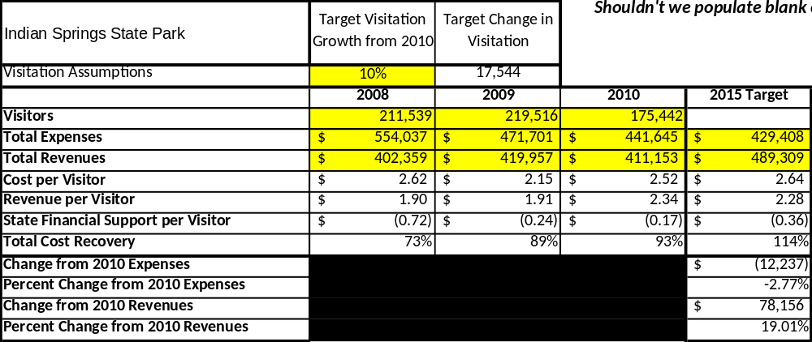

Key Recommendations

Primary / Short Term Recommendations
- Operate the site using cost-based accounting, including the net cost recovery achieved annually.
- Conduct in-park surveys annually to assess how well customer satisfaction levels are being met. Indian Springs State Park should strive to have 90% of visitors responding to ‘Comment Cards’ and reporting that they were either ‘satisfied’ or ‘very satisfied’ (or some comparable metric to be developed). Programs or services that fall below that standard should be critically reviewed, enhanced, and results monitored; those with a history of poor performance should be considered for elimination.
- Evaluate and pursue opportunities to employ concessionaires or private or public service providers on-site if they can be more cost-effective. For example, explore the development of a concessionaire agreement to manage private events on-site.
- Collect a statistically valid sample of ZIP code data from visitors in a non-intrusive way to gauge their origins and demographics (e.g., age, ethnicity, income, etc.) and use the results to improve programming and marketing efforts to appeal to a broader audience.
- Utilize a minimum of four special events annually to help draw more visitors to the site.
- Seek local partners to help support operations, programs and service delivery and for cross-marketing purposes.
- Sustain sufficient non-labor operational funding or reduce staff so that required staff operational costs (with benefits) do not exceed 65% of the total operational budget.
- Enhance facilities and program offerings to provide a minimum of 10 unique experiences for each visitor while maintaining at least a 90% customer satisfaction rating.
- Manage Indian Springs State Park according to well-defined maintenance, program and operational standards monitored and enforced by region managers and senior management.
- Partner with local Chambers of Commerce or other destination marketing organizations (DMOs) to promote Indian Springs State Park.
- Continue to work with the Indian Springs State Park Chapter of the Friends of Georgia State Parks and Historic Sites to help raise funds or provide volunteers for improvements and program support.
- Perform a thorough net cost-of-service analysis on major functions of site operations, including the detailed analysis of labor requirements (by task) that has already been produced by site staff. Thereafter, update costs to deliver services on a biennial schedule.
- Review and update rates at the site on an annual basis to recover the total net cost of service for important and visitor-supported services.
- Track total economic impact of the site on the local communities and region and share with decision-makers, elected officials, local business operators, and others to demonstrate the impact of Indian Springs State Park.
- Develop a more detailed analysis of labor requirements of all major park functions to match the right position with the right job at the right pay.
- Develop funding to provide additional training to site staff for improved business management and marketing effectiveness.
- Construct and upgrade facilities and amenities at the site that are likely to have a cost recovery level at or above 100%.
- Add more youth-focused services, programs and amenities at the site that appeal to younger audiences, families and educational groups.
- Add more services, programs and amenities that appeal to older adults. In 2012 we added a new rental facility for weddings and family reunions. We would like to increase our cable capabilities to offer better service and more channels.
Secondary / Long Term Recommendations
- Improve the recreational amenities of the site to address modern and diverse uses.
- Engage the local community, user groups and private organizations to improve connectivity between High Falls State Park, Dauset Trails Nature Center and Jarrell Plantation Historic Site.
- Improve retail point-of-sale and inventory tracking system. The Division’s retail specialist and our secretary have helped to renovate the retail area and have added new merchandise. The retail area maintains a level of 40% profit throughout the year.

Site and Operations Assessment
This site and operations assessment is a culmination of analyses and findings from a review of the condition of facilities, infrastructure, and operations at Indian Springs State Park. The findings and observations are not intended to be an exhaustive review of all issues present, but provide a basic understanding of the predominant issues that contribute to the site’s current operating conditions. The assessment includes the following:
- Site Inventory and Facility Assessment
- Operational Assessment
- Financial Assessment
Site Inventory and Facility Assessment

Methodology
Facility and asset conditions are rated using a differential scale of excellent, good, fair, or poor. Descriptions of conditions that are attributed to each of these findings are also provided.
Scale of Conditions
Rating | General Description
Excellent | Facilities/amenities are in ‘excellent’ condition when they show little or no maintenance or repair problems. Facilities do not feature any major design or operational issues or flaws that contribute to diminished use or increased maintenance or upkeep. Facilities are easy to clean and maintain in order to place them back into public use and the users perceive them to be in excellent shape.
Good | Facilities/amenities are in ‘good’ condition when they show only minor maintenance or repair problems. Most maintenance issues with these facilities typically appear to be the result of age and/or heavy use. Facilities may only feature minor design or operational issues that contribute to diminished use or increased maintenance or upkeep. Facilities are moderately easy to clean and maintain in order to place them back into service and the users perceive them to be adequate for their use, but probably not in excellent shape.
Fair | Facilities/amenities are in ‘fair’ condition when they show significant maintenance or repair problems. Facilities generally exhibit ongoing maintenance issues that appear to be the result of age, heavy use, or design or operational flaws. Some maintenance and repair needs may compound their fair condition by being deferred because of budget and/or resource limitations. Facilities require more effort to clean and maintain before placing them back into service and the users may perceive them as being less than adequate for their use and in a state of deterioration. The facility or structure may need of major repair or replacement.
Poor | Facilities/amenities are in ‘poor’ condition when they show significant, on-going maintenance or repair problems that ultimately may result in suspended use for repair/replacement. Maintenance and repair issues are possibly the result of poor maintenance and clearly the result of age, heavy use, or design or operational flaws. Problems with the facilities are often compounded over time due to consistently deferred maintenance and repair because of budget and/or resource limitations. Facilities may feature major design or operational issues that contribute to diminished use or increased maintenance or upkeep. Facilities require excessive effort to clean and maintain before placing them back into service and the users often perceive them as being inadequate for their use and in a state of serious deterioration. The facility or structure may need of major repair or replacement.

Inventory and Assessment
The table below is an inventory of facilities and amenities at Indian Springs and provides the assessed condition of each as reviewed in May 2011.
Site Asset / Amenity | Quantity | Condition
Camping Area 1 | 28 | Poor - Closed
Camping Area 2 | 62 | Good
Pioneer | 1 | Fair
Cottages | 10 | Fair
Group Shelter | 1 | Good
Picnic Shelters | 7 | Fair
Day-use Restrooms | 4 | Fair
Comfort Stations | 3 | Good
Beach House | 1 | Poor - Closed except restrooms
Office | 1 | Fair
CCC Buildings/Structures | 6 | Fair
Group Camp Buildings | 10 | Fair (some poor) but being renovated currently
Managers/ SR. Ranger Residence | 2 | Good
Assistant Residence | 1 | Fair
Maintenance Building | 3 | Fair
Mini-golf | 1 | Good
Playground | 3 | Poor/Good

Prioritized Facility Needs
Based on the facility inventory and assessment, these prioritized needs have been identified. Each need has been aligned with a priority category of high, moderate, or low to support future decision-making regarding project sequencing, investment of public resources, and meeting community expectations. The priority assignment for each need is not a measure of importance. Rather, these recommended priorities reflect a phased implementation approach over the next several years.
Facility Need | Priority Assignment
Install Yurts in camping area 1 | High
Remodel cottages 6-10 Bathrooms | High
Remodel Dorms 3 and 4 Bathrooms | High
Beach House renovation to include turning into rental area | Moderate
Install sleeping platforms at Pioneer area to increase revenue | Moderate
Remodel Staff buildings/Infirmary/Craft Buildings QTY 5 | Moderate
Remodel Museum to include updated exhibits | Low
Remodel Dining hall Kitchen | Low

Operational Assessment
The Operational Assessment includes:
- An inventory and classification of programs and services being provided at the site
- A review of staffing at the site
- A review of concessionaires and partners operating at the site
- Visitation and customer satisfaction

Inventory and Classification of Programs and Services
Programs and services are classified into one of three major categories:
1) Core or Essential Services
2) Important Services
3) Visitor Supported Services
Programs and services at the site are classified into these categories based in part on the mission and public mandates for both the site and the agency. For the services in each of these categories, there are financial performance expectations that will define how services are funded and evaluated.

Category 1 – Core Services [Largely supported by tax funds]
Core programs, services and facilities are those the agency must provide and/or are essential in order to capably govern and meet statutory requirements. The failure of the agency to provide Category 1 services at adequate levels could result in significant negative consequences for the public and the resources under protection. The criteria for services to be classified as core or essential are:
- The services are mandated by the agency’s law or charter or are contractually obligated by agreement to provide the services.
- The services are essential to protecting and supporting the public’s health and safety.
- The services protect and maintain valuable assets and infrastructure.
- The services would generally and reasonably be expected and supported by residents, businesses, customers and partners.
- The services are those that cannot or should not be provided by the private sector.
- The services provide a sound investment of public funds.
The following programs and services offered at Indian Springs have been identified as core services:
Active management of the natural / cultural resources of the site in order to protect their integrity

Open and public access to the site and its resources

Site appropriate education, interpretation and recreational opportunities
Effectively manage Indian Springs and the structures located within its boundaries
Public safety
Maintenance of grounds, facilities and infrastructure

Category 2 – Important Services [Supported by a balance of tax funds and earned revenues]
Important programs, services and facilities are those the agency should provide, and are important to governing and effectively serving residents, businesses, customers and partners. Providing Category 2 services expands or enhances the agency’s ability to provide and sustain its core services. The criteria for programs or services to be classified as important are:
- The services expand, enhance or support identified core services.
- The services are broadly supported and utilized by the community, and are considered an appropriate, important, and valuable public good. Public support may be conditional upon the manner by which the services are paid for or funded.
- The services generate income or revenue that offsets some or all of the operating cost and/or are deemed to provide economic, social or environmental outcomes or results.
The following services offered at Indian Springs have been identified as important services:
- Self-guided interpretation and education programs
• Camping, cottages, group camp and pioneer sites used for overnight facilities
• Day-use facilities such as picnic shelters and a group shelter

Category 3 – Visitor Supported Services [Almost exclusively supported by earned revenue]
Visitor supported programs, services and facilities are those discretionary services that the agency may provide when additional funding or revenue exists to offset the cost of providing those services. Category 3 services provide added value above and beyond what is required or expected. The criteria for programs or services to be classified as visitor supported are:
- The services expand, enhance or support core services or important services and the quality of life of the visitors, community or stakeholders.
- The services are supported, valued and well utilized and provide an appropriate and valuable public benefit.
- The services generate income or funding from sponsorships, grants, user fees or other sources that offset some or all of their cost and/or provides a meaningful return on investment.

- The services can possibly be provided through outsourcing or use of concessionaires, providing opportunities for community enterprises that may not otherwise be provided by the agency.

The following services offered at Indian Springs have been identified as visitor supported services:
- Gift shop
- Ranger guided interpretation and elective educational programs
- Special events / programs related to the mission of the site
- Special events / programs not related to the mission of the site or outside the normal programming standards (e.g., wedding receptions, etc.)
• Boat rentals
• Mini-golf rentals

Staffing Assessment
Labor costs at Indian Springs represent the largest area of budgetary expense at an average of 64 % of the total operating budget each year for the last three complete years, which is lower than the target of total labor costs (including benefits) not exceeding 65% of the site’s total operating expenditures. The tables below and on the following page provide a basic review of the current staffing at the site.

Full Time Equivalent Employees
Position / Title | Quantity (FTE) | Vacancies | Annual Hours
Park Manager | 1 | 0 | 2400
Assistant Manager | 1 | 0 | 2400
Sr. Ranger | 1 | 0 | 2400
Enforcement Ranger | 1 | 0 | 2080
Secretary | 1 | 0 | 2080
Utility Worker | 1 | 0 | 2080
TOTAL | 6 | 0 | 13,440

Part Time Employees
Position / Title | Quantity (FTE) | Vacancies | Hours
Office Clerk | 1 | 0 | 1508
Seasonal Maintenance | 2 | 0 | 3016
Part Time Housekeepers | 3 | 0 | 4524
TOTAL | 6 | 0 | 9,048

Labor Support
Labor Support | Annual Hours
Park Pass Attendants | 2200
Volunteers | 450
Community Service Workers | 750
Engineering and Construction Crews | 0
Resource Management Crews | 0
TOTAL | 3,400

Total Labor Hours
Labor Type | Annual Hours
Full Time Equivalent Employees | 13,440
Part Time Employees | 9,048
Labor Support | 3,400
TOTAL Annual Labor Hours | 25,888

Labor Budget Summary

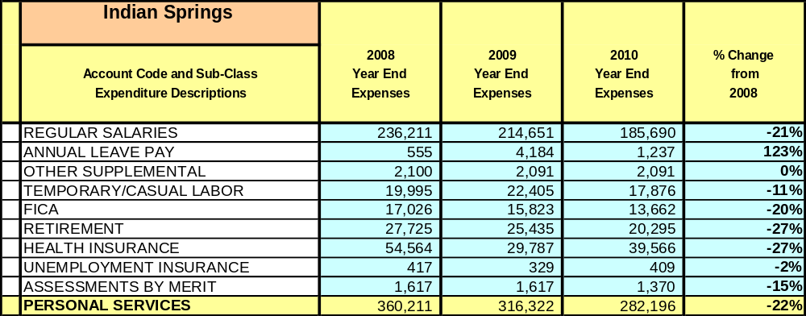

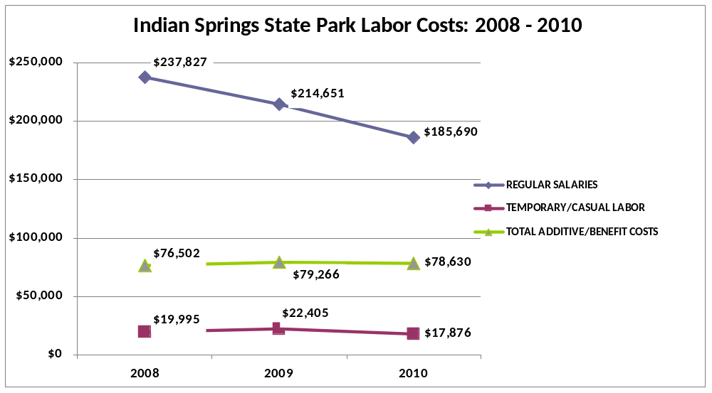

Visitation and Occupancy
Overall annual visitation to the site has trended downward from 2008 to 2010, decreasing by or over 44,074 visitors. This is largely attributed to the economy effecting both the volume of overnight reservations and day-use guests visitation.

Year | Total Visitation
2008 | 211,539
2009 | 219,516
2010 | 175,442

Occupancy for the overnight accommodations at Indian Springs State Park the last three years is detailed in the table below. Overall occupancy has trended downward from 2008 to 2010, decreasing by 6%. The group camp is increasing due to renovation projects.

Year | Camping Occupancy | Cottage Occupancy | Group Camp Occupancy
2008 | 22.85% | 41.70% | 25%
2009 | 23.20% | 38.94% | 31%
2010 | 20.23% | 35.82% | 33%

Customer Service and Satisfaction

Site | Year | Customer Satisfaction Level
Indian Springs | 2009 | 75%
Indian Springs | 2010 | 80%
Financial Performance Assessment

Operational Expenses
A summary of total operating expenses at Indian Springs State Park from 2008 to 2010, as well as their percent change from 2008 is provided in the table below.
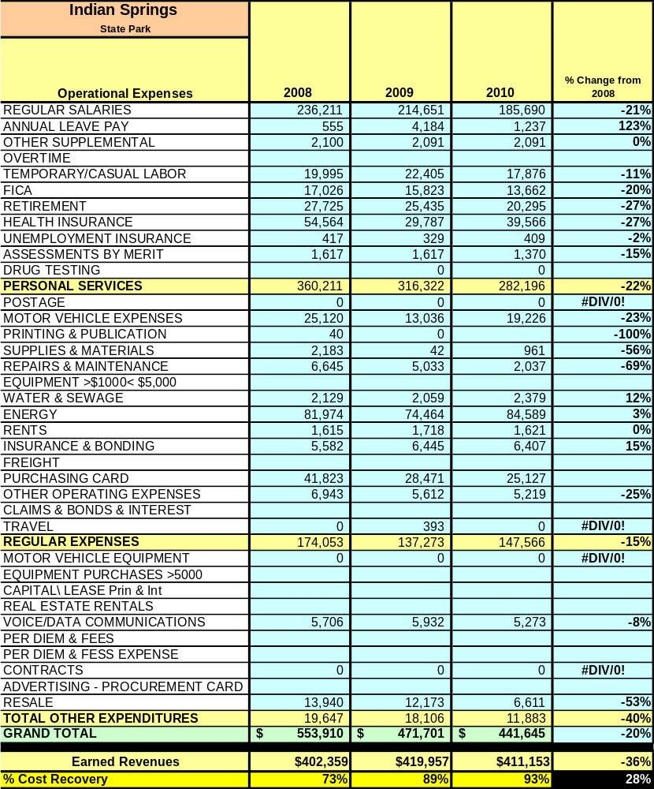

Earned Revenues
Earned revenues at Indian Springs have increased since 2008, which is largely attributed to the corresponding increase in rates
Monthly earned revenues for the last two years (see table on the following page) indicate that the total annual revenue increased by 4% from 2009 to 2010, with the largest increases in monthly revenues in November (12%) and February (15%).

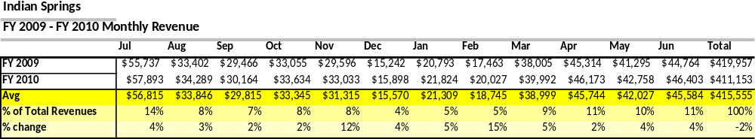

The graphs below illustrate the monthly revenue trends each year and the average percent of total annual revenue earned each month.
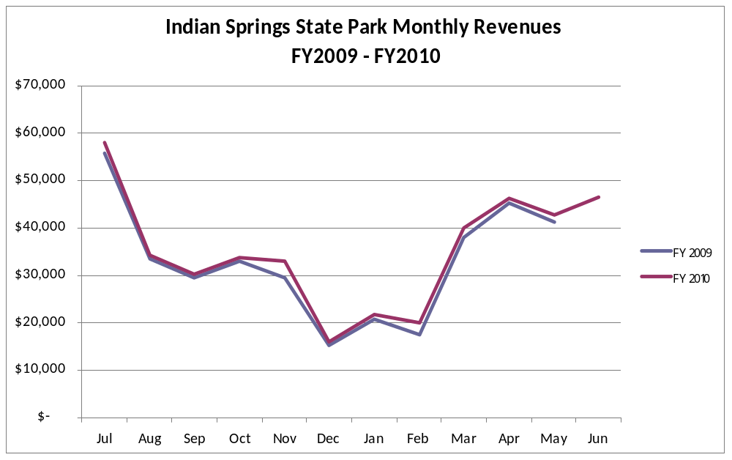

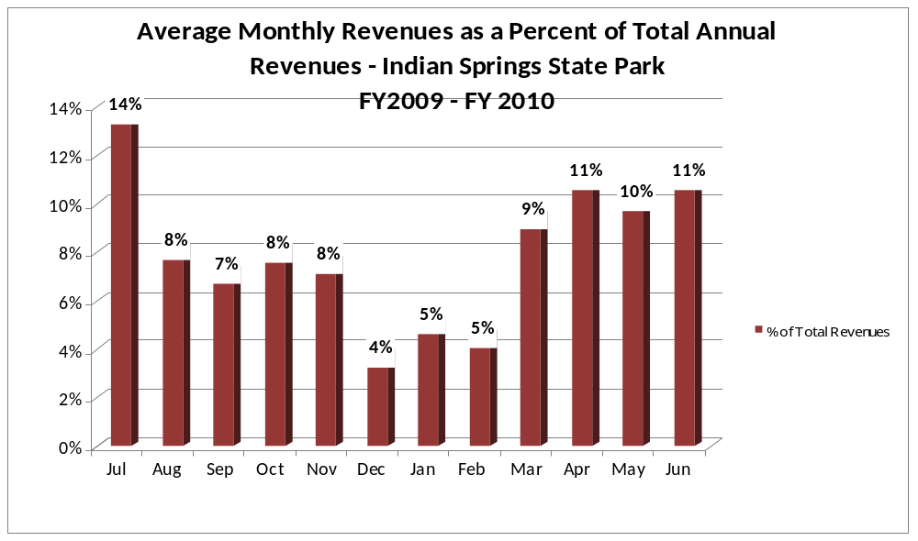
Cost Recovery Trends
Indian Springs has achieved an average cost recovery of 86% of annual operational expenses through earned revenues from FY 2008 to FY 2010. This is detailed and illustrated in the table and graph below.
Year | Operational  Expenses | Earned  Revenues | Percent Cost  Recovery
2008 | $554,037 | $402,359 | 72%
2009 | $471,701 | $419,957 | 89%
2010 | $441,645 | $411,153 | 93%
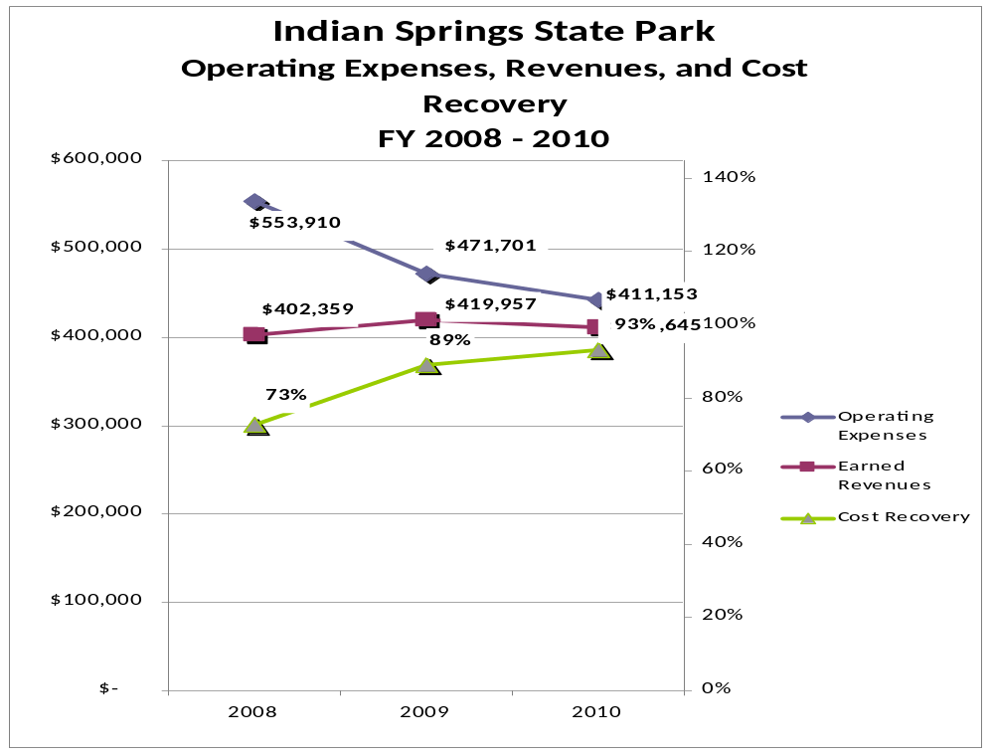

Review of Pricing
Data on rate information is available as far back as 2002, but only the last five years are evaluated. There has been notable growth in fees charged at Indian Springs State Park since 2005, with the largest increase being FY2010. A table detailing the rates for Indian Springs State Park is provided below.

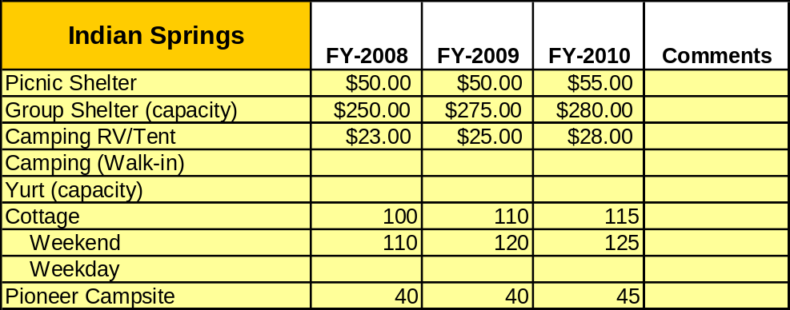
Business and Management Plan

Business Goals
The following goals serve as the foundation for the key recommendations and strategies in this business plan for Indian Springs State Park.

Enhance Cost Recovery of Site Operations
Indian Springs State Park is operating at 93% cost recovery of operational expenses through earned revenues.

Enhance Revenue Generation Strategies
Special events should be used to attract visitors when the staffing level increases. The events should be geared toward events that will encourage guests to stay overnight in our facilities. Special attention should also be given to marketing the group shelter as a rentable meeting facility. The park staff should also market specialty facilities such as the stone pavilion for weddings. Strong consideration should be given to competitive pricing and bundling of services such as renting the group shelter and stone pavilion on the same day and getting a discount.

Expand Special Events at the Site
The special events at Indian Springs State Park have been very limited over the past five years due to not having a full time or steady seasonal naturalist, although the Tri-the-Parks Triathlon has been held. The park’s location makes it ideal for hosting special events. However, the staff will need to be in place or the park should partner with other agencies to produce the desired special events.

Improve the Diversity and Innovation of Recreational and Interpretive Programs
The interpretation of the site has been drastically limited due to the low level of staff. Indian Springs, having so much natural and cultural diversity, could benefit from a full-time interpretive ranger to help bring visitors to the park. The site could start partnering with a bike club to offer races and how to mountain bike classes.

Improve the Effectiveness of Marketing and Sales
The effectiveness of marketing at Indian Springs State Park could be drastically improved by targeting the specific markets that we serve. The use of billboards along the interstate as you near the park exit would be a great help to sales. A good percentage of the customer base at the site comes from walk-ins off the interstate. Attention should be directed to marketing the experience of Indian Springs State Park and the added benefits of nature and security that cannot be found at the other local campgrounds.

Establish Greater Consistency of Managing and Monitoring Customer Service & Satisfaction
Indian Springs State Park should strive to maintain a customer satisfaction rating of at least 90%. However, there is not a mechanism in place to accurately track the numeric values of the satisfaction level of the customers served at the site. A tracking system should be established to help accurately track these ratings. The customer should be offered a small discount to make it advantages for them to take the time to turn in their opinions on the site and the services provided.

Expand Partnership Opportunities
The opportunities for partnerships are limitless in the Indian Springs area. The Friends of Indian Springs State Park Chapter is beginning to gain momentum in the community. They will be a great source for funds, service and partnership opportunities. A great deal of progress could be made through reaching out to local non-profit organizations such as Dauset Trails Nature Center.

Classification of Programs and Services
The tables below summarize the classifications of programs and services at Indian Springs as either core, important, or visitor supported and projects a range of cost recovery percentages that might be achieved for each. These classifications establish financial performance goals for each category of services that are linked to the recommendations and strategies of this business plan.

Core Services
Program / Service | Target Cost Recovery
Active management of the natural and cultural resources of the site in order to protect their integrity | 0%
Open and public access to the site and its resources | 0%
Site appropriate education, interpretation and recreational opportunities | 100%
Effectively manage Indian Springs and the structures located within its boundaries | 10%
Public safety | 0%
Maintenance of grounds, facilities and infrastructure | 0%

Important Services
Program / Service | Target Cost Recovery
Self-guided interpretation and education programs | 50%
Camping, group camp, cottages, pioneer sites to be used for overnight facilities at the site | 125-150%
Day-use facilities such as picnic shelters and a group shelter | 125-150%

Visitor Supported
Program / Service | Target Cost Recovery
Gift shop | 100%-125%
Ranger guided interpretation and elective educational programs | 100-125%
Special events / programs related to the mission of the site | 100-125%
Special events / programs not related to the mission of the site or outside the normal programming standards (e.g., wedding receptions, etc.) | 100%-125%
Boat rentals | 100%-125%
Mini-golf rentals | 100%-125%

Partnership Development Plan
The table below summarizes existing partners and targeted partnerships by classification (operational, vendor, service, co-branding, funding partners) and by organizational type.
 | Public Partners | Not-for-profit Partners | Private / Enterprise Partners
Operational Partners | - Butts County Sheriffs Office and EMS  - Flovilla Fire Dept.  - City of Jackson | - Dauset Trails Nature center  - Friends of Indian Springs | - Sweet Shop at Village
Vendor Partners |  |  | - Coca-Cola
Service Partners |  | - Butts County Chamber of Commerce
Co-branding Partners | - High Falls State Park  - Jarrell Plantation Historic Site
Funding Resource Development Partner |  | - Friends of Indian Springs

Marketing and Sales Plan

Marketing and Sales Goals
Marketing and sales goals for Indian Springs State Park are based on the following desired outcomes:
- Increase campsite, cottage and group camp rentals by 5%-10% over the next few years through extended stay discounts and package deals.
- Increase day-use rentals by 5%-10% over the next few years through advertising our meeting facilities for special events such as weddings. Also, do away with free shelters when not rented, charge half price if being used.
In order to meet these goals, examples of specific target outcomes were identified in the areas detailed in the table below.
Area  of Focus | Current  Performance | Goal  by 2011 | Goal  by 2012 | Goal  by 2015
Camping | 20% | 25% | 25% | 30%
Cottages | 35% | 35% | 35% | 40%
Day use Rental | 9% | 12% | 15% | 15%

Marketing and Promotion Strategies

Publicity and Social Media
Indian Springs State Park will approach marketing and publicity planning using the following guidelines and themes:
- Event publicity
Major events benefit by having short stories in local, regional, and statewide newspapers and online social media hooks planted that run three to four weeks in advance of the event up to the date of the event itself. Stories and media need to be cultivated with contacts and online sales channels several weeks in advance of the time the stories need to run. Special interest interviews on morning, noon, and evening television news programs, radio interviews on popular rush-hour programs, and blogs on known affinity online sites should also be included.
- Program publicity
Special and unique programs should have feature stories in magazines, local and regional weekly newspapers, and statewide daily newspapers that are aimed at placements as front-page or sectional front-page stories. These stories are most effective if they run shortly before the season that the featured program begins. This will likely require several weeks of advanced planning with media contacts. Similar coverage on television and radio should also be considered. If pre-publicity cannot be generated, post-publicity can help promote future programs.
- Site Publicity
Site publicity focusing on a single site or sub-set of sites requires more intense planning efforts to attract multiple writers and editors from target publications. Each site could host several seasonal media familiarization tours (with 10 to 15 writers or editors) to familiarize them with the site and its benefits and amenities. Stories and features resulting from such tours typically take between two and six months to materialize so the tours should focus on experiences, benefits, and programs that would be available when the stories are expected to run.
Examples and suggested opportunities for events, programs and related publicity efforts based on the themes described above at Indian Springs are provided in the table below.

Event Publicity | Program Publicity | Site Publicity
Triathlon | Trail walk | Cottage packages
Fishing rodeo | Bike ride | Friends Group
Bike Race
Jr. Rangers

Packaging
Examples and suggested packages for Indian Springs are provided in the table below.

Package | Package Details
Camping Package | Stay three nights get free boat rental or mini golf free
Cottage Package | Stay three nights and get 10% off admission to Jarrell Plantation
Wedding package | Rent both the group shelter and Stone Pavilion same day get 20 Park Passes free

Group Sales
Types of groups within which specific target customers can be identified for Indian Springs are listed below:
- Weddings | - Interstate traffic | - Extended stay workers

Incentivizing New and Repeat Visitation
Indian Springs will utilize the following strategies and/or incentives to encourage new and repeat visitation starting in FY 2012:
- Camping Club for repeat visitors
- Group camp incentives for groups who can help with repair work
- Encourage more weddings
- Extended stay workers or guests during non-peak time

Marketing and Sales Metric Goals
The following marketing and sales metric goals and/or others will be monitored and progress reported at Indian Springs State Park:
- Loyalty and repeat customers = 60% repeat customers.
- Brand confidence & customers recruiting customers = 20% of new customers recruited by previous customers.
Revenue Generation Plan
Revenue / Cost Recovery Goals
Indian Springs State Park has set a financial goal of increasing annual revenues 2-3% annually between 2012 and 2015. The largest revenue growth opportunity is most likely cottages, Camping, and group camp. The table below details projected revenue growth leading up to 2015, based upon a nominal growth of revenues each year.
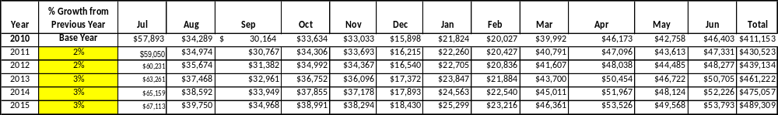

These projections would result in a total of 19% cumulative growth in total annual revenues between FY2010 and FY2015. If operational expenses can be managed with a cumulative reduction of 3% between FY 2010 and FY 2015, then the overall cost recovery of the site will be approximately 114% in FY 2015 at these projected revenue levels. This is higher than the annual financial performance of the site in FY 2010, which was operated at 93% cost recovery in that year.
Revenue Generation Strategies

Pricing Plan
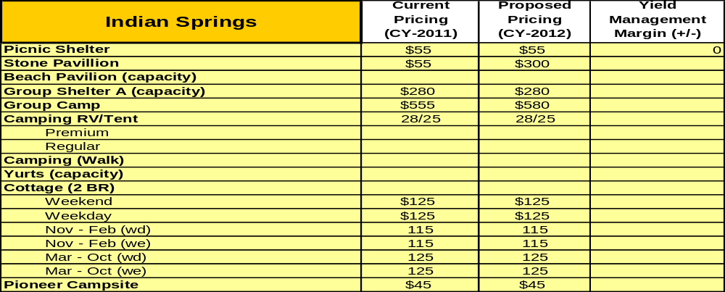
Innovative Programming and Special Events Plan
Program / Event | Theme / Purpose | Scheduled Date/Season | Frequency | Target Participation | Target User Fee | Target Cost Recovery
Fishing Rodeo |  | July | Yearly | Kids | Parkpass | None
Triathlon |  | June
Santa Program |  | December | Yearly | Kids | Parkpass | None Sponsored by friends group

Partnerships and Concessions Plan
Service / Partnership | Term of Service | Financial Objective | Contract Manager
Local Sweet Shop | 1yr | 10% | Park Manager

Expense Management Plan
Personnel Assignments
The following actions will be taken to proactively manage labor costs via personnel assignments and classifications.

Action | Timeline | Outcome
Eliminate one vacant full-time maintenance position | FY2012 | Eliminate over $22,400 in salaries and benefits.
Eliminate two filled full-time housekeeping position | FY2012 | Eliminate over $44,800 in salaries and benefits.

Management Techniques
The following actions will be taken to proactively manage labor costs via management techniques.

Action | Timeline | Outcome
Hire 2 additional part-time maintenance workers and housekeepers as needed for peak periods. | As needed | Reduce time to hire the employee and save money on salaries and benefit packages

Adjusted Levels of Service
The following actions will be taken to proactively manage labor costs via reduced levels of service.

Action | Timeline | Outcome
Reduce ground maintenance upkeep and projects. | As needed | Reduce operating expenditures of equipment maintenance and fuel cost
Close day-use/campground bathrooms until busy days when needed. | Effective now | Reduce operating expenditures of power and water cost

Financial Pro Forma
The following five-year financial pro forma projects operating expenses, earned revenues and cost recovery through FY 2015. These pro forma are based on the strategies and desired outcomes identified in this business plan, especially the revenue generation and expense management plans, and are linked to corresponding performance goals.

Expense Pro Forma
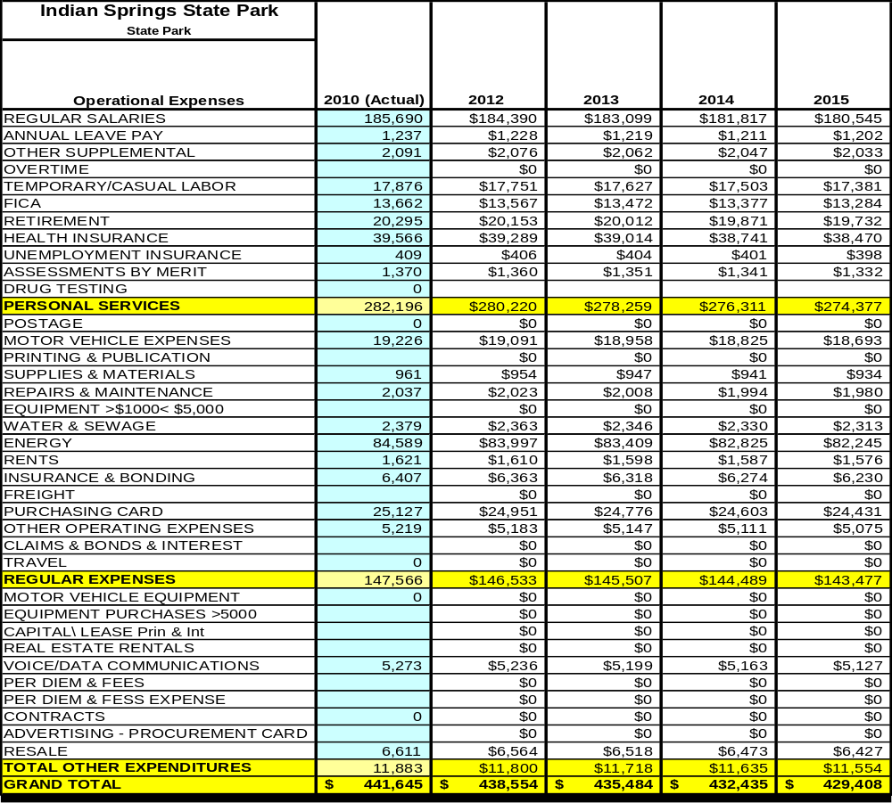

Revenue Pro Forma
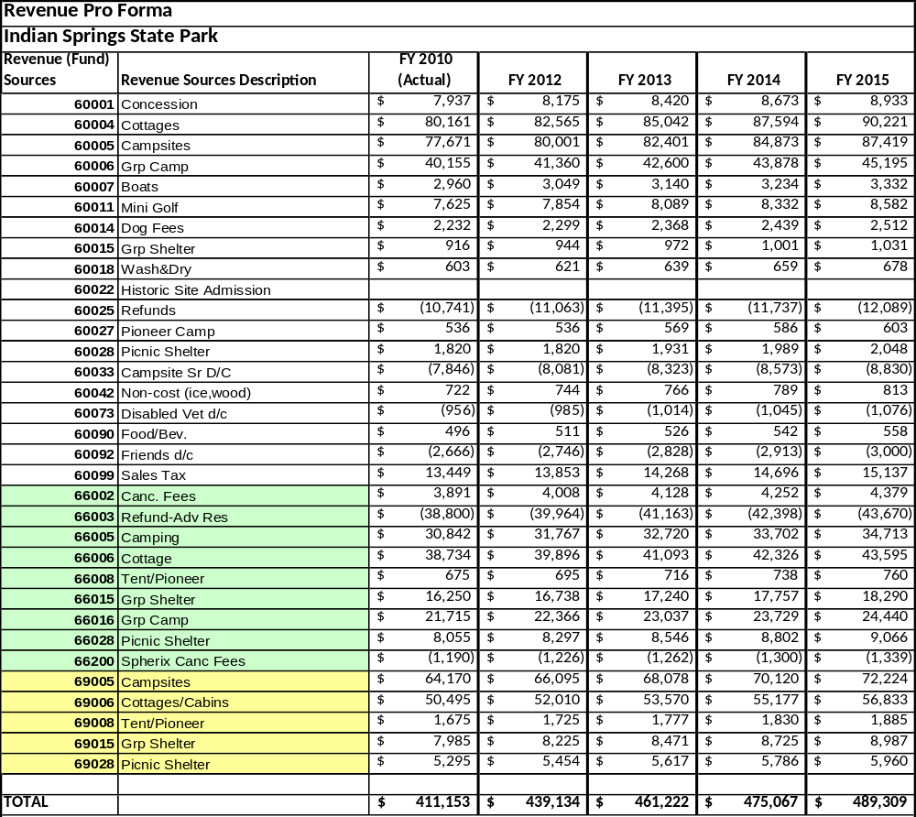

Total / Cost Recovery Pro Forma
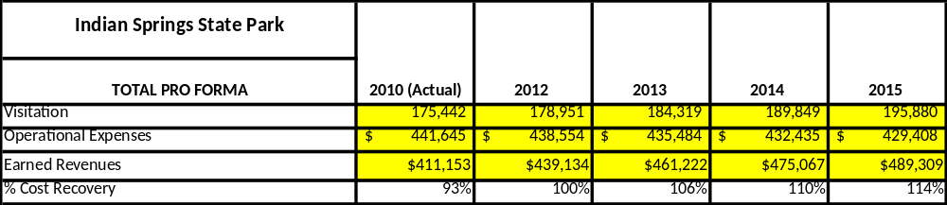

Action Plan
ACTION PLAN
Site: |  | Site Manager: |  |  | Date:
Month:
Strategy | Tasks | Costs / Funding | Revenues / ROI | Responsibilities | Metrics

ACTION PLAN
Site: |  | Site Manager: |  |  | Date:
Month:
Strategy | Tasks | Costs / Funding | Revenues / ROI | Responsibilities | Metrics

This is the average of the last three years – FY 2008, FY 2009, and FY 2010
Current employees, not including vacancies.
Current employees, not including vacancies.
Major population centers within a two-hour drive from the site

