James H. Floyd State Park
Business & Management Plan

Prepared June 2011; Finalized February 2013
Direction 2015 – Sustainable Business Planning

Table of Contents

Executive Summary 3

Site and Operations Assessment 7
Site Inventory and Facility Assessment 7
Operational Assessment 9
Financial Performance Assessment 14

Business and Management Plan 17
Business Goals 17
Classification of Programs and Services 19
Partnership Development Plan 20
Marketing and Sales Plan 21
Revenue Generation Plan 23
Expense Management Plan 25
Financial Pro Forma 26

Action Plan 28

Executive Summary
The Parks, Recreation and Historic Sites Division (PRHSD) of the Georgia Department of Natural Resources (DNR) is transitioning the management of James H. “Sloppy” Floyd State Park (JHF) to operate more like a business, reflecting the Direction 2015 – Sustainable Business Planning initiative to improve the fiscal performance and management of the state parks and historic sites system. This business and management plan is designed to help the site recover more operating expenses through earned revenues, productive partnerships, and innovative programs.

Site Fact Sheet
Site Name | James H. “Sloppy” Floyd State Park
Site Manager | Will Wagner
Region Manager | Joe Yeager
Date of Business Plan completion | May 8, 2011
Site size | 561 acres
Total number of visitors (FY 2010) | 101,034
Total operating budget (FY 2010) | $237,073
Total earned revenues (FY 2010) | $169,822
Operational cost recovery (FY 2010) | 72%
Average operating cost per visitor (FY 2010) | $2.35
Average earned revenue per visitor (FY 2010) | $1.68
Average cost recovery (FY 2008 – 2010) | 70%
Target cost recovery (FY 2015) | 83%
Total full-time employees | 3
Total part-time employees | 2
Primary service markets | Chattanooga, TN, Rome and Atlanta, GA
Primary attractors/visitor appeal factors | Cabins, camping, managed fishing lakes and hiking
Leading opportunities for improved site performance | Expansion of cottages, developed trail system

Site Summary and Key Attractions
The 561-acre site of JHF is located in a rural setting, roughly 50 miles from major population centers like Chattanooga, Tennessee and 25 miles from Rome, Georgia. It is roughly 30 miles from Interstate 75 and Interstate 59. The relative isolation of JHF will prove a challenge to achieving the cost recovery target for FY 2015 in this business plan.

Key Attractions
The amenities or features listed below are those that seem to be most popular for visitors.
- Fishing Lakes
- Cottage Rentals
- Camping
- Hiking
- Boat Rentals
- Interpretive Events and Special Programs

Financial Targets
The table below details the total operating expenses and earned revenues for James H. Floyd State Park over the last three years (2008 – 2010). This table also calculates total cost per visitor and revenues per visitor during these operating years, and details the target financial performance goals in the context of achieving at least 75% cost recovery. This table also calculates the necessary change from 2010 operating expenses and revenues.
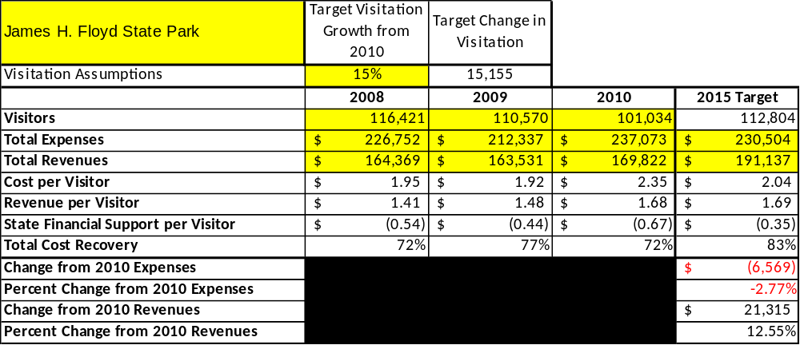

Key Recommendations

Primary / Short Term Recommendations
- Conduct in-park surveys monthly to assess how well customer satisfaction levels are being met. JFH should strive to have 90% of visitors responding to ‘Comment Cards’ report that they were either ‘satisfied’ or ‘very satisfied’ (or some comparable metric to be developed). Programs or services that fall below that standard should be critically reviewed, enhanced, and results monitored; those with a history of poor performance should be considered for elimination.
- Utilize a minimum of four special events annually to help draw more visitors to the site. These will include the Lucky Clover Cruise In, Twisted Ankle Marathon, Outdoor Adventure Day, Taylor Ridge Jamboree and the Lakeside Light Show.
- Seek local partners to help support operations, programs, and service delivery and for cross-marketing purposes. This has been addressed to include local clubs, individuals and boy scouts.
- Manage James H. Floyd according to well-defined maintenance, program and operational standards monitored and enforced by region managers and senior management. This maintenance will include assistance from local DNR partners such of the fish hatchery to maintain a thriving lake habitat and boost visitation.
- Partner with local Chambers of Commerce or other destination marketing organizations (DMOs) to promote JHF. Have a goal that the local Chamber, Optimist and Rotary Clubs meet here at least once a year. Use this opportunity to generate/build partnerships and promote business.
- Continue to work with the JHF Chapter of the Friends of Georgia State Parks and Historic Sites to help raise funds or provide volunteers for improvements and program support.
- Review and update rates at the site on an annual basis to recover the total net cost of service for important and visitor-supported services. Possibly cut cost in concessions, firewood and ice in category.
- Track total economic impact of the site on the local communities and region and share with decision-makers, elected officials, local business operators, and others to demonstrate the impact of JFH. Maintain a good relationship with the sole county commissioner and sheriff.
- Develop funding to provide additional training to site staff for improved business management and marketing effectiveness. Search out grants in order to fund particular projects.
- Construct and upgrade facilities and amenities at the site that are likely to have a cost recovery level at or above 100%. Suggestions include managing fishing lakes, enhancing signage throughout the site and at its entrance, enhancing native landscaping, updating interpretive displays and exhibits, and providing free Wi-Fi at the site.
- Add more youth-focused services, programs and amenities at the site that appeal to younger audiences, families and educational groups, such as the First Time Camper program and Backpacking 101.
- Add more services, programs and amenities that appeal to older adults.

Secondary Recommendations
- Improve the recreational amenities of the site to address modern and diverse uses. Improve the experience of hiking the trails or seeing the historical Marble Mine.
- Engage the local community, user groups, local government, Finster’s Museum and private organizations to improve connectivity between surrounding attractions and James H. Floyd.
- Install an improved retail point-of-sale and inventory tracking system.

Site and Operations Assessment
This site and operations assessment is a culmination of analyses and findings from a review of the condition of facilities, infrastructure, and operations at James H. Floyd State Park. The findings and observations are not intended to be an exhaustive review of all issues present, but provide a basic understanding of the predominant issues that contribute to the site’s current operating conditions. The assessment includes the following:
- Site Inventory and Facility Assessment
- Operational Assessment
- Financial Assessment
Site Inventory and Facility Assessment

Methodology
Facility and asset conditions are rated using a differential scale of excellent, good, fair, or poor. Descriptions of conditions that are attributed to each of these findings are also provided.
Scale of Conditions
Rating | General Description
Excellent | Facilities/amenities are in ‘excellent’ condition when they show little or no maintenance or repair problems. Facilities do not feature any major design or operational issues or flaws that contribute to diminished use or increased maintenance or upkeep. Facilities are easy to clean and maintain in order to place them back into public use and the users perceive them to be in excellent shape.
Good | Facilities/amenities are in ‘good’ condition when they show only minor maintenance or repair problems. Most maintenance issues with these facilities typically appear to be the result of age and/or heavy use. Facilities may only feature minor design or operational issues that contribute to diminished use or increased maintenance or upkeep. Facilities are moderately easy to clean and maintain in order to place them back into service and the users perceive them to be adequate for their use, but probably not in excellent shape.
Fair | Facilities/amenities are in ‘fair’ condition when they show significant maintenance or repair problems. Facilities generally exhibit ongoing maintenance issues that appear to be the result of age, heavy use, or design or operational flaws. Some maintenance and repair needs may compound their fair condition by being deferred because of budget and/or resource limitations. Facilities require more effort to clean and maintain before placing them back into service and the users may perceive them as being less than adequate for their use and in a state of deterioration. The facility or structure may need of major repair or replacement.
Poor | Facilities/amenities are in ‘poor’ condition when they show significant, on-going maintenance or repair problems that ultimately may result in suspended use for repair/replacement. Maintenance and repair issues are possibly the result of poor maintenance and clearly the result of age, heavy use, or design or operational flaws. Problems with the facilities are often compounded over time due to consistently-deferred maintenance and repair because of budget and/or resource limitations. Facilities may feature major design or operational issues that contribute to diminished use or increased maintenance or upkeep. Facilities require excessive effort to clean and maintain before placing them back into service and the users often perceive them as being inadequate for their use and in a state of serious deterioration. The facility or structure may need of major repair or replacement.

Inventory and Assessment
The table below is an inventory of facilities and amenities at James H. Floyd State Park, and provides the assessed condition of each as reviewed in May 1rst, 2011.

Site Asset / Amenity | Quantity | Condition
Total Acreage | 561 | Good
Park Office Area | 1 | Poor
Campground Sites | 25 | Good
Campground Comfort Station | 1 | Fair/Poor
Campground Playground | 1 | Good
Cottages | 4 | Good
Linen House | 1 | Good
Shelters | 4 | Good
Maintenance Complex | 1 | Fair
Pole Barn / Shed | 1 | Fair
Manager’s Residence | 1 | Good
Ranger’s Residence | 1 | Good
Day Use Playground | 1 | Excellent
Day Use Picnic Area | 1 | Good
Day Use Bathroom Facilities | 1 | Good
Boardwalk | 1 | Good
Boat Dock | 1 | Poor
Handicap Fishing Dock | 1 | Good
Pioneer Campground Shelters | 4 | Good

Prioritized Facility Needs
Based on the facility inventory and assessment, these prioritized needs have been identified. Each need has been aligned with a priority category of high, moderate, or low to support future decision making regarding project sequencing, investment of public resources, and meeting community expectations. The priority assignment for each need is not a measure of importance. Rather, these recommended priorities reflect a phased implementation approach over the next several years.

Facility Need | Priority Assignment
New Lower Lake Day Use / Pioneer Bathroom | HIGH
New / Enlarge Park Office / Nature Center | HIGH
Campground Comfort Station Renovated | HIGH
New Upper Lake Boat Storage & Shelter | HIGH
New Lower Lake Boat Storage & Shelter | HIGH
Lower Lake Boat Dock | HIGH
Native Plant / Drought Tolerant Landscaping | HIGH
New Pinhoti Trail Scenic Overlook | MODERATE
New Group Shelter | MODERATE
Create Nature Trail | LOW

Operational Assessment
The Operational Assessment includes:
- An inventory and classification of programs and services being provided at the site
- A review of staffing at the site
- A review of concessionaires and partners operating at the site
- Visitation and customer satisfaction

Inventory and Classification of Programs and Services
Programs and services are classified into one of three major categories:
1) Core or Essential Services
2) Important Services
3) Visitor Supported Services
Programs and services at the site are classified into these categories based in part on the mission and public mandates for both the site and the agency. For the services in each of these categories, there are financial performance expectations that will define how services are funded and evaluated.

Category 1 – Core Services [Largely supported by tax funds]
Core programs, services and facilities are those the agency must provide and/or are essential in order to capably govern and meet statutory requirements. The failure of the agency to provide Category 1 services at adequate levels could result in significant negative consequences for the public and the resources under protection. The criteria for programs or services to be classified as core or essential are:
- The services are mandated by the agency’s law or charter or are contractually obligated by agreement to provide the services.
- The services are essential to protecting and supporting the public’s health and safety.
- The services protect and maintain valuable assets and infrastructure.
- The services would generally and reasonably be expected and supported by residents, businesses, customers and partners.
- The services are those that cannot or should not be provided by the private sector.
- The services provide a sound investment of public funds.
The following programs and services offered at James H. Floyd State Park have been identified as core services:
- Active management of the natural resources and fishing lakes of the site in order to protect their native diversity game fish populations
- Open and public access to the site and its resources
- Site appropriate recreational opportunities
- Public safety on the grounds
- Maintenance of the grounds, facilities and infrastructure
Category 2 – Important Services [Supported by a balance of tax funds and earned revenues]
Important programs, services and facilities are those the agency should provide, and are important to governing and effectively serving residents, businesses, customers and partners. Providing Category 2 services expands or enhances the agency’s ability to provide and sustain its core services. The criteria for programs or services to be classified as important are:
- The services expand, enhance or support identified core services.
- The services are broadly supported and utilized by the community, and are considered an appropriate, important, and valuable public good. Public support may be conditional upon the manner by which the services are paid for or funded.
- The services generate income or revenue that offsets some or all of the operating cost and/or are deemed to provide economic, social or environmental outcomes or results.
The following services offered at James H. Floyd State Park have been identified as important services:
- Support of researchers for natural resource studies
- Provide environmental educational services for the public
- Provide outdoor recreation opportunities at a minimal cost
- Supply an area for day use, grilling and picnicking
- Offer an area for large group camping

Category 3 – Visitor Supported Services [Almost exclusively supported by earned revenue]
Visitor supported programs, services, and facilities are those discretionary services that the agency may provide when additional funding or revenue exists to offset the cost of providing those services. Category 3 services provide added value above and beyond what is required or expected. The criteria for programs or services to be classified as visitor supported are:
- The services expand, enhance or support core services or important services and the quality of life of the visitors, community or stakeholders.
- The services are supported, valued and well utilized and provide an appropriate and valuable public benefit.
- The services generate income or funding from sponsorships, grants, user fees or other sources that offset some or all of their cost and/or provides a meaningful return on investment.

- The services can possibly be provided through outsourcing or use of concessionaires, providing opportunities for community enterprises that may not otherwise be provided by the agency.
The following services offered at James H. Floyd have been identified as visitor supported services:
- Gift shop / retail
- Cottages
- Campground
- Shelter rentals
- Boat rentals

Staffing Assessment
Labor costs at James H. Floyd State Park represent the largest area of budgetary expense at an average of 71% of the total operating budget each year for the last three complete years, which is higher than the target of total labor costs (including benefits) not exceeding 65% of the site’s total operating expenditures. The tables below and on the following page provide a basic review of the current staffing at the site.

Full Time Equivalent Employees
Position / Title | Quantity (FTE) | Vacancies | Annual Hours
Parks Facility Management Specialist | 1 | 0 | 2320
Parks/Golf Maintenance Technician | 1 | 0 | 2200
Clerk | 1 | 0 | 2080
Food Service Worker | 0 | 1 | 2080
TOTAL | 3 | 1 | 8,680

Part Time Employees
Position / Title | Quantity (FTE) | Vacancies | Hours
Housekeeper | 1 | 0 | 1508
Grounds Maintenance Worker | 1 | 0 | 1508
TOTAL | 2 | 0 | 3,016

Labor Support
Labor Support | Annual Hours
Volunteers | 1248
Community Service Workers | 240
Engineering and Construction Crews | 40
Resource Management Crews | 0
TOTAL | 1,528

Total Labor Hours
Labor Type | Annual Hours
Full Time Equivalent Employees | 8,680
Part Time Employees | 3,016
Labor Support | 1,528
TOTAL Annual Labor Hours | 13,224

Labor Budget Summary
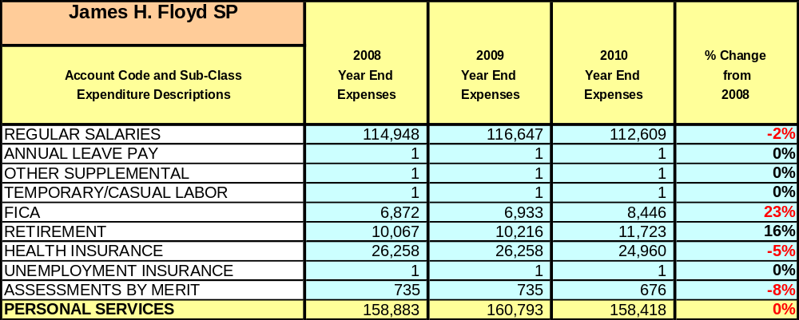
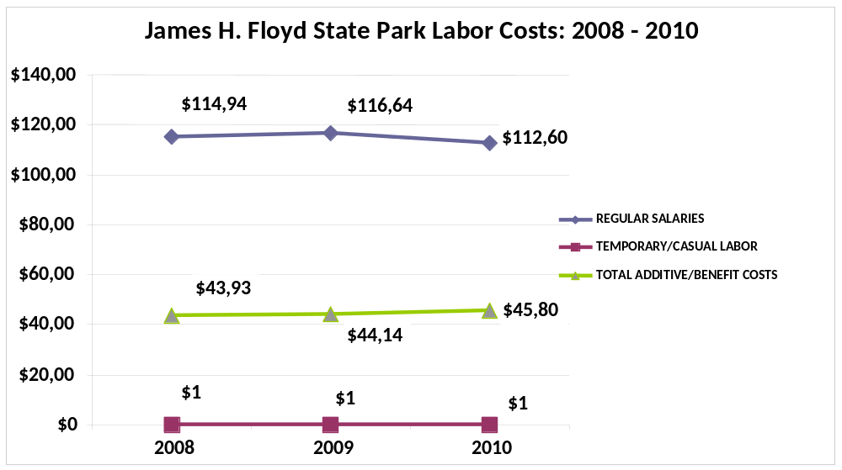

Visitation and Occupancy
Overall annual visitation to the site has trended downward from 2008 to 2010, decreasing 15,377 visitors. This is largely attributed to the economy.

Year | Total Visitation
2008 | 116,411
2009 | 110,570
2010 | 101,034

Occupancy for the overnight accommodations at James H. Floyd the last three years is detailed in the table below. Overall occupancy has trended downward from 2008 to 2010, decreasing by 7.9%. This is largely attributed to the economy.

Year | Campground Occupancy | Cabin Occupancy | Pioneer Occupancy | Shelter Occupancy
2008 | 32.48% | 49.35% | N/A | N/A
2009 | 31.99% | 44.18% | N/A | N/A
2010 | 29.18% | 36.84% | N/A | N/A

Customer Service and Satisfaction

Site | Year | Customer Satisfaction Level
James H. Floyd State Park | 2009 | 55%
James H. Floyd State Park | 2010 | 77%

Financial Performance Assessment

Operational Expenses
A summary of total operating expenses at James H. Floyd from 2008 to 2010, as well as their percent change from 2008 are provided in the table below.
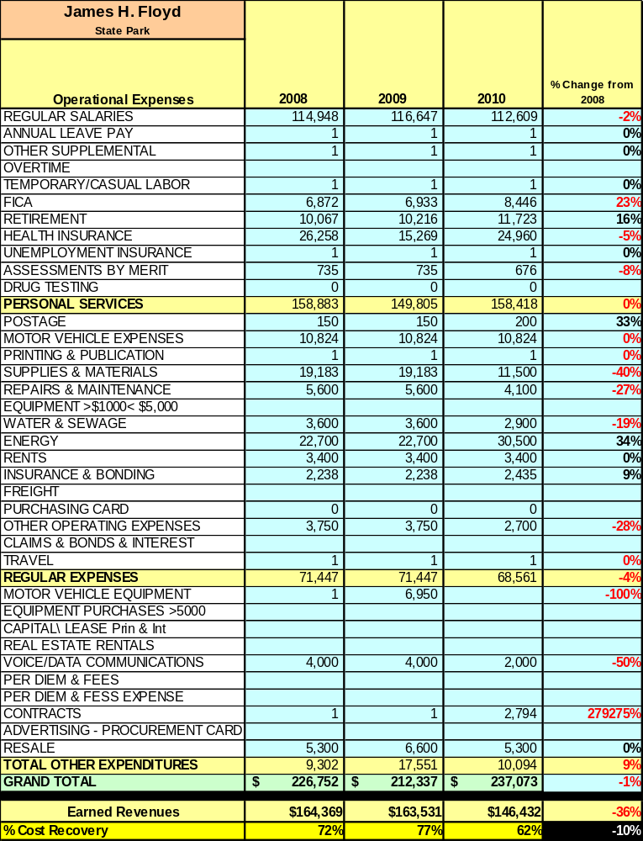

Earned Revenues
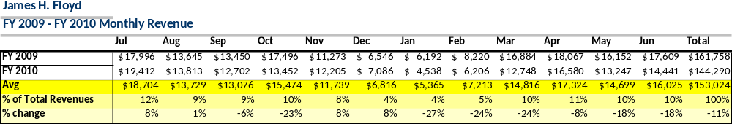
Earned revenues at JHF have decreased since 2008, which is largely attributed to the corresponding decrease in overall visitation. Monthly earned revenues for the last two years (see table below) indicate that the total annual revenue decreased 11% from 2009 to 2010, with the largest increases in monthly revenues in July, November and December (8%) and the largest decreases in the months of January, February and March (24-27%).

The graphs below illustrate the monthly revenue trends each year and the average percent of total annual revenue earned each month.
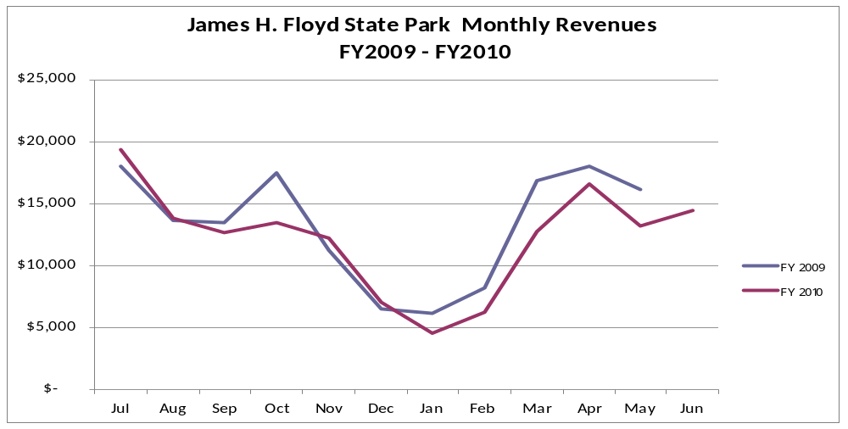

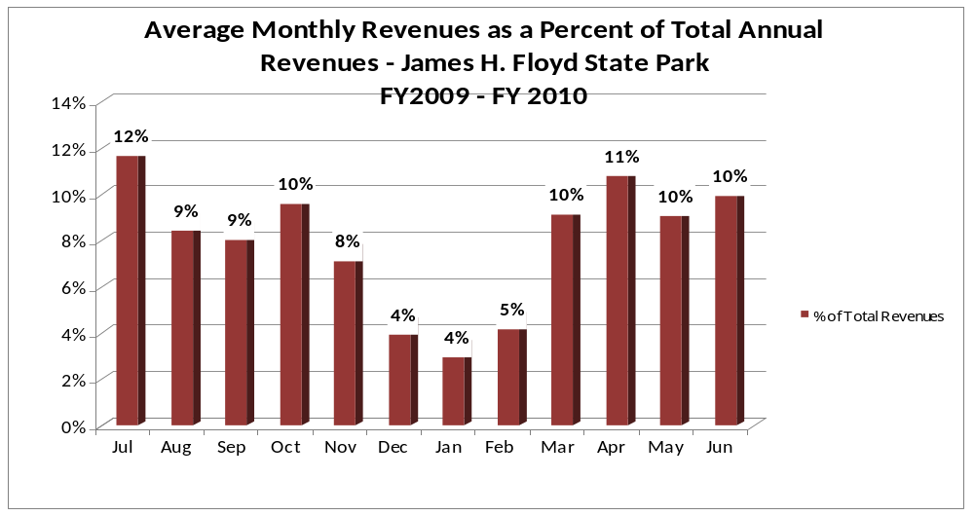
Cost Recovery Trends
James H. Floyd has achieved an average cost recovery of 70% of annual operational expenses through earned revenues from FY 2008 to FY 2010. This is detailed and illustrated in the table and graph below.

Year | Operational  Expenses | Earned  Revenues | Percent Cost  Recovery
2008 | $226,752 | $164,369 | 72%
2009 | $212, 327 | $163,531 | 77%
2010 | $237,073 | $146,432 | 62%

Review of Pricing
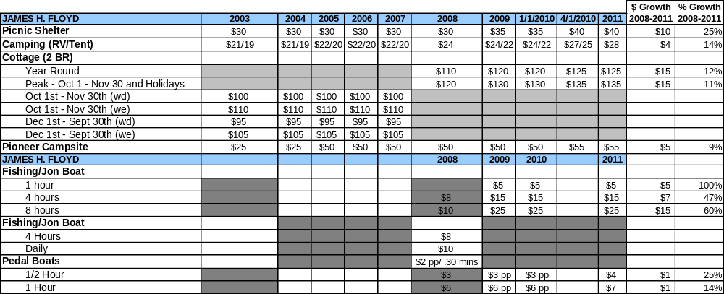
Data on rate information is available as far back as 2003, but only the last three years are evaluated. There has been notable growth in fees charged at JHF since 2003, with the largest increase being picnic shelters at 25%. A table detailing the rates for JHF is provided below.

Business and Management Plan

Business Goals
The following goals serve as the foundation for the key recommendations and strategies in this business plan for James H. Floyd State Park.

Enhance Cost Recovery of Site Operations
James H. Floyd State Park is operating at a 70% average cost recovery of operational expenses through earned revenues. While small parks in a rural setting generally have a more difficult time generating revenues to offset expenses, JHF can likely improve revenues through additional special events and other measures to draw more visitors to the site as well as additional cottages and generate higher revenues. It is critical that the site seek to increase its cost recovery to no less than 80% through enhanced revenue generation and strategic expense reductions.

Enhance Revenue Generation Strategies
Increasing earned revenues will most likely result from the impacts of both increased visitation at the site and specific revenue enhancement strategies. JHF will improve revenue generation through more the addition of more cottages, creating special events to increase visitation, making boat rentals and hiking more user-friendly and by overall fee increases for programs and facility usage.

Expand Special Events at the Site
James H. Floyd State Park’s goal is to have a special event for every season and create other signature events throughout the year in order to increase the publics desire to choose JHF at a destination. These events may include marathons, bluegrass festivals or wildlife adventures days. Smaller events may include focus on outdoor recreation seminars or natural feature courses. Events not led by the park but managed within may include wedding packages.

Improve the Diversity and Innovation of Recreational and Interpretive Programs
James H. Floyd State Park’s plan to appeal to a varied audience will be to include programs such as movie nights to attract a younger crowd as well as historical hikes to the Marble Mine to attract a more mature audience, thus also producing family programs to draw in groups as a whole. By also utilizing surrounding DNR assets programs and tasks at hand may change from time to time to encourage repeat visitation.

Improve the Effectiveness of Marketing and Sales
The effectiveness of marketing and promotional activities of the James H. Floyd State Park could be improved to produce greater visitation and revenues during peak, shoulder, and off seasons. James H. State Park is often called one of Georgia’s best keep secrets. While still holding on to that title the goal of the park will be to attempt to be regular in newspaper and television programs to promote the facility.

Establish Greater Consistency of Managing and Monitoring Customer Service & Satisfaction
James H. Floyd plans to improve the consistency of managing and monitoring customer service and satisfaction by conducting on-site surveys annually to assess how well customer satisfaction levels are being met. JHF will strive to have 90% of visitors responding to ‘Comment Cards’ report that they were either ‘satisfied’ or ‘very satisfied’ (or some comparable metric to be developed). Programs or services that fall below that standard should be critically reviewed, enhanced, and results monitored; those with a history of poor performance will be evaluated and potentially considered for elimination.

Expand Partnership Opportunities
James H. Floyd State Park will begin to take advantage of partnering with several local environmental groups, outdoor recreational centers as well as historical clubs in order to help facilitate and participate in programs and advertising. JHF will also contribute to events in the local communities to create awareness about the park and amenities.

Classification of Programs and Services
The tables below summarize the classifications of programs and services at JHF as either core, important, or visitor supported and projects a range of cost recovery percentages that might be achieved for each. These classifications establish financial performance goals for each category of services that are linked to the recommendations and strategies of this business plan.

Core Services
Program / Service | Target Cost Recovery
Active management of the natural resources and fishing lakes of the site in order to protect their native diversity game fish populations | 10% to 25%
Open and public access to the site and its resources | 25% to 50%
Site appropriate recreational opportunities | 25% to 50%
Public safety on the grounds | 0%
Maintenance of the grounds, facilities and infrastructure | 0%

Important Services
Program / Service | Target Cost Recovery
Support of researchers for natural resource studies | 50%
Provide environmental educational services for the public | 70% to 85%
Provide outdoor recreation opportunities at a minimal cost | 75% to 90%
Supply an area for day use, grilling and picnicking | 35% to 50%
Offer an area for large group camping | 65% to 85%

Visitor Supported
Program / Service | Target Cost Recovery
Gift shop / retail | 120% to 150%
Cottages | 125% to 150%
Campground | 100% to 120%
Shelter rentals | 100% to 120%
Boat rentals | 120% to 150%

Partnership Development Plan
The table below summarizes existing partners and targeted partnerships by classification (operational, vendor, service, co-branding, funding partners) and by organizational type.
 | Public Partners | Not-for-profit Partners | Private / Enterprise Partners
Operational Partners |  | - Pinhoti Trail Alliance  - Armuchee Bluegrass Assc.  - Optimist Club
Vendor Partners |  |  | - Coco-Cola  - Georgia Power
Service Partners | - City of Summerville  - Chattooga County | - Chamber of Commerce | - Reynolds Barn
Co-branding Partners | - Summerville Fish Hatchery  - US Forest Service  - Georgia Forestry Commission  - Wildlife Resources
Funding Resource Development Partner |  | - Friends of Georgia State Parks  - Friends of Sloppy Floyd

Marketing and Sales Plan

Marketing and Sales Goals
Marketing and sales goals for James H. Floyd State Park are based on the following desired outcomes:
- To create better signage and trail markings with Point of Interest development
- To develop monthly programs and quarterly events to attract large crowds
- To generate outreach opportunities to create general awareness
- To design a more efficient gift store, offer more tourist products and create visitor appeal
In order to meet these goals, examples of specific target outcomes are identified in the table below.
Area  of Focus | Current  Performance | Goal  by 2011 | Goal  by 2012 | Goal  by 2015
Mine Trail Usage | Unknown | 175 | 225 | 300
Programs/Events | Unknown | 500 | 750 | 1000
Outreach | Unknown | 250 | 350 | 500
Visitor Center | 101,034 | 109,000 | 114,000 | 117,000
Marketing and Promotion Strategies

Publicity and Social Media
JHF will approach marketing and publicity planning using the following guidelines and themes:
- Event publicity
Major events benefit by having short stories in local, regional, and statewide newspapers and online social media hooks planted that run three to four weeks in advance of the event up to the date of the event itself. Stories and media need to be cultivated with contacts and online sales channels several weeks in advance of the time the stories need to run. Special interest interviews on morning, noon, and evening television news programs, radio interviews on popular rush-hour programs, and blogs on known affinity online sites should also be included.
- Program publicity
Special and unique programs should have feature stories in magazines, local and regional weekly newspapers, and statewide daily newspapers that are aimed at placements as front-page or sectional front-page stories. These stories are most effective if they run shortly before the season that the featured program begins. This will likely require several weeks of advanced planning with media contacts. Similar coverage on television and radio should also be considered. If pre-publicity cannot be generated, post-publicity can help promote future programs.
- Site Publicity
Site publicity focusing on a single site or sub-set of sites requires more intense planning efforts to attract multiple writers and editors from target publications. The site could host several seasonal media familiarization tours (with 10 to 15 writers or editors) to familiarize them with the site and its benefits and amenities. Stories and features resulting from such tours typically take between two and six months to materialize so the tours should focus on experiences, benefits, and programs that would be available when the stories are expected to run.
Examples and suggested opportunities for events, programs and related publicity efforts based on the themes described above at James H. Floyd State Park are provided in the table below.
Event Publicity | Program Publicity | Site Publicity
Pickin’ on the Pinhoti Bluegrass Festival | Lakeside Movie Night | Georgia’s Ridge and Valley Tour
Twisted Ankle Marathon | Backpacking 101 | Armuchee Scenic Drive
Wildlife Adventure Day | Reptiles in Georgia | Fishing Tournament
Taylor Ridge  Bluegrass Jamboree | Fishing Rodeo | Geocaching

Packaging
Examples and suggested packages for James H. Floyd State Park are provided in the table below.
Package | Package Details
Fishing Package | Camping, Jon Boat Rental, Parkpass and bait discount
Wedding Package | Shelter Rental, Two Cabins for two nights and multiple Parkpass discount
Backpacking Package | Backpacking 101 course, Two nights in campground, Parkpass and 10%

Group Sales
Types of groups within which specific target customers can be identified for JHF are listed below:
- Families  - Youth service organizations  - Churches  - Activity or special interest clubs | - Businesses and professional groups  - Schools (public and private)  - Colleges and universities  - Associations | - Other public agencies  - Women’s groups  - Community organizations  - Recreation groups

Incentivizing New and Repeat Visitation
James H. Floyd State Park will utilize the following strategies and/or incentives to encourage new and repeat visitation starting in FY 2012:
- Early registration discounts
- Group / bulk pricing options
- Differential pricing based upon days of week, peak or off-peak seasons, etc.
- Post peak season follow-up with visitors
- Co-branding partner benefits (e.g., members of affinity museums get discounts for certain services during specified times or redeem six Coca-Cola cans for a free souvenir from the gift shop).
Marketing and Sales Metric Goals
The following marketing and sales metric goals and/or others will be monitored and progress reported at James Floyd State Park:
- Loyalty and repeat customers = 65% of customers repeat their visit in a 12-month period.
- Brand confidence & customers-recruiting-customers = Customer referrals equal a minimum of 50% of “Where did you hear about us?” responses from visitors polled.
Revenue Generation Plan
Revenue / Cost Recovery Goals
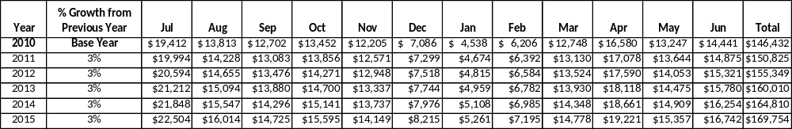
James H. Floyd State Park has set a financial goal of increasing annual revenues 3% annually between 2012 and 2015. The largest revenue growth opportunity is most likely in the shoulder season months of March, May, August, September, and October. In these months revenues are not at their lowest or highest point of the year, and have the potential to grow. The table below details projected revenue growth leading up to 2015, based upon a nominal growth of revenues each year.

These projections would result in a total of 16% cumulative growth in total annual revenues between FY2010 and FY2015. If operational expenses can be managed with a cumulative reduction of 3% between FY 2010 and FY 2015, then the overall cost recovery of the site will be approximately 75% in FY 2015 at these projected revenue levels. This is higher than the annual financial performance of the site in FY 2010, which was operated at 68% cost recovery in that year.
Revenue Generation Strategies

Pricing Plan
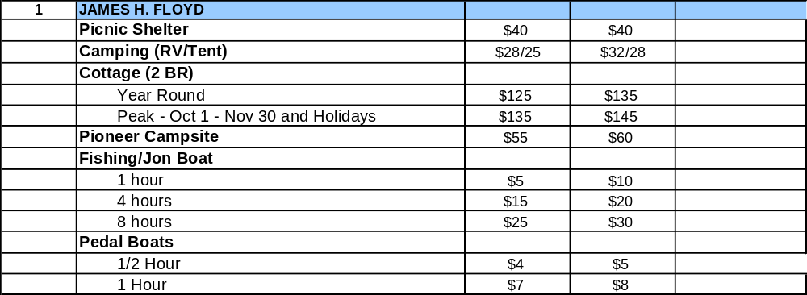
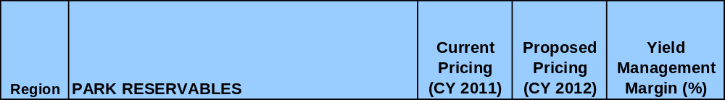

Innovative Programming and Special Events Plan
Program / Event | Theme / Purpose | Scheduled Date/Season | Frequency | Target Participation | Target User Fee | Target Cost Recovery
Outdoor Movie Night | Community Event | Shoulder months | 4x / year | 150 | $2 | 150%
Backpacking 101 | Outdoor Recreation | Fall and Spring | 2x / year | 30 | $2 | 150%
Reptiles in Georgia | Wildlife | Shoulder months | 4x / year | 50 | $2 | 80%-100%
Historic Mine Hike | Interpretive | Shoulder months | 6x /year | 30 | $3 | 80%-100%

Partnerships and Concessions Plan
Service / Partnership | Term of Service | Financial Objective | Contract Manager
Coco-Cola concessions | Ongoing | 15% of gross revenue | Park Manager
Waste collections | No contract | Free, saves cost to park | Park Manager

Expense Management Plan
Personnel Assignments
The following actions will be taken to proactively manage labor costs via personnel assignments and classifications.

Action | Timeline | Outcome
Convert current salary housekeeper part-time | Fall 2012 | Annual cost reduction of $9,000

Management Techniques
The following actions will be taken to proactively manage labor costs via management techniques.

Action | Timeline | Outcome
Convert snack machines to concession | Summer 2011 | Annual cost reduction of $1,000

Adjusted Levels of Service
The following actions will be taken to proactively manage labor costs via reduced levels of service.

Action | Timeline | Outcome
Reduce mowing and return site to natural state | Summer 2012 | Annual cost reduction of $3,000

Financial Pro Forma
The following five-year financial pro forma projects operating expenses, earned revenues and cost recovery through FY 2015. These pro forma are based on the strategies and desired outcomes identified in this business plan, especially the revenue generation and expense management plans, and are linked to corresponding performance goals.

Expense Pro Forma
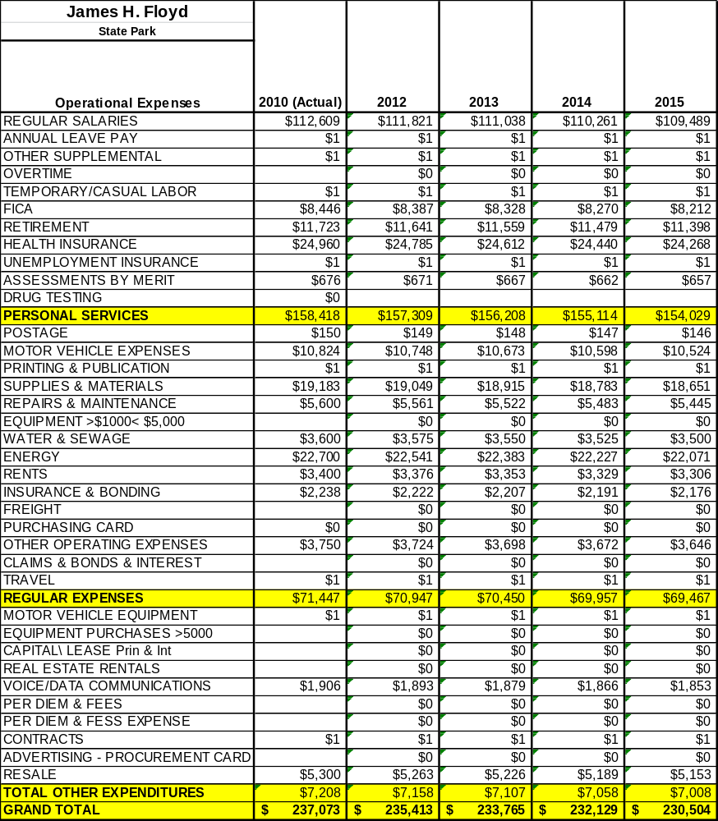

Revenue Pro Forma
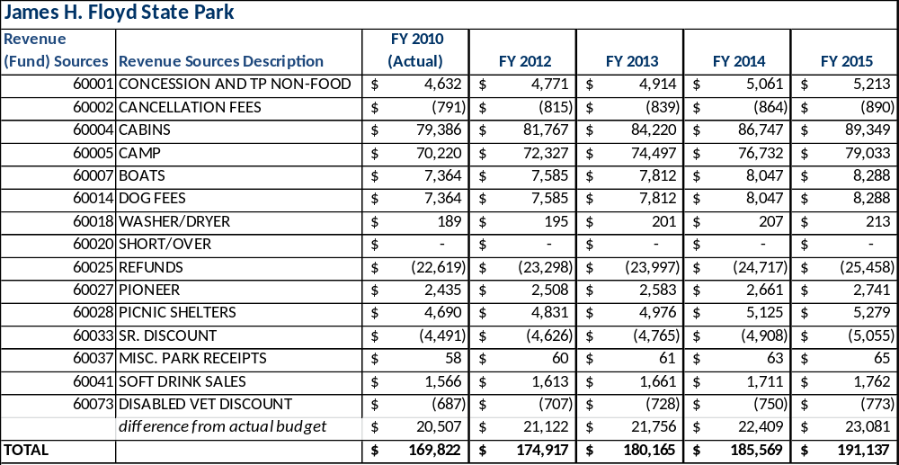
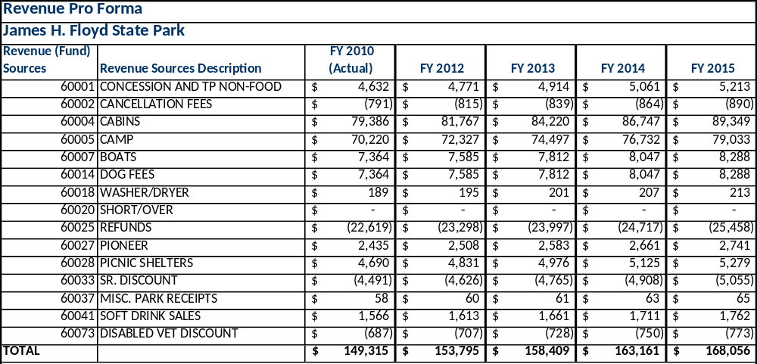

Total / Cost Recovery Pro Forma
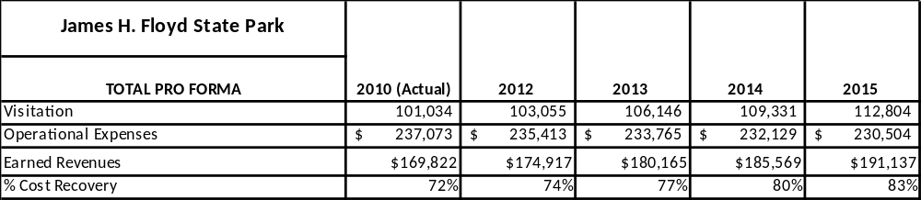

Action Plan
ACTION PLAN
Site: |  | Site Manager: |  |  | Date:
Month:
Strategy | Tasks | Costs / Funding | Revenues / ROI | Responsibilities | Metrics

ACTION PLAN
Site: |  | Site Manager: |  |  | Date:
Month:
Strategy | Tasks | Costs / Funding | Revenues / ROI | Responsibilities | Metrics

This is the average of the last three years – FY 2008, FY 2009, and FY 2010
Current employees, not including vacancies.
Current employees, not including vacancies.
Major population centers within a two-hour drive from the site

