Kolomoki Mounds State Park
Business & Management Plan

Prepared June 2011; Finalized December 2012
Direction 2015 – Sustainable Business Planning

Table of Contents

Executive Summary 3

Site and Operations Assessment 8
Site Inventory and Facility Assessment 8
Operational Assessment 11
Financial Performance Assessment 16

Business and Management Plan 20
Business Goals 20
Classification of Programs and Services 22
Partnership Development Plan 23
Marketing and Sales Plan 24
Revenue Generation Plan 26
Expense Management Plan 28
Financial Pro Forma 29

Action Plan 31

Executive Summary
The Parks, Recreation and Historic Sites Division (PRHSD) of the Georgia Department of Natural Resources (DNR) is transitioning the management of Kolomoki Mounds State Historic Park to operate more like a business, reflecting the Direction 2015 – Sustainable Business Planning initiative to improve the fiscal performance and management of the state parks and historic sites system. This business and management plan is designed to help the site recover more operating expenses through earned revenues, productive partnerships, and innovative programs.

Site Fact Sheet
Site Name | Kolomoki Mounds State Historic Park
Site Manager | Matt Bruner
Region Manager | Eric Bentley
Date of Business Plan completion | 6/13/2011
Site size | 1,293 Acres
Total number of visitors (FY 2010) | 85,700
Total operating budget (FY 2010) | $350,496
Total earned revenues (FY 2010) | $105,668
Operational cost recovery (FY 2010) | 30%
Average operating cost per visitor (FY 2010) | $4.09
Average earned revenue per visitor (FY 2010) | $1.23
Average cost recovery (FY 2008 – 2010) | 34.3%
Target cost recovery (FY 2015) | 40%
Total full-time employees | 4
Total part-time employees | 1
Primary service markets | Tallahassee , Dothan , Albany and Columbus
Primary attractors/visitor appeal factors | Museum, mound complex, campground, group camp and lakes.
Leading opportunities for improved site performance | Add revenue generating facilities on the recreational side of the park: 5 cottages/camper cabins, and 1 swimming beach. Renovate old office and group camp buildings for cabin rentals.

Site Summary and Key Attractions
The 1,293 acre site of Kolomoki is the oldest and largest Woodland Indian site in the southeastern U.S., occupied by American Indians from 350 to 750 A.D. Georgia’s oldest great temple mound, standing 57 feet high, dominates two smaller burial mounds and several ceremonial mounds. The park’s museum is built around an excavated mound, providing an unusual setting for learning who these people were and how they lived. Inside, visitors will find numerous artifacts and a film. Outdoor activities include camping, fishing, picnicking and boating. The major population centers include Dothan, located approximately 31 miles west, Albany, located 52 miles east, Tallahassee, located 83 miles south, and Columbus, located 87 miles north. The challenge is operating a site like this in a very rural location.

Key Attractions
The amenities or features listed below are those that seem to be most popular for visitors.
- Kolomoki Museum
- Kolomoki Village Area and Indian Mounds
- Lake Kolomoki Campground
- Group Camp Hicita
- Day Use/Picnic Area
- Group Shelters
- Pioneer Camping
- Lake Kolomoki and Lake Yahola
- Programs and Special Events
- Nature Trails
- Diverse habitats and natural areas

Financial Targets
The table below details the total operating expenses and earned revenues for Kolomoki Mounds over the last three years (2008 – 2010). This table also calculates total cost per visitor and revenues per visitor during these operating years, and details the target financial performance goals in the context of achieving at least 40% cost recovery. This table also calculates the necessary change from 2010 operating expenses and revenues.

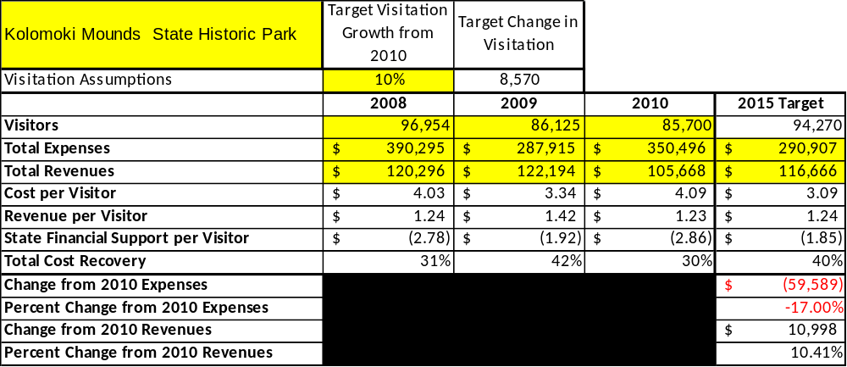

Key Recommendations

Primary / Short Term Recommendations
- Plan more special events for the site. Utilize one special event per month to attract guests.
- Provide Kolomoki with a site specific marketing fund. These funds can be used for marketing special events and public programming.
- Seek local partners to help support operations, programs, and service delivery and for cross-marketing purposes. (Early County Chamber of Commerce, Better Home Initiative, Early County 2055, Early County Historical Society).
- Collect a statistically-valid sample of ZIP code data from visitors in a non-intrusive way to gauge their origins and demographics (e.g., age, ethnicity, income, etc.) and use the results to improve programming and marketing efforts to appeal to a broader audience.
- Strive to keep labor costs at or below 65% of total operational costs.
- Add more resale and keep introducing new items. We just received new resale displays that should help us increase revenue.
- Enhance facilities and program offerings to provide a minimum of 10 unique experiences for each visitor while maintaining at least a 90% customer satisfaction rating.
- Manage Kolomoki according to well-defined maintenance, program and operational standards monitored and enforced by region managers and senior management.
- Continue to work with the Kolomoki Chapter of the Friends of Georgia State Parks and Historic Sites to help raise funds, provide volunteers for improvements and program support and implement the chapter’s following project priorities:
- Kolomoki Festival – Continue providing sponsorship and volunteers to support the event.
- Programming – Help park staff with educational programs (Junior Rangers, Water Ways Festival, School Groups). Provide volunteers and financial support
- Volunteer Projects – Help coordinate volunteer projects at the site (Trail clean up, Litter Control, Facilities Maintenance).
- Community Support – Recruit from our local community to help the Park Manager gain more support for the park (Early County Officials, Rotary Club, Lion’s Club and Churches).
- Financial Support – Help the park finance programming and maintenance projects when outside help is needed (Restroom Repair, Beach Construction).
- Track total economic impact of the site on the local communities and region and share with decision-makers, elected officials, local business operators, and others to demonstrate the impact of Kolomoki.
- Develop funding to provide additional training to site staff for improved business management and marketing effectiveness.
- Construct and upgrade facilities and amenities at the site that are likely to have a cost recovery level at or above 100%. Suggestions include adding 5 cabins (or possibly camper cabins) and/or converting old office and staff cabins at the group camp at Kolomoki.

Secondary / Long Term Recommendations
- Establish a reserve fund or revolving account that allows for earned revenues above a certain percentage of operational cost recovery to be reinvested in the site.
- Improve the recreational amenities of the site to address modern and diverse uses. Which can include adding motors (electric or gas) to Jon boats for increased rental fees.
- Install an improved retail point-of-sale and inventory tracking system.
- Develop an on the road program for the site. This could be taken into the schools to generate more revenue since our school groups are decreasing due to budget cuts and travel cost.
- The Park Ranger Position will retire in two years. I recommend not filling the full time position and hire two 1508 employees.

Site and Operations Assessment
This site and operations assessment is a culmination of analyses and findings from a review of the condition of facilities, infrastructure, and operations at Kolomoki Mounds State Historic Park. The findings and observations are not intended to be an exhaustive review of all issues present, but provide a basic understanding of the predominant issues that contribute to the site’s current operating conditions. The assessment includes the following:
- Site Inventory and Facility Assessment
- Operational Assessment
- Financial Assessment
Site Inventory and Facility Assessment

Methodology
Facility and asset conditions are rated using a differential scale of excellent, good, fair, or poor. Descriptions of conditions that are attributed to each of these findings are also provided.
Scale of Conditions
Rating | General Description
Excellent | Facilities/amenities are in ‘excellent’ condition when they show little or no maintenance or repair problems. Facilities do not feature any major design or operational issues or flaws that contribute to diminished use or increased maintenance or upkeep. Facilities are easy to clean and maintain in order to place them back into public use and the users perceive them to be in excellent shape.
Good | Facilities/amenities are in ‘good’ condition when they show only minor maintenance or repair problems. Most maintenance issues with these facilities typically appear to be the result of age and/or heavy use. Facilities may only feature minor design or operational issues that contribute to diminished use or increased maintenance or upkeep. Facilities are moderately easy to clean and maintain in order to place them back into service and the users perceive them to be adequate for their use, but probably not in excellent shape.
Fair | Facilities/amenities are in ‘fair’ condition when they show significant maintenance or repair problems. Facilities generally exhibit ongoing maintenance issues that appear to be the result of age, heavy use, or design or operational flaws. Some maintenance and repair needs may compound their fair condition by being deferred because of budget and/or resource limitations. Facilities require more effort to clean and maintain before placing them back into service and the users may perceive them as being less than adequate for their use and in a state of deterioration. The facility or structure may need of major repair or replacement.
Poor | Facilities/amenities are in ‘poor’ condition when they show significant, on-going maintenance or repair problems that ultimately may result in suspended use for repair/replacement. Maintenance and repair issues are possibly the result of poor maintenance and clearly the result of age, heavy use, or design or operational flaws. Problems with the facilities are often compounded over time due to consistently-deferred maintenance and repair because of budget and/or resource limitations. Facilities may feature major design or operational issues that contribute to diminished use or increased maintenance or upkeep. Facilities require excessive effort to clean and maintain before placing them back into service and the users often perceive them as being inadequate for their use and in a state of serious deterioration. The facility or structure may need of major repair or replacement.

Inventory and Assessment
The table below is an inventory of facilities and amenities at Kolomoki Mounds, and provides the assessed condition of each as reviewed in May 2011(month, year).

Site Asset / Amenity | Quantity | Condition
Total Acres | 1293 | Excellent
Visitor Center/Museum | 1 | Good
Indian Mounds | 7 | Excellent
Temple Mound A | 1 | Good
Indian Village/ Plaza Area | 1 | Excellent
Group Shelters | 2 | 1 Good, 1 Fair
Lake Kolomoki Campground | 1 | Good
Manager’s Residence | 1 | Fair
Asst. Manager’s Residence | 1 | Fair
Maintenance Shop | 1 | Fair
Swimming Pool Facility | 1 | Poor
Mini Golf Course | 1 | Fair
Picnic Shelter’s | 6 | Good
Pump Houses | 6 | Poor
Amphitheater | 1 | Excellent
Day Use Restroom | 1 | Fair
Playfield | 1 | Good
Pioneer Camping Areas | 2 | Fair
Camp Hicita Group Camp | 1 | Fair
White Oak Nature Trail 1.5mi. | 1 | Good
Trillium Nature Trail 1.25 mi. | 1 | Good
Spruce Pine Nature Trail 2.5mi. | 1 | Good
Playgrounds | 5 | Good
Old Office | 1 | Fair

Prioritized Facility Needs
Based on the facility inventory and assessment, these prioritized needs have been identified. Each need has been aligned with a priority category of high, moderate, or low to support future decision making regarding project sequencing, investment of public resources, and meeting community expectations. The priority assignment for each need is not a measure of importance. Rather, these recommended priorities reflect a phased implementation approach over the next several years.

Facility Need | Priority Assignment
Lake Kolomoki Campground restroom repairs- skylight /sheet rock/tile in restrooms | High
Rebuild old beach area in the park to replace swimming pools | High
Remodel old office/Group Camp buildings for Cabin Rentals | High
Remodel Group Camp Building for year round rentals or smaller groups | High
Remodel Manager and Asst. Manager Housing | High
Rebuild Mini Golf Course | Moderate
Remodel Group Shelters including Kitchen and Restrooms | Moderate
Visitor Center needs inner and outer signage | Moderate
Lake Kolomoki Campground needs more gravel in sites | Moderate
Upgrade lighting in the Museum | Moderate

Operational Assessment
The Operational Assessment includes:
- An inventory and classification of programs and services being provided at the site
- A review of staffing at the site
- A review of concessionaires and partners operating at the site
- Visitation and customer satisfaction

Inventory and Classification of Programs and Services
Programs and services are classified into one of three major categories:
1) Core or Essential Services
2) Important Services
3) Visitor Supported Services
Programs and services at the site are classified into these categories based in part on the mission and public mandates for both the site and the agency. For those in each of these categories, there are financial performance expectations that will define how services are funded and evaluated.

Category 1 – Core Services [Largely supported by tax funds]
Core programs, services and facilities are those the agency must provide and/or are essential in order to capably govern and meet statutory requirements. The failure of the agency to provide Category 1 services at adequate levels could result in significant negative consequences for the public and the resources under protection. The criteria for programs or services to be classified as core or essential are:
- The services are mandated by the agency’s law or charter or are contractually obligated by agreement to provide the services.
- The services are essential to protecting and supporting the public’s health and safety.
- The services protect and maintain valuable assets and infrastructure.
- The services would generally and reasonably be expected and supported by residents, businesses, customers and partners.
- The services are those that cannot or should not be provided by the private sector.
- The services provide a sound investment of public funds.
The following programs and services offered have been identified as core services:
- Preserve, conserve, protect, manage and enhance the natural, cultural and recreational resources within Kolomoki Mounds for the education and enjoyment of present and future generations.
- Operate balanced interpretation, education & outdoor recreation programs to expand knowledge & understanding of Kolomoki's natural, cultural and recreational resources in a manner consistent with protection of the resource.
- Maintenance of grounds, facilities and infrastructure
- Public Safety/ Law Enforcement
Category 2 – Important Services [Supported by a balance of tax funds and earned revenues]
Important programs, services and facilities are those the agency should provide, and are important to governing and effectively serving residents, businesses, customers and partners. Providing Category 2 services expands or enhances the agency’s ability to provide and sustain its core services. The criteria for programs or services to be classified as important are:
- The services expand, enhance or support identified core services.
- The services are broadly supported and utilized by the community, and are considered an appropriate, important, and valuable public good. Public support may be conditional upon the manner by which the services are paid for or funded.
- The services generate income or revenue that offsets some or all of the operating cost and/or are deemed to provide economic, social or environmental outcomes or results.
The following programs and services offered have been identified as important services:
- Self-guided interpretation and educational programs
- Self-directed site exhibits, interpretation, education and recreation
Category 3 – Visitor Supported Services [Almost exclusively supported by earned revenue]
Visitor supported programs, services and facilities are those discretionary services that the agency may provide when additional funding or revenue exists to offset the cost of providing those services. Category 3 services provide added value above and beyond what is required or expected. The criteria for programs or services to be classified as visitor supported are:
- The services expand, enhance or support core services or important services and the quality of life of the visitors, community or stakeholders.
- The services are supported and well utilized and provide a valuable public benefit.
- The services generate income or funding from sponsorships, grants, user fees or other sources that offset some or all of their cost and/or provides a meaningful return on investment.

- The services can possibly be provided through outsourcing or use of concessionaires, providing opportunities for community enterprises that may not otherwise be provided by the agency.
The following programs and services offered have been identified as visitor supported services:
- Gift shop / resale area
- Ranger guided interpretive and educational programs
- Special events
- Overnight facilities and recreation amenities
Staffing Assessment
Labor costs at Kolomoki Mounds represent the largest area of budgetary expense at an average of 75% of the total operating budget each year for the last three complete years, which is higher than the target of total labor costs (including benefits) not exceeding 65% of the site’s total operating expenditures. The tables below and on the following page provide a basic review of the current staffing at the site.

Full Time Equivalent Employees
Position / Title | Quantity (FTE) | Vacancies | Annual Hours
Park Manager 2 | 1 |  | 2400
Assistant Park Manager 1 | 1 | 1 | 2400
Interpretive Ranger | 1 | 1 | 2080
Park Ranger 1 | 1 |  | 2080
Secretary | 1 |  | 2080
General Trades Craftsman | 1 |  | 2080
TOTAL | 6 | 2 | 13120

Part Time Employees
Position / Title | Quantity (FTE) | Vacancies | Hours
Office Clerk | 1 |  | 1500
TOTAL |  |  | 1500

Labor Support
Labor Support | Annual Hours
Volunteers | 1000
Community Service Workers | 40
Engineering and Construction Crews | 40
Resource Management Crews | 0
TOTAL | 1080

Total Labor Hours
Labor Type | Annual Hours
Full Time Equivalent Employees | 13120
Part Time Employees | 1500
Labor Support | 1080
TOTAL Annual Labor Hours | 15700

Labor Budget Summary

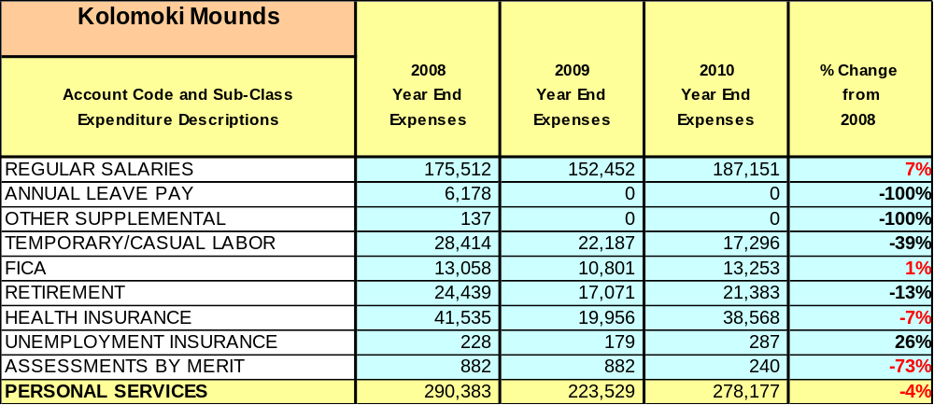

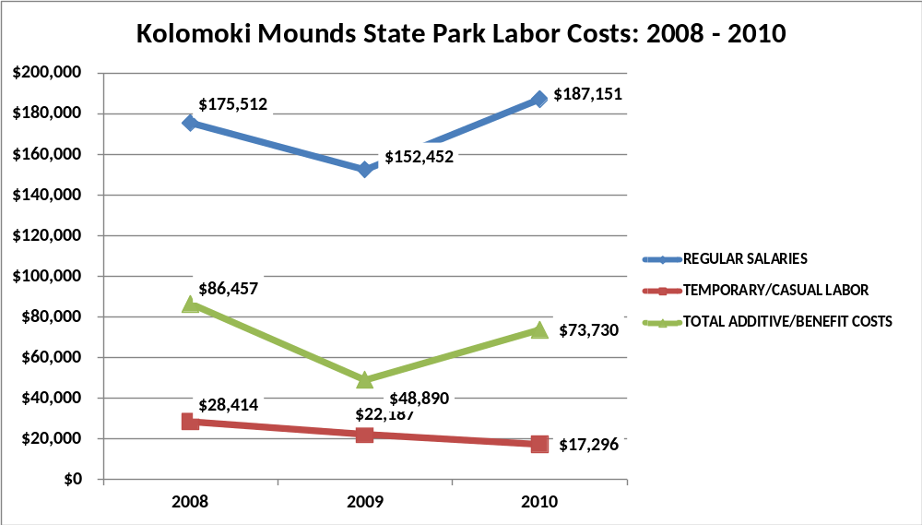

Visitation and Occupancy
Overall annual visitation to the site has trended downward from 2008 to 2010, decreasing by 12% or over 11,254 visitors. This is largely attributed to economic conditions prohibiting school group visitation, as well as gasoline prices prohibiting day use and stay use attendance. We also lost some business due to the closing of the swimming pool.
Year | Total Visitation
2008 | 96954
2009 | 86125
2010 | 85700
Occupancy for the overnight accommodations at Kolomoki Mounds the last three years is detailed in the table below. Overall occupancy has trended upward from 2008 to 2010, increasing by 60%. This is largely attributed to the fact that we shut down one of our campgrounds, reducing the number of campsites from 43 to 24.

Year | Visitors | Camping Occupancy | Group Camp Occupancy
2008 | 96954 | 12.86 | 9.12
2009 | 86125 | 21.32 | 8.73
2010 | 85700 | 21.29 | 7.48

Customer Service and Satisfaction

Site | Year | Customer Satisfaction Level
Kolomoki Mounds | 2009 | 89%
Kolomoki Mounds | 2010 | 100%

Financial Performance Assessment

Operational Expenses
A summary of total operating expenses at Kolomoki Mounds from 2008 to 2010, as well as their percent change from 2008 are provided in the table below.

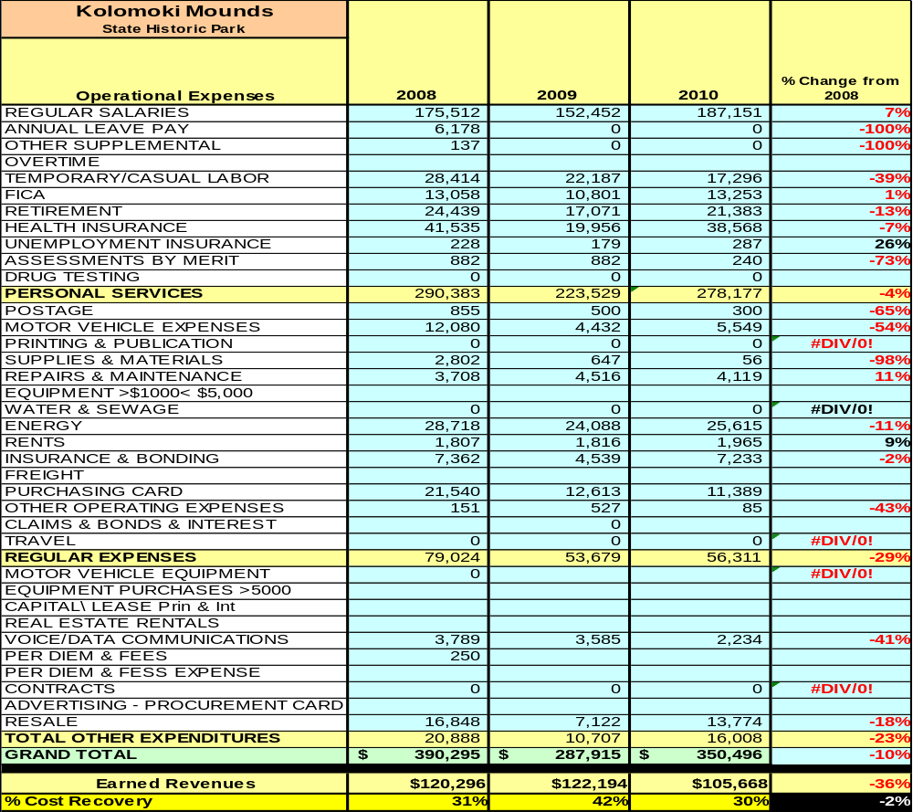

Earned Revenues

Earned revenues at Kolomoki Mounds have decreased since 2008, which is largely attributed to the corresponding decrease in overall visitation. Monthly earned revenues for the last two years indicate that the total annual revenue decreased 14% from 2009 to 2010, with the largest increases in monthly revenues in April (11%), and the largest decreases in the month of August (48%), October (31%) and January (24%). The decrease in July, August, and June could reflect the closure of the swimming pool.

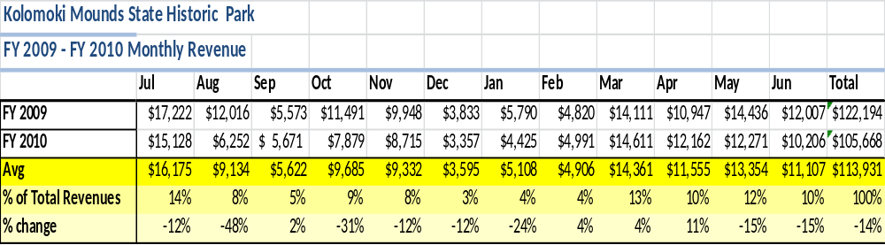

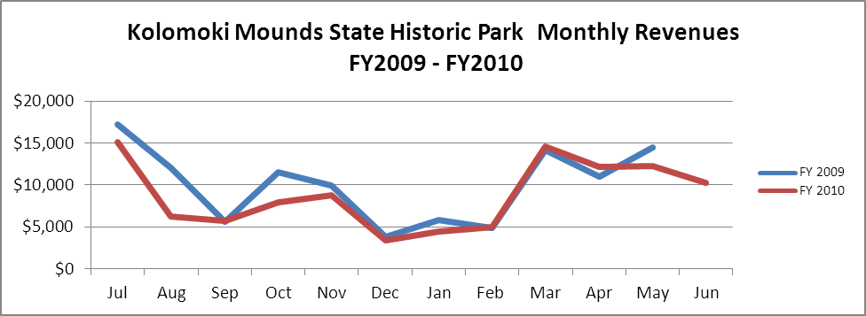

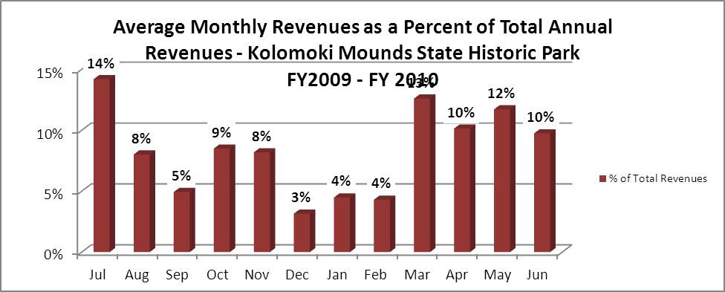

Cost Recovery Trends
Kolomoki Mounds has achieved an average cost recovery of 34% of annual operational expenses through earned revenues from FY 2008 to FY 2010. This is detailed and illustrated in the table and graph below.

Year | Operational  Expenses | Earned  Revenues | Percent Cost  Recovery
2008 | 390,295 | 120,296 | 31
2009 | 287,915 | 122,194 | 42
2010 | 350,496 | 105,668 | 30

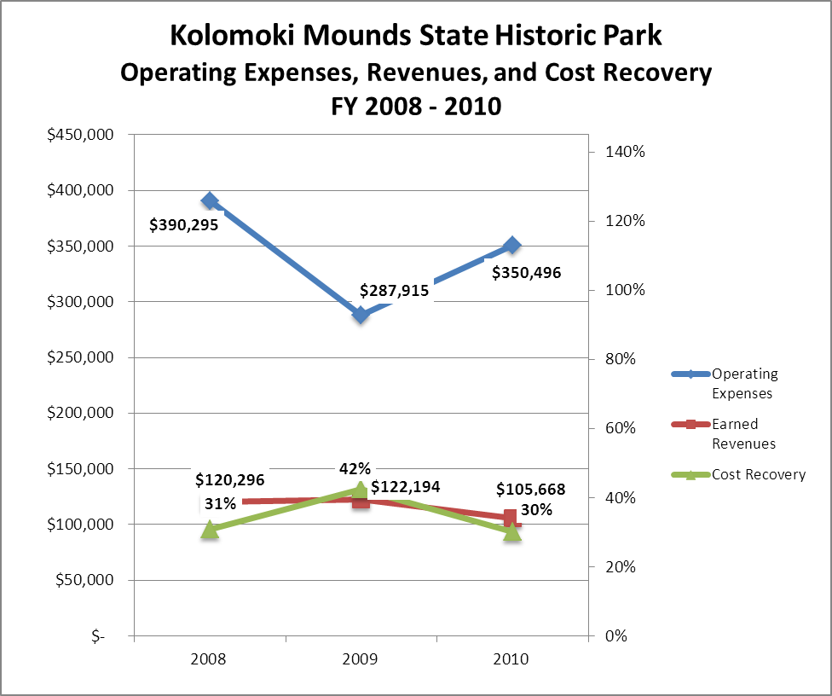

Review of Pricing
There has been notable growth in fees charged at Kolomoki Mounds since 2005, with the largest increase being Campsites and Group Camp. A table detailing the rates is provided below.
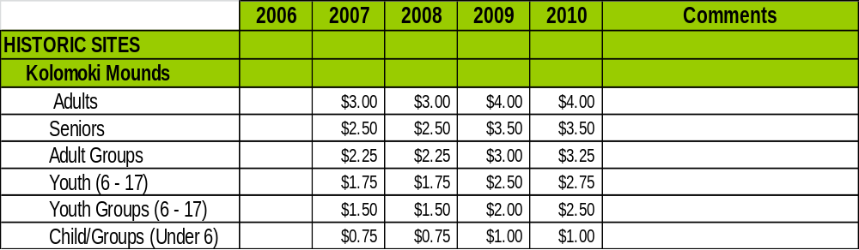

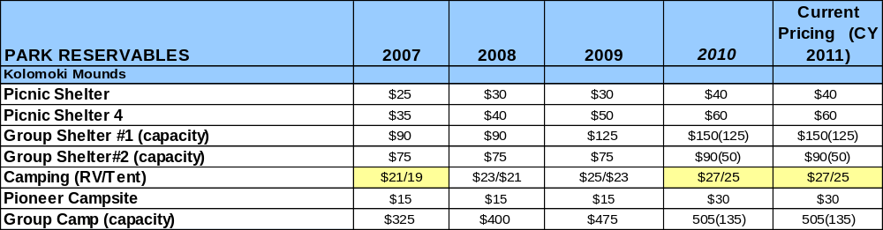

Business and Management Plan

Business Goals
The following goals serve as the foundation for the key recommendations and strategies in this business plan for Kolomoki Mounds.

Enhance Cost Recovery of Site Operations
The Kolomoki Mounds State Historic Site is operating at a 30% cost recovery of operational expenses through earned revenues. While historic sites generally have a more difficult time generating revenues to offset expenses, Kolomoki can likely improve revenues through additional special events and other measures to draw more visitors to the site and generate higher revenues. It is critical that the site seek to increase its cost recovery to no less than 40% through enhanced revenue generation and strategic expense reductions.
Enhance Revenue Generation Strategies
Increasing earned revenues will most likely result from the impacts of both increased visitation at the site and specific revenue enhancement strategies. Kolomoki Mounds will improve revenue generation through more flexible fees, fee increases for programs, and the addition of revenue generating facilities like cottages or camper cabins.
- Continue to market to our school groups. Look at developing an on the road program to take into the schools.
- Expand site programming to include more special events.
- Figure out a way to increase group camp occupancy. Rent to smaller groups.

Expand Special Events at the Site
Most of the major programs and events at the site are directly linked to the unique cultural history of the site and the abundant natural resources. Special events are an area we will have to work at in order to increase revenue. We will increase special events to include, primitive skills demonstrations, tree and plant identification, canoeing lessons, etc.

Improve the Diversity and Innovation of Recreational and Interpretive Programs
As with many historic sites, Kolomoki Mounds features quality exhibits and displays that are predominantly appealing to adults. It will be crucial for the site to improve the appeal of all interpretative resources (e.g., displays, exhibits, and programs) to a wider range of age groups. For example, consideration should be given to developing exhibits that are tactile and experiential in order to best connect with younger audiences. Additionally, consideration should be given to providing more innovative exhibits including traveling displays on loan from other museums in order to encourage repeat visitation.

Improve the Effectiveness of Marketing and Sales
The effectiveness of marketing and promotional activities of the Kolomoki Mounds State Historic Park could be improved to produce greater visitation and revenues during peak, shoulder, and off seasons. This could be achieved in part through a shift in the existing marketing approach to one that is more targeted and focused on experiential and inspirational messaging geared to historic sites. Additionally, partnerships with nearby attractions and amenities in the region should improve the ability of the site to maintain an increased and steady flow of visitors and revenue throughout the year. Our friends group is currently looking at ways to help us in this area.

Establish Greater Consistency of Managing and Monitoring Customer Service & Satisfaction
Kolomoki Mounds plans to improve the consistency of managing and monitoring customer service and satisfaction by conducting on-site surveys annually to assess how well customer satisfaction levels are being met. Kolomoki will strive to have 90% of visitors responding to ‘Comment Cards’ report that they were either ‘satisfied’ or ‘very satisfied’ (or some comparable metric to be developed). Programs or services that fall below that standard should be critically reviewed, enhanced, and results monitored; those with a history of poor performance will be evaluated and potentially considered for elimination.

Expand Partnership Opportunities
Multiple priorities will drive partnership opportunities for Kolomoki. This will include expanding service partnerships in which alternative and related providers in the community support the provision of programs and services to visitors; expanding vendor partners to reduce the costs of materials and supplies, and related services needed by the site; and seeking co-branding partners to off-set event and program costs, and to expand awareness of site programs and facilities in the site’s market area.

Classification of Programs and Services
The tables below summarize the classifications of programs and services at Kolomoki Mounds as either core, important, or visitor supported and projects a range of cost recovery percentages that might be achieved for each. These classifications establish financial performance goals for each category of services that are linked to the recommendations and strategies of this business plan.

Core Services
Program / Service | Target Cost Recovery
Preserve, conserve, protect, manage and enhance the natural, cultural and recreational resources within Kolomoki Mounds for the education and enjoyment of present and future generations | 0%
Operate balanced interpretation, education & outdoor recreation programs to expand knowledge & understanding of Kolomoki's natural, cultural and recreational resources in a manner consistent with protection of the resource | 100%
Maintenance of grounds, facilities and infrastructure | 0%
Public Safety/ Law Enforcement | 0%

Important Services
Program / Service | Target Cost Recovery
Self-guided interpretive and educational programs | 100%
Self-directed site exhibits, interpretation, education and recreation | 20-30%

Visitor Supported
Program / Service | Target Cost Recovery
Gift Shop/Resale | 120%
Ranger guided interpretive and educational programs | 80%
Special events | 120%
Overnight facilities and recreation amenities | 100-125%

Partnership Development Plan
The table below summarizes existing partners and targeted partnerships by classification (operational, vendor, service, and co-branding, funding partners) and by organizational type.
 | Public Partners | Not-for-profit Partners | Private / Enterprise Partners
Operational Partners | - Early County Board of Commissioners | - The Nature Conservancy
Vendor Partners |  |  | - Coca Cola  - Georgia Power  - Georgia Pacific
Service Partners | - Early County Board of Commissioners  - City of Blakely  - Georgia Forestry Commission | - Early County/Blakely Chamber of Commerce  - Early County Historical Society
Co-branding Partners | - Providence  - G.T. Bagby  - Florence  - Seminole  - WRD  - Dept. Of Corrections | - WRD Non-Game Division
Funding Resource Development Partner |  | - Friends of GA State Parks  - Friends of Kolomoki

Marketing and Sales Plan

Marketing and Sales Goals
Marketing and sales goals for Kolomoki Mounds State Park are based on the following desired outcomes:
- To produce more interpretive programs that draw visitors to the site
- To produce more large, signature events with large participation
- To produce increased overall visitation and revenues
- Increase group camp occupancy by 10% over the next year through marketing the experience to small weekend groups.
- Increase camping rentals 5%-10% by marketing extended stay discounts and package deals.
- Increase shelter rentals over the next year through advertising uses such as; weddings, business meetings, family reunions and offering package deals.
Area  of Focus | Current  Performance | Goal  by 2011 | Goal  by 2012 | Goal  by 2015
Program/Event Attendance | Approximately 2% of revenue | 5% | 10% | 25%
Group Camp Occupancy | 7% | 8% | 9% | 10%
Campground  Occupancy | 21% | 25% | 30% | 40%
Visitation | 85,700 | 86,000 | 90,000 | 100,000
Marketing and Promotion Strategies

Publicity and Social Media
Kolomoki Mounds will approach marketing and publicity planning using the following guidelines:
- Event publicity
Major events benefit by having short stories in local, regional, and statewide newspapers and online social media hooks planted that run three to four weeks in advance of the event up to the date of the event itself. Stories and media need to be cultivated with contacts and online sales channels several weeks in advance of the time the stories need to run. Special interest interviews on morning, noon, and evening television news programs, radio interviews on popular rush-hour programs, and blogs on known affinity online sites should also be included.
- Program publicity
Special and unique programs should have feature stories in magazines, weekly newspapers, and statewide daily newspapers that are aimed at placements as front-page or sectional front-page stories. These stories are most effective if they run shortly before the season that the featured program begins. This will likely require several weeks of advanced planning with media contacts. Similar coverage on television and radio should also be considered. If pre-publicity cannot be generated, post-publicity can help promote future programs.

- Site Publicity
An advertising budget will be generated for this project in conjunction with our marketing department in Atlanta. Funds for this will need to come from both the friends group and the marketing department. The site will host media, educator, and tour operator familiarization events that will allow these professionals the opportunity to visit our site and see what we have to offer. Travel brochures featuring Kolomoki will be distributed to tour operators.
Examples and suggested opportunities for events, programs and related publicity efforts based on the themes described above at Kolomoki Mounds are provided in the table below.
Event Publicity | Program Publicity | Site Publicity
Kolomoki Festival | Junior Ranger Camps | Guided Mound Tours
Waterways Festival | Artifact Identification Day | Campfire Programs
Music Concerts | Easter Egg Hunt | Canoe Races
5k Runs | Historical lectures and presentations | Geocaching

Packaging
Examples and suggested packages for Kolomoki Mounds are provided in the table below.
Package | Package Details
Group Camp | Stay 3 nights receive 4th night free
Campground | Stay 2 nights receive 3rd night free
Kolomoki and Bagby | Camp at Kolomoki and receive 10% off Lodge meals at Bagby

Group Sales
Types of groups within which specific target customers can be identified for Kolomoki Mounds are listed below:
- Families  - Youth organizations  - Canoeist/Kayakers  - Recreational Enthusiasts | - Businesses groups  - Schools (public and private)  - Churches | - Scout Groups  - Fisherman  - Community organizations

Incentivizing New and Repeat Visitation
Kolomoki Mounds State Park will utilize the following strategies and/or incentives to encourage new and repeat visitation starting in FY 2012:
- Group / bulk pricing options
- Differential pricing based upon days of week, peak or off-peak seasons, etc.
- Post peak season follow-up with visitors
- Year round monthly extended camping rates
Marketing and Sales Metric Goals
The following marketing and sales metric goals and/or others will be monitored and progress reported at Kolomoki:
- Loyalty and repeat customers = 60% Repeat customers.
- Brand confidence & customers-recruiting-customers = 20% of new customers recruited by previous customers.
Revenue Generation Plan
Revenue / Cost Recovery Goals
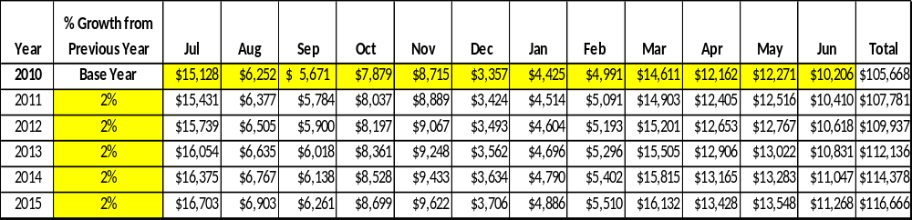
Kolomoki Mounds has set a financial goal of increasing annual revenues 2% annually between 2012 and 2015. The largest revenue growth opportunity is most likely Campground and Group Camp. The table below details projected revenue growth leading up to 2015, based upon a nominal growth of revenues each year.

These projections would result in a total of 10% cumulative growth in total annual revenues between FY2010 and FY2015. If operational expenses can be managed between FY 2010 and FY 2015, then the overall cost recovery of the site will be approximately 40% in FY 2015 at these projected revenue levels. This is higher than the annual financial performance of the site in FY 2010, which was operated at 30% cost recovery in that year.
Revenue Generation Strategies

Pricing Plan
PARK RESERVABLES | Current Pricing (CY 2011) | Proposed Pricing  (CY 2012) | Positive Yield Management Margin (%)
Kolomoki Mounds
Picnic Shelter | $40 | $30 | -20%
Picnic Shelter 4 | $70 | $50 | -20%
Group Shelter #1 (capacity) | $155(125) | $150 | -20%
Group Shelter#2 (capacity) | $95(50) | $75 | -20%
Camping (RV/Tent) | $27/25 | $25/$20 | -30%
Pioneer Campsite | $35 | $30 | -10%
Amphitheater | $55 | $55 | -20%
Group Camp (capacity) | 505(135) | $475 | -10%

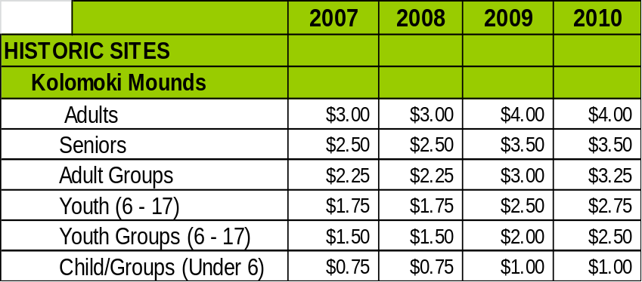

Innovative Programming and Special Events Plan
Program / Event | Theme / Purpose | Scheduled Date/Season | Frequency | Target Participation | Target User Fee | Target Cost Recovery
Kolomoki Festival | Promote Park and support community | 2nd Saturday in October | Annual | 2500 | $1500 | 100%
Easter Egg Hunt | Kids under 12 hunt eggs | April | Annual | 150 | $300 | 100%
Junior Ranger Programs | Educate youth about outdoor recreation | June/July | Annual | 40 | $2400 | 100%
Primitive Skills Demonstrations | Kolomoki Life | Varies | 4 times a year | 50 | $500 | 100%
Canoeing Workshop | Recreational | Spring and Summer Seasons |  | 12 People Per Class | $35 Per person | 100%

Partnerships and Concessions Plan
Service / Partnership | Term of Service | Financial Objective | Contract Manager
Waste Collection/Early County Road Department | 5 Years | Free Waste Collection | Site Manager
Packaging and promotions with area businesses | 1 Year | Shared Revenue | Site Manager
Georgia Pacific | 1 Year | Sponsorship of Kolomoki Kids Program | Site Manager

Expense Management Plan
Personnel Assignments
The following actions will be taken to proactively manage labor costs via personnel assignments and classifications.

Action | Timeline | Outcome
Eliminate summer seasonal positions | July 2012
Eliminate Historic Site Manager position | July 2012
Park Ranger I position is up for retirement in two years. I recommend leaving the position vacant and providing two 1508 positions for the year. | July 2014
Will not fill Interpretive Ranger position | July 2012

Management Techniques
The following actions will be taken to proactively manage labor costs via management techniques.

Action | Timeline | Outcome
Manager and Asst. Manager will conduct programs | July 2011
Increase Volunteer Use for maintenance and programming | July 2011

Adjusted Levels of Service
The following actions will be taken to proactively manage labor costs via reduced levels of service.

Action | Timeline | Outcome
Conduct selective mowing and maintenance techniques | July 2011
Proactively follow energy and operation reductions as proposed. | July 2011

Financial Pro Forma
The following five-year financial pro forma projects operating expenses, earned revenues and cost recovery through FY 2015. These pro forma are based on the strategies and desired outcomes identified in this business plan, especially the revenue generation and expense management plans, and are linked to corresponding performance goals.

Expense Pro Forma
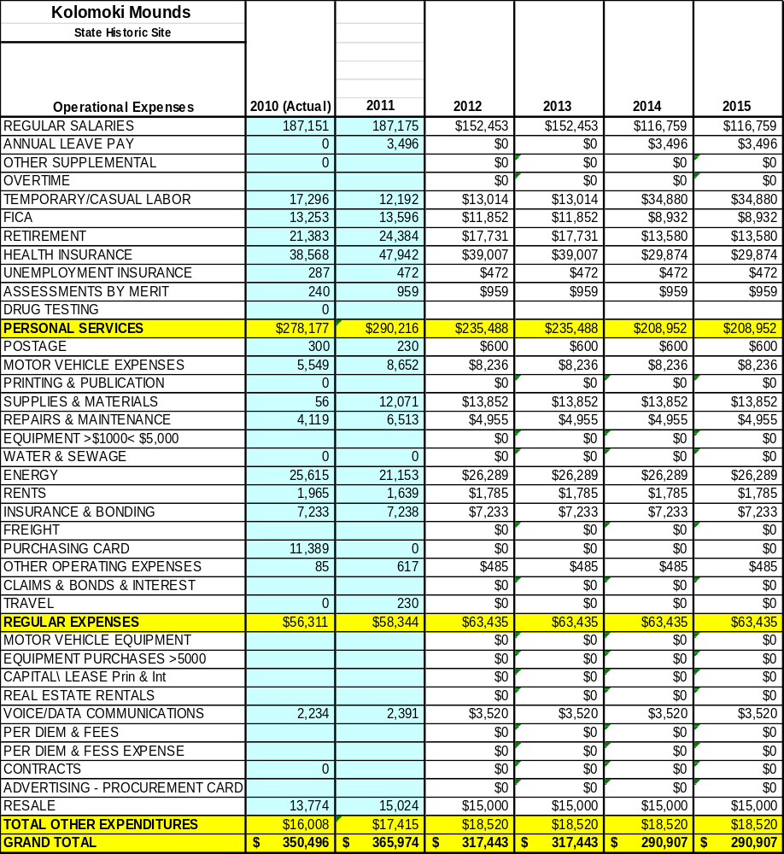

Revenue Pro Forma

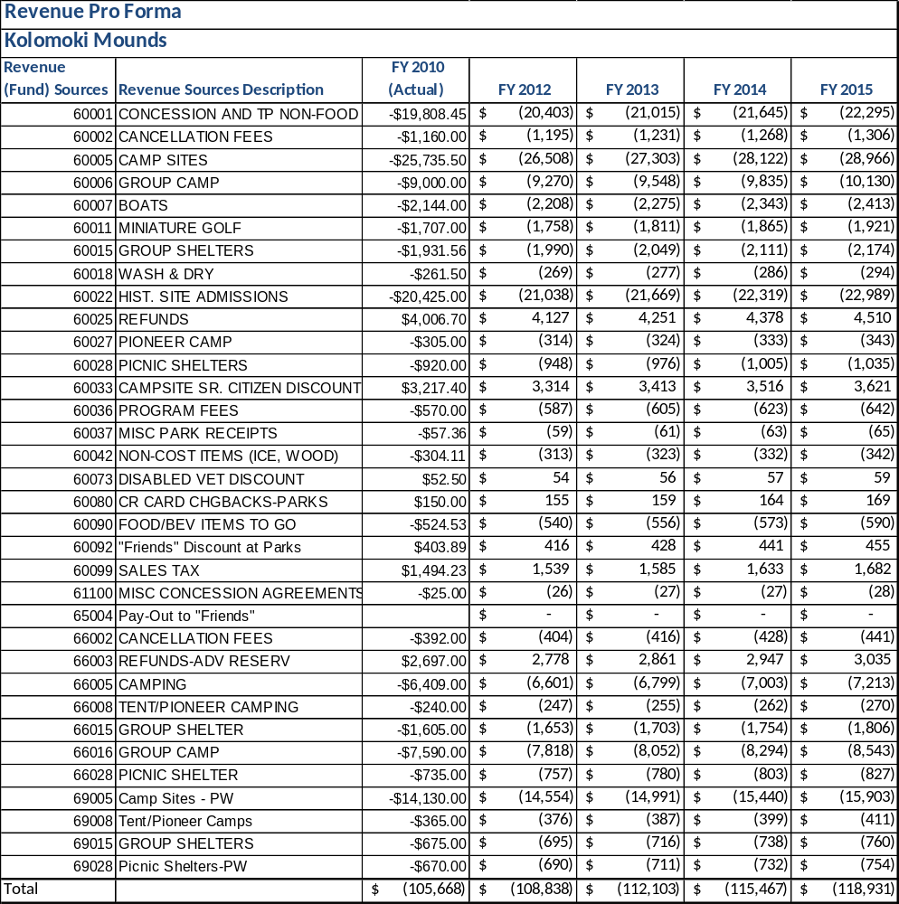

Total / Cost Recovery Pro Forma
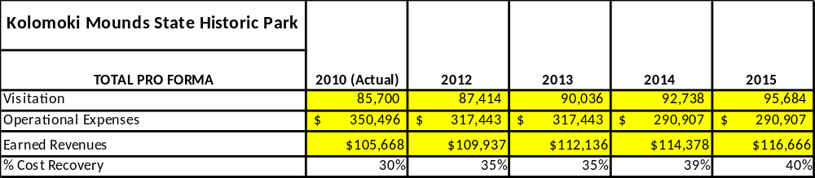

Action Plan
ACTION PLAN
Site: |  | Site Manager: |  |  | Date:
Month:
Strategy | Tasks | Costs / Funding | Revenues / ROI | Responsibilities | Metrics

ACTION PLAN
Site: |  | Site Manager: |  |  | Date:
Month:
Strategy | Tasks | Costs / Funding | Revenues / ROI | Responsibilities | Metrics

This is the average of the last three years – FY 2008, FY 2009, and FY 2010
Current employees, not including vacancies.
Current employees, not including vacancies.
Major population centers within a two-hour drive from the site

