Little White House Historic Site
Business & Management Plan

June 2011
Direction 2015 – Sustainable Business Planning

Table of Contents

Executive Summary 3

Site and Operations Assessment 7
Site Inventory and Facility Assessment 7
Operational Assessment 9
Financial Performance Assessment 13

Business and Management Plan 17
Business Goals 17
Classification of Programs and Services 18
Partnership Development Plan 19
Marketing and Sales Plan 20
Revenue Generation 22
Expense Management Plan 24
Financial Pro Forma 25

Action Plan 27

Executive Summary
The Parks, Recreation and Historic Sites Division (PRHSD) of the Georgia Department of Natural Resources (DNR) is transitioning the management of Roosevelt’s Little White House State Historic Site (LWH) to operate more like a business, reflecting the Direction 2015 – Sustainable Business Planning initiative to improve the fiscal performance and management of the state parks and historic sites system. This business and management plan is designed to help the site recover more operating expenses through earned revenues, productive partnerships, and innovative programs.

Site Fact Sheet
Site Name | Little White House State Historic Site
Site Manager | Robin Glass
Region Manager | Ronnie Eakins
Date of Business Plan completion | March 15, 2011
Site size | 163 acres
Total number of visitors (FY 2010) | 75,635
Total operating budget (FY 2010) | $867,413
Total earned revenues (FY 2010) | $618,705
Operational cost recovery (FY 2010) | 71%
Average operating cost per visitor (FY 2010) | $11.47
Average earned revenue per visitor (FY 2010) | $8.18
Average cost recovery (FY 2008 – 2010) | 73%
Target cost recovery (FY 2015) | 85%
Total full-time employees | 16
Total part-time employees | 2
Primary service markets | Atlanta, Macon, Columbus
Primary attractors/visitor appeal factors | Presidential history of Franklin D. Roosevelt
Leading opportunities for improved site performance | Expanded usage of site, additional recreational opportunities, updated exhibits and facilities

Site Summary and Key Attractions
The 163-acre site of LWH is located in a rural setting, roughly 70 miles from major population centers in Georgia like Atlanta and Macon and 40 miles from Columbus. It is roughly 50 miles from Interstate 75 and 30 miles from Interstate 85. The relative isolation of LWH will prove a challenge to achieving the identified cost recovery target.

Key Attractions
The amenities or features listed below are those that seem to be most popular for visitors.
- Little White House
- Memorial Museum
- Servant’s Quarters
- Guest House
- Flag and Stone Walk
- Historic Pool Complex
- Legacy Exhibit
- Gift shop
- Interpretive programs and special events

Financial Targets for Little White House State Historic Site
The table below details the total operating expenses and earned revenues for Little White House State Historic Site over the last three years (2008 – 2010). This table also calculates total cost per visitor and revenues per visitor during these operating years, and details the target financial performance goals in the context of achieving at least 85% cost recovery. This table also calculates the necessary change from 2010 operating expenses and revenues.
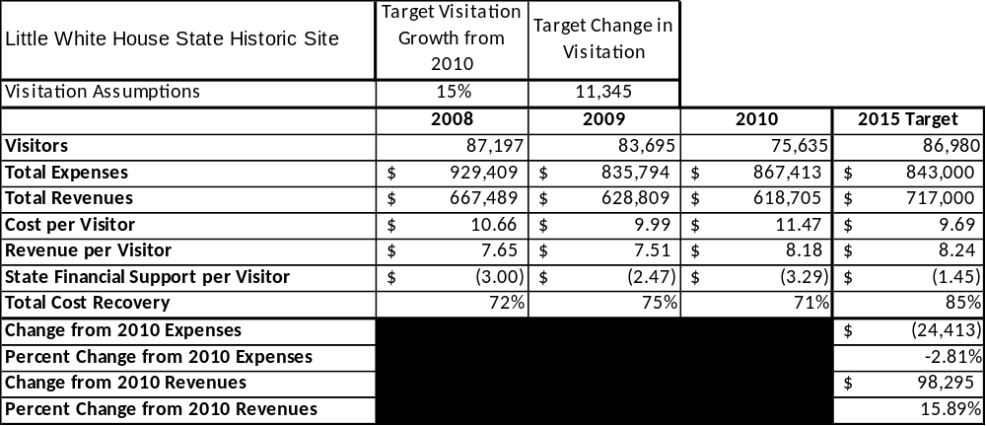

Key Recommendations

Primary Recommendations
- Operate the site using cost-based accounting, including the net cost recovery achieved annually.
- Conduct in-park surveys annually to assess how well customer satisfaction levels are being met. LWH should strive to have 90% of visitors responding to ‘Comment Cards’ report that they were either ‘satisfied’ or ‘very satisfied’ (or some comparable metric to be developed). Programs or services that fall below that standard should be critically reviewed, enhanced, and results monitored; those with a history of poor performance should be considered for elimination.
- Evaluate and pursue opportunities to employ concessionaires or private or public service providers on-site if they can be more cost-effective. For example, explore the development of a concessionaire agreement to manage private events on-site.
- Collect a statistically-valid sample of ZIP code data from visitors in a non-intrusive way to gauge their origins and demographics (e.g., age, ethnicity, income, etc.) and use the results to improve programming and marketing efforts to appeal to a broader audience.
- Utilize a minimum of six special events annually to help draw more visitors to the site.
- Seek local partners to help support operations, programs, and service delivery and for cross-marketing purposes.
- Sustain sufficient non-labor operational funding or reduce staff so that required staff operational costs (with benefits) do not exceed 65% of the total operational budget.
- Enhance facilities and program offerings to provide a minimum of 10 unique experiences for each visitor while maintaining at least a 90% customer satisfaction rating.
- Manage Little White House according to well-defined maintenance, program and operational standards monitored and enforced by region managers and senior management.
- Partner with local Chambers of Commerce or other destination marketing organizations (DMOs) to promote LWH.
- Continue to work with the LWH Chapter of the Friends of Georgia State Parks and Historic Sites to help raise funds or provide volunteers for improvements and program support.
- Perform a thorough net cost-of-service analysis on major functions of site operations, including the detailed analysis of labor requirements (by task) that has already been produced by site staff. Thereafter, update costs to deliver services on a biennial schedule.
- Review and update rates at the site on an annual basis to recover the total net cost of service for important and visitor-supported services.
- Develop on-line sales of gift shop and retail items associated with the site in order to increase site generated revenues.
- Track total economic impact of the site on the local communities and region and share with decision-makers, elected officials, local business operators, and others to demonstrate the impact of LWH.
- Develop a more detailed analysis of labor requirements of all major park functions to match the right position with the right job at the right pay.
- Develop funding to provide additional training to site staff for improved business management and marketing effectiveness.
- Construct and upgrade facilities and amenities at the site that are likely to have a cost recovery level at or above 100%. Suggestions include developing a special event venue near the museum, upgrading the theater, enhancing signage throughout the site and at its entrance, enhancing landscaping, updating interpretive displays and exhibits, and providing free Wi-Fi at the site.
- Add more youth-focused services, programs and amenities at the site that appeal to younger audiences, families and educational groups.
- Add more services, programs and amenities that appeal to older adults.

Secondary Recommendations
- Establish a reserve fund or revolving account that allows for earned revenues above a certain percentage of operational cost recovery to be reinvested in the site.
- Improve the recreational amenities of the site to address modern and diverse uses. Although the historic ‘footprint’ is a reasonably small portion of the total acreage of the site, installing walking trails or low-infrastructure recreational facilities could draw additional visitors without significantly affecting the historic flavor of the property.
- Engage the local community, user groups, and private organizations to improve connectivity between LWH and both FDR State Park and the Roosevelt-Warm Springs Institute for Rehabilitation.
- Install an improved retail point-of-sale and inventory tracking system.

Site and Operations Assessment
This site inventory and operations assessment is a culmination of analyses and findings from a review of the condition of facilities, infrastructure, and operations at Little White House State Historic Site (LWH). The findings and observations provide a basic understanding of the predominant issues that contribute to the site’s current operating conditions. The assessment includes the following:
- Site Inventory and Facility Assessment
- Operational Assessment
- Financial Assessment
Site Inventory and Facility Assessment

Methodology
Facility and asset conditions are rated using a differential scale of excellent, good, fair, or poor. Descriptions of conditions that are attributed to each of these findings are also provided.
Scale of Conditions
Rating | General Description
Excellent | Facilities/amenities are in ‘excellent’ condition when they show little or no maintenance or repair problems. Facilities do not feature any major design or operational issues or flaws that contribute to diminished use or increased maintenance or upkeep. Facilities are easy to clean and maintain in order to place them back into public use and the users perceive them to be in excellent shape.
Good | Facilities/amenities are in ‘good’ condition when they show only minor maintenance or repair problems. Most maintenance issues with these facilities typically appear to be the result of age and/or heavy use. Facilities may only feature minor design or operational issues that contribute to diminished use or increased maintenance or upkeep. Facilities are moderately easy to clean and maintain in order to place them back into service and the users perceive them to be adequate for their use, but probably not in excellent shape.
Fair | Facilities/amenities are in ‘fair’ condition when they show significant maintenance or repair problems. Facilities generally exhibit ongoing maintenance issues that appear to be the result of age, heavy use, or design or operational flaws. Some maintenance and repair needs may compound their fair condition by being deferred because of budget and/or resource limitations. Facilities require more effort to clean and maintain before placing them back into service and the users may perceive them as being less than adequate for their use and in a state of deterioration. The facility or structure may need of major repair or replacement.
Poor | Facilities/amenities are in ‘poor’ condition when they show significant, on-going maintenance or repair problems that ultimately may result in suspended use for repair/replacement. Maintenance and repair issues are possibly the result of poor maintenance and clearly the result of age, heavy use, or design or operational flaws. Problems with the facilities are often compounded over time due to consistently-deferred maintenance and repair because of budget and/or resource limitations. Facilities may feature major design or operational issues that contribute to diminished use or increased maintenance or upkeep. Facilities require excessive effort to clean and maintain before placing them back into service and the users often perceive them as being inadequate for their use and in a state of serious deterioration. The facility or structure may need of major repair or replacement.

Inventory and Assessment
The table below is an inventory of facilities and amenities at LWH, and provides the assessed condition of each as reviewed in November 2010.
Site Asset / Amenity | Quantity | Condition
Total acreage | 163 | Good
Little White House | 1 | Fair
Memorial Museum | 1 | Good
Servant’s Quarters | 1 | Fair
Guest House | 1 | Fair
Flag and Stone Walk | 1 | Poor (being refurbished)
Historic Pool Complex | 1 | Poor
Legacy Building | 1 | Good
Gift Shop | 1 | Fair
Maintenance Complex | 1 | Good
Picnic Area | 3 | Poor
Office Area | 1 | Fair
Manager’s Residence | 1 | Fair
Pump house building | 1 | Good
Willys Pavilion | 1 | Fair
Marine Corps Sentry Posts | 9 | Fair
Secret Service Post | 1 | Poor

Prioritized Facility Needs
Based on the facility inventory and assessment, these prioritized needs have been identified. Each need has been aligned with a priority category of high, moderate, or low to support future decision making regarding project sequencing, investment of public resources, and meeting community expectations. The priority assignment for each need is not a measure of importance. Rather, these recommended priorities reflect a phased implementation approach over the next several years.
Facility Need | Priority Assignment
Event area / program space addition | High
Improved signage at entrance and roadway | High
Theater improvements including seat backs | High
Upgrade lighting in Museum | High
Updated / enhanced landscaping | High
Storage area of gift shop | Moderate
Interactive / updated displays and exhibits | Moderate
Memorial Fountain improvements | Moderate
Water irrigation system for landscaping | Moderate
Nature boardwalk | Low
Enlarge Visitor Center | Low

Operational Assessment
The Operational Assessment includes:
- An inventory and classification of programs and services being provided at the site,
- A review of staffing at the site,
- A review of concessionaires and partners operating at the site, and
- Visitation and customer satisfaction.

Inventory and Classification of Programs and Services
Programs and services are classified into one of three major categories:
1) Core or Essential Services
2) Important Services
3) Value added or Visitor Supported Services
Programs and services at the site are classified into these categories based in part on the mission and public mandates for both the site and the agency. For the programs and services in each of these categories, there are financial performance expectations that will define how services are funded and evaluated.

Category 1 – Core Services [Largely supported by tax funds]
Core programs, services and facilities are those the agency must provide and/or are essential in order to capably govern and meet statutory requirements. The failure of the agency to provide Category 1 services at adequate levels could result in significant negative consequences for the public and the resources under protection. The criteria for programs or services to be classified as core or essential are:
- The services are mandated by the agency’s law or charter or are contractually obligated by agreement to provide the services.
- The services are essential to protecting and supporting the public’s health and safety.
- The services protect and maintain valuable assets and infrastructure.
- The services would generally and reasonably be expected and supported by residents, businesses, customers and partners.
- The services are those that cannot or should not be provided by the private sector.
- The services provide a sound investment of public funds.
The following programs and services offered at the Little White House have been identified as core services:
- Active management of the natural and cultural resources of the site (i.e., FDR structures and artifacts) in order to protect their integrity
- Artifact management
- Open and public access to the site and its resources
- Site appropriate education, interpretation, and recreational opportunities
- Public safety
- Maintenance of grounds, facilities and infrastructure

Category 2 – Important Services [Supported by a balance of tax funds and earned revenues]
Important programs, services and facilities are those the agency should provide, and are important to governing and effectively serving residents, businesses, customers and partners. Providing Category 2 services expands or enhances the agency’s ability to provide and sustain its core services. The criteria for programs or services to be classified as important are:
- The services expand, enhance or support identified core services.
- The services are broadly supported and utilized by the community, and are considered an appropriate, important, and valuable public good. Public support may be conditional upon the manner by which the services are paid for or funded.
- The services generate income or revenue that offsets some or all of the operating cost and/or are deemed to provide economic, social or environmental outcomes or results.

The following programs and services offered at the Little White House have been identified as important services:
- Self-guided interpretation and education programs
- Support for historic researchers

Category 3 – Visitor Supported Services [Almost exclusively supported by earned revenue]
Visitor supported programs, services and facilities are those discretionary services that the agency may provide when additional funding or revenue exists to offset the cost of providing those services. Category 3 services provide added value above and beyond what is required or expected. The criteria for programs or services to be classified as visitor supported are:
- The services expand, enhance or support Core Services, Important Services and the quality of life of the visitors, community or stakeholders.
- The services are supported, valued and well utilized and provide an appropriate and valuable public benefit.
- The services generate income or funding from sponsorships, grants, user fees or other sources that offset some or all of their cost and/or provides a meaningful return on investment.

- The services can possibly be provided through outsourcing or use of concessionaires, providing opportunities for community enterprises that may not otherwise be provided by the agency.

The following programs and services offered at the Little White House have been identified as visitor supported services:
- Gift Shop
- Ranger guided interpretation and elective educational programs
- Special events / programs related to the mission of the site
- Special events / programs not related to the mission of the site or outside the normal programming standards (e.g., wedding receptions, etc.)

Staffing Assessment
Labor costs at the Little White House State Historic Site represent the largest area of budgetary expense at an average of 69% of the total operating budget each year for the last five years, which is higher than the target of labor costs (including benefits) not exceeding 65% of total operating expenditures. The tables below and on the following page provide a basic review of the current staffing at the site.
Full Time Equivalent Employees
Position / Title | Current Quantity (filled FTE positions) | Vacancies | Annual Hours
Historic Site Manager | 1 | 0 | 2,600
Secretary 2 | 1 | 0 | 2,080
Interpretive Ranger | 2 | 0 | 4,160
General Clerk | 0 | 1 | 2,080
Maintenance Engineer | 1 | 0 | 2,340
Sales Manager 2 | 1 | 0 | 2,340
Utility Worker 1 | 2 | 1 | 4,160
Assistance Manager 2 | 0 | 1 | 2,600
Exhibit Guide | 7 | 2 | 14,560
General Trades Craftsman | 1 | 0 | 2,080
TOTAL | 16 | 5 | 39,000
Part Time Employees
Position / Title | Current Quantity (filled FTE positions) | Vacancies | Hours
Tour Guide | 2 | 2 | 3,016
TOTAL | 2 | 2 | 3,016
Labor Support
Labor Support | Annual Hours
Volunteers | 1,000
Community Service Workers | 0
Engineering and Construction Crews | 40
Resource Management Crews | 0
TOTAL | 1,040
Total Labor Hours
Labor Type | Annual Hours
Full Time Equivalent Employees | 39,000
Part Time Employees | 3,016
Labor Support | 1,040
TOTAL Annual Labor Hours | 43,056

Labor Budget Summary
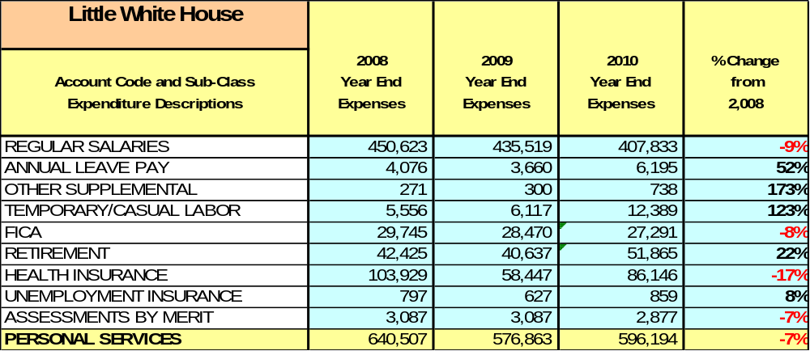

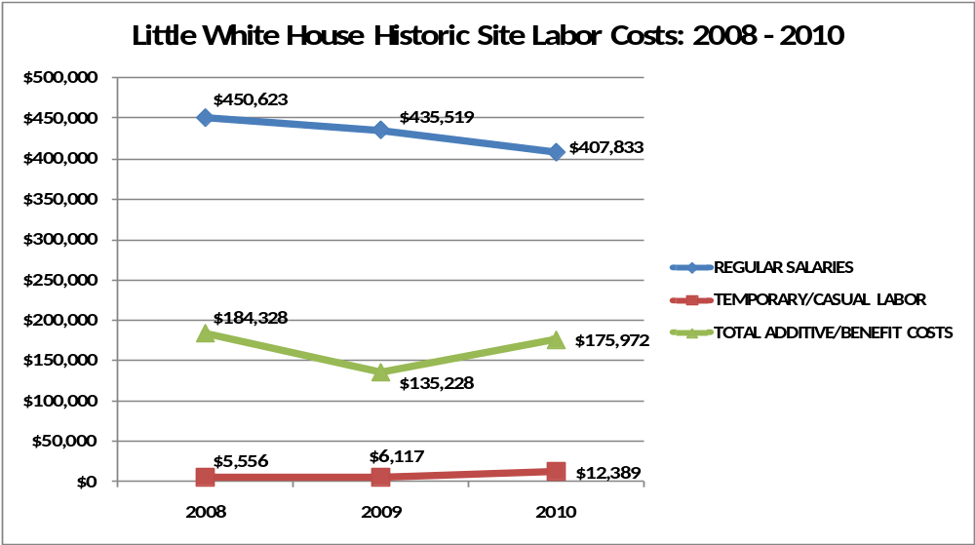

Visitation and Occupancy
Overall annual visitation to the site has trended downward from 2007 to 2010, decreasing by 13% or over 11,000 visitors. This is largely attributed to economic conditions inhibiting school group visitation, as well as gasoline shortages and high prices statewide.
- 2007 – 86,911
- 2008 – 87,197
- 2009 – 83,695
- 2010 – 75,635

The graph below illustrates visitation over the last four years.

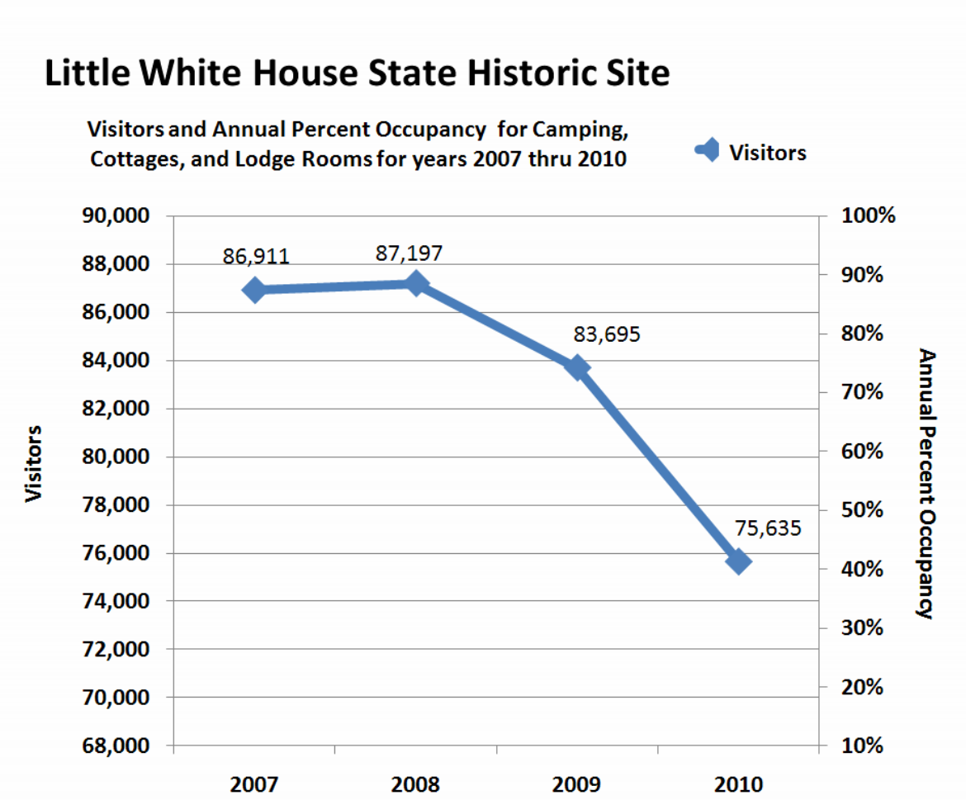

Customer Service and Satisfaction
Currently the site monitors customer service through paper, hard copy customer comment cards. These cards are not collected in a statistically valid method, are often only reviewed to identify areas of customer service concerns or issues, and are not consistently used for managing customer service performance issues overall at the site. However, having said all this, the site is well known for its high level of customer satisfaction and in both 2009 and 2010, 100% of customers responded that they were either ‘satisfied’ or ‘very satisfied’ with their expectations at LWH.

Financial Performance Assessment

Operational Expenses
A summary of total operating expenses from 2008 to 2010, as well as their percent change from 2008 are provided in the table below.

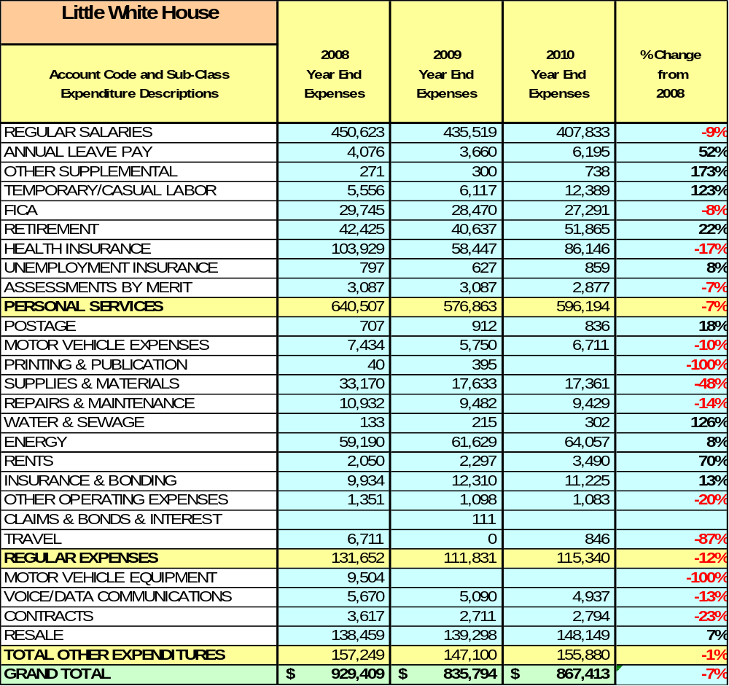

Earned Revenues
Earned revenues at Little White House State Historic Site have decreased since 2008, which is largely attributed to the corresponding decrease in overall visitation.
Monthly earned revenues for the last two years (see table on the following page) indicate that the total annual revenue decreased 2% from 2009 to 2010, with the largest decreases in monthly revenues during August (25%), December (10%), and January (18%), and the largest increases in revenues during the months of September (7%), April (13%), May (14%), and June (16%). The months of increased revenue were not sufficient to account for lost revenues in the remaining months.
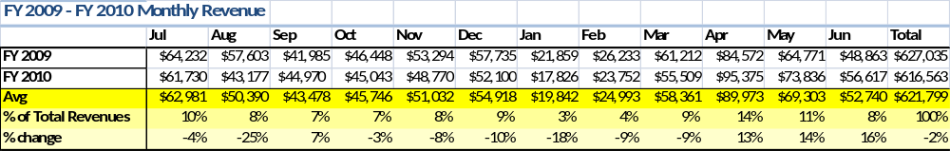
The graphs below illustrate the monthly revenue trends each year and the average percent of total annual revenue earned each month.
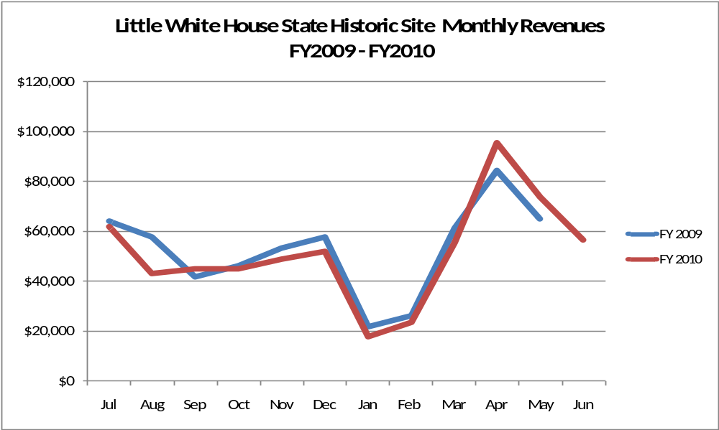

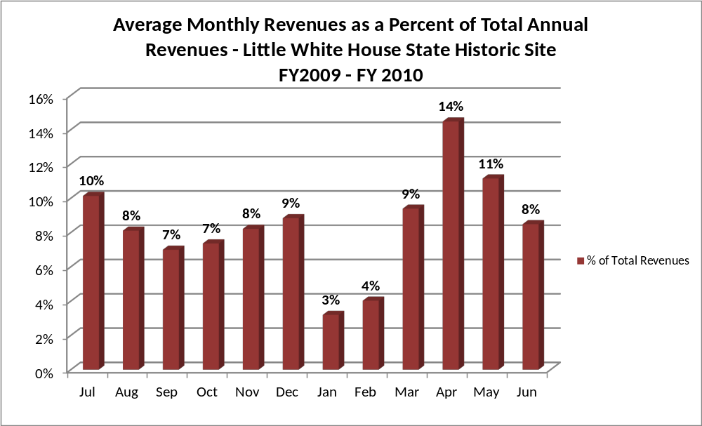
Cost Recovery Trends
Little White House State Historic Site consistently achieves 71-75% cost recovery of annual operational expenses through earned revenues. This is detailed and illustrated in the table and graph below.
Year | Operational  Expenses | Earned  Revenues | Percent Cost  Recovery
2008 | $926,321 | $667,489 | 72%
2009 | $835,794 | $628,809 | 75%
2010 | $867,413 | $618,705 | 71%
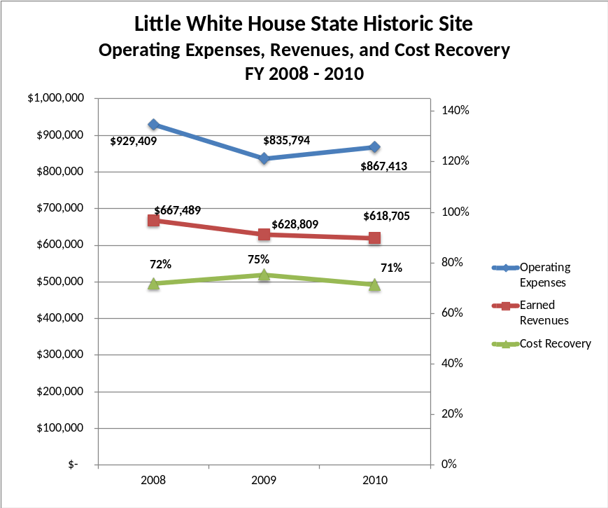

Review of Pricing
Data on rate information for site admission fees is available as far back as 2002, but only the last five years are evaluated. There has been notable flexibility and growth in fees charged at Little White House State Historic Site since 2005, with the largest increase being in the admission fees for youth groups (100%), youth (67%), and seniors (40%). A table detailing the admission fees for Little White House State Historic Site is provided below.
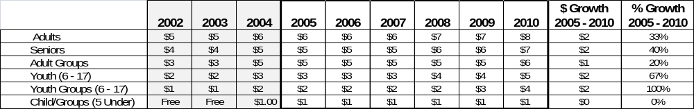
Business and Management Plan

Business Goals
The following goals serve as the foundation for the key recommendations and strategies in this business plan.

Enhance Cost Recovery of Site Operations
The Little White House State Historic Site is operating at a 71-75% cost recovery of operational expenses through earned revenues. While historic sites generally have a more difficult time generating revenues to offset expenses, Little White House can likely improve revenues through additional special events and other measures to draw more visitors to the site and generate higher revenues. It is critical that the site seek to increase its cost recovery to no less than 85% through enhanced revenue generation and strategic expense reductions.

Enhance Revenue Generation Strategies
Increasing earned revenues will most likely result from the impacts of both increased visitation at the site and specific revenue enhancement strategies. Little White House will improve revenue generation through more flexible and dynamic admission fees, expanding retail sales to include on-line sales, increasing the number and type of special events held at the site and the fees charged for the events, and by overall fee increases for programs and facility usage.

Expand Special Events at the Site
Most, if not all, of the major programs and events at the site are directly linked to the unique history of the site. This is commendable and important, but should not be the sole criteria for delivering great programming at the Little White House State Historic Site. The expansion of facilities and amenities to include an events or program area near the museum is important in order to support the development of successful, large-scale events that can be held at the site to dramatically increase overall visitation and revenue generation. These events can include, but not be limited to, art and music festivals, wine festivals, local culinary festivals, weddings and receptions.

Improve the Diversity and Innovation of Recreational and Interpretive Programs
As with many historic sites, the Little White House features quality exhibits and displays that are predominantly appealing to adults. It will be crucial for the site to improve the appeal of all interpretative resources (e.g., displays, exhibits, and programs) to a wider range of age groups. For example, consideration should be given to developing exhibits that are tactile and experiential in order to best connect with younger audiences. Additionally, consideration should be given to providing more innovative exhibits including traveling displays on loan from other museums in order to encourage repeat visitation.

Improve the Effectiveness of Marketing and Sales
The effectiveness of marketing and promotional activities of the Little White House State Historic Site could be improved to produce greater visitation and revenues during peak, shoulder, and off seasons. This could be achieved in part through a shift in the existing marketing approach to one that is more targeted and focused on experiential and inspirational messaging geared to historic sites. Additionally, partnerships with nearby attractions and amenities in the region should improve the ability of the site to maintain an increased and steady flow of visitors and revenue throughout the year.

Establish Greater Consistency of Managing and Monitoring Customer Service & Satisfaction
Little White House plans to improve the consistency of managing and monitoring customer service and satisfaction by conducting on-site surveys annually to assess how well customer satisfaction levels are being met. LWH will strive to have 90% of visitors responding to ‘Comment Cards’ report that they were either ‘satisfied’ or ‘very satisfied’ (or some comparable metric to be developed). Programs or services that fall below that standard should be critically reviewed, enhanced, and results monitored; those with a history of poor performance will be evaluated and potentially considered for elimination.

Expand Partnership Opportunities
Given the breadth of partnership opportunities available to LWH, multiple priorities will drive partnership opportunities for the site. This will include expanding service partnerships in which alternative and related providers in the community support the provision of programs and services to visitors at Little White House State Historic Site; expanding vendor partners to reduce the costs of materials and supplies, and related services needed by the site; and seeking co-branding partners to off-set event and program costs, and to expand awareness of site programs and facilities in the site’s market area.

Classification of Programs and Services
The tables below summarize the classification of programs and services at the Little White House State Historic Site as either core, important, or visitor supported and projects a range of cost recovery percentages that might be achieved for each. These classifications establish financial performance goals for each category of services that are linked to the recommendations and strategies of this business plan.
Core Services
Program / Service | Target Cost Recovery
Active management of the natural and cultural resources of the site in order to protect their integrity | 0%
Artifact management | 0%
Open and public access to the site and its resources | 20% to 50%
Site appropriate education, interpretation, and recreational opportunities | 20% to 50%
Public safety | 0%
Maintenance of site, grounds, facility, and infrastructure | 0%

Important Services
Program / Service | Target Cost Recovery
Self-guided interpretation and education programs | 20 to 80%
Support for historic researchers | 50% to 80%

Visitor Supported
Program / Service | Target Cost Recovery
Gift Shop | 150% to 200+%
Ranger guided interpretation and education programs | 100% to 120+%
Special events / programs beyond normal programming | 150% to 180+%

Partnership Development Plan
The table below summarizes existing partners and targeted partnerships by classification (operational, vendor, service, co-branding, funding partners) and by organizational type.
 | Public Partners | Not-for-profit Partners | Private / Enterprise Partners
Operational Partners | - Roosevelt Institute For Rehabilitation | - The Wilderness Camp  - Good Sheppard Therapeutic Camp | - AT&T Pioneers Southside Council of Atlanta
Vendor Partners |  |  | - Coca Cola  - Georgia Power  - Georgia EMC’s  - Georgia Poultry Federation
Service Partners | - City of Warm Springs | Chamber of Commerce  March of Dimes
Co-branding Partners | - FDR State Park  - Roosevelt Institute for Rehabilitation |  | - The Bullock House  - Callaway Gardens  - Best Western  - Hills and Dales  - Wild Animal Safari
Funding Resource Development Partner |  | - Friends of Georgia State Parks and Historic Sites  - Friends of Roosevelt’s Little White House  - Warm Springs Memorial Commission

Marketing and Sales Plan

Marketing and Sales Goals
Marketing and sales goals for the Little White House State Historic Site are based on the following criteria and desired outcomes:
- To produce more interpretive programs that draw visitors to the site
- To produce more large, signature events with large participation
- To produce increased overall visitation and revenues
In order to meet these goals, examples of specific target outcomes were identified in the areas of special events participation and overall visitation and are detailed in the table below.
Area  of Focus | Current  Performance | Goal  by 2011 | Goal  by 2012 | Goal  by 2015
Special Events | Unknown | 5,000 vis. / yr | 6,000 vis./yr | 8,000 vis./yr
Overall Visitation | 86,755 | 88,000 | 90,000 | 95,000

Marketing and Promotion Strategies

Publicity and Social Media
LWH will approach marketing and publicity planning using the following guidelines and themes:
- Event publicity
Major events benefit by having short stories in local, regional, and statewide newspapers and online social media hooks planted that run three to four weeks in advance of the event up to the date of the event itself. Stories and media need to be cultivated with contacts and online sales channels several weeks in advance of the time the stories need to run. Special interest interviews on morning, noon, and evening television news programs, radio interviews on popular rush-hour programs, and blogs on known affinity online sites should also be included.
- Program publicity
Special and unique programs should have feature stories in magazines, local and regional weekly newspapers, and statewide daily newspapers that are aimed at placements as front-page or sectional front-page stories. These stories are most effective if they run shortly before the season that the featured program begins. This will likely require several weeks of advanced planning with media contacts. Similar coverage on television and radio should also be considered. If pre-publicity cannot be generated, post-publicity can help promote future programs.
- Site Publicity
Site publicity focusing on a single site or sub-set of sites requires more intense planning efforts to attract multiple writers and editors from target publications. Each site could host several seasonal media familiarization tours (with 10 to 15 writers or editors) to familiarize them with the site and its benefits and amenities. Stories and features resulting from such tours typically take between two and six months to materialize so the tours should focus on experiences, benefits, and programs that would be available when the stories are expected to run.
Examples and suggested opportunities for events, programs and related publicity efforts based on the themes described above at LWH are provided in the table below.
Little White House State Historic Site
Event Publicity | Program Publicity | Site Publicity
Wine Festival | Artifact Day | FDR Remembered
Arts and Music Festival | Backyard Birding | WWII Commemorations
Swim the Warm Springs | Junior Ranger Camp | Cultural Crossroads Tour
Regional Culinary Festival | Georgia Outdoor Kids

Packaging
Example and suggested packages for Little White House are provided in the table below.
Package | Package Details
FDR Trail | Entrance into Little White House State Historic Site and FDR State Park
Tour and Gifts | Guided tour and discount in gift shop
Season of Fun Passbook | Voucher book of 10 day entries into the site

Group Sales
Categories of groups within which specific target customers can be identified for Little White House State Historic Site are listed below:
- Families  - Youth service organizations  - Churches  - Activity or special interest clubs | - Businesses and professional groups  - Schools (public and private)  - Colleges and universities  - Associations | - Other public agencies  - Women’s groups  - Community organizations

Incentivizing New and Repeat Visitation
LWH will utilize the following practices to incentivize new and repeat visitation starting in FY 2012:
- Early registration discounts
- Group / bulk pricing options
- Differential pricing based upon days of week, peak or off-peak seasons, etc.
- Post peak season follow-up with visitors
- Co-branding partner benefits (e.g., members of affinity museums get discounts for certain services during specified times or redeem six Coca-Cola cans for a free souvenir from the gift shop).

Marketing and Sales Metric Goals
The following marketing and sales metric goals will be monitored and progress reported at LWH:
- Loyalty and repeat customers = 65% of customers repeat their visit in a 12-month period.
- Brand confidence & customers-recruiting-customers = Customer referrals equal a minimum of 50% of “Where did you hear about us?” responses from visitors polled.
Revenue Generation
Revenue / Cost Recovery Goals
Little White House State Historic Site has set a financial goal of increasing annual revenues 3% annually between 2012 and 2015. The largest revenue growth opportunity is most likely in the shoulder season months of March, May, August, September, and October. In these months revenues are not at their lowest or highest point of the year, and have the potential to grow. The table below details projected revenue growth leading up to 2015, based upon a nominal growth of revenues each year.
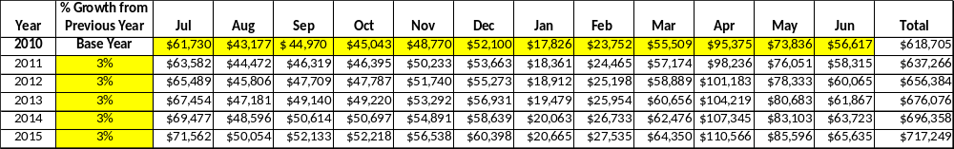

These projections would result in a total of 16% cumulative growth in total annual revenues between FY2010 and FY2015. If operational expenses can be managed with a cumulative reduction of 3% between FY 2010 and FY 2015, then the overall cost recovery of the site will be approximately 85% in FY 2015 at these projected revenue levels. This is higher than the annual financial performance of the site in FY 2010, which was operated at 71% cost recovery in that year.
Revenue Generation Strategies

Pricing Plan
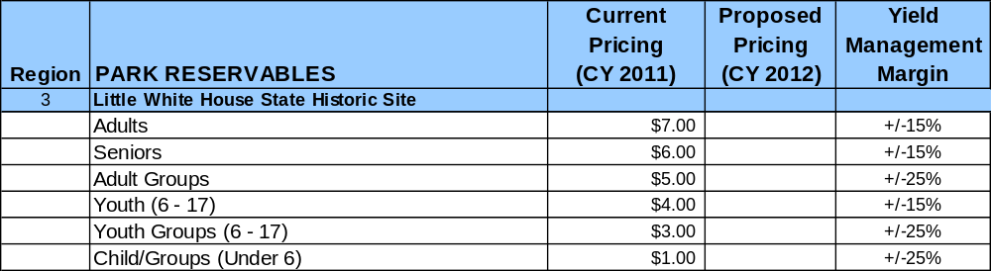

Innovative Programming and Special Events Plan
Program / Event | Theme / Purpose | Scheduled Date/Season | Frequency | Target Participation | Target User Fee | Target Cost Recovery

Partnerships and Concessions
Service / Partnership | Term of Service | Financial Objective | Contract Manager
Food and coffee concessions | 1 year | 15% of gross receipts to park | Park Manager
Event planning and promotion | 2 years | 15% of gross receipts | Region Manager
Landscaping | 2 years | Reduced personnel costs | Park Manager
Waste collection | 1 year | No cost increase from previous year | Park Manager
Packaging and promotions with local businesses | 1 year | Shared revenue | Region Manager

Expense Management Plan
Personnel Assignments
The following actions will be taken to proactively manage labor costs via personnel assignments and classifications.
Action | Timeline | Outcome
Eliminate current Exhibit Guide vacancies | July 2012 | Annual labor cost reduction of $XXX,XXX
Convert full-time Exhibit Guides to part-time employees, volunteers or contract labor | January 2012 | Annual labor cost reduction of $XXX,XXX

Management Techniques
The following actions will be taken to proactively manage labor costs via management techniques.
Action | Timeline | Outcome
Concession coffee service | July 2012 | Annual revenue increase of $XXX,XXX
Contracted event promotion and coordination | July 2012 | Annual revenue increase of $XXX,XXX
Increased use of volunteers for site and grounds maintenance | July 2012 | Annual cost reduction of $XXX,XXX

Adjusted Levels of Service
The following actions will be taken to proactively manage labor costs via reduced levels of service.
Action | Timeline | Outcome
Adjusted mowing and landscaping schedules for portions of the site | July 2012 | Annual cost reduction of $XXX,XXX

Financial Pro Forma
The following five-year financial pro forma projects operating expenses, earned revenues and total/cost recovery through FY 2015. These pro forma are based on the strategies and desired outcomes of the Little White House business plan, especially the revenue generation and expense management plans, and are linked to corresponding performance goals. These financial pro forma has been developed with the assumptions that operating expenses are reduced by 0.7% annually, and that earned revenue and visitation are managed to grow approximately 3% annually.

Expense Pro Forma
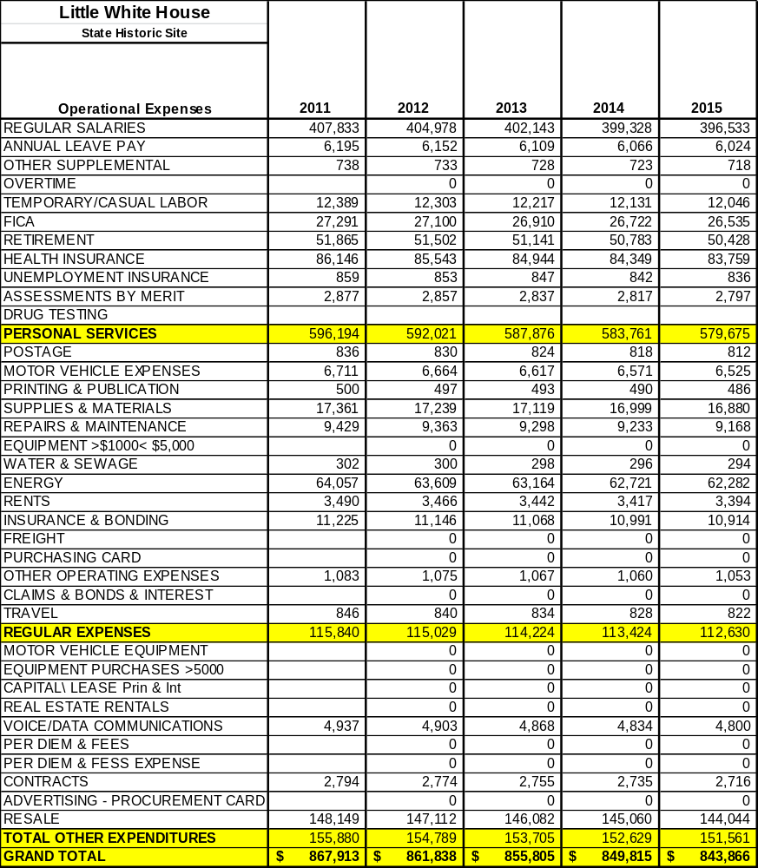

Revenue Pro Forma
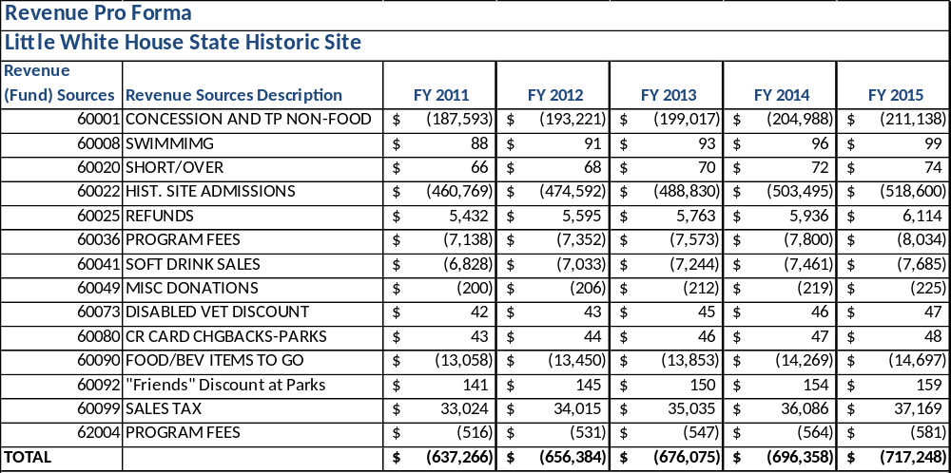

Total / Cost Recovery Pro Forma
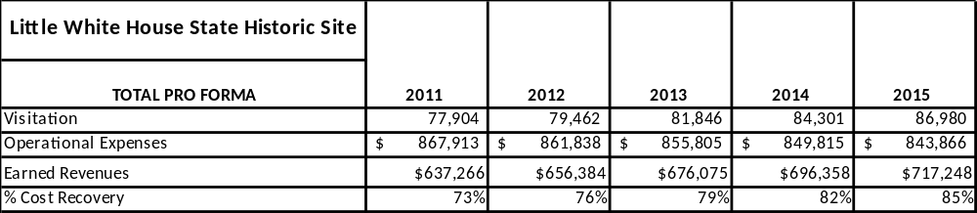

Action Plan
ACTION PLAN
Site: |  | Site Manager: |  |  | Date:
Month:
Strategy | Tasks | Costs / Funding | Revenues / ROI | Responsibilities | Metrics

This is the average of the last three years – FY 2008, FY 2009, and FY 2010
Current employees, not including vacancies.
Current employees, not including vacancies.
Major population centers within a two-hour drive from the site

