Laura S. Walker State Park
Business & Management Plan

Prepared July 2011; Finalized February 2013
Direction 2015 – Sustainable Business Planning

Table of Contents

Executive Summary 3

Site and Operations Assessment 7
Site Inventory and Facility Assessment 7
Operational Assessment 9
Financial Performance Assessment 14

Business and Management Plan 18
Business Goals 18
Classification of Programs and Services 20
Partnership Development Plan 21
Marketing and Sales Plan 22
Revenue Generation Plan 24
Expense Management Plan 26
Financial Pro Forma 27

Action Plan 30

Executive Summary
The Parks, Recreation and Historic Sites Division (PRHSD) of the Georgia Department of Natural Resources (DNR) is transitioning the management of Laura S. Walker State Park to operate more like a business, reflecting the Direction 2015 – Sustainable Business Planning initiative to improve the fiscal performance and management of the state parks and historic sites system. This business and management plan is designed to help the site recover more operating expenses through earned revenues, productive partnerships, and innovative programs.

Site Fact Sheet
Site Name | Laura S. Walker State Park
Site Manager | Owen T. Griffin
Region Manager | Tommy Turk
Date of Business Plan completion | May 17, 2011
Site size | 305 acres
Total number of visitors (FY 2010) | 201,959
Total operating budget (FY 2010) | $336,209
Total earned revenues (FY 2010) | $168,901
Operational cost recovery (FY 2010) | 50%
Average operating cost per visitor (FY 2010) | 1.66
Average earned revenue per visitor (FY 2010) | .84
Average cost recovery (FY 2008 – 2010) | 48%
Target cost recovery (FY 2015) | 122%
Total full-time employees | 3
Total part-time employees | 4
Primary service markets | Jacksonville, FL, Brunswick, Valdosta
Primary attractors/visitor appeal factors | Camping, Group Camp, Picnicking, Reunions, Weddings, Boating, Fishing, Trails and the Lakes Golf Course at Laura S. Walker. Close proximity to Okefenokee Swamp Park, one of 3 main entrances to the Okefenokee Wildlife Refuge.
Leading opportunities for improved site performance | Strong market opportunity for cottages. Renovation of Group Camp Staff House and Interpretive Center would provide more overnight rental opportunities along with Group Camp Cabin cluster renovations for off season camper cabin rentals.

Site Summary and Key Attractions
The 305-acre site of Laura S. Walker State Park is located approximately an hour’s drive from the metropolitan areas of Jacksonville FL, Brunswick GA, and Valdosta GA. Laura Walker is 10 miles east of the northern edge of the Okefenokee Swamp. The isolation and long distance from interstate traffic will prove challenges to meeting cost recovery goals for the site.

Key Attractions
The amenities or features listed below are those that seem to be most popular for visitors.
- Camping
- Proximity to the Okeefenokee Swamp
- Picnicking
- Group shelters for reunions, parties, weddings
- Boating & fishing
- Nature trails
- Geo-caching
- Group camp
- The Lakes Golf Course at Laura S. Walker

Financial Targets
The table below details the total operating expenses and earned revenues for Laura S. Walker State Park over the last three years (2008 – 2010). This table also calculates total cost per visitor and revenues per visitor during these operating years, and details the target financial performance goals in the context of achieving at least 122% cost recovery. This table also calculates the necessary change from 2010 operating expenses and revenues.

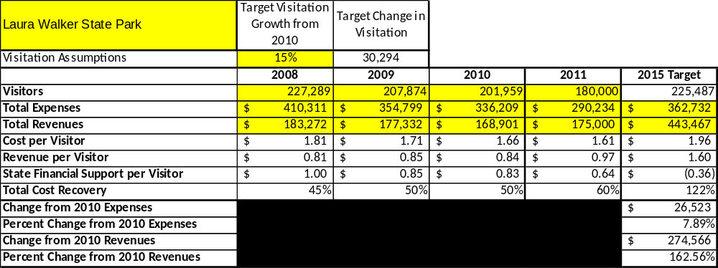

Key Recommendations

Primary / Short Term Recommendations
- Site operations should be conducted on a “cost-based” standard, tracking revenue vs. expenditures to obtain net cost recovery realized annually
- Plan and develop a minimum of four special events per year(one per season) to help attract visitors and increase awareness of the site
- Engage the Friends of Laura Walker group to help raise funding and provide a source of volunteer labor and support for the site.
- Conduct in-house surveys to determine resale items desired by site visitors. More heavily promote gift shop and retail offerings at the site utilizing social media and local advertising
- Develop active partnerships with other key public and private area recreation providers including the Okefenokee Swamp Park and the Okefenokee Swamp National Wildlife Refuge, seek out revenue-sharing activities and cooperative programming ventures between LWSP and these providers
- Sustain adequate operational funding or reduce staff so that staff operational costs, including benefits for full-time associates, do not exceed 65% of total expenses.
- Collect and compile a statistically viable sample of ZIP code data from visitors to obtain demographic cross-section of LWSP visitors to meet programming, recreational, and facility demands.
- Plan and construct ten cottages and renovate campsites to provide a source of sustainable “stay-use” revenue.
- Develop concession agreement for the collection pine straw from day use areas.
- Enhance existing facilities, both through modernization of existing buildings and introduction of native plants, flowers, and botanical elements, to give each customer a more unique experience, while keeping intact the historical authenticity of the site and site structures.
- Review and analyze rates yearly to determine net cost of services rendered for both crucial and visitor-supported services
- Closely analyze labor in all operational areas to maximize service delivery and maximize return on investment with right position, right job, right person, right pay.
- Continue to weigh pros and cons of amending horsepower restrictions on lake out of Georgia code and placing in park rules to maximize recreation opportunities for all water enthusiasts—canoeists, kayakers, boaters and fishermen.
- Plan and develop special events that appeal specifically to key user groups that are revenue-generating, such as fishing tournaments and concert events that appeal to families.
- Enhance pod/cluster of the group camp cabins (preferably 11-14, lakeside), insulate, new furnishings, paint and repair wooden structures, and aggressively market to target groups.
- Plan, develop, and install two lake swimming areas, one on day-use side of park, and one on boat ramp side of park.
- Demolish existing pool facility and block day-use bathroom. Plan and construct modern restroom at site of pool facility.
- Add 5 to 10 camper cabins in the closed pioneer area and add infrastructure for future cottages at the same time.

Secondary / Long Term Recommendations
- Enhance existing interior trail system to expand related recreational opportunities, to promote a healthy lifestyle, and allow expanded, controlled public access to the natural resources of the site.
- Engage local public figures, stakeholders, and specific user groups to determine feasibility of installing bike path along GA Hwy 177 from Hwy 82 to Okefenokee Swamp Park.
- Continue to add and develop overnight accommodations at LWSP, amenities which have never existed at the site such as cottages, camper cabins, bunkhouse(s), etc.
- Develop hiking and biking trails in the adjacent Dixon Forest.

Site and Operations Assessment
This site and operations assessment is a culmination of analyses and findings from a review of the condition of facilities, infrastructure, and operations at Laura S. Walker State Park. The findings and observations are not intended to be an exhaustive review of all issues present, but provide a basic understanding of the predominant issues that contribute to the site’s current operating conditions. The assessment includes the following:
- Site Inventory and Facility Assessment
- Operational Assessment
- Financial Assessment
Site Inventory and Facility Assessment

Methodology
Facility and asset conditions are rated using a differential scale of excellent, good, fair, or poor. Descriptions of conditions that are attributed to each of these findings are also provided.
Scale of Conditions
Rating | General Description
Excellent | Facilities/amenities are in ‘excellent’ condition when they show little or no maintenance or repair problems. Facilities do not feature any major design or operational issues or flaws that contribute to diminished use or increased maintenance or upkeep. Facilities are easy to clean and maintain in order to place them back into public use and the users perceive them to be in excellent shape.
Good | Facilities/amenities are in ‘good’ condition when they show only minor maintenance or repair problems. Most maintenance issues with these facilities typically appear to be the result of age and/or heavy use. Facilities may only feature minor design or operational issues that contribute to diminished use or increased maintenance or upkeep. Facilities are moderately easy to clean and maintain in order to place them back into service and the users perceive them to be adequate for their use, but probably not in excellent shape.
Fair | Facilities/amenities are in ‘fair’ condition when they show significant maintenance or repair problems. Facilities generally exhibit ongoing maintenance issues that appear to be the result of age, heavy use, or design or operational flaws. Some maintenance and repair needs may compound their fair condition by being deferred because of budget and/or resource limitations. Facilities require more effort to clean and maintain before placing them back into service and the users may perceive them as being less than adequate for their use and in a state of deterioration. The facility or structure may need of major repair or replacement.
Poor | Facilities/amenities are in ‘poor’ condition when they show significant, on-going maintenance or repair problems that ultimately may result in suspended use for repair/replacement. Maintenance and repair issues are possibly the result of poor maintenance and clearly the result of age, heavy use, or design or operational flaws. Problems with the facilities are often compounded over time due to consistently-deferred maintenance and repair because of budget and/or resource limitations. Facilities may feature major design or operational issues that contribute to diminished use or increased maintenance or upkeep. Facilities require excessive effort to clean and maintain before placing them back into service and the users often perceive them as being inadequate for their use and in a state of serious deterioration. The facility or structure may need of major repair or replacement.

Inventory and Assessment
The table below is an inventory of facilities and amenities at Laura S. Walker State Park, and provides the assessed condition of each as reviewed in May, 2011 .
Site Asset / Amenity | Quantity | Condition
Total acreage | 305
Visitors Center/office | 1 | Good
Campsites | 44 | Fair
Group Shelters | 4 | Fair
Day-use comfort station | 1 | Poor
Fishing dock | 1 | Fair
Group camp cabins | 16 | Poor
Group camp comfort stations | 4 | Poor
Maintenance Shop | 1 | Fair
Barn | 1 | Fair
Interpretive Center | 1 | Fair
Picnic Shelters | 7 | Good
Manager’s Residence  a | 1 | Good
Asst Mgrs. Residence | 1 | Good
Pioneer Area | 1 | Good
Pool Complex | 1 | Poor
Staff House | 1 | Fair
Nature Trails | 2 | Fair
Softball Field | 1 | Poor

Prioritized Facility Needs
Based on the facility inventory and assessment, these prioritized needs have been identified. Each need has been aligned with a priority category of high, moderate, or low to support future decision making regarding project sequencing, investment of public resources, and meeting community expectations. The priority assignment for each need is not a measure of importance. Rather, these recommended priorities reflect a phased implementation approach over the next several years.

Facility Need | Priority Assignment
Group camp renovation(kitchen, staff house, camper cabins) | High
Installation of boat dock at lake | Moderate
Visitor Center expansion(increase resale space, renovate office space) | Moderate
Renovate campground, sites to combat erosion and uneven sites | High
Convert interpretive center into 4-person “bunkhouse”, with kitchen. Can rent as part of entire group camp or separately in off-season | High
Demolish pool facility, demolish block day-use bathroom and construct modern bathroom facility at old pool facility site | High
Plan and construct 2 swimming areas, one in day-use and one at boat ramp area. | High
Enhance pod/cluster of group camp cabins and bath house by lake. (Insulate, repair and paint) | High
Convert staff cottage into more traditional cottage facility, maximize space, install kitchen. | High

Operational Assessment
The Operational Assessment includes:
- An inventory and classification of programs and services being provided at the site
- A review of staffing at the site
- A review of concessionaires and partners operating at the site
- Visitation and customer satisfaction

Inventory and Classification of Programs and Services
Programs and services are classified into one of three major categories:
1) Core or Essential Services
2) Important Services
3) Visitor Supported Services
Programs and services at the site are classified into these categories based in part on the mission and public mandates for both the site and the agency. For the services in each of these categories, there are financial performance expectations that will define how services are funded and evaluated.

Category 1 – Core Services [Largely supported by tax funds]
Core programs, services and facilities are those the agency must provide and/or are essential in order to capably govern and meet statutory requirements. The failure of the agency to provide Category 1 services at adequate levels could result in significant negative consequences for the public and the resources under protection. The criteria for services to be classified as core or essential are:
- The services are mandated by the agency’s law or charter or are contractually obligated by agreement to provide the services.
- The services are essential to protecting and supporting the public’s health and safety.
- The services protect and maintain valuable assets and infrastructure.
- The services would generally and reasonably be expected and supported by residents, businesses, customers and partners.
- The services are those that cannot or should not be provided by the private sector.
- The services provide a sound investment of public funds.
The following services offered at Laura S. Walker State Park have been identified as core services:
- Active management of the site and its resources in order to protect the integrity and future viability of the site
- Open access to the site and its resources
- Site appropriate educational, interpretation and recreational opportunities
- Public safety
- Maintenance of site, grounds, facilities and infrastructure

Category 2 – Important Services [Supported by a balance of tax funds and earned revenues]
Important programs, services and facilities are those the agency should provide, and are important to governing and effectively serving residents, businesses, customers and partners. Providing Category 2 services expands or enhances the agency’s ability to provide and sustain its core services. The criteria for programs or services to be classified as important are:
- The services expand, enhance or support identified core services.
- The services are broadly supported and utilized by the community, and are considered an appropriate, important, and valuable public good. Public support may be conditional upon the manner by which the services are paid for or funded.
- The services generate income or revenue that offsets some or all of the operating cost and/or are deemed to provide economic, social or environmental outcomes or results.
The following programs and services offered at Laura S. Walker State Park have been identified as important services:
- Self-guided recreational activities (hiking, canoeing, biking, geocaching)
- Fishing and recreational boating on Laura Walker Lake

Category 3 – Visitor Supported Services [Almost exclusively supported by earned revenue]
Visitor supported programs, services and facilities are those discretionary services that the agency may provide when additional funding or revenue exists to offset the cost of providing those services. Category 3 services provide added value above and beyond what is required or expected. The criteria for programs or services to be classified as visitor supported are:
- The services expand, enhance or support core services or important services and the quality of life of the visitors, community or stakeholders.
- The services are supported, valued and well utilized and provide an appropriate and valuable public benefit.
The services generate income or funding from sponsorships, grants, user fees or other sources that offset some or all of their cost and/or provides a meaningful return on investment.
The services can possibly be provided through outsourcing or use of concessionaires, providing opportunities for community enterprises that may not otherwise be provided by the agency.
The following programs and services offered at Laura S. Walker State Park have been identified as visitor supported services:
- Retail / gift shop
- Ranger-led programs and activities
- Rentals (bikes, canoes, camping, day-use shelters)
- Special events (holiday, historically significant, resource-oriented)
- Events not site-related (weddings, family reunions, scouting events)
- Friends Chapter supported (plant sales, consignment, etc.)

Staffing Assessment
Labor costs at Laura S. Walker State Park represent the largest area of budgetary expense at an average of 71% of the total operating budget each year for the last three complete years, which is higher than the target of total labor costs (including benefits) not exceeding 65% of the site’s total operating expenditures. The tables below and on the following page provide a basic review of the current staffing at the site.
Full Time Equivalent Employees
Position / Title | Quantity (FTE) | Vacancies | Annual Hours
Manager Manager | 1 | 0 | 2600
Assistant Manager Manager 2 | 0 | 1 | 0
Utility Worker 2 | 1 | 0 | 2080
Park Ranger 1 | 0 | 1 | 0
TOTAL | 2 | 2 | 4,680

Labor Support | Annual Hours
Volunteers | 4000
Community Service Workers | 1800
Engineering and Construction Crews | 0
Resource Management Crews | 0
TOTAL | 5,800
Part Time Employees

Position / Title | Quantity (FTE) | Vacancies | Hours
Clerk | 2 | 0 | 3016
Maintenance Helper | 3 | 0 | 3016
TOTAL | 5 | 0 | 6,032
Labor Support

Total Labor Hours

Labor Type | Annual Hours
Full Time Equivalent Employees | 4,680  6032
Part Time Employees | 5,800
Labor Support | 6,032
TOTAL Annual Labor Hours | 16,512

Labor Budget Summary

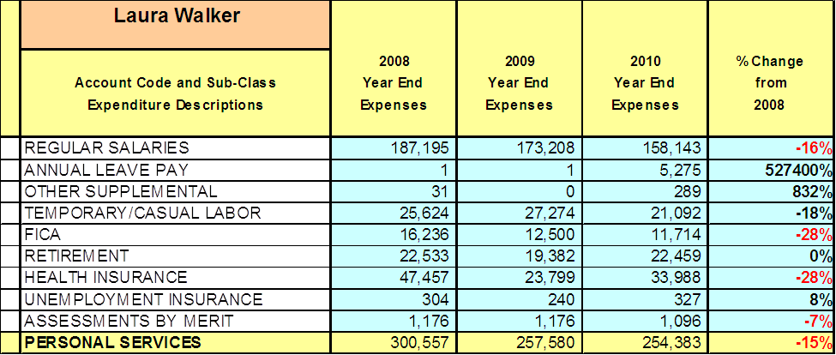

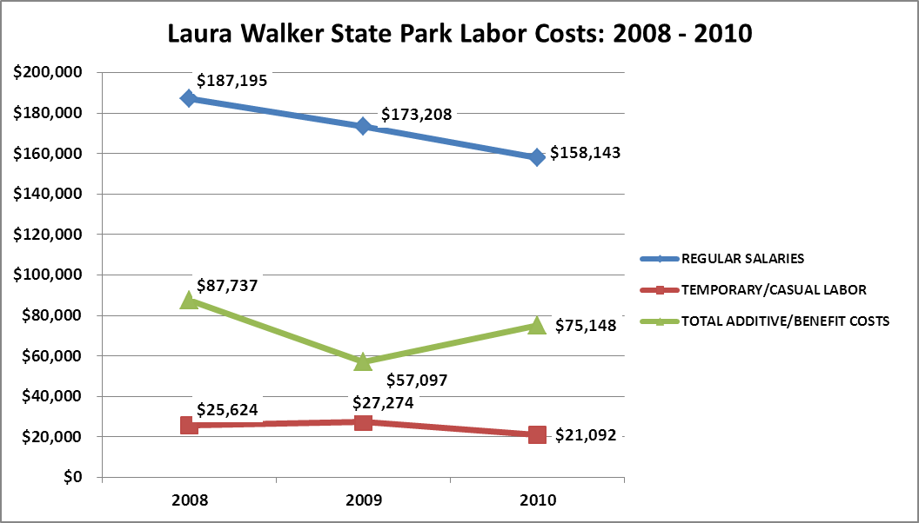

Visitation and Occupancy
Overall annual visitation to the site has trended downward from 2008 to 2010, decreasing by 11% or over 25,330 visitors. This is largely attributed to a general downturn in the economy, rising fuel prices, and hotter than usual temperatures in late spring and early summer.

Year | Total Visitation
2008 | 227,289
2009 | 207,874
2010 | 201,959

Occupancy for the overnight accommodations at Laura S. Walker State Park the last three years is detailed in the table below. Overall occupancy has remained constant from 2008 to 2010.

Year | Camping Occupancy
2008 | 33.06%
2009 | 33.46%
2010 | 32.84%

Customer Service and Satisfaction

Site | Year | Customer Satisfaction Level
Laura S. Walker State Park | 2009 | 100%
Laura S. Walker State Park | 2010 | 100%
Financial Performance Assessment

Operational Expenses
A summary of total operating expenses at Laura S. Walker State Park from 2008 to 2010, as well as their percent change from 2008 are provided in the table below.
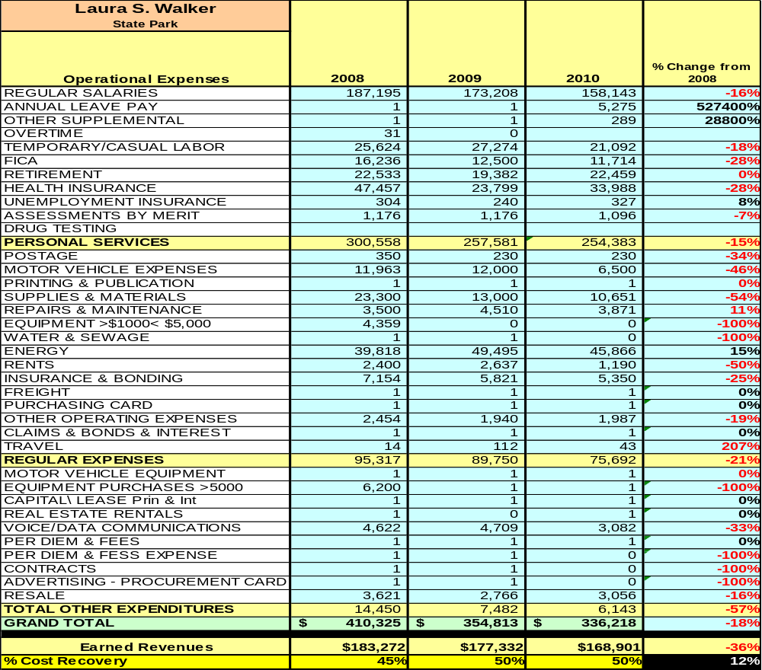

Earned Revenues
Earned revenues at Laura S. Walker State Park have decreased since 2008, which is largely attributed to the corresponding decrease in overall visitation. Monthly earned revenues for the last two years (see table on the following page) indicate that the total annual revenue decreased 5% from 2009 to 2010, with the largest increases in monthly revenues in Oct. (7%) and Sept. (43%) and the largest decreases in the months of July (-12%),Dec. (-10%), Feb. (-17%) and March (-17%).

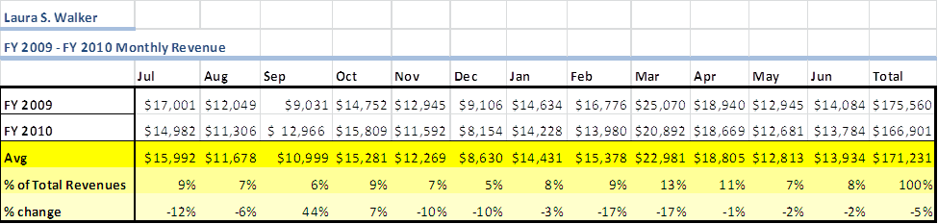

The graphs below illustrate the monthly revenue trends each year and the average percent of total annual revenue earned each month.

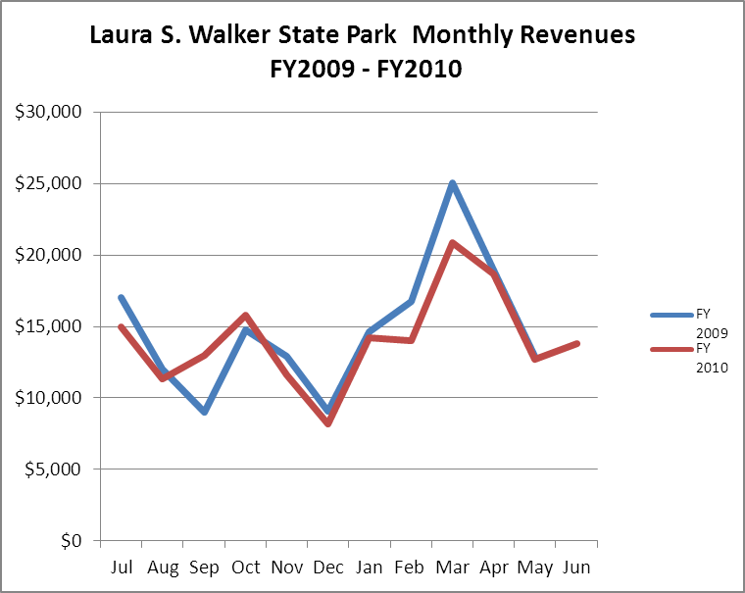

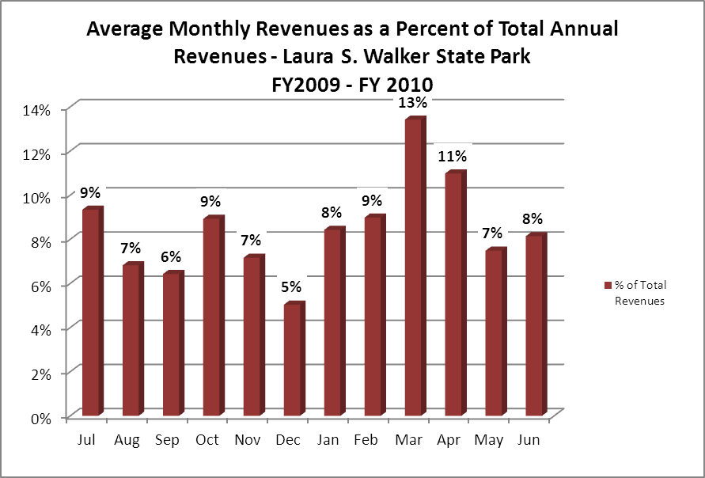
Cost Recovery Trends
Laura S. Walker State Park has achieved an average cost recovery of 49% of annual operational expenses through earned revenues from FY 2008 to FY 2010. This is detailed and illustrated in the table and graph below.
Year | Operational  Expenses | Earned  Revenues | Percent Cost  Recovery
2008 | $410,311 | $183,272 | 45%
2009 | $354,799 | $177,332 | 50%
2010 | $336,209 | $168,901 | 50%

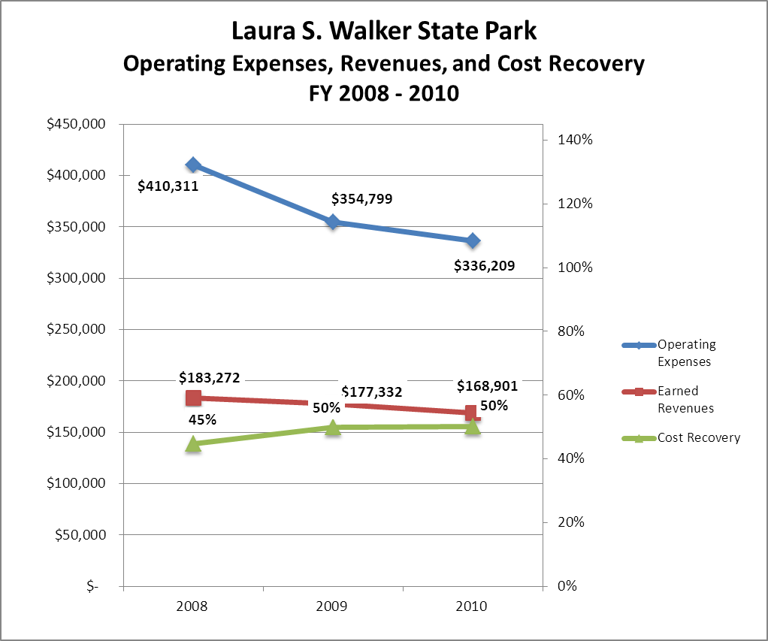

Review of Pricing
Data on rate information is available as far back as 2002, but only the last five years are evaluated. There has been notable growth in fees charged at Laura S. Walker State Park since 2005, with the largest increase being nightly rates for camping (23%), the group camp (19%), and the pioneer camp (86%).
A table detailing the rates for park reserveables is provided below.

 | 2005 | 2006 | 2007 | 2008 | 2009 | 1/1/2010 | 4/1/2010 | 2011
STATE PARKS
Laura S. Walker
Picnic Shelters-Regular | $35 | $35 | $35 | $40 | $40 | $40 | $45 | $45
Picnic Shelter-Premium #1 | $40 | $40 | $40 | $40 | $45 | $45 | $50 | $50
Picnic Shelter-Premium #6 | $40 | $40 | $40 | $40 | $45 | $45 | $50 | $50
Group Shelter #1 | $215 | $140 | $140 | $140 | $160 | $160 | $165 | $165
Group Shelter #2 | $65 | $65 | $65 | $65 | $75 | $75 | $80 | $80
Group Shelter #3 | $90 | $90 | $90 | $90 | $100 | $100 | $105 | $105
Group Shelter #4 | $125 | $125 | $125 | $125 | $130 | $130 | $135 | $135
Camping RV/Tent |  |  |  | 23/21 | 23/21 | 23/21 | 26/24 | 26/24
RV/Tent Regular | 20/18 | 20/18 | 20/18
RV/Tent Premium | 22/20 | 22/20 | 22/20
Pioneer Premium | $25 | $25 | $25 | $25 | $25 | $25 | $28 | $28
Pioneer Regular | $15 | $15 | $15 | $15 | $25 | $25 | $28 | $28
Group Camp | $360 | $385 | $385 | $385 | $425 | $425 | $430 | $430
Cabins | $25 | $25 | $25 | $25 | $35 | $35 | $40 | $40
Group Camp Kitchen |  | $90 | $90 | $90 | $100 | $100 | $105 | $105
Staff House |  | $100 | $100 | $100 | $100 | $100 | $105 | $105
Business and Management Plan

Business Goals
The following goals serve as the foundation for the key recommendations and strategies in this business plan for Laura S. Walker State Park

Enhance Cost Recovery of Site Operations
Laura S. Walker is operating at an average of 50% cost recovery of operational expenses through earned revenues. Great measures have been taken in the past 2-3 years to cut operating expenses while still continuing to operate and satisfy the expectations and demands of park visitors. Laura S. Walker lacks an adequate number of overnight facilities to offer our guests, which greatly decreases sustainable revenue. Laura Walker can increase revenue with the addition of modern overnight facilities, such as traditional cottages or camper cabins, and also by more heavily promoting the site through special events. The site is fairly well isolated from major population centers. It is critical to the site to increase cost recovery to no less than 75% by increasing revenue streams.

Enhance Revenue Generation Strategies
Revenue increases can most likely be realized from increased visitation to the site and through specific, measureable and attainable revenue enhancement strategies. Laura Walker will improve revenue generation through the addition of overnight reserveable facilities, the offering of at least four special events to gain exposure and recognition for the site, and by more heavily promoting retail sales of branded items that provide a memory of unique experiences realized by guests during their stay.

Expand Special Events at the Site
Laura Walker currently provides two annual special events that are linked to the Thanksgiving and Christmas holidays, and also holds games and activities on July 4th weekend. Special event offerings should be expanding to offer at least two more special events, one for each season, taking into consideration the changing demographics of visitors to the site in each particular season. The Friends Chapter of Laura S. Walker is critical to the success of special events at the park, given the very small number of staff available at the site for such expanded programs. With volunteer help from the Friends of LWSP and other volunteers, Laura Walker can also increase visitation numbers with the development of the ball field area located behind the park office, so that local groups can hold softball and baseball tournaments, and are charged a fee for any organized event held in the area. Benefits could be obtained from partnering with the Okefenokee Swamp Park to offer complimentary programs to special events held at the Swamp Park.

Improve the Diversity and Innovation of Recreational and Interpretive Programs
Recreational and interpretive programs at Laura Walker are primarily of the self-guided variety, involving outdoor recreation activities such as hiking, biking, geocaching, canoeing, and kayaking. Measures should be taken to develop ranger or volunteer-led programs that satisfy the interests of each of these different user groups. Particular effort should be given to offer day camps for youth that are educational in nature and promote the recreational aspect of the site, notably Junior Ranger day camps and partnerships with DNR’s Wildlife Resources Shooting Sports Director in providing Archery Summer Day Camps, in which revenue sharing is practiced between the PRHSD and Wildlife Resources Division. Consideration should be given to exploring partnerships with local outfitters near the Okefenokee Swamp and the Satilla River to offer canoeing and kayaking excursions, with the thought that participants in these programs will stay as overnight guests at Laura S. Walker. Programs could be explored as revenue-makers similar to the golf/camping package available for guests that stay at Laura S. Walker and golf at the Lakes golf course.

Improve the Effectiveness of Marketing and Sales
Marketing and promotion of Laura S. Walker can be pursued more aggressively to promote greater visitation and occupancy during all seasons. Partnerships with other similar organizations should be developed in order to increase occupancy numbers and provided a more balanced number of visitors and revenue, rather than putting the majority of effort in one or two special events and only during peak and shoulder seasons.

Establish Greater Consistency of Managing and Monitoring Customer Service & Satisfaction
Laura Walker can more properly and easily evaluate customer satisfaction with the site through the use of on-site surveys, conducted periodically among different user-group segments. Laura Walker needs to have 90%-95% of customers rate their responses as “satisfied”, “excellent”, or similar, depending on the particular survey and what method(s) are utilized. Programs, services, or service delivery that consistently scores lower than desired need to be re-evaluated, and if it is determined that the proper improvements cannot be achieved, the program or service will be phased out. As for service delivery ratings that fall below desired levels, staff will be re-trained in problem areas and progress reports will be developed to complement current e-performance SOPs.

Expand Partnership Opportunities
There are a number of providers in the area proximal to Laura Walker that offer similar services, including the Okefenokee Wildlife Refuge, the Okefenokee Swamp Park, and private campgrounds. Partnerships need to be aggressively developed with these local providers to provide support service delivery at Laura Walker. Corporate co-sponsorships need to be pursued for major events, to help defray costs and to utilize the extra resources to more effectively Laura Walker to major markets and demographic groups.

Classification of Programs and Services
The tables below summarize the classifications of programs and services at Laura S Walker State Park as either core, important, or visitor supported and projects a range of cost recovery percentages that might be achieved for each. These classifications establish financial performance goals for each category of services that are linked to the recommendations and strategies of this business plan.

Core Services
Program / Service | Target Cost Recovery
Active management of the site and its resources in order to protect the integrity and future viability of the site | 0%
Open access to the site and its resources | 30% -60%
Site appropriate education, interpretation and recreational opportunities | 20%-40%
Public safety | 0%
Maintenance of site, grounds, facilities and infrastructure | 0%

Important Services
Program / Service | Target Cost Recovery
Self-guided recreational activities(hiking, canoeing, biking, geocaching) | 20%-50%
Fishing and recreational boating on Laura Walker Lake | 30% - 70%

Visitor Supported
Program / Service | Target Cost Recovery
Retail/gift shop | 140% +
Ranger-led programs and activities | 100%
Rentals (bikes, canoes, camping, day-use) | 150%-200%
Special events (holiday, historically significant, resource-oriented) | 150%-200%
Events not site-related (weddings, family reunions, scouting events) | 100%-150%
Friends Chapter supported (plant sales, consignment, etc.) | 100%-150%

Partnership Development Plan
The table below summarizes existing partners and targeted partnerships by classification (operational, vendor, service, co-branding, funding partners) and by organizational type.
 | Public Partners | Not-for-profit Partners | Private / Enterprise Partners
Operational Partners | - The Lakes Golf Course at Laura S. Walker | - Lions Camp for the Blind
Vendor Partners |  |  | - Coca-Cola  - REI  - GA Power
Service Partners | - City of Waycross  - Waycross YMCA | - Waycross Tourism Board  - BSA/GSA
Co-branding Partners | - Stephen Foster State Park  - Okefenokee NWR |  | - Okefenokee Swamp Park  - Twin Oaks Park  - Wild Adventures
Funding Resource Development Partner |  | - Friends of GA State Parks & Hist. Sites  - Friends of LWSP

Marketing and Sales Plan

Marketing and Sales Goals
Marketing and sales goals for Laura S. Walker State Park are based on the following desired outcomes:
- To achieve higher overall visitation and net revenues
- To develop and produce more site/area-themed special events that draw large attendance
- To develop more nature-themed, outdoor recreation based programs to bring visitors to the site that might not visit the site due to a lack, or perceived lack, of activities offered.
In order to meet these goals, examples of specific target outcomes were identified in the areas detailed in the table below.
Area  of Focus | Current  Performance | Goal  by 2011 | Goal  by 2012 | Goal  by 2015
Special events | 500 vis./yr. | 1000 vis./yr. | 2000 vis./yr. | 4000 vis./yr
Overall Visitation | 168,000 | 180,000 | 210,000 | 225,000

Marketing and Promotion Strategies

Publicity and Social Media
Laura S. Walker State Park will approach marketing and publicity planning using the following guidelines and themes:
- Event publicity
Major events benefit by having short stories in local, regional, and statewide newspapers and online social media hooks planted that run three to four weeks in advance of the event up to the date of the event itself. Stories and media need to be cultivated with contacts and online sales channels several weeks in advance of the time the stories need to run. Special interest interviews on morning, noon, and evening television news programs, radio interviews on popular rush-hour programs, and blogs on known affinity online sites should also be included.
- Program Publicity
Special and unique programs should have feature stories in magazines, weekly newspapers, and statewide daily newspapers that are aimed at placements as front-page or sectional front-page stories. These stories are most effective if they run shortly before the season that the featured program begins. This will likely require several weeks of advanced planning with media contacts. Similar coverage on television and radio should also be considered. If pre-publicity cannot be generated, post-publicity can help promote future programs.
- Site Publicity
Site publicity focusing on a single site or sub-set of sites requires more intense planning efforts to attract multiple writers and editors from target publications. Each site could host several seasonal media familiarization tours (with 10 to 15 writers or editors) to familiarize them with the site and its benefits and amenities. Stories and features resulting from such tours typically take between two and six months to materialize so the tours should focus on experiences, benefits, and programs that would be available when the stories are expected to run.
Examples and suggested opportunities for events, programs and related publicity efforts based on the themes described above at Laura S. Walker State Park are provided in the table below.
Event Publicity | Program Publicity | Site Publicity
Fall Festival | Junior Ranger Day Camp | Swamp Fest
Christmas Program | Summer Archery Day Camp | Twin Oaks Bluegrass Festival
Bass Fishing Tournament | Backyard Birding | Swamp Run
 | July 4th Field Day | Bass Fishing Tournament

Packaging
Examples and suggested packages for Laura S. Walker State Park are provided in the table below.
Package | Package Details
Fish Tales | Free or discounted night camping/camper cabin if catching biggest/most unusual fish, tie into fishing tournament(s)
Regional Discount/Promotion | Promotional gift shop item if completing specific challenges at several parks/sites in same area(LWSP, S. Foster, Crooked River, Hofwyl), partnering with corporate partner such as Coca-Cola or REI
Local business discounts | Booklet of discount opportunities for local recreation providers, leisure activities, family businesses, with proceeds shared between LWSP and local providers

Group Sales
Types of groups within which specific target customers can be identified for Laura S. Walker State Park are listed below:
- Families  - Boy Scouts/Girl Scouts  - Churches  - Colleges | - Businesses  - Clubs  - Sister Agencies  - Local community organizations | - School groups(public/private  - Local intramural sports leagues  - Activity/Special Interest Enthusiasts

Incentivizing New and Repeat Visitation
Laura S. Walker State Park will utilize the following strategies and/or incentives to encourage new and repeat visitation starting in FY 2012:
- Returning customer discounts
- Group pricing(camping clubs, group camp)
- Weekday/weekend, on-peak/off-peak variable pricing
- Partnership discounts(selected club or organization members)

Marketing and Sales Metric Goals
The following marketing and sales metric goals and/or others will be monitored and progress reported at Laura S. Walker Park:
- Loyalty and repeat customers = 60% of customers return within 12-months.
- Brand confidence & customers-recruiting-customers = 45%-50% customers referred by friend of family member that has previously visited LWSP.
Revenue Generation Plan
Revenue / Cost Recovery Goals
Laura S. Walker State Park has set a financial goal of increasing annual revenues 4% in 2012 and 5% in 2015 (based on presumptive addition of new overnight rental facilities). The largest revenue growth opportunity is most likely in May, June, and July. Families seeking summer vacation destinations can be drawn to the park as Laura Walker adds more family-oriented programs and overnight accommodations. The table below details projected revenue growth leading up to 2015, based upon a nominal growth of revenues each year.
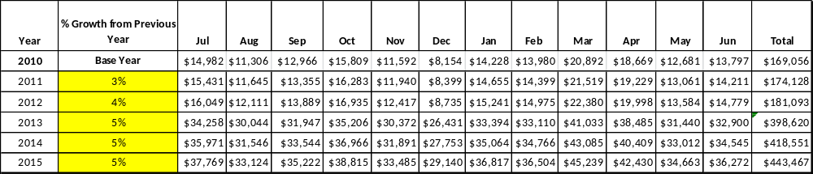

These projections would result in a total of 162% cumulative growth in total annual revenues between FY2010 and FY2015. If operational expenses can be managed with a cumulative increase of 8% between FY 2010 and FY 2015, then the overall cost recovery of the site will be approximately 122% in FY 2015 at these projected revenue levels. This is higher than the annual financial performance of the site in FY 2010, which was operated at 50% cost recovery in that year.

Revenue Generation Strategies

Pricing Plan

LAURA S WALKER PARK RESERVABLES | Current Pricing (CY 2011) | Proposed Pricing  (CY 2012) | Yield Mgmt Margin (%)
Camping (RV/Tent) | $26/$24 | $26/$24 | +/- 7%
Picnic Shelter-Regular | $45 | $50 | +/- 10%
Picnic Shelter-Premium 1 and 6 | $28 | $50 | +/- 10%
Group Shelter 1 (capacity) | $165(150) | $180 | +/- 10%
Group Shelter 2 (capacity) | $80(125) | $90 | +/- 10%
Group Shelter 3 (capacity) | $105(75) | $120 | +/- 10%
Group Shelter 4 (capacity) | $135(90) | $150 | +/- 10%
Pioneer Campsite | 28($1pp over 25) | $60 | +/- 10%
Group Camp | $430 | $450 | +/- 10%
Camper Cabin | $40 | $50 | +/- 10%
Staff House | $105 | $125 | +/- 10%
Camp Kitchen | $105 | $120 | +/- 10%

Innovative Programming and Special Events Plan

Program / Event | Theme / Purpose | Scheduled Date/Season | Frequency | Target Participation | Target User Fee | Target Cost Recovery
Fall Festival | Holiday | Fall | Once/year | 1000+ | 2.00 | 150%-200%
Christmas-lights program | Holiday | December | Once/year | 1000+ | 2.00 | 150%-200%
Fishing tournament | Recreation | Spring/Fall | Biennially | 20-40 boats(trolling motors | 50.00 | 150%-200%

Partnerships and Concessions Plan

Service / Partnership | Term of Service | Financial Objective | Contract Manager
Food concessions(lake/events) | 1 year | 15% of gross proceeds to park | Park Manager
Packages/promotions w/ local businesses | 1 year | Shared revenue | Region Manager
Pine straw collection/landscaping | 1 year | 15% of gross proceeds to park | Park Manager

Expense Management Plan
Personnel Assignments
The following actions will be taken to proactively manage labor costs via personnel assignments and classifications.

Action | Timeline | Outcome
Eliminate seasonal naturalist position | July 2011 | Annual labor cost reduction of $12,064
Fill Senior Ranger position, eliminate vacant utility 1 position, eliminate vacant clerk position | January 2012 | Annual labor cost reduction of $10000

Management Techniques
The following actions will be taken to proactively manage labor costs via management techniques.

Action | Timeline | Outcome
Concession service at lake | Mid/late summer 2011 | Increased revenue

Adjusted Levels of Service
The following actions will be taken to proactively manage labor costs via reduced levels of service.

Action | Timeline | Outcome
Pioneer 2 area closed | Immediate | Annual cost reduction of $3000

Financial Pro Forma
The following five-year financial pro forma projects operating expenses, earned revenues and cost recovery through FY 2015. These pro forma are based on the strategies and desired outcomes identified in this business plan, especially the revenue generation and expense management plans, and are linked to corresponding performance goals.

Expense Pro Forma
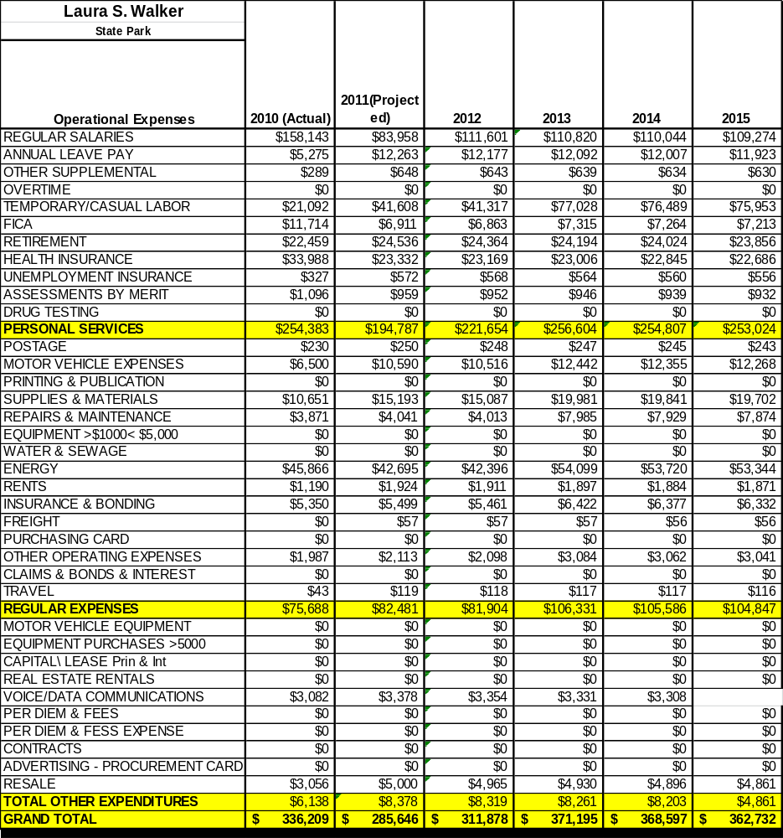

Revenue Pro Forma

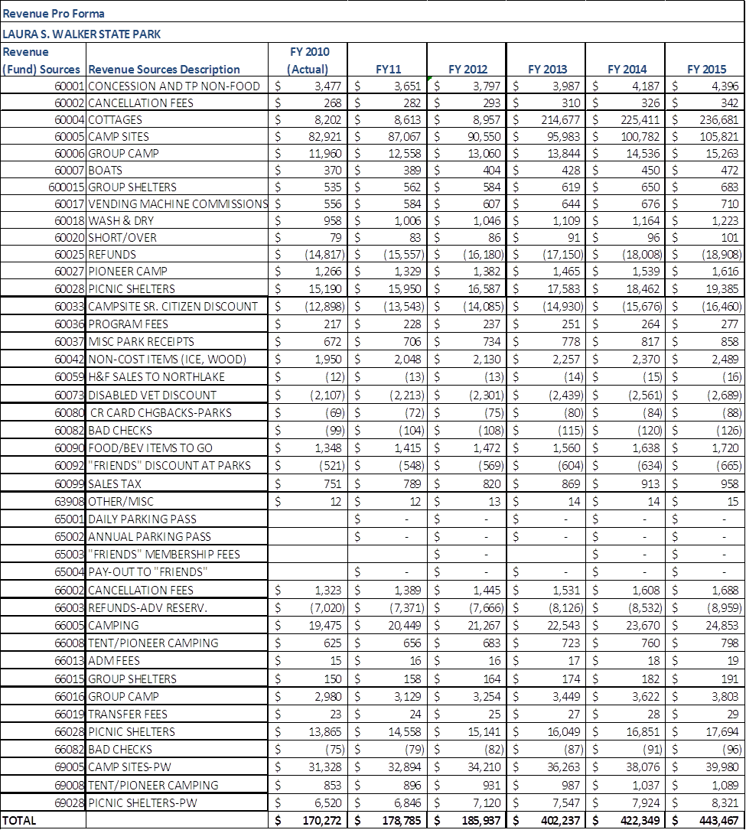

Total / Cost Recovery Pro Forma

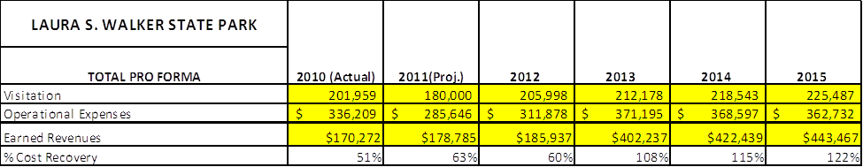

ACTION PLAN
Site: |  | Site Manager: |  |  | Date:
Month:
Strategy | Tasks | Costs / Funding | Revenues / ROI | Responsibilities | Metrics

Action Plan

ACTION PLAN
Site: |  | Site Manager: |  |  | Date:
Month:
Strategy | Tasks | Costs / Funding | Revenues / ROI | Responsibilities | Metrics

This is the average of the last three years – FY 2008, FY 2009, and FY 2010
Current employees, not including vacancies.
Current employees, not including vacancies.
Major population centers within a two-hour drive from the site

