Little Ocmulgee State Park
Business & Management Plan

Prepared 7/5/11; Finalized 3/8/12
Direction 2015 – Sustainable Business Planning

Table of Contents

Executive Summary 3

Site and Operations Assessment 7
Site Inventory and Facility Assessment 7
Operational Assessment 10
Financial Performance Assessment 15

Business and Management Plan 19
Business Goals 19
Classification of Programs and Services 20
Partnership Development Plan 21
Marketing and Sales Plan 21
Revenue Generation Plan 24
Expense Management Plan 26
Financial Pro Forma 27

Action Plan 30

Executive Summary
The Parks, Recreation and Historic Sites Division (PRHSD) of the Georgia Department of Natural Resources (DNR) is transitioning the management of Little Ocmulgee State Park to operate more like a business, reflecting the Direction 2015 – Sustainable Business Planning initiative to improve the fiscal performance and management of the state parks and historic sites system. This business and management plan is designed to help the site recover more operating expenses through earned revenues, productive partnerships, and innovative programs.

Site Fact Sheet
Site Name | Little Ocmulgee State Park
Site Manager | Jay Lewis
Region Manager | Tommy Turk
Date of Business Plan completion | July 5, 2011
Site size | 1360 acres
Total number of visitors (FY 2010) | 262,954
Total operating budget (FY 2010) | $ 1,801,358
Total earned revenues (FY 2010) | $ 1,456,062
Operational cost recovery (FY 2010) | 81%
Average operating cost per visitor (FY 2010) | $ 6.85
Average earned revenue per visitor (FY 2010) | $ 5.54
Average cost recovery (FY 2008 – 2010) | 76%
Target cost recovery (FY 2015) | 91%
Total full-time employees | 13
Total part-time employees | 34
Primary service markets | Macon, Atlanta, Jacksonville, and Savannah
Primary attractors/visitor appeal factors | Golf course, lake, CCC history, and Splash Pad
Leading opportunities for improved site performance | Clean up lake for increased/improved boating, fishing & recreation; construct “Sports Bar” & exercise room, & renovate tennis courts; and make better use of amphitheater for concerts/performances.

Site Summary and Key Attractions
Conveniently located off Highway 441 in south Georgia, this 1,360-acre park features a wide variety of amenities. Golfers can test their skills on the 18-hole Wallace Adams Golf Course with clubhouse, golf pro and junior/senior discounts. The 2.3-mile Oak Ridge Trail winds through scrub oaks and pines towards a vulture roost and boardwalk. During summertime, children will enjoy the park's splash pad where they can run through fountains and squirt their friends. A 60-room lodge offers hotel-style guest rooms, meeting facilities and a restaurant with golf course view. Facilities are available for meetings, reunions, weddings and other group gatherings.

Key Attractions
The amenities or features listed below are those that seem to be most popular for visitors:
- Golf Course
- Lake
- Splash Pad
- Civilian Conservation Corps Structures
- Camping
- Cottages
- Hiking
- Restaurant
- Picnicking
- Interpretation/Programs
- Bike Rental
- Special Events
- Canoe and Paddle Boat Rental
- Miniature Golf

Financial Targets
The table below details the total operating expenses and earned revenues for Little Ocmulgee State Park over the last three years (2008 – 2010). This table also calculates total cost per visitor and revenues per visitor during these operating years, and details the target financial performance goals in the context of achieving at least 91% cost recovery. This table also calculates the necessary change from 2010 operating expenses and revenues.
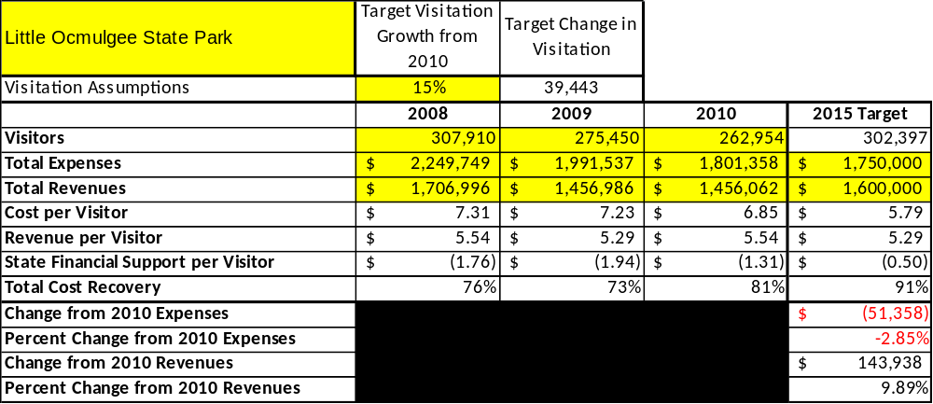

Key Recommendations

Primary / Short Term Recommendations
- Operate Little Ocmulgee State Park using cost-based accounting, including the net cost recovery achieved annually.
- Conduct on-site surveys annually to assess how well customer satisfaction levels are being met. Sites should strive to have 90% of visitors responding to ‘Comment Cards’ report that they were either ‘satisfied’ or ‘very satisfied’ (or some comparable metric to be developed). Programs or services that fall below that standard should be critically reviewed, enhanced, and results monitored; those with a history of poor performance should be considered for elimination.
- Pursue opportunities to employ concessionaires or private or public service providers on-site if they can be more cost-effective or provide desirable services, programs or amenities the Division cannot. Promote the use of the amphitheater as a venue for musical performances and outdoor dramas. Partner with concert promoter to stage concerts.
- Utilize a minimum of 10 special events annually to help draw more visitors to the site.
- Seek local partners and volunteers to help support operations, programs, and service delivery and for cross-marketing purposes.
- Sustain sufficient non-labor operational funding or reduce staff so that required staff operational costs (with benefits) do not exceed 65% of the total operational budget.
- Manage Little Ocmulgee according to well-defined maintenance, programming and operational standards, monitored and enforced by region managers and senior management.
- Partner with Wheeler and Telfair Chambers of Commerce for promotion of the park.
- Continue to work with the statewide and chapter Friends of Georgia State Parks and Historic Sites to help raise funds or provide volunteers for improvements and program support.
- Perform a thorough net cost-of-service analysis on major functions of site operations, including a detailed analysis of labor requirements by task. Thereafter, update costs to deliver services on a biennial schedule. This is being accomplished through the use of cost centers on employee grid sheets.
- Review and update rates at the site on an annual basis to meet cost recovery targets for important and visitor supported services. This is currently being evaluated at Little Ocmulgee.
- Enhance retail operations at Little Ocmulgee to increase site generated revenues. This includes experimenting with new items and removing items not selling on a regular basis.
- Develop a more detailed analysis of labor requirements of all major park functions to match the right position with the right job at the right pay.
- Develop funding to provide additional training to site staff for improved business management and marketing effectiveness.
- Upgrade facilities and amenities that are likely to have a cost recovery level at or above 80%. This includes lodge room renovations, cottage renovation, swimming pool upgrades, lake improvements (weed control), etc. and amphitheater.
- Add more youth and family focused services, programs and amenities at Little Ocmulgee that appeal to younger audiences, families and educational groups. Partner with local schools, churches and theater groups to bring performances to the amphitheater.
- Add more services, programs and amenities at Little Ocmulgee that appeal to older adults such as senior fishing tournaments and partnering with assisted living and senior groups for senior day programs
- Resolve weed issues in the lake in order to attract boaters and fishermen.

Secondary / Long Term Recommendations
- Improve the recreational amenities at Little Ocmulgee to meet the needs of modern and emerging uses, including addressing the recreational preferences of a diverse public.
- Engage local communities, user groups, and private organizations to improve connectivity between and within Little Ocmulgee through trail development and maintenance projects.
- Install an improved retail point-of-sale and inventory tracking system.
- Improve sustainability by generating revenue from various sources including lake activities if lake is cleaned up and maintained to a level guests can utilize it for recreational and sporting activities.

Site and Operations Assessment
This site and operations assessment is a culmination of analyses and findings from a review of the condition of facilities, infrastructure, and operations at Little Ocmulgee State Park. The findings and observations are not intended to be an exhaustive review of all issues present, but provide a basic understanding of the predominant issues that contribute to the site’s current operating conditions. The assessment includes the following:
- Site Inventory and Facility Assessment
- Operational Assessment
- Financial Assessment

Site Inventory and Facility Assessment

Methodology
Facility and asset conditions are rated using a differential scale of excellent, good, fair, or poor. Descriptions of conditions that are attributed to each of these findings are also provided.
Scale of Conditions
Rating | General Description
Excellent | Facilities/amenities are in ‘excellent’ condition when they show little or no maintenance or repair problems. Facilities do not feature any major design or operational issues or flaws that contribute to diminished use or increased maintenance or upkeep. Facilities are easy to clean and maintain in order to place them back into public use and the users perceive them to be in excellent shape.
Good | Facilities/amenities are in ‘good’ condition when they show only minor maintenance or repair problems. Most maintenance issues with these facilities typically appear to be the result of age and/or heavy use. Facilities may only feature minor design or operational issues that contribute to diminished use or increased maintenance or upkeep. Facilities are moderately easy to clean and maintain in order to place them back into service and the users perceive them to be adequate for their use, but probably not in excellent shape.
Fair | Facilities/amenities are in ‘fair’ condition when they show significant maintenance or repair problems. Facilities generally exhibit ongoing maintenance issues that appear to be the result of age, heavy use, or design or operational flaws. Some maintenance and repair needs may compound their fair condition by being deferred because of budget and/or resource limitations. Facilities require more effort to clean and maintain before placing them back into service and the users may perceive them as being less than adequate for their use and in a state of deterioration. The facility or structure may need of major repair or replacement.
Poor | Facilities/amenities are in ‘poor’ condition when they show significant, on-going maintenance or repair problems that ultimately may result in suspended use for repair/replacement. Maintenance and repair issues are possibly the result of poor maintenance and clearly the result of age, heavy use, or design or operational flaws. Problems with the facilities are often compounded over time due to consistently-deferred maintenance and repair because of budget and/or resource limitations. Facilities may feature major design or operational issues that contribute to diminished use or increased maintenance or upkeep. Facilities require excessive effort to clean and maintain before placing them back into service and the users often perceive them as being inadequate for their use and in a state of serious deterioration. The facility or structure may need of major repair or replacement.

Inventory and Assessment
The table below is an inventory of facilities and amenities at Little Ocmulgee State Park, and provides the assessed condition of each as reviewed in April 2011.

Site Asset / Amenity | Quantity | Condition
Total Acreage | 1360 acreacres | Good
Lodge Guest Rooms | 60 | Fair
Lodge Conference Rooms | 4 | Fair
Lodge Restaurant | 1 | Good
Lodge Swimming Pool | 1 | Fair
Lodge Tennis Courts | 1 | Poor
Family Group Shelter #1 | 1 | Good
Amphitheater/Group Shelter #2 | 1 | Good
Maintenance Complex | 1 | Good
Manager’s Residence | 1 | Good
Asst. Manager’s Residence | 1 | Good
Lodge Manager’s Residence | 1 | Good
Intern Residence | 1 | Good
Lake Beach/Beach Restrooms | 1 | Closed
CCC Visitor Center/Museum | 1 | Good
Rental Cottages | 10 | Good/Fair
CCC Restrooms | 2 | Fair
Day-use Restrooms | 2 | Good
Campsites | 54 | Good
Campground Comfort Stations | 2 | Good/Fair
Picnic Shelters | 7 | Good/Fair
Miniature Golf Course | 1 | Good
Ranger’s Station | 1 | Good
Splash Pad | 1 | Good
Lake and Beach | 1 | Poor

Prioritized Facility Needs
Based on the facility inventory and assessment, these prioritized needs have been identified. Each need has been aligned with a priority category of high, moderate, or low to support future decision making regarding project sequencing, investment of public resources, and meeting community expectations. The priority assignment for each need is not a measure of importance; rather, these recommended priorities reflect a phased implementation approach over the next several years.

Facility Need | Priority Assignment
Renovate Lodge Guest Rooms | High
Renovate 10 Rental Cottages | High
Re-roof Various Park Facilities | High
Expand Capacity of Restaurant | High
Re-surface Lodge Tennis Courts | High
Renovate Group Shelter #2 | Moderate
Replace Comfort Station #2 | Low
Develop a lounge area for lodge guests | High
Renovate Lodge Swimming Pool | High
Resolve weed problems in lake | High
Renovate Lake Restrooms | Moderate
Renovate amphitheater | Moderate

Operational Assessment
The Operational Assessment includes:
- An inventory and classification of programs and services being provided at the site
- A review of staffing at the site
- A review of concessionaires and partners operating at the site
- Visitation and customer satisfaction

Inventory and Classification of Programs and Services
Programs and services are classified into one of three major categories:
1) Core or Essential Services
2) Important Services
3) Visitor Supported Services
Programs and services at the site are classified into these categories based in part on the mission and public mandates for both the site and the agency. For the programs and services in each of these categories, there are financial performance expectations that will define how services are funded and evaluated.

Category 1 – Core Services [Largely supported by tax funds]
Core programs, services and facilities are those the agency must provide and/or are essential in order to capably govern and meet statutory requirements. The failure of the agency to provide Category 1 services at adequate levels could result in significant negative consequences for the public and the resources under protection. Criteria for programs or services to be classified as core or essential are:
- The services are mandated by the agency’s law or charter or are contractually obligated by agreement to provide the services.
- The services are essential to protecting and supporting the public’s health and safety.
- The services protect and maintain valuable assets and infrastructure.
- The services would generally and reasonably be expected and supported by residents, businesses, customers and partners.
- The services are those that cannot or should not be provided by the private sector.
- The services provide a sound investment of public funds.
The following programs and services at Little Ocmulgee State Park have been identified as core services:
- Active management of the natural and historical resources of the site in order to protect their integrity
- Maintenance and upkeep of historic structures, grounds, facilities, and infrastructure
- Open and public access to the site and its resources
- Site appropriate education, interpretation, and recreational opportunities
- Public safety

Category 2 – Important Services [Supported by a balance of tax funds and earned revenues]
Important programs, services and facilities are those the agency should provide, and are important to governing and effectively serving residents, businesses, customers and partners. Providing Category 2 services expands or enhances the agency’s ability to provide and sustain its core services. The criteria for programs or services to be classified as important are:
- The services expand, enhance or support identified core services.
- The services are broadly supported and utilized by the community, and are considered an appropriate, important, and valuable public good. Public support may be conditional upon the manner by which the services are paid for or funded.
- The services generate income or revenue that offsets some or all of the operating cost and/or are deemed to provide economic, social or environmental outcomes or results.
The following programs and services at Little Ocmulgee State Park have been identified as important:
- Organized interpretation and education programs
- Active Friends group which supports mission and vision of the site
- Active management of lodge (guest rooms, conference facilities, cottages & restaurant)
- Active management and maintenance of park facilities and amenities including campground, group shelters, picnic shelters, SplashPad, Visitor Center, day-use rentals (bicycles, canoes, pedal boats), volleyball court, nature trails, amphitheater and restrooms

Category 3 – Visitor Supported Services [Almost exclusively supported by earned revenue]
Visitor supported programs, services and facilities are those discretionary services that the agency may provide when additional funding or revenue exists to offset the cost of providing those services. Category 3 services provide added value above and beyond what is required or expected. The criteria for programs or services to be classified as visitor supported are:
- The services expand, enhance or support core services or important services and the quality of life of the visitors, community or stakeholders.
- The services are supported, valued and well utilized and provide a valuable public benefit.
- The services generate income or funding from sponsorships, grants, user fees or other sources that offset some or all of their cost and/or provides a meaningful return on investment.
- The services can possibly be provided through outsourcing or use of concessionaires, providing opportunities for community enterprises that may not otherwise be provided by the agency.
The following programs and services offered at Little Ocmulgee State Park have been identified as visitor supported services:
- Park visitor center
- Special events (holiday events (Easter, Christmas, Valentines), Spanish Moss Arts and Crafts program)
- Educational and recreational programs, such as hunter education, boating safety, canoe trips, school programs and junior ranger programs

Staffing Assessment
Labor costs at Little Ocmulgee State Park represent the largest area of budgetary expense at an average of 70% of the total operating budget each year for the last three years, which is higher than the target of total labor costs (including benefits) not exceeding 65% of the site’s total operating expenditures. The tables below and on the following page provide a basic review of the current staffing at the site.

Full Time Equivalent Employees
Position / Title | Quantity (FTE) | Vacancies | Annual Hours
Park Manager | 1 | 0 | 2,340
Lodge Manager | 0 | 1 | 2,340
Assistant Manager | 1 | 0 | 2,340
Maintenance Engineer | 1 | 0 | 2,080
AOC | 1 | 0 | 2,080
Front desk Supervisor | 1 | 0 | 2,080
Housekeeping Supervisor | 1 | 0 | 2,080
Craftsman | 1 | 0 | 2,080
Conference Supervisor | 1 | 0 | 2,080
Conference Worker | 1 | 0 | 2,080
Food Service Director | 1 | 0 | 2,080
Food Service Supervisor | 1 | 0 | 2,080
Maintenance Worker | 1 | 0 | 2,080
Dining Room Supervisor | 1 | 0 | 2,080
TOTAL | 13 | 1 | 29,900

Part Time Employees
Position / Title | Quantity (PTE) | Vacancies | Hours
Maintenance | 3 |  | 3,900
Housekeeping | 6 |  | 9,048
Food/Beverage | 20 |  | 30,160
Visitor Services | 6 |  | 9,048
Security | 2 |  | 3,016
Front Desk Clerks | 4 |  | 6,200
TOTAL | 34 |  | 61,372

Labor Support
Labor Support | Annual Hours
Volunteers | 15,000
Community Service Workers | 1,100
ParkPass Kiosk Attendants | 800
Resource Management Crews | 100
TOTAL | 17,000

Total Labor Hours
Labor Type | Annual Hours
Full Time Equivalent Employees | 29,900
Part Time Employees | 61,372
Labor Support | 17,000
TOTAL Annual Labor Hours | 108,272

Labor Budget Summary

Little Ocmulgee State Park
 | 2008 | 2009 | 2010 | % Change
Account Code and Sub-Class | Year End | Year End | Year End | from
Expenditure Descriptions | Expenses | Expenses | Expenses | 2008
REGULAR SALARIES | 846,550 | 858,643 | 647,027 | -24%
ANNUAL LEAVE PAY | 1,625 | 810 | 27,231 | 1576%
OTHER SUPPLEMENTAL | 44,874 | 38,608 | 44,915 | 0%
TEMPORARY/CASUAL LABOR | 178,860 | 153,468 | 181,693 | 2%
FICA | 64,507 | 64,104 | 51,650 | -20%
RETIREMENT | 88,018 | 89,326 | 70,708 | -20%
HEALTH INSURANCE | 197,848 | 116,147 | 142,443 | -28%
UNEMPLOYMENT INSURANCE | 1,593 | 1,315 | 1,801 | 13%
ASSESSMENTS BY MERIT | 6,174 | 6,468 | 6,028 | -2%
PERSONAL SERVICES | 1,430,234 | 1,329,069 | 1,173,497 | -18%

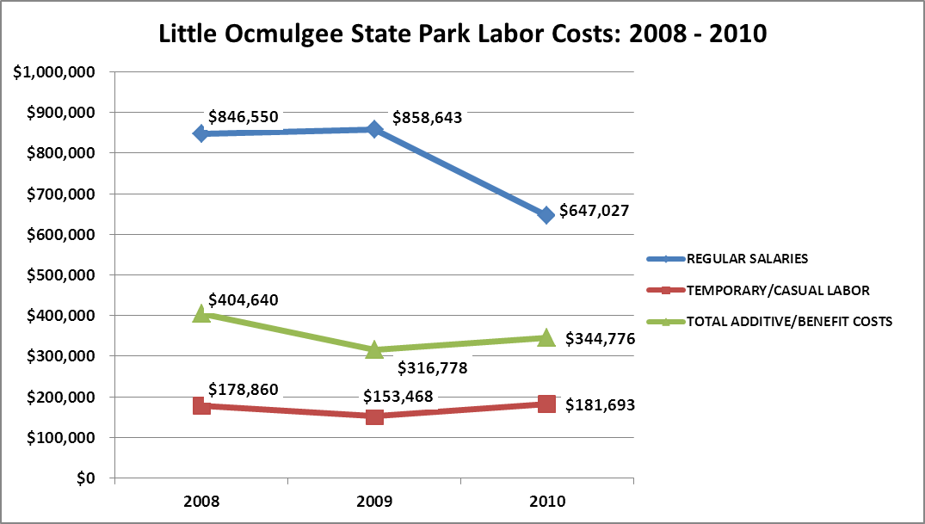

Visitation and Occupancy
Overall annual visitation to the site has trended downward from 2008 to 2010, decreasing by 17% or over 45,000 visitors. This is largely attributed to economic conditions as well as an increase in consumer fuel costs.
Year | Total Visitation
2008 | 307,910
2009 | 275,450
2010 | 262,954

Occupancy for the overnight accommodations at Little Ocmulgee State Park the last three years is detailed in the table below. Overall occupancy has trended downward from 2008 to 2010, decreasing by 11%. This is largely attributed to a decline in group bookings and the condition of the lake.
Year | Lodge Room Occupancy | Cottage Occupancy | Campsite Occupancy
2008 | 45.10% | 61.80% | 36.67%
2009 | 39.26% | 51.09% | 27.04%
2010 | 39.24% | 53.48% | 28.39%

Customer Service and Satisfaction

Site | Year | Customer Satisfaction Level
Little Ocmulgee State Park | 2009 | 73%
Little Ocmulgee State Park | 2010 | 88%
Financial Performance Assessment

Operational Expenses
A summary of total operating expenses at Little Ocmulgee State Park from 2008 to 2010, as well as its percent change from 2008 are provided in the table below.
Little Ocmulgee State Park | 2008 | 2009 | 2010 | % Change from 2008
Operational Expenses
REGULAR SALARIES | 846,550 | 858,643 | 647,027 | -24%
ANNUAL LEAVE PAY | 1,625 | 810 | 27,231 | 1576%
OTHER SUPPLEMENTAL | 44,874 | 38,608 | 44,915 | 0%
OVERTIME | 184 | 180 | 0
TEMPORARY/CASUAL LABOR | 178,860 | 153,468 | 181,693 | 2%
FICA | 64,507 | 64,104 | 51,650 | -20%
RETIREMENT | 88,018 | 89,326 | 70,708 | -20%
HEALTH INSURANCE | 197,848 | 116,147 | 142,443 | -28%
UNEMPLOYMENT INSURANCE | 1,593 | 1,315 | 1,801 | 13%
ASSESSMENTS BY MERIT | 6,174 | 6,468 | 6,028 | -2%
PERSONAL SERVICES | 1,430,234 | 1,329,069 | 1,173,497 | -18%
POSTAGE | 2,000 | 1,500 | 18 | -99%
MOTOR VEHICLE EXPENSES | 25,997 | 16,452 | 20,161 | -22%
PRINTING & PUBLICATION | 1,100 | 0 | 0 | -100%
SUPPLIES & MATERIALS | 110,229 | 67,897 | 67,229 | -39%
REPAIRS & MAINTENANCE | 26,286 | 13,253 | 23,249 | -12%
EQUIPMENT >$1000< $5,000 | 0 | 5,840 | 1,632
ENERGY | 167,054 | 149,209 | 151,399 | -9%
RENTS | 11,894 | 13,087 | 10,662 | -10%
INSURANCE & BONDING | 15,690 | 15,038 | 18,890 | 20%
FREIGHT | 63 | 62 | 41 | -35%
OTHER OPERATING EXPENSES | 54,040 | 45,704 | 26,739 | -51%
TRAVEL | 773 | 217 | 0 | -100%
REGULAR EXPENSES | 415,124 | 328,260 | 320,021 | -23%
MOTOR VEHICLE EQUIPMENT
EQUIPMENT PURCHASES >5000 | 5,926 | 0 | 0
VOICE/DATA COMMUNICATIONS | 16,985 | 9,562 | 27,296 | 61%
PER DIEM & FEES
CONTRACTS | 1,975 | 0 | 995 | -50%
RESALE | 379,504 | 324,646 | 279,549 | -26%
TOTAL OTHER EXPENDITURES | 404,391 | 334,208 | 307,840 | -24%
GRAND TOTAL | $ 2,249,749 | $ 1,991,537 | $ 1,801,358 | -20%
Earned Revenues | $1,751,456 | $1,493,582 | $1,439,836 | -36%
% Cost Recovery | 78% | 75% | 80% | 3%

Earned Revenues
Earned revenues at Little Ocmulgee State Park have decreased significantly since 2008, which is largely attributed to the corresponding decrease in overall occupancy and visitation. This is primarily due to an economic downturn experienced throughout our state and country. Our group business (especially government) has also dropped due to restrictions on travel and training. The lake situation has also played a big part in the drop in attendance. Recreational boating and fishing has been seriously hampered by the weed infestation on the lake. Cottage and lodge occupancy has dropped off during normal fishing seasons since guests can no longer get boats out on the lake.
Monthly earned revenues for the last two years (see table on the following page) indicate that the total annual revenue decreased 4% from 2009 to 2010, with the largest increases in monthly revenues in September and February (7%), December (43%), and April (26%), etc., due to golf packages, group bookings and holiday parties by business and groups. The largest decreases in the months of August and January (-20%), May (-17%), and June (-26%) were due to school starting back in August and the inclement weather in January.

Little Ocmulgee State Park
FY 2009 - FY 2010 Monthly Revenue
 | Jul | Aug | Sep | Oct | Nov | Dec | Jan | Feb | Mar | Apr | May | Jun | Total
FY 2009 | $132,096 | $111,380 | $134,761 | $127,719 | $134,735 | $55,849 | $106,405 | $99,535 | $145,951 | $140,094 | $154,691 | $150,365 | $1,493,582
FY 2010 | $137,403 | $88,971 | $143,561 | $108,931 | $133,474 | $79,779 | $84,691 | $106,035 | $142,264 | $175,849 | $128,158 | $110,721 | $1,439,836
Avg | $134,749 | $100,175 | $139,161 | $118,325 | $134,105 | $67,814 | $95,548 | $102,785 | $144,108 | $157,972 | $141,424 | $130,543 | $1,466,709
% of Total Revenues | 9% | 7% | 9% | 8% | 9% | 5% | 7% | 7% | 10% | 11% | 10% | 9% | 100%
% change | 4% | -20% | 7% | -15% | -1% | 43% | -20% | 7% | -3% | 26% | -17% | -26% | -4%

The graphs below illustrate the monthly revenue trends each year and the average percent of total annual revenue earned each month.

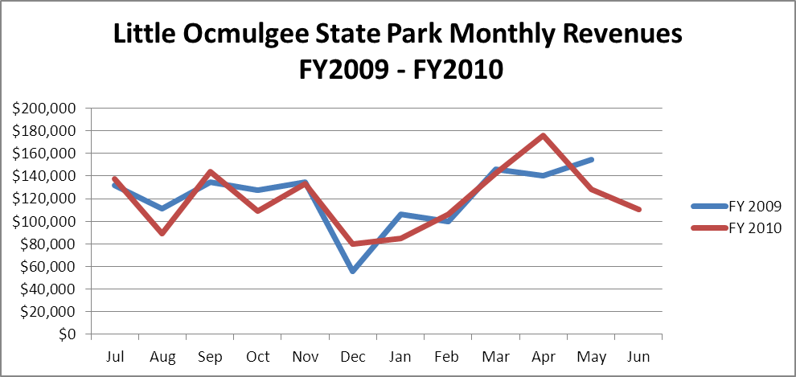

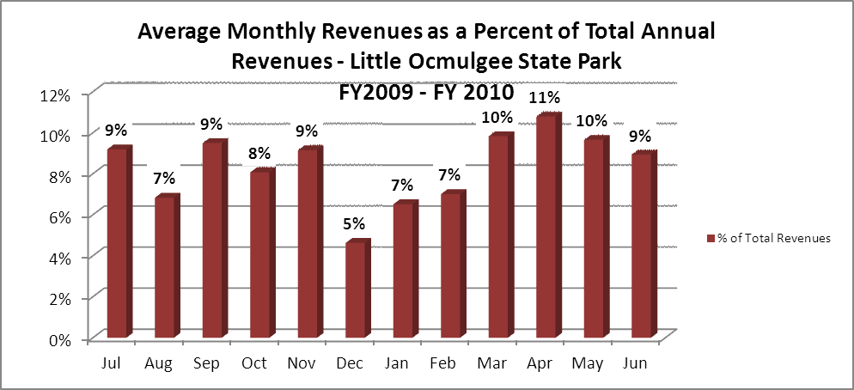
Cost Recovery Trends
Little Ocmulgee State Park has achieved an average cost recovery of 76% of annual operational expenses through earned revenues from FY 2008 to FY 2010 as detailed and illustrated in the table/graph below.
Year | Operational  Expenses | Earned  Revenues | Percent Cost  Recovery
2008 | 2,249,749 | 1,706,996 | 76%
2009 | 1,991,537 | 1,456,896 | 73%
2010 | 1,801,358 | 1,456,062 | 81%

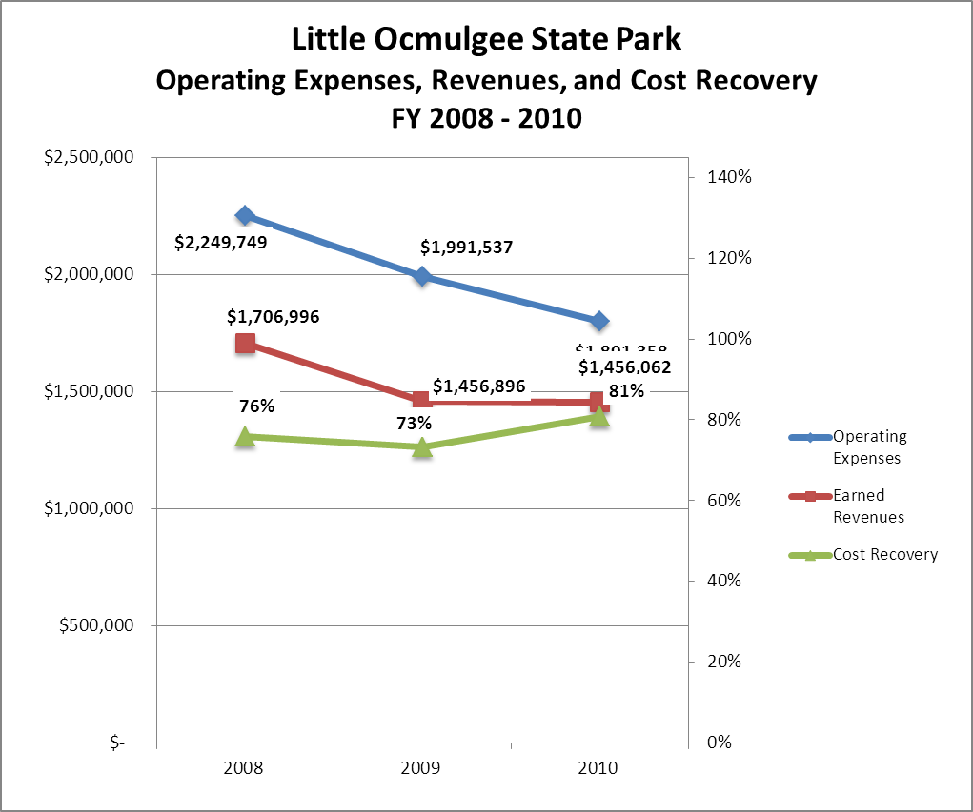

Review of Pricing
Data on rate information is available as far back as 2002, but only the last five years are evaluated. There has been notable growth in fees charged at Little Ocmulgee State Park since 2005, with the largest increase being in camping fees. A table detailing the rates for Little Ocmulgee State Park is provided below.
 | 2005 | 2006 | 2007 | 2008 | 2009 | 2010
Little Ocmulgee
State Park
Cottage - 1BR | $85 | $90 | $90 | $90 | $90 | $95
Cottage - 2 BR | $95 | $100 | $100 | $100 | $100 | $105
Lodge Double | $70 | $70 | $70 | $75 | $80 | $80
Lodge Suite | $125 | $125 | $125 | $125 | $130 | $130
Picnic Shelters | $40 | $40 | $40 | $40 | $40 | $45
Group Shelter 1 | $95 | $100 | $100 | $100 | $110 | $115
Group Shelter #2 | $210 | $210 | $210 | $210 | $250 | $255
Camping RV | $19 | $21 | $21 | $23 | $25 | $28
Camping Tent | $17 | $19 | $19 | $21 | $23 | $25
Group Shelter 1 | $95 | $100 | $100 | $100 | $110 | $115
Business and Management Plan

Business Goals
The following goals serve as the foundation for the key recommendations and strategies in this business plan for Little Ocmulgee State Park.

Enhance Cost Recovery of Site Operations
Little Ocmulgee State Park is operating at a 75-77% cost recovery of operational expenses through earned revenues. The site is currently looking for ways to improve its cost recovery. One of the most efficient means is through evaluating our current workforce to ensure the right people are in the right positions and cut back as many full-time positions to part-time as possible. The site has already completed three rounds of these personnel cutbacks. We will also seek to expand revenue through additional special events and promoting the site as a venue for concerts and outdoor productions at the amphitheater. Events at the amphitheater will create spin-off business for the lodge and restaurant. Improvements to the lake will bring in more water skiers and fishermen for longer stays in the lakeside cottages. The site is also reducing operating costs by utilizing volunteers to the maximum capacity.

Enhance Revenue Generation Strategies
Increasing earned revenues will most likely result from the impacts of both increased visitation at the site and specific revenue enhancement strategies. Management staff is currently evaluating the site’s fee structure to ensure that maximum revenues are being collected for each facility. Resource management personnel have also begun charging for school groups to attend interpretive programs. The site has also increased revenue sales through adding new resale items in high visibility areas such as the visitor center and lodge lobby area. Resolving the weed issue in the lake will attract boaters, skiers, and fishermen that will rent cottage and lodge rooms. A clean lake with boating and swimming activities will result in higher summer day use and overnight rentals.

Expand Special Events at the Site
Programming and special events have always been an important part of Little Ocmulgee State Park. In the past couple of years, several new programs have been added or resurrected. This has resulted in a direct impact to revenue through an increase in sales and parking fees. New ideas for special events include, but are not limited to, theatrical events, weddings, music festivals, and arts and crafts festivals.

Improve the Diversity and Innovation of Recreational and Interpretive Programs
Little Ocmulgee State Park is currently seeking to improve both the diversity and innovation of our programs. Recently, several new CCC interpretive displays were added throughout the park. An effort has also been made to reach out to school groups in an effort to provide new recreational and interpretive programs for students. This has resulted in a notable increase in school groups attending and paying for site-sponsored activities, including the Splash Pad, a unique feature in our area.

Improve the Effectiveness of Marketing and Sales
The effectiveness of marketing and promotional activities of Little Ocmulgee State Park could be improved to produce greater visitation, occupancy and revenues during peak, shoulder, and off seasons. Recently, the site has begun offering new lodging and food/beverage packages with varying degrees of success. The park and the golf course can both benefit by pooling their resources and advertising them together. The site has also partnered with the local Chamber of Commerce to market the site through various media and publications including billboards, magazines, and newspaper/radio advertisements. The Friends group has also provided financial support to help market the site. An increased emphasis has also been placed on improving our presence through the Internet and social media outlets.

Establish Greater Consistency of Managing and Monitoring Customer Service & Satisfaction
Little Ocmulgee State Park plans to improve the consistency of managing and monitoring customer service and satisfaction by conducting on-site surveys annually to assess how well customer satisfaction levels are being met. Little Ocmulgee will strive to have 90% of visitors responding to comment cards that they were either “satisfied” or “very satisfied.” Programs that fall below that standard should be critically reviewed, enhanced, and results monitored; those with a history of poor performance will be evaluated and potentially considered for elimination. An emphasis will also be placed on providing customer service training to all front-line staff to ensure customer’s needs are being met in an efficient and timely manner.

Expand Partnership Opportunities
Given the breadth of partnership opportunities available to Little Ocmulgee, multiple priorities will drive partnership opportunities for the site. This will include growing our Friends group and volunteer base. We will also seek to establish new partnerships with local industries and other government entities.

Classification of Programs and Services
The tables below summarize the classifications of programs and services at Little Ocmulgee State Park as either core, important, or visitor supported and projects a range of cost recovery percentages that might be achieved for each. These classifications establish financial performance goals for each category of services that are linked to the recommendations and strategies of this business plan.
Core Programs / Services | Target Cost Recovery
Active management of the natural and historical resources of the site in order to protect their integrity | 0%
Maintenance and upkeep of historic structures, grounds, facilities, and infrastructure | 0%
Open and public access to the site and its resources | 20 - 30%
Site appropriate education, interpretation, and recreational opportunities | 20 - 100%
Public safety | 0%

Core Programs / Services | Target Cost Recovery
Organized interpretation and education programs | 100%
Active Friends group which supports mission and vision of the site | 0%
Active management of lodge (lodge rooms, conference facilities, cottages, and restaurant) | 120%
Active management and maintenance of park facilities and amenities includicampground, campground, group shelters, picnic shelters, SplashPad, Visitor Center, day-use rentals(bicycles, canoes, pedal boats), volleyball court, nature trails, amphitheater and restrooms | 0%

Visitor Supported Programs / Services | Target Cost Recovery
Park Visitor Center | 50%
Special Events | 120%
Educational and recreational programs | 120%

Partnership Development Plan
The table below summarizes existing partners and targeted partnerships by classification (operational, vendor, service, co-branding, funding partners) and by organizational type.
 | Public Partners | Not-for-profit Partners | Private / Enterprise Partners
Operational Partners | - Wallace Adams Golf Course | - Friends of LOSP | - Concert Promoters (to be identified)
Vendor Partners |  |  | - Coca-Cola  - Husqvarna  - Georgia Power
Service Partners | - City of McRae  - City of Alamo | - Wheeler COC  - Telfair COC  - Friends of LOSP
Co-branding Partners | - General Coffee State Park  - Gordonia-Alatamaha State Park | - Telfair and Wheeler COC
Funding Resource Development Partner |  | - Friends of Georgia State Parks and Historic Sites  - Friends of LOSP

Marketing and Sales Plan

Marketing and Sales Goals
Marketing and sales goals for Little Ocmulgee State Park are based on the following desired outcomes:
- To produce increased overall visitation, occupancy and revenues
- To produce new lodging/food packages to increase visitation and revenue
- To produce larger programs and special events with large visitation
In order to meet these goals, examples of specific target outcomes were identified in the areas detailed in the table below.
Area  of Focus | Current  Performance | Goal  by 2011 | Goal  by 2012 | Goal  by 2015
Overall Visitation | 262,954 vis./yr. | 270,000 vis./ yr. | 276,000 vis./ yr. | 302,000 vis./ yr.
Special Events | Unknown | 2 per year | 3 per year | 6 per year

Marketing and Promotion Strategies

Publicity and Social Media
Little Ocmulgee State Park will approach marketing and publicity planning using the following guidelines and themes:
- Event publicity
Major events benefit by having short stories in local, regional, and statewide newspapers and online social media hooks planted that run three to four weeks in advance of the event up to the date of the event itself. Stories and media need to be cultivated with contacts and online sales channels several weeks in advance of the time the stories need to run. Special interest interviews on morning, noon, and evening television news programs, radio interviews on popular rush-hour programs, and blogs on known affinity online sites should also be included.
- Program publicity
Special and unique programs should have feature stories in magazines, local and regional weekly newspapers, and statewide daily newspapers that are aimed at placements as front-page or sectional front-page stories. These stories are most effective if they run shortly before the season that the featured program begins. This will likely require several weeks of advanced planning with media contacts. Similar coverage on television and radio should also be considered. If pre-publicity cannot be generated, post-publicity can help promote future programs.
- Site Publicity
Site publicity focusing on a single site or sub-set of sites requires more intense planning efforts to attract multiple writers and editors from target publications. Each site could host several seasonal media familiarization tours (with 10 to 15 writers or editors) to familiarize them with the site and its benefits and amenities. Stories and features resulting from such tours typically take between two and six months to materialize so the tours should focus on experiences, benefits, and programs that would be available when the stories are expected to run.
Examples and suggested opportunities for events, programs and related publicity efforts based on the themes described above at Little Ocmulgee State Park are provided in the table below.

Event Publicity | Program Publicity | Site Publicity
Arts and Crafts Festival | Junior Ranger Camp | CCC Remembered
Concerts at Amphitheater

Packaging
Examples and suggested packages for Little Ocmulgee State Park are provided in the table below.

Package | Package Details
Valentines Package | Discounts for lodging and food
Get Outdoors Package | Discounts for overnight stay and recreational activities
Anniversary Package | Discounts for lodging and food

Group Sales
Types of groups within which specific target customers can be identified for Little Ocmulgee State Park are listed below:
- Families | - Businesses and professional groups | - Other public agencies
- Youth service organizations | - Schools | - Women’s/Men’s groups
- Churches | - Colleges and Universities | - Community organizations
- Activity or special interest clubs | - Associations | - Government

Incentivizing New and Repeat Visitation
Little Ocmulgee State Park will utilize the following strategies and/or incentives to encourage new and repeat visitation starting in FY 2012:
- Increased advertising on social media websites
- Group pricing options
- Peak/Off peak pricing options

Marketing and Sales Metric Goals
The following marketing and sales metric goals and/or others will be monitored and progress reported at Little Ocmulgee State Park:
- Loyalty and repeat customers = 75% of customers repeat their visit in a 12-month period.
- Brand confidence & customers-recruiting-customers =increase customer referrals equal a minimum of 50% responses from visitors polled.
Revenue Generation Plan
Revenue / Cost Recovery Goals
Little Ocmulgee State Park has set a financial goal of increasing annual revenues 3% annually between 2012 and 2015. The largest revenue growth opportunity is most likely in the months of March-July and September-November. The table below details projected revenue growth leading up to 2015, based upon a nominal growth of revenues each year.
Year | % Growth from Previous Year | Jul | Aug | Sep | Oct | Nov | Dec | Jan | Feb | Mar | Apr | May | Jun | Total
2010 | Base Year | $137,403 | $87,533 | $144,115 | $109,144 | $147,348 | $76,797 | $84,691 | $106,035 | $142,264 | $175,799 | $113,584 | $115,409 | $1,440,122
2011 | 3% | $141,525 | $90,159 | $148,438 | $112,418 | $151,768 | $79,101 | $87,232 | $109,216 | $146,532 | $181,073 | $116,992 | $118,871 | $1,483,325
2012 | 3% | $145,771 | $92,864 | $152,892 | $115,791 | $156,321 | $81,474 | $89,849 | $112,493 | $150,928 | $186,505 | $120,501 | $122,437 | $1,527,825
2013 | 3% | $150,144 | $95,650 | $157,478 | $119,265 | $161,011 | $83,918 | $92,544 | $115,867 | $155,456 | $192,100 | $124,116 | $126,111 | $1,573,660
2014 | 3% | $154,648 | $98,519 | $162,203 | $122,843 | $165,841 | $86,436 | $95,320 | $119,343 | $160,119 | $197,863 | $127,840 | $129,894 | $1,620,870
2015 | 3% | $159,288 | $101,475 | $167,069 | $126,528 | $170,817 | $89,029 | $98,180 | $122,924 | $164,923 | $203,799 | $131,675 | $133,791 | $1,669,496

These projections would result in a total of 16% cumulative growth in total annual revenues between FY2010 and FY2015. If operational expenses can be managed with a cumulative reduction of 3% between FY 2010 and FY 2015, then the overall cost recovery of the site will be approximately 91% in FY 2015 at these projected revenue levels. This is higher than the annual financial performance of the site in FY 2010, which was operated at 81% cost recovery in that year.

Revenue Generation Strategies

Pricing Plan
Region | PARK RESERVABLES | Current Pricing (CY 2011) | Proposed Pricing  (CY 2012) | Yield Management Margin (%)
2 | Little Ocmulgee
 | Picnic Shelter | $45 | $50 | 10%
 | Group Shelter (capacity) | $255 | $275 | 10%
 | Camping (RV/Tent) | $28/25 | $28/25 | 10%
 | Cottage (1 BR)
 | Non-Peak | $80 | $80 | 20%
 | Peak | $95 | $95 | 20%
 | Cottage (2 BR)
 | Non-Peak | $90 | $90 | 20%
 | Peak | $105 | $105 | 20%
 | Lodge Rooms
 | Doubles and King | $70 | $80 | 20%
 | Suite | $130 | $150 | 10%

Innovative Programming and Special Events Plan
Program / Event | Theme / Purpose | Scheduled Date/Season | Frequency | Target Participation | Target User Fee | Target Cost Recovery
CCC Reunion | Interpret Park CCC History | Spring | Annually |  | $5.00 | 120%
Restaurant Themed Events | Increase Restaurant business and visibility | Major seasonal holidays | Monthly |  | $25+ per person | 150%
Performances at Amphitheater | Increase park attendance and occupancy | Spring &  Fall | 6 times per year | 250 | $10 - $25 depending on performance | 125%

Partnerships and Concessions Plan
Service / Partnership | Term of Service | Financial Objective | Contract Manager
Grass cutting by volunteers (Husqvarnah) | Summer months | Reduction in labor costs and less wear on site equipment | Friends Group
Concert Promoter (amphitheater) | 2 years | 15% of gross receipts | Region Manager/Park Manager

Expense Management Plan
Personnel Assignments
The following actions will be taken to proactively manage labor costs via personnel assignments and classifications.

Action | Timeline | Outcome
Convert operation of Splash Pad to volunteers | Summer 2012 | Annual labor cost reduction

Management Techniques
The following actions will be taken to proactively manage labor costs via management techniques.

Action | Timeline | Outcome
Increased use of volunteers for site and grounds maintenance | Ongoing | Annual labor cost reduction  Reduced wear on site equipment
Re-assign visitor center clerk to front desk when needed | Ongoing | Annual labor cost reduction

Adjusted Levels of Service
The following actions will be taken to proactively manage labor costs via reduced levels of service.

Action | Timeline | Outcome
Adjust Park visitor center hours during non-peak months | Winter 2012 | Annual labor cost reduction

Financial Pro Forma
The following five-year financial pro forma projects operating expenses, earned revenues and cost recovery through FY 2015. These pro forma are based on the strategies and desired outcomes identified in this business plan, especially the revenue generation and expense management plans, and are linked to corresponding performance goals.

Expense Pro Forma
Little Ocmulgee State Park | 2010 (Actual) | 2012 | 2013 | 2014 | 2015
Operational Expenses
REGULAR SALARIES | $647,027 | $642,498 | $638,001 | $633,535 | $629,100
ANNUAL LEAVE PAY | $27,231 | $27,040 | $26,851 | $26,663 | $26,476
OTHER SUPPLEMENTAL | $44,915 | $44,600 | $44,288 | $43,978 | $43,670
TEMPORARY/CASUAL LABOR | $181,693 | $180,422 | $179,159 | $177,905 | $176,659
FICA | $51,650 | $51,289 | $50,930 | $50,573 | $50,219
RETIREMENT | $70,708 | $70,214 | $69,722 | $69,234 | $68,749
HEALTH INSURANCE | $142,443 | $141,446 | $140,456 | $139,473 | $138,497
UNEMPLOYMENT INSURANCE | $1,801 | $1,788 | $1,776 | $1,763 | $1,751
ASSESSMENTS BY MERIT | $6,028 | $5,986 | $5,944 | $5,902 | $5,861
PERSONAL SERVICES | $1,173,497 | $1,165,282 | $1,157,125 | $1,149,025 | $1,140,982
POSTAGE | $18 | $18 | $18 | $18 | $18
MOTOR VEHICLE EXPENSES | $20,161 | $20,020 | $19,880 | $19,741 | $19,603
SUPPLIES & MATERIALS | $67,229 | $66,759 | $66,291 | $65,827 | $65,367
REPAIRS & MAINTENANCE | $23,249 | $23,087 | $22,925 | $22,765 | $22,605
EQUIPMENT >$1000< $5,000 | $1,632 | $1,620 | $1,609 | $1,597 | $1,586
ENERGY | $151,399 | $150,339 | $149,287 | $148,242 | $147,204
RENTS | $10,662 | $10,587 | $10,513 | $10,439 | $10,366
INSURANCE & BONDING | $18,890 | $18,758 | $18,627 | $18,496 | $18,367
FREIGHT | $41 | $41 | $41 | $40 | $40
OTHER OPERATING EXPENSES | $26,739 | $26,552 | $26,366 | $26,182 | $25,998
REGULAR EXPENSES | $320,021 | $317,781 | $315,557 | $313,348 | $311,154
MOTOR VEHICLE EQUIPMENT |  | $0 | $0 | $0 | $0
EQUIP PURCHASES >5000 |  | $0 | $0 | $0 | $0
CAPITAL\ LEASE Prin & Int |  | $0 | $0 | $0 | $0
REAL ESTATE RENTALS |  | $0 | $0 | $0 | $0
VOICE/DATA COMMUNICATIONS | $27,296 | $27,105 | $26,915 | $26,727 | $26,540
PER DIEM & FEES |  | $0 | $0 | $0 | $0
CONTRACTS | $995 | $988 | $981 | $974 | $967
RESALE | $279,549 | $277,592 | $275,649 | $273,719 | $271,803
TOTAL OTHER EXPENSES | $307,840 | $305,685 | $303,545 | $301,420 | $299,310
GRAND TOTAL | $1,801,358 | $1,788,748 | $1,776,227 | $1,763,793 | $1,751,447

Revenue Pro Forma

Little Ocmulgee State Park
Revenue (Fund) Sources | Revenue Sources Description | FY 2010 (Actual) | FY 2012 | FY 2013 | FY 2014 | FY 2015
62001 | Lodge Rooms | 572,534 | 589,710 | 607,402 | 625,624 | 644,393
62002 | Restaurant | 495,600 | 510,468 | 525,782 | 541,555 | 557,802
62004 | Program Fees | 35 | 36 | 37 | 38 | 39
62005 | Conference Room Fee Rental | 15,304 | 15,763 | 16,236 | 16,723 | 17,225
62006 | Cottages | 177,359 | 182,680 | 188,160 | 193,805 | 199,619
62008 | Pioneer Camping | 230 | 237 | 244 | 251 | 259
62014 | Misc (Copies, etc.) | 117 | 121 | 125 | 128 | 132
62015 | Tips | (1,125) | (1,159) | (1,194) | (1,230) | (1,267)
62016 | Hunting & Fishing Comm. | 12 | 13 | 13 | 13 | 14
62017 | Banquet Sales | 56,580 | 58,278 | 60,026 | 61,827 | 63,681
62020 | Short/Over | (399) | (411) | (423) | (436) | (449)
62021 | Bicycles | 1,333 | 1,372 | 1,414 | 1,456 | 1,500
62022 | Mini Golf | 3,564 | 3,671 | 3,781 | 3,894 | 4,011
62025 | Picnic Shelters | 5,671 | 5,841 | 6,016 | 6,197 | 6,383
62026 | Concessions | 31,169 | 32,104 | 33,067 | 34,059 | 35,081
62027 | Boating Rental | 1,020 | 1,051 | 1,082 | 1,115 | 1,148
62029 | Vending (Full Service Commission) | 641 | 660 | 680 | 701 | 722
62030 | Washer/Dyer | 1,079 | 1,111 | 1,144 | 1,179 | 1,214
62031 | VISA/MC Charges | (81) | (84) | (86) | (89) | (92)
62035 | AM Express Charges | (6,121) | (6,305) | (6,494) | (6,689) | (6,889)
62036 | Group Shelter | 25,240 | 25,997 | 26,777 | 27,580 | 28,408
62038 | Conference Equipment Rental | 265 | 273 | 281 | 290 | 298
62042 | Non-Cost Items (Ice, Wood) | 982 | 1,011 | 1,042 | 1,073 | 1,105
62046 | Camp Sites | 145,907 | 150,284 | 154,792 | 159,436 | 164,219
62048 | Sr. Disc Camp Sites | (18,217) | (18,764) | (19,326) | (19,906) | (20,503)
62049 | Pet Fees for Dogs | 720 | 742 | 764 | 787 | 810
62051 | Service Charge Wages | (1,182) | (1,217) | (1,254) | (1,291) | (1,330)
62052 | Pedal Boats | 915 | 942 | 971 | 1,000 | 1,030
62059 | H & F Sales | 22 | 23 | 24 | 24 | 25
62065 | Alcohol/Beverage | 8,872 | 9,138 | 9,412 | 9,694 | 9,985
62073 | Disabled Vet Disc | (837) | (862) | (888) | (915) | (942)
62076 | Discover Card Charges | (260) | (267) | (275) | (284) | (292)
62080 | CR Card Chgback-Park Lodge | (156) | (161) | (165) | (170) | (176)
62081 | House Service Charge (3%) | 3,650 | 3,759 | 3,872 | 3,988 | 4,108
62084 | Regular Golf/Green Fees | 101 | 0 | 0 | 0 | 0
62086 | Electric Golf Cart | 106 | 0 | 0 | 0 | 0
62092 | Friends Discount-Rm,Cttg,Cmp,Resale | (739) | (761) | (784) | (807) | (832)
62093 | SPLASH PAD Daily & Annual Pass | 4,947 | 0 | 0 | 0 | 0
62098 | Hotel/Motel Tax-Lodges | (35,509) | (36,574) | (37,671) | (38,802) | (39,966)
62099 | Sales Tax | (83,867) | (86,383) | (88,974) | (91,643) | (94,393)
63908 | Bad Debt Collection | 22 | 22 | 23 | 23 | 24
97008 | Other Revenue-Tip Credit | 34,333 | 35,362 | 36,423 | 37,516 | 38,642
TOTAL |  | $ 1,439,836 | $ 1,477,723 | $ 1,522,055 | $ 1,567,716 | $ 1,614,748

Total / Cost Recovery Pro Forma

Little Ocmulgee State Park | 2010 (Actual) | 2012 | 2013 | 2014 | 2015
TOTAL PRO FORMA
Visitation | 262,954 | 276,259 | 284,547 | 293,084 | 302,395
Operational Expenses | $ 1,801,358 | $ 1,788,748 | $1,776,227 | $ 1,763,793 | $1,751,447
Earned Revenues | ($1,439,836) | ($1,477,723) | ($1,522,055) | ($1,567,716) | ($1,614,748)
% Cost Recovery | 81% | 83% | 86% | 89% | 91%

Action Plan
ACTION PLAN
Site: |  | Site Manager: |  |  | Date:
Month:
Strategy | Tasks | Costs / Funding | Revenues / ROI | Responsibilities | Metrics

ACTION PLAN
Site: |  | Site Manager: |  |  | Date:
Month:
Strategy | Tasks | Costs / Funding | Revenues / ROI | Responsibilities | Metrics

This is the average of the last three years – FY 2008, FY 2009, and FY 2010
Current employees, not including vacancies.
Current employees, not including vacancies.
Major population centers within a two-hour drive from the site

