Magnolia Springs State Park
Business & Management Plan

Prepared June 2011; Finalized January 2013
Direction 2015 – Sustainable Business Planning

Table of Contents

Executive Summary 3

Site and Operations Assessment 7
Site Inventory and Facility Assessment 7
Operational Assessment 9
Financial Performance Assessment 14

Business and Management Plan 18
Business Goals 18
Classification of Programs and Services 20
Partnership Development Plan 21
Marketing and Sales Plan 22
Revenue Generation Plan 24
Expense Management Plan 26
Financial Pro Forma 27

Action Plan 30

Executive Summary
The Parks, Recreation and Historic Sites Division (PRHSD) of the Georgia Department of Natural Resources (DNR) is transitioning the management of Magnolia Springs State Park to operate more like a business, reflecting the Direction 2015 – Sustainable Business Planning initiative to improve the fiscal performance and management of the state parks and historic sites system. This business and management plan is designed to help the site recover more operating expenses through earned revenues, productive partnerships, and innovative programs.

Site Fact Sheet
Site Name | Magnolia Springs
Site Manager | Preparation by Sam Williams  Implementation by Dusty Fuller
Region Manager | Tommy Turk
Date of Business Plan completion | June 9, 2011
Site size | 1,070 acres
Total number of visitors (FY 2010) | 100,279
Total operating budget (FY 2010) | $311,331
Total earned revenues (FY 2010) | $225,887
Operational cost recovery (FY 2010) | 73%
Average operating cost per visitor (FY 2010) | $3.10
Average earned revenue per visitor (FY 2010) | $2.25
Average cost recovery (FY 2008 – 2010) | 58%
Target cost recovery (FY 2015) | 69%
Total full-time employees | 5
Total part-time employees | 8
Primary service markets | Statesboro, Augusta, Savannah
Primary attractors/visitor appeal factors | Camp Lawton, camping, cottages, group camp, picnicking, lake activities
Leading opportunities for improved site performance | Construct Camp Lawton Museum, year-round small group use of group camp, expand nature trails to increase mountain biking and cross country running

Site Summary and Key Attractions
The 1,070-acre site of Magnolia Springs State Park is located in a rural area. The more populated areas near the park are Statesboro, Augusta, and Savannah. Camp Lawton, a Civil War POW Camp for Union prisoners, was located on the property that now makes up the park. Archaeological work on the site began in the spring of 2010 and has opened numerous new possibilities for the park, changing it from a mostly recreational park to also a historical park. Expanding Magnolia Springs’ interpretive programming possibilities to include recreational, nature-based, and historical programs would be a positive move forward to attract new visitors and keep returning visitors attracted to the site.

Key Attractions
The amenities or features listed below are those that seem to be most popular for visitors.
- Camp Lawton
- Springs
- Nature Trails
- Camping
- Cottages
- Group Camp
- Lake Activities
- Picnicking/Group Shelters

Financial Targets
The table below details the total operating expenses and earned revenues for Magnolia Springs State Park over the last three years (2008 – 2010). This table also calculates total cost per visitor and revenues per visitor during these operating years, and details the target financial performance goals in the context of achieving at least 69% cost recovery. This table also calculates the necessary change from 2010 operating expenses and revenues.
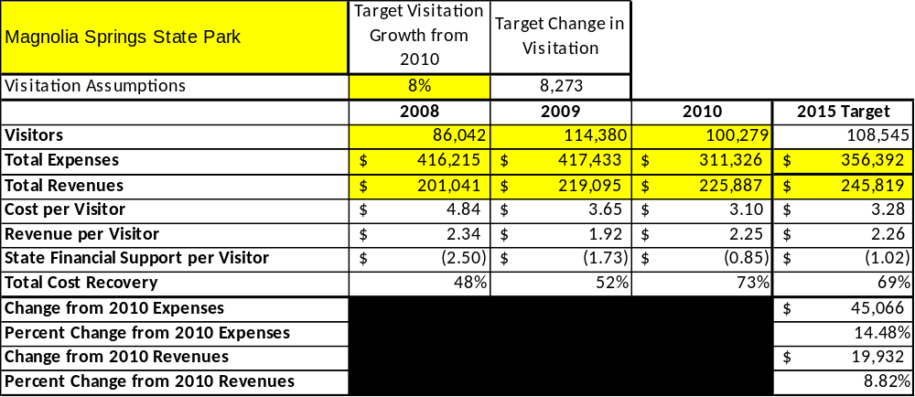

Key Recommendations

Primary / Short Term Recommendations
- Operate Magnolia Springs using cost-based accounting, including the net cost recovery achieved annually.
- Conduct on-site surveys annually to assess how well customer satisfaction levels are being met. Magnolia Springs should strive to have 90% of visitors responding to ‘Comment Cards’ report that they were either ‘satisfied’ or ‘very satisfied’. Programs or services that fall below that standard should be critically reviewed, enhanced, and results monitored; those with a history of poor performance should be considered for elimination.
- Collect a statistically-valid sample of ZIP code data from day visitors in a non-intrusive way to gauge their origins and demographics (e.g., age, ethnicity, income, etc.) and use the results to improve programming and marketing efforts to appeal to a broader audience.
- Utilize a minimum of five special events annually to help draw more visitors to Magnolia Springs.
- Seek local partners such as Di-Lane WMA and private hunting preserves to help support operations, programs, and service delivery and for cross-marketing purposes.
- Reduce full-time staff so that required staff operational costs (with benefits) do not exceed 65% of the total operational budget.
- Manage Magnolia Springs according to well-defined maintenance, programming, and operational standards, monitored and enforced by region managers and senior management.
- Partner with Jenkins County Chamber of Commerce or other destination marketing organizations (DMOs) to promote Magnolia Springs.
- Continue to work with the Friends of Magnolia Springs State Park and Buckhead – Camp Lawton Sons of Confederate Veterans to help raise funds or provide volunteers for improvements and program support.
- Perform a thorough net cost-of-service analysis on major functions of site operations, including a detailed analysis of labor requirements by task. Thereafter, update costs to deliver services on a biennial schedule.
- Review and update rates at the site on an annual basis to meet cost recovery targets for “important” and “visitor supported” services (see detail below).
- Enhance retail operations to increase site generated revenues.
- Track total economic impact of Magnolia Springs on the local communities and region and share with decision-makers, elected officials, local business operators and others to demonstrate the impact.
- Develop a more detailed analysis of labor requirements of all major park functions to match the right position with the right job at the right pay.
- Develop funding to provide additional training to site staff for improved business management and marketing effectiveness.
- Upgrade facilities and amenities such as the Staff House that are likely to have a cost recovery level at or above 100%.
- Add more amenities and programs such as geo-caching and bike trails that appeal to the age group where the most increase in visitation could be achieved.
- Renovate the Group Camp to make it more appealing for rentals. Include more options for smaller groups (such as the Staff House remodeling) and off-season rentals.
- Establish an Interpretive Plan for the new Camp Lawton Museum and incorporate the findings from excavations into the plan.

Secondary / Long Term Recommendations
- Improve the recreational amenities at Magnolia Springs to meet the needs of modern and emerging uses. One example could be a scrimmage field at the Group Camp to meet the needs of various sports camps. The large acreage of the park would allow more trails for outdoor recreational activities, including cross country running, bike trails and geo-caching.
- Engage the Friends of Magnolia Springs, Buckhead – Camp Lawton Sons of Confederate Veterans, and private organizations to improve connectivity between and within Magnolia Springs through maintenance projects.
- Develop a long range plan to continue to attract previous and new visitors to Magnolia Springs by upgrading the Camp Lawton Museum on a regular basis. Work with Georgia Southern University and the Historic Preservation Division to continue to develop new ideas and exhibits.
- Reconstruct sections of the Camp Lawton stockade including wall, guard towers and gate.
- Develop comprehensive lesson plans on Camp Lawton, the Civil War, archeology and natural resources in order to attract school groups.

Site and Operations Assessment
This site and operations assessment is a culmination of analyses and findings from a review of the condition of facilities, infrastructure, and operations at Magnolia Springs State Park. The findings and observations are not intended to be an exhaustive review of all issues present, but provide a basic understanding of the predominant issues that contribute to the site’s current operating conditions. The assessment includes the following:
- Site Inventory and Facility Assessment
- Operational Assessment
- Financial Assessment
Site Inventory and Facility Assessment

Methodology
Facility and asset conditions are rated using a differential scale of excellent, good, fair, or poor. Descriptions of conditions that are attributed to each of these findings are also provided.
Scale of Conditions
Rating | General Description
Excellent | Facilities/amenities are in ‘excellent’ condition when they show little or no maintenance or repair problems. Facilities do not feature any major design or operational issues or flaws that contribute to diminished use or increased maintenance or upkeep. Facilities are easy to clean and maintain in order to place them back into public use and the users perceive them to be in excellent shape.
Good | Facilities/amenities are in ‘good’ condition when they show only minor maintenance or repair problems. Most maintenance issues with these facilities typically appear to be the result of age and/or heavy use. Facilities may only feature minor design or operational issues that contribute to diminished use or increased maintenance or upkeep. Facilities are moderately easy to clean and maintain in order to place them back into service and the users perceive them to be adequate for their use, but probably not in excellent shape.
Fair | Facilities/amenities are in ‘fair’ condition when they show significant maintenance or repair problems. Facilities generally exhibit ongoing maintenance issues that appear to be the result of age, heavy use, or design or operational flaws. Some maintenance and repair needs may compound their fair condition by being deferred because of budget and/or resource limitations. Facilities require more effort to clean and maintain before placing them back into service and the users may perceive them as being less than adequate for their use and in a state of deterioration. The facility or structure may need of major repair or replacement.
Poor | Facilities/amenities are in ‘poor’ condition when they show significant, on-going maintenance or repair problems that ultimately may result in suspended use for repair/replacement. Maintenance and repair issues are possibly the result of poor maintenance and clearly the result of age, heavy use, or design or operational flaws. Problems with the facilities are often compounded over time due to consistently-deferred maintenance and repair because of budget and/or resource limitations. Facilities may feature major design or operational issues that contribute to diminished use or increased maintenance or upkeep. Facilities require excessive effort to clean and maintain before placing them back into service and the users often perceive them as being inadequate for their use and in a state of serious deterioration. The facility or structure may need of major repair or replacement.

Inventory and Assessment
The table below is an inventory and assessment of facilities as reviewed in June, 2011.
Site Asset / Amenity | Quantity | Condition
Office Area | 1 | Good
Swimming Pool | 1 | Good
Group Shelter | 3 | Good
Picnic Shelters | 8 | Good
Day Use Area | 1 | Good
Nature Trails | 4 | Fair
Day Use Comfort Station | 1 | Good
Cottages | 7 | Good
Campsites | 30 | Good
Campground Comfort Station | 1 | Excellent
Lake | 1 | Good
Fishing Dock | 1 | Fair
Boat Ramp | 1 | Good
Museum | 1 | Good
Group Camp | 1 | Poor
Well House | 3 | Fair
Shop Area | 1 | Good
Linen House | 1 | Poor
Manager’s Residence | 1 | Good
Assistant’s Residence | 1 | Good
Pioneer Campground | 2 | Good
Boardwalk | 1 | Fair

Prioritized Facility Needs
Based on the facility inventory and assessment, these prioritized needs have been identified with a priority category of high, moderate, or low to support future project sequencing, investment of public resources, and meeting community expectations. These recommended priorities reflect a phased implementation approach over the next several years and are not a measure of importance.
Facility Need | Priority Assignment
Camp Lawton Museum | High
Close Group Camp | High
Reduce aquatic vegetation in spring/creek | High
Replace picnic tables & grills in day use area / Upgrade picnic pads | High
Construct porch to make office more visible | Low
Increase length of nature trails & repair eroded areas | Moderate
Make repairs to well house structures | High
Improve campsite access as needed | Moderate
Replace fishing dock | Moderate
Add addition to maintenance/shop area | Moderate
Repair boardwalk at spring | Moderate
Upgrade day use comfort station | Low
Replace linen building | High

Operational Assessment
The Operational Assessment includes:
- An inventory and classification of programs and services being provided at the site
- A review of staffing at the site
- A review of concessionaires and partners operating at the site
- Visitation and customer satisfaction

Inventory and Classification of Programs and Services
Programs and services are classified into one of three major categories:
1) Core or Essential Services
2) Important Services
3) Visitor Supported Services
Programs and services at the site are classified into these categories based in part on the mission and public mandates for both the site and the agency. For the programs and services in each of these categories, there are financial performance expectations that will define how services are funded and evaluated.

Category 1 – Core Services [Largely supported by tax funds]
Core programs, services and facilities are those the agency must provide and/or are essential in order to capably govern and meet statutory requirements. The failure of the agency to provide Category 1 services at adequate levels could result in significant negative consequences for the public and the resources under protection. The criteria for programs or services to be classified as core or essential are:
- The services are mandated by the agency’s law or charter or are contractually obligated by agreement to provide the services.
- The services are essential to protecting and supporting the public’s health and safety.
- The services protect and maintain valuable assets and infrastructure.
- The services would generally and reasonably be expected and supported by residents, businesses, customers and partners.
- The services are those that cannot or should not be provided by the private sector.
- The services provide a sound investment of public funds.
The following programs and services at Magnolia Springs have been identified as core services:
- Protection of visitors, natural resources, cultural resources, & facilities
- Upkeep and maintenance of necessary facilities and grounds
- Open to public access

Category 2 – Important Services [Supported by a balance of tax funds and earned revenues]
Important programs, services and facilities are those the agency should provide, and are important to governing and effectively serving residents, businesses, customers and partners. Providing Category 2 services expands or enhances the agency’s ability to provide and sustain its core services. The criteria for programs or services to be classified as important are:
- The services expand, enhance or support identified core services.
- The services are broadly supported and utilized by the community, and are considered an appropriate, important, and valuable public good. Public support may be conditional upon the manner by which the services are paid for or funded.
- The services generate income or revenue that offsets some or all of the operating cost and/or are deemed to provide economic, social or environmental outcomes or results.
The following programs and services at Magnolia Springs have been identified as important services:
- Day use facilities, such as picnic sites & group shelters
- Maintenance and expansion of nature trails
- Operation of swimming pool

Category 3 – Visitor Supported Services [Almost exclusively supported by earned revenue]
Visitor supported programs, services and facilities are those discretionary services that the agency may provide when additional funding or revenue exists to offset the cost of providing those services. Category 3 services provide added value above and beyond what is required or expected. The criteria for programs or services to be classified as visitor supported are:
- The services expand, enhance or support core services or important services and the quality of life of the visitors, community or stakeholders.
- The services are supported, valued and well utilized and provide an appropriate and valuable public benefit.
- The services generate income or funding from sponsorships, grants, user fees or other sources that offset some or all of their cost and/or provides a meaningful return on investment.

- The services can possibly be provided through outsourcing or use of concessionaires, providing opportunities for community enterprises that may not otherwise be provided by the agency.
The following programs and services at Magnolia Springs have been identified as visitor supported services:

- Special programming/events (Earth Day, Camp Lawton Education Day, & Heritage Festival)
- Ranger led programming
- Cottages
- Camping

Staffing Assessment
Labor costs at Magnolia Springs represent the largest area of budgetary expense at an average of 67% of the total operating budget each year for the last three complete years, which is 2% higher than the target of total labor costs (including benefits) not exceeding 65% of the site’s total operating expenditures. The tables below and on the following page provide a basic review of the current staffing at the site.
Full Time Equivalent Employees
Position / Title | Quantity (FTE) | Vacancies | Annual Hours
Manager | 1 | 0 | 2860
Assistant Manager | 1 | 0 | 2600
Secretary/Clerk | 1 | 0 | 2080
Park Ranger | 1 | 0 | 2080
Skilled Craftsman | 1 | 0 | 2080
TOTAL | 5 | 0 | 11,700

Part Time Employees
Position / Title | Quantity (FTE) | Vacancies | Hours
Clerk | 1 | 0 | 1500
Housekeeper | 2 | 0 | 2200
Lifeguard | 5 | 0 | 2200
TOTAL | 8 | 0 | 5,900

Labor Support
Labor Support | Annual Hours
Kiosk Attendant | 800
Volunteers | 600
Community Service Workers | 100
Engineering and Construction Crews | 0
Resource Management Crews | 0
TOTAL | 1,500

Total Labor Hours
Labor Type | Annual Hours
Full Time Equivalent Employees | 11,700
Part Time Employees | 5,900
Labor Support | 1,500
TOTAL Annual Labor Hours | 19,100

Labor Budget Summary
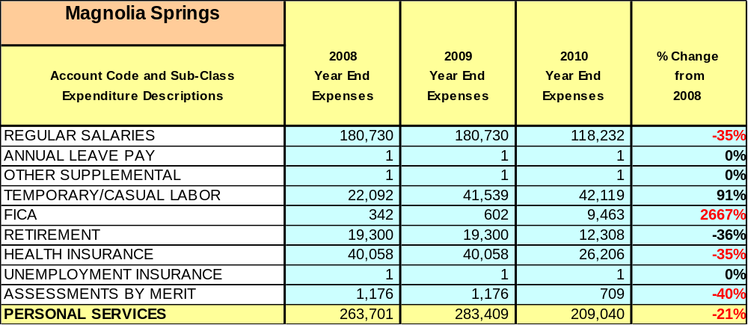

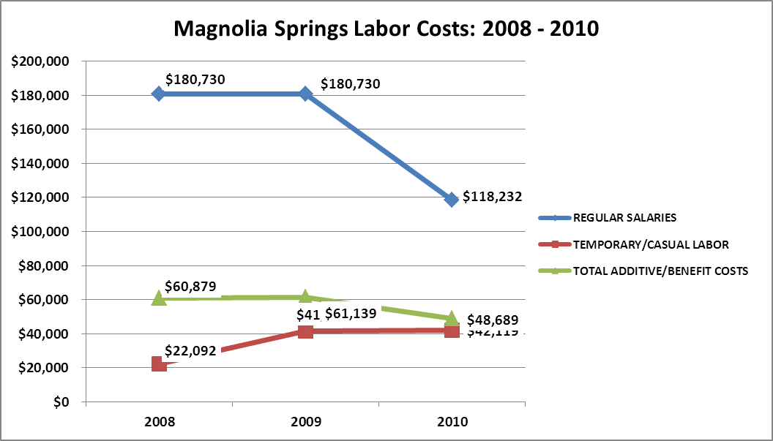

Visitation and Occupancy
Overall annual visitation to the site has trended upward from 2008 to 2010, increasing by 14% or over 14,237 visitors. This is largely attributed to people using the park for vacations and day trips that are closer to home and more affordable due to the decline in the economy and increased fuel prices. The decrease from 2009 to 2010 is attributed to incorrect calculations.

Year | Total Visitation
2008 | 86,042
2009 | 114,380
2010 | 100,279

Occupancy for the overnight accommodations at Magnolia Springs the last three years is detailed in the table below. Overall occupancy for the campground has trended downward from 2008 to 2010, decreasing by 3%. Overall occupancy for the cottages has trended upward from 2008 to 2010, increasing by 4%.

Year | Campground Occupancy | Cottage Occupancy
2008 | 28% | 41%
2009 | 29% | 41%
2010 | 25% | 45%

Customer Service and Satisfaction

Site | Year | Customer Satisfaction Level
Magnolia Springs | 2009 | 100%
Magnolia Springs | 2010 | 83%

Financial Performance Assessment

Operational Expenses
A summary of total operating expenses at Magnolia Springs from 2008 to 2010, as well as their percent change from 2008 are provided in the table below.

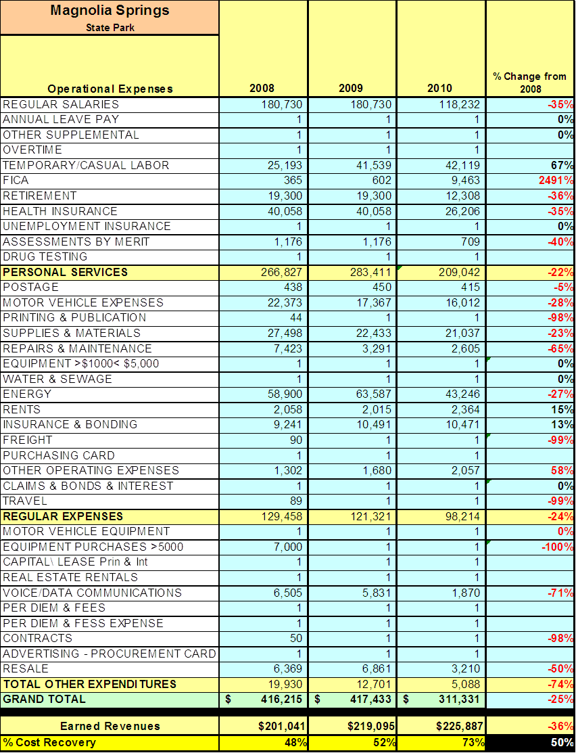

Earned Revenues
Earned revenues at Magnolia Springs have increased since 2008, which is largely attributed to the corresponding increase overall visitation and occupancy.
Monthly earned revenues for the last two years (see table on the following page) indicate that the total annual revenue increased 3% from 2009 to 2010, with the largest increases in monthly revenues in September (24%), and March (18%), etc., and the largest decreases in the months of January (-23%), August (-22%), and October (-20%).
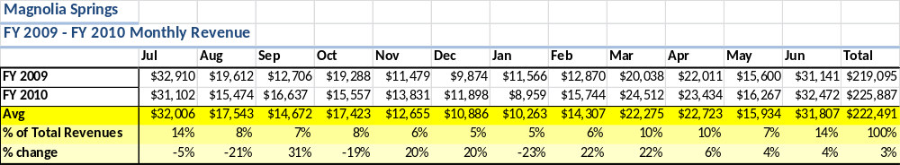

The graphs below illustrate the monthly revenue trends each year and the average percent of total annual revenue earned each month.
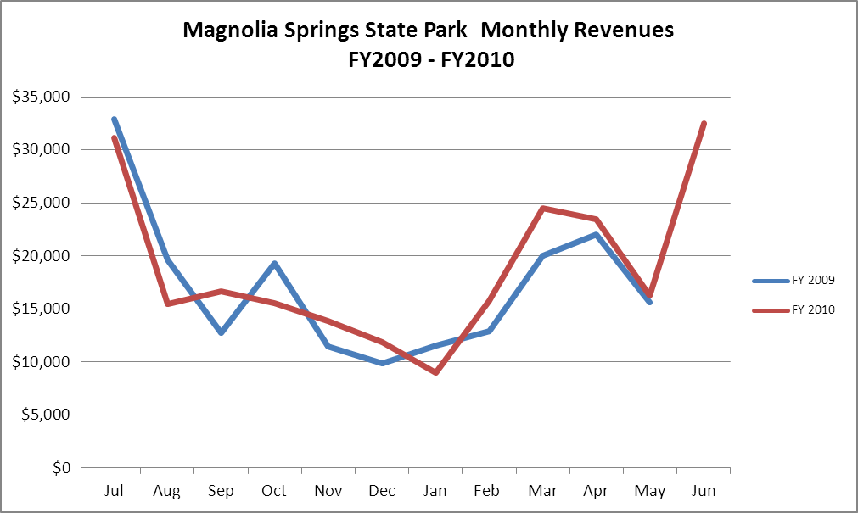

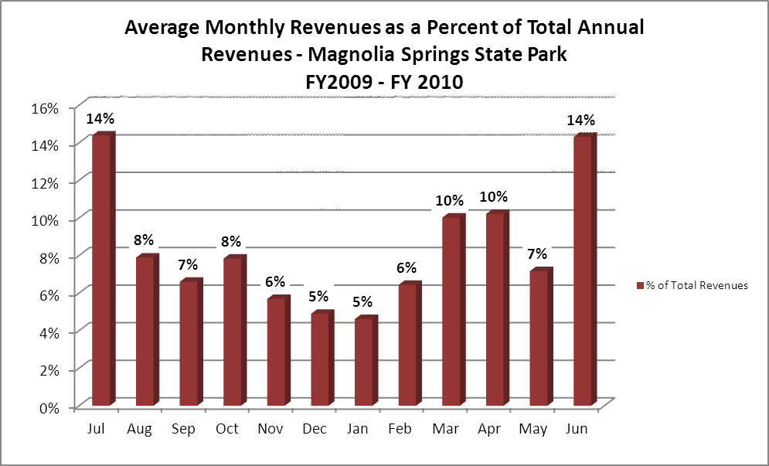

Cost Recovery Trends
Magnolia Springs has achieved an average cost recovery of 63% of annual operational expenses through earned revenues from FY 2008 to FY 2010. This is detailed and illustrated in the table and graph below. Although rate increases and increases in visitation have helped to increase revenue, operational expenses may not be accurately depicted due to position vacancies in FY10.
Year | Operational  Expenses | Earned  Revenues | Percent Cost  Recovery
2008 | 402,184 | 201,041 | 50%
2009 | 359,016 | 219,095 | 61%
2010 | 311,326 | 225,887 | 73%

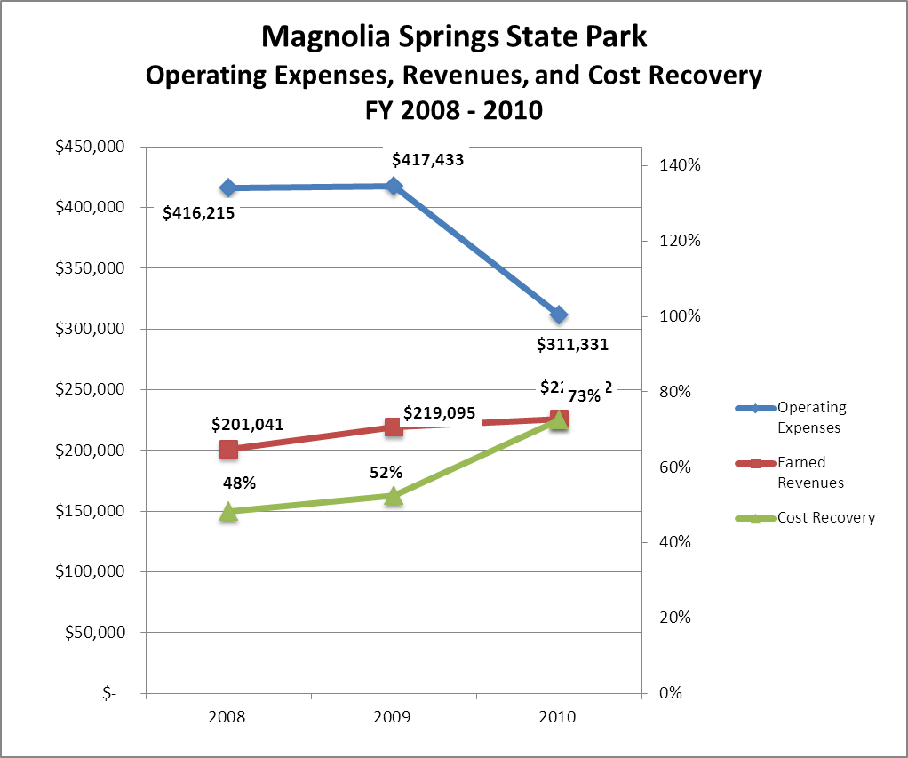

Review of Pricing
Data on rate information is available as far back as 2002, but only the last five years are evaluated. There has been notable growth in fees charged at Magnolia Springs since 2005, with the largest increase being in group shelters, campsites and cottages in 2010. A table detailing the rates for Magnolia Springs is provided below.
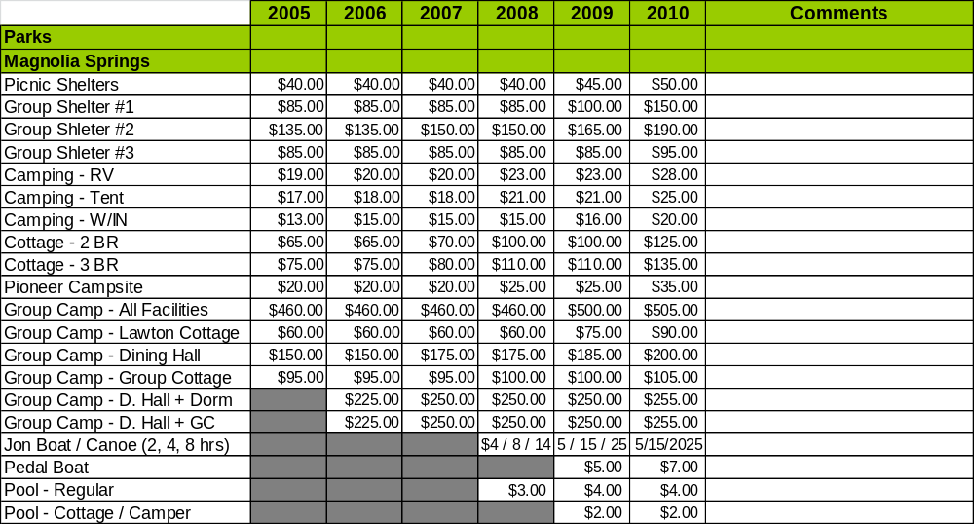
Business and Management Plan

Business Goals
The following goals serve as the foundation for the key recommendations and strategies in this business plan for Magnolia Springs State Park.

Enhance Cost Recovery of Site Operations
Magnolia Springs State Park is operating below the expected 75% cost recovery goal. Labor and operational costs can quickly be reduced by closing the swimming pool. This alone would save Magnolia Springs approximately $20,000 a year. The condition of the Group Camp and the high cost of repairs and low revenue do not justify its continued operation. The Staff House and Lawton Cottage offer good rental opportunities if renovated.

Enhance Revenue Generation Strategies
Constructing a museum for the Camp Lawton artifacts would be one way to generate extra revenue. Even if the museum is designed as a self-guided experience (vs. fee based), having a facility that would bring in extra visitation would help increase revenue in retail sales and facility rentals. Developing comprehensive lesson plans on Camp Lawton, the Civil War, archaeology, and natural resources in order to attract school groups will increase programming revenue. Other options would be to raise rental fees to the maximum (we could charge premium rates during special events, such as Master’s Week).

Expand Special Events at the Site
There are existing special events that occur annually at Magnolia Springs. Over past years, reduced interest in these events has led to reduced visitation for the events. Reinvigorating the events with new ideas and support should help to rebuild these events and increase visitation and revenue to the site. Civil War and Archeological events tied to the history of the site offer options for new programming. The large acreage offers opportunities for geo-caching and cross country running events.

Improve the Diversity and Innovation of Recreational and Interpretive Programs
Very little interpretive programming has been done at Magnolia Springs in the past several years. There are many opportunities to provide recreational programming, ranging from team building games to incorporating educational programs with hiking or biking trips. With the new interest in Camp Lawton, historical programs can be offered for all age groups and there are many other types of interpretive programs that can be offered just on the natural resources we have on site, such as the spring, lime sinks, longleaf pine ecosystem restoration, and wildlife programming. With the increase in programming at Magnolia Springs, there will in an increase in programming revenue, visitation and occupancy generated for the site.

Improve the Effectiveness of Marketing and Sales
Camp Lawton has offered a great marketing opportunity for Magnolia Springs. Camp Lawton has changed the status of Magnolia Springs from a traditional park to also a historic site. This gives us the opportunity to market it as a historic site also and reach out to visitors that are more into history and not so much into traditional park activities.

Establish Greater Consistency of Managing and Monitoring Customer Service & Satisfaction
Magnolia Springs plans to improve the consistency of managing and monitoring customer service and satisfaction by conducting on-site surveys annually to assess how well customer satisfaction levels are being met. Magnolia Springs will strive to have 90% of visitors responding to ‘Comment Cards’ report that they were either ‘satisfied’ or ‘very satisfied’ (or some comparable metric to be developed). Programs or services that fall below that standard should be critically reviewed, enhanced, and results monitored; those with a history of poor performance will be evaluated and potentially considered for elimination.

Expand Partnership Opportunities
Recent new partnerships between Magnolia Springs and other state and federal entities and private organizations have helped to generate new support for the site. The support has come in the form of increased visitation and volunteer labor. Magnolia Springs is planning to continue to grow the recent new partnerships and to look at other areas to create other partnerships.

Classification of Programs and Services
The tables below summarize the classifications of programs and services at Magnolia Springs as either core, important, or visitor supported and projects a range of cost recovery percentages that might be achieved for each. These classifications establish financial performance goals for each category of services that are linked to the recommendations and strategies of this business plan.

Core Services
Program / Service | Target Cost Recovery
Protection of visitors, natural resources, cultural resources, and facilities | 0%
Upkeep and maintenance of facilities and grounds | 0%
Open to public access | 5%

Important Services
Program / Service | Target Cost Recovery
Day-use facilities, such as picnic sites & group shelters | 50%
Maintenance and expansion of nature trails | 50%
Operation of swimming pool | 40%

Visitor Supported
Program / Service | Target Cost Recovery
Special programming/events | 120%
Ranger led programming | 65%
Cottages | 120%
Camping | 125%

Partnership Development Plan
The table below summarizes existing partners and targeted partnerships by classification (operational, vendor, service, co-branding, funding partners) and by organizational type.

 | Public Partners | Not-for-profit Partners | Private / Enterprise Partners
Operational Partners | - U.S. Fish & Wildlife Service  - Jenkins County  - Historic Preservation Division | - Buckhead-Fort Lawton SCV  - Friends of Magnolia Springs
Vendor Partners
Service Partners | - Georgia Southern University | - Garden Club
Co-branding Partners | - U.S. Fish & Wildlife Service  - Andersonville National Historic Site
Funding Resource Development Partner | - Jenkins County Development Authority | - Friends of Magnolia Springs

Marketing and Sales Plan

Marketing and Sales Goals
Marketing and sales goals for Magnolia Springs State Park are based on the following desired outcomes:
- Increase overall visitation and occupancy to Magnolia Springs.
- Increase revenue from overnight and day use facility rentals.
- Increase visitation to special events and increase revenue in programming activities.
In order to meet these goals, examples of specific target outcomes were identified in the areas detailed in the table below.

Area  of Focus | Current  Performance | Goal  by 2011 | Goal  by 2012 | Goal  by 2015
Cottage Occupancy | 45% | 47% | 49% | 57%
Campground Occupancy | 25% | 26% | 28% | 30%

Marketing and Promotion Strategies

Publicity and Social Media
Magnolia Springs will approach marketing and publicity planning using the following guidelines and themes:
- Event publicity
Major events benefit by having short stories in local, regional, and statewide newspapers and online social media hooks planted that run three to four weeks in advance of the event up to the date of the event itself. Stories and media need to be cultivated with contacts and online sales channels several weeks in advance of the time the stories need to run. Special interest interviews on morning, noon, and evening television news programs, radio interviews on popular rush-hour programs, and blogs on known affinity online sites should also be included.
- Program publicity
Special and unique programs should have feature stories in magazines, local and regional weekly newspapers, and statewide daily newspapers that are aimed at placements as front-page or sectional front-page stories. These stories are most effective if they run shortly before the season that the featured program begins. This will likely require several weeks of advanced planning with media contacts. Similar coverage on television and radio should also be considered. If pre-publicity cannot be generated, post-publicity can help promote future programs.
- Site Publicity
Site publicity focusing on a single site or sub-set of sites requires more intense planning efforts to attract multiple writers and editors from target publications. Each site could host several seasonal media familiarization tours (with 10 to 15 writers or editors) to familiarize them with the site and its benefits and amenities. Stories and features resulting from such tours typically take between two and six months to materialize so the tours should focus on experiences, benefits, and programs that would be available when the stories are expected to run.
Examples and suggested opportunities for events, programs and related publicity efforts based on the themes described above at Magnolia Springs are provided in the table below.

Event Publicity | Program Publicity | Site Publicity
Heritage Day Festival | Camp Lawton Public Day | Wildflower ID Hikes
 |  | Birding By Bike

Packaging
Examples and suggested packages for Magnolia Springs are provided in the table below.

Package | Package Details
Season of Fun Passbook | Voucher book of 10 nights of camping at Magnolia Springs State Park
Sportsman’s Delight | Two overnight stays with one day free boat rental

Group Sales
Types of groups within which specific target customers can be identified for Magnolia Springs are listed below:
- Schools  - Civil War History Groups | - Churches  - Birders | - Kid’s Camps  - Archeology Study Groups

Incentivizing New and Repeat Visitation
Magnolia Springs will utilize the following strategies and/or incentives to encourage new and repeat visitation starting in FY 2012:
- Differential pricing
- Post-peak season offers

Marketing and Sales Metric Goals
The following marketing and sales metric goals and/or others will be monitored and progress reported at Magnolia Springs:
- Loyalty and repeat customers = 65% of customers repeat their visit in a 12-month period.
- Brand confidence & customers-recruiting-customers = Customer referrals equal a minimum of 50% of “Where did you hear about us?” responses from visitors polled.

Revenue Generation Plan
Revenue / Cost Recovery Goals
Magnolia Springs has set a financial goal of increasing annual revenues an average of approximately 1.5% annually between 2012 and 2015. The largest revenue growth opportunity is most likely in the months of March, April, May, October, and November. The table below details projected revenue growth leading up to 2015, based upon a nominal growth of revenues each year.
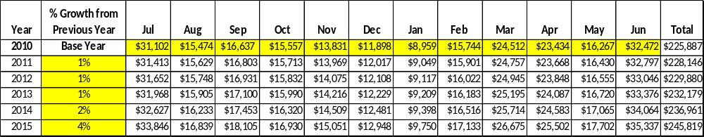

These projections would result in a total of 9% cumulative growth in total annual revenues between FY2010 and FY2015. If operational expenses can be managed with a cumulative increase of 26% between FY 2010 and FY 2015, then the overall cost recovery of the site will be approximately 69% in FY 2015 at these projected revenue levels. This is lower than the annual financial performance of the site in FY 2010, which was operated at 73% cost recovery in that year, but was artificially low due to multiple staff vacancies and not sustainable.

Revenue Generation Strategies

Pricing Plan
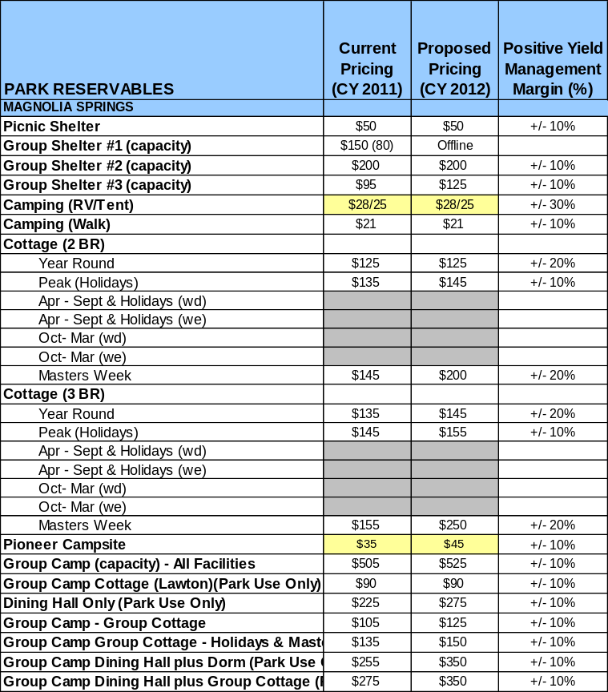

Innovative Programming and Special Events Plan
Program / Event | Theme / Purpose | Scheduled Date/Season | Frequency | Target Participation | Target User Fee | Target Cost Recovery
Heritage Day Festival | Demonstrate Early American Life | 1st Saturday in December | Annual | 500 | $5 | 120%
Camp Lawton Public Day | History of Camp Lawton | March –May  Sept.-Nov. | Monthly | 150 | $3 | 100%
Birding By Bike | Wildlife Appreciation | Spring / Summer / Fall | Monthly | 10 | $10 | 120%

Partnerships and Concessions Plan
Service / Partnership | Term of Service | Financial Objective | Contract Manager
Garden Club | 2 yr. | Reduce grounds maintenance costs | Park Manager
Georgia Southern University | 1 yr. | Provide programming at no cost | Park Manager
US Fish & Wildlife Service | 1 yr. | Provide programming at no cost | Park Manager

Expense Management Plan
Personnel Assignments
The following actions will be taken to proactively manage labor costs via personnel assignments and classifications.

Action | Timeline | Outcome
Eliminate one Ranger position | 2012 | Reduced Labor Costs
Eliminate Full-time Housekeeper | 2012 | Reduced Labor Costs

Management Techniques
The following actions will be taken to proactively manage labor costs via management techniques.

Action | Timeline | Outcome
Replace full-time maintenance and housekeepers with hourly positions | 2012 | Reduced labor costs

Adjusted Levels of Service
The following actions will be taken to proactively manage labor costs via reduced levels of service.

Action | Timeline | Outcome
Adjust mowing schedules and acreage | March 2012 | Reduce cost
Reduce ornamental shrubbery | March 2012 | Reduce cost
Remove unnecessary fencing – reduces upkeep and weed eating | January 2012 | Annual cost reduction

Financial Pro Forma
The following five-year financial pro forma projects operating expenses, earned revenues and cost recovery through FY 2015. These pro forma are based on the strategies and desired outcomes identified in this business plan, especially the revenue generation and expense management plans, and are linked to corresponding performance goals.

Expense Pro Forma
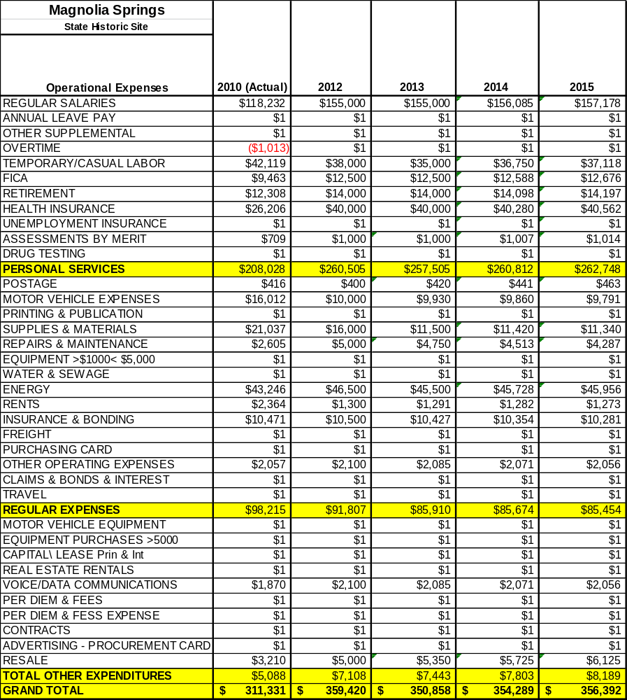

Revenue Pro Forma
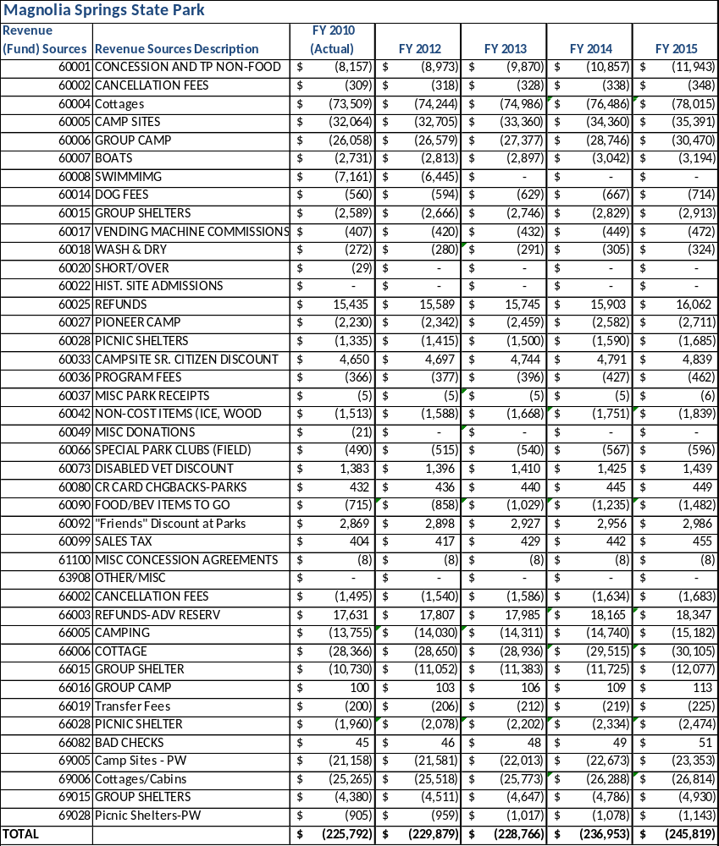

Total / Cost Recovery Pro Forma
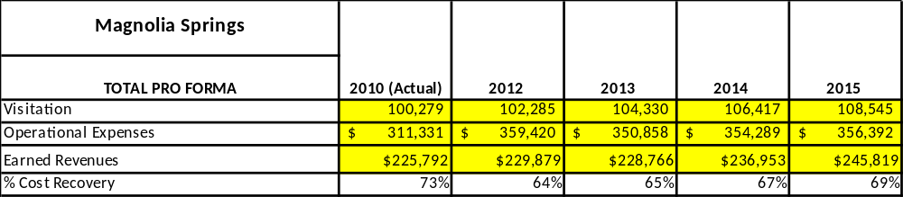

Action Plan
ACTION PLAN
Site: |  | Site Manager: |  |  | Date:
Month:
Strategy | Tasks | Costs / Funding | Revenues / ROI | Responsibilities | Metrics

ACTION PLAN
Site: |  | Site Manager: |  |  | Date:
Month:
Strategy | Tasks | Costs / Funding | Revenues / ROI | Responsibilities | Metrics

This is the average of the last three years – FY 2008, FY 2009, and FY 2010
Current employees, not including vacancies.
Current employees, not including vacancies.
Major population centers within a two-hour drive from the site

