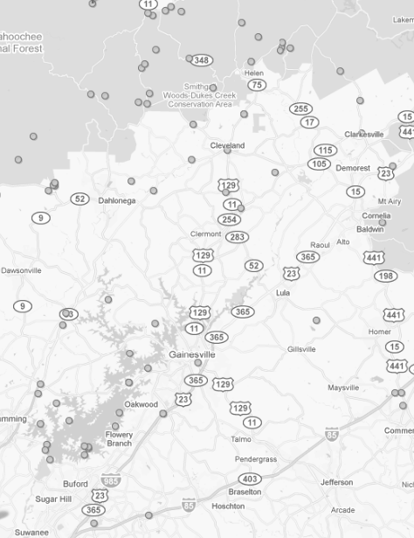

A cursory survey of
select campgrounds and cabin rentals
in the vicinity of Don Carter State Park

Prepared by:
Eric VanDeGenachte
August 2010

Background image reflects points in the vicinity of Don Carter State Park (noted by the star)
which (mostly) reflect alternate camping destinations as recognized by Google Maps.

Figure 1, below, demonstrates the population density in the vicinity of Don Carter State Park. It provides a basis for a source of likely guests from Georgia.
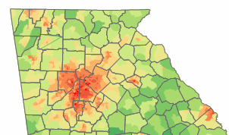
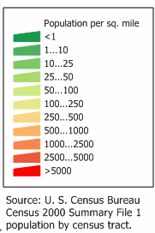
Figure 1. Population Density (per 2000 US Census)

Figure 2, below, identifies the location of Don Carter State Park with concentric circles representing a 25-mile radius and a 50-mile radius. Note that there are few other DNR lands within the 25-mile radius, but there are several within the fifty-mile radius. Not all of the DNR lands highlighted here provide ‘improved’ camping facilities or, indeed, any facilities at all. The purpose of the figure is solely to show relative placement and likelihood of creating competition with existing facilities.

Figure 2. Twenty-five-mile and fifty-mile radii from Don Carter State Park (represented as ‘air miles’).
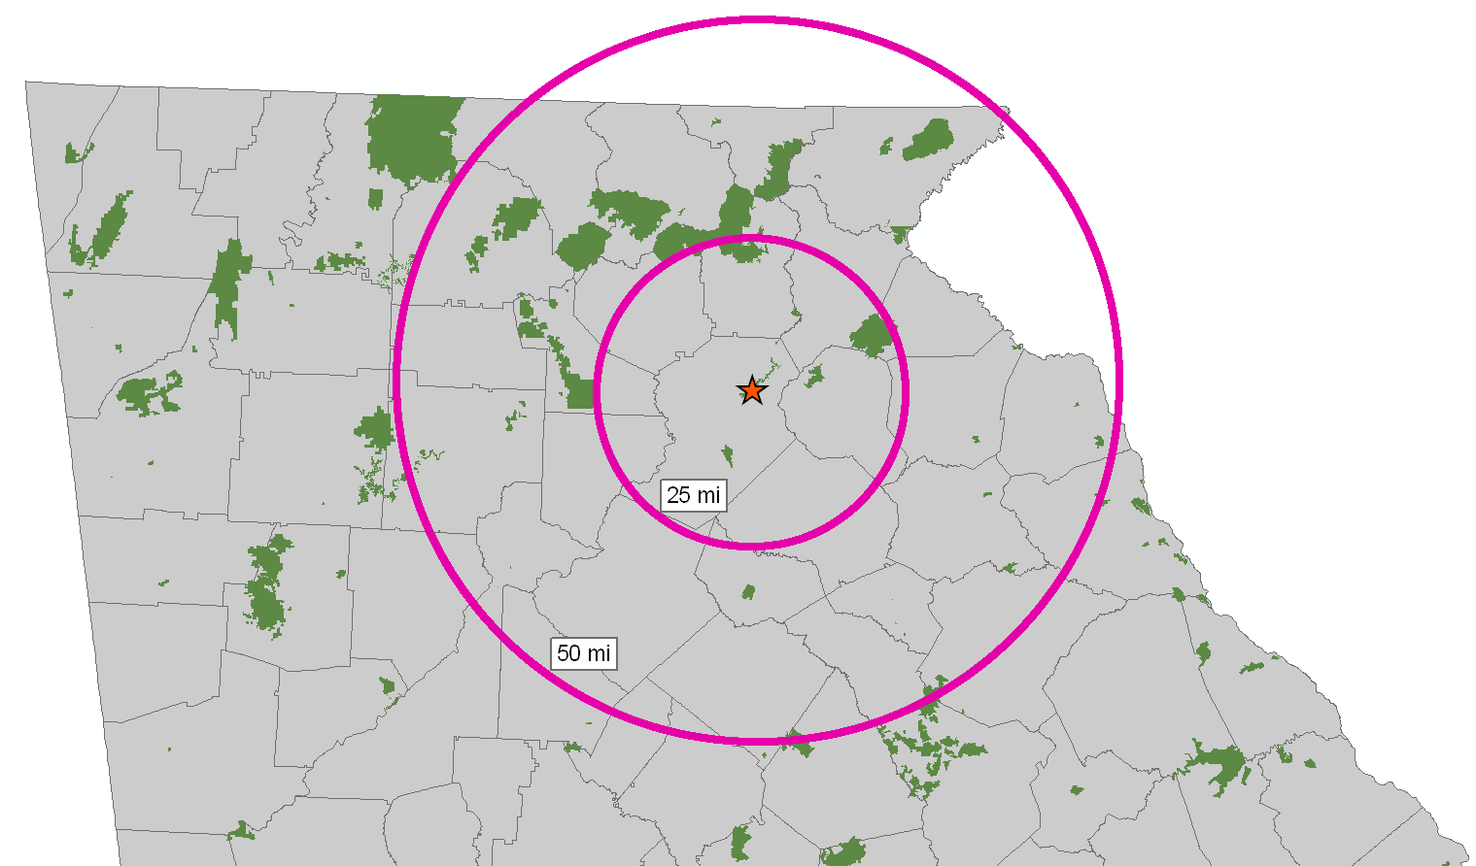

Gauging Competitive Landscape for Camping and Cabins

Process:
Several websites were reviewed to assess the number of operations that provide camping facilities and cabin facilities in the vicinity of Don Carter State Park. Some of those websites include Google Maps and ReserveAmerica.com.

Limitations and Caveats:
It should be noted that this process likely does not capture all camping facilities. Moreover, some of these facilities may occur a little outside the 50-mile radius due to the limitations of the selection process. This process could not ensure that all individual federal facilities were captured (e.g., U.S. Army Corps of Engineers, U.S. Forest Service). Lastly, because the term “cabin rentals” could represent both the kinds of cabin facilities provided by the PRSHD as well as stand-alone, privately-owned cabins for rent, it is possible that some competitors are identified here that do not provide the same kind of services provided by the PRHSD and may not reflect an actual competitive entity.

That being said, this analysis should provide a basic overview of the likely market and competitive forces in the vicinity of Don Carter State Park.

This analysis did not take into account many other factors that would qualify the competitive-intensity of other providers including: cost, number of units, auxiliary amenities, ease of reservations, nature of rental agreements, associated attractions, accessibility, etc. These factors would have to be taken into account to better qualify the competitive landscape that we would experience.

Results:
Provided below is a listing of select camping entities and a listing of select cabin-rental facilities and services. Also provided is a list of PRHSD properties that provide camping and / or cabin rentals.

The PRHSD properties located within the 50-mile radius which provide camping or cabin rentals include:
- Amicalola Falls State Park
- Black Rock Mountain State Park
- Fort Yargo State Park
- Hard Labor Creek State Park
- Moccasin Creek State Park
- Smithgall Woods State Park
- Tallulah Gorge State Park
- Tugaloo State Park
- Victoria Bryant State Park
- Vogel State Park
- Watson Mill Bridge State Park
- Unicoi State Park

Many of the WRD-managed properties within the 50-acre radius were not specifically identified.

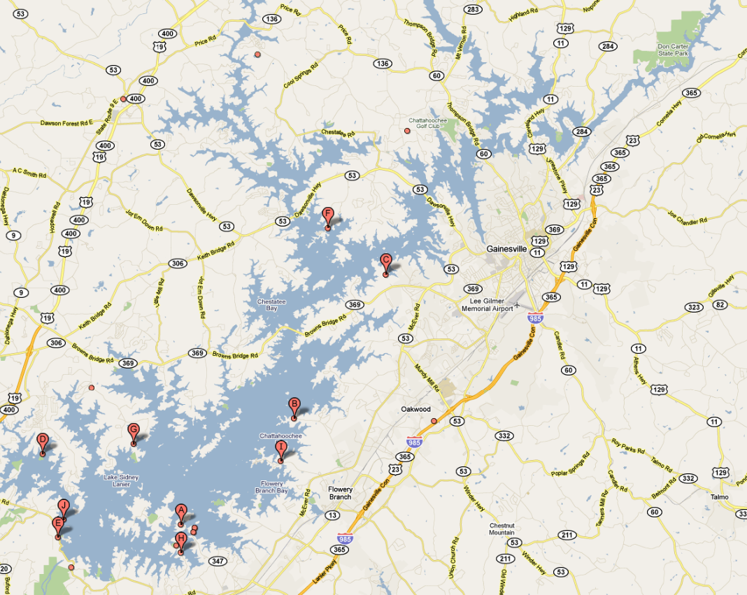
Camping Facilities on Lake Lanier
Produced from data mined from Google Maps

Duckett Mill
Campground

River Forks
Campground

Shady Grove
Campground
Bald Ridge Creek Campground
Old Federal
Campground

Sawnee
Campground

Shoal Creek
Campground

Camping facilities on Lake Lanier

- Bald Ridge Creek Campground‎- 4100 Bald Ridge Park Road, Cumming, GA‎ - (770) 889-1591‎
- Duckett Mill Campground‎- 3720 Duckett Mill Road, Gainesville, GA‎ - (770) 532-9802‎
- Old Federal Campground‎- 6219 Old Federal Road, Flowery Branch, GA‎ - (770) 967-6757‎
- River Forks Park & Campground‎-3500 Keith Bridge Road, Gainesville, GA‎ - (770) 531-3952‎
- Sawnee Campground‎- 3200 Buford Dam Road, Cumming, GA‎ - (770) 887-0592‎
- Shady Grove Campground‎- 7800 Shadburn Ferry Road, Cumming, GA‎ - (770) 205-6849‎
- Shoal Creek Campground‎- 6300 Shadburn Ferry Road, Buford, GA‎ - (678) 482-0332‎
* Note that Antioch Campground‎- was discounted because it caters to specialized clientele (religious).

Site | Lake? | Range of Rates  as of August 2010 | Power | Water | Commentary
Bald Ridge Creek | Yes | $27 | Yes | Yes | No details on power & water. 82 sites w/ hook-up. Two-day minimum stay. Dump station, Laundry, Restrooms, Hot showers, Boat ramp, Swimming beach. Federal facility.
Duckett Mill | Yes | $17 to $27 | Yes | Yes | No details on power & water. 97 sites w/ hook-up; 14 tent-only sites, Hot showers, laundry, boat ramp, playground, dump station, and swimming area. Federal facility.
Old Federal | Yes | $19 to $27 | Yes | Yes | No details on power & water. 59 sites w/ hook-up; 24 tent-only sites, Hot showers, laundry, boat ramp, playground, dump station, and swimming area. Federal facility.
River Forks | Yes | $30(RV) to $20(tent) | Yes | Yes | 50 amp Service, No details on water. 63 sites w hook-up; 20 tent sites. Four playgrounds many recreational opportunities. County facility.
Sawnee | Yes | $19 to $27 | Yes | Yes | No details on power & water. 44 sites w/ hook-up; 11 tent-only sites, Hot showers, laundry, boat ramp, playground, dump station, and swimming area. Federal facility.
Shady Grove | Yes | $26(RV) to $18(tent) | Yes | Yes | $15 for dump station. County facility.
Shoal Creek |  |  |  |  | I get the sense that this is a federal facility that has been shut-down.

Cabin-rental facilities on Lake Lanier

There are a couple ‘vacation home’ rentals on Lake Lanier, according to Google Maps. Many of these represent larger, stand-alone, private homes (presumably rented for weeks or months at a time). However, there don’t appear to be any accommodations fitting the keywords ‘cottage’ or ‘cabin,’ on Lake Lanier according to Google Maps. A similar search for ‘cabins’ via ReserveAmerica found the closest record 30 miles away on Lake Winifred Scott.

Results from ReserveAmerica for cabins near Gainesville, GA
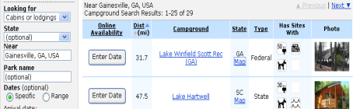

Camping facilities in the ‘northern arc’ of Don Carter State Park
In addition to highlighting camping providers on Lake Lanier, a secondary set of providers was identified for an area north of Don Carter State Park demarked by the cities of Dahlonega, Cleveland, and Cornelia.

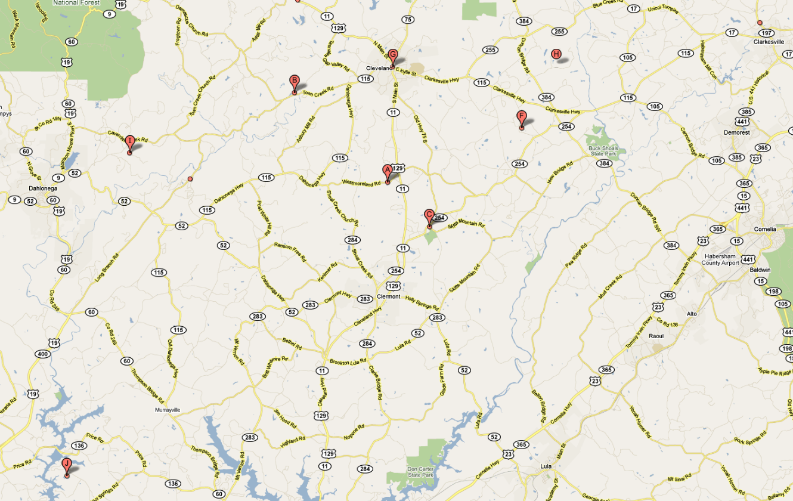

Gold n Gem Grubbin
Campground

Hidden Valley
Campground

Union Grove
Campground
Leisure Acres
Campground

Mossy Creek
Campground

Details on the camping facilities in the ‘northern arc’ of Don Carter State Park

Site | Lake? | Range of Rates  as of August 2010 | Power | Water | Commentary
Foothills | No | $25 | Yes | Yes | No details on power or water. Shower house, dumping station,
Gold n Gem Grubbin | No | $28(RV) to $20(tent) | Yes | Yes | No details provided on power / water, number of sites, etc.
Hidden Valley | No | ?? | ?? | ?? | No contact information, website, or details could be found on the internet.
Leisure Acres | No | $32 | Yes | Yes | 30amp and 50amp Very high density campground (per aerial photo). Swimming pool, fishing pond, camp store, playground, WiFi, sewer, laundry.
Mossy Creek | No | ?? | ?? | ?? | No contact information, website, or details could be found on the internet.
Union Grove | No | ?? | ?? | ?? | Few details could be found on the internet. I have the impression it serves a religious clientele.

- Hidden Valley Campground‎- Dahlonega, Georgia‎ <No contact information found>
- Foothills Campground‎- 5320 Long Branch Rd, Dahlonega, GA‎ - (706) 867-9979‎
- Leisure Acres Campground Inc‎- 3840 Westmoreland Road, Cleveland, GA‎ - (706) 865-6466‎
- Union Grove Campground‎ 80 Tabernacle St, Cleveland, Georgia‎ - (706) 865-4623‎
- Gold n Gem Grubbin; 75 Gold Nugget Lane; Cleveland, GA 30528; (706) 865-5454

Cabin / Cottage facilities in the ‘northern arc’ of Don Carter State Park
In addition to highlighting camping providers on Lake Lanier, a secondary set of providers was identified for an area north of Don Carter State Park demarked by the cities of Dahlonega, Cleveland, and Cornelia.

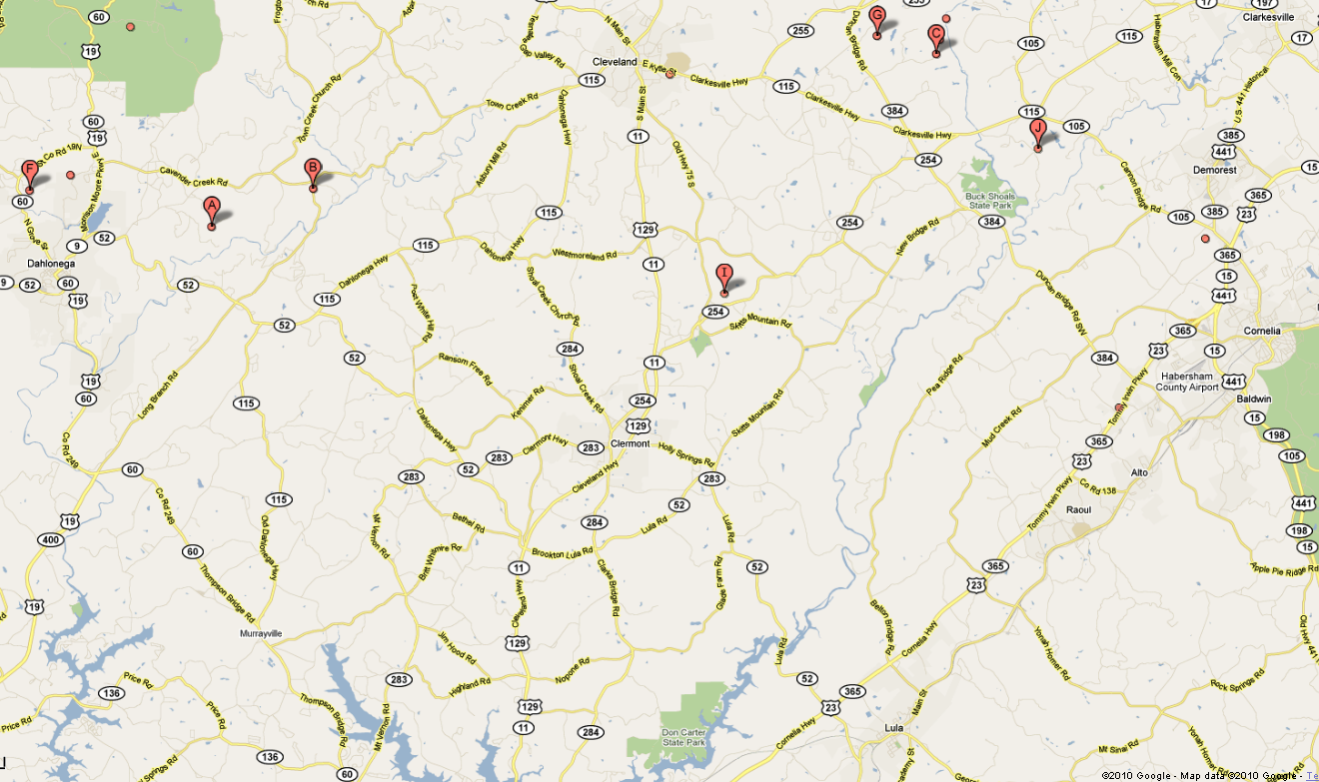

Twin Rivers Resort
Rivers Edge
Cottage
Hatfield Hideaway
Cabins

Yahoola Creek
Cabins
Cozy Moose Cabins

Cavender Creek Cabins

Details on the cabin / cottage facilities in the ‘northern arc’ of Don Carter State Park

Site | Lake? | Range of Rates  as of August 2010 | Commentary
Yahoola Creek | No | $150 to $175
River's Edge | No |  | Few details available.
Cavender Creek | No | $125 to $200
Hatfield’s Hideaway | No | $115
Cozy Moose | No | $79 & up
Twin Rivers | No | $1,400 to $1,705 | Sleeps 32 to 65 people.

- Yahoola Creek Cabin; 448 North Hidden Valley Trail; Dahlonega, GA 30533; (706) 973-0265
- River's Edge Cottage; 124 Golden Autumn Drive; Dahlonega, GA 30533-3928; (706) 864-0790
- Cavender Creek Cabins; 200 Beaver Dam Road; Dahlonega, GA 30533; (866) 373-6307; cavendercreek.com
- Hatfield's Hideaway Cabins; 3109 Copper Mine Road · Dahlonega, GA 30533-4219; (706) 864-6743
- Cozy Moose Cabins; 521 Crane Trail; Cleveland, GA 30528; (706) 892-8215; cozymoosecabins.com‎
- Twin Rivers Resort; 210 Twin River Orchard Road; Demorest, GA 30535; (706) 754-2010; twinriverscabins.com

