A cursory survey of
select campgrounds and cabin rentals
in the vicinity of
Hard Labor Creek State Park

Friday 19 November 2010

Prepared by:
Eric VanDeGenachte
Parks, Recreation and Historic Sites Division
Atlanta, GA

Results and Discussion

Within about a 90-minute drive of Hard Labor Creek State Park, about 90 service providers offering camping facilities of various types were found. Acknowledging that this does not reflect all the possible camping opportunities, there may be a couple dozen additional service-providers. Based on these data, it appears that there is a wide range of options for individual campers, implying that competition may be intense, particularly when seasonal demand is low and availability of substitutes is high (e.g., during the ‘shoulder-season’ or ‘off-season’). In order for Hard Labor Creek State Park (and other nearby PRHSD sites) to ensure a competitive advantage, it will be paramount to provide exceptional quality, service and experiences at our facilities at a competitive price.

Although additional research has to be completed, one hypothesis is that the greatest opportunity to increase revenue from occupancy is not during the peak season (since we may be booked anyway) nor during the off-season (when demand is low), but during the so-called ‘shoulder-seasons’ when demand is still reasonably high, but substitute service-providers also remains high. Currently, the occupancy data currently available is too coarse to serve as useful evidence for this hypothesis, so it cannot yet be advanced as a recommendation, but it is an issue to explore further.
There are 90+ other campsites within
a 90-minute drive of HLC.

Staying competitive during the
‘shoulder-season’ may be key.

Low-density primitive camping is permitted at many properties managed by the Wildlife Resources Division (WRD). Perhaps five of the WRD-managed properties in this 90-minute radius allow for primitive camping. Because primitive camping is not widely marketed by WRD and because they provide few (if any) support services, these sites are not expected to have a significant competitive impact on PRHSD services. There are also seven PRHSD properties in this areas (five of which provide over-night accommodations), but because they are part of the Division, their competitive impact is discounted. For the purposes of this report, we are assuming that the collective capacity of all PRHSD is not enough to saturate the market and that there are plenty of potential guests that could be drawn from other vendors. Based on this assumption, any actual competition created by nearby PRHSD facilities is discounted.
There are only five other cabin-rental services within a 90-minute drive of Hard Labor Creek.

HLC may have a greater marketshare for cabins than for camping and might be able to charge more during peak seasons.
Within that same 90-minute driving radius there are many fewer service-providers for cabin (cottage) rental services that are similar to those provided by PRHSD. Only five possible service-providers were identified by this survey (other PRHSD site not withstanding). Although no effort was made to assess the capacity and quality of these five sites, if we assume that they are roughly similar to those offered at Hard Labor Creek State Park, it suggests that HLC has a much greater marketshare in cabins than it does with camping.

This analysis did not take into account many other factors that would qualify the competitive-intensity of other providers including: cost, number of units, auxiliary amenities, ease of reservations, nature of rental agreements (e.g., length of required stay), associated attractions, accessibility, etc. These factors would have to be taken into account to better qualify the competitive landscape that we would experience. Perhaps identifying sites for a more thorough assessment is a job best left for Site Managers.

Introduction
Assessing the landscape of competition is an important component of any business plan to ensure fiscal sustainability. This report is a coarse attempt to identify other sites providing services similar to that offered by Hard Labor Creek State Park; those services being: tent camping, RV camping, pioneer (primitive) camping and cabins (aka ‘cottages’). No effort is made to assess competition for group shelters nor picnic shelters. This process likely does not capture all facilities, but probably captures many of them. Lastly, it is more difficult to assess competition for cabins (cottages) because the term represents the kinds of facilities offered by PRSHD as well as single, stand-alone, privately-owned facilities and segregating them via internet searches is difficult. For the most part, only results from ReserveAmerica.com are presented here for cabin/cottage rental sites.

This analysis did not take into account many other factors that would qualify the competitive-intensity of other providers including: cost, number of units, auxiliary amenities, ease of reservations, nature of rental agreements (e.g., length of required stay), associated attractions, accessibility, etc. These factors would have to be taken into account to better qualify the competitive landscape that we would experience. Perhaps identifying sites for a more thorough assessment is a job best left for Site Managers. Moreover, no effort was made to confirm that these service providers actually existed or were even still open.

Methodology
Division staff have historically considered a 60-minute drive radius as the primary competitive market for a given property. Analysis of ZIP codes from reservations made in 2010 reveals that only about 45.5% of reservations come from that 60-minute drive radius. In order to capture more than 50% of the reservations made, it is necessary to go out to about a 90-minute drive radius. Assuming drive speeds around 55 to 60 miles per hour, a ninety-minute drive radius will hover between 80 and 90 miles from Hard Labor Creek.
Percent of  reservations…. | …within a drive-  time radius of:
45.5% | 60-minutes
57.3% | 90 minutes
64.3% | 120 minutes
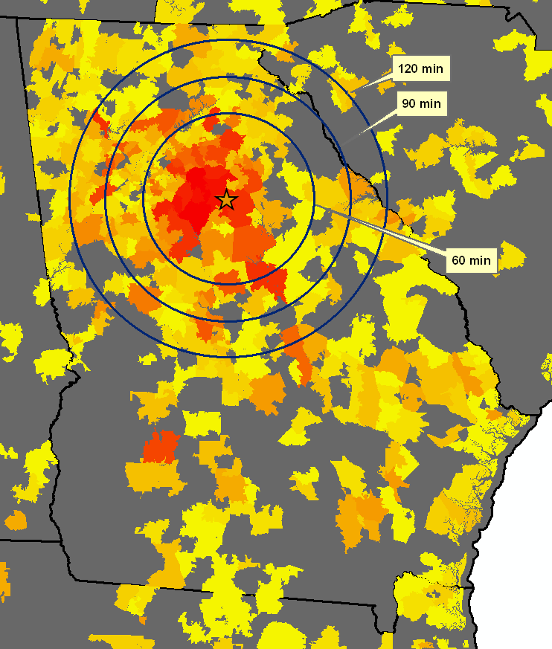
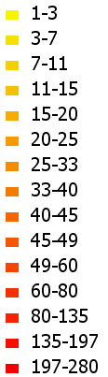
Figure 1. Intensity of reservations in Georgia.

Four approaches were taken to assess the competitive landscape for Hard Labor Creek State Park, which included:

- Asking the Site Manager and Region Manager
- Reviewing state and federal facilities via desktop GIS software and the accommodations they provided
- Review of ReserveAmerica.com website
- Review of Camping.com website

It appears that ReserveAmerica.com focuses its results on state and federal properties, but does mention some private sites as well. Conversely, Camping.com highlights many of the private sites. Previous attempts to mine Google Maps for camping venues did not produce output that was satisfactory. That is, some sites would display whereas others would not until you went to subsequent ‘page’ of the search results. Moreover, collecting the name and other information was cumbersome.

The information provided by each of these sources is diverse and not necessarily consistent. That is, one source might indicate the amperage of electrical power provided, but not the address of the location whereas another source might provide the address, but little about the amenities offered.

Results: Camping Service-Providers
Site Manager, Daniel Hill identified two properties as local competitors, namely

Country Boy RV Park  2750 Eatonton Road  Madison, GA  (706) 342-1799 | Pine Lake RV Campground  5540 High Shoals Road  Bishop, GA  (706) 769-5486

A review of GIS software revealed the following results:

DNR-Managed Properties within a drive radius of ~90 minutes
from Hard Labor Creek State Park with narrative

 | WRD Properties
B.F. Grant WMA | No services offered
Broad River NA | No services offered
Buford FH | No overnight accommodations
Cedar Creek WMA | No services offered
Charlie Elliott Wildlife Center | Lodge room, and a walk-in campsite but not much competition
Oconee WMA | Primitive backcountry sites, but not much competition
Redlands WMA | Primitive backcountry sites, but not much competition
Rock and Shoals Outcrop NA | No overnight accommodations
Rum Creek WMA | A walk-in campsite, but not much competition
Walton FH | No services offered
 | PRHSD Properties
A.H. Stephens SP | Not considered competition w/in the Division
Fort Yargo SP | Not considered competition w/in the Division
High Falls SP | Not considered competition w/in the Division
Indian Springs SP | Not considered competition w/in the Division
Jarrell Plantation HS | No overnight accommodations
Panola Mountain SP | No overnight accommodations
Watson Mill Bridge SP | Not considered competition w/in the Division

ReserveAmerica.com referenced many sites, but failed to identify Hard Labor Creek State Park nor either of the two campgrounds cited by the Site Manager. This was somewhat disconcerting as one would strive to see continuity and even redundancy to ensure accuracy. It appears that ReserveAmerica focuses on federal and state service-providers.

Campgrounds within 90 miles of the ZIP code of HLC (30663)

Campground | Distance  (Miles) | Type | Power  (amps) | Full  Hook-Up | Pets  Allowed? | Near  Water?
Lake Sinclair Recreation Area (GA) | 33.3 | Federal | 50 | Full | Pets | Water
Van Pugh South Campground (GA) | 43.9 | Federal | 50 |  | Pets | Water
Old Federal (GA) | 44.7 | Federal | 50 |  | Pets | Water
Sawnee (GA) | 46.6 | Federal | 50 |  | Pets | Water
Bald Ridge Creek (GA) | 48.4 | Federal | 50 |  | Pets | Water
Duckett Mill (GA) | 49.2 | Federal | 50 |  | Pets | Water
Bolding Mill (GA) | 51.9 | Federal | 50 |  | Pets | Water
Nancytown Group Campground (GA) | 57.1 | Federal
Gill Point (GA) | 57.2 | Federal
Broad River (GA) | 58.7 | Federal | 30 |  | Pets
Big Hart (Group Shelter) (GA) | 59 | Federal | 20
Big Hart Campground (GA) | 59.3 | Federal | 50 |  | Pets
Hesters Ferry (GA) | 59.6 | Federal | 30
Mt Carmel (SC) | 60.5 | Federal | 50
Raysville (GA) | 61 | Federal | 50
Amity (GA) | 61 | Federal | 15
Watsadler (GA) | 61.1 | Federal | 50 |  | Pets
Big Oaks (GA) | 61.2 | Federal | 15
Fern Springs Day Use Picnic Area (GA) | 61.4 | Federal
Calhoun Falls | 61.5 | State | 30 |  | Pets | Water
Elrod Ferry (GA) | 61.5 | Federal | 15
Long Point (GA) | 62.7 | Federal | 15
Singing Pines (SC) | 63.3 | Federal | 15
Milltown (GA) | 63.4 | Federal |  |  | Pets
Lake Hartwell | 63.7 | State | 30 |  | Pets | Water
Crescent (SC) | 64 | Federal | 50 |  | Pets
Winfield (GA) | 64.2 | Federal | 50
Fair Play (SC) | 64.2 | Federal | 15
Paynes Creek(Hartwell Lake) (GA) | 64.3 | Federal | 50 |  | Pets
Carolina Landing | 65.4 | Private | 30
Sadlers Creek | 65.9 | State | 30 |  | Pets | Water
Springfield (SC) | 67.3 | Federal | 50 |  | Pets
Payne Campground-Allatoona Lake (GA) | 67.4 | Federal | 50 | Full | Pets | Water
Weldon Island (SC) | 67.6 | Federal | 15
River Forks (SC) | 69.3 | Federal | 15
Hawe Creek (SC) | 69.8 | Federal | 50
Sweetwater Cg (GA) | 69.8 | Federal | 50 | Full | Pets | Water
Victoria Campground (GA) | 70.4 | Federal | 50 | Full | Pets | Water
Broyles (SC) | 70.9 | Federal | 15
Hickory Knob | 71.9 | State | 30 |  | Pets | Water
Baker Creek | 71.9 | State | 30 |  | Pets | Water
Clark Creek North (GA) | 72 | Federal | 50 |  | Pets | Water
Anderson / Lake Hartwell KOA | 72.8 | Private | 50 | Full | Pets
Mckinney Campground (GA) | 73 | Federal | 50 |  | Pets | Water
Coneross Park (SC) | 73.2 | Federal | 50 |  | Pets
Old Hwy 41 No 3 (GA) | 73.3 | Federal | 50 | Full | Pets | Water
Petersburg (GA) | 73.4 | Federal | 50 |  | Pets | Water
Ridge Road (GA) | 73.5 | Federal | 50
Oconee Point (SC) | 74.6 | Federal | 50 |  | Pets
Parksville (SC) | 74.7 | Federal | 15 |  |  | Water
Upper Stamp Creek Cg (GA) | 75 | Federal | 50 |  | Pets | Water
Modoc (SC) | 75.6 | Federal | 50
Lake Springs (GA) | 76 | Federal | 15
Twin Lakes (SC) | 76.3 | Federal | 50 |  | Pets
Below Dam South Carolina (SC) | 76.4 | Federal | 15
Mckaskey Creek Cg (GA) | 76.7 | Federal | 50 |  | Pets | Water
West Dam (GA) | 76.9 | Federal | 15
Hamilton Branch | 76.9 | State | 50 |  | Pets | Water
Clarks Hill (SC) | 77.5 | Federal | 15
Lake Winfield Scott Rec (GA) | 77.8 | Federal | 50 | Full | Pets
Cassidy Bridge Primitive Camp (SC) | 79 | Federal
Twin Lakes Day Use Area (SC) | 80.4 | Federal | 15
Twelve Mile (SC) | 81.8 | Federal | 15
Whetstone Horse Camp (SC) | 85.6 | Federal |  |  | Pets
Oconee | 86.1 | State | 30 |  | Pets | Water
Willis Knob Horse Camp (GA) | 86.6 | Federal | 50
Doll Mt. Campground (GA) | 90 | Federal | 50 |  | Pets
Source: Website of Reserve America accessed Friday 19 November 2010 via URL:
http://www.reserveamerica.com/campgroundSearchResult.do?startIdx=50
Camping.com revealed fewer than did ReserveAmerica.com and there was little overlap between the two websites. Camping.com also included at least one of the sites identified by the Site Manager.

Campground | Address | Distance  from ZIP  30663
Country Boys RV Park | 2750 Eatonton Rd; Madison, GA 30650 | 10.58
Country Boys RV Park | 5473 Mount Olive Rd; Commerce, GA 30529 | 46.37
The Pottery Campgrounds/Craven Inc | 100 Pottery Rd; Commerce, GA 30529 | 47.38
Atlanta South Rv Resort | 281 Mt Olive Rd; Mcdonough, GA 30253 | 42.73
Forest Glen Mobile Home & RV Park | 218 Glade Rd; Jackson, GA 30233 | 40.23
Forsyth KOA | 414 South Frontage Road; Forsyth, GA 31029-0967 | 43.16
High Falls Campground | 1046 High Falls Park Road; Barnesville, GA 30204 | 41.40
Brookwood RV Resort Park | 1031 Wylie Road SE; Marietta, GA 30067 | 66.78
Atlanta West Campground | 2420 Old Alabama Rd; Austell, GA 30168 | 71.91
Creekwood Resort & Cabins | 5730 Highway 356; Sautee-Helen, GA 30571 | 64.29
Allatoona Landing Marine Resort | 24 Allatoona Landing Rd; Cartersville, GA 30120 | 84.68
Banning Mills RV Park | 1105 Banning Rd.; Whitesburg, GA 30185 | 91.64
Fair Harbor RV Park | 515 Marshallville Rd; Perry, GA 31069 | 78.46
Hillside Bluegrass RV Park | 592 Highway 87 South; Cochran, GA 31014 | 85.73
Holiday Harbor Marina and Campground | 5989 Groovers Landing; Acworth, GA 30102 | 81.29
River Vista Mountain Village | 960 Highway 246; Dillard, GA 30537 | 98.36
Tiger Cove Campground | 4023 Whitehall Road; Anderson, SC 29626 | 86.63
Sleepy Hollow Campground | 307 Sleepy Hollow Road; Sautee, GA 30571 | 80.43
Whispering Pines Campground | 290 Whispering Pines Road; Morganton, GA 30560 | 98.70
Anderson/Lake Hartwell KOA | 200 Wham Road; Anderson, SC 29625 | 86.29
Bald Mountain Park Camping Resort | 751 Gander Gap Road; Hiawassee, GA 30546 | 91.26
Boland's Perry Overnight Park | 800 Perimeter Rd; Perry, GA 31069 | 76.75
Cherokee Campground | 45 Bethel Road; Sautee, GA 30571 | 80.26

Source: Website of Camping.com accessed on Friday 19 November 2010 via URL:
http://travel.camping.com/

Results: Cabin Service-Providers

Results from ReserveAmerica.com

Site | Distance  (miles) | Type | Power  (amperes) | Full  Hook-Up | Pets | Near  Water?
Lake Hartwell | 63.7 | State | 30 |  | Pets | Water
Hickory Knob | 71.9 | State | 30 |  | Pets | Water
Anderson / Lake Hartwell KOA | 72.8 | Private | 50 | Full | Pets
Lake Winfield Scott Rec (GA) | 77.8 | Federal | 50 | Full | Pets
Oconee | 86.1 | State | 30 |  | Pets | Water

Figure 2, below, demonstrates the population density in the vicinity of Hard Labor Creek State Park. It provides a basis for a source of likely guests from Georgia and surrounding states.

Figure 2. Population Density (per 2000 US Census)
