Mistletoe State Park
Business & Management Plan

Prepared June 2011; Finalized December 2012
Direction 2015 – Sustainable Business Planning

Table of Contents

Executive Summary 3

Site and Operations Assessment 6
Site Inventory and Facility Assessment 6
Operational Assessment 9
Financial Performance Assessment 14

Business and Management Plan 17
Business Goals 17
Classification of Programs and Services 18
Partnership Development Plan 19
Marketing and Sales Plan 20
Revenue Generation Plan 22
Expense Management Plan 24
Financial Pro Forma 25

Action Plan 28

Executive Summary
The Parks, Recreation and Historic Sites Division (PRHSD) of the Georgia Department of Natural Resources (DNR) is transitioning the management of Mistletoe State Park to operate more like a business, reflecting the Direction 2015 – Sustainable Business Planning initiative to improve the fiscal performance and management of the state parks and historic sites system. This business and management plan is designed to help the site recover more operating expenses through earned revenues, productive partnerships, and innovative programs.

Site Fact Sheet
Site Name | Mistletoe State Park
Site Manager | Trevor Bullard
Region Manager | Tommy Turk
Date of Business Plan completion | June 10, 2011
Site size | 1,920 Acres
Total number of visitors (FY 2010) | 110,834
Total operating budget (FY 2010) | $446,280
Total earned revenues (FY 2010) | $431,494
Operational cost recovery (FY 2010) | 97%
Average operating cost per visitor (FY 2010) | $ 4.15
Average earned revenue per visitor (FY 2010) | $ 4.00
Average cost recovery (FY 2008 – 2010) | 93%
Target cost recovery (FY 2015) | 104%
Total full-time employees | 4
Total part-time employees | 6
Primary service markets | Augusta, Savannah, Atlanta
Primary attractors/visitor appeal factors | Fishing, boating and swimming on Clarks Hill Lake; campsite and cottage rentals; hiking and biking
Leading opportunities for improved site performance | Expanded usage of site, additional recreational opportunities, updated facilities, increased special events

Site Summary and Key Attractions
The 1,920-acre site of Mistletoe State Park is located in a semi-rural area in close proximity to the rapidly growing city of Augusta. The park is only a 45-minute ride to downtown Augusta, and the Masters golf tournament. It is a two-hour drive to downtown Atlanta from the park. The main attraction of this site is the 72,000-acre Clarks Hill Lake, the largest lake in the state. A key challenge to maintaining the park’s visitation is the drought conditions that result in low lake levels.

Key Attractions
The amenities or features listed below are those that seem to be most popular for visitors.
- Clarks Hill Lake
- Log cabin and cottage rentals
- Fishing opportunities
- 40 foot campsites
- 3 boat ramps
- Beach house group shelter
- Nature center
- Educational programs and special events
- Hiking and biking trails

Financial Targets
The table below details the total operating expenses and earned revenues for Mistletoe State Park over the last three years (2008 – 2010). This table also calculates total cost per visitor and revenues per visitor during these operating years, and details the target financial performance goals in the context of achieving at least 106% cost recovery. This table also calculates the necessary change from 2010 operating expenses and revenues.
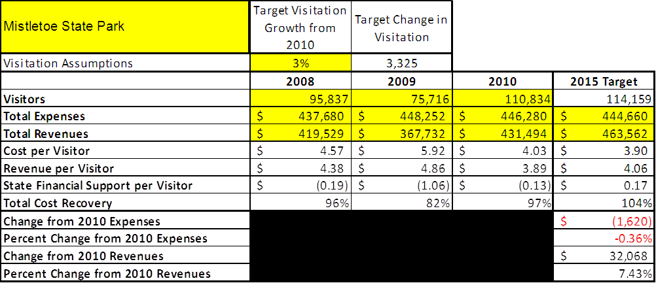

Key Recommendations

Primary / Short Term Recommendations
- Build 5-10 more cottages to improve site cost recovery.
- Renovate the group shelter to modernize the facility and to improve its overall integrity.
- Operate the site using cost-based accounting, including the net cost recovery achieved annually.
- Develop plans to increase the number of special events hosted at the site and implement them.
- Increase the amount of educational and daily programming events during the peak season.
- Create a group sales marketing plan to increase visitation, especially during the off-season.
- Review and improve the retail operation on site to increase revenue.
- Review and adjust rates at the site on an annual basis to recover the total net cost of service for the important and visitor supported services.
- Improve the overall maintenance program at site, ensuring that the grounds and facilities are being maintained to a high standard and at a sustainable level.
- Continue working with the Friends group to help invigorate the overall program at the site.
- Develop a detailed analysis of labor requirements of all major park functions to match the right position with the right job at the right pay.
- Improve networking with local agencies and marketing opportunities.
- Offer more programs that guests will be willing to pay for, such as weekend hayrides, interpretive school fieldtrips, school outreach programs, junior rangers, etc.

Secondary / Long Term Recommendations
- Modernize the main boat ramp area and parking to accommodate large fishing tournaments.
- Appropriate the UGA building adjacent to the main boat ramp and use it as a rentable facility, such as a “fishermen’s bunkhouse.”
- Renovate all maintenance facilities.
- Renovate all cottages.
- Offer Wi-Fi Internet and cable to all cottage guests and at least Wi-Fi for the camping guests.

Site and Operations Assessment
This site and operations assessment is a culmination of analyses and findings from a review of the condition of facilities, infrastructure, and operations at Mistletoe State Park. The findings and observations are not intended to be an exhaustive review of all issues present, but provide a basic understanding of the predominant issues that contribute to the site’s current operating conditions. The assessment includes the following:
- Site Inventory and Facility Assessment
- Operational Assessment
- Financial Assessment
Site Inventory and Facility Assessment

Methodology
Facility and asset conditions are rated using a differential scale of excellent, good, fair, or poor. Descriptions of conditions that are attributed to each of these findings are also provided.
Scale of Conditions
Rating | General Description
Excellent | Facilities/amenities are in ‘excellent’ condition when they show little or no maintenance or repair problems. Facilities do not feature any major design or operational issues or flaws that contribute to diminished use or increased maintenance or upkeep. Facilities are easy to clean and maintain in order to place them back into public use and the users perceive them to be in excellent shape.
Good | Facilities/amenities are in ‘good’ condition when they show only minor maintenance or repair problems. Most maintenance issues with these facilities typically appear to be the result of age and/or heavy use. Facilities may only feature minor design or operational issues that contribute to diminished use or increased maintenance or upkeep. Facilities are moderately easy to clean and maintain in order to place them back into service and the users perceive them to be adequate for their use, but probably not in excellent shape.
Fair | Facilities/amenities are in ‘fair’ condition when they show significant maintenance or repair problems. Facilities generally exhibit ongoing maintenance issues that appear to be the result of age, heavy use, or design or operational flaws. Some maintenance and repair needs may compound their fair condition by being deferred because of budget and/or resource limitations. Facilities require more effort to clean and maintain before placing them back into service and the users may perceive them as being less than adequate for their use and in a state of deterioration. The facility or structure may need of major repair or replacement.
Poor | Facilities/amenities are in ‘poor’ condition when they show significant, on-going maintenance or repair problems that ultimately may result in suspended use for repair/replacement. Maintenance and repair issues are possibly the result of poor maintenance and clearly the result of age, heavy use, or design or operational flaws. Problems with the facilities are often compounded over time due to consistently-deferred maintenance and repair because of budget and/or resource limitations. Facilities may feature major design or operational issues that contribute to diminished use or increased maintenance or upkeep. Facilities require excessive effort to clean and maintain before placing them back into service and the users often perceive them as being inadequate for their use and in a state of serious deterioration. The facility or structure may need of major repair or replacement.

Inventory and Assessment
The table below is an inventory of facilities and amenities at Mistletoe State Park, and provides the assessed condition of each as reviewed in April 2011.
Site Asset / Amenity | Quantity | Condition
Total Acreage | 1,920 | Good
Cottages 1-5 | 5 | Good
Mistletoe Road boat ramp | 1 | Good
Office/Visitor Center | 1 | Good
Nature Center | 1 | Poor
Main boat ramp | 1 | Fair
“Tackle Box” w/restrooms | 1 | Fair
Fish Cleaning Station | 1 | Good
Group Shelter | 1 | Fair
Restroom near group shelter | 1 | Fair
Picnic Shelters | 5 | Good
Restroom near picnic shelter 2 | 1 | Fair
Beach House | 1 | Good
Beach | 1 | Good
Cottages 6-10 | 5 | Fair
Comfort Station 1 | 1 | Excellent
Comfort Station 2 | 1 | Good
Comfort Station 3 | 1 | Good
40 foot campsites | 92 | Good
Walk-in tent campsites | 4 | Fair
Back country campsites | 3 | Fair
Pioneer camp | 1 | Good
Playgrounds | 4 | Good
Camper cabin | 1 | Good
Well houses | 4 | Fair
Sewage pump houses | 4 | Fair
Manager’s Residence | 1 | Good
Asst. Manager’s Residence | 1 | Good
Maintenance Facilities | 5 | Good
Underground fuel tank | 1 | Good (closed)

Prioritized Facility Needs
Based on the facility inventory and assessment, these prioritized needs have been identified. Each need has been aligned with a priority category of high, moderate, or low to support future decision-making regarding project sequencing, investment of public resources, and meeting community expectations. The priority assignment for each need is not a measure of importance. Rather, these recommended priorities reflect a phased implementation approach over the next several years.

Facility Need | Priority Assignment
5- 10 additional cottages/cabins | High
Construct Yurts in Group Shelter area to create a group camp | High
Group shelter renovation | High
Comfort station 2 – rebuild to new style comfort station | High
Main boat ramp parking renovation | High
Expand/ rebuild nature center | Low
Restroom at picnic shelter 2 renovation | Moderate
Upgrade Electrical service in outdated areas of campground | Moderate
Replace ADA fishing pier | Moderate
Replace restrooms at main boat ramp | Moderate
Finish paving ADA trail | Low
Refurbish porch at beach house | Low
Build restrooms at Mistletoe Road boat ramp | Low

Operational Assessment
The Operational Assessment includes:
- An inventory and classification of programs and services being provided at the site
- A review of staffing at the site
- A review of concessionaires and partners operating at the site
- Visitation and customer satisfaction

Inventory and Classification of Programs and Services
Programs and services are classified into one of three major categories:
1) Core or Essential Services
2) Important Services
3) Visitor Supported Services
Programs and services at the site are classified into these categories based in part on the mission and public mandates for both the site and the agency. For the programs and services in each of these categories, there are financial performance expectations that will define how services are funded and evaluated.

Category 1 – Core Services [Largely supported by tax funds]
Core programs, services and facilities are those the agency must provide and/or are essential in order to capably govern and meet statutory requirements. The failure of the agency to provide Category 1 services at adequate levels could result in significant negative consequences for the public and the resources under protection. The criteria for programs or services to be classified as core or essential are:
- The services are mandated by the agency’s law or charter or are contractually obligated by agreement to provide the services.
- The services are essential to protecting and supporting the public’s health and safety.
- The services protect and maintain valuable assets and infrastructure.
- The services would generally and reasonably be expected and supported by residents, businesses, customers and partners.
- The services are those that cannot or should not be provided by the private sector.
- The services provide a sound investment of public funds.
The following programs and services offered at Mistletoe have been identified as core services:
- Public safety and resource protection
- Facility and grounds maintenance
- Site appropriate education, interpretation, and recreational opportunities
- Public access
Category 2 – Important Services [Supported by a balance of tax funds and earned revenues]
Important programs, services and facilities are those the agency should provide, and are important to governing and effectively serving residents, businesses, customers and partners. Providing Category 2 services expands or enhances the agency’s ability to provide and sustain its core services. The criteria for programs or services to be classified as important are:
- The services expand, enhance or support identified core services.
- The services are broadly supported and utilized by the community, and are considered an appropriate, important, and valuable public good. Public support may be conditional upon the manner by which the services are paid for or funded.
- The services generate income or revenue that offsets some or all of the operating cost and/or are deemed to provide economic, social or environmental outcomes or results.
The following programs and services offered at Mistletoe have been identified as important services:
- Nature center operations
- Beach
- Hiking trails
- Picnic sites with grills

Category 3 – Visitor Supported Services [Almost exclusively supported by earned revenue]
Visitor supported programs, services and facilities are those discretionary services that the agency may provide when additional funding or revenue exists to offset the cost of providing those services. Category 3 services provide added value above and beyond what is required or expected. The criteria for programs or services to be classified as visitor supported are:
- The services expand, enhance or support core services or important services and the quality of life of the visitors, community or stakeholders.
- The services are supported, valued and well utilized and provide an appropriate and valuable public benefit.
- The services generate income or funding from sponsorships, grants, user fees or other sources that offset some or all of their cost and/or provides a meaningful return on investment.
- The services can possibly be provided through outsourcing or use of concessionaires, providing opportunities for community enterprises that may not otherwise be provided by the agency.
The following programs and services offered at Mistletoe have been identified as visitor supported:
- Cottages
- Campgrounds
- Retail operations
- Educational programs
- Special events
- Picnic shelters
- Group shelters
- Canoe Rentals
- Swimming Beach
- Hiking Trails

Staffing Assessment
Labor costs at Mistletoe State Park represent the largest area of budgetary expense at an average of 69% of the total operating budget each year for the last three complete years, which is higher than the target of total labor costs (including benefits) not exceeding 65% of the site’s total operating expenditures. The tables below and on the following page provide a basic review of the current staffing at the site.
Full Time Equivalent Employees
Position / Title | Quantity (FTE) | Vacancies | Annual Hours
Park Manager | 1 | 0 | 2080
Assistant Park Manager | 0 | 1 | 2080
Park Ranger | 0 | 1 | 2080
Clerk | 1 | 0 | 2080
TOTAL | 2 | 2 | 8320

Part Time Employees
Position / Title | Quantity (FTE) | Vacancies | Hours
Desk Clerk | 1 | 0 | 1508
Housekeeper | 4 | 0 | 6032
Maintenance | 3 | 0 | 4524
Naturalist | 0 | 1 | 640
TOTAL | 8 | 3 | 12704

Labor Support
Labor Support | Annual Hours
Volunteers | 4,000
Community Service Workers | 1,664
Resource Management Crews | 20
Park Pass Kiosk Attendant | 754
TOTAL | 6438

Total Labor Hours
Labor Type | Annual Hours
Full Time Equivalent Employees | 8320
Part Time Employees | 12704
Labor Support | 6438
TOTAL Annual Labor Hours | 27462

Labor Budget Summary

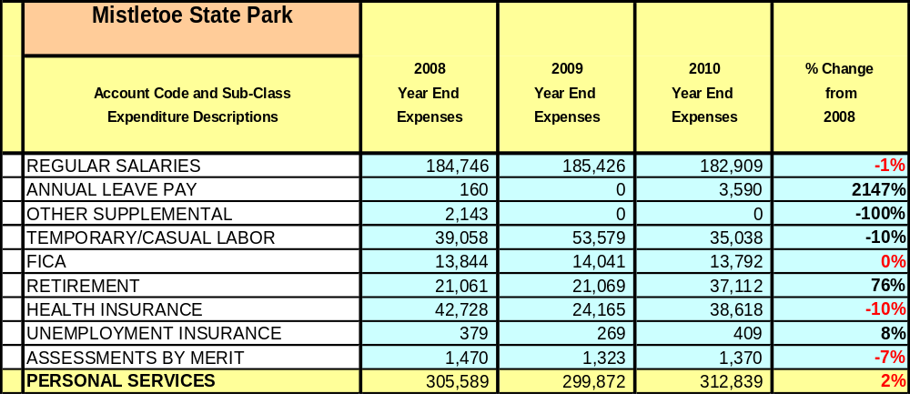

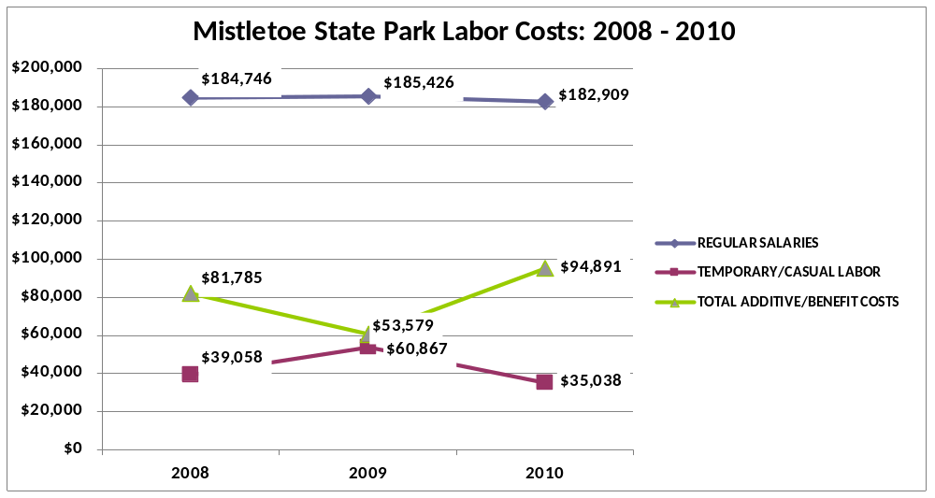

Visitation and Occupancy
Overall annual visitation to the site has trended upward from 2008 to 2010, increasing by 14% or over 14,997 visitors. This is largely attributed to the end of the drought and normal lake levels.
Year | Total Visitation
2008 | 95,837
2009 | 75,716
2010 | 110,834
Occupancy for the overnight accommodations at Mistletoe State Park the last three years is detailed in the table below. Overall occupancy has trended downward from 2008 to 2010, decreasing by 5%. This is largely attributed to the downturn in the economy.
Year | Camping Occupancy | Cottages Occupancy
2008 | 20.36% | 55.81%
2009 | 16.95% | 45.08%
2010 | 19.78% | 50.22%

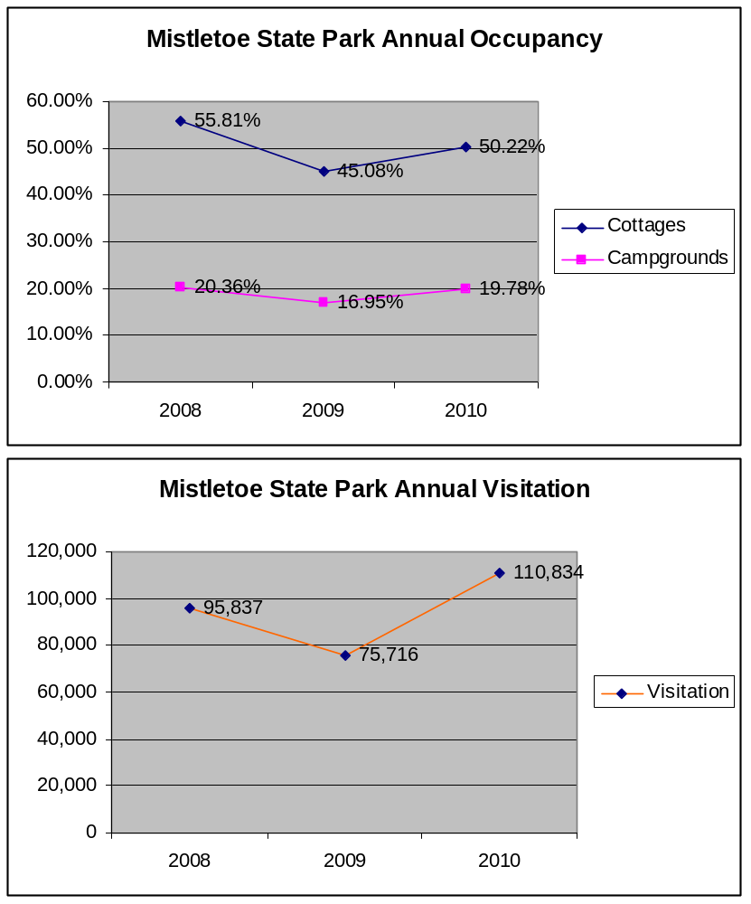
The graphs below illustrate visitation and occupancy over the last three years.

Customer Service and Satisfaction

Site | Year | Customer Satisfaction Level
Mistletoe State Park | 2009 | 75%
Mistletoe State Park | 2010 | 68%
Financial Performance Assessment

Operational Expenses
A summary of total operating expenses at Mistletoe State Park from 2008 to 2010, as well as their percent change from 2008, is provided in the table below.

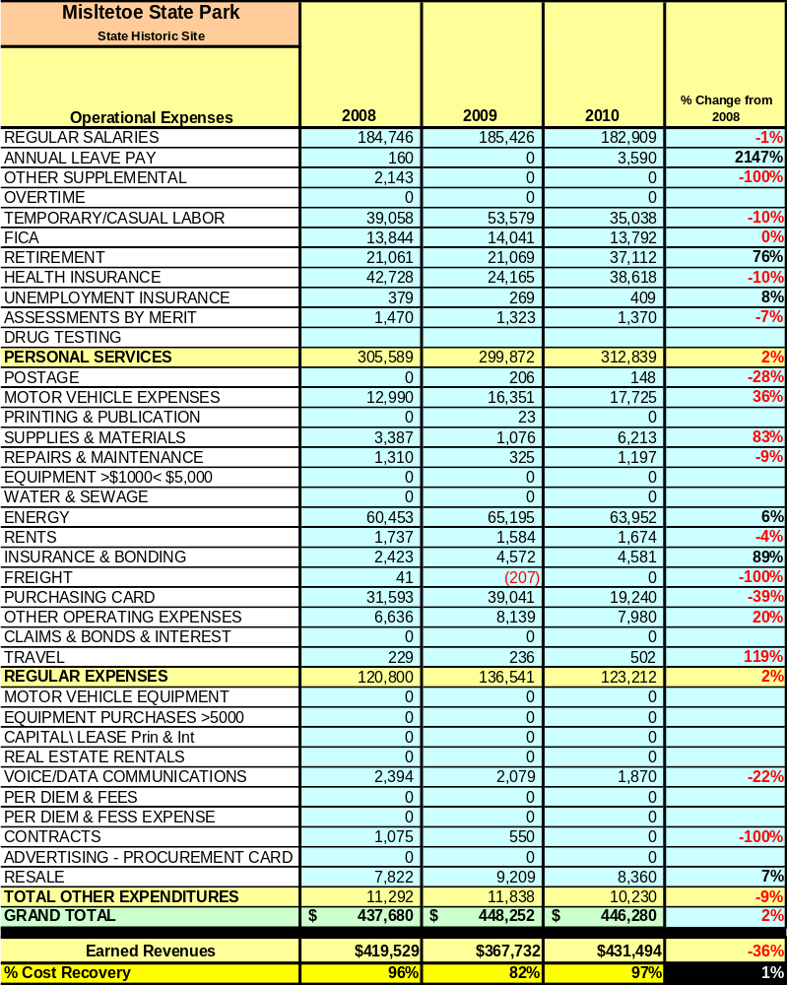

Earned Revenues
Earned revenues at Mistletoe have increased since 2008, which is largely attributed to the corresponding increases in visitation and rates. Monthly earned revenues for the last two years (see table on the following page) indicate that total annual revenue increased 17% from 2009 to 2010, with the largest increases in monthly revenues in August (23%), September (28%), October (38%), November (42%), December (42%), February (27%), and March (27%) and no decreases during any month.

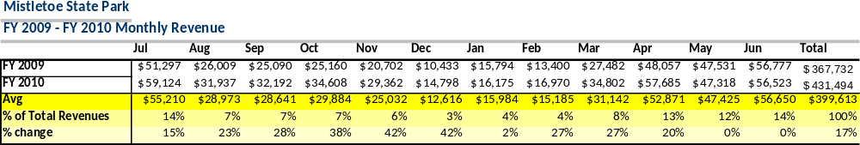

The graphs below illustrate the monthly revenue trends each year and the average percent of total annual revenue earned each month.
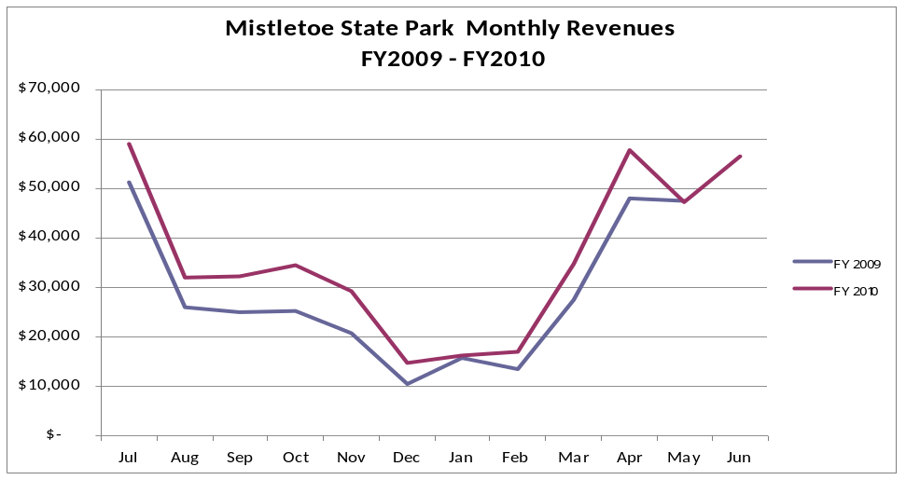

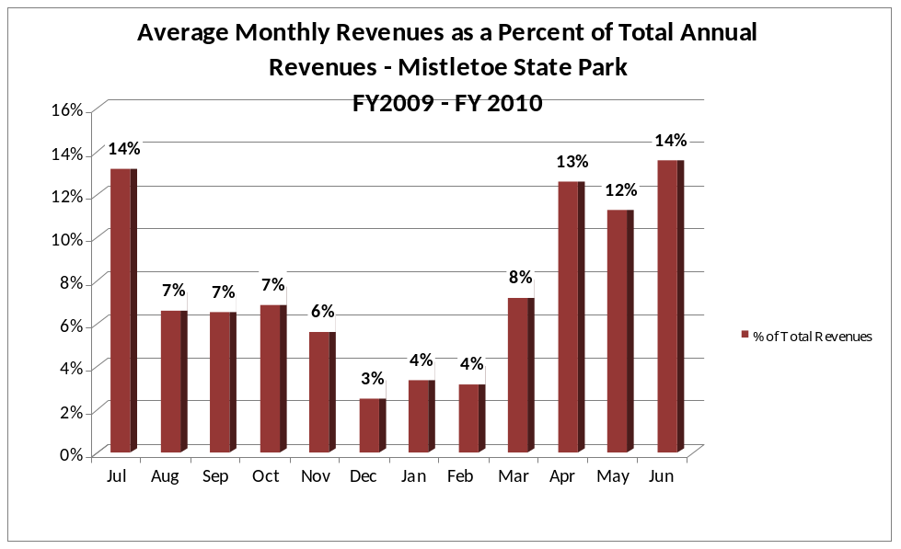
Cost Recovery Trends
Mistletoe has achieved an average cost recovery of 93% of annual operational expenses through earned revenues from FY 2008 to FY 2010. This is detailed and illustrated in the table and graph below.
Year | Operational  Expenses | Earned  Revenues | Percent Cost  Recovery
2008 | $437,680 | $419,529 | 96%
2009 | $448,252 | $367,732 | 82%
2010 | $446,280 | $431,494 | 97%
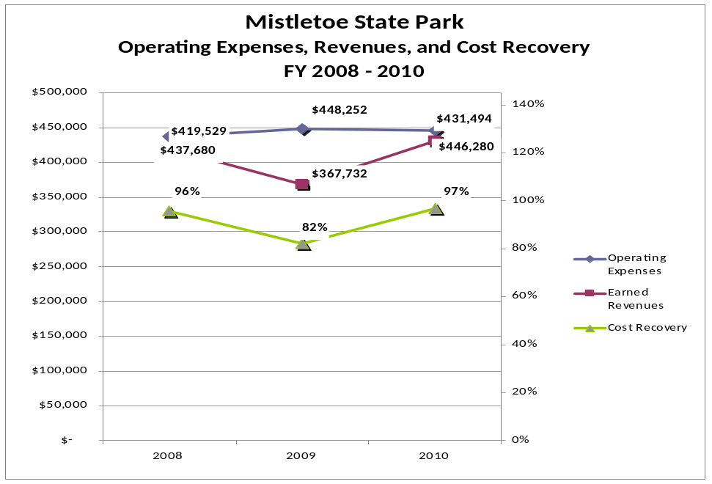

Review of Pricing
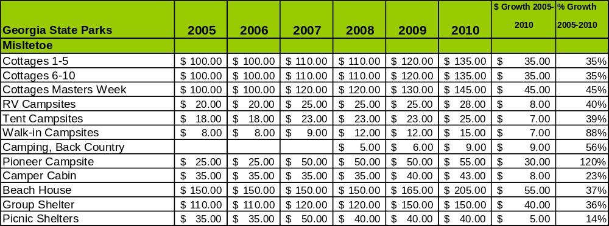
Data on rate information is available as far back as 2002, but only the last five years are evaluated. There has been notable growth in fees charged at Mistletoe State Park since 2007, with the largest increase being in the walk-in campsites at 88%. A table detailing the rates for Mistletoe State Park is provided below.

Business and Management Plan

Business Goals
The following goals serve as the foundation for the key recommendations and strategies in this plan.

Enhance Cost Recovery of Site Operations
Mistletoe State Park is operating at a 93% average cost recovery of operational expenses through earned revenue. Excluding additional revenue generating capital projects, such as more cottages, the greatest improvement in cost recovery must come from a more competitive rate schedule, group sales, and additional special events to generate more guests and revenues to cover the park’s expenses.

Enhance Revenue Generation Strategies
As mentioned above, other than adding more cottages, increasing earned revenues for this site must entail increasing the volume of guests utilizing the existing rentable facilities. This can be done by offering more off-season competitive discounts/deals, creating a marketing plan to attract groups, enhancing our retail operations, and hosting more special events that would draw overnight guests.

Expand Special Events at the Site
Mistletoe has a lot of potential to host a variety of small to medium sized events. Currently, some of the special events that are hosted on the site are triathlons, dulcimer jams, orienteering meets, fishing tournaments, and site provided events such as “Fall Fest” and “Spring Fling.” Each of these events generates about 200-500 guests. To expand the current special event calendar, a network of community leaders, event organizers, etc. needs to be established and nurtured.

Improve the Diversity and Innovation of Recreational and Interpretive Programs
Currently, the park’s daily programming is offered mostly by our local volunteers who tend to focus on more adult programming themes. An increase in Junior Ranger style programming, weekend hayrides, canoe trips, nature hikes, and other programs that would interest a younger audience is recommended. These programs must also be cost effective and revenue generating.

Improve the Effectiveness of Marketing and Sales
Targeting and tailoring the Mistletoe experience towards specific groups and markets can improve our site’s marketing and sales. Partnering with nearby attractions in the Central Savannah River Area, especially around Clarks Hill Lake, is critical for any success. This can be done by improving community outreach with local officials, tourist agencies, clubs such as SORBA-CSRA, and local business leaders.

Establish Greater Consistency of Managing and Monitoring Customer Service & Satisfaction
The key to managing a successful customer service operation is the ability to monitor its performance. A more scientific survey/evaluation system needs to be developed with a type of incentive program for participating in the service, such as “chance to win” or even a minimal prize or discount upon submittal of the survey. The existing survey card or online system can be used in lieu of a more scientific survey, but to increase customer participation, approval is needed for the incentive program.

Expand Partnership Opportunities
Expanding partnership opportunities goes hand in hand with marketing and community outreach. Currently, Mistletoe has several strong partnerships with the local community; however, the opportunity to expand exists. Mistletoe needs to expand the partnership mission into Columbia County and the surrounding recreational areas and cities surrounding Clarks Hill Lake to increase visitation and marketing opportunities. Engage Friends members in the business plan as a partner to help the site meet or exceed its sustainability goals.

Classification of Programs and Services
The tables below summarize the classifications of programs and services at Mistletoe State Park as either core, important, or visitor supported, and project a range of cost recovery percentages that might be achieved for each. These classifications establish financial performance goals for each category of services that are linked to the recommendations and strategies of this business plan.

Core Services
Program / Service | Target Cost Recovery
Active management of the natural and cultural resources of the site in order to protect their integrity. | 0%
Public access | 0%
Site appropriate education, interpretation, and recreational opportunities | 130%
Public safety and resource protection | 0%
Facility and grounds maintenance | 0%

Important Services
Program / Service | Target Cost Recovery
Nature center operations  - Beach  - Day use operations, generally  Voluner programs | 110%
Beach  - Beach  - Day use operations, generally  Volunteer programs | 0%
Hiking Trails | 0%
Picnic sites with grills | 0%
Volunteer programs | 120%

Visitor Supported
Program / Service | Target Cost Recovery
Cottages | 130%
Campgrounds | 125%
Picnic shelters | 120%
Retail operations | 150%
Group shelters | 120%
Interpretive programming | 120%
Special events | 150%

Partnership Development Plan
The table below summarizes existing partners and targeted partnerships by classification (operational, vendor, service, co-branding, funding partners) and by organizational type.

 | Public Partners | Not-for-profit Partners | Private / Enterprise Partners
Operational Partners | - Army Corps of Engineers  - Columbia County Sheriff’s Office  - Martinez Fire Department | - Retired Senior Volunteer Program | - Augusta Best Hotels
Vendor Partners |  |  | - Coca Cola  - Bubba’s Fun Foods  - Jefferson EMC
Service Partners |  | - McDuffie Chamber of Commerce
Co-branding Partners
Funding Resource Development Partner |  | - Friends of Mistletoe State Park

Marketing and Sales Plan

Marketing and Sales Goals
Marketing and sales goals for Mistletoe State Park are based on the following desired outcomes:
- To increase occupancy percentages during peak and off seasons.
- To target group sales.
- To produce increased overall visitation and revenues.
In order to meet these goals, examples of specific target outcomes were identified in the areas detailed in the table below.

Area  of Focus | Current  Performance | Goal  by 2011 | Goal  by 2012 | Goal  by 2015
Special Events | 1,600 vis./yr | 2,500 vis./ year | 3,000 vis./ year | 5,000 vis./ year
Overall Visitation | 110,500 | 111,300 | 116,000 | 123,746
Marketing and Promotion Strategies

Publicity and Social Media
Mistletoe State Park will approach marketing and publicity planning using the following guidelines and themes:
- Event publicity
Major events benefit by having short stories in local, regional, and statewide newspapers and online social media hooks planted that run three to four weeks in advance of the event up to the date of the event itself. Stories and media need to be cultivated with contacts and online sales channels several weeks in advance of the time the stories need to run. Special interest interviews on morning, noon, and evening television news programs, radio interviews on popular rush-hour programs, and blogs on known affinity online sites should also be included.
- Program publicity
Special and unique programs should have feature stories in magazines, local and regional weekly newspapers, and statewide daily newspapers that are aimed at placements as front-page or sectional front-page stories. These stories are most effective if they run shortly before the season that the featured program begins. This will likely require several weeks of advanced planning with media contacts. Similar coverage on television and radio should also be considered. If pre-publicity cannot be generated, post-publicity can help promote future programs.
- Site Publicity
Site publicity focusing on a single site or sub-set of sites requires more intense planning efforts to attract multiple writers and editors from target publications. Each site could host several seasonal media familiarization tours (with 10 to 15 writers or editors) to familiarize them with the site and its benefits and amenities. Stories and features resulting from such tours typically take between two and six months to materialize so the tours should focus on experiences, benefits, and programs that would be available when the stories are expected to run.
Examples and suggested opportunities for events, programs and related publicity efforts based on the themes described above at Mistletoe State Park are provided in the table below.

Event Publicity | Program Publicity | Site Publicity
Wild Edibles | Spring Fling | Arts and Craft Festival
Geo Caching 101 | Fall Fest | Fishing Tournament
Stargazing | Dulcimer Jam
Wildflower hikes | Jr. Ranger Day Camps

Packaging
Examples and suggested packages for Mistletoe State Park are provided in the table below.
Package | Package Details
Winter Group Retreat Deal | 25%-30% off and free group shelter for 2 or more cottages for 2 or more nights
Camping with the Chef | Rent 10 sites and get the assembly shelter free with mobile grill if available
Campfire cookout | Purchase firewood and s’mores package for reduced price

Group Sales
Types of groups within which specific target customers can be identified for Mistletoe State Park are listed below:
- Families  - Youth service organizations  - Activity or special interest clubs  - Fishing clubs | - Churches  - Businesses and professional groups  - Colleges and universities  - Associations | - Schools  - Other public agencies  - Community organizations  - Scout groups

Incentivizing New and Repeat Visitation
Mistletoe State Park will utilize the following strategies and/or incentives to encourage new and repeat visitation starting in FY 2012:
- Differential pricing based upon days of week, peak or off-peak seasons, etc.
- Group / bulk pricing options
- Early reservation opportunities for returning guests
Marketing and Sales Metric Goals
The following marketing and sales metric goals and/or others will be monitored and progress reported at Mistletoe State Park:
- Loyalty and repeat customers = 50% of customers repeat their visit in a 12-month period.
- Brand confidence & customers-recruiting-customers = Customer referrals equal a minimum of 50% of “Where did you hear about us?” responses from visitors polled.
Revenue Generation Plan
Revenue / Cost Recovery Goals
Mistletoe State Park has set a financial goal of increasing the average annual revenues 3% annually between 2012 and 2015. The largest revenue growth opportunity is most likely overnight facility rentals. The table below details projected revenue growth leading up to 2015, based upon a nominal growth of revenues each year.
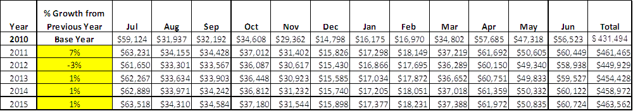
These projections would result in a total of 8% cumulative growth in total annual revenues between FY2010 and FY2015. If operational expenses can be managed with a cumulative reduction of 1.5% between FY 2010 and FY 2015, then the overall cost recovery of the site will be approximately 105% in FY 2015 at these projected revenue levels. This is higher than the annual financial performance of the site in FY 2010, which was operated at 97% cost recovery in that year.

Revenue Generation Strategies

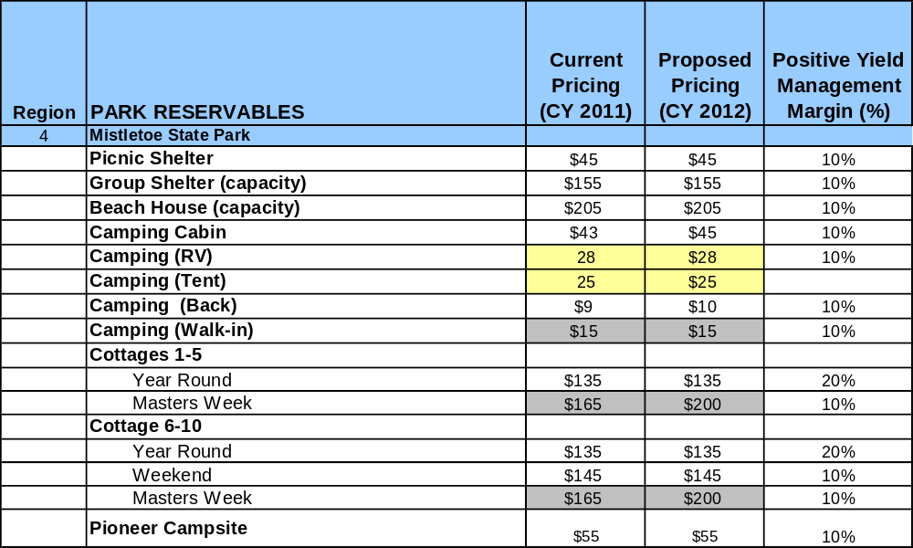
Pricing Plan

Innovative Programming and Special Events Plan

Program / Event | Theme / Purpose | Scheduled Date/Season | Frequency | Target Participation | Target User Fee | Target Cost Recovery
Spring Fling | Outdoor Festival | April 30th/ Spring | Annually | 400 | $5.00 per vehicle (not including park pass) | 150%
Fall Fest | Outdoor Festival | October 23rd/ Fall | Annually | 400 | $5.00 per vehicle (not including park pass) | 150%
Earth Day | Educational Program | April/ Spring | Annual | 150 | $5.00 per child | 130%
Jr. Rangers | Educational  Program | June/ Summer | Annual | 15 | $25 per child | 130%
Pioneers | Educational Program | November/ Fall | Annual | 15 | $25 per child | 130%

Partnerships and Concessions Plan

Service / Partnership | Term of Service | Financial Objective | Contract Manager
Tri the Parks Triathlon Series | 1 year | 15% of gross receipts to park | Park Manager
Bubbas Fun Foods | 1 year | 15% of gross receipts to park | Park Manager
Cottage/guided fishing packages with local guides | 1 year | 15% of gross receipts to park | Park Manager
Pontoon boat rental concession with local marina | 1 year | 15% of gross receipts to park | Park Manager

Expense Management Plan
Personnel Assignments
The following actions will be taken to proactively manage labor costs via personnel assignments and classifications.
Action | Timeline | Outcome

Management Techniques
The following actions will be taken to proactively manage labor costs via management techniques.
Action | Timeline | Outcome
Increase use of volunteers for site and grounds maintenance | July 2012 | Annual cost reduction of $24,000
Increase use of volunteers as front desk clerks | July 2012 | Annual cost reduction of $5,000
Increase volunteer operated hayrides in campgrounds | July 2012 | Annual revenue increase of $600

Adjusted Levels of Service
The following actions will be taken to proactively manage labor costs via reduced levels of service.
Action | Timeline | Outcome
Reduce hourly employee hours during the off season | July 2012 | Annual cost reduction of $6,000

Financial Pro Forma
The following five-year financial pro forma projects operating expenses, earned revenues and cost recovery through FY 2015. These pro forma are based on the strategies and desired outcomes identified in this business plan, especially the revenue generation and expense management plans, and are linked to corresponding performance goals.

Expense Pro Forma
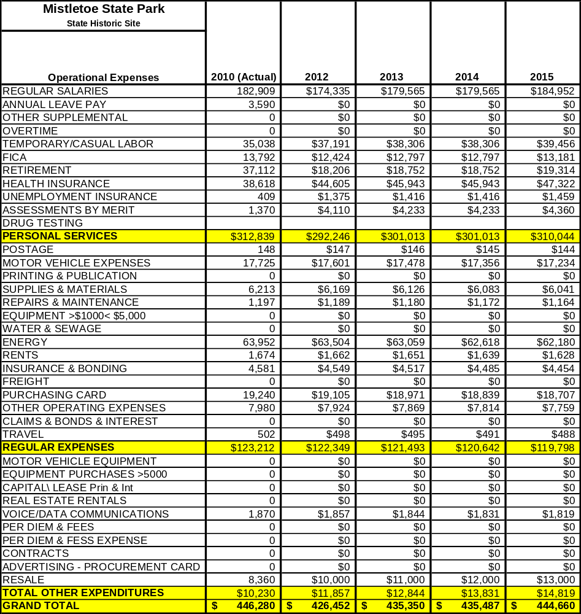

Revenue Pro Forma
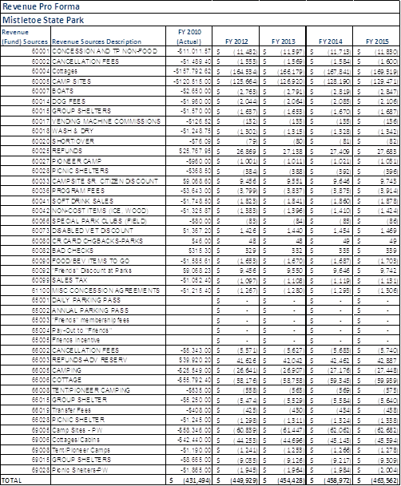

Total / Cost Recovery Pro Forma
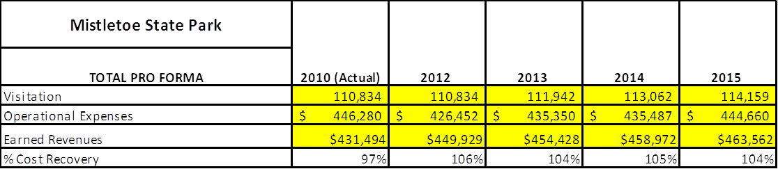

Action Plan
ACTION PLAN
Site: |  | Site Manager: |  |  | Date:
Month:
Strategy | Tasks | Costs / Funding | Revenues / ROI | Responsibilities | Metrics

ACTION PLAN
Site: |  | Site Manager: |  |  | Date:
Month:
Strategy | Tasks | Costs / Funding | Revenues / ROI | Responsibilities | Metrics

This is the average of the last three years – FY 2008, FY 2009, and FY 2010
Current employees, not including vacancies.
Current employees, not including vacancies.
Major population centers within a two-hour drive from the site

