Moccasin Creek State Park
Business & Management Plan

Prepared June 2012; Finalized February 2013
Direction 2015 – Sustainable Business Planning

Table of Contents

Executive Summary 3

Site and Operations Assessment 6
Site Inventory and Facility Assessment 6
Operational Assessment 8
Financial Performance Assessment 13

Business and Management Plan 16
Business Goals 16
Classification of Programs and Services 18
Partnership Development Plan 18
Marketing and Sales Plan 20
Revenue Generation Plan 22
Expense Management Plan 24
Financial Pro Forma 25

Action Plan 27

Executive Summary
The Parks, Recreation and Historic Sites Division (PRHSD) of the Georgia Department of Natural Resources (DNR) is transitioning the management of Moccasin Creek State Park to operate more like a business, reflecting the Direction 2015 – Sustainable Business Planning initiative to improve the fiscal performance and management of the state parks and historic sites system. This business and management plan is designed to help the site recover more operating expenses through earned revenues, productive partnerships, and innovative programs.

Site Fact Sheet
Site Name |  | Moccasin Creek State Park
Site Manager |  | Danny Tatum
Region Manager |  | Joe Yeager
Date of Business Plan completion |  | Friday September 15 2012
Site size (acres) |  | 32
Total number of visitors (FY 2010) |  | 82,381
Total operating budget (FY 2010) |  | $189,279
Total earned revenues (FY 2010) |  | $238,970
Operational cost recovery (FY 2010) |  | 126%
Average operating cost per visitor (FY 2010) |  | $2.30
Average earned revenue per visitor (FY 2010) |  | $2.90
Average cost recovery[1] (FY 2008 – 2010) |  | 134%
Target cost recovery (FY 2015) |  | 142%
Total full-time employees[2] |  | 2
Total part-time employees[3] |  | 2
Primary service markets[4] |  | Gainesville, Atlanta, Athens GA, Greenville SC
Primary attractors/visitor appeal factors |  | Fishing, Lake Burton, cool temperatures, mountain location
Leading opportunities for improved site performance |  | Increase amenities (50 amp, full hook-up sites, more parking)

Site Summary and Key Attractions
Moccasin Creek State Park is the smallest state park at 32 acres. Traditionally known for its elderly camping clientele, favorite pastimes include on-site trout fishing, boating and socializing. Younger families now frequent the site and are involved in trout fishing, trail walking, lake-kayaking and playing on the playground.

Key Attractions
The amenities or features listed below are those that seem to be most popular for visitors.
- Moccasin Creek trout stream, catfish ponds
- Lake Burton
- Lake Burton Fish Hatchery
- Hemlock Waterfalls
- Nearby public trout fishing areas
- Playground
- Gray water dump stations

Financial Targets
The table below details the total operating expenses and earned revenues for Moccasin Creek State Park over the last three years (2008 – 2010). This table also calculates total cost per visitor and revenues per visitor during these operating years, and details the target financial performance goals in the context of achieving at least 142% cost recovery. This table also calculates the necessary change from 2010 operating expenses and revenues.

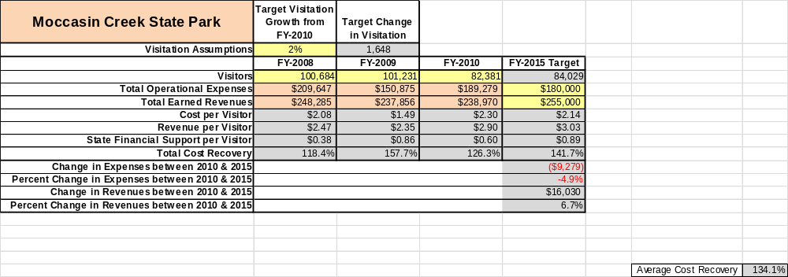

Key Recommendations

Primary / Short Term Recommendations
- Operate Moccasin Creek State Park using cost-based accounting, including the net cost recovery achieved annually.
- Collect a statistically-valid sample of ZIP code data through the existing reservation system for overnight visitors to gauge their origins and demographics (i.e. age, ethnicity, income) and use the results to improve programming and marketing efforts to appeal to a broader audience.
- Monitor required staff operational costs (with benefits) to ensure expenditures do not exceed 65% of the total operational budget.
- Partner with local parks (Black Rock, Tallulah Gorge, Unicoi) and the Department’s Marketing and Communication Unit to promote the individual sites and system.
- Improve the diversity and quantity of daily programs at Moccasin Creek by utilizing interpretive staff from nearby parks, interpretive hosts and other outside resources.
- Consider establishing a Friends of MCSP Chapter while strictly adhering to volunteer management “best practices.” Seek funding and volunteer assistance from the statewide Friends of GSP Chapter.
- Perform a thorough net cost-of-service analysis on major functions of site operations, including a detailed analysis of labor requirements by task.
- Continue refreshing retail inventory to accommodate returning customers.
- Upgrade amenities to match current rates (Wi-Fi, 50 AMP sites, playground upgrades, etc.)
- Retain the core market with return visits at least once each year at 70% or greater, while proactively managing constituent groups to maintain balanced and appropriate park use consistent with Departmental standards and ethics.

Secondary / Long Term Recommendations
- Due to the park’s small size, recommendations for improvements are limited to replacement versus installation of new facilities/structures.
- Improve the recreational amenities at Moccasin Creek State Park to meet the needs of modern and emerging uses, including addressing the recreational preferences of a diverse public. This could include adding new apparatus and a separate playground for younger children, adding family games such as ladder golf and bean bag toss.
- Prepare a pro forma to explore the cost recovery and feasibility of building a game room with pool tables, table tennis, pinball and arcade type games. Could be staffed by a volunteer and only open to registered campers and guests. This would give people something to do any time of the day in any weather and would produce revenue. This could also be used for programs and family movie nights.

Site and Operations Assessment
This site and operations assessment is a culmination of analyses and findings from a review of the condition of facilities, infrastructure, and operations at Moccasin Creek State Park. The findings and observations are not intended to be an exhaustive review of all issues present, but provide a basic understanding of the predominant issues that contribute to the site’s current operating conditions. The assessment includes the following:
- Site Inventory and Facility Assessment
- Operational Assessment
- Financial Assessment
Site Inventory and Facility Assessment

Methodology
Facility and asset conditions are rated using a differential scale of excellent, good, fair, or poor. Descriptions of conditions that are attributed to each of these findings are also provided.
Scale of Conditions
Rating | General Description
Excellent | Facilities/amenities are in ‘excellent’ condition when they show little or no maintenance or repair problems. Facilities do not feature any major design or operational issues or flaws that contribute to diminished use or increased maintenance or upkeep. Facilities are easy to clean and maintain in order to place them back into public use and the users perceive them to be in excellent shape.
Good | Facilities/amenities are in ‘good’ condition when they show only minor maintenance or repair problems. Most maintenance issues with these facilities typically appear to be the result of age and/or heavy use. Facilities may only feature minor design or operational issues that contribute to diminished use or increased maintenance or upkeep. Facilities are moderately easy to clean and maintain in order to place them back into service and the users perceive them to be adequate for their use, but probably not in excellent shape.
Fair | Facilities/amenities are in ‘fair’ condition when they show significant maintenance or repair problems. Facilities generally exhibit ongoing maintenance issues that appear to be the result of age, heavy use, or design or operational flaws. Some maintenance and repair needs may compound their fair condition by being deferred because of budget and/or resource limitations. Facilities require more effort to clean and maintain before placing them back into service and the users may perceive them as being less than adequate for their use and in a state of deterioration. The facility or structure may need of major repair or replacement.
Poor | Facilities/amenities are in ‘poor’ condition when they show significant, on-going maintenance or repair problems that ultimately may result in suspended use for repair/replacement. Maintenance and repair issues are possibly the result of poor maintenance and clearly the result of age, heavy use, or design or operational flaws. Problems with the facilities are often compounded over time due to consistently-deferred maintenance and repair because of budget and/or resource limitations. Facilities may feature major design or operational issues that contribute to diminished use or increased maintenance or upkeep. Facilities require excessive effort to clean and maintain before placing them back into service and the users often perceive them as being inadequate for their use and in a state of serious deterioration. The facility or structure may need of major repair or replacement.

Inventory and Assessment
The table below is an inventory of facilities and amenities at Moccasin Creek State Park and provides the assessed condition of each as reviewed in May, 2011.
Site Asset / Amenity | Quantity | Condition
Total acreage | 32 | Good
Park office | 1 | Good
Campsites (overall) | 54 | Good
Well house #1/Naturalist bldg. | 1 | Good
Comfort Station “A” | 1 | Good
Fish cleaning station | 1 | Good
Playground | 1 | Good
Fishing piers | 2 | Good
Boat docks | 2 | Good
Fulton Lovell pavilion | 1 | Excellent
Picnic area/day-use | 1 | Excellent
Picnic shelter | 1 | Excellent
Maintenance shop/out bldgs. | 1 | Good
Comfort station “B” | 1 | Excellent
Well house #2 | 1 | Good
Rental canoes | 4 | Good
Sidewalks | 1 | Good/fair

Prioritized Facility Needs
Based on the facility inventory and assessment, these prioritized needs have been identified. Each need has been aligned with a priority category of high, moderate, or low to support future decision making regarding project sequencing, investment of public resources, and meeting community expectations. The priority assignment for each need is not a measure of importance. Rather, these recommended priorities reflect a phased implementation approach over the next several years.

Facility Need | Priority Assignment
Office- replace shingle roof, gutters and fascia board | High
Sidewalk repair | High
Pavement- repave | Moderate
Playground- add apparatus | Low
Comfort Station “A” -remodel or replace | Moderate
Campsites- extending, upgrade to 50 amp and add sewer hook-up | Moderate

Operational Assessment
The Operational Assessment includes:
- An inventory and classification of programs and services being provided at the site
- A review of staffing at the site
- A review of concessionaires and partners operating at the site
- Visitation and customer satisfaction

Inventory and Classification of Programs and Services
Programs and services are classified into one of three major categories:
1) Core or Essential Services
2) Important Services
3) Visitor Supported Services
Programs and services at the site are classified into these categories based in part on the mission and public mandates for both the site and the agency. For the programs and services in each of these categories, there are financial performance expectations that will define how services are funded and evaluated.

Category 1 – Core Services [Largely supported by tax funds]
Core programs, services and facilities are those the agency must provide and/or are essential in order to capably govern and meet statutory requirements. The failure of the agency to provide Category 1 services at adequate levels could result in significant negative consequences for the public and the resources under protection. The criteria for programs or services to be classified as core or essential are:
- The services are mandated by the agency’s law or charter or are contractually obligated by agreement to provide the services.
- The services are essential to protecting and supporting the public’s health and safety.
- The services protect and maintain valuable assets and infrastructure.
- The services would generally and reasonably be expected and supported by residents, businesses, customers and partners.
- The services are those that cannot or should not be provided by the private sector.
- The services provide a sound investment of public funds.
The following programs and services offered at Moccasin Creek S.P. have been identified as core services:
- Resource management and protection of the park’s natural resources
- Maintaining reasonable public access to park facilities
- Public safety
- Proper maintenance and safe operation of public drinking water system
- Management and maintenance of dirt banks using rip-rap, etc.

Category 2 – Important Services [Supported by a balance of tax funds and earned revenues]
Important programs, services and facilities are those the agency should provide, and are important to governing and effectively serving residents, businesses, customers and partners. Providing Category 2 services expands or enhances the agency’s ability to provide and sustain its core services. The criteria for programs or services to be classified as important are:
- The services expand, enhance or support identified core services.
- The services are broadly supported and utilized by the community, and are considered an appropriate, important, and valuable public good. Public support may be conditional upon the manner by which the services are paid for or funded.
- The services generate income or revenue that offsets some or all of the operating cost and/or are deemed to provide economic, social or environmental outcomes or results.
The following programs and services offered at Moccasin Creek S.P. have been identified as important services:
- Day-use (picnicking, fishing, playground, fish cleaning station, Lovell Pavilion)
- 1-mile nature trail
- General public programs
- Visitor Center

Category 3 – Visitor Supported Services [Almost exclusively supported by earned revenue]
Visitor supported programs, services and facilities are those discretionary services that the agency may provide when additional funding or revenue exists to offset the cost of providing those services. Category 3 services provide added value above and beyond what is required or expected. The criteria for programs or services to be classified as visitor supported are:
- The services expand, enhance or support core services or important services and the quality of life of the visitors, community or stakeholders.
- The services are supported, valued and well utilized and provide an appropriate and valuable public benefit.
- The services generate income or funding from sponsorships, grants, user fees or other sources that offset some or all of their cost and/or provides a meaningful return on investment.
- The services can possibly be provided through outsourcing or use of concessionaires, providing opportunities for community enterprises that may not otherwise be provided by the agency.
The following programs and services offered at Moccasin Creek S.P. have been identified as visitor supported services:
- Camping (RV, tent)
- Retail shop
- Canoe rentals
- Picnic shelter rentals

Staffing Assessment
Labor costs at Moccasin Creek S.P. represent the largest area of budgetary expense at an average of 60% of the total operating budget each year for the last three complete years, which is lower than the target of total labor costs (including benefits) not exceeding 65% of the site’s total operating expenditures. The tables below and on the following page provide a basic review of the current staffing at the site.
Full Time Equivalent Employees
Position / Title | Quantity (FTE) | Vacancies | Annual Hours
Clerk | 1 | 0 | 2080
Park Ranger | 1 | 0 | 2080
TOTAL | 2 | 0 | 4,160

Part Time Employees
Position / Title | Quantity (FTE) | Vacancies | Hours
Clerk | 1 | 0 | 1152
Clerk | 1 | 0 | 1152
TOTAL | 2 | 0 | 2,304

Labor Support
Labor Support | Annual Hours
Volunteers | 5472
Community Service Workers | 0
Engineering and Construction Crews | 0
Resource Management Crews | 0
TOTAL | 5,472

Total Labor Hours
Labor Type | Annual Hours
Full Time Equivalent Employees | 4,160
Part Time Employees | 2,304
Labor Support | 5,472
TOTAL Annual Labor Hours | 11,939

Labor Budget Summary
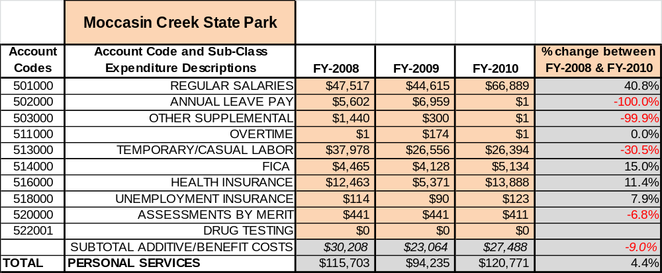

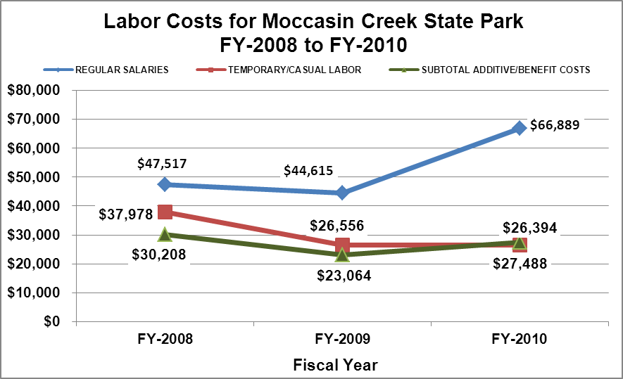

Visitation and Occupancy
Overall annual visitation to the site has trended downward from 2008 to 2010, decreasing by 18% or over 18,303 visitors. This is largely attributed to the downturn in the economy, particularly impacting the park’s elderly clientele on fixed incomes.

Year | Total Visitation
2008 | 100,684
2009 | 101,231
2010 | 82,381

Occupancy for the overnight accommodations at Moccasin Creek S.P. the last three years is detailed in the table below. Overall occupancy has trended downward from 2008 to 2010, decreasing by 4%. This is largely attributed to the economic downturn.

Year | Campground Occupancy
2008 | 48%
2009 | 41%
2010 | 46%

Customer Service and Satisfaction

Site | Year | Customer Satisfaction Level
Moccasin Creek S.P. | 2009 | 50% (2 cards collected)
Moccasin Creek S.P. | 2010 | 100% (5 cards collected)
Financial Performance Assessment

Operational Expenses
A summary of total operating expenses at Moccasin Creek from 2008 to 2010, as well as their percent change from 2008, are provided in the table below.

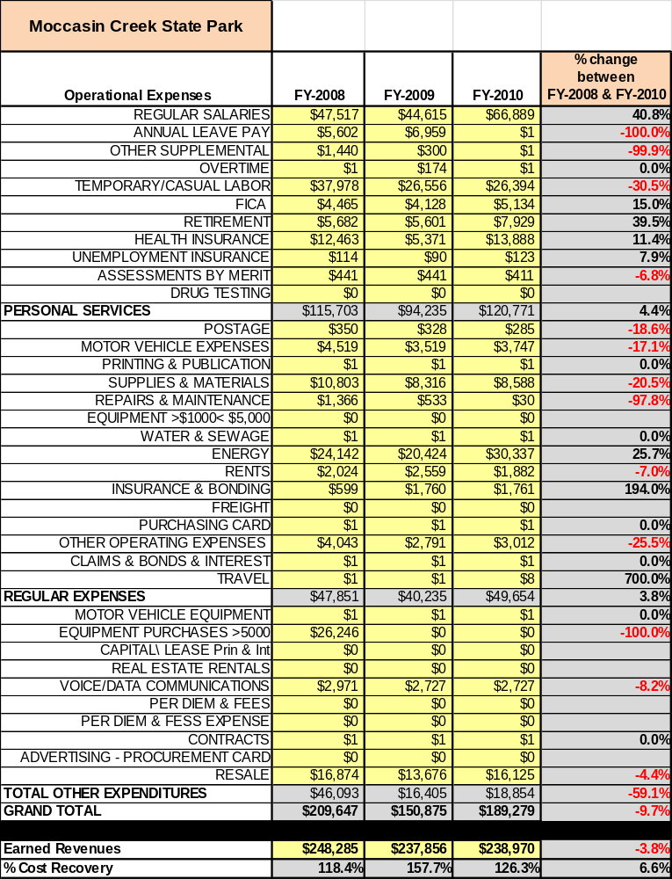

Earned Revenues
Earned revenues at Moccasin Creek have decreased since 2008, which is largely attributed to the corresponding decrease in overall visitation. Monthly earned revenues for the last two years (see table below) indicate that the total annual revenue stayed the same from 2009 to 2010, with the largest increases in monthly revenues in April (16%), January (7%) and May (6%), and the largest decreases in the months of September (-18%), February (-8%), March (-8%) and October (-5%).
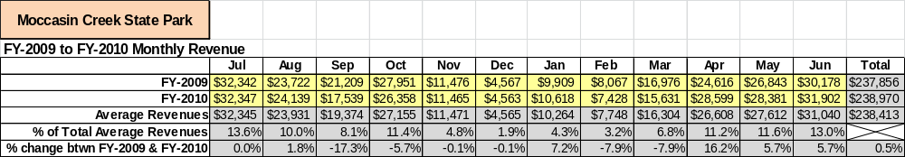

The graphs below illustrate the monthly revenue trends each year and the average percent of total
annual revenue earned each month.

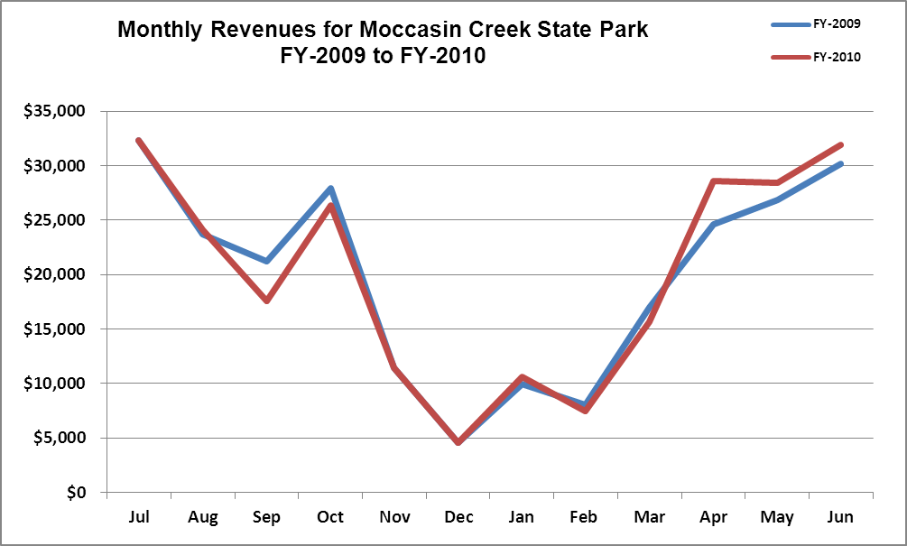

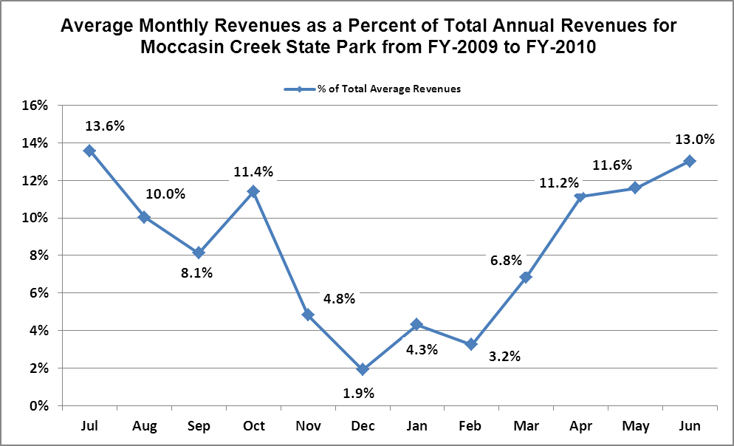
Cost Recovery Trends
Moccasin Creek State Park has achieved an average cost recovery of 134% of annual operational expenses through earned revenues from FY 2008 to FY 2010. This is detailed and illustrated in the table and graph below. FY 2008: Large equipment purchased ($26,246) and posted to budget reduced ROI from 135% to 118%. FY2009: Due to not posting transferred Ranger’s salary to Moccasin Creek’s budget, ROI should have been 122% instead of 158%.
Fiscal  Year | Operational  Expenses | Earned  Revenues | Percent Cost  Recovery
FY-2008 | $209,647 | $248,285 | 118.4%
FY-2009 | $150,875 | $237,856 | 157.7%
FY-2010 | $189,279 | $238,970 | 126.3%
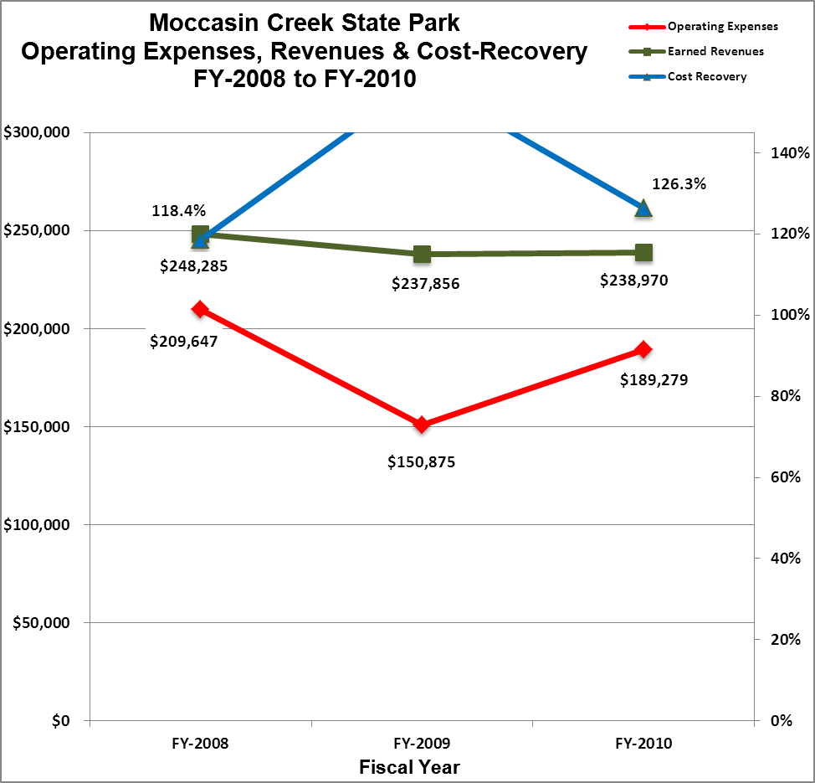

Review of Pricing
There has been notable growth in fees charged at Moccasin Creek S.P. since 2005, with the largest increase being (60%) for the picnic shelter. A table detailing the rates for Moccasin Creek S.P. is provided below.
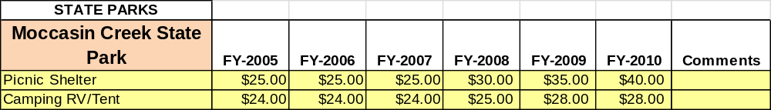

Business and Management Plan

Business Goals
The following goals serve as the foundation for the key recommendations and strategies in this business plan for Moccasin Creek State Park.

Enhance Cost Recovery of Site Operations
Moccasin Creek is operating at a 134% average cost recovery of operational expenses through earned revenues. However, due to discrepancies (large equipment purchase in FY 2008 and not posting transferred Park Ranger’s salary in FY 2009), this figure should be closer to 128%. This percentage is due to relatively low overhead and high volume occupancy. Focus should remain primarily on revenue generation versus expense reduction.

Enhance Revenue Generation Strategies
Enhanced revenue generation should occur, but not through increased camping rates (current rates exceed amenities). Recommendations include: Increasing visitation/occupancy during traditionally slower periods (August, September) and enhancing amenities (Wi-fi, 50 AMP campsite service, playground upgrade) to compete with private sector.

Expand Special Events at the Site
As stated earlier, Moccasin Creek is the smallest traditional state park at 32 acres. The park possesses limited space (particularly parking) to host large-scale events. Personnel is also limited (2 salaried employees) to directly conduct special events. Focus will be on retaining/gaining off-site special event assistance (i.e. astronomy clubs, nature photography, geocaching, fly fishing organizations, etc.).

Improve the Diversity and Innovation of Recreational and Interpretive Programs
Improving the diversity and innovation of programs will be critical to customer retention, a primary goal of Moccasin Creek. Due to the restrictions listed above, strong support should be given to off-site, DNR interpreters/naturalists (“Regional Roving Rangers”) conducting scheduled programs two to three times per month at the park. Staff would advertise and promote the programs in advance and prepare facilities and needed supplies. Other non-traditional resources, such as “Interpretive Hosts” and sharing interns with nearby sites (with housing) should be pursued. Current park management would be willing to cross sectional lines and assist DNR Fisheries in conducting engaging, hands-on programming (i.e. job shadowing Fisheries biologists, trout feeding & stocking, etc.) In addition, non-staff intensive programming (self-guided/motivated) opportunities, such as scavenger hunts, fitness course, coordinated recreational events, etc. should be pursued.

Improve the Effectiveness of Marketing and Sales
Historically the site has had limited need for marketing, outside of special events, due to sustainable high occupancy. However, due to the effects of the recent economic downturn and increased fuel costs (particularly on the elderly with fixed incomes), marketing may be necessary. Improvements can be made by utilizing the current reservation system to promote special events/seasonal occurrences. Larger scale marketing efforts, such as zip code analysis, can be coordinated with DNR’s Marketing and Communications Unit.

Establish Greater Consistency of Managing and Monitoring Customer Service & Satisfaction
Due to unspecified, yet widely acknowledged, dynamics unique to Moccasin Creek, the best customer service and satisfaction management practice would involve distributing a site-specific survey, or conducting an in-depth interview, of objective consumers as determined by park management.

Expand Partnership Opportunities
Within 27 miles, four state parks and one historic site exist in addition to Moccasin Creek. Efforts should be made to coordinate opportunities (customer packages, marketing efforts, retail services, etc.) amongst these facilities.

Classification of Programs and Services
The tables below summarize the classifications of programs and services at Moccasin Creek State Park as either core, important or visitor supported, and projects a range of cost recovery percentages that might be achieved for each. These classifications establish financial performance goals for each category of services that are linked to the recommendations and strategies of this business plan.

Core Services
Program / Service | Target Cost Recovery
Resource management and protection of the park’s natural resources | 0%
Maintaining reasonable public access to park facilities | 0%
Public safety | 0%
Proper maintenance and safe operation of public drinking water system | 0%
Management and maintenance of dirt banks using rip-rap, etc. | 0%

Important Services
Program / Service | Target Cost Recovery
Day-use (picnicking, fishing, playground, fish cleaning station, Lovell Pavilion) | 10% - 25%
1-mile nature trail | 0% - 10%
General public programs | 0%
Visitors center | 0%

Visitor Supported
Program / Service | Target Cost Recovery
Camping (RV, tent) | 150% – 200%
Retail shop | 130% – 150%
Canoe rentals | 250% – 300%
Picnic shelter rentals | 140% – 160%

Partnership Development Plan
The table below summarizes existing partners and targeted partnerships by classification (operational, vendor, service, co-branding, funding partners) and by organizational type.
 | Public Partners | Not-for-profit Partners | Private / Enterprise Partners
Operational Partners | - Marketing & Communications,  - Lake Burton Fish Hatchery,  - USDA | - FDR Boys Camp (previous volunteer work)  - Trout Unlimited | - Georgia Power Land Management Unit
Vendor Partners |  |  | - Coca-Cola  - Georgia Power
Service Partners | - DNR- Friends of GA SAR Team | - Chamber of Commerce  - Goodwill Industries Supported Emp.  - GA Nat. Plant Soc.
Co-branding Partners |  |  | - Laprades  - North 40 Lodge  - Sunburst Stables  - GA Mtn. RV  - Wal-Mart Community Support
Funding Resource Development Partner |  | - Friends of GA State Parks & Hist. Sites  - Friends of Moccasin Creek (to be developed)

Marketing and Sales Plan

Marketing and Sales Goals
Marketing and sales goals for Moccasin Creek State Park are based on the following desired outcomes:
- Increase overnight stays in the campground
- Increase % use of rental amenities for the year
- Increase participation in signature events
- Increase revenue amount per visitor
In order to meet these goals, examples of specific target outcomes were identified in the areas detailed in the table below.

Area  of Focus | Current  Performance | Goal  by 2011 | Goal  by 2012 | Goal  by 2015
Campground occupancy | 45% (avg.) | 46% | 47% | 50%
Rental amenities | Unknown | +5% | +7% | +10%
Signature events | 300 | 400 | 500 | 750
Revenue/visitor | $2.90 | $2.93 | $2.97 | $3.01

Marketing and Promotion Strategies

Publicity and Social Media
Moccasin Creek State Park will approach marketing and publicity planning using the following guidelines and themes:
- Event publicity
Major events benefit by having short stories in local, regional, and statewide newspapers and online social media hooks planted that run three to four weeks in advance of the event up to the date of the event itself. Stories and media need to be cultivated with contacts and online sales channels several weeks in advance of the time the stories need to run. Special interest interviews on morning, noon, and evening television news programs, radio interviews on popular rush-hour programs, and blogs on known affinity online sites should also be included.
- Program publicity
Special and unique programs should have feature stories in magazines, local and regional weekly newspapers, and statewide daily newspapers that are aimed at placements as front-page or sectional front-page stories. These stories are most effective if they run shortly before the season that the featured program begins. This will likely require several weeks of advanced planning with media contacts. Similar coverage on television and radio should also be considered. If pre-publicity cannot be generated, post-publicity can help promote future programs.
- Site Publicity
Site publicity focusing on a single site or sub-set of sites requires more intense planning efforts to attract multiple writers and editors from target publications. The site could host several seasonal media familiarization tours (with 10 to 15 writers or editors) to familiarize them with the site and its benefits and amenities. Stories and features resulting from such tours typically take between two and six months to materialize so the tours should focus on experiences, benefits, and programs that would be available when the stories are expected to run.
Examples and suggested opportunities for events, programs and related publicity efforts based on the themes described above at Moccasin Creek State Park are provided in the table below.

Event Publicity | Program Publicity | Site Publicity
Beneath these Waters | Canoe workshop | Rabun Ramble
JR Fishing Rodeo | Junior Ranger Camp | CCC Camp sites
Trout Fishing 101 | Leaf Watch | Fat Tire Summer Series
For the Birds | Fitness for Life | Old Railroads Revisited

Packaging
Examples and suggested packages for Moccasin Creek S.P. are provided in the table below.

Package | Package Details
Fit for fun | 2 nights camping, 1 day canoe rental
Family Get-away | 2 nights camping, 1 day picnic shelter rental, 1 day boat rental
Trout for Two | 2 nights camping, tour of LB Fish Hatchery, 2 days loaner fishing poles

Group Sales
Types of groups within which specific target customers can be identified for Moccasin Creek State Park are listed below:
- Church  - Business/work | - Senior Centers  - Scout | - Families  - Conservation
- Summer day camps | - Service organizations

Incentivizing New and Repeat Visitation
Moccasin Creek State Park will utilize the following strategies and/or incentives to encourage new and repeat visitation starting in FY 2012:
- Maintain 40% resale mark-up on apparel items & change designs frequently.

Marketing and Sales Metric Goals
The following marketing and sales metric goals and/or others will be monitored and progress reported at Moccasin Creek State Park:
- Loyalty and repeat customers = 60% - 65% returnees within 12 months.
- Brand confidence & customers-recruiting-customers = 30% referrals when asked “Where/how did you hear about us?”
Revenue Generation Plan
Revenue / Cost Recovery Goals
Moccasin Creek State Park has set a financial goal of increasing annual revenues 3% annually between 2012 and 2015. The largest revenue growth opportunity is most likely August, September and May. The table below details projected revenue growth leading up to 2015, based upon a nominal growth of revenues each year.

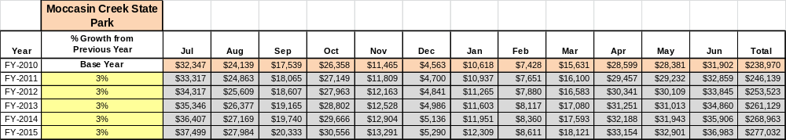
These projections would result in a total of 16% cumulative growth in total annual revenues between FY2010 and FY2015. If operational expenses can be managed with a cumulative decrease of 2% between FY 2010 and FY 2015, then the overall cost recovery of the site will be approximately 142% in FY 2015 at these projected revenue levels. This is higher than the annual financial performance of the site in FY 2010, which was operated at 126% cost recovery in that year.

Revenue Generation Strategies
Region | PARK RESERVABLES | Current Pricing (CY 2011) | Proposed Pricing  (CY 2012) | Positive Yield Management Margin (%)
1 | Moccasin Creek
 | Picnic Shelter | $40 | $40 | +/-0%
 | Camping (RV/Tent) | $28/25 | $29/25 | +/-0%

Pricing Plan

Note: due to dynamics referenced above, it is not recommended to introduce a discretionary yield management margin.

Innovative Programming and Special Events Plan
Program / Event | Theme / Purpose | Scheduled Date/Season | Frequency | Target Participation | Target User Fee | Target Cost Recovery
Senior Fishing Rodeo | Elderly recreation/ | Last Saturday in April | Annual | 30+ | $0 | 100%
Junior Fishing Rodeo | Youth recreation/ outdoor skill | 2nd Saturday June | Annual | 100+ | $0 | 100%
Canoe Workshop | Family/outdoor skill/recreation | June, July & August | 3x’s per summer | 15 | $15 | 120%
Trout Fishing 101 | Community | April & May | 2x’s per spring | 12 | $20 | 200%+
Wildflower Hike | Nature appreciation/ education | 1st Saturday in May | Annual | 12 | $0 | 100%
Family Film Night | Education/ just for fun | May, June & July | 2x’s per month | 40+ | $0 | 100%

Partnerships and Concessions Plan
Service / Partnership | Term of Service | Financial Objective | Contract Manager
LP gas service (campers) | 1 year | 15% of gross receipts to park | Park Manager
Septic pump-out (campers) | 1 year | 15% of gross receipts to park | Park Manager
Garbage collection | 1 year | Maintain cost from previous year | Park Manager

Expense Management Plan
Personnel Assignments
The following actions will be taken to proactively manage labor costs via personnel assignments and classifications.

Action | Timeline | Outcome
Replace day labor staff with campground hosts. | Currently in action | Annual cost reduction of $6,200
Use volunteers and/or interpretive hosts to conduct programs. | March 2013 | To provide more public programs and paid staff would have more time for other assignments.

Management Techniques
The following actions will be taken to proactively manage labor costs via management techniques.

Action | Timeline | Outcome
Assign more administrative duties to Clerk in order for Ranger to spend more time working on site and at joint operations. | Currently in action. | More repairs and maintenance have been completed. We save on contracted work and have more adequate and very limited closures of public facilities.
Have campground hosts cover afternoon duties instead of paid staff. | Currently in action. | Paid staff work normal hours except when doing security rounds or during an emergency. Higher morale and more work accomplished by staff.

Adjusted Levels of Service
The following actions will be taken to proactively manage labor costs via reduced levels of service.

Action | Timeline | Outcome
Limit mowing & landscaping efforts to only high-traffic areas. | Currently in action. | Reduce fuel consumption and extend useful life of equipment.
Support reduction of restrictive contract purchasing processes, allowing mgt. staff to focus on rev. generating efforts. | July 2013 | Revenue increase of 10%

Financial Pro Forma
The following five-year financial pro forma projects operating expenses, earned revenues and cost recovery through FY 2015. These pro forma are based on the strategies and desired outcomes identified in this business plan, especially the revenue generation and expense management plans, and are linked to corresponding performance goals.
Expense Pro Forma
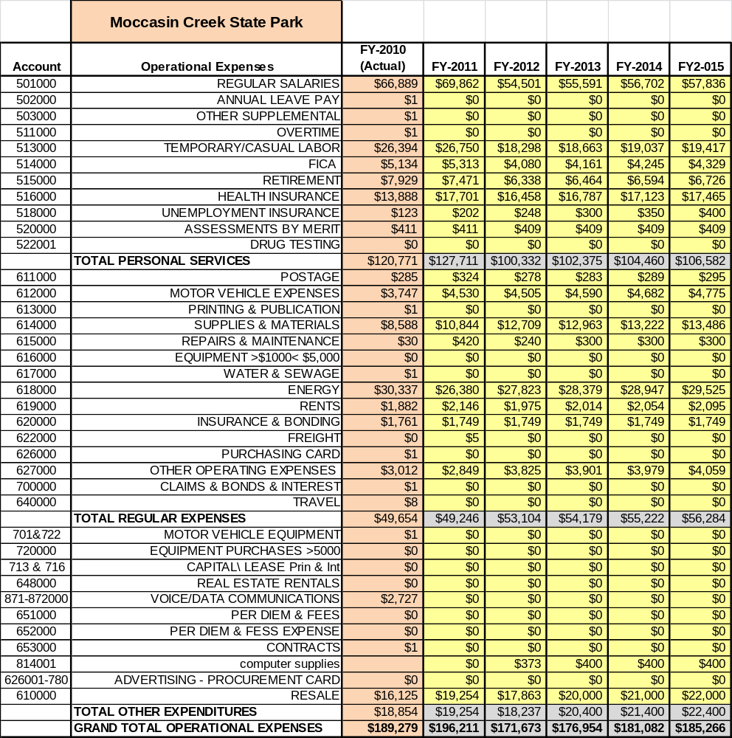

Revenue Pro Forma
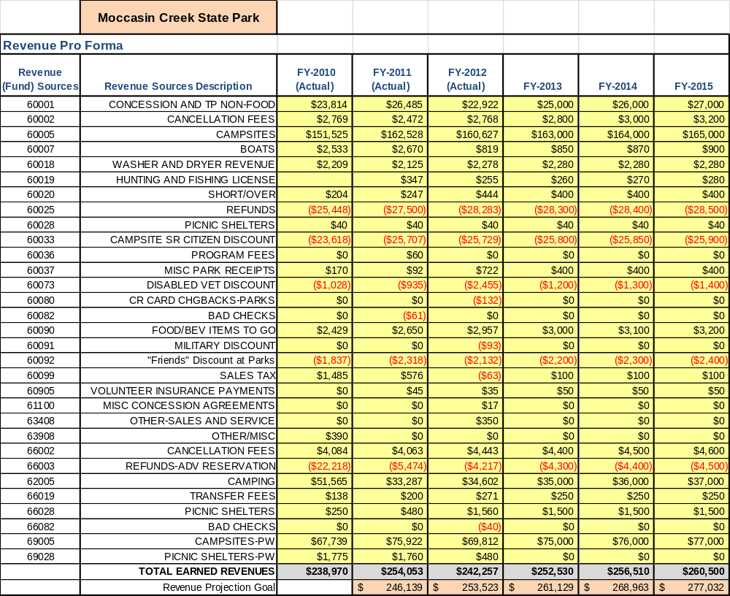

Total / Cost Recovery Pro Forma
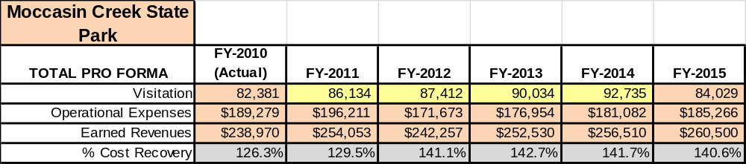

Action Plan
ACTION PLAN
Site: |  | Site Manager: |  |  | Date:
Month:
Strategy | Tasks | Costs / Funding | Revenues / ROI | Responsibilities | Metrics

ACTION PLAN
Site: |  | Site Manager: |  |  | Date:
Month:
Strategy | Tasks | Costs / Funding | Revenues / ROI | Responsibilities | Metrics

