New Echota Cherokee Capital State Historic Site

Business & Management Plan


Prepared June 2011; Finalized December 2012

Direction 2015 – Sustainable Business Planning

Table of Contents

Executive Summary 3

Site and Operations Assessment 7
Site Inventory and Facility Assessment 7
Operational Assessment 9
Financial Performance Assessment 14

Business and Management Plan 17
Business Goals 17
Classification of Programs and Services 19
Partnership Development Plan 20
Marketing and Sales Plan 21
Revenue Generation Plan 24
Expense Management Plan 26
Financial Pro Forma 27

Action Plan 29

Executive Summary
The Parks, Recreation and Historic Sites Division (PRHSD) of the Georgia Department of Natural Resources (DNR) is transitioning the management of New Echota State Historic Site to operate more like a business, reflecting the Direction 2015 – Sustainable Business Planning initiative to improve the fiscal performance and management of the state parks and historic sites system. This business and management plan is designed to help the site recover more operating expenses through earned revenues, productive partnerships, and innovative programs.

Site Fact Sheet
Site Name | New Echota Cherokee Capital State Historic Site
Site Manager | David Gomez
Region Manager | Joe Yeager
Date of Business Plan completion | June 2011
Site size | 200 acres
Total number of visitors (FY 2010) | 9,727
Total operating budget (FY 2010) | $138,758
Total earned revenues (FY 2010) | $42,930
Operational cost recovery (FY 2010) | 31%
Average operating cost per visitor (FY 2010) | $14.27
Average earned revenue per visitor (FY 2010) | $4.41
Average cost recovery (FY 2008 – 2010) | 32%
Target cost recovery (FY 2015) | 38%
Total full-time employees | 2
Total part-time employees | 2
Primary service markets | North Metropolitan Atlanta, Northwest Georgia, Chattanooga, Tennessee & I-75 travelers
Primary attractors/visitor appeal factors | Cherokee Trail of Tears and early 19th century Cherokee Renaissance culture
Leading opportunities for improved site performance (see details on next page below) | 1) Increased marketing, 2) Improved interstate signage,  3) Increased number of smaller programs, 4) Improve local awareness of site nature trails, 5) Use internet and social media based technology to improve visitor experience,  6) Improve Friends / volunteer involvement in site operations.

Site Summary and Key Attractions
The 200-acre site of New Echota State Historic Site is located along the Oostanaula River and Interstate 75 corridor between Atlanta, Georgia and Chattanooga, Tennessee. It is a National Historic Landmark and listed on the National Register of Historic Places, and is a federally certified Traditional Cultural Property.

Key Attractions
The amenities or features listed below are those that seem to be most popular for visitors.
- Visitor Center with exhibits, film and research library.
- Original and reconstructed early 19th century Cherokee Town, including:
  - Two 19th century farmsteads with cabins, barns and other support structures
  - Reconstructed Cherokee public government buildings, including Cherokee Council House and Supreme Court House
  - 1803 Cherokee Tavern/Store
  - 1827 Missionary home of Samuel Worcester
  - Reconstructed 19th century Cherokee Phoenix Newspaper Printing Office with operating printing press
- Two nature trails:
- 1 mile New Town Creek Trail
- .25 mile Pond Overlook Trail
Leading Opportunities for Improved Site Performance
- Increase I-75 corridor marketing at overnight lodging & regional visitor centers with emphasis on Trail of Tears connection.
- Increase events marketing to improve attendance to limit of site carrying capacity without damage to site and without investing in capital outlay infrastructure expenses.
- Improve and supplement signage along I-75 corridor between Cartersville and Chattanooga.
- Increase the number of smaller sized programs aimed at local community populations; may include non-traditional programs focused on natural resources, as well as historic resources, off-season guest speaker series, etc.
- Improve local population awareness of availability of on-site nature trails to increase local population usage and support of site.
- Provide web/internet based enhancements to visitor experience using social media and QR code additions to interpretive displays and exhibits.
- Improve volunteer and Friends of New Echota involvement in daily operations to decrease operating expenses and increase / improve visitor services offerings.

Financial Targets for New Echota Cherokee Capital State Historic Site
The table below details the total operating expenses and earned revenues for New Echota State Historic Site over the last three years (2008 – 2010). This table also calculates total cost per visitor and revenues per visitor during these operating years, and details the target financial performance goals in the context of achieving at least 50% cost recovery. This table also calculates the necessary change from 2010 operating expenses and revenues.

New Echota  State Historic Site | Target Visitation Growth from 2010 | Target Change  in Visitation
Visitation Assumptions | 23% | 3,273
 | 2008 | 2009 | 2010 | 2015 Target
Visitors | 15,526 | 13,209 | 9,727 | 8,500
Total Expenses | $210,838 | $192,727 | $138,758 | $143,716
Total Revenues | $66,504 | $65,017 | $42,930 | $55,000
Cost per Visitor | $13.58 | $14.59 | $14.27 | $16.91
Revenue per Visitor | $4.28 | $4.92 | $4.41 | $6.47
State Financial Support per Visitor | $(9.30) | $(9.67) | $(9.86) | $10.44
Total Cost Recovery | 32% | 34% | 31% | 38%
Change from 2010 Expenses |  |  |  | $4,958
% Change from 2010 Expenses |  |  |  | +.3.6%
Change from 2010 Revenues |  |  |  | +$12,070
% Change from 2010 Revenues |  |  |  | +28.1%

Key Recommendations

Primary / Short Term Recommendations
- Utilize target audience marketing, including Interstate 75 billboard. Improve current I-75 signage by adding ‘Trail of Tears Site’ wording to signs.
- Continue Friends of New Echota current successful events and expand events to increase visitation, as parking will allow. Add services, vendors, and other revenue generating activities to programs that have been mainly educational in nature.
- Increase retail sales generated revenue by encouraging phone sales of subject matter books and other retail items through on-line marketing on Division site web page.
- Increase marketing of site in local overnight Interstate 75 corridor lodging establishments.
- Develop partnerships with local overnight Interstate 75 corridor lodging establishments.

Secondary / Long Term Recommendations
- Explore possibility of developing a pioneer camping area within the wooded eastern boundary zone of park property towards the Coosawattee River.

Site and Operations Assessment
This site and operations assessment is a culmination of analyses and findings from a review of the condition of facilities, infrastructure, and operations at New Echota State Historic Site. The findings and observations are not intended to be an exhaustive review of all issues present, but provide a basic understanding of the predominant issues that contribute to the site’s current operating conditions. The assessment includes the following:
- Site Inventory and Facility Assessment
- Operational Assessment
- Financial Assessment
Site Inventory and Facility Assessment

Methodology
Facility and asset conditions are rated using a differential scale of excellent, good, fair, or poor. Descriptions of conditions that are attributed to each of these findings are also provided.
Scale of Conditions
Rating | General Description
Excellent | Facilities/amenities are in ‘excellent’ condition when they show little or no maintenance or repair problems. Facilities do not feature any major design or operational issues or flaws that contribute to diminished use or increased maintenance or upkeep. Facilities are easy to clean and maintain in order to place them back into public use and the users perceive them to be in excellent shape.
Good | Facilities/amenities are in ‘good’ condition when they show only minor maintenance or repair problems. Most maintenance issues with these facilities typically appear to be the result of age and/or heavy use. Facilities may only feature minor design or operational issues that contribute to diminished use or increased maintenance or upkeep. Facilities are moderately easy to clean and maintain in order to place them back into service and the users perceive them to be adequate for their use, but probably not in excellent shape.
Fair | Facilities/amenities are in ‘fair’ condition when they show significant maintenance or repair problems. Facilities generally exhibit ongoing maintenance issues that appear to be the result of age, heavy use, or design or operational flaws. Some maintenance and repair needs may compound their fair condition by being deferred because of budget and/or resource limitations. Facilities require more effort to clean and maintain before placing them back into service and the users may perceive them as being less than adequate for their use and in a state of deterioration. The facility or structure may need of major repair or replacement.
Poor | Facilities/amenities are in ‘poor’ condition when they show significant, on-going maintenance or repair problems that ultimately may result in suspended use for repair/replacement. Maintenance and repair issues are possibly the result of poor maintenance and clearly the result of age, heavy use, or design or operational flaws. Problems with the facilities are often compounded over time due to consistently-deferred maintenance and repair because of budget and/or resource limitations. Facilities may feature major design or operational issues that contribute to diminished use or increased maintenance or upkeep. Facilities require excessive effort to clean and maintain before placing them back into service and the users often perceive them as being inadequate for their use and in a state of serious deterioration. The facility or structure may need major repair or replacement.

Inventory and Assessment
The table below is an inventory of facilities and amenities at New Echota State Historic Site, and provides the assessed condition of each as reviewed in May, 2011

Site Asset / Amenity | Quantity | Condition
Visitor Center/Museum | 1 | Good (Needs efficient heat pump system to replace aged total electrical strip heat furnace, and museum exhibit area ceiling height needs to be dropped to save cost.)
Cherokee Middle-class Farmstead (four buildings) | 2 | Good
Cherokee Council House-reconstruction | 1 | Good
Cherokee Supreme Court-reconstruction | 1 | Good
Samuel Worcester Mission Home | 1 | Fair (However, needs repair work on rock footings under building; other than footings, building itself is in very good shape.)
1803 Cherokee Vann’s Tavern | 1 | Poor (Needs structural timber walls and footings work done – see note below*)
Cherokee Phoenix Printing Office (reconstruction) | 1 | Good
Cherokee Common Farmstead (3 buildings) | 1 | Good
Various outbuildings including 2 barns, 2 corn cribs, 2 smoke houses | 6 | Good
* Conservation Assessment Plan / Survey performed in winter 2011
on Tavern and Worcester House is available upon request.

Prioritized Facility Needs
Based on the facility inventory and assessment, these prioritized needs have been identified. Each need has been aligned with a priority category of high, moderate, or low to support future decision making regarding project sequencing, investment of public resources, and meeting community expectations. The priority assignment for each need is not a measure of importance. Rather, these recommended priorities reflect a phased implementation approach over the next several years.

Facility Need | Priority Assignment
Improved I-75 corridor signage, including billboard emphasizing Trail of Tears. | High
Structural stabilization of Vann’s Tavern and Samuel Worcester home-see below, next listing; based on 2011 Conservation Assessment Plan inspections. | High
Structural stabilization of Worcester House based on 2011 Conservation Assessment Plan inspections. | Fair

Operational Assessment
The Operational Assessment includes:
- An inventory and classification of programs and services being provided at the site
- A review of staffing at the site
- A review of concessionaires and partners operating at the site
- Visitation and customer satisfaction

Inventory and Classification of Programs and Services
Programs and services are classified into one of three major categories:
1) Core or Essential Services
2) Important Services
3) Visitor Supported Services
Programs and services at the site are classified into these categories based in part on the mission and public mandates for both the site and the agency. For the services in each of these categories, there are financial performance expectations that will define how services are funded and evaluated.

Category 1 – Core Services [Largely supported by tax funds]
Core programs, services and facilities are those the agency must provide and/or are essential in order to capably govern and meet statutory requirements. The failure of the agency to provide Category 1 services at adequate levels could result in significant negative consequences for the public and the resources under protection. The criteria for services to be classified as core or essential are:
- The services are mandated by the agency’s law or charter or are contractually obligated by agreement to provide the services.
- The services are essential to protecting and supporting the public’s health and safety.
- The services protect and maintain valuable assets and infrastructure.
- The services would generally and reasonably be expected and supported by residents, businesses, customers and partners.
- The services are those that cannot or should not be provided by the private sector.
- The services provide a sound investment of public funds.
The following programs and services offered at New Echota State Historic Site have been identified as core services:
- Protection, preservation and maintenance of historic structures, grounds and artifacts
- Open and public access to historic buildings and grounds
- Site appropriate education, programs and recreational use of land (when not in conflict with protection/preservation of site)
- Support materials, including interpretive exhibits and brochures to tell story/significance of site

Category 2 – Important Services [Supported by a balance of tax funds and earned revenues]
Important programs, services and facilities are those the agency should provide, and are important to governing and effectively serving residents, businesses, customers and partners. Providing Category 2 services expands or enhances the agency’s ability to provide and sustain its core services. The criteria for programs or services to be classified as important are:
- The services expand, enhance or support identified core services.
- The services are broadly supported and utilized by the community, and are considered an appropriate, important, and valuable public good. Public support may be conditional upon the manner by which the services are paid for or funded.
- The services generate income or revenue that offsets some or all of the operating cost and/or are deemed to provide economic, social or environmental outcomes or results.
The following programs and services offered at New Echota State Historic Site have been identified as important services:
- Educational events / programs

Category 3 – Visitor Supported Services [Almost exclusively supported by earned revenue]
Visitor supported programs, services and facilities are those discretionary services that the agency may provide when additional funding or revenue exists to offset the cost of providing those services. Category 3 services provide added value above and beyond what is required or expected. The criteria for programs or services to be classified as visitor supported are:
- The services expand, enhance or support core services or important services and the quality of life of the visitors, community or stakeholders.
- The services are supported, valued and well utilized and provide an appropriate and valuable public benefit.
- The services generate income or funding from sponsorships, grants, user fees or other sources that offset some or all of their cost and/or provides a meaningful return on investment.

- The services can possibly be provided through outsourcing or use of concessionaires, providing opportunities for community enterprises that may not otherwise be provided by the agency.

The following programs and services offered at New Echota State Historic Site have been identified as visitor supported services:
- Special events / programs
- Subject / site appropriate retail sales
- Natural resource focused recreation use of site and nature trails
- Historical / genealogical research library
- Non-traditional use of grounds/property, such as rental of grounds for events by private concessionaires / groups for programs or events
- Volunteer guided tours beyond normal self-guided tour offerings

Staffing Assessment
Labor costs at New Echota State Historic Site represent the largest area of budgetary expense at an average of 74% of the total operating budget each year for the last three complete years, which is higher than the target of total labor costs (including benefits) not exceeding 65% of the site’s total operating expenditures. The tables below and on the following page provide a basic review of the current staffing at the site.

Full Time Equivalent Employees
Position / Title | Quantity (FTE) | Vacancies | Annual Hours
Site Manager | 1 | 0 | 2,080+
General Craftsman | 1 | 0 | 2,080
TOTAL | 2 | 0 | 4,160

Part Time Employees
Position / Title | Quantity (FTE) | Vacancies | Hours
Tour Guide | 2 | 0 | 630
TOTAL | 2 | 0 | 630

Labor Support
Labor Support | Annual Hours
Volunteers | 2,200+
Community Service Workers | 600
Engineering and Construction Crews | 20
Resource Management Crews | 0
TOTAL | 2,820

Total Labor Hours
Labor Type | Annual Hours
Full Time Equivalent Employees | 4,160
Part Time Employees | 630
Labor Support | 2,820
TOTAL Annual Labor Hours | 7,610

Labor Budget Summary

 | New Echota Historic Site
 |  | 2008 | 2009 | 2010 | % Change
Account | Account Code and Sub-Class | Year End | Year End | Year End | from
Codes | Expenditure Descriptions | Expenses | Expenses | Expenses | 2008
501000 | REGULAR SALARIES | 111,910 | 111,910 | 69,475 | -38%
502000 | ANNUAL LEAVE PAY
503000 | OTHER SUPPLEMENTAL
513000 | TEMPORARY/CASUAL LABOR | 5,150 | 7,483 | 4,713 | -8%
514000 | FICA | 8,779 | 8,954 | 5,279 | -40%
515000 | RETIREMENT | 11,706 | 11,939 | 7,232 | -38%
516000 | HEALTH INSURANCE | 24,844 | 24,844 | 15,399 | -38%
518000 | UNEMPLOYMENT INSURANCE
520000 | ASSESSMENTS BY MERIT | 671 | 671 | 417 | -38%
TOTAL | PERSONAL SERVICES | 163,060 | 165,801 | 102,515 | -37%

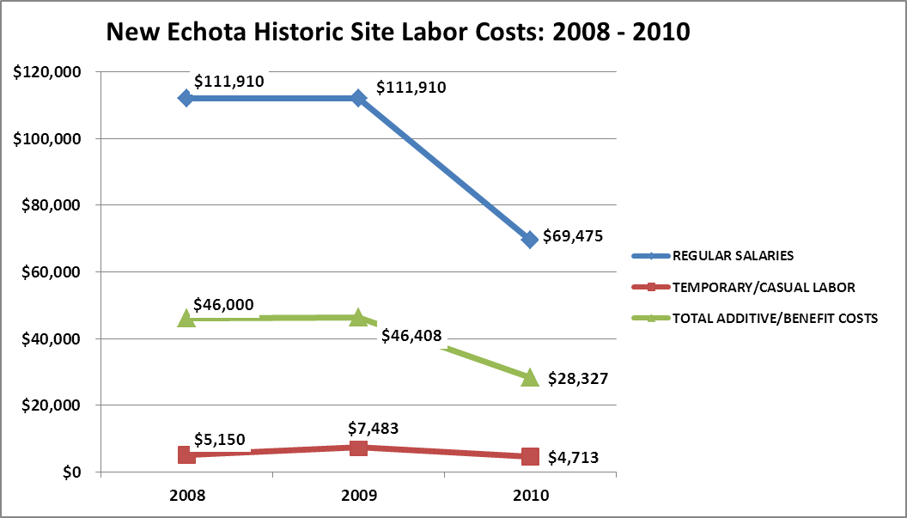

Visitation and Occupancy
Overall annual visitation to New Echota State Historic Site has trended downward from 2008 to 2010, decreasing by 63% or over 5,700 visitors. This is attributed to a decrease in open days (decreased from 5.5 days/week of open operation to current schedule of 3 days/week of open operation, a decrease of 45% open hours). Decrease also slightly due to a downturn in the economy.

Year | Total Visitation
2008 | 15,526
2009 | 13,141
2010 | 9,727
Financial Performance Assessment

Operational Expenses
A summary of total operating expenses at New Echota Historic Site from 2008 to 2010, as well as their percent change from 2008 are provided in the table below.
New Echota  State Historic Site  Operational Expenses | 2008 | 2009 | 2010 | % Change from 2008
REGULAR SALARIES | 111,910 | 111,910 | 69,476 | -38%
ANNUAL LEAVE PAY
OTHER SUPPLEMENTAL
OVERTIME
TEMPORARY/CASUAL LABOR | 5,150 | 7,483 | 4,713 | -8%
FICA | 8,779 | 8,954 | 5,21  9 | -40%
RETIREMENT | 11,706 | 11,939 | 7,300 | -38%
HEALTH INSURANCE | 24,844 | 24,844 | 15,399 | -38%
UNEMPLOYMENT INSURANCE
ASSESSMENTS BY MERIT | 617 | 617 | 417 | -32%
DRUG TESTING | 0 | 0 | 0
PERSONAL SERVICES | 163,006 | 165,747 | 102,524 | -37%
POSTAGE | 300 | 282 | 250 | -17%
MOTOR VEHICLE EXPENSES | 1,892 | 1,778 | 1,778 | -6%
PRINTING & PUBLICATION
SUPPLIES & MATERIALS | 6,440 | 6,054 | 6,054 | -6%
REPAIRS & MAINTENANCE | 1,000 | 940 | 940 | -6%
EQUIPMENT >$1000< $5,000
WATER & SEWAGE | 0 | 0 | 625
ENERGY | 7,500 | 7,050 | 9,860 | 31%
RENTS | 3,400 | 3,196 | 3,196 | -6%
INSURANCE & BONDING | 1,242 | 1,167 | 2,472 | 99%
FREIGHT
PURCHASING CARD
OTHER OPERATING EXPENSES | 500 | 470 | 470 | -6%
CLAIMS & BONDS & INTEREST
TRAVEL
REGULAR EXPENSES | 22,274 | 20,937 | 25,645 | 15%
MOTOR VEHICLE EQUIPMENT
EQUIPMENT PURCHASES >5000
CAPITAL\ LEASE Prin & Int
REAL ESTATE RENTALS
VOICE/DATA COMMUNICATIONS | 2,000 | 2,000 | 2,000 | 0%
PER DIEM & FEES | 800 | 1,200 | 0
PER DIEM & FESS EXPENSE
CONTRACTS
ADVERTISING - PROCUREMENT CARD
RESALE | 13,000 | 13,000 | 8,589 | -34%
TOTAL OTHER EXPENDITURES | 15,800 | 16,200 | 10,589 | -33%
GRAND TOTAL | $ 201,080 | $ 202,884 | $ 138,818 | -31%
Earned Revenues | $66,500 | $65,000 | $45,500
% Cost Recovery | 33% | 32% | 33% | -1%

Earned Revenues
Earned revenues at New Echota Historic Site have decreased since 2008, largely attributed to the corresponding decrease in overall visitation caused by a reduction in open operating hours and as a result to a lesser degree because of the economy. Monthly earned revenues for the last two years (see table below) indicate that the total annual revenue decreased 30% from 2009 to 2010, with the largest decreases in the months of December (-42%), February (-42%), March (-35%), and May (-51%).
New Echota Historic Site
FY 2009 - FY 2010 Monthly Revenue
 | Jul | Aug | Sep | Oct | Nov | Dec | Jan | Feb | Mar | Apr | May | Jun | Total
FY 2009 | $5,314 | $3,618 | $5,156 | $8,500 | $6,419 | $4,759 | $1,506 | $3,751 | $4,806 | $8,222 | $7,876 | $5,087 | $65,014
FY 2010 | $4,421 | $2,668 | $3,791 | $6,928 | $4,755 | $2,745 | $1,104 | $2,184 | $3,118 | $5,966 | $3,838 | $3,967 | $45,485
Average | $4,868 | $3,143 | $4,474 | $7,714 | $5,587 | $3,752 | $1,305 | $2,968 | $3,962 | $7,094 | $5,857 | $4,527 | $55,250
% of Total Revenues | 9% | 6% | 8% | 14% | 10% | 7% | 2% | 5% | 7% | 13% | 11% | 8% | 100%
% change | -17% | -26% | -26% | -18% | -26% | -42% | -27% | -42% | -35% | -27% | -51% | -22% | -30%
The graphs below illustrate the monthly revenue trends each year and the average percent of total annual revenue earned each month.
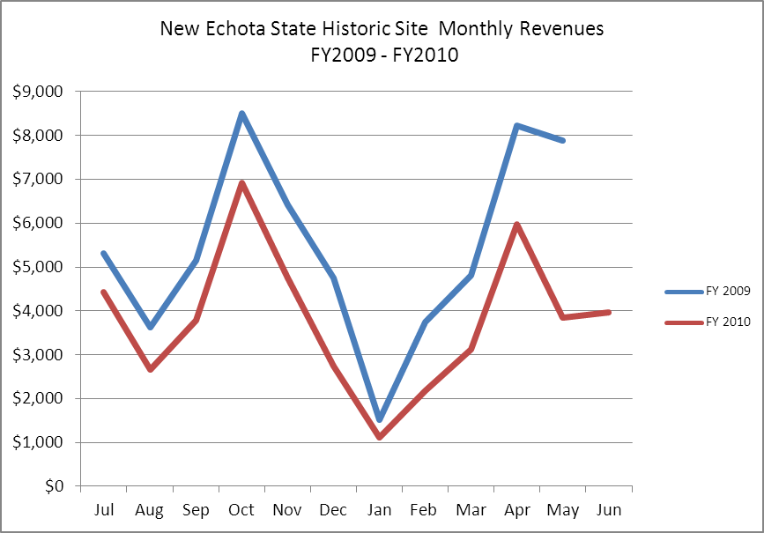
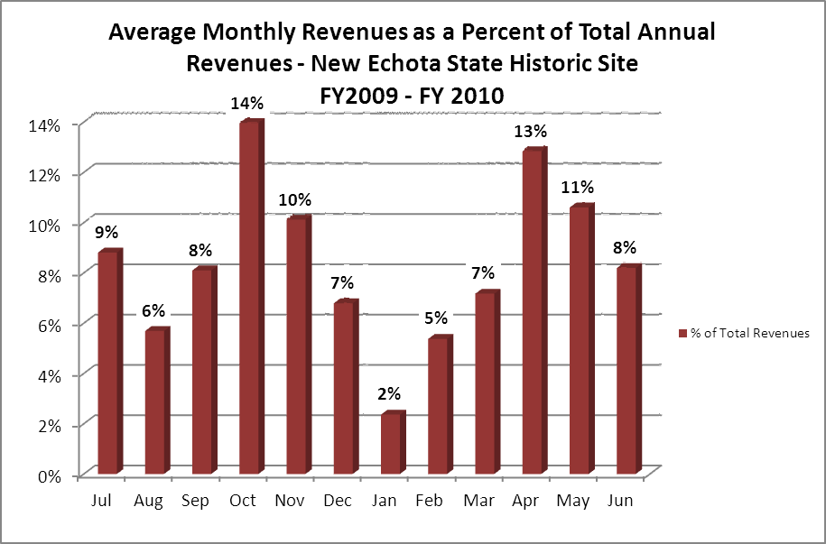

Cost Recovery Trends
New Echota State Historic Site has achieved an average cost recovery of 33% of annual operational expenses through earned revenues from FY 2008 to FY 2010. This is detailed and illustrated in the table and graph below.
Year | Operational  Expenses | Earned  Revenues | Percent Cost  Recovery
2008 | 201,080 | 66,500 | 33%
2009 | 202,884 | 65,000 | 32%
2010 | 138,818 | 45,500 | 33%

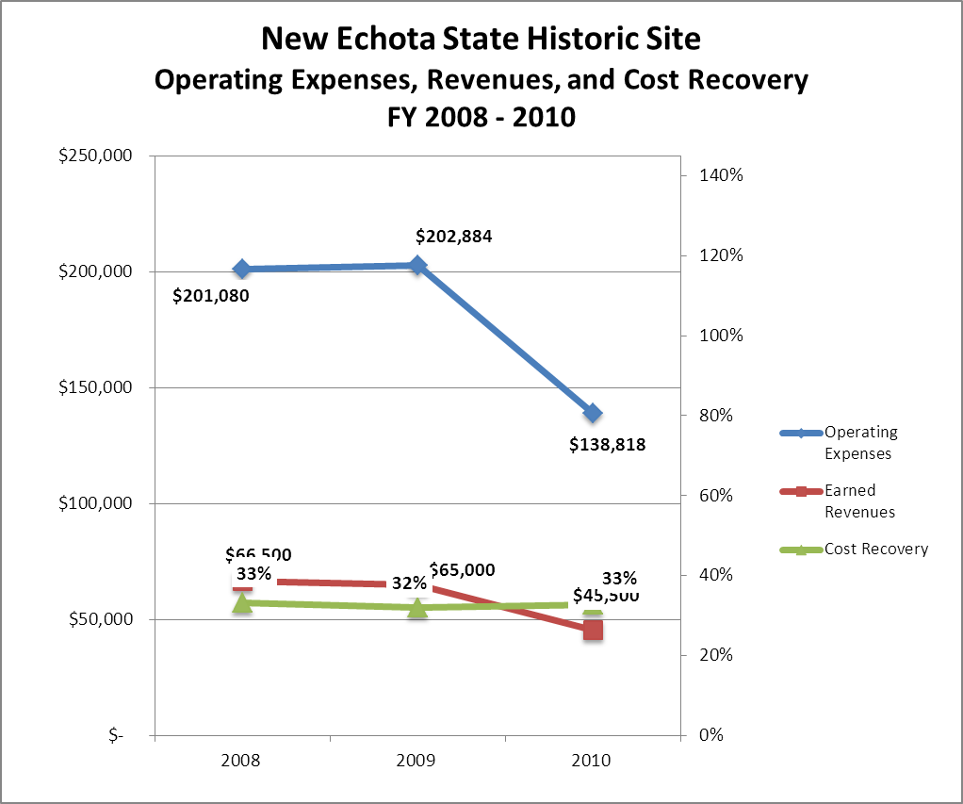

Review of Pricing
Data on rate information is available as far back as 2002, but only the last five years are evaluated. There has been minimal growth in fees charged at New Echota State Historic Site since 2005, with only one price increase occurring in 2009, with an increase of $1.00 in all price categories. A table detailing the rates for New Echota State Historic Site is provided below.
 | CY 2005 | CY 2006 | CY 2007 | CY 2008 | CY 2009 | CY 2010 | $ Growth 2005-2010 | % Growth 2005-2010
Adults | $4.00 | $4.00 | $4.00 | $4.00 | $5.00 | $5.00 | $1.00 | 25%
Seniors | $3.50 | $3.50 | $3.50 | $3.50 | $4.50 | $4.50 | $1.00 | 29%
Youth | $2.50 | $2.50 | $2.50 | $2.50 | $3.50 | $3.50 | $1.00 | 40%
Youth Group | $2.00 | $2.00 | $2.00 | $2.00 | $3.00 | $3.00 | $1.00 | 50%
Adult Group | $3.00 | $3.00 | $3.00 | $3.00 | $4.00 | $4.00 | $1.00 | 33%
Child Group | $1.00 | $1.00 | $1.00 | $1.00 | $2.00 | $2.00 | $1.00 | 100%

Business and Management Plan

Business Goals
The following goals serve as the foundation for the key recommendations and strategies in this business plan for New Echota State Historic Site.

Enhance Cost Recovery of Site Operations
New Echota is operating at a 33% cost recovery of operational expenses through earned revenues. With staff and services already reduced to a minimum, New Echota plans to improve cost recovery of site operations through controlling operational expenses, specifically in program costs, vehicle/equipment operational costs and by increasing visitation, increased resale revenue generation and expanding special event(s) offerings. New Echota needs to regain school field trip visitation lost during recent 2009 restructuring (reduced staff and operating hours) and increase non-school group visitation by target marketing of the site in various publications and improved/increased marketing along the Interstate 75 corridor, resulting in increased visitation/revenue generation. The addition of larger special events will require improved parking capabilities than currently available at the site.

Enhance Revenue Generation Strategies
- Picnic area construction including fencing, picnic tables and park pass box system installation.
- Construction of rentable shelter for local and regional group meetings would provide increase in site revenue without impacting historic structures.

Expand Special Events at the Site
The site has great potential for increased visitation and revenue generation through larger Native American arts/crafts/music events; however, construction of increased parking area would be required to accommodate this type event.

Improve the Diversity and Innovation of Recreational and Interpretive Programs
New Echota State Historic Site currently offers a variety of both historical and nature based programming. Although an even greater increase in diversity of programs is a reachable goal, it must be balanced to prevent negative effects on the historic grounds and buildings (especially buildings).

Improve the Effectiveness of Marketing and Sales
A significant opportunity to increase visitation to New Echota State Historic Site exists with the Interstate 75 corridor traffic. Current signage is not explanatory enough. Many visitors comment that they have seen the signs for years, but were not aware of what the site is about. Added signage along the interstate (including billboard) emphasizing Cherokee Indians and Trail of Tears and distance from Interstate (one mile) would prove beneficial in increasing traffic.

Establish Greater Consistency of Managing and Monitoring Customer Service & Satisfaction
Customer comment card evaluations by guests of New Echota State Historic Site’s staff, facilities and services have consistently ranked New Echota State Historic Site in the ‘very good’ and ‘excellent’ level. Better processes for evaluation of special programs by staff, volunteers and visitors should be established to improve programs being offered. All events/programs offered should be closely evaluated and value(s) determined to decide whether event is held regularly/annually or discontinued.

Expand Partnership Opportunities
Although New Echota State Historic Site has a history of network marketing with other north Georgia and Eastern Tennessee Cherokee sites and museums, opportunities for greater marketing and partnering for special events and programs still exist. Greater corporate and local municipal co-sponsorship or partial support from the northwest Georgia region for both special events and regular operations should be solicited and increased.

Classification of Programs and Services
The tables below summarize the classifications of programs and services at New Echota State Historic Site as either core, important, or visitor supported and projects a range of cost recovery percentages that might be achieved for each. These classifications establish financial performance goals for each category of services that are linked to the recommendations and strategies of this business plan.

Core Services
Program / Service | Target Cost Recovery
Protection, preservation and maintenance of historic structures, grounds and artifacts | 0%
Open and public access to historic buildings and grounds | 21%
Site appropriate education, programs and recreational use of property | 40%
Support materials including interpretive exhibits and brochures to tell story/significance of site | 0%

Important Services
Program / Service | Target Cost Recovery
Educational events/programs | 125+%

Visitor Supported
Program / Service | Target Cost Recovery
Special events/programs | 150+%
Subject/site appropriate retail sales | 150+%
Natural resource focused recreation use of site and nature trails | Target is to recover all operational costs (signage, routine maintenance, cleaning to be community service worker and volunteer based). Staff time will be required for patrol, inspection, etc.
Historical/genealogical research library | Fee based system; will be regular site admission fee based access starting in 2012.
Non-traditional use of property-rental of grounds for events by private concessionaires / groups for programs or events | 100+%  (Fee based system)
Volunteer guided tours beyond normal self-guided tour offerings | 150%

Partnership Development Plan
The table below summarizes existing partners and targeted partnerships by classification (operational, vendor, service, co-branding, funding partners) and by organizational type.
 | Public Partners | Not-for-profit Partners | Private / Enterprise Partners
Operational Partners | - Friends of New Echota Historic Site  - Non-Friends Volunteers  - Local municipal city / county/ volunteer/ Friends involvement in staffing support to expand hours and/or services | - Chieftains Museum / Major Ridge Home Site  - Trail of Tears Association-GA Chapter & National Association  - BSA/GSA  - Local, regional, state and national service organizations  - NERA (New Echota River Alliance)
Vendor Partners |  |  | - Coca cola
Service Partners | - Gordon County & City of Calhoun | - Friends of New Echota  - Trail of Tears Association  - BSA/GSA Troops  - Historical Society
Co-branding Partners | - National Park Service / Trail of Tears Historic Trail
Funding Resource Development Partner | - National Park Service / Trail of Tears Historic Trail  - GDOT | - Friends of New Echota State Historic Site  - Friends of GSPHS  - Local grants including Calhoun Gordon County Historical Society, Northwest Georgia Community Foundation, Ratner Foundation, and local civic organizations

Marketing and Sales Plan

Marketing and Sales Goals
Marketing and sales goals for New Echota State Historic Site are based on the following desired outcomes:
- To increase awareness of site and visitation to site
- To regain school group field trip visitation
- To increase visitation to monthly and quarterly special programs and events
- To develop increased visitors into strong advocates for New Echota State Historic Site, including an increase in membership in Friends of New Echota State Historic Site (FONEHS)/FOGSPHS
In order to meet these goals, examples of specific target outcomes were identified in the areas detailed in the table below.

Area of Focus | Current  Performance | Goal  by 2011 | Goal  by 2012 | Goal  By 2013 | Goal  By 2014 | Goal  by 2015 | 2015  Average % of total visitation
Individual visitation (not including groups or special event day visitation) | 5,668 | 5,926 | 6,184 | 6,442 | 6,700 | 6,000 | 70%
Group visitation | 2,936 | 3,068 | 3,200 | 3,332 | 4,000 | 1,800 | 21%
Program/Event visitation | 1,123 | 1,300 | 1,650 | 1,524 | 1,600 | 700 | 8%
Total visitation (not counting Friends Memberships below) | 9,727 | 10,294 | 11,034 | 11,298 | 12,300 | 8,500
Friends of New Echota membership | 68 | 78 | 80 | 95 | 100 | 115

Marketing and Promotion Strategies

Publicity and Social Media
New Echota will continue to approach marketing and publicity planning using the following guidelines and themes:
- Event publicity
Major events benefit by having short stories in local, regional, and statewide newspapers and online social media hooks planted that run three to four weeks in advance of the event up to the date of the event itself. Stories and media need to be cultivated with contacts and online sales channels several weeks in advance of the time the stories need to run. Special interest interviews on morning, noon, and evening television news programs, radio interviews on popular rush-hour programs, and blogs on known affinity online sites should also be included.
- Program publicity
Special and unique programs should have feature stories in magazines, local and regional weekly newspapers, and statewide daily newspapers that are aimed at placements as front-page or sectional front-page stories. These stories are most effective if they run shortly before the season that the featured program begins. This will likely require several weeks of advanced planning with media contacts. Similar coverage on television and radio should also be considered. If pre-publicity cannot be generated, post-publicity can help promote future programs.
- Site Publicity
Site publicity focusing on a single site or sub-set of sites requires more intense planning efforts to attract multiple writers and editors from target publications. Each site could host several seasonal media familiarization tours (with 10 to 15 writers or editors) to familiarize them with the site and its benefits and amenities. Stories and features resulting from such tours typically take between two and six months to materialize so the tours should focus on experiences, benefits, and programs that would be available when the stories are expected to run.
Examples and suggested opportunities for events, programs and related publicity efforts based on the themes described above at New Echota State Historic Site are provided in the table below.

Event Publicity | Program Publicity | Site Publicity
Frontier Day | Three Sisters Dinner & Auction | New Echota, Chieftains Trail and Trial of Tears Familiarization Tour
Christmas Candlelight Tour | Seasonal outdoor recreation activity based programs
Historical River Canoe Trip | Electronic History (GPS, geocache, internet genealogy, etc.)
Cherokee Season based cultural programs
Native American Storytellers Festival

Packaging
Examples and suggested packages for are provided in the table below.
Package | Package Details
Chief’s Council Trail of Tears Package | Discounts not advisable due to negative effect on revenue goals. Push Historian Level Friends Memberships instead.
School Group Tour/Gift | Discounts not advisable due to negative effect on revenue goals. Advertise availability to teachers in advance w/out giving discounts.
Student Rate | Offering additional discounts to any groups not advisable due to negative effect on revenues.

Group Sales
Types of groups within which specific target customers can be identified for New Echota State Historic Site are listed below:
- School field trips  - Georgia Department of Education  - Historical Societies | - Boy Scouts of America  - Girl Scouts of America | - Civic Clubs  - Youth Organizations

Incentivizing New and Repeat Visitation
New Echota State Historic Site will utilize the following strategies and/or incentives to encourage new and repeat visitation starting in FY 2012:
- Regional publicity/marketing with Georgia Chapter Trail of Tears Historic Site articles
- Increased marketing/advertising along the I-75 corridor between Atlanta and Chattanooga, TN with special focus on over-night lodging lobby advertising

Marketing and Sales Metric Goals
New Echota State Historic Site will develop a written special event/program evaluation survey and will utilize the Parks and Historic Sites Division written and on-line customer comment tools to increase new and repeat customers and to build brand confidence. The following marketing and sales metric goals and/or others will be monitored and progress reported at New Echota State Historic Site:
- Loyalty and repeat customers = 33+% for special programs/events and group visits
- Brand confidence & customers-recruiting-customers = a target of 15% of customers will be developed from brand confidence & customer-recruiting customers referrals. Guest registration form at Visitor Center will be developed to record and track needed information to analyze visitor population origins. Site is already utilizing Division zip code tracking analysis. Possible zip code analysis based marketing funded by Friends to be considered in the future.

Revenue Generation Plan
Revenue / Cost Recovery Goals
New Echota State Historic Site has set a financial goal of increasing annual revenues 5% annually between 2012 and 2015. The largest revenue growth opportunity is most likely during special events and during the spring and fall seasons due to favorable weather conditions. The table below details projected revenue growth leading up to 2015, based upon a nominal growth of revenues each year.

Year | % Growth from Previous Year | Jul | Aug | Sep | Oct | Nov | Dec | Jan | Feb | Mar | Apr | May | Jun | Total
2010 | Base Year | $4,421 | $2,668 | $3,791 | $6,928 | $4,755 | $2,745 | $1,104 | $2,184 | $3,118 | $5,966 | $3,838 | $3,967 | $45,485
2011 | 1.03% | $4,532 | $2,735 | $3,886 | $7,101 | $4,874 | $2,814 | $1,132 | $2,239 | $3,196 | $6,115 | $3,934 | $4,066 | $46,547
2012 | 1.04% | $4,971 | $2,893 | $4,208 | $5,605 | $5,361 | $2,982 | $1,159 | $2,346 | $3,410 | $6,910 | $4,264 | $4,420 | $48,722
2013 | 1.05% | $5,220 | $3,038 | $4,419 | $5,885 | $5,629 | $3,132 | $1,217 | $2,463 | $3,581 | $7,256 | $4,478 | $4,641 | $50,897
2014 | 1.04% | $5,428 | $3,159 | $4,595 | $6,121 | $5,854 | $3,257 | $1,265 | $2,562 | $3,724 | $7,546 | $4,657 | $4,827 | $53,072
2015 | 1.04% | $5,646 | $3,286 | $4,779 | $6,365 | $6,089 | $3,387 | $1,316 | $2,664 | $3,873 | $7,848 | $4,843 | $5,020 | $55,250

These projections would result in a total of $14,151.00 cumulative growth in total annual revenues between FY2010 and FY2015. If operational expenses can be managed with an average growth rate of 4% between FY 2010 and FY 2015, then the overall cost recovery of the site will be approximately 50% in FY 2015 at these projected revenue levels. This is higher than the annual financial performance of the site in FY 2010, which was operated at 33% cost recovery in that year.

Revenue Generation Strategies

Pricing Plan
New Echota Historic Site  Pricing forecast chart | Current Pricing  CY2011 | Proposed Pricing  CY2012 | Yield Management  Margin
Adults | $6.00 | $6.50
Seniors | $5.50 | $5.50
Adult Groups | $4.50 | $5.50 | +/-12%
Youth (6-17) | $4.00 | $4.50
Youth Groups (6-17) | $3.50 | $4.25 | +/-12%
Child/Groups (under 6) | $2.00 | $2.00

Innovative Programming and Special Events Plan

Program / Event | Theme / Purpose | Scheduled Date/Season | Frequency | Target Participation | Target User Fee | Target Cost Recovery
Native American Arts/Crafts Festival-2 day | Site awareness, advocacy growth, visitation/revenue generation | 2013 Spring | Annually -two day program | 500 X $6.00 = $3,000.00 | Regular Admission | 200+%
Native American Storytellers Festival | Site awareness, advocacy growth, visitation/revenue generation | 2013 Fall | Annually -every other year | 125 X 10.00 = $1,250.00 | Increased per person admission fee | 200+%
Day and/or Overnight canoe trip | Site and related subject matter awareness | 2012 Early fall | Annually, if successful | 20-30 max  X $35.00+  = $875.00+ | Fee based program profit split with sponsor-NERA | 200+%
Christmas Candlelight Program | Site subject matter awareness and community event | December | Annually | 350 +/-  x $5.00 =  $1,750.00 | Fee based program | 100+%
Frontier Day | Early 19th life skills demonstrations with guest Cherokee artist | October | Annually | 300 +/-  X $5.00 =  $1,500.00 | Fee based program | 100+%

Partnerships and Concessions Plan
Service / Partnership | Term of Service | Financial Objective | Contract Manager
Waste Collection | 1(one) year | Reduce vehicle operation cost of current site vehicle & staff hauling to landfill | David Gomez

Expense Management Plan
Personnel Assignments
The following actions will be taken to proactively manage labor costs via personnel assignments and classifications.

Action | Timeline | Outcome
Reduced full time position #s by 50% | June 2009 | Annual labor cost reduction of 38%
Reduce part time positions budget allocation by 37% | June 2009 | Annual labor cost reduction in part time positions of 37%
Re-allocate manager position as entry level non-commissioned Historic Site I position or Interpretive Ranger level position, from current LE Commissioned Historic Site Mgr II level. | July 2016 | Save site and division $ on LE commissioned Manager II level position training costs & equipment and salary-approximate reduction of $20,000.00

Management Techniques
The following actions will be taken to proactively manage labor costs via management techniques.

Action | Timeline | Outcome
Increase use of volunteers for site grounds and historic building maintenance | Fall 2011 | Reduced operational/repair cost of site equipment & supplies
Historic Marker Adoption Program | Summer 2012 | Reduced fuel and cleaning supplies for routine inspections and Division cost for repairs/replacement.
Visitor Center & residence thermostat setting reduction | Summer 2011 | Reduced 618000 operating cost (largest non-labor cost of the site operations)
Trail Adoption program | Summer 2012 | Recruit Scout Troops to adopt the three trails and hold quarterly maintenance projects for major upkeep / repairs / additions to signage, etc.

Adjusted Levels of Service
The following actions will be taken to proactively manage labor costs via reduced levels of service.

Action | Timeline | Outcome
None recommended at this time

Financial Pro Forma
The following five-year financial pro forma projects operating expenses, earned revenues and cost recovery through FY 2015. These pro forma are based on the strategies and desired outcomes identified in this business plan, especially the revenue generation and expense management plans, and are linked to corresponding performance goals.

Expense Pro Forma

New Echota  State Historic Site  Operational Expenses | 2010 (Actual) | 2012 | 2013 | 2014 | 2015
REGULAR SALARIES | $69,476 | $69,476 | $70,866 | $70,866.00 | $72,283.32
TEMPORARY/CASUAL LABOR | $4,713 | $4,713 | $5,000 | $5,000.00 | $5,500.00
FICA | $5,219 | $5,219 | $5,323 | $5,323.00 | $5,323.00
RETIREMENT | $7,300 | $7,300 | $7,446 | $7,446.00 | $7,600.00
HEALTH INSURANCE | $15,399 | $15,399 | $16,000 | $16,000.00 | $16,000.00
ASSESSMENTS BY MERIT | $417 | $417 | $414 | $414.08 | $414.08
PERSONAL SERVICES | $102,524 | $102,524 | $105,049 | $105,049 | $107,120
POSTAGE | $250 | $245 | $240 | $235 | $231
MOTOR VEHICLE EXPENSES | $1,778 | $1,742 | $1,800 | $1,800 | $1,800
SUPPLIES & MATERIALS | $6,054 | $6,054 | $6,300 | $6,300 | $6,800
REPAIRS & MAINTENANCE | $940 | $921 | $903 | $885 | $867
EQUIPMENT >$1000< $5,000 |  | $0 | $600 |  | $750
WATER & SEWAGE | $625 | $700 | $700 | $775 | $775
ENERGY | $9,860 | $9,663 | $9,500 | $9,500 | $9,600
RENTS | $3,196 | $3,132 | $3,069 | $3,008 | $2,948
INSURANCE & BONDING | $2,472 | $2,423 | $2,374 | $2,327 | $2,280
OTHER OPERATING EXPENSES | $470 | $550 | $600 | $600 | $600
REGULAR EXPENSES | $25,645 | $25,430 | $26,086 | $25,430 | $26,651
VOICE/DATA COMMUNICATIONS | $2,000 | $1,986 | $1,972 | $1,958 | $1,945
RESALE | $8,589 | $8,529 | $8,469 | $8,000 | $8,000
TOTAL OTHER EXPENDITURES | $10,589 | $10,515 | $10,441 | $9,958 | $9,945
GRAND TOTAL | $ 138,758 | $ 138,469 | $ 141,576 | $ 140,437 | $ 143,716

Revenue Pro Forma

New Echota State Historic Site
Revenue (Fund) Sources | Revenue Sources Description | FY 2010 (Actual) | FY 2012 | FY 2013 | FY 2014 | FY 2015
60001 | CONCESSION AND TP NON-FOOD | $15,175 | $13,700 | $14,000 | $14,600 | $15,100
60020 | SHORT/OVER
60022 | HIST. SITE ADMISSIONS | $26,637 | $29,500 | $30,900 | $32,900 | $35,000
60025 | REFUNDS | ($489) | ($200) | ($100) | ($100) | ($75)
60036 | PROGRAM FEES |  | $0.00 | $450.00 | $825.00 | $1,000.00
60041 | SOFT DRINK SALES | $444 | $425 | $781 | $900 | $1,000
60049 | MISC DONATIONS | $170 | $375 | $199 | $428 | $435
60073 | DISABLED VET DISCOUNT | $ - | $ - | $ - | $ - | $ -
60080 | CR CARD CHGBACKS-PARKS | $ - | $ - | $ - | $ - | $ -
60092 | "Friends" Discount at Parks | ($26) | ($29) | ($30) | ($33) | ($35)
60099 | SALES TAX | $988 | $2,229 | $2,300 | $2,480 | $2,575
62004 | PROGRAM FEES
TOTAL |  | $42,930 | $46,000 | $48,500 | $52,000 | $55,000

Total / Cost Recovery Pro Forma

New Echota State Historic Site | 2010 (Actual) | 2012 | 2013 | 2014 | 2015
TOTAL PRO FORMA
Visitation | 9,727 | 7,100 | 7,500 | 8,000 | 8,500
Operational Expenses | $138,758 | $138,469 | $141,576 | $140,437 | $143,716
Earned Revenues | ($42,930) | ($46,000) | ($48,500) | ($52,000) | ($55,000)
% Cost Recovery | 31% | 33% | 34% | 37% | 38%

Action Plan

ACTION PLAN
Site: New Echota-Cherokee Capital State Historic Site |  | Site Manager: David Gomez |  |  | Date: May 25, 2011
Month:
Strategy | Tasks | Costs / Funding | Revenues / ROI | Responsibilities | Metrics
Now…..and forever, amen! | Recruit Friends membership and volunteers to ease operational/maintenance load on staff time & $ resources | 0.00 | 0.00 | Site and FONEHS
Summer & Fall 2012 | Develop and install QR codes/ interpretive aids for historic and nature trails | ?.. time, and minimum printing cost | 0.00 | Site Mgr. and FONEHS
Summer 2012 | Distribute site rack cards at I-75 corridor lodging where allowed and potential prosperous | Work with FONE to reduce/eliminate State gas cost | ? Track rack card returns with small discount sticker on rack card to evaluate success of various location displays | FONEHS
Summer 2012 | Purchase site radio transmitter for ‘drive-by/turn around’ traffic | $350.00-$400.00 FONEHS | Track customer response through guest registration sheets | Site Mgr.
Fall-Winter 2012 | Plan spring river canoe program with NERA (New Echota River Rlliance) | Staff time | To be shared with NERA | Site Mgr.
2012-2013 | Recruit non-FONEHS Friends volunteers to work as historic building docents | 0.00 | ? | Site Mgr.
July 2012 | Working with P. Dunn, Division Retail Specialist, overhaul retail sales area as $ allow.==less books, more ‘stuff’ | ? |  | Site Mgr., Penny Dunn, Region Mgr.
Fall 2012 | Recruit local/regional Scout Troops for trail adoption program…to provide routine, scheduled quarterly trail clean-up/repair | 0.00 |  | FONEHS
Winter 2013 | Plan Summer Jr Ranger camp | ? |  | Site Mgr. & FONEHS
Summer-Fall 2012 | Write articles for Historic Marker Adoption Program-recruit individuals/families to maintain & clean | 0.00 |  | Site Mgr.

ACTION PLAN
Site: New Echota State Historic Site |  | Site Manager: David Gomez |  |  | Date: May 27, 2011
Month
Strategy | Tasks | Costs / Funding | Revenues / ROI | Responsibilities | Metrics

This is the average of the last three years – FY 2008, FY 2009, and FY 2010
Current employees, not including vacancies.
Current employees, not including vacancies.
Major population centers within a two-hour drive from the site

