Panola Mountain State Park
Business & Management Plan

Prepared August 2011; Finalized December 2012
Direction 2015 – Sustainable Business Planning

Table of Contents

Executive Summary 3

Site and Operations Assessment 8
Site Inventory and Facility Assessment 8
Operational Assessment 10
Financial Performance Assessment 15

Business and Management Plan 18
Business Goals 18
Classification of Programs and Services 19
Partnership Development Plan 20
Marketing and Sales Plan 21
Revenue Generation Plan 22
Expense Management Plan 24
Financial Pro Forma 26

Action Plan 28

Executive Summary
The Parks, Recreation and Historic Sites Division (PRHSD) of the Georgia Department of Natural Resources (DNR) is transitioning the management of Panola Mountain State Park to operate more like a business, reflecting the Direction 2015 – Sustainable Business Planning initiative to improve the fiscal performance and management of the state parks and historic sites system. This business and management plan is designed to help the site recover more operating expenses through earned revenues, productive partnerships, and innovative programs.

Site Fact Sheet
Site Name | Panola Mountain State Park
Site Manager | Preparation by Matt Owens  Implementation by Eric VanDeGenachte
Region Manager | Eric Bentley
Date of Business Plan completion | August 2011
Site size | 1,635 acres in Henry, Rockdale & DeKalb
Total number of visitors (FY 2010) | 65,434
Total operating budget (FY 2010) | $246,792
Total earned revenues (FY 2010) | $34,583
Operational cost recovery (FY 2010) | 14 %
Average operating cost per visitor (FY 2010) | $3.77
Average earned revenue per visitor (FY 2010) | 0.53
Average cost recovery (FY 2008 – 2010) | 13 %
Target cost recovery (FY 2015) | 23 %
Total full-time employees | 4
Total part-time employees | 4
Primary service markets | Southeast Atlanta area, Conyers
Primary attractors/ visitor appeal factors | Panola Mtn., Arabia Mtn. Heritage Area, paved & nature trails, nature / interpretive center, group gatherings, fishing, archery range
Leading opportunities for improved site performance | Group shelter, SORBA mountain bike trails, orienteering course, birding area, bouldering, lake activities & planned overnight accommodations

Site Summary and Key Attractions
Panola Mountain State Park was dedicated in 1974 by then Governor Jimmy Carter as Georgia’s first State Conservation Park. The significant natural feature is Panola Mountain, which is a National Natural Landmark and is recognized as the most pristine granite outcrop in the southeastern United States. PMSP has since expanded in size and offers outdoor recreational opportunities including an archery range, fishing lakes and a paved trail system extending well beyond the park boundary. Panola is recognized as a day-use park, though two campgrounds are in the early stages of development. Restoration work on the historic Parker House will eventually support additional guest service and retail efforts. Currently, Panola’s revenue stream is primarily driven by programming activities.

Key Attractions
The amenities or features listed below are those that seem to be most popular for visitors.
- Panola Mountain
- Arabia Mountain Heritage Area site
- Paved PATH trail, nature trails, fishing lake
- The Archery Range at Panola Mountain
- Interpretative and recreational programs
- Nature Center displays, picnic areas

Financial Targets
The table below details the total operating expenses and earned revenues for Panola Mountain over the last three years (2008 – 2010). This table calculates total cost per visitor and revenues per visitor during these operating years, and details the target financial performance goals in the context of Panola achieving a 23% cost recovery. This table also calculates the necessary change from 2010 operating expenses and revenues. Note: lower 2010 costs reflect unfilled Park Manager and Assistant Manager positions for over eight months. Forecasts were made anticipating the opening of two campgrounds and Parker House restoration (retail, office, check-in) by late 2015. Revenue projections are intentionally low but expected to increase following FY15. See p. 23 for additional info.
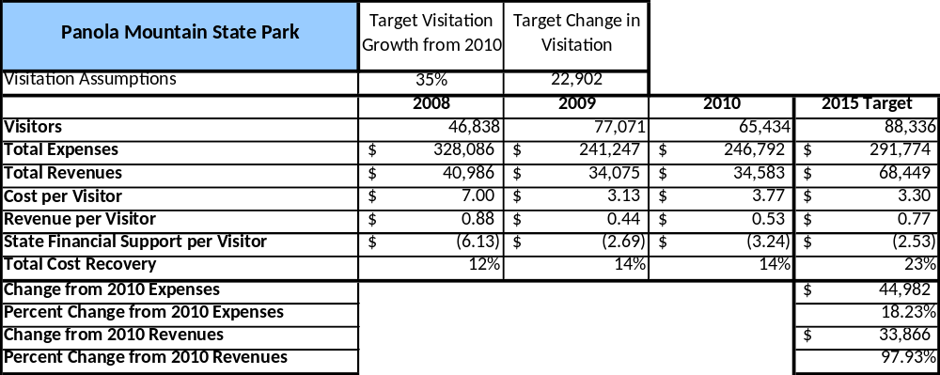

Key Recommendations

Primary / Short Term Recommendations
- Operate the site using cost-based accounting, including the net cost recovery achieved annually.
- Conduct in-park surveys annually to assess how well customer satisfaction levels are being met. PMSP should strive to have 90% of visitors responding to ‘Comment Cards’ report that they were either ‘satisfied’ or ‘very satisfied’ (or some comparable metric to be developed). Programs or services that fall below that standard should be critically reviewed, enhanced, and results monitored; those with a history of poor performance should be considered for elimination.
- Utilize a minimum of four special events annually to help draw more visitors to the site. Examples include Kids Fishing Rodeo, Boy and Girl Scout Council gatherings, an organized trail race, and community sponsored events such as the Henry County “Taste of Tourism.”
- Work closely with Arabia Mountain Heritage Area stakeholders to promote and market local attractions.
- Seek local partners (such as Chick-Fil-A of Stockbridge) to help support operations, programs, and service delivery and for cross-marketing purposes.
- Sustain sufficient non-labor operational funding or reduce staff so that required staff operational costs (with benefits) do not exceed 65% of the total operational budget.
- Enhance facilities and program offerings to provide a minimum of 10 unique experiences for each visitor while maintaining at least a 90% customer satisfaction rating. Examples include unique site and volunteer led programs (Panola Mountain hikes, birding, fly-fishing, orienteering, Lost Person Prevention, Intro to Backpacking, trail running), geocaching, fishing, nature trails, group gatherings, paved PATH trail activities (cycling, wheelchair access, for strollers), orienteering (in development), picnicking, camping, water activities such as fishing, jon boats and pedal boats, geocaching, a dog park and archery.
- Manage Panola Mountain according to well-defined maintenance, program and operational standards monitored and enforced by region managers and senior management.
- Partner with local Chambers of Commerce or other destination marketing organizations (DMOs) to promote Panola Mountain.
- Continue to work with the Panola Mountain Chapter of the Friends of Georgia State Parks and Historic Sites to help raise funds or provide volunteers for improvements and program support.
- Perform a thorough net cost-of-service analysis on major functions of site operations, including the detailed analysis of labor requirements (by task) that has already been produced by site staff. Thereafter, update costs to deliver services on a biennial schedule.
- Review and update rates at the site on an annual basis to recover the total net cost of service for important and visitor-supported services. Explore possible peak rental rates for picnic shelters and conference room.
- Track total economic impact of the site on the local communities and region and share with decision-makers, elected officials, local business operators, and others to demonstrate the impact of Panola Mountain State Park.
- Develop a more detailed analysis of labor requirements of all major park functions to match the right position with the right job at the right pay. Maintain appropriate staffing levels.
- Construct and upgrade facilities and amenities at the site that are likely to have a cost recovery level at or above 100%.
- Maintain the appealing characteristics of Panola by enhancing signage throughout the site and at its entrance, enhancing landscaping and updating interpretive displays and exhibits.
- Provide consistent year round mountain hike opportunities while maintaining the integrity of the mountain itself and controlling access to the conservation area.
- The Power of Flight (POF) area is a native grassland restoration site managed to attract migratory bird species. Due to unmarked roads/trails, an abandoned house that would attract exploration and the existence of bird banding equipment, the area is currently accessible by “permit only.” The Power of Flight area should be opened for public use and bird watching opportunities promoted. A bird blind type observation platform with a secure bird banding equipment storage area needs to be constructed and interpretive signage installed. Trails should be blazed. Support efforts to get this area designated as an Important Birding area through the national Audubon Society.
- Better market and promote The Archery Range at Panola Mountain and host events.
- Consider options for adding more services, programs, amenities and retail items that appeal to both older and younger adults. Retail items should reflect some program/activity related accessories, such as map & compass materials, birding books / CDs and rock outcrop literature.
- Support site development efforts including Parker House restoration, the PATH trail extension, a mountain bike trail, an orienteering course, the Power of Flight area birding trails and an interior connector trail bridging the Nature Center and the Alexander Lake area.
- Support ongoing efforts to open backcountry (tent pads) and developed (6-7 yurts, tent platforms) campgrounds.
- If not able to use the Parker House, consider some form of building for canoe, kayak, pedal boat and bike rental, as well as bait sales in the Alexander Lake area.
- Design and construct a natural playground area using boulders around the southern end of Upper Alexander Lake.
- Design and construct a dog park on an unused section of Southerness property.
- Begin discussions on developing a group shelter in the lower Alexander Lake area. Numerous “mega churches”, schools and neighborhoods surround Panola Mountain State Park. The four simple picnic shelters are consistently rented during the weekends for family reunions, adult social groups, day care groups, churches and graduation parties. Much of Panola’s user group is just that – groups. A group shelter would stay consistently rented during the weekends, especially if it were located in a scenic location, such as along the shore of lower Alexander Lake.

Secondary / Long Term Recommendations
- Engage the local community, user groups, and private organizations to improve connectivity between Panola and the communities and businesses of Rockdale, Conyers, Stockbridge, DeKalb and Henry.
- Support a program to collect a statistically-valid sample of ZIP code data from visitors in a non-intrusive way to gauge their origins and demographics (e.g., age, ethnicity, income, etc.) and use the results to improve programming and marketing efforts to appeal to a broader audience.

Site and Operations Assessment
This site and operations assessment is a culmination of analyses and findings from a review of the condition of facilities, infrastructure, and operations at Panola Mountain. The findings and observations are not intended to be an exhaustive review of all issues present, but provide a basic understanding of the predominant issues that contribute to the site’s current operating conditions. The assessment includes the following:
- Site Inventory and Facility Assessment
- Operational Assessment
- Financial Assessment
Site Inventory and Facility Assessment

Methodology
Facility and asset conditions are rated using a differential scale of excellent, good, fair, or poor. Descriptions of conditions that are attributed to each of these findings are also provided.
Scale of Conditions
Rating | General Description
Excellent | Facilities/amenities are in ‘excellent’ condition when they show little or no maintenance or repair problems. Facilities do not feature any major design or operational issues or flaws that contribute to diminished use or increased maintenance or upkeep. Facilities are easy to clean and maintain in order to place them back into public use and the users perceive them to be in excellent shape.
Good | Facilities/amenities are in ‘good’ condition when they show only minor maintenance or repair problems. Most maintenance issues with these facilities typically appear to be the result of age and/or heavy use. Facilities may only feature minor design or operational issues that contribute to diminished use or increased maintenance or upkeep. Facilities are moderately easy to clean and maintain in order to place them back into service and the users perceive them to be adequate for their use, but probably not in excellent shape.
Fair | Facilities/amenities are in ‘fair’ condition when they show significant maintenance or repair problems. Facilities generally exhibit ongoing maintenance issues that appear to be the result of age, heavy use, or design or operational flaws. Some maintenance and repair needs may compound their fair condition by being deferred because of budget and/or resource limitations. Facilities require more effort to clean and maintain before placing them back into service and the users may perceive them as being less than adequate for their use and in a state of deterioration. The facility or structure may need of major repair or replacement.
Poor | Facilities/amenities are in ‘poor’ condition when they show significant, on-going maintenance or repair problems that ultimately may result in suspended use for repair/replacement. Maintenance and repair issues are possibly the result of poor maintenance and clearly the result of age, heavy use, or design or operational flaws. Problems with the facilities are often compounded over time due to consistently deferred maintenance and repair because of budget and/or resource limitations. Facilities may feature major design or operational issues that contribute to diminished use or increased maintenance or upkeep. Facilities require excessive effort to clean and maintain before placing them back into service and the users often perceive them as being inadequate for their use and in a state of serious deterioration. The facility or structure may need of major repair or replacement.

Inventory and Assessment
The table below is an inventory of facilities and amenities at Panola Mountain, and provides the assessed condition of each as reviewed in June 2011.
Site Asset / Amenity | Quantity | Condition
Nature Center (NC) | 1 | Good
Picnic Shelters | 4 | Fair
Playground | 1 | Fair
NC area trails | 3 | Fair
Playground restroom | 1 | Fair
Alexander Lake Restroom | 1 | Good
Archery Range | 1 | Excellent
Paved PATH Trail | 1 | Excellent
Maint. areas (NC / Southerness) | 2 | Fair / Poor
Kiosk | 1 | Poor
Southerness buildings (closed) | 3 | Poor
Parker House (closed) | 1 | Poor
Vaughters House /Barn (closed) | 2 | Poor
Mgr residence | 1 | Good
Asst Mgr residence | 1 | Good
Resource Mgr Residence | 1 | Fair
Mtn cabin #1 | 1 | Fair

Prioritized Facility Needs
Based on the facility inventory and assessment, these prioritized needs have been identified. Each need has been aligned with a priority category of high, moderate, or low to support future decision making regarding project sequencing, investment of public resources, and meeting community expectations. The priority assignment for each need is not a measure of importance. Rather, these recommended priorities reflect a phased implementation approach over the next several years.
Facility Need | Priority Assignment
Develop / open campground w yurts along upper Alexander Lake | High
Restore historic Parker House w office, retail, campground check-in | High
Establish staff presence at Alex. Lake with kiosk at Southerness entrance | High
Connect via internal trail W side of park with E side | Moderate
Address worn / tired landscape in NC picnic areas | Moderate
Develop backcountry walk-in campground | Moderate
Open Power of Flight area to birding (with blind), hiking | Moderate
Develop picnic / group shelter at lower Alexander Lake | Moderate
Demolish mtn cabins #2 & 3, McCrary house, Southerness buildings | Moderate
Develop Vaughters area Master Plan | Low
Repair / upgrade seasonal mtn cabin #1 | Low

Operational Assessment
The Operational Assessment includes:
- An inventory and classification of programs and services being provided at the site
- A review of staffing at the site
- A review of concessionaires and partners operating at the site
- Visitation and customer satisfaction

Inventory and Classification of Programs and Services
Programs and services are classified into one of three major categories:
1) Core or Essential Services
2) Important Services
3) Visitor Supported Services
Programs and services at the site are classified into these categories based in part on the mission and public mandates for both the site and the agency. For the services in each of these categories, there are financial performance expectations that will define how services are funded and evaluated.

Category 1 – Core Services [Largely supported by tax funds]
Core programs, services and facilities are those the agency must provide and/or are essential in order to capably govern and meet statutory requirements. The failure of the agency to provide Category 1 services at adequate levels could result in significant negative consequences for the public and the resources under protection. The criteria for services to be classified as core or essential are:
- The services are mandated by the agency’s law or charter or are contractually obligated by agreement to provide the services.
- The services are essential to protecting and supporting the public’s health and safety.
- The services protect and maintain valuable assets and infrastructure.
- The services would generally and reasonably be expected and supported by residents, businesses, customers and partners.
- The services are those that cannot or should not be provided by the private sector.
- The services provide a sound investment of public funds.
The following programs and services offered at Panola Mountain have been identified as core services:
- Mgmt of Panola Mountain as a protected, accessible and pristine national natural resource
- Public safety and state property protection
- Maintenance of grounds, facilities and infrastructure
- Scientific research venue
- Resource management

Category 2 – Important Services [Supported by a balance of tax funds and earned revenues]
Important programs, services and facilities are those the agency should provide, and are important to governing and effectively serving residents, businesses, customers and partners. Providing Category 2 services expands or enhances the agency’s ability to provide and sustain its core services. The criteria for programs or services to be classified as important are:
- The services expand, enhance or support identified core services.
- The services are broadly supported and utilized by the community, and are considered an appropriate, important, and valuable public good. Public support may be conditional upon the manner by which the services are paid for or funded.
- The services generate income or revenue that offsets some or all of the operating cost and/or are deemed to provide economic, social or environmental outcomes or results.
The following services offered at Panola Mountain have been identified as important services:
- Support of the Arabia Mountain Heritage Area
- Panola specific recreational and interpretive programs
- Nature Center, retail and staff access (Parker House restoration plan under development)
- Trail and PATH trail access & maintenance
- Lake access

Category 3 – Visitor Supported Services [Almost exclusively supported by earned revenue]
Visitor supported programs, services and facilities are those discretionary services that the agency may provide when additional funding or revenue exists to offset the cost of providing those services. Category 3 services provide added value above and beyond what is required or expected. The criteria for programs or services to be classified as visitor supported are:
- The services expand, enhance or support core services or important services and the quality of life of the visitors, community or stakeholders.
- The services are supported, valued and well utilized and provide an appropriate and valuable public benefit.
- The services generate income or funding from sponsorships, grants, user fees or other sources that offset some or all of their cost and/or provides a meaningful return on investment.

- The services can possibly be provided through outsourcing or use of concessionaires, providing opportunities for community enterprises that may not otherwise be provided by the agency.

The following services offered at Panola Mountain have been identified as visitor supported services:
- The Archery Range at Panola Mountain
- Special event / program activities
- A developed campground with yurts, tent platforms
- Backcountry camping
- Group shelter on lower Alexander Lake
- Picnic shelter rental opportunities

Staffing Assessment
Labor costs at $186,020 annually (average of FY09 & FY10) represent the largest budgetary expense at 76% of the average total operating budget during the last two years, which is higher than the target of total labor costs (including benefits) of 65%- 70% of the site’s total operating expenditures. The tables below and on the following page provide a basic review of the current staffing as of 9/1/11.
Full Time Equivalent Employees
Position / Title | Quantity (FTE) | Vacancies | Paid Annual Hrs
Prk Fac Mgmt Spec / Mgr | 1 | 0 | 2080
Prk Fac Mgmt Spec / Asst Mgr | 1 | 0 | 2080
Prk Fac Mgmt Spec / Res Mgr | 0 | 1 | 0
Park Maint Tech | 1 | 0 | 2080
Grounds Worker / Maint | 1 | 1 | 2080
Secretary | 0 | 1 | 0
TOTAL | 4 | 3 | 8320

Part Time Employees
Position / Title | Quantity (FTE) | Vacancies | Hours
1508 Prk Services Worker / NC | 1 | 0 | 1508
1508 Programmer (anticipated) | 2 | 0 | 3016
1508 Kiosk | 1 | 0 | n/a
TOTAL | 4 | 0 | 4524

Labor Support
Labor Support | Annual Hours
Volunteers | 6035
Community Service Workers | 1750
Engineering and Construction Crews | 40
Resource Management Crews | 335
TOTAL | 8160

Total Labor Hours
Labor Type | Annual Hours
Full Time Equivalent Employees | 8320
Part Time Employees | 4524
Labor Support | 8160
TOTAL Annual Labor Hours | 21,004

Labor Budget Summary

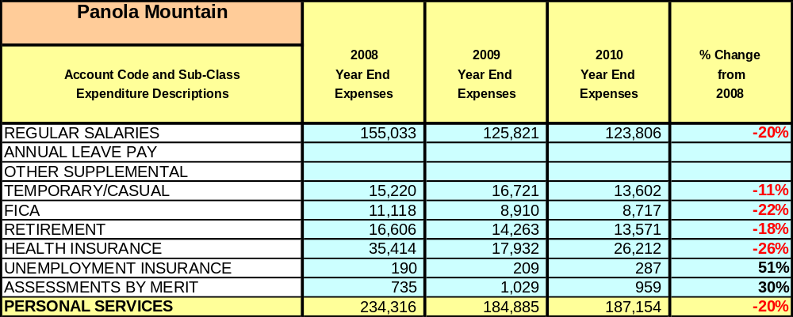

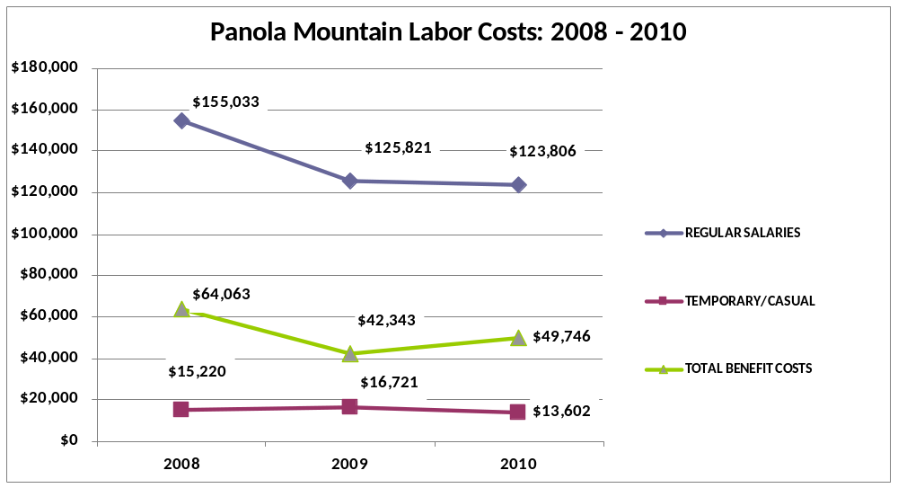

Visitation and Occupancy
Overall annual visitation to the site has trended upward from 2008 to 2010, increasing by 28% or over 18,596 visitors. This is attributed to increased programming activities and the opening of the Alexander Lake & PATH trail area. The decrease in 2010 visitation numbers is the result (in part) of a combination of frequently damaged counting equipment and a continued economic downturn.

Year | Total Visitation
2008 | 46,838
2009 | 77,071
2010 | 65,434

Panola Mountain State Park does not yet have overnight camping, cottage or lodge facilities. However two campgrounds are currently planned. Note: Panola occasionally hosts organized overnight groups, such as scout groups. Associated fees are applied to programming revenue.

Customer Service and Satisfaction

Panola Mountain | Year | Customer Satisfaction Level
Customer Survey cards noting Satisfied or Very Satisfied | 2009 | 100%
Customer Survey cards noting Satisfied or Very Satisfied | 2010 | 80%

Efforts will be made to monitor customer service comments and share regularly with staff. Satisfaction levels should not fall below 90% annually.
Financial Performance Assessment

Operational Expenses
A summary of total operating expenses at Panola Mountain from 2008 to 2010, as well as their percent change from 2008, is provided in the table below. The absence of a Park Manager or Assistant Manager for most of FY10 affected retail operations, which was not addressed until early FY11.
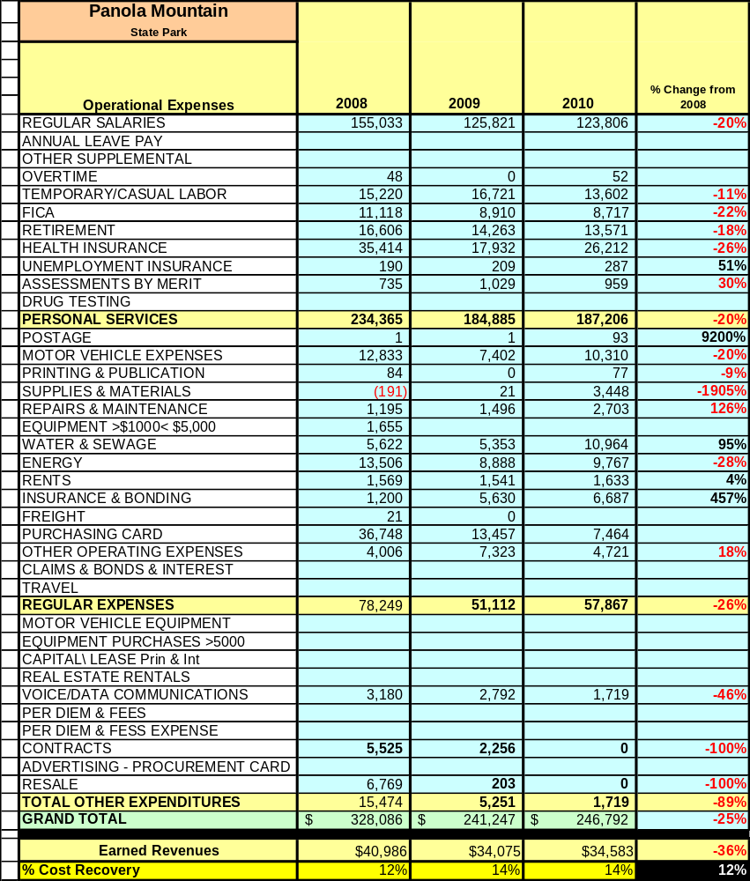

Earned Revenues
Earned revenues at Panola Mountain have decreased since 2008. However, a review of revenue from the last two years indicates a slight increase of 1.5% from 2009 to 2010. The largest percentage increases in monthly revenues between FY09 and FY10 occurred in August (53%), as well as 17% increases in Jan, Feb and March. The largest decreases occurred in September (-29%) & October (-27%).
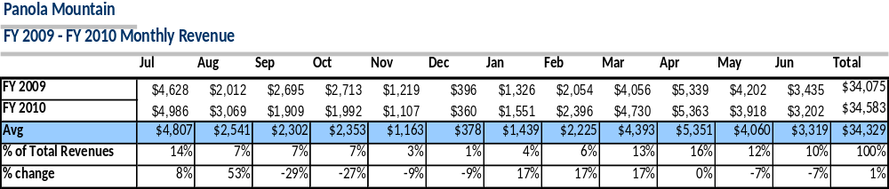
The graphs below illustrate the monthly revenue trends each year and the average total percent of revenue earned by month during FY09 & FY10.

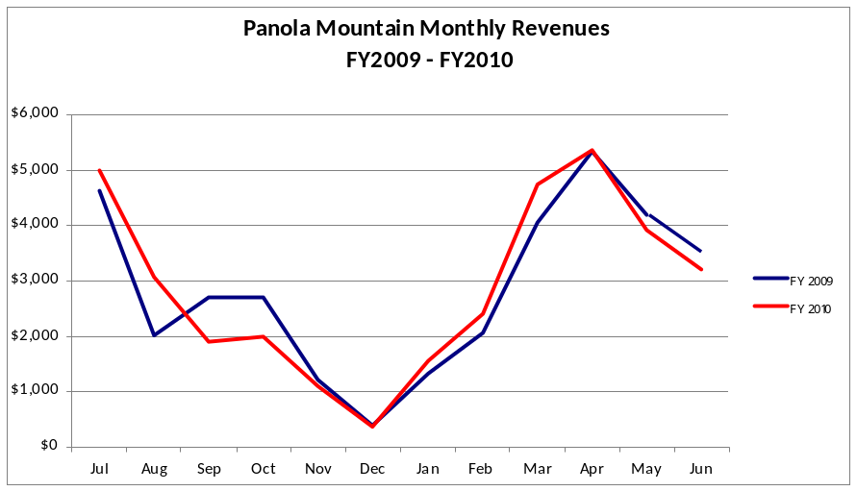

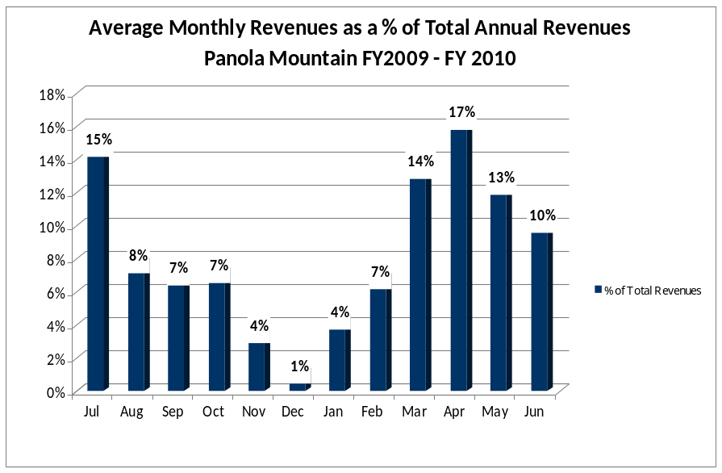

Cost Recovery Trends
Panola Mountain has achieved an average cost recovery of 13% of annual operational expenses through earned revenues from FY 2008 to FY 2010. This is detailed and illustrated in the table and graph below.
Year | Operational  Expenses | Earned  Revenues | Percent Cost  Recovery
2008 | $328,086 | $40,986 | 12%
2009 | $241,247 | $34,075 | 14%
2010 | $246,792 | $34,583 | 14%
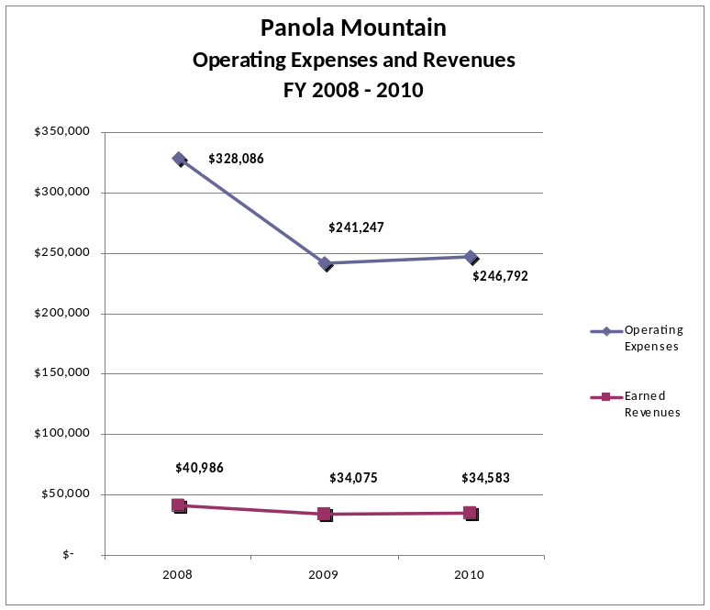

Review of Pricing
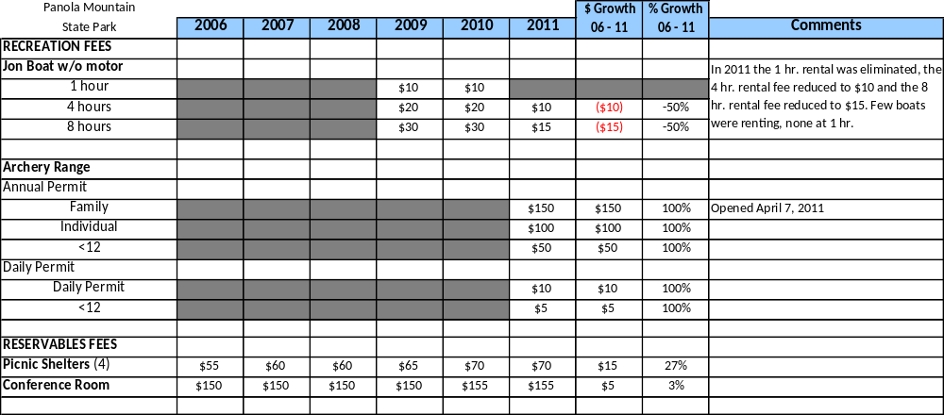
Data on rate information is available as far back as 2002, however only the last six years are evaluated. There have been adjustments to fees charged at Panola Mountain since 2006, including the addition of Archery Range permit fees and a decrease in boat rental fees. A table detailing rates for recreation and reservables at Panola is provided below.

Business and Management Plan

Business Goals
The following goals serve as the foundation for the key recommendations and strategies in this business plan for Panola Mountain State Park.

Enhance Cost Recovery of Site Operations
Panola Mountain currently has few revenue generating resources, but there are opportunities to increase the return on existing outlets (primarily involving retail items). In addition, near future developments will increase visitation to the site. The PATH trail, which currently ends in the Alexander Lake parking area, will connect to an existing trail section south of the park, bringing guests both through and to Panola. Progress is being made towards restoration work at the historic Parker House, where retail and convenient boat rental purchases can be made. The development of two campgrounds in the area will also increase both visitation and retail opportunities.

Enhance Revenue Generation Strategies
- Dedicate staff to retail management while providing the tools and time to be successful
- Expand retail sales while catering toward our visitor / target market
- Expand rental opportunities (canoes, jon boats, pedal boats, bicycles)
- Support campground development & Parker House restoration

Expand Special Events at the Site
Panola hosts a number of fairly small special events, such as the 4th of July and New Years fireworks hikes up the mountain (Atlanta is visible from the top, and participants can see multiple shows). Though Panola is the closest state park to downtown Atlanta, the site has traditionally struggled to attract large numbers to special events. Examples of events with disappointingly low turnouts include a highly promoted Search & Rescue “Bark & Walk” program, a bluegrass concert at Vaughters farm, a dog show and our Free Fishing Festivals. Chick-Fil-A of Stockbridge heavily promoted the 2011 fishing event by placing a coupon for free food when attending in each drive-through bag for a week before the event, but the (high estimate) turnout all day was only about 350 visitors. A likely reason may be the high number of outdoor recreational opportunities, events, festivals and alternative “free time” options available in the metro area. However, groups do come to Panola looking for facilities to hold events. The park is surrounded by multiple “mega-churches” often looking for somewhere to go as a group. The picnic shelters are typically rented during pleasant weather weekends, and guests often arrive as part of a larger group.
- Support group/picnic shelter development at Alexander Lake for rental use
- Respond to non-traditional inquiries looking for facilities to rent (i.e. the Cart Barn)

Improve the Effectiveness of Marketing and Sales
Current efforts to promote park activities and events include press releases covering significant or unique events and activities, social media updates, updating Panola’s DNR web page, communicating with PRHSD marketing staff, word of mouth, site flyers and community postings.

Establish Greater Consistency of Managing and Monitoring Customer Service & Satisfaction
- Staff should encourage guests to pick up comment cards (online or flyer mail-in)
- Comments should be reviewed during staff meetings
- When possible, concerns should be addressed and resolved promptly

Classification of Programs and Services
The tables below summarize the classifications of programs and services at Panola Mountain as either core, important, or visitor supported and projects a range of cost recovery percentages that might be achieved for each. These classifications establish financial performance goals for each category of services that are linked to the recommendations and strategies of this business plan.
Core Programs / Services | Target Cost Recovery
Management of Panola Mtn. as a protected, accessible and pristine resource | 20% cost recovery
Public safety and property protection | 0% cost recovery
Maintenance of grounds, facilities and infrastructure | 0% cost recovery
Scientific research | 0% cost recovery
Resource Management | 0% cost recovery

Important Programs / Services | Target Cost Recovery
Support of the Arabia Mountain Heritage Area | 0% cost recovery
Panola specific recreational and interpretive programs | 100– 150% cost recovery
Nature Center, retail & staff access (Parker House under development) | 140% cost recovery
Trail and PATH trail access / maintenance | 0% cost recovery
Lake access | 10 - 15% cost recovery

Visitor Supported Programs / Services | Target Cost Recovery
The Archery Range at Panola Mountain | 100% cost recovery
Special event / program activities | 120 – 150% cost recovery
Developed campground with yurts, tent platforms | 100 - 125% cost recovery
Backcountry camping | 100 - 150% cost recovery
Group shelter on lower Alexander Lake | 100 – 150% cost recovery
Picnic shelter rental opportunities | 100 - 150% cost recovery

Partnership Development Plan
The table below summarizes existing partners and targeted partnerships by classification (operational, vendor, service, co-branding, funding partners) and by organizational type.

 | Public Partners | Not-for-profit Partners | Private / Enterprise Partners
Operational Partners | - Local Probation Offices (CSW’s)  - WRD | - Friends of Panola  - Panola volunteers
Vendor Partners |  | - Ga Orienteering Club | - Chick-Fil-A of Stockbridge  - Shane’s Ribshack  - Clif Bars  - Melwood water  - North Face  - REI  - Bass Pro shop
Service Partners | - Local Probation Offices (CSW’s)  - USGS | - Audubon  - SORBA  - Atl. Outdoor Club | - North Face (staff)
Co-branding Partners | - Arabia Mtn Heritage Area  - NPS  - Davidson-Arabia  - Henry Co Tourism | - Conyers / Rockdale Chamber of Commerce
Funding Resource Development Partner |  | - Rockdale Historical Society  - PATH  - Friends of Ga PRHS  - Friends of Panola  - Rotary

Marketing and Sales Plan

Marketing and Sales Goals
Marketing and sales goals for Panola Mountain are based on the following desired outcomes:
- Increased visitation- 35% goal by 2015
- Increased revenue generation
In order to meet these goals, examples of target outcomes are identified in the areas detailed in the table below.
Area  of Focus | Current  Performance | Goal  by 2012 | Goal  by 2013 | Goal  by 2015
Campgrounds (2), backcountry & Alexander Lake | Planning | Support efforts | Backcountry campground open | Alexander Lake campground open
Parker House restoration | Planning | Planning | Master & Adaptive Use Plan in place | Physical construction
PATH / Connector Trail | Planning | Support efforts | PATH open | Connector open

Marketing and Promotion Strategies

Publicity and Social Media
Panola Mountain State Park will approach marketing and publicity planning using the following guidelines and themes:
- Event publicity
Major events benefit by having short stories in local, regional, and statewide newspapers and online social media hooks planted that run three to four weeks in advance of the event up to the date of the event itself. Stories and media need to be cultivated with contacts and online sales channels several weeks in advance of the time the stories need to run. Special interest interviews on morning, noon, and evening television news programs, radio interviews on popular rush-hour programs, and blogs on known affinity online sites should also be included.
- Program publicity
Special and unique programs should have feature stories in magazines, local and regional weekly newspapers, and statewide daily newspapers that are aimed at placements as front-page or sectional front-page stories. These stories are most effective if they run shortly before the season that the featured program begins. This will likely require several weeks of advanced planning with media contacts. Similar coverage on television and radio should also be considered. If pre-publicity cannot be generated, post-publicity can help promote future programs.

- Site Publicity
Site publicity focusing on a single site or sub-set of sites requires more intense planning efforts to attract multiple writers and editors from target publications. Each site could host several seasonal media familiarization tours (with 10 to 15 writers or editors) to familiarize them with the site and its benefits and amenities. Stories and features resulting from such tours typically take between two and six months to materialize so the tours should focus on experiences, benefits, and programs that would be available when the stories are expected to run.
An example of opportunities for events, programs and related publicity efforts based on the themes described above at Panola Mountain are provided in the table below.

Event Publicity | Program Publicity | Site Publicity
Kids Fishing Festival | BK Outdoor Survival | Panola Mtn hikes
Scouting Weekend | Cycling / running club | 4th fireworks

Revenue Generation Plan
Revenue / Cost Recovery Goals
Panola Mountain has set a financial goal of increasing annual revenues annually between 2012 and 2015. The largest revenue growth opportunity is dependent on planned campground development and Parker House retail sales. This table assumes the opening of a primitive backcountry campground in FY13 and the larger planned campground in FY14, as well as the continuation of FY10 program revenue generation (note: as of this edit we have lost our Resource Manager which will impact FY12 revenue generation). Completion of Parker House restoration efforts (offering retail opportunities) will also support FY14 & FY 15 goals. The table below details projected revenue growth leading up to 2015.
Projections are intentionally low for two reasons: 1) Significant projects (campground opening, Parker House restoration) seem to be completed later rather than sooner so opening is expected in late FY14 & FY15. 2) As we are seeing with The Archery Range at Panola Mountain, the market takes time to embrace new facilities. Use and revenues will increase following FY15.
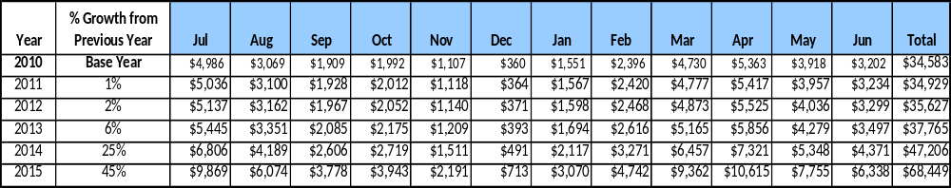

These projections would result in a 98% change from 2010 revenues. With operational expenses forecasted at $291,774 (again, anticipating increases due to campground development and Parker House expenses), the overall cost recovery of the site in FY15 would be approximately 23% at projected revenue levels. This is higher than the annual financial performance of the site in FY10, which operated at 14% cost recovery that year.
Revenue Generation Strategies

Pricing Plan
Picnic shelter rental rates could be raised to $75 Fri.-Sun., and reduced to $25 Mon-Thurs. Currently, due to the lack of need and expected availability, picnic shelters rarely rent during the week. With a reduced rate available to guarantee availability, groups may consider mid-week rentals. Needs discussion.
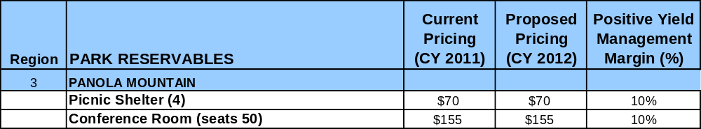

Programming and Special Events
Programming falls into one of a few categories- Staff led, volunteer led with fee and volunteer led with no fee. Staff led programs include mountain hikes, various others (depending on staff) and special events. Examples of volunteer led fee based programs include the fly-fishing or the upcoming Bryan Kerns Outdoor Survival. No fee volunteer led programs (trail running, cycling) are led by registered volunteers, often introduce participants to the park and are more group events than instructional programs. Target participation below is per event, and program fees vary depending on the program.

Innovative Programming and Special Events Plan
Program / Event | Theme / Purpose | Scheduled Date/Season | Frequency | Target Participation | Target User Fee | Target Cost Recovery
Panola Mtn guided hike | Education / recreation | Year round | 1-3x weekly | 6+, <40 | $7 per | 75 – 100%
Spec. event Mtn hike | Education / Recreation | 4th July, New Years | 2x annually | 6+, <40 | $7 per | 75 – 125%
Various Ed programs | School group Ed. | As requested | Varies, seasonal | 6+ | Varies | 50 – 75%
Free Fishing Festival | Education / Recreation | May | 1x | 350 – 500+ | Free | 0%
Park Programming | Education / Recreation | Seasonal, weekends | 2 – 5x monthly | 6+ | Varies | 50 – 75%
Volunteer led – fee | Education / Recreation | Year round | 2 – 5x monthly | 6+ | Varies | 75 – 100%
Volunteer led – no fee | Education / Recreation | Year round | 2 – 5x monthly | 6+ | Free | 50 – 75%

Expense Management Plan
Personnel Assignments
The following actions will be taken to proactively manage labor costs via personnel assignments and classifications.

Action | Timeline | Outcome
Two 1508 employees to cover nature center & park operations to replace budgeted full-time staff | Begin Fall 2011 | Operational consistency, 1508 staff replacing salaried position

Issue
The Nature Center is the nerve center of park operations, where retail items are available, calls are answered, emergencies or problems are reported and where guests can find a park ranger. A 1508 employee currently manages the Nature Center, but working five days a week, uncovered days off remain while a “new” 1508 must be hired after less than a year. Maintaining consistent coverage is challenging, with full-time staff jumping in and out to cover lunches, days off, absences, etc.

With two 1508 employees working concurrently, Nature Center operations could be covered with <29 hours scheduled weekly, allowing employees to work year-round. A second 1508 employee could also function as an intermittent seasonal naturalist, assisting with program activities during the busy summer months (replacing the vacant seasonal naturalist position). Additionally, when full time employees are out for (training, etc.) the availability of a second flexible employee would allow for continual coverage of site operations. Reduced winter hours may extend employee availability so not to exceed 1508 hrs.

The restructured roster would allow for consistent and appropriate coverage (right person, right place, right price) replacing a (currently vacant) full time secretary / clerk position. Note this does not address future Parker House operational staffing needs, which will include the hiring of a third 1508 employee.

Restructured Panola Employee Roster

Current Positions | # | Hrs | Hrs | Proposed Positions | # | Hrs | Hrs
Prk Fac Mgmt Spec / Prk Mgr | 1 | 2080 |  | Prk Fac Mgmt Spec / Prk Mgr | 1 | 2080
Prk Fac Mgmt Spec / Ass’t Mgr | 1 | 2080 |  | Prk Fac Mgmt Spec / Ass’t Mgr | 1 | 2080
Prk Fac Mgmt Spec / Res Mgr | 1 | 2080 |  | Prk Fac Mgmt Spec / Res Mgr | 0 | 0
Prk Maint Tech / Maint | 1 | 2080 |  | Prk Maint Tech / Maint | 1 | 2080
Prk Maint Tech / Grounds | 1 | 2080 |  | Prk Maint Tech / Grounds | 1 | 2080
1508 / NC | 1.3 |  | 2080 | 1508 / Nature Center | 1 |  | 1508
1508 Seasonal Naturalist | 0 |  |  | 1508 / Nature Center, Prog | 1 |  | 1508
Secretary / Clerk | 0
Total: |  | 10400 | 2080 | Total: |  | 8320 | 3016

Management Techniques
The following actions will be taken to proactively manage labor costs via management techniques.
Action | Timeline | Outcome
Host sites with campground development | Campground | Reduced labor costs

With the proliferation of full-time RVers needing an affordable spot where to park for extended periods, constructing sites with water / septic / electricity when developing a campground is an inexpensive way to lower labor costs. Camp hosts trade service hours for rent-free use of the site.

Adjusted Levels of Service
The following actions will be taken to proactively manage labor costs via reduced levels of service.
Action | Timeline | Outcome
Reduced Nature Center schedule | Nov-Apr | Reduced labor costs when slow

Weekends excluded, visitation at Panola’s Nature Center varies dramatically through the week and season. Recognizing the Nature Center is the nerve center of park operations, some adjustments to operating hours should be considered (both seasonal and mid week) so as to reduce labor costs. During winter months (Nov – Feb) it may be appropriate to close the Nature Center Mon-Thu. However, it should be noted this will impact retail operations to a degree, and guests calling the park would get an answering machine. Depending on progress with Parker House restoration work, this action will need to be revisited due to the need for check-in when the campground opens.

Financial Pro Forma
The following five-year financial pro forma projects operating expenses, earned revenues and cost recovery through FY 2015. These pro forma are based on the strategies and desired outcomes identified in this business plan, especially the revenue generation and expense management plans, and are linked to corresponding performance goals.
Notes: Accounting procedures have moved from catch-all Purchase Card entry to being entered by account type (ex. Motor Vehicle, Supplies & Materials, etc.). Note 2010 labor costs reflect unfilled Park Manager and Assistant Manager positions for over eight months. Expenses (electricity, water & sewage, supplies, resale, labor, etc.) increase in late 2014 anticipating the opening of the Parker House & campground facilities.

Expense Pro Forma
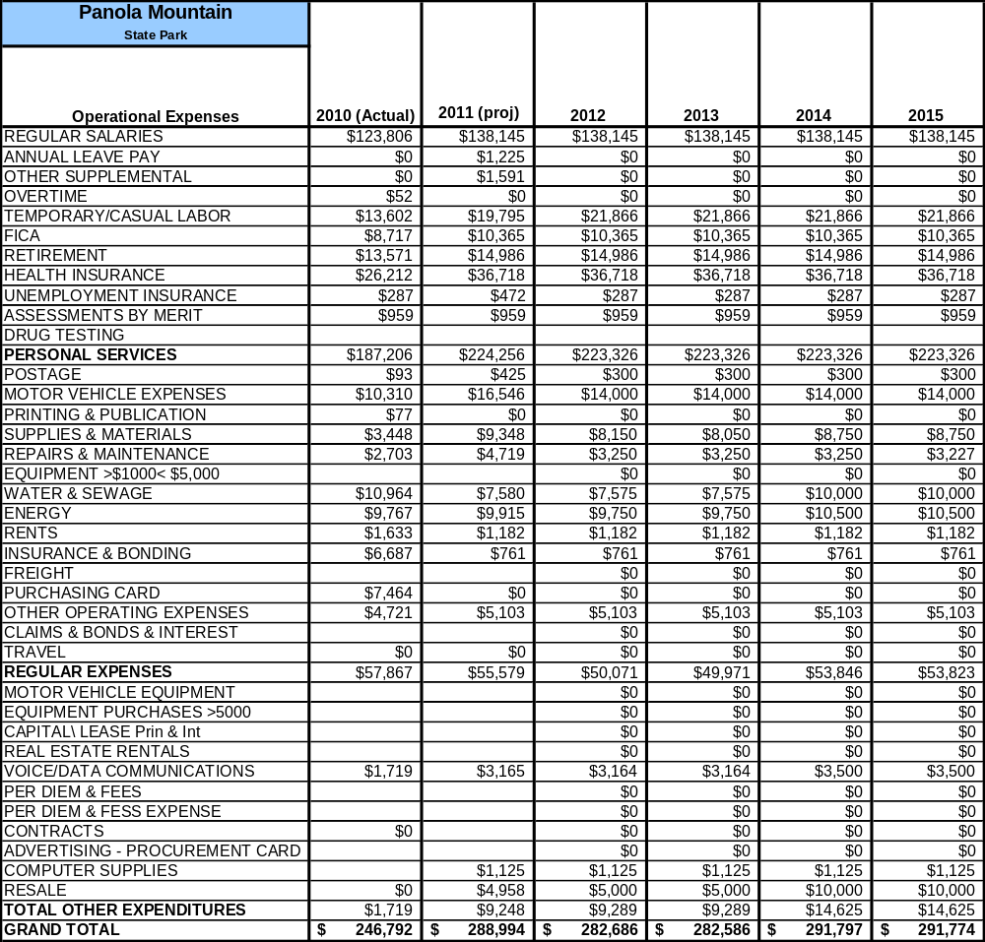

Four assumptions are being made when forecasting the Revenue Pro Forma.
1. A Resource Manager full time position has been replaced by a part time naturalist and the goal is to continue to generate existing levels of program revenue.
2. A five-tent pad backcountry hike-in campground will open in FY13, catering primarily to groups such as boy and girl scouts. (Note this is a site developed volunteer driven grant supported project)
3. Parker House restoration efforts will be complete (supporting retail, rentals, etc.) by late FY14.
4. The planned yurt / tent platform developed campground on Alexander Lake will open by late FY15.
An additional assumption is that visitation will gradually increase in part based on the extension of the PATH trail through the park and with increased use of The Archery Range at Panola Mountain. Parker House retail sales will benefit from increased area traffic.

Revenue Pro Forma
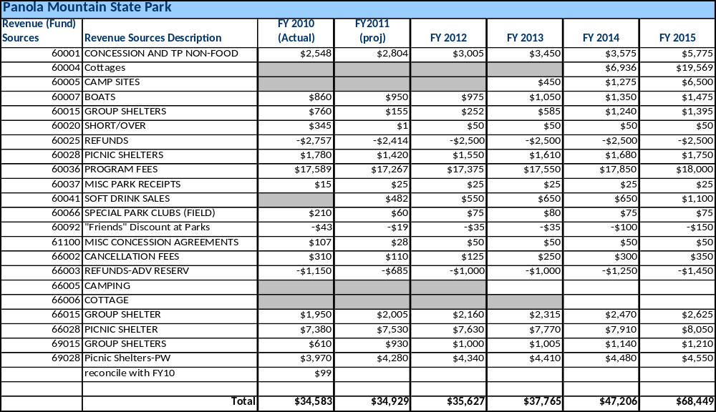

Total / Cost Recovery Pro Forma
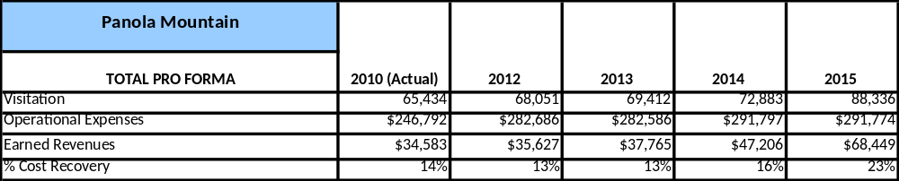

Action Plan
ACTION PLAN
Site: |  | Site Manager: |  |  | Date:
Month:
Strategy | Tasks | Costs / Funding | Revenues / ROI | Responsibilities | Metrics

ACTION PLAN
Site: |  | Site Manager: |  |  | Date:
Month:
Strategy | Tasks | Costs / Funding | Revenues / ROI | Responsibilities | Metrics

This is the average of the last three years – FY 2008, FY 2009, and FY 2010
Current employees, not including vacancies.
Current employees, not including vacancies.
Major population centers within a two-hour drive from the site

