Pickett’s Mill State Historic Site

Business & Management Plan

Prepared January 2012; Finalized February 2013

Direction 2015 – Sustainable Business Planning

Table of Contents

Executive Summary 3

Site and Operations Assessment 7
Site Inventory and Facility Assessment 7
Operational Assessment 9
Financial Performance Assessment 14

Business and Management Plan 17
Business Goals 17
Classification of Programs and Services 18
Partnership Development Plan 20
Marketing and Sales Plan 20
Revenue Generation Plan 23
Expense Management Plan 25
Financial Pro Forma 26

Action Plan 28

Executive Summary
The Parks, Recreation and Historic Sites Division (PRHSD) of the Georgia Department of Natural Resources (DNR) is transitioning the management of Pickett’s Mill Historic Site to operate more like a business, reflecting the Direction 2015 – Sustainable Business Planning initiative to improve the fiscal performance and management of the state parks and historic sites system. This business and management plan is designed to help the site recover more operating expenses through earned revenues, productive partnerships, and innovative programs.

Site Fact Sheet
Site Name | Pickett’s Mill State Historic Site
Site Manager | Daniel Hill
Region Manager | Joe Yeager (Region 1)
Date of Business Plan completion | 1/1/12
Site size | 765 acres
Total number of visitors (FY 2010) | 11,159
Total operating budget (FY 2010) | $103,397
Total earned revenues (FY 2010) | $18,523
Operational cost recovery (FY 2010) | 18%
Average operating cost per visitor (FY 2010) | $8.20
Average earned revenue per visitor (FY 2010) | $1.55
Average cost recovery (FY 2008 – 2010) | 18.3%
Target cost recovery (FY 2015) | 21%
Total full-time employees | 1
Total part-time employees | 0
Primary service markets | Atlanta, Dallas, Woodstock , Marietta, Roswell, Acworth, Cartersville, Rome, Calhoun, Dalton, Kennesaw
Primary attractors/visitor appeal factors | Museum and trails
Leading opportunities for improved site performance | Partnerships with local attractions and expand amenity offerings

Site Summary and Key Attractions
The 765 acre historic site of Pickett’s Mill is located in a metro/rural setting is one of the best preserved Civil War battlefields in the nation. Visitors can travel roads used by Federal and Confederate troops, see earthworks constructed by these men, and walk through the same ravine where hundreds died. An authentic 1800’s pioneer cabin is furnished and open for tours during certain events.

Key Attractions
The amenities or features listed below are those that seem to be most popular for visitors.
- Visitor Center with film, artifacts, and exhibits.
- Earthworks
- Hiking – 4 miles of trails
- Programs and Special Events
- Group Shelter
- Picnic Tables
- Bus Parking
- Gift Shop
- Pioneer Cabin
- Nearby world-class museums in Cartersville

Financial Targets
The table below details the total operating expenses and earned revenues for Pickett’s Mill over the last three years (2008 – 2010). This table also calculates total cost per visitor and revenues per visitor during these operating years, and details the target financial performance goals in the context of achieving at least 21% cost recovery. This table also calculates the necessary change from 2010 operating expenses and revenues.
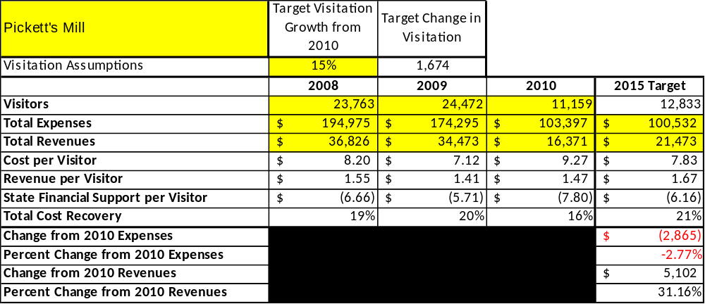
Key Recommendations

Primary / Short Term Recommendations
- Operate the site using cost-based accounting, including the net cost recovery achieved annually.
- Conduct in-park surveys annually to assess how well customer satisfaction levels are being met. Pickett’s Mill should strive to have 90% of visitors responding to ‘Comment Cards’ report that they were either ‘satisfied’ or ‘very satisfied’ (or some comparable metric to be developed). Programs or services that fall below that standard should be critically reviewed, enhanced, and results monitored; those with a history of poor performance should be considered for elimination.
- Evaluate and pursue opportunities to employ concessionaires or private or public service providers on-site if they can be more cost-effective. For example, explore the development of a concessionaire agreement for beach concession.
- Collect a statistically-valid sample of ZIP code data from visitors in a non-intrusive way to gauge their origins and demographics (e.g., age, ethnicity, income, etc.) and use the results to improve programming and marketing efforts to appeal to a broader audience.
- Utilize a minimum of six special events annually to help draw more visitors to the site.
- Seek local partners to help support operations, programs, and service delivery and for cross-marketing purposes.
- Sustain sufficient non-labor operational funding or reduce staff so that required staff operational costs (with benefits) do not exceed 60% of the total operational budget.
- Enhance facilities and program offerings to provide a minimum of 10 unique experiences for each visitor while maintaining at least a 90% customer satisfaction rating.
- Manage Pickett’s Mill according to well-defined maintenance, program and operational standards monitored and enforced by region managers and senior management.
- Partner with local Chambers of Commerce, CVB, or other destination marketing organizations (DMOs) to promote Pickett’s Mill.
- Redevelop the Pickett’s Mill Chapter of the Friends of Georgia Historic Sites and Historic Sites to help raise funds or provide volunteers for improvements and program support.
- Perform a thorough net cost-of-service analysis on major functions of site operations, including the detailed analysis of labor requirements (by task) that has already been produced by site staff. Thereafter, update costs to deliver services on a biennial schedule.
- Review and update rates at the site on an annual basis to recover the total net cost of service for important and visitor-supported services.
- Track total economic impact of the site on the local communities and region and share with decision-makers, elected officials, local business operators, and others to demonstrate the impact of Pickett’s Mill.
- Develop a more detailed analysis of labor requirements of all major site functions to match the right position with the right job at the right pay.
- Develop funding to provide additional training to site staff for improved business management and marketing effectiveness.
- Regain presence with local school community on program / educational offerings at Allatoona Pass, Red Top, Etowah Mounds and Pickett’s Mill.
- Develop immediate partner/amenity packages with local attractions.

Secondary / Long Term Recommendations
- Evaluate and adjust hourly staffing rules to allow full-time employment for hourly employees and thereby more scheduling and operational efficiencies.
- Engage the local community, user groups, and private organizations to improve connectivity.
- Install an improved retail point-of-sale and inventory tracking system.
- Continue evaluating use of personnel to cover Pickett’s Mill, Pickett’s Mill, and Red Top Mountain operations.

Site and Operations Assessment
This site and operations assessment is a culmination of analyses and findings from a review of the condition of facilities, infrastructure, and operations at Pickett’s Mill Historic Site. The findings and observations are not intended to be an exhaustive review of all issues present, but provide a basic understanding of the predominant issues that contribute to the site’s current operating conditions. The assessment includes the following:
- Site Inventory and Facility Assessment
- Operational Assessment
- Financial Assessment
Site Inventory and Facility Assessment

Methodology
Facility and asset conditions are rated using a differential scale of excellent, good, fair, or poor. Descriptions of conditions that are attributed to each of these findings are also provided.
Scale of Conditions
Rating | General Description
Excellent | Facilities/amenities are in ‘excellent’ condition when they show little or no maintenance or repair problems. Facilities do not feature any major design or operational issues or flaws that contribute to diminished use or increased maintenance or upkeep. Facilities are easy to clean and maintain in order to place them back into public use and the users perceive them to be in excellent shape.
Good | Facilities/amenities are in ‘good’ condition when they show only minor maintenance or repair problems. Most maintenance issues with these facilities typically appear to be the result of age and/or heavy use. Facilities may only feature minor design or operational issues that contribute to diminished use or increased maintenance or upkeep. Facilities are moderately easy to clean and maintain in order to place them back into service and the users perceive them to be adequate for their use, but probably not in excellent shape.
Fair | Facilities/amenities are in ‘fair’ condition when they show significant maintenance or repair problems. Facilities generally exhibit ongoing maintenance issues that appear to be the result of age, heavy use, or design or operational flaws. Some maintenance and repair needs may compound their fair condition by being deferred because of budget and/or resource limitations. Facilities require more effort to clean and maintain before placing them back into service and the users may perceive them as being less than adequate for their use and in a state of deterioration. The facility or structure may need of major repair or replacement.
Poor | Facilities/amenities are in ‘poor’ condition when they show significant, on-going maintenance or repair problems that ultimately may result in suspended use for repair/replacement. Maintenance and repair issues are possibly the result of poor maintenance and clearly the result of age, heavy use, or design or operational flaws. Problems with the facilities are often compounded over time due to consistently-deferred maintenance and repair because of budget and/or resource limitations. Facilities may feature major design or operational issues that contribute to diminished use or increased maintenance or upkeep. Facilities require excessive effort to clean and maintain before placing them back into service and the users often perceive them as being inadequate for their use and in a state of serious deterioration. The facility or structure may need of major repair or replacement.

Inventory and Assessment
The table below is an inventory of facilities and amenities at Pickett’s Mill Historic Site, and provides the assessed condition of each as reviewed in May 2011.
Site Asset / Amenity | Quantity | Condition
Total Acreage | 765 | Good
Museum | 1 | Fair
Hiking Trails | 8 | Good
Maintenance Facility | 1 | Good

Prioritized Facility Needs
Based on the facility inventory and assessment, these prioritized needs have been identified. Each need has been aligned with a priority category of high, moderate, or low to support future decision making regarding project sequencing, investment of public resources, and meeting community expectations. The priority assignment for each need is not a measure of importance. Rather, these recommended priorities reflect a phased implementation approach over the next several years.

Facility Need | Priority Assignment
Develop Bike Trails | High
Full service campsites (no comfort station) | Medium

Operational Assessment
The Operational Assessment includes:
- An inventory and classification of programs and services being provided at the site
- A review of staffing at the site
- A review of concessionaires and partners operating at the site
- Visitation and customer satisfaction

Inventory and Classification of Programs and Services
Programs and services are classified into one of three major categories:
1) Core or Essential Services
2) Important Services
3) Visitor Supported Services
Programs and services at the site are classified into these categories based in part on the mission and public mandates for both the site and the agency. For the programs and services in each of these categories, there are financial performance expectations that will define how services are funded and evaluated.

Category 1 – Core Services [Largely supported by tax funds]
Core programs, services and facilities are those the agency must provide and/or are essential in order to capably govern and meet statutory requirements. The failure of the agency to provide Category 1 services at adequate levels could result in significant negative consequences for the public and the resources under protection. The criteria for programs or services to be classified as core or essential are:
- The services are mandated by the agency’s law or charter or are contractually obligated by agreement to provide the services.
- The services are essential to protecting and supporting the public’s health and safety.
- The services protect and maintain valuable assets and infrastructure.
- The services would generally and reasonably be expected and supported by residents, businesses, customers and partners.
- The services are those that cannot or should not be provided by the private sector.
- The services provide a sound investment of public funds.
The following programs and services offered at Pickett’s Mill Historic Site have been identified as core services:
- Public safety
- Protection of cultural and natural resources

Category 2 – Important Services [Supported by a balance of tax funds and earned revenues]
Important programs, services and facilities are those the agency should provide, and are important to governing and effectively serving residents, businesses, customers and partners. Providing Category 2 services expands or enhances the agency’s ability to provide and sustain its core services. The criteria for programs or services to be classified as important are:
- The services expand, enhance or support identified core services.
- The services are broadly supported and utilized by the community, and are considered an appropriate, important, and valuable public good. Public support may be conditional upon the manner by which the services are paid for or funded.
- The services generate income or revenue that offsets some or all of the operating cost and/or are deemed to provide economic, social or environmental outcomes or results.
The following programs and services offered at Pickett’s Mill Historic Site have been identified as important services:
- Hiking trails
- Self-guided interpretation and education programs
- Artifact management
- Historic research support
- Maintenance (grass cutting, buildings, bathrooms, etc.)
- Passive interpretation (bulletin boards, interpretive panels, maps, etc.)

Category 3 – Visitor Supported Services [Almost exclusively supported by earned revenue]
Visitor supported programs, services and facilities are those discretionary services that the agency may provide when additional funding or revenue exists to offset the cost of providing those services. Category 3 services provide added value above and beyond what is required or expected. The criteria for programs or services to be classified as visitor supported are:
- The services expand, enhance or support core services or important services and the quality of life of the visitors, community or stakeholders.
- The services are supported, valued and well utilized and provide an appropriate and valuable public benefit.
- The services generate income or funding from sponsorships, grants, user fees or other sources that offset some or all of their cost and/or provides a meaningful return on investment.

- The services can possibly be provided through outsourcing or use of concessionaires, providing opportunities for community enterprises that may not otherwise be provided by the agency.

The following programs and services offered at Pickett’s Mill Historic Site have been identified as visitor supported services:
- Special events and staffed interpretive programming

Staffing Assessment
Labor costs at Pickett’s Mill Historic Site represent the largest area of budgetary expense at an average of 60% of the total operating budget each year for the last three complete years, which is lower than the target of total labor costs (including benefits) not exceeding 65% of the site’s total operating expenditures. The tables below and on the following page provide a basic review of the current staffing at the site.
Full Time Equivalent Employees
Position / Title | Quantity (FTE) | Vacancies | Annual Hours
Interpretive Ranger | 1 | 0 | 2600
TOTAL | 1 | 0 | 2,600

Part Time Employees
Position / Title | Quantity (FTE) | Vacancies | Hours
None | 0 | 0 | 0
TOTAL | 0 | 0 | 0

Labor Support
Labor Support | Annual Hours
Volunteers | 500
Community Service Workers | 250
Engineering and Construction Crews | 0
Resource Management Crews | 40
Prison Crew Detail | 200
TOTAL | 990

Total Labor Hours
Labor Type | Annual Hours
Full Time Equivalent Employees | 2,600
Part Time Employees | 0
Labor Support | 990
TOTAL Annual Labor Hours | 3,590

Labor Budget Summary
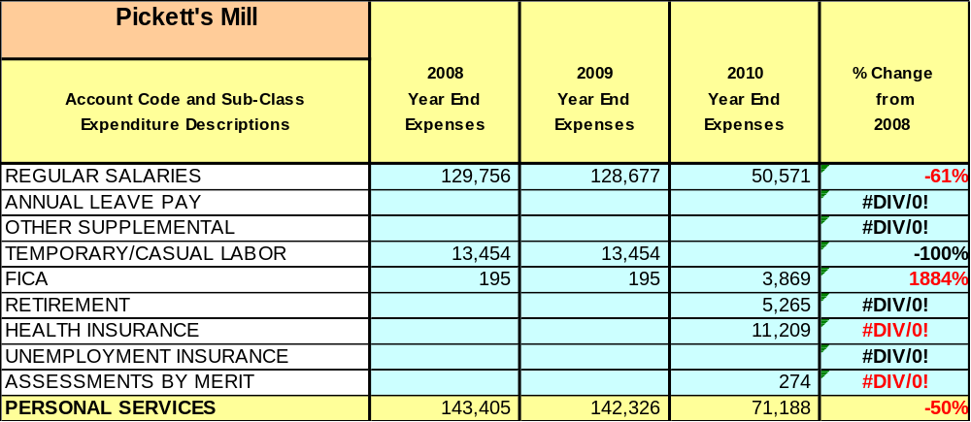

Note: Labor by code for 2008-2009 is unavailable at site level. Totals are correct.

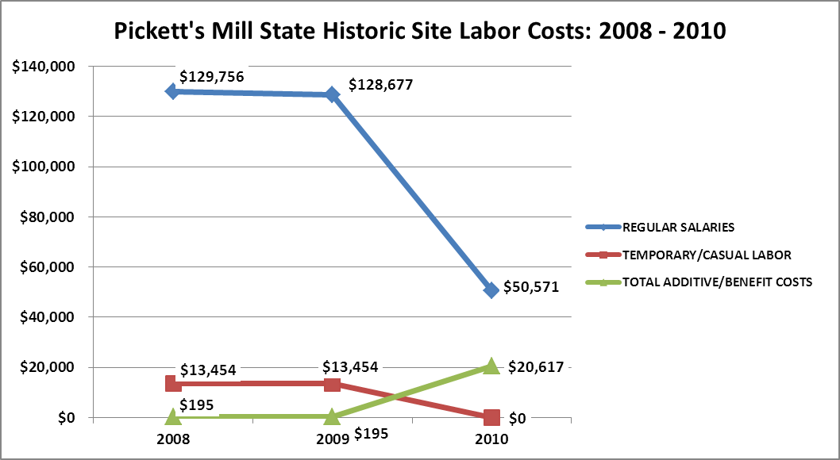

Visitation and Occupancy
Overall annual visitation to the site has trended downward from 2008 to 2010, decreasing by 9% or over 65,371 visitors. This is largely attributed to economic downturns causing decreased business levels.

Year | Total Visitation
2008 | 23,763
2009 | 24,472
2010 | 11,159

Customer Service and Satisfaction

Site: Pickett’s Mill | Year | Customer Satisfaction Level
 | 2009 | 100%
 | 2010 | 100%
Financial Performance Assessment

Operational Expenses
A summary of total operating expenses at Pickett’s Mill Historic Site from 2008 to 2010, as well as their percent change from 2008 are provided in the table below.

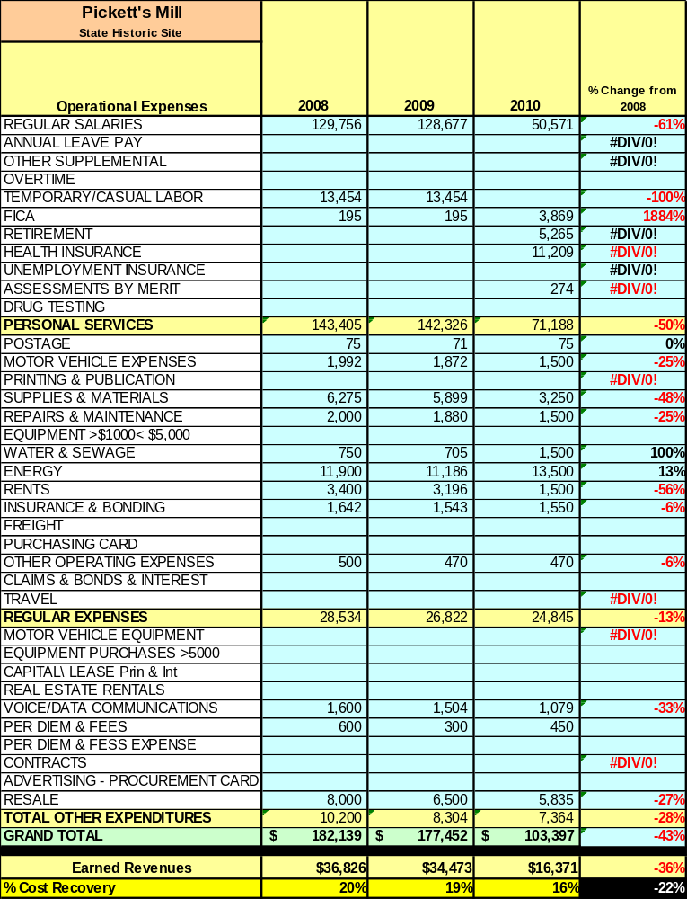

Earned Revenues
Earned revenues at Pickett’s Mill have decreased since 2008, which is largely attributed to speculation and closure of the lodge facility, decrease in overall visitation in addition, and poor economy.
Monthly earned revenues for the last two years (see table on the following page) indicate that the total annual revenue decreased 62% from 2009 to 2010, with the largest increases in monthly revenues in November (46%) and April (23%), and the largest decreases in the months of September (80%), December (88%) and January (90%).
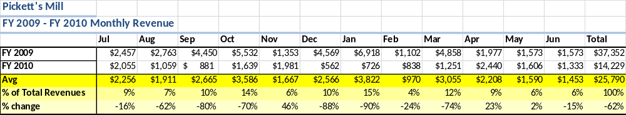

The graphs below illustrate the monthly revenue trends each year and the average percent of total annual revenue earned each month.
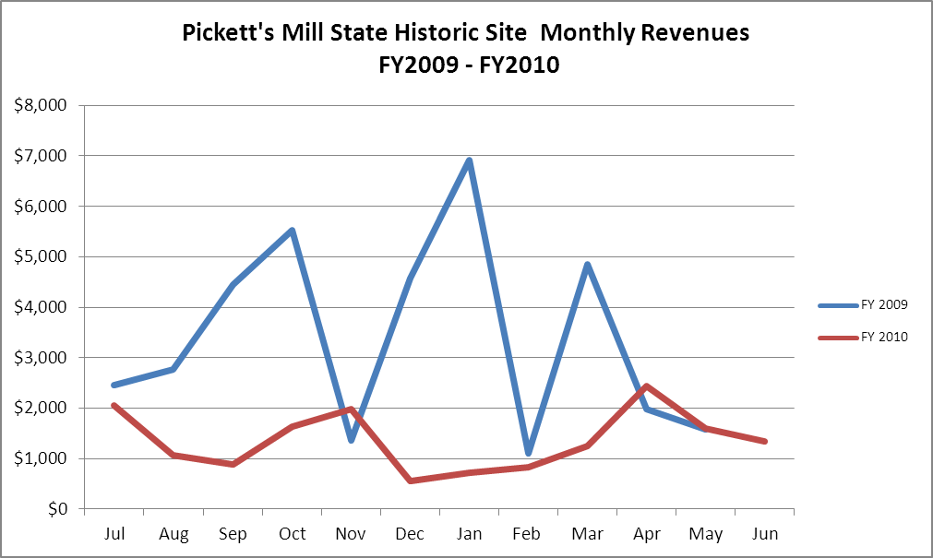

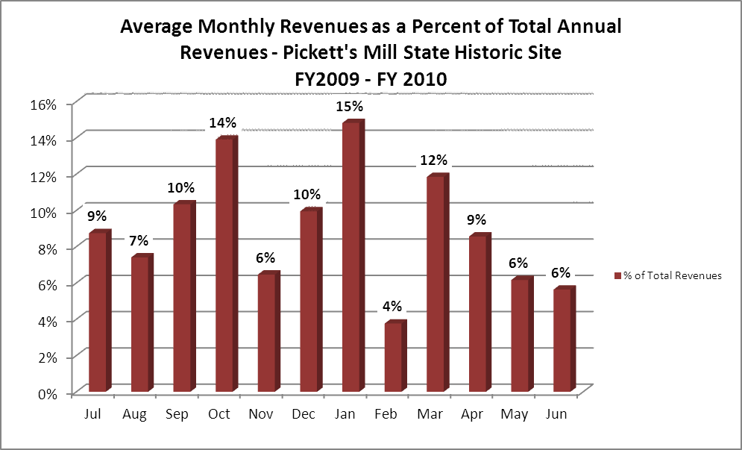

Cost Recovery Trends
Pickett’s Mill has achieved an average cost recovery of 86% of annual operational expenses through earned revenues from FY 2008 to FY 2010. This is detailed and illustrated in the table and graph below.
Year | Operational  Expenses | Earned  Revenues | Percent Cost  Recovery
2008 | $182,139 | $36,826 | 20%
2009 | $177,452 | $34,473 | 19%
2010 | $103,397 | $18523 | 18%
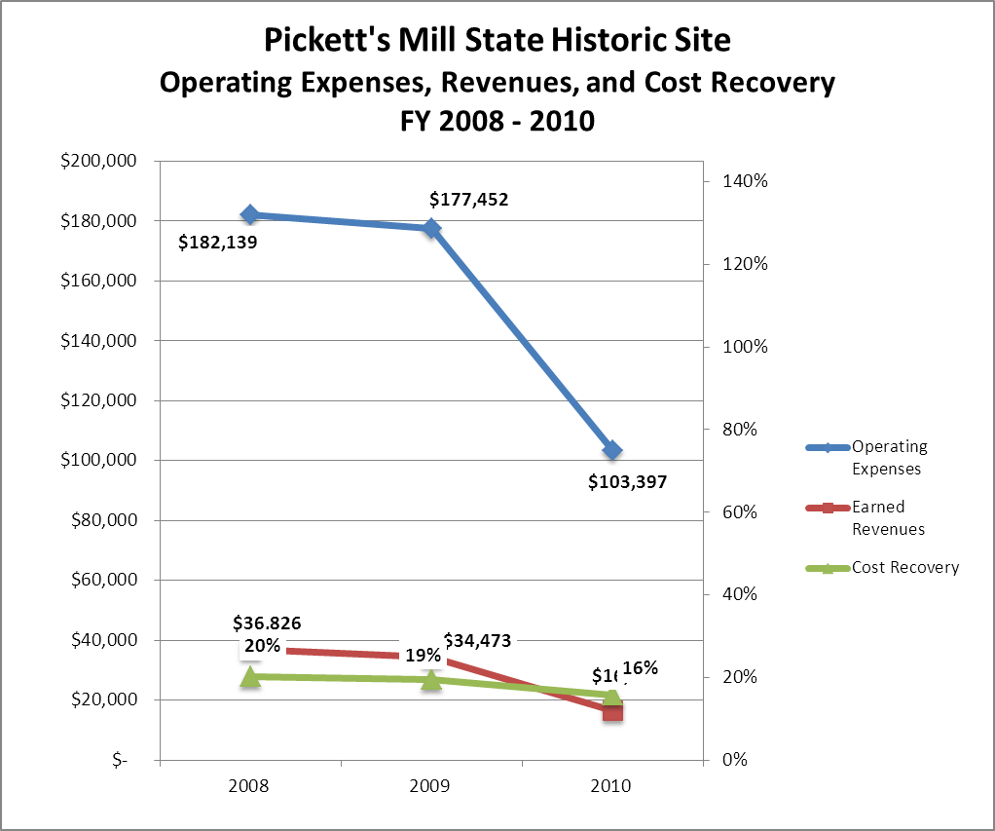

Review of Pricing
Data on rate information is available as far back as 2002, but only the last four years are evaluated. There has been little growth in fees charged at Pickett’s Mill since 2008, with the largest increase occurring across the board in 2009. A table detailing the rates for Pickett’s Mill is provided below.
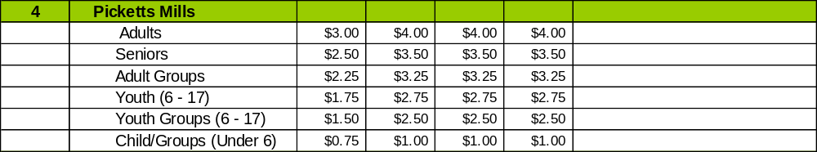

Business and Management Plan

Business Goals
The following goals serve as the foundation for the key recommendations and strategies in this business plan for Pickett’s Mill Historic Site.
Enhance Cost Recovery of Site Operations
A key outcome of this business planning process and the D15 sustainability initiative is to better define the parameters of sustainable operations for Georgia State Parks and Historic Sites. This plan identifies the criteria for sustainable operations at Hard Labor Creek State Park, as well as establishes a minimum standard under which operations at the park should be drastically altered, suspended, or discontinued.
Enhance Revenue Generation Strategies
Improving earned revenues will most likely result from the impacts of both increased traffic and visitation in the park, and increased proportional revenues from services based on pricing and fee adjustments. Proactive and progressive pricing and fees that are appropriately aligned with costs of service should be established and routinely monitored. Pricing and fee policies and practices are central to producing more resources at the park. The following recommendations should be considered and monitored over the next five years:
- Develop a cost of service assessment for each attraction, amenity and program in the site to determine its level of tax funding and or revenue contribution.
- Develop a pricing policy based on core and non-core services and based on its public, merit and private value and benefit received.
- Price services based on benefit received level of exclusivity, prime-time and non-prime time basis, season or off-season time, market place and length of stay.
- Train staff on how pricing works and how to communicate prices to users.
- Create a tiered pricing structure that encourages early reservations, off-peak usage, diverse user groups, and supports the cost recovery goals of the System.
Expand Special Events at the Site
- Establish criteria for evaluating whether programs are core programs and services, value-added, or peripheral to the mission and objectives of the site.
- Develop and implement program standards as it applies to core programs and services including health and wellness, outdoor recreation, and natural and cultural resource stewardship.
- Create functional and productive year- round programs, including enhancement of facilities and services targeting special events.
- Develop a youth services program partnership plan with youth service organizations throughout the region.
- Develop an active recreation program plan for senior adults between the age of 55 and 85 for the next ten years.
- Develop appropriate programs for people with disabilities.
- Increase programs targeting family recreation to increase families participating together.

Develop a diverse blend of special events that engage the local community and draw tourists to the Historic Site.

Develop programs that represent a tiered level of service with varied and appropriate pricing.

Reinvigorate the marketing and communications promoting programs at Pickett’s Mill Historic Site and other state parks in the region.

Improve the Diversity and Innovation of Recreational and Interpretive Programs

The needs of Historic Site guests are evolving as more diverse interests grow in the market. Pickett’s Mill can improve its ability to meet the needs of the modern user by diversifying the age appeal of the site, hosting special events and/or competitions in themes and activities that are becoming increasingly popular, and by engaging alternative providers in supporting the amenities and programs at the historic site.

Improve the Effectiveness of Marketing and Sales

The effectiveness of marketing and promotional activities of Pickett’s Mill can be improved in order to produce greater outcomes from both peak, shoulder, and off seasons. Much of this can be achieved through a shift in the basic platform of marketing to a more targeted approach and inspirational mantra. Additionally, the use of pre-season incentives to promote off season usage and advanced registration for peak and shoulder seasons will improve the ability of the park to maintain an increased and balanced flow of usage throughout the year. Most importantly, all marketing and promotional efforts must be monitored through sales goals the site – marketing without sales is just an awareness campaign that has little or no effect on the financial performance of the park.

Establish Greater Consistency of Managing and Monitoring Customer Service & Satisfaction

Creating a more efficient and consistent process for soliciting visitor and user feedback will improve the ability of the site to be a more proactive facility and service provider in the region.

Expand Partnership Opportunities

Many times partnerships are inequitable to the public agency and do not produce reasonable shared benefits between parties. The recommended policies will promote fairness and equity within the existing and future partnerships while helping staff to manage against what may have caused conflicts internally and externally. Certain partnership principles must be adopted by the Department for existing and future partnerships to work effectively.

Classification of Programs and Services
The tables below summarize the classifications of programs and services at Pickett’s Mill as either core, important, or visitor supported and projects a range of cost recovery percentages that might be achieved for each. These classifications establish financial performance goals for each category of services that are linked to the recommendations and strategies of this business plan.
Core Services
Program / Service | Target Cost Recovery
Public safety | 0%
Protection of cultural and natural resources | 0%

Important Services
Program / Service | Target Cost Recovery
Hiking trails | 50%
Self-guided interpretation and education programs | 20%
Artifact management | 20%
Historic research support | 50%
Maintenance (grass cutting, buildings, bathrooms, etc.) | 50%
Passive interpretation | 25%

Visitor Supported
Program / Service | Target Cost Recovery
Special events and staffed interpretive programming | 80%

Partnership Development Plan
The table below summarizes existing partners and targeted partnerships by classification (operational, vendor, service, co-branding, funding partners) and by organizational type.
 | Public Partners | Not-for-profit Partners | Private / Enterprise Partners
Operational Partners |  | - FOPCW  - SCV  - Re-enactors
Vendor Partners
Service Partners
Co-branding Partners
Funding Resource Development Partner |  | - FOPCW  - SCV

Marketing and Sales Plan

Marketing and Sales Goals
Marketing and sales goals for Pickett’s Mill are based on the following desired outcomes:
- Increased group visitation
- Increased public programs
In order to meet these goals, examples of specific target outcomes were identified in the areas detailed in the table below.
Area  of Focus | Current  Performance | Goal  by 2011 | Goal  by 2012 | Goal  by 2015
Candlelight Tour | 25 | 25 | 40 | 60
Cabin Life program | 40 | 40 | 80 | 150
Battle Re-enactment | 40 | 40 | 100 | 200
Guided Tour | 200 | 200 | 400 | 1000

Marketing and Promotion Strategies

Publicity and Social Media
Pickett’s Mill will approach marketing and publicity planning using the following guidelines and themes:
- Event publicity
Major events benefit by having short stories in local, regional, and statewide newspapers and online social media hooks planted that run three to four weeks in advance of the event up to the date of the event itself. Stories and media need to be cultivated with contacts and online sales channels several weeks in advance of the time the stories need to run. Special interest interviews on morning, noon, and evening television news programs, radio interviews on popular rush-hour programs, and blogs on known affinity online sites should also be included.

- Program publicity
Special and unique programs should have feature stories in magazines, local and regional weekly newspapers, and statewide daily newspapers that are aimed at placements as front-page or sectional front-page stories. These stories are most effective if they run shortly before the season that the featured program begins. This will likely require several weeks of advanced planning with media contacts. Similar coverage on television and radio should also be considered. If pre-publicity cannot be generated, post-publicity can help promote future programs.
- Site Publicity
Site publicity focusing on a single site or sub-set of sites requires more intense planning efforts to attract multiple writers and editors from target publications. The site could host several seasonal media familiarization tours (with 10 to 15 writers or editors) to familiarize them with the site and its benefits and amenities. Stories and features resulting from such tours typically take between two and six months to materialize so the tours should focus on experiences, benefits, and programs that would be available when the stories are expected to run.
Examples and suggested opportunities for events, programs and related publicity efforts based on the themes described above at Pickett’s Mill Historic Site are provided in the table below.
Event Publicity | Program Publicity | Site Publicity
FOPCCW | SCV
SCV | FOPCCW
Kennesaw College | Kennesaw College

Packaging
Examples and suggested packages for Pickett’s Mill are provided in the table below.
Package | Package Details
Home School Day | Rotating programs: Soldier life, Cabin, Weapons demonstration
Public School Day | Rotating programs: Soldier life, Cabin, Weapons demonstration

Group Sales
Types of groups within which specific target customers can be identified for Pickett’s Mill are listed below:
- School Groups | - History Groups | - Military
- Scouts  - Family Reunions | - Cyclists  - Weddings | - Dog Walkers

Incentivizing New and Repeat Visitation
Pickett’s Mill will utilize the following strategies and/or incentives to encourage new and repeat visitation starting in FY 2012:
- Creative Special Events
- Community Partnership and Outreach
Marketing and Sales Metric Goals
The following marketing and sales metric goals and/or others will be monitored and progress reported at Pickett’s Mill:
- Loyalty and repeat customers = Reenactment groups, school groups.
- Brand confidence & customers-recruiting-customers = Historical societies, word of mouth.

Revenue Generation Plan
Revenue / Cost Recovery Goals
Pickett’s Mill has set a financial goal of increasing annual revenues 3% annually between 2012 and 2015. The largest revenue growth opportunity is most likely special events attendance. The table below details projected revenue growth leading up to 2015, based upon a nominal growth of revenues each year.
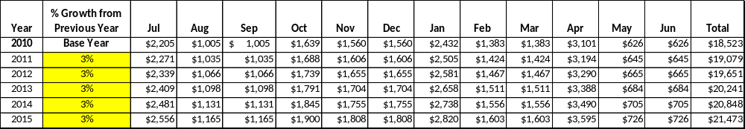

These projections would result in a total of 16% cumulative growth in total annual revenues between FY2010 and FY2015. If operational expenses can be managed with a cumulative reduction of 3% between FY 2010 and FY 2015, then the overall cost recovery of the site will be approximately 21% in FY 2015 at these projected revenue levels. This is higher than the annual financial performance of the site in FY 2010, which was operated at 16% cost recovery in that year and 19% cost recovery in 2008.
Revenue Generation Strategies

Pricing Plan
Current Pricing and Proposed CY2012 Pricing
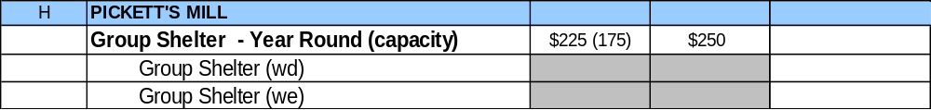

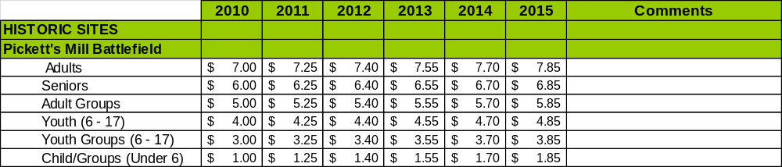

Innovative Programming and Special Events Plan
Program / Event | Theme / Purpose | Scheduled Date/Season | Frequency | Target Participation | Target User Fee | Target Cost Recovery
Behind the scenes hike | See areas of the park not on the trails | January February March | 3 times | Mixed | Regular admission fee | 50%
Soldier Life | Learn about a soldiers life | November April | 1 time | Mixed | Regular admission fee | 50%
Cabin Life | Learn about the life of farmers | May, July October December | 4 times | Mixed | Regular admission fee | 50%
Battle anniversary | Learn about the PM battle | June | 1 time | Mixed | Regular admission fee | 50%
Junior Rangers | Learn history of PM | July | 1 time | Mixed | Regular admission fee | 80%
Lecture | Learn about weapons used | August | 1 time | Mixed | Regular admission fee | 50%

Partnerships and Concessions Plan
Service / Partnership | Term of Service | Financial Objective | Contract Manager
FOPCCW | Candle Light Tour |  | Inter. Ranger
SCV | Candle Light Tour |  | Inter. Ranger

Expense Management Plan
Personnel Assignments
The following actions will be taken to proactively manage labor costs via personnel assignments and classifications.

Action | Timeline | Outcome
Utilize staff at EM & RTM to cross support Pickett’s Mill | Immediate & Ongoing | Better support for events at Pickett’s Mill.
Fill Maint. Engineer position at RTM | Spring 2012 | Better cross-site support for maintenance at all three sites
Utilize Resource Manager 2 to oversee EM and PM operations, RTM programming | Immediate & Ongoing | Increased efficiency and cross support of programs and ops.

Management Techniques
The following actions will be taken to proactively manage labor costs via management techniques.

Action | Timeline | Outcome
Utilize retired park managers with LE to support special events, heavy use weekends, etc. | Immediate | Eliminate need to fill additional salaried LE position to support site.

Adjusted Levels of Service
The following actions will be taken to proactively manage labor costs via reduced levels of service.

Action | Timeline | Outcome
Museum Hours of Operation | 2011 | Better balance service to customers at this key location, close operation at times when traffic is slow.

Financial Pro Forma
The following five-year financial pro forma projects operating expenses, earned revenues and cost recovery through FY 2015. These pro forma are based on the strategies and desired outcomes identified in this business plan, especially the revenue generation and expense management plans, and are linked to corresponding performance goals.

Expense Pro Forma
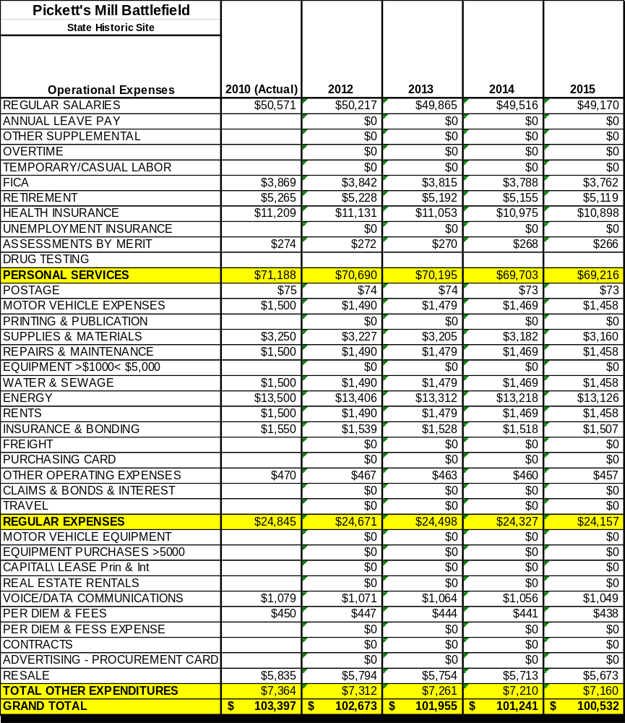

Revenue Pro Forma
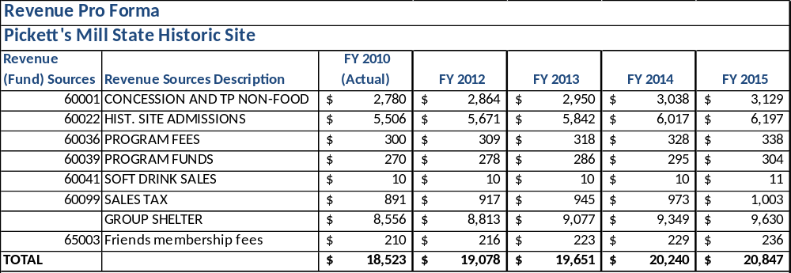

Total / Cost Recovery Pro Forma
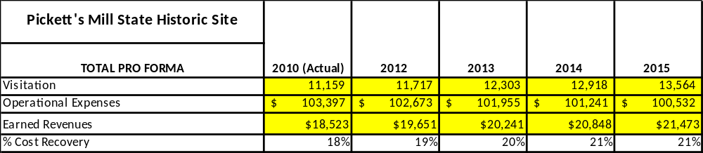

Action Plan
ACTION PLAN
Site: Pickett’s Mill |  | Site Manager: Daniel Hill |  |  | Date:
Month:
Strategy | Tasks | Costs / Funding | Revenues / ROI | Responsibilities | Metrics

ACTION PLAN
Site: Pickett’s Mill |  | Site Manager: Daniel Hill |  |  | Date:
Month:
Strategy | Tasks | Costs / Funding | Revenues / ROI | Responsibilities | Metrics

This is the average of the last three years – FY 2008, FY 2009, and FY 2010
Current employees, not including vacancies.
Current employees, not including vacancies.
Major population centers within a two-hour drive from the site

