Richard B. Russell State Park
Business & Management Plan

Prepared June 2011; Finalized December 2012
Direction 2015 – Sustainable Business Planning

Table of Contents

Executive Summary 3

Site and Operations Assessment 8
Site Inventory and Facility Assessment 8
Operational Assessment 10
Financial Performance Assessment 15

Business and Management Plan 19
Business Goals 19
Classification of Programs and Services 20
Partnership Development Plan 21
Marketing and Sales Plan 22
Revenue Generation Plan 24
Expense Management Plan 26
Financial Pro Forma 27

Action Plan 30

Executive Summary
The Parks, Recreation and Historic Sites Division (PRHSD) of the Georgia Department of Natural Resources (DNR) is transitioning the management of Richard B. Russell State Park to operate more like a business, reflecting the Direction 2015 – Sustainable Business Planning initiative to improve the fiscal performance and management of the state parks and historic sites system. This business and management plan is designed to help the site recover more operating expenses through earned revenues, productive partnerships, and innovative programs.

Site Fact Sheet
Site Name | Richard B. Russell State Park
Site Manager | TBD
Region Manager | Joe Yeager
Date of Business Plan completion | June 10, 2011
Site size | 2,508 Acres
Total number of visitors (FY 2010) | 562,515
Total operating budget (FY 2010) | $ 504,817
Total earned revenues (FY 2010) | $ 582,463
Operational cost recovery (FY 2010) | 112%
Average operating cost per visitor (FY 2010) | $ .90
Average earned revenue per visitor (FY 2010) | $ 1.00
Average cost recovery (FY 2008 – 2010) | 115%
Target cost recovery (FY 2015) | 123%
Total full-time employees | 7
Total part-time employees | 13
Primary service markets | GA – Atlanta, Augusta, Athens  SC – Greenville, Spartanburg, Anderson  NC - Asheville
Primary attractors/visitor appeal factors | Lake Richard B. Russell (boating & fishing), Arrowhead Pointe Golf Course, cottages, swimming beach
Leading opportunities for improved site performance | 3 new cottages were added in spring 2011

Site Summary and Key Attractions
Located on a 26,650-acre lake, Richard B. Russell State Park offers some of the state’s finest fishing and boating. The park’s campground and fully equipped cottages are located on or near the water’s edge for a relaxing getaway. A nature trail follows the shoreline to one of the oldest steel pin bridges in the area, loops through the adjoining woods and returns to the beach. The park's 18-hole championship golf course, Arrowhead Pointe, was named "2nd Best New Affordable Public Course in America" by Golf Digest Magazine when it opened. The course features a LEED-certified clubhouse, golf pro and junior/senior citizen discounts. Several Indian sites were excavated near the park in 1980 before the lake was filled, indicating that Paleo-Indians lived in the area more than 10,000 years ago. This area is now called Rucker’s Bottom and lies deep within the waters of Lake Richard B. Russell. All park facilities are designed for wheelchair accessibility, including the swimming beach.

Key Attractions
The amenities or features listed below are those that seem to be most popular for visitors.
- 2,508 Acres
- Arrowhead Pointe Golf Course
- 20 – 2 Bedroom Cottages
- 28 Campsites
- 27 Hole Disc Golf Course
- Lake Swimming (Beach Open Seasonally)
- Lake Richard B. Russell
- Picnic Shelters
- Group Shelter
- 2,000 Meter Olympic Rowing Lanes
- Go Fish Mega Ramp
- 5.5 miles of Multi-Use Hike or Bike Trails
- 1.5 miles of Hiking Trails

Financial Targets
The table below details the total operating expenses and earned revenues for Richard B. Russell State Park over the last three years (2008 – 2010). This table also calculates total cost per visitor and revenues per visitor during these operating years, and details the target financial performance goals in the context of achieving at least 123% cost recovery. This table also calculates the necessary change from 2010 operating expenses and revenues.

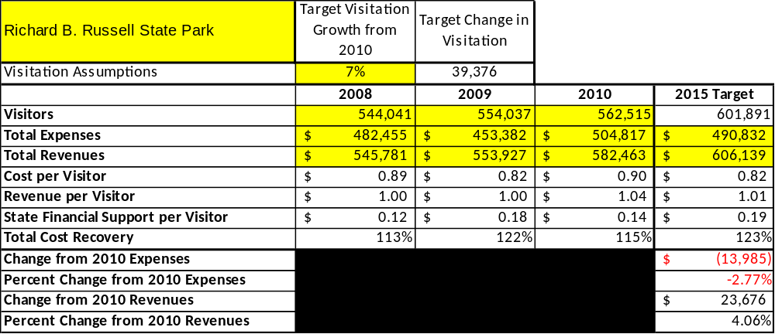

Key Recommendations

Primary / Short Term Recommendations
- In July RBR implemented a cost-based accounting system. With use of data collected, RBR will operate accordingly and make every effort to achieve a 123% cost recovery.
- RBR will distribute customer satisfaction surveys to overnight guests and encourage use of the comments section of the web-site in order to achieve a 90% or better satisfaction rating. Programs that fall below the 90% satisfaction standard will be critically reviewed. These programs will be eliminated or enhanced depending on results of the surveys.
- RBR currently contracts out the beach concession operation annually, and will consider other potential concession opportunities.
- RBR is collecting zip codes from day visitors. This information will be used to improve programming and marketing efforts.
- RBR conducts five annual special events (Jack Frost Jump (Jan.), FLW Regional Fishing Tournament (April), 4th of July Fireworks (July), Tri-the-Parks Triathlon (August), and Super 6 Series Professional Disc Golf Tournament (Sept.). RBR will continue its efforts to add new annual special events to its schedule in order to draw more visitors to the site.
- Seek local partners to help support operations, programs, and service delivery and for cross-marketing purposes.
- RBR has eliminated 3 full time salary positions in an effort to sustain sufficient non-labor operational funding or reduce staff so that required staff operational costs (with benefits) do not exceed 65% of the total operational budget.
- Enhance facilities and program offerings to provide a minimum of 10 unique experiences for each visitor while maintaining at least a 90% customer satisfaction rating. Current offerings include: Hiking, Biking, Picnicking, Canoeing, Pedal Boats, Fishing, Swimming, Geo-Caching, Disc Golf, and Boating.
- Manage Richard Russell according to well-defined maintenance, program and operational standards monitored and enforced by region managers and senior management.
- RBR partners with the local Chamber of Commerce, Elbert County Memorial Hospital and City of Elberton to promote special events and activities at Richard Russell. Hotel/Motel tax is collected and distributed to the City of Elberton where it must be spent promoting Richard B. Russell State Park.
- Perform a thorough net cost-of-service analysis on major functions of site operations, including the detailed analysis of labor requirements (by task) that has already been produced by site staff. Thereafter, update costs to deliver services on a biennial schedule.
- RBR reviews and update rates on an annual basis to recover the total net cost of service for important and visitor-supported services.
- Track total economic impact of the site on the local communities and region and share with decision-makers, elected officials, local business operators, and others to demonstrate the impact of Richard Russell state park.
- Develop a more detailed analysis of labor requirements of all major park functions to match the right position with the right job at the right pay.
- Develop funding to provide additional training to site staff for improved business management and marketing effectiveness.
- RBR has put 3 new cottages on0line in May 2011. Improved cable service has been added throughout all park facilities in March 2012. RBR could support at least 5 new cottages.
- Wi-Fi services have been added throughout the entire park; including all day-use areas. These enhancements will bring a younger market of consumer who require internet services.

Secondary / Long Term Recommendations
- Install an improved retail point-of-sale and inventory tracking system. Working with Penny to reassess retail area needs.
- Continue to develop partnerships with the City of Elberton, Elbert County Chambers of Commerce and government agencies to bring regional fishing tournaments and other events to the site.
- Look for opportunities to start a Friends Chapter at Richard Russell State Park.

Site and Operations Assessment
This site and operations assessment is a culmination of analyses and findings from a review of the condition of facilities, infrastructure, and operations at Richard B. Russell State Park. The findings and observations are not intended to be an exhaustive review of all issues present, but provide a basic understanding of the predominant issues that contribute to the site’s current operating conditions. The assessment includes the following:
- Site Inventory and Facility Assessment
- Operational Assessment
- Financial Assessment
Site Inventory and Facility Assessment

Methodology
Facility and asset conditions are rated using a differential scale of excellent, good, fair, or poor. Descriptions of conditions that are attributed to each of these findings are also provided.
Scale of Conditions
Rating | General Description
Excellent | Facilities/amenities are in ‘excellent’ condition when they show little or no maintenance or repair problems. Facilities do not feature any major design or operational issues or flaws that contribute to diminished use or increased maintenance or upkeep. Facilities are easy to clean and maintain in order to place them back into public use and the users perceive them to be in excellent shape.
Good | Facilities/amenities are in ‘good’ condition when they show only minor maintenance or repair problems. Most maintenance issues with these facilities typically appear to be the result of age and/or heavy use. Facilities may only feature minor design or operational issues that contribute to diminished use or increased maintenance or upkeep. Facilities are moderately easy to clean and maintain in order to place them back into service and the users perceive them to be adequate for their use, but probably not in excellent shape.
Fair | Facilities/amenities are in ‘fair’ condition when they show significant maintenance or repair problems. Facilities generally exhibit ongoing maintenance issues that appear to be the result of age, heavy use, or design or operational flaws. Some maintenance and repair needs may compound their fair condition by being deferred because of budget and/or resource limitations. Facilities require more effort to clean and maintain before placing them back into service and the users may perceive them as being less than adequate for their use and in a state of deterioration. The facility or structure may need of major repair or replacement.
Poor | Facilities/amenities are in ‘poor’ condition when they show significant, on-going maintenance or repair problems that ultimately may result in suspended use for repair/replacement. Maintenance and repair issues are possibly the result of poor maintenance and clearly the result of age, heavy use, or design or operational flaws. Problems with the facilities are often compounded over time due to consistently-deferred maintenance and repair because of budget and/or resource limitations. Facilities may feature major design or operational issues that contribute to diminished use or increased maintenance or upkeep. Facilities require excessive effort to clean and maintain before placing them back into service and the users often perceive them as being inadequate for their use and in a state of serious deterioration. The facility or structure may need of major repair or replacement.

Inventory and Assessment
The table below is an inventory of facilities and amenities at Richard B. Russell State Park, and provides the assessed condition of each as reviewed in May 2011.
Site Asset / Amenity | Quantity | Condition
2-Bedroom Cottages | 20 | Excellent
RV/Tent Sites | 28 | Good
Picnic Shelters | 3 | Good
Group Shelter | 1 | Excellent
Disc Golf Course | 1 | Good
Office/Gift Shop | 1 | Good
Manager’s Residence | 1 | Good
Asst. Manager’s Residence | 1 | Good
Maintenance Complex | 1 | Good
Campground Comfort Station | 1 | Good
Day-Use Comfort Station | 1 | Good
Boat Ramp Vault Restrooms | 3 | Good
Boat Ramp Pit Toilet Restrooms | 4 | Poor
Beach/Concession Complex | 1 | Good
Day-Use Playground | 1 | Excellent
Playgrounds | 2 | Excellent
Picnic Area | 1 | Good
Trails | 6 | Good

Prioritized Facility Needs
Based on the facility inventory and assessment, these prioritized needs have been identified. Each need has been aligned with a priority category of high, moderate, or low to support future decision making regarding project sequencing, investment of public resources, and meeting community expectations. The priority assignment for each need is not a measure of importance. Rather, these recommended priorities reflect a phased implementation approach over the next several years.
Facility Need | Priority Assignment
Campsite Renovation | Moderate
Day-Use / Picnic Area Renovation | Low
Fish Cleaning Station Relocation | High
Group Shelter Flooring and Lighting Renovation | Moderate
Resale Expansion at Office | Moderate
Comfort Station Renovation in Existing Campground | Low
Trail Signage | Moderate
Mega Boat Ramp Parking | High
Beach Concession Stand and Restroom Complex | Low
Coldwater Boat Ramp Pit Toilet Restroom | High
Middleton Boat Ramp Pit Toilet Restroom | High
Dry Fork Boat Ramp Pit Toilet Restroom | High
Hwy 368 Fishing Pier Pit Toilet Restroom Demolition | High
Operational Assessment
The Operational Assessment includes:
- An inventory and classification of programs and services being provided at the site
- A review of staffing at the site
- A review of concessionaires and partners operating at the site
- Visitation and customer satisfaction

Inventory and Classification of Programs and Services
Programs and services are classified into one of three major categories:
1) Core or Essential Services
2) Important Services
3) Visitor Supported Services
Programs and services at the site are classified into these categories based in part on the mission and public mandates for the site and the agency. For the programs and services in each of these categories, there are financial performance expectations that will define how services are funded and evaluated.

Category 1 – Core Services [Largely supported by tax funds]
Core programs, services and facilities are those the agency must provide and/or are essential in order to capably govern and meet statutory requirements. The failure of the agency to provide Category 1 services at adequate levels could result in significant negative consequences for the public and the resources under protection. The criteria for programs or services to be classified as core are:
- The services are mandated by the agency’s law or charter or are contractually obligated by agreement to provide the services.
- The services are essential to protecting and supporting the public’s health and safety.
- The services protect and maintain valuable assets and infrastructure.
- The services would generally and reasonably be expected and supported by residents, businesses, customers and partners.
- The services are those that cannot or should not be provided by the private sector.
- The services provide a sound investment of public funds.
The following programs and services offered at Richard B. Russell have been identified as core services:
- Open and public access to the site and its resources
- Maintenance of grounds, facilities and infrastructure
- Public safety
- Lake activities, such as Boating, Fishing, Swimming, Skiing
- Picnicking
- Trails (Hiking and Biking)
Category 2 – Important Services [Supported by a balance of tax funds and earned revenues]
Important programs, services and facilities are those the agency should provide, and are important to governing and effectively serving residents, businesses, customers and partners. Providing Category 2 services expands or enhances the agency’s ability to provide and sustain its core services. The criteria for programs or services to be classified as important are:
- The services expand, enhance or support identified core services.
- The services are broadly supported and utilized by the community, and are considered an appropriate, important, and valuable public good. Public support may be conditional upon the manner by which the services are paid for or funded.
- The services generate income or revenue that offsets some or all of the operating cost and/or are deemed to provide economic, social or environmental outcomes or results.
The following programs and services at Richard B. Russell have been identified as important services:
- Rowing lanes
- Self-directed and site appropriate recreational opportunities

Category 3 – Visitor Supported Services [Almost exclusively supported by earned revenue]
Visitor supported programs, services and facilities are those discretionary services that the agency may provide when additional funding or revenue exists to offset the cost of providing those services. Category 3 services provide added value above and beyond what is required or expected. The criteria for programs or services to be classified as visitor supported are:
- The services expand, enhance or support core services or important services and the quality of life of the visitors, community or stakeholders.
- The services are supported, valued and well utilized and provide an appropriate and valuable public benefit.
- The services generate income or funding from sponsorships, grants, user fees or other sources that offset some or all of their cost and/or provides a meaningful return on investment.

- The services can possibly be provided through outsourcing or use of concessionaires, providing opportunities for community enterprises that may not otherwise be provided by the agency.
The following programs and services offered at Richard B. Russell State Park have been identified as visitor supported services:
- Cottages
- RV camping
- Gift shop
- Special events
- Group shelters
- Picnic shelters
- Disc golf
- Pontoon Boat Rentals
- Canoe and Pedal Boat Rentals
- Bicycle Rentals

Staffing Assessment
Labor costs at Richard B. Russell State Park represent the largest area of budgetary expense at an average of 70.6% of the total operating budget each year for the last three complete years, which is higher than the target of total labor costs (including benefits) not exceeding 65% of the site’s total operating expenditures. The tables below and on the following page provide a basic review of the current staffing at the site.
Full Time Equivalent Employees
Position / Title | Quantity (FTE) | Vacancies | Annual Hours
Park Manager | 1 | 0 | 2080
Assistant Park Manager | 1 | 0 | 2080
LE Ranger | 1 | 0 | 1560
Administrative Clerk | 1 | 0 | 2080
Maintenance Ranger | 2 | 0 | 3744
Housekeeper | 1 | 0 | 2080
TOTAL | 7 | 0 | 13624

Part Time Employees
Position / Title | Quantity (FTE) | Vacancies | Hours
Maintenance Worker | 2 | 0 | 2208
Housekeepers | 7 | 0 | 7262
Night Clerk | 1 | 0 | 1508
Maintenance/Housekeepers on-call | 1 | 0 | 400
Kiosk Clerk | 2 | 0 | 400
TOTAL | 13 | 0 | 11778
Labor Support
Labor Support | Annual Hours
Volunteers | 1248
Community Service Workers
Engineering and Construction Crews
Resource Management Crews
Detainee Crews | 1960
TOTAL | 3208
Total Labor Hours
Labor Type | Annual Hours
Full Time Equivalent Employees | 13624
Part Time Employees | 11778
Labor Support | 3208
TOTAL Annual Labor Hours | 28610

Labor Budget Summary

 | Richard B. Russell State Park
 |  | 2008 | 2009 | 2010 | % Change
 | Account Code and Sub-Class | Year End | Year End | Year End | from
 | Expenditure Descriptions | Expenses | Expenses | Expenses | 2008
 | REGULAR SALARIES | 190,343 | 187,511 | 233,974 | 23%
 | ANNUAL LEAVE PAY | 0 | 0 | 0 | #DIV/0!
 | OTHER SUPPLEMENTAL | 0 | 0 | 0 | #DIV/0!
 | OVERTIME | 0 | 0 | 32 | #DIV/0!
 | TEMPORARY/CASUAL LABOR | 68,411 | 56,535 | 42,136 | -38%
 | FICA | 14,655 | 14,326 | 16,813 | 15%
 | RETIREMENT | 21,212 | 20,821 | 26,878 | 27%
 | HEALTH INSURANCE | 43,480 | 25,428 | 48,854 | 12%
 | UNEMPLOYMENT INSURANCE | 341 | 269 | 450 | 32%
 | ASSESSMENTS BY MERIT | 1,323 | 1,323 | 1,507 | 14%
 | PERSONAL SERVICES | 339,764 | 306,213 | 370,645 | 9%

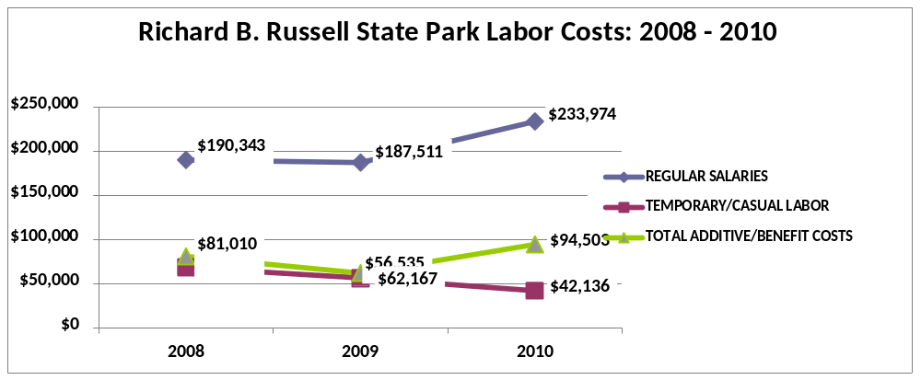
Visitation and Occupancy
Overall annual visitation to the site has trended upward from 2008 to 2010, increasing by 3.4% or over 18,000 visitors. This is largely attributed to increased local visitation as a result of gas price increases and the poor economy.

Year | Total Visitation
2008 | 544,041
2009 | 554,037
2010 | 562,515

Occupancy for the overnight accommodations at Richard B. Russell State Park the last three years is detailed in the table below. Overall occupancy has trended downward from 2008 to 2010, decreasing by 10%. This is largely attributed to the poor economy, gas prices, rate increases and a decrease in golf packages.

Year | Camping Occupancy | Cottages Occupancy
2008 | 43.23 % | 70.20 %
2009 | 37.34 % | 65.74 %
2010 | 34.88 % | 60.65 %

Customer Service and Satisfaction

Site | Year | Customer Satisfaction Level
Richard B. Russell State Park | 2009 | 80%
Richard B. Russell State Park | 2010 | 80%
*The sample size for this data is so small that it should not be considered statistically significant.
Financial Performance Assessment

Operational Expenses
A summary of total operating expenses at Richard B. Russell State Park from 2008 to 2010, as well as their percent change from 2008 are provided in the table below.

Richard B. Russell State Park | 2008 | 2009 | 2010 | % Change from 2008
Operational Expenses
REGULAR SALARIES | 190,343 | 187,511 | 233,974 | 23%
OVERTIME |  |  | 32
TEMPORARY/CASUAL LABOR | 68,411 | 56,535 | 42,136 | -38%
FICA | 14,655 | 14,326 | 16,813 | 15%
RETIREMENT | 21,212 | 20,821 | 26,878 | 27%
HEALTH INSURANCE | 43,480 | 25,428 | 48,854 | 12%
UNEMPLOYMENT INSURANCE | 341 | 269 | 450 | 32%
ASSESSMENTS BY MERIT | 1,323 | 1,323 | 1,507 | 14%
PERSONAL SERVICES | 339,764 | 306,213 | 370,645 | 9%
POSTAGE | 220 | 64 | 259 | 17%
MOTOR VEHICLE EXPENSES | 11,321 | 17,731 | 10,857 | -4%
SUPPLIES & MATERIALS | 2,294 | 2,258 | 7,629 | 232%
REPAIRS & MAINTENANCE | 9,489 | 9,782 | 9,056 | -5%
ENERGY | 59,548 | 62,086 | 61,535 | 3%
RENTS | 1,641 | 1,864 | 1,867 | 14%
INSURANCE & BONDING | 5,427 | 10,602 | 11,947 | 120%
PURCHASING CARD | 36,197 | 25,729 | 17,630
OTHER OPERATING EXPENSES | 4,675 | 4,993 | 5,533 | 18%
TRAVEL |  |  | 984 | #DIV/0!
REGULAR EXPENSES | 130,812 | 135,109 | 127,296 | -3%
VOICE/DATA COMMUNICATIONS | 4,544 | 4,347 | 2,566 | -44%
PER DIEM & FEES |  | 45
RESALE | 7,334 | 7,667 | 4,309 | -41%
TOTAL OTHER EXPENDITURES | 11,878 | 12,060 | 6,875 | -42%
GRAND TOTAL | $ 482,455 | $ 453,382 | $ 504,817 | 5%
Earned Revenues | $545,781 | $553,927 | $582,643 | -36%
% Cost Recovery | 113% | 122% | 112% | -1%

Earned Revenues
Earned revenues at Richard B. Russell State Park have increased since 2008, which is largely attributed to increased overnight rates. Monthly earned revenues for the last two years (see table below) indicate that the total annual revenue increased 5% from 2009 to 2010, with the largest increases in monthly revenues during September (61%), February (32%), March (32%), and April (58%), and the largest decreases during November (-37%), December (-37%), January (-18%), May (-12%) and June (-12%).
Richard B. Russell

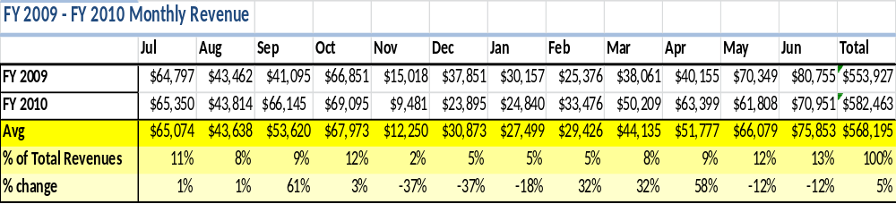

The graphs below illustrate the monthly revenue trends each year and the average percent of total annual revenue earned each month.
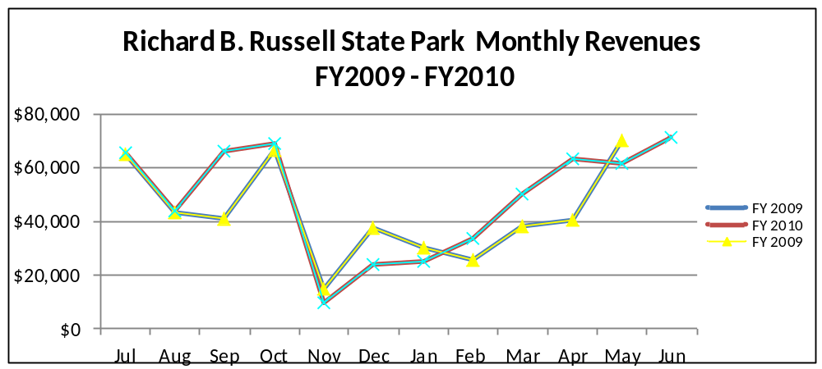

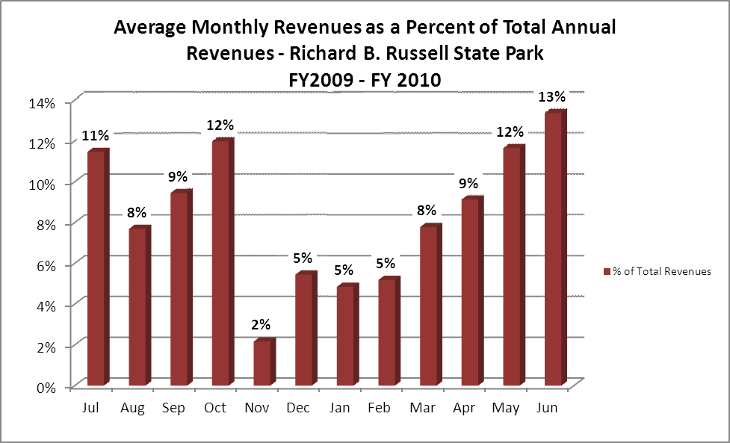
Cost Recovery Trends
Richard B. Russell State Park has achieved an average cost recovery of 115% of annual operational expenses through earned revenues from FY 2008 to FY 2010. This is detailed and illustrated in the table and graph below.
Year | Operational  Expenses | Earned  Revenues | Percent Cost  Recovery
2008 | 482,455 | 545,781 | 113%
2009 | 453,382 | 553,927 | 122%
2010 | 504,817 | 582,463 | 115%

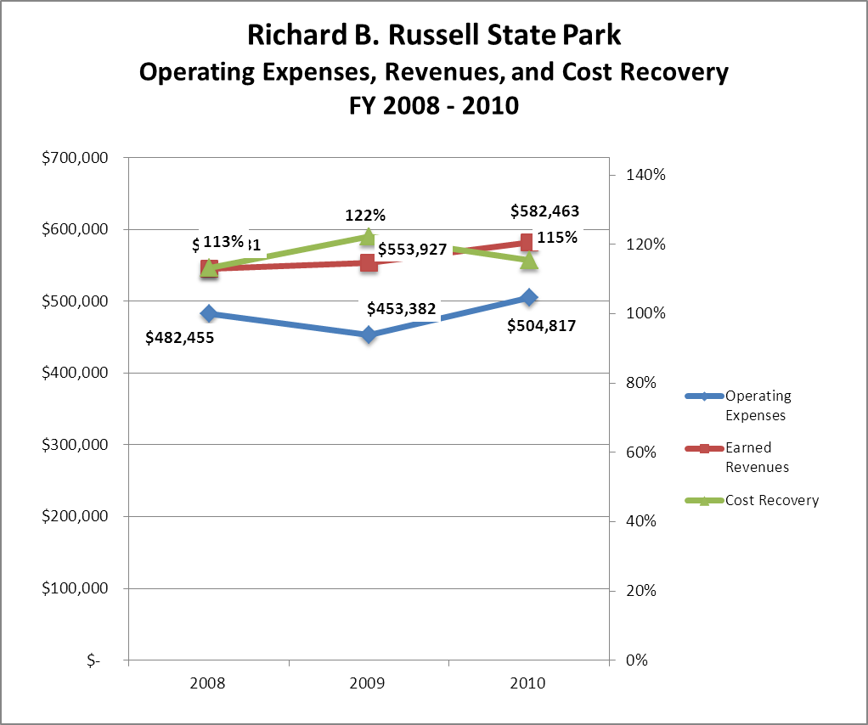

Review of Pricing
There has been notable growth in fees charged at Richard B. Russell State Park since 2008, with the largest increase being cottages. A table detailing the rates for Richard B. Russell State Park is provided below.
 |  | 2008 | 2009 |  | 2010 |  | 2011 |  | 2012
STATE PARK
RICHARD B. RUSSELL
Disc Golf |  | $2.00 | $2.00 |  | $3.00 |  | $3.00 |  | $3.00
1 Hr. Bike Rental |  |  |  |  |  |  |  |  | $5.00
4 Hr. Bike Rental |  |  |  |  |  |  |  |  | $10.00
8 Hr. Bike Rental |  |  |  |  |  |  |  |  | $15.00
1/2 Hr. Paddle Boats |  | $2.50 | $3.00 |  | $4.00 |  | $4.00 |  | $4.00
1 Hr. Paddle Boats |  | $5.00 | $6.00 |  | $7.00 |  | $7.00 |  | $7.00
1 Hr. Canoe |  | N/A | N/A |  | $5.00 |  | $5.00 |  | $5.00
4 Hr. Canoe |  | $12.00 | $12.00 |  | $15.00 |  | $15.00 |  | $15.00
8 Hr. Canoe |  | $20.00 | $20.00 |  | $25.00 |  | $25.00 |  | $25.00
8 Hr. Pontoon |  | $125.00 | $125.00 |  | $150.00 |  | $150.00 |  | $150.00
Picnic Shelters | $30.00 |  | $35.00 | $40.00 |  | $40.00 |  | $40.00
Group Shelter | $200.00 |  | $200.00 | $205.00 |  | $205.00 |  | $205.00
RV Camping | $25.00 |  | $26.00 | $28.00 |  | $28.00 |  | $28.00
Tent Camping | $23.00 |  | $24.00 | $25.00 |  | $25.00 |  | $25.00
Cottages | $120.00 |  | $130.00 | $140.00 |  | $140.00 |  | $140.00

Business and Management Plan

Business Goals
The following goals serve as the foundation for the key recommendations and strategies in this business plan for Richard B. Russell State Park.

Enhance Cost Recovery of Site Operations
Richard Russell state park is currently operating between 112-122% cost recovery for operational expenses through earned revenues. We can improve revenues through additional rental facilities. We have just added three new cottages. These new facilities should cause a significant revenue increase. Another area in which we could help revenues is to continue to market our cottages in the off-season so we can make our slow months of November, December, and January more cost recovery efficient.

Enhance Revenue Generation Strategies
Richard Russell will improve revenue generation by having more flexible and dynamic rates on overnight facilities on a walk-in basis. We will use a more targeted marketing strategy to pinpoint customers to fill our slower months with cottage and campsite rentals. This would mean targeting more colleges with rowing teams and putting together packages to make our rowing facilities more attractive. This also would entail pinpointing customers that want weekday and weekend getaways during the fall and winter months and making these getaways more attractive through reduced rates and golf packages.

Expand Special Events at the Site
With the addition of the new Go Fish mega ramp, we foresee attracting more and larger tournaments on Lake Russell. These tournaments would of course bring in more revenue, visitation and overnight occupancy for the park. This facility may also be used for other programming uses, such as boat shows, craft shows and possibly gospel sings. This is the only area with adequate parking and a possible stage.

Improve the Diversity and Innovation of Recreational and Interpretive Programs
Richard Russell has been working on an annual basis to upgrade our interpretive signage on all of our trails. We need to continue to upgrade not only these areas but also the interpretive signs at the office, beach, cottage and campground areas.

Improve the Effectiveness of Marketing and Sales
To improve the marketing at Richard Russell we need to pinpoint the off-season customer. This could be achieved by a reduced rate for these times or a winter package for multiple days. We also need to search out colleges that could use our rowing facilities and make it more attractive for them to come this time of year. Also marketing the mega ramp fishing facility and attracting several tournaments during our fall months would increase our overnight occupancy and revenues.

Establish Greater Consistency of Managing and Monitoring Customer Service & Satisfaction
Richard Russell plans to improve the consistency of monitoring customer satisfaction by conducting on-site surveys annually to assess how well customer satisfaction levels are being met. Services that fall below a 90% satisfaction level should be reviewed and enhanced and the results monitored.

Expand Partnership Opportunities
Richard Russell has limited partnership opportunities. We will seek out individuals interested in forming a Friends group. We also need to work on expanding vendor partners to reduce the costs of materials and supplies and related services needed by the site; and seeking co-branding partners to off-set event and program costs, and to expand awareness of site programs and facilities in the site’s market area.

Classification of Programs and Services
The tables below summarize the classifications of programs and services at Richard B. Russell State Park as either core, important, or visitor supported and projects a range of cost recovery percentages that might be achieved for each. These classifications establish financial performance goals for each category of services that are linked to the recommendations and strategies of this business plan.

Core Services
Program / Service | Target Cost Recovery
Open and public access to the site and its resources | 0%
Maintenance of grounds, facilities, and infrastructure | 0%
Public safety | 0%
Lake activities, Boating, Fishing, Swimming, Skiing | 0%
Picnicking | 0%
Hiking and Biking Trails | 0%

Important Services
Program / Service | Target Cost Recovery
Rowing Lanes | 0%
Self-directed and site appropriate recreational opportunities | 0%

Visitor Supported
Program / Service | Target Cost Recovery
Cottages | 150%
RV camping | 150%
Gift shop | 140%
Special events | 120%
Group shelters | 150%
Picnic shelters | 150%
Disc Golf | 150%
Pontoon rentals | 150%
Canoe and paddle boat rental | 150%
Bicycle Rentals | 150%

Partnership Development Plan
The table below summarizes existing partners and targeted partnerships by classification (operational, vendor, service, co-branding, funding partners) and by organizational type.
 | Public Partners | Not-for-profit Partners | Private / Enterprise Partners
Operational Partners | - Arrowhead Golf Course  - Highland Walk Golf Course  - Department of Corrections |  | - Christy Downey (Beach Concession)
Vendor Partners |  |  | - Coca Cola  - Hart EMC
Service Partners | - City of Elberton Georgia  - Elbert County | - Chamber of Commerce  - Elbert County EMS  - Elbert Memorial Hospital  - Whitworth Detention Center
Co-branding Partners |  |  | - Shade Tree Cabins  - Sunset Campground  - Pine-Der-Rosa Campground  - Lazy L Cabins
Funding Resource Development Partner |  | - Friends of Georgia State Parks and Historic sites

Marketing and Sales Plan

Marketing and Sales Goals
Marketing and sales goals for Richard B. Russell State Park are based on the following desired outcomes:
- Increase cottage occupancy for November through February by marketing cottages and rowing lanes to university and college rowing teams;
- Attract large fishing tournaments with high participation to help occupancy in the slow months.
In order to meet these goals, examples of specific target outcomes were identified in the areas detailed in the table below.

Area  of Focus | Current  Performance | Goal  by 2011 | Goal  by 2012 | Goal  by 2015
Total revenue | $ 582,462 | $ 587,123 | $ 591,820 | $ 606,137
Overall visitation | 562,515 | 565,000 | 575,000 | 601,891

Marketing and Promotion Strategies

Publicity and Social Media
Richard B. Russell State Park will approach marketing and publicity planning using the following guidelines and themes:
- Event publicity
Major events benefit by having short stories in local, regional, and statewide newspapers and online social media hooks planted that run three to four weeks in advance of the event up to the date of the event itself. Stories and media need to be cultivated with contacts and online sales channels several weeks in advance of the time the stories need to run. Special interest interviews on morning, noon, and evening television news programs, radio interviews on popular rush-hour programs, and blogs on known affinity online sites should also be included.
- Program publicity
Special and unique programs should have feature stories in magazines, local and regional weekly newspapers, and statewide daily newspapers aimed at placements as front-page or sectional front-page stories. These stories are most effective if they run shortly before the season that the featured program begins. This will likely require several weeks of advanced planning with media contacts. Similar coverage on television and radio should also be considered. If pre-publicity cannot be generated, post-publicity can help promote future programs.
- Site Publicity
Site publicity focusing on a single site or sub-set of sites requires more intense planning efforts to attract multiple writers and editors from target publications. Each site could host several seasonal media familiarization tours (with 10 to 15 writers or editors) to familiarize them with the site and its benefits and amenities. Stories and features resulting from such tours typically take between two and six months to materialize so the tours should focus on experiences, benefits, and programs that would be available when the stories are expected to run.
Examples and suggested opportunities for events, programs and related publicity efforts based on the themes described above at Richard B. Russell State Park are provided in the table below.

Event Publicity | Program Publicity | Site Publicity
Jack Frost Jump (January)
FLW Bass Tournament (April) | Junior Ranger camp
Chamber pre fourth fireworks (July)
Tri the Parks Triathlon (August)
Disc Golf Tournament (September) | Halloween Campsite Decorating and Costume Contest
Public Deer Hunt (December)

Packaging
Examples and suggested packages for Richard B. Russell State Park are provided in the table below.

Package | Package Details
Cottage and golf | Discounted rates on cottage and golf packages
Campsite and golf | Discounted rates on camping and golf packages
RV Club Discount | Discounted rates for RV Clubs of 10 or more during Dec., Jan., and Feb.
Rowing team discount | Discount on multiple cottages booked in slow months

Group Sales
Types of groups within which specific target customers can be identified for Richard B. Russell State Park are listed below:
- Families  - Youth service organizations  - Churches  - Rowing teams | - Business and professional groups  - Schools public and private  - Colleges  - Associations | - Other public agencies  - Women’s groups  - Men’s groups  - Fishing groups

Incentivizing New and Repeat Visitation
Richard B. Russell State Park will utilize the following strategies and/or incentives to encourage new and repeat visitation starting in FY 2012:
- Off-season discounts
- Group/bulk discounts
- Differential pricing based upon days of the week
Marketing and Sales Metric Goals
The following marketing and sales metric goals and/or others will be monitored and progress reported at Richard B. Russell State Park:
- Loyalty and repeat customers = 75% of customers repeat their visit in a 12 month period.
- Brand confidence & customers-recruiting-customers = customer referrals equal a minimum of 50%.
Revenue Generation Plan
Revenue / Cost Recovery Goals
Richard B. Russell State Park has set a financial goal of increasing annual revenues 3% annually between 2012 and 2015. The largest revenue growth opportunity is most likely cottage revenue. The table below details projected revenue growth leading up to 2015, based upon a nominal growth of revenues each year.

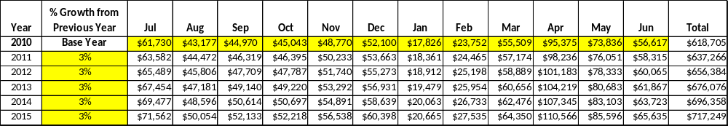

These projections would result in a total of 16% cumulative growth in total annual revenues between FY2010 and FY2015. If operational expenses can be managed with a cumulative reduction of 3% between FY 2010 and FY 2015, then the overall cost recovery of the site will be approximately 123% in FY 2015 at these projected revenue levels. This is higher than the annual financial performance of the site in FY 2010, which was operated at 115% cost recovery in that year.

Revenue Generation Strategies

Pricing Plan

Region | PARK RESERVABLES | Current Pricing (CY 2011) | Proposed Pricing  (CY 2012) | Positive Yield Management Margin (%)
1 | RICHARD B. RUSSELL
 | Picnic Shelter | $40 | 40 | 10%
 | Group Shelter (capacity-175) | $205 | 205 | 10%
 | Camping (RV) | $28 | 28 | 10%
 | Camping (TENT) | $25 | 25 | 10%
 | Cottage (2 BR) Year Round | $140 | $140 | 20%
 | Masters Week | $150 | $165 | 20%

Innovative Programming and Special Events Plan

Program / Event | Theme / Purpose | Scheduled Date/Season | Frequency | Target Participation | Target User Fee | Target Cost Recovery
Jack Frost Jump | Hospital Fundraiser | January | Annually | 300 | $200 plus ParkPasses | 120%
FLW Fishing Tournament | Fishing Tournamnet | April | Annually | 400 | $500 plus ParkPasses | 120%
Independence Day Fireworks | Independence Day | Friday prior to July 4th | Annually | 1500 | 15% sales ParkPasses | 120%
Tri the Parks | Tri-Athlon | August | Annually | 400 | $3/person ParkPasses | 120%
Super 6 Series Disc Golf Tournament | Disc Golf 2 day Tournament | September | Annually | 72 | $3/person /day plus ParkPasses | 120%

Partnerships and Concessions Plan

Service / Partnership | Term of Service | Financial Objective | Contract Manager
Beach Concessions | 4 months | 15% of gross receipts | Park Manager

Expense Management Plan
Personnel Assignments
The following actions will be taken to proactively manage labor costs via personnel assignments and classifications.
Action | Timeline | Outcome
Convert full time housekeepers to hourly positions | As position becomes vacant | Annual labor reduction of more than $16,000
Part Time Housekeeping Staff will no longer be scheduled 24/32 hours per week through winter. Housekeeping Staff will be scheduled as needed November through February. | Beginning in FY2013 | Estimated $6000 to $8000 in labor costs.

Management Techniques
The following actions will be taken to proactively manage labor costs via management techniques.
Action | Timeline | Outcome
Concession beach service | July 2012 | $800 in gross revenue and savings of $8000 in seasonal labor costs.

Adjusted Levels of Service
The following actions will be taken to proactively manage labor costs via reduced levels of service.
Action | Timeline | Outcome

Financial Pro Forma
The following five-year financial pro forma projects operating expenses, earned revenues and cost recovery through FY 2015. These pro forma are based on the strategies and desired outcomes identified in this business plan, especially the revenue generation and expense management plans, and are linked to corresponding performance goals.

Expense Pro Forma

Richard B. Russell State Park | 2010 (Actual) | 2012 | 2013 | 2014 | 2015
Operational Expenses
REGULAR SALARIES | $233,974 | $232,336 | $230,710 | $229,095 | $227,491
OVERTIME | $32 | $32 | $31 | $31 | $31
TEMPORARY/CASUAL LABOR | $42,136 | $41,842 | $41,549 | $41,258 | $40,969
FICA | $16,813 | $16,696 | $16,579 | $16,463 | $16,348
RETIREMENT | $26,878 | $26,690 | $26,503 | $26,318 | $26,133
HEALTH INSURANCE | $48,854 | $48,512 | $48,173 | $47,835 | $47,501
UNEMPLOYMENT INSURANCE | $450 | $447 | $444 | $441 | $438
ASSESSMENTS BY MERIT | $1,507 | $1,496 | $1,486 | $1,476 | $1,465
PERSONAL SERVICES | $370,645 | $368,051 | $365,474 | $362,916 | $360,376
POSTAGE | $259 | $257 | $255 | $253 | $251
MOTOR VEHICLE EXPENSES | $10,857 | $10,781 | $10,705 | $10,630 | $10,556
SUPPLIES & MATERIALS | $7,629 | $7,575 | $7,522 | $7,470 | $7,417
REPAIRS & MAINTENANCE | $9,056 | $8,992 | $8,929 | $8,867 | $8,805
ENERGY | $61,535 | $61,105 | $60,677 | $60,252 | $59,830
RENTS | $1,867 | $1,854 | $1,841 | $1,828 | $1,816
INSURANCE & BONDING | $11,947 | $11,863 | $11,780 | $11,698 | $11,616
PURCHASING CARD | $17,630 | $17,506 | $17,384 | $17,262 | $17,141
OTHER OPERATING EXPENSES | $5,533 | $5,495 | $5,456 | $5,418 | $5,380
TRAVEL | $984 | $977 | $970 | $963 | $957
REGULAR EXPENSES | $127,296 | $126,405 | $125,520 | $124,642 | $123,769
VOICE/DATA COMMUNICATIONS | $2,566 | $2,548 | $2,530 | $2,512 | $2,495
RESALE | $4,309 | $4,279 | $4,249 | $4,220 | $4,190
TOTAL OTHER EXPENDITURES | $6,875 | $6,827 | $6,779 | $6,732 | $6,685
GRAND TOTAL | $ 504,817 | $ 501,283 | $ 497,774 | $ 494,290 | $ 490,830

Revenue Pro Forms

Richard B. Russell State Park
Revenue (Fund) Sources | Revenue Sources Description | FY 2010 (Actual) | FY 2012 | FY 2013 | FY 2014 | FY 2015
60001 | CONCESSION AND TP NON-FOOD | $8,685 | $8,824 | $8,895 | $8,966 | $9,038
60002 | CANCELLATION FEES | $820 | $833 | $840 | $847 | $853
60003 | TELESCOPES | $(1,205) | $(1,224) | $(1,234) | $(1,244) | $(1,254)
60004 | COTTAGES | $363,316 | $369,152 | $372,105 | $375,082 | $378,083
60005 | CAMPING | $55,507 | $56,399 | $56,850 | $57,305 | $57,763
60007 | BOATS | $1,839 | $1,869 | $1,883 | $1,899 | $1,914
60014 | DOG FEES | $2,160 | $2,195 | $2,212 | $2,230 | $2,248
60015 | GROUP SHELTERS | $255 | $259 | $261 | $263 | $265
60017 | VENDING MACHINE COMMISSIONS | $873 | $887 | $895 | $902 | $909
60018 | WASH & DRY | $1,283 | $1,303 | $1,314 | $1,324 | $1,335
60020 | SHORT/OVER | $(1,410) | $(1,432) | $(1,444) | $(1,455) | $(1,467)
60025 | REFUNDS | $(14,212) | $(14,440) | $(14,556) | $(14,672) | $(14,789)
60028 | PICNIC SHELTERS | $745 | $757 | $763 | $769 | $775
60033 | CAMPSITE SR. CIT. DISCOUNT | $(6,541) | $(6,646) | $(6,699) | $(6,753) | $(6,807)
60036 | PROGRAM FEES | $305 | $310 | $312 | $315 | $317
60037 | MISC PARK RECEIPTS | $70 | $71 | $72 | $72 | $73
60042 | NON-COST ITEMS (FIREWOOD) | $478 | $486 | $490 | $494 | $498
60051 | DAY PASS FRISBEE GOLF | $1,181 | $1,200 | $1,210 | $1,219 | $1,229
60071 | PUBLIC DEER HUNT FEES | $780 | $793 | $799 | $805 | $812
60073 | DISABLED VETERAN DISCOUNT | $(2,255) | $(2,291) | $(2,309) | $(2,328) | $(2,346)
60075 | TV CABLE RENTAL | $(7,408) | $(7,527) | $(7,587) | $(7,648) | $(7,709)
60080 | CR CARD CHGBACKS-PARKS | $100 | $102 | $102 | $103 | $104
60082 | BAD CHECKS | $(30) | $(30) | $(31) | $(31) | $(31)
60090 | FOOD/BEVERAGE ITEMS TO GO | $2,277 | $2,313 | $2,332 | $2,350 | $2,369
60092 | "FRIENDS" DISCOUNT AT PARKS | $(6,565) | $(6,670) | $(6,723) | $(6,777) | $(6,831)
60099 | SALES TAX | $5,643 | $5,733 | $5,779 | $5,825 | $5,872
61021 | BEAVER DAM MARINA LEASE | $6,390 | $6,493 | $6,545 | $6,597 | $6,650
61100 | MISC CONCESSION AGREEMENTS | $1,083 | $1,100 | $1,109 | $1,118 | $1,127
63819 | DONATIONS-NONRESTRICTED | $2,000 | $2,032 | $2,048 | $2,065 | $2,081
63908 | OTHER-MISC | $60 | $61 | $61 | $62 | $62
66002 | CANCELLATION FEES | $4,762 | $4,838 | $4,877 | $4,916 | $4,956
66003 | REFUNDS - ADV RESERVATIONS | $(56,778) | $(57,690) | $(58,152) | $(58,617) | $(59,086)
66005 | CAMPING | $15,714 | $15,966 | $16,094 | $16,223 | $16,353
66006 | COTTAGES | $98,577 | $100,161 | $100,962 | $101,770 | $102,584
66015 | GROUP SHELTERS | $5,200 | $5,284 | $5,326 | $5,368 | $5,411
66019 | TRANSFER FEES | $1,878 | $1,908 | $1,923 | $1,939 | $1,954
66028 | PICNIC SHELTERS | $1,185 | $1,204 | $1,214 | $1,223 | $1,233
69005 | CAMPSITES - PW | $27,398 | $27,838 | $28,061 | $28,285 | $28,512
69006 | COTTAGES/CABINS | $48,275 | $49,050 | $49,443 | $49,838 | $50,237
69015 | GROUP SHELTERS | $3,030 | $3,079 | $3,103 | $3,128 | $3,153
69029 | PICNIC SHELTERS - PW | $795 | $808 | $814 | $821 | $827
 |  | $16,202 | $16,462 | $16,594 | $16,727 | $16,861
TOTAL |  | $582,463 | $591,820 | $596,554 | $601,327 | $606,137

Total / Cost Recovery Pro Forma

Richard B. Russell State Park | 2010 (Actual) | 2012 | 2013 | 2014 | 2015
TOTAL PRO FORMA
Visitation | 579,390 | 590,978 | 608,708 | 626,969 | 646,888
Operational Expenses | $504,817 | $501,283 | $497,774 | $494,290 | $490,830
Earned Revenues | $582,463 | $591,820 | $596,554 | $601,327 | $606,137
% Cost Recovery | 115% | 118% | 120% | 122% | 123%

Action Plan
ACTION PLAN
Site: |  | Site Manager: |  |  | Date:
Month:
Strategy | Tasks | Costs / Funding | Revenues / ROI | Responsibilities | Metrics

ACTION PLAN
Site: |  | Site Manager: |  |  | Date:
Month:
Strategy | Tasks | Costs / Funding | Revenues / ROI | Responsibilities | Metrics

This is the average of the last three years – FY 2008, FY 2009, and FY 2010
Current employees, not including vacancies.
Current employees, not including vacancies.
Major population centers within a two-hour drive from the site

