Red Top Mountain State Park
Business & Management Plan

Prepared June 2011; Finalized December 2012
Direction 2015 – Sustainable Business Planning

Table of Contents

Executive Summary 4
Site Fact Sheet 4
Site Summary and Key Attractions 6
Key Attractions 6
Financial Targets 7
Key Recommendations 7
Primary / Short Term Recommendations 8
Secondary / Long Term Recommendations 9
Methodology 10
Inventory and Assessment 11
Prioritized Facility Needs 12
Operational Assessment 13
Inventory and Classification of Programs and Services 13
Category 1 – Core Services ……13
Category 2 – Important Services ……………………………………………………………………………….……………14
Category 3 – Visitor Supported Services ………………………………………………………………………………..14
Staffing Assessment 16
Labor Budget Summary 17
Visitation and Occupancy 18
Customer Service and Satisfaction 18
Operational Expenses 19
Business Goals 22
Enhance Cost Recovery of Site Operations 22
Improve the Diversity and Innovation of Recreational and Interpretive Programs 22
Improve the Effectiveness of Marketing and Sales 22
Establish Greater Consistency of Managing and Monitoring Customer Service & Satisfaction 22
Expand Partnership Opportunities 22
Partnership Development Plan 24
Marketing and Sales Plan 25
Marketing and Sales Goals 25
Publicity and Social Media 25
Packaging 26
Group Sales 26
Incentivizing New and Repeat Visitation 27
Pricing Plan 28
Innovative Programming and Special Events Plan 29
Expense Management Plan 30
Management Techniques 30
Financial Pro Forma 31
Expense Pro Forma 31
Revenue Pro Forma 32
Total / Cost Recovery Pro Forma 33
Action Plan 34

Executive Summary
The Parks, Recreation and Historic Sites Division (PRHSD) of the Georgia Department of Natural Resources (DNR) is transitioning the management of Red Top Mountain State Park (RTM) to operate more like a business, reflecting the Direction 2015 – Sustainable Business Planning initiative to improve the fiscal performance and management of the state parks and historic sites system. This business and management plan is designed to help the site recover more operating expenses through earned revenues, productive partnerships, and innovative programs.

Site Fact Sheet
Site Name | Red Top Mountain State Park
Site Manager | Daniel Hill
Region Manager | Joe Yeager
Date of Business Plan completion | 6/10/11
Site size | 1775 acres
Total number of visitors (FY 2010) | 721,956
Total operating budget (FY 2010) | $ 1,873,568
Total earned revenues (FY 2010) | $ 1,812,078
Operational cost recovery (FY 2010) | 97%
Average operating cost per visitor (FY 2010) | $ 2.59
Average earned revenue per visitor (FY 2010) | $ 2.50
Average cost recovery (FY 2008 – 2010) | 85%
Target cost recovery (FY 2015) | 128%
Total full-time employees | 8
Total part-time employees | 10
Primary service markets | Metro Atlanta, Woodstock , Marietta, Roswell, Acworth, Cartersville, Rome, Calhoun, Dalton and Kennesaw
Primary attractors/visitor appeal factors | Lake Allatoona, camping and cottages, hiking trails and programming for metro users; large marina; very close to  I-75, Cartersville museums
Leading opportunities for improved site performance | - Developing partnerships with local attractions and DMOs.  - Aligning Red Top to be a successful player with the enormous LakePoint Sports complex development in our front yard.  - Continuing to evaluate upgrading or re-opening overnight facilities to remain competitive with the over 4,000 new hotel rooms to be built within 2 miles of the park over the next two years. Red Top holds the perfect location for 2-3 higher end cottages. These cottages would offer guests a mountain/lake view at the end of the peninsula with our existing cottages. These amenities will directly compete for the new business the LakePoint development will deliver to this area. Two level cottages would allow for selectable 2-bed/4-bed offerings in the same unit to provide flexibility.  - Expanding our programming offerings, and tailoring our programs to the clientele the LakePoint development will bring is also key to expanding our performance. This can be accomplished by partnering with Bass Pro Shops as they open a new store within two miles of the park in 2013.

Site Summary and Key Attractions
The 1,775-acre park of Red Top Mountain State Park (RTM) is located in a metro/rural setting two miles east of Interstate 75, centered between several large population centers and approximately 40 miles north of downtown Atlanta. Red Top is situated on U.S. Army Corps of Engineers property and is located on Lake Allatoona, one of the most heavily used Corps impoundments in the United States. In 1989, a lodge and restaurant was constructed on the park and operated until July, 2010 when closed due to budget cuts. . With closure of the lodge, the staffing and budget performance for Red Top have been significantly improved and the site is expected to consistently exceed operating expense with generated revenue. For FY 2012 Red Top Mountain will realize a 119% – 124% return on investment. Red Top offers several choices of activities and the town of Cartersville 5 miles from the park offers several world-quality museums and attractions. Red Top Mountain is the host park for operation of two nearby historic sites: Etowah Mounds (Cartersville) and Pickett’s Mill Battlefield (Dallas). The proximity of population centers, interstate, recreational and cultural offerings should benefit the park’s ability to achieve the identified cost recovery target. Concerning analysis of expenditures, revenues, and facilities, it should be noted that the baseline figures reported are from years (fiscal years 2008, 2009 and 2010) that the lodge facilities were open and operating. Effective July 1, 2010 (beginning FY 2011), Red Top Mountain has been operated as a traditional state park (no lodge). As such, the financial history prior to FY11 reported in this plan will not have much relevance to the projections forecast for the next several years at Red Top Mountain.

Key Attractions
The amenities or features listed below are those that seem to be most popular for visitors.
- Hiking Trails
- Day-Use activities (picnic, beach, group and picnic shelter rentals)
- Boating and lake activities, supported by boat ramps
- Park Marina
- Campground
- Rental cabins
- Programs and special events
- Allatoona Pass, Etowah Mounds, Pickett’s Mill
- Nearby world-class museums in Cartersville

Financial Targets
The table below details the total operating expenses and earned revenues for Red Top Mountain over the last three years (2008 – 2010). This table also calculates total cost per visitor and revenues per visitor during these operating years, and details the target financial performance goals in the context of achieving at least 113% cost recovery. This table also calculates the necessary change from 2010 operating expenses and revenues.

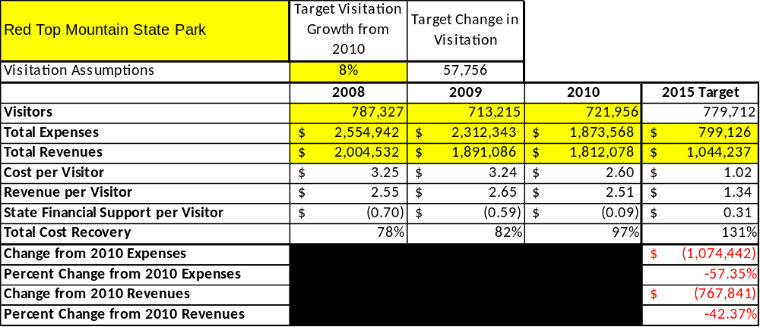

Key Recommendations

Primary / Short Term Recommendations
- Operate the site using cost-based accounting, including the net cost recovery achieved annually.
- Conduct in-park surveys annually to assess how well customer satisfaction levels are being met. RTM should strive to have 90% of visitors responding to ‘Comment Cards’ report that they were either ‘satisfied’ or ‘very satisfied’ (or some comparable metric to be developed). Programs or services that fall below that standard should be critically reviewed, enhanced, and results monitored; those with a history of poor performance should be considered for elimination.
- Evaluate and pursue opportunities to employ concessionaires or private or public service providers on-site if they can be more cost-effective. For example, explore the development of a concessionaire agreement for beach concession.
- Collect a statistically-valid sample of ZIP code data from visitors in a non-intrusive way to gauge their origins and demographics (e.g., age, ethnicity, income, etc.) and use the results to improve programming and marketing efforts to appeal to a broader audience.
- Utilize a minimum of twelve special events annually to help draw more visitors to the site.
- Seek local partners to help support operations, programs, and service delivery and for cross-marketing purposes.
- Sustain sufficient non-labor operational funding or reduce staff so that required staff operational costs (with benefits) do not exceed 65% of the total operational budget.
- Enhance facilities and program offerings to provide a minimum of 10 unique experiences for each visitor while maintaining at least a 90% customer satisfaction rating.
- Manage Red Top Mountain and satellite operations according to well-defined maintenance, program and operational standards monitored and enforced by region managers and senior management.
- Partner with local Chambers of Commerce, CVB, or other destination marketing organizations (DMOs) to promote RTM.
- Continue to work with the RTM Chapter of the Friends of Georgia State Parks and Historic Sites to help raise funds or provide volunteers for improvements and program support.
- Perform a thorough net cost-of-service analysis on major functions of site operations, including the detailed analysis of labor requirements (by task) that has already been produced by site staff. Thereafter, update costs to deliver services on a biennial schedule.
- Review and update rates at the site on an annual basis to recover the total net cost of service for important and visitor-supported services.
- Track total economic impact of the site on the local communities and region and share with decision-makers, elected officials, local business operators, and others to demonstrate the impact of RTM.
- Develop a more detailed analysis of labor requirements of all major park functions to match the right position with the right job at the right pay.
- Develop funding to provide additional training to site staff for improved business management and marketing effectiveness.
- Construct and upgrade facilities and amenities at the site that are likely to have a cost recovery level at or above 100%. Suggestions include additional yurts in the campground, multi-family cabin facilities and cabin boat docks, and an additional parkpass kiosk.
- Regain our presence in the local school community with program / educational offerings at Allatoona Pass, Red Top, Etowah Mounds and Pickett’s Mill.
- Fill critical manager level vacancies to enhance our ability to drive the business plan.
- Improve internet connectivity to key venues including the Visitor Center and Park Office.
- Develop immediate partner/amenity packages with local attractions, Park Marina, and reopen the pool facility to cottage and camper overnight guests.

Secondary / Long Term Recommendations
- Evaluate and adjust hourly staffing rules to allow full-time employment for hourly employees and thereby more scheduling and operational efficiencies.
- Engage the local community, user groups, and private organizations to improve connectivity.
- Install an improved retail point-of-sale and inventory tracking system.
- Continue partnering with Friends chapter to promote several large special events each year and develop long range plans that utilize Friends of Red Top as key operational partners.
- Continue evaluating the best use of personnel to cover Red Top Mountain, Pickett’s Mill, and Etowah Mounds operations. Achieve a personnel cost to budget ratio of below 65% at Red Top.
- Continue to evaluate the integration of Park Marina’s operation within Red Top, and revisit concession revenue percentage at time of renewal.

Site and Operations Assessment
This site and operations assessment is a culmination of analyses and findings from a review of the condition of facilities, infrastructure, and operations at Red Top Mountain State Park. The findings and observations are not intended to be an exhaustive review of all issues present, but provide a basic understanding of the predominant issues that contribute to the site’s current operating conditions. The assessment includes the following:
- Site Inventory and Facility Assessment
- Operational Assessment
- Financial Assessment
Site Inventory and Facility Assessment

Methodology
Facility and asset conditions are rated using a differential scale of excellent, good, fair, or poor. Descriptions of conditions that are attributed to each of these findings are also provided.
Scale of Conditions
Rating | General Description
Excellent | Facilities/amenities are in ‘excellent’ condition when they show little or no maintenance or repair problems. Facilities do not feature any major design or operational issues or flaws that contribute to diminished use or increased maintenance or upkeep. Facilities are easy to clean and maintain in order to place them back into public use and the users perceive them to be in excellent shape.
Good | Facilities/amenities are in ‘good’ condition when they show only minor maintenance or repair problems. Most maintenance issues with these facilities typically appear to be the result of age and/or heavy use. Facilities may only feature minor design or operational issues that contribute to diminished use or increased maintenance or upkeep. Facilities are moderately easy to clean and maintain in order to place them back into service and the users perceive them to be adequate for their use, but probably not in excellent shape.
Fair | Facilities/amenities are in ‘fair’ condition when they show significant maintenance or repair problems. Facilities generally exhibit ongoing maintenance issues that appear to be the result of age, heavy use, or design or operational flaws. Some maintenance and repair needs may compound their fair condition by being deferred because of budget and/or resource limitations. Facilities require more effort to clean and maintain before placing them back into service and the users may perceive them as being less than adequate for their use and in a state of deterioration. The facility or structure may need of major repair or replacement.
Poor | Facilities/amenities are in ‘poor’ condition when they show significant, on-going maintenance or repair problems that ultimately may result in suspended use for repair/replacement. Maintenance and repair issues are possibly the result of poor maintenance and clearly the result of age, heavy use, or design or operational flaws. Problems with the facilities are often compounded over time due to consistently-deferred maintenance and repair because of budget and/or resource limitations. Facilities may feature major design or operational issues that contribute to diminished use or increased maintenance or upkeep. Facilities require excessive effort to clean and maintain before placing them back into service and the users often perceive them as being inadequate for their use and in a state of serious deterioration. The facility or structure may need of major repair or replacement.

Inventory and Assessment
The table below is an inventory of facilities and amenities at Red Top Mountain State Park and provides the assessed condition of each as reviewed in May 2011.
Site Asset / Amenity | Quantity | Condition
Total Acreage | 1,775 | Good
Visitor Center | 1 | Fair
Historic Interpretive Cabin | 1 | Good
Iron Furnace Casting Shed | 1 | Excellent
Rental Cabins | 18 | Good
Campsites | 92 | Fair
Swimming Beach | 1 | Fair
Beach Building/Concession | 1 | Poor
Miniature Golf | 1 | Good
Hiking Trails | 8 | Good
Group Shelters | 2 | Fair
Park Office (Old Conference Ctr) | 1 | Good
Closed lodge rooms and pool | 33 | Fair
Picnic Shelters | 8 | Good
Comfort Stations | 9 | Fair
Boat Ramps | 2 | Good
Tennis Courts | 2 | Good
Maintenance Facility | 1 | Good
Playgrounds | 2 | Good
Day-Use Picnic Areas | 4 | Fair
Allatoona Pass Battlefield AreaA. are HistArea | 1 | Excellent
Manager Residence | 1 | Excellent
Asst. Manager Residence | 1 | Good
Enforcement Ranger Residence | 1 | Good
Intern Residence | 1 | Good
Wastewater Treatment Facility | 1 | Good
Boat Docks | 2 | Good
Park Marina (outsourced) | 1 | Good

Prioritized Facility Needs
Based on the facility inventory and assessment, these prioritized needs have been identified. Each need has been aligned with a priority category of high, moderate, or low to support future decision making regarding project sequencing, investment of public resources, and meeting community expectations. The priority assignment for each need is not a measure of importance. Rather, these recommended priorities reflect a phased implementation approach over the next several years.

Facility Need | Priority Assignment
Expansion of Visitor Center & centralize park office | Low
Replace campground comfort stations | High
Install boat docks at cabin area | High
Renovate and rehab picnic areas | High
Renovate or replace beach concession and restrooms | High
Renovate campsites, add utilities to no power no water campsites, add additional sites | High
Replace park interior signs and highway trail blazer signs | High
Replace trail steps to Allatoona Pass Star Fort | Moderate
Renovate Group Shelter 2 and add playground | Moderate
Stabilize shoreline erosion in camping and Webster’s Ferry areas | Moderate
Construct 4-5 yurts in campground | Moderate
Construct 2 additional cabins | Moderate

Operational Assessment
The Operational Assessment includes:
- An inventory and classification of programs and services being provided at the site
- A review of staffing at the site
- A review of concessionaires and partners operating at the site
- Visitation and customer satisfaction

Inventory and Classification of Programs and Services
Programs and services are classified into one of three major categories:
1) Core or Essential Services
2) Important Services
3) Visitor Supported Services
Programs and services at the site are classified into these categories based in part on the mission and public mandates for both the site and the agency. For the programs and services in each of these categories, there are financial performance expectations that will define how services are funded and evaluated.

Category 1 – Core Services [Largely supported by tax funds]
Core programs, services and facilities are those the agency must provide and/or are essential in order to capably govern and meet statutory requirements. The failure of the agency to provide Category 1 services at adequate levels could result in significant negative consequences for the public and the resources under protection. The criteria for programs or services to be classified as core or essential are:
- The services are mandated by the agency’s law or charter or are contractually obligated by agreement to provide the services.
- The services are essential to protecting and supporting the public’s health and safety.
- The services protect and maintain valuable assets and infrastructure.
- The services would generally and reasonably be expected and supported by residents, businesses, customers and partners.
- The services are those that cannot or should not be provided by the private sector.
- The services provide a sound investment of public funds.
The following programs and services offered at Red Top Mountain State Park have been identified as core services:
- Access to publicly owned lands and Lake Allatoona
- Safe environment for public to utilize these lands
- Protection of cultural and natural resources on site
- Maintenance of the grounds, facilities, and structures
- Site appropriate education, interpretation and recreational opportunities

Category 2 – Important Services [Supported by a balance of tax funds and earned revenues]
Important programs, services and facilities are those the agency should provide, and are important to governing and effectively serving residents, businesses, customers and partners. Providing Category 2 services expands or enhances the agency’s ability to provide and sustain its core services. The criteria for programs or services to be classified as important are:
- The services expand, enhance or support identified core services.
- The services are broadly supported and utilized by the community, and are considered an appropriate, important, and valuable public good. Public support may be conditional upon the manner by which the services are paid for or funded.
- The services generate income or revenue that offsets some or all of the operating cost and/or are deemed to provide economic, social or environmental outcomes or results.
The following programs and services offered at Red Top Mountain State Park have been identified as important services:
- Hiking trails
- Boat ramps
- Picnic areas
- Passive interpretation (bulletin boards, interpretive panels, maps, etc.)
- Picnic shelter rentals
- Visitor Center & Park Office
- Swimming beach
- Camping facilities
- Public restrooms
- Administrative and maintenance services

Category 3 – Visitor Supported Services [Almost exclusively supported by earned revenue]
Visitor supported programs, services and facilities are those discretionary services that the agency may provide when additional funding or revenue exists to offset the cost of providing those services. Category 3 services provide added value above and beyond what is required or expected. The criteria for programs or services to be classified as visitor supported are:
- The services expand, enhance or support core services or important services and the quality of life of the visitors, community or stakeholders.
- The services are supported, valued and well utilized and provide an appropriate and valuable public benefit.
- The services generate income or funding from sponsorships, grants, user fees or other sources that offset some or all of their cost and/or provides a meaningful return on investment.

- The services can possibly be provided through outsourcing or use of concessionaires, providing opportunities for community enterprises that may not otherwise be provided by the agency.

The following programs and services offered at Red Top Mountain State Park have been identified as visitor supported services:
- Rental cabins
- Park Marina – boat rentals
- Active interpretive programming and special events
- Group shelter rentals
- Pioneer camping areas
- Tennis courts
- Miniature golf
- Retail operations (beach, office, visitor center)

Staffing Assessment
Labor costs at Red Top Mountain represent the largest area of budgetary expense at an average of 60% of the total operating budget each year for the last three complete years, which is lower than the target of total labor costs (including benefits) not exceeding 65% of the site’s total operating expenditures. The tables below and on the following page provide a basic review of the current staffing at the site.
Full Time Equivalent Employees
Position / Title | Quantity (FTE) | Vacancies | Annual Hours
Park Manager 3 | 1 | 0 | 2600
Park Asst. Manager 2 | 1 | 0 | 2600
Resource Mgr. 2 (EM&PM) | 1 | 0 | 2600
Parks Enforcement Ranger | 0 | 1 | 1000
General Trades Craftsman | 2 | 0 | 2080
Accounting Clerk | 1 | 0 | 2080
Clerk 1 | 1 | 0 | 2080
Housekeeping Team Leader | 1 | 0 | 2080
TOTAL | 8 | 1 | 17120

Part Time Employees
Position / Title | Quantity (FTE) | Vacancies | Hours
Seasonal Naturalist | 1 | 0 | 1508
Park Services Worker (Hourly) | 2 | 0 | 3016
Park Services Worker (Clerk) | 4 | 0 | 5500
Park Services Worker (Housekeeper) | 3 | 0 | 4524
TOTAL | 9 |  | 14,548

Labor Support
Labor Support | Annual Hours
Volunteers | 1,600
ParkPass Kiosk Attendant | 1508
Community Service Workers | 2,912
Engineering and Construction Crews | 300
Resource Management Crews | 40
Prison Crew Detail | 5,200
TOTAL | 11,560

Total Labor Hours
Labor Type | Annual Hours
Full Time Equivalent Employees | 17,120
Part Time Employees | 14,548
Labor Support | 13,288
TOTAL Annual Labor Hours | 44,956

Labor Budget Summary
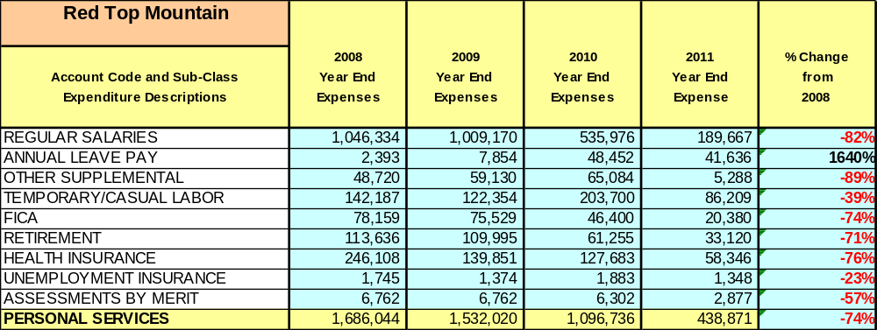

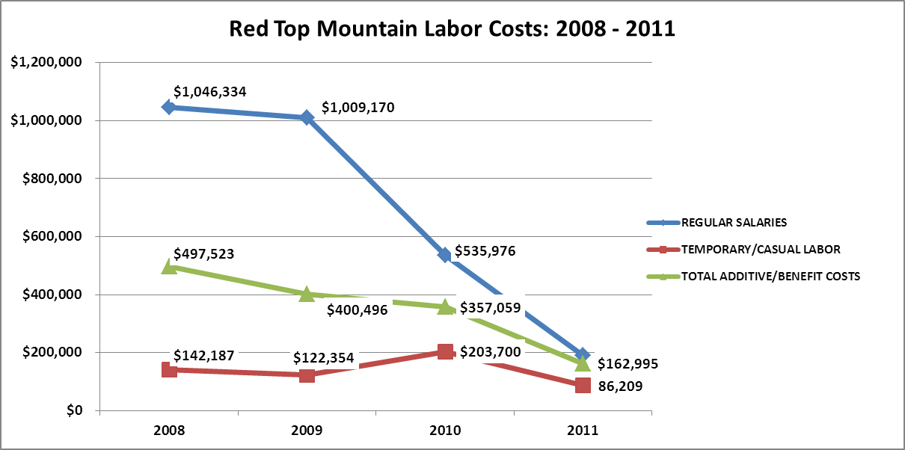

Visitation and Occupancy
Overall annual visitation to the site has trended downward from 2008 to 2010, decreasing by 9% or over 65,371 visitors. This is largely attributed to economic downturns causing decreased business levels at the lodge and marina, very cold winters, reductions in programming staff and interpretive programs, and reaction to the news of the impending lodge closure.
Year | Total Visitation
2008 | 787,327
2009 | 713,215
2010 | 721,956

Occupancy for the overnight accommodations at Red Top Mountain State Park the last three years is detailed in the table below. Overall occupancy has trended downward from 2008 to 2011, decreasing by 8%. This is largely attributed to economic downturns effecting leisure travel and expenditures, park operational adjustments, and possibly an incorrect occupancy percentage for the campground in 2008.
Year | Camping Occupancy | Cottage Occupancy | Lodge Occupancy
2008 | 44% | 61% | 49%
2009 | 40% | 57% | 37%
2010 | 38% | 53% | 39%
2011 | 35.7% | 38.4%*  *3 month cottage renovation | 0%

Customer Service and Satisfaction
Park management is taking a proactive approach in response to customer complaints, both at the staff level and public levels. Along with implementing strategies across the board to improve our service delivery and customer experience, park management is reviewing and responding to the online customer comments, including gastateparks.org as well as Trip Advisor.
Site: | Year | Customer Satisfaction Level
Red Top Mountain State Park | 2009 | Not Available
Red Top Mountain State Park | 2010 | 60%
Financial Performance Assessment

Operational Expenses
A summary of total operating expenses at Red Top Mountain State Park from 2008 to 2012 Projected, as well as their percent change from 2008 are provided in the table below.

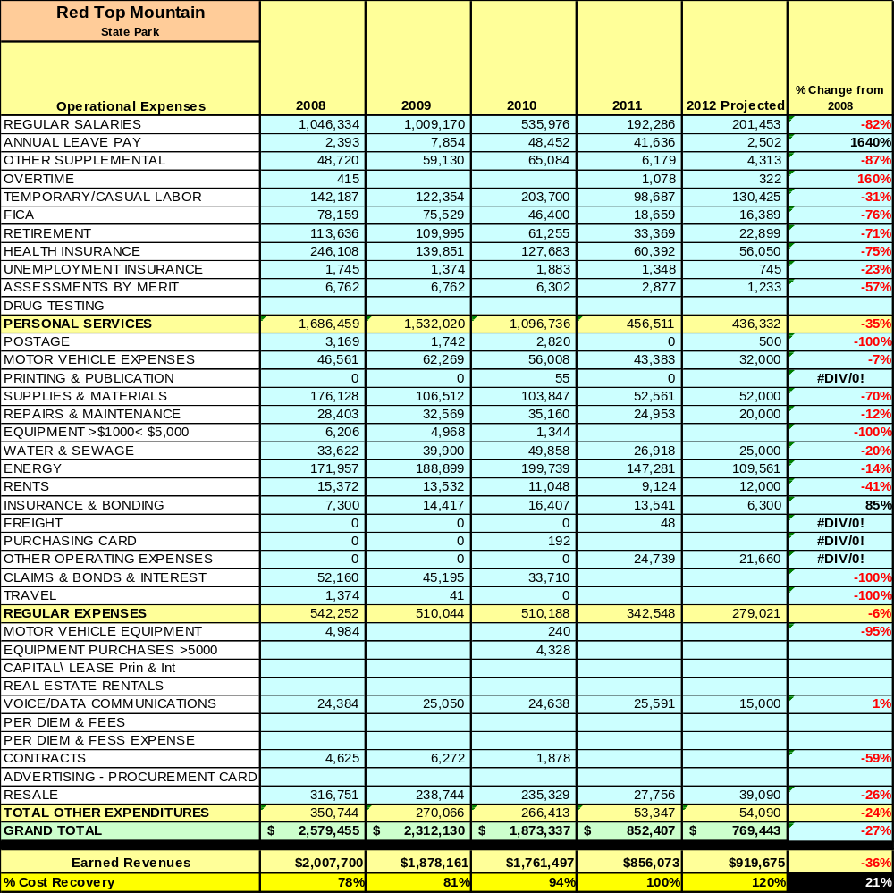

Earned Revenues
Earned revenues at Red Top Mountain have decreased since 2008, which is largely attributed to speculation regarding the closure of the lodge facility, decrease in overall visitation, and in addition the poor economy. Monthly earned revenues for the last two years (see table below) indicate that the total annual revenue decreased 7% from 2009 to 2010, with the largest increases in monthly revenues in October (18%), and the largest decreases in the months of August (-16%), January (-18%),
February (-17%), March (-17%), May (-11%) and June (-11%).

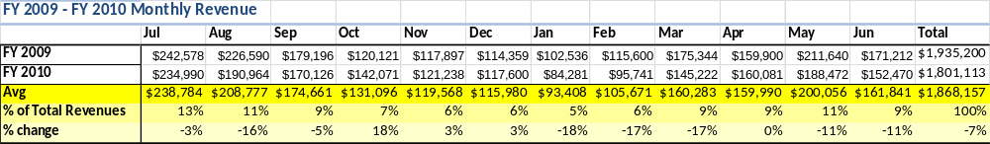

The graphs below illustrate the monthly revenue trends each year and the average percent of total annual revenue earned each month.
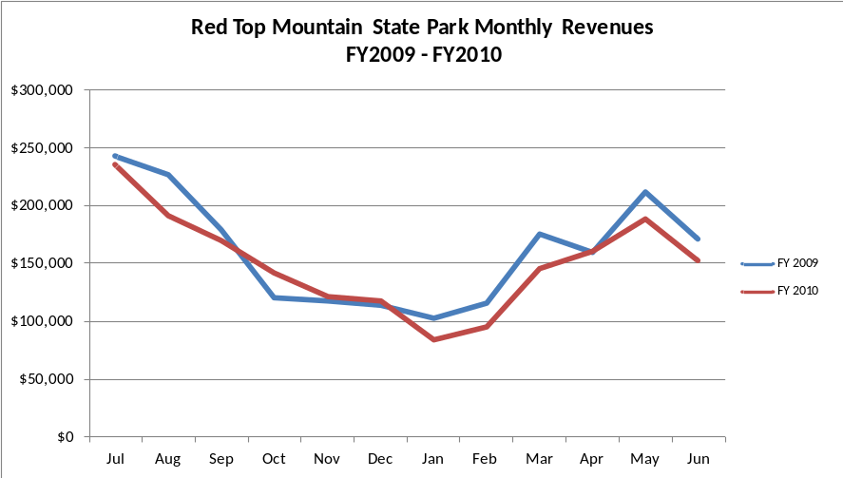

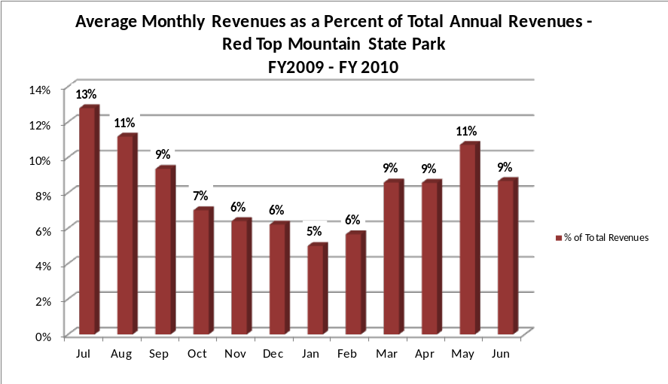

Cost Recovery Trends
Red Top Mountain has achieved an average cost recovery of 85% of annual operational expenses through earned revenues from FY 2008 to FY 2010. This is detailed and illustrated in the table and graph below.
Year | Operational  Expenses | Earned  Revenues | Percent Cost  Recovery
2008 | $2,535,200 | $2,007,700 | 79%
2009 | $2,253,532 | $1,878,161 | 83%
2010 | $1,822,987 | $1,761,497 | 97%

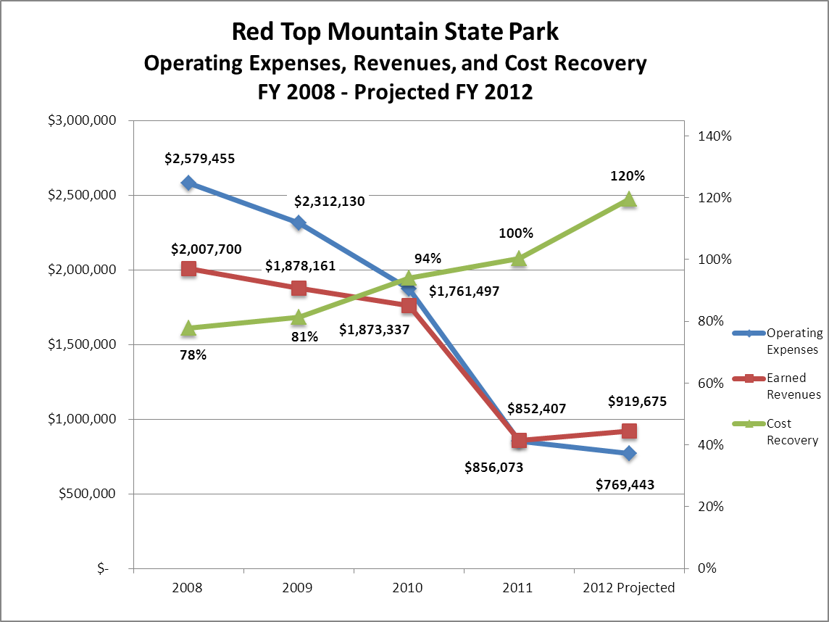

Review of Pricing
There has been notable growth in fees charged at Red Top Mountain since 2005, with the largest increase being the yurts and campsites. A table detailing the rates is provided below.
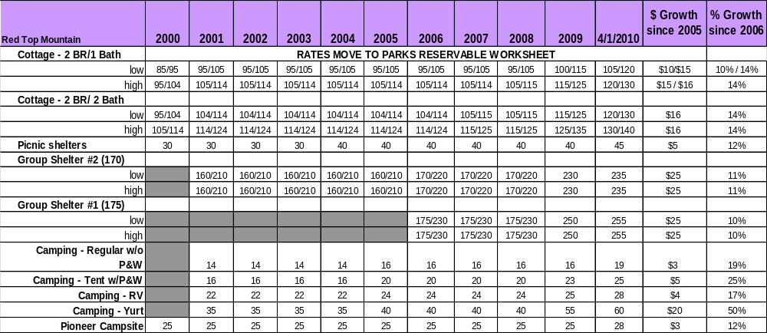

Business and Management Plan

Business Goals
The following goals serve as the foundation for the key recommendations and strategies in this business plan for Red Top Mountain State Park.

Enhance Cost Recovery of Site Operations
Red Top Mountain State Park is already a high performing site in the Georgia State Parks and Historic Sites System with an average recovery of 85% of operating expenses through earned revenues each year. It is critical that the park continue to perform at this level, and potentially seek to enhance the recovery of operating expenses to no less than 118% through improving revenue generation versus further cutting of expenses.

Improve the Diversity and Innovation of Recreational and Interpretive Programs
Red Top is expanding program opportunities by bring in outside providers. Some of our outside providers are REI, South East Bluegrass Association, Southeast School of Survival, and Atlanta Astronomy Club. Interpretation of our history and iron pours continues as a focus. Improving passive interpretation and educational displays around our history is key to market to our guests. We are developing a mobile set of interpretive panels which can be customized and transported to any special event will help draw our visitors into the Red Top experience.

Improve the Effectiveness of Marketing and Sales
The effectiveness of marketing and promotional activities of Red Top Mountain State Park can be improved in order to produce greater outcomes from both peak, shoulder, and off seasons by utilizing the Friends of Red Top to sponsor marketing tools such as local advertisements in media (radio, flyers, brochures, etc.). Park management is also working with Bartow CVB and the Historic High Country to ensure our presence in those community round tables and other associations. Being integrated with the local community for support and networking is necessary for success within the Bartow County business community.

Establish Greater Consistency of Managing and Monitoring Customer Service & Satisfaction

Creating a more efficient and consistent process for soliciting visitor and user feedback will improve the ability of the park to be a more proactive facility and service provider in the region.

Expand Partnership Opportunities
Red Top has engaged its Friends Group as a partner to help the site meet or exceed its sustainability goals. The realization of these goals has just begun. The Friends of Red Top Mountain have been instrumental over the last year in engaging the local CVB with park management in various region-wide programming projects. These relationships have been reinforced with hands-on participation between the Friends chapter and site staff. The Friends of Red Top Mountain have a strong presence in many of our public programs. Their assistance with marketing to these associations will continue to solidify success for Red Top Mountain and expand our partnership opportunities.
Classification of Programs and Services
The tables below summarize the classifications of programs and services at Red Top Mountain as either core, important, or visitor supported and projects a range of cost recovery percentages that might be achieved for each. These classifications establish financial performance goals for each category of services that are linked to the recommendations and strategies of this business plan.

Core Programs / Services | Target Cost Recovery
Access to publically owned lands and Lake Allatoona | 0%
Safe environment for public to utilize these lands | 0%
Protection of the cultural and natural resources on site | 0%
Maintenance of the grounds, facilities, and structures | 10%
Site appropriate education, interpretation, and recreational opportunities | 30%

Important Programs / Services | Target Cost Recovery
Hiking Trails | 50%
Boat Ramps | 10%
Picnic Areas | 50%
Passive interpretation (bulletin boards, interpretive panels, maps, etc.) | 10%
Picnic Shelter Rentals | 25%
Visitor Center and Park Office | 90%
Swimming Beach | 10%
Camping facilities | 120%
Public Restrooms | 10%
Administration and maintenance services | 25%

Visitor Supported Programs / Services | Target Cost Recovery
Rental cabins | 120%
Park Marina boat and slip rentals (outsourced) | 100%
Active interpretive programming and special events | 90%-100%
Group Shelter Rentals | 100% - 135%
Pioneer Camping Areas | 100% - 110%
Tennis courts | 100%
Miniature golf | 100%
Retail Operations (beach, office, visitor center) | 150%

Partnership Development Plan
The table below summarizes existing partners and targeted partnerships by classification (operational, vendor, service, co-branding, funding partners) and by organizational type.
 | Public Partners | Not-for-profit Partners | Private / Enterprise Partners
Operational Partners | - Corps of Engineers  - Bartow County Sheriff’s Office and EMS  - Historic Preservation Division  - Wildlife Resources Division  - Kennesaw State | - Friends of RTM | - Park Marina
Vendor Partners |  | - Atlanta Astronomy Club | - Southeast School of Survival  - Beach Concessionaire -2012  - Coca Cola
Service Partners | - Bartow County School System  - Department of Corrections | - Cartersville/Bartow CVB  - Etowah Valley Historical Society | - REI
Co-branding Partners | - Etowah Indian Mounds  - Pickett’s Mill Battlefield | - Cartersville/Bartow CVB
Funding Resource Development Partner |  | - Friends of Red Top  - Friends of Georgia State Parks and Historic Sites

Marketing and Sales Plan

Marketing and Sales Goals
Marketing and sales goals for Red Top Mountain are based on the following desired outcomes:
- To increase revenue, visitation, and awareness of the park requires increased community involvement and outreach to local governmental organizations, community groups, and visitor bureaus.
- Increased visitation by promoting special events, quality of programs, increased variety of programming offerings
- Increased cottage nights sold are the backbone for revenue increases at Red Top. To become competitive with surrounding markets, advertisements along I-75 and local/social media have been identified as key routes to reach the general public.
In order to meet these goals, examples of specific target outcomes were identified in the areas detailed in the table below.
Area  of Focus | Current  Performance | Goal  by 2011 | Goal  by 2012 | Goal  by 2015
Community Involvement | Weak – no previous manager involvement | Establish manager’s role with outreach | Develop community plans with stakeholders | Complete plan implementation and ongoing involvement
Increased programs | Some active programs – many passive | Continue working with Friends of Red Top Mountain | Develop marketing plans for all our major programs to increase visitation | Host 8 annual programs throughout the year that focus on park history & community
Cottage Occupancy | 53% | 55% | 57% | 61%

Marketing and Promotion Strategies

Publicity and Social Media
Red Top Mountain State Park will approach marketing and publicity planning using the following guidelines and themes:
- Event publicity
Major events benefit by having short stories in local, regional, and statewide newspapers and online social media hooks planted that run three to four weeks in advance of the event up to the date of the event itself. Stories and media need to be cultivated with contacts and online sales channels several weeks in advance of the time the stories need to run. Special interest interviews on morning, noon, and evening television news programs, radio interviews on popular rush-hour programs, and blogs on known affinity online sites should also be included.

- Program publicity
Special and unique programs should have feature stories in magazines, local and regional weekly newspapers, and statewide daily newspapers that are aimed at placements as front-page or sectional front-page stories. These stories are most effective if they run shortly before the season that the featured program begins. This will likely require several weeks of advanced planning with media contacts. Similar coverage on television and radio should also be considered. If pre-publicity cannot be generated, post-publicity can help promote future programs.
- Site Publicity
Site publicity focusing on a single site or sub-set of sites requires more intense planning efforts to attract multiple writers and editors from target publications. Each site could host several seasonal media familiarization tours (with 10 to 15 writers or editors) to familiarize them with the site and its benefits and amenities. Stories and features resulting from such tours typically take between two and six months to materialize so the tours should focus on experiences, benefits, and programs that would be available when the stories are expected to run.
Examples and suggested opportunities for events, programs and related publicity efforts based on the themes described above at Red Top Mountain State Park are provided in the table below.

Event Publicity | Program Publicity | Site Publicity
Holiday Events | Leaf Watch | Georgia History Trail
Allatoona Pass | Get Outdoors Georgia | Family Lake Getaways
Halloween Hayrides | Iron Pours | Bluegrass concerts
Astronomy | Homestead events | SAVE our state park day
Governors Work-Day | Junior Ranger camp | Red Top Rumble
Hills of Iron | Animal programs | Race for the Fallen
Great Lake Allatoona Cleanup | Canoe and Kayak class | PT Solutions Triathalon

Packaging
Examples and suggested packages for Red Top Mountain State park are provided in the table below.
Package | Package Details
Stay and Play | Includes cabin rental and boat rental from Park Marina
Casting Weekend | Includes cottage rental boat rental and participation in Iron Pour

Group Sales
Types of groups within which specific target customers can be identified for Red Top Mountain State Park are listed below:
- Religious Groups / Church Groups  - Families  - Associations | - Scout Troops  - Business and Professional Groups  - Community Organizations  - Other Public Agencies | - Other non-profit organizations  - Women’s Groups  - Colleges & Universities

Incentivizing New and Repeat Visitation
Red Top Mountain will utilize the following strategies and/or incentives to encourage new and repeat visitation starting in FY 2012:
- Detailed marketing survey to former stay-use guests (customer surveys)
- Early registration discounts
- Group/bulk discount pricing
- Loyalty programs
- Co-branding programs
- Post peak season follow-up for past season visitors
- Differential pricing

Marketing and Sales Metric Goals
The following marketing and sales metric goals and/or others will be monitored and progress reported at Red Top Mountain State Park:
- Loyalty and repeat customers = Full time campers, cottage guests. Utilize guest surveys that vary throughout the year based upon location. Surveys will be conducted by all site staff regardless of location. A survey for day-users will be different from overnight guests. Questions will be tailored to discover the various incentives on why guests choose to visit Red Top.
- Brand confidence & customers-recruiting-customers = pioneer campers, trail users, school groups. During the in-park surveys, guests will also be asked how they found about facilities/programs/events/etc. to help us determine what avenues of advertisement are working, and where to bolster our advertising efforts.
Revenue Generation Plan
Revenue / Cost Recovery Goals
Red Top Mountain State Park has set a financial goal of increasing annual revenues 3% annually between 2012 and 2015. The largest revenue growth opportunity is most likely in programming and stay use facilities. The table below details projected revenue growth leading up to 2015, based upon a nominal growth of revenues each year.

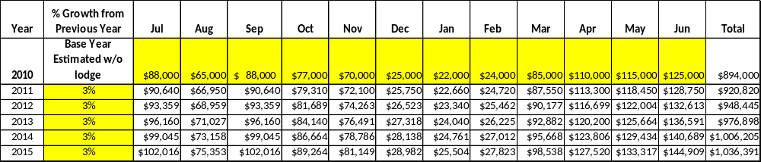

These projections would result in a total of 15% cumulative growth in total annual revenues between FY2010 and FY2015. If operational expenses can be managed with a cumulative increase of 15% between FY 2010 and FY 2015, then the overall cost recovery of the site will be approximately 115% in FY 2015 at these projected revenue levels. This is higher than the annual financial performance of the site in FY 2010, which was operated at 89% cost recovery in that year.
Revenue Generation Strategies

Pricing Plan
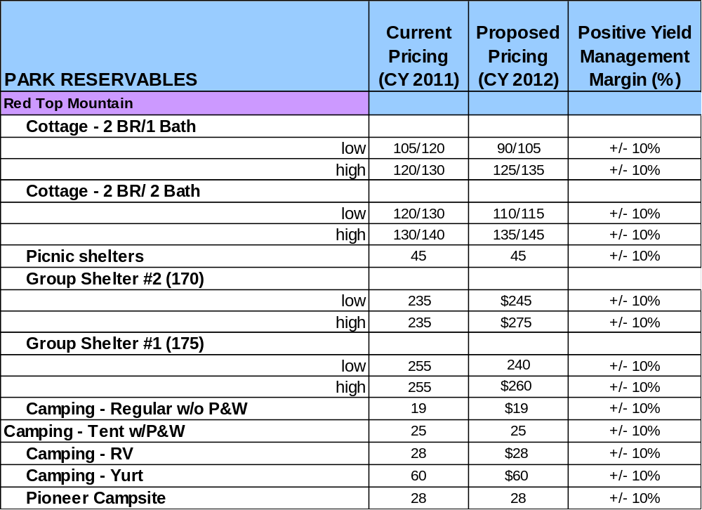

Innovative Programming and Special Events Plan
Program / Event | Theme / Purpose | Scheduled Date/Season | Frequency | Target Participation | Target User Fee | Target Cost Recovery
Iron Pours | History /  Community | Quarterly | 3 times a year | 600 annually | $ 7.00 | 135%
Homestead | History /  Community | Spring Fall | 2 | 500 annually
Astronomy | Science | winter | 1 | 100
Halloween Hayride | Recreation | fall | 3 weekends |  | $7.00 | 140%
Red Top Rumble | Recreation | Early Spring | Annually | 300 | $4.00 | 120%
Night Hike | Recreation | Summer Weekends | Weekly | 10-30 | $2.00 | 50-75%
Allatoona Pass – Great Locomotive Chase | Interpretation | Spring | Annually | 400 | 0.00 | 50-70% (resale)
Morning Bird Walk | Recreation/Interpretation | May 12 | Annually | 5-10 | 0.00 | 100% (Volunteer)
Mountain Music Series | Family Recreation | May-Sept | Weekly | 50-100 | $5.00 | 100% - (Friends)
Junior Ranger Camp | Recreation / Interpretation | June 5-7 | Annually | 5-15 | $30.00 | 100-125%
Family Camp | Recreation/Interpretation | July 16-20 | Annually | 6-20 | $35.00 + camping | 110-120%
Pioneer Christmas | Recreation/Interpretation | Dec 1 | Annually | 50-125 | $5.00 | 110-120%

Partnerships and Concessions Plan
Service / Partnership | Term of Service | Financial Objective | Contract Manager
Beach Concessionaire | Seasonal | 15% total revenue | Daniel Hill
Promotions with community | Per-Event | Shared Revenue | Daniel Hill

Expense Management Plan
Personnel Assignments
The following actions will be taken to proactively manage labor costs via personnel assignments and classifications.

Action | Timeline | Outcome
Utilize staff at EIM & PMB to cross support RTM | Immediate | Better support for events at EIM/PMB and RTM
Fill Maintenance Engineer position | Spring 2012 | Better cross-site support for maintenance at all three sites
Utilize Resource Manager 2 to oversee EIM and PMB operations, and RTM programming | Immediate | Increased efficiency and cross support of programs and ops

Management Techniques
The following actions will be taken to proactively manage labor costs via management techniques.

Action | Timeline | Outcome
Effectively schedule clerks at Visitor Center and Park Office | Immediate | Better use of labor to meet customer expectations and eliminate labor costs during slow periods
Utilize retired park managers with POST training to support special events, heavy use weekends, etc. | Immediate | Eliminate need to fill additional salaried LE position to support site

Adjusted Levels of Service
The following actions will be taken to proactively manage labor costs via reduced levels of service.

Action | Timeline | Outcome
Adjust Visitor Center hours of operation | 2011 | Better balance service to customer load at this key location; close operation at times when traffic is slow

Financial Pro Forma
The following five-year financial pro forma projects operating expenses, earned revenues and cost recovery through FY 2015. These pro forma are based on the strategies and desired outcomes identified in this business plan, especially the revenue generation and expense management plans, and are linked to corresponding performance goals.

Expense Pro Forma
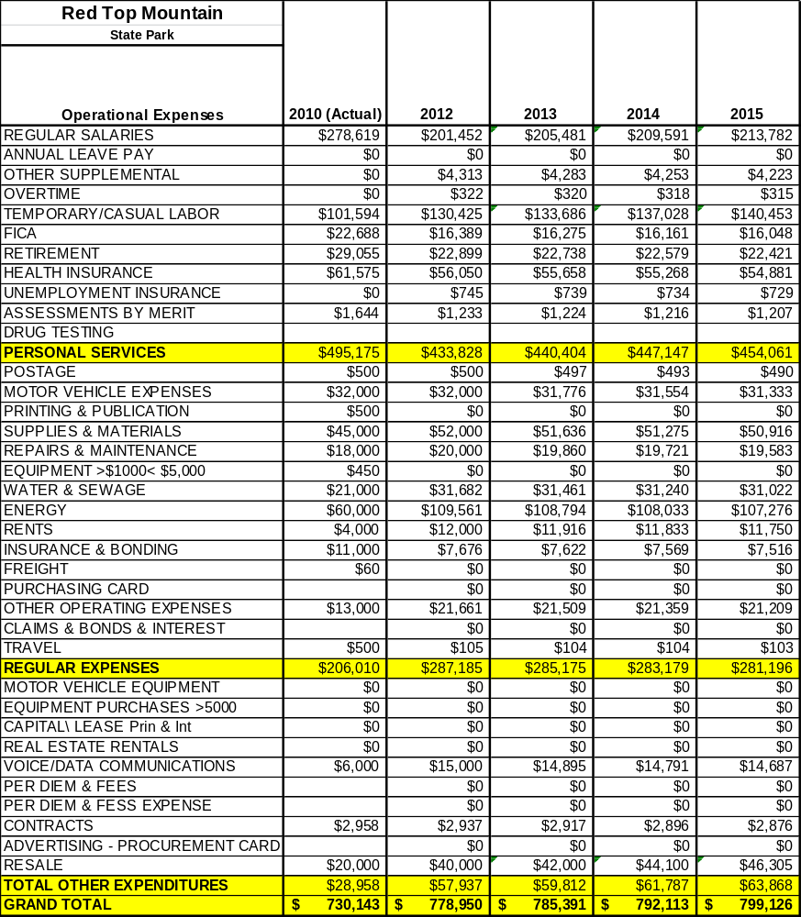

Revenue Pro Forma
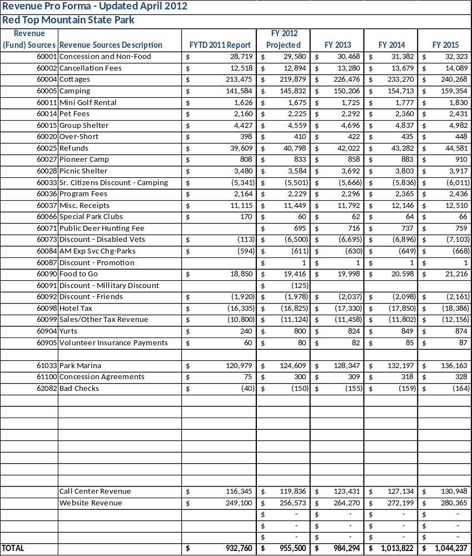

Total / Cost Recovery Pro Forma
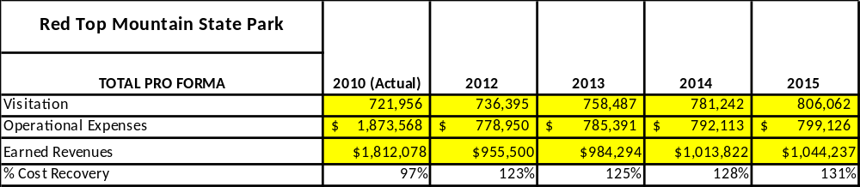

Action Plan
ACTION PLAN
Site: Red Top Mountain State Park |  | Site Manager: Daniel Hill |  |  | Date:
Month:
Strategy | Tasks | Costs / Funding | Revenues / ROI | Responsibilities | Metrics

ACTION PLAN
Site: Red Top Mountain State Park |  | Site Manager: Daniel Hill |  |  | Date:
Month:
Strategy | Tasks | Costs / Funding | Revenues / ROI | Responsibilities | Metrics

This is the average of the last three years – FY 2008, FY 2009, and FY 2010
Current employees, not including vacancies.
Current employees, not including vacancies.
Major population centers within a two-hour drive from the site

