Reed Bingham State Park
Business & Management Plan

Prepared 6/12/11; Finalized 3/8/12
Direction 2015 – Sustainable Business Planning

Table of Contents

Executive Summary 3

Site and Operations Assessment 8
Site Inventory and Facility Assessment 8
Operational Assessment 10
Financial Performance Assessment 15

Business and Management Plan 20
Business Goals 20
Classification of Programs and Services 21
Partnership Development Plan 22
Marketing and Sales Plan 23
Revenue Generation Plan 26
Expense Management Plan 29
Financial Pro Forma 30

Action Plan 32

Executive Summary
The Parks, Recreation and Historic Sites Division (PRHSD) of the Georgia Department of Natural Resources (DNR) is transitioning the management of Reed Bingham State Park to operate more like a business, reflecting the Direction 2015 – Sustainable Business Planning initiative to improve the fiscal performance and management of the state parks and historic sites system. This business and management plan is designed to help the site recover more operating expenses through earned revenues, productive partnerships, and innovative programs.

Site Fact Sheet
Site Name | Reed Bingham State Park
Site Manager | Suzanne Passmore
Region Manager | Eric Bentley
Date of Business Plan completion | 06-12-11
Site size | 1,613 acres
Total number of visitors (FY 2010) | 85,880
Total operating budget (FY 2010) | $232,823
Total earned revenues (FY 2010) | $166,421
Operational cost recovery (FY 2010) | 71%
Average operating cost per visitor (FY 2010) | $2.71
Average earned revenue per visitor (FY 2010) | $1.94
Average cost recovery (FY 2008 – 2010) | 59%
Target cost recovery (FY 2015) | 85%
Total full-time employees | 4
Total part-time employees | 2
Primary service markets | Albany, Valdosta, Tallahassee
Primary attractors/visitor appeal factors | Campground, 375-acre lake, diverse natural habitats
Leading opportunities for improved site performance | Up- grade camping facilities, maintain a usable lake free of vegetation, additions of overnight facilities other than camping (cabins or camper cabins)

Site Summary, Key Attractions and Unique Visitor Experiences
The 1,613-acre site of Reed Bingham State Park is located 6 miles west of Interstate 75 in rural Cook and Colquitt Counties. The major population centers include Valdosta, located approximately 22 miles south, Albany, located roughly 40 miles northwest, and Tallahassee, located 55 miles southwest.

Key Attractions
The amenities or features listed below are those that seem to be most popular for visitors:
- 46 site campground
- 375-acre lake, including 3 miles of river
- Coastal Plain Nature Trail
- Swimming beach
- Interpretive programming (seasonal)
- Diverse habitats and natural areas
- Gopher Tortoise Management Project
- Rental facilities for meetings, reunions, etc.

Unique Visitor Experiences
- Hike the Gopher Tortoise Loop (0.6 miles) and look for our state reptile, the gopher tortoise; gopher tortoise burrows are evident along the trail.
- Bird watching is a popular activity on the park. Look for wading birds like herons and egrets as well as common moorhens and American coots. Reed Bingham has one of the few active bald eagle nests in the state park system and one of the largest wintering roosts of vultures in Georgia.
- Hike or bike the Coastal Plain Nature Trail, an 8-mile series of trails and boardwalks with options for shorter loops. Travel along a black water river, wind through bottomland forests and dry ridge tops and get good views of vultures soaring overhead and alligators on the waterway. Blooming azaleas are a highlight in the spring.
- Canoe or kayak on the Little River, a 3-mile paddle from the boat launch to Red Roberts landing. Enjoy a quiet scenic paddle and view wildlife along the way. Rent canoes or kayaks at the Park Office; staff can help visitors get started if they’ve never paddled before.
- Attend a program by the Park Naturalist. Typically scheduled on weekends, programs range from guided hikes and paddling trips to live animal programs.
- Enjoy a picnic on the island. A boardwalk on the west side of the park connects to a small island in the middle of the river. Pack a picnic and enjoy the afternoon, picnic tables and grills are available.
- Enjoy a swim at the designated swimming area and beach. Be aware that there are alligators on the lake; they have however, never caused any problems for swimmers.
- Fishing is a popular activity on the 375-acre lake. Guests should bring their own fishing gear. Bait and a fishing license may be purchased at the park office.
- Rent a bike at the campground and explore the park or rent clubs and play miniature golf. Bikes may be ridden on the park roads and trails. The miniature golf course is located near the campground.
- Guests looking for shopping and dining visit nearby Moultrie, just 15 minutes from the park, or Adel , just 6 miles from the park. There is antique shopping and more. Ask the staff for information about other nearby attractions.

Financial Targets
The table below details the total operating expenses and earned revenues for Reed Bingham State Park over the last three years (2008 – 2010). This table also calculates total cost per visitor and revenues per visitor during these operating years, and details the target financial performance goals in the context of achieving at least 85% cost recovery. This table also calculates the necessary change from 2010 operating expenses and revenues.

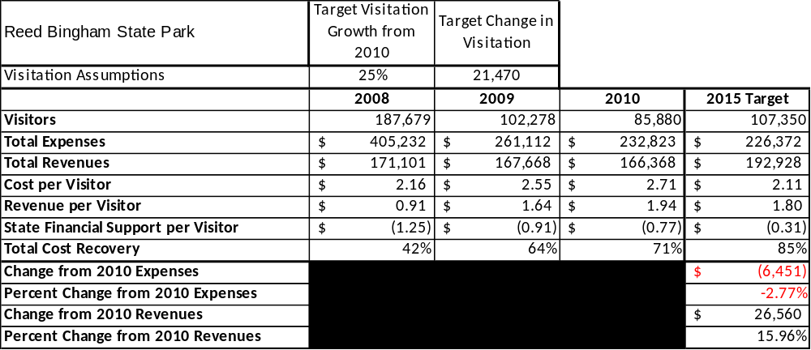

Key Recommendations

Primary / Short Term Recommendations
- Operate the site using cost-based accounting, including the net cost recovery achieved annually.
- Conduct customer surveys to assess how well customer satisfaction levels are being met. RBSP should strive to have 90% of guest responding to survey types with results being “satisfied” or “very satisfied”. Services that are below this measure should be seriously reviewed, modified, or discontinued.
- Explore the possibility of having cost-effective concessionaires or alternative providers for on-site events and/or park programming.
- Collect zip code information from guest to improve programming and marketing efforts based on origins and demographics.
- Utilize one special event per month to attract guest to RBSP.
- Enhance marketing opportunities by seeking local partners such as Cook and Colquitt County Chamber of Commerce.
- Continue to search for non-cost labor opportunities such as interns, Friend’s members, and local volunteers who are willing to assist in operational duties. Keep staff operational cost (with benefits) at or below 65%.
- Create, focus on, and heavily market 10 unique experiences for guests to enjoy while visiting RBSP. These experiences should be monitored for a high level of customer satisfaction and changed or added to over time to keep “fresh” for repeat guests.
- Create and operate well-defined maintenance, program, and operational standards monitored and enforced by park manager, region manager, and senior management staff.
- Continue to work with and regain a positive working relationship with Friends of Reed Bingham State Park. FORB can raise funds for projects, events, and services. Also, engage FORB members in the business plan as a partner to help the park meet or strive to meet or exceed 85% sustainability.
- Perform a thorough net cost-of-services analysis on major functions of site operations, including the detailed analysis of labor requirements (by task) that has already been produced by site staff. Thereafter, update costs to deliver services on a biennial schedule.
- Review and update rates annually to recover the total net cost of services for important and visitor-supported services.
- Engage Friends chapter members in the business plan as a partner to help the site meet or exceed its sustainability goals. Utilize State Friend’s “Site Fact” cards to demonstrate the economic impact of the RBSP to local communities, elected officials, and local business operators.
- Develop a more detailed analysis of labor requirements of all major park functions to match the right position with the right job at the right pay.
- Add more services that appeal to various groups by age and race.
- Construct and upgrade facilities and amenities to increase cost recovery. A few suggestions are to replace comfort station #2, add full sewer hook-up to all pull thru campsites, and add wireless Internet to the camping area. The wireless Internet could be an additional charge above the camping rate for guests who would like long access periods to the internet. After campground renovations are complete, camping prices can be increased by $3-$4 per night and extended stays during winter months could be offered. Adding recreational amenities to the campground could enhance the area. A few suggestions include adding a volleyball area, sprucing up the horseshoe pits, and adding a small playground set.
- Continue with lake management for invasive aquatic vegetation types. The lake is the major source of day-use generated revenues, including park pass. The weed harvester is in fair condition and has been used very little over the last three years. The lack of use is mainly due to constant mechanical breakdowns and lack of personnel to operate the machine. The estimated repair expense since FY 08 is $15,000. Currently, aquatic vegetation management is not budgeted into the site budget. There are two avenues to annually treat the aquatic vegetation with the primary target being Hydrilla verticillata. The first treatment option is with Sonar Q and Sonar PR, pelletized chemicals that kill the tuber or “root” system of the plant. The initial chemical cost is estimated at $36,711. Once the perennial plants are heavily treated the first year, the follow up annual treatments will cost significantly less, eventually reaching a maintenance phase with chemical cost about $10,000 annually. The second option, a burn back treatment using Komeen with Diquat, is estimated at $39,546. Both estimates are chemical cost only. An additional $2,500-$5,000 in labor costs is estimated for proper application of each treatment.
- Promote the unique habitat diversity of the park and focus on targeting specific nature groups to the area including bird watchers, canoeists, and hikers.
- Explore the possibility of expanding the use of current trails to other recreational activities including mountain biking. Currently, trails are foot traffic only.
- Explore the possibility of adding “canoe-in” or “kayak-in” campsites along the river or islands. Additional canoes and kayaks should be purchased at this time to accommodate both campers and rentals for day guest user groups.
- Focus on retail enhancement to generate additional park revenue. Retail expansion project will be complete in March 2012.

Secondary / Long Term Recommendations
- Continue to gain local support of the surrounding communities. Also, programming and events should engage these groups in order to gain their support. Target groups should include, but are not limited to, scouts, youth organizations, the Chamber of Commerce, local schools, colleges, and universities, camping clubs, etc.
- Explore providing alternate stay-use facilities other than camping. Cabins or camper cabins would provide guests who do not camp the opportunity to stay overnight.

Site and Operations Assessment
This site and operations assessment is a culmination of analyses and findings from a review of the condition of facilities, infrastructure, and operations at Reed Bingham State Park. The findings and observations are not intended to be an exhaustive review of all issues present, but provide a basic understanding of the predominant issues that contribute to the site’s current operating conditions. The assessment includes the following:
- Site Inventory and Facility Assessment
- Operational Assessment
- Financial Assessment
Site Inventory and Facility Assessment

Methodology
Facility and asset conditions are rated using a differential scale of excellent, good, fair, or poor. Descriptions of conditions that are attributed to each of these findings are also provided.
Scale of Conditions
Rating | General Description
Excellent | Facilities/amenities are in ‘excellent’ condition when they show little or no maintenance or repair problems. Facilities do not feature any major design or operational issues or flaws that contribute to diminished use or increased maintenance or upkeep. Facilities are easy to clean and maintain in order to place them back into public use and the users perceive them to be in excellent shape.
Good | Facilities/amenities are in ‘good’ condition when they show only minor maintenance or repair problems. Most maintenance issues with these facilities typically appear to be the result of age and/or heavy use. Facilities may only feature minor design or operational issues that contribute to diminished use or increased maintenance or upkeep. Facilities are moderately easy to clean and maintain in order to place them back into service and the users perceive them to be adequate for their use, but probably not in excellent shape.
Fair | Facilities/amenities are in ‘fair’ condition when they show significant maintenance or repair problems. Facilities generally exhibit ongoing maintenance issues that appear to be the result of age, heavy use, or design or operational flaws. Some maintenance and repair needs may compound their fair condition by being deferred because of budget and/or resource limitations. Facilities require more effort to clean and maintain before placing them back into service and the users may perceive them as being less than adequate for their use and in a state of deterioration. The facility or structure may need of major repair or replacement.
Poor | Facilities/amenities are in ‘poor’ condition when they show significant, on-going maintenance or repair problems that ultimately may result in suspended use for repair/replacement. Maintenance and repair issues are possibly the result of poor maintenance and clearly the result of age, heavy use, or design or operational flaws. Problems with the facilities are often compounded over time due to consistently-deferred maintenance and repair because of budget and/or resource limitations. Facilities may feature major design or operational issues that contribute to diminished use or increased maintenance or upkeep. Facilities require excessive effort to clean and maintain before placing them back into service and the users often perceive them as being inadequate for their use and in a state of serious deterioration. The facility or structure may need of major repair or replacement.

Inventory and Assessment
The table below is an inventory of facilities and amenities at RBSP and provides the assessed condition of each as reviewed in May 2011.
Site Asset / Amenity | Quantity | Condition
Total Acreage | 1,613
Group Shelters 2 & 4 | 2 | Good
Group Shelter 1 | 1 | Good
Group Shelter 3 | 1 | Good
Picnic Shelters | 6 | Fair-Good
Beach Pavilion | 1 | Good
Manager’s Residence  A | 1 | Good
Assistant Manger’s Residence | 1 | Good
Colquitt Well House | 1 | Fair
Visitor Center | 1 | Excellent
Stage | 1 | Fair
Cook Well House | 2 | Fair
Comfort Station 1 | 1 | Fair
Comfort Station 2 | 1 | Poor (replacement 2012)  2012
Nature Trail Storage/ Nook | 1 | Fair
Maintenance Complex | 1 | Good
Boat House | 1 | Fair
Day Use Bathrooms | 3 | Fair
Handicap Day Use Bathrooms | 1 | Good
Playground (Colquitt) | 1 | Fair
Playground (Cook) | 1 | Fair- Good

Prioritized Facility Needs
Based on the facility inventory and assessment, these prioritized needs have been identified. Each need has been aligned with a priority category of high, moderate, or low to support future decision making regarding project sequencing, investment of public resources, and meeting community expectations. The priority assignment for each need is not a measure of importance. Rather, these recommended priorities reflect a phased implementation approach over the next several years.
Facility Need | Priority Assignment
Replace Comfort Station 2 and add full hookups to all pull thru sites | High
Renovation of Comfort Station 1 | High
Renovation of Group shelter 3 | High
Replacement/Renovation of Colquitt day-use bathroom | Moderate
Playground – replace old play sets on Colquitt and Cook Co. sides | Moderate
Renovation of Group Shelter 3 day-use bathroom | Moderate
Renovation of ball field day-use bathroom | Moderate
Renovation of Group shelter 4 | Moderate
Renovation of Picnic shelters 2-6 | Low
Renovation of Nature Trail Storage Building/Nature Nook | Low

Operational Assessment
The Operational Assessment includes:
- An inventory and classification of programs and services being provided at the site
- A review of staffing at the site
- A review of concessionaires and partners operating at the site
- Visitation and customer satisfaction

Inventory and Classification of Programs and Services
Programs and services are classified into one of three major categories:
1) Core or Essential Services
2) Important Services
3) Visitor Supported Services
Programs and services at the site are classified into these categories based in part on the mission and public mandates for both the site and the agency. For the programs and services in each of these categories, there are financial performance expectations that will define how services are funded and evaluated.

Category 1 – Core Services [Largely supported by tax funds]
Core programs, services and facilities are those the agency must provide and/or are essential in order to capably govern and meet statutory requirements. The failure of the agency to provide Category 1 services at adequate levels could result in significant negative consequences for the public and the resources under protection. The criteria for programs or services to be classified as core or essential are:
- The services are mandated by the agency’s law or charter or are contractually obligated by agreement to provide the services.
- The services are essential to protecting and supporting the public’s health and safety.
- The services protect and maintain valuable assets and infrastructure.
- The services would generally and reasonably be expected and supported by residents, businesses, customers and partners.
- The services are those that cannot or should not be provided by the private sector.
- The services provide a sound investment of public funds.
The following programs and services offered at RBSP have been identified as core services:
- Protection of the natural resources on site
- Public access to the park
- Maintaining a safe environment for guest / security
- Maintenance of grounds, facilities, and structures
- Maintaining the lake(free of vegetation) for recreational opportunities
- Operating the Visitor Center for purposes of information, check-ins, etc.

Category 2 – Important Services [Supported by a balance of tax funds and earned revenues]
Important programs, services and facilities are those the agency should provide, and are important to governing and effectively serving residents, businesses, customers and partners. Providing Category 2 services expands or enhances the agency’s ability to provide and sustain its core services. The criteria for programs or services to be classified as important are:
- The services expand, enhance or support identified core services.
- The services are broadly supported and utilized by the community, and are considered an appropriate, important, and valuable public good. Public support may be conditional upon the manner by which the services are paid for or funded.
- The services generate income or revenue that offsets some or all of the operating cost and/or are deemed to provide economic, social or environmental outcomes or results.
The following programs and services offered at RBSP have been identified as important services:
- Operating a campground facility
- Rental of shelter facilities for meetings, reunion, etc.

Category 3 – Visitor Supported Services [Almost exclusively supported by earned revenue]
Visitor supported programs, services and facilities are those discretionary services that the agency may provide when additional funding or revenue exists to offset the cost of providing those services. Category 3 services provide added value above and beyond what is required or expected. The criteria for programs or services to be classified as visitor supported are:
- The services expand, enhance or support core services or important services and the quality of life of the visitors, community or stakeholders.
- The services are supported, valued and well utilized and provide an appropriate and valuable public benefit.
- The services generate income or funding from sponsorships, grants, user fees or other sources that offset some or all of their cost and/or provides a meaningful return on investment.

- The services can possibly be provided through outsourcing or use of concessionaires, providing opportunities for community enterprises that may not otherwise be provided by the agency.
The following programs and services offered at RBSP have been identified as visitor supported services:
- Active interpretive programming and special events
- Recreational rentals including kayaks, canoes, bikes, and mini-golf
- Retail sales

Staffing Assessment
Labor costs at RBSP represent the largest area of budgetary expense at an average of 64% of the total operating budget each year for the last three complete years, which is lower than the target of total labor costs (including benefits) not exceeding 65% of the site’s total operating expenditures. The tables below and on the following page provide a basic review of the current staffing at the site.
Full Time Equivalent Employees
Position / Title | Quantity (FTE) | Vacancies | Annual Hours
Park Manager 2 | 1 | 0 | 2,400
Assistant Park Manager 1 | 1 | 0 | 2,400
General Clerk 1 | 1 | 0 | 2,080
Utility Worker 1 | 0 | 1 | 2,080
Park Ranger 1 | 0 | 1 | 2,080
Interpretive Ranger | 0 | 1 | 2,080
TOTAL | 4 | 2 | 13,520

Part Time Employees
Position / Title | Quantity (FTE) | Vacancies | Hours
Clerk | 1 | 0 | 1,200
Utility Worker | 2 | 0 | 2,400
Seasonal Naturalist | 1 | 0 | 1,100
TOTAL | 3 | 0 | 4,700

Labor Support
Labor Support | Annual Hours
Volunteers | 5,800
Community Service Workers | 1,300
Engineering and Construction Crews | 60
Resource Management Crews | 200
TOTAL | 8,580

Total Labor Hours
Labor Type | Annual Hours
Full Time Equivalent Employees | 13,520
Part Time Employees | 4,700
Labor Support | 8,580
TOTAL Annual Labor Hours | 26800

Labor Budget Summary

 | Reed Bingham State Park
 |  | 2008 | 2009 | 2010 | % Change
 | Account Code and Sub-Class | Year End | Year End | Year End | from
 | Expenditure Descriptions | Expenses | Expenses | Expenses | 2008
 | REGULAR SALARIES | 136,970 | 123,231 | 85,497 | -38%
 | ANNUAL LEAVE PAY | 0 | 0 | 12,851 | 100%
 | OTHER SUPPLEMENTAL | 882 | 882 | 822 | -7%
 | TEMPORARY/CASUAL LABOR | 10,677 | 18,279 | 16,215 | 52%
 | FICA | 9,925 | 9,224 | 7,900 | -20%
 | RETIREMENT | 15,215 | 14,274 | 9,687 | -36%
 | HEALTH INSURANCE | 31,473 | 16,523 | 22,908 | -27%
 | UNEMPLOYMENT INSURANCE | 228 | 179 | 246 | 8%
 | ASSESSMENTS BY MERIT | 882 | 882 | 822 | -7%
 | PERSONAL SERVICES | 206,252 | 183,474 | 156,948 | -24%

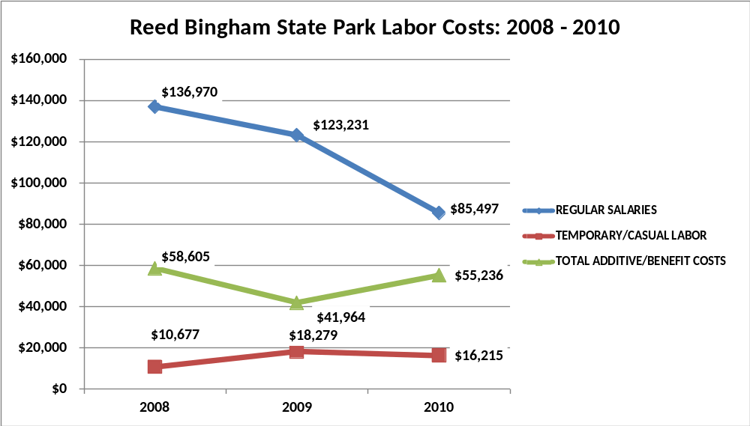

Visitation and Occupancy
Overall annual visitation to the site has trended downward from 2008 to 2010, decreasing by 54% or over 101,799 visitors. This is largely attributed to inaccurate visitation reporting due to a broken traffic counter in the later part of FY 09 and the first months of FY 10. The counter was replaced when new park management began in April FY 10.

Year | Total Visitation
2008 | 187,679
2009 | 102,278
2010 | 85,880

Occupancy for the overnight accommodations at Reed Bingham State Park the last three years is detailed in the table below. Overall occupancy has trended downward from 2008 to 2010, decreasing by 1.65%. This is largely attributed to increased gas prices and negative publicity surrounding the park during the change in park leadership and management.

Year | Camping Occupancy
2008 | 35.27%
2009 | 35.96%
2010 | 33.62%

Customer Service and Satisfaction

Site | Year | Customer Satisfaction Level
Reed Bingham State Park | 2009 | 97%
Reed Bingham State Park | 2010 | 95%
Financial Performance Assessment

Operational Expenses
A summary of total operating expenses at RBSP from 2008 to 2010, as well as their percent change from 2008 are provided in the table below.
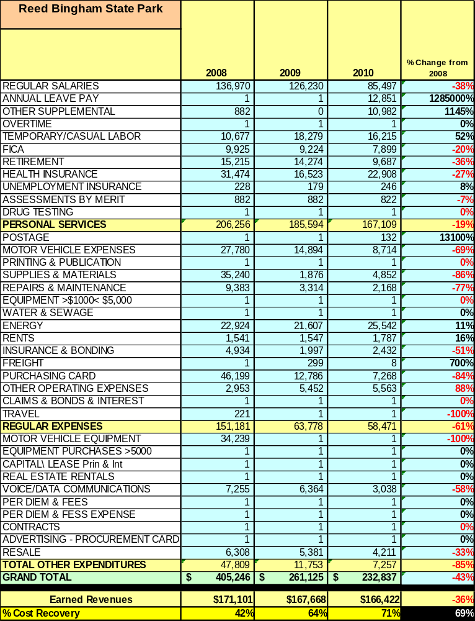

Earned Revenues
Earned revenues at Reed Bingham State Park have decreased since 2008, which is largely attributed to the corresponding decrease in overall visitation and occupancy.
Monthly earned revenues for the last two years (see table below) indicate that the total annual revenue decreased 1% from 2009 to 2010, with the largest increases in monthly revenues in August (115%), July (24%), November (24%), December (24%), and the largest decreases in the months of February (32%), March (32%), January (20%), and October (11%).
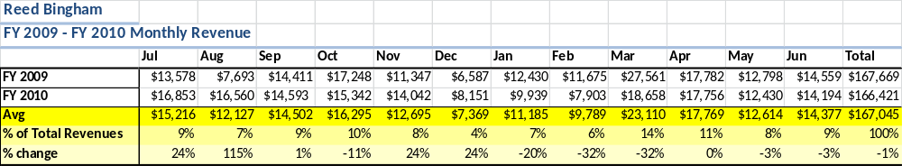

The graphs below illustrate the monthly revenue trends each year and the average percent of total annual revenue earned each month. May and November will be months with the greatest opportunities to increase visitation, occupancy, and revenues. A focus will be placed on programming, marketing, and promotion during these two months.

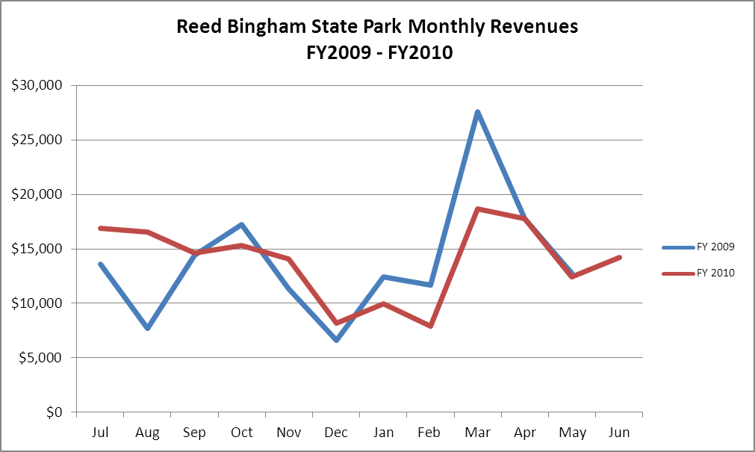

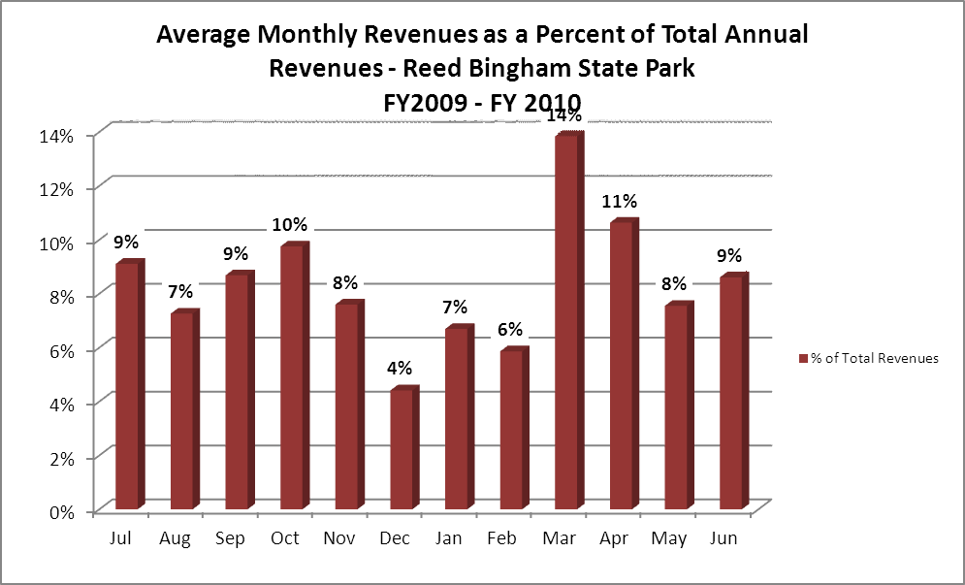
Cost Recovery Trends
RBSP has achieved an average cost recovery of 59% of annual operational expenses through earned revenues from FY 2008 to FY 2010. Significant decreases in operating expenses has been the trend since FY08. Additional improvements in cost recovery will be achieved by increasing revenue while trying to hold the line on expenses. The trends are detailed and illustrated in the table and graph below.

Year | Operational  Expenses | Earned  Revenues | Percent Cost  Recovery
2008 | $405,231.51 | $171,101.00 | 42%
2009 | $261,113.00 | $167,668.00 | 64%
2010 | $232,824.00 | $166,421.93 | 71%

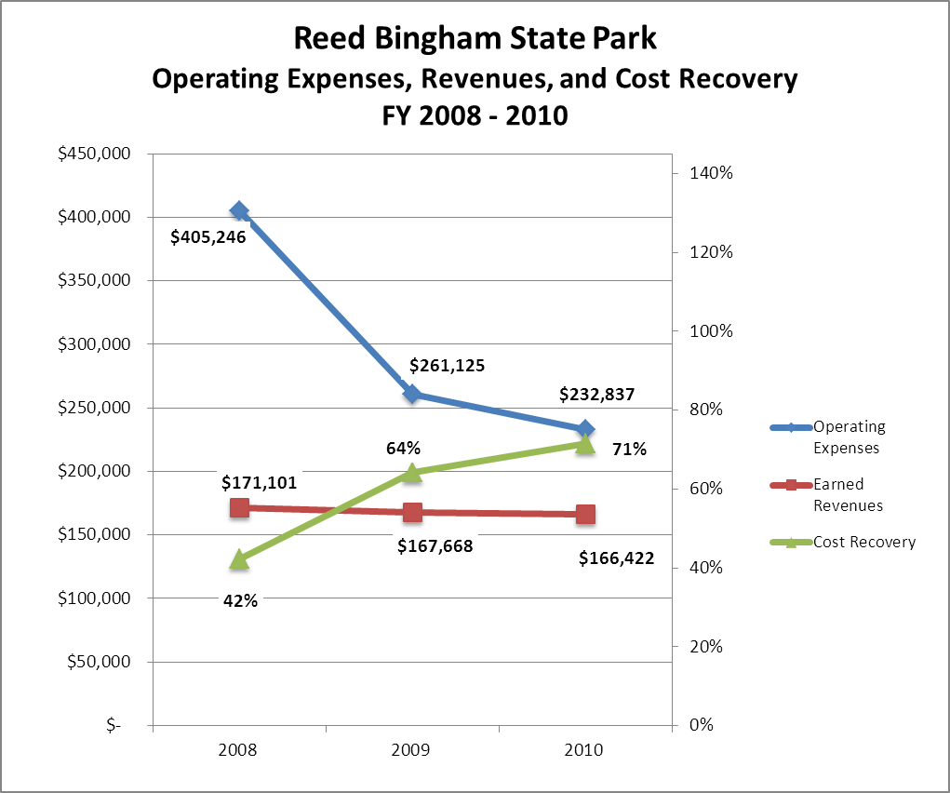

Review of Pricing
Data on rate information is available as far back as 2002, but only the last five years are evaluated. There has been notable growth in fees charged at RBSP since 2005, with the largest increase being recreational rental fees. A table detailing the rates for facility rental fees, camping fees, and recreational rental fees is provided below.
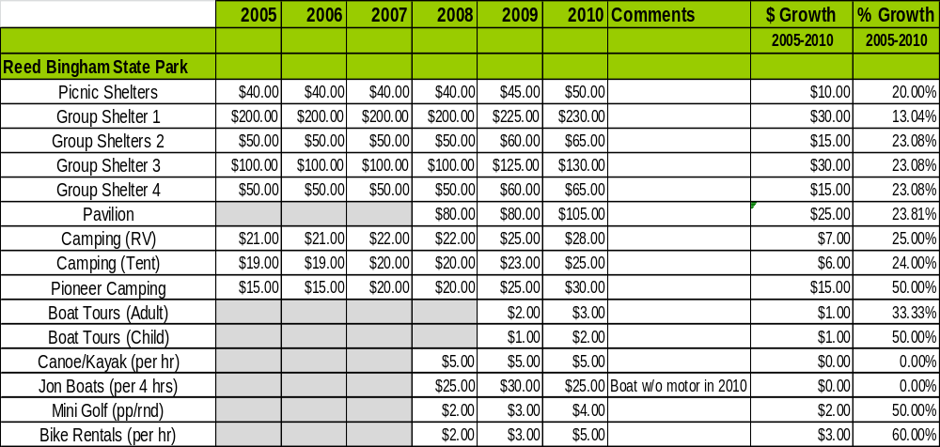
Business and Management Plan

Business Goals
The following goals serve as the foundation for the key recommendations and strategies in this business plan for Reed Bingham State Park.

Enhance Cost Recovery of Site Operations
Reed Bingham State Park is operating at an average of 59% cost recovery of operational expenses over the last three years. The lowest cost recovery during the previous three years was 42% in FY08 when more park staff positions were occupied. Expenses will continue to be closely monitored and part-time positions will be considered when possible in lieu of filling full-time positions to improve cost recovery. Additional special events will be held monthly to generate revenue.
Enhancing camping services such as adding sewage to the Loop 2 campground and providing wireless internet, and offering extended stay packages, will generate additional revenue. Other RV parks in this area offer full hook-up sites and wireless internet service; the value placed on those services is $4-$6 per night. These additions will allow RBSP to increase camping rates and be more accommodating for extended stays. Marketing should promote the advantages of staying in Georgia State Parks versus the average RV Park located on I-75. Those advantages include experience, activities, and the safe, friendly atmosphere we create for families.
With the retail enhancement project completed during FY12, RBSP will regenerate more revenue. We currently have an extremely small retail area. Being able to increase volume and variety of items will give us a resale advantage that we currently do not have.

Enhance Revenue Generation Strategies
Increased earned revenues will most likely result from special events, retail improvements, and campground renovations. Since the park is not located near a major natural or manmade attraction, special events and interpretive programming will make people more aware of Reed Bingham’s location and amenities and bring them to the park. Retail enhancements will provide guests with basic items needed during their stay, as well as souvenirs items. Campground renovations will allow RBSP to be more competitive with the surrounding facilities along the interstate in this area.

Expand Special Events at the Site
Current special events are primarily being held during holidays and our busiest weekends. These events should continue to be part of the site operation, but more events should be held during the shoulder season, May and November, to attract more visitors to the park. These events may be more creative and detailed to accomplish the increased visitation and occupancy goals. Examples of such events include a wildlife festival, arts and craft festival, and triathlons.

Improve the Diversity and Innovation of Recreational and Interpretive Programs
Reed Bingham State Park is known for the natural habitats and wildlife that can be viewed while visiting the park. Also, the lake at RBSP allows for various recreational opportunities including boating, fishing, and swimming. Maintaining the lake and keeping it treated for invasive vegetation should always be a high priority to the department. Since many stay-use guests use the lake for one of the above activities, it drives much of our camping revenue.
Interpretation of the park’s natural areas should continue to be a focus for programming. Highlights on species such as gopher tortoises, vultures, and bald eagles should be emphasized. More diversity in programming should be done to appeal to all age groups and to more ethnic groups.

Improve the Effectiveness of Marketing and Sales
Improved marketing for Reed Bingham State Park can possibly best be done on a local level. Asking Friends of Reed Bingham State Park to sponsor radio ads and/or billboard advertising along Interstate 75 are two examples. Also, Cook and Colquitt Counties’ Chamber of Commerce should be considered for assisting in marketing opportunities. Partnerships with the local golf courses and theme park could improve increased visitation.

Establish Greater Consistency of Managing and Monitoring Customer Service & Satisfaction
Reed Bingham State Park uses the Region 3 customer service training manual for all new employees and volunteers. The manual serves as a tool to teach new personnel the expectations of great customer service. Surveys should be done on a local level and created specifically for this park. The park should strive to have 90% of visitors responding to surveys with a level of “satisfied” or “very satisfied”. Areas that fall below this standard should be evaluated.

Expand Partnership Opportunities
Partnership opportunities for Reed Bingham State Park may not be as available as other parks but we should strive to partner with local communities. Continuing to win the support of local citizens, whether businesses or individuals, is essential to the vitality of RBSP. Establishing relationships with reliable, notable vendors for special events will provide partnership opportunities. Continuing to engage the park’s Friends chapter as a partner will help the site meet or exceed its sustainability goals.

Classification of Programs and Services
The tables below summarize the classifications of programs and services at RBSP as either core, important, or visitor supported and project a range of cost recovery percentages that might be achieved for each. These classifications establish financial performance goals for each category of services that are linked to the recommendations and strategies of this business plan.
Core Services
Program / Service | Target Cost Recovery
Protection of the natural resources on site | 0%
Public access to the park | 0%
Maintaining a safe environment for guests (public safety) | 0%
Maintenance of grounds, facilities, and structures | 0%
Maintaining a lake (free of vegetation) for recreational opportunities | 0%
Operating the Visitor Center for purposes of information, check-ins, etc. | 5-15%

Important Services
Program / Service | Target Cost Recovery
Operating a campground facility | 125%
Rental of shelter facilities for meeting, reunions, etc. | 125%

Visitor Supported
Program / Service | Target Cost Recovery
Active interpretive programming and special events | 150-175%
Recreational rentals including kayaks, canoes, bikes, and mini-golf | 175-200%
Retail sales | 125-150%

Partnership Development Plan
The table below summarizes existing partners and targeted partnerships by classification (operational, vendor, service, co-branding, funding partners) and by organizational type.
 | Public Partners | Not-for-profit Partners | Private / Enterprise Partners
Operational Partners | - Abraham Baldwin Agricultural College  - Valdosta State University  - Moultrie Technical College | - Friends of Reed Bingham State Park | - Various Businesses at I-75 Exit 39
Vendor Partners |  | - Local FFA or 4H school clubs | - Coca Cola  - Colquitt EMC  - Jeff Stalvey (food vendor for special events)
Service Partners | - City of Adel  - City of Moultrie  - Cook County Chamber  - Colquitt County Chamber | - Friends of Reed Bingham State Park
Co-branding Partners | - Georgia Veterans State Park  - Sam Shortline Excursion Train | - Cook and Colquitt Chamber of Commerce  - Friends of Reed Bingham State Park | - Wild Adventures Theme Park (shared revenue by increased visitation)
Funding Resource Development Partner |  | - Friends of Reed Bingham  - Friends of Georgia State Parks

Marketing and Sales Plan

Marketing and Sales Goals
Marketing and sales goals for RBSP are based on the following desired outcomes:
- To increase revenue by increasing public awareness of available camping facilities, day-use rental availability for meetings, reunions, etc., as well as recreational rentals.
- Increase visitation by promoting special events, interpretive programming, and recreational opportunities.
- To become competitive with surrounding, similar markets. Many surrounding camping/recreational facilities are well advertised on large billboards along I-75. These sites also use local radio and television as promotion opportunities.
In order to meet these goals, examples of specific target outcomes were identified in the areas detailed in the table below.

Area  of Focus | Current  Performance | Goal  by 2011 | Goal  by 2012 | Goal  by 2015
Campground Occupancy | 33.62% | 35% | 36% | 45%
Site Visitation (annually) | 85,880 | 100,000 | 104,000 | 107,350
Program/Event Attendance (annually) | 4,500 | 6,200 | 7,000 | 10,000

Marketing and Promotion Strategies

Publicity and Social Media
Reed Bingham State Park will approach marketing and publicity planning using the following guidelines and themes:
- Event publicity
Major events benefit by having short stories in local, regional, and statewide newspapers and online social media hooks planted that run three to four weeks in advance of the event up to the date of the event itself. Stories and media need to be cultivated with contacts and online sales channels several weeks in advance of the time the stories need to run. Special interest interviews on morning, noon, and evening television news programs, radio interviews on popular rush-hour programs, and blogs on known affinity online sites should also be included.
- Program publicity
Special and unique programs should have feature stories in magazines, local and regional weekly newspapers, and statewide daily newspapers that are aimed at placements as front-page or sectional front-page stories. These stories are most effective if they run shortly before the season that the featured program begins. This will likely require several weeks of advanced planning with media contacts. Similar coverage on television and radio should also be considered. If pre-publicity cannot be generated, post-publicity can help promote future programs.
- Site Publicity
Site publicity focusing on a single site or sub-set of sites requires more intense planning efforts to attract multiple writers and editors from target publications. Each site could host several seasonal media familiarization tours (with 10 to 15 writers or editors) to familiarize them with the site and its benefits and amenities. Stories and features resulting from such tours typically take between two and six months to materialize so the tours should focus on experiences, benefits, and programs that would be available when the stories are expected to run.
Examples and suggested opportunities for events, programs and related publicity efforts based on the themes described above at Reed Bingham Stat Park are provided in the table below.

Event Publicity | Program Publicity | Site Publicity
Fall Festival & Haunted House | Day Camps | Gopher Tortoise Habitat Management
Road-Kill Run | Events/Programs for all major holidays | Nesting Pair of Bald Eagles
Bass Tournament | Weekly Programs | Hiking and Biking the Trails

Packaging
Examples and suggested packages for Reed Bingham State Park are provided in the table below.

Package | Package Details
Paddler’s Paradise | 2 nights camping with 1 kayak or canoe rental for 4 hours
Scouts’ Package | 2 nights camping with 2 programs of your choice for Boys/Girls Scout Troops
Camp it, Hike it, Bike it | 2 nights camping with 2 bike rentals for one day
Winter Season Special | Weekly and monthly rates for guest who want to escape the extreme temperatures of the northern U.S. and Canada
Early Bird Special | Book your weekend during off-peak season 2 months in advance to receive a 15% discount on your stay
The Outdoor Package | 3 nights camping and pick 2 of the following recreational activities for the family (one round of mini-golf, bike rentals for an hour, kayak/canoes for an hour)
Camping Club Special | Bring your camping club and receive 10% off each site per night (minimum 10 sites and 2 nights)

Group Sales
Types of groups within which specific target customers can be identified for RBSP are listed below:
- Families  - Youth Organizations  - Canoeist/Kayakers | - Scout Groups  - Recreational Enthusiasts  - Churches | - School/Day care groups  - Fishermen  - Colleges/Universities
- Business Groups

Incentivizing New and Repeat Visitation
RBSP will utilize the following strategies and/or incentives to encourage new and repeat visitation starting in FY 2012:
- Early registration discounts
- Group pricing options
- Price changes depending on season
- Loyalty programs
- Co-branding with other venues such Wild Adventures
- Program series that would encourage guest to return for the remainder of the program dates
- Discounts for returning guests who bring a new family to the park for their first camping experience at RBSP

Marketing and Sales Metric Goals
The following marketing and sales metric goals and/or others will be monitored and progress reported at RBSP:
- Loyalty and repeat customers = 75% of repeat customers within a 12 month period. Surveys can be conducted at the Visitor Center, Kiosk, and routinely throughout the day-use area. Different survey types will exist. A survey for stay-use guess will not be the same as day-use guest. Specific questions should be asked to determine why customers are returning to the park…”Why do you repeatedly visit RBSP?”, “Why do you enjoy camping at RBSP?”, “Why do you choose to utilize your event at RBSP?”
- Brand confidence & customers-recruiting-customers = 50% = “Where/how did you hear about us?”… Various categories should be created to determine the most effective advertisement. Also, an incentive may be considered for guests whom often refer other visitors to RBSP.
Revenue Generation Plan
Revenue / Cost Recovery Goals
RBSP has set a financial goal of increasing annual revenues 3% annually between 2012 and 2015. The largest revenue growth opportunity is most likely from November to February and again during the May shoulder season. Camping packages can be created to encourage longer stays during this season. An emphasis should be placed on developing rates/promotions to capture RV snowbirds traveling I-75. The table below details projected revenue growth leading up to 2015 and is based upon a volume based business for revenue each year.

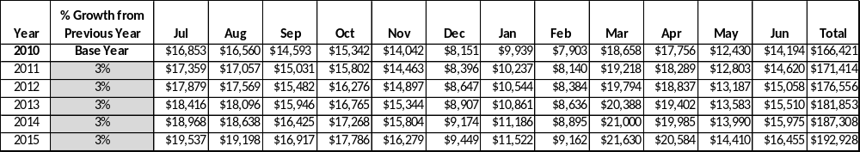

These projections would result in a total of 16% cumulative growth in total annual revenues between FY2010 and FY2015. If operational expenses can be managed with a cumulative reduction of 2.8% between FY 2010 and FY 2015, then the overall cost recovery of the site will be approximately 85% in FY 2015 at these projected revenue levels. This is higher than the annual financial performance of the site in FY 2010, which was operated at 71% cost recovery in that year.
Revenue Generation Strategies

Pricing Plan

Region | PARK RESERVABLES | Current Pricing (CY 2011) | Proposed Pricing  (CY 2012) | Positive Yield Management Margin (%)
3 | REED BINGHAM
 | Picnic Shelter | $50 | $55 | +/-20%
 | Group Shelter
 | Group Shelter #1 (capacity) | $230 (120) | $240 | +/-20%
 | Group Shelter #2 (capacity) | $65 (50) | $70 | +/-20%
 | Group Shelter #3 (capacity) | $130 (80) | $140 | +/-20%
 | Group Shelter #4 (capacity) | $65 (50) | $75 | +/-20%
 | Pavilion | $105 | $130 | +/-20%
 | Camping (RV/ Tent) | $28/25 | $30/25 | +/-30%
 | Pioneer Campsite | $30 | $35 | +/-30%

Innovative Programming and Special Events Plan
An hourly interpretive ranger should be kept on staff to enhance programming opportunities. This position should be designed to accommodate group request, special events, holiday weekends, and interpretive programs for the busy season. The individual obtaining the position must be flexible enough to work fewer hours during the off season and increased hours as program demands dictate.
Volunteers and other staff members will contribute to the program efforts of the park. Both special events and interpretive programs should attract day-use and stay-use guests alike, increasing park pass revenue as well as cover over 100% of the cost of the hourly position.

Program / Event | Theme / Purpose | Scheduled Date/Season | Frequency | Target Participation | Target User Fee | Target Cost Recovery
Camp Reed Bingham | Recreation/Interpretation | Summer Camp | Once annually/age group | 25 | $50/  child | 150%
Jr. Ranger Camp | Recreation/Interpretation | Summer Camp | Twice annually | 25 | $45/  Child | 150%
Jr. Ranger Camp | Recreation/Interpretation | Fall Weekend Camp | One Saturday per month for 4 months | 10-25 | $15/ Child | 100%
Fall Family Fun Camp | Family Recreation/Interpretation | Fall | One weekend per month for Oct & Nov | 8 families | $75/ family | 80-90%
Lake Tours | Interpretation of RBSP’s lake and natural aquatic areas | Spring-Summer | First Saturday of each month March - June | 16 per tour | $3/  child  $5/ adult | 90%
Road-Kill Run | Recreational Activity | February | Annually | 100 | $35/ entry | 85%
Wildlife Art and Crafts Show | Nature and Wildlife appreciation | November | Annually | 2,000 | $35 booth fee | 50%-75%
Reptile Program | Education of Native Reptiles | Jan-Dec | Bi-Monthly | 12/program | $2/ per. | 100%

Partnerships and Concessions Plan
Service / Partnership | Term of Service | Financial Objective | Contract Manager
Food Concessions | Per Event | 15% of gross receipts to the park | Park Manager
Promotions with local businesses | Per Event | Shared revenue | Park Manager
Landscaping | 2 years | Reduced personnel cost, fuel cost,  and supplies and materials cost | Park Manager

Expense Management Plan
Personnel Assignments
The following actions will be taken to proactively manage labor costs via personnel assignments and classifications.

Action | Timeline | Outcome
Continue to fill vacant interpretive ranger position with part-time employee | Immediately | Annual labor cost will not increase if position remains vacant
Fill Ranger 1 position in place of loss of full-time Utility worker | Immediately | Annual labor cost will slightly increase

Management Techniques
The following actions will be taken to proactively manage labor costs via management techniques.

Action | Timeline | Outcome
Build a stronger local volunteer base group that is willing to assist in routine maintenance | July 2012 | Annual cost reduction
Build a stronger local volunteer base group that is willing to assist in routine programming | July 2012 | Annual increase in program revenue

Adjusted Levels of Service
The following actions will be taken to proactively manage labor costs via reduced levels of service.

Action | Timeline | Outcome
Adjust mowing and landscaping schedules for portions of the site | July 2012 | Annual cost reduction

Financial Pro Forma
The following five-year financial pro forma projects operating expenses, earned revenues and cost recovery through FY 2015. These pro forma are based on the strategies and desired outcomes identified in this business plan, especially the revenue generation and expense management plans, and are linked to corresponding performance goals.

Expense Pro Forma
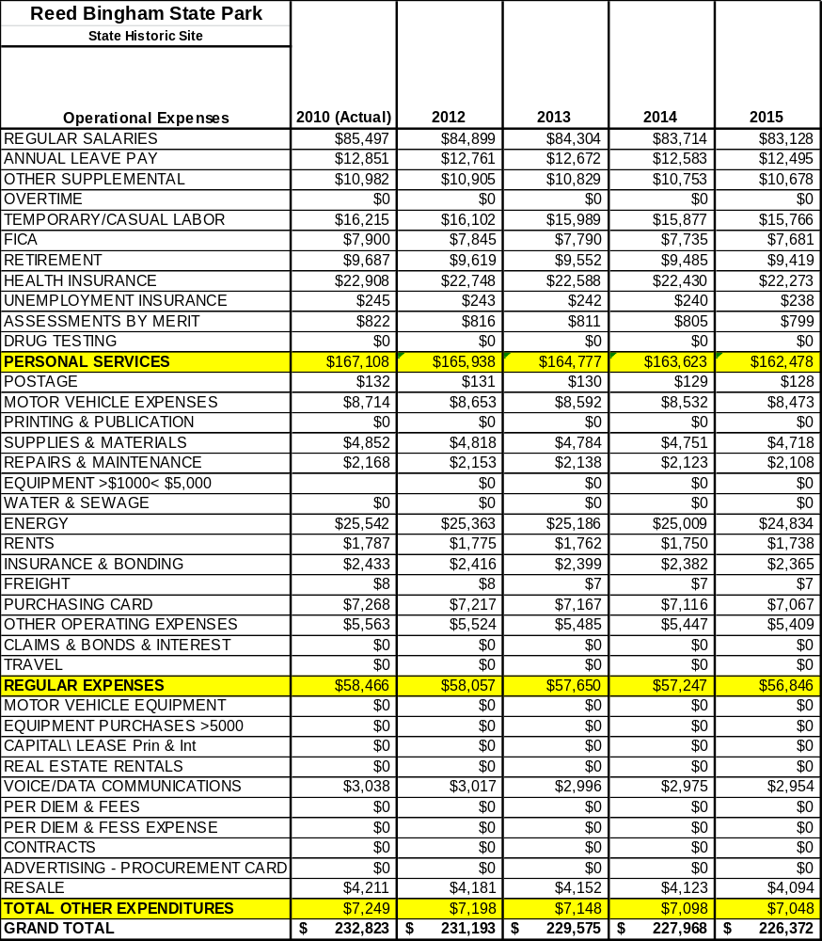

Revenue Pro Forma
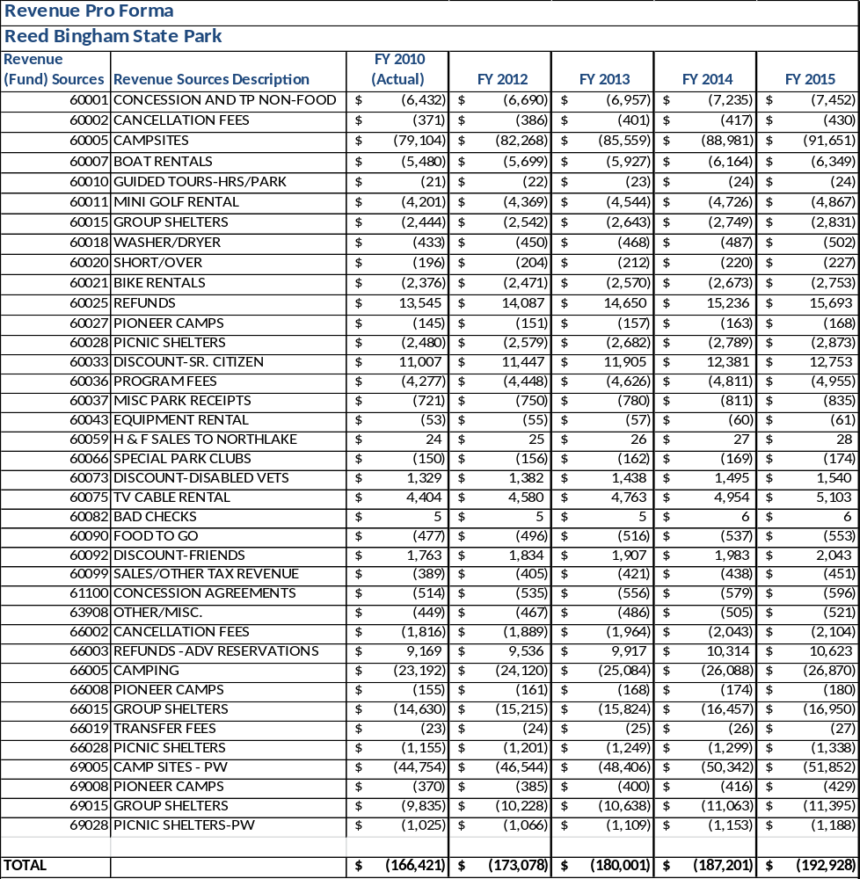

Total / Cost Recovery Pro Forma
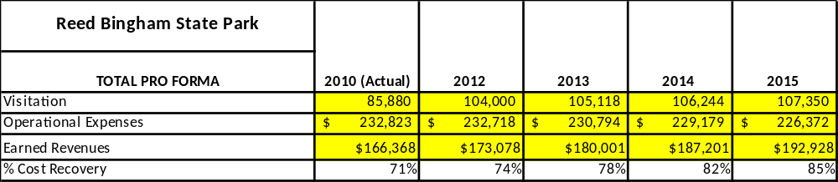

Action Plan
ACTION PLAN
Site: |  | Site Manager: |  |  | Date:
Month:
Strategy | Tasks | Costs / Funding | Revenues / ROI | Responsibilities | Metrics

ACTION PLAN
Site: |  | Site Manager: |  |  | Date:
Month:
Strategy | Tasks | Costs / Funding | Revenues / ROI | Responsibilities | Metrics

This is the average of the last three years – FY 2008, FY 2009, and FY 2010
Current employees, not including vacancies.
Current employees, not including vacancies.
Major population centers within a two-hour drive from the site

