R J Reynolds Mansion
Business & Management Plan

Prepared June 2011; Finalized February 2013
Direction 2015 – Sustainable Business Planning

Table of Contents

Executive Summary 3

Site and Operations Assessment 6
Site Inventory and Facility Assessment 6
Operational Assessment 8
Financial Performance Assessment 13

Business and Management Plan 16
Business Goals 16
Classification of Programs and Services 17
Partnership Development Plan 18
Marketing and Sales Plan 19
Revenue Generation Plan 21
Expense Management Plan 23
Financial Pro Forma 24

Action Plan 26

Executive Summary
The Parks, Recreation and Historic Sites Division (PRHSD) of the Georgia Department of Natural Resources (DNR) is transitioning the management of R J Reynolds Mansion to operate more like a business, reflecting the Direction 2015 – Sustainable Business Planning initiative to improve the fiscal performance and management of the state parks and historic sites system. This business and management plan is designed to help the site recover more operating expenses through earned revenues, productive partnerships, and innovative programs.

Site Fact Sheet
Site Name | R. J. Reynolds Mansion
Site Manager | James Maund
Region Manager | Tommy Turk
Date of Business Plan completion | May 10, 2011
Site size | 212 Acres (including Cabretta Island)
Total number of visitors (FY 2010) | 8,978
Total operating budget (FY 2010) | $537,489
Total earned revenues (FY 2010) | $474,212
Operational cost recovery (FY 2010) | 88%
Average operating cost per visitor (FY 2010) | $59.87
Average earned revenue per visitor (FY 2010) | $52.82
Average cost recovery (FY 2008 – 2010) | 88%
Target cost recovery (FY 2015) | 112%
Total full-time employees | 2 State Employees, 3 UGA per diem employees
Total part-time employees | 1
Primary service markets | Savannah, Brunswick, Saint Simons, Jekyll, Tybee, Jacksonville
Primary attractors/visitor appeal factors | Historic Reynolds Mansion, pristine beaches, privacy and seclusion
Leading opportunities for improved site performance | Reconfigure rooms to make them more appealing to couples and families with children. Upgrade furniture and amenities in order to command a more premium price. Offer more recreational and educational opportunities to expand customer base. Increase resale inventory and broaden target scope of resale items to include souvenirs, books, etc. encompassing more general audience in addition to Reynolds Mansion specific items. Enhance outreach materials to target event coordinators such as wedding planners, local schools and university reunions, local church retreat groups, adventure and eco-tourism, and corporate groups.

Site Summary and Key Attractions
Sapelo Island offers a peaceful, relaxing, and tranquil setting accessible only by a State-run Ferry or authorized private boat. This site consists of two distinct areas on Sapelo Island, the R J Reynolds Mansion and the Cabretta Island Campground, for a total of 212 acres. Both units require group reservations with a minimum of a two-night stay: Cabretta Campground requires a minimum of 15 and a maximum of 25; Reynolds Mansion requires a minimum of 16 and a maximum of 29. The Ferry departs from Meridian, which is 45 minutes north of Brunswick and 60 minutes south of Savannah off
I-95. The island setting and accessibility, in addition to group requirements, may prove to be more challenging than the traditional park setting in achieving cost recovery targets.

Key Attractions
The amenities or features listed below are those that seem to be most popular for visitors.
- R J Reynolds Mansion
- Sapelo Island Lighthouse
- Nanny Goat Beach and Cabretta Beach
- Hog Hammock Community
- Chocolate Plantation Ruins, Long Tabby Historic Building, and other Historic Churches and Buildings
- UGA Marine Research Institute and Sapelo Island National Estuarine Research Facility

Financial Targets
The table below details the total operating expenses and earned revenues for R J Reynolds Mansion over the last three years (2008 – 2010). This table also calculates total cost per visitor and revenues per visitor during these operating years, and details the target financial performance goals in the context of achieving at least 112% cost recovery. This table also calculates the necessary change from 2010 operating expenses and revenues.
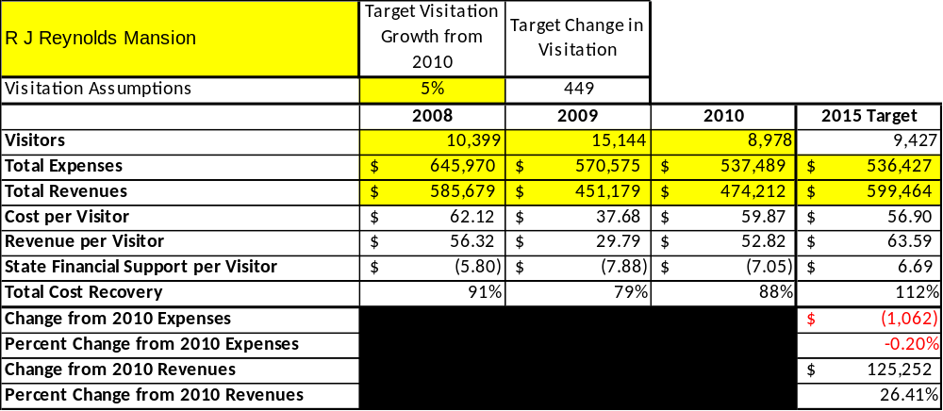

Key Recommendations

Primary / Short Term Recommendations
- Upgrade facilities and amenities at the site that are likely to offer a cost recovery of 100% or greater. Offering higher quality amenities will justify increasing rates. Mr. Reynolds Suite, Ms. Reynolds Suite, Kitchen Wing, and Nursery Wings would be converted into ‘private suites’ that would be more attractive to couples and family groups. Other rooms can be upgraded with new furnishings, including sitting areas. Rooms would be equipped with ‘Swing King’ beds that can be set up as twin beds or king sized beds, based on the make-up of the guest groups. This will accommodate the traditional non-family groups and also attract more families and couples.
- Offer more recreational opportunities for guests to include use of the tennis courts, installation of disc golf, expanding bike rentals, etc.
- Market more aggressively to attract new users. Expand website to offer ‘virtual tours’ or videos.
- Work with WRD, SINER, SICARS and vendors to provide more historic/natural tours of the island.
- Work with area guides and outfitters to provide mansion and campground packages that include fishing charters and kayak excursions.
- Expand our Customer Survey system to better access individual guest’s ideas and comments.
- Adopt Cost-Based accounting to achieve 100%+ return on investment.
- Expand and re-evaluate retail gift shop to increase sales volume and profits. Investigate installation of vending machines for snacks and coke products.
- Re-evaluate labor requirements to staff the site at the most cost effective level while assuring staffing levels are met.
- Continue to work with volunteer groups to gain the advantage of grounds maintenance, minor repairs and housekeeping services without cost associated with DNR staff.
- Manage Reynolds Mansion according to well-defined maintenance, program and operational standards monitored and enforced by Region Managers and senior management.
- Expand the December Holiday Season Luncheon/Brunch tours to maximize food service income.
- More closely monitor rates and fees to ascertain that the maximum “what the market with bear” pricing is maintained.

Secondary / Long Term Recommendations
- Acquire and install a modern point of sale accounting system to replace the PARS program.
- Improve beach amenities to take advantage of the site’s unique pristine environment while greatly enhancing the guest experience.
- Develop plans and changes to the configuration of the mansion so that unrelated groups could occupy the separate wings of the house at the same time.
- Install a retractable cover on the pool to allow the area to be used as seating for special events or for swimming at an extra charge.
- Discuss with the University of Georgia the possibility of operating the Azalea Cottage as a rental facility.
Site and Operations Assessment
This site and operations assessment is a culmination of analyses and findings from a review of the condition of facilities, infrastructure, and operations at R J Reynolds Mansion. The findings and observations are not intended to be an exhaustive review of all issues present, but provide a basic understanding of the predominant issues that contribute to the site’s current operating conditions. The assessment includes the following:
- Site Inventory and Facility Assessment
- Operational Assessment
- Financial Assessment
Site Inventory and Facility Assessment

Methodology
Facility and asset conditions are rated using a differential scale of excellent, good, fair, or poor. Descriptions of conditions that are attributed to each of these findings are also provided.
Scale of Conditions
Rating | General Description
Excellent | Facilities/amenities are in ‘excellent’ condition when they show little or no maintenance or repair problems. Facilities do not feature any major design or operational issues or flaws that contribute to diminished use or increased maintenance or upkeep. Facilities are easy to clean and maintain in order to place them back into public use and the users perceive them to be in excellent shape.
Good | Facilities/amenities are in ‘good’ condition when they show only minor maintenance or repair problems. Most maintenance issues with these facilities typically appear to be the result of age and/or heavy use. Facilities may only feature minor design or operational issues that contribute to diminished use or increased maintenance or upkeep. Facilities are moderately easy to clean and maintain in order to place them back into service and the users perceive them to be adequate for their use, but probably not in excellent shape.
Fair | Facilities/amenities are in ‘fair’ condition when they show significant maintenance or repair problems. Facilities generally exhibit ongoing maintenance issues that appear to be the result of age, heavy use, or design or operational flaws. Some maintenance and repair needs may compound their fair condition by being deferred because of budget and/or resource limitations. Facilities require more effort to clean and maintain before placing them back into service and the users may perceive them as being less than adequate for their use and in a state of deterioration. The facility or structure may need of major repair or replacement.
Poor | Facilities/amenities are in ‘poor’ condition when they show significant, on-going maintenance or repair problems that ultimately may result in suspended use for repair/replacement. Maintenance and repair issues are possibly the result of poor maintenance and clearly the result of age, heavy use, or design or operational flaws. Problems with the facilities are often compounded over time due to consistently-deferred maintenance and repair because of budget and/or resource limitations. Facilities may feature major design or operational issues that contribute to diminished use or increased maintenance or upkeep. Facilities require excessive effort to clean and maintain before placing them back into service and the users often perceive them as being inadequate for their use and in a state of serious deterioration. The facility or structure may need of major repair or replacement.

Inventory and Assessment
The table below is an inventory of facilities and amenities at R J Reynolds Mansion, and provides the assessed condition of each as reviewed In May, 2011
Site Asset / Amenity | Quantity | Condition
Reynolds Mansion | 1 | Fair
Cabretta Isle | 1 | Good
Ashantilly Residence | 1 | Good
Duty Quarters | 1 | Poor
Hydra Sport Boat | 1 | Fair

Prioritized Facility Needs
Based on the facility inventory and assessment, these prioritized needs have been identified. Each need has been aligned with a priority category of high, moderate, or low to support future decision making regarding project sequencing, investment of public resources, and meeting community expectations. The priority assignment for each need is not a measure of importance. Rather, these recommended priorities reflect a phased implementation approach over the next several years.

Facility Need | Priority Assignment
Reynolds Mansion | High
Duty Quarters | High
Cabretta isle Campground | Moderate
Ashantilly Residence | Moderate

Operational Assessment
The Operational Assessment includes:
- An inventory and classification of programs and services being provided at the site
- A review of staffing at the site
- A review of concessionaires and partners operating at the site
- Visitation and customer satisfaction

Inventory and Classification of Programs and Services
Programs and services are classified into one of three major categories:
1) Core or Essential Services
2) Important Services
3) Visitor Supported Services
Programs and services at the site are classified into these categories based in part on the mission and public mandates for both the site and the agency. For the programs and services in each of these categories, there are financial performance expectations that will define how services are funded and evaluated.

Category 1 – Core Services [Largely supported by tax funds]
Core programs, services and facilities are those the agency must provide and/or are essential in order to capably govern and meet statutory requirements. The failure of the agency to provide Category 1 services at adequate levels could result in significant negative consequences for the public and the resources under protection. The criteria for programs or services to be classified as core or essential are:
- The services are mandated by the agency’s law or charter or are contractually obligated by agreement to provide the services.
- The services are essential to protecting and supporting the public’s health and safety.
- The services protect and maintain valuable assets and infrastructure.
- The services would generally and reasonably be expected and supported by residents, businesses, customers and partners.
- The services are those that cannot or should not be provided by the private sector.
- The services provide a sound investment of public funds.
The following programs and services offered at R J Reynolds Mansion have been identified as core services:
- Management of natural and cultural resources in order to protect their integrity. This includes the physical upkeep of the Reynolds Mansion, residence and duty quarters.
- Preservation of artifacts, i.e. furniture and relics from the Spalding, Coffin and Reynolds eras.
- Provide interpretive staff to adequately offer guided tours of the property.

Category 2 – Important Services [Supported by a balance of tax funds and earned revenues]
Important programs, services and facilities are those the agency should provide, and are important to governing and effectively serving residents, businesses, customers and partners. Providing Category 2 services expands or enhances the agency’s ability to provide and sustain its core services. The criteria for programs or services to be classified as important are:
- The services expand, enhance or support identified core services.
- The services are broadly supported and utilized by the community, and are considered an appropriate, important, and valuable public good. Public support may be conditional upon the manner by which the services are paid for or funded.
- The services generate income or revenue that offsets some or all of the operating cost and/or are deemed to provide economic, social or environmental outcomes or results.
The following programs and services offered at R J Reynolds Mansion have been identified as important services:
- Maintain beach pavilion comfort station and pavilion area, Adirondack shelters at Cabretta Island Campground, and beach nature trail

Category 3 – Visitor Supported Services [Almost exclusively supported by earned revenue]
Visitor supported programs, services and facilities are those discretionary services that the agency may provide when additional funding or revenue exists to offset the cost of providing those services. Category 3 services provide added value above and beyond what is required or expected. The criteria for programs or services to be classified as visitor supported are:
- The services expand, enhance or support core services or important services and the quality of life of the visitors, community or stakeholders.
- The services are supported, valued and well utilized and provide an appropriate and valuable public benefit.
- The services generate income or funding from sponsorships, grants, user fees or other sources that offset some or all of their cost and/or provides a meaningful return on investment.

The services can possibly be provided through outsourcing or use of concessionaires, providing opportunities for community enterprises that may not otherwise be provided by the agency.
The following programs and services offered at R J Reynolds Mansion have been identified as visitor supported services:
- Mansion gift shop
- December Holiday Brunch and Lunch Tours
- Overnight rental of Mansion and Cabretta Campground

Staffing Assessment
Labor costs at R J Reynolds Mansion represent the largest area of budgetary expense at an average of 68% of the total operating budget each year for the last three complete years, which is higher than the target of total labor costs (including benefits) not exceeding 65% of the site’s total operating expenditures. The tables below and on the following page provide a basic review of the current staffing at the site.
Full Time Equivalent Employees
Position / Title | Quantity (FTE) | Vacancies | Annual Hours
Financial Ops Gen | 1 | 0 | 2080
Parks Fac Mgt Spec | 1 | 0 | 2080
Food Svc Operations Wkr | 3 | 0 | 2080
TOTAL | 5 | 0 | 6,240

Part Time Employees
Position / Title | Quantity (FTE) | Vacancies | Hours
Clerical Worker | 1 | 0 | 1508
TOTAL | 1 | 0 | 1,508

Labor Support
Labor Support | Annual Hours
Volunteers | 2368
Three UGA Per diem employees | 6240
TOTAL | 8,608

Total Labor Hours
Labor Type | Annual Hours
Full Time Equivalent Employees | 6,240
Part Time Employees | 1,508
Labor Support | 8,608
TOTAL Annual Labor Hours | 16,356

Labor Budget Summary

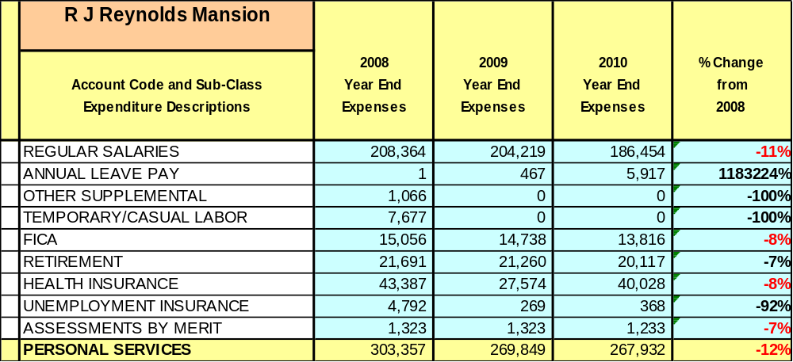

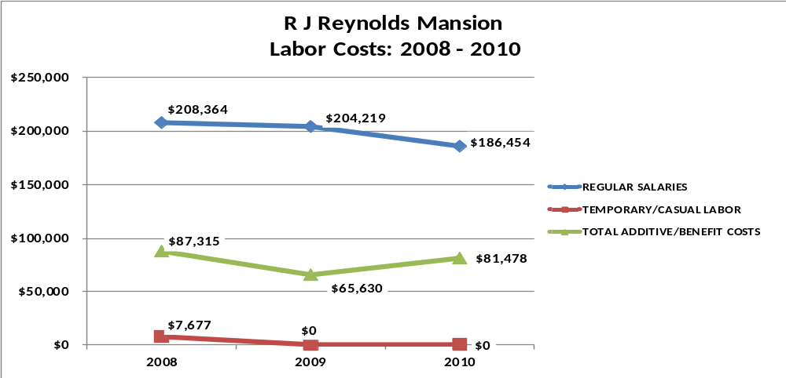

Visitation and Occupancy
Overall annual visitation to the site has trended downward from 2008 to 2010, decreasing by 17% or over 1,423 visitors. This is largely attributed to the economy.

Year | Total Visitation
2008 | 10,399
2009 | 15,144
2010 | 8,978

Occupancy for the overnight accommodations at R J Reynolds Mansion the last three years is detailed in the table below. Overall occupancy has trended downward from 2008 to 2010, decreasing by 22.5%. This is largely attributed to the economy and the ensuing travel restrictions by government and non-profit users of the Mansion.
Year | Mansion  Occupancy
2008 | 57%
2009 | 50%
2010 | 47%

Customer Service and Satisfaction

Site | Year | Customer Satisfaction Level
Reynolds Mansion | 2009 | 98%
Reynolds Mansion | 2010 | 98%
Financial Performance Assessment

Operational Expenses
A summary of total operating expenses at R J Reynolds Mansion from 2008 to 2010, as well as their percent change from 2008 are provided in the table below.

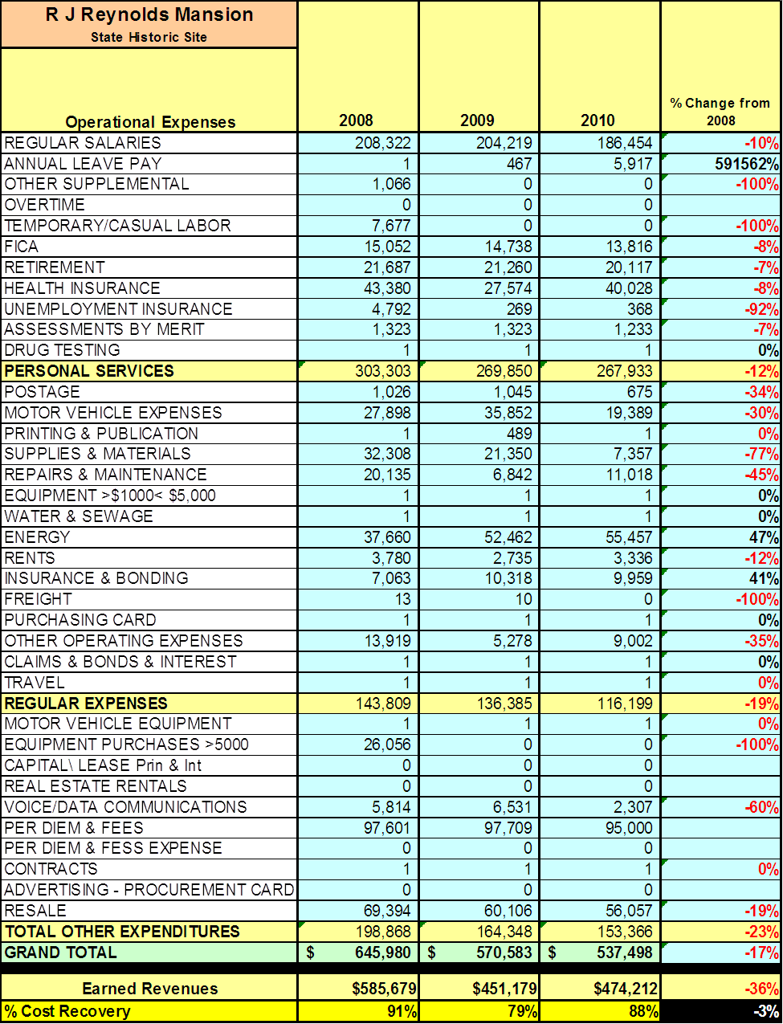
Earned Revenues
Earned revenues at R J Reynolds Mansion have decreased since 2008, which is largely attributed to the corresponding decrease in overall visitation. Monthly earned revenues for the last two years (see table on the following page) indicate that the total annual revenue increased 5% from 2009 to 2010, with the largest increases in monthly revenues in December (132%), January (56%), and September (34%) and the largest decreases in the months of July (-46%), April (-37%), June (-21%), and March (-17%).
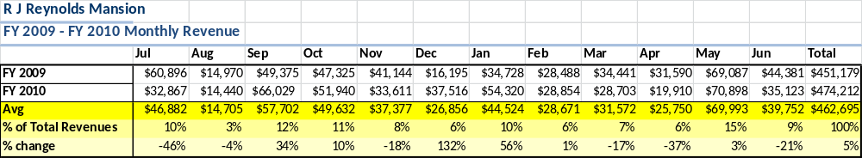

The graphs below illustrate the monthly revenue trends each year and the average percent of total annual revenue earned each month.
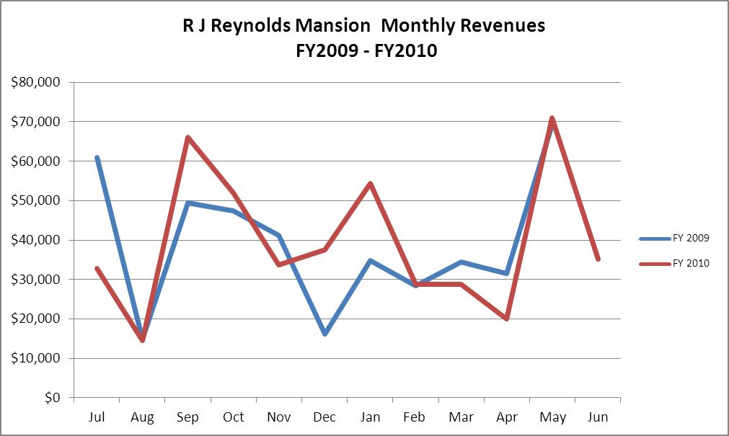

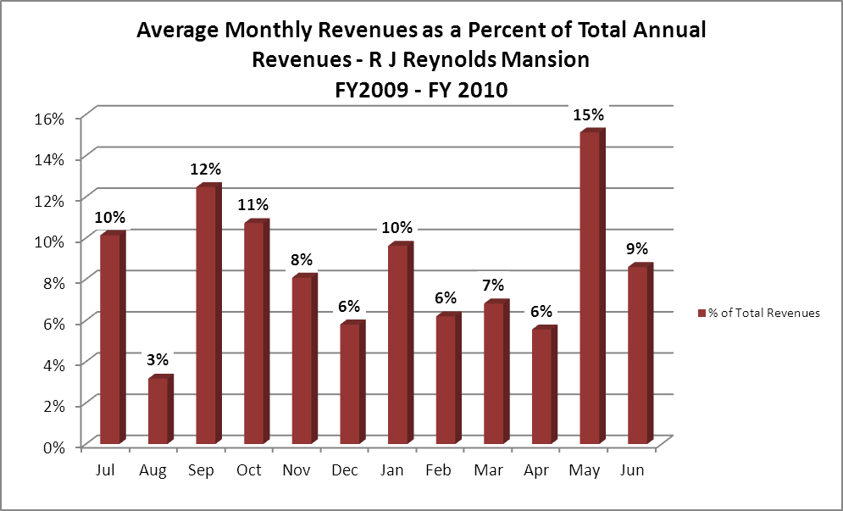

Cost Recovery Trends
R J Reynolds Mansion has achieved an average cost recovery of 82% of annual operational expenses through earned revenues from FY 2008 to FY 2010. This is detailed and illustrated in the table and graph below.
Year | Operational  Expenses | Earned  Revenues | Percent Cost  Recovery
2008 | $645,970 | $585,679 | 91%
2009 | $570,575 | $451,179 | 79%
2010 | $537,489 | $474,212 | 88%
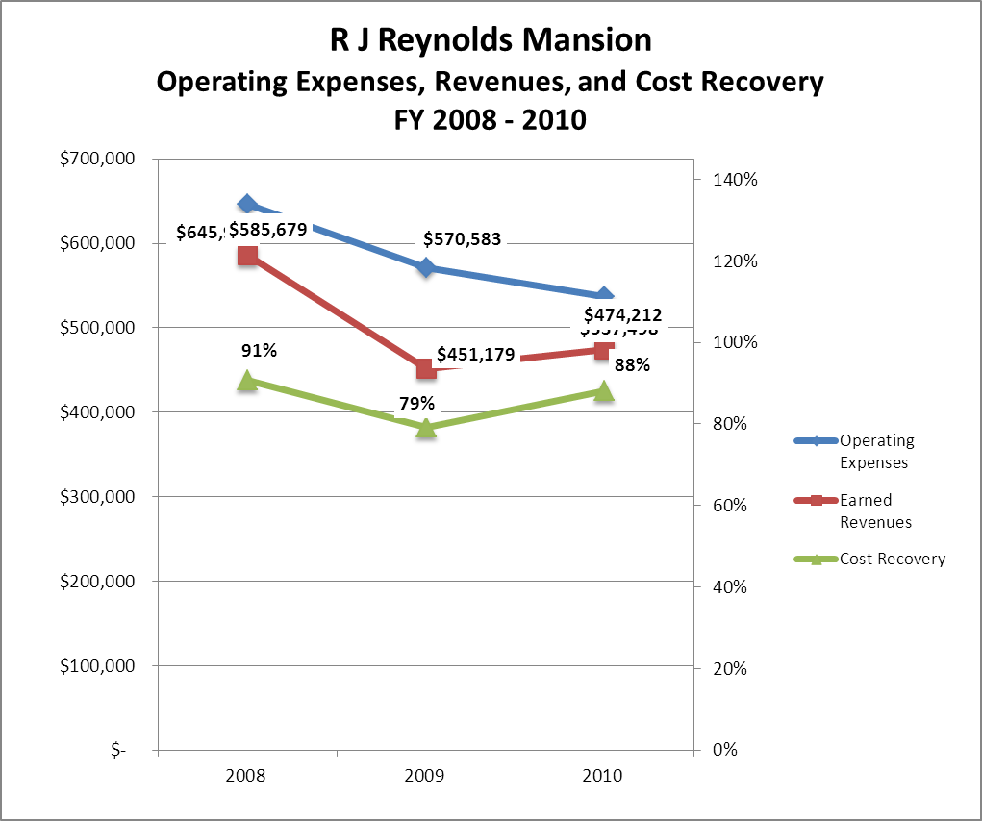

Review of Pricing
Data on rate information is available as far back as 2002, but only the last five years are evaluated. There has been notable growth in fees charged at R J Reynolds Mansion since 2005, with the largest increase being lodge rooms. A table detailing the rates for R J Reynolds Mansion is provided below.

 | 2005 | 2006 | 2007 | 2008 | 2009 | 2010 | Comments
RJ Reynolds Mansion
Mansion (per person) | $160 | $160 | $160 | $160 | $170 | $175
Campground (per person) | $12 | $12 | $12 | $12 | $12 | $15
Business and Management Plan

Business Goals
The following goals serve as the foundation for the key recommendations and strategies in this business plan for R J Reynolds Mansion.

Enhance Cost Recovery of Site Operations
Offering higher quality amenities will justify increasing rates. Mr. Reynolds Suite, Ms. Reynolds Suite, Kitchen Wing, and Nursery Wings would be converted into ‘private suites’ that would be more attractive to couples and family groups. Other rooms can be upgraded with new furnishings including sitting areas. Rooms would be equipped with ‘Swing King’ beds that can be set up as twin beds or king sized beds based on the make-up of the guest groups. This will accommodate the traditional non-family groups and also attract more families and couples.

Enhance Revenue Generation Strategies
Expand and re-evaluate retail gift shop to increase sales volume and profits. Investigate installation of vending machines for snacks and Coke products. Develop a broader customer base beyond the traditional group users. The mansion has a very high repeat customer base but these groups are aging and new users need to be attracted.

Expand Special Events at the Site
Expand the December Holiday Season Luncheon/Brunch tours to maximize food service income.

Improve the Diversity and Innovation of Recreational and Interpretive Programs
Work more closely with WRD, SINER, SICARS, and area outfitters to offer more opportunities for historic and nature tours of the island. Work at a department level to have other than mansion staff deliver tours of the island. Develop business relationships with outfitters and guides in order to provide fishing charters and kayak excursions in overnight packages with the mansion and the campground. Offer more recreational opportunities for mansion guests such as use of the tennis courts and the installation of disc golf to appeal to younger and more active groups.

Improve the Effectiveness of Marketing and Sales
Post ‘virtual tours’ and videos on the sites web page to reach customers not familiar with what the site has to offer. Develop relationships with companies specializing in high end corporate retreats to market executive retreat adventure packages.

Establish Greater Consistency of Managing and Monitoring Customer Service & Satisfaction
Expand our customer Survey system to better access individual guest’s ideas and comments.

Expand Partnership Opportunities
Aggressively seek partnerships with private tour operators, outfitters, and fishing charter businesses. Build relationships with corporate retreat planners, wedding coordinators, and high end adventure tourism companies.

Classification of Programs and Services
The tables below summarize the classifications of programs and services at R J Reynolds Mansion as either core, important, or visitor supported and projects a range of cost recovery percentages that might be achieved for each. These classifications establish financial performance goals for each category of services that are linked to the recommendations and strategies of this business plan.
Core Services
Program / Service | Target Cost Recovery
Management of natural and cultural resources in order to protect their integrity. This includes the physical upkeep of the Reynolds Mansion, Residence & Duty Quarters. | 0% Cost Recovery
Preservation of artifacts, i.e. furniture and relics from the Spalding, Coffin, and Reynolds eras. | 5-10% Cost Recovery
Provide interpretive staff to adequately offer guided tours of the property. | 50% Cost Recovery

Important Services
Program / Service | Target Cost Recovery
Maintain beach pavilion comfort station and pavilion area, Adirondack shelters at Cabretta Island Campground, and beach nature trail. | 0% Cost Recovery

Visitor Supported
Program / Service | Target Cost Recovery
Mansion gift shop. | 140% Cost Recovery
December Holiday Brunch and Lunch Tours. | 120% Cost Recovery
Overnight rental of Mansion and Cabretta Campground. | 115% Cost Recovery

Partnership Development Plan
The table below summarizes existing partners and targeted partnerships by classification (operational, vendor, service, co-branding, funding partners) and by organizational type.
 | Public Partners | Not-for-profit Partners | Private / Enterprise Partners
Operational Partners | - WRD  - UGA  - SINER |  | - SICARS
Vendor Partners |  |  | - Local tour guides  - Island B&B’s
Service Partners |  | - Odum Garden Club  - Friends of Sapelo  - GA Conservancy
Co-branding Partners
Funding Resource Development Partner

Marketing and Sales Plan

Marketing and Sales Goals
Marketing and sales goals for R J Reynolds Mansion are based on the following desired outcomes:
- Expand area advertisement of the December Holiday Season lunch/brunch program
- Solicit advertisements and site visits from wedding oriented magazines and specialized television media programs. These have provided extensive national exposure with little or no capital outlay.
- Utilizing Atlanta Group Sales, advertise the modernization of the Mansion and its new family suite layout plan.
In order to meet these goals, examples of specific target outcomes were identified in the areas detailed in the table below.
Area  of Focus | Current  Performance | Goal  by 2011 | Goal  by 2012 | Goal  by 2015
Lodge Occupancy | 46% | 48% | 52% | 55%
Marketing and Promotion Strategies

Publicity and Social Media
R J Reynolds Mansion will approach marketing and publicity planning using the following guidelines and themes:
- Event publicity
Major events benefit by having short stories in local, regional, and statewide newspapers and online social media hooks planted that run three to four weeks in advance of the event up to the date of the event itself. Stories and media need to be cultivated with contacts and online sales channels several weeks in advance of the time the stories need to run. Special interest interviews on morning, noon, and evening television news programs, radio interviews on popular rush-hour programs, and blogs on known affinity online sites should also be included.
- Program publicity
Special and unique programs should have feature stories in magazines, weekly newspapers, and statewide daily newspapers that are aimed at placements as front-page or sectional front-page stories. These stories are most effective if they run shortly before the season that the featured program begins. This will likely require several weeks of advanced planning with media contacts. Similar coverage on television and radio should also be considered. If pre-publicity cannot be generated, post-publicity can help promote future programs.
- Site Publicity
Site publicity focusing on a single site or sub-set of sites requires more intense planning efforts to attract multiple writers and editors from target publications. Each site could host several seasonal media familiarization tours (with 10 to 15 writers or editors) to familiarize them with the site and its benefits and amenities. Stories and features resulting from such tours typically take between two and six months to materialize so the tours should focus on experiences, benefits, and programs that would be available when the stories are expected to run.
Examples and suggested opportunities for events, programs and related publicity efforts based on the themes described above at R J Reynolds Mansion are provided in the table below.

Event Publicity | Program Publicity | Site Publicity
December Events Lunch/Brunch | Wedding Groups | Mansion Modernization

Packaging
Examples and suggested packages for R J Reynolds Mansion are provided in the table below.

Package | Package Details
Weekday Discounts | Discounting room rate from $180 to $150 Sunday-Thursday nights
Late Date Fill-In Rate | Accepting less than 16 guest minimum when booking is very close to arrival date and unbooked.
Paddle and Play | Contract with outfitter to lead groups on kayak trip during stay at mansion or campground
Surf and Turf | Fishing guide provides campground guests equipment and instruction in surf fishing. Bonfire and cook-out catered by Mansion staff.

Group Sales
Types of groups within which specific target customers can be identified for R J Reynolds Mansion are listed below:
- Family Reunions | - Church and Church Related Groups | - Photography and art groups
- Research Groups | - Environmental Studies | - Educational
- Weddings | - Business Retreats | - College & Universities

Incentivizing New and Repeat Visitation
R J Reynolds Mansion will utilize the following strategies and/or incentives to encourage new and repeat visitation starting in FY 2012:
- Offering more one on one customer service. Paying personal attention to group individuals
- Weekday rate
- Accepting less than 16 group minimum on last minute booking
- Invite retreat planners, adventure guides, event coordinators, and travel writers for an overnight stay and tour of the island.

Marketing and Sales Metric Goals
The following marketing and sales metric goals and/or others will be monitored and progress reported at R J Reynolds Mansion:
- Loyalty and repeat customers = 88% of our guests are repeat customers.
- Brand confidence & customers-recruiting-customers = 88%
Revenue Generation Plan
Revenue / Cost Recovery Goals
R J Reynolds Mansion has set a financial goal of increasing annual revenues 5% annually between 2012 and 2015. The largest revenue growth opportunity is most likely November, June and September. The table below details projected revenue growth leading up to 2015, based upon a nominal growth of revenues each year.

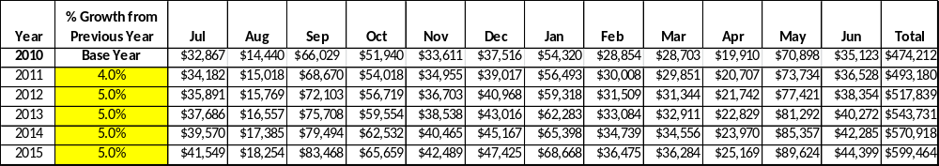

These projections would result in a total of 26% cumulative growth in total annual revenues between FY2010 and FY2015. If operational expenses can be managed to hold steady (neither increase or decrease) between FY 2010 and FY 2015, then the overall cost recovery of the site will be approximately 112% in FY 2015 at these projected revenue levels. This is higher than the annual financial performance of the site in FY 2010, which was operated at 88% cost recovery in that year.
Revenue Generation Strategies

Pricing Plan
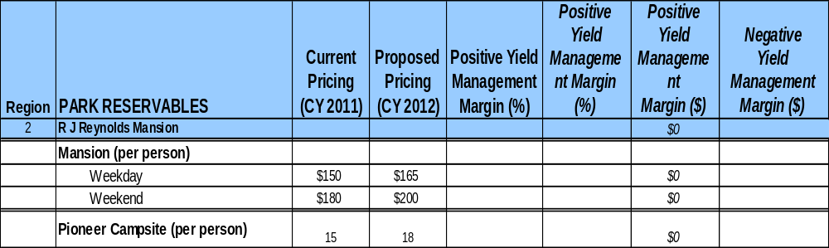

INNOVATIVE PROGRAMMING AND SPECIAL EVENTS PLAN
Program / Event | Theme / Purpose | Scheduled Date/Season | Frequency | Target Participation | Target User Fee | Target Cost Recovery
December Holiday Lunch/Brunch | Build support, attract new users | December | 3-5 times per week | 88 per day | $20 | 125%
Birding Weekend | Lectures/Tours by noted birding figures | May & October | Twice annually | 25 | $450 | 125%

PARTNERSHIPS AND CONCESSIONS PLAN
Service / Partnership | Term of Service | Financial Objective | Contract Manager
Odum Garden Club | 1 Year | Reduce grounds maintenance | Park Manager
WRD provide natural and historic interpretation of island | Permanent | Free Mansion staff to perform more relevant duties | Park Manger

Expense Management Plan
Personnel Assignments
The following actions will be taken to proactively manage labor costs via personnel assignments and classifications.

Action | Timeline | Outcome
Eliminate guided island tours | April 2011 | Annual labor cost of $6,300
Convert Conf Coordinator to part time | July 2010 | Annual labor cost of $3,000
Eliminate Resource Manager Position | July 2010 | Annual labor cost of $10,000

Management Techniques
The following actions will be taken to proactively manage labor costs via management techniques.

Action | Timeline | Outcome
Utilize WRD staff for beach/lighthouse grounds maintenance | June 2011 | Annual labor reduction of $4,500

Adjusted Levels of Service
The following actions will be taken to proactively manage labor costs via reduced levels of service.

Action | Timeline | Outcome
Turn over tours of island to WRD and private vendors | In progress, ongoing | Free Mansion staff to perform more relevant duties

Financial Pro Forma
The following five-year financial pro forma projects operating expenses, earned revenues and cost recovery through FY 2015. These pro forma are based on the strategies and desired outcomes identified in this business plan, especially the revenue generation and expense management plans, and are linked to corresponding performance goals.

Expense Pro Forma
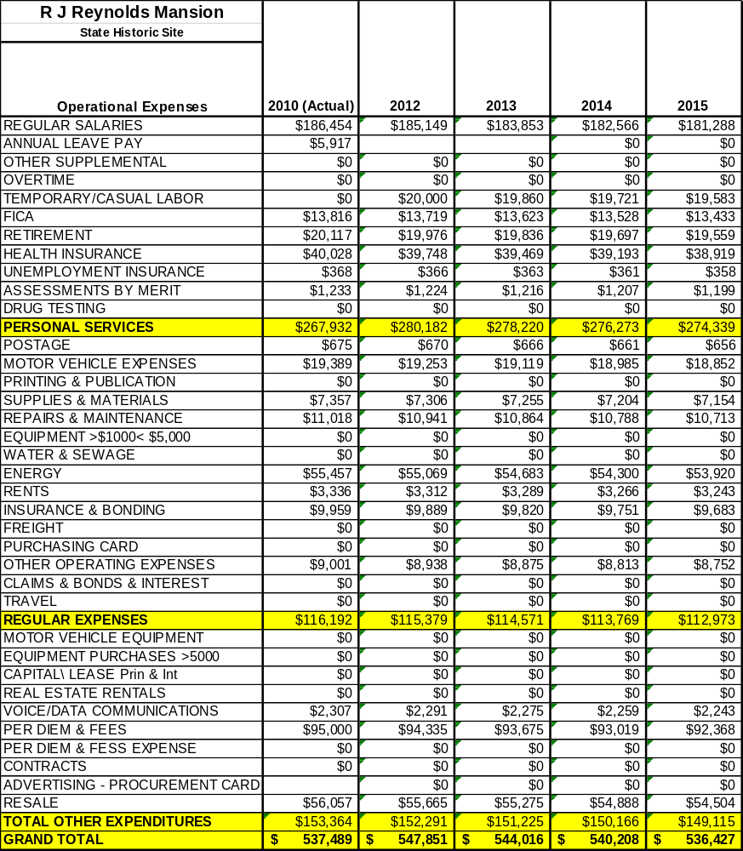

Revenue Pro Forma

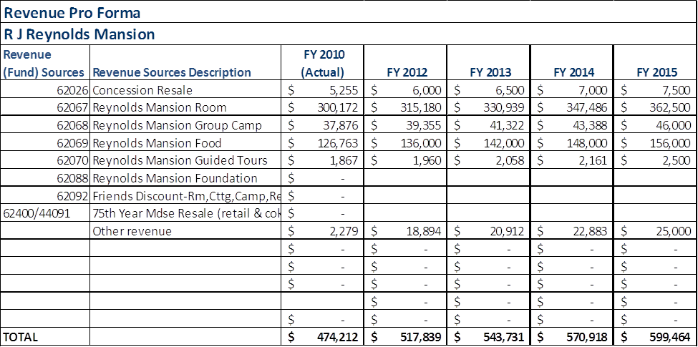

Total / Cost Recovery Pro Forma

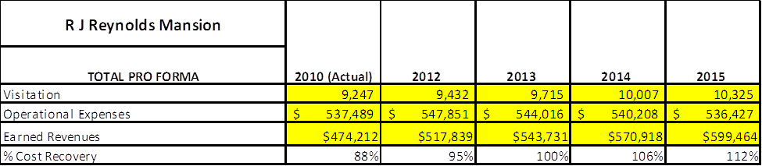

Action Plan
ACTION PLAN
Site: R J Reynolds Mansion |  | Site Manager: James Maund |  |  | Date:
Month:
Strategy | Tasks | Costs / Funding | Revenues / ROI | Responsibilities | Metrics

ACTION PLAN
Site: R J Reynolds Mansion |  | Site Manager: James Maund |  |  | Date:
Month:
Strategy | Tasks | Costs / Funding | Revenues / ROI | Responsibilities | Metrics

This is the average of the last three years – FY 2008, FY 2009, and FY 2010
Current employees, not including vacancies.
Current employees, not including vacancies.
Major population centers within a two-hour drive from the site

