SAM Shortline Excursion Train
Business & Management Plan

Prepared June 2011; Finalized January 2013
Direction 2015 – Sustainable Business Planning

Table of Contents

Executive Summary 3

Site and Operations Assessment 6
Site Inventory and Facility Assessment 6
Operational Assessment 8
Financial Performance Assessment 13

Business and Management Plan 16
Business Goals 17
Classification of Programs and Services 18
Partnership Development Plan 20
Marketing and Sales Plan 21
Revenue Generation Plan 24
Expense Management Plan 26
Financial Pro Forma 27

Action Plan 30

Executive Summary
The Parks, Recreation and Historic Sites Division (PRHSD) of the Georgia Department of Natural Resources (DNR) is transitioning the management of SAM Shortline Excursion Train to operate more like a business, reflecting the Direction 2015 – Sustainable Business Planning initiative to improve the fiscal performance and management of the state parks and historic sites system. This business and management plan is designed to help the site recover more operating expenses through earned revenues, productive partnerships, and innovative programs.

Site Fact Sheet
Site Name | SAM Shortline Excursion Train
Site Manager | Kathy Odom
Region Manager | Eric Bentley
Date of Business Plan completion | 12/3/12
Site size | 17 train cars
Total number of visitors (FY 2010) | 23,194
Total operating budget (FY 2010) | $ 898,519
Total earned revenues (FY 2010) | $ 561,031
Operational cost recovery (FY 2010) | 62%
Average operating cost per visitor (FY 2010) | $ 38.74
Average earned revenue per visitor (FY 2010) | $ 24.19
Average cost recovery (FY 2008 – 2010) | 97.33%
Target cost recovery (FY 2015) | 88%
Total full-time employees | 4
Total part-time employees | 2
Primary service markets | Valdosta, Albany, Columbus, Macon, Warner Robbins
Primary attractors/visitor appeal factors | President Carter, unique experience
Leading opportunities for improved site performance | Addition of alcohol sales, Overnight Packages, and Entertainment

Site Summary and Key Attractions
SAM Shortline train is plugged into a stationary power source at Georgia Veterans State Park. The mainline and a sidetrack are found on the north side of the property. The office is located in Cordele, just 2 miles from I-75 and only 10 miles east of the park. There are four primary service markets within 100 miles, which are Columbus, Macon, Valdosta and Albany.

Key Attractions
The amenities or features listed below are those that seem to be most popular for visitors.
- Visit the hometown & boyhood farm of President Jimmy Carter
- Riding a passenger train
- Possibility of seeing President Carter
- Viewing Habitat for Humanity Global Village
- Unique opportunity for a full day experience
- Visiting the Windsor Hotel in Americus

Financial Targets for SAM Shortline Train
The table below details the total operating expenses and earned revenues for SAM Shortline Excursion Train over the last three years (2008 – 2010). This table also calculates total cost per visitor and revenues per visitor during these operating years, and details the target financial performance goals in the context of achieving at least 97% cost recovery. This table also calculates the necessary change from 2010 operating expenses and revenues.
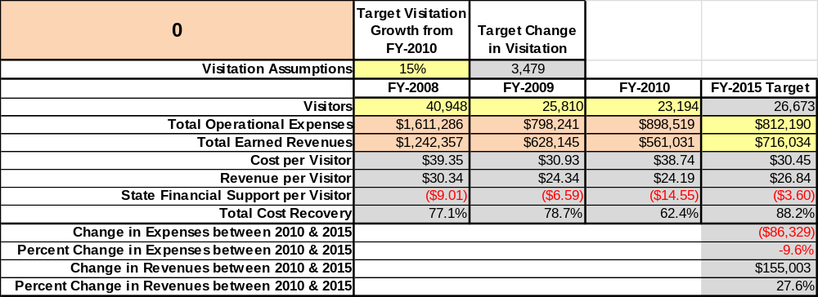

Key Recommendations for SAM Shortline Train

Primary / Short Term Recommendations
- Continue to operate the train on self-sustaining principals.
- Continue to work with local partners to assist with financial contributions.
- Researched vendors to manage the commissary car for maximum revenue generation; however, the decision was made to continue with it being operated with staff and volunteers.
- Evaluate Day Out with Thomas event for additional days or ways to add revenue.
- Partner with local businesses for packages to increase value of purchase for customers.
- Continue to work with Friends of SAM Chapter with 2 fundraisers per year.
- Research grants opportunities and apply if valuable to our operation.
- Collaborate with two county tourism committees for advertising and promotion.
- Increase volunteer labor to assist answering telephones, routing calls and taking reservations.
- Continue training for all new volunteers with hands-on guidance from seasoned volunteers.
- Develop a procedure to measure economic benefits to the Tier One counties in our area.
- Create the correct mix of resale merchandise and food to meet our guest needs and not be overstocked.
- Work with the SAMS Authority Board to make its members more aware of the self-sustaining challenges for the train and why we need to modify operations to reduce expenses and increase revenues.
- Work closely with Heart of Georgia Railroad and Department of Transportation to request funding for track restoration.
Secondary / Long Term Recommendations
- Continue to try to add funds to our reserve or fund balance.
- Work toward creating a run schedule for a year at a time in advance.
- Improve communications with legislators on the need to support funding for track restoration and upkeep.
- Analyze benefits of developing train runs to communities outside the normal two county corridor that were serviced previously including Dublin, Macon, Vidalia, Savannah and Milan.
Site and Operations Assessment
This site and operations assessment is a culmination of analyses and findings from a review of the condition of facilities, infrastructure, and operations at SAM Shortline Excursion Train. The findings and observations are not intended to be an exhaustive review of all issues present, but provide a basic understanding of the predominant issues that contribute to the site’s current operating conditions. The assessment includes the following:
- Site Inventory and Facility Assessment
- Operational Assessment
- Financial Assessment
Site Inventory and Facility Assessment

Methodology
Facility and asset conditions are rated using a differential scale of excellent, good, fair, or poor. Descriptions of conditions that are attributed to each of these findings are also provided.
Scale of Conditions
Rating | General Description
Excellent | Facilities/amenities are in ‘excellent’ condition when they show little or no maintenance or repair problems. Facilities do not feature any major design or operational issues or flaws that contribute to diminished use or increased maintenance or upkeep. Facilities are easy to clean and maintain in order to place them back into public use and the users perceive them to be in excellent shape.
Good | Facilities/amenities are in ‘good’ condition when they show only minor maintenance or repair problems. Most maintenance issues with these facilities typically appear to be the result of age and/or heavy use. Facilities may only feature minor design or operational issues that contribute to diminished use or increased maintenance or upkeep. Facilities are moderately easy to clean and maintain in order to place them back into service and the users perceive them to be adequate for their use, but probably not in excellent shape.
Fair | Facilities/amenities are in ‘fair’ condition when they show significant maintenance or repair problems. Facilities generally exhibit ongoing maintenance issues that appear to be the result of age, heavy use, or design or operational flaws. Some maintenance and repair needs may compound their fair condition by being deferred because of budget and/or resource limitations. Facilities require more effort to clean and maintain before placing them back into service and the users may perceive them as being less than adequate for their use and in a state of deterioration. The facility or structure may need of major repair or replacement.
Poor | Facilities/amenities are in ‘poor’ condition when they show significant, on-going maintenance or repair problems that ultimately may result in suspended use for repair/replacement. Maintenance and repair issues are possibly the result of poor maintenance and clearly the result of age, heavy use, or design or operational flaws. Problems with the facilities are often compounded over time due to consistently deferred maintenance and repair because of budget and/or resource limitations. Facilities may feature major design or operational issues that contribute to diminished use or increased maintenance or upkeep. Facilities require excessive effort to clean and maintain before placing them back into service and the users often perceive them as being inadequate for their use and in a state of serious deterioration. The facility or structure may need of major repair or replacement.

Inventory and Assessment
The table below is an inventory of facilities and amenities at SAM Shortline Excursion Train, and provides the assessed condition of each as reviewed in April, 2011. Additional assessment will be needed for track conditions and the necessity of repairs and restoration.

Site Asset / Amenity | Quantity | Condition
Depot in Cordele | 1 | Good
Depot at Ga. Veterans Park | 1 | Good
Train Cars (operational) | 10 | Good
Train cars (at Florida Central RR) | 4 | Fair
Train cars (unoperational) | 3 | Poor

Prioritized Facility Needs
Based on the facility inventory and assessment, these prioritized needs have been identified. Each need has been aligned with a priority category of high, moderate, or low to support future decision making regarding project sequencing, investment of public resources, and meeting community expectations. The priority assignment for each need is not a measure of importance; rather, these recommended priorities reflect a phased implementation approach over the next several years.

Facility Need | Priority Assignment
Train Cars – Need interior painting; wheels on two cars within next two years; will need COT&S (full maintenance on wheels and axles) on cars. The baggage car needs repairs on the interior, but has great wheels and a spare generator on it. The ‘spare’ car needs new flooring. | High
Train Cars – These cars are located in Florida and were leased. They are in bad need of repair (windows, wheels, COT&S); however, do not recommend repairing as we are currently in negotiations for sale of them to another railroad. | Moderate
Train Cars – These are two Stone Mountain cars which are not good for much and definitely not worth repairing. The Flint River car is a sleeper car – not recommended for repair but for salvaging wheels and parts. | Low

Operational Assessment
The Operational Assessment includes:
- An inventory and classification of programs and services being provided at the site
- A review of staffing at the site
- A review of concessionaires and partners operating at the site
- Visitation and customer satisfaction

Inventory and Classification of Programs and Services
Programs and services are classified into one of three major categories:
1) Core or Essential Services
2) Important Services
3) Visitor Supported Services
Programs and services at the site are classified into these categories based in part on the mission and public mandates for both the site and the agency. For the services in each of these categories, there are financial performance expectations that will define how services are funded and evaluated.

Category 1 – Core Services [Largely supported by tax funds]
Core programs, services and facilities are those the agency must provide and/or are essential in order to capably govern and meet statutory requirements. The failure of the agency to provide Category 1 services at adequate levels could result in significant negative consequences for the public and the resources under protection. The criteria for services to be classified as core or essential are:
- The services are mandated by the agency’s law or contractually obligated.
- The services are essential to protecting and supporting the public’s health and safety.
- The services protect and maintain valuable assets and infrastructure.
- The services would reasonably be expected to be supported by customers and partners.
- The services are those that cannot or should not be provided by the private sector.
- The services provide a sound investment of public funds.
The following services offered at SAM Shortline Excursion Train have been identified as core services:
- Encourage and promote the improvement and advancement of the region and the enhancement and profitability of tourism to the region and its citizens. Develop and promote the public good, general welfare, trade, commerce, tourism, industry and employment opportunities within the service area.
- Develop and execute cooperative excursion programming and marketing initiatives with local and regional tourist attractions and events, hospitality providers and retail businesses.
- The key function of the excursion train is to stimulate economic development in several Tier One Southwest Georgia communities and promote tourism in Georgia.
- Ensure the safety of all the passengers and crew through maintenance checks before each excursion and training of staff and volunteers.
Category 2 – Important Services [Supported by a balance of tax funds and earned revenues]
Important programs, services and facilities are those the agency should provide, and are important to governing and effectively serving residents, businesses, customers and partners. Providing Category 2 services expands or enhances the agency’s ability to provide and sustain its core services. The criteria for programs or services to be classified as important are:
- The services expand, enhance or support identified core services.
- The services are broadly supported and utilized by the community, and are considered an appropriate, important, and valuable public good. Public support may be conditional upon the manner by which the services are paid for or funded.
- The services generate income or revenue that offsets some or all of the operating cost and/or are deemed to provide economic, social or environmental outcomes or results.
The following services offered at SAM Shortline have been identified as important services:
- Provide a recreational and educational opportunity for citizens of Georgia and visitors from other states to be able to enjoy.
- Generate retail sales of concession items and souvenirs at reasonable / affordable prices.
- Provide a setting for local volunteers and train hosts to be able to commit to the creation and sustainability of the excursion service.

Category 3 – Visitor Supported Services [Almost exclusively supported by earned revenue]
Visitor supported programs, services and facilities are those discretionary services that the agency may provide when additional funding or revenue exists to offset the cost of providing those services. Category 3 services provide added value above and beyond what is required or expected. The criteria for programs or services to be classified as visitor supported are:
- The services expand, enhance or support core services or important services and the quality of life of the visitors, community or stakeholders.
- The services are supported and well utilized to provide a valuable public benefit.
- The services generate income or funding from sponsorships, grants, user fees or other sources that offset some or all of their cost and/or provides a meaningful return on investment.

- The services can possibly be provided through outsourcing or use of concessionaires, providing opportunities for community enterprises that may not otherwise be provided by the agency.
The following services offered at SAM Shortline have been identified as visitor supported services:
- Operate special train excursions and events related to the mission of the Authority.
- Sell retail merchandise as souvenirs on the train.
- Provide various food items for sale on the train to meet public demand.
- Provide packages which include overnight and food, or food and tour.
- Develop and promote trains and special excursions off the normal corridor to increase awareness and support.

Staffing Assessment
Labor costs at SAM Shortline Excursion Train do not represent the largest area of budgetary expense. Labor costs averaged 28% of the total operating budget each year for the last three complete years, which is lower than the target of total labor costs (including benefits) not exceeding 65% of a site’s total operating expenditures. The tables below and on the following page provide a basic review of the current staffing at the site.

Full Time Equivalent Employees
Position / Title | Quantity (FTE) | Vacancies | Annual Hours
Excursion Train Manager | 1 | 0 | 2080
Administrative Op. Coord II | 1 | 0 | 2080
Administrative Op. Coord. I | 0 | 1 | 2080
Bldg/Const Trades Spec. | 1 | 0 | 2080
SS: Clerk (WL) Regular | 3 | 3 | 4160
SS: Food Svc Operation Wkr (WL) Regular | 0 | 2 | 4160
TOTAL | 6 | 6 | 16,640

Part Time Employees
Position / Title | Quantity (FTE) | Vacancies | Hours
Maintenance Worker | 1 | 1 | 1508
Support Services Worker | 1 | 1 | 1508
Housekeeper | 1 | 1 | 1508
Desk Clerk | 1 | 1 | 1508
Cashier | 1 | 0 | 1508
Utility Worker | 1 | 0 | 1508
TOTAL | 6 | 4 | 9,048

Labor Support
Labor Support | Annual Hours
Volunteers | 15,755
Community Service Workers | 0
Engineering and Construction Crews | 0
Resource Management Crews | 0
TOTAL | 15,755

Total Labor Hours
Labor Type | Annual Hours
Full Time Equivalent Employees | 16,640
Part Time Employees | 9,048
Labor Support | 15,755
TOTAL Annual Labor Hours | 41,443

Labor Budget Summary

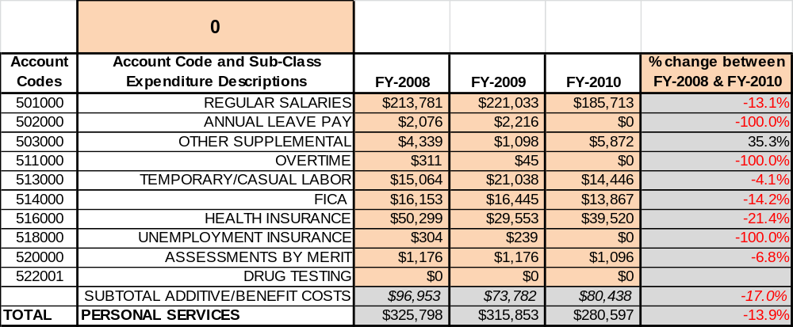

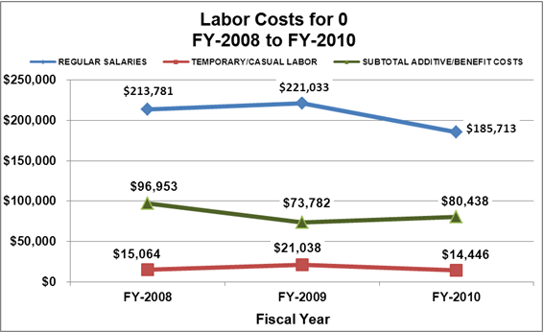

Ridership and Occupancy
Overall annual ridership has trended downward from 2008 to 2010, decreasing by 30% or over 7,406 riders. This is largely attributed to the economy and the track conditions. Track speeds were reduced for safety reasons due to the poor conditions of the tracks. Tracks are maintained by Georgia DOT and the Heart of Georgia Railroad with funding coming through the legislature.
- 2008 – 31,830 riders
- 2009 – 22,947 riders
- 2010 – 24,424 riders
The chart below illustrates coach occupancy over the last three years per seating style.

Year | Coach Occupancy | Premium Occupancy | Hawkins Occupancy | Total Occupancy | Hawkins Car  In Service
2008 | 28,836 | 2,487 | 507 | 31,830 | (7 months)
2009 | 20,728 | 2,104 | 115 | 22,947 | (4 months)
2010 | 21,024 | 1,944 | 635 | 24,290 | (11 months)

Customer Service and Satisfaction
Currently the train does not monitor customer service with comment cards; however, all issues or concerns are addressed as they arise. The train is well known for the high level of customer satisfaction; however, this is an area that needs to be addressed with comment cards or online comments.

Financial Performance Assessment

Operational Expenses
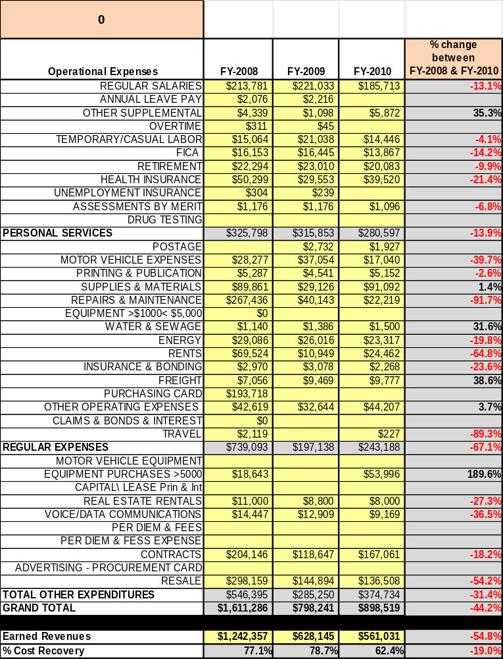
A summary of total operating expenses at SAM Shortline Excursion Train from 2008 to 2010, as well as their percent change from 2008 are provided in the table below.

Earned Revenues
Earned revenues at SAM Shortline Train have decreased since 2008, which is largely attributed to the corresponding decrease in overall visitation and the economy. Monthly earned revenues for the last two years indicate that the total annual revenue decreased from 2009 to 2010, with the largest increases in monthly revenues in July (153%), December (21%), and May (19%), and the largest decreases in the months of October (-29%), August (-25%), February (-20%), September & April (-15%).
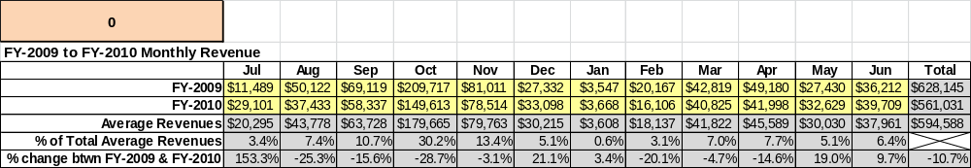

The graphs below illustrate the monthly revenue trends each year and the average percent of total annual revenue earned each month.

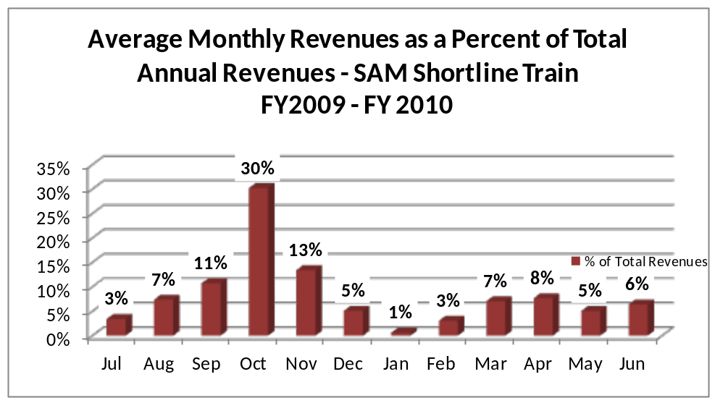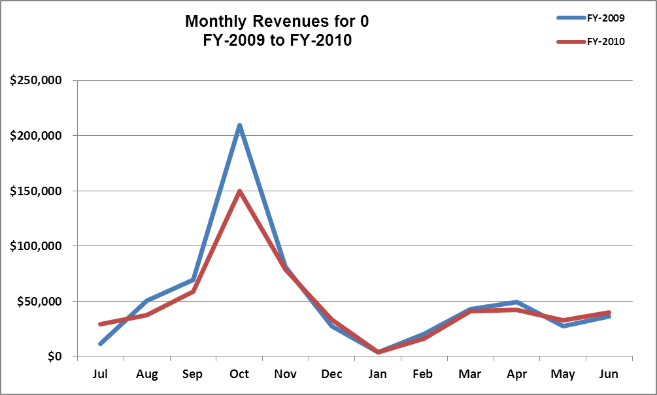
Cost Recovery Trends

SAM Shortline Train has achieved an average cost recovery of 74% of annual operational expenses through earned revenues from FY2008 to FY2010. This is detailed and illustrated in the graph and table below.

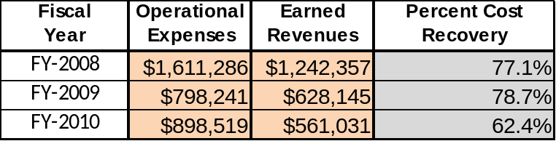

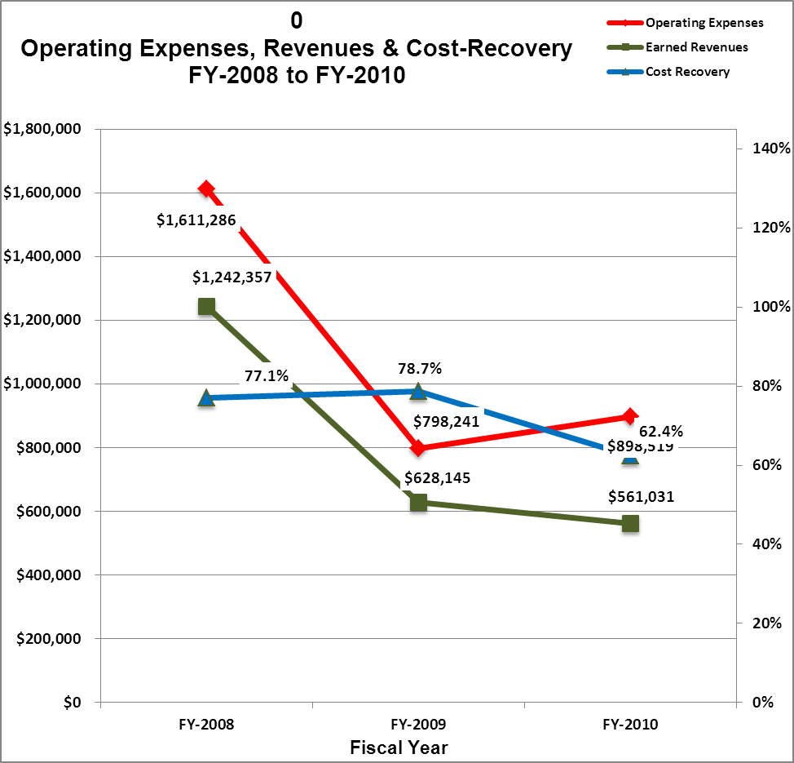

Review of Pricing
Data on rate information is available as far back as 2002, but only the last five years are evaluated. There has been minor growth in fees charged at SAM Shortline since 2005, with the largest increase being 2008. A table detailing the rates for SAM Shortline is provided below.

SAM Shortline Train | 2005 | 2006 | 2007 | 2008 | 2009 | 2010 | Comments
Coach Adults | $22.99 |  |  | $25.50 |  | $27.99
Coach Sr./Vet/Military | $19.99 |  |  | $22.50 |  | $25.99
Coach Child | $12.99 |  |  | $15.50 |  | $17.99 | Ages 2-12
Coach Group Adult | $19.99 |  |  | $22.50 |  | $25.99 | 1 Comp/20
Coach Group Child | $11.99 |  |  | $13.50 |  | $16.99 | 1 Comp/20
Premium Adult | $29.99 |  |  | $33.50 |  | $35.99
Premium Child | $17.99 |  |  | $21.50 |  | $25.99 | Ages 2-12
Adult Only Car | $29.99 |  |  | $37.50 |  | $35.99
Scouts, Homeschool, 4-H & Daycamps | $9.99 |  |  | $12.50 |  | $15.99
Chaperones, Homeschool, Scouts, 4-H & Daycamps | $15.99 |  |  | $20.50 |  | $25.99
School Students & Staff | $8.50 |  |  | $9.99 |  | $11.99
School Chaperones | $15.99 |  |  | $20.50 |  | $25.99
Coach Tour & Travel Adult | $18.99 |  |  | $21.50 |  | $25.99 | 1 Comp/20
Coach Tour & Travel Child | $10.99 |  |  | $12.50 |  | $16.99 | 1 Comp/20
Premium Tour & Travel Adult | $29.99 |  |  | $33.50 |  | $35.99
Premium Tour & Travel Child | $17.99 |  |  | $21.50 |  | $25.99
Walk-Up Americus to Plains Coach Adult | $11.99 |  |  | $13.50 |  | $13.50
Walk-up Americus to Plains Coach Child | $6.99 |  |  | $8.50 |  | $8.50
Walk-up Americus to Plains Premium Adult | $22.99 |  |  | $25.50 |  | $25.50
Walk-up Americus to Plains Premium Child | $11.99 |  |  | $15.50 |  | $15.50
Walk-up Plains to Archery Coach Adult or Child | $5.99 |  |  | $7.00 |  | $7.00
Upgrade from Coach to Premium | $7.00 |  |  | $8.00 |  | $8.00
Train Charter 1/2 hour | $1,650.00 |  |  | $1,815.00 |  | $1,815.00
Train Charter 1 hour | $2,100.00 |  |  | $2,310.00 |  | $2,310.00
Train Charter 2 hours | $3,150.00 |  |  | $3,465.00 |  | $3,465.00
Train Charter 4 hours | $4,200.00 |  |  | $4,620.00 |  | $4,620.00
Train Charter 10 hours | $5,250.00 |  |  | $5,775.00 |  | $5,775.00
Coach Car Charters | $1,200.00 |  |  | $1,500.00 |  | $1,500.00
Americus Car Charter | $1,300.00 |  |  | $1,500.00 |  | $1,500.00
Hawkins Car Charter | $1,300.00 |  |  | $1,750.00 |  | $1,750.00
Stationary Train Charter 1-3 hours | $150.00 |  |  | $250.00 |  | $250.00
Stationary Train Charter 3-6 hours | $275.00 |  |  | $475.00 |  | $475.00

Business and Management Plan

Business Goals
The following goals serve as the foundation for the key recommendations and strategies in this business plan for SAM Shortline Excursion Train.

Enhance Cost Recovery of Site Operations
SAM Train will be operating at 70% cost recovery of operational expenses through earned revenues for FY 2011. While this is the first year of not receiving state funding, SAM has made drastic cuts in staffing and the number of trains we schedule. Special train runs will draw visitors and media coverage which will increase revenues. Keeping a tight rein on spending, plus generating additional revenues, will be vital to the success of SAM.

Enhance Revenue Generation Strategies
SAM started reducing retail inventory in July, 2010 to generate additional revenue on slow moving items. The gift shop had always been a place to purchase additional merchandise at year’s end when our financial goals had been reached; however, with the late-FY2011 launch of D15’s sustainability goals of becoming self-sustaining, this was the most reasonable option.

Expand Special Events at the Site
Up until June 2010, all events were centered around the train and special events on the train. In the fall of 2010, a parking lot was developed adjacent to the Cordele depot as a venue to expand site-specific events to increase revenues. This will be a source of additional revenue and major specific events. Collaborative efforts between the Cordele Mainstreet program, Arts Alliance and Chamber will help us expand on the development of successful events to be held at the Cordele Depot.

Improve the Diversity and Innovation of Recreational and Interpretive Programs
The SAM train is in a league of its own within Georgia’s State Parks. It is critical to the success of the operation to continue to be diverse in opportunities. We will always be looking for additional opportunities for programs.

Improve the Effectiveness of Marketing and Sales
Marketing and promotional activities at SAM Shortline continues to be a challenge due to reduced funding and ridership. Greater revenues from ridership will assist with funding for rack cards and other marketing items. SAM continues to work with the two tourism committees in Sumter and Crisp Counties, plus members and staff of the Presidential Pathways tourism region. Friends of SAM have been resourceful by obtaining a tourism grant in previous years. Additional partnerships with local businesses and other amenities in the area have also proven helpful. To promote tourism, the Cordele-Crisp County Tourism Committee invests in SAM Shortline through advertising and marketing.

Establish Greater Consistency of Managing and Monitoring Customer Service & Satisfaction
SAM Shortline will have to make a stronger effort to capture the information and feedback from our customers to ensure we are meeting or exceeding their needs. This will help the staff and management team determine the desires and satisfaction rate of passengers. This will also assist in identification of trains or services that are less desired or have poor performance. The information may give us insight into future train schedules and wishes of customers.

Expand Partnership Opportunities

Partnerships have always been vital to the partnerships for SAM Train. It has been five years since a survey of the two communities has been performed. A new Community Survey will be done to see how we can meet the needs of area businesses and enhance the profitability of tourism in the region. Also, it will be vitally important to engage Friends members in the business plan as a partner to help the site meet or exceed its sustainability goals.

Classification of Programs and Services
The tables below summarize the classifications of programs and services at SAM Shortline Excursion Train as either core, important, or visitor supported and projects a range of cost recovery percentages that might be achieved for each. These classifications establish financial performance goals for each category of services that are linked to the recommendations and strategies of this business plan.

Core Services
Program / Service | Target Cost Recovery
Encourage and promote tourism | 0%
Programming and marketing initiatives | 20% to 50%
Stimulate economic development | 30% to 40%
Perform maintenance to ensure the safety of all the passengers and crew | 0%

Important Services

Program/Service | Target Cost Recovery
Provide recreational and educational opportunities | 0%
Retail sales through the depot gift shop and commissary train car | 20% to 50%
Provide a venue for volunteers to donate time | 5% to 10%

Visitor Supported Services
Program/Service | Target Cost Recovery
Various special train excursions and events | 100% to 110%
Retail merchandise sales | 150% to 175%
Food to go on the train | 125% to 150%
Packages | 125% to 150%
Specialty trains off normal corridor | 100% to 125%

Partnership Development Plan
The table below summarizes existing partners and targeted partnerships by classification (operational, vendor, service, co-branding, funding partners) and by organizational type.
 | Public Partners | Not-for-profit Partners | Private / Enterprise Partners
Operational  Partners | - Ga. State Parks & Historic Sites  - Georgia Veterans State Park  - City of Cordele  - Crisp County  - City of Americus  - City of Leslie  - City of Plains  - Sumter County  - Crisp County Power Commission  - Cordele Mainstreet  - Plains Better Hometown  - Americus-Sumter Tourism  - Americus Mainstreet  - Cordele-Crisp Tourism Committee  - Cordele-Crisp Industrial Development Authority | - Friends of Ga. State Parks  - Friends of SAM Shortline | - Heart of Georgia Railroad  - HIT Entertaiment (Thomas the Train)  - Lake Blackshear Resort
Vendor Partners |  |  | - ACE Hardware of Cordele  - ACE Hardware of Macon  - Sunbelt Ford
Service Partners | - Cordele-Crisp Chamber  - Sumter Co. Chamber  - Sumter Co. Tourism  - Cordele-Crisp Tourism
Co-Branding Partners |  |  | - Lake Blackshear Resort and Golf Club
Funding Resource Partner | - City of Americus  - Cordele-Crisp Tourism Committee  - City of Cordele  - Crisp County  - Cordele Mainstreet  - Sumter Co. Tourism  - Friends of SAM Chapter

Marketing and Sales Plan

Marketing and Sales Goals
Marketing and sales goals for SAM Shortline Excursion Train are based on the following desired outcomes:
- Produce effective rack cards to draw customers to site.
- Signs on Interstate 75 and in communities.
- Produce increased overall visitation and revenues.
In order to meet these goals, examples of specific target outcomes were identified in the areas detailed in the table below.
Area  of Focus | Current  Performance | Goal  by 2011 | Goal  by 2012 | Goal  by 2015
Special Events | 5 per year | 200 riders  per train | 210 riders  per train | 215 riders  per train
Overall Ridership | 24,290 | +5%  25,505 | +5%  26,780 | +5%  31,001

Marketing and Promotion Strategies

Publicity and Social Media
SAM Shortline will approach marketing and publicity planning using the following guidelines and themes:
- Event publicity
Major events benefit by having short stories in local, regional, and statewide newspapers and online social media hooks planted that run three to four weeks in advance of the event up to the date of the event itself. Stories and media need to be cultivated with contacts and online sales channels several weeks in advance of the time the stories need to run. Special interest interviews on morning, noon, and evening television news programs, radio interviews on popular rush-hour programs, and blogs on known affinity online sites should also be included.
- Program publicity
Special and unique programs should have feature stories in magazines, local and regional weekly newspapers, and statewide daily newspapers that are aimed at placements as front-page or sectional front-page stories. These stories are most effective if they run shortly before the season that the featured program begins. This will likely require several weeks of advanced planning with media contacts. Similar coverage on television and radio should also be considered. If pre-publicity cannot be generated, post-publicity can help promote future programs.
- Site Publicity
Site publicity focusing on a single site or sub-set of sites requires more intense planning efforts to attract multiple writers and editors from target publications. Each site could host several seasonal media familiarization tours (with 10 to 15 writers or editors) to familiarize them with the site and its benefits and amenities. Stories and features resulting from such tours typically take between two and six months to materialize so the tours should focus on experiences, benefits, and programs that would be available when the stories are expected to run.
Examples and suggested opportunities for events, programs and related publicity efforts based on the themes described above at SAM Shortline Train are provided in the table below.

Event Publicity | Program Publicity | Site Publicity
Peanut Festival | Breakfast with Santa | Loop the Lake with SAM
Rudolph’s Favorite | Valentine Special | Friends of GA State Parks membership incentive
Plains Car Show | Red Hat Day | State Georgia Employee Discount
Day Out With Thomas | Find the Leprechaun | 100 mile yard sale
Plains Festival of Lights | President Carter’s Hometown | Watermelon Festival
Arts N Rees Park | Celebrate Mom
Silent Auction | Red, White & Blue Memorial
A Night of Christmas Enchantment | Betsy Ross Run
Plains Pig Pick’ Festival
Vidalia Onion Festival
May Day Festivities
Dublin’s Centennial
Plains Pig Pick’n Festival
Watermelon Festival

Packaging
Examples and suggested packages for SAM Shortline are provided in the table below.
Package | Package Details
Be My Valentine | Overnight, train ride, supper, breakfast
Southern Delight | Train ride, lunch and telephone museum tour
Habitat’s Village | Train ride and tour
Breakfast with Santa | Train ride, visit with Santa, breakfast
Conductor’s Choice | Train ride and bandanna lunch
Jr. Engineer | Train ride and bandanna lunch
Jr. Conductor | Train ride and patch
Onion Special | Train ride, supper, overnight and breakfast
Overnight Stay | Camp inside the train and get astronomy program from GA Vets

Group Sales
Types of groups within which specific target customers can be identified for SAM Shortline are listed below:
- Schools – Public & Private | - Families | - Tour & Travel
- Senior | - Red Hat Clubs | - Scouts – Boys and Girls
- Home school Groups | - Churches | - Summer Day Camps
- Businesses | - Associations | - Women’s Groups
- Youth Service Organizations | - Day Cares | - Public organizations
- Activity or Community Clubs | - Colleges & Technical Schools | - Community Organizations

Incentivizing New and Repeat Visitation
SAM Shortline Excursion Train will utilize the following strategies and/or incentives to encourage new and repeat visitation starting in FY 2012:
- Free patches for scouts
- Complimentary tickets for each 20 purchased
- Early registration discounts
- Added value for purchases
- Differential pricing based on season
- Bounce back coupons
- Co-branding with partners (Ex: 1 complimentary for overnight stay)

Marketing and Sales Metric Goals
The following marketing and sales metric goals and/or others will be monitored and progress reported at SAM Shortline Excursion Train.
- Loyalty and repeat customers (unsure of the percentage of repeat visitation).
- Brand confidence & customers-recruiting-customers = Customer referrals equal a minimum of 50% of “Where did you hear about us?” response from visitors polled.
Revenue Generation Plan
Revenue / Cost Recovery Goals
SAM Shortline Excursion Train has set a financial goal of increasing annual revenues 5% annually between 2011 and 2015. The table below details projected revenue growth leading up to 2015, based upon a nominal growth of revenues each year.

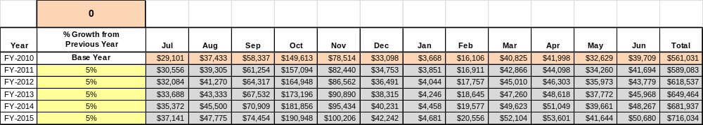
These projections would result in a total of 28% cumulative growth in total annual revenues between FY2010 and FY2015. If operational expenses can be managed with a cumulative reduction of 10% between FY 2010 and FY 2015, then the overall cost recovery of the site will be approximately 88% in FY 2015 at these projected revenue levels. This is higher than the annual financial performance of the site in FY 2010, which was operated at 62% cost recovery in that year.
Revenue Generation Strategies

Innovative Programming and Special Events Plan
Program / Event | Theme / Purpose | Scheduled Date/Season | Frequency | Target Participation | Target User Fee | Target Cost Recovery
100 Mile Yard Sale | Increase Revenue | October 8, 2011 | Yearly | 100 participants | $30 | 80%
Steak Cook-off | Increase Revenue | November 18, 2011 | Yearly | 10 vendors | $50 | 75%
Breakfast with Santa | Increase Revenue & Exposure | December, 2011 | Yearly | 150 | NA
Wonderland in Cordele | Increase Revenue | December, 2011 | Yearly
Vegas Night | Increase Revenue | February, 2012 | Yearly

Partnerships and Concessions Plan
Service / Partnership | Term of Service | Financial Objective | Contract Manager
Concessionaire for DOWT (Thomas) | 2 weekends | 15% of gross receipts | Authority Chairman / Site Mgr.
Cordele Mainstreet | 1 day | 50% of gross receipts | Site Manager
Day Out with Thomas Event | 1 season | 68% of ticket sales / 91% of retail sales / sliding scale for photography / ticket web charges their fee directly to customer but we pay cc charge of 3% | Authority Chairman/Site Mgr.
Packaging and Promotion with local businesses | Per event | Shared revenue generally | Site Manager

Pricing Plan

Region | Seats Reservable | Current Pricing  (CY 2011) | Proposed Pricing  (CY 2012) | Positive Yield Management Margin (%) | Positive Yield Management Margin (%) | Positive  Yield  Management  Margin ($)
3 | SAM Shortline Excursion Train
 | Coach Adults | $27.99 | $29.99 | 7% |  | $2.00
 | Coach Sr./Vet/Military | $25.99 | $28.99 | 11% |  | $3.00
 | Coach Child | $17.99 | $19.99 | 11% |  | $2.00
 | Coach Group Adult | $25.99 | $28.99 | 11% |  | $3.00
 | Coach Group Child | $16.99 | $18.99 | 11% |  | $2.00
 | Premium Adult | $35.99 | $38.99 | 7% |  | $3.00
 | Premium Child | $25.99 | $27.99 | 7% |  | $2.00
 | Adult Only Car | $35.99 | $38.99 | 7% |  | $3.00
 | Scouts, Homeschool, 4-H & Daycamps | $15.99 | $18.99 | 18% |  | $3.00
 | Chaperones Scouts, Homeschool, 4-H & Daycamps | $25.99 | $28.99 | 11% |  | $3.00
 | School Students & Staff | $11.99 | $11.99 | 0 |  | $0.00
 | School Chaperones | $25.99 | $28.99 | 11% |  | $3.00
 | Coach Tour & Travel Adult | $25.99 | $28.99 | 11% |  | $3.00
 | Coach Tour & Travel Child | $16.99 | $18.99 | 11% |  | $2.00
 | Premium Tour & Travel Adult | $35.99 | $37.99 | 6% |  | $2.00
 | Premium Tour & Travel Child | $25.99 | $27.99 | 7% |  | $2.00
 | Walk-Up Americus to Plains Coach Adult | $13.50 | $16.99 | 26% |  | $3.49
 | Walk-up Americus to Plains Coach Child | $8.50 | $10.99 | 28% |  | $2.49
 | Walk-up Americus to Plains Premium Adult | $25.50 | $30.99 | 21% |  | $5.49
 | Walk-up Americus to Plains Premium Child | $15.50 | $20.99 | 35% |  | $5.49
 | Walk-up Plains to Archery Coach Adult or Child | $7.00 | $7.00 | 0 |  | $0.00
 | Up grade from Coach to Premium | $8.00 | $8.00 | 0 |  | $0.00
 | Train Charter 1/2 hour | $1,815.00 | $1,815.00 | 0 |  | $0.00
 | Train Charter 1 hour | $2,310.00 | $2,310.00 | 0 |  | $0.00
 | Train Charter 2 hours | $3,465.00 | $3,465.00 | 0 |  | $0.00
 | Train Charter 4 hours | $4,620.00 | $4,620.00 | 0 |  | $0.00
 | Train Charter 10 hours | $5,775.00 | $5,775.00 | 0 |  | $0.00
 | Coach Car Charters | $1,500.00 | $1,500.00 | 0 |  | $0.00
 | Americus Car Charter | $1,500.00 | $1,500.00 | 0 |  | $0.00
 | Hawkins Car Charter | $1,750.00 | $1,750.00 | 0 |  | $0.00
 | Stationary Train Charter 1-3 hours | $250.00 | $250.00 | 0 |  | $0.00
 | Stationary Train Charter 3-6 hours | $475.00 | $475.00 | 0 |  | $0.00

Expense Management Plan
Personnel Assignments
The following actions will be taken to proactively manage labor costs via personnel assignments and classifications.

Action | Timeline | Outcome
Reduction of part-time contract employee from 1508 to 900 per year | July 2012 | Annual contract labor cost reduction of $4,530

Management Techniques
The following actions will be taken to proactively manage labor costs via management techniques.

Action | Timeline | Outcome
Train campground host to answer phone and take reservations | July 2012 | The above reduction of $4,530 in labor costs

Adjusted Levels of Service
The following actions will be taken to proactively manage labor costs via reduced levels of service.

Action | Timeline | Outcome
Adjust hours of gift shop being open in Cordele | September 2011 | Annual cost reduction in power of 20% in depot
Reduce number of souvenirs offered | July 2011 | Less inventory and storage and increase revenue to operation to move old products
Eliminate some food items | September 2011 | Reduce inventory loss

Financial Pro Forma
The following five-year financial pro forma projects operating expenses, earned revenues and cost recovery through FY 2015. These pro forma are based on the strategies and desired outcomes identified in this business plan, especially the revenue generation and expense management plans, and are linked to corresponding performance goals.

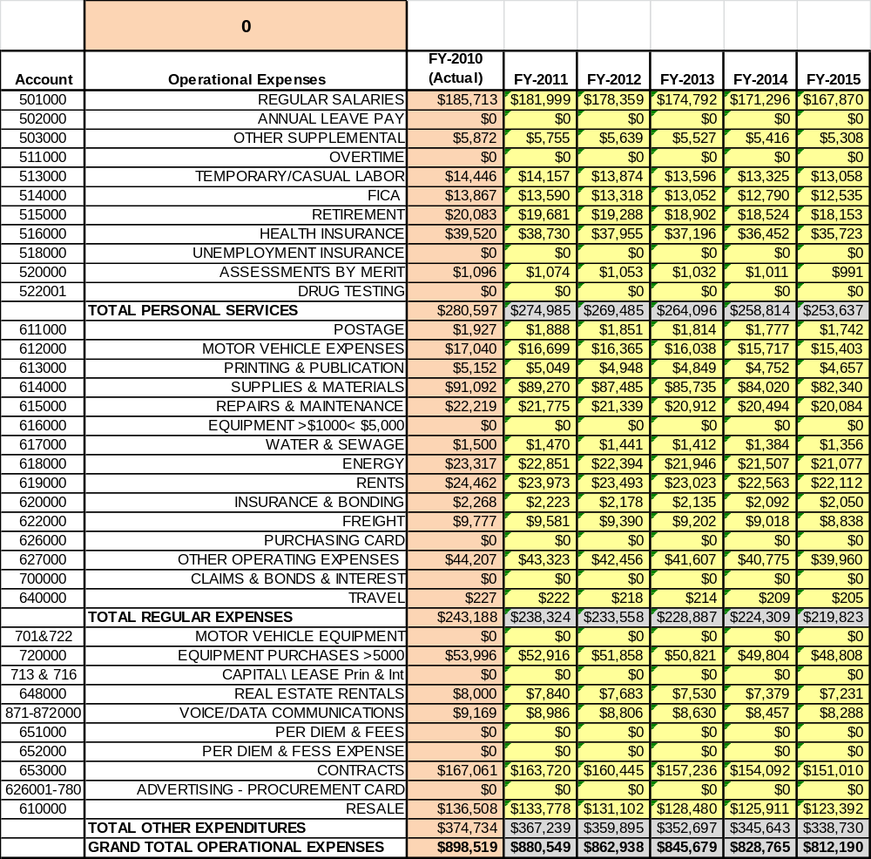
Expense Pro Forma

Revenue Pro Forma
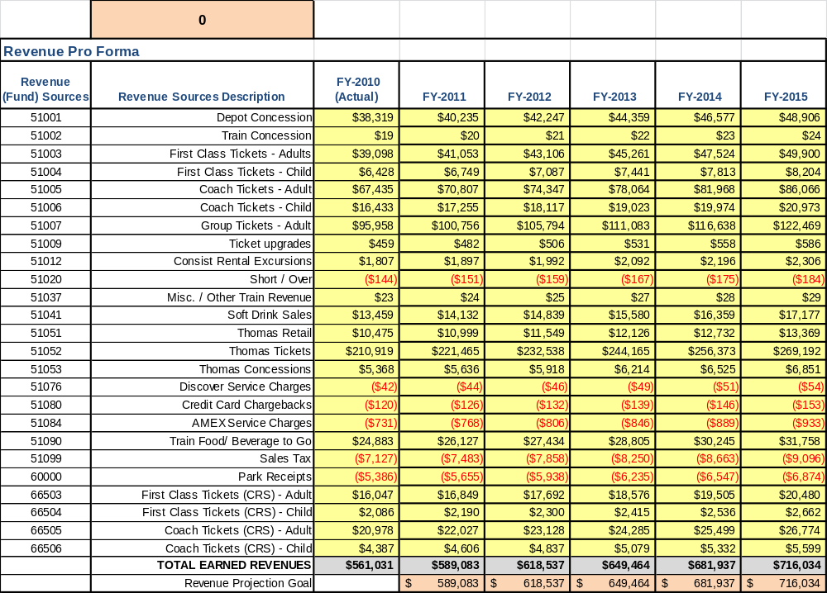

Total / Cost Recovery Pro Forma
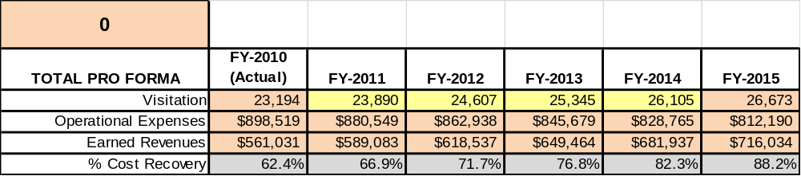

Action Plan
ACTION PLAN
Site: SAM Shortline Excursion Train |  | Site Manager: Kathy Odom |  |  | Date:
Month:
Strategy | Tasks | Costs / Funding | Revenues / ROI | Responsibilities | Metrics

ACTION PLAN
Site: |  | Site Manager: |  |  | Date:
Month:
Strategy | Tasks | Costs / Funding | Revenues / ROI | Responsibilities | Metrics

A
T
T
P

