Stephen C. Foster State Park
Business & Management Plan

Prepared August 2011; Finalized February 2013
Direction 2015 – Sustainable Business Planning

Table of Contents

Executive Summary 3

Site and Operations Assessment 7
Site Inventory and Facility Assessment 7
Operational Assessment 10
Financial Performance Assessment 15

Business and Management Plan 19
Business Goals 19
Classification of Programs and Services 21
Partnership Development Plan 22
Marketing and Sales Plan 23
Revenue Generation Plan 25
Expense Management Plan 27
Financial Pro Forma 28

Action Plan 31

Executive Summary
The Parks, Recreation and Historic Sites Division (PRHSD) of the Georgia Department of Natural Resources (DNR) are transitioning the management of Stephen C. Foster State Park to operate more like a business, reflecting the Direction 2015 – Sustainable Business Planning initiative to improve the fiscal performance and management of the state parks and historic sites system. This business and management plan is designed to help the site recover more operating expenses through earned revenues, productive partnerships, and innovative programs.

Site Fact Sheet
Site Name |  | Stephen C. Foster State Park
Site Manager |  | Bryan S. Gray
Region Manager |  | Tommy Turk
Date of Business Plan completion |  | 11/19/2012
Site size (acres) |  | 400
Total number of visitors (FY 2010) |  | 61,871
Total operating budget (FY 2010) |  | $667,283
Total earned revenues (FY 2010) |  | $540,962
Operational cost recovery (FY 2010) |  | 81%
Average operating cost per visitor (FY 2010) |  | $10.79
Average earned revenue per visitor (FY 2010) |  | $8.74
Average cost recovery[1] (FY 2008 – 2010) |  | 83%
Target cost recovery (FY 2015) |  | 92%
Total full-time employees[2] |  | 5
Total part-time employees[3] |  | 7
Primary service markets[4] |  | Jacksonville FL, Lake City FL, Valdosta GA, Atlanta GA, Germany
Primary attractors/visitor appeal factors |  | Okefenokee Swamp, boat tours, motor boat/canoe rentals, overnight facilities, nature trails, programming
Leading opportunities for improved site performance |  | New Office/Museum Complex, remodel cabins, market park as a premier star gazing venue in the southeast, marketing Eco-Lodge

Site Summary and Key Attractions
The 80-acre Stephen C. Foster State Park in the heart of the Okefenokee National Wildlife Refuge, along with the 350-acre Suwannee River Eco-lodge and Suwannee River Visitor Center, is located in Fargo, GA. S.C. Foster is approximately 1 hour and 30 minutes from I-75 in Valdosta, GA and 1 hour from I-10 in Lake City, FL.

Key Attractions
The amenities or features listed below are those that seem to be most popular for visitors.
- Okefenokee National Wildlife Refuge
- Suwannee River
- Boat Tours
- Boat Rentals
- Cottages
- Camping
- Alligators
- Bird watching
- Fishing

Financial Targets
The table below details the total operating expenses and earned revenues for Stephen C. Foster State Park over the last three years (2008 – 2010). This table also calculates total cost per visitor and revenues per visitor during these operating years, and details the target financial performance goals in the context of achieving at least 92% cost recovery. This table also calculates the necessary change from 2010 operating expenses and revenues.

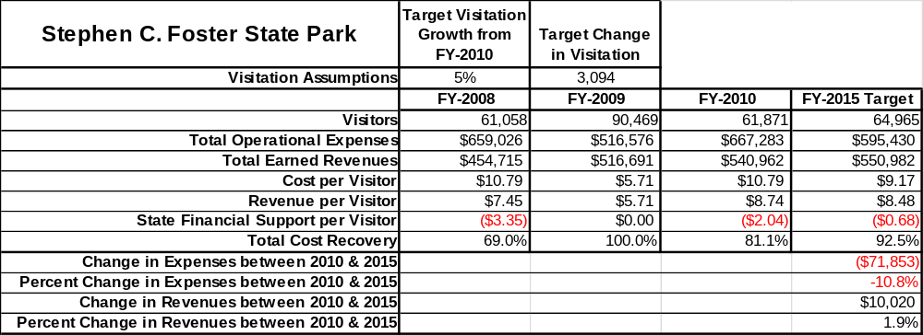

Key Recommendations

Primary / Short Term Recommendations
- Operate the site using cost-based accounting, including the net cost recovery achieved annually.
- Conduct in-park surveys annually to assess how well customer satisfaction levels are being met. Stephen Foster should strive to have 90% of visitors responding to ‘Comment Cards’ report that they were either ‘satisfied’ or ‘very satisfied’ (or some comparable metric to be developed). Programs or services that fall below that standard should be critically reviewed, enhanced, and results monitored; those with a history of poor performance should be considered for elimination.
- Evaluate and pursue opportunities to employ concessionaires or private or public service providers on-site if they can be more cost-effective. For example, explore the development of a concessionaire agreement to manage private events on-site.
- Collect a statistically-valid sample of ZIP code data from visitors in a non-intrusive way to gauge their origins and demographics (e.g., age, ethnicity, income, etc.) and use the results to improve programming and marketing efforts to appeal to a broader audience.
- Utilize a minimum of six special events annually to help draw more visitors to the site.
- Seek local partners to help support operations, programs, and service delivery and for cross-marketing purposes.
- Sustain sufficient non-labor operational funding or reduce staff so that required staff operational costs (with benefits) do not exceed 65% of the total operational budget.
- Enhance facilities and program offerings to provide a minimum of 10 unique experiences for each visitor while maintaining at least a 90% customer satisfaction rating.
- Manage Stephen Foster according to well-defined maintenance, program and operational standards monitored and enforced by region managers and senior management.
- Partner with local Chambers of Commerce or other destination marketing organizations (DMOs) to promote Stephen Foster.
- Perform a thorough net cost-of-service analysis on major functions of site operations, including the detailed analysis of labor requirements (by task) that has already been produced by site staff. Thereafter, update costs to deliver services on a biennial schedule.
- Review and update rates at the site on an annual basis to recover the total net cost of service for important and visitor-supported services.
- Track total economic impact of the site on the local communities and region and share with decision-makers, elected officials, local business operators, and others to demonstrate the impact of Stephen Foster.
- Develop a more detailed analysis of labor requirements of all major park functions to match the right position with the right job at the right pay.
- Develop funding to provide additional training to site staff for improved business management and marketing effectiveness.
- Construct and upgrade facilities and amenities at the site that are likely to have a cost recovery level at or above 100%. Suggestions include adding renovate the current cabins in park, start providing rental of canoes at the visitor center, build new office for retail and museum combined.
- Add more youth-focused services, programs and amenities at the site that appeal to younger audiences, families and educational groups.
- Add more services, programs and amenities that appeal to older adults.
- Develop partnerships with canoeing/kayaking outfitters using the park and Eco-Lodge as a staging point for excursions.
- Promote the park and Eco-Lodge as the premier astronomy viewing destination in the Southeast. Market viewing opportunities astronomy clubs and university classes using direct contacts and social media.
- Promote the Eco-Lodge as an outdoor education venue for public schools, universities, and environmental interest groups.
- Lease the operation of the Eco-Lodge to a private vendor.

Secondary / Long Term Recommendations
- Improve the recreational amenities of the site to address modern and diverse uses.
- Install an improved retail point-of-sale and inventory tracking system.
- Replace the current Office/Visitor Center/Boat Rental buildings with a combined Visitor/Interpretive Center containing administrative areas, boat rental, displays, theater, resale area, and wildlife viewing areas. Connect new facility with an extended nature trail with viewing platforms and fishing docks that reaches to the open water of Billy’s Lake.

Site and Operations Assessment
This site and operations assessment is a culmination of analyses and findings from a review of the condition of facilities, infrastructure, and operations at Stephen Foster. The findings and observations are not intended to be an exhaustive review of all issues present, but provide a basic understanding of the predominant issues that contribute to the site’s current operating conditions. The assessment includes the following:
- Site Inventory and Facility Assessment
- Operational Assessment
- Financial Assessment
Site Inventory and Facility Assessment

Methodology
Facility and asset conditions are rated using a differential scale of excellent, good, fair, or poor. Descriptions of conditions that are attributed to each of these findings are also provided.
Scale of Conditions
Rating | General Description
Excellent | Facilities/amenities are in ‘excellent’ condition when they show little or no maintenance or repair problems. Facilities do not feature any major design or operational issues or flaws that contribute to diminished use or increased maintenance or upkeep. Facilities are easy to clean and maintain in order to place them back into public use and the users perceive them to be in excellent shape.
Good | Facilities/amenities are in ‘good’ condition when they show only minor maintenance or repair problems. Most maintenance issues with these facilities typically appear to be the result of age and/or heavy use. Facilities may only feature minor design or operational issues that contribute to diminished use or increased maintenance or upkeep. Facilities are moderately easy to clean and maintain in order to place them back into service and the users perceive them to be adequate for their use, but probably not in excellent shape.
Fair | Facilities/amenities are in ‘fair’ condition when they show significant maintenance or repair problems. Facilities generally exhibit ongoing maintenance issues that appear to be the result of age, heavy use, or design or operational flaws. Some maintenance and repair needs may compound their fair condition by being deferred because of budget and/or resource limitations. Facilities require more effort to clean and maintain before placing them back into service and the users may perceive them as being less than adequate for their use and in a state of deterioration. The facility or structure may need of major repair or replacement.
Poor | Facilities/amenities are in ‘poor’ condition when they show significant, on-going maintenance or repair problems that ultimately may result in suspended use for repair/replacement. Maintenance and repair issues are possibly the result of poor maintenance and clearly the result of age, heavy use, or design or operational flaws. Problems with the facilities are often compounded over time due to consistently-deferred maintenance and repair because of budget and/or resource limitations. Facilities may feature major design or operational issues that contribute to diminished use or increased maintenance or upkeep. Facilities require excessive effort to clean and maintain before placing them back into service and the users often perceive them as being inadequate for their use and in a state of serious deterioration. The facility or structure may need of major repair or replacement.

Inventory and Assessment
The table below is an inventory of facilities and amenities at Stephen Foster, and provides the assessed condition of each as reviewed in May 2011.

Site Asset / Amenity | Quantity | Condition
Park Office and maintenance area | 1 | fair
Boat Ramp | 1 | excellent
Day use restroom | 1 | good
Picnic Shelters | 3 | good
Two nature trails | 2 | good
cottages | 9 | good
Asst. Mgr. residence | 1 | Good
Staff Duplex | 1 | good
Interpretive center | 1 | poor
Staff trailers | 3 | poor
Storage trailers | 2 | poor
Staff residence storage shed | 1 | fair
Campground comfort stations | 2 | fair
Pioneer picnic Shelter | 1 | good
Pioneer adirondack shelters | 2 | good
Laundry shed | 1 | fair
Well house | 1 | good
Fish cleaning station | 1 | good
Suwannee River Visitor Center | 1 | good
Manager’s Residence | 1 | Excellent
Laundry Shed | 1 | Excellent
Suwannee River Eco-Lodge | 1 | Excellent
Suwannee River Boat Ramp | 1 | Good
Playground | 1 | good
Amphitheater | 1 | fair
Campsites | 64 | fair

Prioritized Facility Needs
Based on the facility inventory and assessment, these prioritized needs have been identified. Each need has been aligned with a priority category of high, moderate, or low to support future decision making regarding project sequencing, investment of public resources, and meeting community expectations. The priority assignment for each need is not a measure of importance. Rather, these recommended priorities reflect a phased implementation approach over the next several years.

Facility Need | Priority Assignment
Extend boardwalk at Visitor center | Moderate
Install new retaining wall around boat basin | High
Build nature trail at Eco-Lodge | Moderate
New park office, maintenance area, and interpretive center | High
Renovate Campground | High
Replace Comfort Stations | High
Extend boardwalk to Billy’s Lake | High
Rebuild boardwalk damaged during Honey Prairie fire | High
Replace staff trailers | Moderate

Operational Assessment
The Operational Assessment includes:
- An inventory and classification of programs and services being provided at the site
- A review of staffing at the site
- A review of concessionaires and partners operating at the site
- Visitation and customer satisfaction

Inventory and Classification of Programs and Services
Programs and services are classified into one of three major categories:
1) Core or Essential Services
2) Important Services
3) Visitor Supported Services
Programs and services at the site are classified into these categories based in part on the mission and public mandates for both the site and the agency. For the services in each of these categories, there are financial performance expectations that will define how services are funded and evaluated.

Category 1 – Core Services [Largely supported by tax funds]
Core programs, services and facilities are those the agency must provide and/or are essential in order to capably govern and meet statutory requirements. The failure of the agency to provide Category 1 services at adequate levels could result in significant negative consequences for the public and the resources under protection. The criteria for services to be classified as core or essential are:
- The services are mandated by the agency’s law or charter or are contractually obligated by agreement to provide the services.
- The services are essential to protecting and supporting the public’s health and safety.
- The services protect and maintain valuable assets and infrastructure.
- The services would generally and reasonably be expected and supported by residents, businesses, customers and partners.
- The services are those that cannot or should not be provided by the private sector.
- The services provide a sound investment of public funds.
The following services offered at Stephen Foster have been identified as core services:
- Open and public access to the site and its resources
- Site appropriate education, interpretation, and recreational opportunities
- Effective management of Stephen Foster, Suwannee River Visitor Center and Eco-lodge and the structures located within each facility
- Safety of the visitors and guests to each facility
- Active management of natural and cultural resources of the site in order to protect its integrity
- Maintenance of grounds, facilities and infrastructure

Category 2 – Important Services [Supported by a balance of tax funds and earned revenues]
Important programs, services and facilities are those the agency should provide, and are important to governing and effectively serving residents, businesses, customers and partners. Providing Category 2 services expands or enhances the agency’s ability to provide and sustain its core services. The criteria for programs or services to be classified as important are:
- The services expand, enhance or support identified core services.
- The services are broadly supported and utilized by the community, and are considered an appropriate, important, and valuable public good. Public support may be conditional upon the manner by which the services are paid for or funded.
- The services generate income or revenue that offsets some or all of the operating cost and/or are deemed to provide economic, social or environmental outcomes or results.
The following services offered at Stephen Foster have been identified as important services:
- Self-guided interpretive and educational programs
- Day-use area

Category 3 – Visitor Supported Services [Almost exclusively supported by earned revenue]
Visitor supported programs, services and facilities are those discretionary services that the agency may provide when additional funding or revenue exists to offset the cost of providing those services. Category 3 services provide added value above and beyond what is required or expected. The criteria for programs or services to be classified as visitor supported are:
- The services expand, enhance or support core services or important services and the quality of life of the visitors, community or stakeholders.
- The services are supported, valued and provide an appropriate and valuable public benefit.
- The services generate income or funding from sponsorships, grants, user fees or other sources that offset some or all of their cost and/or provides a meaningful return on investment.
- The services can possibly be provided through outsourcing or use of concessionaires, providing opportunities for community enterprises that may not otherwise be provided by the agency.
The following services offered at Stephen Foster have been identified as visitor supported services:
- Visitor Center / gift shop
- Ranger-guided interpretative and educational programs
- Rental motor boats, kayaks and canoes
- Camping
- Cottages
- Eco-Lodge

Staffing Assessment
Labor costs at Stephen Foster represents the largest area of budgetary expense at an average of 67% of the total operating budget each year for the last three complete years, which is higher than the target of total labor costs (including benefits) not exceeding 65% of the site’s total operating expenditures. The tables below and on the following page provide a basic review of the current staffing at the site.

Full Time Equivalent Employees
Position / Title | Quantity (FTE) | Vacancies | Annual Hours
Park Manager 3 | 1 | 0 | 2600
Asst. Park Manager 2 | 0 | 1 | 0
Park Ranger | 1 | 0 | 2080
Interpretive Ranger | 0 | 1 | 0
General Trades Craftsman | 1 | 0 | 2080
Boat Mechanic | 1 | 0 | 2080
Clerk | 1 | 3 | 2080
TOTAL | 5 | 5 | 10,920

Part Time Employees
Position / Title | Quantity (FTE) | Vacancies | Hours
Housekeepers | 3 | 0 | 4524
Clerk | 3 | 0 | 4524
Tour Guide | 1 | 0 | 1508
TOTAL | 7 | 0 | 10,556

Labor Support
Labor Support | Annual Hours
Volunteers/camp host | 12,064
TOTAL | 12,064

Total Labor Hours
Labor Type | Annual Hours
Full Time Equivalent Employees | 10,920
Part Time Employees | 10,556
Labor Support | 12,064
TOTAL Annual Labor Hours | 33,540

Labor Budget Summary

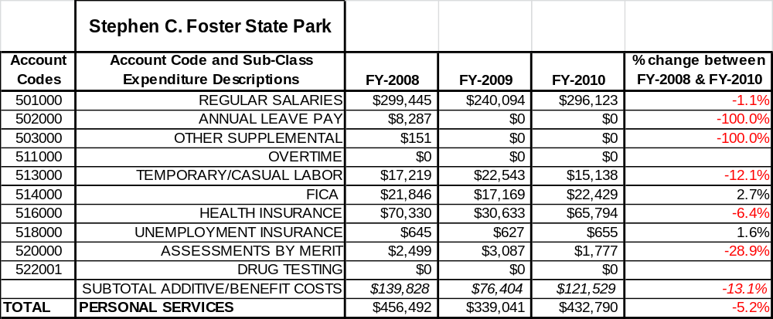
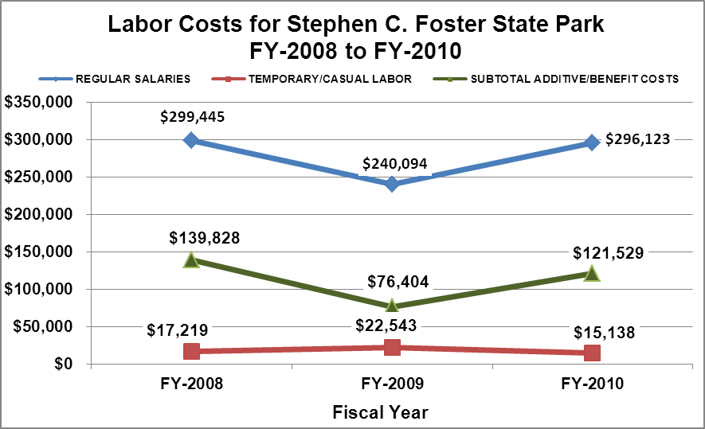

Visitation and Occupancy
Overall annual visitation to the site has fluctuated between 2008 to 2010 by over 30,000 visitors. This is largely attributed to fire closures and changing water levels.

Year | Total Visitation
2008 | 61,058
2009 | 90,469
2010 | 61,871

Occupancy for the overnight accommodations at Stephen Foster the last three years is detailed in the table below. Overall occupancy has stayed relatively the same from 2008 to 2010 in spite of fire closures and changing water levels. These events occurred mainly in low visitation periods.

Year | Camping Occupancy | Cottages Occupancy
2008 | 18.59 % | 53.83 %
2009 | 21 % | 55.03 %
2010 | 21.26 % | 52.59 %

Customer Service and Satisfaction

Stephen C. Foster | Year | Customer Satisfaction Level
 | 2009 | 92%
 | 2010 | 95%
Financial Performance Assessment

Operational Expenses
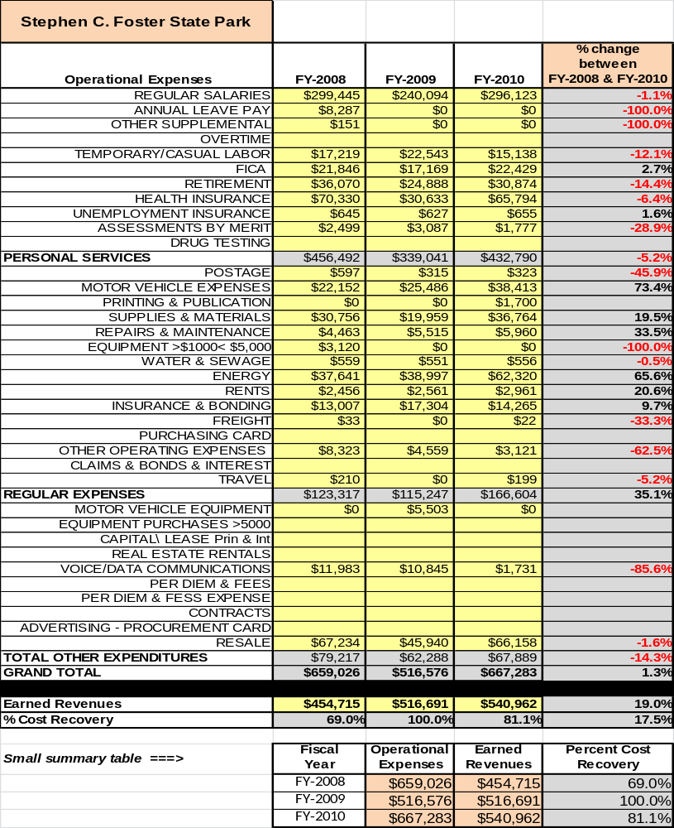
A summary of total operating expenses at Stephen Foster from 2008 to 2010, as well as their percent change from 2008 are provided in the table below.

Earned Revenues
Earned revenues at Stephen Foster have increased since 2008, which is largely attributed to the corresponding increase in overall visitation. Monthly earned revenues for the last two years (see table on the following page) indicate that the total annual revenue increased 5% from 2009 to 2010, with the largest increases in monthly revenues in July (22%), April (11%) and September (7%), and the largest decreases in the months of February (-3%) and March (-3%).

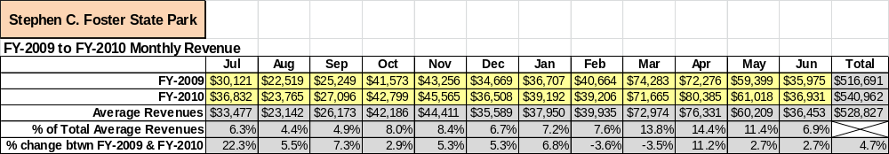

The graphs below illustrate the monthly revenue trends each year and the average percent of total annual revenue earned each month.

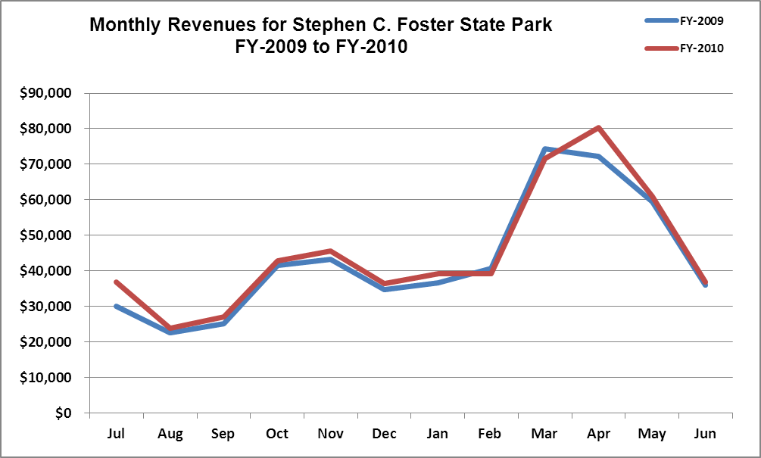
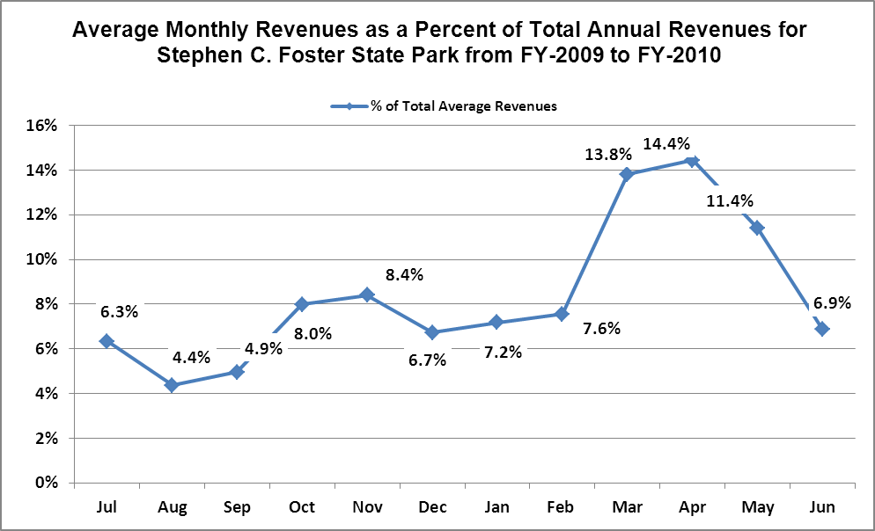

Cost Recovery Trends
Stephen Foster has achieved an average cost recovery of 83% of annual operational expenses through earned revenues from FY 2008 to FY 2010. This is detailed and illustrated in the table and graph below.
Year | Operational  Expenses | Earned  Revenues | Percent Cost  Recovery
2008 | $659,026 | $454,715 | 69%
2009 | $516,691 | $516,691 | 100%
2010 | $667,283 | $540,962 | 81%
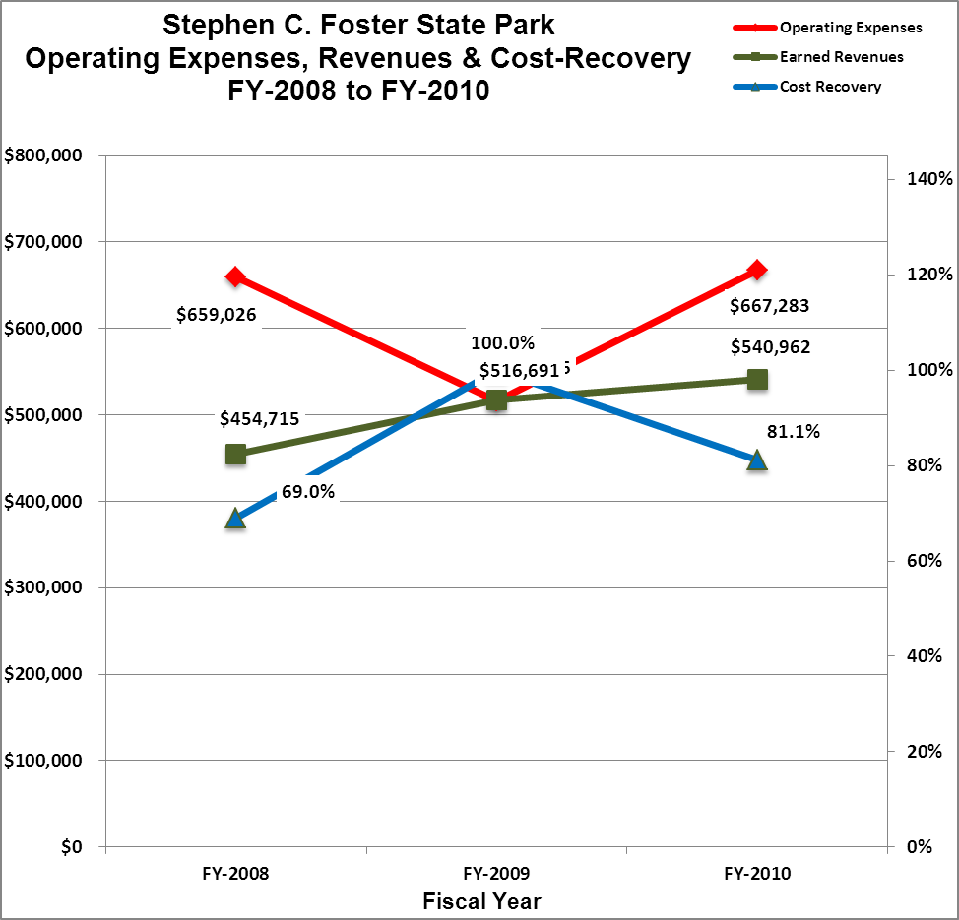

Review of Pricing
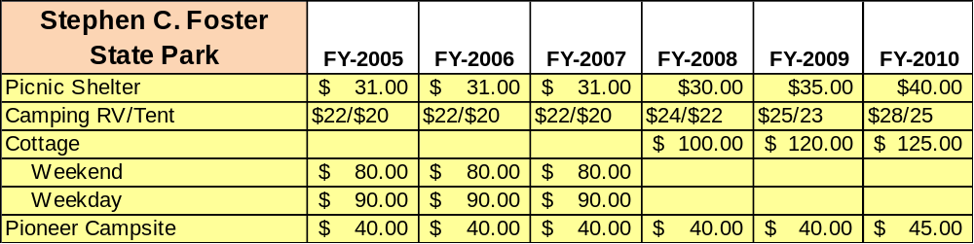
There has been notable growth in fees charged at Stephen Foster since 2005, with the largest increase being boat tour fees. A table detailing the rates for recreational fees is provided below.

Business and Management Plan

Business Goals
The following goals serve as the foundation for the key recommendations and strategies in this business plan for Stephen Foster.

Enhance Cost Recovery of Site Operations
Stephen Foster’s cost recovery generally hovers around the 85% mark with occasional increases. In FY 2010, the cost recovery was 81% due to drought conditions. Stephen Foster’s revenue fluctuates with weather conditions such as floods, droughts, and wildfires. With the current lease agreement with the U.S. Wildlife Refuge, any cost recovery over 100% is paid back to the USFWS. Eliminating excessive and vacant positions at Stephen Foster will help its cost recovery greatly.

Enhance Revenue Generation Strategies
Enhanced revenue can be generated by creating new programs and experiences for visitors to all sites (Stephen Foster, Suwannee River Visitor Center, and Eco-lodge). Many of these strategies involve business relationships with local outfitters.
- A shuttle service would allow guests to kayak and canoe between Stephen C. Foster, Suwannee River Sill and the Suwannee River Visitors Center with return service between each.
- Renting canoes and kayaks from the Suwannee River Visitor Center would allow guests that do not want to drive the additional 17 miles to Stephen C. Foster access to the Suwannee River in Fargo.
- Develop a trail system around the Suwannee River Eco-lodge allowing guest access to miles of trails.
- Use a main hiking trail route at the Eco-Lodge as a private boat launch for kayak and canoes to allow Georgia State Parks to tie in with the Florida Waterway Trail system allowing guests to paddle from the headwaters of the Suwannee River to the Gulf of Mexico. An overnight shelter on the Suwannee River could be utilized as an overnight location for guests paddling the trail.

Expand Special Events at the Site
Festivals could be held at the Suwannee River Eco-Lodge offering arts and crafts, live music, and interpretive programming. Park pass monies generated from parking fees and fees paid by vendors would be the primary source of revenue.

Improve the Diversity and Innovation of Recreational and Interpretive Programs
Boat tours offered at Stephen C. Foster are the focus of many guests visiting the park. Adding diverse recreational and interpretive programs would take staff away from programs that already have profound impact on revenue throughout the park. Current recreational programing revenue could be increased by improved cost effectiveness of each program or tour. Marketing the park as the premier star viewing venue in the Southeast will increase visitation and rentals.

Improve the Effectiveness of Marketing and Sales
Stephen C. Foster currently has a good marketing and sales program utilizing the current state park website and social media. The Suwannee River Visitor Center and Eco-lodge are the areas that need to be improved. Park staff should begin networking with local chambers, state visitor’s center, churches, companies and wedding planners. Staff can also pursue opportunities to advertising in publications that pertain to potential user groups. Marketing to astronomy clubs and university classes is a high priority.

Establish Greater Consistency of Managing and Monitoring Customer Service & Satisfaction
Stephen C. Foster has had a customer service rating over 90% for the past two fiscal years. Customers giving feedback on service should be compensated in some form which could be discounts on stay, merchandise, or recreational activities. Customer service is a core value for all staff and being such, staff should be regular educated in the importance of quality customer service. Staff should also be aware of all customer comment cards received about the park whether positive or negative.

Expand Partnership Opportunities
Stephen C. Foster can expand partnerships with the Okefenokee National Wildlife Refuge, Okefenokee Adventures, and the Okefenokee Swamp Park by offering group discounts, awards for visiting each location, and by offering shuttle services for canoeist and kayakers. Rentals of facilities to outdoor adventure outfitters and Eco-Tourism businesses offer great potential.

Classification of Programs and Services
The tables below summarize the classifications of programs and services at Stephen C. Foster as either core, important, or visitor supported and projects a range of cost recovery percentages that might be achieved for each. These classifications establish financial performance goals for each category of services that are linked to the recommendations and strategies of this business plan.

Core Services
Program / Service | Target Cost Recovery
Open and public access to the site and its resources | 0%
Site appropriate education, interpretation and recreational opportunities | 10%
Effective management of Stephen Foster, Suwannee River Visitor Center and Eco-Lodge and the structures located within each facility | 0%
Safety of the visitors and guests to each facility | 0%
Active management of natural and cultural resources of the site in order to protect its integrity | 0%
Maintenance of park grounds, buildings and infrastructure. | 0%

Important Services
Program / Service | Target Cost Recovery
Self-guided interpretive and educational programs | 40%
Day-use area | 50%

Visitor Supported
Program / Service | Target Cost Recovery
Visitor Center / gift shop | 130%
Ranger-guided interpretive and educational programs | 125%
Rental motor boats, kayaks and canoes | 150%
Camping | 150%
Cottages | 120%
Eco-Lodge | 120%

Partnership Development Plan
The table below summarizes existing partners and targeted partnerships by classification (operational, vendor, service, co-branding, funding partners) and by organizational type.

 | Public Partners | Not-for-profit Partners | Private / Enterprise Partners
Operational Partners | - Clinch SO  - Charlton SO  - Okefenokee National Wildlife Refuge  - City of Fargo | - Nature Conservancy  - Greater Okeefenokee Area Landowners (GOAL)  - Okefenokee Swamp Park
Vendor Partners |  |  | - Coca-Cola  - Okefenokee Adventures  - Suwannee River Outfitters
Service Partners |  | - Clinch Co. Chamber  - Charlton Co. Chamber  - Boy Scouts of America | - Superior Pine
Co-branding Partners | - Georgia Forestry Commission  - Okefenokee National Wildlife Refuge
Funding Resource Development Partner |  | - Friends of Georgia State Parks | - Superior Pine

Marketing and Sales Plan

Marketing and Sales Goals
Marketing and sales goals for Stephen C. Foster are based on the following desired outcomes:
- Increase cabin rentals by 10% - 15% through marketing the experience of the Okefenokee Swamp and Suwannee River with the addition of extended stay discounts and packaged deals.
- Increase camping rentals by 5% - 10% through marketing the experience of the Okefenokee Swamp and Suwannee River with the addition of extended stay discounts and packaged deals.
- Increase shelter and conference rentals over the next year through advertising uses such as; weddings, business meetings, family reunions, church outings, and introducing package deals.
In order to meet these goals, examples of specific target outcomes were identified in the areas detailed in the table below.
Area  of Focus | Current  Performance | Goal  by 2011 | Goal  by 2012 | Goal  by 2015
Cottages | 52.59% | 56% | 59% | 64%
Camping | 21.26% | 24% | 28% | 32%
Conference Rooms | 0% | 15% | 20% | 40%
Marketing and Promotion Strategies

Publicity and Social Media
Stephen Foster will approach marketing and publicity planning using the following guidelines:
- Event publicity
Major events benefit by having short stories in local, regional, and statewide newspapers and online social media hooks planted that run three to four weeks in advance of the event up to the date of the event itself. Stories and media need to be cultivated with contacts and online sales channels several weeks in advance of the time the stories need to run. Special interest interviews on morning, noon, and evening television news programs, radio interviews on popular rush-hour programs, and blogs on known affinity online sites should also be included.
- Program publicity
Special and unique programs should have feature stories in magazines, weekly newspapers, and statewide daily newspapers that are aimed at placements as front-page or sectional front-page stories. These stories are most effective if they run shortly before the season that the featured program begins. This will likely require several weeks of advanced planning with media contacts. Similar coverage on television and radio should also be considered. If pre-publicity cannot be generated, post-publicity can help promote future programs.
- Site Publicity
Site publicity focusing on a single site or sub-set of sites requires more intense planning efforts to attract multiple writers and editors from target publications. The site could host several seasonal media familiarization tours (with 10 to 15 writers or editors) to familiarize them with the site and its benefits and amenities. Stories and features resulting from such tours typically take between two and six months to materialize so the tours should focus on experiences, benefits, and programs that would be available when the stories are expected to run.
Examples and suggested opportunities for events, programs and related publicity efforts based on the themes described above at Stephen C. Foster are provided in the table below.
Event Publicity | Program Publicity | Site Publicity
 |  | Guided Canoe Trip
 | Fall Festival | Boat Tours
 |  | Geo Cache
Stargazing Events |  | Weekend Programing

Packaging
Examples and suggested packages for Stephen C. Foster are provided in the table below.
Package | Package Details
Summer Cottage Special  June through August | Stay for more than 2 nights at a Stephen Foster State Park Cottage or Eco-lodge cabin and get a free canoe rental for up to 8 hours.
Rental of whole Eco-lodge Facility | Rent the whole Eco-lodge facility for only $800.00 per night plus park pass fees.
Stay at Stephen C. Foster State Park 5 or more times in a year and get a free boat tour | Stay five or more nights in a year and get a free boat tour up to 8 people. (Per Calendar Year)

Group Sales
Types of groups within which specific target customers can be identified for Stephen C. Foster are listed below:
- Local citizens  - Astronomy Clubs | - Business Groups  - University Classes | - Family Reunions  - Eco-Tourism/Paddling Groups

Incentivizing New and Repeat Visitation
Stephen C. Foster will utilize the following strategies and/or incentives to encourage new and repeat visitation starting in FY 2012:
- Seasonal discounts for non-peak season
- Monthly discounts during the winter months
Marketing and Sales Metric Goals
The following marketing and sales metric goals and/or others will be monitored and progress reported at Stephen C. Foster:
- Loyalty and repeat customers = 60% repeat customers
- Brand confidence & customers-recruiting-customers = 20% of new customers recruited by previous customers
Revenue Generation Plan
Revenue / Cost Recovery Goals
Stephen C. Foster has set a financial goal of increasing annual revenues between 2012 and 2015. The largest revenue growth opportunity is most likely Stephen C. Foster Cottages and the Suwannee River Eco-Lodge. The table below details projected revenue growth leading up to 2015, based upon a nominal growth of revenues each year. The 35% decrease in FY2011 reflected loss revenue from low water levels and fires.
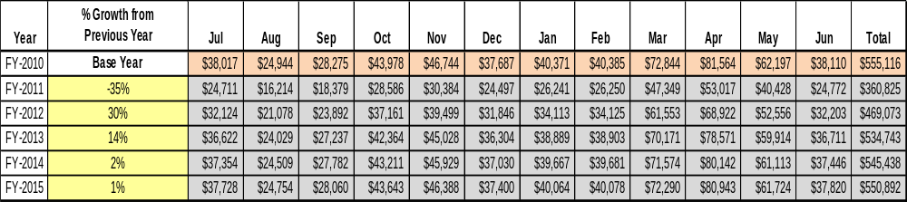

These projections would result in a total of 53% cumulative growth in total annual revenues between FY2011 and FY2015. If operational expenses can be managed with no cumulative increase or decrease between FY 2010 and FY 2015, then the overall cost recovery of the site will be approximately 93% in FY 2015 at these projected revenue levels. This is higher than the annual financial performance of the site in FY 2010, which was operated at 81% cost recovery in that year.

Revenue Generation Strategies

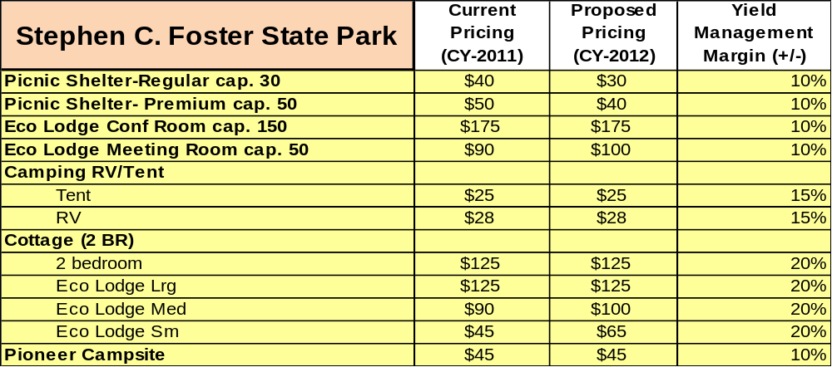
Pricing Plan

Innovative Programming and Special Events Plan

Program / Event | Theme / Purpose | Scheduled Date/Season | Frequency | Target Participation | Target User Fee | Target Cost Recovery
Fall Festival at Eco-lodge | Fall Harvest | 0ct. 2012 | Yearly | 1000 | $5 per | 125%
Stargazing Event | Promote Park as premier stargazing venue in the Southeast | August & October during annual meteor showers | Annually | 250 | $3 | 125%

Partnerships and Concessions Plan

Service / Partnership | Term of Service | Financial Objective | Contract Manager
Discounts to other Swamp Parks | Year round | Increase visitation to all location around the Okefenokee by offering discounts to each swamp park. | Park Manager
Staging location for paddling groups | Year round | Increase rentals of Eco-Lodge and park facilities by outfitters leading trips in the swamp | Park Manager

Expense Management Plan
Personnel Assignments
The following actions will be taken to proactively manage labor costs via personnel assignments and classifications.

Action | Timeline | Outcome
Eliminate 2 full-time housekeeping positions | Summer 2011 | Reduce expenditures of full time employee expense
Eliminate all vacant positions | Summer 2011 | Relieves budget of $91,000 in salaries

Management Techniques
The following actions will be taken to proactively manage labor costs via management techniques.

Action | Timeline | Outcome
Add 3 part time housekeepers | Summer 2011 | Allows hours lost from full time housekeepers to be recovered
Use volunteers for housekeeping at Eco-lodge | Summer 2011 | Keeps labor cost down

Adjusted Levels of Service
The following actions will be taken to proactively manage labor costs via reduced levels of service.

Action | Timeline | Outcome
Close campground #1 during the off season | Summer 2011 | Reduce energy consumption from comfort station and maintenance cost
Conduct selective mowing and maintenance techniques | Summer 2011 | Reduce employee time, fuel, and maintenance cost on equipment

Financial Pro Forma
The following five-year financial pro forma projects operating expenses, earned revenues and cost recovery through FY 2015. These pro forma are based on the strategies and desired outcomes identified in this business plan, especially the revenue generation and expense management plans, and are linked to corresponding performance goals.

Expense Pro Forma
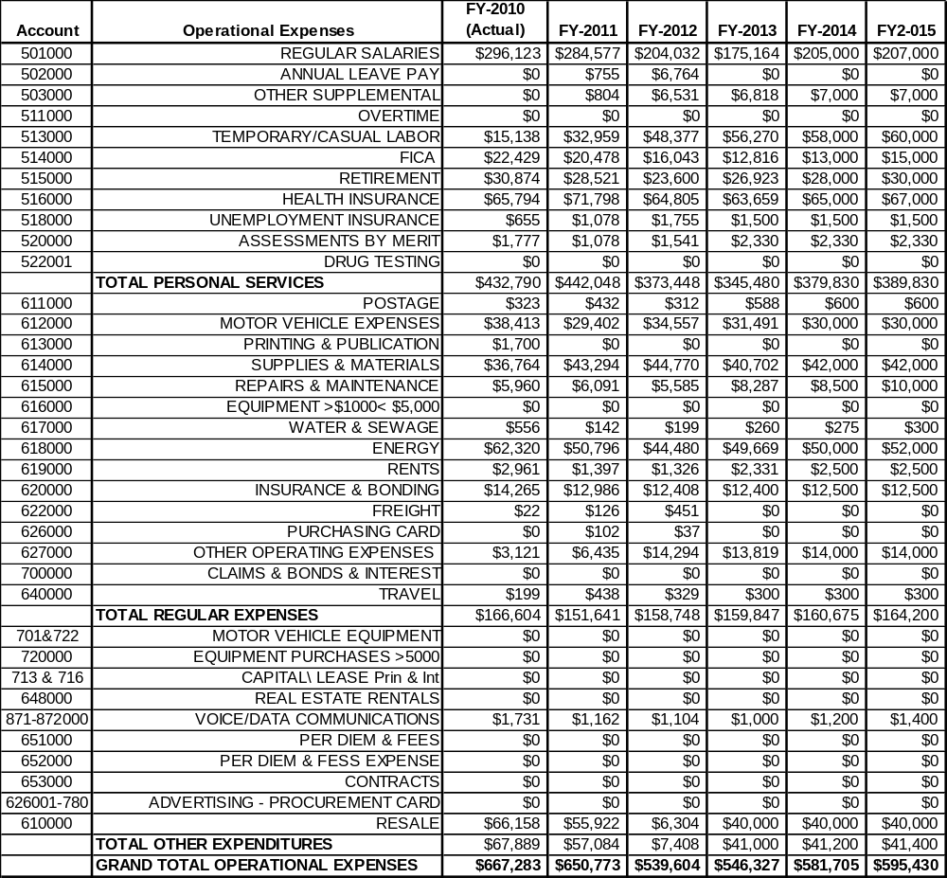

Revenue Pro Forma
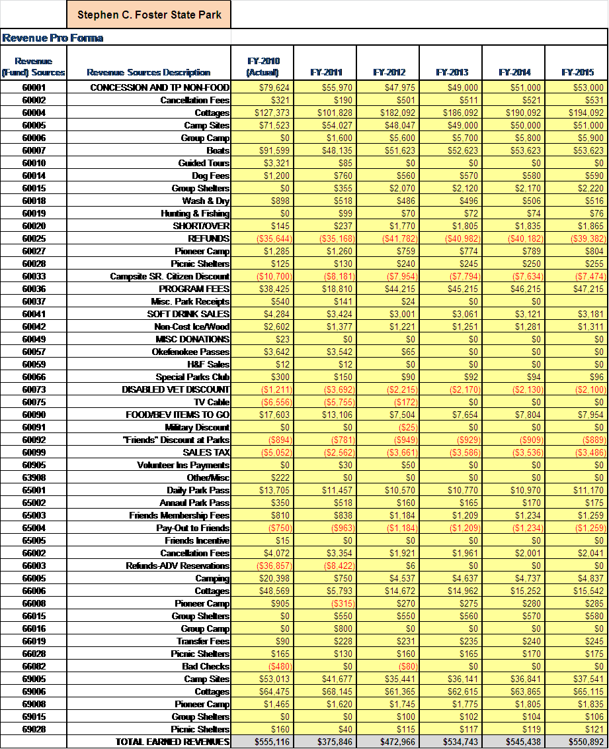

Total / Cost Recovery Pro Forma

Stephen C. Foster State Park
TOTAL PRO FORMA | FY-2010  (Actual) | FY-2011 | FY-2012 | FY-2013 | FY-2014 | FY-2015
Visitation | 61,871 | 50,000 | 42,000 | 60,000 | 65,000 | 64,965
Operational Expenses | $667,283 | $650,773 | $539,604 | $546,327 | $581,705 | $595,430
Earned Revenues | $555,116 | $375,846 | $472,966 | $534,743 | $545,438 | $550,892
% Cost Recovery | 83.2% | 57.8% | 87.7% | 97.9% | 93.8% | 92.5%

Action Plan
ACTION PLAN
Site: Stephen C. Foster/Suwannee VC/Eco Lodge |  | Site Manager: Bryan S. Gray |  |  | Date:
Month:
Strategy | Tasks | Costs / Funding | Revenues / ROI | Responsibilities | Metrics

ACTION PLAN
Site: Stephen C. Foster/Suwanee VC/Eco Lodge |  | Site Manager: Bryan S. Gray |  |  | Date:
Month:
Strategy | Tasks | Costs / Funding | Revenues / ROI | Responsibilities | Metrics

