Seminole State Park
Business & Management Plan

Prepared June 2011; Finalized February 2013
Direction 2015 – Sustainable Business Planning

Table of Contents

Executive Summary 3

Site and Operations Assessment 8
Site Inventory and Facility Assessment 8
Operational Assessment 10
Financial Performance Assessment 15

Business and Management Plan 19
Business Goals 19
Classification of Programs and Services 20
Partnership Development Plan 21
Marketing and Sales Plan 22
Revenue Generation Plan 24
Expense Management Plan 25
Financial Pro Forma 27

Action Plan 30

Executive Summary
The Parks, Recreation and Historic Sites Division (PRHSD) of the Georgia Department of Natural Resources (DNR) is transitioning the management of Seminole State Park to operate more like a business, reflecting the Direction 2015 – Sustainable Business Planning initiative to improve the fiscal performance and management of the state parks and historic sites system. This business and management plan is designed to help the site recover more operating expenses through earned revenues, productive partnerships, and innovative programs.

Site Fact Sheet

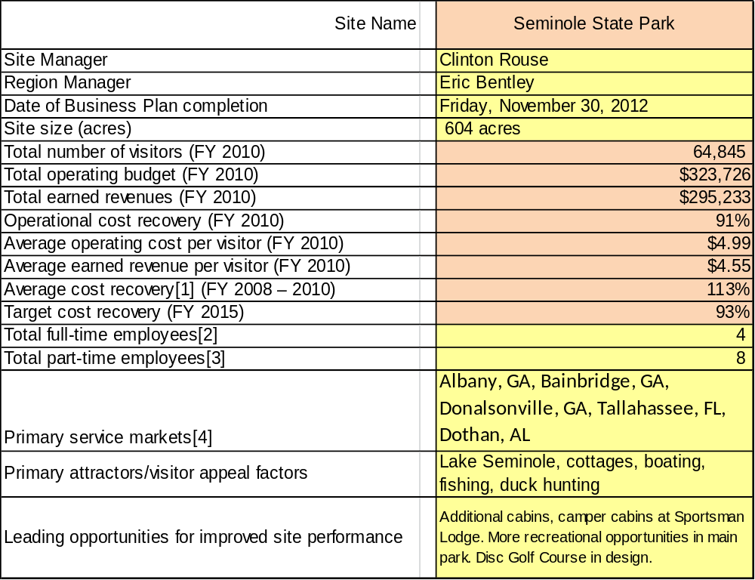

Site Summary and Key Attractions
In 1956, the Army Corps of Engineers leased this property to the State of Georgia for the purpose of creating a state park. The park was originally called Marvin Griffin State Park in honor of the governor at that time.
In 1960, the park’s name was changed to Seminole State Park, in reference to Lake Seminole on the shores of which the park is located. Lake Seminole is a 38,000-acre lake created and maintained by the Army Corps of Engineers. The lake was formed by the construction of the Jim Woodruff Dam located at Chattahoochee, Florida. The three major tributaries that flow into Lake Seminole are the Chattahoochee and Flint Rivers, as well as Spring Creek.
In 1992, the Harvel Pond tract was added to the park bringing the total park acres to 604. The addition of this land was for the purpose of preventing further residential encroachment and to create a barrier between adjacent private hunting land and public use areas within the park. The acquisition of the Harvel Pond tract included an existing boat ramp and parking area. Cummings Landing was acquired in September 2006 for the protection of the endangered Longleaf Pine/Wiregrass Ecosystem.
The lake offers some of the best bass fishing in the southeast U.S. and is the location of several major bass tournaments. In the fall and winter months, duck hunters replace the bass fishermen since there is an abundance of ducks present at that time of the year.
In addition to the above facilities is a 2.2-mile nature trail that is designed to interpret the Longleaf Pine/Wiregrass Ecosystem. The trail is named for the Gopher Tortoise (Gopherus Polyphemus), which is a native resident of this type of habitat.
Seminole State Park is located near Lake Seminole Wildlife Management Area, which provides up to 18,000 acres of public land for hunting and other outdoor related activities.

Key Attractions
The amenities or features listed below are those that seem to be most popular for visitors.
- 14 cottages
- 50 campsites
- Group shelter
- 5 picnic shelters
- 1 picnic shelter chapel
- 2.2 miles of nature trails
- Tree house pioneer camping
- Mini golf
- Beach
- Boat rentals

Financial Targets
The table below details the total operating expenses and earned revenues for Seminole over the last three years (2008 – 2010). This table also calculates total cost per visitor and revenues per visitor during these operating years, and details the target financial performance goals in the context of achieving at least 111% cost recovery. This table also calculates the necessary change from 2010 operating expenses and revenues.
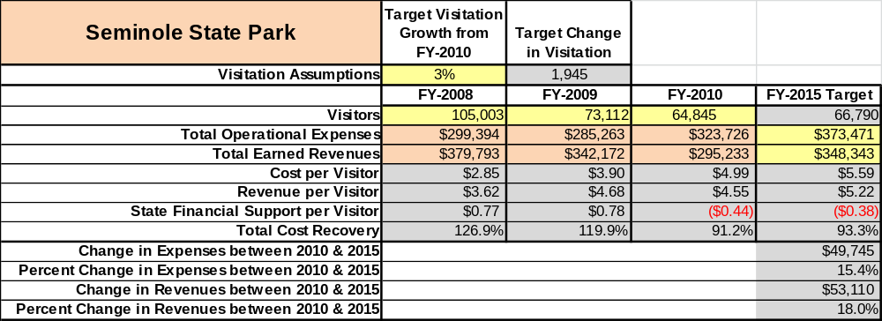

Key Recommendations

Primary / Short Term Recommendations
- Operate the site using cost-based accounting, including the net cost recovery achieved annually.
- Conduct in-park surveys annually to assess how well customer satisfaction levels are being met. Seminole should strive to have 90% of visitors responding to ‘Comment Cards’ report that they were either ‘satisfied’ or ‘very satisfied’ (or some comparable metric to be developed). Programs or services that fall below that standard should be critically reviewed, enhanced, and results monitored; those with a history of poor performance should be considered for elimination.
- Evaluate and pursue opportunities to employ concessionaires or private or public service providers on-site if they can be more cost-effective. For example, explore the development of a concessionaire agreement to manage private events on-site.
- Collect a statistically-valid sample of ZIP code data from visitors in a non-intrusive way to gauge their origins and demographics (e.g., age, ethnicity, income, etc.) and use the results to improve programming and marketing efforts to appeal to a broader audience.
- Utilize a minimum of six special events annually to help draw more visitors to the site.
- Seek local partners to help support operations, programs, and service delivery and for cross-marketing purposes.
- Sustain sufficient non-labor operational funding or reduce staff so that required staff operational costs (with benefits) do not exceed 65% of the total operational budget.
- Enhance facilities and program offerings to provide a minimum of 10 unique experiences for each visitor while maintaining at least a 90% customer satisfaction rating.
- Manage Seminole according to well-defined maintenance, program and operational standards monitored and enforced by region managers and senior management.
- Partner with local Chambers of Commerce or other destination marketing organizations (DMOs) to promote Seminole.
- Continue to work with the Seminole Chapter of the Friends of Georgia State Parks and Historic Sites to help raise funds or provide volunteers for improvements and program support.
- Perform a thorough net cost-of-service analysis on major functions of site operations, including the detailed analysis of labor requirements (by task) that has already been produced by site staff. Thereafter, update costs to deliver services on a bi-annual schedule.
- Review and update rates at the site on an annual basis to recover the total net cost of service for important and visitor-supported services.
- Track total economic impact of the site on the local communities and region and share with decision-makers, elected officials, local business operators, and others to demonstrate the impact of Seminole.
- Develop a more detailed analysis of labor requirements of all major park functions to match the right position with the right job at the right pay.
- Develop funding to provide additional training to site staff for improved business management and marketing effectiveness.
- Construct and upgrade facilities and amenities at the site that are likely to have a cost recovery level at or above 100%. Suggestions include adding 4 cabins (possibly camper cabins) at the Sportsman Lodge site; moving shelter # 5 into the day use area where it would be better utilized; and constructing a disc golf course.
- Add more youth-focused services, programs and amenities at the site that appeal to younger audiences, families and educational groups.
- Add more services, programs and amenities that appeal to older adults.

Secondary / Long Term Recommendations
- Improve the recreational amenities of the site to address modern and diverse uses, which can include adding motors (electric or gas) to our jon boats for increased rental fees.
- Install an improved retail point-of-sale and inventory tracking system.

Site and Operations Assessment
This site and operations assessment is a culmination of analyses and findings from a review of the condition of facilities, infrastructure, and operations at Seminole. The findings and observations are not intended to be an exhaustive review of all issues present, but provide a basic understanding of the predominant issues that contribute to the site’s current operating conditions. The assessment includes the following:
- Site Inventory and Facility Assessment
- Operational Assessment
- Financial Assessment
Site Inventory and Facility Assessment

Methodology
Facility and asset conditions are rated using a differential scale of excellent, good, fair, or poor. Descriptions of conditions that are attributed to each of these findings are also provided.
Scale of Conditions
Rating | General Description
Excellent | Facilities/amenities are in ‘excellent’ condition when they show little or no maintenance or repair problems. Facilities do not feature any major design or operational issues or flaws that contribute to diminished use or increased maintenance or upkeep. Facilities are easy to clean and maintain in order to place them back into public use and the users perceive them to be in excellent shape.
Good | Facilities/amenities are in ‘good’ condition when they show only minor maintenance or repair problems. Most maintenance issues with these facilities typically appear to be the result of age and/or heavy use. Facilities may only feature minor design or operational issues that contribute to diminished use or increased maintenance or upkeep. Facilities are moderately easy to clean and maintain in order to place them back into service and the users perceive them to be adequate for their use, but probably not in excellent shape.
Fair | Facilities/amenities are in ‘fair’ condition when they show significant maintenance or repair problems. Facilities generally exhibit ongoing maintenance issues that appear to be the result of age, heavy use, or design or operational flaws. Some maintenance and repair needs may compound their fair condition by being deferred because of budget and/or resource limitations. Facilities require more effort to clean and maintain before placing them back into service and the users may perceive them as being less than adequate for their use and in a state of deterioration. The facility or structure may need of major repair or replacement.
Poor | Facilities/amenities are in ‘poor’ condition when they show significant, on-going maintenance or repair problems that ultimately may result in suspended use for repair/replacement. Maintenance and repair issues are possibly the result of poor maintenance and clearly the result of age, heavy use, or design or operational flaws. Problems with the facilities are often compounded over time due to consistently-deferred maintenance and repair because of budget and/or resource limitations. Facilities may feature major design or operational issues that contribute to diminished use or increased maintenance or upkeep. Facilities require excessive effort to clean and maintain before placing them back into service and the users often perceive them as being inadequate for their use and in a state of serious deterioration. The facility or structure may need of major repair or replacement.

Inventory and Assessment
The table below is an inventory of facilities and amenities at Seminole and provides the assessed condition of each as reviewed in April 2011.
Site Asset / Amenity | Quantity | Condition
Cottages | 4 | 1,2,13,14 Good
Cottages | 10 | 3-12 Excellent
Storage Building (Old Grp Shltr) | 1 | Fair
Campground | 50 | Fair
Comfort Station | 2 | Fair / Poor
Day-use restroom | 2 | Poor-Fair
Picnic Shelter | 6 | Good
Group Shelter | 1 | Excellent
Docks | 8 | Fair - Good
Visitor Center | 1 | Good
Kiosk Booth | 1 | Excellent
Manager & Asst. Mgr Residence  Staff Residence | 2 | Good
Linen Barn | 1 | Good
Host Shack | 1 | Good
Well house | 2 | Good
Hiking Board Walk | 1 | Fair
Tree House | 1 | Good
Maintenance Facility | 1 | Fair
Boat Ramps | 6 | Good

Prioritized Facility Needs
Based on the facility inventory and assessment, these prioritized needs have been identified. Each need has been aligned with a priority category of high, moderate, or low to support future decision making regarding project sequencing, investment of public resources, and meeting community expectations. The priority assignment for each need is not a measure of importance. Rather, these recommended priorities reflect a phased implementation approach over the next several years.
Facility Need | Priority Assignment
Master Plan Update with U.S. Corps of Engineers | High
Cummings Landing Ramp Dock repaired or replaced | High
ADA Dock replaced | High
Hiking Trail Board Walk repaired | High
Cottages 1, 2, 13, 14/Siding, roofing, floor covering, paint. Or renovate | High
Visitor Center/Roofing | Med
Group Shelter Day use restroom tear down | Med
Park Manager/roofing, siding and paint | Med
Park Assistant Manager/roofing, siding and paint | Med
Day use water lines / pipes need replaced with PVC | Med
Small Group Shelter/re-model to make storage building | Low
Picnic Shelters/roofing and paint | Low
Entire Park needs painting – on Prison schedule | Low
Loop 1 Comfort Station – minor repairs | Low

Operational Assessment
The Operational Assessment includes:
- An inventory and classification of programs and services being provided at the site
- A review of staffing at the site
- A review of concessionaires and partners operating at the site
- Visitation and customer satisfaction

Inventory and Classification of Programs and Services
Programs and services are classified into one of three major categories:
1) Core or Essential Services
2) Important Services
3) Visitor Supported Services
Programs and services at the site are classified into these categories based in part on the mission and public mandates for both the site and the agency. For the services in each of these categories, there are financial performance expectations that will define how services are funded and evaluated.

Category 1 – Core Services [Largely supported by tax funds]
Core programs, services and facilities are those the agency must provide and/or are essential in order to capably govern and meet statutory requirements. The failure of the agency to provide Category 1 services at adequate levels could result in significant negative consequences for the public and the resources under protection. The criteria for services to be classified as core or essential are:
- The services are mandated by the agency’s law or charter or are contractually obligated by agreement to provide the services.
- The services are essential to protecting and supporting the public’s health and safety.
- The services protect and maintain valuable assets and infrastructure.
- The services would generally and reasonably be expected and supported by residents, businesses, customers and partners.
- The services are those that cannot or should not be provided by the private sector.
- The services provide a sound investment of public funds.
The following programs and services offered at Seminole have been identified as core services:
- Active management of the natural resources (Long Leaf Pine and Gopher Tortoise ecosystems) of the site in order to protect their integrity
- Open and public access to the site and its resources
- Site appropriate education, interpretation and recreational opportunities
- Effective management of the park and structures located within its boundaries
- Safety of visitors and guests
- Maintenance of park grounds, facilities and infrastructure

Category 2 – Important Services [Supported by a balance of tax funds and earned revenues]
Important programs, services and facilities are those the agency should provide, and are important to governing and effectively serving residents, businesses, customers and partners. Providing Category 2 services expands or enhances the agency’s ability to provide and sustain its core services. The criteria for programs or services to be classified as important are:
- The services expand, enhance or support identified core services.
- The services are broadly supported and utilized by the community, and are considered an appropriate, important, and valuable public good. Public support may be conditional upon the manner by which the services are paid for or funded.
- The services generate income or revenue that offsets some or all of the operating cost and/or are deemed to provide economic, social or environmental outcomes or results.
The following programs and services offered at Seminole have been identified as important services:
- Camping and cottages
- Day-use picnic shelters
- Group shelter
- Picnic sites
- Playgrounds
- Hiking trails
- Beach area

Category 3 – Visitor Supported Services [Almost exclusively supported by earned revenue]
Visitor supported programs, services and facilities are those discretionary services that the agency may provide when additional funding or revenue exists to offset the cost of providing those services. The criteria for programs or services to be classified as visitor supported are:
- The services expand, enhance or support core services or important services and the quality of life of the visitors, community or stakeholders.
- The services are supported, valued and provide an appropriate and valuable public benefit.
- The services generate income or funding from sponsorships, grants, user fees or other sources that offset some or all of their cost and/or provides a meaningful return on investment.
- The services can possibly be provided through outsourcing or use of concessionaires, providing opportunities for community enterprises that may not otherwise be provided by the agency.
The following services offered at Seminole have been identified as visitor supported services:
- Visitor center / gift shop
- Special events / programs
- Ranger guided interpretation and educational programs
- Tree house/pioneer camping
- Boat rentals

Staffing Assessment
Labor costs at Seminole represent the largest area of budgetary expense at an average of 60% of the total operating budget each year for the last three complete years, which is lower than the target of total labor costs (including benefits) not exceeding 65% of the site’s total operating expenditures. The tables below and on the following page provide a basic review of the current staffing at the site.
Full Time Equivalent Employees
Position / Title | Quantity (FTE) | Vacancies | Annual Hours
Park Manager 2 | 1 | 0 | 2400
Asst. Park Manager 1 | 1 | 0 | 2400
Secretary 1 | 1 | 0 | 2080
Park Ranger 1 | 1 | 0 | 2080
TOTAL | 4 | 0 | 8,960

Part Time Employees
Position / Title | Quantity (FTE) | Vacancies | Hours
Part Time Maint. | 1 | 1 | 2324
Kiosk Clerk | 0 | 1 | 416
Weekend Clerk | 1 | 0 | 1248
Part Time Interpreter | 0 | 1 | 624
Part Time Housekeeper | 5 | 0 | 2912
TOTAL | 7 | 2 | 7,524

Labor Support
Labor Support | Annual Hours
Volunteers | 6656
Community Service Workers | 25
Engineering and Construction Crews | 0
Resource Management Crews | 0
TOTAL | 6,681

Total Labor Hours
Labor Type | Annual Hours
Full Time Equivalent Employees | 8,960
Part Time Employees | 7,524
Labor Support | 6,681
TOTAL Annual Labor Hours | 23,165

Labor Budget Summary

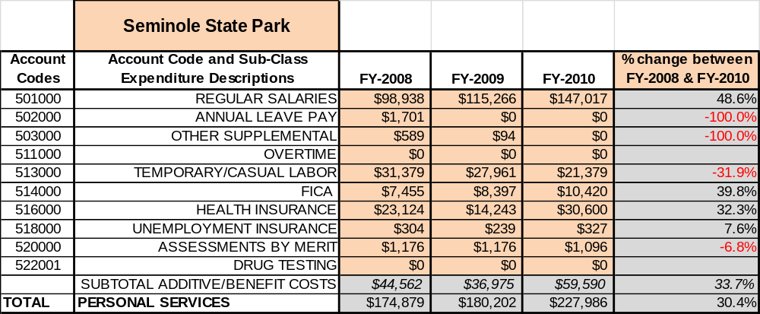

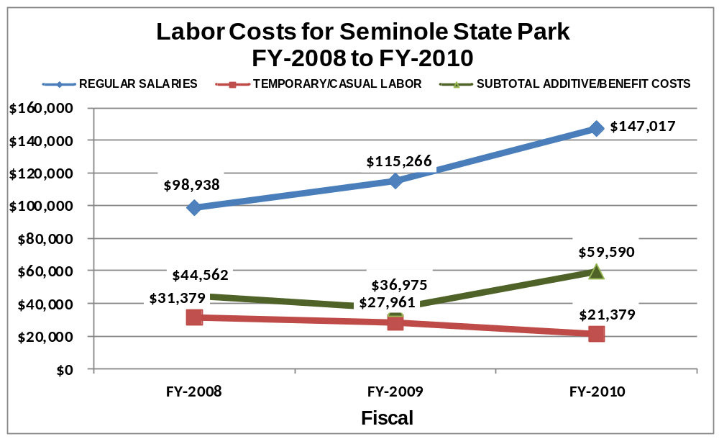

Visitation and Occupancy
Overall annual visitation to the site has trended downward from 2008 to 2010, decreasing by 38% or over 40,158 visitors. This is largely attributed to high gas prices, increasing prices statewide, and poor economy.
Year | Total Visitation
2008 | 105,003
2009 | 73,112
2010 | 64,845

Occupancy for the overnight accommodations at Seminole the last three years is detailed in the table below. Overall occupancy has trended downward from 2008 to 2010, decreasing by 14%. This is largely attributed to high gas prices, increasing prices statewide, and poor economy.

Year | Campground Occupancy | Cottage Occupancy
2008 | 21.93% | 50.38 %
2009 | 21.46 % | 47.15 %
2010 | 21.30 % | 36.86 %

Customer Service and Satisfaction

Site | Year | Customer Satisfaction Level
Seminole | 2009 | 86%
Seminole | 2010 | 100%

Financial Performance Assessment

Operational Expenses
A summary of total operating expenses at Seminole from 2008 to 2010, as well as their percent change from 2008 are provided in the table below.
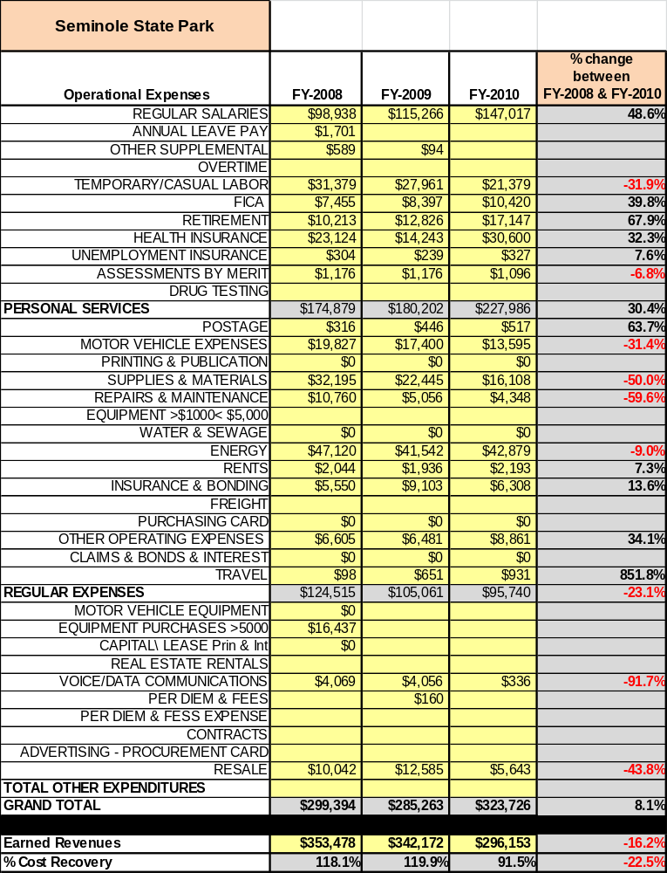

Earned Revenues
Earned revenues at Seminole have decreased since 2008, which is largely attributed to the corresponding decrease in overall visitation. Monthly earned revenues for the last two years indicate that the total annual revenue decreased 14% from 2009 to 2010, with the largest increases in monthly revenues in April (4%) and the largest decreases in the months of January (-45%), November (-22%) and December (-22%).
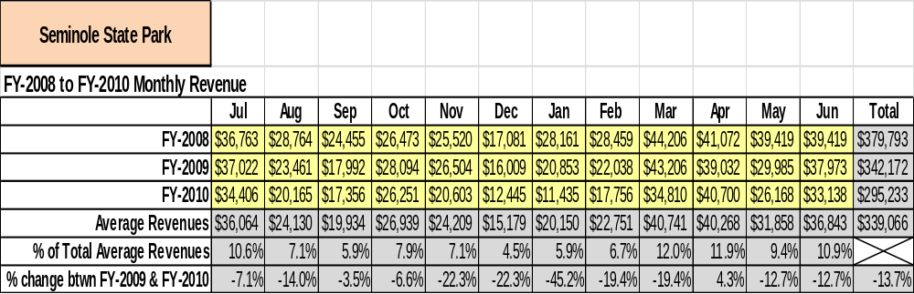

The graphs below illustrate the monthly revenue trends each year and the average percent of total annual revenue earned each month.
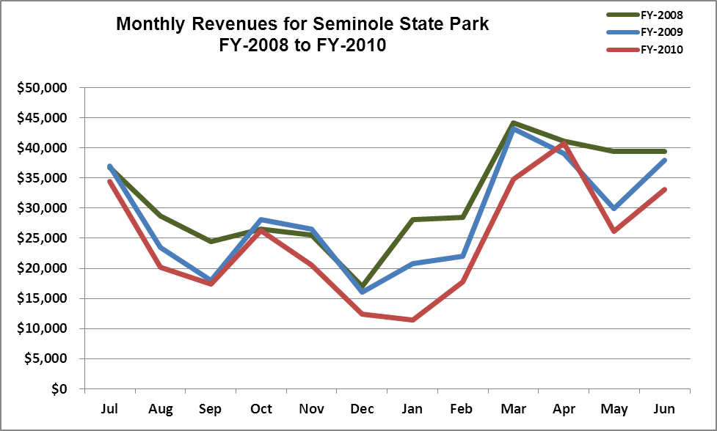

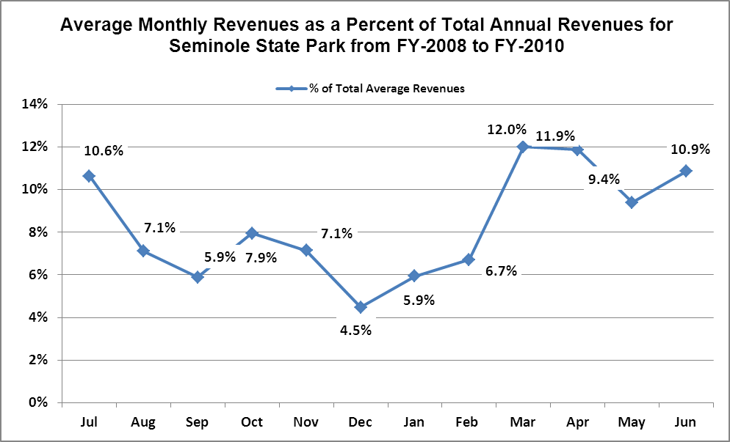

Cost Recovery Trends
Seminole has achieved an average cost recovery of 109% of annual operational expenses through earned revenues from FY 2008 to FY 2010. This is detailed and illustrated in the table and graph below.
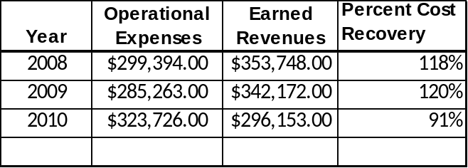

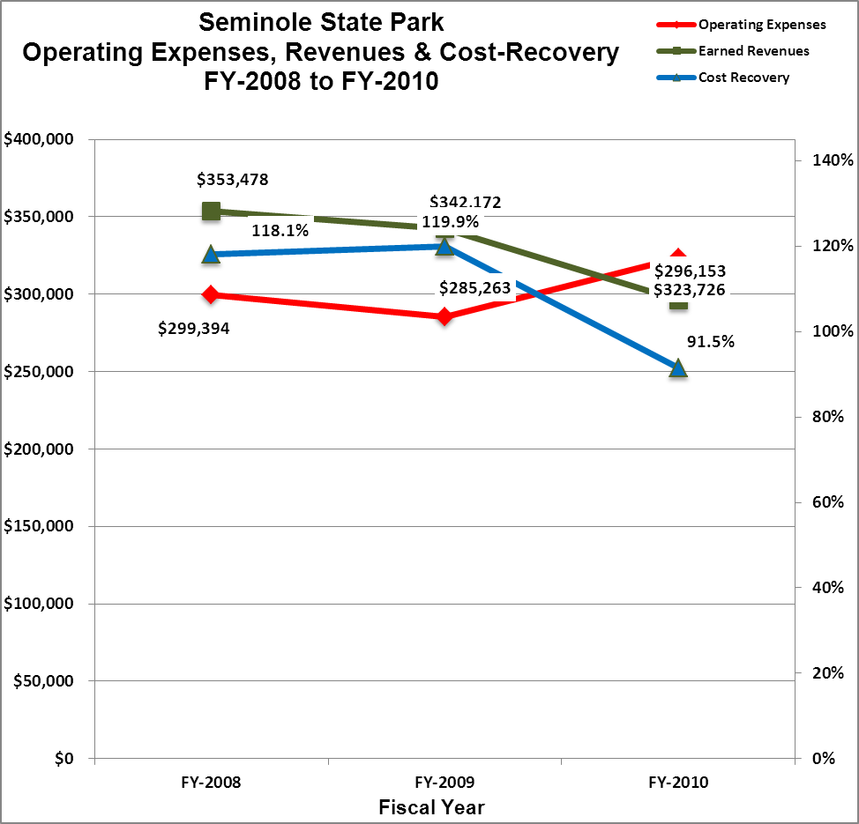

Review of Pricing
Data on rate information is available as far back as 2002, but only the last five years are evaluated. There has been notable growth in fees charged at Seminole since 2005, with the largest increase being cottages. A table detailing the rates is provided below.

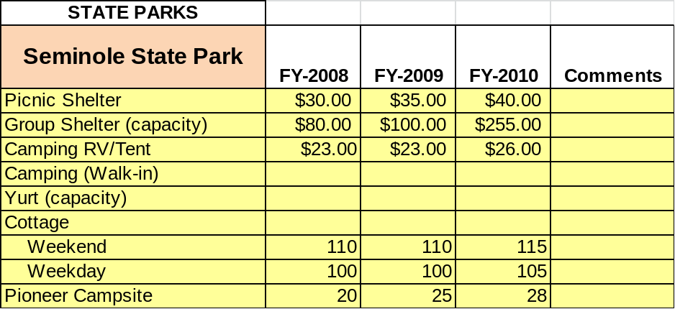

Business and Management Plan

Business Goals
The following goals serve as the foundation for the key recommendations and strategies in this business plan for Seminole.

Enhance Cost Recovery of Site Operations
Seminole State Park operates close to 100% cost recovery. Many factors have influenced this recently with cottages being closed for renovations, staffing promotions leaving vacant positions throughout the year, and overall impact of the economy. The primary focus will be to increase revenue and visitation.

Enhance Revenue Generation Strategies
Seminole State Park’s primary revenue generator is our cottages. Four more cottages should be constructed to increase rentals. A campground renovation to support full service sites would allow Seminole State Park to compete with surrounding campgrounds to increase overall occupancy. We should also look into possibility of development at Sportsman Lodge. A disc golf course has been designed and is awaiting installation once approved on a Master Plan.

Expand Special Events at the Site
Seminole State Park has special events to include the Shellcracker Tournament, 4th of July celebration, and a revamped Christmas light display. These events are being re-evaluated for effectiveness. This is an area for increased participation and a potential source for revenue.

Improve the Diversity and Innovation of Recreational and Interpretive Programs
Guests who come to Seminole State Park are here primarily for lake activities. Park programs are not drawing people away from the lake. Programs need to be enhanced when weather is not permitting heavy lake use. Partnering with Home School Associations and the Seminole County School system should be best avenues for programmatic outreach. Boat tours would do well and should be investigated. Standard park programs can drain the park budget with no return of any kind.

Improve the Effectiveness of Marketing and Sales
In our community there are several small publications that are free to the public and very inexpensive to advertise in. We currently advertise in these and should continue to do so. There should be a system set up to quantify whether these ads are cost effective. Seminole is close to two large population centers and we should look into the possibility of TV ads in those centers.

Establish Greater Consistency of Managing and Monitoring Customer Service & Satisfaction
Seminole has traditionally done well with customer satisfaction and has stayed above 90% by the comment card system. Guests should be offered something in return for their time when filling out comment cards. Staff will be even more open-minded to guest concerns and complaints.

Expand Partnership Opportunities
The Friends of Seminole State Park is the most visible of our existing partners. Maintaining a good partnership with the Convention and Visitors Bureau in Bainbridge and also expanding with local recreational providers will lend a positive yield. We currently enlist help from the U.S. Army Corps of Engineers, Seminole County, Seminole Sheriff’s Department, and Seminole County Board of Commissioners; however, these are on a very limited basis.

Classification of Programs and Services
The tables below summarize the classifications of programs and services at Seminole as either core, important, or visitor supported and projects a range of cost recovery percentages that might be achieved for each. These classifications establish financial performance goals for each category of services that are linked to the recommendations and strategies of this business plan.
Core Services
Program / Service | Target Cost Recovery
Active management of the natural and cultural resources of the site in order to protect their integrity | 0%
Open and public access to the site and its resources | 0%
Site appropriate education, interpretation and recreational opportunities | 0%
Effective management of the park and structures located within its boundaries | 0%
Safety of visitors and guests | 0%
Maintenance of park grounds, buildings and infrastructure. | 0%

Important Services
Program / Service | Target Cost Recovery
Camping and cottages | 125-150%
Day-use picnic shelters | 40%
Group shelter | 40%
Picnic sites | 40%
Playgrounds | 0%
Hiking trails | 0%
Beach area | 0%

Visitor Supported
Program / Service | Target Cost Recovery
Visitor center / gift shop | 100%
Special events/programs | 100%
Ranger guided interpretation and educational programs | 100-125%
Tree house / pioneer camping | 100%
Boat rentals | 200%

Partnership Development Plan
The table below summarizes existing partners and targeted partnerships by classification (operational, vendor, service, and co-branding, funding partners) and by organizational type.
 | Public Partners | Not-for-profit Partners | Private / Enterprise Partners
Operational Partners | - Seminole County Sheriff’s Department, Fire Department and EMS.  - The U.S. Army Corps of Engineers | - Nature Conservancy  - Joseph W. Jones Ecological Research Center at Ichauway  - Lake Seminole Association  - Lion’s Club
Vendor Partners |  |  | - Coca Cola  - Farley Nuclear Plant  - GA Power  - Home Depot
Service Partners | - Seminole Co Board of Commissioners | - Seminole/Donalsonville Chamber of Commerce
Co-branding Partners | - Seminole County campground | - Wildlife Resources Non-Game Division | - Trails End  - Spring Creek Resort
Funding Resource Development Partner |  | - Friends of GA State Parks  - Friends of Seminole

Marketing and Sales Plan

Marketing and Sales Goals
Marketing and sales goals for Seminole are based on the following desired outcomes:
- Increase cottage rentals by 10%-15% over the next year through marketing the experience of water front cabins and scenic views and package deals
- Increase camping rentals 5%-10% by marketing extended stay discounts and package deals
- Increase shelter rentals over the next year through advertising uses such as; weddings, business meetings, family reunion’s and offering package deals
In order to meet these goals, examples of specific target outcomes were identified in the areas detailed in the table below.

Area  of Focus | Current  Performance | Goal  by 2011 | Goal  by 2012 | Goal  by 2015
Cabin rental | 37% | 43% | 50% | 55%
Camping rentals | 23% | 26% | 30% | 35%

Marketing and Promotion Strategies

Publicity and Social Media
Seminole will approach marketing and publicity planning using the following guidelines and themes:
- Event publicity
Major events benefit by having short stories in local, regional, and statewide newspapers and online social media hooks planted that run three to four weeks in advance of the event up to the date of the event itself. Stories and media need to be cultivated with contacts and online sales channels several weeks in advance of the time the stories need to run. Special interest interviews on morning, noon, and evening television news programs, radio interviews on popular rush-hour programs, and blogs on known affinity online sites should also be included.
- Program publicity
Special and unique programs should have feature stories in magazines, local and regional weekly newspapers, and statewide daily newspapers that are aimed at placements as front-page or sectional front-page stories. These stories are most effective if they run shortly before the season that the featured program begins. This will likely require several weeks of advanced planning with media contacts. Similar coverage on television and radio should also be considered. If pre-publicity cannot be generated, post-publicity can help promote future programs.
- Site Publicity
Site publicity focusing on a single site or sub-set of sites requires more intense planning efforts to attract multiple writers and editors from target publications. The site could host several seasonal media familiarization tours (with 10 to 15 writers or editors) to familiarize them with the site and its benefits and amenities. Stories and features resulting from such tours typically take between two and six months to materialize so the tours should focus on experiences, benefits, and programs that would be available when the stories are expected to run.
Examples and suggested opportunities for events, programs and related publicity efforts based on the themes described above at Seminole are provided in the table below.

Event Publicity | Program Publicity | Site Publicity
Gopher Tortoise Trot | Junior Ranger Camp | Long Leaf Pine and Wiregrass Eco
2k/run/walk | Easter Egg Hunt | Guided Canoe trip
Renew our rivers and lands | Fall Festival | Weekend Programming
 | National Trails Day | Junior Fishing Rodeo
 | 4th of July Fireworks | Geocaching Adventure

Packaging
Examples and suggested packages for Seminole are provided in the table below.
Package | Package Details
Off Season Cottage Special | Stay for more than two nights at one of Seminole State Parks Cottages and receive two free rounds of mini-golf or 2 free canoe rentals for up to 8 hours.
Business Retreat Package | Host overnight business meeting at Seminole State Park and have fee waived for use of Group Shelter. Included group dynamic programming at reduced rate.

Group Sales
Types of groups within which specific target customers can be identified for Seminole are listed below:
- Local citizens | - Boat clubs | - Special event groups such as Fishing tournaments

Incentivizing New and Repeat Visitation
Seminole will utilize the following strategies and/or incentives to encourage new and repeat visitation starting in FY 2012:
- Seasonal discounts for non-peak times
- Monthly discounts during the off season

Marketing and Sales Metric Goals
The following marketing and sales metric goals and/or others will be monitored and progress reported at Seminole:
- Loyalty and repeat customers = 60% repeat customers.
- Brand confidence & customers-recruiting-customers = 20% of new customers recruited by previous customers.

Revenue Generation Plan
Revenue / Cost Recovery Goals
Seminole has set a financial goal of increasing annual revenues 1% annually between 2012 and 2015. The largest revenue growth opportunity is most likely cottages and the large group shelter. The table below details projected revenue growth leading up to 2015, based upon a nominal growth of revenues each year.
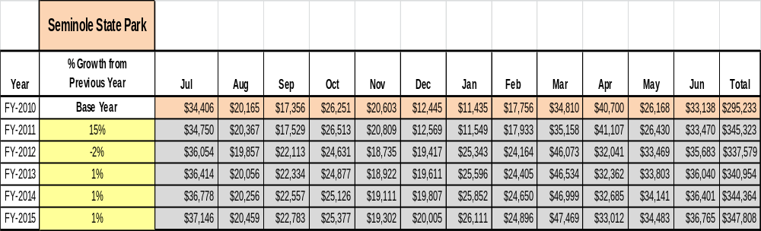

These projections would result in a total of 18% cumulative growth in total annual revenues between FY2010 and FY2015. If operational expenses can be managed with a cumulative increase of 15% between FY 2010 and FY 2015, then the overall cost recovery of the site will be approximately 93% in FY 2015 at these projected revenue levels. This is higher than the annual financial performance of the site in FY 2010, which was operated at 91% cost recovery in that year.
Revenue Generation Strategies

Pricing Plan
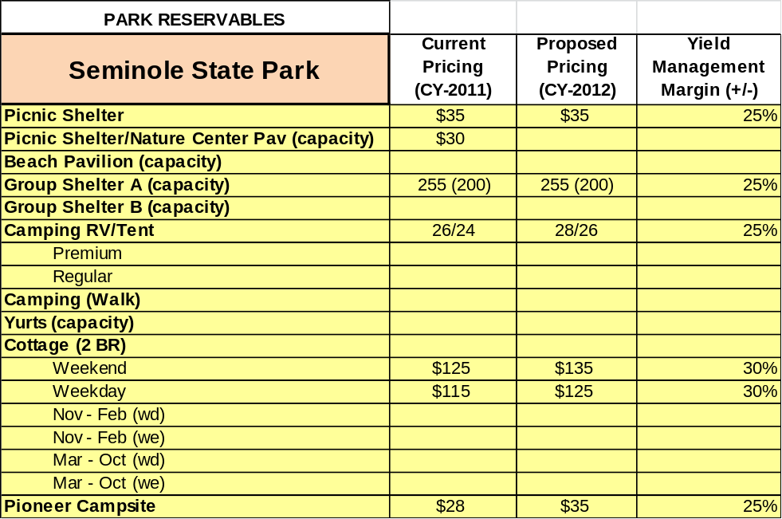

Innovative Programming and Special Events Plan
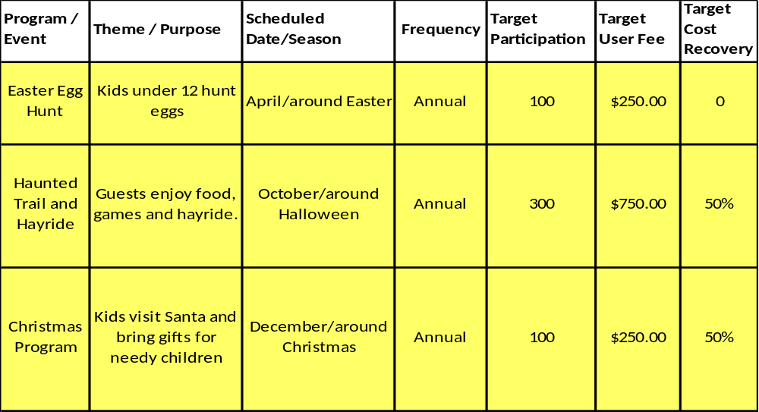

Partnerships and Concessions Plan
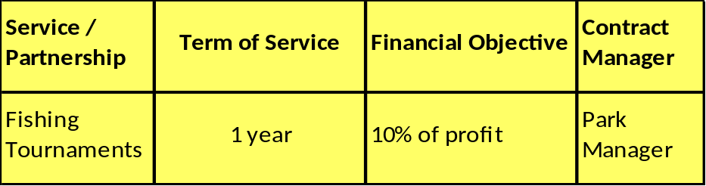

Expense Management Plan
Personnel Assignments
The following actions will be taken to proactively manage labor costs via personnel assignments and classifications.

Action | Timeline | Outcome
Eliminate vacant utility worker position | July 2011 | Savings of 29,030 a year
Eliminate vacant housekeeper position | July 2011 | Savings of 21,846 a year

Management Techniques
The following actions will be taken to proactively manage labor costs via management techniques.

Action | Timeline | Outcome
Maintain 1-2 1508 maintenance positions | As needed | Replaces utility worker position without paying salary and benefits
Maintain 4-5 Housekeeping positions | As Needed | Replaces Housekeeper positions without paying salary and benefits

Adjusted Levels of Service
The following actions will be taken to proactively manage labor costs via reduced levels of service.

Action | Timeline | Outcome
Reduce mowing | Peak season | Requires less man power, and reduction in funds spent
Leave only one day use restroom open unless others are needed which will be dictated to rentals and usage. | Year round | Reduces labor cost and funds
Adjust the amount of linens provided to guest | Year round | Guest will be less likely to use more than needed if there isn’t an overabundance of linens provided. This will cut time and funds needed to wash linens
Keep loop 2 comfort station closed except when camping usage dictates it’s need | Year round | Reduces funds and man power to maintain and run.

Financial Pro Forma
The following five-year financial pro forma projects operating expenses, earned revenues and cost recovery through FY 2015. These pro forma are based on the strategies and desired outcomes identified in this business plan, especially the revenue generation and expense management plans, and are linked to corresponding performance goals.

Expense Pro Forma

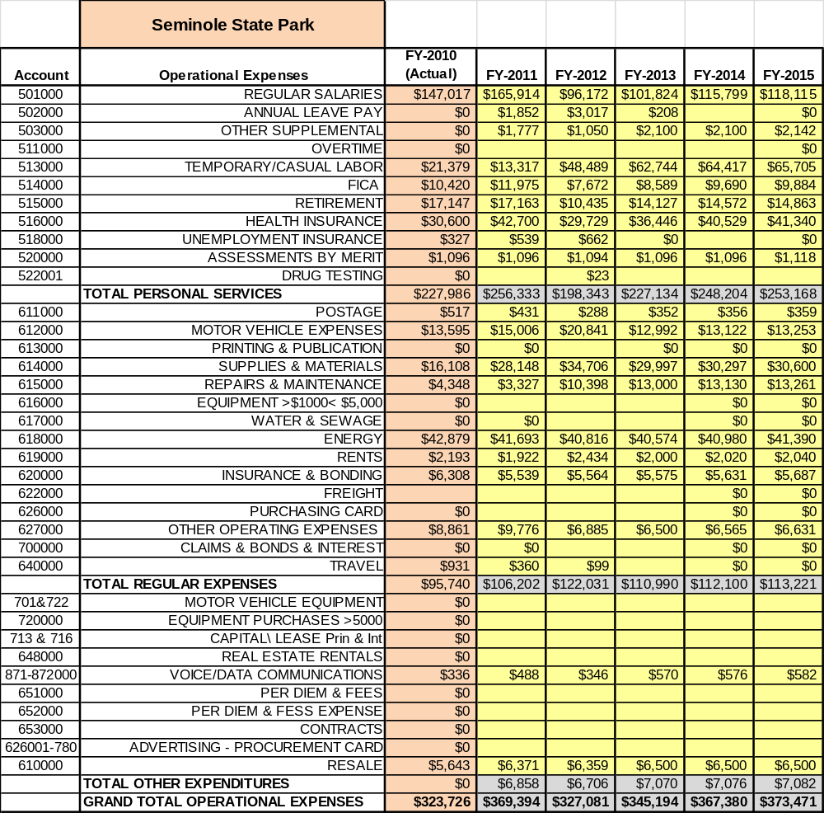

Revenue Pro Forma

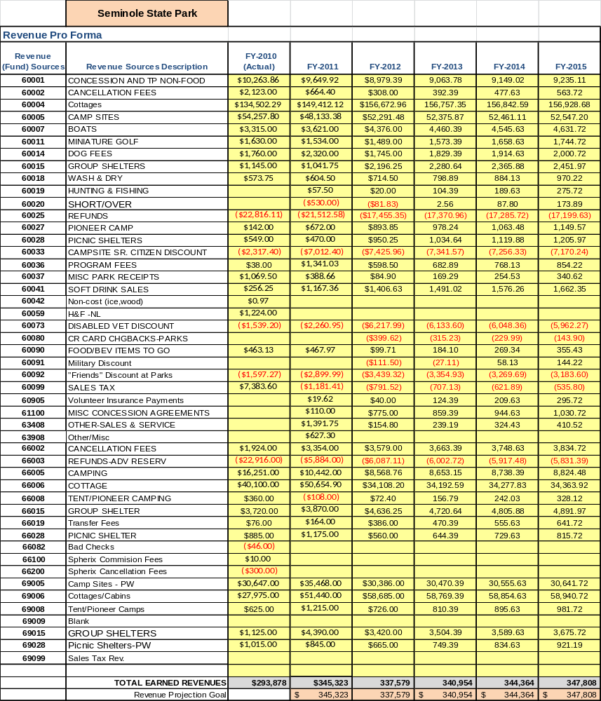

Total / Cost Recovery Pro Forma
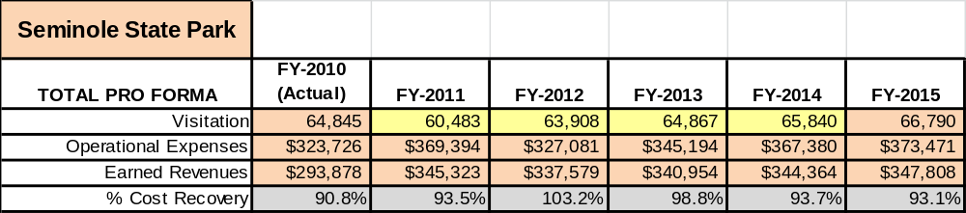

Action Plan
ACTION PLAN
Site: Seminole |  | Site Manager: |  |  | Date:
Month:
Strategy | Tasks | Costs / Funding | Revenues / ROI | Responsibilities | Metrics

ACTION PLAN
Site: |  | Site Manager: |  |  | Date:
Month:
Strategy | Tasks | Costs / Funding | Revenues / ROI | Responsibilities | Metrics

