Skidaway Island State Park
Business & Management Plan

Prepared June 2011; Finalized December 2012
Direction 2015 – Sustainable Business Planning

Table of Contents

Executive Summary 3

Site and Operations Assessment 7
Site Inventory and Facility Assessment 7
Operational Assessment 9
Financial Performance Assessment 14

Business and Management Plan 18
Business Goals 18
Classification of Programs and Services 20
Partnership Development Plan 21
Marketing and Sales Plan 22
Revenue Generation Plan 25
Expense Management Plan 26
Financial Pro Forma 27

Action Plan 29

Executive Summary
The Parks, Recreation and Historic Sites Division (PRHSD) of the Georgia Department of Natural Resources (DNR) is transitioning the management of Skidaway Island State Park to operate more like a business, reflecting the Direction 2015 – Sustainable Business Planning initiative to improve the fiscal performance and management of the state parks and historic sites system. This business and management plan is designed to help the site recover more operating expenses through earned revenues, productive partnerships, and innovative programs.

Site Fact Sheet
Site Name | Skidaway Island State Park
Site Manager | Holly Holdsworth
Region Manager | Tommy Turk
Date of Business Plan completion | June 6, 2011
Site size | 588 acres
Total number of visitors (FY 2010) | 195,490
Total operating budget (FY 2010) | $340,926
Total earned revenues (FY 2010) | $442,031
Operational cost recovery (FY 2010) | 130%
Average operating cost per visitor (FY 2010) | $1.74
Average earned revenue per visitor (FY 2010) | $2.26
Average cost recovery (FY 2008 – 2010) | 124%
Target cost recovery (FY 2015) | 125%
Total full-time employees | 4
Total part-time employees | 7
Primary service markets | Savannah, Jacksonville, Hilton Head
Primary attractors/visitor appeal factors | Historic Savannah, Tybee Island Beach, Fishing
Leading opportunities for improved site performance | Additional rental facilities (efficiency cabins, improved campground w/ full hook-ups), partnering with the Savannah tourism industry, increased programming

Site Summary and Key Attractions
The 588-acre site of Skidaway Island State Park is located in an urban residential setting, roughly 12 miles from downtown Historic Savannah. It is roughly 17 miles from Interstate 95, and 15 miles from Interstate 16. The tourism industry of Savannah, and the “snowbird” travelers up and down I-95, bring the site the highest revenue generation through campsite rentals. The opportunities to expand that revenue and seek new opportunities through programming and package deals provide the biggest opportunity to reach the identified cost recovery target.

Key Attractions
The amenities or features listed below are those that seem to be most popular for visitors.
- Campground
- Group Shelter
- Interpretive Programs & Special Events
- Retail Area/Gift Shop
- Trails & Picnic Area

Financial Targets
The table below details the total operating expenses and earned revenues for Skidaway Island State Park over the last three years (2008 – 2010). This table also calculates total cost per visitor and revenues per visitor during these operating years, and details the target financial performance goals in the context of achieving at least 125% cost recovery. This table also calculates the necessary change from 2010 operating expenses and revenues.
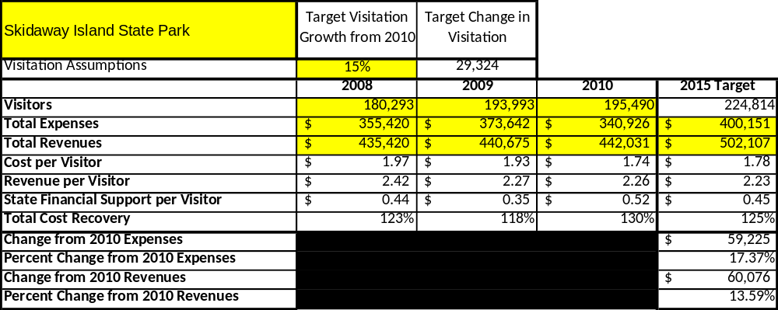

Key Recommendations

Primary / Short Term Recommendations
- Operate the site using cost-based accounting, including the net cost recovery achieved annually.
- Weekly monitoring of online comment cards and online review websites including Trip advisor, Yelp, RV Park Reviews, Campground report, Campster, and others. Responding to those reviews to address any issues or create relationships with guests and thank them for taking the time to give us feedback (whether good or bad). Issues that arise should be addressed immediately and programs, services, or facilities that fall below that standard should be critically reviewed, enhanced, and results monitored.
- Evaluate and pursue opportunities to employ concessionaires or private or public service providers on-site if they can be more cost effective or provide desirable services, programs, or amenities the Park cannot. For example, explore the development of a concessionaire agreement to provide public events on site or kayaking trips.
- Collect a statistically valid sample of ZIP code data from visitors in a non-intrusive way to gauge their origins and demographics (e.g., age, ethnicity, income, etc.) and use the results to improve programming and marketing efforts to appeal to a broader audience.
- Continue the five special events we offer and add a sixth to help draw more visitors to the site during more off seasons, months, or weekends.
- Seek local partners to help support programs, and for cross marketing opportunities.
- Seek out a final decision on the swimming pool operation. Reach out to all local community leaders and those in the pool industry and see if there is any interest to operate under their own management. If there are no interest plan for permanent closure and filling in for the use as a community garden.
- Sustain sufficient non-labor operational funding or increase staff so that required staff operational costs (with benefits) are 60 - 65% of the total operational budget.
- Manage Skidaway Island State Park according to well-defined maintenance program, and operational standards monitored and enforced by region managers and senior management.
- Work with the Marketing department to develop a site-specific marketing plan for Skidaway Island State Park.
- Continue to work with Friends of Skidaway Island State Park to help raise funds and recruit volunteers for programming and improvement projects.
- Perform a thorough net cost of service analysis on major functions of site operations, including the detailed analysis of labor requirements by task.
- Review and update rates on an annual basis and meet cost recovery targets for important and visitor-supported services.
- Develop online sales of retail merchandise associated with the site in order to increase retail revenues.
- Track total economic impact of the park in the local communities and region and share with decision- makers, elected officials, local business operators, and others to demonstrate the impact of Skidaway Island State Park.
- Develop a more detailed analysis of labor requirements of park operations and create job descriptions and requirements to match the right position with the right job at the right pay.
- Seek out and provide additional training to site staff for improved business management and marketing effectiveness.
- Construct and upgrade facilities and amenities at the site that are likely to have a cost recovery level at or above 100%. Suggestions include expanding the park office and retail space, upgrading the comfort stations, enhancing signage at the site entrance; enhance landscaping, update interpretive displays and exhibits, construct efficiency cabins, upgrade campsites to include sewer hook-ups and expand Wi-Fi throughout the campground.
- Add more programs, special events, amenities and educational opportunities that appeal to demographics we currently do not serve as much as others, like middle school ages, high school ages and elderly adults.

Secondary / Long Term Recommendations
- Establish a reserve fund or revolving account that allows for earned revenues above a certain percentage of operational cost recovery to be reinvested in the site or held for future use when revenue shortfalls may occur (think hurricanes).
- Improve the recreational amenities of the site to meet the needs of modern and emerging uses. (i.e., a disc golf course, archery range, etc)
- Engage the local community, user groups, and private organizations to improve connectivity between Skidaway Island State Park, The Village on Skidaway Island, The Landings Residential Community, Skidaway Institute of Oceanography, UGA Marine Education Center & Aquarium, and Wormsloe State Historic Site.
- Complete the slated construction of efficiency cabins and market to key user groups.
- Complete the slated campground renovations and additions of full hook-up campsites. Aggressively price the full hook-up sites and look at developing long-term rentals.
- In order to provide more recreational use of the park, create a fitness trail, and market it to local exercise enthusiasts.
- Develop and market hammock camping opportunities in the Pioneer Area.
Site and Operations Assessment
This site and operations assessment is a culmination of analyses and findings from a review of the condition of facilities, infrastructure, and operations at Skidaway Island State Park. The findings and observations are not intended to be an exhaustive review of all issues present, but provide a basic understanding of the predominant issues that contribute to the site’s current operating conditions. The assessment includes the following:
- Site Inventory and Facility Assessment
- Operational Assessment
- Financial Assessment
Site Inventory and Facility Assessment

Methodology
Facility and asset conditions are rated using a differential scale of excellent, good, fair, or poor. Descriptions of conditions that are attributed to each of these findings are also provided.
Scale of Conditions
Rating | General Description
Excellent | Facilities/amenities are in ‘excellent’ condition when they show little or no maintenance or repair problems. Facilities do not feature any major design or operational issues or flaws that contribute to diminished use or increased maintenance or upkeep. Facilities are easy to clean and maintain in order to place them back into public use and the users perceive them to be in excellent shape.
Good | Facilities/amenities are in ‘good’ condition when they show only minor maintenance or repair problems. Most maintenance issues with these facilities typically appear to be the result of age and/or heavy use. Facilities may only feature minor design or operational issues that contribute to diminished use or increased maintenance or upkeep. Facilities are moderately easy to clean and maintain in order to place them back into service and the users perceive them to be adequate for their use, but probably not in excellent shape.
Fair | Facilities/amenities are in ‘fair’ condition when they show significant maintenance or repair problems. Facilities generally exhibit ongoing maintenance issues that appear to be the result of age, heavy use, or design or operational flaws. Some maintenance and repair needs may compound their fair condition by being deferred because of budget and/or resource limitations. Facilities require more effort to clean and maintain before placing them back into service and the users may perceive them as being less than adequate for their use and in a state of deterioration. The facility or structure may need of major repair or replacement.
Poor | Facilities/amenities are in ‘poor’ condition when they show significant, on-going maintenance or repair problems that ultimately may result in suspended use for repair/replacement. Maintenance and repair issues are possibly the result of poor maintenance and clearly the result of age, heavy use, or design or operational flaws. Problems with the facilities are often compounded over time due to consistently-deferred maintenance and repair because of budget and/or resource limitations. Facilities may feature major design or operational issues that contribute to diminished use or increased maintenance or upkeep. Facilities require excessive effort to clean and maintain before placing them back into service and the users often perceive them as being inadequate for their use and in a state of serious deterioration. The facility or structure may need of major repair or replacement.

Inventory and Assessment
The table below is an inventory of facilities and amenities at Skidaway Island State Park, and provides the assessed condition of each as reviewed in May 2011.

Site Asset / Amenity | Quantity | Condition
Total Acreage | 588 | Good
Park Office | 1 | Excellent
Managers Residence | 1 | Excellent
Assistant Managers Residence | 1 | Good
Group Shelter | 1 | Good
Maintenance Shop | 1 | Poor
Interpretive Center | 1 | Fair
Picnic Shelters & Area | 5 | Good
Swimming Pool Facility | 1 | Poor
Pioneer Campground | 1 | Good
Comfort Stations | 3 | Good
Campsites | 87 | Good
Miles of Trails | 7 | Good
Public Parking for Park Office | 1 | Poor (non-existent)

Prioritized Facility Needs
Based on the facility inventory and assessment, these prioritized needs have been identified. Each need has been aligned with a priority category of high, moderate, or low to support future decision making regarding project sequencing, investment of public resources, and meeting community expectations. The priority assignment for each need is not a measure of importance. Rather, these recommended priorities reflect a phased implementation approach over the next several years.

Facility Need | Priority Assignment
Entrance Sign | High
Campground Upgrades (sewer, new comfort station, electrical, etc) | High
Efficiency Cabins | High
Final decision on swimming pool (demolition, concessionaire, etc.) | Moderate
Outdoor Lighting throughout park especially at Interpretive Center | Moderate
Office Expansion for check-in and retail display and storage | High
Big Ferry Trail Boardwalk replacement and tower refurbishment | High
Additional Programming Space at Interpretive Center | Low
Upgrade Maintenance Shop | High
Interactive / Updated displays & exhibits | Moderate
Tree removal in campground | High
Construct new office with expanded resale, parking and check-in capabilities | High

Operational Assessment
The Operational Assessment includes:
- An inventory and classification of programs and services being provided at the site
- A review of staffing at the site
- A review of concessionaires and partners operating at the site
- Visitation and customer satisfaction

Inventory and Classification of Programs and Services
Programs and services are classified into one of three major categories:
1) Core or Essential Services
2) Important Services
3) Visitor Supported Services
Programs and services at the site are classified into these categories based in part on the mission and public mandates for both the site and the agency. For the programs and services in each of these categories, there are financial performance expectations that will define how services are funded and evaluated.

Category 1 – Core Services [Largely supported by tax funds]
Core programs, services and facilities are those the agency must provide and/or are essential in order to capably govern and meet statutory requirements. The failure of the agency to provide Category 1 services at adequate levels could result in significant negative consequences for the public and the resources under protection. The criteria for programs or services to be classified as core or essential are:
- The services are mandated by the agency’s law or charter or are contractually obligated by agreement to provide the services.
- The services are essential to protecting and supporting the public’s health and safety.
- The services protect and maintain valuable assets and infrastructure.
- The services would generally and reasonably be expected and supported by residents, businesses, customers and partners.
- The services are those that cannot or should not be provided by the private sector.
- The services provide a sound investment of public funds.
The following programs and services offered at Skidaway Island State Park have been identified as core services:
- Active management of the natural and cultural resources of the site
- Open and public access to the site and its resources
- Maintenance of grounds, facilities, and infrastructure
- Public safety
- Trails and Wildlife Viewing areas

Category 2 – Important Services [Supported by a balance of tax funds and earned revenues]
Important programs, services and facilities are those the agency should provide, and are important to governing and effectively serving residents, businesses, customers and partners. Providing Category 2 services expands or enhances the agency’s ability to provide and sustain its core services. The criteria for programs or services to be classified as important are:
- The services expand, enhance or support identified core services.
- The services are broadly supported and utilized by the community, and are considered an appropriate, important, and valuable public good. Public support may be conditional upon the manner by which the services are paid for or funded.
- The services generate income or revenue that offsets some or all of the operating cost and/or are deemed to provide economic, social or environmental outcomes or results.

The following programs and services offered at Skidaway Island State Park have been identified as important services:

- Site Appropriate education, interpretation, and recreation opportunities
- Picnicking
- Public educational programs
- School group programming

Category 3 – Visitor Supported Services [Almost exclusively supported by earned revenue]
Visitor supported programs, services and facilities are those discretionary services that the agency may provide when additional funding or revenue exists to offset the cost of providing those services. Category 3 services provide added value above and beyond what is required or expected. The criteria for programs or services to be classified as visitor supported are:
- The services expand, enhance or support core services or important services and the quality of life of the visitors, community or stakeholders.
- The services are supported, valued and well utilized and provide an appropriate and valuable public benefit.
- The services generate income or funding from sponsorships, grants, user fees or other sources that offset some or all of their cost and/or provides a meaningful return on investment.

- The services can possibly be provided through outsourcing or use of concessionaires, providing opportunities for community enterprises that may not otherwise be provided by the agency.

The following programs and services offered at Skidaway Island State Park have been identified as visitor supported services:
- Retail
- Special events
- Group programs
- Camping

Staffing Assessment
Labor costs at Skidaway Island State Park represent the largest area of budgetary expense at an average of 59% of the total operating budget each year for the last three complete years, which is lower than the target of total labor costs (including benefits) not exceeding 65% of the site’s total operating expenditures. The tables below and on the following page provide a basic review of the current staffing at the site.

Full Time Equivalent Employees
Position / Title | Quantity (FTE) | Vacancies | Annual Hours
Park Manager | 1 | 0 | 2300
Assistant Park Manager | 1 | 0 | 2300
Clerk 1 | 1 | 0 | 2080
Park Ranger | 1 | 0 | 2080
Interpretive Ranger | 0 | 1 | 0
Utility Worker | 0 | 1 | 0
TOTAL | 4 | 2 | 8760

Part Time Employees
Position / Title | Quantity (FTE) | Vacancies | Hours
Naturalist | 2 | 0 | 2080
Clerk | 2 | 0 | 3000
Maintenance | 2 | 0 | 3000
TOTAL | 6 | 0 | 8080

Labor Support
Labor Support | Annual Hours
Volunteers | 8000
Community Service Workers | 2000
Park Pass Booth Clerk (1) | 1000
Engineering and Construction Crews | 200
Resource Management Crews | 60
TOTAL | 11260

Total Labor Hours
Labor Type | Annual Hours
Full Time Equivalent Employees | 8760
Part Time Employees | 8080
Labor Support | 11260
TOTAL Annual Labor Hours | 28100

Labor Budget Summary

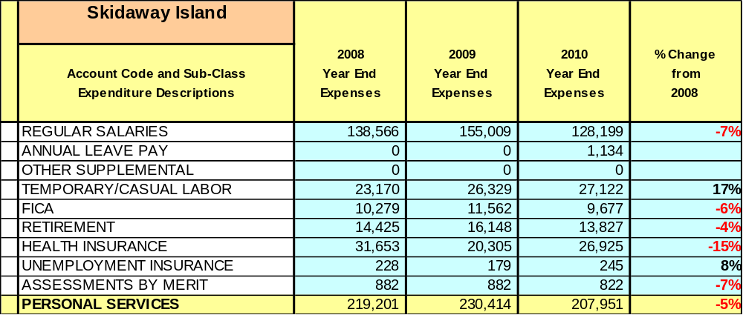

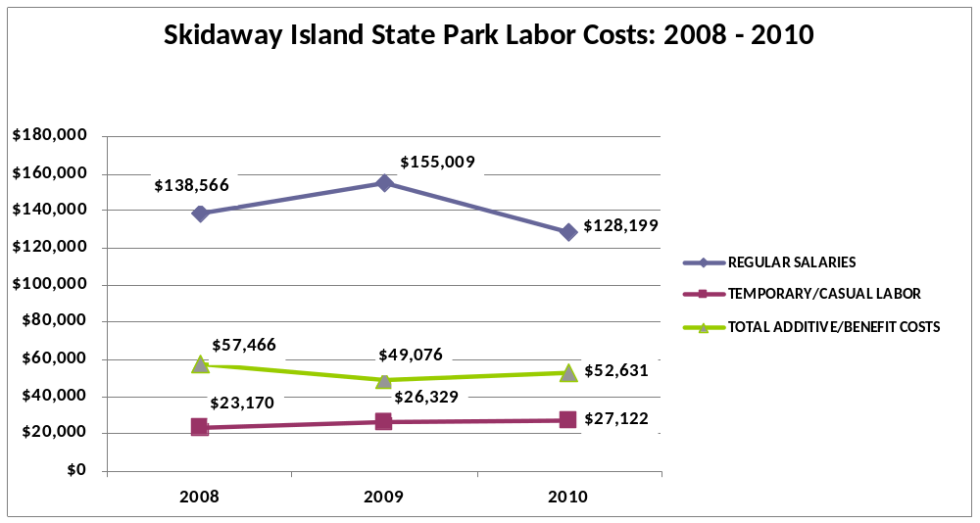

Visitation and Occupancy
Overall annual visitation to the site has trended upward from 2008 to 2010, increasing by 8% or over 15,000 visitors. This is largely attributed to increase in day use, trails usage, increasing attendance at programs and events, and constantly improving on the services that the site offers.
Year | Total Visitation
2008 | 180,293
2009 | 193,993
2010 | 195,490
Occupancy for the overnight accommodations at Skidaway Island State Park the last three years is detailed in the table below. Overall occupancy has trended slightly downward from 2008 & 2009 to 2010, only slightly decreasing by 2%. This is largely attributed to regular returning campers that come here year after year, on their way to and from Florida, and the tourism industry of Savannah keeps our occupancy consistent. Overall visitation has risen even with our biggest contributor of campground occupancy dropping. This is largely attributed to the increase in day visitation and program attendance. 2008 program attendance was 7,075 while in 2010 we rose to 17,460.
Year | Campground Occupancy
2008 | 56 %
2009 | 56 %
2010 | 54 %

Customer Service and Satisfaction
Currently the site monitors customer service through paper, hard copy customer comment cards. These cards are not collected in a statistically valid method, are often only reviewed to identify areas of customer service praises, concerns or issues, and are not consistently used for managing customer service performance issues overall at the sites. Starting June 2010, sites will implement an online customer service reporting system, emailing guests to receive feedback. The chart on the following page shows the customer satisfaction level from a total of 38 customers reporting through the paper method.

Site | Year | Customer Satisfaction Level
Skidaway Island State Park | 2009 | 50 %
Skidaway Island State Park | 2010 | 79 %

The park also utilizes the many online reporting websites, i.e. www.rvparkreviews.com, www.campgroundreport.com, & www.campster.com. The measurable information gathered in the chart below is from the RV Park Reviews website that rates campgrounds on a 1 to 10 scale.

Site | Year | Rating out of 10
Skidaway Island State Park | 2009 | 8.6 – 32 reviews
Skidaway Island State Park | 2010 | 8.5 – 21 reviews
(Through April) | 2011 | 8.9 – 19 reviews

Financial Performance Assessment

Operational Expenses
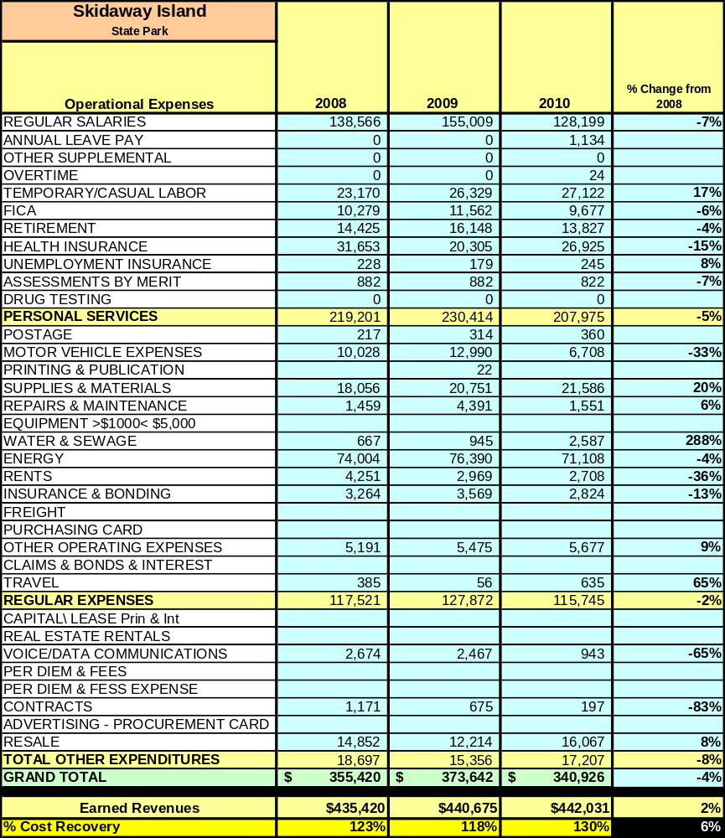
A summary of total operating expenses at Skidaway Island State Park from 2008 to 2010, as well as their percent change from 2008 are provided in the table below.
Earned Revenues
Earned revenues at Skidaway Island State Park have increased since 2008, which is largely attributed to the corresponding increase in overall visitation and increases in pricing.
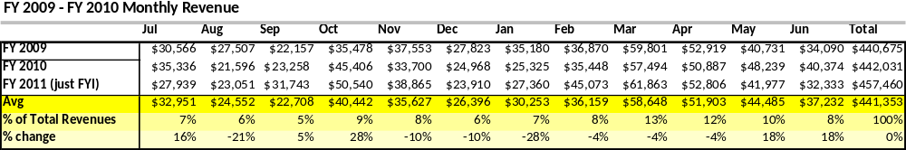
Monthly earned revenues for the last two years (see table on the following page) indicate that the total annual revenue increased slightly by $1,300 (less than 1%) from 2009 to 2010, with the largest increases in monthly revenues in October (28%), May (18%), June (18%), and July (16%), and the largest decreases in the months of January (28%), August (21%), November (10%), and December (10%). The increases in some months were enough to cover the decreases in other months, leveling out the total revenue with little change from 2009 to 2010.

The graphs below and on the next page illustrate the monthly revenue trends each year and the average percent of total annual revenue earned each month.
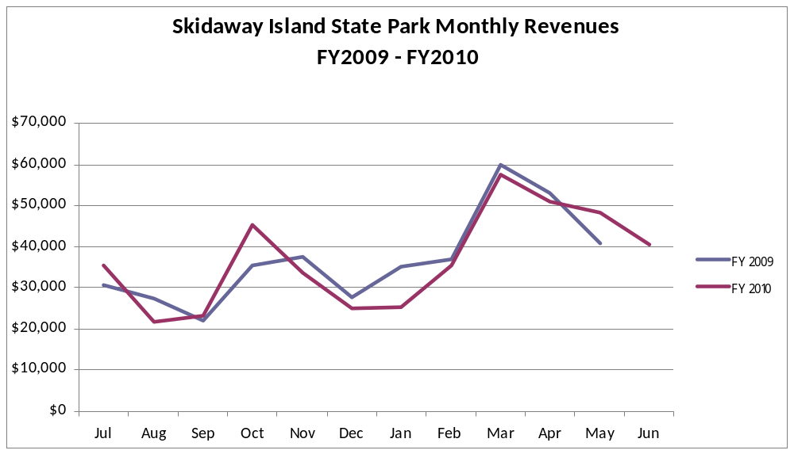

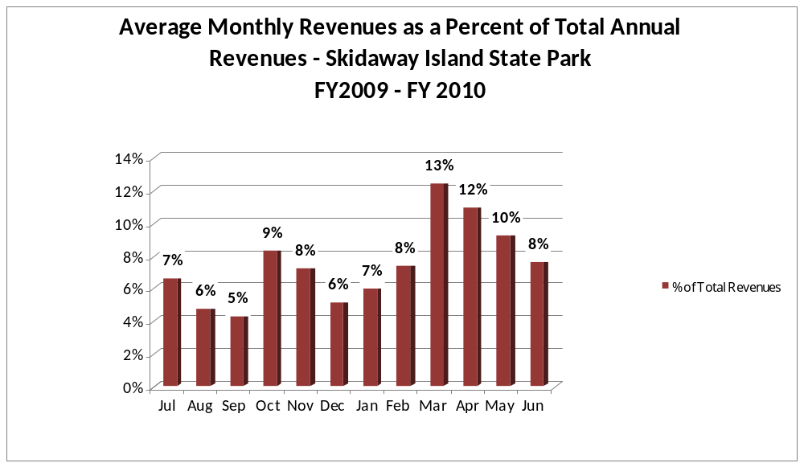

Cost Recovery Trends
Skidaway Island State Park has achieved an average cost recovery of 120% of annual operational expenses through earned revenues from FY 2008 to FY 2010. This is detailed and illustrated in the table and graph below.
Year | Operational  Expenses | Earned  Revenues | Percent Cost  Recovery
2008 | $355,420 | $435,420 | 123%
2009 | $373,642 | $440,675 | 118%
2010 | $340,926 | $442,031 | 130%
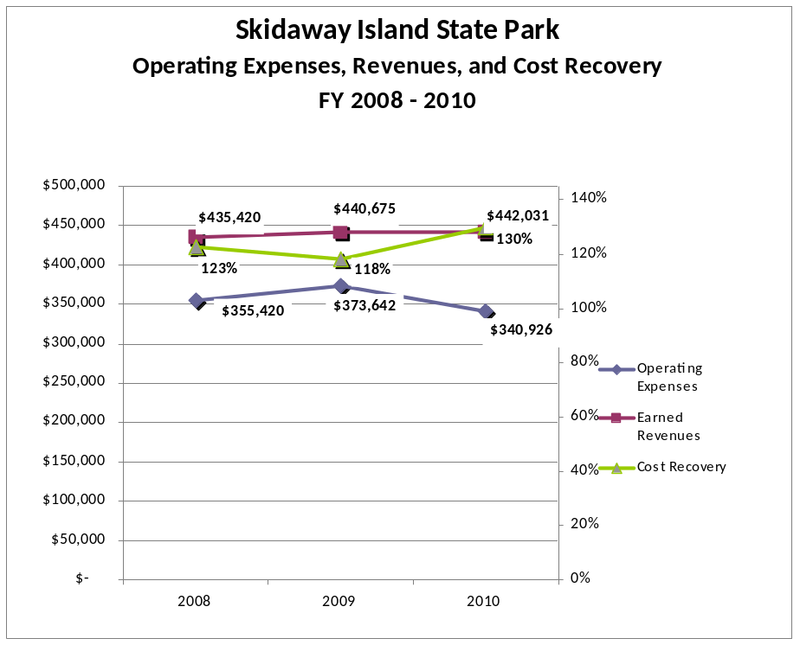

Review of Pricing
Data on rate information is available as far back as 2002, but only the last five years are evaluated. There has been notable growth in fees charged at Skidaway Island State Park since 2005, with the largest increase being the Pioneer Campground (60%), Picnic Shelters (38%), and Group Shelter (30%). A table detailing the rates for Skidaway Island State Park is provided below.

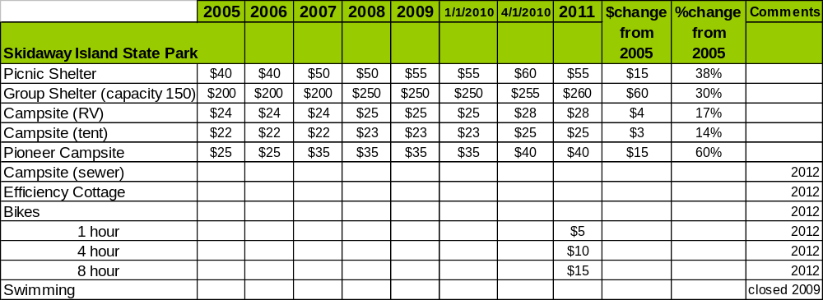
Business and Management Plan

Business Goals
The following goals serve as the foundation for the key recommendations and strategies in this business plan for Skidaway Island State Park.

Enhance Cost Recovery of Site Operations
Skidaway Island State Park is operating at a 118%- 130% cost recovery of operational expenses through earned revenues. While the 130% is highly profitable, it is not sustainable for the long term. Skidaway Island State Park plans to improve cost recovery to a more sustainable percentage through reducing operational expenses in some of the higher areas like fuel and energy by researching other energy methods, and by improving revenues through programming, special events, and partnering with Savannah tour companies. Addition of efficiency cabins and full hook-up sites will increase revenue.

Enhance Revenue Generation Strategies
Increasing earned revenues will most likely result from the impacts of both increased visitation at the site and specific revenue enhancement strategies. Skidaway Island State Park will improve revenue generation through more flexible and dynamic fees for camping and rental facilities. The site will also improve retail sales through appealing to older visitors, and revenue generation possibilities through propane sales, as well as concessionaire agreements through local trolley tours and other tourist attractions.

Expand Special Events at the Site
Most of our special events appeal to younger children and their families. While those events are successful, expansion of special events to appeal to older adults (a majority of our camping population), older youth (high school and middle school age), and college age to young adults would tap into a population that we currently do not serve. These events can include, but not be limited to, art and music festivals, wine and cheese festivals, local culinary shows, arts & crafts festivals, Frisbee golf tournaments, science fairs, single mom’s camping clubs, and music events.

Improve the Diversity and Innovation of Recreational and Interpretive Programs
Skidaway Island State Park’s Interpretive Center features displays that are appealing to all age ranges, however they are becoming outdated. With nothing new to see, it is difficult to attract repeat visitors. It will be crucial for the site to improve the appeal of interpretive resources including displays, exhibits, and program supplies to update the experience and provide something new for people to see. New programs could include environmental movie night, senior ranger program, “Wanna be” Rangers, kickball, flag football, exercise trails, and running clubs. Improvements to the Skidaway Meadow to stay dry all year could provide year round recreational opportunities in an open area.

Improve the Effectiveness of Marketing and Sales
The effectiveness of marketing of Skidaway Island State Park could be improved to produce greater visitation and revenues during specific timeframes through a more site-specific marketing campaign. This could be achieved through a marketing approach that is responsive to zip code data and other information gathered by the site (busy vs. slower timeframes, clientele served, target populations). Effectiveness could be greatly increased through linking promotional material with the city of Savannah, local Chamber of Commerce, The Landings, visitor centers, and tourism industry. Also researching how to attract existing camping groups and expand that relationship (e.g, “snowbird” travelers, or foreigners with rental RVs visiting Savannah and up the coast, locals, and full timers). Also expanding promotion of special events and programming efforts.

Establish Greater Consistency of Managing and Monitoring Customer Service & Satisfaction
The site is implementing an online customer service reporting system, emailing guests to receive feedback. This system will allow quicker review of information and hopefully result in more feedback from customers and more usable data to monitor customer service and satisfaction. Skidaway Island State Park will strive to have 90% of visitors responding to surveys report that they were either ‘satisfied’ or ‘very satisfied’ (or some comparable metric to be developed). Programs or services that fall below that standard should be critically reviewed, enhanced, and results monitored; those with a history of poor performance will be evaluated and potentially considered for elimination. The site is also developing a programming survey to send to all groups and schools that have booked programs with us over the previous month. This data will be less quantitative and more qualitative, but will be used for enhancing the programming department’s effectiveness and service delivery. The site will also utilize other online review websites. Listening to the customer and using their feedback will be on the forefront of future Park planning.

Expand Partnership Opportunities
Partnership opportunities should look first to local Skidaway Island organizations and then expand into the City of Savannah and tourism industry organizations. This could include outfitters for kayaking, kayak fishing, outdoor adventure education, trolley and walking tour companies, and funding to help promote our existing offered programs. The site will continue to engage Friends members in the business plan as a partner to help the site meet or exceed its sustainability goals.

Classification of Programs and Services
The tables below summarize the classifications of programs and services at Skidaway Island State Park as either core, important, or visitor supported and projects a range of cost recovery percentages that might be achieved for each. These classifications establish financial performance goals for each category of services that are linked to the recommendations and strategies of this business plan.

Core Programs / Services | Target Cost Recovery
Active management of the natural and cultural resources of the site | 0%
Open & public access to the site and its resources | 0%
Maintenance of grounds, facilities, and infrastructure | 0%
Public safety | 10%
Trails/wildlife viewing areas | 0%

Important Programs / Services | Target Cost Recovery
Site appropriate education, interpretation, and recreational opportunities | 50%
Picnicking | 20%
Public education programs | 20%
School group programming | 80%

Visitor Supported Programs / Services | Target Cost Recovery
Retail | 150%
Special events | 120%
Group programs | 120%
Camping | 300%

Partnership Development Plan
The table below summarizes existing partners and targeted partnerships by classification (operational, vendor, service, co-branding, funding partners) and by organizational type.
 | Public Partners | Not-for-profit Partners | Private / Enterprise Partners
Operational Partners | - Wormsloe State Historic Site  - Fort McAllister State Historic Park | - Friends of Skidaway Island State Park | - The Landings Association
Vendor Partners |  |  | - Publix  - Kroger  - Sam’s Club  - Wal-Mart  - Coke  - Wild Birds Unlimited
Service Partners | - Chatham County Commission  - Chatham County Parks & Recreation  - Oatland Island Wildlife Center  - Health Department  - Savannah Wildlife Refuge | - Savannah Area Chamber of Commerce
Co-branding Partners |  | - Georgia Geocaching Association  - Covenant Care
Funding Resource Development Partner |  | - Friends of Georgia State Parks and Historic Sites  - Friends of Skidaway Island State Park | - Skidaway Audubon

Marketing and Sales Plan

Marketing and Sales Goals
Marketing and sales goals for Skidaway Island State Park are based on the following desired outcomes:
- To produce increase overall visitation and revenues
- To produce increased day visitation through program and special event attendance
- To produce increased campsite occupancy
In order to meet these goals, examples of specific target outcomes were identified in the areas detailed in the table below.

Area  of Focus | 2010  Performance | Actual through May 2011 | Goal  by 2012 | Goal  by 2015
Special Event Attendance | 2009 | 2,411 | 2,600 | 3,000
Group Program Attendance | 11,557 | 11,512 | 12,000 | 15,000
School Program Attendance | 2,191 | 1,834 | 2,200 | 2,500
Public Program Attendance | 1,703 | 1,342 | 2,200 | 2,500
Overall Program Revenue | $4,561 | $8,631 | $10,000 | $20,000
Overall Visitation | 195,490 | 201,355 | 205,382 | 224,814
Campground Occupancy | 54% | 56% | 57% | 60%

Marketing and Promotion Strategies

Publicity and Social Media
Skidaway Island State Park will approach marketing and publicity planning using the following guidelines and themes:
- Event publicity
Special Events will be pushed to have short stories in local or regional newspapers like the Landings Journal, TWATL, The Skinnie, The Connect, etc., and online social media hooks planted that run three to four weeks in advance of the event up to the date of the event itself. Continue to update the list of contacts for news releases and radio spots, keeping good contact names for local radio stations and news papers. Continue interviews with local television programs like Mid Morning Live, and news channels sometime the week before the event weekend.
- Program publicity
We have seen a huge increase in attendance just being able to post our events on the park website. Instead of sending out calendar announcements, news releases and radio spots that do not see many, if any results, the park will work to use the state parks website and insure programs are posted accurately and timely. Continue to utilize our mailing list and send out the monthly program schedule by the 25th of each month to give people time to plan their schedules accordingly. Any special, unique, or newly developed and offered program should be marketed separately, reaching out to groups that are likely to attend (home school, geocaching, adventure clubs) and highlight it as a new event on the monthly emails and postings. If pre-publicity is not successful, post-publicity can help promote future programs.
- Site Publicity
Skidaway Island State Park will work with the Marketing department to develop a site specific marketing plan. One idea is to host several media familiarization tours (with 2 to 5 writers or editors) to familiarize them with the site and its benefits and amenities. Tours would focus on experiences, benefits, facilities and programs that would be available when the possible stories are expected to run.
Examples and suggested opportunities for events, programs and related publicity efforts based on the themes described above at Skidaway Island State Park are provided in the table below.

Event Publicity | Program Publicity | Site Publicity
Fall-o-Ween Festival | Junior Ranger Camp | Coastal State Parks & Historic Sites
Luminary Fun Night with Santa | Fossil Fridays | Savannah Camping
Easter Blast | “Wanna Be” Rangers  (They have always “wanted to be” a Park Ranger) | Wormsloe’s Marine Boatmen invade Skidaway!
Earthfest | Senior Rangers (55 and above)

Packaging
Examples and suggested packages for Skidaway Island State Park are provided in the table below.

Package | Package Details
Birthday Party Special | Picnic shelter rental & take home craft and nature programs
Skidaway/Wormsloe Stay (Wormaway Getaway) | Overnight camping at Skidaway Island State Park and entrance into Wormsloe State Historic Site
Skidaway/Wormsloe Day  (Skidloe Special) | Package entrance into Skidaway Island State Park and Wormsloe State Historic Site
Maymester savings discount | Beat all the Memorial Day Guests and enjoy 25% off your camping stay by coming during this off-season window (3 weeks before Memorial Day, includes weekdays and weekends)
Football Kick off September discount | The kids are back in school, so enjoy 30% off your camping stay by coming during this off-season window. (3 weeks after Labor Day, includes weekdays and weekends)
Embrace the summer heat discount | June, July, &/or August (except July 4th) – 25% off
Wilderness Pioneer Camping Package | Camping and Wilderness Survival Programs (including lost prevention and make survival kits, knot tying, shelter building, and fire building)
Camping & tour Savannah | Tickets on trolley tours (Ghost, On/Off, Paula Dean), includes downtown shuttle there and back, and camping stay
Kayak Skidaway Narrows | A concession agreement with Moon River Kayak Tours or package deals with camping. Possibly as a Groupon offering
Tents & Tee Time Package | Package with camping at Skidaway and 1 to 2 rounds of golf at Bacon Park Golf Course. Possibly as a Groupon offering.
Hike & Hook Package | A concession agreement with Miss Judy Fishing Charters or package deals with camping or our new efficiency cabins.
Skidaway A La Cart | Includes a ranger led night hike Friday night. Choose your Saturday day activity - Kayak tour, downtown trolley tour, fishing charter or golf outing. Dinner voucher for Pearl’s Saltwater Grill and Sunday Morning Breakfast at the Omelet House.

Group Sales
Types of groups within which specific target customers can be identified for Skidaway Island State Park are listed below:
- Girl Scout Troops | - Boy Scout Troops | - Women’s Groups
- Schools (public & private) | - Retired Adults | - Churches
- Families | - Young Adults | - Colleges & Universities
- Special Interest Groups | - Businesses & Professionals | - Foreigners traveling in U.S.

Incentivizing New and Repeat Visitation
Skidaway Island state Park will utilize the following strategies and/or incentives to encourage new and repeat visitation starting in FY 2012:
- Loyalty programs like “points” earned based on dollars spent or camping stays that can be redeemed for future visits or purchases at the site.
- Differential pricing based upon days of week, busy and slow periods, etc.
- Site specific, return stay coupons good for a specific time frame.

Marketing and Sales Metric Goals
The following marketing and sales metric goals and/or others will be monitored and progress reported at Skidaway Island State Park:
- Loyalty and repeat customers = 60% of customers repeat their visit in a 12-month period.
- Brand confidence & customers-recruiting-customers = Customer referrals equal a minimum of 50% of “Where did you hear about us?” responses from visitors polled.

Revenue Generation Plan
Revenue / Cost Recovery Goals
Skidaway Island State Park has set a financial goal of increasing annual revenues 2-6% annually between 2012 and 2015. The largest revenue growth opportunity is most likely Fiscal Year 2013, when the new efficiency cabins and campground sewer hook-up sites will be finished. The table below details projected revenue growth leading up to 2015, based upon a nominal growth of revenues each year. The 2011 growth is very high because it reflects already high revenues collected through April.
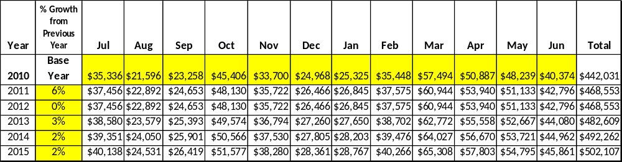

These projections would result in a total of 13% cumulative growth in total annual revenues between FY2010 and FY2015. If operational expenses can be managed with a cumulative increase of 14% between FY 2010 and FY 2015, then the overall cost recovery of the site will be approximately 125% in FY 2015 at these projected revenue levels. This is lower than the annual financial performance of the site in FY 2010, which was operated at 130% cost recovery in that year; however, this was not a sustainable cost recovery. Staffing shortages lend to higher cost recovery, however they present an operational shortfall that is not sustainable for the long-term achievement of park goals. Without an Interpretive Ranger, park programming can only be expanded so far with part time help and really sees challenges with regular turnover of part time help. We have gotten to a point of only being able to stay afloat and put out fires rather than achieve long term planning with continued staff that can work more and stay on for longer periods of time. Hiring procedures bring about the largest challenge for full time employee turnover. We have also seen these challenges with only 1 full time maintenance staff; his two days off or vacation lend to a stop in some completion of projects, with a lack of ability for any part time staff to make purchases, etc. that only a full time employee can do.
Revenue Generation Strategies

Pricing Plan
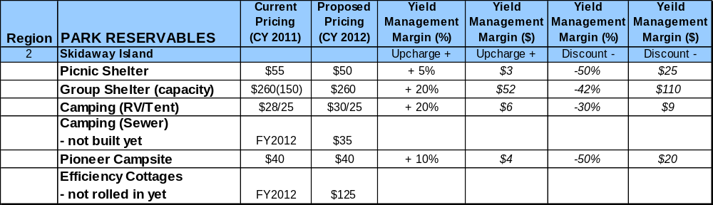

Innovative Programming and Special Events Plan
Program / Event | Theme / Purpose | Scheduled Date/Season | Frequency | Target Participation | Target User Fee | Target Cost Recovery
Sensory Awareness Night Hikes | Active, Educational, Fun | Spring & Fall | Weekly | 400 | $2 per person | 50%
Fall-o-ween Festival | Holiday Fun | October | Yearly | 800 | $10 per person | 150%
Frog Hike | Educational | Summer | Weekly | 400 | $2 / person | 50%
Easter Blast | Holiday Fun | April | Yearly | 500 | $2 / person | 120%
Carnival | Fun | March | Yearly | 500 | $10/ person | 150%
Junior Ranger Camp | Active, Fun, Educational | Summer | Yearly | 50 | $80/ person | 200%
Partnerships and Concessions Plan
Service / Partnership | Term of Service | Financial Objective | Contract Manager
Event planning & promotion | 1 year | 15% of gross receipts | Park Manager
Packaging and promotions with local businesses | 1 year | Shared Revenue | Park Manager

Expense Management Plan
Personnel Assignments
The following actions will be taken to proactively manage labor costs via personnel assignments and classifications.
Action | Timeline | Outcome
Hire an Interpretive Ranger | July 2011 | Increased programming revenue.
Fill Utility Worker position with General Trades Craftsman | July 2012 | Improved maintenance services and more skilled work completion by onsite staff with less funds spent on repairs.

Management Techniques
The following actions will be taken to proactively manage labor costs via management techniques.
Action | Timeline | Outcome
Continue use of volunteers for site and grounds maintenance | July 2011 | Complete Maintenance Plan for park
Outsource new programming possibilities with area outfitters | January 2012 | Increased annual revenue generation possibilities
Adjusted Levels of Service
The following actions will be taken to proactively manage labor costs via reduced levels of service.
Action | Timeline | Outcome
Continue adjusted mowing schedules for park maintenance | July 2011 | Annual cost reduction of $500

Financial Pro Forma
The following five-year financial pro forma projects operating expenses, earned revenues and cost recovery through FY 2015. These pro forma are based on the strategies and desired outcomes identified in this business plan, especially the revenue generation and expense management plans, and are linked to corresponding performance goals.

Expense Pro Forma
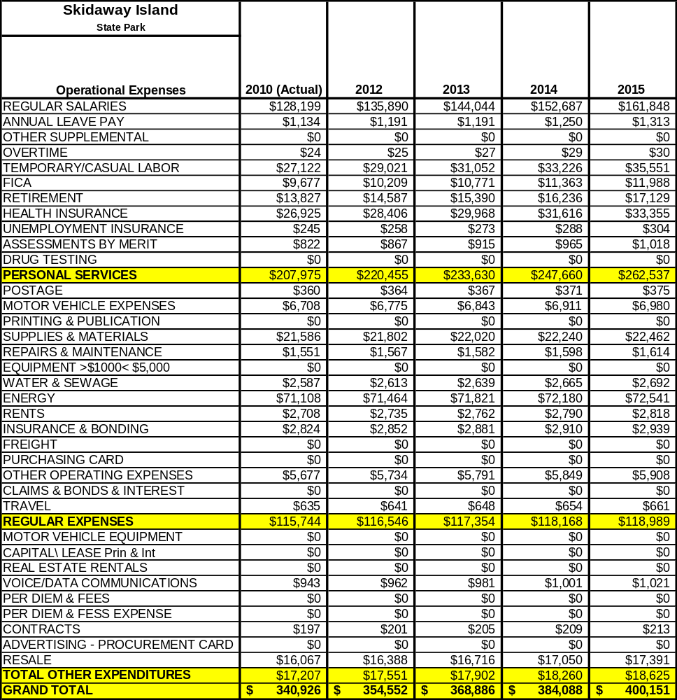

Revenue Pro Forma
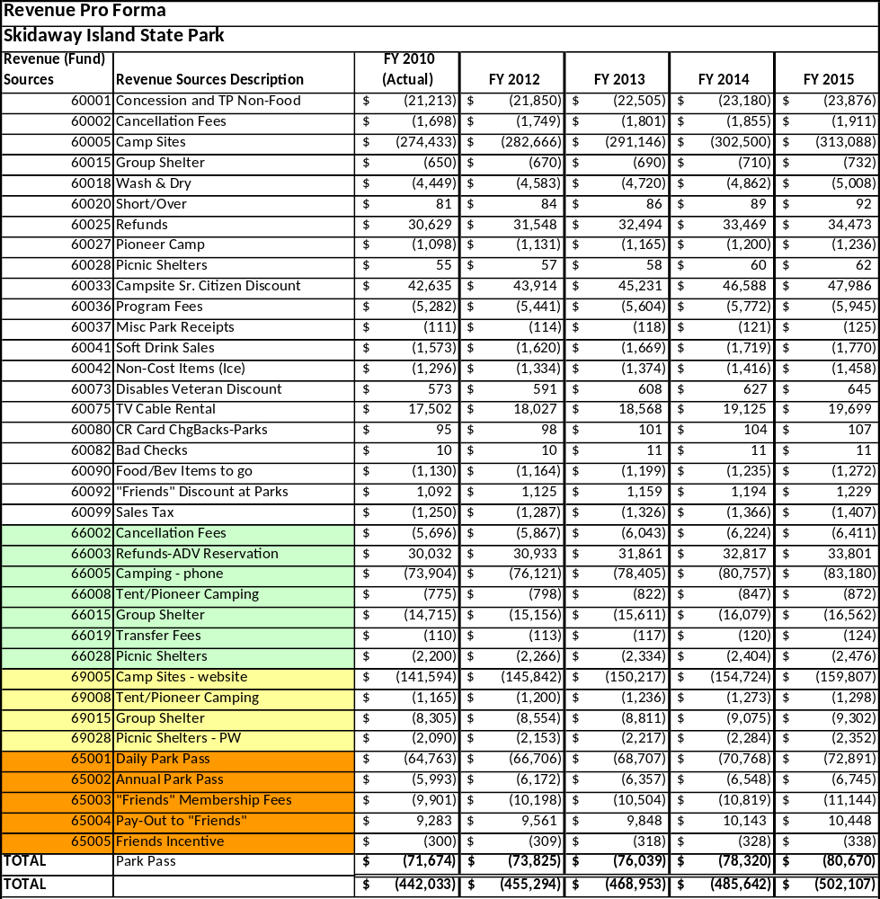

Total / Cost Recovery Pro Forma
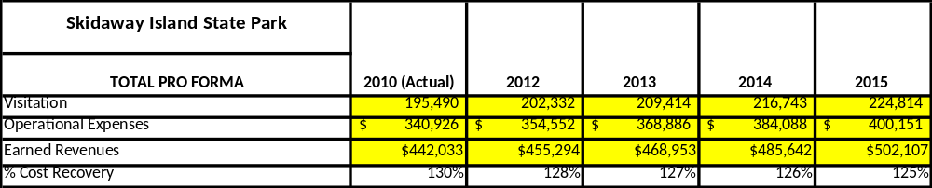

Action Plan
ACTION PLAN
Site: Skidaway Island State Park |  | Site Manager: Holly Holdsworth |  |  | Date:
Month:
Strategy | Tasks | Costs / Funding | Revenues / ROI | Responsibilities | Metrics

ACTION PLAN
Site: |  | Site Manager: |  |  | Date:
Month:
Strategy | Tasks | Costs / Funding | Revenues / ROI | Responsibilities | Metrics

This is the average of the last three years – FY 2008, FY 2009, and FY 2010
Current employees, not including vacancies.
Current employees, not including vacancies.
Major population centers within a two-hour drive from the site

