Smithgall Woods State Park
Business & Management Plan

Prepared June 2011; Finalized December 2012
Direction 2015 – Sustainable Business Planning

Table of Contents

Executive Summary 3

Site and Operations Assessment 6
Site Inventory and Facility Assessment 6
Operational Assessment 8
Financial Performance Assessment 13

Business and Management Plan 16
Business Goals 17
Classification of Programs and Services 18
Partnership Development Plan 19
Marketing and Sales Plan 20
Revenue Generation Plan 22
Expense Management Plan 24
Financial Pro Forma 25

Action Plan 28

Executive Summary
The Parks, Recreation and Historic Sites Division (PRHSD) of the Georgia Department of Natural Resources (DNR) is transitioning the management of Smithgall Woods State Park to operate more like a business, reflecting the Direction 2015 – Sustainable Business Planning initiative to improve the fiscal performance and management of the state parks and historic sites system. This business and management plan is designed to help the site recover more operating expenses through earned revenues, productive partnerships, and innovative programs.

Site Fact Sheet
Site Name | Smithgall Woods State Park
Site Manager | John Erbele
Region Manager | Joe Yeager
Date of Business Plan completion | June 15,2011
Site size | 5,665 acres
Total number of visitors (FY 2010) | 26,178
Total operating budget (FY 2010) | $ 424,990
Total earned revenues (FY 2010) | $ 322,181
Operational cost recovery (FY 2010) | 76%
Average operating cost per visitor (FY 2010) | $ 16.23
Average earned revenue per visitor (FY 2010) | $ 12.31
Average cost recovery (FY 2008 – 2010) | 55%
Target cost recovery (FY 2015) | 88%
Total full-time employees | 5
Total part-time employees | 5
Primary service markets | Atlanta, Athens, Greenville, SC.
Primary attractors/visitor appeal factors | Upscale streamside cottages, scenic beauty, hiking, biking, fishing, hunting
Leading opportunities for improved site performance | Increasing cottage occupancy and Visitor Center retail sales

Site Summary and Key Attractions
The 5665-acre site of SW is located in a rural setting, roughly 70 miles from Atlanta, and in close proximity to the tourist destination of Helen, Ga. The site enjoys fairly easy access from GA Highway 400 and also I-985 both easy routes from Atlanta. Beautiful mountain setting with over 5 miles of frontage on Dukes Creek.

Key Attractions
The amenities or features listed below are those that seem to be most popular for visitors.
- Helen, GA
- Area wineries
- Area golf courses
- Unicoi State Park
- Sautee Nacoochee Community Association
- Folk Pottery Museum
- Cabbage Patch Hospital
- Outdoor mountain adventure

Financial Targets
The table below details the total operating expenses and earned revenues for Smithgall Woods over the last three years (2008 – 2010). This table also calculates total cost per visitor and revenues per visitor during these operating years, and details the target financial performance goals in the context of achieving at least 80% cost recovery. This table also calculates the necessary change from 2010 operating expenses and revenues.
Smithgall Woods State Park | Target Visitation Growth from 2010 | Target Change in Visitation
Visitation Assumptions | 15% | 3,927
 | 2008 | 2009 | 2010 | 2015 Target
Visitors | 20,704 | 22,578 | 26,178 | 30,105
Total Expenses | $ 957,461 | $ 782,170 | $ 424,990 | $ 413,205
Total Revenues | $ 504,612 | $ 354,920 | $ 322,181 | $ 362,617
Cost per Visitor | $ 46.25 | $ 34.64 | $ 16.23 | $ 13.73
Revenue per Visitor | $ 24.37 | $ 15.72 | $ 12.31 | $ 12.05
State Financial Support per Visitor | $ (21.87) | $ (18.92) | $ (4.29) | $ (1.68)
Total Cost Recovery | 53% | 45% | 76% | 88%
Change from 2010 Expenses |  |  |  | $ (11,785)
Percent Change from 2010 Expenses |  |  |  | -2.77%
Change from 2010 Revenues |  |  |  | $ 40,436
Percent Change from 2010 Revenues |  |  |  | 12.55%

Key Recommendations

Primary / Short Term Recommendations
- Increase awareness about our rental cottages as well as ongoing activities at the park.
- Visitor Center staff to show pictures and ask guests if they are aware of our rental cottages.
- We will also be adding a sixth cottage in the near future (Parkside Cottage). It is currently being refurbished.
- Visitor Center to be remodeled and coordinated with Retail Specialist Penny Dunn.

Secondary / Long Term Recommendations
- Improve onsite marketing (of the cottages) through employee referrals, improved signage, brochures, a defined marketing plan, as well as refurbishing the cottages to exceed guest expectations

Site and Operations Assessment
This site and operations assessment is a culmination of analyses and findings from a review of the condition of facilities, infrastructure, and operations at Smithgall Woods. The findings and observations are not intended to be an exhaustive review of all issues present, but provide a basic understanding of the predominant issues that contribute to the site’s current operating conditions. The assessment includes the following:
- Site Inventory and Facility Assessment
- Operational Assessment
- Financial Assessment
Site Inventory and Facility Assessment

Methodology
Facility and asset conditions are rated using a differential scale of excellent, good, fair, or poor. Descriptions of conditions that are attributed to each of these findings are also provided.
Scale of Conditions
Rating | General Description
Excellent | Facilities/amenities are in ‘excellent’ condition when they show little or no maintenance or repair problems. Facilities do not feature any major design or operational issues or flaws that contribute to diminished use or increased maintenance or upkeep. Facilities are easy to clean and maintain in order to place them back into public use and the users perceive them to be in excellent shape.
Good | Facilities/amenities are in ‘good’ condition when they show only minor maintenance or repair problems. Most maintenance issues with these facilities typically appear to be the result of age and/or heavy use. Facilities may only feature minor design or operational issues that contribute to diminished use or increased maintenance or upkeep. Facilities are moderately easy to clean and maintain in order to place them back into service and the users perceive them to be adequate for their use, but probably not in excellent shape.
Fair | Facilities/amenities are in ‘fair’ condition when they show significant maintenance or repair problems. Facilities generally exhibit ongoing maintenance issues that appear to be the result of age, heavy use, or design or operational flaws. Some maintenance and repair needs may compound their fair condition by being deferred because of budget and/or resource limitations. Facilities require more effort to clean and maintain before placing them back into service and the users may perceive them as being less than adequate for their use and in a state of deterioration. The facility or structure may need of major repair or replacement.
Poor | Facilities/amenities are in ‘poor’ condition when they show significant, on-going maintenance or repair problems that ultimately may result in suspended use for repair/replacement. Maintenance and repair issues are possibly the result of poor maintenance and clearly the result of age, heavy use, or design or operational flaws. Problems with the facilities are often compounded over time due to consistently-deferred maintenance and repair because of budget and/or resource limitations. Facilities may feature major design or operational issues that contribute to diminished use or increased maintenance or upkeep. Facilities require excessive effort to clean and maintain before placing them back into service and the users often perceive them as being inadequate for their use and in a state of serious deterioration. The facility or structure may need of major repair or replacement.

Inventory and Assessment
The table below is an inventory of facilities and amenities at Smithgall Woods, and provides the assessed condition of each as reviewed in June 2011.

Site Asset / Amenity | Quantity | Condition
Rental Cottages | 5 | Good
Maintenance shop/outbuildings | 1 | Good
Visitor Center/office | 1 | Good
Group camps | 2 | Good
Education Cabin | 1 | Good
Site residences | 5 | Fair
Picnic Shelters | 3 | Good
Primitive cabin | 1 | Good
Rives Kitchen laundry/office | 1 | Good
Sosebee Shop | 1 | Good

Prioritized Facility Needs
Based on the facility inventory and assessment, these prioritized needs have been identified. Each need has been aligned with a priority category of high, moderate, or low to support future decision making regarding project sequencing, investment of public resources, and meeting community expectations. The priority assignment for each need is not a measure of importance. Rather, these recommended priorities reflect a phased implementation approach over the next several years.
Facility Need | Priority Assignment
Storage area at Visitor Center/Office | Moderate
Enlarge Visitor Center | High
Event area/program area addition | Moderate
Upgrade and repair rental cottages | High
Evaluate rental potential of primitive cabin | Moderate
Evaluate rental potential of educational cabin | Moderate

Operational Assessment
The Operational Assessment includes:
- An inventory and classification of programs and services being provided at the site
- A review of staffing at the site
- A review of concessionaires and partners operating at the site
- Visitation and customer satisfaction

Inventory and Classification of Programs and Services
Programs and services are classified into one of three major categories:
1) Core or Essential Services
2) Important Services
3) Visitor Supported Services
Programs and services at the site are classified into these categories based in part on the mission and public mandates for both the site and the agency. For the programs and services in each of these categories, there are financial performance expectations that will define how services are funded and evaluated.

Category 1 – Core Services [Largely supported by tax funds]
Core programs, services and facilities are those the agency must provide and/or are essential in order to capably govern and meet statutory requirements. The failure of the agency to provide Category 1 services at adequate levels could result in significant negative consequences for the public and the resources under protection. The criteria for programs or services to be classified as core or essential are:
- The services are mandated by the agency’s law or charter or are contractually obligated by agreement to provide the services.
- The services are essential to protecting and supporting the public’s health and safety.
- The services protect and maintain valuable assets and infrastructure.
- The services would generally and reasonably be expected and supported by residents, businesses, customers and partners.
- The services are those that cannot or should not be provided by the private sector.
- The services provide a sound investment of public funds.
The following programs and services offered at Smithgall Woods have been identified as core services:
- Open and public access to the site and its resources
- Maintenance of site, grounds, facility and infrastructure
- Public safety and certifications
- Active management of the natural and cultural resources of the site

Category 2 – Important Services [Supported by a balance of tax funds and earned revenues]
Important programs, services and facilities are those the agency should provide, and are important to governing and effectively serving residents, businesses, customers and partners. Providing Category 2 services expands or enhances the agency’s ability to provide and sustain its core services. The criteria for programs or services to be classified as important are:
- The services expand, enhance or support identified core services.
- The services are broadly supported and utilized by the community, and are considered an appropriate, important, and valuable public good. Public support may be conditional upon the manner by which the services are paid for or funded.
- The services generate income or revenue that offsets some or all of the operating cost and/or are deemed to provide economic, social or environmental outcomes or results.
The following programs and services offered at Smithgall Woods have been identified as important services:
- Education, interpretation, and recreational opportunities
- Self-guided interpretation and education programs
- Education and special events
- Fishing shuttle (donation requested)
- Friends and volunteer organization

Category 3 – Visitor Supported Services [Almost exclusively supported by earned revenue]
Visitor supported programs, services and facilities are those discretionary services that the agency may provide when additional funding or revenue exists to offset the cost of providing those services. Category 3 services provide added value above and beyond what is required or expected. The criteria for programs or services to be classified as visitor supported are:
- The services expand, enhance or support core services or important services and the quality of life of the visitors, community or stakeholders.
- The services are supported, valued and well utilized and provide an appropriate and valuable public benefit.
- The services generate income or funding from sponsorships, grants, user fees or other sources that offset some or all of their cost and/or provides a meaningful return on investment.
- The services can possibly be provided through outsourcing or use of concessionaires, providing opportunities for community enterprises that may not otherwise be provided by the agency.
The following programs and services offered at Smithgall Woods have been identified as visitor supported services:
- Rental cottages and camping/picnic shelters
- Visitor Center gift shop
- Ranger guided/assisted interpretation and educational programs
- Special events

Staffing Assessment
Labor costs at Smithgall Woods represent the largest area of budgetary expense at an average of 72% of the total operating budget each year for the last three complete years, which is higher than the target of total labor costs (including benefits) not exceeding 65% of the site’s total operating expenditures. The tables below and on the following page provide a basic review of the current staffing at the site.
Full Time Equivalent Employees
Position / Title | Quantity (FTE) | Vacancies | Annual Hours
Parks General Manager | 1 | 0 | 2500
Administrative Assistant | 1 | 0 | 2100
Maintenance Supervisor | 1 | 0 | 2100
Housekeeping | 0 | 0 | 0
Interpretive Naturalist | 1 | 0 | 2080
TOTAL | 5 | 0 | 10,860

Part Time Employees
Position / Title | Quantity (FTE) | Vacancies | Hours
VC/Maintenance | 5 | 0 | 7540
TOTAL | 5 | 0 | 7,540

Labor Support
Labor Support | Annual Hours
Volunteers | 3200
Community Service Workers | 2400
Engineering and Construction Crews | 50
Resource Management Crews | 0
TOTAL | 5,650

Total Labor Hours
Labor Type | Annual Hours
Full Time Equivalent Employees | 10,860
Part Time Employees | 6,032
Labor Support | 5,650
TOTAL Annual Labor Hours | 21,510

Labor Budget Summary

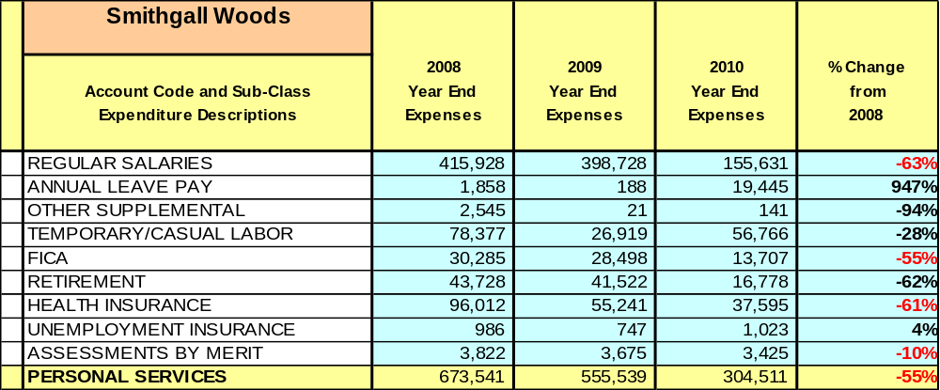

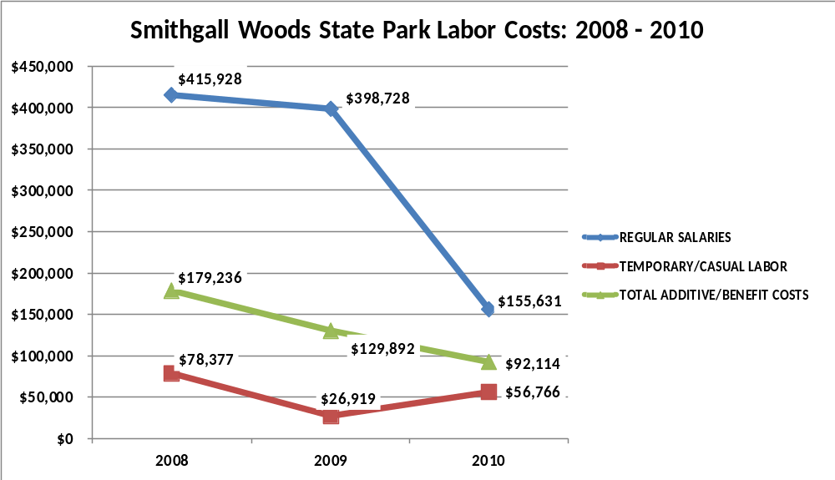

Visitation and Occupancy
Overall annual visitation to the site has trended upward from 2008 to 2010, increasing by 26% or over 5,474 visitors. This is largely attributed to school groups/outreach programs.

Year | Total Visitation
2008 | 20,704
2009 | 22,578
2010 | 26,178

Occupancy for the overnight accommodations at Smithgall Woods the last three years is detailed in the table below. Overall occupancy has trended downward from 2008 to 2010, decreasing by 18%. This is largely attributed to basing 2008 and 2009 occupancy on the number of bedrooms occupied; whereas, 2010 occupancy (and beyond) was based on the number of individual cottages occupied.

Year | Lodge Occupancy | Cottage  Occupancy
2008 | 39%
2009 | 32%
2010 |  | 21%

Customer Service and Satisfaction

Site | Year | Customer Satisfaction Level
Smithgall Woods | 2009 | 100%
Smithgall Woods | 2010 | 50%  (Very limited # of responses)
Financial Performance Assessment

Operational Expenses
A summary of total operating expenses at Smithgall Woods from 2008 to 2010, as well as their percent change from 2008 are provided in the table below.
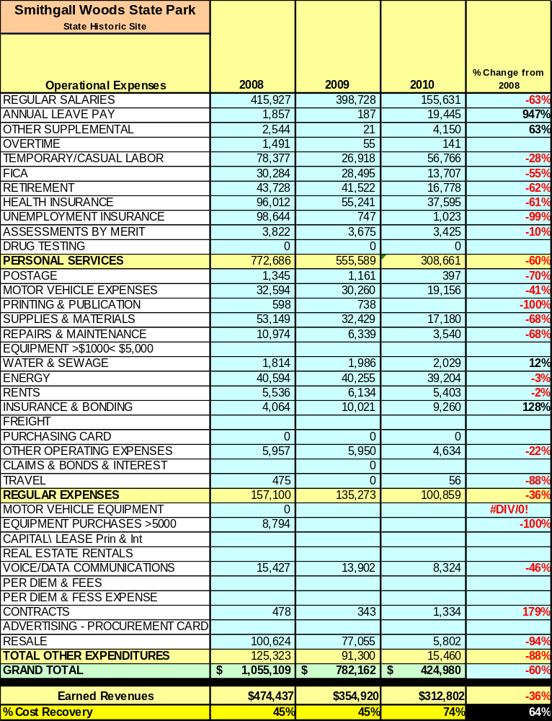

Earned Revenues
Earned revenues at Smithgall Woods have decreased since 2008. In 2008 we were providing food service in addition to lodging with higher inclusive pricing. We are no longer offering food service and our cottage rates are proportionately less. Additionally, we are renting the cottages individually as opposed to individual bedrooms, which were relatively more expensive. Our lower cottage rates and online reservations have also attributed to the corresponding increase in overall visitation, based on a change to the site’s business model.
Monthly earned revenues for the last two years (see table on the following page) indicate that the total annual revenue decreased 13% from 2009 to 2010, with the largest increases in monthly revenues in July (30%), August (115%) and June (147%), and the largest decreases in the months of November
(-58%), December (-64%), January (-38%), February (-37%) and May (-25%).

Smithgall Woods
FY 2009 - FY 2010 Monthly Revenue
 | Jul |  | Aug | Sep | Oct | Nov | Dec | Jan | Feb | Mar | Apr | May | Jun | Total
FY 2009 | $29,222 |  | $29,946 | $29,871 | $43,210 | $51,573 | $23,404 | $30,351 | $25,623 | $18,633 | $22,948 | $34,735 | $15,401 | $354,917
FY 2010 | $38,043 |  | $32,000 | $ 32,241 | $44,168 | $21,626 | $8,356 | $18,926 | $16,152 | $16,193 | $20,956 | $26,137 | $37,999 | $312,797
Avg | $33,633 |  | $30,973 | $31,056 | $43,689 | $36,600 | $15,880 | $24,639 | $20,888 | $17,413 | $21,952 | $30,436 | $26,700 | $333,857
% of Total Revenues | 10% |  | 9% | 9% | 13% | 11% | 5% | 7% | 6% | 5% | 7% | 9% | 8% | 100%
% change | 30% |  | 7% | 8% | 2% | -58% | -64% | -38% | -37% | -13% | -9% | -25% | 147% | -12%

The graphs below illustrate the monthly revenue trends each year and the average percent of total annual revenue earned each month.

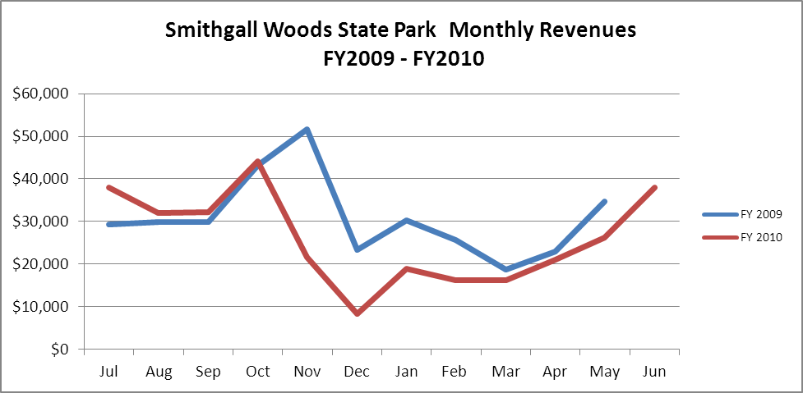

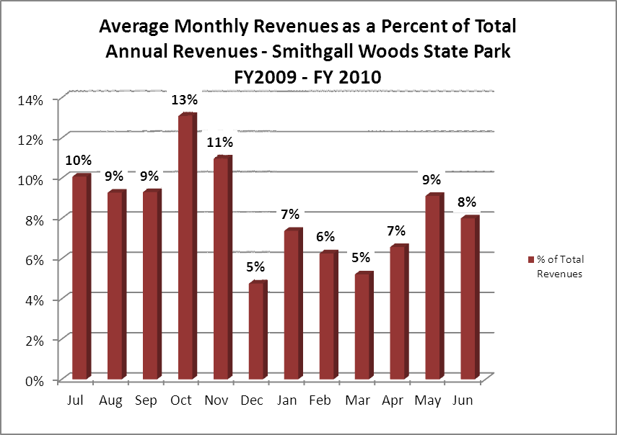

Cost Recovery Trends
Smithgall Woods has achieved an average cost recovery of 55% of annual operational expenses through earned revenues from FY 2008 to FY 2010, with the cost recovery improving significantly after a business model was implemented. This is detailed and illustrated in the table and graph below.

Year | Operational  Expenses | Earned  Revenues | Percent Cost  Recovery
2008 | $957,461 | $504,612 | 53%
2009 | $782,170 | $354,920 | 46%
2010 | $424,990 | $312,802 | 74%

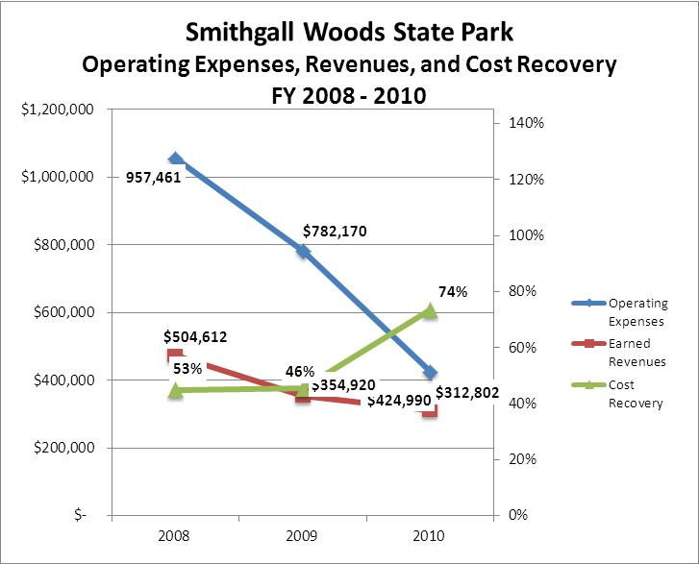

Review of Pricing
Data on rate information is available as far back as 2002, but only the last five years are evaluated. It is noteworthy that we changed our business model to cottage rentals without food in 2008. Prior to 2008 we charged by the person and by the bedroom (food included). Since 2009 there has been a 1% growth in fees charged at Smithgall Woods. A table detailing the rates for facility rental fees, camping fees, and recreational rental fees is provided below.

 | 2005 | 2006 | 2007 | 2008 | 2009 | 2010 | Comments
State Park
Smithgall Woods
Campers-person/ nightly | $5.00 | $5.00 | $5.00 | $5.00 | $5.00 | $5.00 | Group Camps ONLY
Picnic Shelter | $25.00 | $25.00 | $25.00 | $55.00 | $55.00 | $55.00 | minimum price
Dover Cottage |  |  |  |  | $499.00 | $504.00 | Discounted weekdays and Dec-Mar.
Smithgall Cottage |  |  |  |  | $499.00 | $504.00 | Discounted weekdays and Dec-Mar.
Creekside Cottage |  |  |  |  | $399.00 | $404.00 | Discounted weekdays and Dec-Mar.
Garden/Laurel Cottage |  |  |  |  | $199.00 | $204.00 | Discounted weekdays and Dec-Mar.
Business and Management Plan

Business Goals
The following goals serve as the foundation for the key recommendations and strategies in this business plan for Smithgall Woods.

Enhance Cost Recovery of Site Operations
Smithgall Woods has drastically changed its business model and reduced its staff. Since 2008 we have improved cost recovery from 53% to 74%. We eliminated several positions relating to food service and changed the way we rented cottages/bedrooms. This change should lead to improved cost recovery.

Enhance Revenue Generation Strategies
The obvious target for revenue generation is our five cottages: improving occupancy while maintaining our current rates will be our mantra. Additionally, the gift shop in our Visitor Center will be targeted for increased retail sales.

Expand Special Events at the Site
Smithgall Woods does a good job of special events and “more is better” in order to increase visitation and occupancy as we market our cottages and retail to all guests that visit the site.

Improve the Diversity and Innovation of Recreational and Interpretive Programs
We will try to educate our day-use guest about the cottages and similarly will market our programming to overnight guests whenever possible.

Improve the Effectiveness of Marketing and Sales
With a new business model (described above), we need to promote our cottages in order to increase demand for same. Partnerships with nearby attractions in the region will certainly help.

Establish Greater Consistency of Managing and Monitoring Customer Service & Satisfaction
It will be critical to better manage and monitor customer service and satisfaction. Guest referrals are important for growth. We need to know what our guests are thinking.

Expand Partnership Opportunities
We will share with our local community our willingness to create partnerships with local businesses or other groups/individuals.

Classification of Programs and Services
The tables below summarize the classifications of programs and services at Smithgall Woods as either core, important, or visitor supported and projects a range of cost recovery percentages that might be achieved for each. These classifications establish financial performance goals for each category of services that are linked to the recommendations and strategies of this business plan.

Core Services
Program / Service | Target Cost Recovery
Maintenance of site and infrastructure | 0
Public safety and certification | 0
Open and public access to the site and its resources | 0
Active management of the natural and cultural resources of the site | 0

Important Services
Program / Service | Target Cost Recovery
Education, recreation, and interpretation opportunities | 10% to 30%
Self-guided interpretation and education programs | 20% to 80%
Education and special events | 20% to 60%
Fishing shuttle (donations requested) | 20% to 50%
Friends and volunteer organization | 20% to 80%

Visitor Supported
Program / Service | Target Cost Recovery
Rental cottages and camping/picnic shelters | 100% to 200+%
Visitor Center gift shop | 100% to 120%
Ranger guided/assisted interpretation and educational programs | 100% to 120%
Special events (rentals) | 100% to 120%

Partnership Development Plan
The table below summarizes existing partners and targeted partnerships by classification (operational, vendor, service, co-branding, funding partners) and by organizational type.
 | Public Partners | Not-for-profit Partners | Private / Enterprise Partners
Operational Partners | - WRD | - Smithgall Woods Foundation
Vendor Partners |  |  | - Garden Gate Catering  - Honeybrook Catering  - Manners 4You Catering  - Woody’s Mountain Bikes  - Unicoi Outfitters  - 8 Local Wineries  - Cabbage Patch Kids
Service Partners | - SNCA | - Smithgall Woods Humane Society
Co-branding Partners | - Unicoi State Park | - White County Chamber of Commerce  - Helen CVB
Funding Resource Development Partner |  | - Friends of Ga. State Parks  - Friends of Smithgall Woods  - Smithgall Woods Foundation

Marketing and Sales Plan

Marketing and Sales Goals
Marketing and sales goals for Smithgall Woods are based on the following desired outcomes:
- Increase income for rental cottages 3% to 5% annually
- Increase retail sales in Visitor Center 3% to 5% annually
- Improve marketing focus (cottages) and begin soliciting email addresses from guests.
In order to meet these goals, examples of specific target outcomes were identified in the areas detailed in the table below.

Area  of Focus | Current  Performance | Goal  by 2011 | Goal  by 2012 | Goal  by 2015
Cottage Income | $288,494 | $300,000 | $315,000 | $362,617

Marketing and Promotion Strategies

Publicity and Social Media
Smithgall Woods will approach marketing and publicity planning using the following guidelines and themes:
- Event publicity
Continue major event publicity. Add to social media sites well in advance of scheduled events. Add publicity whenever possible. Solicit “no capture” email addresses and include prior guests/partners on all email distribution.
- Program publicity
Use outdoor bulletin boards, flyers, newspaper and other media contacts to generate awareness of upcoming or past programs. Social media and internet lists should always be used.
- Site Publicity
Working to schedule FAM tours with writers is an ongoing, everyday focus. Promoting our cottages internally to day use guests will also pay big dividends. Local community members and businesses could be invited to open houses. Helen CVB staff could be invited for a tour, wedding planners, others.
Examples and suggested opportunities for events, programs and related publicity efforts based on the themes described above at Smithgall Woods are provided in the table below.

Event Publicity | Program Publicity | Site Publicity
Flies & Flywater | Jr. Ranger Camp | FAM Tours
Jakes Day | Ga. Master Naturalist | Open House
Fall Festival | Birding By Ear | Meeting/Wedding Planners

Packaging
Examples and suggested packages for Smithgall Woods are provided in the table below.
Package | Package Details
Golf | Lodging plus golfing
Fishing | Lodging plus fishing
Winery Tour | Lodging plus winery tour

Group Sales
Types of groups within which specific target customers can be identified for Smithgall Woods are listed below:
- Families  - Business and professional groups  - Schools (public and private)  - Colleges and universities | - Youth service organizations  - Associations  - Other public agencies  - Cabbage Patch Kids | - Churches  - Activity or special clubs  - Fishing/outdoor groups  - Community organizations

Incentivizing New and Repeat Visitation
Smithgall Woods will utilize the following strategies and/or incentives to encourage new and repeat visitation starting in FY 2012:
- Third night free to promote weekday stays
- Refer a Friend promotion
- Call for last minute discounts (within 72 hours)

Marketing and Sales Metric Goals
The following marketing and sales metric goals and/or others will be monitored and progress reported at Smithgall Woods:
- Loyalty and repeat customers = 50% of customers repeat their visit in a 12-month period.
- Brand confidence & customers-recruiting-customers = 50% customer referrals from responses from previous guests.
- Capture email addresses whenever possible and do email blasts.
Revenue Generation Plan
Revenue / Cost Recovery Goals
Smithgall Woods has set a financial goal of increasing annual revenues 3% annually between 2012 and 2015. The largest revenue growth opportunity is cottage rentals. The table below details projected revenue growth leading up to 2015, based upon a nominal growth of revenues each year.

Year | % Growth from Previous Year | Jul | Aug | Sep | Oct | Nov | Dec | Jan | Feb | Mar | Apr | May | Jun | Total
2010 | Base Year | $38,043 | $32,000 | $32,241 | $44,168 | $21,626 | $8,356 | $18,926 | $16,152 | $16,193 | $20,912 | $26,137 | $38,043 | $312,797
2011 | 3% | $39,184 | $32,960 | $33,208 | $45,493 | $22,275 | $8,607 | $19,494 | $16,637 | $16,679 | $21,539 | $26,921 | $39,184 | $322,181
2012 | 3% | $40,360 | $33,949 | $34,204 | $46,858 | $22,943 | $8,865 | $20,079 | $17,136 | $17,179 | $22,186 | $27,729 | $40,360 | $331,846
2013 | 3% | $41,571 | $34,967 | $35,231 | $48,264 | $23,631 | $9,131 | $20,681 | $17,650 | $17,695 | $22,851 | $28,561 | $41,571 | $341,802
2014 | 3% | $42,818 | $36,016 | $36,288 | $49,711 | $24,340 | $9,405 | $21,301 | $18,179 | $18,225 | $23,537 | $29,417 | $42,818 | $352,056
2015 | 3% | $44,102 | $37,097 | $37,376 | $51,203 | $25,070 | $9,687 | $21,940 | $18,725 | $18,772 | $24,243 | $30,300 | $44,102 | $362,617
These projections would result in a total of 16% cumulative growth in total annual revenues between FY2010 and FY2015. If operational expenses can be managed with a cumulative decrease of 1% between FY 2010 and FY 2015, then the overall cost recovery of the site will be approximately 80% in FY 2015 at these projected revenue levels. This is higher than the annual financial performance of the site in FY 2010, which was operated at 74% cost recovery in that year.
Revenue Generation Strategies

Pricing Plan
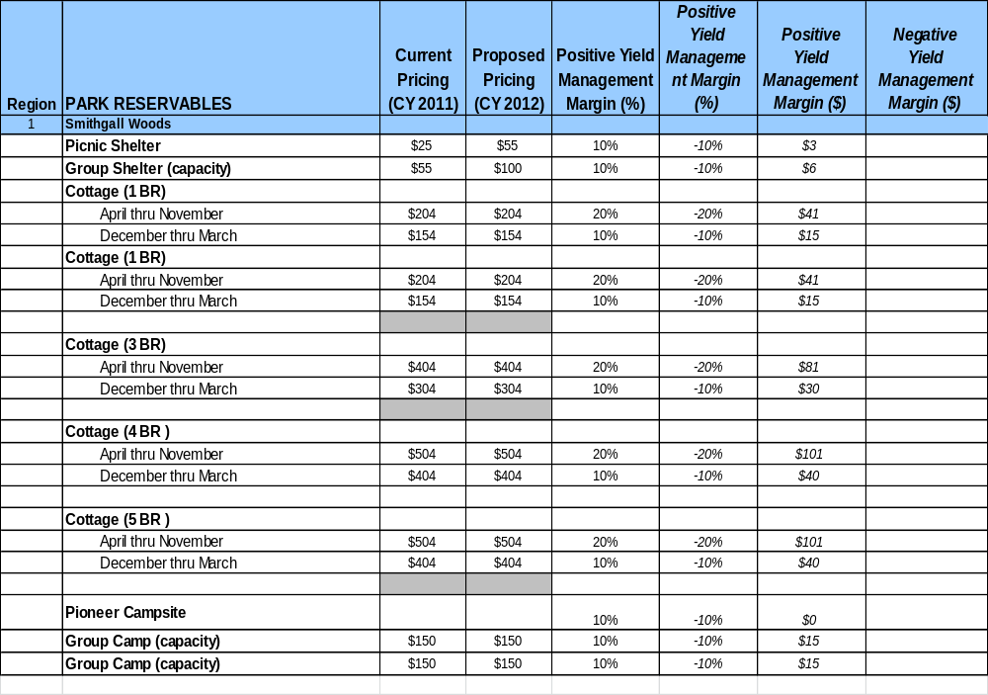

A price increase for cottages at Smithgall Woods is not recommended during the next 5 years. Discretionary spending is at an all-time low; we need to maintain pricing and increase demand. We will look at other current activities for which we may begin charging, such as fishing, hunting, firewood, etc.

Innovative Programming and Special Events Plan
Program / Event | Theme / Purpose | Scheduled Date/Season | Frequency | Target Participation | Target User Fee | Target Cost Recovery
Fall Festival | Appalachian Culture | October | Annual | 350 | $2.00 | 30%
JAKES DAY | Childrens Outdoor Ed. | May | Annual | 350 | $1.00 | 25%
On-Going | Conservation & Education | Year Round | Monthly | 25 | $5.00 | 30%

Partnerships and Concessions Plan
Service / Partnership | Term of Service | Financial Objective | Contract Manager
Wedding/Event Planner | Negotiable | 10% of Gross Revenue | Park Manager
Packaging and promotions with local businesses | Negotiable | 10% of Gross Revenue | Park Manager

Expense Management Plan
Personnel Assignments
The following actions will be taken to proactively manage labor costs via personnel assignments and classifications.

Action | Timeline | Outcome
Part-time positions will be monitored to reduce hours whenever possible. | July 2011 and ongoing | Reduced labor cost

Management Techniques
The following actions will be taken to proactively manage labor costs via management techniques.

Action | Timeline | Outcome
Increase use of volunteers for site and grounds maintenance | July 2011 and  ongoing | Reduced labor cost

Adjusted Levels of Service
The following actions will be taken to proactively manage labor costs via reduced levels of service.

Action | Timeline | Outcome
Evaluate mowing landscape schedule | July 2011 and  ongoing | Reduced labor cost
Reduce the number of phone lines to cottages/office/visitor center | July 2011 | Reduced operating cost

Financial Pro Forma
The following five-year financial pro forma projects operating expenses, earned revenues and cost recovery through FY 2015. These pro forma are based on the strategies and desired outcomes identified in this business plan, especially the revenue generation and expense management plans, and are linked to corresponding performance goals.

Expense Pro Forma
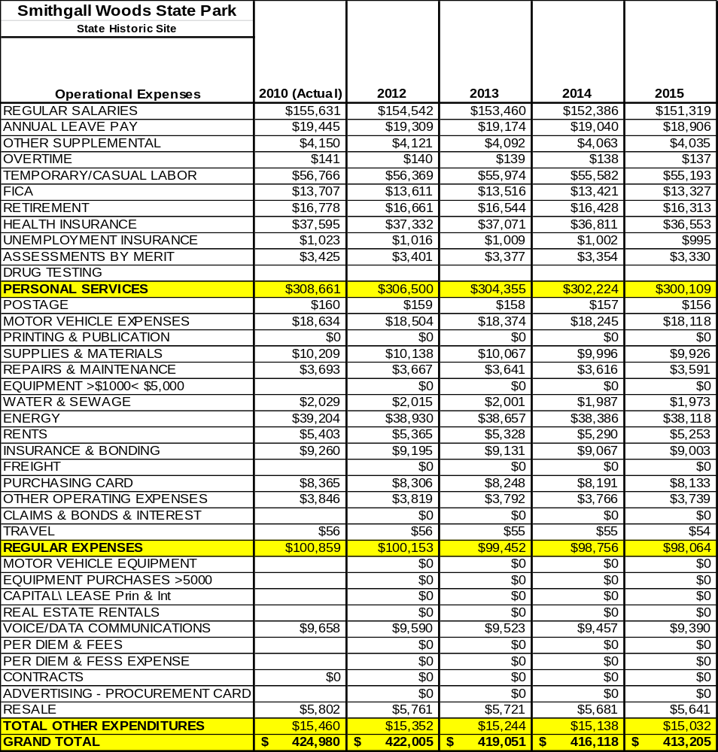

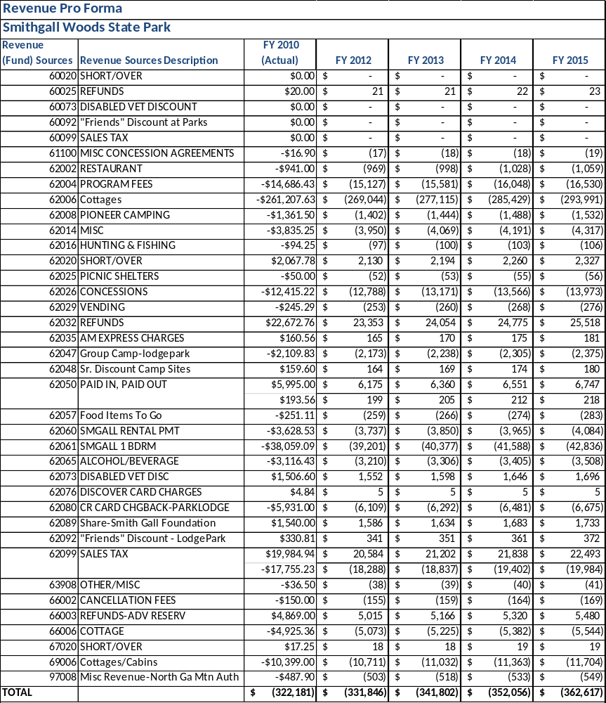
Revenue Pro Forma

Total / Cost Recovery Pro Forma

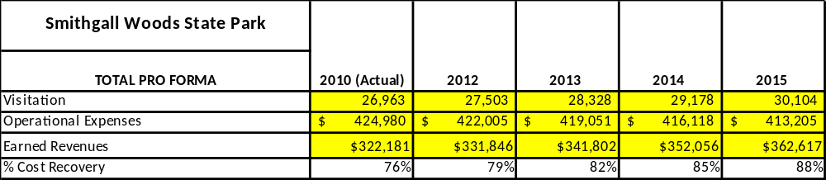

Action Plan
ACTION PLAN
Site: |  | Site Manager: |  |  | Date:
Month:
Strategy | Tasks | Costs / Funding | Revenues / ROI | Responsibilities | Metrics

ACTION PLAN
Site: |  | Site Manager: |  |  | Date:
Month:
Strategy | Tasks | Costs / Funding | Revenues / ROI | Responsibilities | Metrics

This is the average of the last three years – FY 2008, FY 2009, and FY 2010
Current employees, not including vacancies.
Current employees, not including vacancies.
Major population centers within a two-hour drive from the site

