Sweetwater Creek State Conservation Park

Business & Management Plan


Prepared June 2011; Finalized December 2012
Direction 2015 – Sustainable Business Planning

Table of Contents

Executive Summary 3

Site and Operations Assessment 6
Site Inventory and Facility Assessment 6
Operational Assessment 8
Financial Performance Assessment 13

Business and Management Plan 16
Business Goals 16
Classification of Programs and Services 18
Partnership Development Plan 19
Marketing and Sales Plan 20
Revenue Generation Plan 22
Expense Management Plan 25
Financial Pro Forma 26

Action Plan 29

Executive Summary
The Parks, Recreation and Historic Sites Division (PRHSD) of the Georgia Department of Natural Resources (DNR) is transitioning the management of Sweetwater Creek State Conservation Park to operate more like a business, reflecting the Direction 2015 – Sustainable Business Planning initiative to improve the fiscal performance and management of the state parks and historic sites system. This business and management plan is designed to help the site recover more operating expenses through earned revenues, productive partnerships, and innovative programs.

Site Fact Sheet
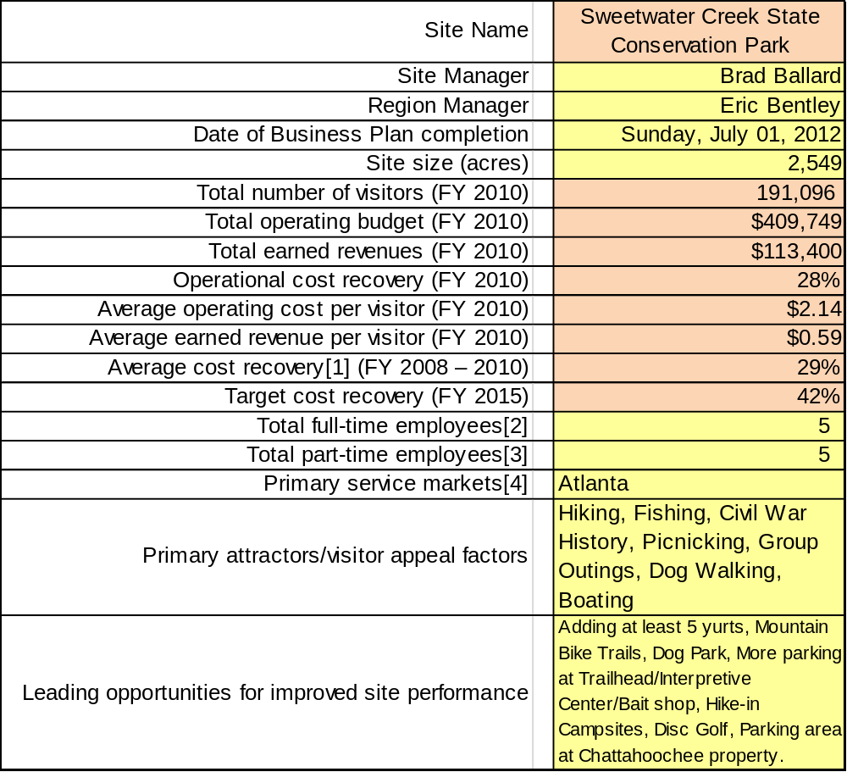

Site Summary and Key Attractions
This 2549-acre park is in Metro Atlanta. This park is important for city dwellers seeking a close outdoor retreat, and is in the top 6 parks on any given month for visitation and park pass revenue. Only a short drive from I-20 and 15 minutes from downtown Atlanta, the park’s revenue potential is currently restricted to day use only.

Key Attractions
The amenities or features listed below are those that seem to be most popular for visitors.
- 9 miles of gorgeous hiking trails providing a wilderness setting close to Atlanta
- The ruins of an 1840’s mill, burned by General Sherman’s troops during the Civil War
- 215-acre Sparks Reservoir (operated by the City of Eastpoint)
- Bait shop and boat rental facility
- LEED Platinum Interpretive Center/Gift Shop/Meeting Room
- 150 capacity group shelter
- 11 picnic shelters

Financial Targets
The table below details the total operating expenses and earned revenues for Sweetwater Creek State Conservation Park over the last three years (2008 – 2010). This table also calculates total cost per visitor and revenues per visitor during these operating years, and details the target financial performance goals in the context of achieving at least 42% cost recovery. This table also calculates the necessary change from 2010 operating expenses and revenues.
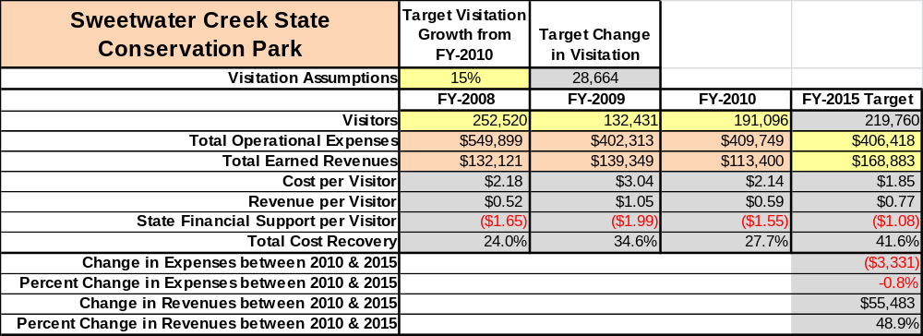

Key Recommendations

Primary / Short Term Recommendations
- Complete stabilization of the Mill Ruins is essential to this site.
- Evaluate and pursue opportunities to employ concessionaires or private or public service providers on-site if they can be more cost-effective. For example, explore the development of a concessionaire agreement to manage private events on-site such as races, festivals, fishing tournaments, etc.
- Engage Friends of Sweetwater members to become an active partner in obtaining or exceeding our sustainability goals.
- Seek local partners to help support operations, programs, and service delivery and for cross-marketing purposes such as advertising park amenities and programs.
- Develop a more detailed analysis of labor requirements of all major park functions to match the right position with the right job at the right pay.
- Certain areas of the park peak with visitation at different times of the year. Closing certain facilities such as the Bait Shop during the winter or closing the Interpretive Center on Mondays and Tuesdays could save revenue with little impact on visitors.
- Develop package deals to go with group shelter or meeting room rentals. Packages could include a history hike or interpretive program with rental.
- Upgrade facilities and amenities at the site that are likely to have a cost recovery level at or above 100%. This would include upgrading the group shelter’s heating and air. Enhancing signage throughout the site and at the Interpretive Center, adding new landscaping, and providing free Wi-Fi at the site. Construct new parking areas and move all trailheads to the front of the Interpretive Center.
- Improve and add parking areas around the Interpretive Center and bait shop to handle the amount of traffic. Currently both locations suffer from lack of available parking spaces. One fix might be a reduction in picnic shelters close to the trailhead to allow for more parking. Also the interior roads need repaving soon.
- Create a hike in or back country camping area that can hold 4 to 6 campers. Many hikers come to Sweetwater to train and prepare to hike the Appalachian Trail. With a back country area, hikers could also test out their gear.
- In the next five years, it would be imperative to have at least five yurts available for overnight rental. This would bring in an additional $40,000 in revenue.

Secondary / Long Term Recommendations
- Enlarge the bait shop to hold more merchandise and to better serve customers. Have the ability to accept credit cards for fishing/hunting license sales. Fishing license sales at the bait shop can exceed thirty per day which at this point is cash or check only.
- Incorporate mountain biking with the current trails. Most trails are wide enough to support hiking and biking. Also create new mountain trails around the eastside and riverside areas of the park.
- Make the north causeway parking area loop back out to the main road. When lot is full guest must try to back their way out. This is also a problem for LE rangers patrolling the area. Also the restroom for that area is in dire need of an upgrade.
- Construct a dog park with obstacles, open areas, and water fountains that can include an additional fee or annual pass.

Site and Operations Assessment
This site and operations assessment is a culmination of analyses and findings from a review of the condition of facilities, infrastructure, and operations at Sweetwater Creek State Conservation Park. The findings and observations are not intended to be an exhaustive review of all issues present, but provide a basic understanding of the predominant issues that contribute to the site’s current operating conditions. The assessment includes the following:
- Site Inventory and Facility Assessment
- Operational Assessment
- Financial Assessment
Site Inventory and Facility Assessment

Methodology
Facility and asset conditions are rated using a differential scale of excellent, good, fair, or poor. Descriptions of conditions that are attributed to each of these findings are also provided.
Scale of Conditions
Rating | General Description
Excellent | Facilities/amenities are in ‘excellent’ condition when they show little or no maintenance or repair problems. Facilities do not feature any major design or operational issues or flaws that contribute to diminished use or increased maintenance or upkeep. Facilities are easy to clean and maintain in order to place them back into public use and the users perceive them to be in excellent shape.
Good | Facilities/amenities are in ‘good’ condition when they show only minor maintenance or repair problems. Most maintenance issues with these facilities typically appear to be the result of age and/or heavy use. Facilities may only feature minor design or operational issues that contribute to diminished use or increased maintenance or upkeep. Facilities are moderately easy to clean and maintain in order to place them back into service and the users perceive them to be adequate for their use, but probably not in excellent shape.
Fair | Facilities/amenities are in ‘fair’ condition when they show significant maintenance or repair problems. Facilities generally exhibit ongoing maintenance issues that appear to be the result of age, heavy use, or design or operational flaws. Some maintenance and repair needs may compound their fair condition by being deferred because of budget and/or resource limitations. Facilities require more effort to clean and maintain before placing them back into service and the users may perceive them as being less than adequate for their use and in a state of deterioration. The facility or structure may need of major repair or replacement.
Poor | Facilities/amenities are in ‘poor’ condition when they show significant, on-going maintenance or repair problems that ultimately may result in suspended use for repair/replacement. Maintenance and repair issues are possibly the result of poor maintenance and clearly the result of age, heavy use, or design or operational flaws. Problems with the facilities are often compounded over time due to consistently-deferred maintenance and repair because of budget and/or resource limitations. Facilities may feature major design or operational issues that contribute to diminished use or increased maintenance or upkeep. Facilities require excessive effort to clean and maintain before placing them back into service and the users often perceive them as being inadequate for their use and in a state of serious deterioration. The facility or structure may need of major repair or replacement.

Inventory and Assessment
The table below is an inventory of facilities and amenities at Sweetwater Creek State Conservation Park, and provides the assessed condition of each as reviewed in March 2012.

Site Asset / Amenity | Quantity | Condition
Interpretive Center/Gift Shop | 1 | Excellent
Boat Ramp | 1 | Good
North Causeway Pit toilet | 1 | Poor (Needs remodeled)
Bait shop restroom | 1 | Good
Main Trailhead Restroom | 1 | Good
Bait shop | 1 | Good (Needs AC work)
Picnic Shelters | 11 | Fair
Group Shelter | 1 | Good (Needs heat pump to help reduce power bill)
Interior Roads/Parking Areas | 3 | Poor – Scheduled for FY 2014 bond funding
Waterlines | 4 | Factory Shoals is Poor
Maintenance Shop | 1 | Fair (Needs restroom and parking area)
Rangers Residence | 1 | Good
Assistant Manager’s Residence | 1 | Good
Manager’s Residence | 1 | Good
Red Trail | 1 | Fair
White Trail | 1 | Fair
Blue Trail | 1 | Fair
Yellow Trail | 1 | Fair
New Manchester Mill Ruins | 1 | Poor - Working on funding for Preservation Plan
Boat Rental Dock | 1 | Fair (Need to consider floating dock or remodeling current)
Picnic Areas | 10 | Fair (Need uplift with mulch, new tables, and parking)

Prioritized Facility Needs
Based on the facility inventory and assessment, these prioritized needs have been identified. Each need has been aligned with a priority category of high, moderate, or low to support future decision making regarding project sequencing, investment of public resources, and meeting community expectations. The priority assignment for each need is not a measure of importance. Rather, these recommended priorities reflect a phased implementation approach over the next several years.

Facility Need | Priority Assignment
Conserve Mill Ruins | High
Improve roads and parking areas | High
North Causeway Restroom and parking loop | High
Bait Shop AC Unit | High
Maintenance Area restroom and parking area | High
Replace water lines along Factory Shoals Road (Main lines are old) | High
Replace rental boat dock | Moderate
New Roof , dropped ceiling, new HVAC unit at group shelter | Moderate
Picnic Shelters (Paint, tables, grills, landscape) | Moderate
Revitalize picnic areas (New grills, tables, gravel) | Moderate
Trail upkeep and maintenance | Moderate
2nd building/classroom area at Interpretive center | Low

Operational Assessment
The Operational Assessment includes:
- An inventory and classification of programs and services being provided at the site
- A review of staffing at the site
- A review of concessionaires and partners operating at the site
- Visitation and customer satisfaction

Inventory and Classification of Programs and Services
Programs and services are classified into one of three major categories:
1) Core or Essential Services
2) Important Services
3) Visitor Supported Services
Services at the site are classified into these categories based in part on the mission and public mandates for both the site and the agency. For the programs and services in each of these categories, there are financial performance expectations that will define how services are funded and evaluated.

Category 1 – Core Services [Largely supported by tax funds]
Core programs, services and facilities are those the agency must provide and/or are essential in order to capably govern and meet statutory requirements. The failure of the agency to provide Category 1 services at adequate levels could result in significant negative consequences for the public and the resources under protection. The criteria for services to be classified as core or essential are:
- The services are mandated by the agency’s law or charter or are contractually obligated by agreement to provide the services.
- The services are essential to protecting and supporting the public’s health and safety.
- The services protect and maintain valuable assets and infrastructure.
- The services would generally and reasonably be expected and supported by residents, businesses, customers and partners.
- The services are those that cannot or should not be provided by the private sector.
- The services provide a sound investment of public funds.
The following programs and services offered at Sweetwater Creek have been identified as core services:
- Actively manage/protect the cultural and natural resources of the park. (The 1840’s mill, artifacts associated with the mill, the unique habitats throughout the park, G2 Mountain Longleaf community on ridge top)
- Provide a safe environment for park visitors
- Public access
- Maintenance of park grounds and facilities
- Site appropriate education, interpretation and recreational opportunities

Category 2 – Important Services [Supported by a balance of tax funds and earned revenues]
Important programs, services and facilities are those the agency should provide, and are important to governing and effectively serving residents, businesses, customers and partners. Providing Category 2 services expands or enhances the agency’s ability to provide and sustain its core services. The criteria for programs or services to be classified as important are:
- The services expand, enhance or support identified core services.
- The services are broadly supported and utilized by the community, and are considered an appropriate, important, and valuable public good. Public support may be conditional upon the manner by which the services are paid for or funded.
- The services generate income or revenue that offsets some or all of the operating cost and/or are deemed to provide economic, social or environmental outcomes or results.
The following services offered at Sweetwater Creek have been identified as important services:
- Providing guided interpretation and educational programs
- Providing areas for interested parties to study history/natural resources
- Providing areas for fishing and access to the public boat ramp
- Providing trails for walkers/hikers

Category 3 – Visitor Supported Services [Almost exclusively supported by earned revenue]
Visitor supported programs, services and facilities are those discretionary services that the agency may provide when additional funding or revenue exists to offset the cost of providing those services. Category 3 services provide added value above and beyond what is required or expected. The criteria for programs or services to be classified as visitor supported are:
- The services expand, enhance or support core services or important services and the quality of life of the visitors, community or stakeholders.
- The services are supported, valued and well utilized and provide an appropriate and valuable public benefit.
- The services generate income or funding from sponsorships, grants, user fees or other sources that offset some or all of their cost and/or provides a meaningful return on investment.

- The services can possibly be provided through outsourcing or use of concessionaires, providing opportunities for community enterprises that may not otherwise be provided by the agency.
The following services offered at Sweetwater Creek have been identified as visitor supported services:
- Gift / retail shop at Interpretive Center
- Bait Shop for fisherman to buy food, bait, supplies
- Providing public access to the Interpretive Center
- Group and picnic shelters available for family reunions, birthday parties, etc.
- Boat Rentals
- Special events such as races and festivals

Staffing Assessment
Labor costs at Sweetwater Creek State Conservation Park represent the largest area of budgetary expense at an average of 67% of the total operating budget each year for the last three complete years, which is slightly higher than the target of total labor costs (including benefits) not exceeding 65% of the site’s total operating expenditures. The tables below and on the following page provide a basic review of the current staffing at the site.

Full Time Equivalent Employees
Position / Title | Quantity (FTE) | Vacancies | Annual Hours
Park Manager | 1 |  | 2340
Assistant Park Manager | 1 |  | 2340
Interpretive Ranger | 1 |  | 2080
Maintenance Ranger | 1 |  | 2080
Utility Worker |  | 1 | 2080
Secretary | 1 |  | 2080
TOTAL | 5 | 1 | 13000

Part Time Employees
Position / Title | Quantity (FTE) | Vacancies | Hours
Clerk | 3 |  | 4524
Maintenance | 2 |  | 2500
TOTAL | 5 |  | 7024

Labor Support
Labor Support | Annual Hours
Volunteers | 3000
Community Service Workers | 11795
Kiosk Workers | 2000
Resource Management Crews | 104
TOTAL | 16899

Total Labor Hours
Labor Type | Annual Hours
Full Time Equivalent Employees | 13000
Part Time Employees | 7024
Labor Support | 16899
TOTAL Annual Labor Hours | 36923

Labor Budget Summary
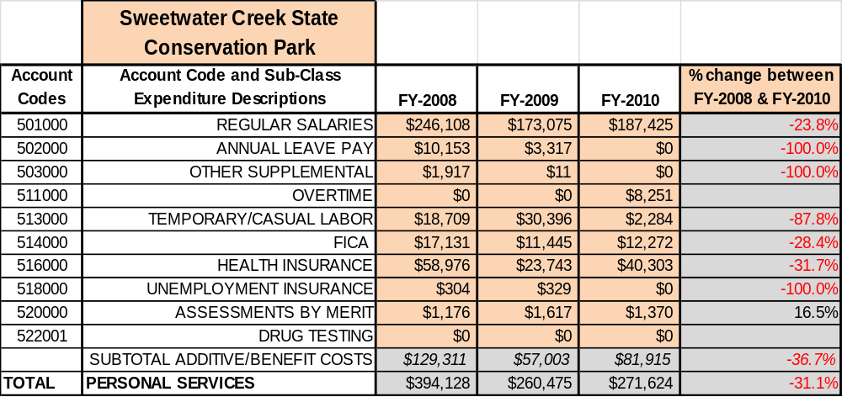

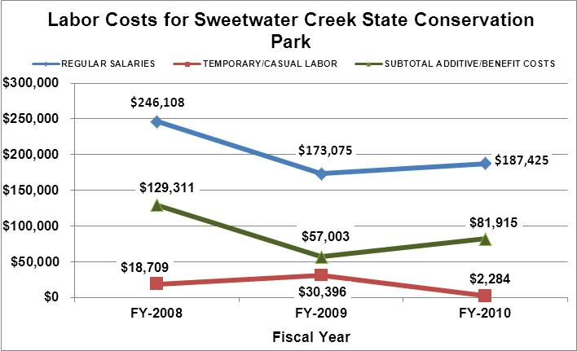

Visitation and Occupancy
Overall annual visitation to the site has trended downward from 2008 to 2010, decreasing by 24% or 61,424 visitors. Weather and economic forces have played an important role in the downward turn. The flood of 2009 in the Douglas County area led to a decline in local guest visits and a cold wet winter in 2010 led to a decline in winter guests. Sweetwater Creek State Conservation Park also suffers from lack of parking, bad roads, and unique opportunities. With the addition of yurts, mountain bike trails, and a dog park, attendance will have the opportunity to reach the 2008 mark. Additionally, the park staff is working with private groups to offer more races and other special events to help boost visitation.

Year | Total Visitation
2008 | 252,520
2009 | 132,431
2010 | 191,096

Customer Service and Satisfaction

Site | Year | Customer Satisfaction Level
Sweetwater Creek State Park | 2009 | 84%
Sweetwater Creek State Park | 2010 | 95%

Financial Performance Assessment

Operational Expenses
A summary of total operating expenses at Sweetwater Creek State Conservation Park from 2008 to 2010, as well as their percent change from 2008 are provided in the table below.
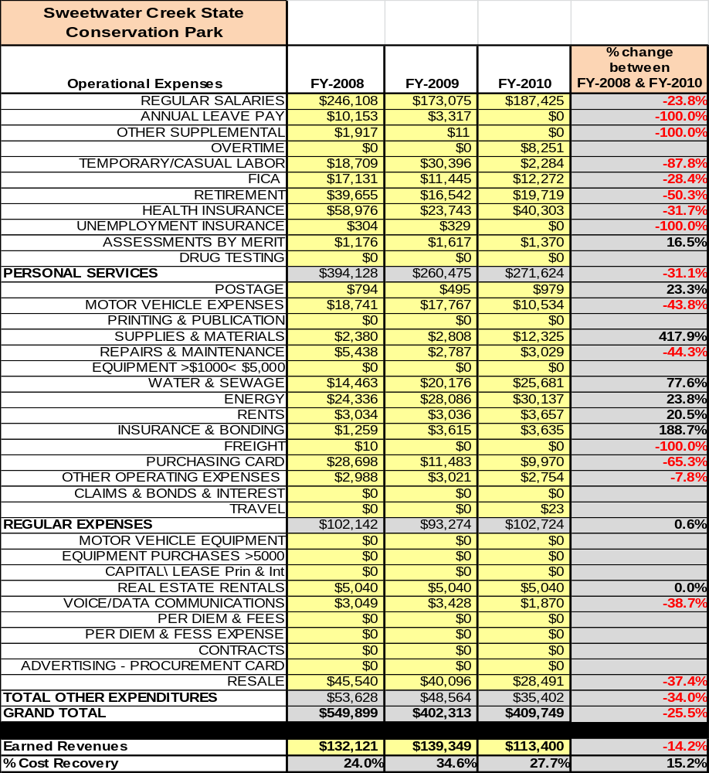

Earned Revenues
Earned revenues at Sweetwater Creek State Conservation Park have decreased since 2008, which is largely attributed to the corresponding decrease in overall visitation.
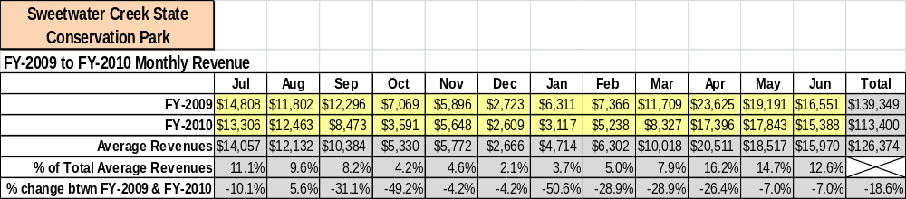

Monthly earned revenues for the last two years indicate that total annual revenue decreased 19% from 2009 to 2010, with the largest increase in monthly revenues in August (10%) and the largest decreases in the months of January (-51%), October (-49%), February (-29%), and March (-29%).
The graphs below illustrate the monthly revenue trends each year and the average percent of total annual revenue earned each month.
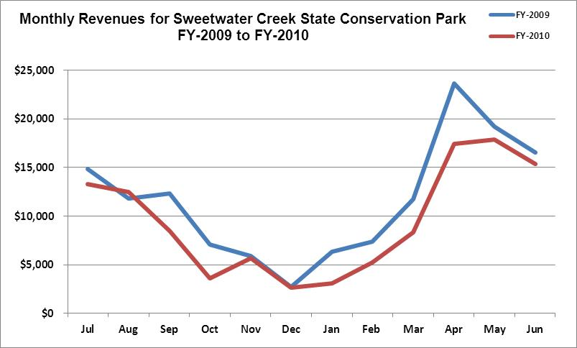

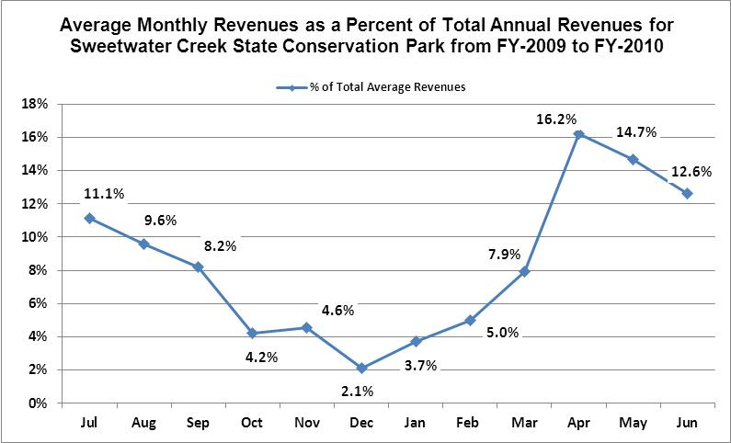
Cost Recovery Trends
Sweetwater Creek State Conservation Park has achieved an average cost recovery of 29% of annual operational expenses through earned revenues from FY 2008 to FY 2010. This is detailed and illustrated in the table and graph below.
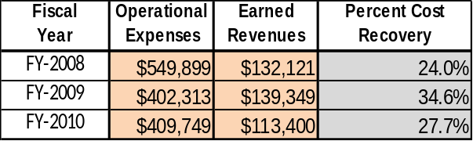

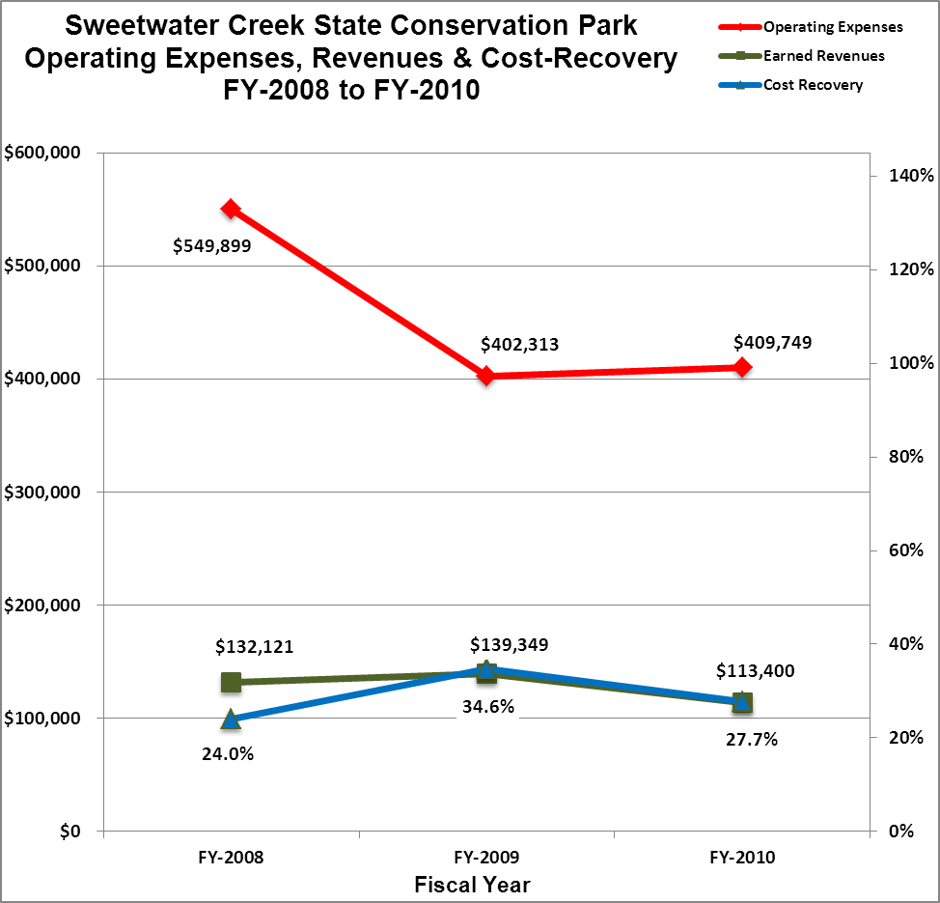

Review of Pricing
Data on rate information on program rates is not readily available, only the last five years are evaluated. There has been some growth in fees charged at Sweetwater Creek State park since 2008, with the largest increase being $5.00 and $15.00 program fees, and addition of pedal boats for rent. A table detailing the rates for 2008 – 2010 is provided below.
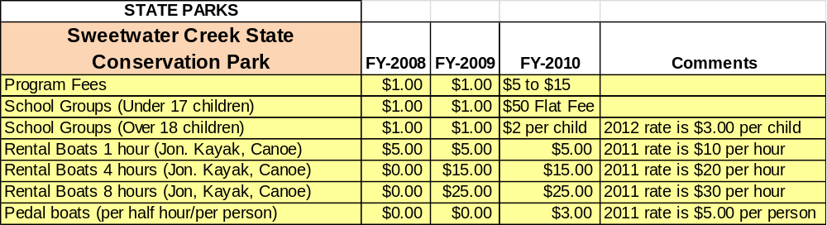

Business and Management Plan

Business Goals
The following goals serve as the foundation for the key recommendations and strategies in this business plan for Sweetwater Creek State Conservation Park

Enhance Cost Recovery of Site Operations
Sweetwater Creek State Conservation Park is operating at a 29% cost recovery of operational expenses through earned revenues. Sweetwater Creek plans to improve cost recovery of site operations by cutting labor costs, expanding interpretive programming, plus adding overnight facilities such as yurts and adding amenities to draw more visitors to the site. New interpretive programming will include interpretive kayak trips on the reservoir and creek plus additional Junior Ranger programs throughout the summer.

Enhance Revenue Generation Strategies
Increased revenue will most likely come from the addition of overnight facilities and increased visitation to the park. An additional strategy is currently being planned to move all the trail heads to the front of the Interpretive Center and retail area. With the position of the current trail head it is estimated that 60% to 75% of guests never get to within 100 yards of the Interpretive Center. Prices and times for rental boats will also be reviewed and adjusted to increase revenue.

Expand Special Events at the Site
Current special events at Sweetwater Creek are operated with concession agreements and include activities such as cross country races, family fun days, and small festivals. Sweetwater Creek will have a goal of creating three new special events in 2013.

Improve the Diversity and Innovation of Recreational and Interpretive Programs
The interpretive center at Sweetwater Creek features quality history exhibits and the unique design of a LEED certified building that predominately appeals to adults and history enthusiasts. The interpretive center needs to be able to attract other park users such as hikers, paddlers, and nature lovers. In the past year, the staff at Sweetwater Creek have put quite a bit of energy in offering a new variety of recreational/educational programs such as dog hikes, and twilight paddles. Sweetwater Creek is in need of new programming that attracts larger groups than the average 3 or 4 people. With the addition of interpretive kayaking trips and the addition of new special events, program revenues will increase.

Improve the Effectiveness of Marketing and Sales
We already utilize the park’s web page and local newspapers, but do not do a very good job of using social media to advertise programs and events. A marketing strategy will soon go into effect reaching out to local school and day care facilities to increase public awareness of park facilities and programs. Sweetwater Creek will also be talking to area chamber of commerce groups to advertise facilities for meetings and group events and will also reach out to new citizens moving into the area.

Establish Greater Consistency of Managing and Monitoring Customer Service & Satisfaction
Sweetwater Creek State Park will strive for a 90% or higher approval rating. Part of this will be established with improving facilities, upkeep of the park, a variety of programs, hiring and retaining employees with good customer service skills. We will monitor the new online comment cards available to all visitors to the park.

Expand Partnership Opportunities
Sweetwater Creek State Park will be seeking to establish relationships with its Friends chapter, trail running clubs, local businesses, and the surrounding community to seek out stakeholders willing to invest in the park. We will be seeking partners on small-scale projects such as building improvements, picnic area improvements, and trail maintenance. We will also seek out new partners to assist with adding new amenities such as mountain biking and a dog park.

Classification of Programs and Services
The tables below summarize the classifications of programs and services at Sweetwater Creek State Park as either core, important, or visitor supported and projects a range of cost recovery percentages that might be achieved for each. These classifications establish financial performance goals for each category of services that are linked to the recommendations and strategies of this business plan.

Core Services
Program / Service | Target Cost Recovery
Active management and protection of the cultural and natural resources of the park (1840 mill ruins and artifacts, G2 Mountain Longleaf, unique habitats throughout the park) | 0%
Provide a safe environment for park visitors | 0%
Public access to site | 100%
Maintenance of park grounds and facilities | 0%
Site appropriate education, interpretation and recreational opportunities | 125-150%

Important Services
Program / Service | Target Cost Recovery
Providing guided interpretation and educational programs | 125%
Providing areas for interested parties to study history/natural resources | 100%
Providing areas for fishing and access to the public boat ramp | 100%
Providing trails for walkers/hikers | 10-20%

Visitor Supported
Program / Service | Target Cost Recovery
Gift / retail shop at the Interpretive Center | 150%
Bait shop for fishermen to buy food, bait and supplies | 150%
Public access to Interpretive Center | 100%
Special events | 125%
Boat rentals | 100%
Group and picnic shelters | 100%

Partnership Development Plan
The table below summarizes existing partners and targeted partnerships by classification (operational, vendor, service, co-branding, funding partners) and by organizational type.
 | Public Partners | Not-for-profit Partners | Private / Enterprise Partners
Operational Partners | - Douglas County | - Douglas Co. Rogue Runners  - Long-Leaf Alliance  - The Nature Conservancy  - Non-Game Wildlife  - Atlanta Audubon Society  - Boy Scouts of America | - Martina Dorm (Private Hikes)  - Penny Perel (Yoga Instructor)
Vendor Partners |  |  | - REI  - Coca Cola
Service Partners | - City of East Point | - Friends of Sweetwater Creek State Park  - Douglas County Rogue Runners  - Atlanta Audubon Society  - Douglas County Kiwanis Club  - Georgia Ultra running
Co-branding Partners
Funding Resource Development Partner |  | - Friends of Sweetwater Creek State Park  - Georgia Wildlife Resources Division  - National Park Service  - Friends of Georgia State Parks and Historic Sites

Marketing and Sales Plan

Marketing and Sales Goals
Marketing and sales goals for Sweetwater Creek State Park are based on the following desired outcomes:
- Increase numbers and diversity of visitors to the site by reaching out to local chamber of commerce, state welcome centers, and civic groups.
- Produce at least three signature events with large public participation which in turn will increase revenue and visitation figures.
- Increase overall visitation and revenues
In order to meet these goals, examples of specific target outcomes were identified in the areas detailed in the table below.
Area  of Focus | Current  Performance | Goal  by 2011 | Goal  by 2012 | Goal  by 2015
Interpretive Program Revenue | $9,500/yr | $12,000 | $14,000 | $20,000
Special Event Programming | 2 | 2 | 3 | 5
Marketing and Promotion Strategies

Publicity and Social Media
Sweetwater Creek State Park will approach marketing and publicity planning using the following guidelines and themes:
- Event publicity
Major events benefit by having short stories in local, regional, and statewide newspapers and online social media hooks planted that run three to four weeks in advance of the event up to the date of the event itself. Stories and media need to be cultivated with contacts and online sales channels several weeks in advance of the time the stories need to run. Special interest interviews on morning, noon, and evening television news programs, radio interviews on popular rush-hour programs, and blogs on known affinity online sites should also be included. Sweetwater Creek will also provide major event flyers and information to area chamber of commerce and civic groups.
- Program publicity
Special and unique programs should have feature stories in magazines, local and regional weekly newspapers, and statewide daily newspapers that are aimed at placements as front-page or sectional front-page stories. These stories are most effective if they run shortly before the season that the featured program begins. This will likely require several weeks of advanced planning with media contacts. Similar coverage on television and radio should also be considered. If pre-publicity cannot be generated, post-publicity can help promote future programs. Programs must be put on all Atlanta Area social media sites as well as posted throughout the park for guest to view.
- Sweetwater Creek State Conservation Park Publicity
Sweetwater Creek State Conservation Park can focus its publicity toward sharing its programing opportunities, recreational amenities, resource management goals, and long term plans through yearly park tours with local media, local leaders, civic groups, and the interested public. Stories and features resulting from such tours typically take between two and six months to materialize so the tours should focus on experiences, benefits, and programs that would be available when the stories are expected to run.
Examples and suggested opportunities for events, programs and related publicity efforts based on the themes described above at Sweetwater Creek State Park are provided in the table below.
Event Publicity | Program Publicity | Site Publicity
Sweetwater Factory Days | Atlanta Audubon Hikes | Spring Bloom when dogwoods are out
Family Fun Night | Jr. Ranger Day Camps | Candle Light Hike inside Mill Ruins
New Manchester Days | Ruins to Rapids Full Moon Hike | Prescribed Fire Burns
Kayak Fishing Tournament | Twilight Paddle | Longleaf Pine Area

Packaging
Examples and suggested packages for Sweetwater Creek are provided in the table below.
Package | Package Details
Group Shelter or Conference Room Rental/Program | Rent the group shelter and get a 30 minute nature or history presentation.
Boat Rental/Mill Tour | Rent any boat for 1 hour or more and receive two passes for mill tour.

Group Sales
Types of groups within which specific target customers can be identified for Sweetwater Creek State Park are listed below:
- Families  - Church Groups  - Kayakers | - Nature enthusiasts  - Photographers  - Historians | - Hikers/Dog walkers  - Trail Runners  - Schools

Incentivizing New and Repeat Visitation
Sweetwater Creek State Park will utilize the following strategies and/or incentives to encourage new and repeat visitation starting in FY 2012:
- Offer new and unique programming/packages for return visitors
- Moving trail heads to front of Interpretive Center
- Increase signage leading guest to Interpretive Center or Bait shop

Marketing and Sales Metric Goals
The following marketing and sales metric goals and/or others will be monitored and progress reported at Sweetwater Creek State Conservation Park:
- Loyalty and repeat customers = 65% customers repeat visit with in 12 month period.
- Brand confidence & customers recruiting customers = 50 % of visitors from customer referrals.
Revenue Generation Plan
Revenue / Cost Recovery Goals
Sweetwater Creek has set a financial goal of increasing annual revenues 5% annually between 2011 and 2013. Increased visitation along with new attractions will help Sweetwater Creek continue the 5% increase. The largest revenue growth opportunity is most likely after implementation of yurts in 2014 with a 10% increase in 2014 and a 16% increase in 2015. The table below details projected revenue growth leading up to 2015, based upon a nominal growth of revenues each year.

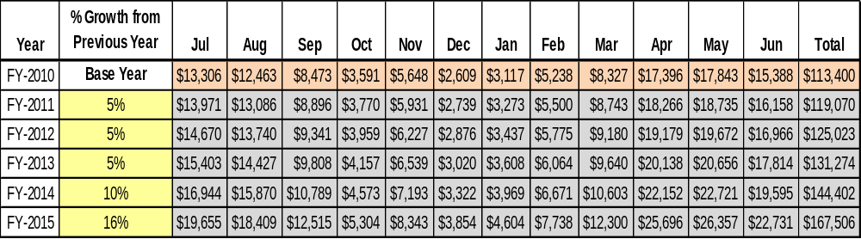

These projections would result in a total of 42% cumulative growth in total annual revenues between FY2010 and FY2015. If operational expenses can be managed with a cumulative decrease of 2% between FY 2010 and FY 2015, then the overall cost recovery of the site will be approximately 42% in FY 2015 at these projected revenue levels. This is higher than the annual financial performance of the site in FY 2010, which was operated at 28% cost recovery in that year.

Revenue Generation Strategies

Pricing Plan
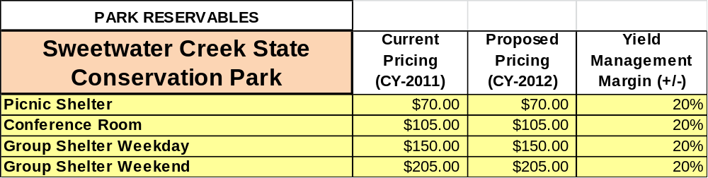

Innovative Programming and Special Events Plan
Program / Event | Theme / Purpose | Scheduled Date/Season | Frequency | Target Participation | Target User Fee | Target Cost Recovery
Ruins to Rapids | History/Recreation | Full moon weekends | 12/yr | All age groups | $6 | 125%
Twilight Paddles | Interpretive tour of the reservoir | Spring/Summer/  Fall | 12/yr | 12 and up | $15 | 150%
Mill Ruin Interpretation Tour | History/Photography/  Curiosity | Every Weekend  1pm to 3pm | 52/yr | All park visitors | $5 | 110%
Bird Walks | Nature Lovers/Photographers | 1/every two months | 6/yr | All age groups | $5 | 100%
Hayrides | Families, Church Groups, Elderly or very young, new parents | Fall | 1/week | Families and Groups | $5 | 100%
Mother/Son Night Outside | A chance for moms to enjoy the outdoors with their son or sons | Spring | 1/year | Mothers and sons | $30 per couple | 100%
Civil War Camp Reenactment | To show what a civil war looked like | Fall  Spring | 2/year | All age groups | $5 park pass | 100%

Partnerships and Concessions Plan
Service / Partnership | Term of Service | Financial Objective | Contract Manager
Friends of Sweetwater State Conservation Park | Revolving | Assist with park projects, programming, and advertising including financially and with labor. To help maintain community awareness and outreach. | John Johnston
REI |  | To bring new guests to Sweetwater through joint advertising.
Ga DNR Wildlife Resources Division |  | To improve the health of the lake inside Sweetwater Creek State Conservation Park and restock fish.
National Park Service |  | Assist with making the Chattahoochee River Property a more viable site for programming. | Charlotte Gillis
Douglas County Rogue Runners |  | Continue working together to provide cross country races at SWC with proceeds going to the friends of SWC. | Johnny Buice
GET GUTS Running Group |  | Continue working together to provide cross country races at SWC with proceeds going to the friends of SWC. | Ryan Cobb
Kiwanis Club of Douglas Co. |  | Continue working together to provide Tri-Athlons at SWC with proceeds benefiting local children’s charities and the friends of SWC. | John Sell
Atlanta Audubon Society |  | To provide guided bird hikes once a month at SWC
City of East Point |  | To keep a working relationship with the city in order to maintain the lease for the reservoir and bait shop.

Expense Management Plan
Personnel Assignments
The following actions will be taken to proactively manage labor costs via personnel assignments and classifications.

Action | Timeline | Outcome
Convert one bait shop clerk to part time hourly worker | 2011 | Salaried labor costs have decreased from $130,599.44 (March 2011) to $84,632.97 (March 2012)
Eliminate vacant full time office clerk position | 2011 | Complete

Management Techniques
The following actions will be taken to proactively manage labor costs via management techniques.

Action | Timeline | Outcome
Continue use of part time clerks and maintenance staff. | 2012 | Salaried labor costs have decreased from $130,599.44 (March 2011) to $84,632.97 (March 2012)

Adjusted Levels of Service
The following actions will be taken to proactively manage labor costs via reduced levels of service.

Action | Timeline | Outcome
Close bait shop during winter months | 2012 | Salaried labor costs have decreased from $130,599.44 (March 2011) to $84,632.97 (March 2012)
Change hours and days of operation at Interpretive Center through winter months | 2012 | Close Interpretive Center on Mondays and Tuesdays December through February

Financial Pro Forma
The following five-year financial pro forma projects operating expenses, earned revenues and cost recovery through FY 2015. These pro forma are based on the strategies and desired outcomes identified in this business plan, especially the revenue generation and expense management plans, and are linked to corresponding performance goals.

Expense Pro Forma

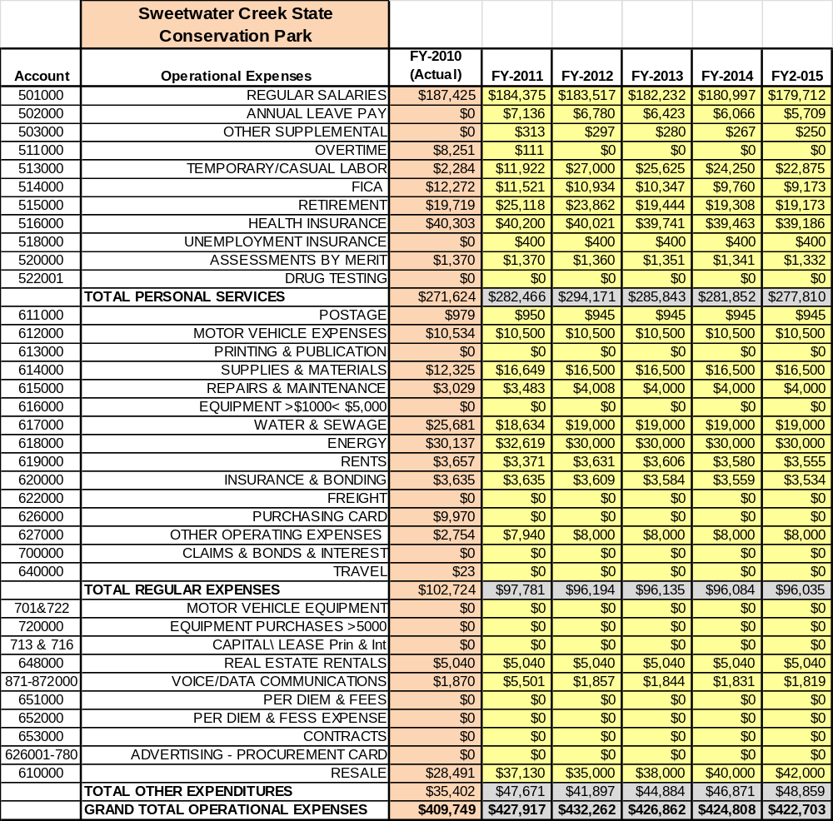

Revenue Pro Forma
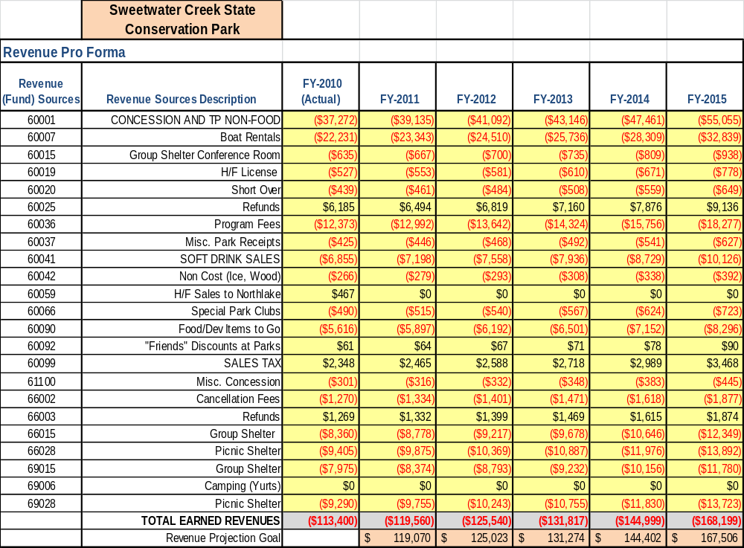

Total / Cost Recovery Pro Forma
