Tallulah Gorge State Park
Business & Management Plan

Prepared June 2011; Finalized February 2013
Direction 2015 – Sustainable Business Planning

Table of Contents

Executive Summary 3

Site and Operations Assessment 6
Site Inventory and Facility Assessment 7
Operational Assessment 9
Financial Performance Assessment 14

Business and Management Plan 17
Business Goals 17
Classification of Programs and Services 18
Partnership Development Plan 19
Marketing and Sales Plan 20
Revenue Generation Plan 22
Expense Management Plan 25
Financial Pro Forma 27

Action Plan 28

Executive Summary
The Parks, Recreation and Historic Sites Division (PRHSD) of the Georgia Department of Natural Resources (DNR) is transitioning the management of Tallulah Gorge State Park to operate more like a business, reflecting the Direction 2015 – Sustainable Business Planning initiative to improve the fiscal performance and management of the state parks and historic sites system. This business and management plan is designed to help the site recover more operating expenses through earned revenues, productive partnerships, and innovative programs.

Site Fact Sheet
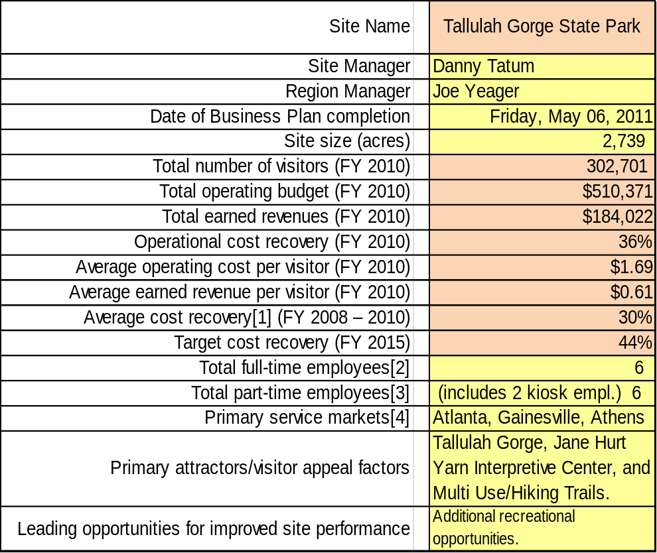

Site Summary and Key Attractions
The 2,739-acre site of Tallulah Gorge State Park is located within the small town of Tallulah Falls and is located in both Rabun and Habersham counties. The park is located approximately 90 miles north of Atlanta, 45 miles north of Gainesville, and 60 miles northwest of Athens. U.S. Highway 441 (four lane) runs through the park; Interstate 85 is approximately 45 miles southeast; and Interstate 985 is 40 miles south. Areas along U.S. Highway 441 and below the Jane Hurt Yarn Interpretive Center were opened up approximately four years ago so views of the gorge and Interpretive Center could be seen.

Key Attractions
The amenities or features listed below are those that seem to be most popular for visitors.
- Gorge (2.5 miles in length, 1000’ wide, and five waterfalls)
- Jane Hurt Yarn Interpretive Center
- Theater
- Trails
- 1,100-step staircase (to the floor of the gorge and back out)
- Interpretive Programs and Special Hikes
- Gift Shop

Financial Targets
The table below details the total operating expenses and earned revenues for Tallulah Gorge State Park over the last three years (2008 – 2010). This table also calculates total cost per visitor and revenues per visitor during these operating years, and details the target financial performance goals in the context of achieving at least 44% cost recovery. This table also calculates the necessary change from 2010 operating expenses and revenues.
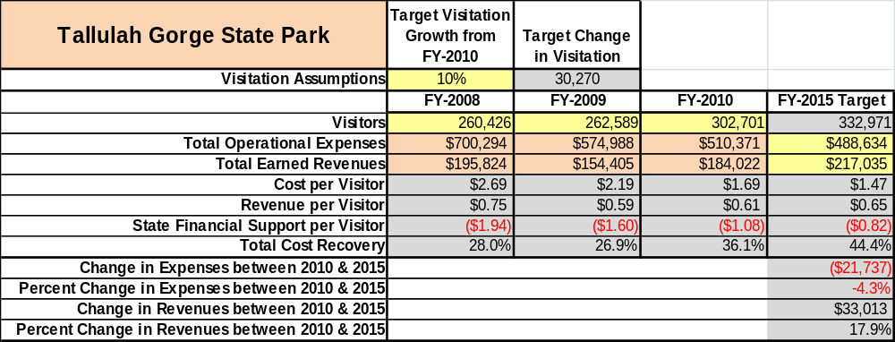

Key Recommendations

Primary / Short Term Recommendations
- Operate the site using cost-based accounting, including the net cost recovery achieved annually.
- Sustain sufficient non-labor operational funding and/or reduce staff so that required staff operational costs (with benefits) do not exceed 45% (FY11 was 52% & FY12 was 47%) of the total operational budget.
- Collect a statistically-valid sample of ZIP code data from random visitors to gauge their origins and demographics. Info is sent to the Atlanta office. Will use the results to improve programming and marketing efforts to appeal to a broader audience.
- Manage Tallulah Gorge State Park according to well-defined maintenance, program and operational standards monitored and enforced by the Region Manager and Senior Management.
- Enhance facilities and program offerings to provide a minimum of six unique experiences for each visitor while maintaining at least a 90 % customer satisfaction rating.
- Work with both the Habersham and Rabun County Chambers of Commerce and other destination marketing organizations to promote Tallulah Gorge State Park.
- Utilize a minimum of five special events annually to help draw more visitors to the site.
- Work closely with the Friends of Tallulah Gorge State Park Chapter to help raise funds and provide volunteers for improvements, program support, and labor. This includes renovation of the Jane Hurt Yarn Interpretive Center HD theater equipment and sprinkler system.
- Review and update camping rates at the site on an annual basis to recover the total net cost of service for important and visitor-supported services.
- Monitor and develop new sales of gift shop items associated with the site in order to increase site-generated revenues. This will involve working closely with Division’s Retail Specialist.
- Meet with decision-makers, elected officials, local business operators, and others to demonstrate the economic impact that Tallulah Gorge State Park offers.
- Evaluate and pursue opportunities to employ concessionaires or private or public service providers on-site if they can be more cost-effective. For example, explore concessioning out our gift shop.
- Construct and upgrade facilities and amenities at the site. Suggestions include upgrading our theater, updating interpretive displays and exhibits in the Jane Hurt Yarn Interpretive Center; enhance landscaping, and installation of a playground near the Jane Hurt Yarn Interpretive Center.
- Coordinate staff at Tallulah Gorge, Black Rock Mountain and Moccasin Creek state parks to complete maintenance projects, administrative procedures, resale operations, etc.

Secondary / Long Term Recommendations
- Install an improved retail point-of-sale and inventory tracking system (replace PARS). The new Active registration/resale/inventory system will be installed in FY13. Training of staff will begin in December 2012.
- Additional revenue (cottages, campground, etc.) are needed at Tallulah Gorge, but we are limited due to terrain, cost and Georgia Power’s decision to not assist us on electricity cost or transfer the operation of the campground.
Site and Operations Assessment
This site and operations assessment is a culmination of analyses and findings from a review of the condition of facilities, infrastructure, and operations at Tallulah Gorge State Park. The findings and observations are not intended to be an exhaustive review of all issues present, but provide a basic understanding of the predominant issues that contribute to the site’s current operating conditions. The assessment includes the following:
- Site Inventory and Facility Assessment
- Operational Assessment
- Financial Assessment
Site Inventory and Facility Assessment

Methodology
Facility and asset conditions are rated using a differential scale of excellent, good, fair, or poor. Descriptions of conditions that are attributed to each of these findings are also provided.
Scale of Conditions
Rating | General Description
Excellent | Facilities/amenities are in ‘excellent’ condition when they show little or no maintenance or repair problems. Facilities do not feature any major design or operational issues or flaws that contribute to diminished use or increased maintenance or upkeep. Facilities are easy to clean and maintain in order to place them back into public use and the users perceive them to be in excellent shape.
Good | Facilities/amenities are in ‘good’ condition when they show only minor maintenance or repair problems. Most maintenance issues with these facilities typically appear to be the result of age and/or heavy use. Facilities may only feature minor design or operational issues that contribute to diminished use or increased maintenance or upkeep. Facilities are moderately easy to clean and maintain in order to place them back into service and the users perceive them to be adequate for their use, but probably not in excellent shape.
Fair | Facilities/amenities are in ‘fair’ condition when they show significant maintenance or repair problems. Facilities generally exhibit ongoing maintenance issues that appear to be the result of age, heavy use, or design or operational flaws. Some maintenance and repair needs may compound their fair condition by being deferred because of budget and/or resource limitations. Facilities require more effort to clean and maintain before placing them back into service and the users may perceive them as being less than adequate for their use and in a state of deterioration. The facility or structure may need of major repair or replacement.
Poor | Facilities/amenities are in ‘poor’ condition when they show significant, on-going maintenance or repair problems that ultimately may result in suspended use for repair/replacement. Maintenance and repair issues are possibly the result of poor maintenance and clearly the result of age, heavy use, or design or operational flaws. Problems with the facilities are often compounded over time due to consistently deferred maintenance and repair because of budget and/or resource limitations. Facilities may feature major design or operational issues that contribute to diminished use or increased maintenance or upkeep. Facilities require excessive effort to clean and maintain before placing them back into service and the users often perceive them as being inadequate for their use and in a state of serious deterioration. The facility or structure may need of major repair or replacement.

Inventory and Assessment
The table below is an inventory of facilities and amenities at Tallulah Gorge State Park, and provides the assessed condition of each as reviewed in April 2011.
Site Asset / Amenity | Quantity | Condition
Total Acreage | 2,739 | Good
Jane Hurt Yarn Interp. Center | 1 | Good
Maintenance Barn | 1 | Fair
Pole Shed | 1 | Good
Gas Building | 1 | Poor
Maintenance Storage Shed | 1 | Good
Ranger Station | 1 | Poor
Manager’s Residence | 1 | Good
Asst. Manager’s Residence | 1 | Good
Bulletin Boards | 7 | Good
Sewage Pump Building | 1 | Good
Int. Center AC/Heat Air System | 1 | Fair
Theater AV Equipment | 1 | Good

Prioritized Facility Needs
Based on the facility inventory and assessment, these prioritized needs have been identified. Each need has been aligned with a priority category of high, moderate, or low to support future decision making regarding project sequencing, investment of public resources, and meeting community expectations. The priority assignment for each need is not a measure of importance. Rather, these recommended priorities reflect a phased implementation approach over the next several years.
Facility Need | Priority Assignment
Update Interpretive Center displays | Moderate
Theater projector replacement due to age of component. | Moderate
Construct rest station near the Shortline trail | Moderate
Replace aged rubberized trail from Int. Center to North Rim trail. | High
Replace all track lights downstairs in the Int. Center | High
Replace heat and air system at Int. Center | Moderate
Replace maintenance facility | Low

Operational Assessment
The Operational Assessment includes:
- An inventory and classification of programs and services being provided at the site
- A review of staffing at the site
- A review of concessionaires and partners operating at the site
- Visitation and customer satisfaction

Inventory and Classification of Programs and Services
Programs and services are classified into one of three major categories:
1) Core or Essential Services
2) Important Services
3) Visitor Supported Services
Programs and services at the site are classified into these categories based in part on the mission and public mandates for both the site and the agency. For the services in each of these categories, there are financial performance expectations that will define how services are funded and evaluated.

Category 1 – Core Services [Largely supported by tax funds]
Core programs, services and facilities are those the agency must provide and/or are essential in order to capably govern and meet statutory requirements. The failure of the agency to provide Category 1 services at adequate levels could result in significant negative consequences for the public and the resources under protection. The criteria for services to be classified as core or essential are:
- The services are mandated by the agency’s law or charter or are contractually obligated by agreement to provide the services.
- The services are essential to protecting and supporting the public’s health and safety.
- The services protect and maintain valuable assets and infrastructure.
- The services would generally and reasonably be expected and supported by residents, businesses, customers and partners.
- The services are those that cannot or should not be provided by the private sector.
- The services provide a sound investment of public funds.
The following services offered at Tallulah Gorge State Park have been identified as core services:
- Public safety and health
- Maintenance of grounds, facilities and infrastructure
- Site appropriate education, interpretation and recreational opportunities
- Public access to the site and its natural resources
- Interpretive Center display management
- Resource management of wildlife management areas and gorge

Category 2 – Important Services [Supported by a balance of tax funds and earned revenues]
Important programs, services and facilities are those the agency should provide, and are important to governing and effectively serving residents, businesses, customers and partners. Providing Category 2 services expands or enhances the agency’s ability to provide and sustain its core services. The criteria for programs or services to be classified as important are:
- The services expand, enhance or support identified core services.
- The services are broadly supported and utilized by the community, and are considered an appropriate, important, and valuable public good. Public support may be conditional upon the manner by which the services are paid for or funded.
- The services generate income or revenue that offsets some or all of the operating cost and/or are deemed to provide economic, social or environmental outcomes or results.
The following services offered at Tallulah Gorge State Park have been identified as important services:
- Self-guided interpretation / education programs with the Jane Hurt Yarn Interpretive Center
- Whitewater releases
- Aesthetic water releases

Category 3 – Visitor Supported Services [Almost exclusively supported by earned revenue]
Visitor supported programs, services and facilities are those discretionary services that the agency may provide when additional funding or revenue exists to offset the cost of providing those services. Category 3 services provide added value above and beyond what is required or expected. The criteria for programs or services to be classified as visitor supported are:
- The services expand, enhance or support core services or important services and the quality of life of the visitors, community or stakeholders.
- The services are supported, valued and well utilized and provide an appropriate and valuable public benefit.
- The services generate income or funding from sponsorships, grants, user fees or other sources that offset some or all of their cost and/or provides a meaningful return on investment.

The services can possibly be provided through outsourcing or use of concessionaires, providing opportunities for community enterprises that may not otherwise be provided by the agency.
The following services offered at Tallulah Gorge have been identified as visitor supported services:
- Ranger guided interpretation and educational programs
- Special events and programs related to the mission of the site
- Gift shop

Staffing Assessment
Labor costs at Tallulah Gorge State Park represent the largest area of budgetary expense at an average of 71% of the total operating budget each year for the last three complete years, which is higher than the target of total labor costs (including benefits) not exceeding 65% of the site’s total operating expenditures. The tables below and on the following page provide a basic review of the current staffing.
Full Time Equivalent Employees
Position / Title | Quantity (FTE) | Vacancies | Annual Hours
Park Manager | 1 | 0 | 2,340
Assistant Park Manager | 1 | 0 | 2,080
Bldg/Const. Trades Spec.(retires i. | 1 | 0 | 2,080
Secretary | 0 | 1 | 0
Senior Ranger Maint. | 0 | 1 | 0
Naturalist/Curators/Preserv. | 1 | 1 | 2,080
Facilities Safety Officer | 2 | 0 | 4,160
Clerk (WL) | 0 | 1 | 0
Clerk (EL) | 0 | 1 | 0
TOTAL | 6 | 5 | 12,740
Part Time Employees
Position / Title | Quantity (FTE) | Vacancies | Hours
Clerical Worker | 1 | 0 | 1508
Resale Clerk | 1 | 1 | 1508
Maint. Worker | 0 | 6 | 0
Housekeeper | 0 | 1 | 1240
Inf. Clerk | 1 | 0 | 1240
Seasonal Clerk | 1 | 0 | 1240
ParkPass Kiosk Attendants | 2 | 0 | 3,012
TOTAL | 4 | 8 | 9,752
Labor Support
Labor Support | Annual Hours
Volunteers | 3,697
Community Service Workers | 80
Engineering and Construction Crews | 0
Resource Management Crews | 40
TOTAL | 3,817
Total Labor Hours
Labor Type | Annual Hours
Full Time Equivalent Employees | 12,740
Part Time Employees | 9,752
Labor Support | 3,817
TOTAL Annual Labor Hours | 26,309

Labor Budget Summary
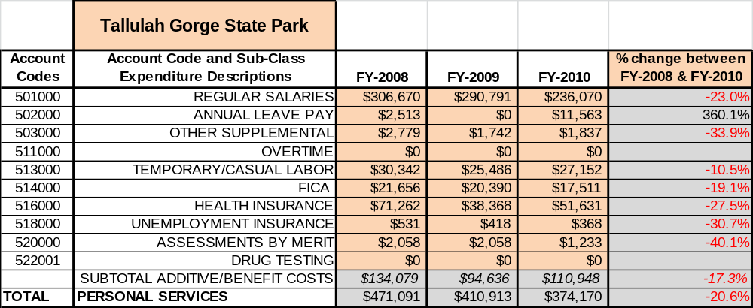

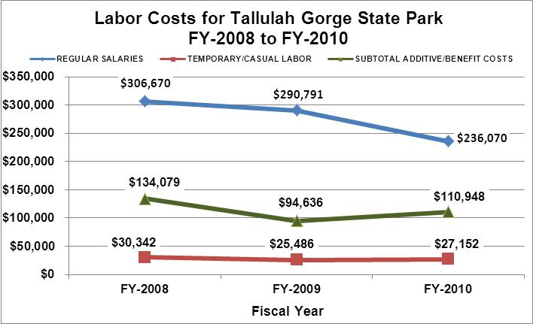

Visitation and Occupancy
Overall annual visitation to the site has trended upward from 2008 to 2010, increasing by 15% or over 44,891 visitors. This is largely attributed to high gasoline cost, with visitors staying close to home, and effective marketing and promotions such as geocaching, canyon climbers club, website, etc.

Year | Total Visitation
2008 | 260,426
2009 | 262,589
2010 | 302,701

Occupancy for the overnight accommodations at Tallulah Gorge State Park the last three years is detailed in the table below. Overall occupancy has trended upward from 2008 to 2010, increasing by 24%. This is largely attributed to a recession with visitors staying closer to home in order to spend less for vacations and weekend getaways.

Year | Back Country Campsites Occupancy | Pioneer  Campsites  Occupancy
2008 | 1650 | 2525
2009 | 1755 | 2300
2010 | 2175 | 2900

Customer Service and Satisfaction

Tallulah Gorge State Park | Year | Customer Satisfaction Level
 | 2009 | 95 to 98%
 | 2010 | 95 to 98%
Financial Performance Assessment

Operational Expenses
A summary of total operating expenses at Tallulah Gorge State Park from 2008 to 2010, as well as their percent change from 2008 are provided in the table below.
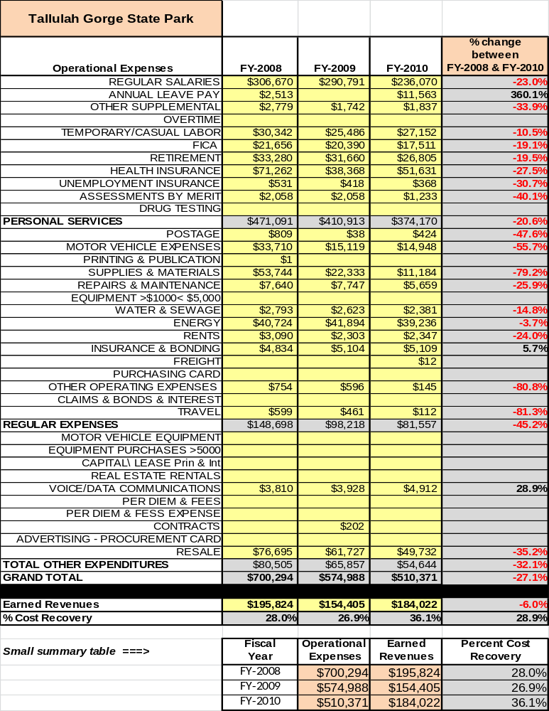

Earned Revenues
Earned revenues at Tallulah Gorge State Park have increased since 2008, which is largely attributed to the corresponding increase in overall visitation. Monthly earned revenues for the last two years (see table below) indicate that the total annual revenue increased 7% from 2009 to 2010, with the largest increases in monthly revenues in Sept. (180%), June (12%), and May (4%), and the largest decreases in the months of Jan. (26%), Feb. (21%), March (21%) and Dec. (13%).
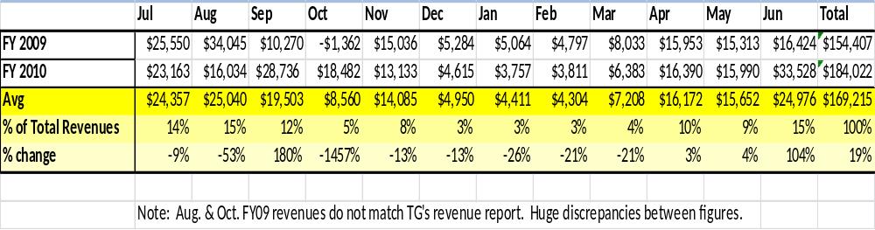

The graphs below illustrate the monthly revenue trends each year and the average percent of total
annual revenue earned each month.
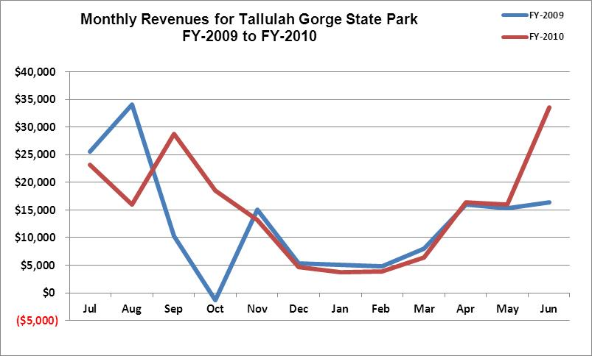

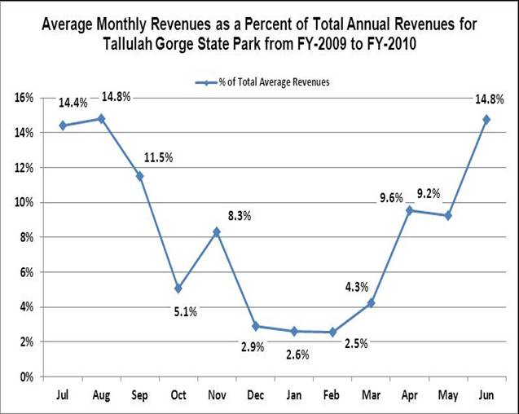

Cost Recovery Trends
Tallulah Gorge State Park has achieved an average cost recovery of 32% of annual operational expenses through earned revenues from FY 2008 to FY 2010. This is detailed and illustrated in the table and graph below.
Year | Operational  Expenses | Earned  Revenues | Percent Cost  Recovery
2008 | $700,294 | $195,824 | 28%
2009 | $574,988 | $154,405 | 27%
2010 | $510,371 | $184,022 | 36%

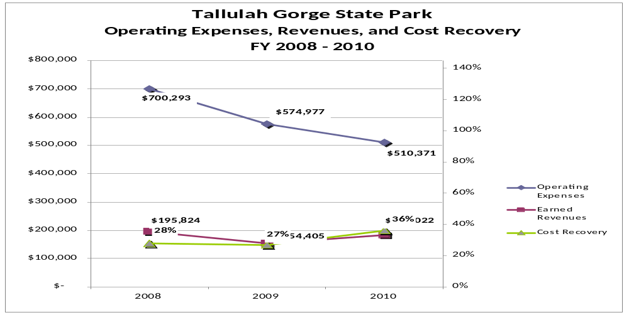

Review of Pricing
Data on rate information is available as far back as 2002, but only the last five years are evaluated. There has been notable growth in fees charged at Tallulah Gorge State Park since 2005, with the largest increase being Pioneer Campsites (38%). A table detailing the rates for Pioneer, Back Country, and Georgia Power’s Campground are provided below.
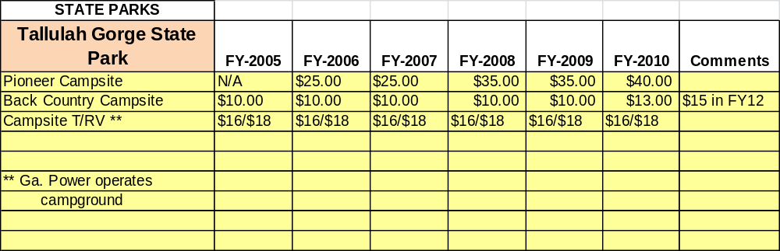

Business and Management Plan

Business Goals
The following goals serve as the foundation for the key recommendations and strategies in this business plan for Tallulah Gorge State Park.

Enhance Cost Recovery of Site Operations
Tallulah Gorge State Park is operating at a 34-36% cost recovery of operating expenses through earned revenues. Tallulah Gorge State Park cannot sustain a high cost recovery level because of limited revenue generating options. The Jane Hurt Yarn Interpretive Center’s Gift Shop, two back country campsites, one pioneer campsite, and special interpretive programming fees are the only revenue generation we have. Tallulah Gorge plans on increasing our recovery cost by a reduction in regular salary cost (with benefits) , adding limited hourly paid employees, increasing the number of special programs with fees, and a more efficient scheduling of maintenance upkeep of the park.

Enhance Revenue Generation Strategies
Increasing earned revenue will result from the impacts of both increased visitation at the site and specific revenue enhancement strategies. Tallulah Gorge State Park will improve revenue generation by increasing the number and type of special programs at the site and charge fees that cover the labor cost with a profit. Also, one additional back country campsite is currently being constructed and will assist in added revenue.

Expand Special Events at the Site
The site’s major programs and events are directly linked to the unique history of Tallulah Gorge, the city of Tallulah Falls, and the natural resources of the gorge. Our plans are to offer more exciting programs and events that will allow visitors to not only learn various natural resource aspects of the gorge, but be able to hike into restricted/historical areas.

Improve the Diversity and Innovation of Recreational and Interpretive Programs
Establish interpretive programs that provide our visitors with the opportunity to hike, explore, and learn about areas of the gorge and resources that are not accessible under normal conditions. Work with our Friends Group to bring in recreational programming instructors from various resources to assist in innovate programs.

Improve the Effectiveness of Marketing and Sales
Place all special events and interpretive programs on Facebook, twitter, local radio & TV stations to enhance educational and recreational opportunities for the public to enjoy.

Establish Greater Consistency of Managing and Monitoring Customer Service & Satisfaction
Perform zip code data base from random surveys at our park pass booth and survey quest at our front desk operations on visitation of the park in the previous twelve months and how they found out about Tallulah Gorge State Park. Our goal is to have a 90% satisfied or very satisfied level from our comment card report.

Expand Partnership Opportunities
Continue to work with Georgia Power on funding of labor and programming exhibits for the Interpretive Center. Expand our community partnership opportunities through our Friends Group to work towards donations and volunteers to assist in our entire operation.

Classification of Programs and Services
The tables below summarize the classifications of programs and services at Tallulah Gorge State Park as either core, important, or visitor supported and projects a range of cost recovery percentages that might be achieved for each. These classifications establish financial performance goals for each category of services that are linked to the recommendations and strategies of this business plan.

Core Services
Program / Service | Target Cost Recovery
Public safety and health | 0%
Maintenance of grounds, facilities and infrastructure | 0%
Site appropriate education, interpretation, and recreational opportunities | 145%
Public access to the site and its natural resources | 0%
Interpretive Center display management | 0%
Resource management of wildlife management areas and gorge | 0%

Important Services
Program / Service | Target Cost Recovery
Self-guided interpretation / education programs within the Jane Hurt Yarn Interpretive Center | 40%
Whitewater releases | 20%
Aesthetic water releases | 20%

Visitor Supported
Program / Service | Target Cost Recovery
Ranger guided interpretation and educational programs | 150%
Special events and programs related to the mission of the site | 125%
Gift shop | 145%

Partnership Development Plan
The table below summarizes existing partners and targeted partnerships by classification (operational, vendor, service, co-branding, funding partners) and by organizational type.
 | Public Partners | Not-for-profit Partners | Private / Enterprise Partners
Operational Partners |  |  | - Georgia Power
Vendor Partners |  |  | - Georgia Power  - Coca Cola
Service Partners | - City of Tallulah Falls | - Habersham and Rabun County Chambers of Commerce
Co-branding Partners
Funding Resource Development Partner |  | - Friends of Georgia State Parks and Historic Sites  - Friends of Tallulah Gorge State Park

Marketing and Sales Plan

Marketing and Sales Goals
Marketing and sales goals for Tallulah Gorge State Park are based on the following desired outcomes:
- To produce increased overall visitation and revenues.
- To produce interpretive and historical signature programs with large participation
- Highlight that Tallulah Gorge is one of the “Seven Wonders” of Georgia
In order to meet these goals, examples of specific target outcomes were identified in the areas detailed in the table below.
Area  of Focus | Current  Performance | Goal  by 2011 | Goal  by 2012 | Goal  by 2015
Overall Visitation | 302,701 | 310,000 | 308,755 | 337,965

Marketing and Promotion Strategies

Publicity and Social Media
Tallulah Gorge State Park will approach marketing and publicity planning using the following guidelines and themes:
- Event publicity
Major events benefit by having short stories in local, regional, and statewide newspapers and online social media hooks planted that run three to four weeks in advance of the event up to the date of the event itself. Stories and media need to be cultivated with contacts and online sales channels several weeks in advance of the time the stories need to run. Special interest interviews on morning, noon, and evening television news programs, radio interviews on popular rush-hour programs, and blogs on known affinity online sites should also be included.
- Program publicity
Special and unique programs should have feature stories in magazines, local and regional weekly newspapers, and statewide daily newspapers that are aimed at placements as front-page or sectional front-page stories. These stories are most effective if they run shortly before the season that the featured program begins. This will likely require several weeks of advanced planning with media contacts. Similar coverage on television and radio should also be considered. If pre-publicity cannot be generated, post-publicity can help promote future programs.
- Site Publicity
Site publicity focusing on a single site or sub-set of sites requires more intense planning efforts to attract multiple writers and editors from target publications. The site could host several seasonal media familiarization tours (with 10 to 15 writers or editors) to familiarize them with the site and its benefits and amenities. Stories and features resulting from such tours typically take between two and six months to materialize so the tours should focus on experiences, benefits, and programs that would be available when the stories are expected to run.
Examples and suggested opportunities for events, programs and related publicity efforts based on the themes described above at Tallulah Gorge State Park are provided in the table below.

Event Publicity | Program Publicity | Site Publicity
Hunter Safety | Full Moon Hike | Whitewater Kayak
Antique Auto Show | Wildflower Hike | Historical Rock Hike
 | Holiday Gorge Floor Hike | Six Waterfall Hike
 | Jr. Ranger Camp | Wails to Trails
 | Walk off the Turkey | Learn how to Rappel
 | Christmas at the Gorge
 | Mountain Biking
 | Full Moon Canoe
 | Day Canoe Trip

Packaging
Examples and suggested packages for Tallulah Gorge State Park are provided in the table below.

Package | Package Details
N/A | N/A

Group Sales
Types of groups within which specific target customers can be identified for Tallulah Gorge State Park are listed below:
- Families | - Youth Groups | - Churches
- Hiking | - Swiftwater | - Schools
- Businesses | - Youth Camps

Incentivizing New and Repeat Visitation
Tallulah Gorge State Park will utilize the following strategies and/or incentives to encourage new and repeat visitation starting in FY 2012:
- Customer Service Skills for all employees
- Marketing
Marketing and Sales Metric Goals
The following marketing and sales metric goals and/or others will be monitored and progress reported at Tallulah Gorge State Park:
- Loyalty and repeat customers = 41% of customers repeat their visit in a 12 month period.
- Brand confidence & customers-recruiting-customers = 55% of new customers have been informed by previous guest.
Revenue Generation Plan

Revenue / Cost Recovery Goals
Tallulah Gorge State Park has set a financial goal of increasing annual revenues 2.50% annually between 2012 and 2015. The largest revenue growth opportunity is most likely from the months of May through the middle of November. The table below details projected revenue growth leading up to 2015, based upon a nominal growth of revenues each year.
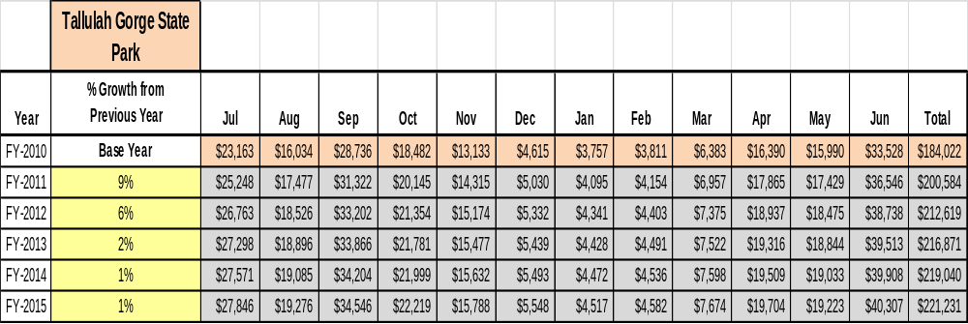

These projections would result in a total of 20% cumulative growth in total annual revenues between FY2010 and FY2015. If operational expenses can be managed with a cumulative reduction of 4% between FY 2010 and FY 2015, then the overall cost recovery of the site will be approximately 44% in FY 2015 at these projected revenue levels. This is higher than the annual financial performance of the site in FY 2010, which was operated at 36% cost recovery in that year.
Revenue Generation Strategies

Pricing Plan
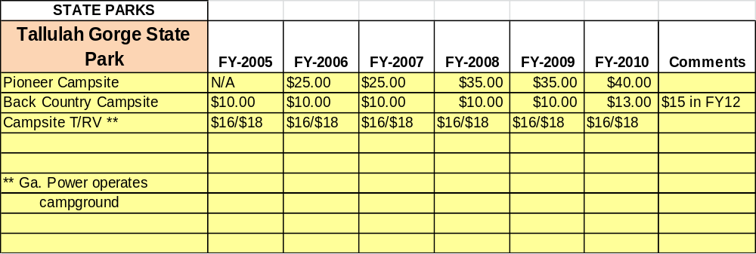

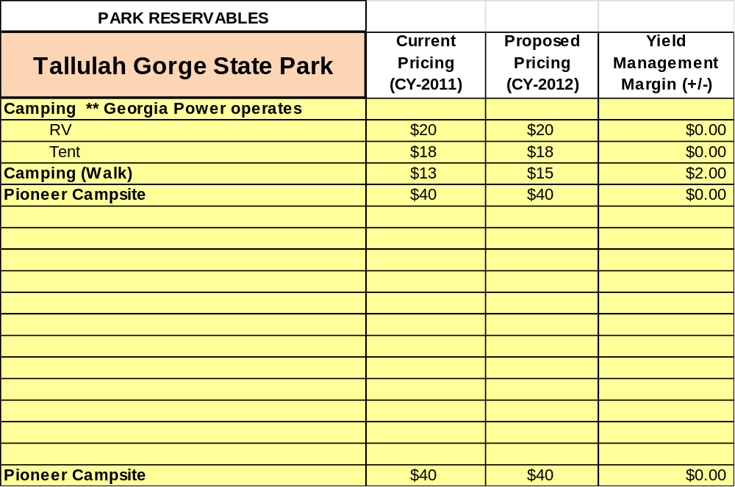

Partnerships and Concessions Plan
Service / Partnership | Term of Service | Financial Objective | Contract Manager
Georgia Power | Partnership | $14,000 every six months | Mike Phillips

Innovative Programming and Special Events Plan
Program / Event | Theme / Purpose | Scheduled Date/Season | Frequency | Target Participation | Target User Fee | Target Cost Recovery
Full Moon Hike | To view Full Moon rising from Suspension Bridge | Twice per month from March -- November | Every fourth week | 50 | $5.00 per person | 176 %+
Historical Rock Hike | Victorian History | Twice per year | Every six months | 25 | $15.00 per person | 148%+
Wildflower Hike | Wildflowers | Twice per year | Spring and fall | 30 | $5.00 per person | 166%
Six Waterfall Hike | View all six waterfalls of the gorge | Four times per year | Every other week | 20 | $25.00 per person | 131%
Witches Head Hike | View the witches head rock formation | Four times per year | Once per month from June –August & once in October | 20 | $15.00 per person | 166%
Holiday Gorge Floor Hike | Hike to Sliding Rock | Holiday Weekends | Summer Holidays | 25 | $5.00 per person | 146%
Jr. Ranger Camp | Camp for youth | Two weeks in June | Once per year | 15 | $25.00 per child | 116%
Wail to Trails | Halloween Hike on our Shortline Trail | October | Once per year | 200 | $3.00 per person | 0%  (Friends performs)
Walk off the Turkey Hike | Exercise by hiking the gorge floor | Friday after Thanksgiving | Once per year | 25 | $5.00 per person | 146%
Christmas at the Gorge | Christmas | December | Once per year | 200+ | No Charge | 0%(Friends performs)
Canoe Day Trip | Fun on the Water | Two times per summer | Twice per year | 16 | $15.00 per person | 178%
Rappelling Skills | Rappelling | Four times – Spring & Fall | Twice in the Spring /Fall | 20 | $20.00 per person | 150%+
Whitewater Kayaking | Whitewater Releases | First two weekends in April and First Three Weekends in November | Five Weekends | 200 | N/A | 10 to 20 %
Mountain Biking Tour | Mountain Bking | One time during the winter | February | 20 | $5.00 per person | 141%
Hunter Safety | Hunter Safety Education | Twice per year |  |  |  | 0%
Full Moon Canoe | Full moon canoeing | Six times from Spring through Fall | Every month | 16 | $15.00 per person | 178%

Expense Management Plan
Personnel Assignments
The following actions will be taken to proactively manage labor costs via personnel assignments and classifications.

Action | Timeline | Outcome
Convert the Parks/Golf Maint. Full-time unclassified position to a 1508 hourly position. | July 1, 2011 | A savings of a minimum of $25,341
If L.E. Ranger position becomes vacant, convert to an hourly security position. | Vacancy occurs | Potential savings of $33,739

Management Techniques
The following actions will be taken to proactively manage labor costs via management techniques.

Action | Timeline | Outcome
Increase camp host and local volunteers for the Interpretive Center and maintenance by an additional 1500 hours per year. | July 2011 | Hourly 1508 employee hours will be reduced.

Adjusted Levels of Service
The following actions will be taken to proactively manage labor costs via reduced levels of service.

Action | Timeline | Outcome
Adjust mowing schedules for entire site | July 2011 | Annual cost reduction of $700
Daily work log from maintenance and L.E. | June 2011 | Better use of time

Financial Pro Forma
The following five-year financial pro forma projects operating expenses, earned revenues and cost recovery through FY 2015. These pro forma are based on the strategies and desired outcomes identified in this business plan, especially the revenue generation and expense management plans, and are linked to corresponding performance goals.

Expense Pro Forma
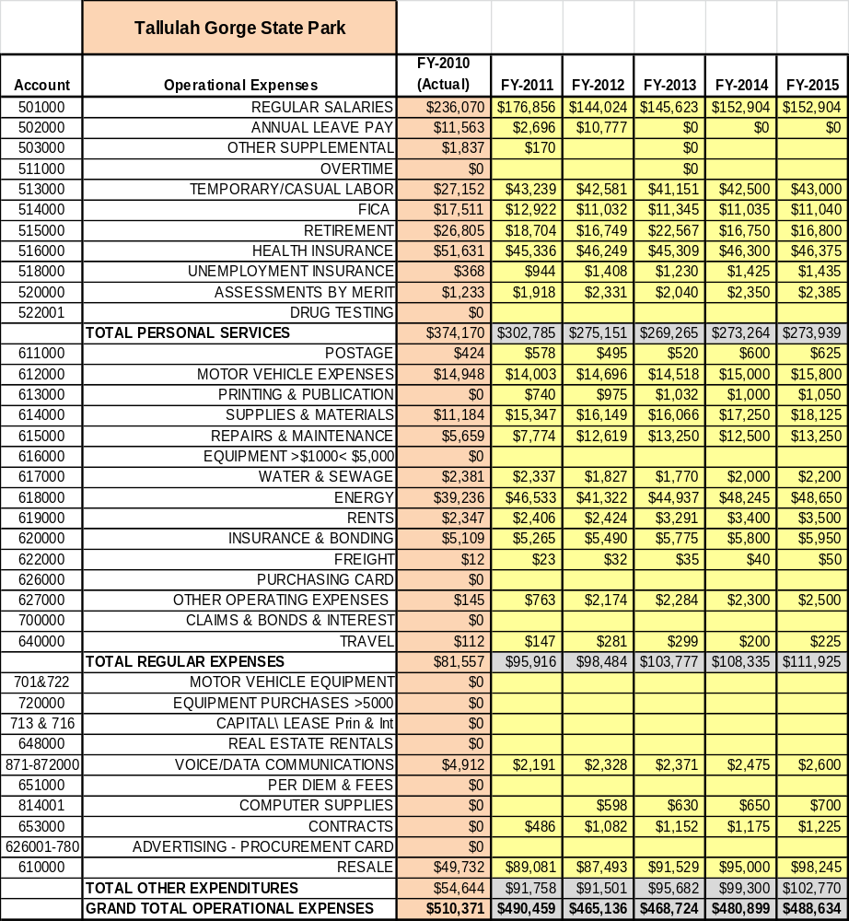

Revenue Pro Forma
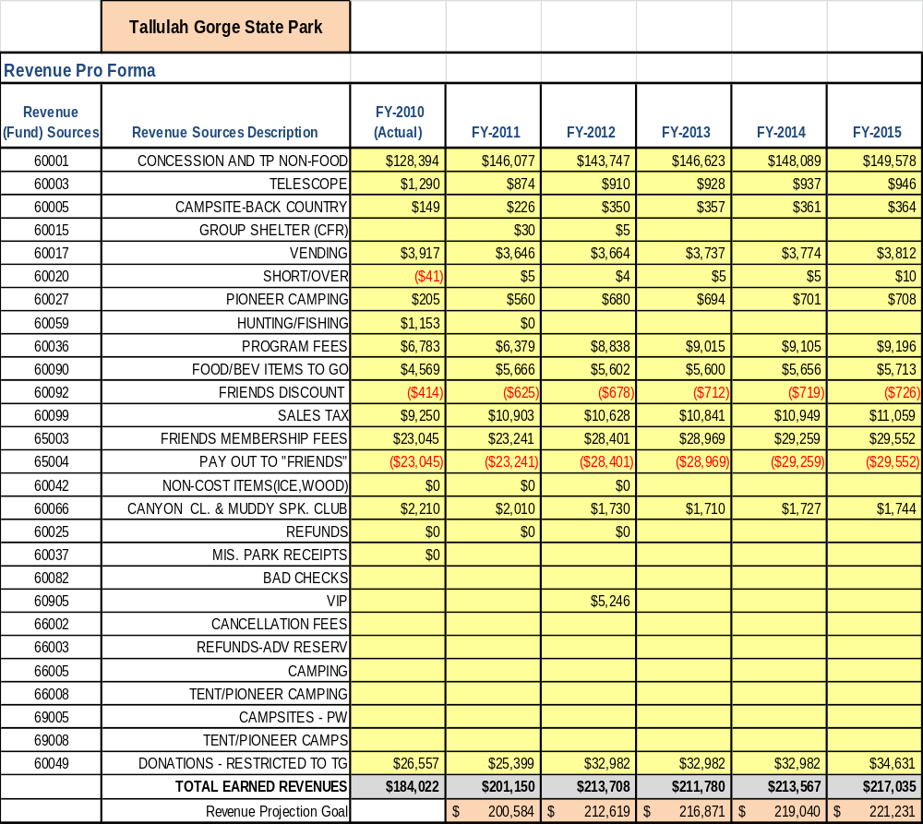

Total / Cost Recovery Pro Forma
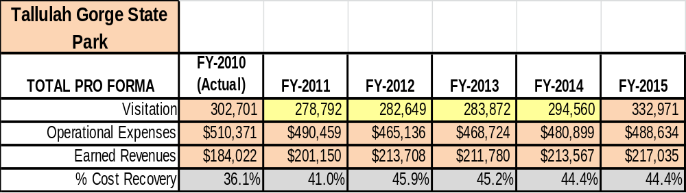

Action Plan
ACTION PLAN
Site: Tallulah Gorge State Park |  | Site Manager: Danny Tatum |  |  | Date:
Month:
Strategy | Tasks | Costs / Funding | Revenues / ROI | Responsibilities | Metrics

ACTION PLAN
Site: |  | Site Manager: |  |  | Date:
Month:
Strategy | Tasks | Costs / Funding | Revenues / ROI | Responsibilities | Metrics

