Travelers Rest Historic Site
Business & Management Plan

Prepared June 2011; Finalized April 2013
Direction 2015 – Sustainable Business Planning

Table of Contents

Executive Summary 3

Site and Operations Assessment 6
Site Inventory and Facility Assessment 6
Operational Assessment 8
Financial Performance Assessment 13

Business and Management Plan 17
Business Goals 17
Classification of Programs and Services 18
Partnership Development Plan 19
Marketing and Sales Plan 20
Revenue Generation Plan 22
Expense Management Plan 24
Financial Pro Forma 25

Action Plan 27

Executive Summary
The Parks, Recreation and Historic Sites Division (PRHSD) of the Georgia Department of Natural Resources (DNR) is transitioning the management of Travelers Rest Historic Site to operate more like a business, reflecting the Direction 2015 – Sustainable Business Planning initiative to improve the fiscal performance and management of the state parks and historic sites system. This business and management plan is designed to help the site recover more operating expenses through earned revenues, productive partnerships, and innovative programs.

Site Fact Sheet
Site Name | Travelers Rest Historic Site
Site Manager | Robert Emery, Park Manager, Tugaloo State Park
Region Manager | Joe Yeager
Date of Business Plan completion | June, 2011
Site size | 6 acres
Total number of visitors (FY 2010) | 823
Total operating budget (FY 2010) | $7,663
Total earned revenues (FY 2010) | $2,247
Operational cost recovery (FY 2010) | 29%
Average operating cost per visitor (FY 2010) | $9.31
Average earned revenue per visitor (FY 2010) | $2.73
Average cost recovery (FY 2008 – 2010) | 17%
Target cost recovery (FY 2015) | 45%
Total full-time employees | 0
Total part-time employees | 1
Primary service markets | Atlanta, Greenville/ Spartanburg, Western NC
Primary attractors/visitor appeal factors | Historical Site
Leading opportunities for improved site performance | Consistent hours of operation, more special events including school programs

Site Summary and Key Attractions

Key Attractions
The amenities or features listed below are those that seem to be most popular for visitors.
- 6,000 square foot stagecoach inn, built in the early 1800’s.
- Antique collection, many of the original furnishings of the house
- Original and restored outbuildings typical of the farm life of the early 1800’s
- 2-3 special events annually

Financial Targets
The table below details the total operating expenses and earned revenues for Travelers Rest Historic Site over the last three years (2008 – 2010). This table also calculates total cost per visitor and revenues per visitor during these operating years, and details the target financial performance goals in the context of achieving at least 30% cost recovery. This table also calculates the necessary change from 2010 operating expenses and revenues.

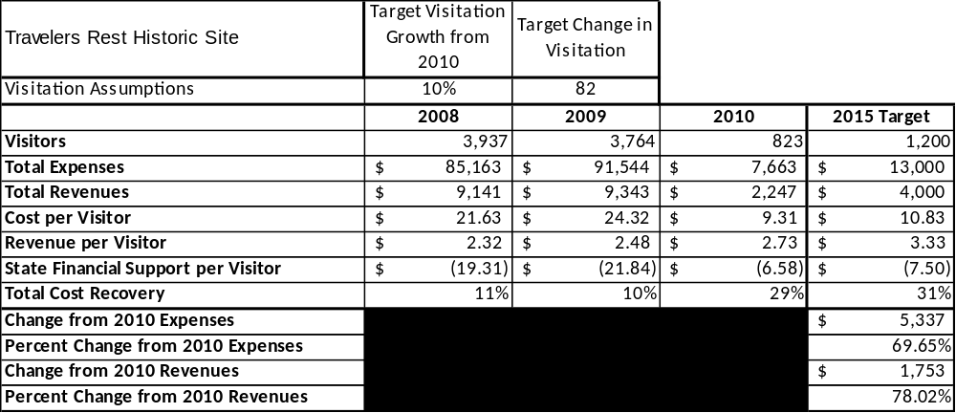

Key Recommendations

Primary / Short Term Recommendations
- Travelers Rest needs to be open every Saturday and on other days as requested. To do otherwise, we fail to meet our #1 core service: Open and public access to the site and its resources.
- A large portion of the operation of Travelers Rest is currently being funded by the Travelers Rest Friends group. Of the four or five days that the site is open each month, the state pays for operations (including labor and utilities) one day and the Friends Group pays for 3 or 4 additional days. The recommendation is for the state to fund the operation of the site each Saturday, and allow the Friends Group to use its funding for organized groups and special events. The expense and revenue figures presented here are based on this scenario.

Secondary / Long Term Recommendations

The site, in coordination with the Friends Group, should offer 3-4 special events each year.
- School programs should be offered on an as needed basis. An effort should be made to reach out to the local schools to have more school programs.

Site and Operations Assessment
This site and operations assessment is a culmination of analyses and findings from a review of the condition of facilities, infrastructure, and operations at Travelers Rest Historic Site. The findings and observations are not intended to be an exhaustive review of all issues present, but provide a basic understanding of the predominant issues that contribute to the site’s current operating conditions. The assessment includes the following:
- Site Inventory and Facility Assessment
- Operational Assessment
- Financial Assessment
Site Inventory and Facility Assessment

Methodology
Facility and asset conditions are rated using a differential scale of excellent, good, fair, or poor. Descriptions of conditions that are attributed to each of these findings are also provided.
Scale of Conditions
Rating | General Description
Excellent | Facilities/amenities are in ‘excellent’ condition when they show little or no maintenance or repair problems. Facilities do not feature any major design or operational issues or flaws that contribute to diminished use or increased maintenance or upkeep. Facilities are easy to clean and maintain in order to place them back into public use and the users perceive them to be in excellent shape.
Good | Facilities/amenities are in ‘good’ condition when they show only minor maintenance or repair problems. Most maintenance issues with these facilities typically appear to be the result of age and/or heavy use. Facilities may only feature minor design or operational issues that contribute to diminished use or increased maintenance or upkeep. Facilities are moderately easy to clean and maintain in order to place them back into service and the users perceive them to be adequate for their use, but probably not in excellent shape.
Fair | Facilities/amenities are in ‘fair’ condition when they show significant maintenance or repair problems. Facilities generally exhibit ongoing maintenance issues that appear to be the result of age, heavy use, or design or operational flaws. Some maintenance and repair needs may compound their fair condition by being deferred because of budget and/or resource limitations. Facilities require more effort to clean and maintain before placing them back into service and the users may perceive them as being less than adequate for their use and in a state of deterioration. The facility or structure may need of major repair or replacement.
Poor | Facilities/amenities are in ‘poor’ condition when they show significant, on-going maintenance or repair problems that ultimately may result in suspended use for repair/replacement. Maintenance and repair issues are possibly the result of poor maintenance and clearly the result of age, heavy use, or design or operational flaws. Problems with the facilities are often compounded over time due to consistently-deferred maintenance and repair because of budget and/or resource limitations. Facilities may feature major design or operational issues that contribute to diminished use or increased maintenance or upkeep. Facilities require excessive effort to clean and maintain before placing them back into service and the users often perceive them as being inadequate for their use and in a state of serious deterioration. The facility or structure may need of major repair or replacement.

Inventory and Assessment
The table below is an inventory of facilities and amenities at Travelers Rest Historic Site, and provides the assessed condition of each as reviewed in June, 2001.
Site Asset / Amenity | Quantity | Condition
Historic Stagecoach Inn  (Original | 1 | Fair
Mammy’s Cabin | 1 | Fair
Adam’s Cabin | 1 | Fair
Loom Room | 1 | Fair
Smokehouse | 1 | Good
Well House | 1 | Good
Rest Station | 1 | Good
Residence | 1 | Good
Residence Storage | 1 | Good

Prioritized Facility Needs
Based on the facility inventory and assessment, these prioritized needs have been identified. Each need has been aligned with a priority category of high, moderate, or low to support future decision making regarding project sequencing, investment of public resources, and meeting community expectations. The priority assignment for each need is not a measure of importance. Rather, these recommended priorities reflect a phased implementation approach over the next several years.

Facility Need | Priority Assignment
Shingle Roof for Main House | High
Upgrade Security/ Fire System | Medium
Various carpentry repairs, including rails on back deck of main house | Medium

Operational Assessment
The Operational Assessment includes:
- An inventory and classification of programs and services being provided at the site
- A review of staffing at the site
- A review of concessionaires and partners operating at the site
- Visitation and customer satisfaction

Inventory and Classification of Programs and Services
Programs and services are classified into one of three major categories:
1) Core or Essential Services
2) Important Services
3) Visitor Supported Services
Programs and services at the site are classified into these categories based in part on the mission and public mandates for both the site and the agency. For the pservices in each of these categories, there are financial performance expectations that will define how services are funded and evaluated.

Category 1 – Core Services [Largely supported by tax funds]
Core programs, services and facilities are those the agency must provide and/or are essential in order to capably govern and meet statutory requirements. The failure of the agency to provide Category 1 services at adequate levels could result in significant negative consequences for the public and the resources under protection. The criteria for services to be classified as core or essential are:
- The services are mandated by the agency’s law or charter or are contractually obligated by agreement to provide the services.
- The services are essential to protecting and supporting the public’s health and safety.
- The services protect and maintain valuable assets and infrastructure.
- The services would generally and reasonably be expected and supported by residents, businesses, customers and partners.
- The services are those that cannot or should not be provided by the private sector.
- The services provide a sound investment of public funds.
The following services offered at Travelers Rest Historic Site have been identified as core services:
- Open and public access to the site and its resources
- Active management of the natural and cultural resources of the site
- Artifact management
- Site appropriate education, interpretation, and recreational opportunities
- Public safety
- Maintenance of grounds, facilities, and infrastructure

Category 2 – Important Services [Supported by a balance of tax funds and earned revenues]
Important programs, services and facilities are those the agency should provide, and are important to governing and effectively serving residents, businesses, customers and partners. Providing Category 2 services expands or enhances the agency’s ability to provide and sustain its core services. The criteria for programs or services to be classified as important are:
- The services expand, enhance or support identified core services.
- The services are broadly supported and utilized by the community, and are considered an appropriate, important, and valuable public good. Public support may be conditional upon the manner by which the services are paid for or funded.
- The services generate income or revenue that offsets some or all of the operating cost and/or are deemed to provide economic, social or environmental outcomes or results.
The following programs and services offered at Travelers Rest Historic Site have been identified as important services:
- Interpretive and educational programming
- Special events

Category 3 – Visitor Supported Services [Almost exclusively supported by earned revenue]
Visitor supported programs, services and facilities are those discretionary services that the agency may provide when additional funding or revenue exists to offset the cost of providing those services. Category 3 services provide added value above and beyond what is required or expected. The criteria for programs or services to be classified as visitor supported are:
- The services expand, enhance or support core services or important services and the quality of life of the visitors, community or stakeholders.
- The services are supported, valued and well utilized and provide an appropriate and valuable public benefit.
- The services generate income or funding from sponsorships, grants, user fees or other sources that offset some or all of their cost and/or provides a meaningful return on investment.

- The services can possibly be provided through outsourcing or use of concessionaires, providing opportunities for community enterprises that may not otherwise be provided by the agency.

The following programs and services offered at Travelers Rest Historic Site have been identified as visitor supported services:
- Educational programs
- Special tours

Staffing Assessment
Labor costs at Travelers Rest represent the largest area of budgetary expense at an average of 58% of the total operating budget each year for the last three complete years, which is lower than the target of total labor costs (including benefits) not exceeding 65% of the site’s total operating expenditures. The tables below and on the following page provide a basic review of the current staffing at the site.

Full Time Equivalent Employees
Position / Title | Quantity (FTE) | Vacancies | Annual Hours
None | 0 | 0 | 0
TOTAL | 0 | 0 | 0

Part Time Employees
Position / Title | Quantity (FTE) | Vacancies | Hours
Tour Guide | 1 | 0 | 102
TOTAL | 1 | 0 | 102

Labor Support
Labor Support | Annual Hours
Volunteers | 200
Community Service Workers | 0
Engineering and Construction Crews | 80
Resource Management Crews | 12
Staff paid by Friends Group | 408
Tugaloo Staff Support | 300
TOTAL | 1,000

Total Labor Hours
Labor Type | Annual Hours
Full Time Equivalent Employees | 0
Part Time Employees | 102
Labor Support | 1,000
TOTAL Annual Labor Hours | 1,102

Labor Budget Summary

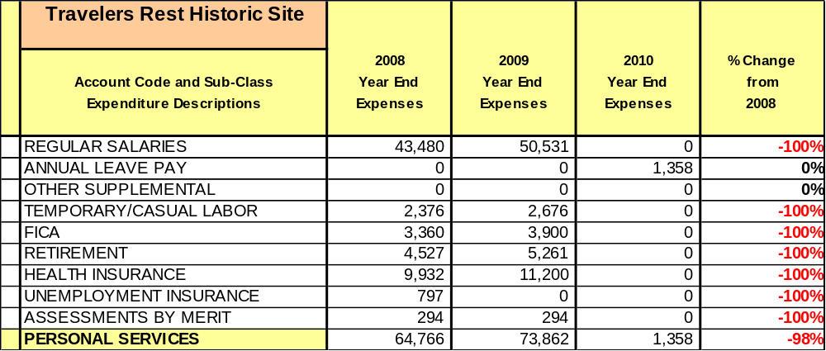
Note: About $800 in Temporary/ Casual Labor funds are currently used out of the Tugaloo State Park budget to allow Travelers Rest to be open one day a month.

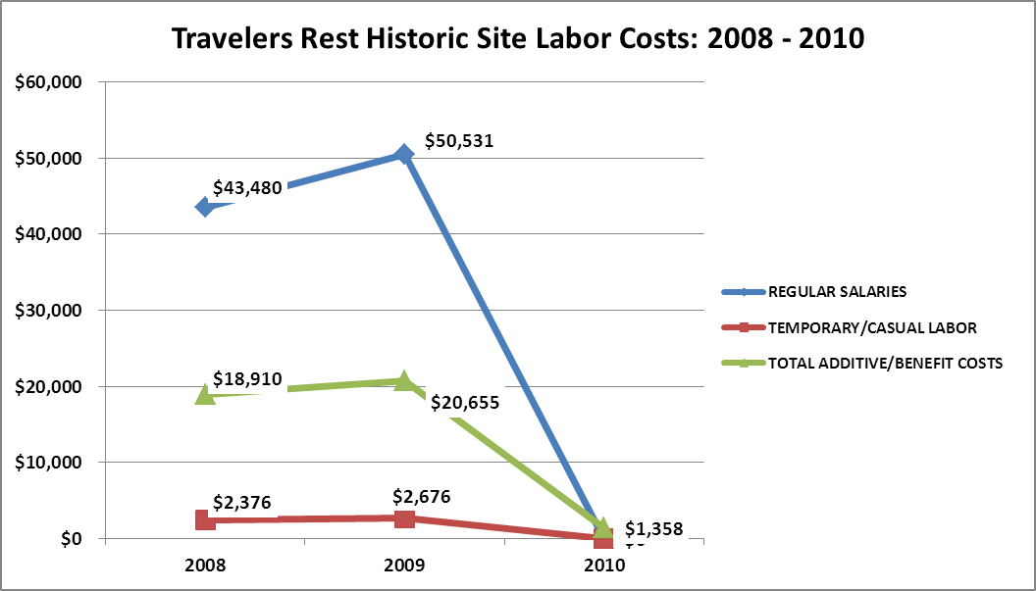

Visitation and Occupancy
Overall annual visitation to the site has trended downward from 2008 to 2010, decreasing by 478% or over 3,114 visitors. This is largely attributed to the fact that the site’s hours and days of operation have been cut drastically.

Year | Total Visitation
2008 | 3,937
2009 | 3,764
2010 | 823

Customer Service and Satisfaction

Site | Year | Customer Satisfaction Level
Travelers Rest Historic Site | 2009 | 95%
Travelers Rest Historic Site | 2010 | 100%
Financial Performance Assessment

Operational Expenses
A summary of total operating expenses a Travelers Rest Historic Site from 2008 to 2010, as well as their percent change from 2008 are provided in the table below.
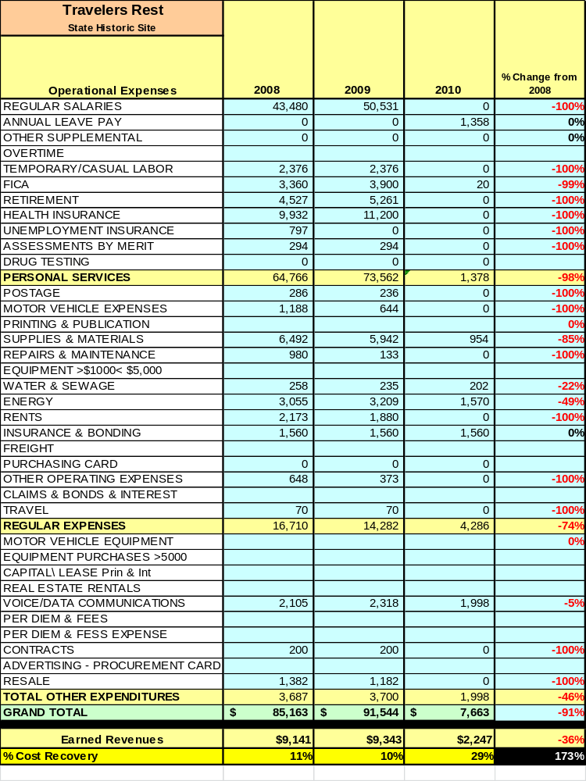

Earned Revenues
Earned revenues at Travelers Rest Historic Site have decreased since 2008, which is largely attributed to the corresponding decrease in overall visitation. This decrease can mostly be attributed to a decrease in operational hours for the site due to budget cuts.
Monthly earned revenues for the last two years (see table on the following page) indicate that the total annual revenue decreased 70% from 2009 to 2010, with the largest decreases in the months of
July (-95%), September (-93%), October (-91%) and February (-84%). Again, these decreases are mostly due to the cuts in operational hours for the site from 5 to 3 days a week to 1 to 5 days a month.

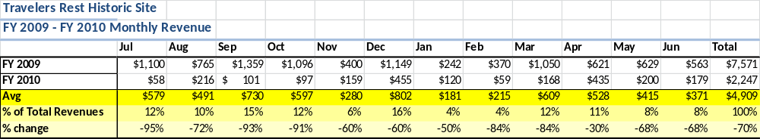
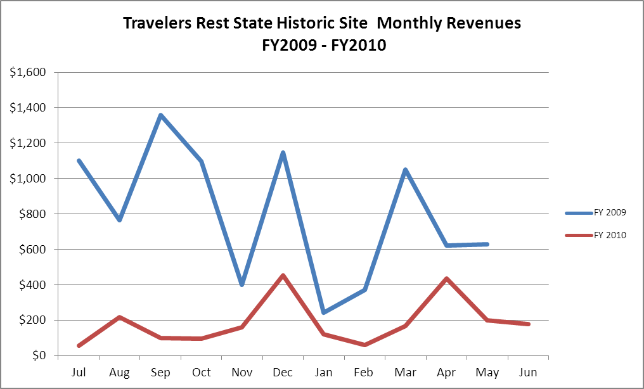

The graph below illustrates the monthly revenue trends each year and the average percent of total annual revenue earned each month.
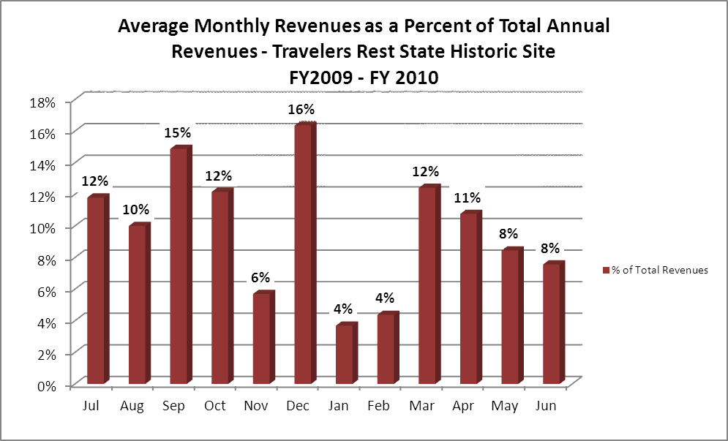

Cost Recovery Trends
Travelers Rest Historic Site has achieved an average cost recovery of 17% of annual operational expenses through earned revenues from FY 2008 to FY 2010. This is detailed and illustrated in the table and graph below.
Year | Operational  Expenses | Earned  Revenues | Percent Cost  Recovery
2008 | $100,466 | $9,141 | 9%
2009 | $51,187 | $9,343 | 18%
2010 | $7663 | $2,247 | 29%
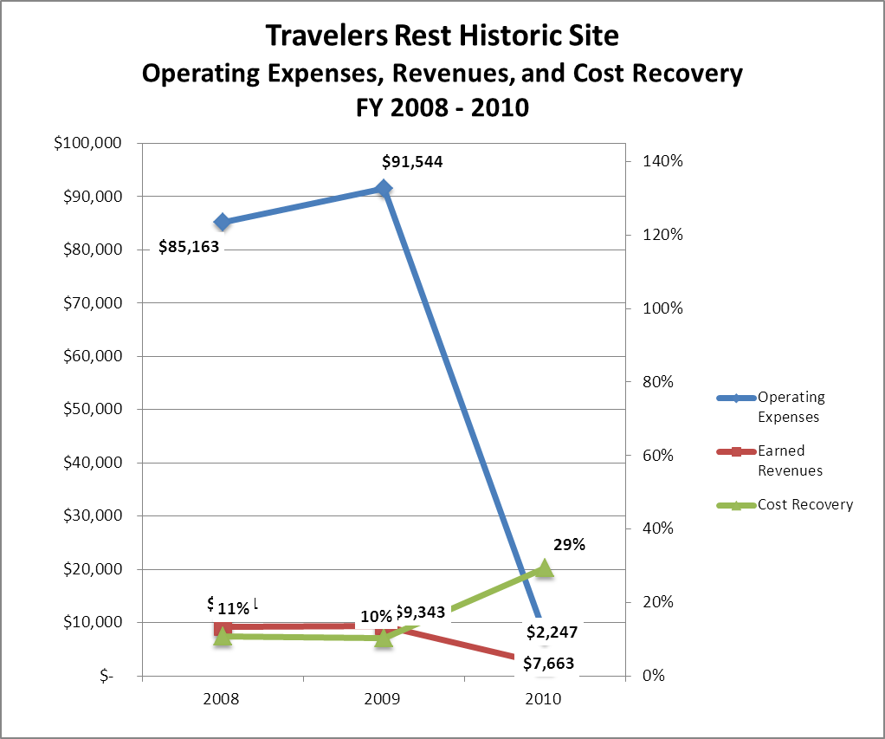

Review of Pricing
Data on rate information is available as far back as 2002, but only the last five years are evaluated. There has not been a notable growth in fees charged at Travelers Rest Historic Site since 2008. A table detailing the rates for Travelers Rest is provided below.
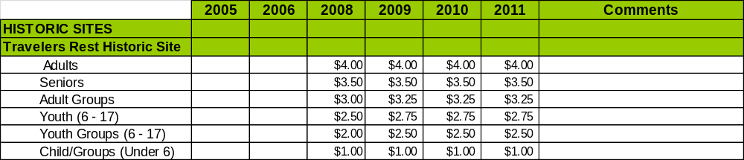

Business and Management Plan

Business Goals
The following goals serve as the foundation for the key recommendations and strategies in this business plan for Travelers Rest Historic Site.

Enhance Cost Recovery of Site Operations
In order to have any improved cost recovery, or even maintain the current cost recovery at this site, it must be open at least every Saturday, and at other times when organized groups wish to visit.

Enhance Revenue Generation Strategies
Revenue generation at this site is tied to the hours of operation and special events. If additional revenue is to be generated, it must be through these two avenues. There is some limited potential for resale improvements.

Expand Special Events at the Site
Additional special events at the site would be well accepted and successful. At this time, however, there is no staff to coordinate these and very limited funds in order to put them on.

Improve the Diversity and Innovation of Recreational and Interpretive Programs
This will be difficult with current staffing levels, but working with an active Friends group, some additional opportunities are possible.

Improve the Effectiveness of Marketing and Sales
We need to be sure that limited hours are consistent and consistently advertised, so that customers do not arrive when the site is closed. The days of operation have been changed at this site a number of times over the past several years.

Establish Greater Consistency of Managing and Monitoring Customer Service & Satisfaction
Historically, visitors to this site are almost always pleased with their visit.

Expand Partnership Opportunities
Partnership opportunities that have been established should be maintained and expanded if possible: the Stephens County Chamber of Commerce, the Stephens County Foundation, and the Stephens County Historical Society. The Travelers Rest Friends group should be expanded if possible. The possibility of a future partnership with the Hardman Farm exists, which was linked to Travelers Rest by way of the Unicoi Turnpike.

Classification of Programs and Services
The tables below summarize the classifications of programs and services at Travelers Rest Historic Site as either core, important, or visitor supported and projects a range of cost recovery percentages that might be achieved for each. These classifications establish financial performance goals for each category of services that are linked to the recommendations and strategies of this business plan.
Core Services
Program / Service | Target Cost Recovery
Open and public access to the site and its resources | 100%
Active management of the natural and cultural resources of the site | 0%
Artifact management | 0%
Site appropriate education and interpretation opportunities | 50%
Public safety | 0%
Maintenance of grounds, facilities and infrastructure | 0%

Important Services
Program / Service | Target Cost Recovery
Interpretive and educational programming  - Special Events | 50%
Special events | 100%

Visitor Supported
Program / Service | Target Cost Recovery
Educational programs | 120%
Special ours | 120%

Partnership Development Plan
The table below summarizes existing partners and targeted partnerships by classification (operational, vendor, service, co-branding, funding partners) and by organizational type.
 | Public Partners | Not-for-profit Partners | Private / Enterprise Partners
Operational Partners |  | - Friends of Travelers Rest
Vendor Partners
Service Partners |  | - Chamber of Commerce  - Stephens County Historic Society
Co-branding Partners | - Tugaloo State Park  - Hardman Farm | - Curahee Museum
Funding Resource Development Partner |  | - Stephens / Tugaloo Corridor Foundation  - Friends of Georgia State Parks

Marketing and Sales Plan

Marketing and Sales Goals
Marketing and sales goals for Travelers Rest Historic Site are based on the following desired outcomes:
- To develop more interpretive programs to draw visitors to the site.
- To produce increased visitation and revenue.
In order to meet these goals, examples of specific target outcomes were identified in the areas detailed in the table below.

Area  of Focus | Current  Performance | Goal  by 2011 | Goal  by 2012 | Goal  by 2015
Special Events | 2 per year | 3 per year | 4 per year | 5 per year
Overall Visitation | 823 | 1,000 | 1,100 | 1,300

Marketing and Promotion Strategies

Publicity and Social Media
Travelers Rest Historic Site will approach marketing and publicity planning using the following guidelines and themes:
- Event publicity
Major events benefit by having short stories in local, regional, and statewide newspapers and online social media hooks planted that run three to four weeks in advance of the event up to the date of the event itself. Stories and media need to be cultivated with contacts and online sales channels several weeks in advance of the time the stories need to run. Special interest interviews on morning, noon, and evening television news programs, radio interviews on popular rush-hour programs, and blogs on known affinity online sites should also be included.
- Program publicity
Special and unique programs should have feature stories in magazines, local and regional weekly newspapers, and statewide daily newspapers that are aimed at placements as front-page or sectional front-page stories. These stories are most effective if they run shortly before the season that the featured program begins. This will likely require several weeks of advanced planning with media contacts. Similar coverage on television and radio should also be considered. If pre-publicity cannot be generated, post-publicity can help promote future programs.
- Site Publicity
Site publicity focusing on a single site or sub-set of sites requires more intense planning efforts to attract multiple writers and editors from target publications. The site could host several seasonal media familiarization tours (with 10 to 15 writers or editors) to familiarize them with the site and its benefits and amenities. Stories and features resulting from such tours typically take between two and six months to materialize so the tours should focus on experiences, benefits, and programs that would be available when the stories are expected to run.
Examples and suggested opportunities for events, programs and related publicity efforts based on the themes described above at Travelers Rest Historic Site are provided in the table below.

Event Publicity | Program Publicity | Site Publicity
Christmas for Travelers | Black History Month/ Candlelight Tour
Pioneer Day
Storytelling Event

Packaging
Examples and suggested packages for Travelers Rest Historic Site are provided in the table below.

Package | Package Details
Travelers Special | Free admission with cottage rental at Tugaloo State Park

Group Sales
Types of groups within which specific target customers can be identified for Travelers Rest Historic Site are listed below:
- Families | - Historical Clubs/ Groups | - School Groups

Incentivizing New and Repeat Visitation
Travelers Rest Historic Site will utilize the following strategies and/or incentives to encourage new and repeat visitation starting in FY 2012:
- Offer additional special events through the Friends Group to attract repeat visitors.

Marketing and Sales Metric Goals
The following marketing and sales metric goals and/or others will be monitored and progress reported at Travelers Rest Historic Site:
- Loyalty and repeat customers = Overall site visitation, special event attendance.
- Brand confidence & customers-recruiting-customers = Overall site visitation, special event attendance.
Revenue Generation Plan
Revenue / Cost Recovery Goals
Travelers Rest Historic Site has set a financial goal of increasing annual revenues 2% annually between 2012 and 2015. The largest revenue growth opportunity is most likely special events and programs. The table below details projected revenue growth leading up to 2015, based upon a nominal growth of revenues each year.

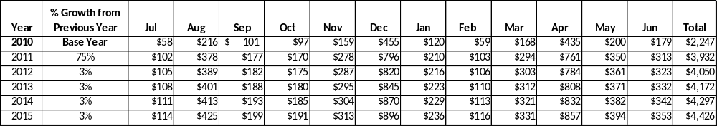

We are projecting a large increase in 2011, mainly because of increased hours during the year. This is a realistic total for FY11, so basing future numbers on FY2010 (when the site hours were lower) would not have given us a realistic figure for the future.

These projections would result in a total of 97% cumulative growth in total annual revenues between FY2010 and FY2015. If operational expenses can be managed with a cumulative increase of 70% between FY 2010 and FY 2015, then the overall cost recovery of the site will be approximately 34% in FY 2015 at these projected revenue levels. This is higher than the annual financial performance of the site in FY 2010, which was operated at 29% cost recovery in that year.

Revenue Generation Strategies

Pricing Plan
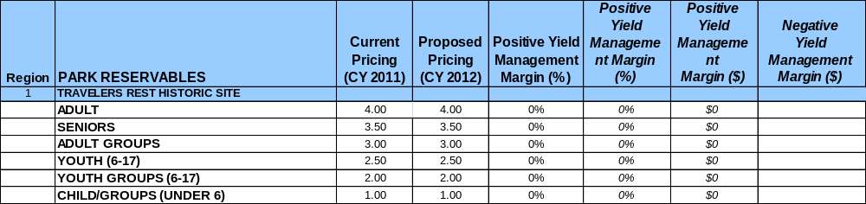
Innovative Programming and Special Events Plan
Program / Event | Theme / Purpose | Scheduled Date/Season | Frequency | Target Participation | Target User Fee | Target Cost Recovery
Christmas for Travelers | Historical Interpretation | December | 1 annual | 1000 | Regular Admission | 120%
Pioneer Day | Historical Interpretation | September | 1 annual | 500 | Regular Admission | 120%
Candlelight Tour | Historical Interpretation | February | 1 annual | 250 | Regular Admission | 120%
Storytelling Event | Historical Interpretation | June | 1 annual | 100 | Regular Admission | 120%
Paddling in the Past | Historical Interpretation | May | 1 annual | 20 | $20 per person | 100%

Expense Management Plan
Personnel Assignments
The following actions will be taken to proactively manage labor costs via personnel assignments and classifications.

Action | Timeline | Outcome
Schedule volunteers to assist with special events | Ongoing | Success will depend on getting use more volunteers

Management Techniques
The following actions will be taken to proactively manage labor costs via management techniques.

Action | Timeline | Outcome
Use volunteers to help with special events | Ongoing | Labor savings, better events
Use volunteers to help maintain grounds | 2012 | Friends Work Day

Adjusted Levels of Service
The following actions will be taken to proactively manage labor costs via reduced levels of service.

Action | Timeline | Outcome
Cut hours of operation (this has already been done) | Ongoing | Decrease in visitation/ revenue

Financial Pro Forma
The following five-year financial pro forma projects operating expenses, earned revenues and cost recovery through FY 2015. These pro forma are based on the strategies and desired outcomes identified in this business plan, especially the revenue generation and expense management plans, and are linked to corresponding performance goals.

Expense Pro Forma
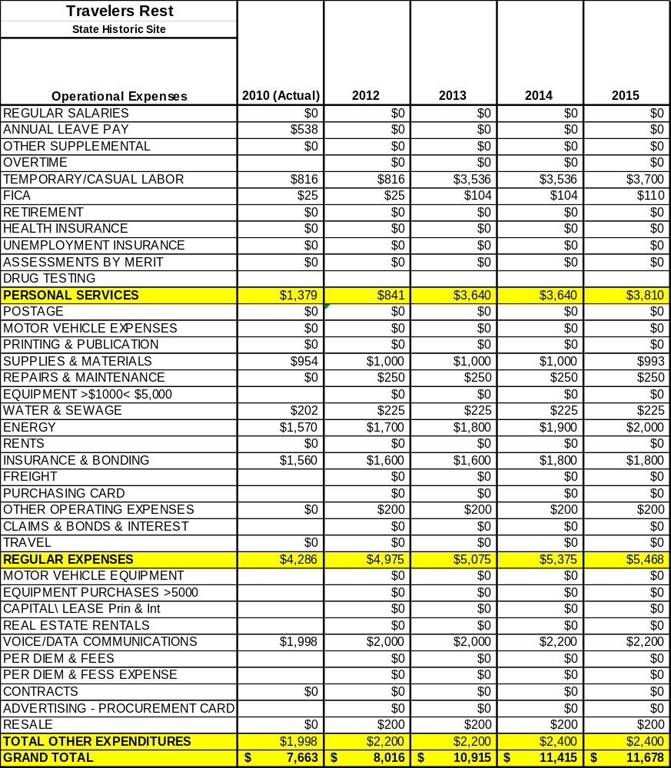

Revenue Pro Forma
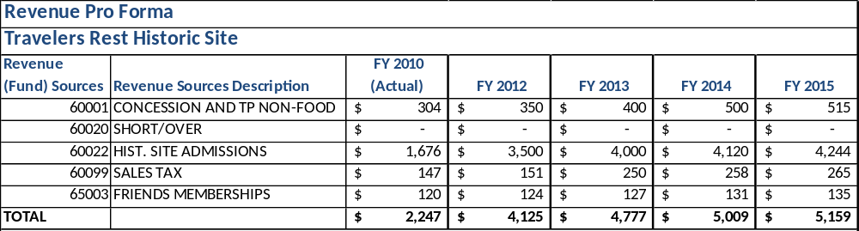

Total / Cost Recovery Pro Forma
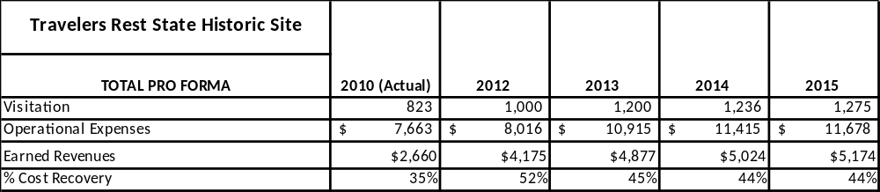

Action Plan
ACTION PLAN
Site: |  | Site Manager: |  |  | Date:
Month:
Strategy | Tasks | Costs / Funding | Revenues / ROI | Responsibilities | Metrics

ACTION PLAN
Site: |  | Site Manager: |  |  | Date:
Month:
Strategy | Tasks | Costs / Funding | Revenues / ROI | Responsibilities | Metrics

This is the average of the last three years – FY 2008, FY 2009, and FY 2010
Current employees, not including vacancies.
Current employees, not including vacancies.
Major population centers within a two-hour drive from the site

