

Tugaloo State Park
Business & Management Plan
June 2011

Direction 2015 – Sustainable Business Planning

Table of Contents

Executive Summary 3

Site and Operations Assessment 6
Site Inventory and Facility Assessment 6
Operational Assessment 8
Financial Performance Assessment 14

Business and Management Plan 18
Business Goals 18
Classification of Programs and Services 19
Partnership Development Plan 20
Marketing and Sales Plan 21
Revenue Generation Plan 23
Expense Management Plan 23
Financial Pro Forma 26

Action Plan 31

Executive Summary
The Parks, Recreation and Historic Sites Division (PRHSD) of the Georgia Department of Natural Resources (DNR) is transitioning the management of Tugaloo State Park to operate more like a business, reflecting the Direction 2015 – Sustainable Business Planning initiative to improve the fiscal performance and management of the state parks and historic sites system. This business and management plan is designed to help the site recover more operating expenses through earned revenues, productive partnerships, and innovative programs.

Site Fact Sheet
Site Name | Tugaloo State Park
Site Manager | Robert Emery
Region Manager | Joe Yeager
Date of Business Plan completion | Prepared 6/12/11; Finalized 3/8/12
Site size | 393 acres
Total number of visitors (FY 2010) | 401,715
Total operating budget (FY 2010) | $ 547,367
Total earned revenues (FY 2010) | $ 584,724
Operational cost recovery (FY 2010) | 107%
Average operating cost per visitor (FY 2010) | $ 1.36
Average earned revenue per visitor (FY 2010) | $ 1.46
Average cost recovery (FY 2008 – 2010) | 102%
Target cost recovery (FY 2015) | 110%
Total full-time employees | 7
Total part-time employees | 12
Primary service markets | Atlanta, Greenville/Spartanburg, Asheville
Primary attractors/visitor appeal factors | Lake Hartwell, camping, cottages, boat ramps, swimming beach, trails
Leading opportunities for improved site performance | New mega ramp facility, upcoming tent and yurt camping area, additional recreation rentals

Site Summary and Key Attractions
Tugaloo State Park is located on the shores of Lake Hartwell in Northeast Georgia. Visitors come to the site mainly for the outdoor experience and the access to Lake Hartwell. The site is easily accessed from I-85 and not only draws a lot of visitors from northeast Georgia, but also upstate South Carolina and western North Carolina.

Key Attractions
The amenities or features listed below are those that seem to be most popular for visitors.
- Lake Hartwell access
- Campgrounds, regular and primitive
- Cottages
- Swimming and beach area
- 3 boat ramps including large tournament facility
- Picnic areas, 7 shelters, 2 group shelters
- Pioneer camping
- Tennis courts
- 4 miles of trails
- 2 playgrounds
- Nature center/ amphitheater
- Special events/ interpretive programs

Financial Targets
The table below details the total operating expenses and earned revenues for Tugaloo State Park over the last three years (2008–2010). This table also calculates total cost per visitor and revenues per visitor during these operating years, and details the target financial performance goals in the context of achieving at least 110% cost recovery. This table also calculates the necessary change from 2010 operating expenses and revenues.

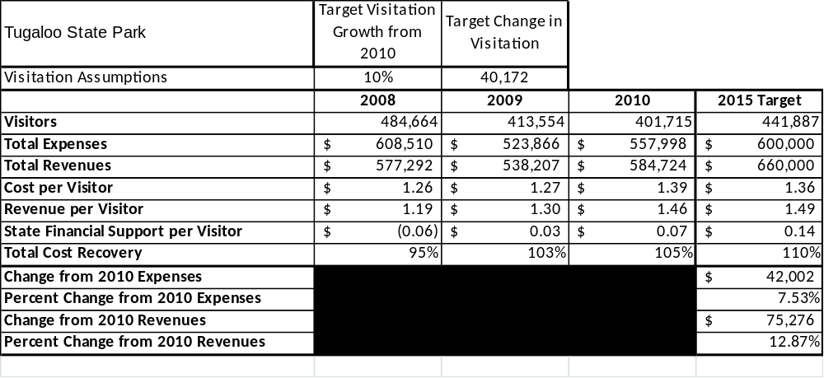

Key Recommendations

Primary / Short Term Recommendations
- Achieve a goal of 110% cost recovery by 2015, using a variety of strategies as described below.
- Pursue a new pricing strategy to achieve a cottage occupancy rate of 42% and a reconfiguration of the campground to achieve a campsite occupancy rate of 32% by 2015.
- Drop the 7-night minimum on cottages during the summer and try a 5-night minimum with no specific check-in days. Monitor the impact of this on the housekeeping staff.
- Consider adding one or two more dog cottages, based on the current demand.
- Add two additional campground hosts during nine months of the year to assist with staff cuts and add one additional host when tent camping and yurt areas come on line.
- Utilize a minimum of 10-12 special events each year which will include 3-4 major fishing tournaments, 2-3 other major events, and 5-6 interpretive events to draw additional guests to the site.
- Manage Tugaloo State Park according to well defined maintenance, program and operational standards.
- Continue the process of upgrading and repairing an aging infrastructure. Specific areas that need to be addressed are roads, campsite upgrades and day-use restroom facilities.
- Look for opportunities to grow the retail operation (with limited space considered) to increase site generated revenues.
- Market and promote the new tent/yurt camping area when it comes on line, to appeal to a new segment of users, as well as current tent campers.

Secondary / Long Term Recommendations
- Continue to develop partnerships with the City of Lavonia, Franklin County and Stephens County Chambers of Commerce and government agencies to bring regional fishing tournaments and other events to the site.
- Grow the Friends of Tugaloo State Park to have more involvement in other aspects of the park operation other than the boat ramp, as well as continued involvement with the boat ramp operation.
- Track the total economic impact of the site on the local community and region and share this information with decision-makers, elected officials, local business operators, and others to demonstrate the impact of Tugaloo State Park.
- Review and update rates on an annual basis to recover the net cost of visitor supported services.
Site and Operations Assessment
This site and operations assessment is a culmination of analyses and findings from a review of the condition of facilities, infrastructure, and operations at Tugaloo State Park. The findings and observations are not intended to be an exhaustive review of all issues present, but provide a basic understanding of the predominant issues that contribute to the site’s current operating conditions. The assessment includes the following:
- Site Inventory and Facility Assessment
- Operational Assessment
- Financial Assessment

Site Inventory and Facility Assessment

Methodology
Facility and asset conditions are rated using a differential scale of excellent, good, fair, or poor. Descriptions of conditions that are attributed to each of these findings are also provided.
Scale of Conditions
Rating | General Description
Excellent | Facilities/amenities are in ‘excellent’ condition when they show little or no maintenance or repair problems. Facilities do not feature any major design or operational issues or flaws that contribute to diminished use or increased maintenance or upkeep. Facilities are easy to clean and maintain in order to place them back into public use and the users perceive them to be in excellent shape.
Good | Facilities/amenities are in ‘good’ condition when they show only minor maintenance or repair problems. Most maintenance issues with these facilities typically appear to be the result of age and/or heavy use. Facilities may only feature minor design or operational issues that contribute to diminished use or increased maintenance or upkeep. Facilities are moderately easy to clean and maintain in order to place them back into service and the users perceive them to be adequate for their use, but probably not in excellent shape.
Fair | Facilities/amenities are in ‘fair’ condition when they show significant maintenance or repair problems. Facilities generally exhibit ongoing maintenance issues that appear to be the result of age, heavy use, or design or operational flaws. Some maintenance and repair needs may compound their fair condition by being deferred because of budget and/or resource limitations. Facilities require more effort to clean and maintain before placing them back into service and the users may perceive them as being less than adequate for their use and in a state of deterioration. The facility or structure may need of major repair or replacement.
Poor | Facilities/amenities are in ‘poor’ condition when they show significant, on-going maintenance or repair problems that ultimately may result in suspended use for repair/replacement. Maintenance and repair issues are possibly the result of poor maintenance and clearly the result of age, heavy use, or design or operational flaws. Problems with the facilities are often compounded over time due to consistently-deferred maintenance and repair because of budget and/or resource limitations. Facilities may feature major design or operational issues that contribute to diminished use or increased maintenance or upkeep. Facilities require excessive effort to clean and maintain before placing them back into service and the users often perceive them as being inadequate for their use and in a state of serious deterioration. The facility or structure may need of major repair or replacement.

Inventory and Assessment
The table below is an inventory of facilities and amenities at Tugaloo State Park, and provides the assessed condition of each as reviewed in May, 2011.

Site Asset / Amenity | Quantity | Condition
Infrastructure- roads | 13.4 miles | Fair
Infrastructure- boat ramps bbbbbbbrboarrramramps | 3 | Excellent/Fair
Visitor Center | 1 | Fair
Park pass Kiosk | 1 | Good
Cottages 1-10 | 10 | Good
Cottages 11A-19 | 10 | Good
Picnic Shelters | 7 | Good
Pavilion | 1 | Good
Group Shelter | 1 | Fair
Campsites, Water and Electric | 105 | Fair
Campsites, Primitive | 6 | Fair
Campsites, Pioneer | 1 | Fair
Comfort Stations | 4 | Excellent
Rest Stations | 2 | Fair
Beach House | 1 | Fair
Concession Building | 1 | Fair
Maintenance Shop | 1 | Fair
Maintenance Outbuildings | 9 | Fair
Residences | 2 | Good
Stewart Lodge | 1 | Good
Residence Outbuildings | 2 | Good
Nature Hut | 1 | Good
Horse Barn | 1 | Fair
Trails | 4 miles | Good
Pit Privies | 5 | Good
Pump Houses | 6 | Fair
Linen House | 1 | Excellent
Cleaning Supply Storage | 1 | Fair
Playground Equipment | 2 | Good
Tennis Courts | 2 | Fair
Miniature Golf | 1 | Poor
Amphitheater | 1 | Good
Docks | 13 | Excellent/Good/Fair

Prioritized Facility Needs
Based on the facility inventory and assessment, these prioritized needs have been identified. Each need has been aligned with a priority category of high, moderate, or low to support future decision making regarding project sequencing, investment of public resources, and meeting community expectations. The priority assignment for each need is not a measure of importance; rather, these recommended priorities reflect a phased implementation approach over the next several years.

Facility Need | Priority Assignment
Roads - paving of 13.4 miles of roads plus cottage drives | High
Renovation of day-use restrooms, bathhouse, 2 rest stations | High
Rip-rap on cottage 11A-19 shoreline | High
Replace sewage systems in campground and beach area | High
Dock re-decking | High
Campsite renovation ( 25 sites) | High
Miniature golf renovation | High
Group shelter renovation | Moderate
Replace playground in camping area | Moderate
Office renovation/ expansion | Moderate
Tennis court resurfacing | Moderate
New maintenance facility | Moderate
Mega Ramp Improvements - restroom, seating, grass | Moderate

Operational Assessment
The Operational Assessment includes:
- An inventory and classification of programs and services being provided at the site
- A review of staffing at the site
- A review of concessionaires and partners operating at the site
- Visitation and customer satisfaction

Inventory and Classification of Programs and Services
Programs and services are classified into one of three major categories:
1) Core or Essential Services
2) Important Services
3) Visitor Supported Services
Programs and services at the site are classified into these categories based in part on the mission and public mandates for both the site and the agency. For the programs and services in each of these categories, there are financial performance expectations that will define how services are funded and evaluated.

Category 1 – Core Services [Largely supported by tax funds]
Core programs, services and facilities are those the agency must provide and/or are essential in order to capably govern and meet statutory requirements. The failure of the agency to provide Category 1 services at adequate levels could result in significant negative consequences for the public and the resources under protection. The criteria for programs or services to be classified as core or essential are:
- The services are mandated by the agency’s law or charter or are contractually obligated by agreement to provide the services.
- The services are essential to protecting and supporting the public’s health and safety.
- The services protect and maintain valuable assets and infrastructure.
- The services would generally and reasonably be expected and supported by residents, businesses, customers and partners.
- The services are those that cannot or should not be provided by the private sector.
- The services provide a sound investment of public funds.
The following programs and services offered at Tugaloo State Park have been identified as core:
- Open and public access to the site and its resources
- Public safety
- Active management of the natural and cultural resources of the site
- Maintenance of grounds, facilities and infrastructure

Category 2 – Important Services [Supported by a balance of tax funds and earned revenues]
Important programs, services and facilities are those the agency should provide, and are important to governing and effectively serving residents, businesses, customers and partners. Providing Category 2 services expands or enhances the agency’s ability to provide and sustain its core services. The criteria for programs or services to be classified as important are:
- The services expand, enhance or support identified core services.
- The services are broadly supported and utilized by the community, and are considered an appropriate, important, and valuable public good. Public support may be conditional upon the manner by which the services are paid for or funded.
- The services generate income or revenue that offsets some or all of the operating cost and/or are deemed to provide economic, social or environmental outcomes or results.
The following programs and services offered at Tugaloo State Park have been identified as important services:
- Providing public sales of fishing licenses
- Site appropriate basic education, interpretation and recreational opportunities
- Special events and programs to enhance education, interpretation and recreational opportunities appropriate to the site

Category 3 – Visitor Supported Services [Almost exclusively supported by earned revenue]
Visitor supported programs, services and facilities are those discretionary services that the agency may provide when additional funding or revenue exists to offset the cost of providing those services. Category 3 services provide added value above and beyond what is required or expected. The criteria for programs or services to be classified as visitor supported are:
- The services expand, enhance or support core services or important services and the quality of life of the visitors, community or stakeholders.
- The services are supported, valued and well utilized and provide an appropriate and valuable public benefit.
- The services generate income or funding from sponsorships, grants, user fees or other sources that offset some or all of their cost and/or provides a meaningful return on investment.

- The services can possibly be provided through outsourcing or use of concessionaires, providing opportunities for community enterprises that may not otherwise be provided by the agency.

The following programs and services offered at Tugaloo State Park have been identified as visitor supported services:
- Cottages
- Camping
- Shelter rentals
- Retail sales
- Recreational equipment rental (canoes, putt-putt)
- Special events that have an impact on the site or staff resources
- Rental boats
- Dry boat/RV storage

Staffing Assessment
Labor costs at Tugaloo State Park represent the largest area of budgetary expense at an average of 70% of the total operating budget each year for the last three complete years, which is higher than the target of total labor costs (including benefits) not exceeding 65% of the site’s total operating expenditures. The tables below and on the following page provide a basic review of the current staffing at the site.
Full Time Equivalent Employees
Position / Title | Quantity (FTE) | Vacancies | Annual Hours
Park Manager 3 | 1 | 0 | 2,300
Assistant Park Manager 2 | 1 | 0 | 2,200
Park Enforcement Ranger | 1 | 0 | 2,080
Park Ranger 2 | 1 | 0 | 2,100
General Trades Craftsman | 1 | 0 | 2,080
Program Assistant | 1 | 0 | 2,080
Housekeeper Supervisor | 1 | 0 | 2,080
TOTAL | 7 | 0 | 14,920

Part Time Employees
Position / Title | Quantity (FTE) | Vacancies | Hours
Desk Clerk | 2 | 0 | 2,000
Maintenance Worker | 4 | 1 | 5,000
Naturalist | 1 | 0 | 600
Housekeeper | 5 | 0 | 5,000
TOTAL | 12 | 1 | 12,600

Labor Support
Labor Support | Annual Hours
Kiosk Clerk | 2,000
Campground Hosts | 5,800
General Volunteers | 500
Community Service W  orkers | 1,000
Resource Management Crews | 100
TOTAL | 9,400

Total Labor Hours
Labor Type | Annual Hours
Full Time Equivalent Employees | 14,920
Part Time Employees | 12,600
Labor Support | 9,400
TOTAL Annual Labor Hours | 36,920

Labor Budget Summary
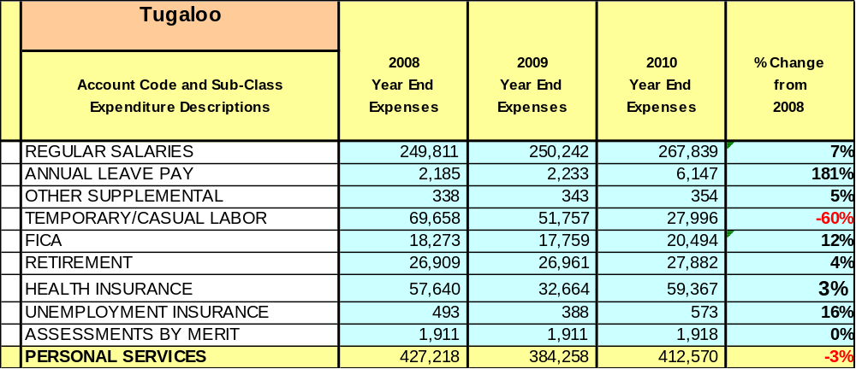

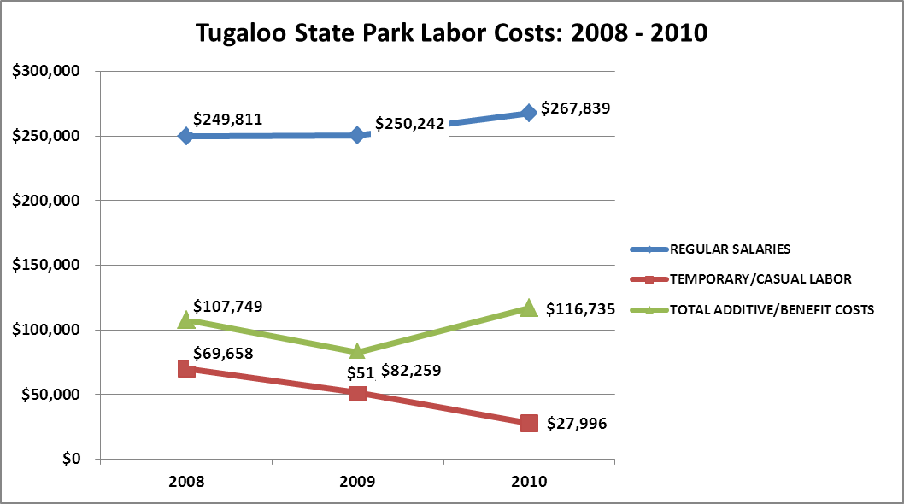

Visitation and Occupancy
Overall annual visitation to the site has trended downward from 2008 to 2010, decreasing by over 80,000 visitors. This is largely attributed to the economy and the increase in parking fees.

Year | Total Visitation
2008 | 484,664
2009 | 413,554
2010 | 401,715

Occupancy for the overnight accommodations at Tugaloo State Park for the last three years is detailed in the table below. Overall occupancy has trended downward from 2008 to 2010, decreasing by 5%. Specifically, campsite occupancy has decreased by 3%, and cottage occupancy has decreased by a rate of 7%. This is largely attributed to continued rate increases and the economy. The decrease in cottage occupancy is part of a larger trend for the past 7 years where occupancy has decreased from close to 50%, due to continuous rate increases. Our cottage rates recommended for 2012 and 2013 are designed to resolve this problem by offering more seasonal rates to match the market demand for our overnight facilities.

Year | Cottage Occupancy | Campsites Occupancy
2008 | 41.27% | 30.28%
2009 | 34.77% | 25.65%
2010 | 34.15% | 27.39%

Customer Service and Satisfaction

Site | Year | Customer Satisfaction Level
Tugaloo State Park | 2009 | 100% *
Tugaloo State Park | 2010 | 70% *
*The sample size for this data is so small that it could not be considered statistically significant.

Financial Performance Assessment
Operational Expenses
A summary of total operating expenses at Tugaloo State Park from 2008 to 2010, as well as their percent change from 2008 are provided in the table below.

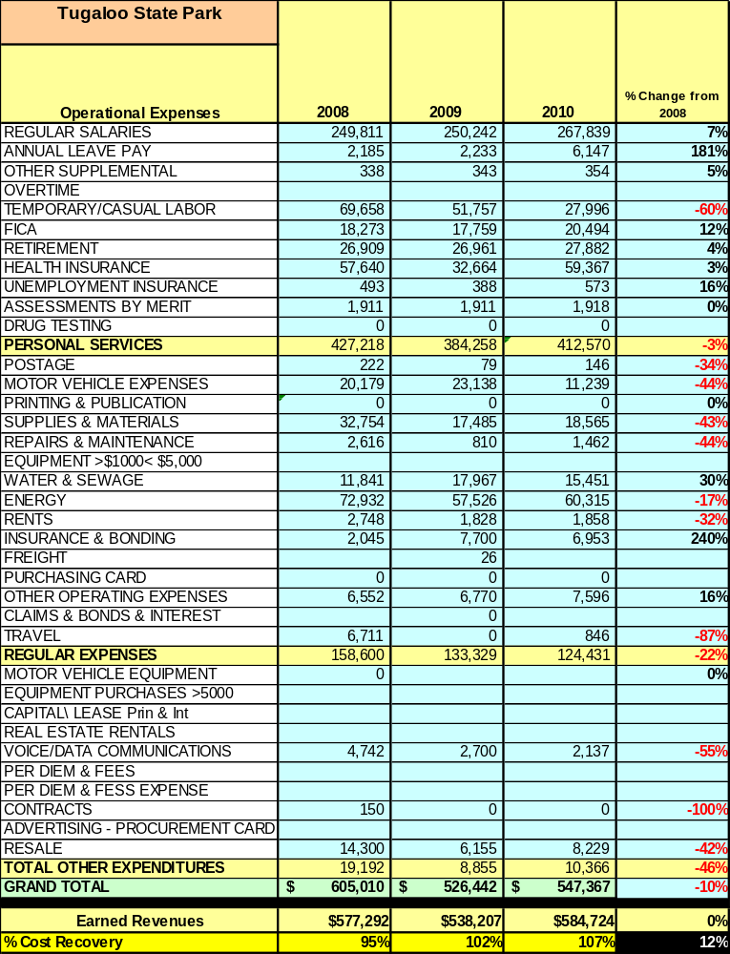

Earned Revenues
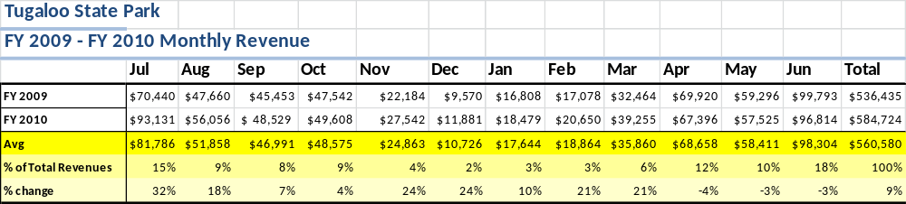
Earned revenues at Tugaloo State Park have remained constant since 2008, despite a decrease in visitation to the site. Monthly earned revenues for the last two years (see table on the following page) indicate that the total annual revenue increased 9% from 2009 to 2010, with the largest increases in monthly revenues in July (32%), August (24%), and November (24%) and the largest decreases in the months of April (4%), May (3%), and June (3%). The significant increases can be attributed to the historical low levels of Lake Hartwell during FY09.
The graphs below illustrate the monthly revenue trends each year and the average percent of total annual revenue earned each month.
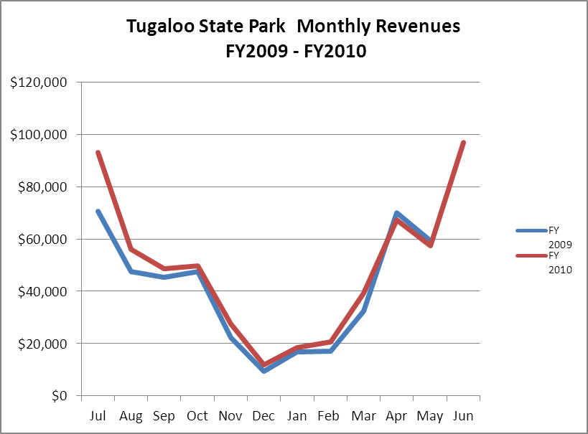

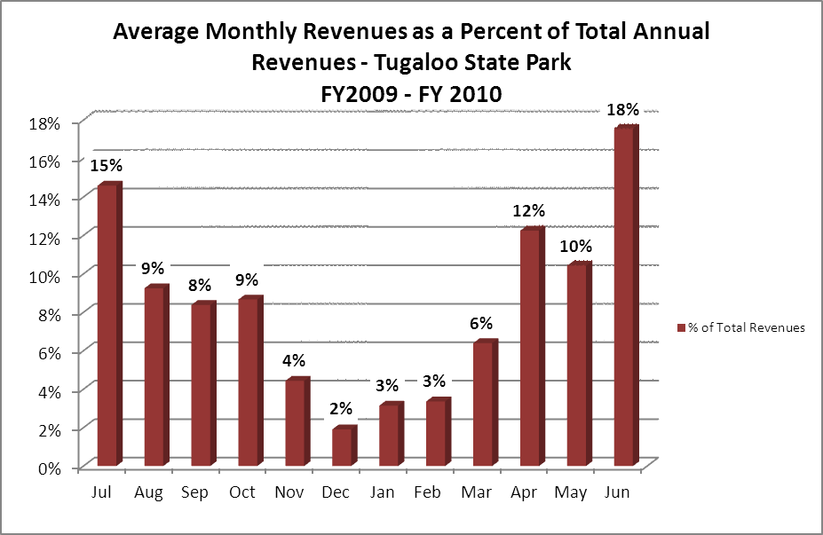

Cost Recovery Trends
Tugaloo State Park has achieved an average cost recovery of 101% of annual operational expenses through earned revenues from FY 2008 to FY 2010. This is detailed and illustrated in the table and graph below.
Year | Operational  Expenses | Earned  Revenues | Percent Cost  Recovery
2008 | $605,010 | $577,292 | 95%
2009 | $526,442 | $538,207 | 102%
2010 | $547,367 | $584,724 | 106%

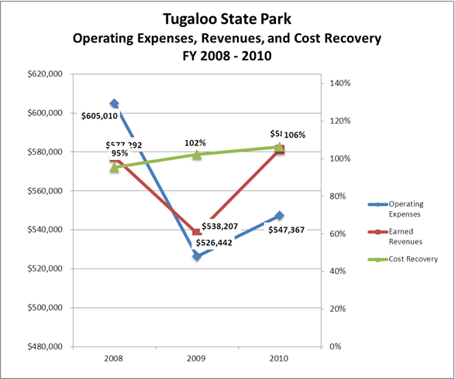

Review of Pricing
Data on rate information is available as far back as 2002, but only the last five years are evaluated. There has been notable growth in fees charged at Tugaloo State Park since 2005, with the largest increase being cottage rentals, which have increased 50% since 2005. A table detailing the rate history for Tugaloo State Park is provided below.
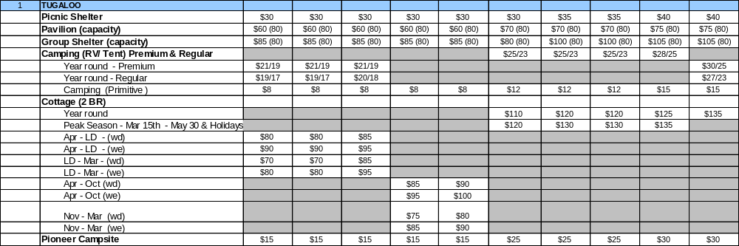

Business and Management Plan

Business Goals
The following goals serve as the foundation for the key recommendations and strategies in this business plan for Tugaloo State Park.

Enhance Cost Recovery of Site Operations
Implement more strategic pricing of cottages to reflect real peak seasons and demand. Promote use of cottages and camping to fishing tournament groups. Market and promote the new tent camping area when it comes on line.

Enhance Revenue Generation Strategies
Update and be more creative in the resale operation. Guests to this park are not necessarily looking for souvenir items, but there are opportunities. Limited space is an issue without expansion. Consider changing two cottage policies: 1) reduce/drop seven night minimum during June and July, and 2) increase dog friendly cottages from two to three, or four. Also, look at offering reduced rates and specials during slower seasons. Consider adding pontoon boat rentals, possibly through a concession agreement with a local marina. Explore the possibility of camper/ boat storage.

Expand Special Events at the Site
Continue to work with the Friends Group, City of Lavonia, and Chamber of Commerce to attract special events to the tournament ramp. Explore other events that might be hosted using this facility.

Improve the Diversity and Innovation of Recreational and Interpretive Programs
Additional interpretive programming cannot be done at current staffing levels; however, if funding allows, consider increasing the hours for the naturalist position to permit this. Recreational opportunities exist with the new boat ramp and there is also a need to enhance fishing opportunities, especially for those without boats. Fishing clinics should be considered by bringing in “experts.”

Improve the Effectiveness of Marketing and Sales
Consider advertising in local magazines and publications.

Establish Greater Consistency of Managing and Monitoring Customer Service & Satisfaction
Rangers on site need to interact more with the public about their needs and desires for the park, time permitting. The new online comment card system will provide us a better tool to monitor feedback from the public.

Expand Partnership Opportunities
Partner with local Chambers of Commerce, City of Lavonia, Franklin County, and Stephens County to promote the site and site events. Continue to grow the Friends group to expand to other aspects of the park operation in addition to the boat ramp area.

Classification of Programs and Services
The tables below summarize the classifications of programs and services at Tugaloo State Park as either core, important, or visitor supported and projects a range of cost recovery percentages that might be achieved for each. These classifications establish financial performance goals for each category of services that are linked to the recommendations and strategies of this business plan.

Core Services
Program / Service | Target Cost Recovery
Open and public access to the site and its resources | 0%
Public safety | 0%
Active management of natural and cultural resources of the site | 0%
Maintenance of grounds, facilities and infrastructure | 0%

Important Services
Program / Service | Target Cost Recovery
Providing public sales of fishing licenses | 5%
Site appropriate basic education, interpretation, and recreational opportunities | 110%
Special events and programs to enhance education, interpretation and recreational opportunities appropriate to the site | 150%

Visitor Supported
Program / Service | Target Cost Recovery
Cottages | 120%
Camping | 120%
Shelter rentals | 150%
Retail sales | 150%
Recreational equipment (canoes, putt-putt) | 120%
Special events that have an impact on the site or staff resources | 150%
Rental boats | NA*
Dry boat/RV storage | NA*

* Target cost recovery not available until research on costs and provider is performed

Partnership Development Plan
The table below summarizes existing partners and targeted partnerships by classification (operational, vendor, service, co-branding, funding partners) and by organizational type.
 | Public Partners | Not-for-profit Partners | Private / Enterprise Partners
Operational Partners | - Corps of Engineers  - Franklin County Sheriff’s Office  - Georgia WRD | - Friends of Tugaloo State Park  - Various Bass Clubs/ Associations | - Georgia Multi-Sports Corp
Vendor Partners | - Highland Walk and Arrowhead Point Golf Courses | - Hart EMC | - Linda Schuler Concessions  - George Wilcox Cable
Service Partners | - City of Lavonia  - Franklin County  - Stephens County  - Dept. of Corrections | - Chamber(s) of Commerce (City of LA, Franklin Co., Stephens Co.)  - Lake Hartwell Marketing Alliance
Co-branding Partners | - Travelers Rest Historic Site
Funding Resource Development Partner |  | - Friends of Georgia State Parks  - Friends of Tugaloo State Park

Marketing and Sales Plan

Marketing and Sales Goals
Marketing and sales goals for Tugaloo State Park are based on the following desired outcomes:
- To get cottage occupancy back above 40% year round by aggressively pricing cottages based on seasonal demand.
- To produce increased overall visitation and revenues. Two specific areas of opportunity are the new boat ramp and the upcoming tent camping area.
- To increase the retail sales.
- To increase the sites cost recovery figure above 110%.
In order to meet these goals, examples of specific target outcomes were identified in the areas detailed in the table below.
Area  of Focus | Current  Performance | Goal  by 2011 | Goal  by 2012 | Goal  by 2015
Cottage Occupancy Rate | 34% | 37% | 40% | 42%
Camping Occupancy Rate | 27% | 29% | 30% | 37%
Park Attendance | 401,000 | 410,000 | 420,000 | 430,000
Retail Sales | $10,919 | $12,000 | $13,000 | $15,000
Cost Recovery | 107% | 107% | 108% | 110%

Marketing and Promotion Strategies

Publicity and Social Media
Tugaloo State Park will approach marketing and publicity planning using the following guidelines and themes:
- Event publicity
Major events benefit by having short stories in local, regional, and statewide newspapers and online social media hooks planted that run three to four weeks in advance of the event up to the date of the event itself. Stories and media need to be cultivated with contacts and online sales channels several weeks in advance of the time the stories need to run. Special interest interviews on morning, noon, and evening television news programs, radio interviews on popular rush-hour programs, and blogs on known affinity online sites should also be included.
- Program publicity
Special and unique programs should have feature stories in magazines, local and regional weekly newspapers, and statewide daily newspapers that are aimed at placements as front-page or sectional front-page stories. These stories are most effective if they run shortly before the season that the featured program begins. This will likely require several weeks of advanced planning with media contacts. Similar coverage on television and radio should also be considered. If pre-publicity cannot be generated, post-publicity can help promote future programs.
- Site Publicity
Site publicity focusing on a single site or sub-set of sites requires more intense planning efforts to attract multiple writers and editors from target publications. Each site could host several seasonal media familiarization tours (with 10 to 15 writers or editors) to familiarize them with the site and its benefits and amenities. Stories and features resulting from such tours typically take between two and six months to materialize so the tours should focus on experiences, benefits, and programs that would be available when the stories are expected to run.
Examples and suggested opportunities for events, programs and related publicity efforts based on the themes described above at Tugaloo State Park are provided in the table below.
Event Publicity | Program Publicity | Site Publicity
Fishing Tournaments | Summer Programs | Summer Programs
Tugaloo Triathlon | Junior Ranger Camp | Nature Hut
Other boating/ specials events

Packaging
Examples and suggested packages for Tugaloo State Park are provided in the table below.
Package | Package Details
Stay and Paddle | Free canoe use with a 3 night cottage rental
Travelers Delight | Free family admission to Travelers Rest HS with a 3 night cottage rental
Golfer’s Special | Golf packages offered with Victoria Bryant and Richard Russell
Pay for two, get one free | During the months of March and November (except Thanksgiving), pay for two nights and get the third free for cottages and campsites

Group Sales
Types of groups within which specific target customers can be identified for Tugaloo State Park are listed below:
- Bass Clubs  - Scout Groups | - Church Groups  - School Groups | - Camping Clubs

Incentivizing New and Repeat Visitation
Tugaloo State Park will utilize the following strategies and/or incentives to encourage new and repeat visitation starting in FY 2012:
- Pay for 10, get one free. Over the course of the calendar year, pay for ten nights on a campsite, and get the next night free.
- Encourage Friends membership sales from the front counter staff to bring repeat customers.
Revenue Generation Plan
Revenue / Cost Recovery Goals
Tugaloo State Park has set a financial goal of increasing annual revenues 2-3% annually between 2012 and 2015. The largest revenue growth opportunity is most likely boat ramp operations, new tent camping area, increased occupancy of cottages, and retail. The table below details projected revenue growth leading up to 2015, based upon a nominal growth of revenues each year.
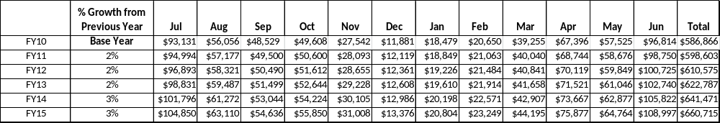
These projections would result in a total of 12.6% cumulative growth in total annual revenues between FY2010 and FY2015. If operational expenses can be managed with a cumulative increase of 9.6% between FY2010 and FY2015, then the overall cost recovery of the site will be approximately 110% in FY2015 at these projected revenue levels. This is higher than the annual financial performance of the site in FY2010, which was operated at 107% cost recovery in that year.
Pricing Plan
This pricing plan reflects the current business approach to fees. Campsites are charged at a higher rate for premium (waterfront) sites, a difference that history has shown that customers are willing to pay for the better site. Standard sites remain at a lower rate in order to try to keep those filled. Cottages rates reflect a reduced demand for cottages with only a single bath in order to keep those filled. Carefree discounts will be offered during the off season in an attempt to utilize unused facilities.
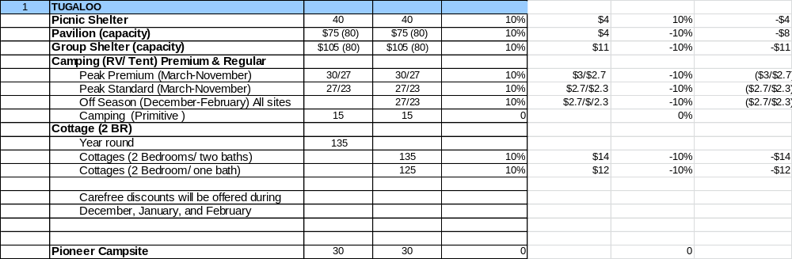

Innovative Programming and Special Events Plan

Program / Event | Theme / Purpose | Scheduled Date/Season | Frequency | Target Participation | Target User Fee | Target Cost Recovery
Fishing Tournaments (100+ boats) | Recreation | Spring/ Fall/ Winter | 5 or more events per year | 200+ fishermen | $5.00 parking | Cost recovery through rental of facilities
Fishing Tournaments  (<100 boats) | Recreation | Anytime | 10 or more events per year | 10 or more fisherman | $5.00 parking | No real cost
Boat / Jet Ski Shows and Events | Recreation | Spring Summer | 1-2 events per year | General public  500+ | $5.00  parking | 100%
Tugaloo Triathlon | Recreation | September | 1 per year | 500+ participants | $1000 use fee. $5.00 parking fee | 120%
School Programs | Education | Spring | 4 or more per year | 400 + students | $2.00 student fee. | 80%+
Other Interpretive Programs | Education/ Recreation | Summer | Weekly | varies | Park guests  & locals | 10%
Other Special Events | Recreation | Anytime | 2-3 per year | To be determined | To be determined | 100%+

Partnerships and Concessions Plan

Service / Partnership | Term of Service | Financial Objective | Contract Manager
Beach Concession | Summer months | 10% gross to park | Robert Emery
Cable Television | Ongoing | $1.00 per night to vendor | Robert Emery

Expense Management Plan
Personnel Assignments
The following actions will be taken to proactively manage labor costs via personnel assignments and classifications.

Action | Timeline | Outcome
Adjust mowing and landscaping schedules for portions of the site | Ongoing | Savings of fuel and manpower
Use campground host for kiosk operation | Ongoing | Labor savings
New host site in new tent camping area | Spring 2012 | Labor savings
Detainee and community service work labor | Ongoing | Labor savings
Reduce hours of office and kiosk operation | Ongoing | Labor savings
Concessionaire for beach concession stand | Ongoing | Labor savings

Management Techniques
The following actions will be taken to proactively manage labor costs via management techniques.

Action | Timeline | Outcome
Increase use of volunteers for site and grounds maintenance with assistance from Friends group. | Ongoing | Labor savings

Adjusted Levels of Service
The following actions will be taken to proactively manage labor costs via reduced levels of service.

Action | Timeline | Outcome
Adjust mowing and landscaping schedules for portions of the site | Ongoing | Savings of fuel and manpower
Adjust hours of operation for office and kiosk | Ongoing | Manpower savings
Concessionaire at beach operation | Summer | Savings of Manpower, labor

Financial Pro Forma
The following five-year financial pro forma projects operating expenses, earned revenues and cost recovery through FY 2015. These pro forma are based on the strategies and desired outcomes identified in this business plan, especially the revenue generation and expense management plans, and are linked to corresponding performance goals.

Expense Pro Forma
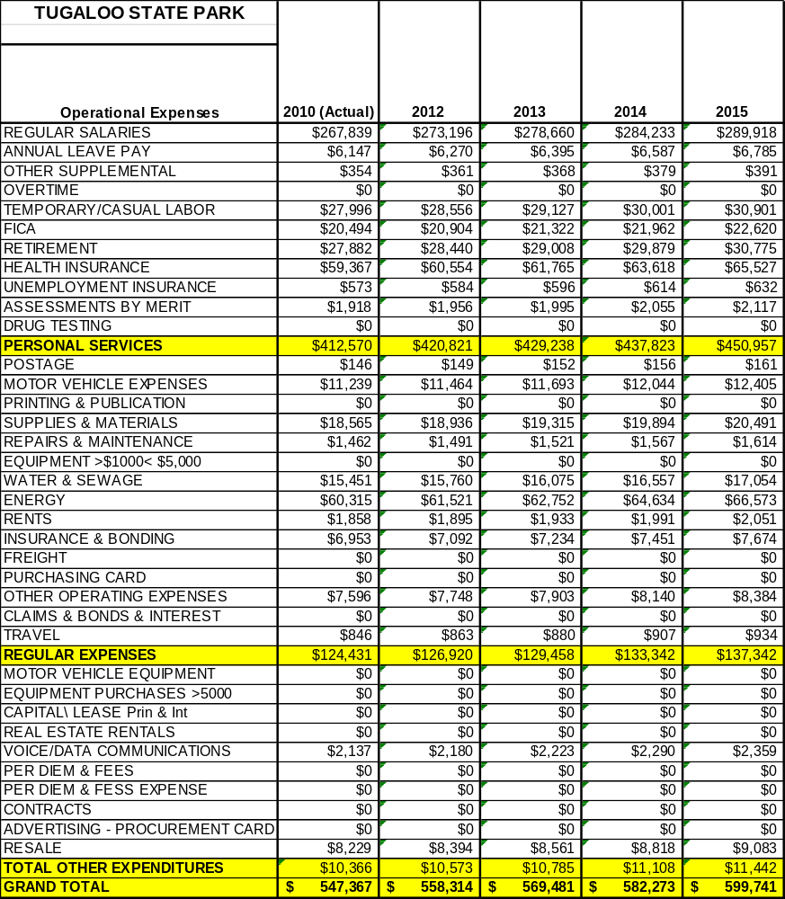

Revenue Pro Forma

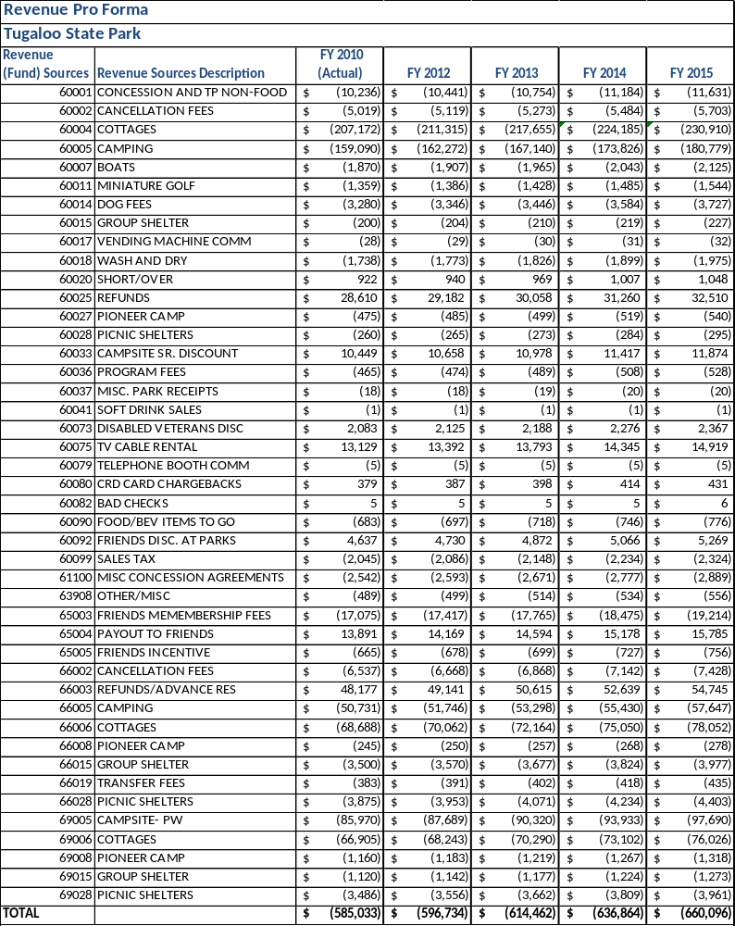

Total Pro Forma
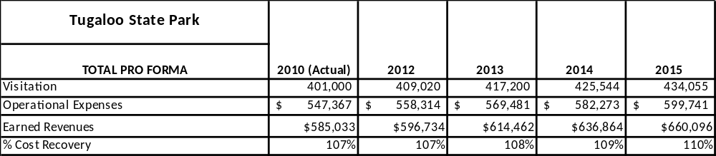

ACTION PLAN
Site: Tugaloo State Park |  | Site Manager: Robert Emery |  |  | Date: June, 2011
Month:
Strategy | Tasks | Costs / Funding | Revenues / ROI | Responsibilities |  | Metrics
Aggressively market cottage vacancies and be sure housekeeping staff is there to do it. | Look at listing on Facebook, Craig’s List, etc. Base rates on seasonal demand. | Staff time to make reservations and to clean additional units | Unknown, but potentially great based on historical occupancy | Additional responsibility to office staff of making reservations |  | Revenue
Market and promote new tent camping area | Work with marketing, local chambers | Staff time | Unknown, but potentially great | Additional responsibilities to staff |  | Revenue
Enhance Retail Operation | Reviewing sales, looking for opportunities | Staff time, resale money, space needs | Unknown, but potentially good | Additional responsibility to staff |  | Revenue
Work with local government and chambers of commerce to attract some large special events | Networking, working through Friends Group | Staff time | Revenue potential is great, especially on parking fees | Additional responsibility to staff |  | Revenue
Updating infrastructure | Requesting capital outlay funds | Staff time, funding for projects | Potential negative ROI | Park Manager |  | Revenue- loss or gain

This is the average of the last three years – FY 2008, FY 2009, and FY 2010
Current employees, not including vacancies.
Current employees, not including vacancies.
Major population centers within a two-hour drive from the site

