Unicoi State Park and Lodge
Business & Management Plan

Prepared June 2011; Finalized July 2012
Direction 2015 – Sustainable Business Planning

Table of Contents

Executive Summary 3

Site and Operations Assessment 7
Site Inventory and Facility Assessment 7
Operational Assessment 11
Financial Performance Assessment 18

Business and Management Plan 23
Classification of Programs and Services 25
Partnership Development Plan 26
Marketing and Sales Plan 27
Revenue Generation Plan 30
Expense Management Plan 32
Financial Pro Forma 33

Action Plan 36

Executive Summary
The Parks, Recreation and Historic Sites Division (PRHSD) of the Georgia Department of Natural Resources (DNR) is transitioning the management of Unicoi State Park and Lodge to operate more like a business, reflecting the Direction 2015 – Sustainable Business Planning initiative to improve the fiscal performance and management of the state parks and historic sites system. This business and management plan is designed to help the site recover more operating expenses through earned revenues, productive partnerships, and innovative programs.

Site Fact Sheet
Site Name | Unicoi State Park and Lodge
Site Manager | Scott Hudgins
Region Manager | Joe Yeager
Date of Business Plan completion | January 25, 2012
Site size | 1,050 acres
Total number of visitors (FY 2010) | 560,218
Total operating budget (FY 2010) | $ 3,608,272
Total earned revenues (FY 2010) | $ 3,760,115
Operational cost recovery (FY 2010) | 108%
Average operating cost per visitor (FY 2010) | $ 6.44
Average earned revenue per visitor (FY 2010) | $ 6.71
Average cost recovery (FY 2008 – 2010) | 102%
Target cost recovery (FY 2015) | 115%
Total full-time employees | 24
Total part-time employees | 59
Primary service markets | Atlanta, Athens, Chattanooga, Clemson
Primary attractors/visitor appeal factors | Unicoi Lodge, park programming, North Georgia mountains. USFS Anna Ruby Falls, Alpine Helen, Unicoi Lake and Smith Creek
Leading opportunities for improved site performance | Expand lodge and conference center amenities, upgrade guest rooms to be competitive, and add: swimming pool, exercise room and grill. Improve marketing and sales.

Site Summary and Key Attractions
Nestled in the north Georgia Mountains just two miles from the Alpine village of Helen, Unicoi is one of Georgia’s most beloved state parks. Throughout the year, the park offers outstanding programs which focus on natural, cultural, historical and recreational resources. Outdoor enthusiasts will enjoy hiking and biking on scenic mountain trails, especially those leading to Helen and Anna Ruby Falls. Craft lovers should not miss the lodge gift shop specializing in hand-made quilts and local pottery. Numerous picnic tables are located throughout the park.

Key Attractions
The amenities or features listed below are those that seem to be most popular for visitors.
- 53 Acre Lake
- 100 Room Lodge
- Conference Center
- Full Service Restaurant
- Craft Shop
- Campground Store
- 4 – 1 bedroom cottages
- 22 – 2 bedroom cottages
- 4 – 3 bedroom cottages
- 82 Tent, Trailer and RV campsites
- 33 Walk-in Campsites
- 16 Platform Campsites
- Beach House/Group Shelter
- 7 Picnic Shelters
- 4 Lighted Tennis Courts
- 12 miles of Hiking Trails
- 8 Miles of Mountain Bike Trail
- Swimming Beach and Rental Boats
- 3 Playgrounds

Financial Targets
The table below details the total operating expenses and earned revenues for Unicoi State Park and Lodge over the last three years (2008 – 2010). This table also calculates total cost per visitor and revenues per visitor during these operating years, and details the target financial performance goals in the context of achieving at least 115% cost recovery. This table also calculates the necessary change from 2010 operating expenses and revenues. With the drop in revenue from 2008 to 2010 of just over $1M and the responding reduction in expenses of $1.1M, the cost per visitor and revenue per visitor reflect these decreases. Because of the necessity to offer special promotions and discounted rates based on the economy, revenue per visitor has dropped from the 2008 figures to the current figures. Rates in the local competitive market for lodge rooms are much lower and with our “aging facilities,” it has become more difficult for us to achieve rack rate. The increases in visitation are due to our traffic counts including visitors to Anna Ruby Falls.

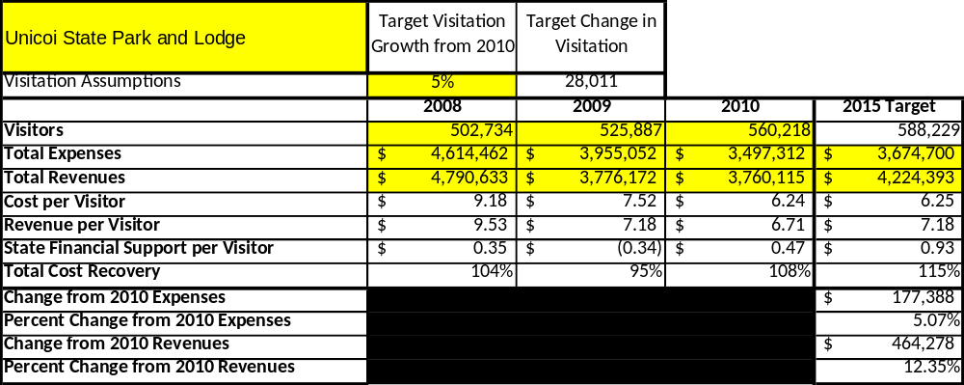

Key Recommendations

Primary / Short Term Recommendations
- Operate the site using cost-based accounting, including the net cost recovery achieved annually.
- Utilize the new online comment card for day-use and overnight visitors.
- Evaluate and pursue opportunities to employ concessionaires or private or public service providers on-site if they can be more cost-effective. For example, explore the development of a concessionaire agreement to manage the boat rental/beach operation. Some additional amenities that could be added to the lake rental operation would be “fishing kayaks” and “sit on top kayaks” along with the canoe and pedal boat rentals. If dock space was added or the existing docks were modified, we could add jon boats with electric motors. For food options, we could renovate the end of the beach house upstairs area to add food service options at the lake; this would be limited items such as hamburgers, hotdogs, fountain drinks, package snack items, etc. We could also expand the picnic area at the beach and add mini shelters/pavilions above the rock wall to expand the picnicking opportunities on the park.
- Utilize a minimum of ten special events annually to help draw more visitors to the site, with three revenue generating special events annually. There are a number of special events, such as Outdoor Adventure Day, that we do not charge the public to attend other than ParkPass. The three major revenue generating events are the Fireside Arts/Craft Show, BirdFest, and Family Camp, which generate indirect revenue in all areas of the park including lodging, restaurant and program fees. See our Business Goals section for new revenue generating events planned.
- Seek local partners to help support operations, programs, and service delivery and for cross-marketing purposes.
- Partner with local Chambers of Commerce or other destination marketing organizations (DMOs) to promote Unicoi. Currently the Site Manager is on the Chamber of Commerce Board; the former Lodge Manager is now the Executive Director of the White County Convention and Visitors Bureau; and the Resource Manager is the liaison for the Friends of Unicoi.
- Continue to work with the Unicoi Chapter of the Friends of Georgia State Parks and Historic Sites to help raise funds or provide volunteers for improvements and program support.
- Fill the Sales and Marketing Manager position (formerly the Conference Planner) to help the site become more sustainable. This is not a new position: when Lori VanSickle transferred to Amicalola Falls we had a Conference Planner and two Conference Coordinators. This position would provide leadership to the sales office and generate more outside sales and conference coordination for Unicoi, with a positive impact on cost recovery that would more than pay for the position.
- Partner with Coral Hospitality and the North Georgia Mountains Authority on various projects and operational opportunities.
- Establish an account with Constant Contact to begin marketing to our past guests. With this account, we can survey our past guests annually for input on the most desirable amenities for the renovation work, and it will also allow us to market the restaurant and holiday events. We are also developing various packages to sell on Groupon.

Secondary / Long Term Recommendations
- Add new lodge amenities and renovate the existing lodge rooms. New amenities could include a swimming pool, exercise room, business center and grill.
- Renovate and expand the Beach House for more attractive and expanded use as a group and wedding venue (it currently accommodates only 75 – 100 guests).
- Work with NGMA to establish a reserve fund or revolving account that allows for earned revenues above a certain percentage of operational cost recovery to be reinvested in the site.
- Evaluate all the mechanical facilities on the park and assess life expectance to establish a plan for future upgrades.
- Renovate picnic shelter #3 in order to create a group shelter with a full kitchen and restroom facilities to accommodate a minimum of 150 guests; a parking area already exists for the facility.
- Utilize a facility at Smithgall Woods to house interns in order to use Stewart Lodges to reopen the group camp as a rentable/revenue generating operation. The revenue potential from renting the group camp would be $30,000 to $40,000 annually.

Site and Operations Assessment
This site and operations assessment is a culmination of analyses and findings from a review of the condition of facilities, infrastructure, and operations at Unicoi State Park and Lodge. The findings and observations are not intended to be an exhaustive review of all issues present, but provide a basic understanding of the predominant issues that contribute to the site’s current operating conditions. The assessment includes the following:
- Site Inventory and Facility Assessment
- Operational Assessment
- Financial Assessment
Site Inventory and Facility Assessment

Methodology
Facility and asset conditions are rated using a differential scale of excellent, good, fair, or poor. Descriptions of conditions that are attributed to each of these findings are also provided.
Scale of Conditions
Rating | General Description
Excellent | Facilities/amenities are in ‘excellent’ condition when they show little or no maintenance or repair problems. Facilities do not feature any major design or operational issues or flaws that contribute to diminished use or increased maintenance or upkeep. Facilities are easy to clean and maintain in order to place them back into public use and the users perceive them to be in excellent shape.
Good | Facilities/amenities are in ‘good’ condition when they show only minor maintenance or repair problems. Most maintenance issues with these facilities typically appear to be the result of age and/or heavy use. Facilities may only feature minor design or operational issues that contribute to diminished use or increased maintenance or upkeep. Facilities are moderately easy to clean and maintain in order to place them back into service and the users perceive them to be adequate for their use, but probably not in excellent shape.
Fair | Facilities/amenities are in ‘fair’ condition when they show significant maintenance or repair problems. Facilities generally exhibit ongoing maintenance issues that appear to be the result of age, heavy use, or design or operational flaws. Some maintenance and repair needs may compound their fair condition by being deferred because of budget and/or resource limitations. Facilities require more effort to clean and maintain before placing them back into service and the users may perceive them as being less than adequate for their use and in a state of deterioration. The facility or structure may need of major repair or replacement.
Poor | Facilities/amenities are in ‘poor’ condition when they show significant, on-going maintenance or repair problems that ultimately may result in suspended use for repair/replacement. Maintenance and repair issues are possibly the result of poor maintenance and clearly the result of age, heavy use, or design or operational flaws. Problems with the facilities are often compounded over time due to consistently-deferred maintenance and repair because of budget and/or resource limitations. Facilities may feature major design or operational issues that contribute to diminished use or increased maintenance or upkeep. Facilities require excessive effort to clean and maintain before placing them back into service and the users often perceive them as being inadequate for their use and in a state of serious deterioration. The facility or structure may need of major repair or replacement.

Inventory and Assessment
The table below is an inventory of facilities and amenities at Unicoi State Park and Lodge that provides the assessed condition of each as reviewed in June, 2011.
Site Asset / Amenity | Quantity | Condition
Total acreage | 1,050 | Good
Unicoi Lodge A | 1 | Fair
Unicoi Lodge B | 1 | Fair
Unicoi Lodge C | 1 | Fair
Unicoi Lodge D | 1 | Fair
Unicoi Lodge - Conference Facilities Masters Hall | 1 | Good
Unicoi Lodge - Conference Facilities Logo Room | 1 | Fair
Unicoi Lodge - Conference Facilities Dogwood Room | 1 | Good
Unicoi Lodge – Restaurant | 1 | Good
Unicoi Lodge - Kitchen | 1 | Fair
Unicoi Lodge – Smith Creek Room | 1 | Fair
Unicoi Lodge Gift Shop | 1 | Good
Visitor Center Trading Post store | 1 | Good
Visitor Center – Interpretive Programming Area | 1 | Good
A Cottages | 4 | Good
B Cottages | 12 | Fair
C Cottages | 4 | Good
Smith Creek Cottages | 10 | Good
Beach House | 1 | Fair
Boat Rentals/Concession Area | 1 | Fair
Intern Camp | 1 | Fair
Picnic Shelter 1 | 1 | Good
Picnic Shelter 2 | 1 | Poor
Picnic Shelter 3 | 1 | Good
Picnic Shelter 4 | 1 | Good
Picnic Shelter 5 | 1 | Good
Picnic Shelter 6 | 1 | Good
Picnic Shelter 7 | 1 | Good
Picnic Shelter 8 | 1 | Good
Hickory Hollow Tent Camping | 33 | Fair
Laurel Ridge Power/Water Camping | 23 | Fair
Little Brook Power/Water Camping | 18 | Fair
Big Brook Full Hook Up Camping | 13 | Fair
Squirrel’s Nest Platform Camping | 16 | Fair
Hickory Hollow Comfort Station | 1 | Good
Little Brook Comfort Station | 1 | Fair
Big Brook Comfort Station | 1 | Good
Squirrel’s Nest Comfort Station | 1 | Fair
Picnic Shelter #7 Comfort Station | 1 | Fair
Anna Ruby Falls/Beach House parking Comfort Station | 1 | Good
Picnic Shelter #6 Comfort Station | 1 | Fair
Tennis Court Comfort Station | 1 | Good
Maintenance Barn | 1 | Fair
Maintenance Shop at Lodge | 1 | Fair
Laundry Facility | 1 | Fair
Frog Pond Intern House | 1 | Poor
Site Manager Residence | 1 | Good
Resource Manager Residence | 1 | Good
Basement Apartment (underground storage) | 1 | Fair
Unicoi Lake | 1 | Good
Upper Smith Creek | 1 | Fair
Lower Smith Creek/Delayed Harvest Stream | 1 | Good
Playground Campground | 1 | Good
Playground Lodge | 1 | Fair
Playground Shelter #6 | 1 | Fair
Tennis Courts | 1 | Fair
Bottoms Loop Trail | 1 | Fair
Lake Trail | 1 | Good
Lake Trail Floating Bridge | 1 | Fair
Frog Pond Nature Trail | 1 | Good
Unicoi/Helen Trail | 1 | Good
Mountain Bike Trail | 1 | Good
Mountain Bike Trail Bridge | 1 | Good
Swimming Beach | 1 | Fair
Sewage Pond and Spray Field | 1 | Fair
Bottoms Fields | 1 | Good
Intern Camp/Bottoms Field Bridge | 1 | Good
Boat House | 1 | Good
Old Campground Laundry Building | 1 | Fair
Fishing Docks | 8 | Fair
SST restrooms in Bottoms | 1 | Fair
Shelter 4 and 5 Bridge | 1 | Fair

Prioritized Facility Needs
Based on the facility inventory and assessment, these prioritized needs have been identified. Each need has been aligned with a priority category of high, moderate, or low to support future decision making regarding project sequencing, investment of public resources, and meeting community expectations. The priority assignment for each need is not a measure of importance; rather, these recommended priorities reflect a phased implementation approach over the next several years.
Facility Need | Priority Assignment
Lodge Rooms Renovation | High
Swimming Pool | High
Exercise Room in Lodge | High
Smith Creek Grill | High
Master Hall and Logo Sound and Lighting System Upgrade | High
Laundry Facility | High
Picnic Shelter 2 | High
Disc Golf | High
Frog Pond Intern House | Moderate
Maintenance Barn | Moderate
Tennis Courts | Moderate
Little Brook Comfort Station | Moderate
Squirrel’s Nest Comfort Station | Moderate
Boat Rentals/Concession Area and Restrooms | Moderate
Unicoi Lake water level gate | Moderate
Upper Smith Creek – bank erosion/trail | Moderate
Beach – depth of swimming area | Low
Basement Apartment (underground storage) | Low

Operational Assessment
The Operational Assessment includes:
- An inventory and classification of programs and services being provided at the site
- A review of staffing at the site
- A review of concessionaires and partners operating at the site
- Visitation and customer satisfaction

Inventory and Classification of Programs and Services
Programs and services are classified into one of three major categories:
1) Core or Essential Services
2) Important Services
3) Visitor Supported Services
Programs and services at the site are classified into these categories based in part on the mission and public mandates for both the site and the agency. For the programs and services in each of these categories, there are financial performance expectations that will define how services are funded and evaluated.

Category 1 – Core Services [Largely supported by tax funds]
Core programs, services and facilities are those the agency must provide and/or are essential in order to capably govern and meet statutory requirements. The failure of the agency to provide Category 1 services at adequate levels could result in significant negative consequences for the public and the resources under protection. The criteria for programs or services to be classified as core or essential are:
- The services are mandated by the agency’s law or charter or are contractually obligated by agreement to provide the services.
- The services are essential to protecting and supporting the public’s health and safety.
- The services protect and maintain valuable assets and infrastructure.
- The services would generally and reasonably be expected and supported by residents, businesses, customers and partners.
- The services are those that cannot or should not be provided by the private sector.
- The services provide a sound investment of public funds.
The following programs and services offered at Unicoi State Park and Lodge have been identified as core services:
- Active management of the natural/cultural resources in order to protect their integrity
- Open and public access to the site and its resources
- Public safety
- Maintenance of grounds, facilities and infrastructure
- Park public programs
- Passive interpretation

Category 2 – Important Services [Supported by a balance of tax funds and earned revenues]
Important programs, services and facilities are those the agency should provide, and are important to governing and effectively serving residents, businesses, customers and partners. Providing Category 2 services expands or enhances the agency’s ability to provide and sustain its core services. The criteria for programs or services to be classified as important are:
- The services expand, enhance or support identified core services.
- The services are broadly supported and utilized by the community, and are considered an appropriate, important, and valuable public good. Public support may be conditional upon the manner by which the services are paid for or funded.
- The services generate income or revenue that offsets some or all of the operating cost and/or are deemed to provide economic, social or environmental outcomes or results.

The following programs and services offered at Unicoi State Park and Lodge have been identified as important services:
- Lake activities
- Picnicking/day use
- Hiking, interpretive/self-guided and mountain bike trails
- Special events
- Visitor center/ interpretive programming center

Category 3 – Visitor Supported Services [Almost exclusively supported by earned revenue]
Visitor supported programs, services and facilities are those discretionary services that the agency may provide when additional funding or revenue exists to offset the cost of providing those services. Category 3 services provide added value above and beyond what is required or expected. The criteria for programs or services to be classified as visitor supported are:
- The services expand, enhance or support core services or important services and the quality of life of the visitors, community or stakeholders.
- The services are supported, valued and well utilized and provide an appropriate and valuable public benefit.
- The services generate income or funding from sponsorships, grants, user fees or other sources that offset some or all of their cost and/or provides a meaningful return on investment.

- The services can possibly be provided through outsourcing or use of concessionaires, providing opportunities for community enterprises that may not otherwise be provided by the agency.

The following programs and services offered at Unicoi State Park and Lodge have been identified as visitor supported services:
- Meeting facilities/conference center services
- Lodge rooms
- Camping
- Cottages
- Lodge gift shop
- Trading post store
- Group programs
- Food service
- Boat rentals

Staffing Assessment
Labor costs at Unicoi State Park and Lodge represent the largest area of budgetary expense at an average of 61% of the total operating budget each year for the last three complete years, which is lower than the target of total labor costs (including benefits) not exceeding 65% of the site’s total operating expenditures. The tables below and on the following page provide a basic review of the current staffing at the site.
Full Time Equivalent Employees
Position / Title | Quantity (FTE) | Vacancies | Annual Hours
Park Manager 3 | 1 |  | 2080
Resource Manager 2 | 1 |  | 2080
Resource Manager 1 | 2 |  | 4160
Parks Rec Admin | 1 |  | 2080
Park Interp Ranger | 0 | 1 | 2080
AOC 2 | 1 |  | 2080
Acct Parapro | 1 |  | 2080
Maintenance Engineer | 1 |  | 2080
General Trades Craftsman | 2 |  | 4160
Utility Worker 1 | 1 |  | 2080
Lodge Manager | 1 |  | 2080
Conference Planner |  | 1 | 2080
Conference Coordinator | 2 |  | 4160
Office Manager (Front Desk) | 1 |  | 2080
Clerk 2 (Night Audit) | 1 |  | 2080
Clerk 2 (FD Lead) |  | 1 | 2080
Sales Manager 2 (Retail) | 1 |  | 2080
F & B Director 1 | 1 |  | 2080
FS Director (Asst) | 2 |  | 4160
FS Manager | 1 |  | 2080
FSE 2 (Cook) | 1 |  | 2080
Housekeeping Supervisor | 1 |  | 2080
Housekeeping Team Leader | 2 |  | 4160
TOTAL | 25 | 3 | 58240

Part Time Employees
Position / Title | Quantity (FTE) | Vacancies | Hours
Seasonal Naturalist | 1 |  | 1508
Accounting Clerk | 2 |  | 3016
Maintenance Worker | 7 | 1 | 12064
Sales Representative | 1 |  | 1508
Night Audit | 1 |  | 1508
Front Desk Clerk | 7 | 5 | 16588
PSW – Gift Shop Clerk | 3 |  | 4524
FSW – Conference Setup | 3 | 1 | 6032
FSW – Cook | 4 |  | 7540
FSW – Cook Helper | 2 |  | 4524
FSW – Dish / Utility | 2 | 1 | 4524
FSW – Cashier / Hostess | 3 | 1 | 6032
FSW1 – Banquet Server | 2 |  | 4524
FSW 1 – Server | 8 | 1 | 13572
Housekeeper | 13 | 1 | 21112
Concession Clerk – Beach | 2 | 3 | 3016
TOTAL | 61 | 14 | 111592

Labor Support
Labor Support | Annual Hours
Volunteers – Campground Hosts | 4374
Volunteers – Friends + Community/Scouts | 1500
Community Service Workers | 800
Engineering and Construction Crews | 120
Resource Management Crews | 80
TOTAL | 6874

Total Labor Hours
Labor Type | Annual Hours
Full Time Equivalent Employees | 58240
Part Time Employees | 111592
Labor Support | 6874
TOTAL Annual Labor Hours | 176,706

Labor Budget Summary
Unicoi State Park and Lodge
 | 2008 | 2009 | 2010 | % Change
Account Code and Sub-Class | Year End | Year End | Year End | from
Expenditure Descriptions | Expenses | Expenses | Expenses | 2008
REGULAR SALARIES | 1,721,762 | 1,669,888 | 1,163,860 | -32%
ANNUAL LEAVE PAY | 5,851 | 4,275 | 32,256 | 451%
OTHER SUPPLEMENTAL | 0 | 0 | 415 | 0%
OVERTIME | 2,171 | 39 | 697 | -68%
TEMPORARY/CASUAL LABOR | 403,283 | 228,340 | 379,971 | -6%
FICA | 130,115 | 124,270 | 89,700 | -31%
RETIREMENT | 182,319 | 178,969 | 124,703 | -32%
HEALTH INSURANCE | 407,884 | 230,340 | 250,365 | -39%
UNEMPLOYMENT INSURANCE | 3,263 | 687 | 1,473 | -55%
ASSESSMENTS BY MERIT | 12,642 | 3,381 | 4,932 | -61%
PERSONAL SERVICES | 2,869,290 | 2,440,189 | 2,048,371 | -29%

Visitation and Occupancy
Overall annual visitation to the site has trended upward from 2008 to 2010, increasing by 11% or over 57,484 visitors. The increase in visitation figures is mostly attributed to day use visitors. Due to the economy, people are coming for more day trips to enjoy the outdoors. The occupancy decreases are largely attributed to loss of group and leisure travel in the lodge. The visitation increase is attributed to higher day use visitors over this same time frame.
Year | Total Visitation
2008 | 502,734
2009 | 525,887
2010 | 560,218

Occupancy for the overnight accommodations at Unicoi State Park and Lodge over the last three years is detailed in the table below. Overall occupancy has trended downward from 2008 to 2010, with a 13% decrease in the lodge being the largest change. This is largely attributed to Loss of group business in the lodge and the economy as a whole.
Year | Lodge Occupancy | Cottage Occupancy | Camping Occupancy
2008 | 50% | 51% | 39%
2009 | 36% | 46% | 37%
2010 | 37% | 49% | 31%

Customer Service and Satisfaction

Site | Year | Customer Satisfaction Level
 | 2009 | 81%
 | 2010 | 68%

Many of our negative customer comments are with regards to “tired and outdated facilities.” Group evaluations have been good with regards to the meeting facilities and food service operation, but the reoccurring comment on our group evaluations is the guest rooms are “tired and need updating.” We have also received numerous group evaluations about the guest rooms being “damp and musty.” We are aware of this issue and have been trying to deal with it for a number of years. The actual rating is subjective and statistically questionable.
Financial Performance Assessment

Operational Expenses
A summary of total operating expenses at Unicoi State Park and Lodge, from 2008 to 2010, as well as their percent change from 2008 are provided in the table below.
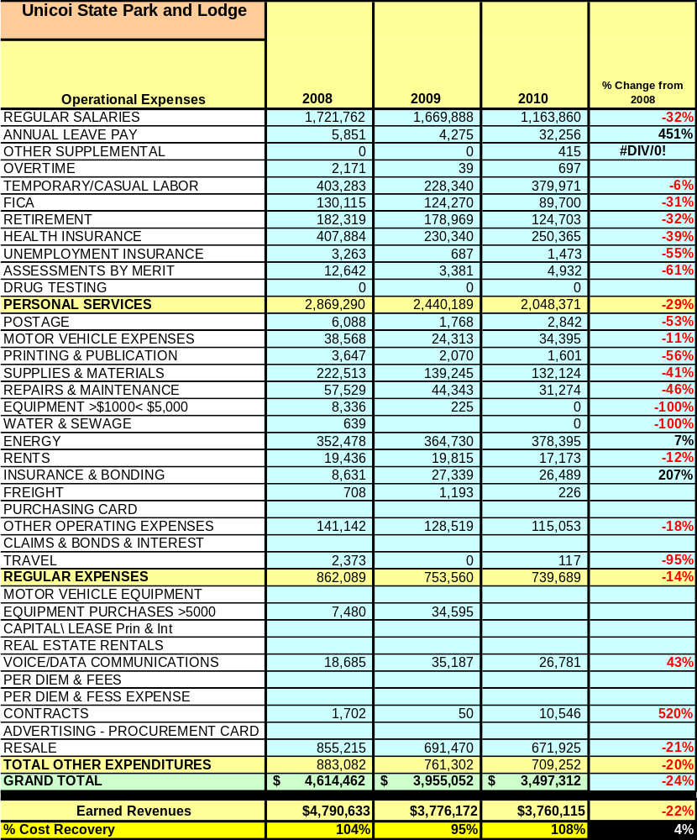

Earned Revenues
Earned revenues at Unicoi State Park and Lodge have decreased since 2008, while visitation has increased overall. Overall visitation, including all visitors to the park, i.e. day-use, camping, restaurant, etc., has increased; however, lodge room visitation has trended downward due to loss of group business.
Monthly earned revenues for the last two years (see table below) indicate that the total annual revenue decreased 3% from 2009 to 2010, with the largest increase in monthly revenues in January (15%), February (10%), April(11%), May (10%) and June (11%), etc., and the largest decreases in the months of July (-9%), August(-36%) , October (-7%), and December (-6%).

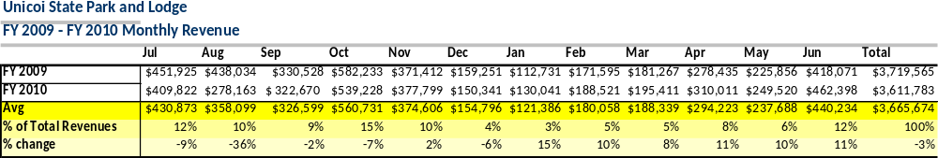

The graphs below illustrate the monthly revenue trends each year and the average percent of total annual revenue earned each month.
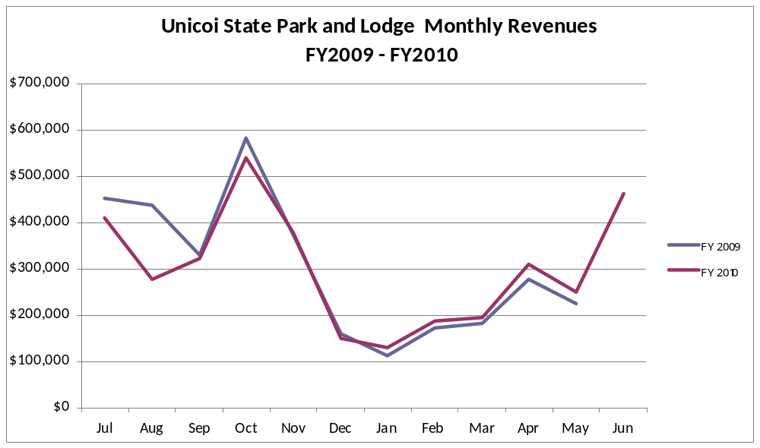

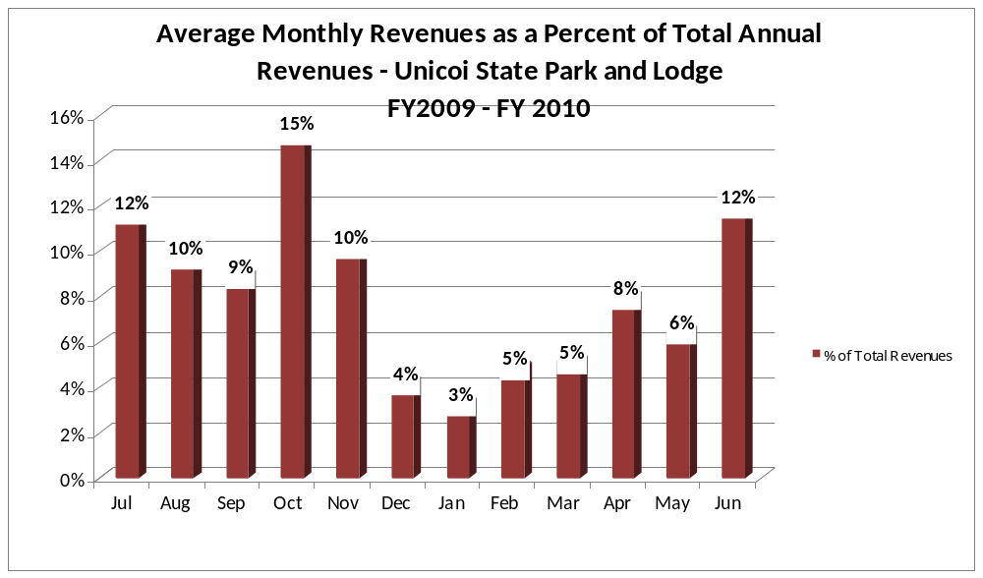

Cost Recovery Trends
Unicoi State Park and Lodge has achieved an average cost recovery of 102% of annual operational expenses through earned revenues from FY 2008 to FY 2010. This is detailed and illustrated in the table and graph below.
Year | Operational  Expenses | Earned  Revenues | Percent Cost  Recovery
2008 | $4,614,462 | $4,790,633 | 104%
2009 | $3,955,052 | $3,776,172 | 95%
2010 | $3,497,312 | $3,760,115 | 108%

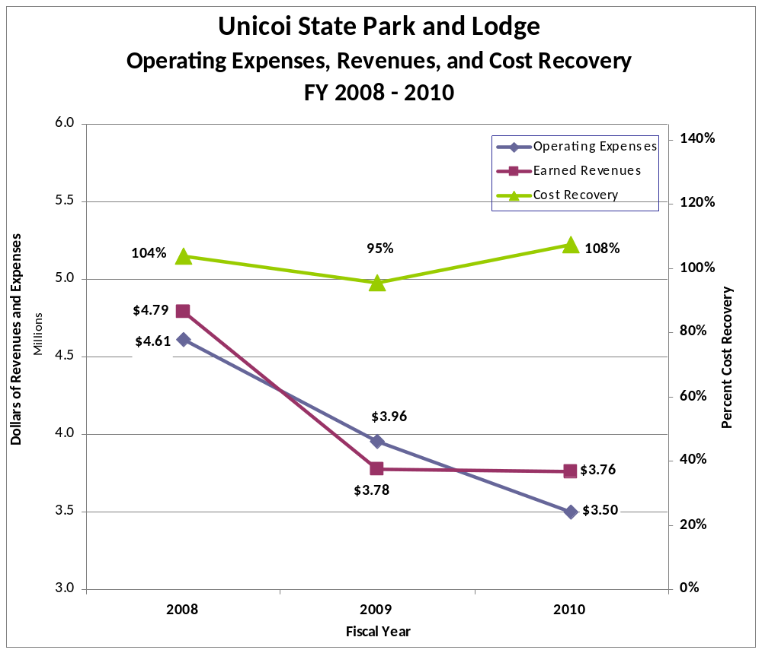

Review of Pricing
Data on rate information is available as far back as 2002, but only the last five years are evaluated. There has been notable growth in fees charged at Unicoi State Park and Lodge since 2005, with the largest increase being in 2010. A table detailing the rates for all facilities is provided below.

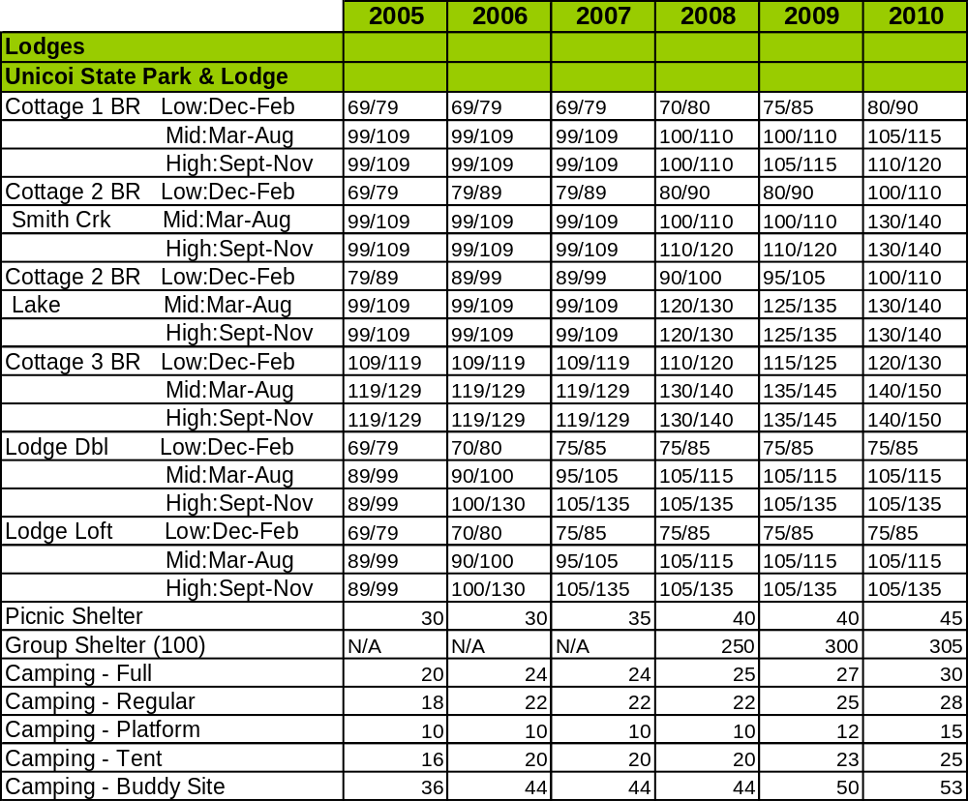

Business and Management Plan

Business Goals
The following goals serve as the foundation for the key recommendations and strategies in this business plan for Unicoi State Park and Lodge.

Enhance Cost Recovery of Site Operations
Unicoi State Park and Lodge is currently operating at a 104% cost recovery of operational expenses through earned revenues. It is critical that the site increases its cost recovery to no less than 108% by 2015. This could be done by adding revenue generating special events to capture a new audience and by adding new visitor services.

Enhance Revenue Generation Strategies
Unicoi State Park and Lodge will improve revenue generation by adding:
- Wedding pavilion overlooking Lake Unicoi off the parking decks of Unicoi Lodge
- Additional parking to handle new wedding facility (expand existing parking deck to accommodate 75 additional spaces)
- Group shelter at current picnic shelter #3 location
- Weight and exercise room in the lodge
- New visitor center near Unicoi Dam to handle camper check-in and visitor information
- Enhanced audiovisual services in lodge conference center
- Business center for lodge guests
- Property management/point of sale updated software to encompass the entire park
- Expansion of gift shop in existing location
- Indoor/outdoor pool
- Add disc golf to the Bottoms Area.

Expand Special Events at the Site
- Continue existing special events with a minimum of 10 per year. Re-evaluate them each year in August to decide if they need to continue, be expanded, or discontinued. Refer to Annual Interpretive Plan for a full listing of our special events. Below are events that have changed.
  - Wildflower Weekend changed to a “Wild About Wildflowers” month. This change was made because it became a stagnant program and attendance was dwindling. The new program will be every Saturday in April and will generate more attendance for this program, as well as more indirect revenue. Also, two of the weekends will now have an evening speaker.
  - Astronomy Night was removed from the list as this program has also become stagnant. Also, many other parks are conducting astronomy programs, and staff time can be better used planning new special events.
- At the annual special event meeting, in addition to re-evaluating existing programs, brainstorm new ideas for events that may bring in new or larger markets.
- Continue to host the annual Family Camp special event that began in 2008. The event brings indirect revenue including cottage and camping and restaurant revenues.
- Continue to host the Georgia Mountain BirdFest that began in 2011 through at least 2016 to realize full potential and revenue.
- Host a “Boomers Club” for people who are 50 years of age or older. This program would incorporate four weekends over the year. Two weekends would be centered on outdoor activities while the other two would be centered on the “arts.” Target date will be winter 2013.
- Continue to offer the Full Moon Paddle program that began in 2010 once a month in June – August as long as a Certified Canoeing Instructor is on staff to generate revenue with little staff time.
- Host a “Science Camp” field trip offering for students during the school year that may be offered as a 1-day, 2-day or 3-day camp. This would be modeled after the 4-H camps and would bring in additional programming, lodging and restaurant revenues. Target date will be fall 2013.
- Fall hayrides through the campground to generate revenue. Target date will be fall 2012.

Improve the Diversity and Innovation of Recreational and Interpretive Programs
- Offer interpretive and recreational programs to the public every Friday and Saturday year round. Seasonally offer programs based on staffing up to 5-7 days a week.
- Expand winter programs to things like Zumba, Jazz in the Atrium and Growing Up Wild (started 2012) and strategically time these programs based on meal times and gift shop hours so as to bring indirect revenue.
- Offer a park sponsored tennis tournament in March 2013.
- Invest in sending interpretive staff to receive certifications such as yoga and Tai Chi instruction so they can provide more diverse recreational/healthy programs and do not have to find outside sources.
- Collect surveys at all special events for one year to properly assess the “visitors” point of view.
- Study scholarly/published information about trends in both recreation and state park settings, as well as learn what programs are already being offered in Habersham and White counties to help understand what “niche” is already being fulfilled and what is not already being provided by other agencies.

Improve the Effectiveness of Marketing and Sales
Fill the vacant Sales Manager position (vacated in 2008) to establish new and bolster current Marketing and Sales efforts. Work with the Division Marketing Unit to establish additional advertising and marketing funding through the hotel/motel tax budget.

Establish Greater Consistency of Managing and Monitoring Customer Service & Satisfaction
Promote the new online comment card, along with the existing group evaluation, to capture a 90% satisfaction rating for all areas of the park. Conduct in-house customer service training annually to ensure all site staff provides the same level of customer service with site management holding staff accountable.

Expand Partnership Opportunities
Build new partnerships with companies/organizations/colleges/universities listed below by creating new value added packages for Unicoi State Park and Lodge guests.

Classification of Programs and Services
The tables below summarize the classifications of programs and services at Unicoi State Park and Lodge, as either core, important, or visitor supported and projects a range of cost recovery percentages that might be achieved for each. These classifications establish financial performance goals for each category of services that are linked to the recommendations and strategies of this business plan.
Core Programs / Services | Target Cost Recovery
Active management of the natural/cultural resources in order to protect their integrity | 0%
Open and public access to the site and its resources | 20% to 50%
Public safety | 0%
Maintenance of grounds, facilities and infrastructure | 0%
Park public programs | 0%
Passive interpretation | 0%

Important Programs / Services | Target Cost Recovery
Lake activities | 20%
Picnicking/day use | 0%
Hiking, interpretive/self-guided and mountain bike trails | 0%
Special events | 50% to 120%
Visitor center/interpretive programming center | 20%-50%

Visitor Supported Programs / Services | Target Cost Recovery
Meeting facilities/ conference center services | 100%
Lodge rooms | 105%
Camping | 60%
Cottages | 100%
Lodge gift shop | 100%
Trading post store | 110%
Group programs | 30%
Food service | 105%
Boat rentals | 20%

Partnership Development Plan
The table below summarizes existing partners and targeted partnerships by classification (operational, vendor, service, co-branding, funding partners) and by organizational type.
 | Public Partners | Not-for-profit Partners | Private / Enterprise Partners
Operational Partners | - Lodge/Conference Center | - Friends of Unicoi | - Wild Wood Outfitters
Vendor Partners |  |  | - Babyland General  - Cool River Tubing  - Habersham Winery  - HEMC – Green Power  - Coca Cola  - Sysco Foods
Service Partners | - Smithgall Woods  - Hardman Farm  - Buck Shoals  - White and Habersham County Schools  - White and Habersham County Libraries | - Friends of Georgia State Parks  - Friends of Unicoi State Park  - CVB  - North GA. Travel Assoc.  - White County Chamber  - Georgia Forestry Commission  - US Forest Service  - All DNR Divisions | - Innsbruck Golf Course  - VIP Travel Services
Co-branding Partners | - Alpine Helen/White County CVB  - Lodge/Conference Center | - Friends of Georgia State Parks  - Friends of Unicoi  - Georgia Ornithological Society  - Atlanta Audubon Society | - Innsbruck Golf Course  - Cradle of Forestry/Anna Ruby Falls  - Cool River Tubing  - Habersham Winery  - Babyland General  - John Kollock  - Best Western  - Hampton Inn  - North GA. Wine Growers  - Travel Store  - Leisure Time
Funding Resource Development Partner |  | - Friends of Georgia State Parks  - Friends of Unicoi State Park

Marketing and Sales Plan

Marketing and Sales Goals
Marketing and sales goals for Unicoi State Park and Lodge are based on the following desired outcomes:
- Maximize revenues by building on our current clients needs such as adding breaks, more programming, meeting audio-visual needs, etc.
- Actualize 3% to 5% higher revenues each year in group bookings
- Grow occupancy by 2% by 2012 and by 5% by 2015 – see below
- Increase visitation through programming.
In order to meet these goals, examples of specific target outcomes were identified in the areas detailed in the table below.
Area  of Focus | Current  Performance | Goal  by 2011 | Goal  by 2012 | Goal  by 2015
Lodge Rooms | 36% | 40% | 42% | 45%
Cabins | 53% | 53% | 55% | 58%

Marketing and Promotion Strategies

Publicity and Social Media
Unicoi State Park and Lodge will approach marketing and publicity planning using the following guidelines and themes:
- Event publicity
Major events benefit by having short stories in local, regional, and statewide newspapers and online social media hooks planted that run three to four weeks in advance of the event up to the date of the event itself. Stories and media need to be cultivated with contacts and online sales channels several weeks in advance of the time the stories need to run. Special interest interviews on morning, noon, and evening television news programs, radio interviews on popular rush-hour programs, and blogs on known affinity online sites should also be included.
- Program publicity
Special and unique programs should have feature stories in magazines, local and regional weekly newspapers, and statewide daily newspapers that are aimed at placements as front-page or sectional front-page stories. These stories are most effective if they run shortly before the season that the featured program begins. This will likely require several weeks of advanced planning with media contacts. Similar coverage on television and radio should also be considered. If pre-publicity cannot be generated, post-publicity can help promote future programs.
- Site Publicity
Site publicity focusing on a single site or sub-set of sites requires more intense planning efforts to attract multiple writers and editors from target publications. Each site could host several seasonal media familiarization tours (with 10 to 15 writers or editors) to familiarize them with the site and its benefits and amenities. Stories and features resulting from such tours typically take between two and six months to materialize so the tours should focus on experiences, benefits, and programs that would be available when the stories are expected to run.
Examples and suggested opportunities for events, programs and related publicity efforts based on the themes described above at Unicoi State Park and Lodge are provided in the table below.
Event Publicity | Program Publicity | Site Publicity
YouTube | Facebook | YouTube
Radio/TV | Newspaper | Radio/TV
Facebook/website | Radio | Facebook/website
Magazines | Website | Magazines
Bulletin Boards | Bulletin Boards | Bulletin Boards
In-house TV Channel | In-house TV Channel | In-house TV Channel
Helen TV Channel | CVB | Helen TV Channel
CVB | White County Chamber | CVB
White County Chamber | Magazines | White County Chamber

Packaging
Examples and suggested packages for Unicoi State Park and Lodge are provided in the table below.
Package | Package Details
Lodgical rate package | Overnight accommodations for two, breakfast for two @ only $69.00 -$99.00 a night (seasonal).
Camp Packages (Band Camps, Soccer Camp, etc) | Overnight accommodations, package rates for meals, meeting facility, field usage. Seasonal/package rates apply.
Anna Ruby Falls Package | Overnight accommodations for two, entrance to Anna Ruby Falls, granola bars and water for two @ $99.00 a night.
Cabbage Patch Kids Package | Overnight accommodations for two, breakfast for two, gift from Babyland General, crib provided in room for newly adopted Cabbage Patch doll @ only $109.00 a night.
Stay N Play Package | Overnight accommodations for two, breakfast for two, greens fees and cart for unlimited play for two at Innsbruck Golf Course @ only $169.00 a night.
Junior Ranger Birthday Party Package | Picnic shelter rental, 2 ranger led programs, pizza and the junior ranger patch for 25 @ $200

Group Sales
Types of groups within which specific target customers can be identified for Unicoi State Park and Lodge are listed below:
- Weddings
- Family Reunions
- Corporations
- Race Organizers

Incentivizing New and Repeat Visitation
Unicoi State Park and Lodge will utilize the following strategies and/or incentives to encourage new and repeat visitation starting in FY 2012:
- RSVP Rate – Offered to group customers at check-out that extends a low rate on next stay.
- Free audio-visual equipment when a two + day meeting is booked.
Marketing and Sales Metric Goals
The following marketing and sales metric goals and/or others will be monitored and progress reported at Unicoi State Park and Lodge:
- Loyalty and repeat customers:
  - 5% discount for every room booked and actualized
  - Dining Club Card to give the 10th meal free
  - Gift certificates for annual programs, i.e. Family Camp, BirdFest
- Adopt-A-Family initiative to provide guests with a personalized stay to include a coupon for 20% discount for their next stay. The front desk staff would pick a family upon check-in to personalize their stay. This would be done by contacting this family throughout their stay to recommend amenities in the area and ideas while at the park.
- Brand confidence & customers-recruiting-customers = Renovations of lodge rooms, continued customer service training.
Revenue Generation Plan
Revenue / Cost Recovery Goals
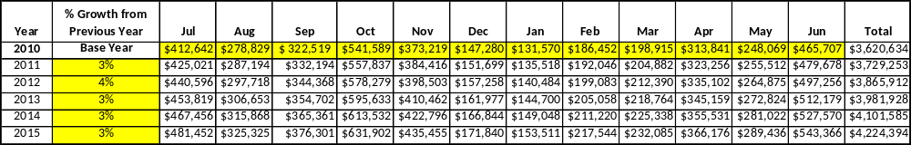
Unicoi State Park and Lodge has set a financial goal of increasing annual revenues 3% annually between 2012 and 2015. The largest revenue growth opportunity is most likely Unicoi Lodge and Conference Center. The table below details projected revenue growth leading up to 2015, based upon a nominal growth of revenues each year.

These projections would result in a total of 14% cumulative growth in total annual revenues between FY2010 and FY2015. If operational expenses can be managed with a cumulative increase of 14% between FY 2010 and FY 2015, then the overall cost recovery of the site will be approximately 115% in FY 2015 at these projected revenue levels. This is higher than the annual financial performance of the site in FY 2010, which was operated at 108% cost recovery in that year.
Revenue Generation Strategies

Pricing Plan
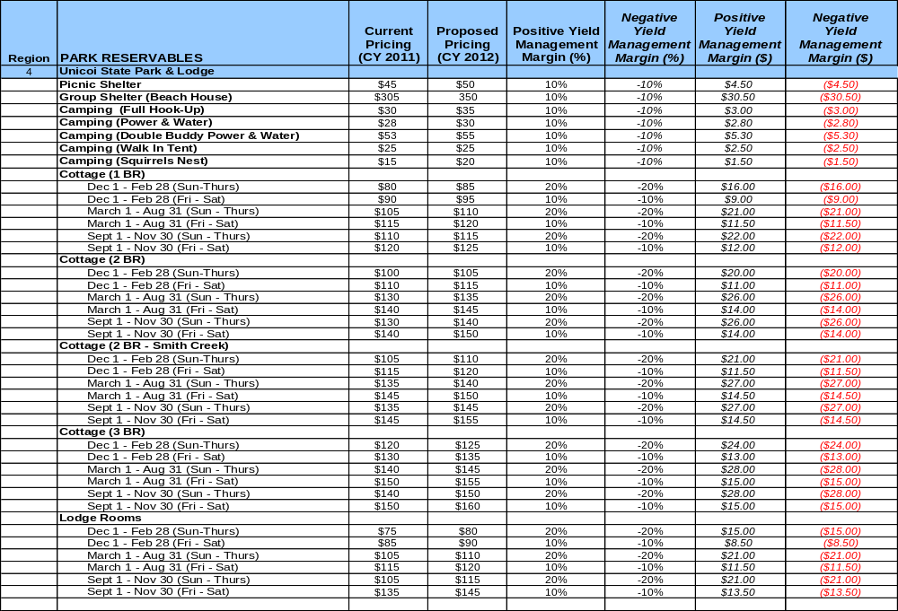
- The current conditions of the facilities will not support an increase in pricing. The proposal was pending room renovations.

Innovative Programming and Special Events Plan
Program / Event | Theme / Purpose | Scheduled Date/Season | Frequency | Target Participation | Target User Fee | Target Cost Recovery
“Fireside” Craft/Art Show | To promote Appalachian/Contemporary Crafts during an other wise “slow” time of year | 3rd Full Weekend in February | Annually | Adults/senior  vendors | $150.00 per vendor | $8,000  Gross Rev.
Georgia Mountain BirdFest | To promote birding, a new audience, and utilize Lodge and Conference Center offerings. | 1st Full Weekend in May | Annually | Birders | $110 per person + field trip fees | $12,000 (this includes lodging and some F&B / programming revenue)  Gross Rev.
Family Camp | To promote “Get Out, Get Fit, Get Outdoors.” | First Full Week in June | Annually | Families | $100.00 (avg. per family not including lodging) | $5,000  (this includes lodging rentals)  Gross Rev.
Full Moon Paddle | To offer a Canoeing program in the evening at Unicoi Lake – a unique experience | Once a month June – Aug | Once a month June – Aug | All – 20 people maximum | $15/person | $300  Gross Rev.
“Science Camp” | Offer expanded Environmental Education programs to students | Spring and Fall | Upon request – 1, 2, 3 day options | Students | $125/ child include Ldg prog., and food. | $15,200  Gross Rev.
“Boomers Club” | To provide an outdoor experience for active and vibrant senior citizens. Three full days of activities. | One weekend a Quarter | Quarterly | Seniors | $400.00/adult for the series. | $10,000 Gross Revenue
Fall Hayrides | To offer a recreational program in the peak season to make revenue | Sep, Oct, Nov around Haunted Trail | Saturdays in Fall | All | $3 per adult  $2 per child  Under 4 free | $250 Gross Revenue

Partnerships and Concessions Plan
Service / Partnership | Term of Service | Financial Objective | Contract Manager
Beach and Boat Concessions | 1 year | Reduced personnel cost and boat maintenance with 15% revenue generation from concessionaires | Park Manager

Expense Management Plan
Personnel Assignments
The following actions will be taken to proactively manage labor costs via personnel assignments and classifications.
Action | Timeline | Outcome
Reduce hourly labor to minimum during  off-season. | November through March | Reduce labor expense
Continue conversion of salary positions to hourly | By August 2011 | Reduce operating expense and closer alignment of resort operations

Management Techniques
The following actions will be taken to proactively manage labor costs via management techniques.
Action | Timeline | Outcome
Have managers evaluate business levels weekly to determine staffing level needs. | Ongoing | Control the labor cost as it happens to ensure we have proper staffing levels at all times.
Pursue contracted labor to reduce the need additional 1508 position and maintain service continuity. | TBD | Improve level of service and reduce expense.

Adjusted Levels of Service
The following actions will be taken to proactively manage labor costs via reduced levels of service.
Action | Timeline | Outcome
Close Little Brook campground loop and comfort station | December through February | Reduce utilities and water use for 16 campsites.
Close Squirrels Nest camp sites and comfort station | December through March | Reduce utilities and water use to the comfort station and 16 platform sites.
Take 20 rooms off line in the system. Shut down water heaters and set thermostat heating at 50°. Dictated by business demand. | December through February | Reduce utility expense and staffing needs to clean the common spaces.

Financial Pro Forma
The following five-year financial pro forma projects operating expenses, earned revenues and cost recovery through FY 2015. These pro forma are based on the strategies and desired outcomes identified in this business plan, especially the revenue generation and expense management plans, and are linked to corresponding performance goals.

Expense Pro Forma
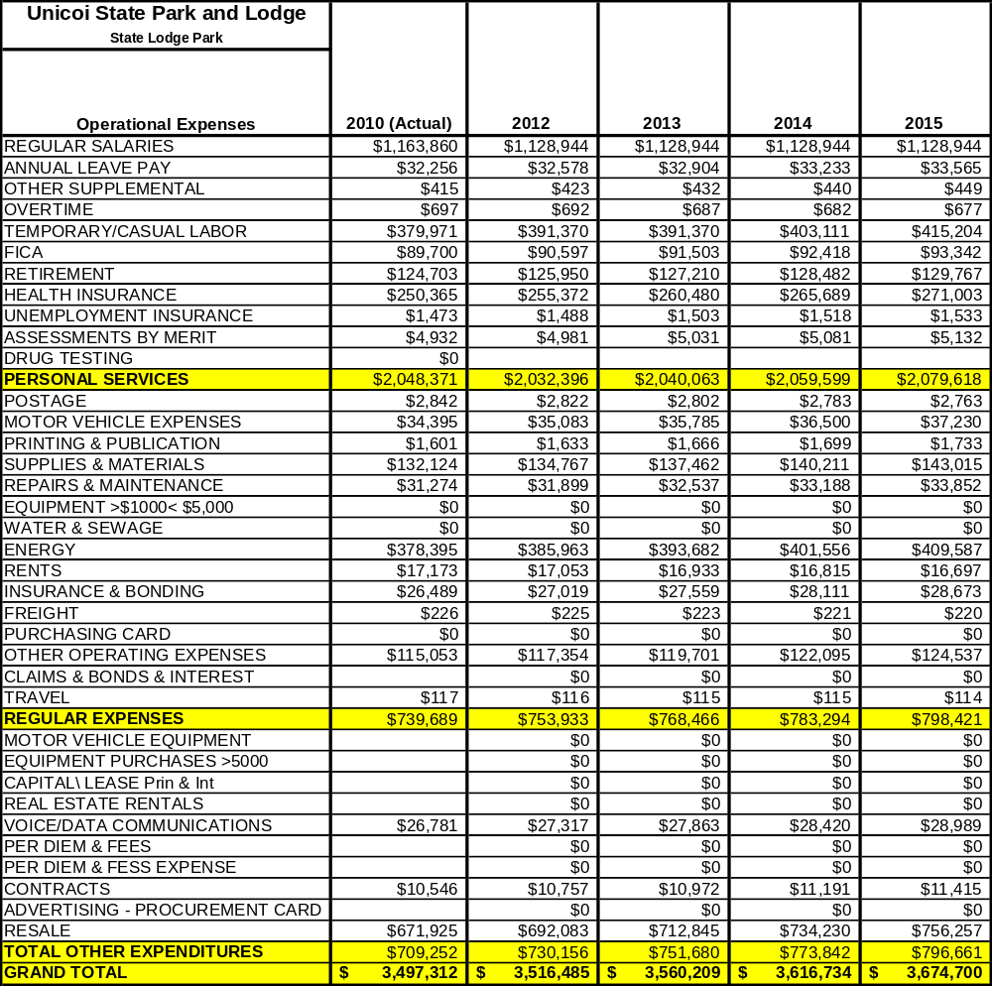

Revenue Pro Forma
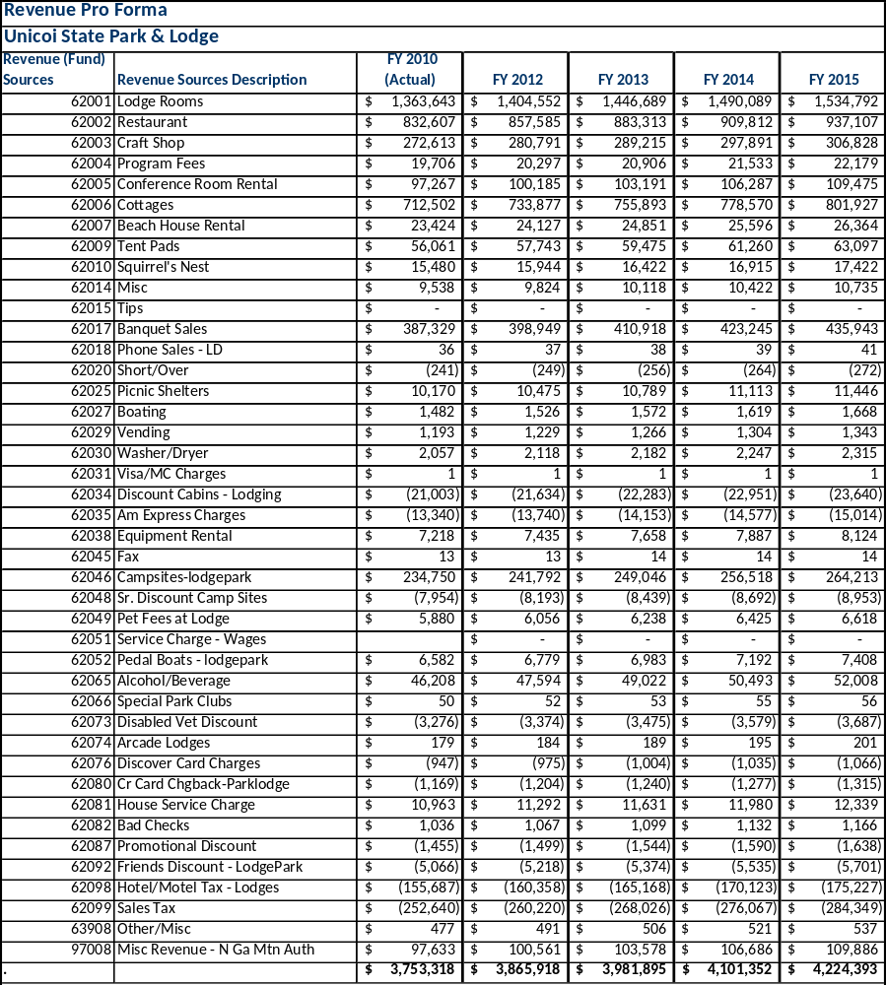

Total / Cost Recovery Pro Forma
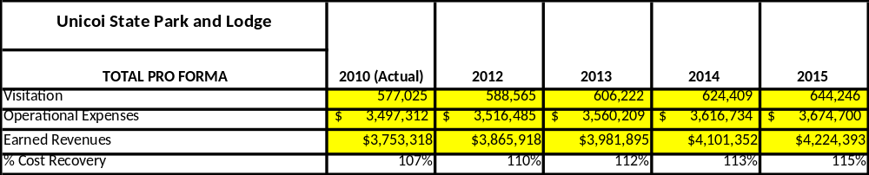

Action Plan
ACTION PLAN
Site: Unicoi State Park and Lodge |  | Site Manager: Scott Hudgins |  |  | Date:
Month:
Strategy | Tasks | Costs / Funding | Revenues / ROI | Responsibilities | Metrics

ACTION PLAN
Site: Unicoi State Park and Lodge |  | Site Manager: Scott Hudgins |  |  | Date:
Month:
Strategy | Tasks | Costs / Funding | Revenues / ROI | Responsibilities | Metrics

This is the average of the last three years – FY 2008, FY 2009, and FY 2010
Current employees, not including vacancies.
Current employees, not including vacancies.
Major population centers within a two-hour drive from the site

