Chief Vann House Historic Site
Business & Management Plan

Prepared June 2011; Finalized March 2013
Direction 2015 – Sustainable Business Planning

Table of Contents

Executive Summary 3

Site and Operations Assessment 8
Site Inventory and Facility Assessment 8
Operational Assessment 10
Financial Performance Assessment 15

Business and Management Plan 18
Business Goals 18
Classification of Programs and Services 20
Partnership Development Plan 21
Marketing and Sales Plan 22
Revenue Generation 25
Expense Management Plan 27
Financial Pro Forma 28

Action Plan 30

Executive Summary
The Parks, Recreation and Historic Sites Division (PRHSD) of the Georgia Department of Natural Resources (DNR) is transitioning the management of Chief Vann House State Historic Site to operate more like a business, reflecting the Direction 2015 – Sustainable Business Planning initiative to improve the fiscal performance and management of the state parks and historic sites system. This business and management plan is designed to help the site recover more operating expenses through earned revenues, productive partnerships, and innovative programs.

Site Fact Sheet
Site Name | Chief Vann House State Historic Site
Site Manager | Jeff Stancil
Region Manager | Joe Yeager
Date of Business Plan completion | June 2011
Site size | 109 acres
Total number of visitors (FY 2010) | 10,742
Total operating budget (FY 2010) | $90,055
Total earned revenues (FY 2010) | $21,863
Operational cost recovery (FY 2010) | 24%
Average operating cost per visitor (FY 2010) | $8.38
Average earned revenue per visitor (FY 2010) | $2.04
Average cost recovery (FY 2008 – 2010) | 20%
Target cost recovery (FY 2015) | 75%
Total full-time employees | 1
Total part-time employees | 2
Primary service markets | Atlanta, Northwest Georgia, Chattanooga, Tennessee & I-75 travelers
Primary attractors/visitor appeal factors | Early 19th century Cherokee Renaissance culture
Leading opportunities for improved site performance | 1) Increased I-75 corridor marketing, including billboards,  2) Increased marketing to attract school field trips, and  3) Increased Atlanta area marketing.

Site Summary and Key Attractions
During the 1790’s, James Vann became a Cherokee Indian political leader and wealthy businessman. He established the largest and most prosperous plantation in the Cherokee Nation, covering 1,000 acres of what is now Murray County. The plantation included 96 buildings, thousands of fruit trees, and hundreds of acres of cultivated fields and was staffed with 110 African slaves.
In 1804 Vann completed construction of a beautiful two and one half story brick home that was the most elegant and expensive in the Cherokee Nation. After Vann was murdered in 1809, his son Joseph inherited the mansion and plantation. Joseph was also a Cherokee political leader and became even wealthier than his father. In the 1830’s, almost the entire Cherokee Nation was forced west by State and Federal troops on the infamous Trail of Tears. The Vann family lost their elegant home and plantation, rebuilding in the Cherokee Territory in Oklahoma.
Chief Vann House State Historic Site was established in 1952 and opened to the public in 1958, comprising 109 acres. Today the Vann House survives as Georgia’s best-preserved Cherokee Indian home.

Key Attractions
The amenities or features listed below are those that seem to be most popular for visitors.
- Visitor Center with exhibits, film and rest rooms.
- Original 1805 Vann Mansion.
- Vann’s Reconstructed Kitchen / Work House with exhibits on Vann’s African Slaves
- Cherokee Farmstead Exhibit with original Cherokee log buildings: Dwelling House, Smoke House and Corn Crib.
- Vann’s Reconstructed Corn Crib
- God’s Acre Moravian Cemetery
- Vann’s Spring Nature Trail

Financial Targets for Chief Vann House State Historic Site
The table below details the total operating expenses and earned revenues for Chief Vann House State Historic Site over the last three years (2008 – 2010). This table also calculates total cost per visitor and revenues per visitor during these operating years, and details the target financial performance goals in the context of achieving at least 75% cost recovery. This table also calculates the necessary change from 2010 operating expenses and revenues.
Chief Vann House Historic Site | Target Visitation Growth from 2010 | Target Change in Visitation
Visitation Assumptions | 21% | 2,258
 | 2008 | 2009 | 2010 | 2015 Target
Visitors | 12,099 | 12,226 | 10,742 | 13,000
Total Expenses | $ 169,710 | $ 145,381 | $ 90,055 | $ 44,570
Total Revenues | $ 29,388 | $ 28,697 | $ 21,863 | $ 33,649
Cost per Visitor | $ 14.03 | $ 11.89 | $ 8.38 | $ 3.43
Revenue per Visitor | $ 2.43 | $ 2.35 | $ 2.04 | $ 2.59
State Financial Support per Visitor | $(11.60) | $(9.54) | $(6.35) | $(0.84)
Total Cost Recovery | 17% | 20% | 24% | 75%
Change from 2010 Expenses |  |  |  | $ (45,485)
Percent Change from 2010 Expenses |  |  |  | -50.51%
Change from 2010 Revenues |  |  |  | $ 11,786
Percent Change from 2010 Revenues |  |  |  | 53.91%

Key Recommendations

Primary / Short Term Recommendations
- Budget a slight increase in part-time labor and fill two existing vacant part-time positions with tour guides who can be scheduled during peak visitation times and to help with school groups. Federal stimulus tour guides have been used for the past two years to help staff the site, but in FY12 most federal stimulus programs will be discontinued. Having a “go-to” team of trained part-time tour guides will decrease the number of times the museum has to be closed during guided house tours. Having a trained staff ready to go will also help during the transition period when the current site manager retires in FY13.
- Better utilize target audience marketing, including Interstate 75 billboards. Improve current I-75 signage by adding ‘Trail of Tears Site’ wording to signs.
- Continue Friends of Chief Vann House current, very successful special programs and expand events to increase visitation.
- Increase retail sales generated revenue by encouraging sales of subject matter books and other retail items through on-line marketing on the Division website.
- Increase marketing of the site in local Chatsworth and Dalton hotels, as well as other I-75 corridor lodging establishments.
- Increase marketing of the site to area schools to increase the number of field trips. Consider marketing incentives offering a small admission discount to groups who visit New Echota and the Chief Vann House on the same field trip.
- Continue farming lease to provide historically correct crops of wheat and corn on 85-acre tract west of the Vann House. The lease provides a substantial cost savings to the division while keeping this highly visible area aesthetically pleasing to the public.
- Consider a hay lease for the 8-acre field next to the museum to save fuel and labor expenses.

Secondary / Long Term Recommendations
- The Chief Vann House is located in a relatively isolated location midway between Atlanta and Chattanooga and a 20-minute drive from Interstate 75. Due to these factors, the site will never reach a 75% sustainable level without changes in staffing. Personnel costs are a large part of the current budget expenses. In FY10, personnel expenses were 72% of the entire budget ($64,712 of the total expenses of $90,005). When the current manager retires in FY13, a number of viable options will be available which will decrease operating expenses and increase revenue generation.
- One option will be to merge New Echota and Vann House into one site, utilizing only two full-time staff members; a site manager and maintenance ranger to cover both sites. New Echota and the Vann House share the same time-period Cherokee Indian history and are only 20 minutes apart. Since the interpretation is similar, staff members could easily work at both sites depending on visitation levels and school group scheduling. Part-time tour guides would serve as the front-line visitor services staff. Admission would still be charged at both sites as normal, but some type of marketing incentives could be offered to allow a small discount if visitors or groups toured both sites on the same day.
- Another option will be to operate the site from Fort Mountain and utilize a front-line visitor services staff of part-time tour guides to operate the site on a daily basis. Many of the current administrative duties for the Vann House are already handled by Fort Mountain. If future Fort Mountain staffing will allow for it, weekly maintenance such as cleaning and mowing could be done by Fort Mountain staff. Both options will allow the site to reach a 75% sustainable level.
- Consideration should also be made to fill the site manager job with an entry level resource manager. Even though this will be a lower paying position, due to the cost of benefits and also having to still have a staff of part-time tour guides, it will be impossible to reach 75% sustainability, but a level of 50% can be reached with this option providing the full-time staff member is paid at or near entry level.
- With any of these options (especially the first and second), it will be necessary to greatly increase part-time staffing to handle daily tours of the Vann House, but additional part-time staffing will also allow the site to be open more days per week. Higher part-time labor expenses will be offset by increased revenue from longer operating hours:
March 1 – December 31 Open Wednesday – Sunday 10 AM – 5 PM
January 1 – February 28 Open only Saturday and Sunday 10 AM – 5 PM

Site and Operations Assessment
This site inventory and operations assessment is a culmination of analyses and findings from a review of the condition of facilities, infrastructure, and operations at Chief Vann House. The findings and observations provide a basic understanding of the predominant issues that contribute to the site’s current operating conditions. The assessment includes the following:
- Site Inventory and Facility Assessment
- Operational Assessment
- Financial Assessment
Site Inventory and Facility Assessment

Methodology
Facility and asset conditions are rated using a differential scale of excellent, good, fair, or poor. Descriptions of conditions that are attributed to each of these findings are also provided.
Scale of Conditions
Rating | General Description
Excellent | Facilities/amenities are in ‘excellent’ condition when they show little or no maintenance or repair problems. Facilities do not feature any major design or operational issues or flaws that contribute to diminished use or increased maintenance or upkeep. Facilities are easy to clean and maintain in order to place them back into public use and the users perceive them to be in excellent shape.
Good | Facilities/amenities are in ‘good’ condition when they show only minor maintenance or repair problems. Most maintenance issues with these facilities typically appear to be the result of age and/or heavy use. Facilities may only feature minor design or operational issues that contribute to diminished use or increased maintenance or upkeep. Facilities are moderately easy to clean and maintain in order to place them back into service and the users perceive them to be adequate for their use, but probably not in excellent shape.
Fair | Facilities/amenities are in ‘fair’ condition when they show significant maintenance or repair problems. Facilities generally exhibit ongoing maintenance issues that appear to be the result of age, heavy use, or design or operational flaws. Some maintenance and repair needs may compound their fair condition by being deferred because of budget and/or resource limitations. Facilities require more effort to clean and maintain before placing them back into service and the users may perceive them as being less than adequate for their use and in a state of deterioration. The facility or structure may need of major repair or replacement.
Poor | Facilities/amenities are in ‘poor’ condition when they show significant, on-going maintenance or repair problems that ultimately may result in suspended use for repair/replacement. Maintenance and repair issues are possibly the result of poor maintenance and clearly the result of age, heavy use, or design or operational flaws. Problems with the facilities are often compounded over time due to consistently-deferred maintenance and repair because of budget and/or resource limitations. Facilities may feature major design or operational issues that contribute to diminished use or increased maintenance or upkeep. Facilities require excessive effort to clean and maintain before placing them back into service and the users often perceive them as being inadequate for their use and in a state of serious deterioration. The facility or structure may need of major repair or replacement.

Inventory and Assessment
The table below is an inventory of facilities and amenities at Chief Vann House, and provides the assessed condition of each as reviewed in June 2011.
Site Asset / Amenity | Quantity | Condition
Acres | 109 | Good
Vann Mansion | 1 | Good, but floating stairway to 3rd floor will eventually need safety supports to allow continued visitor access
Visitor Center | 1 | Good
Cherokee Dwelling | 1 | Good
Vann’s Kitchen | 1 | Fair
Vann’s Corn Crib | 1 | Good
Site Residence | 1 | Good
Maintenance Building | 1 | Good
Old Barn | 1 | Fair
Cherokee Corn Crib | 1 | Good
Cherokee Smokehouse | 1 | Good
Old Restroom (Storage) | 1 | Good
God’s Acre Cemetery & Shelter | 1 | Good
Bradford Springhouse Ruins | 1 | Fair (stabilized)

Prioritized Facility Needs
Based on the facility inventory and assessment, these prioritized needs have been identified. Each need has been aligned with a priority category of high, moderate, or low to support future decision making regarding project sequencing, investment of public resources, and meeting community expectations. The priority assignment for each need is not a measure of importance. Rather, these recommended priorities reflect a phased implementation approach over the next several years.

Facility Need | Priority Assignment
Improved I-75 corridor signage | High
Structural stabilization of Vann House floating stairway to 3rd floor | High
Replace deteriorating logs on south side of Vann’s Kitchen/Workhouse | Moderate
Improve signage on area roads | Moderate
Nature trail and boardwalk | Low
Upgrade front gates for automatic operation | Low

Operational Assessment
The Operational Assessment includes:
- An inventory and classification of programs and services being provided at the site,
- A review of staffing at the site,
- A review of concessionaires and partners operating at the site, and
- Visitation and customer satisfaction.

Inventory and Classification of Programs and Services
Programs and services are classified into one of three major categories:
1) Core or Essential Services
2) Important Services
3) Value added or Visitor Supported Services
Programs and services at the site are classified into these categories based in part on the mission and public mandates for both the site and the agency. For the services in each of these categories, there are financial performance expectations that will define how services are funded and evaluated.

Category 1 – Core Services [Largely supported by tax funds]
Core programs, services and facilities are those the agency must provide and/or are essential in order to capably govern and meet statutory requirements. The failure of the agency to provide Category 1 services at adequate levels could result in significant negative consequences for the public and the resources under protection. The criteria for services to be classified as core or essential are:
- The services are mandated by the agency’s law or charter or are contractually obligated by agreement to provide the services.
- The services are essential to protecting and supporting the public’s health and safety.
- The services protect and maintain valuable assets and infrastructure.
- The services would generally and reasonably be expected and supported by residents, businesses, customers and partners.
- The services are those that cannot or should not be provided by the private sector.
- The services provide a sound investment of public funds.
The following programs and services offered at Chief Vann House have been identified as core services:
- Active management of the natural and cultural resources of the site and maintenance of the various historical artifacts on the site in order to protect their integrity
- Artifact management
- Open and public access to the site and its resources
- Site appropriate education, interpretation and recreational opportunities
- Public safety
- Maintenance of grounds, facilities and infrastructure

Category 2 – Important Services [Supported by a balance of tax funds and earned revenues]
Important programs, services and facilities are those the agency should provide, and are important to governing and effectively serving residents, businesses, customers and partners. Providing Category 2 services expands or enhances the agency’s ability to provide and sustain its core services. The criteria for programs or services to be classified as important are:
- The services expand, enhance or support identified core services.
- The services are broadly supported and utilized by the community, and are considered an appropriate, important, and valuable public good. Public support may be conditional upon the manner by which the services are paid for or funded.
- The services generate income or revenue that offsets some or all of the operating cost and/or are deemed to provide economic, social or environmental outcomes or results.
The following services offered at the Chief Vann House have been identified as important services:
- Staff-guided interpretation and education programs
- Support for historic researchers

Category 3 – Visitor Supported Services [Almost exclusively supported by earned revenue]
Visitor supported programs, services and facilities are those discretionary services that the agency may provide when additional funding or revenue exists to offset the cost of providing those services. Category 3 services provide added value above and beyond what is required or expected. The criteria for programs or services to be classified as visitor supported are:
- The services expand, enhance or support Core Services, Important Services and the quality of life of the visitors, community or stakeholders.
- The services are supported, valued and well utilized and provide an appropriate and valuable public benefit.
- The services generate income or funding from sponsorships, grants, user fees or other sources that offset some or all of their cost and/or provides a meaningful return on investment.
- The services can possibly be provided through outsourcing or use of concessionaires, providing opportunities for community enterprises that may not otherwise be provided by the agency.
The following services offered at the Vann House have been identified as visitor supported services:
- Gift shop
- Ranger-guided interpretation and education programs
- Special events / programs beyond normal programming

Staffing Assessment
Labor costs at Vann House State Historic Site represent the largest area of budgetary expense at an average of 74% of the total operating budget each year for the last three complete years, which is higher than the target of total labor costs (including benefits) not exceeding 65% of the site’s total operating expenditures. The tables below and on the following page provide a basic review of the current staffing at the site.
Full Time Equivalent Employees
Position / Title | Quantity (FTE) | Vacancies | Annual Hours
Site Manager | 1 | 0 | 2,080
TOTAL | 1 | 0 | 2,080

Part Time Employees
Position / Title | Quantity (FTE) | Vacancies | Hours
Tour Guide | 2 | 3 | 1,280
TOTAL | 2 | 3 | 1,280

Labor Support
Labor Support | Annual Hours
Federal Stimulus Workers | 1,248
Inmate Work Detail (average 4-person crew) | 1,456
Engineering and Construction Crews | 24
Volunteers | 1,672
TOTAL | 4,400

Total Labor Hours
Labor Type | Annual Hours
Full Time Equivalent Employees | 2,080
Part Time Employees | 1,280
Labor Support | 4,400
TOTAL Annual Labor Hours | 7,760

Labor Budget Summary

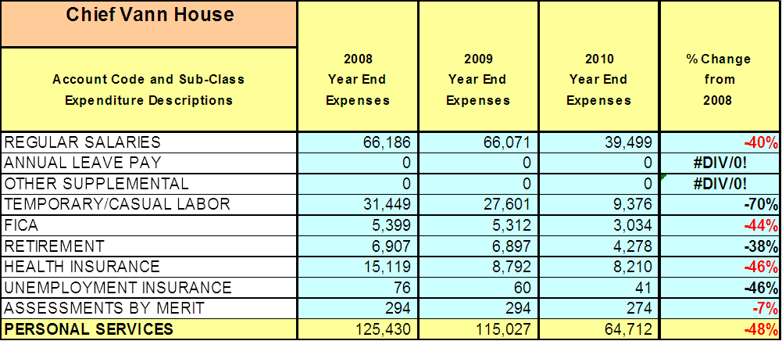
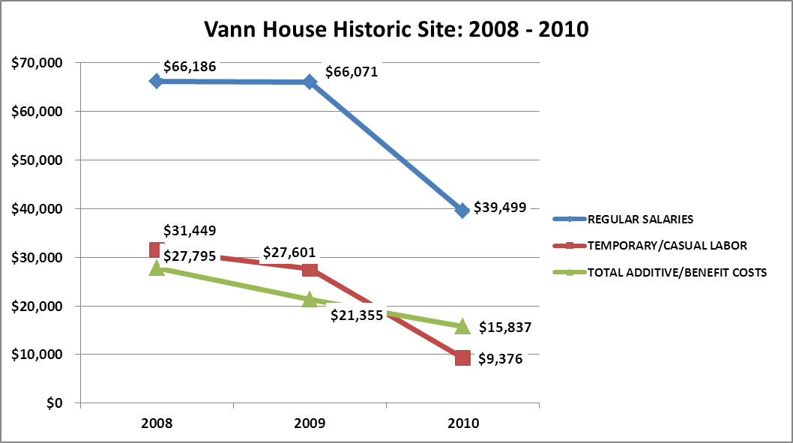
Visitation and Occupancy
Overall annual visitation to Vann House State Historic Site has trended downward from 2008 and 2009 to 2010, decreasing by 12% with a 1,484 reduction in visitors. This is attributed to a decrease in open days (decreased from 5.5 days/week of open operation to current schedule of 3 days/week of open operation, a decrease of 45% open hours. Decrease also slightly due to a downturn in the economy.
Year | Total Visitation
2008 | 12,099
2009 | 12,226
2010 | 10,742

Financial Performance Assessment

Operational Expenses
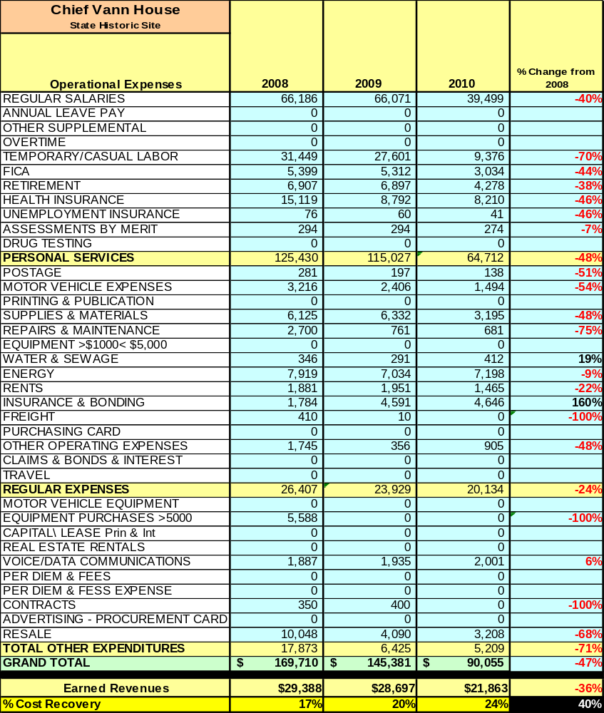
A summary of total operating expenses from 2008 to 2010, as well as their percent change from 2008 are provided in the table below.

Earned Revenues
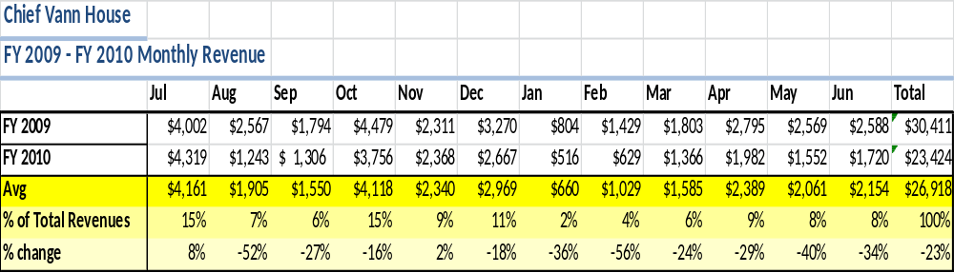
Earned revenues at Vann House Historic Site have decreased since 2008, largely attributed to the corresponding decrease in overall visitation caused by a reduction in open operating hours and to a lesser degree because of the economy.
The graphs below illustrate the monthly revenue trends each year and the average percent of total annual revenue earned each month.
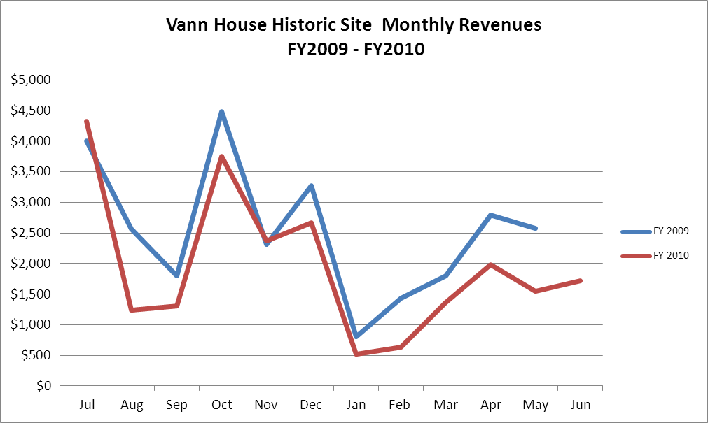

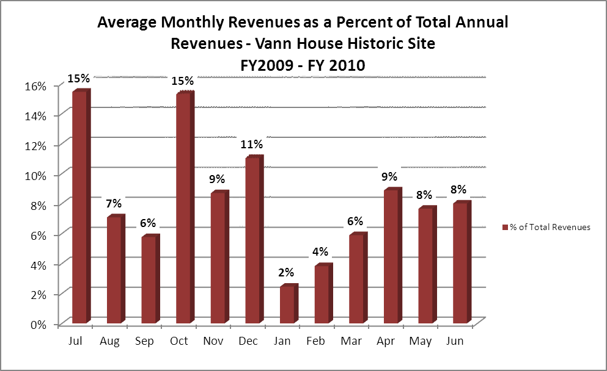
Cost Recovery Trends
Vann House State Historic Site consistently achieves 20% cost recovery of annual operational expenses through earned revenues. This is detailed and illustrated in the table and graph below.
Year | Operational  Expenses | Earned  Revenues | Percent Cost  Recovery
2008 | $ 169,710 | $ 29,388 | 17%
2009 | $ 145,381 | $ 28,697 | 20%
2010 | $ 90,055 | $ 21,863 | 24%
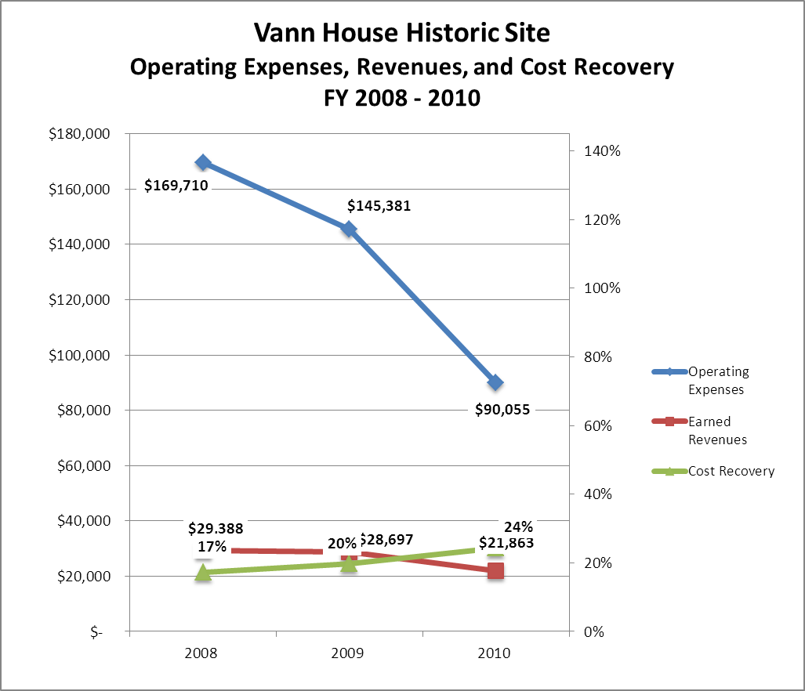

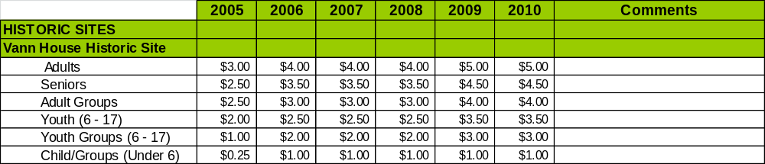
Review of Pricing
Data on rate information for site admission fees is available as far back as 2002, but only the last five years are evaluated.
Business and Management Plan

Business Goals
The following goals serve as the foundation for the key recommendations and strategies in this business plan.

Enhance Cost Recovery of Site Operations
Vann House is operating at a 26% cost recovery of operational expenses through earned revenues. With staff already reduced to a minimum, Vann House plans to improve cost recovery of site operations through controlling operational expenses, increasing visitation, increased resale revenue generation and expanding special event(s) offerings. Vann House needs to regain school field trip visitation lost during the recent 2009 restructuring (loss of staff and operating hours) and increase non-school group visitation by target marketing of the site in various publications and improved/increased marketing along the Interstate 75 corridor, resulting in increased visitation/revenue generation. It is critical that the site seek to increase its cost recovery to no less than 75% through enhanced revenue generation and strategic expense reductions, especially a decrease in labor and benefit expenses when the current manager retires in FY13.

Enhance Revenue Generation Strategies
Increased earned revenues will most likely result from the impacts of both increased visitation at the site and specific revenue enhancement strategies. The Vann House will improve revenue generation through increasing the admission fees, increasing the number and type of special events held at the site and the fees charged for the events, and by enhancing the resale space for more dynamic impact to improve resale sales. After the 2009 budget cuts, many historic sites could no longer offer staff-led tours to visitors and groups and changed over to only offering self-guided tours. The Vann House is filled with historical artifacts and currently there is no way to allow visitors to view the interior without a staff member. So despite the budget cuts, all visitors to the Vann House, including individuals, families, and groups, still receive a staff-guided tour of the mansion. With this extra service, the Vann House can easily justify an increase in admission prices for 2012.

Expand Special Events at the Site
All of the major programs and events at the site are directly linked to the unique history of the site. The expansion of smaller indoor programs, especially during off-season months, could significantly improve visitation. However, because the Vann House is an authentic 200-year old Cherokee home filled with historical artifacts, it is distinctively inhibited by a lack of programming space which makes large-scale events very challenging. The site grounds do offer opportunities for outdoor programming, but the lack of parking limits the size of events.

Improve the Diversity and Innovation of Recreational and Interpretive Programs
As with many historic sites, the Chief Vann House features quality exhibits and displays that are predominantly appealing to adults. It will be crucial for the site to improve the appeal of all interpretative resources (e.g., displays, exhibits, and programs) to a wider range of age groups. For example, consideration should be given to developing exhibits that are tactile and experiential in order to best connect with younger audiences. Additionally, consideration should be given to providing more innovative exhibits including traveling displays on loan from other museums in order to encourage repeat visitation. Work is currently underway on additional wayside interpretive signs outdoors, as well as interpretive panels inside the buildings at the Cherokee farmstead exhibit.

Improve the Effectiveness of Marketing and Sales
The effectiveness of marketing and promotional activities of the Vann House could be improved to produce greater visitation and revenues during peak, shoulder and off seasons. This could be achieved in part through a shift in the existing marketing approach to one that is more targeted and focused on experiential and encouraging messaging geared to historic sites. Additionally, partnerships with nearby attractions and amenities in the region should improve the ability of the site to maintain an increased and steady flow of visitors and revenue throughout the year. A significant opportunity to increase visitation to Vann House State Historic Site exists with the Interstate 75 corridor traffic. Current signage is not explanatory enough. Added signage along the interstate (including billboards), emphasizing Cherokee Indians and the Trail of Tears, would prove beneficial in increasing traffic. Additional directional signs along area roads are being installed this year and these should also improve visitation.

Establish Greater Consistency of Managing and Monitoring Customer Service & Satisfaction
Customer comment card evaluations by visitors of the Vann House staff, facilities and services have consistently ranked Vann House State Historic Site at the ‘very good’ and ‘excellent’ level. Better processes for evaluation of special programs by staff, volunteers and visitors should be established to improve programs being offered. All events/programs offered should be closely evaluated and value(s) determined to decide whether event is held or discontinued.

Expand Partnership Opportunities
Although Vann House State Historic Site has a history of network marketing with other North Georgia and Eastern Tennessee Cherokee sites and museums, opportunities for greater marketing and partnering for special events and programs still exist. Greater corporate and local municipal co-sponsorship, or partial support from the Northwest Georgia region for both special events and regular operations, should be solicited and increased.

Classification of Programs and Services
The tables below summarize the classification of programs and services at the Vann House State Historic Site as either core, important, or visitor supported and projects a range of cost recovery percentages that might be achieved for each. These classifications establish financial performance goals for each category of services that are linked to the recommendations and strategies of this business plan.

Core Services
Program / Service | Target Cost Recovery
Active management of the natural and cultural resources of the site in order to protect their integrity | 0%
Artifact management | 0%
Open and public access to the site and its resources | 20% to 50%
Site appropriate education, interpretation, and recreational opportunities | 20% to 50%
Public safety | 0%
Maintenance of site, grounds, facility, and infrastructure | 0%

Important Services
Program / Service | Target Cost Recovery
Self-guided interpretation and education programs | 20 to 80%
Support for historic researchers | 50% to 80%

Visitor Supported
Program / Service | Target Cost Recovery
Gift Shop | 150% to 200%
Ranger guided interpretation and education programs | 50%
Special events / programs beyond normal programming | 100% to 150%

Partnership Development Plan
The table below summarizes existing partners and targeted partnerships by classification (operational, vendor, service, co-branding and funding partners) and by organizational type (public, not-for-profit and private / enterprise).
 | Public Partners | Not-for-profit Partners | Private / Enterprise Partners
Operational Partners | - Friends of Chief Vann House  - Non-Friends Volunteers  - Georgia DOT | - Chieftains Museum  - Trail of Tears Association and National Association  - Boy Scouts  - Girl Scouts  - Local, Regional, and State Service Organizations
Vendor Partners
Service Partners | - City of Chatsworth  - Murray County | - Friends of Chief Vann House  - Trail of Tears Association  - BSA/GSA Troops  - Whitfield-Murray Historical Society  - Murray County Chamber of Commerce
Co-branding Partners | - National Park Service – Trail of Tears National Historic Trail
Funding Resource Development Partner | - National Park Service – Trail of Tears National Historic Trail  - Georgia DOT | - Friends of Chief Vann House  - Georgia Trail of Tears Association  - Georgia Indian Council  - Whitfield-Murray Historical Society

Marketing and Sales Plan

Marketing and Sales Goals
Marketing and sales goals for the Vann House are based on the following criteria and desired outcomes:
- To produce more interpretive programs that draw visitors to the site
- To produce more large, signature events with large participation
- To produce increased overall visitation and revenues
- To increase awareness of the site and visitation to the site
- To regain school group field trip visitation lost during restructuring of Division in June 2009
- To increase visitation to monthly and quarterly special programs and events
- To develop increased visitors into strong advocates for Vann House State Historic Site, including an increase in membership in Friends of Vann House State Historic Site
In order to meet these goals, examples of specific target outcomes were identified in the areas of special events participation and overall visitation and are detailed in the table below.
Area  of Focus | Current  Performance | Goal  by 2011 | Goal  by 2012 | Goal  by 2015
Special Events Visitation | 1,231 | 1,354 | 1,489 | 1,637
Overall Visitation | 10,742 | 11,657 | 12,492 | 13,000

Marketing and Promotion Strategies

Publicity and Social Media
Vann House will approach marketing and publicity planning using the following guidelines and themes:
- Event publicity
Major events benefit by having short stories in local, regional, and statewide newspapers and online social media hooks planted that run three to four weeks in advance of the event up to the date of the event itself. Stories and media need to be cultivated with contacts and online sales channels several weeks in advance of the time the stories need to run. Special interest interviews on morning, noon, and evening television news programs, radio interviews on popular rush-hour programs, and blogs on known affinity online sites should also be included.
- Program publicity
Special and unique programs should have feature stories in magazines, weekly newspapers, and statewide daily newspapers that are aimed at placements as front-page or sectional front-page stories. These stories are most effective if they run shortly before the season that the featured program begins. This will likely require several weeks of advanced planning with media contacts. Similar coverage on television and radio should also be considered. If pre-publicity cannot be generated, post-publicity can help promote future programs.
- Site Publicity
Site publicity focusing on a single site or sub-set of sites requires more intense planning efforts to attract multiple writers and editors from target publications. Each site could host several seasonal media familiarization tours (with 10 to 15 writers or editors) to familiarize them with the site and its benefits and amenities. Stories and features resulting from such tours typically take between two and six months to materialize so the tours should focus on experiences, benefits, and programs that would be available when the stories are expected to run.
Examples and suggested opportunities for events, programs and related publicity efforts based on the themes described above at the Vann House are provided in the table below.
Event Publicity | Program Publicity | Site Publicity
Vann House Days | Artifact ID Program | Vann House, Chieftains Trail and Trial of Tears Fam Tour
Christmas Candlelight Tours | Cherokee Storytelling
Cherokee Indian Fall Festival | Cherokee Genealogy Class
History Day Lectures | Blacksmithing Workshop

Packaging
Example and suggested packages for Vann House are provided in the table below.
Package | Package Details
Cherokee History Package | Entrance into New Echota and the Chief Vann House. Ideal for both individuals and school groups
School group tour Package | School field trip group admission with staff led guided tour and pre-packaged retail item for each student
College History Classes Package | Entrance into Vann House at Student Rates

Group Sales
Categories of groups within which specific target customers can be identified for Chief Vann House State Historic Site are listed below:
- Families  - Youth service organizations  - Churches  - Activity or special interest clubs  - School Field Trips | - Businesses and professional groups  - Schools (public and private)  - Colleges and universities  - Associations  - Ga Dept of Education | - Other public agencies  - Women’s groups  - Community organizations  - Historical Societies  - Boy Scouts/Girl Scouts

Incentivizing New and Repeat Visitation
Chief Vann House will utilize the following practices to incentivize new and repeat visitation starting in FY 2012:
- Regional publicity/marketing with Georgia Chapter Trail of Tears Historic Site articles
- Increased marketing/advertising along the I-75 corridor between Atlanta and Chattanooga, TN with special focus on over-night lodging lobby advertising

Revenue Generation
Revenue / Cost Recovery Goals
Chief Vann House Historic Site has set a financial goal of increasing annual revenues by 38% between 2010 and 2015. The largest revenue growth opportunity will occur when the site reopens on an increased Wednesday – Sunday schedule in 2014. Growth is also most likely in the shoulder season months of March, May, August, September and October. In these months, revenues are not at their lowest or highest point of the year, and have the potential to grow. The table below details projected revenue growth leading up to 2015, based upon a nominal growth of revenues each year.
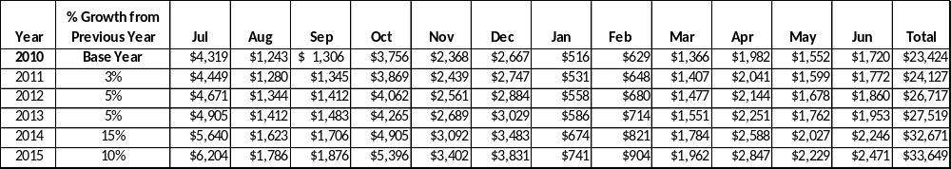
These projections would result in a total of 44% cumulative growth in total annual revenues between FY2010 and FY2015. If operational expenses can be managed with a cumulative reduction of 51% between FY 2010 and FY 2015, then the overall cost recovery of the site will be approximately 75% in FY 2015 at these projected revenue levels. This is higher than the annual financial performance of the site in FY 2010, which was operated at 24% cost recovery in that year.

Revenue Generation Strategies

Pricing Plan
PARK RESERVABLES | Current Pricing (CY 2011) | Proposed Pricing  (CY 2012) | Positive Yield Management Margin (%)
Adult Admission | $5.00 | $6.00 | 20%
Senior Adult Admission | $4.50 | $5.50 | 22%
Adult Group Rate | $4.00 | $5.00 | 25%
Youth (6-18) | $3.50 | $4.50 | 28%
Youth Group | $3 | $4.00 | 33%
Youth Group (6 & Under) | $1 | $2.00 | 100%

Innovative Programming and Special Events Plan
Program / Event | Theme / Purpose | Scheduled Date/Season | Frequency | Target Participation | Target User Fee | Target Cost Recovery
Vann House Days | Historical/ Promotional/ Education | July | Annually | 500+ | Admission Fee | 100% profit
Artifact ID Day | Historical/ Promotional /Educational | Winter | Annually | 50+ | Admission Fee | 100% Profit
Cherokee Storytelling | Historical/ Promotional /Educational | Fall | Annually | 125+ | Admission Fee | 100% Profit
Genealogy Class | Historical/ Promotional /Educational | Winter | Annually | 30+ | Increased Fees | 200% Profit
Lectures | Historical/ Promotional /Educational | Any Saturday throughout the year | Annually | 25+ | Admission Fee | 100% Profit
Candlelight Tours | Historical/ Promotional /Educational | December | Annually | 500+ | Admission Fee | 100% Profit

Partnerships and Concessions
Service / Partnership | Term of Service | Financial Objective | Contract Manager
Friends of the Chief Vann House | Year to Year | To help with the operational costs of special programs, antiques & general site expenses. | Jeff Stancil & Tim Howard

Expense Management Plan
Personnel Assignments
The following actions were taken since June of 2009 to proactively manage labor costs via personnel assignments and classifications.

Action | Timeline | Outcome
Reduced full-time positions by 50% | June 2009 | Annual full-time labor cost reduction of 40% since 2009
Reduced part-time positions by 50% | June 2009 | Part Time labor cost reduction of 70%

Management Techniques
The following actions will be taken to proactively manage labor costs via management techniques.

Action | Timeline | Outcome
Increased the use of volunteers and Federal Stimulus workers to assist in periods of high volume visitation | June 2009 | Helped to lessen the impact labor cutbacks
Increase the use of volunteers for site and grounds maintenance | June 2009 | Helped to lessen the impact of labor cutbacks

Adjusted Levels of Service
The following actions will be taken to proactively manage labor costs via reduced levels of service.

Action | Timeline | Outcome
Leased 85 acres to a local farmer to help eliminate mowing & maintenance costs | June 2010 | Saved significant fuel & labor costs and added to site beautification significantly.

Financial Pro Forma
The following five-year financial pro forma projects operating expenses, earned revenues and total/cost recovery through FY 2015. These pro forma are based on the strategies and desired outcomes of the Vann House business plan, especially the revenue generation and expense management plans, and are linked to corresponding performance goals. These financial pro forma has been developed with the assumptions that operating expenses are reduced by 51% by 2015, earned revenues are increased by 44% and visitation grows approximately 21% by 2015.

Expense Pro Forma
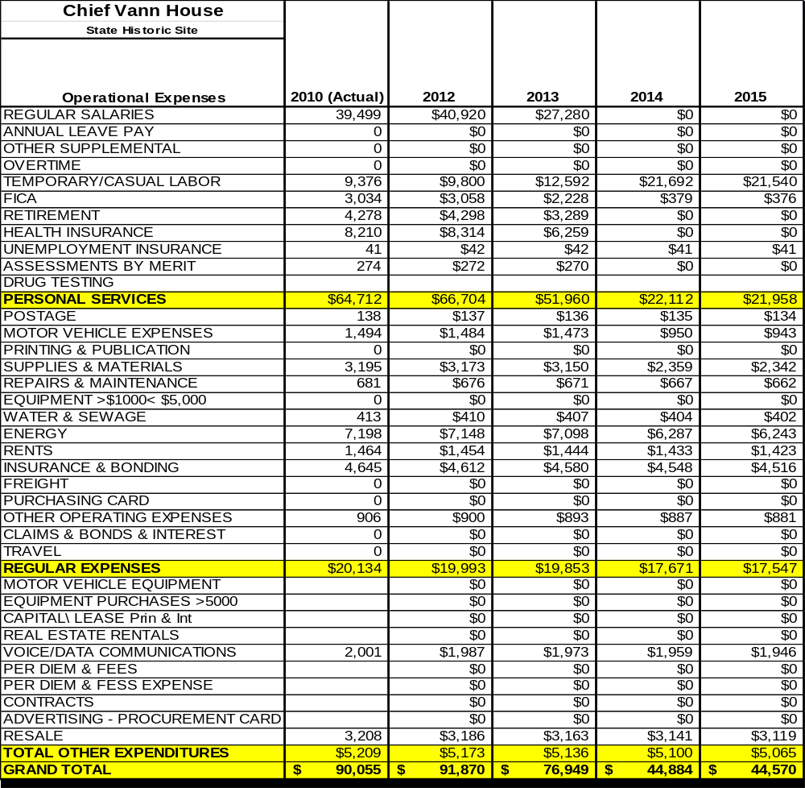

Revenue Pro Forma
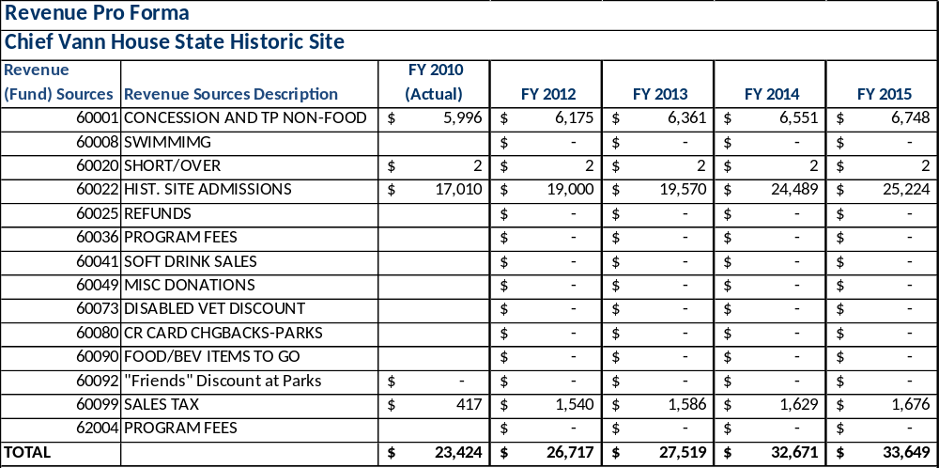

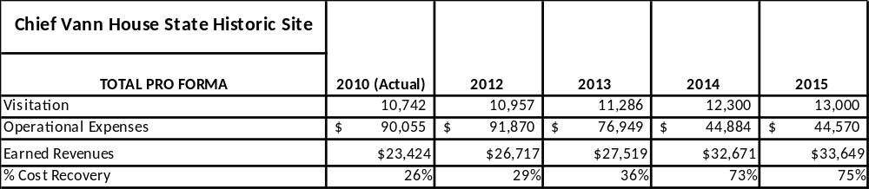
Total / Cost Recovery Pro Forma

Action Plan
ACTION PLAN
Site: |  | Site Manager: |  |  | Date:
Month:
Strategy | Tasks | Costs / Funding | Revenues / ROI | Responsibilities | Metrics

This is the average of the last three years – FY 2008, FY 2009, and FY 2010
Current employees, not including vacancies.
Current employees, not including vacancies.
Major population centers within a two-hour drive from the site

