Victoria Bryant State Park
Business & Management Plan

Prepared June 2011; Finalized February 2013
Direction 2015 – Sustainable Business Planning

Table of Contents

Executive Summary 3

Site and Operations Assessment 7
Site Inventory and Facility Assessment 7
Operational Assessment 9
Financial Performance Assessment 14

Business and Management Plan 19
Business Goals 19
Classification of Programs and Services 21
Partnership Development Plan 22
Marketing and Sales Plan 23
Revenue Generation Plan 26
Expense Management Plan 28
Financial Pro Forma 29

Action Plan 32

Executive Summary
The Parks, Recreation and Historic Sites Division (PRHSD) of the Georgia Department of Natural Resources (DNR) is transitioning the management of Victoria Bryant State Park to operate more like a business, reflecting the Direction 2015 – Sustainable Business Planning initiative to improve the fiscal performance and management of the state parks and historic sites system. This business and management plan is designed to help the site recover more operating expenses through earned revenues, productive partnerships, and innovative programs.

Site Fact Sheet
Site Name | Victoria Bryant State Park
Site Manager | Chelsea Jarrell
Region Manager | Tommy Turk
Date of Business Plan completion | 6/13/2011
Site size | 502 Acres
Total number of visitors (FY 2010) | 100,303
Total operating budget (FY 2010) | $248,833
Total earned revenues (FY 2010) | $140,007
Operational cost recovery (FY 2010) | 56%
Average operating cost per visitor (FY 2010) | $2.48
Average earned revenue per visitor (FY 2010) | $1.40
Average cost recovery (FY 2008 – 2010) | 52%
Target cost recovery (FY 2015) | 63%
Total full-time employees | 4
Total part-time employees | 7
Primary service markets | Clarke, Franklin, Stephens, Banks, Gwinnett, Barrow and Hart Counties (Georgia). Major cities: Athens GA and Greenville SC.
Primary attractors/visitor appeal factors | Camping, picnicking, golf, fishing and swimming.
Leading opportunities for improved site performance | Replace four platform sites with yurts. Increased programming. Partnering with local communities for opportunities of park. Expanding options at the swimming pool.

Site Summary and Key Attractions
Victoria Bryant State Park is nestled in the rolling hills of Georgia’s upper piedmont consisting of 502 acres of land. This park has facilities ranging from more than 100 picnic sites and a swimming pool to an 18-hole golf course, RV campground, tent sites and pioneer camping. A beautiful stream (Rice Creek) flows through the park, providing the perfect setting for an after-picnic stroll or just simple relaxation under the summer sun. Hikers can choose from a 9-mile network of trails, ranging from a short half-mile nature trail to a 2.6 mile perimeter trail or the beautiful 3.5 mile Broad River Loop Trail.

In addition to the natural attractions, the campground has a recreation area complete with horseshoe pits, volleyball court, group fire ring and activity shelter. The campground also has one of the park’s three park playgrounds, and one of the park system’s largest playgrounds is located in the very popular day-use area. Victoria Bryant also has 5 picnic shelters, which are commonly used for family reunions and company outings. Furthermore, the staff offers educational and recreational program activities from mid-March to Labor Day or late September.

Key Attractions
The amenities or features listed below are those that seem to be most popular for visitors.
- RV Camping
- Tent Camping
- Swimming Pool
- Hiking Trails
- Fishing Ponds
- Picnic Shelters
- Pioneer Tent Camping
- Friend’s Memberships
- Playgrounds
- Highland Walk Golf Course

Financial Targets
The table below details the total operating expenses and earned revenues for Victoria Bryant State Park over the last three years (2008 – 2010). This table also calculates total cost per visitor and revenues per visitor during these operating years, and details the target financial performance goals in the context of achieving at least 63% cost recovery. This table also calculates the necessary change from 2010 operating expenses and revenues.

Victoria Bryant State Park | Target Visitation Growth from 2010 | Target Change in Visitation
Visitation Assumptions | 15% | 115,349
 | 2008 | 2009 | 2010 | 2015 Target
Visitors | 120,575 | 102,086 | 100,303 | 115,348
Total Expenses | $247,349 | $276,985 | $248,833 | $241,939
Total Revenues | $130,071 | $133,729 | $140,007 | $152,313
Cost per Visitor | $2.05 | $2.71 | $2.48 | $2.10
Revenue per Visitor | $1.08 | $1.31 | $1.40 | $1.32
State Financial Support per Visitor | $(0.97) | $(1.40) | $(1.08) | $(0.78)
Total Cost Recovery | 53% | 48% | 56% | 63%
Change from 2010 Expenses |  |  |  | $(6,894)
Percent Change from 2010 Expenses |  |  |  | -2.77%
Change from 2010 Revenues |  |  |  | $12,306
Percent Change from 2010 Revenues |  |  |  | 8.79%

Key Recommendations

Primary / Short Term Recommendations
- Operate the site using cost-based accounting, including the net cost recovery achieved annually.
- Evaluate and pursue opportunities to employ concessionaires on-site if they can be more cost effective or provide desirable services, programs, or amenities the park cannot.
- Construct an archery range in the unused area of land across the highway in conjunction with DNR Shooting Sports.
- Add an annual spring and summer event to draw more visitors to the site and increase revenue.
- Utilize and incorporate volunteers and the “Friends of Victoria Bryant State Park” to help with programming efforts thus off-setting operational expenses.
- Continue to incorporate monthly funds from the “Friends of Victoria Bryant State Park” to off-set park operational expenses.
- Construct a welcome kit for guests that provide them with an opportunity to explore VBSP while providing self-guided tours and activities for children (coloring, making crafts, etc.). This will alleviate pressure from staff resources, while still providing a program that allows families to do activities on a park; making the site more dynamic and attractive.
- Review and update rates at the site on annual basis to recover the total net cost for visitor supported services.
- Manage Victoria Bryant State Park according to well-defined maintenance program, and operational standards monitored and enforced by region managers and senior management.
- Perform a thorough net cost-of-services analysis on major functions of site operations, including analysis of labor requirements.
- Develop on-line sales of gift shop and retail items associated with the site in order to increase site generated revenues.
- Continue to track total economic impact of the site on the local communities and region and share with decision-makers, elected officials, local business operators, and others to demonstrate the impact of Victoria Bryant State Park.
- Continue to grow the park’s resale inventory to increase overall revenue for the park.
- Add additional fishing events annual to increase guest visitation and use of the facilities.
- Repair the creek ford for guest accessibility and convenience.
- Create and promote camping/golf packages.

Secondary / Long Term Recommendations
- Build four yurts using four current platform sites.
- Replace old highway bridge with a wooden walking bridge to improve overall aesthetics of the park while providing additional access for guests to all areas of the day-use area of the park.
- Look for opportunities to increase land acquisition for the park to make facilities more marketable through resource conservation.
Site and Operations Assessment
This site and operations assessment is a culmination of analyses and findings from a review of the condition of facilities, infrastructure, and operations at Victoria Bryant State Park. The findings and observations are not intended to be an exhaustive review of all issues present, but provide a basic understanding of the predominant issues that contribute to the site’s current operating conditions. The assessment includes the following:
- Site Inventory and Facility Assessment
- Operational Assessment
- Financial Assessment
Site Inventory and Facility Assessment

Methodology
Facility and asset conditions are rated using a differential scale of excellent, good, fair, or poor. Descriptions of conditions that are attributed to each of these findings are also provided.
Scale of Conditions
Rating | General Description
Excellent | Facilities/amenities are in ‘excellent’ condition when they show little or no maintenance or repair problems. Facilities do not feature any major design or operational issues or flaws that contribute to diminished use or increased maintenance or upkeep. Facilities are easy to clean and maintain in order to place them back into public use and the users perceive them to be in excellent shape.
Good | Facilities/amenities are in ‘good’ condition when they show only minor maintenance or repair problems. Most maintenance issues with these facilities typically appear to be the result of age and/or heavy use. Facilities may only feature minor design or operational issues that contribute to diminished use or increased maintenance or upkeep. Facilities are moderately easy to clean and maintain in order to place them back into service and the users perceive them to be adequate for their use, but probably not in excellent shape.
Fair | Facilities/amenities are in ‘fair’ condition when they show significant maintenance or repair problems. Facilities generally exhibit ongoing maintenance issues that appear to be the result of age, heavy use, or design or operational flaws. Some maintenance and repair needs may compound their fair condition by being deferred because of budget and/or resource limitations. Facilities require more effort to clean and maintain before placing them back into service and the users may perceive them as being less than adequate for their use and in a state of deterioration. The facility or structure may need of major repair or replacement.
Poor | Facilities/amenities are in ‘poor’ condition when they show significant, on-going maintenance or repair problems that ultimately may result in suspended use for repair/replacement. Maintenance and repair issues are possibly the result of poor maintenance and clearly the result of age, heavy use, or design or operational flaws. Problems with the facilities are often compounded over time due to consistently-deferred maintenance and repair because of budget and/or resource limitations. Facilities may feature major design or operational issues that contribute to diminished use or increased maintenance or upkeep. Facilities require excessive effort to clean and maintain before placing them back into service and the users often perceive them as being inadequate for their use and in a state of serious deterioration. The facility or structure may need of major repair or replacement.

Inventory and Assessment
The table below is an inventory of facilities and amenities at Victoria Bryant State Park, and provides the assessed condition of each as reviewed in May 2011.

Site Asset / Amenity | Quantity | Condition
Day-Use Main Bathroom | 1 | Excellent
Rice Creek Bathroom | 1 | Good
Shelters 1,2, and 3 Bathroom | 1 | Good
Office Bathroom and Showers | 1 | Good
Upper Campground Bathroom | 1 | Good
Lower Campground Bathroom | 1 | Excellent
Picnic Shelters | 7 | Good
Nature Center | 1 | Good
Swimming Pool | 1 | Good
RV Campground Sites | 27 | Good
Tent Platform Sites | 8 | Good
Adirondack Shelters Pioneer #1 | 3 | Good
Adirondack Shelters Pioneer #2 | 4 | Good
Maintenance Facility | 1 | Fair
Maintenance Storage Sheds | 3 | Good
Office Building | 1 | Good
Well Houses | 3 | Good

Prioritized Facility Needs
Based on the facility inventory and assessment, these prioritized needs have been identified. Each need has been aligned with a priority category of high, moderate, or low to support future decision making regarding project sequencing, investment of public resources, and meeting community expectations. The priority assignment for each need is not a measure of importance. Rather, these recommended priorities reflect a phased implementation approach over the next several years.

Facility Need | Priority Assignment
New playground area at Shelter’s 1,2 and 3 | High
Repair/replace the concrete walkway at the creek ford for guest accessible and convenience | High
Re-pour the concrete flooring for the swimming pool | Moderate
Construct 4 Yurts | High
Refurbish/remodel office and expand upon resale area | Moderate
Realign park entrance and construct Kiosk building | Moderate
Refurbish creek overlook area and make available for guests to reserve | Moderate
Remodel and refurbish campground bathroom | Moderate
New maintenance building | Moderate
New ADA bathroom at Picnic Shelters 1,2 and 3 | Low

Operational Assessment
The Operational Assessment includes:
- An inventory and classification of programs and services being provided at the site
- A review of staffing at the site
- A review of concessionaires and partners operating at the site
- Visitation and customer satisfaction

Inventory and Classification of Programs and Services
Programs and services are classified into one of three major categories:
1) Core or Essential Services
2) Important Services
3) Visitor Supported Services
Programs and services at the site are classified into these categories based in part on the mission and public mandates for both the site and the agency. For the programs and services in each of these categories, there are financial performance expectations that will define how services are funded and evaluated.

Category 1 – Core Services [Largely supported by tax funds]
Core programs, services and facilities are those the agency must provide and/or are essential in order to capably govern and meet statutory requirements. The failure of the agency to provide Category 1 services at adequate levels could result in significant negative consequences for the public and the resources under protection. The criteria for programs or services to be classified as core or essential are:
- The services are mandated by the agency’s law or charter or are contractually obligated by agreement to provide the services.
- The services are essential to protecting and supporting the public’s health and safety.
- The services protect and maintain valuable assets and infrastructure.
- The services would generally and reasonably be expected and supported by residents, businesses, customers and partners.
- The services are those that cannot or should not be provided by the private sector.
- The services provide a sound investment of public funds.
The following programs and services offered at Victoria Bryant State Park have been identified as core services:
- Hours of park operation (park open for visitation)
- Maintenance and upkeep of grounds, facilities and infrastructure
- Active and visible law enforcement presence
- Active management of the natural and cultural resources of the site in order to protect their integrity
Category 2 – Important Services [Supported by a balance of tax funds and earned revenues]
Important programs, services and facilities are those the agency should provide, and are important to governing and effectively serving residents, businesses, customers and partners. Providing Category 2 services expands or enhances the agency’s ability to provide and sustain its core services. The criteria for programs or services to be classified as important are:
- The services expand, enhance or support identified core services.
- The services are broadly supported and utilized by the community, and are considered an appropriate, important, and valuable public good. Public support may be conditional upon the manner by which the services are paid for or funded.
- The services generate income or revenue that offsets some or all of the operating cost and/or are deemed to provide economic, social or environmental outcomes or results.
The following programs and services offered at Victoria Bryant State Park have been identified as important services:
- Site appropriate education, interpretation and recreational opportunities
- Public education programs
- Day-use facilities

Category 3 – Visitor Supported Services [Almost exclusively supported by earned revenue]
Visitor supported programs, services and facilities are those discretionary services that the agency may provide when additional funding or revenue exists to offset the cost of providing those services. Category 3 services provide added value above and beyond what is required or expected. The criteria for programs or services to be classified as visitor supported are:
- The services expand, enhance or support core services or important services and the quality of life of the visitors, community or stakeholders.
- The services are supported, valued and well utilized and provide an appropriate and valuable public benefit.
- The services generate income or funding from sponsorships, grants, user fees or other sources that offset some or all of their cost and/or provides a meaningful return on investment.

- The services can possibly be provided through outsourcing or use of concessionaires, providing opportunities for community enterprises that may not otherwise be provided by the agency.
The following programs and services offered at Victoria Bryant State Park have been identified as visitor supported services:
- Swimming pool
- Resale
- Special events
- Camping

Staffing Assessment
Labor costs at Victoria Bryant State Park represent the largest area of budgetary expense at an average of 71% of the total operating budget each year for the last three complete years, which is higher than the target of total labor costs (including benefits) not exceeding 65% of the site’s total operating expenditures. The tables below and on the following page provide a basic review of the current staffing at the site.
Full Time Equivalent Employees
Position / Title | Quantity (FTE) | Vacancies | Annual Hours
Park Manager | 1 | 0 | 2600
Assistant Park Manager | 1 | 0 | 2340
Park Ranger | 1 | 0 | 2080
Clerk | 1 | 0 | 2080
TOTAL | 4 | 0 | 9,100

Part Time Employees
Position / Title | Quantity (FTE) | Vacancies | Hours
Lifeguard | 4 | 2 | 1926
Maintenance Worker | 1 | 1 | 2148
Kiosk Clerk | 2 | 0 | 1900
Seasonal Interpreter | 0 | 1 | 640
TOTAL | 7 | 4 | 6,614

Labor Support
Labor Support | Annual Hours
Volunteers (Campground Hosts and Friend’s volunteers). | 4,160
Community Service Workers | 832
Resource Management Crews (Privet, Control Burn, etc.) | 40
TOTAL | 5,032

Total Labor Hours
Labor Type | Annual Hours
Full Time Equivalent Employees | 9,100
Part Time Employees | 6,614
Labor Support | 5,032
TOTAL Annual Labor Hours | 20,746

Labor Budget Summary

 | Victoria Bryant State Park
 |  | 2008 | 2009 | 2010 | % Change
 | Account Code and Sub-Class | Year End | Year End | Year End | from
 | Expenditure Descriptions | Expenses | Expenses | Expenses | 2008
 | REGULAR SALARIES | 99,264 | 113,463 | 130,791 | 32%
 | ANNUAL LEAVE PAY | 1 | 1 | 1 | 0%
 | OTHER SUPPLEMENTAL | 1 | 1 | 1 | 0%
 | TEMPORARY/CASUAL LABOR | 34,756 | 29,001 | 15,398 | -56%
 | FICA | 7,224 | 7,981 | 8,943 | 24%
 | RETIREMENT | 11,246 | 12,919 | 15,212 | 35%
 | HEALTH INSURANCE | 22,675 | 14,852 | 27,186 | 20%
 | UNEMPLOYMENT INSURANCE | 188 | 149 | 246 | 31%
 | ASSESSMENTS BY MERIT | 735 | 735 | 822 | 12%
 | PERSONAL SERVICES | 176,090 | 179,103 | 198,600 | 13%

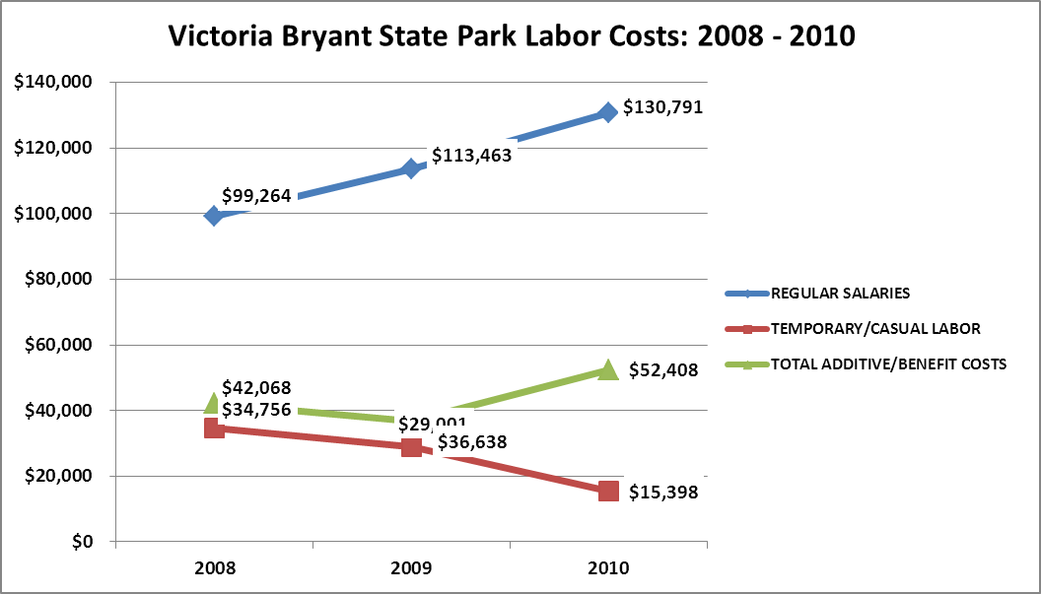

Visitation and Occupancy
Overall annual visitation to the site has trended downward from 2008 to 2010, decreasing by 17 % or over 20,272 visitors. This is largely attributed to economic conditions.

Year | Total Visitation
2008 | 120,575
2009 | 102,086
2010 | 100,303

Occupancy for the overnight accommodations at Victoria Bryant State Park the last three years is detailed in the table below. Overall occupancy has trended downward from 2008 to 2010, decreasing by 2%. This is largely attributed to economic conditions.

Year | Camping  Occupancy
2008 | 42%
2009 | 33%
2010 | 33%

Customer Service and Satisfaction

Site | Year | Customer Satisfaction Level
Victoria Bryant State Park | 2009 | 100 %
Victoria Bryant State Park | 2010 | 95 %

Financial Performance Assessment

Operational Expenses
A summary of total operating expenses at Victoria Bryant State Park from 2008 to 2010, as well as their percent change from 2008 are provided in the table below.
Victoria Bryant State Park | 2008 | 2009 | 2010 | % Change from 2008
State Park
Operational Expenses
REGULAR SALARIES | 99,264 | 113,463 | 130,791 | 32%
ANNUAL LEAVE PAY | 0 | 0 | 0 | 0%
OTHER SUPPLEMENTAL | 0 | 0 | 0 | 0%
OVERTIME | 0 | 0 | 0 | 0%
TEMPORARY/CASUAL LABOR | 34,756 | 29,001 | 15,398 | -56%
FICA | 7,224 | 7,981 | 8,943 | 24%
RETIREMENT | 11,246 | 12,919 | 15,212 | 35%
HEALTH INSURANCE | 22,675 | 14,852 | 27,186 | 20%
UNEMPLOYMENT INSURANCE | 188 | 149 | 246 | 31%
ASSESSMENTS BY MERIT | 735 | 735 | 822 | 12%
DRUG TESTING | 0 | 0 | 0
PERSONAL SERVICES | 176,088 | 179,101 | 198,598 | 13%
POSTAGE | 81 | 0 | 372 | 357%
MOTOR VEHICLE EXPENSES | 12,913 | 14,572 | 3,013 | -77%
PRINTING & PUBLICATION | 0 | 0 | 0 | 0%
SUPPLIES & MATERIALS | 1,460 | 1,761 | 5,485 | 276%
REPAIRS & MAINTENANCE | 0 | 516 | 357 | 0%
EQUIPMENT >$1000< $5,000 | 0 | 0 | 0 | 0%
WATER & SEWAGE | 0 | 0 | 0 | 0%
ENERGY | 21,332 | 37,448 | 21,627 | 1%
RENTS | 1,558 | 2,027 | 1,873 | 20%
INSURANCE & BONDING | 2,729 | 8,549 | 2,454 | -10%
FREIGHT | 0 | 15 | 0 | 0%
PURCHASING CARD | 23,070 | 23,528 | 9,971 | -57%
OTHER OPERATING EXPENSES | 1,105 | 1,071 | 1,432 | 30%
CLAIMS & BONDS & INTEREST | 0 | 0 | 0 | 0%
TRAVEL | 522 | 55 | 106 | -80%
REGULAR EXPENSES | 64,771 | 89,542 | 46,690 | -28%
MOTOR VEHICLE EQUIPMENT
VOICE/DATA COMMUNICATIONS | 4,101 | 3,903 | 1,455 | -65%
PER DIEM & FEES | 800
PER DIEM & FESS EXPENSE
RESALE | 1,617 | 4,439 | 2,091 | 29%
TOTAL OTHER EXPENDITURES | 6,518 | 8,342 | 3,546 | -46%
GRAND TOTAL | $ 247,376 | $ 276,985 | $ 248,833 | 1%
Earned Revenues | $130,071 | $133,724 | $140,007 | -36%
% Cost Recovery | 53% | 48% | 56% | 7%

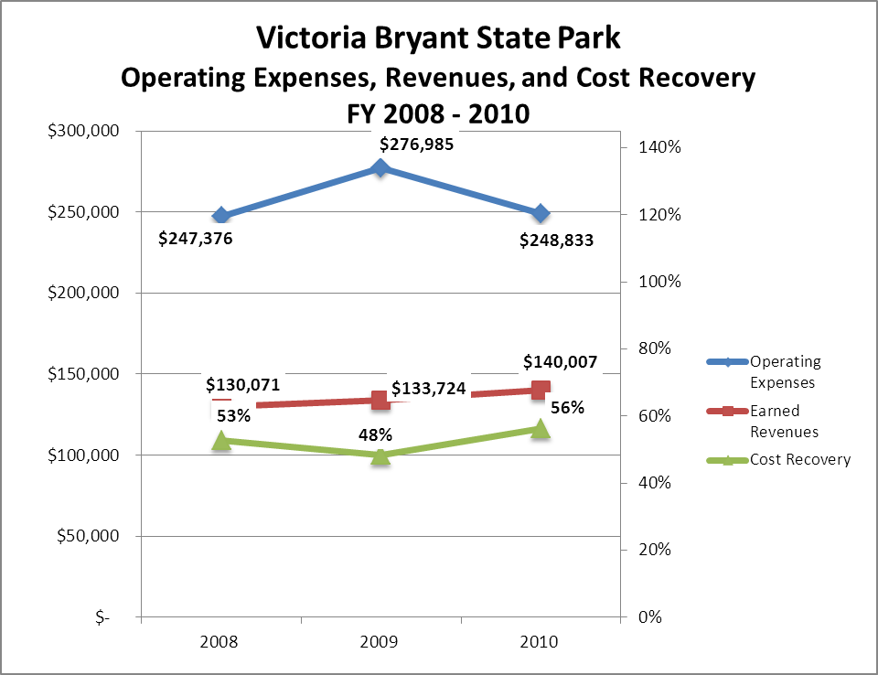
Earned Revenues
Earned revenues at Victoria Bryant State Park have increased since 2008, which is largely attributed to the increase pricing on camping, the introduction of paid programs on the park (hayrides and school programs), increase of quality and quantity resale items and increase usage/revenue on the park’s swimming pool. Monthly earned revenues for the last two years (see table on the following page) indicate that the total annual revenue increased 5% from 2009 to 2010, with the largest increases in monthly revenues in June (8%), October (10%) and April (11%), and the largest decreases in the months of November (-13%), January (-11%) and December (-9%).

FY 2009 - FY 2010 Monthly Revenue
 | Jul | Aug | Sep | Oct | Nov | Dec | Jan | Feb | Mar | Apr | May | Jun | Total
FY 2009 | $18,904 | $11,329 | $9,667 | $9,028 | $7,041 | $1,969 | $5,739 | $5,821 | $10,785 | $13,573 | $16,809 | $23,064 | $133,729
FY 2010 | $19,762 | $10,736 | $9,704 | $9,928 | $6,147 | $1,799 | $5,119 | $6,262 | $11,602 | $15,340 | $18,656 | $24,952 | $140,007
Avg | $19,333 | $11,033 | $9,686 | $9,478 | $6,594 | $1,884 | $5,429 | $6,042 | $11,194 | $14,457 | $17,733 | $24,008 | $136,868
% of Total Revenues | 14% | 8% | 7% | 7% | 5% | 1% | 4% | 4% | 8% | 11% | 13% | 18% | 100%
% change | 5% | -5% | 0% | 10% | -13% | -9% | -11% | 8% | 8% | 13% | 11% | 8% | 5%

The graphs below illustrate the monthly revenue trends each year and the average percent of total annual revenue earned each month.

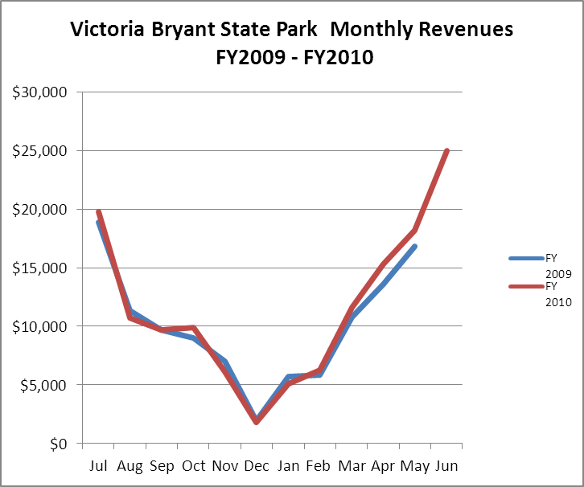

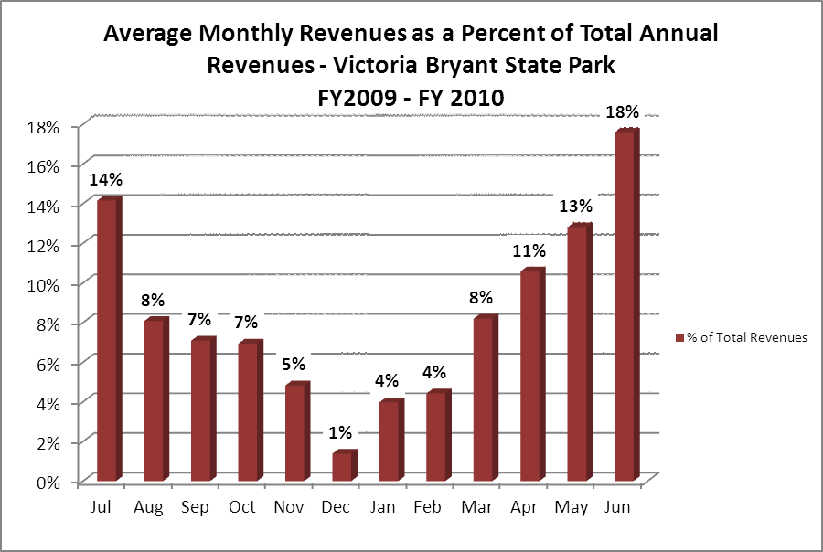
Cost Recovery Trends
Victoria Bryant State Park has achieved an average cost recovery of 52% of annual operational expenses through earned revenues from FY 2008 to FY 2010. This is detailed and illustrated in the table and graph below.
Year | Operational  Expenses | Earned  Revenues | Percent Cost  Recovery
2008 | $247,376 | $130,071 | 53%
2009 | $276,985 | $133,724 | 48%
2010 | $248,833 | $140,007 | 56%

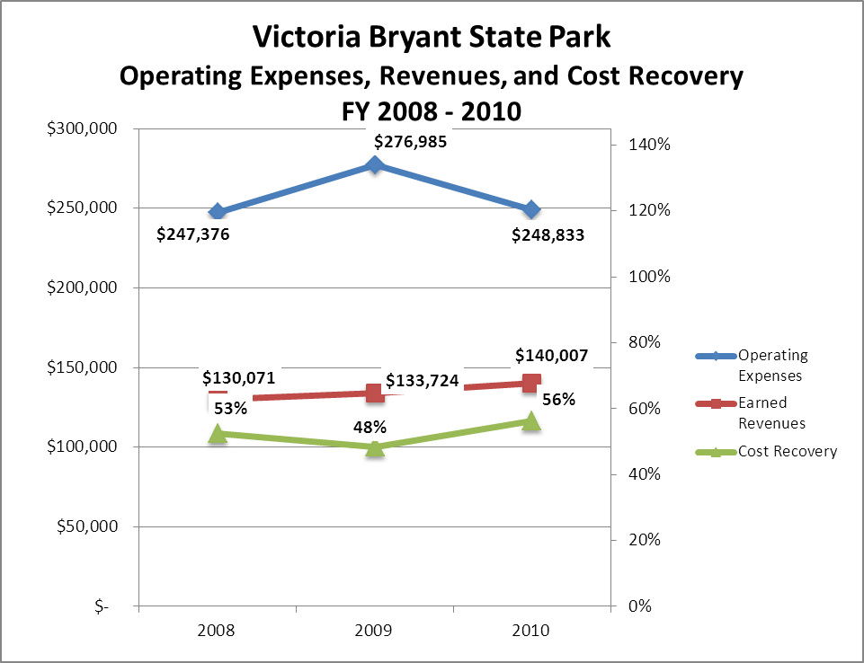

Review of Pricing
Data on rate information is available as far back as 2002, but only the last five years are evaluated. There has been notable growth in fees charged at Victoria Bryant State Park since 2005, with the largest increase being in 2009 when almost all prices were increased. A table detailing the rates is provided below.
Victoria Bryant State Park | 2005 | 2006 | 2007 | 2008 | 2009 | 2010
Picnic Shelters | $35.00 | $35.00 | $35.00 | $35.00 | $40.00 | $45.00
Platform Camping | $20.00 | $20.00 | $20.00 | $24.00 | $27.00 | $27.00
Pioneer Camping | $30.00 | $30.00 | $30.00 | $40.00 | $40.00 | $43.00
RV/Tent Camping Regular | 25 | 25 | 25 | 25 | 28/25 | 28/25
Swim Tickets | $3.00 | $3.00 | $3.00 | $3.00 | $3.00 | $4.00

Business and Management Plan

Business Goals
The following goals serve as the foundation for the key recommendations and strategies in this business plan for Victoria Bryant State Park.

Enhance Cost Recovery of Site Operations
Victoria Bryant State Park is currently operating at 52% cost recovery of operational expenses through earned revenues. The park is primarily a day-use park, with few opportunities for new revenue avenues. However, through increased pricing on campsites, added paid programming efforts and swimming pool revenue, the park continues to experience an increase in earned net revenue annually. There is very little opportunity for expansion or additional facilities at Victoria Bryant. The campground does well seasonally but has no room for additional sites. Converting four of the platform sites into yurt sites would substantially increase the revenue of the campground.

Enhance Revenue Generation Strategies
Increasing earned revenues will most likely result from the impact of both increased visitation at the site and specific revenue enhancement strategies. Victoria Bryant State Park will improve revenue generation through adding yurts, increasing resale inventory and continue to promote special events and programming opportunities. Continual marketing and programming of the pool is necessary to keep it profitable. In the event the pool stops being profitable, its continued operation should be assessed.

Expand Special Events at the Site
The events held at Victoria Bryant State Park are important and educational to the guests who participate in them and have helped generate revenue for the park. Currently, the park provides school programs, a fishing event, an Halloween event, swimming lessons, Junior Ranger Camp, hayrides and a Civil War encampment event. The park can benefit (financially and attendance-wise) from additional events/programs throughout the year.

Improve the Diversity and Innovation of Recreational and Interpretive Programs
Currently the site does not have the funding to hire a seasonal interpreter. However, with concession agreements, it is possible to contract out programming efforts so there is little to no overhead costs to the park. The park is developing both a static and 3-D archery range for public use. The trails network can be promoted for further Geocaching and trail run events.

Improve the Effectiveness of Marketing and Sales
It is imperative to establish local community connections as well as to work with the region and Atlanta offices to attract local residents to the park as well as residents from populated areas. This can be accomplished by utilizing technology such as Facebook, updating park/division webpage and having credible pictures (internet) of the facilities to draw more people to the park. Developing and promoting Stay & Play golf packages with Highland Walk offers revenue opportunities.

Establish Greater Consistency of Managing and Monitoring Customer Service & Satisfaction
Victoria Bryant is currently at a 90% plus customer satisfaction rating. The goal of the staff should always be to provide professional, courtesy and accurate information. This is accomplished by having consistent operating hours, appreciate the customer’s business and inviting them to return.

Expand Partnership Opportunities
Victoria Bryant State Park does have an active volunteer core, the Friends of Victoria Bryant State Park. This group stretches to the local and surrounding communities in regards to promoting/advocating for the park. This volunteer core engages in special events that produces revenue to off-set operational expenses. Partnerships with nearby Emmanuel College for programming and events are possible.

Classification of Programs and Services
The tables below summarize the classifications of programs and services at Victoria Bryant State Park as either core, important, or visitor supported and projects a range of cost recovery percentages that might be achieved for each. These classifications establish financial performance goals for each category of services that are linked to the recommendations and strategies of this business plan.

Core Services
Program / Service | Target Cost Recovery
Hours of park operation (park open for visitation) | 0%
Maintenance and upkeep of grounds, facilities and infrastructure | 0%
Active and visible law enforcement presence | 0%
Active management of natural and cultural resources of the site in order to protect their integrity | 0%

Important Services
Program / Service | Target Cost Recovery
Site appropriate education, interpretation and recreational opportunities | 50%
Public education programs | 50%
Day-use facilities | 50%

Visitor Supported
Program / Service | Target Cost Recovery
Swimming pool | 120%
Resale | 125% - 140%
Special events | 120%
Camping | 110%

Partnership Development Plan
The table below summarizes existing partners and targeted partnerships by classification (operational, vendor, service, co-branding, funding partners) and by organizational type.

 | Public Partners | Not-for-profit Partners | Private / Enterprise Partners
Operational Partners | - Watson Mill Bridge State Park  - Tugaloo State Park  - Highland Walk Golf course | - The Friends Victoria Bryant State Park
Vendor Partners |  |  | - Coca Cola  - Bass Pro Shop  - Wal-mart  - Dixie Dale Grocery
Service Partners | - City of Franklin Springs  - City of Royston  - Franklin County Emergency Services | - Chamber of Commerce  - DDA of Royston  - Boy Scouts and Girl Scouts of America groups  - Emmanuel College
Co-branding Partners | - Highland Walk Golf Course |  | - Dirty Spokes (Xterra Race)
Funding Resource Development Partner |  | - Friends of Georgia State Parks and Historic Sites  - Friends of Victoria Bryant State Park

Marketing and Sales Plan

Marketing and Sales Goals
Marketing and sales goals for Victoria Bryant State Park are based on the following desired outcomes:
- Increase occupancy in camping.
- Increase school programs and special event attendance.
- Increase overall visitation to the park.
In order to meet these goals, examples of specific target outcomes were identified in the areas detailed in the table below.
Area  of Focus | Current  Performance | Goal  by 2011 | Goal  by 2012 | Goal  by 2015
Camping | 33% | 35% | 37% | 41%
School Programs/Events Attendance | 3165 | 3250 | 3450 | 3700
Increase overall visitation | 100,303 | 104,000 | 110,000 | 115,348
Marketing and Promotion Strategies

Publicity and Social Media
Victoria Bryant State Park will approach marketing and publicity planning using the following guidelines:
- Event publicity
Special events will be pushed to have short stories in local or regional newspapers like the Hometown Neighbors and online social media hooks planted that run 3-4 weeks in advance of the event up to the date of the event itself. Continue to update the list of contacts for news releases and radio spots, keeping good contact names for local radio stations and newspapers.
- Program publicity
Special and unique programs should have feature stories in magazines, weekly newspapers, and statewide daily newspapers that are aimed at placements as front-page or sectional front-page stories. These stories are most effective if they run shortly before the season that the featured program begins. This will likely require several weeks of advanced planning with media contacts. Similar coverage on television and radio should also be considered. If pre-publicity cannot be generated, post-publicity can help promote future programs.
- Site Publicity
Site publicity focusing on a single site or sub-set of sites requires more intense planning efforts to attract multiple writers and editors from target publications. Each site could host several seasonal media familiarization tours (with 10 to 15 writers or editors) to familiarize them with the site and its benefits and amenities. Stories and features resulting from such tours typically take between two and six months to materialize so the tours should focus on experiences, benefits, and programs that would be available when the stories are expected to run.
Examples and suggested opportunities for events, programs and related publicity efforts based on the themes described above at Victoria Bryant State Park are provided in the table below.
Event Publicity | Program Publicity | Site Publicity
Halloween Event | Junior Ranger Camp | Civil War Encampment
Spring Carnival | Go Fish Program
Summer Festival | Georgia Outdoor Kids
Dirty Spokes Trail Race | Swimming Lessons
 | High School Cross County Races

Packaging
Examples and suggested packages for Victoria Bryant State Park are provided in the table below.
Package | Package Details
Family Swim Pass/Camping | Purchase a Family Swim Pass and receive 1 free night of camping at Victoria Bryant State Park. (Focus-increase revenue and camping/swimming occupancy)
Winter Camping-Carefree Discount | Continue to offer and promote discount camping during the winter months (25-30%). (Focus-increase revenue and camping occupancy)
Pioneer Camping-Non Peak Season | Bring over 25 people and receive 25% of your site. (Focus-increase attendance.)
Picnic Shelters-Non Peak Season | Rent a Picnic Shelter and receive a 50% discount off the Shelter rental. (Focus, increase attendance).
Attend a Special Events/Resale | Attend a special event and receive a discount off resale items at the Park’s Office. (Focus, increase visitation to events and revenue).
Stay & Play | Rent two nights camping get 20% on two rounds of golf at Highland Walk

Group Sales
Types of groups within which specific target customers can be identified for Victoria Bryant State Park are listed below:
- Families  - Youth service organizations  - Churches  - Golfers | - Businesses and professional groups  - Schools (public and private)  - Colleges and universities  - Associations (Public and Private) | - Community organizations

Incentivizing New and Repeat Visitation
Victoria Bryant State Park will utilize the following strategies and/or incentives to encourage new and repeat visitation starting in FY 2012:
- Early registration discounts
- Group / bulk pricing options
- Differential pricing based upon days of week, peak or off-peak seasons, vacancies, etc.
- Post peak season follow-up with visitors
- Group-public program discount (non-school groups).

Marketing and Sales Metric Goals
The following marketing and sales metric goals and/or others will be monitored and progress reported at Victoria Bryant State Park:
- Loyalty and repeat customers = 75% of customers repeat their visit in a 12-month period.
- Brand confidence & customers-recruiting-customers = 60%. Let guests know to please tell others about the park and its facilities.

Revenue Generation Plan
Revenue / Cost Recovery Goals
Victoria Bryant State Park has set a financial goal of increasing annual revenues 9% annually between 2012 and 2015. The largest revenue growth opportunity is most likely during the months of October, March, April, May, and June. The table below details projected revenue growth leading up to 2015, based upon a nominal growth of revenues each year.

Year | % Growth from Prev. Year | Jul | Aug | Sep | Oct | Nov | Dec | Jan | Feb | Mar | Apr | May | Jun | Total
2010 | Base Year | $19,762 | $10,736 | $9,704 | $9,928 | $6,147 | $1,799 | $5,119 | $6,262 | $11,602 | $15,340 | $18,185 | $24,952 | $139,536
2011 | 4% | $20,552 | $11,165 | $10,092 | $10,325 | $6,393 | $1,871 | $5,324 | $6,512 | $12,066 | $15,954 | $18,912 | $25,950 | $145,117
2012 | 0% | $20,552 | $11,165 | $10,092 | $10,325 | $6,393 | $1,871 | $5,324 | $6,512 | $12,066 | $15,954 | $18,912 | $25,950 | $145,117
2013 | 1% | $20,758 | $11,277 | $10,193 | $10,428 | $6,457 | $1,890 | $5,377 | $6,578 | $12,187 | $16,113 | $19,102 | $26,210 | $146,569
2014 | 2% | $21,173 | $11,503 | $10,397 | $10,637 | $6,586 | $1,927 | $5,485 | $6,709 | $12,430 | $16,435 | $19,484 | $26,734 | $149,500
2015 | 2% | $21,597 | $11,733 | $10,605 | $10,850 | $6,718 | $1,966 | $5,594 | $6,843 | $12,679 | $16,764 | $19,873 | $27,268 | $152,313

These projections would result in a total of 9% cumulative growth in total annual revenues between FY2010 and FY2015. If operational expenses can be managed with a cumulative decrease of 3% between FY 2010 and FY 2015, then the overall cost recovery of the site will be approximately 63% in FY 2015 at these projected revenue levels. This is higher than the annual financial performance of the site in FY 2010, which was operated at 56% cost recovery in that year.
Revenue Generation Strategies
Pricing Plan
PARK RESERVABLES | Current Pricing (CY 2011) | Proposed Pricing  (CY 2012) | Positive Yield Management Margin (%) | Positive Yield Management Margin (%) | Positive  Yield  Management  Margin ($) | Negative  Yield  Management  Margin ($)
Victoria Bryant State Park
Picnic Shelter | $45 | $45 | 0% | 0% | $0
Camping (RV) | 28 | 31 | 10% | -10% | $3
Platform Tent Camping | 27 | 30 | 10% | -10% | $3
Swimming-Day Use | 5 | 5 | 10% | -10% | $1
Swimming-Campers | 3 | 3 | 10% | -10% | $0
Pioneer Campsite | 50 | 50 | 10% | -10% | $5

Innovative Programming and Special Events Plan
Program / Event | Theme / Purpose | Scheduled Date/Season | Frequency | Target Participation | Target User Fee | Target Cost Recovery
Summer Festival | Activities for Children/Increase attendance and revenue | June/2012 | Annual | Youth | $5.00/Child | 150%

Partnerships and Concessions Plan
Service / Partnership | Term of Service | Financial Objective | Contract Manager
Event and planning promotion | 1 Year | 20% of gross receipts to park. | Park Manager
Packaging and promotion with local businesses | 1 Year | Shared revenue | Park Manager/Region Manager

Expense Management Plan
Personnel Assignments
The following actions have been taken to proactively manage labor costs via personnel assignments and classifications.

Action | Timeline | Outcome
Eliminate Seasonal Interpreter and 2 lifeguard positions. | 2011 | Cost savings of approximately $4,500.00 annual.
Eliminate Full-time Maintenance Position | 2011 | $29,386 Labor Savings

Management Techniques
The following actions will be taken to proactively manage labor costs via management techniques.

Action | Timeline | Outcome
Closely monitor weather conditions and pool use trends and adjust lifeguard schedules accordingly. | July 2012 | Reduce pool labor costs 5% - 10%

Adjusted Levels of Service
The following actions will be taken to proactively manage labor costs via reduced levels of service.

Action | Timeline | Outcome
Reduction of landscaping exclusively to recreational areas only. | 2009-Current | Approximately saving from 2009-20%

Financial Pro Forma
The following five-year financial pro forma projects operating expenses, earned revenues and cost recovery through FY 2015. These pro forma are based on the strategies and desired outcomes identified in this business plan, especially the revenue generation and expense management plans, and are linked to corresponding performance goals.
Expense Pro Forma
Victoria Bryant State Park  Operational Expenses | 2010 (Actual) | 2012 | 2013 | 2014 | 2015
REGULAR SALARIES | 130,791 | $129,875 | $128,966 | $128,064 | $127,167
TEMPORARY/CASUAL LABOR | 15,398 | $15,290 | $15,183 | $15,077 | $14,971
FICA | 8,943 | $8,880 | $8,818 | $8,757 | $8,695
RETIREMENT | 15,212 | $15,106 | $15,000 | $14,895 | $14,791
HEALTH INSURANCE | 27,186 | $26,996 | $26,807 | $26,619 | $26,433
UNEMPLOYMENT INSURANCE | 246 | $244 | $243 | $241 | $239
ASSESSMENTS BY MERIT | 822 | $816 | $811 | $805 | $799
PERSONAL SERVICES | 198,598 | $197,208 | $195,827 | $194,457 | $193,095
POSTAGE | 372 | $369 | $367 | $364 | $362
MOTOR VEHICLE EXPENSES | 3,013 | $2,992 | $2,971 | $2,950 | $2,930
SUPPLIES & MATERIALS | 5,485 | $5,447 | $5,408 | $5,371 | $5,333
REPAIRS & MAINTENANCE | 357 | $355 | $352 | $350 | $347
ENERGY | 21,627 | $21,476 | $21,325 | $21,176 | $21,028
RENTS | 1,873 | $1,860 | $1,847 | $1,834 | $1,821
INSURANCE & BONDING | 2,454 | $2,437 | $2,420 | $2,403 | $2,386
FREIGHT |  | $0 | $0 | $0 | $0
PURCHASING CARD | 9,971 | $9,901 | $9,832 | $9,763 | $9,695
OTHER OPERATING EXPENSES | 1,432 | $1,422 | $1,412 | $1,402 | $1,392
TRAVEL | 106 | $105 | $105 | $104 | $103
REGULAR EXPENSES | 46,690 | $46,363 | $46,039 | $45,716 | $45,396
VOICE/DATA COMMUNICATIONS | 1,455 | $1,445 | $1,435 | $1,425 | $1,415
RESALE | 2,091 | $2,076 | $2,062 | $2,047 | $2,033
TOTAL OTHER EXPENDITURES | 3,546 | $3,521 | $3,497 | $3,472 | $3,448
GRAND TOTAL | $248,833 | $247,092 | $245,363 | $243,645 | $241,939

Revenue Pro Forma
Revenue Pro Forma
Victoria Bryant State Park
Revenue (Fund) Sources | Revenue Sources Description | FY 2010 (Actual) | FY 2012 | FY 2013 | FY 2014 | FY 2015
60001 | CONCESSION AND TP NON-FOOD | $ 4,356 | $ 4,487 | $ 4,621 | $ 4,760 | $ 4,903
60002 | Canc. Fees | $ 326 | $ 336 | $ 346 | $ 356 | $ 367
60005 | Campsites | $ 43,684 | $ 44,994 | $ 46,344 | $ 47,735 | $ 49,167
60008 | Swimming | $ 7,563 | $ 7,790 | $ 8,024 | $ 8,264 | $ 8,512
60018 | Washer/Dryer Revenue | $ 377 | $ 388 | $ 400 | $ 412 | $ 424
60019 | Hunting and Fishing | $ 384 | $ 396 | $ 407 | $ 420 | $ 432
60020 | Short/over | $ (369) | $ (380) | $ (391) | $ (403) | $ (415)
60025 | Refunds | $ (6,330) | $ (6,520) | $ (6,715) | $ (6,917) | $ (7,124)
60027 | Pioneer Camp | $ 1,625 | $ 1,673 | $ 1,723 | $ 1,775 | $ 1,828
60028 | Picnic Shelter | $ 1,436 | $ 1,479 | $ 1,523 | $ 1,569 | $ 1,616
60033 | Campsites Sr. Discount | $ (5,117) | $ (5,270) | $ (5,428) | $ (5,591) | $ (5,759)
60036 | Program Fees | $ 2,730 | $ 2,812 | $ 2,896 | $ 2,983 | $ 3,072
60037 | Misc. Park Receipts | $ 484 | $ 499 | $ 514 | $ 529 | $ 545
60042 | Wood/Ice | $ 1,746 | $ 1,798 | $ 1,852 | $ 1,908 | $ 1,965
60066 | Special Clubs | $ 50 | $ 52 | $ 53 | $ 55 | $ 56
60073 | Disable Vet Discount | $ (574) | $ (591) | $ (609) | $ (627) | $ (646)
60090 | Food/Bev Items To go | $ 368 | $ 379 | $ 390 | $ 402 | $ 414
60099 | Sales Tax | $ 232 | $ 239 | $ 246 | $ 253 | $ 261
65011 | Daily Park Pass | $ 24,563 | $ 25,300 | $ 26,059 | $ 26,841 | $ 27,646
65002 | Annual Pass | $ 4,256 | $ 4,384 | $ 4,515 | $ 4,651 | $ 4,790
65003 | Friends memberships | $ 12,705 | $ 13,086 | $ 13,479 | $ 13,883 | $ 14,300
65004 | Pay-out to Friends | $ (15,321) | $ (15,781) | $ (16,254) | $ (16,742) | $ (17,244)
66002 | Canc. Fees | $ 1,270 | $ 1,308 | $ 1,347 | $ 1,388 | $ 1,429
66003 | Refunds/Adv. | $ (7,556) | $ (7,783) | $ (8,016) | $ (8,257) | $ (8,504)
66005 | Camping | $ 18,804 | $ 19,368 | $ 19,949 | $ 20,548 | $ 21,164
66008 | Pioneer Camp | $ 950 | $ 979 | $ 1,008 | $ 1,038 | $ 1,069
66019 | Trans. Fee | $ 76 | $ 78 | $ 81 | $ 83 | $ 86
66028 | Picnic Shelter | $ 2,565 | $ 2,642 | $ 2,721 | $ 2,803 | $ 2,887
69005 | Camping | $ 35,661 | $ 36,731 | $ 37,833 | $ 38,968 | $ 40,137
69008 | Tent/Pioneer | $ 2,675 | $ 2,755 | $ 2,838 | $ 2,923 | $ 3,011
69028 | Picnic Shelter | $ 1,710 | $ 1,761 | $ 1,814 | $ 1,869 | $ 1,925
TOTAL |  | $ 140,007 | $ 139,388 | $ 143,570 | $ 147,877 | $ 152,313

Total / Cost Recovery Pro Forma

Victoria Bryant State Park | 2010 (Actual) | 2012 | 2013 | 2014 | 2015
TOTAL PRO FORMA
Visitation | 100,303 | 102,309 | 105,378 | 108,540 | 115,348
Operational Expenses | $248,833 | $289,000 | $289,000 | $289,000 | $241,939
Earned Revenues | $140,007 | $143,878 | $150,922 | $155,450 | $152,313
% Cost Recovery | 56% | 50% | 52% | 54% | 63%

Action Plan
ACTION PLAN
Site: |  | Site Manager: |  |  | Date:
Month:
Strategy | Tasks | Costs / Funding | Revenues / ROI | Responsibilities | Metrics

ACTION PLAN
Site: |  | Site Manager: |  |  | Date:
Month:
Strategy | Tasks | Costs / Funding | Revenues / ROI | Responsibilities | Metrics

This is the average of the last three years – FY 2008, FY 2009, and FY 2010
Current employees, not including vacancies.
Current employees, not including vacancies.
Major population centers within a two-hour drive from the site

