Vogel State Park
Business & Management Plan

Prepared 5/31/11; Finalized 3/7/12
Direction 2015 – Sustainable Business Planning

Table of Contents

Executive Summary 3

Site and Operations Assessment 10
Site Inventory and Facility Assessment 10
Operational Assessment 13
Financial Performance Assessment 18

Business and Management Plan 21
Business Goals 21
Classification of Programs and Services 21
Partnership Development Plan 23
Marketing and Sales Plan 24
Revenue Generation Plan 26
Expense Management Plan 28
Financial Pro Forma 29

Action Plan 32

Executive Summary
The Parks, Recreation and Historic Sites Division (PRHSD) of the Georgia Department of Natural Resources (DNR) is transitioning the management of Vogel State Park to operate more like a business, reflecting the Direction 2015 – Sustainable Business Planning initiative to improve the fiscal performance and management of the state parks and historic sites system. This business and management plan is designed to help the site recover more operating expenses through earned revenues, productive partnerships, and innovative programs.

Site Fact Sheet
Site Name | Vogel State Park
Site Manager | Cliff Tippens
Region Manager | Joe Yeager
Date of Business Plan completion | Submitted 5/31/11; Finalized 3/7/12
Site size | 233 acres
Total number of visitors (FY 2010) | 214,897
Total operating budget (FY 2010) | $857,731
Total earned revenues (FY 2010) | $1,248,330
Operational cost recovery (FY 2010) | 146%
Average operating cost per visitor (FY 2010) | $3.99
Average earned revenue per visitor (FY 2010) | $5.81
Average cost recovery (FY 2008 – 2010) | 157%
Target cost recovery (FY 2015) | 168%
Total full-time employees | 8
Total part-time employees | 9
Primary service markets | Atlanta Metro Area; Gainesville; Chattanooga, TN; Knoxville, TN
Primary attractors/visitor appeal factors | Aesthetic beauty of the mountains and waterfalls of the surrounding area, swimming beach, pedal boats, mini golf, interpretive programs, music programs, hiking, fishing, bird watching, CCC museum, visitor center, cottages, camping, Chattahoochee National Forest, trout fishing, hunting, gold panning, geocaching, wineries, agri-tourism and cycling
Leading opportunities for improved site performance | • Construct 5 yurts  • Construct 5 cabins in place of shelters 4 and 5  • Renovate campground to include road paving, 50 amp service, sewer hookups, cable and internet access  • Renovate roof of pavilion to convert structure into a rentable facility  • Renovate beach pavilion to include a concession stand and grill to sell food and beverages during the busy season  • Install cable T.V. in all cabins  • Update existing cabins with newer furniture and amenities

Site Summary and Key Attractions
The 233-acre site of Vogel State Park is located in a mountainous setting, roughly 100 miles from major population centers in Georgia such as Atlanta. It is approximately 80 miles from Interstate 75 and 60 miles from Interstate 85, but easily reached from Georgia 400. The amenities or features listed below are those that seem to be most popular for visitors:
- Cottages
- Camping
- Lake fishing, swimming & boating
- Trails
- Mountains & streams
- Waterfall
- Interpretive programs & special events
- Picnicking
- Family group shelter
- Mini golf
- Visitor center & resale

Financial Targets
The table below details the total operating expenses and earned revenues for Vogel State Park over the last three years (2008 – 2010), calculates total cost per visitor and revenues per visitor during these operating years, and details the target financial performance goals in the context of achieving at least 168% cost recovery by 2015.

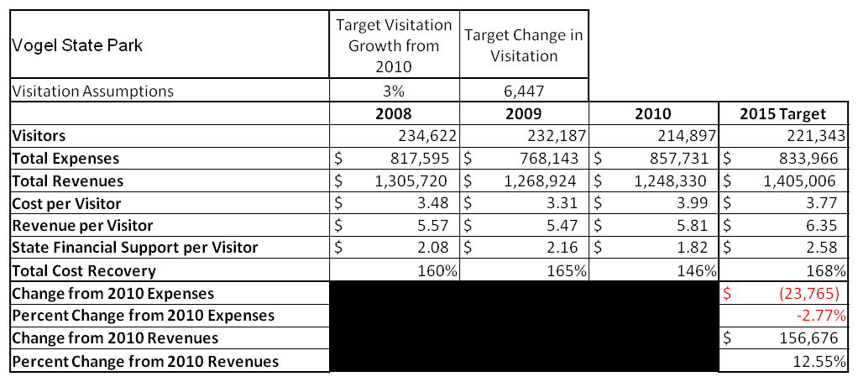

Key Recommendations

Primary / Short Term Recommendations
- Operate the site using cost-based accounting, including the net cost recovery achieved annually.
  - Limit hours of part-time staff to working only when there is a site need.
- Reduce cost associated with operations such as energy consumption.
  - Convert all comfort stations and the linen barn to on demand tankless water heaters to conserve energy cost.
  - Conduct energy audits and upgrade all cabins to conserve energy.
  - Install timers on all public use facilities to reduce energy consumption.
  - Convert all cabins to tankless water heaters as funds allow.
- Conduct in-park surveys annually to assess how well customer satisfaction levels are being met. Vogel State Park should strive to have 90% of visitors responding to ‘Comment Cards’ report that they were either ‘satisfied’ or ‘very satisfied’ (or some comparable metric to be developed). Programs or services that fall below that standard should be critically reviewed, enhanced, and results monitored; those with a history of poor performance should be considered for elimination.
  - Offer customers discounts on retail and overnight stays for completing the online survey in order to increase response, relevance and revenue.
- Evaluate and pursue opportunities to employ concessionaires or private or public service providers on-site if they can be more cost-effective.
  - Explore the development of a concession agreement to provide food concessions on site. This would need to be evaluated to determine if it would benefit the site more to operate a concession stand or allow a concessionaire to operate the facility.
- Collect a statistically-valid sample of ZIP code data from visitors in a non-intrusive way to gauge their origins and demographics (e.g., age, ethnicity, income, etc.) and use the results to improve programming and marketing efforts to appeal to a broader audience.
  - ParkPass Attendant collects 10 zip codes daily throughout their shift to compile into a chart illustrating the present target market of service.
- Utilize a minimum of six special events annually to help draw more visitors to the site. The purposes of these events are to extend the peak season, increase advertising for the site and generate revenue. Some events, however, will not meet all three items listed above. It is not practical to charge admission or make a direct profit from each event. Some events are used strictly to draw overnight guests in a time that they would not normally visit the site.
- Seek local partners to help support operations, programs, and service delivery and for cross-marketing purposes. Vogel State Park has a tremendous amount of support from local partners. These partnerships can be strengthened to generate even more support in the future.
  - Join the Chamber of Commerce to build network opportunities with local business leaders.
  - Partner with local wineries, adventure guides, horseback riding facilities, and agri-tourism sites to develop promotions that are mutually beneficial to both entities.
  - Partner with the Georgia Department of Agriculture, which has farms and facilities throughout the state that we would consider day-use operations. Our department offers day-use and stay-use facilities in remote locations. GA DNR and GA DA could partner to cross promote visiting agri-tourism sites during the day and then return to a local state park for an overnight stay. This would allow us to tap into a market of people who want to return to a simpler, more natural lifestyle while having the resources of two state agencies to promote the ideas to the public.
- Sustain sufficient non-labor operational funding or reduce staff so that required staff operational costs (with benefits) do not exceed 65% of the total operational budget.
- Enhance facilities and program offerings to provide a minimum of 10 unique experiences for each visitor while maintaining at least a 90% customer satisfaction rating.
  - Construct five yurts: There are numerous rentable cabins within a short driving distance of Vogel State Park, so by constructing yurts, Vogel State Park would enter into a niche market for this area which would provide the customer with a unique experience.
- Manage Vogel State Park according to well-defined maintenance, programming and operational standards monitored and enforced by region managers and senior management.
  - Maintenance: Develop and submit winter work plans and annual program of work plans to ensure that preventative maintenance is completed on all equipment and facilities.
  - Programming: Develop and submit an annual program plan which includes the number and types of programs throughout the year as well as the cost recovery expected from each program offering.
  - Operational: Develop a budget that is conservative, while meeting the goals of the operation, and then conduct multiple senior staff meetings throughout the year to discuss priorities and the progress of the operation.
- Partner with local Chambers of Commerce or other destination marketing organizations (DMOs) to promote Vogel State Park.
  - Conduct on-site tours of the facility for local business owners and chamber members. Host chamber meetings or other functions to allow the members to experience the amenities that Vogel State Park has to offer.
- Continue to work with the Vogel Chapter of the Friends of Georgia State Parks and Historic Sites to help raise funds or provide volunteers for improvements and program support.
  - Develop new ideas to increase funds such as raffles, selling merchandise in the visitor center and charging for certain services at special events.
  - Write grant applications to receive funds that could be reinvested into the site to reduce operating cost such as installing tankless water heaters in the cabins.
- Perform a thorough net cost-of-service analysis on major functions of site operations, including the detailed analysis of labor requirements (by task) that has already been produced by site staff. Thereafter, update costs to deliver services on a biennial schedule.
  - Use new cost accounting form to monitor cost of operating facilities such as cabins and campsites. This will allow management decisions to be made that will increase the net profit of the site.
- Review and update rates at the site on an annual basis to recover the total net cost of service for important and visitor-supported services.
- Develop on-line sales of gift shop and retail items associated with the site in order to increase site generated revenues.
- Renovate gift shop to allow more up to date stock rotation and increase ease of use.
  - Market an eco-friendly line of apparel that will appeal to the customer that is more concerned about the environment.
  - Market a line of products geared specifically towards the trail hikers.
  - Rotate apparel items at least twice a year to continue to have a fresh look throughout the year and meet the customer’s needs based on the season of the year.
  - Reduce the amount of food supplies and replace with Vogel specific souvenir and gift items that can only be found onsite.
  - Bring in new lines of apparel and gift items at least annually in order for returning customers to have the opportunity to purchase something distinctly new.
  - Order smaller amounts of items to reduce overstock and write-offs.
- Track total economic impact of the site on the local communities and region and share with decision-makers, elected officials, local business operators, and others to demonstrate the impact of Vogel.
  - Develop fact sheets that can be given out with key talking points to take to local decision makers.
  - Develop presentations that can be given to the groups listed above to build support for the operations of Vogel State Park.
- Develop a more detailed analysis of labor requirements of all major park functions to match the right position with the right job at the right pay.
- Construct and upgrade facilities and amenities at the site that are likely to have a cost recovery level at or above 100%.
  - Construct five cabins to replace shelters 3 and 4. Combined the shelters brought in about $2,700.00 in FY11. By replacing these shelters with cabins, the site stands to potentially increase revenue by $75,000 to $100,000 per year.
  - Construct five yurts to provide a unique niche product in the area.
  - Renovate campground to include paving all roads, 50 amp service, cable, internet and sewer hookup on site.
  - Renovate roof of beach pavilion to convert structure into a rentable facility.
  - Renovate beach pavilion to include a grill to sell food and beverages during the busy season.
  - Install cable T.V. in all cabins.
  - Update existing cabins with newer furniture and amenities.
- Add more youth-focused services, programs and amenities at the site that appeal to younger audiences, families and educational groups, such as high adventure sports, land navigation and wilderness survival.
- Add more services, programs and amenities that appeal to older adults, such as bird watching, fitness hikes, Master Gardeners Programs and Master Naturalist Programs.

Secondary / Long Term Recommendations
- Improve the recreational amenities of the site to address modern and diverse uses.
- Engage the local community, user groups, and private organizations to improve connectivity between Vogel and Dahlonega Gold Museum.
- Install an improved retail point-of-sale and inventory tracking system.
- Engage Friends members in the business plan as a partner to help the site meet or exceed its sustainability goals.

Site and Operations Assessment
This site and operations assessment is a culmination of analyses and findings from a review of the condition of facilities, infrastructure, and operations at Vogel State Park. The findings and observations are not intended to be an exhaustive review of all issues present, but provide a basic understanding of the predominant issues that contribute to the site’s current operating conditions. The assessment includes the following:
- Site Inventory and Facility Assessment
- Operational Assessment
- Financial Assessment
Site Inventory and Facility Assessment

Methodology
Facility and asset conditions are rated using a differential scale of excellent, good, fair, or poor. Descriptions of conditions that are attributed to each of these findings are also provided.
Scale of Conditions
Rating | General Description
Excellent | Facilities/amenities are in ‘excellent’ condition when they show little or no maintenance or repair problems. Facilities do not feature any major design or operational issues or flaws that contribute to diminished use or increased maintenance or upkeep. Facilities are easy to clean and maintain in order to place them back into public use and the users perceive them to be in excellent shape.
Good | Facilities/amenities are in ‘good’ condition when they show only minor maintenance or repair problems. Most maintenance issues with these facilities typically appear to be the result of age and/or heavy use. Facilities may only feature minor design or operational issues that contribute to diminished use or increased maintenance or upkeep. Facilities are moderately easy to clean and maintain in order to place them back into service and the users perceive them to be adequate for their use, but probably not in excellent shape.
Fair | Facilities/amenities are in ‘fair’ condition when they show significant maintenance or repair problems. Facilities generally exhibit ongoing maintenance issues that appear to be the result of age, heavy use, or design or operational flaws. Some maintenance and repair needs may compound their fair condition by being deferred because of budget and/or resource limitations. Facilities require more effort to clean and maintain before placing them back into service and the users may perceive them as being less than adequate for their use and in a state of deterioration. The facility or structure may need of major repair or replacement.
Poor | Facilities/amenities are in ‘poor’ condition when they show significant, on-going maintenance or repair problems that ultimately may result in suspended use for repair/replacement. Maintenance and repair issues are possibly the result of poor maintenance and clearly the result of age, heavy use, or design or operational flaws. Problems with the facilities are often compounded over time due to consistently-deferred maintenance and repair because of budget and/or resource limitations. Facilities may feature major design or operational issues that contribute to diminished use or increased maintenance or upkeep. Facilities require excessive effort to clean and maintain before placing them back into service and the users often perceive them as being inadequate for their use and in a state of serious deterioration. The facility or structure may need of major repair or replacement.

Inventory and Assessment
The table below is an inventory of facilities and amenities at Vogel State Park, and provides the assessed condition of each as reviewed in May 2011.
Site Asset / Amenity | Quantity | Condition
Total acreage | 233 | Good
Visitors Center | 1 | Good
CCC Museum | 1 | Good
Museum Storage | 1 | Good
Trahlyta Lake Pavilion | 1 | Poor
Cottages | 35 | Good
Office | 1 | Good  G
Walk-in Campsites | 18 | Fair
40 Foot-Campsites | 62 | Good
Tent, Van, and Pop-up Sites | 24 total | Good
Comfort Stations | 4 | Fair (due to upgrades)
Picnic Shelters | 4 | Good
Group Shelter | 5 | Good
Beach Storage and Restrooms | 1 | Good
Housekeeping Laundry | 1 | Good
Guest Laundry & Restrooms | 1 | Good
Manager’s Residence | 1 | Good
Assistant Manager’s Residence | 1 | Fair
Naturalist Apartment | 1 | Good
Waste Water Treatment Plant | 1 | Good
Sewer Lines | 1 | Fair
Picnic Area | 1 | Fair
Pioneer Area | 1 | Good
Beach/Swimming Area | 1 | Good
Pedal Boat Dock | 1 | Good
Playground/Horseshoe Pits | 1 | Good
20 Acre Lake | 2 | Good
Miniature Golf | 1 | Fair
1-Mile Lake Trail | 1 | Fair
1-Mile Byron Reece Trail | 1 | Fair
4-Mile Bear Hair Gap Trail | 1 | Fair
13-Mile Coosa Back Country | 1 | Good
½-Mile Bike Trail | 1 | Fair
Memory Walkway | 1 | Fair
Pump-House Building | 1 | Good
Water lines | 1 | Good
Water Storage Tanks | 1 | Fair
Cottage/Day-use Area Paving Pavement | Throughout | Good (due to paving)
Campground Area Pavement | 1 | Good

Prioritized Facility Needs
Based on the facility inventory and assessment, these prioritized needs have been identified. Each need has been aligned with a priority category of high, moderate, or low to support future decision making regarding project sequencing, investment of public resources, and meeting community expectations. The priority assignment for each need is not a measure of importance. Rather, these recommended priorities reflect a phased implementation approach over the next several years.
Facility Need | Priority Assignment
Trahlyta Lake Pavilion roof replacement | High
Construct 5 new cabins in place of shelters 3 and 4 | High
Construct 5 yurts | High
Paving roads throughout campground | High
Remodel campground comfort stations (1 per year until complete) | High
Remodel mini golf | High
Remodel walk-in campsites | Medium
Remodel tent campsites | Medium
Remodel 2 cabins per year | Medium
Update furnishing in cabins | Low
Add cable television to cabins | Low
Replace any flex sewer lines with PVC lines in order to reduce the number of leaks | Low
Trail work to remove debris, stabilize areas prone to erosion and increase trail markings | Low

Operational Assessment
The Operational Assessment includes:
- An inventory and classification of programs and services being provided at the site
- A review of staffing at the site
- A review of concessionaires and partners operating at the site
- Visitation and customer satisfaction

Inventory and Classification of Programs and Services
Programs and services are classified into one of three major categories:
1) Core or Essential Services
2) Important Services
3) Visitor Supported Services
Programs and services at the site are classified into these categories based in part on the mission and public mandates for both the site and the agency. For the programs and services in each category, there are financial performance expectations that will define how services are funded and evaluated.

Category 1 – Core Services [Largely supported by tax funds]
Core programs, services and facilities are those the agency must provide and/or are essential in order to capably govern and meet statutory requirements. The failure of the agency to provide Category 1 services at adequate levels could result in significant negative consequences for the public and the resources under protection. The criteria for programs or services to be classified as core are:
- The services are mandated by the agency’s law or charter or are contractually obligated by agreement to provide the services.
- The services are essential to protecting and supporting the public’s health and safety.
- The services protect and maintain valuable assets and infrastructure.
- The services would generally and reasonably be expected and supported by residents, businesses, customers and partners.
- The services are those that cannot or should not be provided by the private sector.
- The services provide a sound investment of public funds.
The following programs and services offered at Vogel State Park have been identified as core services:
- Active management of the natural and cultural resources of the site (i.e., CCC structures and artifacts) in order to protect their integrity
- Artifact management
- Open and public access to the site and its resources
- Site appropriate education, interpretation, and recreational opportunities
- Public safety
- Maintenance of grounds, facilities and infrastructure

Category 2 – Important Services [Supported by a balance of tax funds and earned revenues]
Important programs, services and facilities are those the agency should provide, and are important to governing and effectively serving residents, businesses, customers and partners. Providing Category 2 services expands or enhances the agency’s ability to provide and sustain its core services. The criteria for programs or services to be classified as important are:
- The services expand, enhance or support identified core services.
- The services are broadly supported and utilized by the community, and are considered an appropriate, important, and valuable public good. Public support may be conditional upon the manner by which the services are paid for or funded.
- The services generate income or revenue that offsets some or all of the operating cost and/or are deemed to provide economic, social or environmental outcomes or results.
The following programs and services offered at Vogel State Park have been identified as important:
- Rentals of overnight facilities such as cabins, campsites, walk-in campsites, pioneer camping and backcountry camping
- Self-guided interpretation and education programs
- Support for researchers and educational groups

Category 3 – Visitor Supported Services [Almost exclusively supported by earned revenue]
Visitor supported programs, services and facilities are those discretionary services that the agency may provide when additional funding or revenue exists to offset the cost of providing those services. Category 3 services provide added value above and beyond what is required or expected. The criteria for programs or services to be classified as visitor supported are:
- The services expand, enhance or support core services or important services and the quality of life of the visitors, community or stakeholders.
- The services are supported, valued and well utilized and provide a valuable public benefit.
- The services generate income or funding from sponsorships, grants, user fees or other sources that offset some or all of their cost and/or provides a meaningful return on investment.
- The services can possibly be provided through outsourcing or use of concessionaires, providing opportunities for community enterprises that may not otherwise be provided by the agency.
The following programs and services offered at Vogel State Park have been identified as visitor supported services:
- Gift Shop
- Ranger guided interpretation and elective educational programs
- Special events / programs related to the mission of the site
- Special events / programs not related to the mission of the site or outside the normal programming standards (e.g., wedding receptions, etc.)
- Boat rentals
- Concessions

Staffing Assessment
Labor costs at Vogel State Park represent the largest area of budgetary expense at an average of 59% of the total operating budget each year for the last three complete years, which is lower than the target of total labor costs (including benefits) not exceeding 65% of the site’s total operating expenditures. The tables below and on the following page provide a basic review of the current staffing at the site.
Full Time Equivalent Employees
Position / Title | Quantity (FTE) | Vacancies | Annual Hours
Site Manager | 1 | 0 | 2080
Assistant Manager | 1 | 0 | 2080
Clerk | 2 | 0 | 4160
Maintenance Tech | 1 | 0 | 2080
General Trades Craftsman | 2 | 0 | 4160
Housekeepers | 1 | 0 | 2080
Utility Worker | 0 | 1 | 0
TOTAL | 8 | 1 | 16,640

Part Time Employees
Position / Title | Quantity (FTE) | Vacancies | Hours
Seasonal Naturalist | 0 | 1 | 960
Boat Clerk | 1 | 0 | 960
Housekeepers | 5 | 1 | 7,540
Desk Clerk | 2 | 3 | 4,868
Maintenance Worker | 1 | 1 | 2,468
TOTAL | 9 | 6 | 16,796

Labor Support
Labor Support | Annual Hours
Volunteers | 6,000
Community Service Workers | 200
Resource Management Crews | 0
Kiosk Clerk | 1624
TOTAL | 7,824

Total Labor Hours
Labor Type | Annual Hours
Full Time Equivalent Employees | 16,640
Part Time Employees | 16,796
Labor Support | 7,824
TOTAL Annual Labor Hours | 41,260

Labor Budget Summary

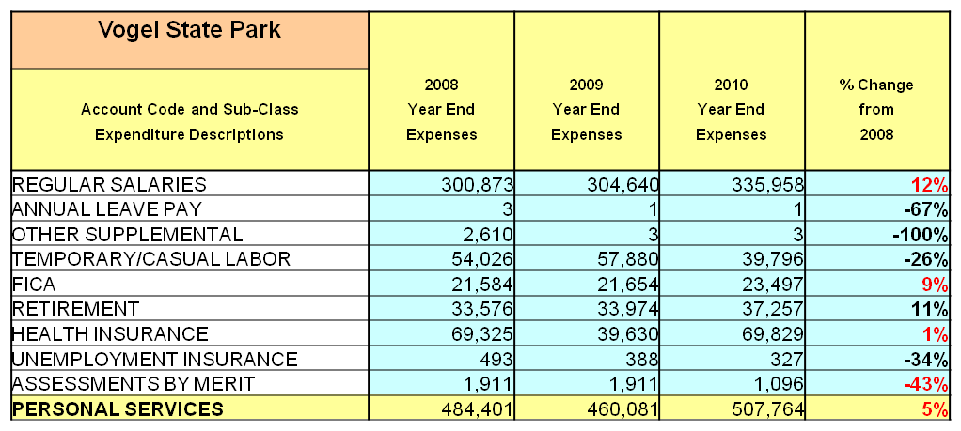

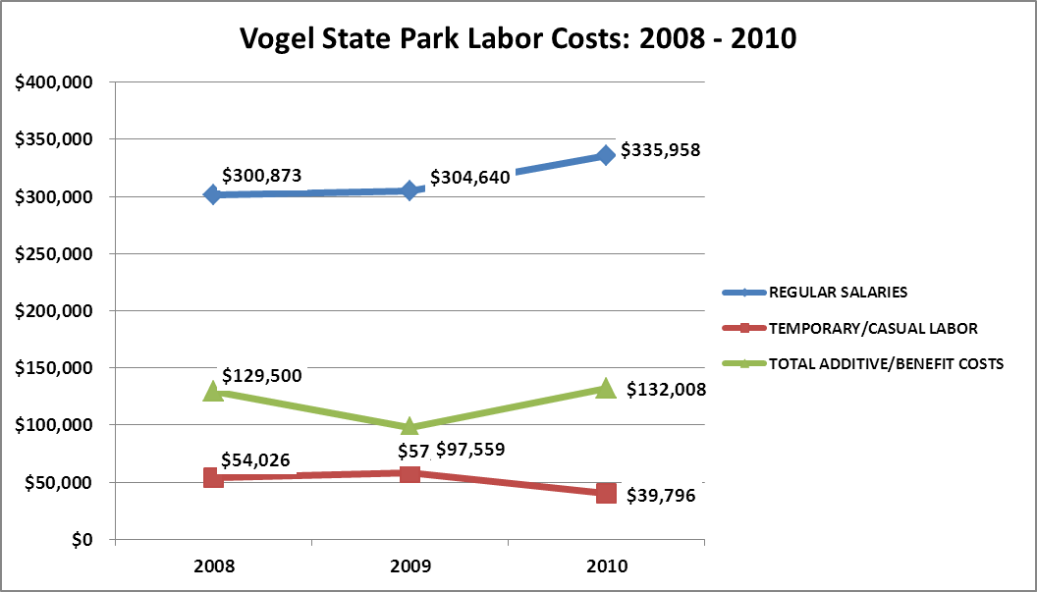

Visitation and Occupancy
Overall annual visitation to the site has trended downward from 2008 to 2010, decreasing by 8% or over 19,725 visitors. This is largely attributed to the economic recession.
Year | Total Visitation
2008 | 234,622
2009 | 232,187
2010 | 214,897
Occupancy for the overnight accommodations at Vogel State Park the last three years is detailed in the table below. Overall occupancy has trended downward from 2008 to 2010, decreasing by 15%. This is largely attributed to the economic recession and limited facilities upgrades due to budget constraints.

Year | Cottage Occupancy | Campsite Occupancy
2008 | 51% | 46%
2009 | 48% | 36%
2010 | 47% | 35%

Customer Service and Satisfaction

Site | Year | Customer Satisfaction Level
Vogel State Park | 2009 | 75%
Vogel State Park | 2010 | 85%

Site staff will review comment cards and online comments to determine why customer satisfaction ratings are less than the Division standard of 90% and work to implement changes that will improve the customer satisfaction level for the site.
Financial Performance Assessment

Operational Expenses
A summary of total operating expenses at Vogel State Park from 2008 to 2010, as well as their percent change from 2008 are provided in the table below.

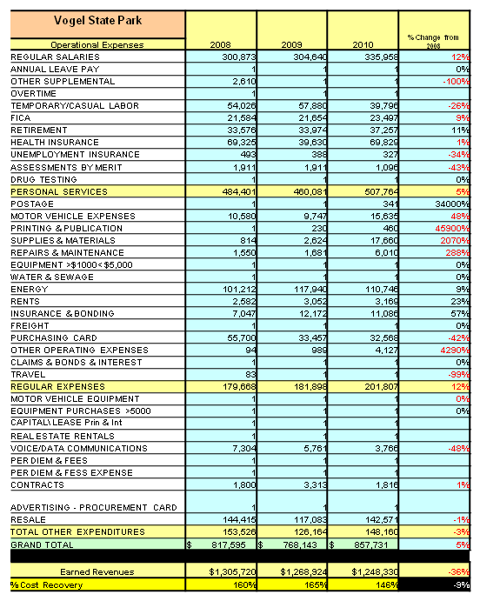
Earned Revenues
Earned revenues at Vogel State Park have decreased since 2008, which is largely attributed to the corresponding decrease in overall visitation and amenities that need to be remodeled and upgraded.
Monthly earned revenues for the last two years (see table on the following page) indicate that the total annual revenue decreased 2% from 2009 to 2010, with the largest increase in monthly revenue in April (12%), and the largest decrease in the month of January (-19%).

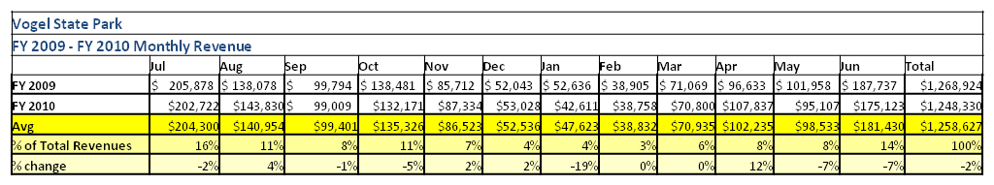

The graphs below illustrate the monthly revenue trends each year and the average percent of total annual revenue earned each month.

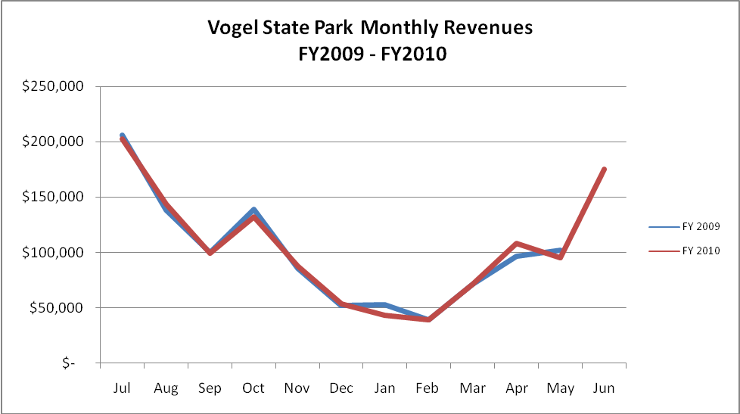

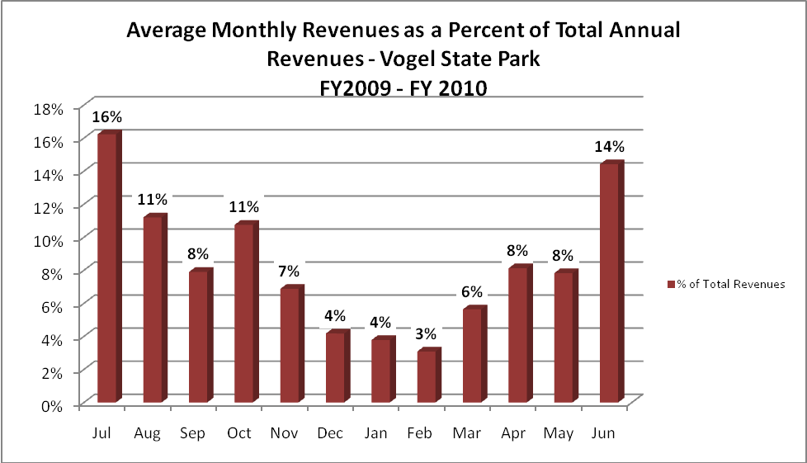

Cost Recovery Trends
Vogel State Park has achieved an average cost recovery of 157% of annual operational expenses through earned revenues from FY 2008 to FY 2010. This is detailed and illustrated in the table and graph below.
Year | Operational  Expenses | Earned  Revenues | Percent Cost  Recovery
2008 | 817,595 | 1,305,720 | 160%
2009 | 768,143 | 1,268,924 | 165%
2010 | 857,731 | 1,248,330 | 146%

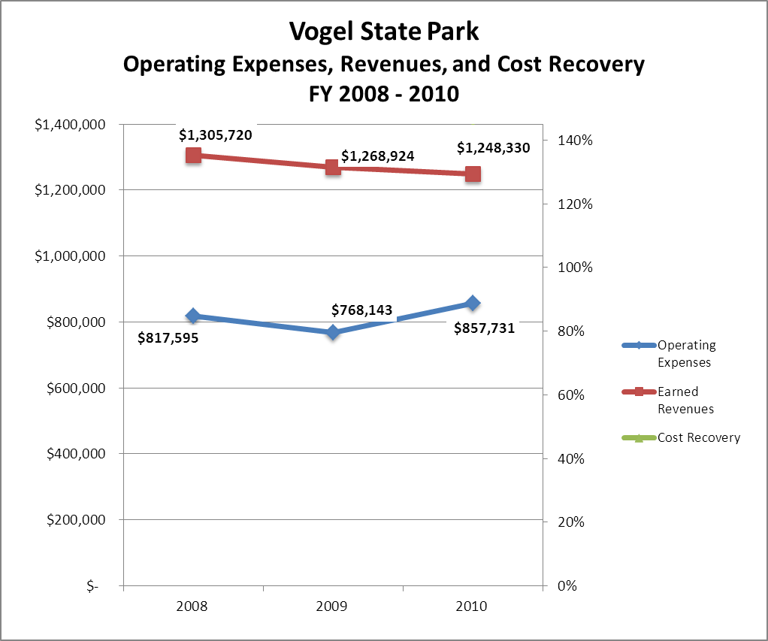

Business and Management Plan

Business Goals
The following goals serve as the foundation for the key recommendations and strategies in this plan.

Enhance Cost Recovery of Site Operations
Vogel State Park is operating well over 100% return on investment. That return on investment can be increased through adding facilities such as yurts and new cabins. The yurts do not require a high level of upkeep and are rentable at a rate that is twice as much as a campsite. Also, the visitation to the cabins would be increased by adding cable TV service. We should also implement a plan to renovate the cabins and campsites in order to draw new and return customers. Repairing the roof on the lake pavilion would allow us to charge a premium fee to rent the facility; also, for a small amount of start-up money, we could install a concession stand at the beach area to sell concessions during the busy season.

Enhance Revenue Generation Strategies
The staff of Vogel State Park has done an excellent job of offering special events to the public in order to attract overnight stays in the park facilities. The programs can be enhanced to appeal to a broader audience. The facility would benefit from frequent renovations and upgrades as listed above to increase customer satisfaction to 90%.

Expand Special Events at the Site
Vogel State Park holds a number of special events annually which have grown into very successful programs that offer guest’s great opportunities for enjoyment and also bring in guests for the overnight facilities. However, it is time to review, refresh and update the special events planned for Vogel.

Improve the Diversity and Innovation of Recreational and Interpretive Programs
The slate of programs at Vogel State Park has been consistent for many years. There needs to be new programs and events added to the slate in order to reach new markets and a more diverse base of customers. There are several examples that range from guided overnight hiking trips to cycling clinics.

Improve the Effectiveness of Marketing and Sales
The effectiveness of the marketing here at Vogel State Park could be improved through marketing the experiences that the site offers. The guests have the opportunity to enjoy the mountains from the comfort of a cabin. The marketing program could focus on reaching new markets in Atlanta, North Carolina and Tennessee.

Establish Greater Consistency of Managing and Monitoring Customer Service & Satisfaction
Vogel State Park should have a minimum of 90% satisfaction rating from the guest. There is presently no way to accurately track the ratings. However, there is a new online system coming into operation that should increase the volume and quality of statistics. It would increase the survey results to offer an incentive of 5% off the next stay for completing a survey. This would allow the park staff to monitor and make changes as needed to increase customer satisfaction.

Expand Partnership Opportunities
The business owners in the surrounding area have played a very active role in supporting Vogel State Park. These partnerships can be expanded for increased support. There is potential to expand support through increased programming support as well as financial support. We are planning to engage Friends members in the business plan as a partner to help the site meet or exceed its sustainability goals.

Classification of Programs and Services
The tables below summarize the classifications of programs and services at Vogel State Park as either core, important, or visitor supported and projects a range of cost recovery percentages that might be achieved for each. These classifications establish financial performance goals for each category of services that are linked to the recommendations and strategies of this business plan.

Core Programs / Services | Target Cost Recovery
Active management of the natural and cultural resources of the site to protect their integrity for future generations | 0%
Artifact management such as Civilian Conservation Corps Memorabilia | 0%
Public access to the site and its resources | 0%
Public safety | 0%
Maintenance of grounds, facilities and infrastructure | 0%

Important Programs / Services | Target Cost Recovery
Rentals of overnight facilities such as cabins, walk-in sites, pioneer camping, and backcountry camping | 25%-85%
Self-guided interpretation and education programs | 40%-60%

Visitor Supported Programs / Services | Target Cost Recovery
Retail area and gift shop | 100%-125%
Ranger led interpretation | 100%
Special events related to the mission of the site | 100%
Special events that are not related to the mission of the site | 100%-150%
Boat rentals | 100%-150%
Concessions | 100%-125%

Partnership Development Plan
The table below summarizes existing partners and targeted partnerships by classification (operational, vendor, service, co-branding, funding partners) and by organizational type.
 | Public Partners | Not-for-profit Partners | Private / Enterprise Partners
Operational Partners | - Union County Sheriff’s Office  - Union County Emergency Management  - Forest Service  - Union County Public Works | - Appalachian Trail Clubs | - United Community Bank
Vendor Partners | - N/A | - Friends of Vogel | - Coca Cola  - Blue Ridge EMC  - Southeastern Publications
Service Partners | - Forest Service | - Blairsville Chamber of Commerce | - N/A
Co-branding Partners | - N/A | - Friends of Georgia State Parks | - Blood Mountain Cabin Rentals  - Walasiyi
Funding Resource Development Partner | - N/A | - Friends of Vogel | - Local professional and business leaders

Marketing and Sales Plan

Marketing and Sales Goals
Marketing and sales goals for Vogel State Park are based on the following desired outcomes:
- Develop marketing focused on increasing occupancy in the campground from 35% up to 45% over the next three years with emphasis focusing on the months from November to April.
- Develop marketing focused on increasing occupancy in the cottages from 44% up to 55% over the next three years with emphasis focusing on the months from November to April.
In order to meet these goals, examples of specific target outcomes were identified in the areas detailed in the table below.
Area  of Focus | Current  Performance | Goal  by 2011 | Goal  by 2012 | Goal  by 2015
Camping Occupancy | 35% | 38% | 40% | 45%
Cottage Occupancy | 47% | 48% | 50% | 55%

Marketing and Promotion Strategies

Publicity and Social Media
Park staff will approach marketing and publicity planning using the following guidelines and themes:
- Event publicity
Major events benefit by having short stories in local, regional, and statewide newspapers and online social media hooks planted that run three to four weeks in advance of the event up to the date of the event itself. Stories and media need to be cultivated with contacts and online sales channels several weeks in advance of the time the stories need to run. Special interest interviews on morning, noon, and evening television news programs, radio interviews on popular rush-hour programs, and blogs on known affinity online sites should also be included.
  - Partner with local news agencies to invite reporters on site during events.
  - Encourage reporters to interview event participants in order to tell the human experience side of the story.
- Program publicity
Special and unique programs should have feature stories in magazines, local and regional weekly newspapers, and statewide daily newspapers that are aimed at placements as front-page or sectional front-page stories. These stories are most effective if they run shortly before the season that the featured program begins. This will likely require several weeks of advanced planning with media contacts. Similar coverage on television and radio should also be considered. If pre-publicity cannot be generated, post-publicity can help promote future programs.
  - Prepare news releases prior to events to increase participation.
  - Use web-based advertising such as social media sites and park web page.
- Site Publicity
Site publicity focusing on a Vogel State Park requires more intense planning efforts to attract multiple writers and editors from target publications. Each site could host several seasonal media familiarization tours (with 10 to 15 writers or editors) to familiarize them with the site and its benefits and amenities. Stories and features resulting from such tours typically take between two and six months to materialize so the tours should focus on experiences, benefits, and programs that would be available when the stories are expected to run.
Examples and suggested opportunities for events, programs and related publicity efforts based on the themes described above at Vogel State Park are provided in the table below.
Event Publicity | Program Publicity | Site Publicity
Volunteer Days | Adventure sports | Weekend Wonderings
Fishing Rodeos | CCC Work Days | Finding Vogel
Mountain Music Days | Cycling clinics | Specialty magazines
Mountain Life Lessons | Hiking clinics | Web-based social networking sites

Packaging
Examples and suggested packages for Vogel State Park are provided in the table below.
Package | Package Details
Cozy Cabin Package | Receive 1 free night when you rent a cabin for 3 nights in the winter months
Weekday Warriors | Receive 1 free night when you reserve a cabin or campsite for 2 nights during the week in the off season

Group Sales
Types of groups within which specific target customers can be identified for Vogel State Park are listed below:
- Religious Organizations | - Special Interest Groups | - Organizations

Incentivizing New and Repeat Visitation
Vogel State Park will utilize the following strategies and/or incentives to encourage new and repeat visitation starting in FY 2012:
- Customers will receive 5% off their next reservation for completing a comment card

Marketing and Sales Metric Goals
The following marketing and sales metric goals and/or others will be monitored and progress reported at Vogel State Park:
- Loyalty and repeat customers = 80% repeat customers.
- Brand confidence & customer recruiting customers = 20% of new customers recruited by previous customers.
Revenue Generation Plan
Revenue / Cost Recovery Goals
Vogel State Park has set a financial goal of increasing annual revenues 3% between 2010 and 2015. The largest revenue growth opportunity is most likely adding facilities such as yurts, cabins and a concession stand. The table below details projected revenue growth leading up to 2015, based upon a nominal growth of revenues each year.
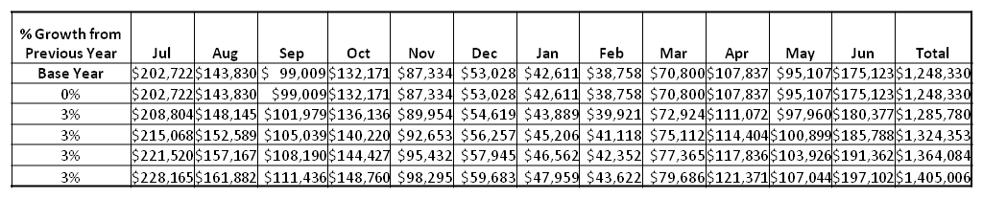

These projections would result in a total of 12.5% cumulative growth in total annual revenues between FY2010 and FY2015. If operational expenses can be managed with a cumulative reduction of 1.5% between FY 2010 and FY 2015, then the overall cost recovery of the site will be approximately 168% in FY 2015 at these projected revenue levels. This is higher than the annual financial performance of the site in FY 2010, which was operated at 146% cost recovery in that year.
Revenue Generation Strategies

Pricing Plan

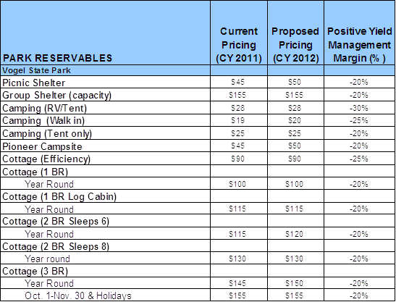

Innovative Programming and Special Events Plan
Program / Event | Theme / Purpose | Scheduled Date/Season | Frequency | Target Participation | Target User Fee | Target Cost Recovery
Vogel Volunteer Day | Service | April | Annually | 100+ | $0.00 | 0%
Wildflower Walk | Natural Education | April | Annually | 25 | $3.00 | 150%
CCC Reunion | History Education | April | Annually | 100+ | $0.00 | 0%
Fishing Rodeo | Outdoor Education | June | Annually | 300+ | $0.00 | 0%
July 4th Celebration | Entertainment | July | Annually | 600 | $0.00 | 0%
Mountain Music Festival | History Education | September | Annually | 1000 | $3.00 | 300%
Fall Hoedown | Entertainment | October | Annually | 500 | $2.00 | 80%
Christmas Tree Lighting | Entertainment | December | Annually | 600 | $0.00 | 0%

Partnerships and Concessions Plan
Service / Partnership | Term of Service | Financial Objective | Contract Manager
Pest Control | 1 year | Increase cabin rentals and satisfaction through a reduction of pests in cabins | Park Manager
Food Concession | 1 year | 20% of retail taken in by provider | Park Manager

Expense Management Plan
Personnel Assignments
The following actions will be taken to proactively manage labor costs via personnel assignments and classifications.
Action | Timeline | Outcome
Convert full time positions into part time positions when possible through attrition | On-going | Greatly reduce labor cost of benefits and annual hours paid

Management Techniques
The following actions will be taken to proactively manage labor costs via management techniques.
Action | Timeline | Outcome
Add additional maintenance/housekeeping host position. This host would be located at the linen barn and would not occupy a campsite in the campground in order to prevent revenue loss. | December 2011 | Utilize volunteer labor in order to reduce the need for part time staff

Adjusted Levels of Service
The following actions will be taken to proactively manage labor costs via reduced levels of service.
Action | Timeline | Outcome
Reduce office hours to operate from  8 AM- 5 PM daily in the off season,  November - March. | September 2011 | Reduce labor cost

Financial Pro Forma
The following five-year financial pro forma projects operating expenses, earned revenues and cost recovery through FY 2015. These pro forma are based on the strategies and desired outcomes identified in this business plan, especially the revenue generation and expense management plans, and are linked to corresponding performance goals.

Expense Pro Forma

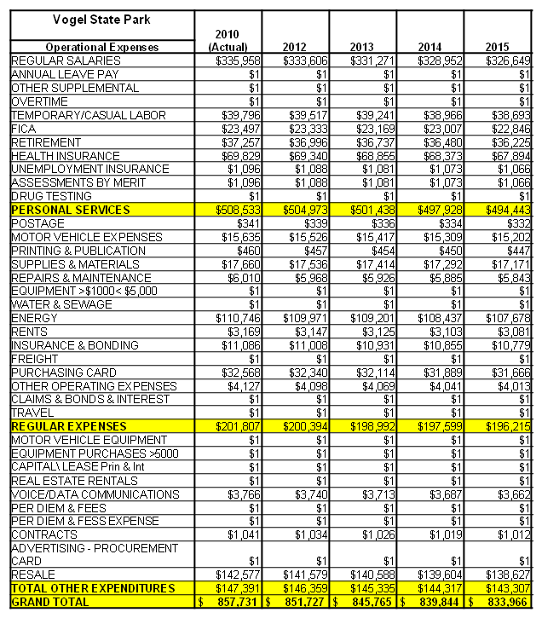

Revenue Pro Forma

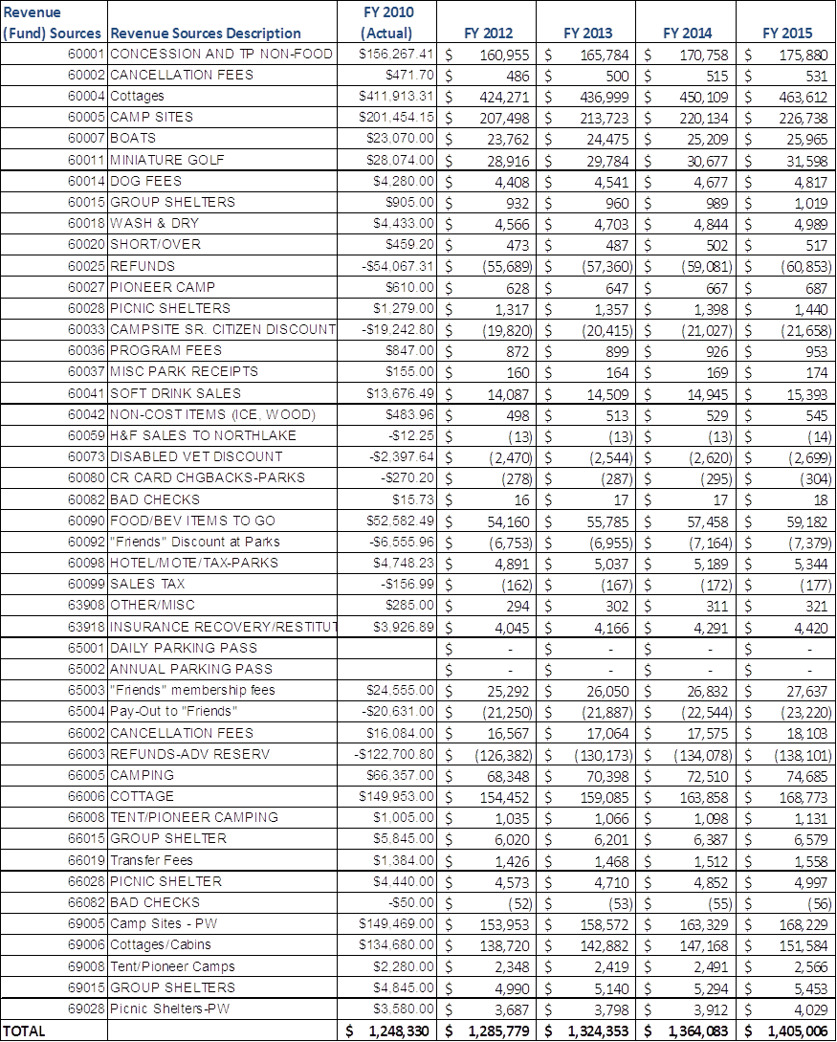

Total / Cost Recovery Pro Forma

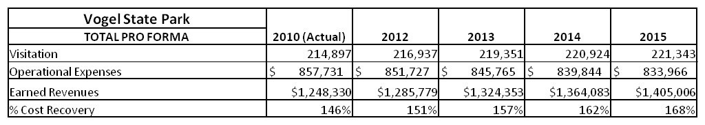

Action Plan
ACTION PLAN
Site: |  | Site Manager: |  |  | Date:
Month:
Strategy | Tasks | Costs / Funding | Revenues / ROI | Responsibilities | Metrics

ACTION PLAN
Site: |  | Site Manager: |  |  | Date:
Month:
Strategy | Tasks | Costs / Funding | Revenues / ROI | Responsibilities | Metrics

This is the average of the last three years – FY 2008, FY 2009, and FY 2010
Current employees, not including vacancies.
Current employees, not including vacancies.
Major population centers within a two-hour drive from the site

