Watson Mill Bridge
Business & Management Plan

Prepared June 2011; Finalized Februrary 2013
Direction 2015 – Sustainable Business Planning

Table of Contents

Executive Summary 3

Site and Operations Assessment 6
Site Inventory and Facility Assessment 6
Operational Assessment 8
Financial Performance Assessment 13

Business and Management Plan 16
Business Goals 16
Classification of Programs and Services 17
Partnership Development Plan 18
Marketing and Sales Plan 19
Revenue Generation Plan 21
Expense Management Plan 23
Financial Pro Forma 24

Action Plan 27

Executive Summary
The Parks, Recreation and Historic Sites Division (PRHSD) of the Georgia Department of Natural Resources (DNR) is transitioning the management of Watson Mill Bridge State Park to operate more like a business, reflecting the Direction 2015 – Sustainable Business Planning initiative to improve the fiscal performance and management of the state parks and historic sites system. This business and management plan is designed to help the site recover more operating expenses through earned revenues, productive partnerships, and innovative programs.

Site Fact Sheet
Site Name | Watson Mill Bridge State Park
Site Manager | Jerry Cook
Region Manager | Tommy Turk
Date of Business Plan completion | Revised December 1, 2012
Site size | 1,118 Acres
Total number of visitors (FY 2010) | 225,469
Total operating budget (FY 2010) | $214,753
Total earned revenues (FY 2010) | $133,852
Operational cost recovery (FY 2010) | 62%
Average operating cost per visitor (FY 2010) | $0.95
Average earned revenue per visitor (FY 2010) | $0.59
Average cost recovery (FY 2008 – 2010) | 58%
Target cost recovery (FY 2015) | 80%
Total full-time employees | 1
Total part-time employees | 4
Primary service markets | Athens, Atlanta, Augusta
Primary attractors/visitor appeal factors | Historic Covered Bridge and Horse Trails
Leading opportunities for improved site performance | Increased use by equestrian groups

Site Summary and Key Attractions
The 1118-acre site of Watson Mill Bridge State Park (WMB) is located in a rural setting, roughly 30 miles from the major population center of Athens, GA. As the historical covered bridge is the focal point of the park that preserves a link to the culture of a bygone era, the bridge crosses a natural flowing river, which is surrounded by rich natural resources of flora and fauna. The biodiversity of this site is varied with different ecosystems within the park. It is one of only four parks in Georgia that operates an equestrian stay-use area. There are presently 19 miles of trails in the park with some designated as horse trails, some as hiking/biking, and some as walking only. With the natural scenic beauty of the site, it is one of the most popular subjects for photographers and many artists in the state.

Key Attractions
The amenities or features listed below are those that seem to be most popular for visitors.
- Covered Bridge
- Horse trails
- Secluded/spacious camping
- Rustic Log Cabins
- Playing in the river (sliding on rocks in the river)

Financial Targets
The table below details the total operating expenses and earned revenues for Watson Mill Bridge State Park over the last three years (2008 – 2010). This table also calculates total cost per visitor and revenues per visitor during these operating years, and details the target financial performance goals in the context of achieving at least 80% cost recovery. This table also calculates the necessary change from 2010 operating expenses and revenues.
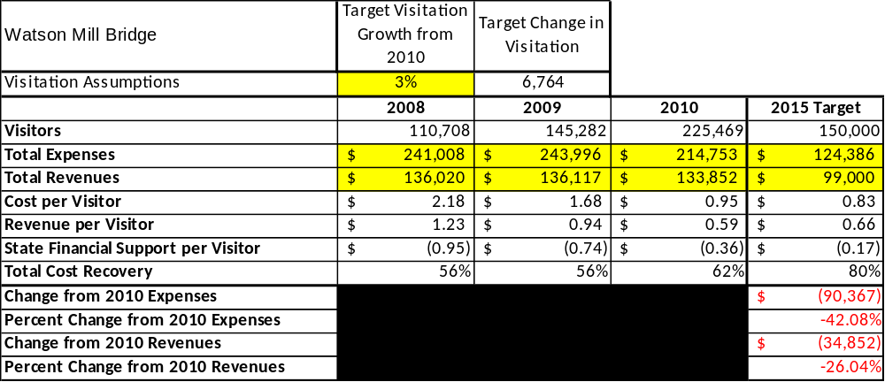

Key Recommendations

Primary / Short Term Recommendations
- Continue financial support of the park from Madison and Oglethorpe Counties.
- Operate regular campground, group shelter and office on a seasonal basis (March 1 to November 30).
- Operate the equestrian campground, stalls and bunk house using the self-registration SORA model in the off-season (December 1 to February 28).
- Operate the park as a satellite operation to Victoria Bryant State Park. Administrative duties will be overseen by Victoria Bryant. The Assistant Manager at Watson Mill Bridge will supervise seasonal employees in the operation of the park.
- Seek local partners including the local chamber of commerce.
- Enhance facilities and programs offered while maintaining at least a 90% customer satisfaction rating.
- Review and update site rates annually to recover the total net cost of services.
- Construct and upgrade facilities and amenities at the site that are likely to have a cost recovery impact of near 100%. This would include renovation of existing comfort stations, upgrading the equestrian campground and a new modern comfort station in the equestrian area.
- Add more family-based amenities to the camping area.

Secondary / Long Term Recommendations
- Improve the recreational amenities of the site to address modern and diverse uses.
- Improve the ADA accessibility to all areas of the park including the river and the canoe rentals.
- Engage the local community and special groups to improve the connectivity between the PHRSD and these organizations.
- Develop a long term maintenance plan that would help keep facilities in a planned rotation of improvements to keep pace with changing needs of the area.
- Continue to develop relationships with horse riders and equestrian organizations.

Site and Operations Assessment
This site and operations assessment is a culmination of analyses and findings from a review of the condition of facilities, infrastructure, and operations at Watson Mill Bridge State Park. The findings and observations are not intended to be an exhaustive review of all issues present, but provide a basic understanding of the predominant issues that contribute to the site’s current operating conditions. The assessment includes the following:
- Site Inventory and Facility Assessment
- Operational Assessment
- Financial Assessment
Site Inventory and Facility Assessment

Methodology
Facility and asset conditions are rated using a differential scale of excellent, good, fair, or poor. Descriptions of conditions that are attributed to each of these findings are also provided.
Scale of Conditions
Rating | General Description
Excellent | Facilities/amenities are in ‘excellent’ condition when they show little or no maintenance or repair problems. Facilities do not feature any major design or operational issues or flaws that contribute to diminished use or increased maintenance or upkeep. Facilities are easy to clean and maintain in order to place them back into public use and the users perceive them to be in excellent shape.
Good | Facilities/amenities are in ‘good’ condition when they show only minor maintenance or repair problems. Most maintenance issues with these facilities typically appear to be the result of age and/or heavy use. Facilities may only feature minor design or operational issues that contribute to diminished use or increased maintenance or upkeep. Facilities are moderately easy to clean and maintain in order to place them back into service and the users perceive them to be adequate for their use, but probably not in excellent shape.
Fair | Facilities/amenities are in ‘fair’ condition when they show significant maintenance or repair problems. Facilities generally exhibit ongoing maintenance issues that appear to be the result of age, heavy use, or design or operational flaws. Some maintenance and repair needs may compound their fair condition by being deferred because of budget and/or resource limitations. Facilities require more effort to clean and maintain before placing them back into service and the users may perceive them as being less than adequate for their use and in a state of deterioration. The facility or structure may need of major repair or replacement.
Poor | Facilities/amenities are in ‘poor’ condition when they show significant, on-going maintenance or repair problems that ultimately may result in suspended use for repair/replacement. Maintenance and repair issues are possibly the result of poor maintenance and clearly the result of age, heavy use, or design or operational flaws. Problems with the facilities are often compounded over time due to consistently-deferred maintenance and repair because of budget and/or resource limitations. Facilities may feature major design or operational issues that contribute to diminished use or increased maintenance or upkeep. Facilities require excessive effort to clean and maintain before placing them back into service and the users often perceive them as being inadequate for their use and in a state of serious deterioration. The facility or structure may need of major repair or replacement.

Inventory and Assessment
The table below is an inventory of facilities and amenities at _Watson Mill Bridge State Park_, and provides the assessed condition of each as reviewed in May 2011.

Site Asset / Amenity | Quantity | Condition
Total Acreage | 1,118 | Good
Manager’s Residence | 1 | Good
Asst. Manager’s Residence | 1 | Good
Group Shelter | 1 | Good
Picnic Shelter | 3 | Good
Maintenance Complex | 1 | Fair
Campground | 1 | Good
Campground Comfort Station | 1 | Fair
Equestrian Campground | 1 | Fair
Equestrian Comfort Station | 1 | Poor
Day Use Bathroom | 1 | Good
Office area | 1 | Good
Picnic area | 1 | Good
Covered Bridge | 1 | Good
Log Cabins | 3 | Good
Power house raceway | 1 | Fair

Prioritized Facility Needs
Based on the facility inventory and assessment, these prioritized needs have been identified. Each need has been aligned with a priority category of high, moderate, or low to support future decision making regarding project sequencing, investment of public resources, and meeting community expectations. The priority assignment for each need is not a measure of importance. Rather, these recommended priorities reflect a phased implementation approach over the next several years.

Facility Need | Priority Assignment
New comfort station in Equestrian Area | High
Renovate Equestrian Campsites | High
Preservation Work on Covered Bridge | High
Stabilize Powerhouse Raceway | Moderate

Operational Assessment
The Operational Assessment includes:
- An inventory and classification of programs and services being provided at the site
- A review of staffing at the site
- A review of concessionaires and partners operating at the site
- Visitation and customer satisfaction

Inventory and Classification of Programs and Services
Programs and services are classified into one of three major categories:
1) Core or Essential Services
2) Important Services
3) Visitor Supported Services
Programs and services at the site are classified into these categories based in part on the mission and public mandates for both the site and the agency. For the programs and services in each of these categories, there are financial performance expectations that will define how services are funded and evaluated.

Category 1 – Core Services [Largely supported by tax funds]
Core programs, services and facilities are those the agency must provide and/or are essential in order to capably govern and meet statutory requirements. The failure of the agency to provide Category 1 services at adequate levels could result in significant negative consequences for the public and the resources under protection. The criteria for programs or services to be classified as core or essential are:
- The services are mandated by the agency’s law or charter or are contractually obligated by agreement to provide the services.
- The services are essential to protecting and supporting the public’s health and safety.
- The services protect and maintain valuable assets and infrastructure.
- The services would generally and reasonably be expected and supported by residents, businesses, customers and partners.
- The services are those that cannot or should not be provided by the private sector.
- The services provide a sound investment of public funds.
The following programs and services offered at Watson Mill Bridge State Park have been identified as core services:
- Active management of the natural and cultural resources of the site in order to maintain and protect their integrity
- Open and public access to the site and its resources
- Public safety

Category 2 – Important Services [Supported by a balance of tax funds and earned revenues]
Important programs, services and facilities are those the agency should provide, and are important to governing and effectively serving residents, businesses, customers and partners. Providing Category 2 services expands or enhances the agency’s ability to provide and sustain its core services. The criteria for programs or services to be classified as important are:
- The services expand, enhance or support identified core services.
- The services are broadly supported and utilized by the community, and are considered an appropriate, important, and valuable public good. Public support may be conditional upon the manner by which the services are paid for or funded.
- The services generate income or revenue that offsets some or all of the operating cost and/or are deemed to provide economic, social or environmental outcomes or results.
The following programs and services offered at Watson Mill Bridge State Park have been identified as important services:
- Self-guided hiking / biking trails
- Site appropriate education, interpretation and recreational opportunities

Category 3 – Visitor Supported Services [Almost exclusively supported by earned revenue]
Visitor supported programs, services and facilities are those discretionary services that the agency may provide when additional funding or revenue exists to offset the cost of providing those services. Category 3 services provide added value above and beyond what is required or expected. The criteria for programs or services to be classified as visitor supported are:
- The services expand, enhance or support core services or important services and the quality of life of the visitors, community or stakeholders.
- The services are supported, valued and well utilized and provide an appropriate and valuable public benefit.
- The services generate income or funding from sponsorships, grants, user fees or other sources that offset some or all of their cost and/or provides a meaningful return on investment.

The services can possibly be provided through outsourcing or use of concessionaires, providing opportunities for community enterprises that may not otherwise be provided by the agency.
The following programs and services offered at Watson Mill Bridge State Park have been identified as visitor supported services:
- Visitor Center / resale (gift shop)
- Ranger guided programs
- Camping and bunk houses
- Equestrian trails

Staffing Assessment
Labor costs at Watson Mill Bridge State Park represent the largest area of budgetary expense at an average of 80% of the total operating budget each year for the last three complete years, which is higher than the target of total labor costs (including benefits) not exceeding 65% of the site’s total operating expenditures. Following changes in the operational model of the park in FY 2011 & 2012, that figure is currently 63%. The tables below and on the following page provide a basic review of the current staffing at the site.

Full Time Equivalent Employees
Position / Title | Quantity (FTE) | Vacancies | Annual Hours
Asst. Park Manager | 1 | 0 | 2500
TOTAL | 1 | 0 | 2,500

Part Time Employees
Position / Title | Quantity (FTE) | Vacancies | Hours
Maintenance Worker | 2 | 0 | 2108
Desk Clerk | 2 | 0 | 2520
TOTAL | 2 | 0 | 4,628

Labor Support
Labor Support | Annual Hours
Volunteers | 500
Labor Support from Victoria Bryant | 500
TOTAL | 1,000

Total Labor Hours
Labor Type | Annual Hours
Full Time Equivalent Employees | 2,500
Part Time Employees | 4,628
Labor Support | 1,000
TOTAL Annual Labor Hours | 8,128

Labor Budget Summary
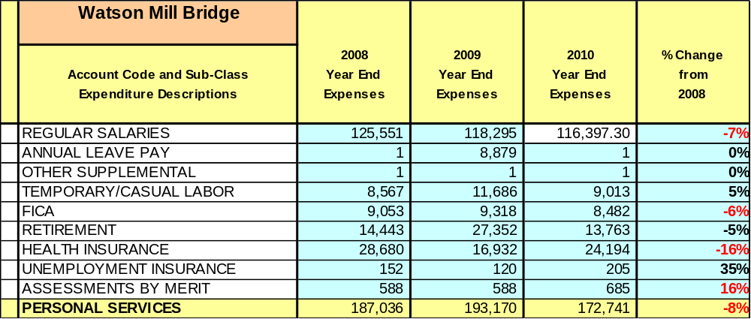

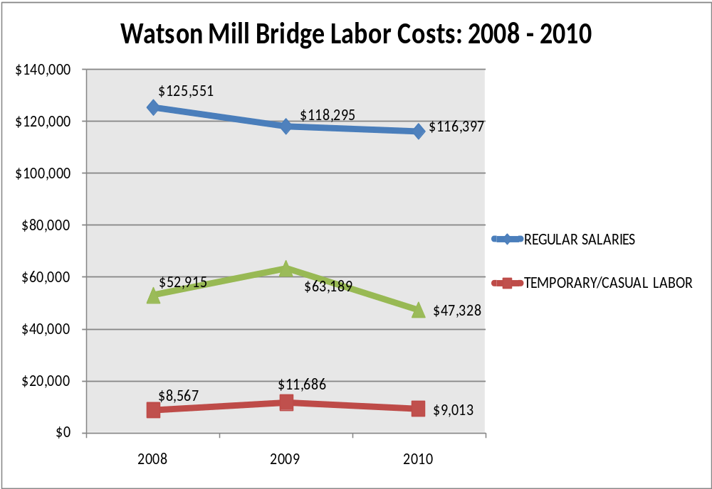

Visitation and Occupancy
Overall annual visitation to the site has trended upward from 2008 to 2010, increasing by 100% or over 114,761 visitors. This is largely attributed to inaccurate placement and reading of traffic meters.

Year | Total Visitation
2008 | 110,708
2009 | 145,282
2010 | 225,469

Occupancy for the overnight accommodations at Watson Mill Bridge the last three years is detailed in the table below. Overall occupancy has trended downward from 2008 to 2010, decreasing by 7.96%. This is largely attributed to the economy.
The graph below illustrates visitation and occupancy over the last three years.

Year | Camping Occupancy | Cabin Occupancy
2008 | 24.52% | 57.47%
2009 | 22.82% | 43.31%
2010 | 23.13% | 42.95%

Customer Service and Satisfaction

Site | Year | Customer Satisfaction Level
Watson Mill Bridge | 2009 | 100%
Watson Mill Bridge | 2010 | 92%
Financial Performance Assessment

Operational Expenses
A summary of total operating expenses at Watson Mill Bridge State Park from 2008 to 2010, as well as their percent change from 2008 are provided in the table below.

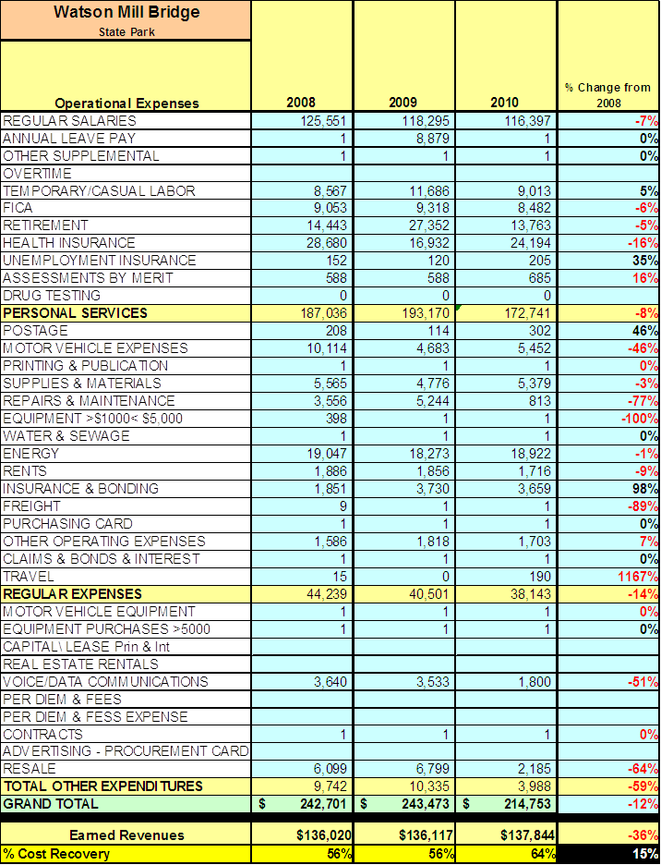
Earned Revenues
Earned revenues at Watson Mill Bridge State Park have increased since 2008, which is largely attributed to the corresponding increase in overall visitation and an increase in horse trail riders. Monthly earned revenues for the last two years (see table on the following page) indicate that the total annual revenue increased 1% from 2009 to 2010, with the largest increases in monthly revenues in May (30%), Aug. (29%), and March (23%) and the largest decreases in the months of Dec. (-45%), Jan. (-41%), Oct. (-33%), and Feb. (-5%).

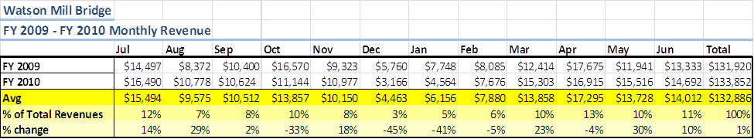

The graphs below illustrate the monthly revenue trends each year and the average percent of total annual revenue earned each month.

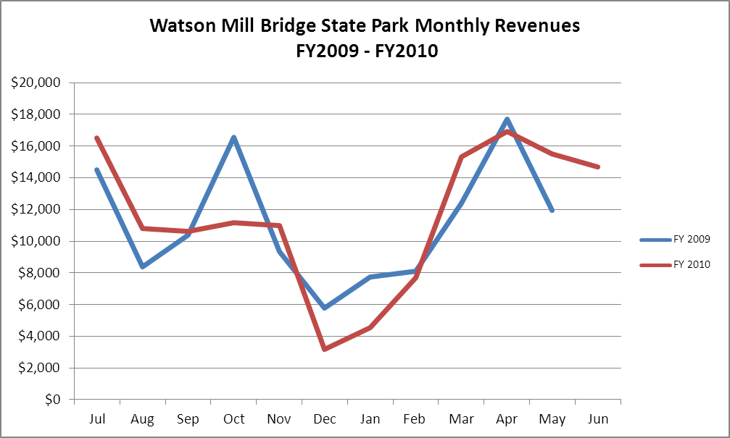

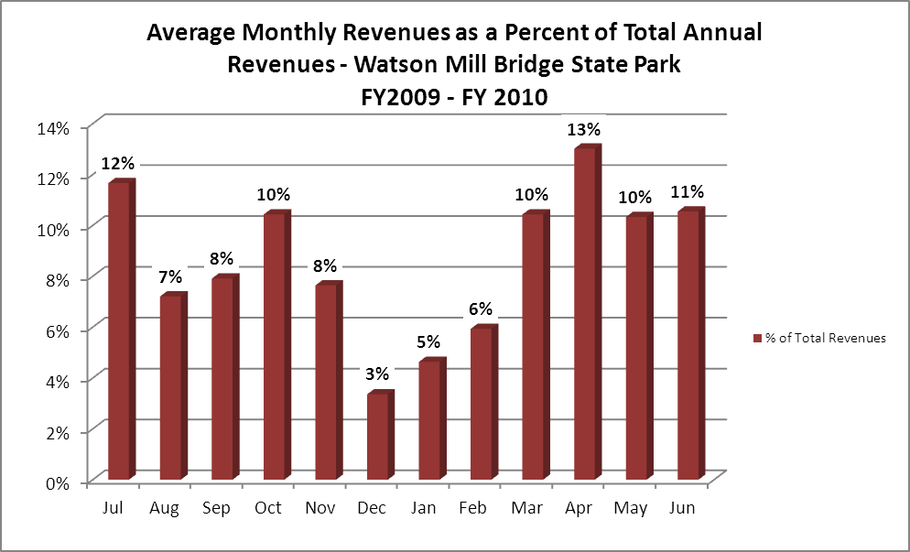
Cost Recovery Trends
Watson Mill Bridge has achieved an average cost recovery of 58% of annual operational expenses through earned revenues from FY 2008 to FY 2010. This is detailed and illustrated in the table and graph below.
Year | Operational  Expenses | Earned  Revenues | Percent Cost  Recovery
2008 | $242,701 | $131,920 | 56%
2009 | $243,473 | $130,243 | 56%
2010 | $214,753 | $133,852 | 62%
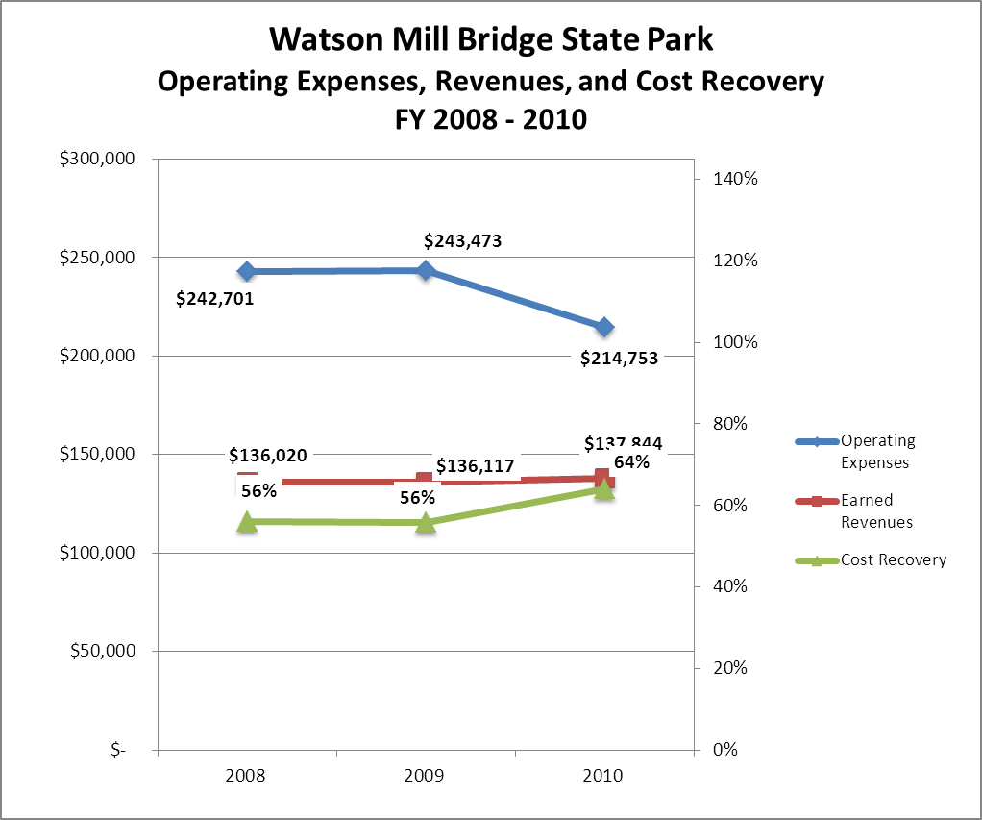

Review of Pricing
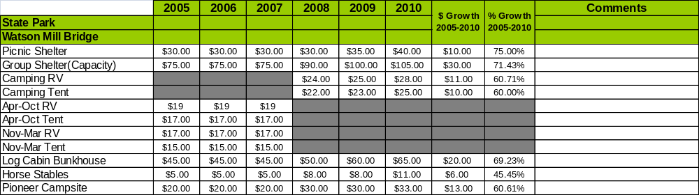
Data on rate information is available for the last five years. There has been notable growth in fees charged at Watson Mill Bridge since 2005, with the largest increase being in picnic shelters. All fees have increased at least 60% over this time period. A table detailing the rates for Watson Mill Bridge State Park is provided below.

Business and Management Plan

Business Goals
The following goals serve as the foundation for the key recommendations and strategies in this business plan for Watson Mill Bridge State Park.

Enhance Cost Recovery of Site Operations
During FY 2011 & 2012 the operational model of Watson Mill Bridge was changed from the traditional state park model to that of a SORA (State Outdoor Recreation Area), a modified state park model under which the site is open for nine months with full operations. During the months of December, January, and February the regular campground, office, and group shelter are closed and the equestrian area operates under the SORA model. Madison and Oglethorpe Counties underwrites a portion of the site budget. This arrangement will continue for the next several years as it is evaluated by all parties.

Enhance Revenue Generation Strategies
Equestrian facilities offer the highest potential for growth. The current comfort station in the equestrian campground is not adequate and needs replacement. The equestrian campground needs renovation to attract more users.

Expand Special Events at the Site

The events that center on this facility are geared toward the covered bridge and the horse trails.
With some creative advertising we might be able to hold more specialized events that will utilize these facilities to draw in more visitors. With the past history of the area we could include specialized events that once centered on small communities.

Improve the Diversity and Innovation of Recreational and Interpretive Programs
Very few programs are held at Watson Mill Bridge and the ones that are geared specifically to the history of the bridge and power plant. With increased community involvement, we could develop programs associated with the Chambers of Commerce in each of the counties.

Improve the Effectiveness of Marketing and Sales
The effectiveness of the marketing and sales for Watson Mill could be improved by better communication with the counties and surrounding communities. Direct contact with equestrian groups will be a priority.

Establish Greater Consistency of Managing and Monitoring Customer Service & Satisfaction
Develop an on-site survey system to help the staff better gauge the overall satisfaction of visitors to the park. This will help the staff better cater to the needed areas of improvement to achieve an overall satisfaction rating of 90% or greater.

Expand Partnership Opportunities
Explore the possibilities of partnerships with the local business and the two Chambers of Commerce associated with Watson Mill Bridge. This could include having chamber meetings in the group shelter to help promote the park to the local community. Knowing when there are events in the community will help the park promote itself at these events.

Classification of Programs and Services
The tables below summarize the classifications of programs and services at Watson Mill Bridge as either core, important, or visitor supported and projects a range of cost recovery percentages that might be achieved for each. These classifications establish financial performance goals for each category of services that are linked to the recommendations and strategies of this business plan.

Core Services
Program / Service | Target Cost Recovery
Active management of the natural and cultural resources of the site in order to maintain and protect their integrity | 0%
Open and public access to the site and its resources | 20%-50%
Public safety | 0%

Important Services
Program / Service | Target Cost Recovery
Self-guided hiking / biking trails | 70%-80%
Site appropriate education, interpretation and recreational opportunities | 25% - 50%

Visitor Supported
Program / Service | Target Cost Recovery
Visitor center / resale (gift shop) | 150%
Ranger guided programs | 100%
Camping & bunk houses | 120%
Equestrian trails | 125%

Partnership Development Plan
The table below summarizes existing partners and targeted partnerships by classification (operational, vendor, service, co-branding, funding partners) and by organizational type.
 | Public Partners | Not-for-profit Partners | Private / Enterprise Partners
Operational Partners | - Madison County  - Oglethorpe County | - Equestrian Groups
Vendor Partners |  |  | - Coca Cola  - Rayle EMC  - Georgia Power
Service Partners | - Madison Co.  - Oglethorpe Co. | - Chamber of Commerce  - Madison/Oglethorpe animal shelter
Co-branding Partners | - Other state parks with equestrian facilities
Funding Resource Development Partner | - Tractor Supply Company trails grants | - Friends of Georgia State Parks and Historic Sites

Marketing and Sales Plan

Marketing and Sales Goals
Marketing and sales goals for Watson Mill Bridge State Park are based on the following desired outcomes:
- To increase overall visitation and revenue
- To entice more groups to hold events at Watson Mill Bridge
In order to meet these goals, examples of specific target outcomes were identified in the areas detailed in the table below.

Area  of Focus | Current  Performance | Goal  by 2011 | Goal  by 2012 | Goal  by 2015
Overall Visitation | 225,469 | 185,000 | 135,000 | 150,000
Special Events | < 100 | 100 | 200 | 300

Marketing and Promotion Strategies

Publicity and Social Media
Watson Mill Bridge State Park will approach marketing and publicity planning using the following guidelines and themes:
- Event publicity
Major events benefit by having short stories in local, regional, and statewide newspapers and online social media hooks planted that run three to four weeks in advance of the event up to the date of the event itself. Stories and media need to be cultivated with contacts and online sales channels several weeks in advance of the time the stories need to run. Special interest interviews on morning, noon, and evening television news programs, radio interviews on popular rush-hour programs, and blogs on known affinity online sites should also be included.
- Program publicity
Special and unique programs should have feature stories in magazines, local and regional weekly newspapers, and statewide daily newspapers that are aimed at placements as front-page or sectional front-page stories. These stories are most effective if they run shortly before the season that the featured program begins. This will likely require several weeks of advanced planning with media contacts. Similar coverage on television and radio should also be considered. If pre-publicity cannot be generated, post-publicity can help promote future programs.
- Site Publicity
Site publicity focusing on a single site or sub-set of sites requires more intense planning efforts to attract multiple writers and editors from target publications. The site could host several seasonal media familiarization tours (with 10 to 15 writers or editors) to familiarize them with the site and its benefits and amenities. Stories and features resulting from such tours typically take between two and six months to materialize so the tours should focus on experiences, benefits, and programs that would be available when the stories are expected to run.
Examples and suggested opportunities for events, programs and related publicity efforts based on the themes described above at Watson Mill Bridge are provided in the table below.

Event Publicity | Program Publicity | Site Publicity
Adopt a pet | Jr. Ranger Camp | Horse clubs

Packaging
Examples and suggested packages for Watson Mill Bridge are provided in the table below.

Package | Package Details
Stay and Play | Stay more than 3 nights and get a free canoe rental (full day)
Stay and Ride | Stay more than 3 night (equestrian) get a free trail day trail pass
Club Rides | Free rental of group shelter for equestrian clubs with 25 or more riders

Group Sales
Types of groups within which specific target customers can be identified for Watson Mill Bridge are listed below:
- Canoers/kayakers  - Churches  - Business and professional groups | - Schools  - Colleges | - Community groups  - Equestrian groups

Incentivizing New and Repeat Visitation
Watson Mill Bridge will utilize the following strategies and/or incentives to encourage new and repeat visitation starting in FY 2012:
- Group/bulk discounts in the campground
- Start the off season rates to help visitation during this time.

Marketing and Sales Metric Goals
The following marketing and sales metric goals and/or others will be monitored and progress reported at Watson Mill Bridge State Park:
- Loyalty and repeat customers =70% of customers repeating their visit within 12 months.
- Brand confidence & customers-recruiting-customers = Customer referrals equal at least 75% of the “Where did you hear about us?” response from the visitors polled.
Revenue Generation Plan
Revenue / Cost Recovery Goals
Watson Mill Bridge State Park has set a financial goal of increasing annual revenues 3% annually between 2013 and 2015. The largest revenue growth opportunity is most likely camping and equestrian fees. The table below details projected revenue growth leading up to 2015, based upon a nominal growth of revenues each year.

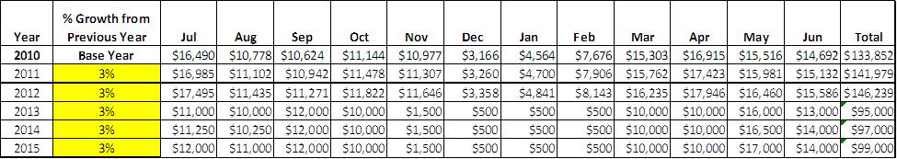

These projections would result in a total of 4% cumulative growth under the new operational model in total annual revenues between FY2013 and FY2015. If operational expenses can be managed with a cumulative reduction of 42% between FY 2010 and FY 2015, then the overall cost recovery of the site will be approximately 80% in FY 2015 at these projected revenue levels. This is higher than the annual financial performance of the site in FY 2010, which was operated at 62% cost recovery in that year.
Revenue Generation Strategies

Pricing Plan
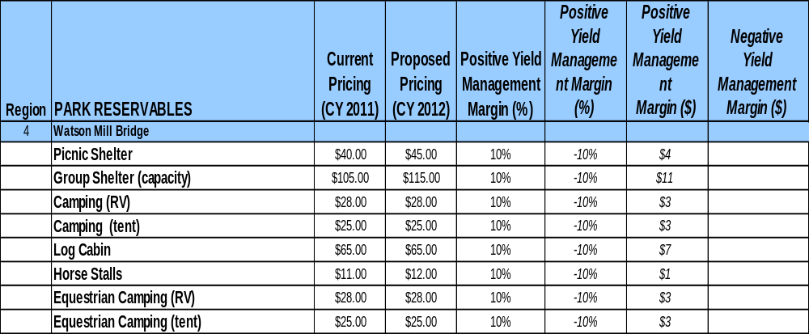

Innovative Programming and Special Events Plan
Program / Event | Theme / Purpose | Scheduled Date/Season | Frequency | Target Participation | Target User Fee | Target Cost Recovery
Pet adoption day | Helping local center | Open | Annually | Local | Park pass | 150%
Covered Bridge | Haunted Bridge | Open (Fall) | Annually | State wide | Parkpass Concessions | 150%
Equestrian Poker ride | Western ride | Fall/spring | Annually | North GA. | Trail fee  Parkpass | 150%

Partnerships and Concessions Plan
Service / Partnership | Term of Service | Financial Objective | Contract Manager
Madison & Oglethorpe County Funding | 4 years | Operate campground, office, & group shelter in state park model | Region Manager

Expense Management Plan
Personnel Assignments
The following actions will be taken to proactively manage labor costs via personnel assignments and classifications.

Action | Timeline | Outcome
Reallocate Manager to Assistant Manager, eliminate Manager, Ranger, and Clerk positions | November 2011 | Reduce labor by $115,029

Management Techniques
The following actions will be taken to proactively manage labor costs via management techniques.

Action | Timeline | Outcome
Madison County funds all operational costs of park office including seasonal clerks | May 2012 | $26,750 of park operation funded by county, increase revenue by having office staffed.

Adjusted Levels of Service
The following actions will be taken to proactively manage labor costs via reduced levels of service.

Action | Timeline | Outcome
Seasonal operation of office, campground, and group shelter | May 2012 | Reduced operational expenses

Financial Pro Forma
The following five-year financial pro forma projects operating expenses, earned revenues and cost recovery through FY 2015. These pro forma are based on the strategies and desired outcomes identified in this business plan, especially the revenue generation and expense management plans, and are linked to corresponding performance goals.

Expense Pro Forma

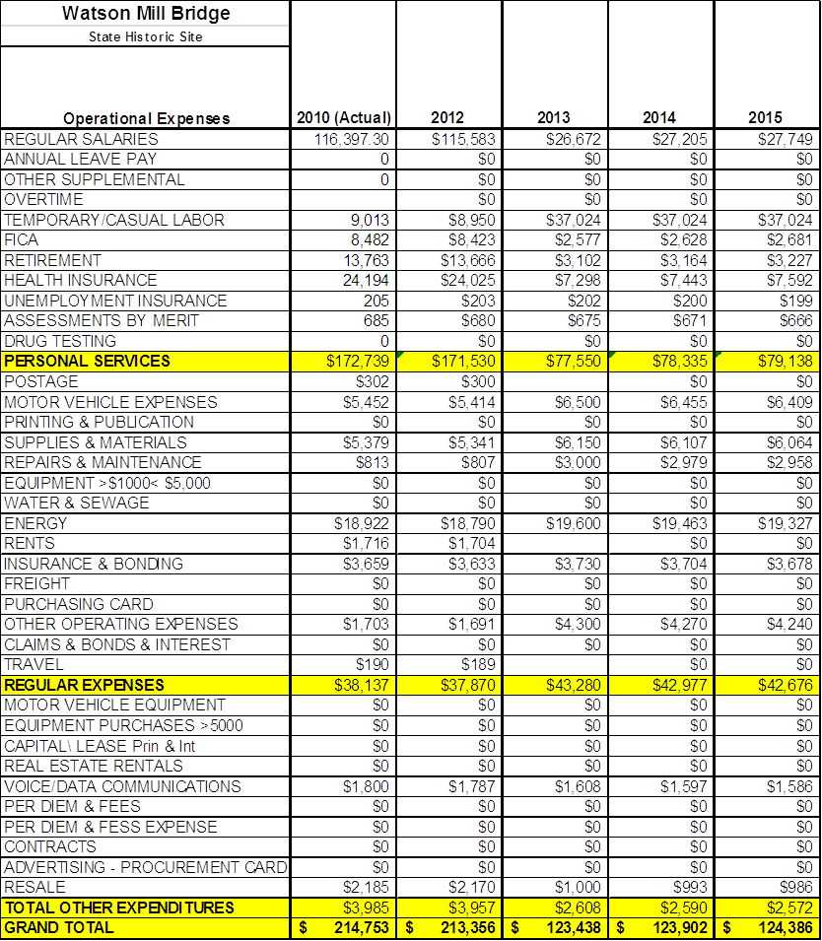

Revenue Pro Forma

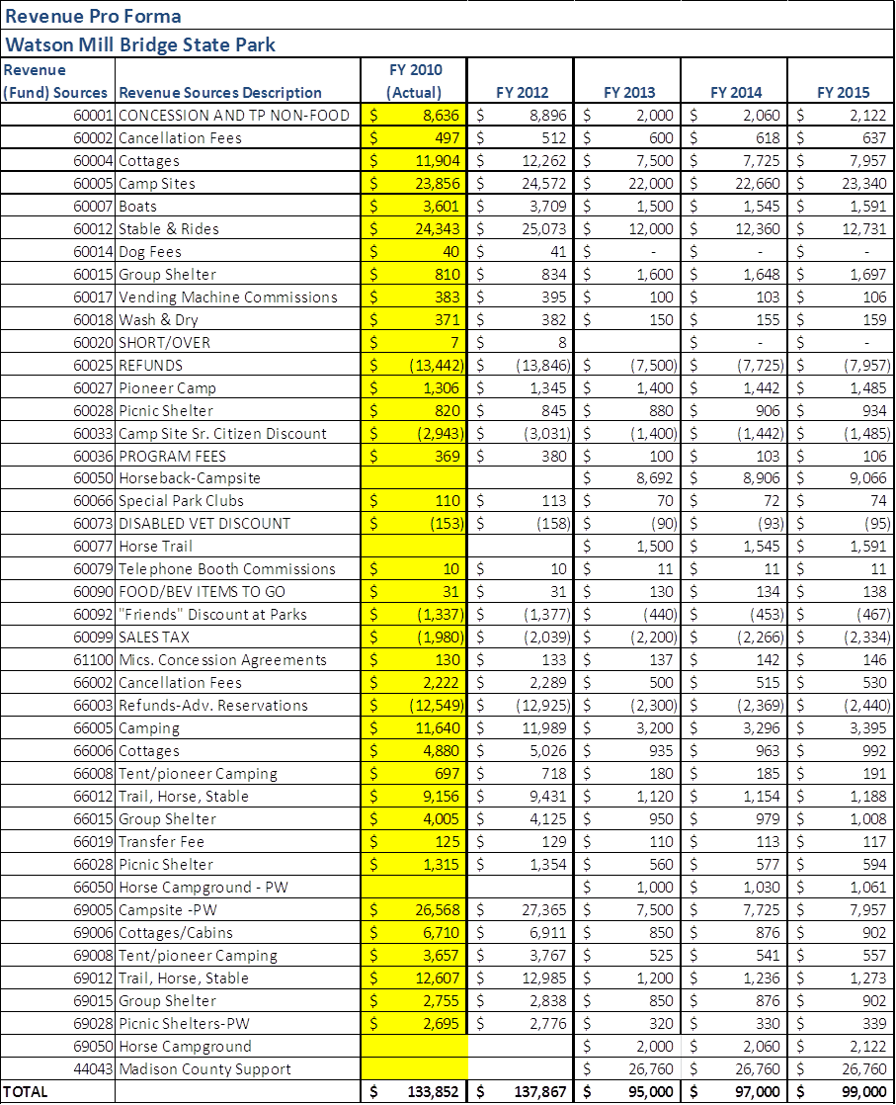

Total / Cost Recovery Pro Forma

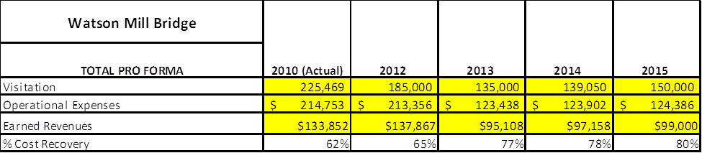

Action Plan
ACTION PLAN
Site: |  | Site Manager: |  |  | Date:
Month:
Strategy | Tasks | Costs / Funding | Revenues / ROI | Responsibilities | Metrics

ACTION PLAN
Site: |  | Site Manager: |  |  | Date:
Month:
Strategy | Tasks | Costs / Funding | Revenues / ROI | Responsibilities | Metrics

This is the average of the last three years – FY 2008, FY 2009, and FY 2010
Current employees, not including vacancies.
Current employees, not including vacancies.
Major population centers within a two-hour drive from the site

