Wormsloe State Historic Site
Business & Management Plan

Prepared June 2011; Finalized December 2012
Direction 2015 – Sustainable Business Planning

Table of Contents

Executive Summary 3

Site and Operations Assessment 7
Site Inventory and Facility Assessment 7
Operational Assessment 9
Financial Performance Assessment 14

Business and Management Plan 17
Business Goals 17
Classification of Programs and Services 18
Partnership Development Plan 19
Marketing and Sales Plan 20
Revenue Generation Plan 22
Expense Management Plan 23
Financial Pro Forma 24

Action Plan 26

Executive Summary
The Parks, Recreation and Historic Sites Division (PRHSD) of the Georgia Department of Natural Resources (DNR) is transitioning the management of Wormsloe State Historic Site to operate more like a business, reflecting the Direction 2015 – Sustainable Business Planning initiative to improve the fiscal performance and management of the state parks and historic sites system. This business and management plan is designed to help the site recover more operating expenses through earned revenues, productive partnerships, and innovative programs.

Site Fact Sheet
Site Name | Wormsloe State Historic Site
Site Manager | Chris Floyd
Region Manager | Tommy Turk
Date of Business Plan completion | February 24, 2012
Site size | 1,233 acres
Total number of visitors (FY 2010) | 28,288
Total operating budget (FY 2010) | $263,974
Total earned revenues (FY 2010) | $165,378
Operational cost recovery (FY 2010) | 63%
Average operating cost per visitor (FY 2010) | $9.33
Average earned revenue per visitor (FY 2010) | $5.84
Average cost recovery (FY 2008 – 2010) | 49%
Target cost recovery (FY 2015) | 97%
Total full-time employees | 4
Total part-time employees | 4
Primary service markets | Savannah, Jacksonville, Hilton Head, Charleston
Primary attractors/visitor appeal factors | Live Oak Allee, Tabby Ruins from 1737, Colonial Life Area, Museum/Film, Trails, View sheds of Allee, Jones’ Narrows, Moon River, Ranger led programs and demonstrations.
Leading opportunities for improved site performance | Addition of historic reconstructions of original structures and expanding living history programs to give a more hands-on, interactive experience.

Site Summary and Key Attractions
Comprising 1,233 acres on Long Island, Pigeon Island, and the southern half of Isle of Hope, Wormsloe State Historic Site is located in an urban residential setting eight miles from Historic Downtown Savannah. It is located 17 miles from Interstate 95, and 15 miles from Interstate 16. The historic and cultural tourism industry of Savannah and the relative proximity to I-95 bring the site the bulk of its visitation. Over six million visitors come to Savannah every year, yet only a tiny fraction visit Wormsloe. Tapping into this market could provide a huge boost to the site’s visitation and revenue. Improved marketing, programming, and package promotions are needed accordingly. For visitors seeking cultural/historical sites, “Colonial Wormsloe” occupies a unique niche as the only colonial-era historic site open to the public in Savannah and serves as a counter balance to the numerous antebellum and Civil War-era attractions in the area.

Key Attractions
The amenities or features listed below are those that seem to be most popular for visitors.
- Live Oak Allee
- Visitor Center (Theater, Museum, Gift Shop)
- Tabby Ruins from 1730s
- Colonial Life Area
- Trails

Financial Targets
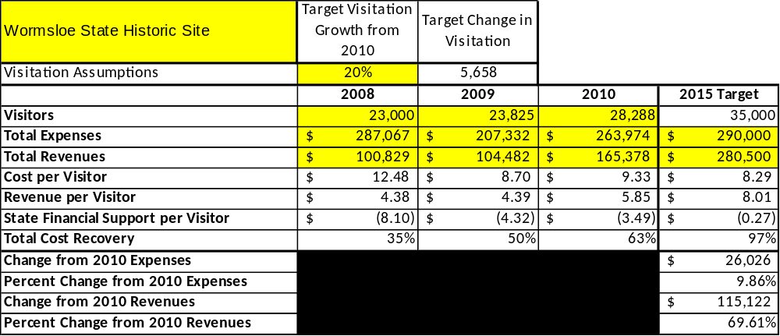
The table below details the total operating expenses and earned revenues for Wormsloe over the last three years (2008 – 2010). This table also calculates total cost per visitor and revenues per visitor during these operating years, and details the target financial performance goals in the context of achieving at least 80% cost recovery. This table also calculates the necessary change from 2010 operating expenses and revenues.

Key Recommendations

Primary / Short Term Recommendations
- Focus the regular operation of the site on providing interpretive programs to attract and retain visitors (in the absence of “park-style” revenue generating facilities). Enhance facilities and program offerings accordingly to provide high-quality interpretive services during all hours of operation.
- Create a site-specific interpretive programming manual and other tools that will assist in training new employees and volunteers to provide high quality interpretive programs.
- Offer a minimum of six special events annually to help draw more visitors to the site.
- Collect a statistically valid sample of ZIP code data from visitors in a non-intrusive way to gauge their origins and demographics (e.g., age, ethnicity, income, etc.) and use the results to improve programming and marketing efforts.
- Conduct in-park surveys regularly to assess customer service. Wormsloe’s goal will be to have 90% of visitors responding to ‘Comment Cards’ reporting that they were either ‘satisfied’ or ‘very satisfied’ (or some comparable metric to be developed in the new online comment system).
- Partner with the Savannah CVB, the Savannah Chamber of Commerce, and other destination marketing organizations to promote the site.
- Engage the Friends of Wormsloe in the business plan as a partner to help the site meet or exceed its sustainability goals. Continue to work with Friends to help raise funds and recruit volunteers for programming and improvement projects.
- Add more programs, special events, and educational opportunities that appeal to elementary, middle, and high school students. Develop relationships and lines of communication with area school teachers and administrators. Actively promote the site to schools in the Savannah area, as well as Macon/Warner Robins, metropolitan Atlanta, and the I-95 corridor.
- Manage Wormsloe according to well-defined maintenance, program, and operational standards supervised by region managers and senior management.
- Work with the Wormsloe Foundation to find areas of collaboration in regard to resource management and research.
- Renovate the museum with new exhibits and interactive displays.
- Market Wormsloe as a wedding ceremony and photography location, but within the limits of the operation. Offer wedding packages in cooperation with Skidaway Island State Park.

Secondary / Long Term Recommendations
- Rebrand the site to focus on the “colonial” aspect of interpretation and programs to make it distinct from other competing historic sites in the Savannah area.
- Perform a thorough net cost of service analysis on major functions of site operations, including a detailed analysis of labor requirements by task. Thereafter, update costs to deliver services on an annual schedule. Develop a more detailed analysis of labor requirements of all major site functions to match the right position with the right job at the right pay.
- Market and sell site-specific retail merchandise online.
- Review and update the rates at the site level on an annual basis. Offer premium interpretive programs with higher fees outside normal hours of operation.
- Track total economic impact of the site in the local communities and region and share with decision- makers, elected officials, local business operators, and others to demonstrate the impact of Wormsloe.
- Develop a detailed set of lesson plans and other educational materials to provide educators with tools to enhance the educational value of their experiences at Wormsloe.
- Combine efforts with other parks and historic sites in the area and along the coast (public and private) to develop package deals and other promotions. For example, create and promote a Skidaway/Wormsloe offer to include both camping and historic site admission.
- Encourage the development of innovative interpretive programs that bring new visitors to the site, particularly those from groups who are typically underrepresented among the site’s visitors.
- Invest in the interpretive infrastructure of the site, including a re-creation of Noble Jones’ fortified house, a new museum, an outdoor shelter (for group programs and day use), and the purchase or construction of a scout boat similar to what Capt. Noble Jones’ marines used at Wormsloe in the 1740s (Ft. King George SHS has one already). The goal is to secure Wormsloe’s place as the premiere colonial historic site in the Savannah area and provide visitor experiences accordingly.

Site and Operations Assessment
This site and operations assessment is a culmination of analyses and findings from a review of the condition of facilities, infrastructure, and operations at Wormsloe. The findings and observations are not intended to be an exhaustive review of all issues present, but provide a basic understanding of the predominant issues that contribute to the site’s current operating conditions. The assessment includes the following:
- Site Inventory and Facility Assessment
- Operational Assessment
- Financial Assessment
Site Inventory and Facility Assessment

Methodology
Facility and asset conditions are rated using a differential scale of excellent, good, fair, or poor. Descriptions of conditions that are attributed to each of these findings are also provided.
Scale of Conditions
Rating | General Description
Excellent | Facilities/amenities are in ‘excellent’ condition when they show little or no maintenance or repair problems. Facilities do not feature any major design or operational issues or flaws that contribute to diminished use or increased maintenance or upkeep. Facilities are easy to clean and maintain in order to place them back into public use and the users perceive them to be in excellent shape.
Good | Facilities/amenities are in ‘good’ condition when they show only minor maintenance or repair problems. Most maintenance issues with these facilities typically appear to be the result of age and/or heavy use. Facilities may only feature minor design or operational issues that contribute to diminished use or increased maintenance or upkeep. Facilities are moderately easy to clean and maintain in order to place them back into service and the users perceive them to be adequate for their use, but probably not in excellent shape.
Fair | Facilities/amenities are in ‘fair’ condition when they show significant maintenance or repair problems. Facilities generally exhibit ongoing maintenance issues that appear to be the result of age, heavy use, or design or operational flaws. Some maintenance and repair needs may compound their fair condition by being deferred because of budget and/or resource limitations. Facilities require more effort to clean and maintain before placing them back into service and the users may perceive them as being less than adequate for their use and in a state of deterioration. The facility or structure may need of major repair or replacement.
Poor | Facilities/amenities are in ‘poor’ condition when they show significant, on-going maintenance or repair problems that ultimately may result in suspended use for repair/replacement. Maintenance and repair issues are possibly the result of poor maintenance and clearly the result of age, heavy use, or design or operational flaws. Problems with the facilities are often compounded over time due to consistently-deferred maintenance and repair because of budget and/or resource limitations. Facilities may feature major design or operational issues that contribute to diminished use or increased maintenance or upkeep. Facilities require excessive effort to clean and maintain before placing them back into service and the users often perceive them as being inadequate for their use and in a state of serious deterioration. The facility or structure may need of major repair or replacement.

Inventory and Assessment
The table below is an inventory of facilities and amenities at Wormsloe, and provides the assessed condition of each as reviewed in June 2011.
Site Asset / Amenity | Quantity | Condition
Total acreage | 1,233 | Good
Visitor Center/Museum | 1 | Good/Fair
Maintenance Shop | 1 | Fair
Manager’s Residence | 1 | Good
Gate Cottage | 1 | Fair
5 miles of Trails | 1 | Good
Oak Allee | 1 | Good
Parking Areas | 2 | Good
Picnic Area | 1 | Fair
Tabby Ruins | 1 | Fair

Prioritized Facility Needs
Based on the facility inventory and assessment, these prioritized needs have been identified. Each need has been aligned with a priority category of high, moderate, or low to support future decision making regarding project sequencing, investment of public resources, and meeting community expectations. The priority assignment for each need is not a measure of importance. Rather, these recommended priorities reflect a phased implementation approach over the next several years.
Facility Need | Priority Assignment
New exhibits in museum | High
Outdoor covered shelter and improved picnic area (drain field also) | High
Black powder storage building | High
Paint and replace some exterior boards/siding on all facilities | High
Surfacing for trails around tabby ruins and bluff | High
Oak Tree Maintenance on Allee | High
Replace some siding on front gate cottage | High
Install campground host site with water, power, septic | High
Replace culverts and clear drainage ditches | Moderate
Improve parking areas, especially at front gate | Low
Line the entire oak allee with a border to protect trees from car traffic | Moderate
Additional crush and run for oak allee | Moderate
Additional fill dirt or mulch for back trails | Moderate
New roof and re-wiring at maintenance shop | Low
Tabby Ruins long-term preservation plan | Low
Dirt for picnic area; sits on top of drain field and is eroding | Low
New Visitor Center and Museum Complex | Low
Docks for Jones’ Narrows for premium programs (scout boat) | Low

Operational Assessment
The Operational Assessment includes:
- An inventory and classification of programs and services being provided at the site
- A review of staffing at the site
- A review of concessionaires and partners operating at the site
- Visitation and customer satisfaction

Inventory and Classification of Programs and Services
Programs and services are classified into one of three major categories:
1) Core or Essential Services
2) Important Services
3) Visitor Supported Services
Programs and services at the site are classified into these categories based in part on the mission and public mandates for both the site and the agency. For the programs and services in each of these categories, there are financial performance expectations that will define how services are funded and evaluated.

Category 1 – Core Services [Largely supported by tax funds]
Core programs, services and facilities are those the agency must provide and/or are essential in order to capably govern and meet statutory requirements. The failure of the agency to provide Category 1 services at adequate levels could result in significant negative consequences for the public and the resources under protection. The criteria for programs or services to be classified as core or essential are:
- The services are mandated by the agency’s law or charter or are contractually obligated by agreement to provide the services.
- The services are essential to protecting and supporting the public’s health and safety.
- The services protect and maintain valuable assets and infrastructure.
- The services would generally and reasonably be expected and supported by residents, businesses, customers and partners.
- The services are those that cannot or should not be provided by the private sector.
- The services provide a sound investment of public funds.
The following programs and services offered at Wormsloe have been identified as core services:
- Management of cultural and natural resources (mandated by Heritage Trust)
- Open public access to the site and its resources (mandated by Heritage Trust)
- Maintenance of grounds facilities and infrastructure
- Basic educational and interpretive services

Category 2 – Important Services [Supported by a balance of tax funds and earned revenues]
Important programs, services and facilities are those the agency should provide, and are important to governing and effectively serving residents, businesses, customers and partners. Providing Category 2 services expands or enhances the agency’s ability to provide and sustain its core services. The criteria for programs or services to be classified as important are:
- The services expand, enhance or support identified core services.
- The services are broadly supported and utilized by the community, and are considered an appropriate, important, and valuable public good. Public support may be conditional upon the manner by which the services are paid for or funded.
- The services generate income or revenue that offsets some or all of the operating cost and/or are deemed to provide economic, social or environmental outcomes or results.
The following programs and services offered at Wormsloe have been identified as important services:
- Trails
- Colonial Life Area
- School and public tour group programs

Category 3 – Visitor Supported Services [Almost exclusively supported by earned revenue]
Visitor supported programs, services and facilities are those discretionary services that the agency may provide when additional funding or revenue exists to offset the cost of providing those services. Category 3 services provide added value above and beyond what is required or expected. The criteria for programs or services to be classified as visitor supported are:
- The services expand, enhance or support core services or important services and the quality of life of the visitors, community or stakeholders.
- The services are supported, valued and well utilized and provide an appropriate and valuable public benefit.
- The services generate income or funding from sponsorships, grants, user fees or other sources that offset some or all of their cost and/or provides a meaningful return on investment.

- The services can possibly be provided through outsourcing or use of concessionaires, providing opportunities for community enterprises that may not otherwise be provided by the agency.

The following programs and services offered at Wormsloe have been identified as visitor supported services:
- Resale operation
- Special events
- Daily interpretive programs

Staffing Assessment
Labor costs at Wormsloe represent the largest area of budgetary expense at an average of 75% of the total operating budget each year for the last three complete years, which is higher than the target of total labor costs (including benefits) not exceeding 65% of the site’s total operating expenditures. The tables below and on the following page provide a basic review of the current staffing at the site.
Full Time Equivalent Employees
Position / Title | Quantity (FTE) | Vacancies | Annual Hours
Historic Site Manager | 1 | 0 | 2400
Interpretive Ranger | 1 | 0 | 2200
General Trades Craftsman | 0 | 1 | 0
TOTAL | 2 | 1 | 4600

Part Time Employees
Position / Title | Quantity (FTE) | Vacancies | Hours
Skilled Trades Worker | 1 | 0 | 1248
Seasonal Naturalist | 1 | 0 | 1248
Seasonal Naturalist | 1 | 0 | 1248
Seasonal Naturalist | 1 | 0 | 1248
Clerk | 1 | 0 | 1248
Gate Attendant | 1 | 0 | 1248
Gate Attendant | 1 | 0 | 1248
TOTAL | 4 | 0 | 8736

Labor Support
Labor Support | Annual Hours
Volunteers | 2500
Community Service Workers | 0
Engineering and Construction Crews | 0
Resource Management Crews | 100
TOTAL | 2600

Total Labor Hours
Labor Type | Annual Hours
Full Time Equivalent Employees | 4600
Part Time Employees | 8736
Labor Support | 2600
TOTAL Annual Labor Hours | 15936

Labor Budget Summary

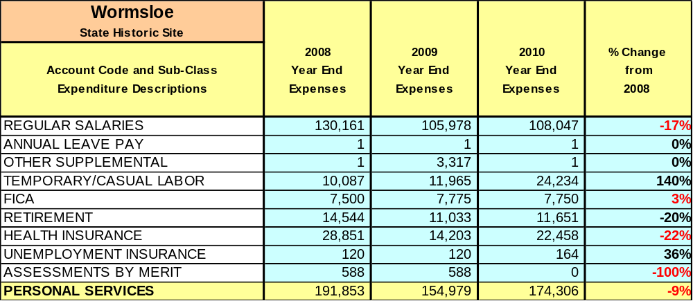

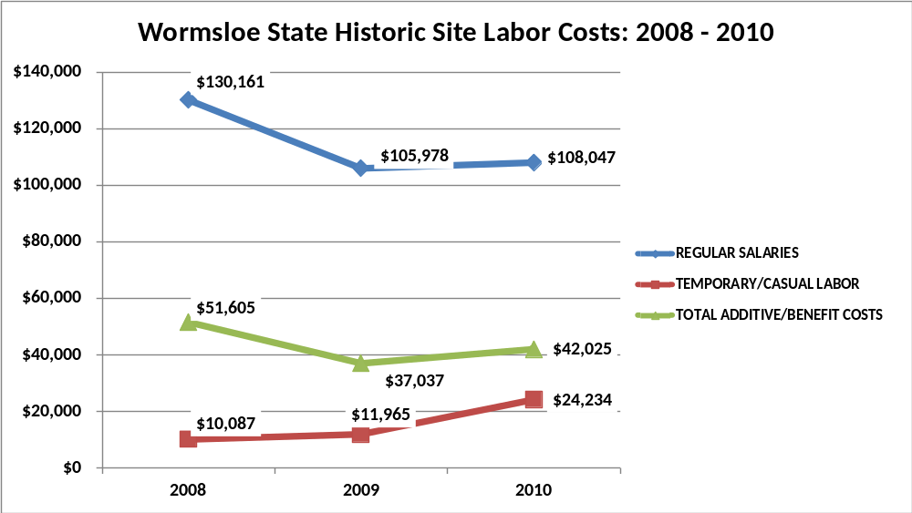

Visitation
Overall annual visitation to Wormsloe has trended upward from 2008 to 2010, increasing by 23% or over 5,000 visitors. This is largely attributed to growth in Savannah tourism, increased operating hours, and better marketing and programming at the site.
Year | Total Visitation
2008 | 23,000 (est)
2009 | 23,825
2010 | 28,288

Customer Service and Satisfaction
The table below indicates the percentage of comment cards returned that indicate that the visitor was “satisfied” or “very satisfied” with their experience. Note: This data is based on a sample of only 13 returned comment cards.

Site | Year | Customer Satisfaction Level
Wormsloe | 2009 | 100%
Wormsloe | 2010 | 70%

Wormsloe also has a rating of 4.5 out of 5 on the travel website www.tripadvisor.com and similarly high rankings on Google and Yelp.
Financial Performance Assessment

Operational Expenses
A summary of total operating expenses at Wormsloe from 2008 to 2010, as well as their percent change from 2008 are provided in the table below.
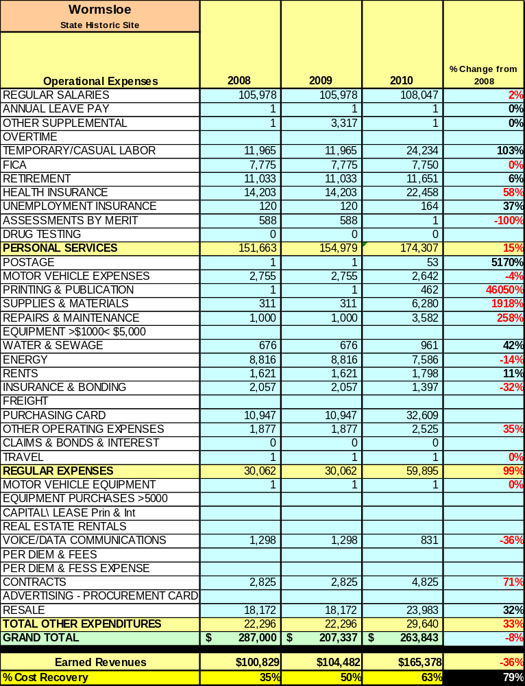

Earned Revenues
Earned revenues at Wormsloe have increased since 2008, which is largely attributed to the corresponding Increase in overall visitation.
Monthly earned revenues for the last two years (see table on the following page) indicate that the total annual revenue increased 58% from 2009 to 2010, with significant percentage increases in monthly revenues in all months except January, February and March. NOTE: July did see an increase in revenue collections through resale and admissions, but the extremely high number is a result of a one-time payment for a major motion picture filmed on site.
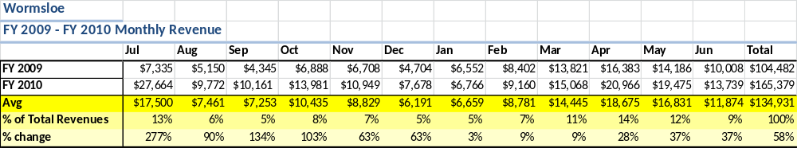

The graphs below illustrate the monthly revenue trends each year and the average percent of total annual revenue earned each month.
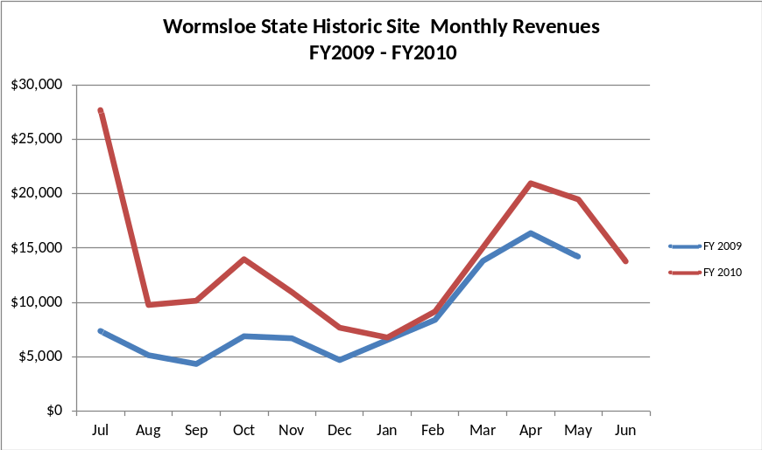

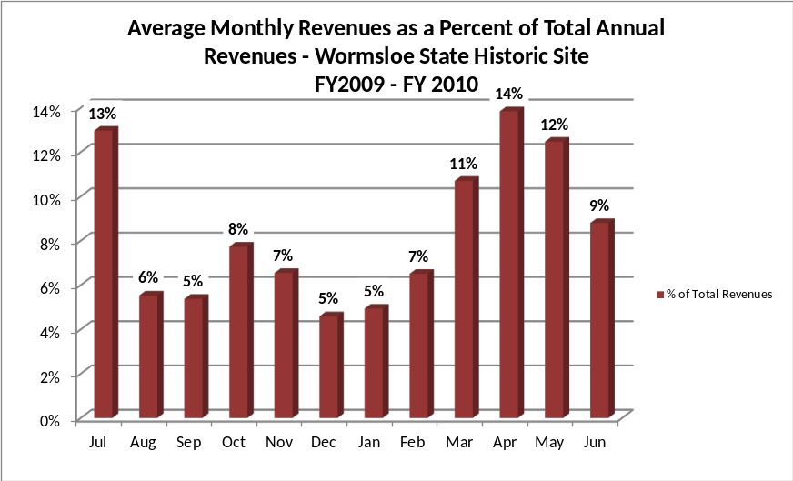

Cost Recovery Trends
Wormsloe has achieved an average cost recovery of 49% of annual operational expenses through earned revenues from FY 2008 to FY 2010. This is detailed and illustrated in the table and graph below.
Year | Operational  Expenses | Earned  Revenues | Percent Cost  Recovery
2008 | $287,067 | $100,829 | 35%
2009 | $207,332 | $104,482 | 50%
2010 | $263,947 | $165,378 | 63%
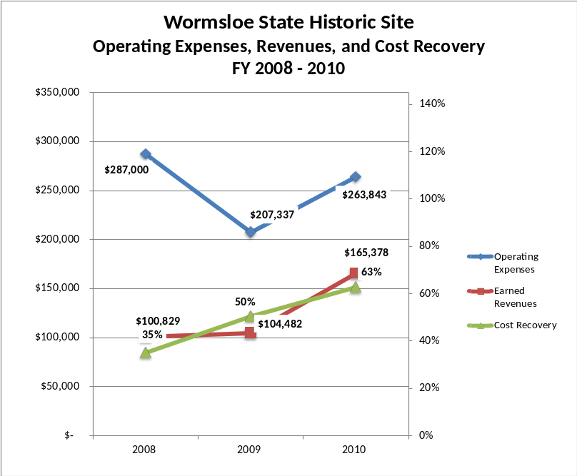

Review of Pricing
Data on rate information is available as far back as 2002, but only the last five years are evaluated. There has been notable growth in fees charged at Wormsloe since 2005, with the largest increase being during the years 2008-2009 and 2010-2011. A table detailing the rates for Wormsloe is provided below.

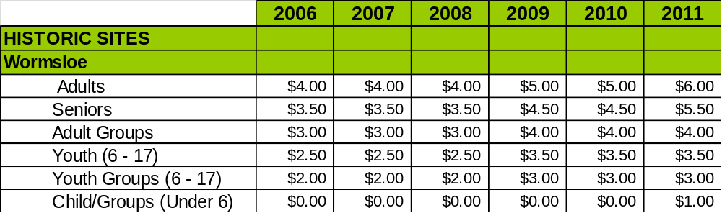
Business and Management Plan

Business Goals
The following goals serve as the foundation for the key recommendations and strategies in this business plan for Wormsloe.

Enhance Cost Recovery of Site Operations
Wormsloe is currently operating at about 63% cost recovery with 97% being the goal by 2015. The site will achieve this goal through a combination of cost reductions and increased revenues from increased rates and visitation.

Enhance Revenue Generation Strategies
Wormsloe will increase revenue generation by continuing to attract more visitors with its daily programming and special event offerings. More site-specific retail items and those with higher possible markups will be made available for purchase. Schools and public tour groups will be actively targeted.

Expand Special Events at the Site
Wormsloe will endeavor to continue its current special events and seek out new ones to host as well. The goal will be to host at least six special events spaced evenly throughout the year. All new events will be evaluated for cost effectiveness.

Improve the Diversity and Innovation of Recreational and Interpretive Programs
Visitors will have something to see and do at Wormsloe every day as a result of active interpretation and plenty of “ranger contact.” Interpretive staff will implement programs that target non-traditional visitors, such as younger, more racially diverse populations, to the site.

Improve the Effectiveness of Marketing and Sales
Only a small percentage of visitors to Historic Downtown Savannah make it to Wormsloe. Every effort will be made to team up with the Savannah Convention and Visitors Bureau to integrate the site into the marketing plan for the city/region. New advertising opportunities in and around Savannah will be explored.

Establish Greater Consistency of Managing and Monitoring Customer Service & Satisfaction
Routine customer service surveys will be implemented and evaluated to gauge the popularity and effectiveness of programs and facilities.

Expand Partnership Opportunities
Site management will work with the Wormsloe Foundation to protect and enhance the natural and cultural resources at Wormsloe. The staff will also reach out to local schools and offer interpretive services accordingly. We will engage Friends members in the business plan as a partner to help the site meet or exceed its sustainability goals.

Classification of Programs and Services
The tables below summarize the classifications of programs and services at Wormsloe as either core, important, or visitor supported and projects a range of cost recovery percentages that might be achieved for each. These classifications establish financial performance goals for each category of services that are linked to the recommendations and strategies of this business plan.

Core Services
Program / Service | Target Cost Recovery
Management of cultural and natural resources | 0%
Open public access to the site and its resources | 75%
Maintenance of grounds, facilities, and infrastructure | 0%
Basic educational and interpretive services | 100%

Important Services
Program / Service | Target Cost Recovery
Trails | 100%
Colonial Life Area | 100%
School and public tour group programs | 200%

Visitor Supported
Program / Service | Target Cost Recovery
Resale Operation | 140%
Special Events | 100%
Daily Interpretive Programs | 125%

Partnership Development Plan
The table below summarizes existing partners and targeted partnerships by classification (operational, vendor, service, co-branding, funding partners) and by organizational type.
 | Public Partners | Not-for-profit Partners | Private / Enterprise Partners
Operational Partners | - Skidaway SP  - Fort Morris SHS  - Fort McAllister SHP  - Fort King George SHS | - Friends of Wormsloe SHS  - Wormsloe Foundation  - Georgia Historical Society | - Area Private Tour Companies
Vendor Partners |  |  | - Sandfly BBQ  - Colonial Sutlers  - Coca-Cola
Service Partners | - Fort Frederica NM | - Savannah CVB  - Savannah CoC  - Nature Conservancy  - Wormsloe Institute for Environmental History  - Georgia Historical Society
Co-branding Partners | - Georgia State Parks and Historic Sites | - Georgia Historical Society
Funding Resource Development Partner |  | - Friends of Wormsloe SHS  - Friends of Georgia State Parks and Historic Sites  - Wormsloe Foundation

Marketing and Sales Plan

Marketing and Sales Goals
Marketing and sales goals for Wormsloe are based on the following desired outcomes:
- Increase visitation
- Increase admissions revenue
- Increase resale revenue
In order to meet these goals, examples of specific target outcomes were identified in the areas detailed in the table below.
Area  of Focus | Current  2011 | Goal  by 2012 | Goal  by 2013 | Goal  by 2014 | Goal  By 2015
Visitation | 29,500 | 30,302 | 31,514 | 33,000 | 35,000
Admissions Revenue | 130,000 | 145,600 | 152,880 | 158,995 | 163,765
Resale Revenue | 30,000 | 33,000 | 34,650 | 36,036 | 37,117

Marketing and Promotion Strategies

Publicity and Social Media
Wormsloe will approach marketing and publicity planning using the following guidelines and themes:
- Event Publicity
Major events benefit by having short stories in local, regional, and statewide newspapers and online social media hooks planted that run three to four weeks in advance of the event up to the date of the event itself. Stories and media need to be cultivated with contacts and online sales channels several weeks in advance of the time the stories need to run. Special interest interviews on morning, noon, and evening television news programs, radio interviews on popular rush-hour programs, and blogs on known affinity online sites should also be included.
- Program Publicity
Special and unique programs should have feature stories in magazines, weekly newspapers, and statewide daily newspapers that are aimed at placements as front-page or sectional front-page stories. These stories are most effective if they run shortly before the season that the featured program begins. This will likely require several weeks of advanced planning with media contacts. Similar coverage on television and radio should also be considered. If pre-publicity cannot be generated, post-publicity can help promote future programs.
- Site Publicity
Site publicity focusing on a single site or sub-set of sites requires more intense planning efforts to attract multiple writers and editors from target publications. Wormsloe could host several seasonal media familiarization tours (with 10 to 15 writers or editors) to familiarize them with the site and its benefits and amenities. Stories and features resulting from such tours typically take between two and six months to materialize so the tours should focus on experiences, benefits, and programs that would be available when the stories are expected to run.
Examples and suggested opportunities for events, programs and related publicity efforts based on the themes described above at Wormsloe are provided in the table below.
Event Publicity |  | Program Publicity |  | Site Publicity
Colonial Faire and Muster | War of Jenkins’ Ear |  | Georgia’s Colonial Coast
 | Colonial Tools and Skills |  | Georgia Plantations
 | Georgia’s First Fourth |  | Hosts of the Coast
 | Colonial Christmas |  | Savannah Sites to See
 | Colonial Cricket |  | Invasion of Skidaway Island
 | A World Lit By Fire

Packaging
Examples and suggested packages for Wormsloe are provided in the table below.
Package | Package Details
Skidaway/Wormsloe Package Deal | Discounted admission to Wormsloe with camping at Skidaway
Skidaway/Wormsloe/Fort McAllister/Fort Morris Package deal | Discounted admission to historic sites with camping at Skidaway or Fort McAllister
Coastal Parks and Historic Sites | Discounted admission to historic sites with camping at a park
Worm sloe/Skidaway Wedding Package | Ceremony and photographs at Wormsloe; reception at Skidaway.

Group Sales
Types of groups within which specific target customers can be identified for Wormsloe are listed below:
- School groups (2nd, 4th, 8th, 10th grades)  - Families  - Retired couples | - Girl/Boy Scouts  - Special interest groups  - International visitors | - Church groups  - Senior groups

Incentivizing New and Repeat Visitation
Wormsloe will utilize the following strategies and/or incentives to encourage new and repeat visitation starting in FY 2012:
- School group programs are particularly cost effective. Extend invitations to school teachers to bring their students to the site for tailor-made educational programs. Encourage the teachers to use Wormsloe and its interpreters as a tool in teaching the curriculum. Conduct outreach programs at schools to attract teachers, students, and parents to the site.
- Regular repeat visitors patronize the gift shop and help spread the word about the site; therefore, we will encourage sales of Friends memberships, which allow visitors to make more regular use of the site and thereby spend more money! Highlight available trails and regular interpretive programs to keep these “regulars” coming back to the site.
- Advertise daily programs on the state parks website and through social media. List these programs in advance and provide visitors with a clear expectation of what it entails.

Marketing and Sales Metric Goals
The following marketing and sales metric goals and/or others will be monitored and progress reported at Wormsloe:
- Loyalty and repeat customers = 20%.
- Brand confidence & customers-recruiting-customers = 40%
Revenue Generation Plan
Revenue / Cost Recovery Goals
Wormsloe has set a financial goal of increasing annual revenues 6% to 15%annually between 2012 and 2015. The largest revenue growth opportunity is most likely FY2011 and FY2014 due to an admission rate increase. The table below details projected revenue growth leading up to 2015, based upon a nominal growth of revenues each year.
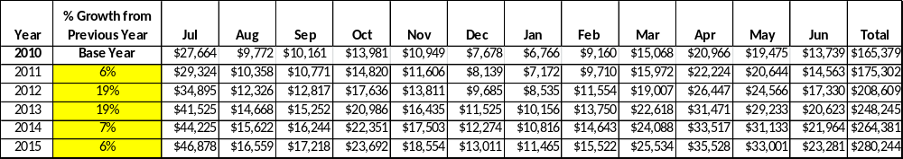
These projections would result in a total of 69% cumulative growth in total annual revenues between FY2010 and FY2015. If operational expenses can remain unchanged between FY 2011 and FY 2015 (with reductions in some areas to offset increases in others), then the overall cost recovery of the site will be approximately 96.5% in FY 2015 at these projected revenue levels. This is higher than the annual financial performance of the site in FY 2010, which was operated at 63% cost recovery in that year.
Revenue Generation Strategies

Pricing Plan
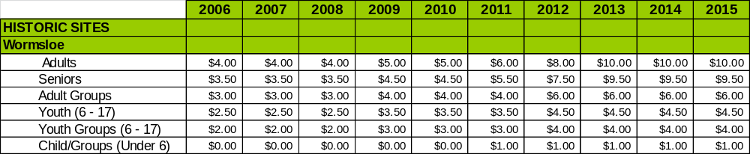

Innovative Programming and Special Events Plan
Program / Event | Theme / Purpose | Scheduled Date/Season | Frequency | Target Participation | Target User Fee | Target Cost Recovery
Fire in the Night | Educational,  Fun, Sensory | October | Annually | 100 | Regular Admission | 150%
Colonial Sports and Games | Educational,  Fitness, Fun | July 4 Weekend | Annually | 100 | Regular Admission | 150%
Partnerships and Concessions Plan
Service / Partnership | Term of Service | Financial Objective | Contract Manager
Georgia Historical Society | 1 weekend | Recover cost of the Colonial Faire and Muster | Site Manager
Sandfly BBQ | 1 weekend | Provide food/beverages at Colonial Faire and Muster | Site Manager

Expense Management Plan

Personnel Assignments
The following actions will be taken to proactively manage labor costs via personnel assignments and classifications.

Action | Timeline | Outcome
Eliminate full-time General Clerk position and replace with two hourly positions | July 2011 | Annual labor cost reduced to 67% from 74%
Re-allocated Trades Craftsman position to Interpretive Ranger. Convert one or two hourly interpreters to hourly maintenance. | 2014 | Increased programming capability and reduced maintenance costs. Much of the skilled maintenance is already outsourced. Would also allow for a seven day operation.

Management Techniques
The following actions will be taken to proactively manage labor costs via management techniques.

Action | Timeline | Outcome
Train hourly employees to handle resale operations and front desk customer service | July 2011 | Reduced labor costs, increased productivity
Continue to use volunteers to assist with site maintenance and operations | July 2011 | Site maintenance plan complete; increased efficiency with routine tasks

Adjusted Levels of Service
The following actions will be taken to proactively manage labor costs via reduced levels of service.

Action | Timeline | Outcome
No reductions in service required according to this plan

Financial Pro Forma
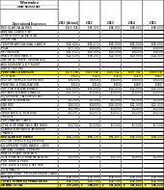
The following five-year financial pro forma projects operating expenses, earned revenues and cost recovery through FY 2015. These pro forma are based on the strategies and desired outcomes identified in this business plan, especially the revenue generation and expense management plans, and are linked to corresponding performance goals.

Expense Pro Forma
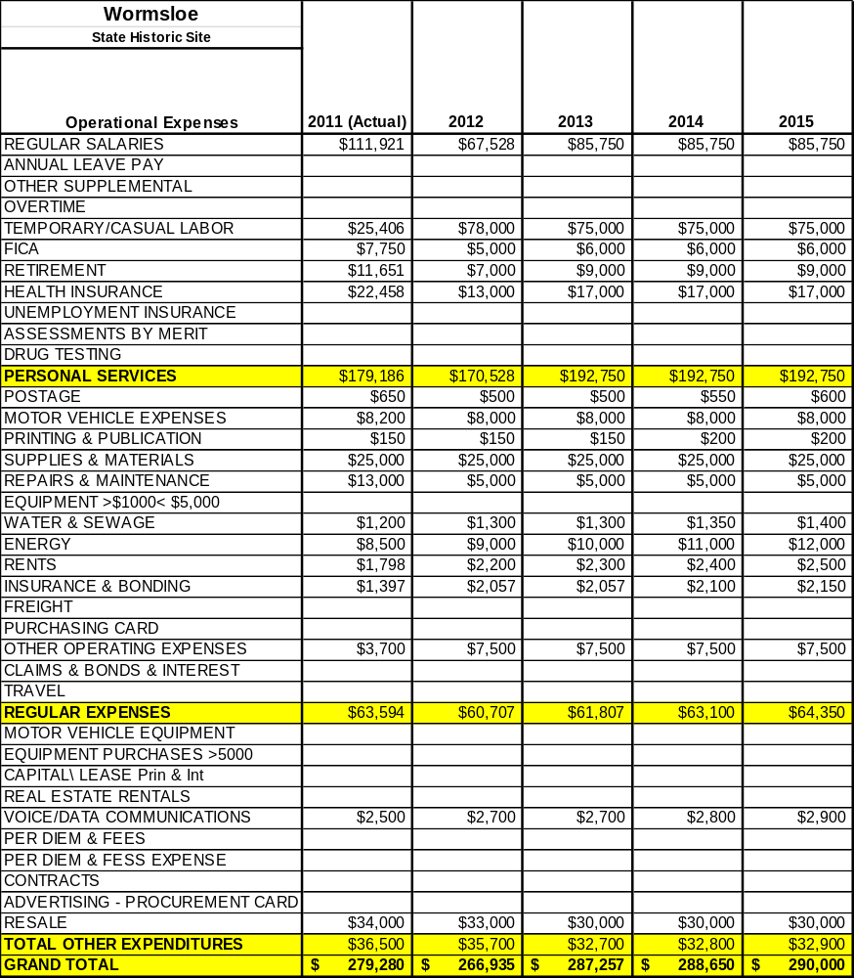

Revenue Pro Forma
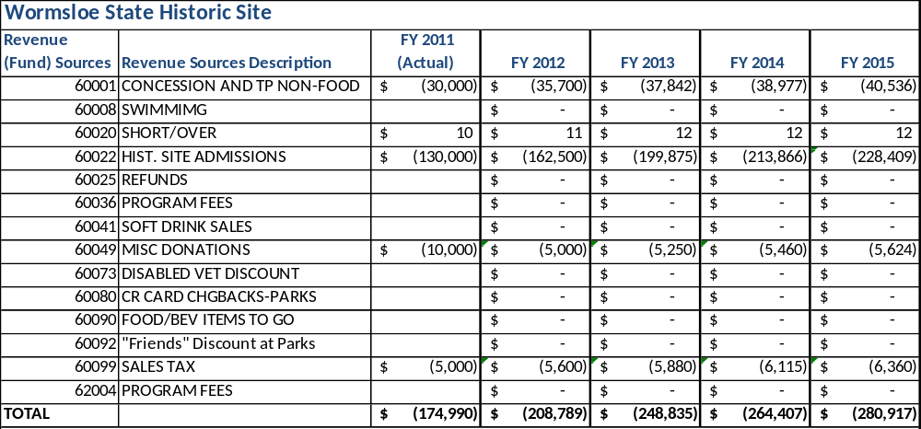

Total / Cost Recovery Pro Forma
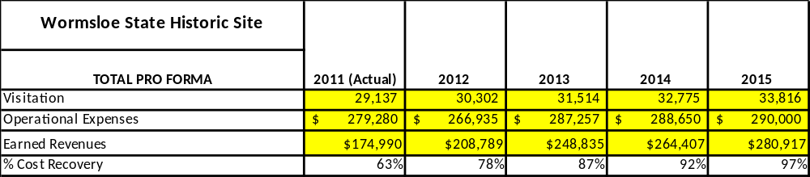

Action Plan
ACTION PLAN
Site: |  | Site Manager: |  |  | Date:
Month:
Strategy | Tasks | Costs / Funding | Revenues / ROI | Responsibilities | Metrics

ACTION PLAN
Site: |  | Site Manager: |  |  | Date:
Month:
Strategy | Tasks | Costs / Funding | Revenues / ROI | Responsibilities | Metrics

This is the average of the last three years – FY 2008, FY 2009, and FY 2010
Current employees, not including vacancies.
Current employees, not including vacancies.
Major population centers within a two-hour drive from the site

