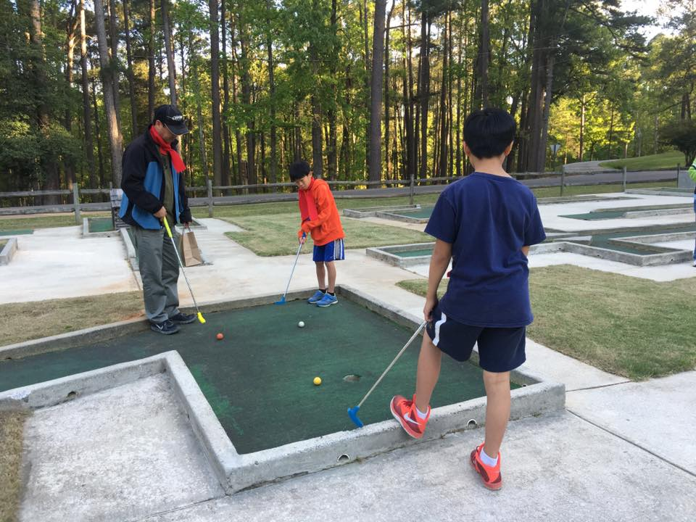
February 15, 2017
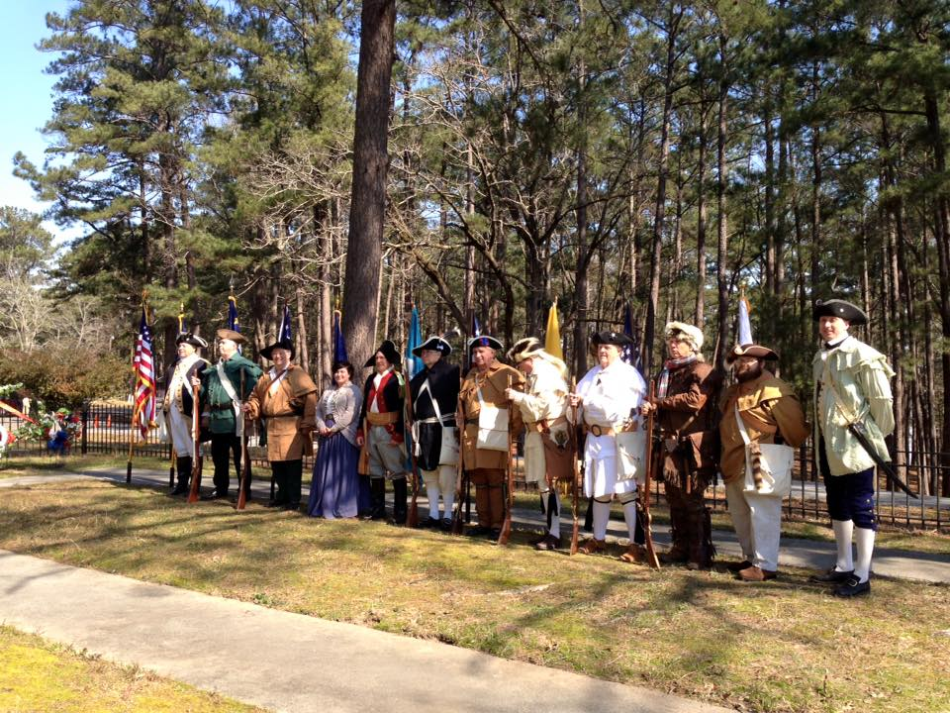
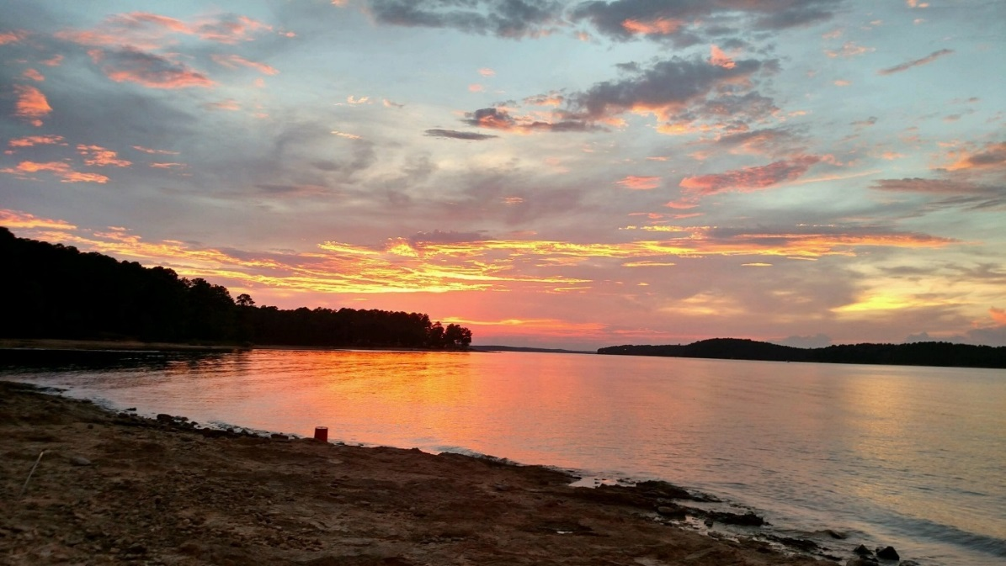
Elijah Clark State Park, a gem of Georgia’s freshwater coast, offers you a glimpse back at our Revolutionary Era history and abundant recreational opportunities in the beautiful setting of Clarks Hill Lake.
Elijah Clark State Park
Interpretation & Recreation Plans

_________________________________________________________________________________________
Table of Contents
- Site Significance and Interpretation
- Recreational Resources
- Potential & Current Audiences
- Nearby Services Serving Similar Audiences/Potential Partners
- Appendix A: Park Facilities: Site Map and List of Program Locations and Trails
- Appendix B: Contact Information (Audiences, Nearby Sites & Potential Partners)
- Appendix: C: References that Address your Sites Unique Resources
- Appendix D: Media Contacts

elijah clark State Park

Interpretation & Recreation Plans march 2017

Purpose:
This plan is intended to provide guidance to site staff in planning interpretive programs, exhibits, and recreational opportunities at Elijah Clark State Park over the next five years. Programs are the Division’s most effective means of generating public support and should be a high priority when making planning and budget decisions for the park.
Why THE PARK was Created

Previous name: Elijah Clark Memorial State Park
Date Established: 1953
Original Acreage: 222
Current Acreage: 447
In 1953 the U.S. Army Corps of Engineers leased to the state of Georgia this property for the purpose of creating a state park. The Corps obtained the property from local landowner J. F. Fortson who became the park’s first superintendent. The park is a memorial to a Georgia Revolutionary War Hero and statesman General Elijah Clarke. He, his wife Hannah and several of their children are buried on the park. In 1958 a replica of their home site was built to honor the men and women who pioneered Georgia and fought for independence.
Elijah Clarke (1742-1799) won fame as a leader of Georgia Patriot militia, fighting against Loyalist militias, British Regulars, and their Cherokee allies. He participated in many battles in the Southern campaign in present day South Carolina, Georgia and Florida including Musgrove’s Mill, Cedar Creek, Wofford’s Iron Works, Augusta, Fishdam Ford, Long Cane, Blackstocks and Alligator Bridge. His most famous victory came at the Battle of Kettle Creek, near what is now Washington, Georgia, where he led a charge and defeated a much larger army comprised of Georgia Loyalists. Clarke promised the British and loyalists that the area would become a “Hornet’s Nest.” After the battle Clarke (and collectively his followers) were known as the “Hero(es) of the Hornet’s Nest.”
After the Revolution, Clarke served in the state assembly from 1781-1790. He was part of Georgia’s Constitutional Convention of 1789. Elijah Clarke died in Augusta on December 5, 1799.
Elijah Clarke’s son John Clark was governor of Georgia from 1819-1823. John Clark dropped the “e” from the family name. The state of Georgia kept the later spelling of Clark when naming the park.
The park provides a variety of recreational activities on Clarks Hill Lake. The lake covers 72,000 acres and is the largest U.S. Army Corps of Engineers project east of the Mississippi River.

Site Significance:

The significance of the site resources includes:

- Elijah Clark is located on the third largest man-made lake east of the Mississippi River, and even though the park is only 447 acres it’s home to white-tailed deer, wild turkey, red fox, osprey, and Bald Eagles.

- Clark Hill Lake is well known for its fishing spots, and with four boat ramps provided by Elijah Clark State Park it is often visited by fishermen and visitors who enjoy the lake.

- Elijah Clark State Park is named for a frontiersman and Georgia war hero who led pioneers during the Revolutionary War. A log cabin replica of the Clarke home displays furniture, utensils and tools circa 1780 and is open weekends April through November. Visitors can also view the graves of Clarke and his wife Hannah.

- Elijah Clarke was a leader for and coined the phrase “Heroes of the Hornet’s Nest”, Georgia and South Carolina Patriot militia (citizen soldiers) who protected the area and fought for freedom from the British during the Revolutionary War.

- There are 20 cottages and 165 campsites, more than any other park in Georgia, and it is often a weekend getaway for guests from metro areas including Atlanta, Augusta, Savannah, as well as Greenville and Charleston, SC.

Overarching Interpretive Theme:
Elijah Clark State Park, a gem of Georgia’s freshwater coast, offers you a glimpse back at our Revolutionary Era history and abundant recreational opportunities in the beautiful setting of Clarks Hill Lake.

Interpretive Media that Relate to the Site’s Significance and Retail Suggestions
Topic | Potential Storylines | Personal Interpretation | Non-Personal Interpretation | Suggested Retail
beautiful setting of Clarks Hill Lake | third largest man-made lake east of the Mississippi River  home to various wildlife species | Clarks Hill Lake: from the river to the lake, fish species, macroinvertebrates, etc.  Wildlife and live animal programs  Birding  Wildflower hikes/ID  Native, non-native and invasive plants  Prescribed burns | Lake and wildlife  information in cottage binders  Nature quest or scavenger hunt  Checklist of birds, wildflowers, etc.  Nature Photography  Interpretive displays in Nature Center | Field guides to trees, wildflowers, birds, mushrooms, scat & tracks, butterflies, mammals, etc.  Souvenir items with the lake and wildlife species  Toys - Plush animals, rubber snakes, etc.  Nature study resources for families with children – kids binoculars, books, bug boxes, magnifiers etc.

Topic | Potential Storylines | Personal Interpretation | Non-Personal Interpretation | Suggested Retail
glimpse back at our Revolutionary Era history | named for a frontiersman and Georgia war hero Elijah Clarke | Elijah Clarke and the Heroes of the Hornet’s Nest  Life during the 18th Century  Land use through time | History information in cottage binders and handouts  Interpretive Panels to interpret land use through time  Self-guided period costume portraits | Folk toys  Period clothing items: Coonskin and tri-corner hats, bonnets, aprons, etc.  Books on Revolutionary Era

Recreational Activities Suited to the Site and Retail Suggestions
Recreational Offerings/Facilities | Staff/Partnership-led Programs | Self-Directed Activities/Resources | Retail Suggestions
Boating: Canoeing, Kayaking, Archery, etc. | Canoe and kayak 101  Guided canoe/kayak programs on the lake: twilight, full moon, etc.  Archery 101 Basic shooting skills | Boat rentals | Books on canoe/kayaking Georgia  Sunglasses, sunscreen, bug repellent, sun hats, visors, flashlights, water shoes, sun shirts  Dry gear & cell phone bags  License/Keychain floats
Fishing | Fishing 101 Programs: introduce inexperienced guests to fishing  Cooking Demos on preparing fish  Kayak fishing | Fishing loaner program | Fishing gear – poles, stringers, bobbers, weights, artificial lures, etc.  Live bait – worms
Astronomy | Astronomy 101 programs  Night time photography | Star gazing (use of mobile apps) | Plane spheres, guide books
Trails & Fitness | Biking clinics  Fitness hikes  Yoga  Races: Triathlon, 5K, etc. | Hiking, Jogging, dog-walking, biking | Leashes & collars  Walking sticks, stick medallions  Related clothing items

Recreational Offerings/Facilities | Staff/Partnership-led Programs | Self-Directed Activities/Resources | Retail Suggestions
Campfires | S’mores & stories  Storytelling  Outdoor cooking  Fire building |  | Marshmallow sticks  S’mores supplies  Outdoor Cooking, Dutch Oven, Campfire Cook Books  Firewood & fat lighter  Lighters, matches, etc.
Arts & Crafts | Kids nature crafts  How to: Basket making, natural dyes, candle making, etc.  Holiday/seasonal crafts  Visiting Artists/Art in the Park |  | Crayons, markers, etc.  Coloring books  Stickers
Yard games | “Recreation Station”/yard games: – Marbles, Bocce, Croquet, Frisbee, Ladder Golf, horseshoes, washer toss, bag toss, slackline, lawn darts, etc.  Group gatherings (birthday parties, family reunion) with ranger led recreation programs | Recreation rental program  Horseshoe pits | Frisbees, horseshoes, puzzles, board games, cards, balls, etc.

Recreational Offerings/Facilities | Staff/Partnership-led Programs | Self-Directed Activities/Resources | Retail Suggestions
Geocaching & Orienteering | Geocaching or Orienteering 101  GPS or Map & Compass “how to” | GPS loaner program  letterbox trail or educational geocache hunt  Virtual educational & recreational geocaches may be an option using smartphones | Books on geocaching and letterboxing  Compasses  Trinkets for the cache, notebooks
Other Innovative Outdoor Recreational | Gaga Ball 101 | Gaga Ball pit  Board game loaner program | Kickball

School Programs: Elijah Clark State Park has created school programs that correlate with the Georgia Dept. of Education Curriculum Standards and incorporate the park’s unique resources. The list includes 12 program topics with programs targeted for Grades K - 4th.

Kindergarten Learning Journey- Science Focus- Nature Discovery
History Focus- Past and Present in Children Play

1st Grade Learning Journey- Science Focus Plant and Animals basic needs
History Focus- Comparing how settlers live in the past to today.

2nd Grade Learning Journey- Science Focus- Plant & Animal lifecycles
History Focus- Similarities & differences of everyday life between today and historic figures during the revolutionary era including Indian culture

3rd Grade Learning Journey- Science Focus- Habitats & Adaptations of plants and animals.
History Focus- How where settlers lived impacted their lives and how the adapted to their surroundings.

4th Grade Learning Journey- Science Focus- adaptations, food chains & webs.
History Focus- Revolutionary Era

5th Grade Learning Journey- Science Focus- Environmental changes and effects and the classification of animals.
History Focus- Bartering and how voluntary exchange helps both buyers and sellers

potential & current Audiences
This plan includes primarily Lincoln County and McCormick, SC, and parts of Columbia, McDuffie, Elbert and Wilkes Counties. The land on the park is only in Lincoln County and the lake is within all six counties.
Contact information listed in Appendix B
Special Interest Groups
- Fishermen – day use to fish lake
- Boaters- using their own personal boats or renting canoes for recreational purposes
- Nature Enthusiasts – birders, nature photographers, day hikers, rock hounds (amateur geologists
- Runners and bicyclists using roads and trails
- Businesses- Company meetings and gatherings rent out facilities

Community
- Churches: There are 31 churches in Lincoln County; 22 in McCormick, SC, 33 churches in McDuffie County; 56 churches in Columbia County; 58 churches in Wilkes County
- Civic Organizations, Tourism Organizations:
- American Legion Veterans Organization of Lincolnton
- Columbia County Chamber of Commerce
- Columbia County Convention and Visitor Bureau
- Elberton Lions Club
- Lincoln County Chambers of Commerce
- Lions Club of Lincolnton
- Lions Club of Thomson
- McCormick County Chamber of Commerce
- Libraries:
- Columbia County Library
- Lincoln County Library
- McCormick Library
- Thomson McDuffie Library
- Area Businesses that could be targeted as partners or potential sponsors include:
  - Lincolnton Marine
  - Lincolnton Outdoors
  - LW’s Bait and Tackle Shop
  - Papa’s Pizza
  - Savannah Lakes Village
  - Spratlin Hardware & Building
  - Thurmond Lake Outdoors
  - Walmart in Grovetown or Thomson

- Schools: K-12, Colleges and Daycare Centers
  - Public Schools
    - Columbia County Public Schools- There are eighteen elementary schools, eight middle schools, and six high schools
    - Elbert County Public Schools- There is one primary school, one elementary school, one middle school and one high school.
    - Lincoln County Public Schools- There is one elementary school, one Middle School, and one high school
    - McCormick County Public Schools- There is one elementary school, one middle school, and one high school
    - McDuffie County Public Schools- There are four elementary schools, one middle school, one high school, and one transitional learning school
    - Wilkes County Public Schools- There is one primary school, one elementary school, one middle school and one high school.
  - Private Schools:
    - Briarwood Academy
    - Columbia County Christian Academy
    - Emmanuel Christian Academy
    - Evans Christian Academy
    - Faith Christian Academy
    - Long Cane Academy
    - New Hope Christian Schools
  - Day-care Centers
    - Creative Kidz Korner
    - Head Start
    - Over the Rainbow Play School
    - Wee Wisdom Little School Inc.
- Homeschool
  - A to Z Home School Group
  - Augusta-Area Home Education Network (AHEN)
  - CSRA Home Education Association, Evans
  - Fort Gordon Homeschool
  - Georgia Cyber Academy
  - Colleges
    - Augusta Technical College
    - Augusta University
    - Piedmont Technical College
Day Visitors
- The day visitors include local families for boating, hiking, fitness, picnicking, fishing and historical.
- Family reunions, church groups, and weddings to use the group and picnic shelters.
Overnight Guests
- The overnight guests come from within a 5-hour radius from the park.
- In the spring and winter seasons the majority of the campers are retirees and primarily families in the summer months.
Current Program Participants

- Public Programs: These are for local residents and campers that are visiting the park
- Special Events: The events draw in a wide array of guest including families on school breaks, retirees, destination campers, and the local community.
- Group Programs: Scouts, Advanced Auto Parts company picnic,
  - Outreach Programs: Lincoln County Library, Lincoln County Chamber of Commerce
  - School Groups: Lincoln County Elementary, Westmont Elementary, Grovetown Elementary, Blueridge Elementary, Westwood Elementary, Evans Elementary, Baker Place Elementary, Greenbrier Elementary, Harlem Elementary, Elbert County Elementary, Euchee Creek Elementary, Parkway Elementary, Elbert County Elementary,

Who is NOT coming that we would like to engage?

- A nearby retirement community, Savannah Lakes has an audience that could be targeted for ranger-led programs.
- There are four public golf courses within 15 minutes of the park. The golfers could be targeted for recreational programs and overnight stays/packages.
- Young adults from Fort Gordon and the surrounding area for day use, overnight stays, and ranger-led programs.
- Local arts and history organizations could be targeted for special events.
Nearby Sites that serve a Similar Audience/Potential Partners
Contact information listed in Appendix B

Parks & Campgrounds:

- Amity Recreation Area, Lincolnton GA
- Baker Creek State Park, McCormick SC
- Big Hart Campground, Thomson GA
- Broad River, Tignall, GA
- Clarks Hill Recreation Area, McCormick SC
- Clay Hill Campground, Lincolnton GA
- Hester’s Ferry, Tignall, GA
- Hickory Knob Resort Park, McCormick SC
- Lake Springs Recreation Area, Appling GA
- Mistletoe State Park, Appling GA
- Ninety Six National Historic Site, Ninety Six, SC
- Petersburg Campground, Appling GA
- Raysville Campground, Thomson GA
- U.S.F.S. Campgrounds in Sumter National Forest
- Wildwood Park, Appling GA

Other Statewide Partnerships/Contacts:

- DNR Fisheries Division
- DNR Law Enforcement Division
- DNR McDuffie Environmental Education Center (MEEC)
- Georgia Forestry Commission
- McDuffie PFA & Archery Range
- UGA Extension Lincoln County – Lincoln County 4-H Club
- US Army Corp of Engineers – Clarks Hill Lake

Nature Centers/Museums/Visitor Centers:

- Phinzy Center for Water Sciences
- Red Creek Interpretative Center
- Robert Toombs Historic Site
- Savannah Rapids Regional Visitor Information Center
- The Laurel and Hardy Museum of Harlem Georgia
- Washington Wilkes Historical Foundation

Arts, Music, Heritage, Farm organizations:

- Abbeville Opera House
- Artists Guild of Columbia County
- Georgia Baptist Historical Society
- Georgia Civil War Heritage Trails
- J.J. Dorn House
- Lincoln County Historical Society
- McCormick County Historical Commission
- Morris Museum of Art

Non-profit/Professional Organizations:

- Boy Scouts of America
- Boys and Girls Club of America
- Girl Scouts of Historic Georgia
- Family Y Camp Lakeside, Lincolnton GA
- Humane Society of McCormick County, Inc.

Other Outdoor Recreational locations:

- Graves Mountain

Appendix A Park MaP & Facilities, LIst of Programming locations and trails
Park Facilities: This 447-acre park has 20 cottages, 165 tent, trailer, and RV sites, 10 walk in campsites, a pioneer campground, 4 picnic shelters, 2 group shelters, a swimming beach on the 72,000 acre Clarks Hill Lake, a log cabin museum, a walking trail, a miniature golf course, an archery range, and a fishing pier.
PARK MAP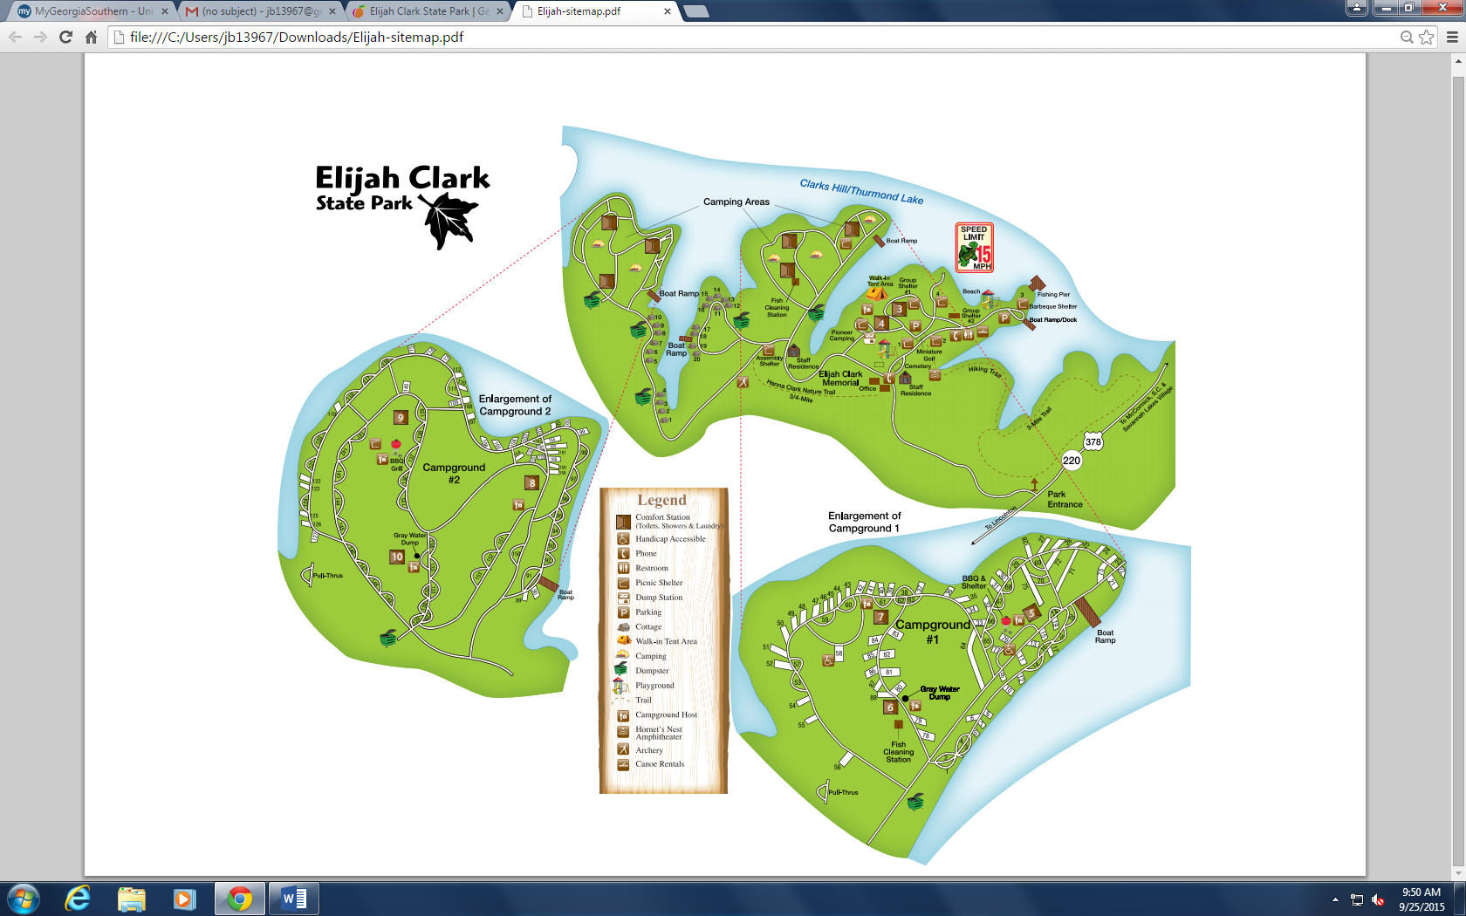

Existing Programming Locations:
Archery
Assembly Shelter
Beach
Campground (Roving Ranger)
Cemetery
Group Shelter (2)
Hornet’s Nest Amphitheater
Log Cabin Museum
Miniature Golf Course
Park Office
Picnic Shelters (4)
Pioneer Campground
Playground
Trail head
Trails
Hannah Clark Nature Trail- ¾ mile
The 3-mile Trail

Potential Trails:
Fifth Finger

Potential Programming Location:
Fishing Pier
Nature Center

Appendix B Nearby Sites that serve similar audiences, Resources & PotentiAl partnerS

Arts, Music, Heritage Organizations

Abbeville Opera House
100 Court Square # 102
Abbeville, SC 29620
(864) 366-2157
http://www.theabbevilleoperahouse.com/

Artists Guild of Columbia County
Po Box 2205
Evans, GA 30809-2205
http://www.artistguildcc.org/

Georgia Baptist Historical Society
1300 Edgewod Ave
Washington, GA 30673
(706) 678-1037

Georgia Civil War Heritage Trails
Po Box 1864
Evans, GA 30809-1864
(706) 868-8403
http://www.civilwarheritagetrails.org/

J.J. Dorn House
206 E Gold St
McCormick, SC 29835
(864) 465-9409

Lincoln County Historical Society
Po Box 869
Lincolnton, GA 30817
(757) 831-9556
https://www.facebook.com/lincolncountyhistoricalsocietyga

McCormick County Historical Commission
Po Box 425
McCormick, SC 29835-0425
https://www.facebook.com/McCormickHistory/

Morris Museum of Art
1 10th St 2nd Floor
Augusta, GA 30901
(706) 724-7501
http://www.themorris.org/

Businesses/Community Services

Lincolnton Marine
1006 Lake Thurmond Parkway
Lincolnton, GA 30817
(706) 359-3124
http://lincolntonmarine.com/

Lincolnton Outdoors
1015 McCormick Hwy
Lincolnton, GA 30817
(706) 359-5928
http://www.lincolntonoutdoors.com/

LW’s Bait and Tackle Shop
2058 Ashmore Barden Rd.
Lincolnton, GA 30817
(706) 359-7979

Papa’s Pizza
135 N Peachtree St.
Lincolnton, GA 30817
(706) 359-3663
http://papaspizzatogo.com/

Savannah Lakes Village
300 Country Club Dr.
McCormick, SC 29835
http://www.savannahlakes.com/
(864) 391-4126

Spratlin Hardware & Building
141 N Peachtree St
Lincolnton, GA 30817-5884
(706) 359-3217

Thurmond Lake Outdoors
569 Washington St.
Lincolnton, GA 30817
http://www.homeprideproperties.com/thurmond-lake-outdoors.html
(706) 359-3823

Wal-Mart
5010 Steiner Way
Grovetown, GA 30813
https://www.walmart.com/store/5735
(706) 860-8883

Wal-Mart
2205 Harrison Rd SE
Thomson, GA 30824
https://www.walmart.com/store/1658
(706) 595-5530

Civic Organizations & Tourism

American Legion Veterans Organization of Lincolnton
1121 American Legions Rd.
Lincolnton, GA 30817
(706) 359-3446

Columbia County Chamber of Commerce
1000 Business Blvd.
Evans, GA 30809
http://www.columbiacountychamber.com/
(706) 651-0018

Columbia County Convention and Visitor Bureau
1000 Business Blvd.
Evans, GA 30809
http://www.columbiacountyitshere.com/
(866) 391-7677

Elberton Lions Club
535 Rhodes Dr, Elberton, GA 30635
http://www.elberthost.com/lions/
(706) 283-2536

Lincoln County Chambers of Commerce
112 Washington St.
Lincolnton, GA 30817
http://www.lincolncountyga.org/chamber.php
(706) 359-7970
Lions Club of Lincolnton
P O Box 113
Lincolnton, GA 30817

Lions Club of Thomson
211 Jeanette St.
Thomson, GA 30824
http://www.e-clubhouse.org/sites/thomsoncc/page-6.php
(706) 595-9705

McCormick County Chamber of Commerce
PO Box 938
100 N. Main St
McCormick, SC 29835
Email: ctallent@mccormickscchamber.org
http://www.mccormickscchamber.org/
(864) 852-2835

Churches

There are 31 Churches in Lincoln County, GA:
http://georgia.hometownlocator.com/features/cultural,class,church,scfips,13181.cfm

There are over 56 churches in Columbia County, GA
http://georgia.hometownlocator.com/features/cultural,class,church,scfips,13073.cfm

There are 58 churches in Wilkes County
http://georgia.hometownlocator.com/features/cultural,class,church,scfips,13317.cfm

There are 66 churches in Elbert County
http://georgia.hometownlocator.com/features/cultural,class,church,scfips,13105.cfm

There are 33 churches in McDuffie County
http://georgia.hometownlocator.com/features/cultural,class,church,scfips,13189.cfm

There are 22 churches in McCormick County, SC
http://www.churchfinder.com/churches/sc/mccormick

Libraries

Columbia County Library
7022 Evans Town Center Blvd.
Evans, GA 30809
http://gchrl.org/locations/columbia-county-library
(706) 863-1946

Lincoln County Library
181 N. Peachtree St.
Lincolnton, GA 30817
http://gchrl.org/locations/lincoln-county-library
(706) 359-4014

McCormick County Library
201 Railroad Ave.
McCormick, SC 29835
http://mccormickcountylibrary.org/
(864) 852-2821

Thomson McDuffie Library
338 Main St.
Thomson, GA 30824
http://www.thomson-mcduffie.com/citycounty/residents/libraries
(706) 595-1341

Nature Centers/Museums/Visitor Centers:

Phinzy Center for Water Sciences
1858 Lock and Dam Rd.
Augusta, GA 30906
http://phinizycenter.org/#research
(706) 828-2109

Red Creek Interpretative Center
3820 Park Ln.
Martinez, GA 30907
http://www.columbiacountyga.gov/government-/departments-l-r/parks-recreation-department/parks-facilities/reed-creek-nature-park-and-interpretive-center
(706) 210-4027

Robert Toombs Historic Site
216 E Robert Toombs Ave.
Washington, GA 30673
http://gastateparks.org/RobertToombsHouse
(706) 678-2226

Savannah Rapids Regional Visitor Information Center
3300 Evans to Locks Rd.
Martinez, GA 30907
http://www.columbiacountyga.gov/visitors-/savannah-rapids-visitor-center
(706) 868-3373

The Laurel and Hardy Museum of Harlem Georgia
250 N. Louisville St.
Harlem, GA 30814
http://www.laurelandhardymuseum.com/
(706) 556-0401

Washington Wilkes Historical Foundation
308 E Robert Toombs Ave.
Washington, GA 30673
http://www.historyofwilkes.org/
(706) 678-5001

Non-profit/Professional Organizations:

Boys and Girls Club of America
1903 Division St.
Augusta, GA 30904
http://www.bgca.org/Pages/index.aspx
(706) 312-2201

Family YMCA of Greater Augusta
Family Y Camp Lakeside
1238 Dogwood Dr,
Lincolnton, GA 30817
http://www.thefamilyy.org/index.php/location/camp-lakeside
(706) 359-2153

Other Government Partnerships/Contacts:

DNR Fisheries Division
Thomson District Office
Bob Kirk Road, NW
Thomson, GA 30824
Ed Bettross, Fisheries Biologist II
(706) 595-1619

DNR Law Enforcement Division
Region III – East Central Office
142 Bob Kirk Rd., NW
Thomson, GA 30824
Captain Stan Elrod, Region Supervisor
(706) 595-4211

DNR McDuffie Environmental Education Center (MEEC)
4695 Fish Hatchery Road, S.E.
Dearing, GA 30808
(706) 969-4373

Georgia Forestry Commission
27 Punkin Junction Rd
Winder, GA 30680
Payton Turner, Chief Ranger, pturner@gfc.state.ga.us
http://www.gfc.state.ga.us/about-us/contact-us/county-units/CountyUnitsShow.cfm?iCounty=Barrow
(770) 868-4041

McDuffie PFA & Archery Range
4695 Fish Hatchery Road, SE
Dearing, GA 30808
Vernon Baldwin, Area Manager
(706) 595-1684

UGA Extension Lincoln County – Lincoln County 4-H Club
288 N. Peachtree Street
Lincolnton, GA 30817
Email: uge3181@uga.edu
http://ugaextension.org/county-offices/lincoln/4-h-youth-development.html
(706) 359-3233

US Army Corp of Engineers – Clarks Hill Lake
Clarks Hill, SC
http://stromthurmond.uslakes.info/
(800) 533-3478

Other Outdoor Recreational locations:

Graves Mountain
Hwy. 378
Lincolnton, GA 30817
http://www.exploregeorgia.org/listing/2030-graves-mountain
(706) 359-3862
(706) 401-3173

Parks & Campgrounds:

Amity Recreation Area
5782 Thomson Hwy.
Lincolnton, GA 30817
https://www.recreation.gov/camping/amity-recreation-area/r/campgroundDetails.do?contractCode=NRSO&parkId=71006
(800) 533-3478

Baker Creek State Park
863 Baker Creek Rd
McCormick, SC 29835
http://southcarolinaparks.com/bakercreek/introduction.aspx
(864) 443-2457

Big Hart Campground COE
5258 Washington Rd
Thomson, GA 30824
http://www.recreation.gov/camping/big-hart-campground/r/campgroundDetails.do?contractCode=NRSO&parkId=71034
(706) 595-8613

Broad River
8181 Elberton Hwy,
Tignall, GA 30668
http://www.lcgagov.org/reservations.html
(706) 359-2053

Clarks Hill Recreation Area, McCormick SC
Clay Hill Campground
5701 Clay Hill Rd.
Lincolnton, GA 30817
http://www.lcgagov.org/reservations.html
(706) 359-7495

Hester’s Ferry
1864 Graball Rd.
Tignall, GA 30668
http://www.lcgagov.org/hesters-ferry-campground.html
(706) 359-2746

Hickory Knob State Resort Park
1591 Resort Dr.
McCormick, SC 29835
http://southcarolinaparks.com/hickoryknob/introduction.aspx
(864) 391-2450

Lake Springs Recreation Area
3900 Lake Springs Rd.
Appling, GA 30802
https://www.recreation.gov/camping/lake-springs/r/campgroundDetails.do?contractCode=NRSO&parkId=71244
(706) 541-0150

Mistletoe State Park
3725 Mistletoe Rd
Appling, GA 30802
http://gastateparks.org/Mistletoe
(706) 541-0321

Ninety Six National Historic Site
1103 Hwy 248 S.
Ninety Six, SC 29666
https://www.nps.gov/nisi/index.htm
(864) 543-4068

Petersburg Campground, Appling GA
3998 Petersburg Rd.
Appling, GA 30802
https://www.recreation.gov/camping/petersburg/r/campgroundDetails.do?contractCode=NRSO&parkId=71348
(706) 541-9464

Raysville Campground
6489 Lincolnton Rd NE
Thomson, GA 30824
http://www.exploregeorgia.org/listing/3758-raysville-campground
(706) 595-6759

U.S.F.S. Campgrounds in Sumter National Forest
https://www.fs.usda.gov/activity/scnfs/recreation/camping-cabins/?recid=47051&actid=29

Wildwood Park
3780 Dogwood Ln, Appling, GA 30802
http://columbiacountyga.gov/
(706) 541-0586

Public Fishing Areas

McDuffie PFA
142 Bob Kirk Road NW
Tomson, GA 30824
http://www.georgiawildlife.org/PFA/McDuffie
(706) 595-1684

Corps of Engineers:

Scott’s Ferry
510 Clarks Hill Highway
Clarks Hill, SC 29821
http://www.sas.usace.army.mil/About/Divisions-and-Offices/Operations-Division/J-Strom-Thurmond-Dam-and-Lake/
(800) 533-3478

Modac Shores
510 Clarks Hill Highway
Clarks Hill, SC 29821
http://www.sas.usace.army.mil/About/Divisions-and-Offices/Operations-Division/J-Strom-Thurmond-Dam-and-Lake/
(800) 533-3478

Dordon Creek
510 Clarks Hill Highway
Clarks Hill, SC 29821
http://www.sas.usace.army.mil/About/Divisions-and-Offices/Operations-Division/J-Strom-Thurmond-Dam-and-Lake/
(800) 533-3478

Keg Creek
510 Clarks Hill Highway
Clarks Hill, SC 29821
http://www.sas.usace.army.mil/About/Divisions-and-Offices/Operations-Division/J-Strom-Thurmond-Dam-and-Lake/
(800) 533-3478

Lincoln County:

Cherokee Boat Ramp
Lincoln County Government
PO Box 340
210 Humphrey Street
Lincolnton, Georgia 30817
http://www.lcgagov.org/cherokee-day-use-area-and-ramp.html
(706) 359-4444

Wildlife Management Areas:

Corp of Engineers
510 Clarks Hill Highway
Clarks Hill, SC 29821
http://www.sas.usace.army.mil/About/Divisions-and-Offices/Operations-Division/J-Strom-Thurmond-Dam-and-Lake/Plan-a-Visit/Hunting/
(800) 533-3478

South Carolina Wildlife Management Areas
Stevens Creek Heritage Preserve/Wildlife Management Area
311 Natural Resources Drive
Clemson, South Carolina 29631
https://www2.dnr.sc.gov/ManagedLands/ManagedLand/ManagedLand/15
(864) 654-1671

WMA’s in Region:
  - Clarks Hill WMA
  - Elbert County: Coody Creek WMA
  - Fishing Creek WMA
  - Germany Creek WMA
  - Keg Creek WMA
  - Lower Broad River WMA
  - Soak Creek WMA
Region 3 WRD Office:
142 Bob Kirk Road NW
Tomson, GA 30824
http://www.georgiawildlife.com/maps/hunting/region3
(706) 595-4222
Public Schools, Private Schools, Colleges & Daycare Centers

Public Schools in Lincoln County:

Columbia County Public Schools: http://www.ccboe.net/pages/Columbia_County

Elbert County Public Schools: http://www.elbert.k12.ga.us/

Lincoln County Public Schools: http://www.lincolncountyschools.org/

McCormick County Public Schools: http://mccormick.k12.sc.us/

McDuffie County Public Schools: http://www.mcduffie.k12.ga.us/

Wilkes County Public Schools: http://www.wilkes.k12.ga.us/

Homeschool Groups:

A to Z Home School Group
http://a2zhomeschooling.com/regional/us/georgia_support/georgia_homeschool_support_eastcentral7/

Augusta-Area Home Education Network (AHEN)
Serving Augusta, GA
Contact: Lynn Reed
Email: reedacademy@comcast.net
(706) 868-5666

CSRA Home Education Association, Evans
P.O. Box 204568, Augusta, GA 30917
Email: csrahea@gmail.com
http://www.csrahea.org
(706) 737-9656

Fort Gordon Homeschool
Email: ftgordonhomeschoolgroup@gmail.com

Georgia Cyber Academy
http://gca.k12.com/

Private Schools:

Briarwood Academy
4859 Thomson Hwy.
Warrington, GA 30828
http://www.briarwoodacademy.com/
(706) 595-5641

Columbia County Christian Academy
4004 Prescott Dr.
Augusta, GA 30907
(706) 863-0568

Evans Christian Academy
213 S. Old Belair Rd.
Grovetown, GA 30813
http://evanschristianacademy.org/
(706) 364-3565

Emmanuel Christian Academy
Po Box 1062
Washington, GA 30673
(706) 678-4270

Long Cane Academy
1317 Overbrook Dr.
McCormick, SC 29835
(864) 852-2981

New Hope Christian Schools
715 S Old Belair Rd.
Grovetown, GA 30813
(706) 868-7249

Day-care Centers:

Head Start
115 Lincoln Cir.
Washington, GA 30673
(706) 678-1819

Creative Kidz Korner
205 Simpson St.
Washington, GA 30673
http://childcarecenter.us/provider_detail/creative_kidz_korner_washington_ga
(706) 678-1817

Over the Rainbow Play School
136 Watson St.
Lincolnton, GA 30817
http://www.otrplayschool.com/
(706) 359-1752

Wee Wisdoms Little Schools Inc.
226 Elm St.
Lincolnton, GA 30817
http://www.weewisdomlittleschool.com/
(706) 359-4840

Colleges:

Augusta Technical College
388 Tech Dr.
Thomson, GA 30824
https://www.augustatech.edu/

Augusta University
1120 15th St.
Augusta, GA 30912
http://www.gru.edu/

Piedmont Technical College
620 Emerald Rd.
N. Greenwood, SC 29646
http://www.ptc.edu/
(800) 868-5528

Special Interest

Boating:

Thurmond Lake Sail & Power Squadron
savlakes@gmail.com

Geocaching/Orienteering partnerships:

Georgia Orienteering Club
http://www.gaorienteering.org/

Volunteer steward contact info with the Georgia Geocachers Association:
Karen & Mark Lougee
geeocaching@gmail.com
(404) 353-4896

Golf:

Bartram Trail Golf Club
470 Bartram Trail Club Dr.
Evans, GA 30809
http://www.bartramtrailgolfclub.org/
(706) 210-4681

Belle Meade Country Club
2660 Twin Peaks Rd.
Thomson, GA 30824
http://www.bellemeadecountryclub.org/
(706) 595-1553

Champions Retreat Golf Club
37 Champions Pkwy.
Evans, GA 30809
http://www.championsretreat.net/
(706) 854-6960

Hickory Knob State Resort Park
1591 Resort Dr.
McCormick, SC 29835
http://www.playhickoryknob.com/
(864) 391-2450

Rocky Branch Golf Course
4711 Double Branches Rd.
Lincolnton, GA 30817
http://www.rockybranchgolf.com/
(706) 359-4304

Savannah Lakes Village Tara Golf Club
300 Country Club Dr.
McCormick, SC 29835
http://www.playthelake.com/
(864) 391-4115

Kennels:

Humane Society of McCormick County, Inc.
P.O. Box 900
McCormick, SC 29835
Email: HSMC2000@gmail.com
http://members.petfinder.com/~SC63/index.html
(864) 391-2349

Sandhill Kennels
3492 GA-220
Lincolnton, GA 30817
(706) 359-1991

Peachtree Grooming
267 N. Peachtree St.
Lincolnton, GA 30817
(706) 359-7170

Wester Veterinary Clinic
905 White Oak Rd.
Thomson, GA 30824
(706) 510-6296

Scout Organizations:

Boy Scouts of America
1150 Fred R. Prater Pkwy.
Lincolnton, GA 30817
(706) 359-5422

Girls Scouts of Historic Georgia
Augusta Service Center
508 Shartom Drive
Augusta, GA 30907
https://www.gshg.org/
(706) 774-0505

Appendix C REFERENCES THAT RELATE TO THE SITES UNIQUE RESOURCES
Business Plan for Elijah Clark State Park (also called D20 Plan) on park webpage: https://gastateparks.org/Staff/Plans/D15material/Stakeholder/Plans/ElijahClarkBP_FinalizedApproved_121712.pdf
Resource Management Plan (2014) – Is located on the multi-user and Assistant Park Manager computers and a paper copy is in the Assistant Park Manager’s office in a file.
The Natural Communities of Georgia by Leslie Edwards, Jonathan Ambrose, Katherine Kirkman and Hugh Nourse
Heroes of Hornet’s Nest – A Biography of Elijah Clark – Louise Frederick Hayes 1946
South Carolina and Georgia in the American Revolution Robert C Jones 2015
The Hornet’s Nest Jimmy Carter 2003
Canoeing & Kayaking Georgia 2nd edition by Suzanne Welander and Bob Sehlinger

Appendix d Media contacts for surrounding Area
Site uses Instagram and Facebook to promote programs and plans to pursue other social media sites: YouTube, Twitter and Snapchat.

MUST BLIND COPY email | Media Outlet | First Name | Last Name | Phone | Address | City | State | Zipcode
editorial@aikenstandard.com | Aiken Standard |  |  |  | http://www.aikenstandard.com/
janet@awesomealpharetta.com | Alpharetta CVB | Janet | Rodgers | 678-297-2811 | 3060 Royal Blvd Suite 145 | Alpharetta | GA | 30022
williamsde@independentmail.com | Anderson Independent Mail | David | Williams |  |  | Anderson | SC
dar8589@bellsouth.net | Athens Banner and GON | Alvin | Richardson |  | 1 Press Place | Athens | GA | 30603
Allison.Floyd@onlineathens.com | Athens Banner Herald | Allison | Floyd | (706) 208-2227 | 1 Press Place | Athens | GA | 30603
April.burkhart@onlineathens.com | Athens Banner-Harald | April | Burkhart |  | P.O. Box 912 | Athens | GA | 30603
cjones@visitathensga.com | Athens CVB | Chuck Jones |  | 706-357-4430 | 300 N. Thomas St | Athens | GA | 30601
hsmith@visitathensga.com | Athens CVB | Hannah | Smith | 706.357.4430 |  | Athens | GA
chris@metromags.com | Athens Parent | Chris | Parsons |  | P.O. Box 465 | Watkinsville | GA | 30677
post events on accessatlanta.com | Atlanta Journal Constitution |  |  | 404 526 7003 |  | Atlanta | GA
 | The Augusta Chronicle |  |  | 706-868-9824 | http://chronicle.augusta.com/
 | Applause: The Augusta Chronicle |  |  | 706-868-9824 | http://chronicle.augusta.com/things-do/applause
cbridges@barrowjournal.com | Barrow Journal -- Main street News Group | Chris | Bridges | 770-867-6397 | 77 East May Street | Winder | GA | 30680
cnt@newstimesonline.com | Columbia County News-Times |  |  | 7068636165 | 4272 Washington Rd, Ste 3B | Evans | GA | 30809-3073

MUST BLIND COPY email |  | Media Outlet |  | First Name |  | Last Name |  | Phone |  | Address |  | City |  | State |  | Zipcode
greensboronewspaper@gmail.com |  | Crawfordville Advocate Democrat &amp; Greensboro Herald Journal |  | Carey |  | Williams |  | 706-453-7988 |  | 107 North Main Street |  | Greensboro |  | GA |  | 30642
happenings@creativeloafing.com |  | Creative Loafing |  |  |  |  |  | (404)614-2529 |  | P.O. Box 54223 |  | Atlanta |  | GA |  | 30308
 |  | Effingham Herald |  |  |  |  |  |  |  | http://www.effinghamherald.net/
deann.komanecky@savannahnow.com |  | Effingham Now |  | Deann |  | Komanecky |  | 912-826-1290 |  |  |  | Effingham |  | GA
mark@markberryman.com |  | Elberton Star Examiner |  | Mark |  | Berryman |  | 7062838500 |  | 25 N Public Sq |  | Elberton |  | GA |  | 30635-2416
senseofplacese@gmail.com |  | Examiner.com Atlanta Nature |  | Clifford |  | Blizard |  |  |  |  |  | Atlanta |  | GA
Note- They only accept submissions that have something to do with military families |  | Fort Gordon Public Affairs |  |  |  |  |  | (706) 791-7069 |  | http://www.ftgordonsignal.com/forms/psasubmission
calendar@georgiaemc.com |  | GEMC Georgia Magazine |  |  |  |  |  |  |  | http://georgiamagazine.com/
hartwellsun@hartcom.net |  | Hartwell Sun |  |  |  |  |  |  |  |  |  | Hartwell |  | GA
htnews@bellsouth.net |  | Hometown News |  | Dean |  | Hesse |  | 770 493 3003 |  | 3638 Summit ridge Dr |  | Atlanta |  | GA |  | 30340-4147
mprice@indexjournal.com |  | Index- Journal |  |  |  |  |  | 864-943-2532 |  | http://www.indexjournal.com/
journal@nu-z.net |  | Lincoln Journal |  | Jacqueline |  | Johnson |  | (706) 359-3229 |  | P.O. Box 399 |  | Lincolnton |  | GA |  | 30817
Melissatyler@macaronikid.com |  | Macaroni Kid Athens |  | Melissa |  | Tyler |  |  |  |  |  | Athens |  | GA
mami2mommy@yahoo.com |  | Mami 2 Mommy |  | Jennifer |  | Salazar Hutcheson |  |  |  |  |  | Atlanta |  | GA
mccmess@wctel.net |  | McCormick Messenger |  |  |  |  |  | 864-852-3311 |  | http://themccormickmessenger.com/72730/2379/1/online-edition |  | Submit event calendar
announcements@mcduffieprogress.com |  | The McDuffie Progress |  | Linda |  | Green |  | (706) 595-1601 |  | http://www.mcduffieprogress.com/
amy@themetrospirit.com |  | Metro Spirit |  |  |  |  |  | 706-589-3718 |  | http://metrospirit.com/
MUST BLIND COPY email | Media Outlet |  | First Name |  | Last Name |  | Phone |  | Address |  | City |  | State |  | Zipcode
negaliving@gmail.com |  | Northeast Georgia Living |  | Melissa |  | Herndon |  | (706) 246-0856 |  | 454 College St |  | Royston |  | GA |  | 30662
occupymyfamily@gmail.com |  | OccupyMyFamily.com |  |  |  |  |  |  |  |  |  | Atlanta |  | GA
perry.parks@patch.com |  | Patch.com East Atlanta Region |  | Perry |  | Parks |  |  |  |  |  | Atlanta |  | GA
 |  | Savannah Herald |  |  |  |  |  |  |  | http://savannahherald.net/ |  | Submit an event left had side of page
jwermers@statesboroherald.com |  | Statesboro Herald |  | Jason |  | Wermers |  | Reporter |  | 1 Proctor St |  | Statesboro |  | GA |  | 30458
mbarnhart@georgia.org |  | Region Tourism Rep - Classic South |  | Mandy |  | Barnhart |  | 404.357.7582 |  | 2331 Union Point Hwy |  | Greensboro |  | GA |  | 30642
thewarrentonclipper@yahoo.com |  | Warrenton Clipper |  | Kim Allen |  | Cason |  | +1 (706) 465-3395 |  | 29 W Gibson St |  | Warrenton |  | GA |  | 30828-8430
chuck@95rock.com |  | WCHZ-FM |  | Chuck |  | Williams |  | 7066501122 |  | 4051 Jimmie Dyess Pkwy |  | Augusta |  | GA |  | 30909-9469
harley@wgac.com |  | WGAC-FM |  | Harley |  | Drew |  | 7063967138 |  | 4051 Jimmie Dyess Pkwy |  | Augusta |  | GA |  | 30909-9469
keith@wgac.com |  | WGUS-FM |  | Keith |  | Beckum |  | 7063967000 |  | 4051 Jimmie Dyess Pkwy |  | Augusta |  | GA |  | 30909-9469
chuckw@bbgi.com |  | WHHD-FM |  | Chuck |  | Whitaker |  | 7063967138 |  | 4051 Jimmie Dyess Pkwy |  | Augusta |  | GA |  | 30909
editor@heraldjournal.net |  | Williams Publishing - Herald Journal |  |  |  |  |  | 7064537988 |  | 107 N Main St |  | Greensboro |  | GA |  | 30642-1143
ab@wrdwam.com |  | WRDW-AM |  | Ashley |  | Brown |  | 7063967000 |  | 4051 Jimmie Dyess Pkwy |  | Augusta |  | GA |  | 30909-9469
gibson@gacaradio.com |  | WSGC-FM |  | Sean |  | Gibson |  | 7062831400 |  | PO Box 340 |  | Elberton |  | GA |  | 30635-0340
bgray@georgia.org |  |  |  | Brittney |  | Gray |  | 678.640.4338 |  | 75 Fifth Street NW, Suite 1200 |  | Atlanta |  | GA |  | 30308

Listings for field trips that Elijah Clark can contact for listings:

http://www.homeschoolbuyersco-op.org/field-trips/homeschooling-georgia/

http://www.homeschoolbuyersco-op.org/field-trips/homeschooling-georgia/

http://www.classtrips.com/region-landing/2589/school-field-trips-in-atlanta

http://www.thehomeschoolmom.com/homeschooling-in-georgia/field-trips/

https://www.pinterest.com/georgiadoe/georgia-field-trip-ideas/

http://a2zhomeschooling.com/regional/us/georgia/georgia_home_school_field_trips/

http://fieldtripswithsue.com/

https://www.ghea.org/pages/resources/fieldTrips.php

http://www.juniortours.com/atlanta/index.html

